Original Research Article

Enhancing CFD Configuration for Accurate Prediction of Wind Loads on Circular Arched Roof Structures

.
ABSTRACT

This study evaluates the influence of Computational Fluid Dynamics (CFD) configurations, including domain size, mesh resolution, and turbulence model, on the prediction of mean wind pressure coefficients ($Cp$) on circular arched roof structures, and determines the optimal configuration for accurate and efficient simulations. A parametric study was conducted using RANS-based CFD simulations for six different arched roof geometries. The domain lengths of downstream, side, and upper were tested for different geometry-based distances to evaluate the flow stabilization and blockage effects. Four mesh densities proportional to the structure dimensions were assessed to obtain high accuracy with low-cost computational demand. Finally, five turbulence models were compared for their ability to predict wind pressure coefficients on six circular-arched roof geometries using statistical metrics. The results indicate that domain dimensions and mesh resolution have a slight impact on the accuracy of CFD predictions for arched roof geometries. A 9S (S is the greater of the total height and half the span) proportion of the downstream length and a 3.45% blockage ratio provide a good balance between accuracy and computational efficiency. A mesh resolution of 0.0125W (W is the average of total height and half of the span) based on structure dimensions was found sufficient to cover the requirements of precision and low-cost computational. Among the turbulence models, the Realizable $k-ϵ$ model produced the most accurate results across all geometries, followed by the RNG $k-ϵ$ model, whereas the $k-ω$ models provide a good distribution but underestimates suction magnitude. Overall, the findings provide a guideline for efficient and accurate CFD simulations for arched roof structures, offering recommendations for domain size, mesh resolution, and turbulence model selection. These guidelines can improve the efficiency of future aerodynamic analyses of similar structural configurations.

Keywords: Circular arched roof structures; Wind pressure coefficients; Computational Fluid Dynamics; Turbulence models.

1. INTRODUCTION

Arched roof structures are widely used due to their attractive architecture and their capacity to cover large spans while maintaining clear interior spaces. These structures are commonly used for general uses as sports venues, pavilions, exhibition halls (Yao et al., 2024); in the industrial sector, such as warehouses, workshops, manufacturing units, and hangars (Jha et al., 2022); or in the agricultural production sector as membrane roofing greenhouses and small-scale farms (Blazhnov, 2020). Since these structures are typically thin, flexible, and lightweight, wind load estimation plays a relevant role in structural design decisions.

The effects of wind pressures on a structure are inherent and sensitive to its geometry because the wind flow responds according to the shape of the structure, leading to variable patterns of pressures on the faces and roofs of the structure. The standards and codes (ASCE, 2021; CEN, 2020; CFE, 2020) provide a simplified methodology to obtain pressure coefficients (Cp), which describe the distribution of pressure along the surfaces exposed to wind, but these distributions do not realistically represent the pressure phenomena, and do not cover all possible scenarios. (Fouad et al., 2018) conducted a study to evaluate the efficiency of international standards for wind design and found a difference between 5% to 10% with numerical and experimental studies on low-rise structures.

In general, wind tunnel testing remains the most reliable tool for evaluating the aerodynamics of any structure (Kim et al., 2017); however, it presents several limitations as: 1) limited simultaneous measurement channels, 2) limited model size due to blockage ratio, 3) cost of manufacturing a model, and 4) time and labor demand. In contrast, computational fluid dynamics (CFD) techniques are increasingly adopted due to their versatility and capability to predict fluid behavior with sufficient accuracy by numerically solving the governing equations (Zawawi et al., 2018).

CFD simulation results are sensitive to variables such as the turbulence model, initial conditions, domain size, and mesh generation. Wijesooriya et al. (2023) recommend adjusting these parameters based on the geometry of the object under study. For instance, they propose defining the domain size as a proportion of the total structure height (H), using 5H in all directions and 15H in the downstream direction, while maintaining a blockage ratio between 2% and 5%, which aligns with the recommendations of Meng et al. (2018) and \Zheng et al. (2020). Similarly, mesh size was also defined as a function of building height. In Meng et al. (2018) study, a sensitivity analysis was conducted to evaluate the influence of mesh size on $Cp$ estimation, testing four mesh densities ranging from 0.0109H to 0.00135H, resulting in element counts from 0.61 to 2.67 million.

Kim et al. (2017) evaluated domain size for gable roofs greenhouses using the structure height as a reference, arriving at similar recommendations to those of Wijesooriya et al. (2023), except for the use of an upstream length of 3H. Other authors have based domain sizing on the width of the structure in the case of low-rise buildings, reaching similar proportions (Salim & Ooka, 2008; San et al., 2019). Abu-Zidan et al. (2021) conducted a domain optimization study based on: 1) wind blockage effects due to short upstream length; 2) downstream length, which affects flow recirculation; and 3) Venturi effects due to insufficient spacing between the object and the lateral and upper boundaries. Since wind behavior is strongly dependent on the geometry of the impacted object, domain dimensions may vary as long as the above considerations are accounted for.

For curved-roof structures in the wind pressure evaluation, some studies used CFD techniques. In their analysis of gable and arched roofs composed of straight segments, Kim et al. (2017) concluded that the Standard $k-ω$, SST $k-ω$ (Shear Stress Transport), and RNG $k-ϵ$ (Renormalization Group) turbulence models provided the highest agreement indices with wind tunnel data, coinciding with the analyses carried out by Vieira Neto & Soriano (2020). Among these, the SST $k-ω$ model showed the best performance in predicting wind pressures, taking into account the results of gabled-roof structures. On the other hand, San et al. (2019) compared the standard $k-ϵ$, RNG $k-ϵ$, SST $k-ω$, and Reynolds Stress Model (RSM), concluding that RSM achieved the most similar results to wind tunnel measurements. This is attributed to the fact that RSM does not rely on the Boussinesq approximation and directly solves the Reynolds stress equations, making it more suitable for complex flow scenarios, albeit with significantly higher computational demands and convergence difficulties (Ali et al., 2024).

Despite the extensive research on CFD techniques over different geometries, there are no established guidelines for arched-roof structure cases. The recommendations found in previous studies focus on standard regular models, which produce different reactions of wind behavior compared to curved geometries. Considering the above, the main contributions of this work are:

- Identification of optimal CFD configuration of computational domain, mesh resolution, and turbulence model, obtaining a balance between the accuracy and efficiency of CFD simulations for arched roof structures.
- Demonstration of the robustness of CFD turbulence models to predict the wind behavior on different geometric configurations of arched roof structures.
- Validation for a systematic evaluation methodology applicable to other complex geometries.

As aimed, this study evaluated how the different CFD simulation configurations (turbulence model, domain size, and mesh size) affect the prediction of $Cp$ (mean pressure coefficient) on circular arched roof structures. The simulation data were compared against the benchmark study reported by Qiu et al. (2014), which has been used in subsequent studies (Qiu et al., 2018; San et al., 2019; Sun et al., 2015).

The remainder of this paper is organized into three principal sections: the next section describes the methodology employed, describing the experiment procced and the mathematical model that CFD solves by numerical methods; the section 3 presents and discusses the results obtained, comparing with the reference study (Qiu et al., 2014); finally, the section 4 provides the conclusion of this research.

2. methodology

In this section, the methodology followed to find the optimum CFD design conditions for wind pressure estimation on circular arched roof structures is described. The evaluation of this study was carried out in three steps: 1) determination of the computational domain size; 2) a grid independence test to determine the optimum mesh size; and 3) the CFD turbulence models. The methodology followed in this work is shown in Fig. 1, where the first step is to establish the wind tunnel experiment as a target to replicate and all geometries evaluated under the different conditions tested. Then, all considerations about the boundary and initial conditions used in CFD simulations are presented in the second part. Finally, the statistical metrics employed to evaluate the accuracy are shown in the last section of the methodology.

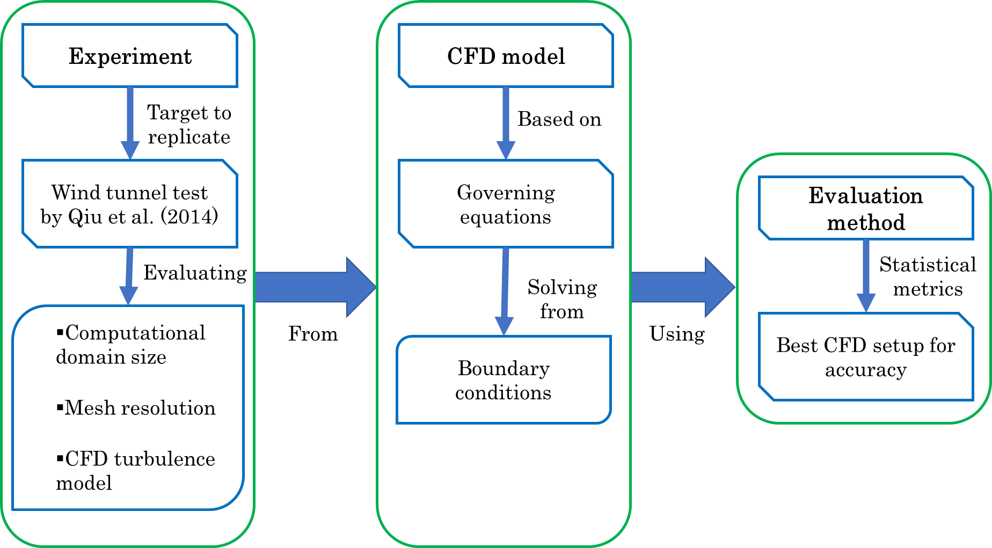
Fig. 1. Flowchart of the methodology used in this research.

2.1 Wind Tunnel Test Target

In this study, various configurations of a CFD model were evaluated to determine the optimal simulation parameters for estimating wind pressures on structures with curved roofs, as shown in Fig. 2, where B is the length, H is the ridge height, and h is the eave height. The CFD simulations were conducted on six different geometric configurations defined by rise height-to-span ratios of R/D = 1/2, 1/3, and 1/6 combined with two different span lengths D shown in Table 1.

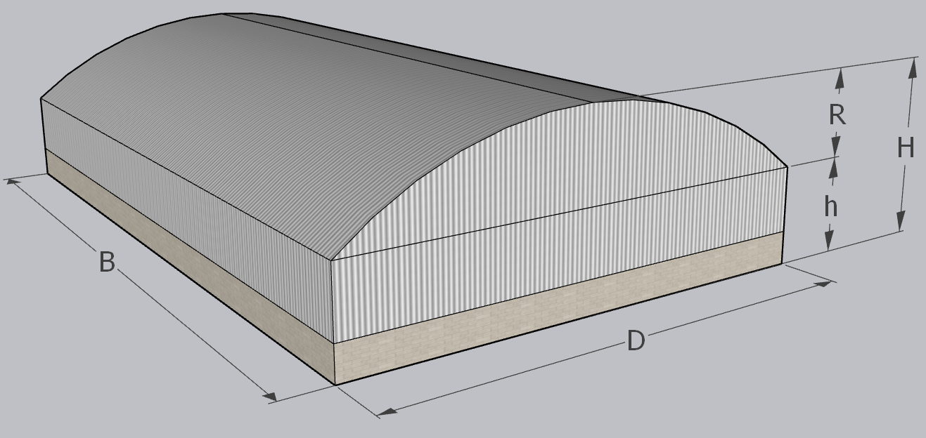
Fig. 2. Geometric representation of the curved roof structures.

Table 1. Geometric configurations used in the CFD simulations. These configurations were selected to replicate the conditions of the wind tunnel experiments.
Geometry | D | R | h | H | h/R | R/D | B/D
Geometry | Span (m) | Rise height (m) | Eave height (m) | Ridge height (m) | Eave-to-rise length ratio | Rise-to-span ratio | Length-to-span ratio
Geom_1 | 60 | 30 | 6 | 36 | 0.2 | 1/2 | 1
Geom_2 | 60 | 20 | 6 | 26 | 0.3 | 1/3 | 1
Geom_3 | 60 | 10 | 6 | 16 | 0.6 | 1/6 | 1
Geom_4 | 20 | 10 | 6 | 16 | 0.6 | 1/2 | 1
Geom_5 | 20 | 6.67 | 6 | 12.67 | 0.9 | 1/3 | 1
Geom_6 | 20 | 3.33 | 6 | 9.33 | 1.8 | 1/6 | 1

Wind tunnel test results were previously published by Qiu (Qiu et al., 2014), in which pressure measurements were taken at the centerline of the structure at 21 discrete locations along the roof, parallel to the flow direction. The experimental study investigated the influence of Reynolds number within the range Re = 1.66 × 10⁵ to 8.28 × 10⁵, based on the span D. It was observed that the pressure distribution along the roof becomes relatively stable for Re > 4.14 × 10⁵ for R/D = 1/2, Re > 2.48 × 10⁵ for R/D = 1/3, and in the case of R/D = 1/6, the pressure distribution was found to be independent within the studied Reynolds number range.

To replicate the fluid behavior observed in wind tunnel testing, the Reynolds similarity conditions were applied (Vergara Sánchez, 1993), setting Re = 8.28 × 10⁵ for the long-span geometries and Re = 2.24 × 10⁵ for the short-span geometries. These values correspond to a wind speed of 20 m/s, as used in the wind tunnel study that used a length scale of 1:100. For the CFD experiment, a full-scale model was used, which corresponds to a wind speed of 0.20 m/s according to the Reynolds similarity condition, described in the Eq. (1).

 | $$\frac{Re_{p}}{Re_{m}}=\frac{{\left(\frac{ρvy}{μ}\right)}_{p} }{{\left(\frac{ρvy}{μ}\right)}_{m} }=1$$ | (1)

Where $p$ sub-indices represent the full-scale prototype and $m$ sub-indices represent the scaled model. The rest of the variables are the air density ($ρ$), the fluid velocity ($v$), the dynamic viscosity ($μ$), and the length ($y$), where $ρ$ and $μ$ are fluid properties that do not change for prototype and model, obtaining the prototype velocity Eq. (2).

 | $$v_{p}=\frac{{\left(vy\right)}_{m}}{y_{p} }$$ | (2)

2.2 CFD configuration test

2.2.1 Computational domain size

The domain dimensions were assigned empirically based on the size of the structure under study. Typically, the domain size is determined using the structure’s height, due to the flow separation and recirculation generated at the maximum height. Many of the recommendations are established for structures with very pronounced edges because their geometries induce a stronger flow separation and longer recirculation zone compared to a circular-arched roof, where flow separation occurs more gradually, producing a smoother and shorter recirculation pattern.

For this reason, a similar analysis was carried out in the present study to identify the optimal domain dimensions for a structure with a circular arched roof. The computational domain was evaluated in two stages (Table 3), based on the structure dimensions. A variable S was defined as the greater of H or D/2, ensuring that the domain dimensions would not be underestimated when the structure’s height is small but its horizontal dimensions are significant. In the first stage, four downstream lengths were tested, ranging from 6S to 15S with an interval of 3S. During this stage, the lateral and upper boundaries were kept fixed at a distance of 5S, a value shown that avoid interference with the flow (Kim et al., 2017). After identifying the optimal downstream length, the second stage involved evaluating three different lateral and top boundary distances, ranging from 3S to 5S with an interval of S, as illustrated in Fig. 3.

Table 2. Conditions for the computational domain test.
Computational domain test | Upstream portions | Downstream portion | Side portions | Upper portions
Test 1 | 3S | 6S | 5S | 5S
Test 1 | 3S | 9S | 5S | 5S
Test 1 | 3S | 12S | 5S | 5S
Test 1 | 3S | 15S | 5S | 5S
Test 2 | 3S | Determined in Test 1 | 3S | 3S
Test 2 | 3S | Determined in Test 1 | 4S | 4S
Test 2 | 3S | Determined in Test 1 | 5S | 5S

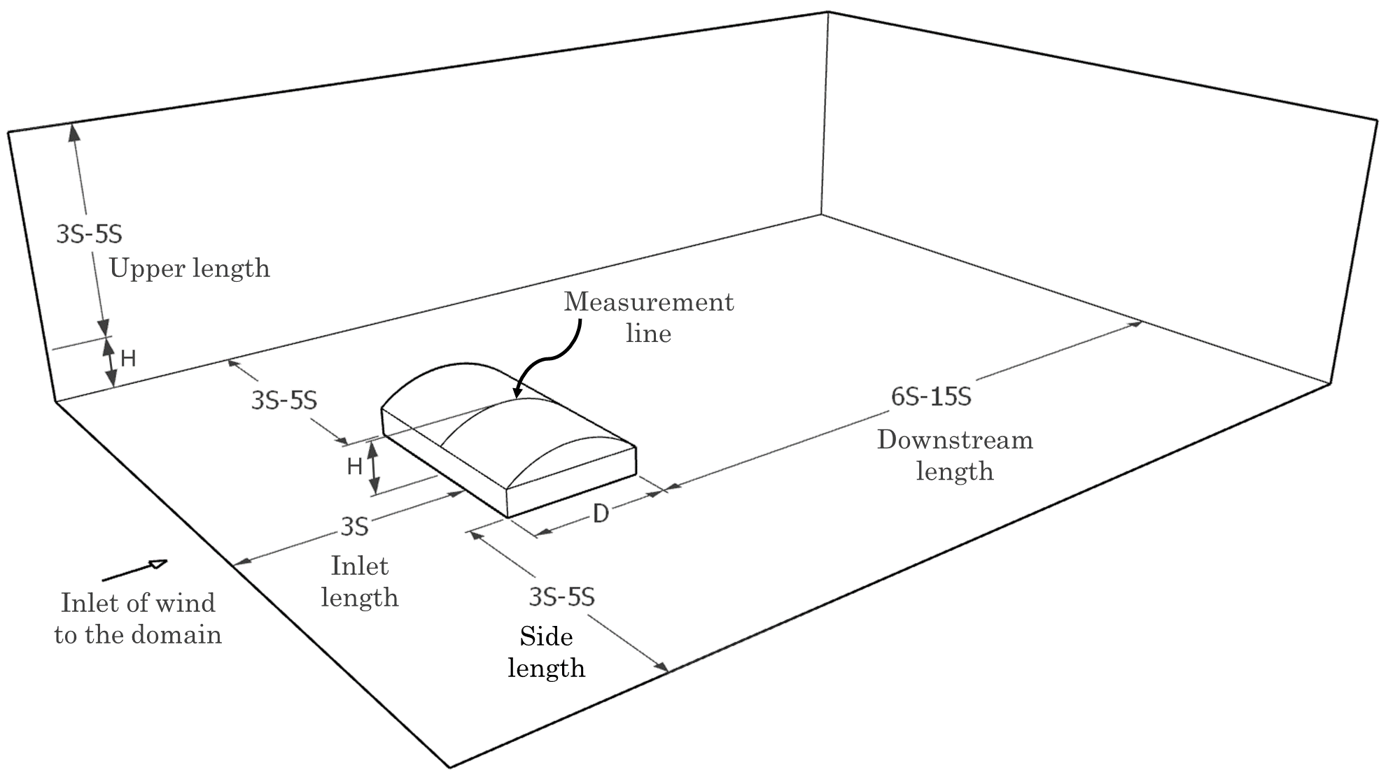
Fig. 3. Length portions for the computational domain test.

These tests were evaluated under the five turbulence model: Standard $k-ω$, SST $k-ω$, Standard $k-ϵ$, RNG $k-ϵ$, and Realizable $k-ϵ$. The purpose of this is to conduct a study that is not biased by the results of a single turbulence model and to evaluate the effect of domain size on each of the turbulence models mentioned.

2.2.2 Mesh size

Another aspect evaluated in this study was the mesh size. A test was conducted to identify the most suitable mesh size for the five turbulence models. It was selected four cases mesh size based on the proportions of the variable W, defined as the average of H and D/2, following the approach used by Meng (Meng et al., 2018). The select mesh sizes correspond to 0.02W, 0.015W, 0.0125W and 0.01W, resulting for the first geometry in approximately 0.53, 0.92, 1.35, and 2.06 million cells, respectively.

The grid type used was the poli-hexahedral, a hybrid mesh that combines polyhedral and hexahedral elements. The hexahedral elements are known for promoting faster convergence, while polyhedral cells offer better adaptability to complex geometries and improved accuracy with a lower total cell number compared to tetrahedral meshes (Wijesooriya et al., 2023).

2.2.3 Turbulence model

Finally, selected the domain and mesh size, were tested six geometries with circular arched roof, under different turbulence models. The evaluated geometries were the presented in Table 1, where different h/R and R/D ratios are considered. The aim was to observe the robustness of the turbulence models to distinct geometrical cases where different fluid behaviors are expected, especially in flow separation and recirculation areas.

The selected turbulence models for this test were: Standard k-ω, SST k-ω, Standard k-ε, RNG k-ε, and Realizable k-ε. Each one was applied to all geometries to determine its ability to compute the wind flow response, as well as the pressure distribution along the roof of the structure.

2.3 CFD model

2.3.1 Governing equations

The Navier–Stokes equations describe the physical behavior of a fluid. For cases involving Newtonian, incompressible, isothermal, and steady-state flow, the equations can be simplified into the following continuity (3) and momentum (4) equations:

 | $$\frac{∂u_{i}}{∂x_{i}}=0$$ | (3)
 | $$\frac{∂u_{i}}{∂t}+u_{j}\frac{∂u_{i}}{∂x_{j}}=ν\frac{∂^{2}u_{i}}{∂x_{j}∂x_{j}}-\frac{1}{ρ}\frac{∂p}{∂x_{i}}+f_{i}$$ | (4)

Where $u$ is the velocity field, $ν$ the kinematic viscosity, $ρ$ the fluid density, $p$ the pressure, and $f$ represents external body forces. Since this study employs the RANS (Reynolds-Averaged Navier–Stokes) approach, Equation (4) is modified by applying Reynolds decomposition, resulting in (5):

 | $$\frac{∂{\overline{u}}_{i}}{∂t}+{\overline{u}}_{j}\frac{∂{\overline{u}}_{i}}{∂x_{j}}=ν\frac{∂^{2}{\overline{u}}_{i}}{∂x_{j}∂x_{j}}-\frac{1}{ρ}\frac{∂\overline{p}}{∂x_{i}}-\frac{∂\overline{u_{i}^{'}u_{j}^{'}}}{∂x_{j}}$$ | (5)

In this equation, the last term $\overline{u_{i}^{'}u_{j}^{'}}$ represents the Reynolds stress (6). The turbulence models used in this work fall under the category of linear Eddy Viscosity Models (EVM), which are Boussinesq hypothesis-based, a widely adopted approach for turbulence closure that allows estimation of turbulent viscosity (Ali et al., 2024).

 | $$\overline{u_{i}^{'}u_{j}^{'}}=\frac{2}{3}kδ_{ij}-ν_{T}\left(\frac{∂{\overline{u}}_{i}}{∂x_{j}}+\frac{∂{\overline{u}}_{j}}{∂x_{i}}\right)$$ | (6)

The term $k=\frac{1}{2}{\overline{u}}_{i}^{2}$ represents the turbulent kinetic energy (TKE), and $ν_{T}$ the turbulent viscosity (7). The EVM, also known as two-equation models (Lateb et al., 2013), works by modeling the turbulent viscosity by the TKE (8) and the turbulence dissipation rate $ϵ$ (9) or on the specific dissipation rate $ω$ (10), depending on the turbulence model used.

 | $$ν_{T}=C_{μ}\frac{k^{2}}{ϵ}$$ | (7)
 | $$\frac{∂k}{∂t}+{\overline{u}}_{j}\frac{∂k}{∂x_{j}}=\frac{∂}{∂x_{j}}\left(ν_{T}\frac{∂k}{∂x_{j}}\right)+P_{k}-ϵ$$ | (8)
 | $$\frac{∂ϵ}{∂t}+{\overline{u}}_{j}\frac{∂ϵ}{∂x_{j}}=\frac{∂}{∂x_{j}}\left(ν_{T}\frac{∂ϵ}{∂x_{j}}\right)+\frac{ϵ}{k}\left[C_{ϵ1}P_{k}-C_{ϵ2}ϵ\right]$$ | (9)
 | $$\frac{∂ω}{∂t}+{\overline{u}}_{j}\frac{∂ω}{∂x_{j}}=\frac{∂}{∂x_{j}}\left((ν+σ_{ω}ν_{T}\frac{∂ω}{∂x_{j}}\right)+α\frac{ν_{T}}{k}P_{k}-βω^{2}$$ | (10)

Where $P_{k}$ is the production of turbulent kinetic energy and $C_{ϵ}$, $C_{μ}$, $α$, $β$ and $σ_{ω}$ are empirical constants that depend on the specific turbulence model.

2.3.2 Boundary conditions

The equations previously described are commonly simplified for domains where the height is within the atmospheric boundary layer (Richards & Hoxey, 1993). In this study, flow properties were assigned as initial conditions at the domain inlet. These properties include the velocity profile $U\left(y\right)$, and turbulent kinetic energy $k\left(y\right)$, along with the appropriate dissipation rate, either $ϵ$ or $ω$, depending on the turbulence model. These quantities are defined by Equations (11)–(15):

 | $$U\left(y\right)=\frac{u^{*}}{K}\ln\left(\frac{y+y_{0}}{y_{0}}\right)$$ | (11)
 | $$u^{*}=K\frac{U_{ref}}{\ln\left(\frac{y_{ref}+y_{0}}{y_{0}}\right)}$$ | (12)
 | $$k=\frac{u^{*2}}{\sqrt{C_{μ}}}$$ | (13)
 | $$ϵ=\frac{u^{*3}}{K(y+y_{0})}$$ | (14)
 | $$ω=\frac{ϵ}{C_{μ}k}$$ | (15)

Where $U_{ref}$ is the wind speed at the reference height $y_{ref}$, $y_{0}$ is the surface roughness length, $u^{*}$ the friction velocity, $K$ the Von Karman constant equal to 0.41.

A steady-state analysis was conducted for this study, based on the SIMPLEC algorithm (Semi-Implicit Method for Pressure-Linked Equations - Consistent) that is an improvement of the SIMPLE algorithm, offering greater speed and robustness (Zeng & Tao, 2003). Additionally, second-order discretization schemes were used to achieve improved accuracy (Bournet et al., 2007). A convergence criterion of 1x10⁻⁴, was established for the residuals of all solved variables, following the recommendations by Oro (2012). The inlet constant values are presented in Table 3 and are consistent with the wind profile type used in the reference study. In this type of analysis, the energy conservation equation is not included in the solution process, as its influence on wind pressure prediction is negligible (Kim et al., 2017).

Table 3. Characteristics of the numerical simulation and constant values for boundary conditions.
Inlet parameter | Value | Unit
Numerical algorithm | SIMPLEC | -
Discretization | Second-order | -
Wind environment | Eq. (11)–(15) | -
Gravitational acceleration | 9.81 | m/s²
Air density | 1.225 | kg/m³
Reference wind speed | 0.20 | m/s
Reference height | 6 | m
Surface roughness length | 2 x10⁻⁴ | m
Air viscosity | 1.789x10⁻⁵ | kg/ms

The $y^{+}$ values were maintained below 5, under the recommendations presented by Wijesooriya et al. (2023). This allowed the use of the Enhanced Wall Treatment (EWT) wall function, which is considered one of the most effective approaches and performs best for $y^{+}< 5$. Although $k-ω$ models do not rely on wall functions, their results are also more accurate when small y+ values are achieved.

2.4 Evaluation method for CFD accuracy

To evaluate the predictive performance of the numerical model, three statistical metrics were applied: the coefficient of determination (R²), the root mean square error-observations standard deviation ratio (RSR), and the index of agreement (d), following the evaluation methodology proposed by Kim (Kim et al., 2017).

The coefficient of determination quantifies the degree of correlation between numerical model and experimental values. The R² takes on values in the 0 - 1 range, with 1 indicating a perfect fit. This metric indicates trends but does not express the magnitude of the error. On another hand, the RSR is a statistical index that standardizes the root mean square error (RMSE) by the standard deviation of observed data. In this case, a lower RSR value reflects a higher predictive accuracy of the model, with 0 indicating a perfect fit. Finally, the index of agreement is the ratio of the mean squared error (MSE) and the potential error (PE). It evaluates the degree of agreement between experimental and simulated values, taking values on the 0-1 range, being a higher accuracy when d is closer to 1. This combined approach provides a robust assessment of the agreement between numerical model predictions and experimental data from Qiu et al. (2014) study, overcoming the limitations of relying on a single metric.

3. results and discussion

3.1 Determination of computational domain size

The first part of the domain size evaluation was the determination of the domain downstream length. To illustrate the fluid development for different outlet length ratios, wind velocity vectors are shown in a cross-section of the domain, parallel to the flow direction, when the wind is perpendicular to the ridge Fig. 4. For the different distances, the recirculating flow is inside the domain and remains unaffected by its dimensions.

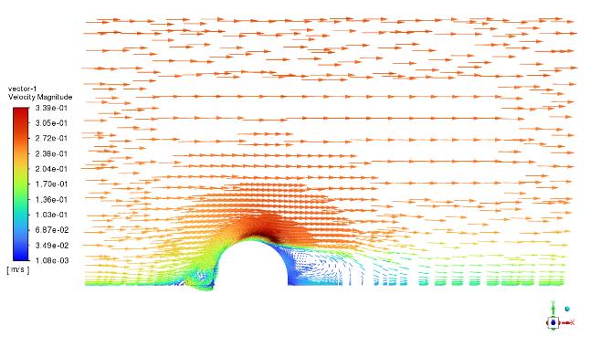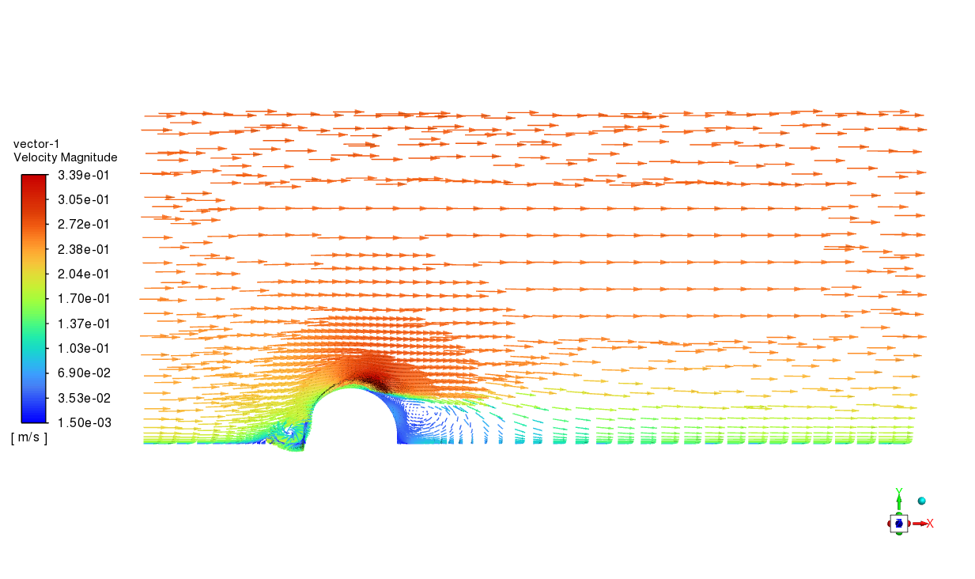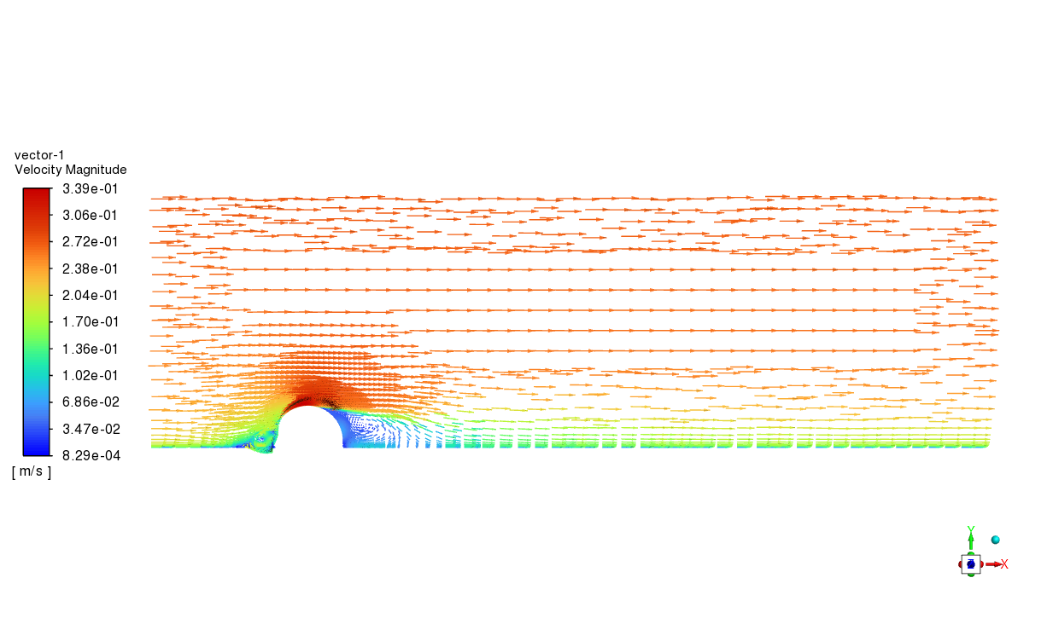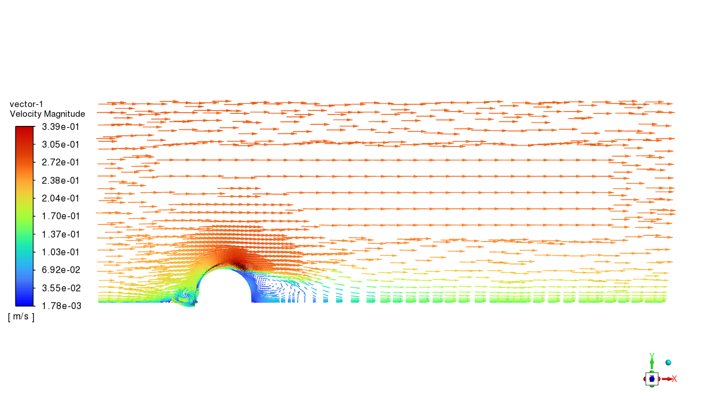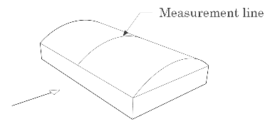Fig. 4. Wind velocity vectors on X-X transversal section of computational domain to different downstream lengths: a) 6S, b) 9S, c) 12S, d) 15S.
a)
b)
c)
d)

The $Cp$ obtained by simulations was compared with the experimental data, as shown in Table 4a. There is a high agreement between the simulation to measurement for all lengths of the downstream portion because the backflow shape could form inside the domain in all cases. In the Standard $k-ω$ and Standard $k-ϵ$ cases, the performance was the same for all portions, but for SST, RNG, and Realizable models, the performance got better with the increase of the downstream length, getting the best results for the 15S portion. The results could be explained by the stability of the flow before its outlet, ensuring a better convergence and accuracy.

Table 4. Evaluation metrics for CFD-computed and experimental-measured wind pressure coefficients according to the lengths of the downstream, side, and upper.
Turbulence model | a) First test – Downstream portion |  |  |  | b) Second test – Side and upper portion
Turbulence model | Downstream portion | R² | RSR | d | Lateral length | Upper length | R² | RSR | D
Standard  k-ω | 6S | 0.92 | 0.27 | 0.98 | 3S | 3S | 0.93 | 0.25 | 0.98
Standard  k-ω | 9S | 0.92 | 0.27 | 0.98 | 4S | 4S | 0.93 | 0.26 | 0.98
Standard  k-ω | 12S | 0.92 | 0.27 | 0.98 | 5S | 5S | 0.92 | 0.27 | 0.98
Standard  k-ω | 15S | 0.92 | 0.27 | 0.98 | - | - | - | - | -
SST k-ω | 6S | 0.95 | 0.23 | 0.99 | 3S | 3S | 0.95 | 0.23 | 0.99
SST k-ω | 9S | 0.94 | 0.24 | 0.98 | 4S | 4S | 0.95 | 0.22 | 0.99
SST k-ω | 12S | 0.95 | 0.23 | 0.99 | 5S | 5S | 0.95 | 0.23 | 0.99
SST k-ω | 15S | 0.95 | 0.22 | 0.99 | - | - | - | - | -
Standard  k-ε | 6S | 0.82 | 0.41 | 0.96 | 3S | 3S | 0.80 | 0.43 | 0.96
Standard  k-ε | 9S | 0.82 | 0.42 | 0.96 | 4S | 4S | 0.81 | 0.42 | 0.96
Standard  k-ε | 12S | 0.82 | 0.41 | 0.96 | 5S | 5S | 0.82 | 0.41 | 0.96
Standard  k-ε | 15S | 0.82 | 0.41 | 0.96 | - | - | - | - | -
RNG k-ε | 6S | 0.92 | 0.27 | 0.98 | 3S | 3S | 0.93 | 0.27 | 0.98
RNG k-ε | 9S | 0.93 | 0.26 | 0.98 | 4S | 4S | 0.94 | 0.24 | 0.98
RNG k-ε | 12S | 0.94 | 0.25 | 0.98 | 5S | 5S | 0.94 | 0.25 | 0.98
RNG k-ε | 15S | 0.94 | 0.25 | 0.98 | - | - | - | - | -
Realizable  k-ε | 6S | 0.97 | 0.17 | 0.99 | 3S | 3S | 0.96 | 0.20 | 0.99
Realizable  k-ε | 9S | 0.97 | 0.16 | 0.99 | 4S | 4S | 0.97 | 0.16 | 0.99
Realizable  k-ε | 12S | 0.97 | 0.16 | 0.99 | 5S | 5S | 0.97 | 0.16 | 0.99
Realizable  k-ε | 15S | 0.98 | 0.15 | 0.99 | - | - | - | - | -

While 15S achieved the best accuracy, based on the analysis across the different length downstream portions, it was determined that 12S was found as the optimal portion in terms of flow stabilization, computational efficiency, and accuracy for most models. Although the 12S portion has a minimal difference from the 15S only in terms of RSR, which presents the best global accuracy. Therefore, the 12S allows optimizing computational resources, because it is a shorter domain distance without losing accuracy.

The computational domain test was also performed to find the optimal side and upper portions of length. These results, shown in Table 4b, were fairly stable across the different length portions. The bigger difference was found in the $k-ε$ models, specifically in the RNG and Realizable models, where the RSR is higher for the 3S case and decreases in the 4S and 5S cases, being most similar between his last two. In the rest of the cases were no big changes in the evaluation metrics. From these results, the lengths of the side and upper portions were selected as 4S, corresponding to a 3.45% blockage ratio, consistent with the recommendations in past studies (Meng et al., 2018; Wijesooriya et al., 2023; Zhao & He, 2017). The determined computational domain size is shown in Fig. 5.

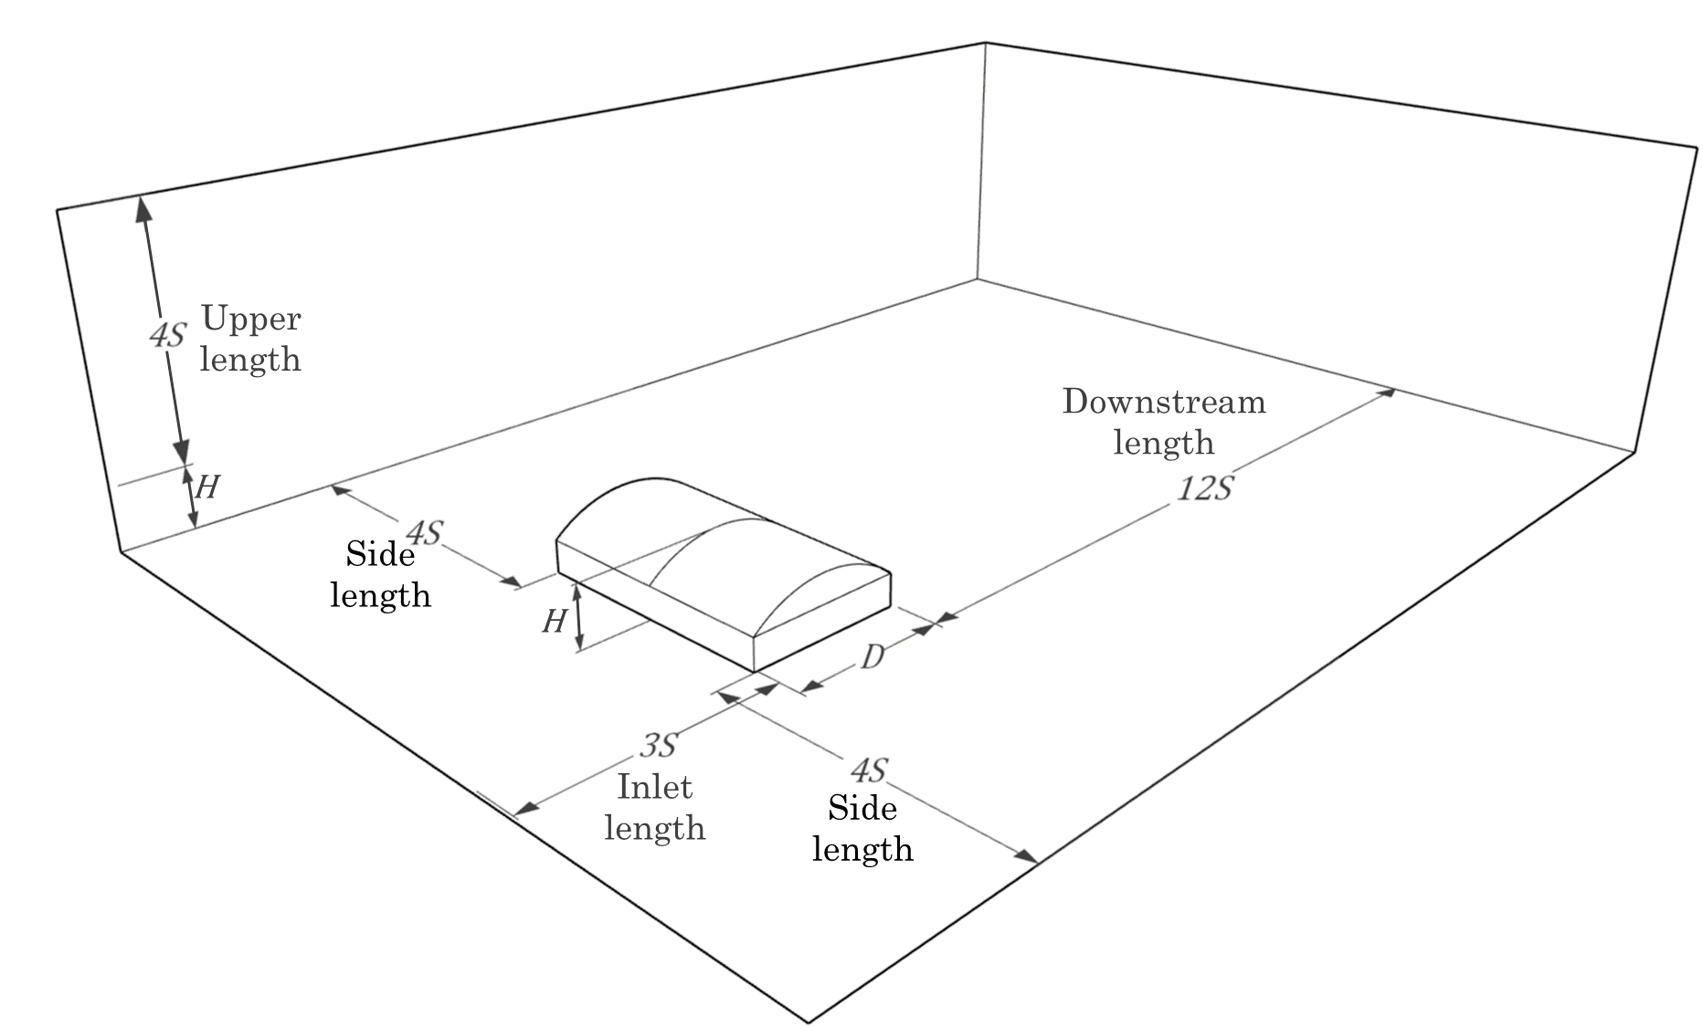
Fig. 5. Determined computational domain size.

3.2 Determination of mesh size

The mesh size evaluation showed that the accuracy of the results is similar for all turbulence models. However, as shown in Table 5, the SST $k-ω$ and RNG $k-ϵ$ models indicate a slightly better fit when the mesh size is smaller. The Fig. 6 shows how, for both cases, the $Cp$ distribution changes with the mesh size, resulting in a higher suction pressure for a smaller mesh. For the Standard and Realizable $k-ϵ$ cases, the performance of the mesh gets worse when the mesh size is reduced. Nevertheless, this is explained for the same reason seen in SST $k-ω$ and RNG $k-ϵ$ cases; the suction is higher in a smaller mesh, but for these cases, the turbulence model was already overestimating the suction, resulting in a higher difference.

Table 5. Evaluation metrics for CFD-computed and experimental-measured Cp for the mesh sizes tested.
Turbulence model | Mesh size | R² | RSR | d
Standard k-ω | 0.02W | 0.93 | 0.26 | 0.98
Standard k-ω | 0.015W | 0.94 | 0.24 | 0.98
Standard k-ω | 0.0125W | 0.94 | 0.24 | 0.98
Standard k-ω | 0.01W | 0.94 | 0.25 | 0.98
SST k-ω | 0.02W | 0.94 | 0.24 | 0.98
SST k-ω | 0.015W | 0.94 | 0.24 | 0.98
SST k-ω | 0.0125W | 0.95 | 0.23 | 0.99
SST k-ω | 0.01W | 0.95 | 0.22 | 0.99
Standard k-ε | 0.02W | 0.81 | 0.43 | 0.96
Standard k-ε | 0.015W | 0.80 | 0.44 | 0.96
Standard k-ε | 0.0125W | 0.82 | 0.42 | 0.96
Standard k-ε | 0.01W | 0.78 | 0.45 | 0.95
RNG k-ε | 0.02W | 0.92 | 0.27 | 0.98
RNG k-ε | 0.015W | 0.93 | 0.25 | 0.98
RNG k-ε | 0.0125W | 0.95 | 0.23 | 0.99
RNG k-ε | 0.01W | 0.95 | 0.22 | 0.99
Realizable k-ε | 0.02W | 0.97 | 0.17 | 0.99
Realizable k-ε | 0.015W | 0.96 | 0.19 | 0.99
Realizable k-ε | 0.0125W | 0.96 | 0.19 | 0.99
Realizable k-ε | 0.01W | 0.96 | 0.20 | 0.99

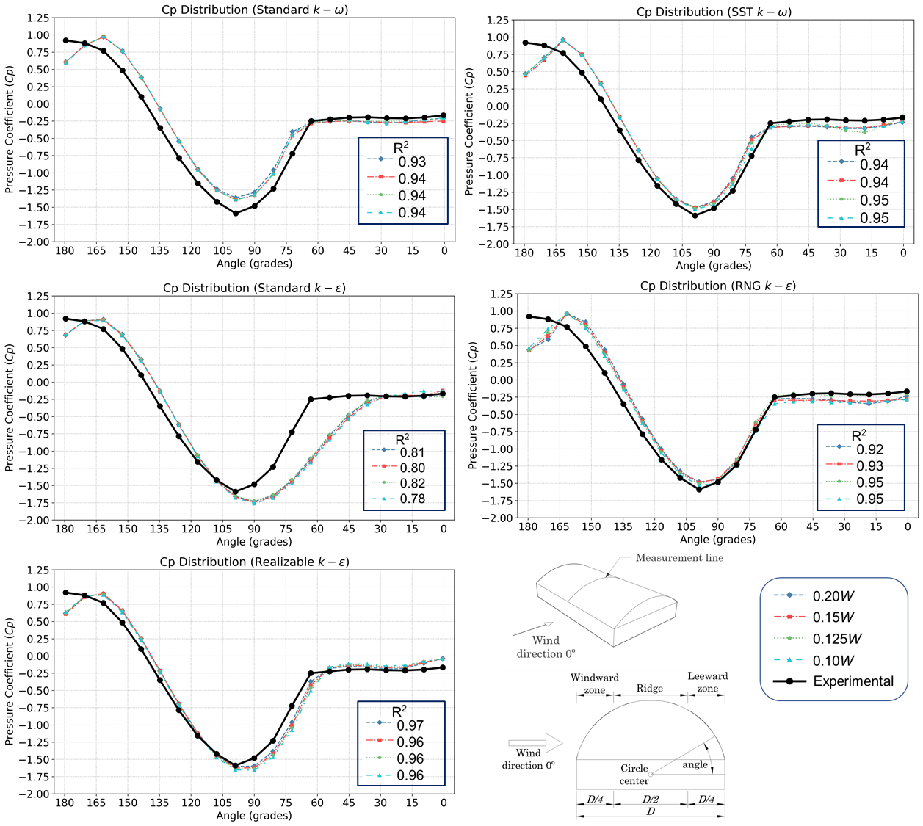
e)
d)
c)
b)
a)

Fig. 6. Comparison of CFD-computed and experimental-measured Cp according to the mesh sizes evaluated with the wind perpendicular to the ridge along the centerline of the roof for the different turbulence models: a) Standard k-ω, b) SST k-ω, c) Standard k-ε, d) RNG k-ε, e) Realizable k-ε.

In general, the 0.0125W mesh size portion was the most suitable, providing a good balance of precision and computational efficiency, obtaining similar values to the 0.01W portion, but with fewer mesh elements. For this reason, the mesh size portion was designed at 0.0125W for the turbulence models test evaluation.

3.3 Determination of turbulence model

Using the domain and mesh size recommended in previous sections, the evaluation was conducted for the turbulence models in six different geometries in Table 1. The results obtained from this test are shown in Table 6. In general, the $k-ω$ models demonstrated regular performance in most cases, except on the first geometry, where both models obtained high indices. In contrast, the RNG and Realizable models showed the highest performance for most geometries, except for the third and sixth cases.

Table 6. Statistical indices for CFD-computed and experimental-measured Cp of circular arched-roof geometries for different turbulence models.
Geometry | Statistical index | Standard k-ω | SST  k-ω | Standard k-ε | RNG k-ε | Realizable k-ε
G_1 | R² | 0.94 | 0.95 | 0.82 | 0.95 | 0.96
G_1 | RSR | 0.24 | 0.23 | 0.42 | 0.23 | 0.19
G_1 | d | 0.98 | 0.99 | 0.96 | 0.99 | 0.99
G_2 | R² | 0.89 | 0.84 | 0.92 | 0.94 | 0.97
G_2 | RSR | 0.32 | 0.39 | 0.28 | 0.24 | 0.17
G_2 | d | 0.97 | 0.95 | 0.98 | 0.98 | 0.99
G_3 | R² | 0.78 | 0.78 | 0.83 | 0.84 | 0.83
G_3 | RSR | 0.46 | 0.45 | 0.41 | 0.40 | 0.40
G_3 | d | 0.95 | 0.94 | 0.96 | 0.96 | 0.96
G_4 | R² | 0.87 | 0.88 | 0.92 | 0.97 | 0.99
G_4 | RSR | 0.35 | 0.33 | 0.28 | 0.16 | 0.06
G_4 | d | 0.96 | 0.97 | 0.98 | 0.99 | 1.00
G_5 | R² | 0.86 | 0.85 | 0.95 | 0.97 | 0.99
G_5 | RSR | 0.37 | 0.38 | 0.23 | 0.16 | 0.09
G_5 | d | 0.96 | 0.95 | 0.99 | 0.99 | 1.00
G_6 | R² | 0.83 | 0.75 | 0.62 | 0.79 | 0.63
G_6 | RSR | 0.40 | 0.49 | 0.60 | 0.45 | 0.60
G_6 | d | 0.95 | 0.93 | 0.89 | 0.93 | 0.90

Furthermore, Fig. 7 illustrates the $Cp$ distribution obtained along the centerline of each geometry. It is shown that both $k-ω$ models obtain a similar distribution that experimental data, but with an underestimation of suction effects values, especially on the ridge and leeward zone of the roof for geometries 2, 4, and 5. Likewise, the Standard $k-ϵ$ exhibits good behavior in the windward area up to the ridge, but the distribution in the leeward zone is different than experimental-measured $Cp$, indicating that this model may not fully capture the flow separation and recirculation effects, resulting in a poor performance. The RNG and Realizable models showed the best accuracy for the distribution in most geometries. For the 2, 4, and 5 cases, the RNG model gets high precision with a slight underestimation for suction effects near to ridge. Whereas, for 1, 4, and 6 cases, the Realizable model obtains a high accuracy with a slight overestimation for suction effects on the ridge and leeward zone.

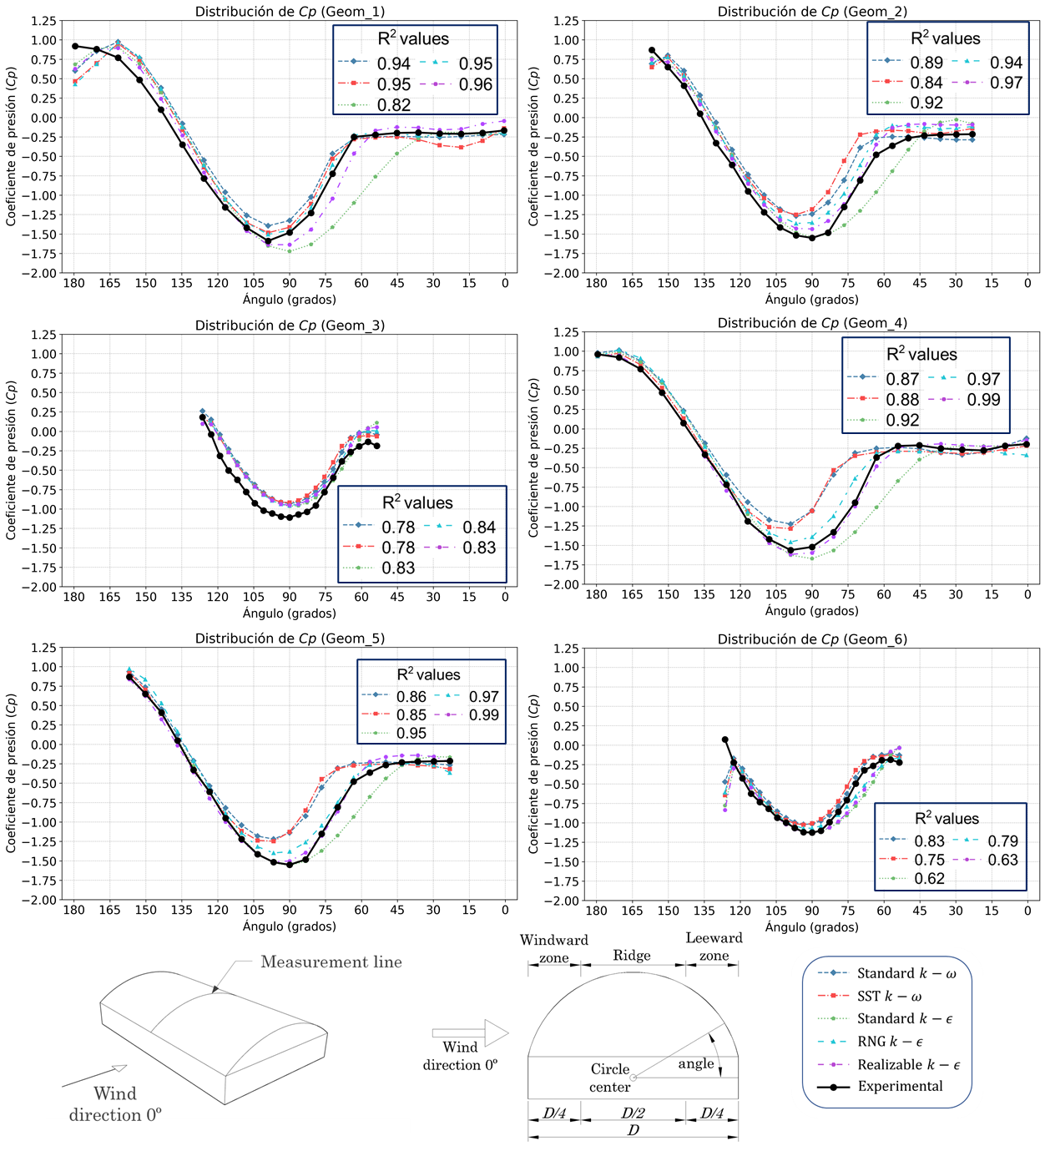
Fig. 7. Comparison of CFD-computed and experimental-measured $Cp$ for each geometry under the different turbulence models.

The third geometry case was the most difficult for all turbulence models, resulting in an underestimation along the measurement line, and obtaining the best accuracy from the RNG and Realizable models. Another case where all models showed a lower accuracy was the sixth geometry, being both cases similar, with a low R/D ratio. In this last case, the statistical indices were generally poor, but this is explained by the values at the beginning of the windward area. The first point in this zone indicates a sudden high suction, but it does not appear in the experimental data, resulting in poor accuracy that is lower for cases where the suction is most notable, as the Realizable case.

3.4 General discussion
In this section, the performance of the turbulence models is analyzed based on the results obtained from the simulations employed on six geometries with circular arched roofs. Table 7 presents the mean of the statistical metrics obtained for the distinct R/D ratios, where the R/D=1/2 ratio corresponds to the first and fourth geometries, R/D=1/3 to the second and fifth, and R/D=1/6 to the third and sixth Table 1.

Table 7. Summary results of statistical indices for CFD-computed and experimental-measured $Cp$ for distinct R/D ratios cases.
Geometries | Statistical metric | Standard $k-ω$ | SST $k-ω$ | Standard $k-ϵ$ | RNG $k-ϵ$ | Realizable $k-ϵ$
R/D = 1/2 | R² | 0.90 | 0.91 | 0.87 | 0.96 | 0.98
R/D = 1/2 | RSR | 0.30 | 0.28 | 0.35 | 0.19 | 0.13
R/D = 1/2 | d | 0.97 | 0.98 | 0.97 | 0.99 | 0.99
R/D = 1/3 | R² | 0.87 | 0.84 | 0.93 | 0.96 | 0.98
R/D = 1/3 | RSR | 0.34 | 0.39 | 0.25 | 0.20 | 0.13
R/D = 1/3 | d | 0.96 | 0.95 | 0.98 | 0.99 | 0.99
R/D = 1/6 | R² | 0.80 | 0.77 | 0.72 | 0.81 | 0.73
R/D = 1/6 | RSR | 0.43 | 0.47 | 0.50 | 0.42 | 0.50
R/D = 1/6 | d | 0.95 | 0.93 | 0.92 | 0.95 | 0.93
Total average | R² | 0.86 | 0.84 | 0.84 | 0.91 | 0.90
Total average | RSR | 0.36 | 0.38 | 0.37 | 0.27 | 0.25
Total average | d | 0.96 | 0.95 | 0.96 | 0.98 | 0.97

Both $k-ω$ models presented similar results. These turbulence models obtained acceptable metrics for R² and RSR for R/D=1/2, close to 0.90 and 0.28 respectability. However, it was observed that the statistical metrics decrease for lower R/D ratios, obtaining R² values under 0.80 for the lowest R/D ratio. In global terms, the performance for $k-ω$ models was acceptable, having a mean performance in the statistical metrics around 0.85 for R² and under 0.38 for RSR.

The standard $k-ϵ$ turbulence model shows a good performance for the R/D=1/3 with R² = 0.93 and RSR = 0.25, but for the ratio of 1/2, this turbulence model obtained the worst performance, being the only case of R²<0.9 for this ratio. In general, the global performance was similar to $k-ω$ models in statistical metric terms. But, for the results shown in Fig. 7, the key difference between these models is the distribution and magnitude of the $Cp$, where the standard $k-ϵ$ model shows similar magnitude according to the experimental-measured $Cp$ but different distributions, in contrast to $k-ω$ models that exhibited an inverse behavior.

Finally, the RNG and Realizable turbulence models exhibited the highest performance, with R²>0.95 and RSR<0.20 for the R/D ratios of 1/2 and 1/3, where the Realizable model is clearly superior to the RNG model for these R/D ratios. However, for the R/D=1/6 case, the situation is reversed, obtaining better results from the RNG model, explained by the sixth geometry, where the metrics of the Realizable model decay, as described in the previous section. Despite the above, the general performance of both turbulence models was the best of all tested, with a similar average. The RNG model shows a slight improvement for R² and d over the Realizable model, but for the relative error RSR, the Realizable model obtained a lower value.

4. Conclusion

In this study, the CFD modelling configuration was evaluated for the mean pressure coefficients ($Cp$) prediction in circular arched roof structures with different rise-to-span ratios. From the evaluation, the most efficient configuration of domain size, mesh resolution, and turbulence model were selected, taking into consideration the accuracy and computational demand.

The results showed that the downstream, side, and upper length portions had a minimal effect on the $Cp$ prediction for circular arched roof geometry. However, there was a slight difference between the portions considered, finding the best accuracy and computational cost balance in the 12S downstream length and the 4S side length, selecting the same for the upper length.

For the mesh resolution, the evaluation showed a higher accuracy with a smaller mesh size. Most models, like SST $k-ω$, RNG $k-ϵ$, obtain the best accuracy for 0.01W size, but with no significant difference to 0.0125W, showing similar results with 35% fewer elements, resulting 0.0125W size the best performance balance.

Finally, the turbulence model evaluation indicates that the Realizable $k-ϵ$ model was the most robust and consistent for most geometry configurations. This turbulence model obtained the higher indices for R² and d, as well as the lower error index (RSR), making it the most adequate model for parametric analysis that involucre a high number of simulations.

In conclusion, this work provides a practical guide for CFD simulation configurations for circular arched roof structures studies, establishing the optimal configuration for domain, mesh, and turbulence model to obtain accurate results with low-cost computational demand. In addition, the findings of this study provide a solid base for future explorations of wind behavior in parametric studies for this same geometry type or CFD validation for complex geometries.

References

Abu-Zidan, Y., Mendis, P., & Gunawardena, T. (2021). Optimising the computational domain size in CFD simulations of tall buildings. Heliyon, 7(4), e06723. https://doi.org/10.1016/j.heliyon.2021.e06723
Ali, I., Hussain, T., Unar, I. N., Kumar, L., & Ahad, I. U. (2024). Turbulence model study for aerodynamic analysis of the leading edge tubercle wing for low Reynolds number flows. Heliyon, 10(11), e32148. https://doi.org/10.1016/j.heliyon.2024.e32148
ASCE, (American Society of Civil Engineers). (2021). Minimum Design Loads and Associated Criteria for Buildings and Other Structures (1st ed). American Society of Civil Engineers. https://doi.org/10.1061/9780784415788
Blazhnov, A. (2020). Static calculation of film roof of cultivation structure. Bulletin of Belgorod State Technological University named after. V. G. Shukhov. https://doi.org/10.34031/2071-7318-2020-5-10-17-22
Bournet, P.-E., Khaoua, S., Boulard, T., Migeon, C., & Chasseriaux, G. (2007). Effect of Roof and Side Opening Combinations on the Ventilation of a Greenhouse Using Computer Simulation. Transactions of the ASABE, 50, 201–212. https://doi.org/10.13031/2013.22401
CEN, (European Committe for Standardization). (2020). EN 1991-1-4: Eurocode 1: Actions on structures—Part 1-4: General actions—Wind actions. https://eurocodes.jrc.ec.europa.eu/eurocode-1-actions-structures
CFE, (Comisión Federal de Electricidad). (2020). Manual de diseño de obras civiles: Diseño por viento. omisión Federal de Electricidad, México. https://www.ineel.gob.mx/gerencias/ingenieria-civil/sistema-viento/
Fouad, N. S., Mahmoud, G. H., & Nasr, N. E. (2018). Comparative study of international codes wind loads and CFD results for low rise buildings. Alexandria Engineering Journal, 57(4), 3623–3639. https://doi.org/10.1016/j.aej.2017.11.023
Jha, A. K., Sinha, A., & Raj, R. (2022). Effect of wind loads on low-rise pitched and circular arch roof structures: A comparative study based on numerical simulation. Civil Engineering and Architecture, 10(3), 1129–1141. https://doi.org/10.13189/cea.2022.100329
Kim, R., Lee, I., & Kwon, K. (2017). Evaluation of wind pressure acting on multi-span greenhouses using CFD technique, Part 1: Development of the CFD model. Biosystems Engineering, 164, 235–256. https://doi.org/10.1016/j.biosystemseng.2017.09.008
Lateb, M., Masson, C., Stathopoulos, T., & Bédard, C. (2013). Comparison of various types of k–ε models for pollutant emissions around a two-building configuration. Journal of Wind Engineering and Industrial Aerodynamics, 115, 9–21. https://doi.org/10.1016/j.jweia.2013.01.001
Meng, F.-Q., He, B.-J., Zhu, J., Zhao, D.-X., Darko, A., & Zhao, Z.-Q. (2018). Sensitivity analysis of wind pressure coefficients on CAARC standard tall buildings in CFD simulations. Journal of Building Engineering, 16, 146–158. https://doi.org/10.1016/j.jobe.2018.01.004
Oro, J. M. F. (2012). Técnicas numéricas en ingeniería de fluidos: Introducción a la dinámica de fluidos computacional (CFD) por el método de volúmenes finitos. Reverte. https://www.reverte.com/catalogo/libro/tecnicas-numericas-en-ingenieria-de-fluidos_1372
Qiu, Y., Sun, Y., Wu, Y., San, B., & Tamura, Y. (2018). Surface roughness and Reynolds number effects on the aerodynamic forces and pressures acting on a semicylindrical roof in smooth flow. Journal of Structural Engineering, 144(9), 04018140. https://doi.org/10.1061/(ASCE)ST.1943-541X.0002129
Qiu, Y., Sun, Y., Wu, Y., & Tamura, Y. (2014). Modeling the mean wind loads on cylindrical roofs with consideration of the Reynolds number effect in uniform flow with low turbulence. Journal of Wind Engineering and Industrial Aerodynamics, 129, 11–21. https://doi.org/10.1016/j.jweia.2014.02.011
Richards, P. J., & Hoxey, R. P. (1993). Appropriate boundary conditions for computational wind engineering models using the k-ϵ turbulence model. Journal of Wind Engineering and Industrial Aerodynamics, 46–47, 145–153. https://doi.org/10.1016/0167-6105(93)90124-7
Salim, M., & Ooka, R. (2008). Influence of cell geometry and mesh resolution on large eddy simulation predictions of flow around a single building. Building Simulation, 1, 251–260. https://doi.org/10.1007/s12273-008-8321-7
San, B., Xu, C., & Qiu, Y. (2019). Three-Dimensional Aerodynamic Optimization of Single-Layer Reticulated Cylindrical Roofs Subjected to Mean Wind Loads. Advances in Civil Engineering, 2019(1), 4156319. https://doi.org/10.1155/2019/4156319
Sun, Y., Wu, Y., Qiu, Y., & Tamura, Y. (2015). Effects of free-stream turbulence and Reynolds number on the aerodynamic characteristics of a semicylindrical roof. Journal of Structural Engineering, 141(9), 04014230. https://doi.org/10.1061/(ASCE)ST.1943-541X.0001209
Vergara Sánchez, M. A. (1993). Técnicas de modelación en hidráulica. Alfaomega.
Vieira Neto, J. G., & Soriano, J. (2020). Computational modelling applied to predict the pressure coefficients in deformed single arch-shape greenhouses. Biosystems Engineering, 200, 231–245. https://doi.org/10.1016/j.biosystemseng.2020.10.003
Wijesooriya, K., Mohotti, D., Lee, C.-K., & Mendis, P. (2023). A technical review of computational fluid dynamics (CFD) applications on wind design of tall buildings and structures: Past, present and future. Journal of Building Engineering, 74, 106828. https://doi.org/10.1016/j.jobe.2023.106828
Yao, J., Peng, M., Huang, J., Zhang, Q., & Zhou, Y. (2024). Numerical simulation study on wind pressure coefficient of variable cross-section arched roof. Results in Engineering, 21, 101844. https://doi.org/10.1016/j.rineng.2024.101844
Zawawi, M. H., Saleha, A., Salwa, A., Hassan, N. H., Zahari, N. M., Ramli, M. Z., & Muda, Z. C. (2018). A review: Fundamentals of computational fluid dynamics (CFD). AIP Conference Proceedings, 2030(1), 020252. https://doi.org/10.1063/1.5066893
Zeng, M., & Tao, W. Q. (2003). A comparison study of the convergence characteristics and robustness for four variants of SIMPLE‐family at fine grids. Engineering Computations, 20(3), 320–340. https://doi.org/10.1108/02644400310467234
Zhao, D.-X., & He, B.-J. (2017). Effects of architectural shapes on surface wind pressure distribution: Case studies of oval-shaped tall buildings. Journal of Building Engineering, 12, 219–228. https://doi.org/10.1016/j.jobe.2017.06.009
Zheng, X., Montazeri, H., & Blocken, B. (2020). CFD simulations of wind flow and mean surface pressure for buildings with balconies: Comparison of RANS and LES. Building and Environment, 173, 106747. https://doi.org/10.1016/j.buildenv.2020.106747

