Cross-Campus Innovation in International Student Management: The “One and Two Wings” Model at China’s Belt and Road School

Abstract
The management of international students across various campuses offers both advantages and difficulties for higher education institutions. Although numerous universities have implemented cross-campus models, there is a shortage of research focused on innovative strategies specifically designed for the distinct cultural and administrative context of China's swiftly expanding international student population. This research investigates the “One and Two Wings” innovative model utilized at the Belt and Road School (BRS) of Beijing Normal University, which combines centralized administration with localized campus support. A mixed-methods design was utilized in this study, integrating surveys from more than 100 students across 15 countries with subsequent interviews to evaluate student satisfaction, cross-campus communication, and engagement strategies. The findings indicate that the model promotes academic collaboration, cultural inclusivity, and resource sharing; however, it encounters challenges related to virtual participation, administrative coordination, and equitable resource allocation. Recommendations aim to strengthen communication, enhance virtual engagement, and improve fairness in resource distribution, providing a scalable framework for other multi-campus institutions.

Key words:
Innovations, One and two wings, cross campus coordination, international student’s management model,
Introduction:
Institutions around the world are investigating cutting-edge multi-campus management solutions as global education systems change to accommodate greater student mobility and cross-cultural involvement. In recent years also, China’s rise as a global education hub has seen the number of international students skyrocket, meaning more students possible new campuses and subsequently necessitating a good student management model. The past two decades has seen a significant change in the international student population, given that in the year 2000, China wasn’t featured in the top ten host countries for international students in the world but barely 20 years after that, China tops the chat at the fourth position as recorded in project atlas, 2020 leaving us wondering where China will find herself on the chat in another decade to come.
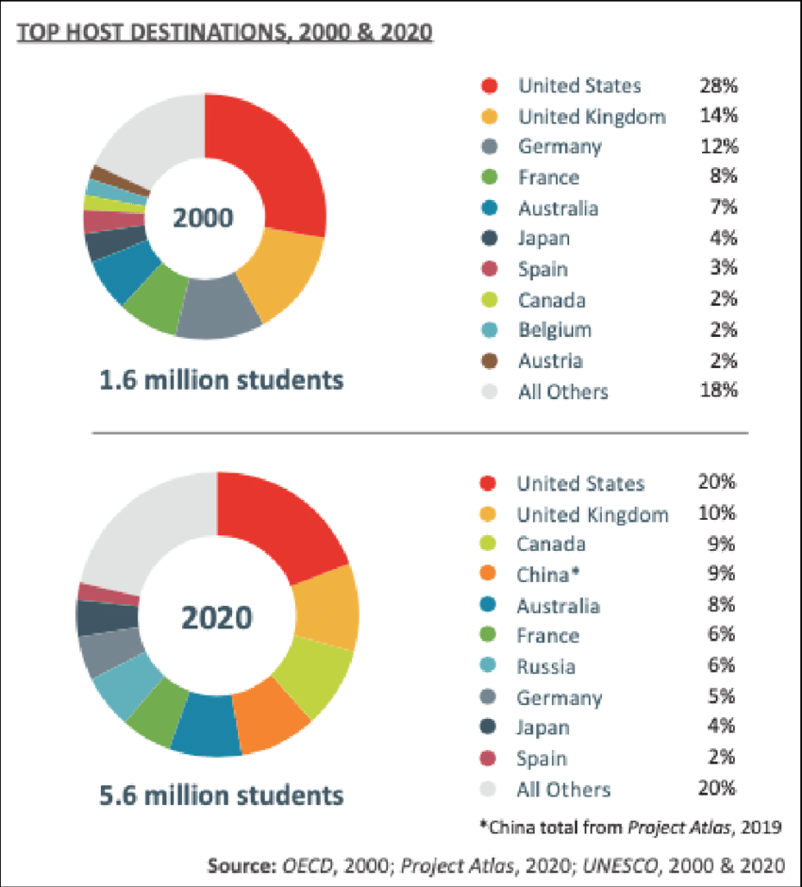

Fig 1. Top Host Destinations,2000 & 2020
Becoming one of the leading host countries for international students, China is host to students from more than 200 countries over the globe, a larger percentage of them coming from South Korea, Thailand, Pakistan, India, and the United States. The government of China is playing a huge part in encouraging the influx of students with scholarship offers like the the CSC, MOFCOM, Confucius Institute, Belt and Road Scholarships etc which are mostly benefitted by the developing nations in Asia and Africa. While the increase in international student enrollment reflects China's growing prominence in global education, it also poses considerable management issues, particularly for schools with several campuses. International students frequently experience language limitations, cultural adjustment difficulties, disparities in academic expectations, restricted social integration, and administrative challenges such as visa processing and inter-campus coordination. For multi-campus schools, these issues are exacerbated by the need to assure consistent academic quality, equal access to resources, and effective communication between campuses.
The Belt and Road School's "One and Two Wings" model aims to tackle these challenges by integrating centralized policy-making and administration with decentralized, localized student support. This study examines the innovation and practical application of the model, emphasizing its role in facilitating academic collaboration, cultural exchange, and student engagement between the Beijing and Zhuhai campuses.

Area of study and relevance

Beijing, the capital of China, is a political and academic powerhouse with top universities and international students, making student management sophisticated. However, Zhuhai, a fast-growing city in the Guangdong-Hong Kong-Macau Greater Bay Area, is noted for its innovation-driven economy and important Belt and Road Initiative location. This contrast allows the study to examine how the “One and Two Wings” model facilitates cross-campus collaboration and resource sharing between a well-established metropolitan center and an emerging innovation hub, providing insights into managing international students in diverse urban and institutional settings.

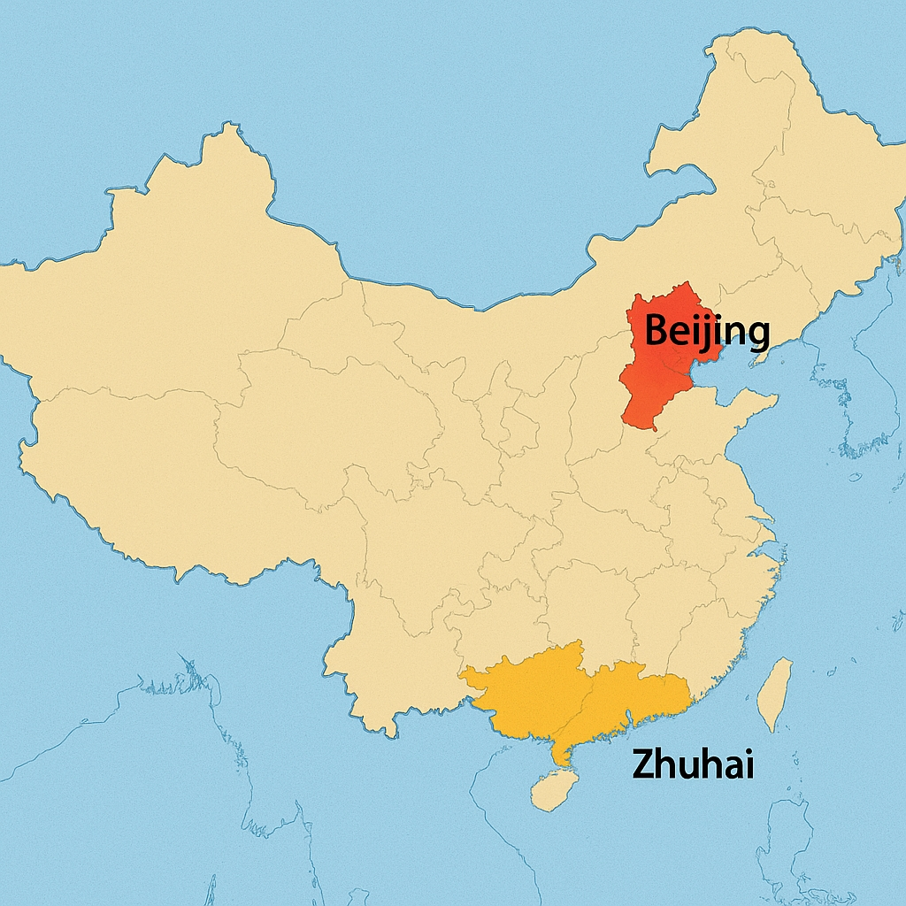
Image generated using DALL·E 2 (OpenAI), 2025.
Fig 2. Map of China highlighting Beijing in the north and Zhuhai in the south

Zhuhai (in the Guandong Provence) and Beijing are seemingly in different parts of the world and have different cultures, climates, and academic focuses. This makes them perfect places to look at how the "One and Two Wings" model adapts centralized policy-making while meeting the specific needs of local students. Learning about how these schools work together can help you see the pros and cons of using a hybrid management model in a college setting that is becoming more international.

Both campuses of Beijing Normal University's Belt and Road School (BRS) are the topic of this study. These are the Zhuhai Campus in Guangdong Province and the Beijing (Liangxiang) Campus in Fangshan District, Beijing Municipality. The Zhuhai Campus is in the Guangdong–Hong Kong–Macao Greater Bay Area in southern China. It is the administrative and academic center of BRS and is where most of the international students, teachers, and administrative staff live. It focuses on hands-on learning, study that is used in the real world, and partnerships with institutions around the world. The Beijing (Liangxiang) Campus opened in 2022 and is in the Future Design Institute of BNU. Its main goals are policy-oriented study, working together with the government, and advanced academic studies. In line with the Belt and Road Initiative's strategic goals, this campus gives people access to national institutions, foreign organizations, and policy-making bodies.

Relevance of the practice of the cross campus international student management model
Established with the purpose of bringing educational aims into line with the Belt and Road Initiative's strategic goals, the Belt and Road School (BRS) of BNU draw’s a large amount of foreign students annually since her inception in 2017 to align educational objectives with the strategic goals of the Belt and Road Initiative. The BRS possesses expertise in educational administration given that the institution has concentrated on cultivating elite management professionals from nations participating in the initiative, successfully educating numerous exceptional economic management talents from over 61 countries. With both their Beijing and Zhuhai Campuses, they have contributed to assist foreign students in adjusting and succeeding, and also provided customized services, language assistance, and cultural integration activities, with the “one and two wings” model.
The "One and Two Wings" model refers to a dual-campus student management system where a centralized core structure ("one wing") coordinates overarching international student affairs, while each individual campus (the "two wings") provides localized services and support tailored to its own environment. While the "two wings" reflect each campus's responsibilities for providing localized cultural integration programs, academic assistance, and peer interactions, the "one wing" usually centers administrative tasks like policy-making, visa administration, and general student support. By offering choices of cities with varied standards of leaving, different course duration and different climatic conditions to accommodate the various student populations, diversity has been promoted cross-cultural cooperation in line with worldwide patterns in higher education.
Objective of study
This Paper is aimed at examining the innovative practices in cross-campus international student management at the Belt and Road School, with a specific focus on the "one and two wings" model. The Belt and Road School emphasizes international collaboration, cultural exchange, and academic integration, necessitating a management model that effectively accommodates its diverse international student population. The "one and two wings" model School's potential for innovating international student management, fostering a cohesive and supportive experience that aligns with the broader objectives of the Belt and Road Initiative (BRI). The study examines the specific challenges associated with managing international students across two campuses in the context of the Belt and Road Initiative (BRI) and presents a scalable approach that other institutions with similar international goals can adapt
Research Question
All that been said, this study begs the question;
In what ways does the Belt and Road School's "one and two wings" cross-campus management model resolve the distinctive problems encountered by international students?

Literature Review

International student management has been a topic of interest to most institutions especially those with more than one Campus like in the case of the Belt and Road school of BNU. Managing the students in both campuses and making sure they all receive the same level of satisfaction while being cost effective is surely a topic worth delving into. A clear example is the paper Multi Campus University in operation: perception of staff and students by Kavanagh, Marie H. and Taysom, Sophie V. Carried out in the University of Queensland, this paper reports the views of staff and students on a number of issues related to the need to travel between campuses for work and study purposes. Results were based on two questionnaires administered to staff and students respectively. They indicate that there are some clear limitations to the operation of the current multi campus system. The findings identify a number of issues which are of relevance to university administration particularly in relation to apportioning time and costs, and being more responsive to the concerns of staff and students. To remedy these challenges, several worldwide cross-campus student management methods have been created and updated by institutions to help manage foreign students on various campuses. Articles and books have been written to this regard, some of which touch key areas of this study. Some of them include:
Centralization and De-centralization in Campus Services" by Alex Usher
Higher education policy specialist Alex Usher examines the trade-offs of decentralized and centralized management strategies in campus services in his article. Understanding how to strike a balance between these two models may assist create administrative structures that are effective and responsive, which makes his work especially pertinent to multi-campus schools like the Belt and Road School (BRS). He identifies that centralized management models unify administrative and academic functions across all campuses under one governing authority which guarantees consistency in policies, resource distribution, and student services, which is especially beneficial for institutions functioning across various countries. The decentralized models on the other hand provide autonomy to individual campuses, enabling them to tailor policies and services to their specific local contexts. This approach is frequently essential for institutions operating in areas characterized by diverse cultural, legal, and academic standards. Decentralization promotes innovation and enhances responsiveness within campus environments, rendering it an appropriate option for institutions characterized by geographical and cultural diversity while centralization reduces variations in student experiences and facilitates adherence to immigration regulations.
Given the advantages of both these models, BRS decided to go for the hybrid model as suggested by Alex Usher, which is a combination of these two, in other to benefit from both the models while avoiding in a way the setbacks that come with picking one of them over the other. This hybrid model utilizes centralized governance to provide institutional consistency while allowing decentralized operations to embrace regional and cultural diversity among its campuses. The centralized components include a standardized curriculum such as identical learning material, some joint lectures for students from both campuses, and uniformity in core rules, like admissions and graduation criteria. In terms of decentralization, each campus establishes region-specific support programs, extracurricular activities, and community involvement initiatives, while also overseeing their daily operations to tackle the distinct issues encountered by their foreign students.

A Collective Action Model of Institutional Innovation by Timothy J. Hargrave and Andrew H. Van De Ven
This study offers a valuable foundation for understanding the Belt and Road School's (BRS) cross-campus management concept. Their view emphasizes that institutional innovation develops from the collaborative efforts of various stakeholders, including as administrators, teachers, students, and policymakers, rather than being dictated by a single central authority. This is consistent with BRS's "One and Two Wings" strategy, in which innovation in international student management is developed by continual cooperation across campuses. A crucial feature of their strategy is the balance of centralization and decentralization, emphasizing that institutional change occurs through stages of experimentation, adaption, and formalization, as seen by BRS's changing cross-campus tactics. By using this model, BRS may improve its governance structure to support innovation via conversation, continuous learning, and stakeholder participation, ensuring that its dual-campus strategy stays successful and inclusive.

Theoretical framework
Tinto's Theory on Student Integration
Institutions struggled with high student dropout rates in the 1970s and lacked a thorough knowledge of the reasons behind student leaving college thus the coming about of this theory. Tinto's thesis emphasizes the need of academic and social integration within an institution for student achievement and retention. Theory shifted the focus from solely blaming students for dropping out to examining how institutions could improve retention through better academic and social support. This idea supports the necessity of cultivating a sense of belonging at the Belt and Road School (BRS), where overseas students frequently traverse a new cultural and academic environment. According to the "One and Two Wings" paradigm, integration initiatives must meet both academic (such as standardized curriculum across campuses) and social demands (such as cultural exchange programs). Effective integration may lower dropout rates, boost academic achievement, and provide a welcoming environment for international students.

Cross-Cultural Adaptation Theory
Cross-cultural adaptation theory came at a time when the need to understand how immigrants, international students, and expatriates adapt to new cultural environments became increasingly relevant. It looks at how international students adjust to new cultural environments over time. This is particularly relevant for international students at BRS, who may encounter language barriers, cultural differences, and unfamiliar academic practices. The dual-campus structure (Two Wings) adds complexity to this adaptation, as students may transition between campuses with differing local cultures and administrative systems. Understanding this theory helps inform practices like orientation programs, intercultural training, and mentorship initiatives designed to ease students’ transitions and support their cultural adaptation.
Dual Campus Management theory
The theory was developed to address logistical challenges, such as maintaining consistent quality across campuses, managing shared resources, and supporting the mobility of students and faculty. Institutions with multiple campuses needed tailored frameworks to create a sense of unity while leveraging the strengths of each location. The dual campus model requires careful coordination between campuses to ensure that academic programs, administrative functions, and student services are effectively aligned. Key features of this management framework include Centralized vs. Decentralized Structures, Academic and Program Integration and the likes This directly aligns with the "One and Two Wings" framework, where coordination between the two campuses is essential for consistency and efficiency. Reviewing successful dual-campus models from other institutions can provide insights into best practices for harmonizing academic programs, integrating administrative systems, and promoting collaboration across campuses.
Methodology
Research Design
This research employed a mixed-methods methodology, integrating quantitative survey data with qualitative interviews. This methodology was selected since it facilitates both statistical trend analysis and an in-depth examination of student experiences, therefore offering a holistic understanding of the “One and Two Wings” model. The target group comprised current and former international students from Beijing Normal University’s Belt and Road School (BRS) at its two campuses: Zhuhai and Beijing (Liangxiang). A purposive sample strategy was employed to recruit 100 participants from more than 15 countries to guarantee diversity in opinions.
Instruments for Data Collection. A systematic questionnaire collected demographic information, student satisfaction levels, and perceptions of inter-campus engagement. Subsequent semi-structured interviews with chosen individuals examined responses more thoroughly. Institutional records and academic papers were also examined for secondary data. Questionnaires were distributed by teaching assistants to highlight the significance of the study. Interviews were performed virtually, recorded with consent, and transcribed for analytical purposes.
When it came to data examination, quantitative data was studied by descriptive statistics, and qualitative comments were thematically coded to discern trends. The mixed-methods design effectively captured both quantifiable trends and intricate experiences, which is essential for assessing a hybrid management style such as “One and Two Wings” that encompasses diverse cultural and geographic settings.

Empirical Evidence
Before we examine what the feedback from the students was, there is need to first of all look in to the practice of the 'One and Two Wings' model at the Belt and Road School.
An overview of the model and innovative practices in Belt and Road School
The "One and Two Wings" model of the Belt and Road school refers to a dual-campus student management system where a centralized core structure which is the Zhuhai main Campus, coordinates overarching international student affairs, while the Beijing (Liangxiang) Campus provides localized services and support tailored to its own environment. The Beijing location wasn't a part of BRS when it started in 2017, but it was later added to make the school stronger in its ability to shape study and policy. The BRS Beijing Campus opened around 2022, and it is at BNU's Future Design Institute in Liangxiang, Fangshan District. The "One and Two Wings" model was used to build this campus to improve cross-campus events, policy involvement, and study collaboration.
The Zhuhai Campus with the most students, administrative functions and faculty, serve as the central hub for students and faculty and extend her reach through cross-campus learning and global collaboration to the Beijing Liangxiang Campus. Although research occurs in Beijing, Zhuhai serves as the primary site for student-led initiatives, local cooperation, and worldwide relationships. Zhuhai emphasizes a two-year practical training program, hands-on research, and networking with international institutions—fundamental components of BRS’s mission. In contrast, the Beijing campus prioritizes advanced academic research, policy studies, and collaboration with government agencies and international organizations related to the Belt and Road initiative. The Beijing campus conducts policy lectures, workshops, and short-term professional development programs for students, professors, and professionals.
As seen above and juging by the Collective Action Model of Institutional Innovation by Timothy J. Hargrave and Andrew H. Van De Ven, that institutional innovation develops from the collaborative efforts of campuses rather than being dictated by the central body. This is a perfect balance of the centralized and decentralized system, where both campuses collaborate with one another, with one focusing on studies and research and the other on policy studies and workshops. To straighten this collaboration, BRS has put in place joint activities to be carried out by students from both campuses. These activities which include field trips and virtual classes promotes collaboration between the students and administrative staffs from both campuses. Even though the campuses offer MBA programs with different duration of studies, initiatives like these alongside online platforms are very instrumental in building a sense of unity amongst students and foster interactions between individuals from different campuses. It is safe to say that when it comes to classroom activities, the collaboration is seamless. The question is when it comes to workshops, seminars and government agencies are the collaboration evident?
Results & Discussions
With a total of 105 responses from both campuses, 55% of our responses came from the students of the main campus in Zhuhai. 57% of respondents attested to the fact that the BRS promotes cultural inclusivity and diversity with extracurricular activities which’s satisfaction amounted to 70% of the satisfaction rate as stated by respondents. The questionnaires distributed had five sections. First of which was for individual information excluding name, second to examine students satisfaction in their various campuses, followed by questions to examine the effectiveness in innovations in student management, then the section to examine the effectiveness in Cross-Campus Communication and student Engagement and the last section aimed at examining the level of cultural integration on the campuses.
This study like we stated examines the innovation and practical application of the “one and two wings” model, emphasizing its role in facilitating academic collaboration, cultural exchange, and student engagement between the Beijing and Zhuhai campuses. That being said, we the findings will be discussed in this light.
Objective 1: Examine innovative practices in cross-campus management
The study found that joint activities such as field trips and shared online courses were key components of the “One and Two Wings” model. Field trips were reported as highly effective in fostering engagement between campuses, while online courses had mixed results due to limited interaction for remote participants.

When it comes to innovations in student management, 54% stated that the schools online platforms are effective in the study process. This percentage however indicates that cultural integration is rather robust, although it is not overpowering. Our focus here none the less is the part of innovation in studies in BNU which supports our topic. The innovations here included that of shared classes and some platforms with both campuses as well as shared field trip experiences. The students where asked: Do you think the cross-campus field trips are effective in helping you engage with students from the other campus? And they had the following to say
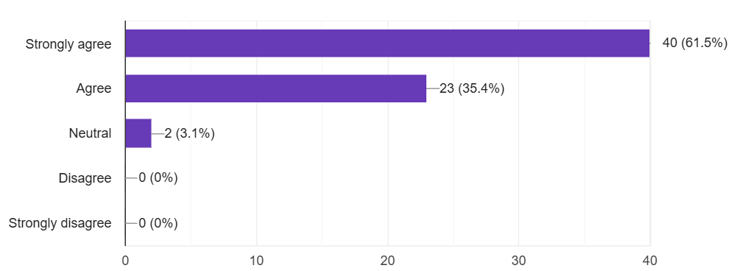

Fig 3. The survey of innovative practices in cross-campus management
But when they were asked the question: Do you agree that shared online courses foster interaction and collaboration between students from both campuses? 45% of the respondents gave positive responses. This reply necessitated a one on one with the students in other to understand why the field trip experience seemed to serve its purpose but not the shared online classes. In as much as the students appreciated the opportunity to be in the same space with seasoned leaders, during the interview amongst other points they advanced, they talked of a difficulty in engagements and interactions during these classes on the part of those attending virtually. This doesn’t come as a surprise given that studies like that of Hrastinski (2008) shows that students frequently struggle to form meaningful relationships while taking classes online. This sheds light on the reason why Belt and Road School online classes were not as effective as was the case with field trips. Conversely, Kolb's (1984) research on experiential learning demonstrates that students are highly motivated to participate and work together in collaborative projects when they participate in hands-on activities such as field excursions. This is in line with the favorable remarks made by students regarding their experiences on field trips.
When the students were asked how they thought engagement between students from both campuses could be fostered, three students had these to say in the questionnaire
1st respondent: “I think that social activities like singing, drama, and debates will better the engagement”
2nd respondent: “Some activities to engage in an compete per campus”
3rd respondent: “Competitions”
When asked during the interviews, they further explained that a better way could also be exchange visit programs between the students of both campuses.
Objective 2: Assess communication effectiveness between campuses;
Another very important aspect in our topic was to find out if both campuses are communicating effectively about events, programs, or opportunities and when asked the question: How effective can you say is the communication between the two campuses regarding student-related matters? The respondents had the following to say
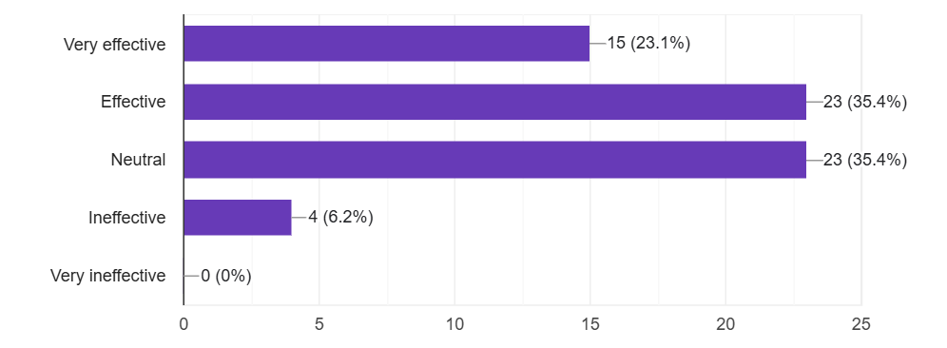
Fig 4. The survey shows assess communication effectiveness between campuses

Survey results indicated that 58.5% of respondents considered communication between campuses effective. However, 35.4% were neutral, highlighting the need for clearer and more consistent information-sharing mechanisms.

When asked more questions during the interview, the students said that when they needed help, whether it was for school-related issues like getting course materials or organizing their research or for non-school-related issues like going to an event or filling out paperwork, the administration of the other campus was always ready and willing to help. This quick response not only eased immediate worries, but it also gave everyone a sense of shared responsibility. It seemed like staff saw students from the sister school as an important part of their own community, not as outsiders. This kind of openness shows an attitude of working together, which makes the "One and Two Wings" model stronger.

This outcome is different from Kavanagh and Taysom's (1999) research of an Australian institution with many campuses, where staff and students said that logistical and communication problems made it hard for campuses to work together. The "One and Two Wings" approach at BRS may make the administration more responsive because it is smaller and makes it clear that both campuses serve the same student community. These results further support Usher's view that hybrid centralization is a good idea since it combines central policies with regional responsiveness, which strikes a balance between consistency and adaptability.
Objective 3: Evaluate equity in resource distribution and student experience;
The students of the Belt and road school generally recorded a 58% satisfaction in the quality of teaching in the school and while most students felt they had fair access to opportunities, 26% believed they were disadvantaged compared to their peers on the other campus. This was particularly evident in access to workshops, seminars, and faculty interaction. Concerns like these have been found in past studies of universities with more than one campus. According to Scott, Grebennikov, and Johnston (2007), students often felt like they were at a disadvantage when some campuses had more workshops, more professors, or more extracurricular activities. Also, Kavanagh and Taysom (1999) said that differences in campus resources and staff access could make people feel like things aren't fair, even if the rules of the school were meant to be fair. Despite the fact that majority of the students felt satisfied, this BRS study still sort of back up these findings by showing that it can be difficult to give all students the same experience on schools that are far apart geographically. When presented with the question; Have you ever felt disadvantaged compared to students from the other campus in terms of grading, participation, or academic recognition? The respondents had this to say
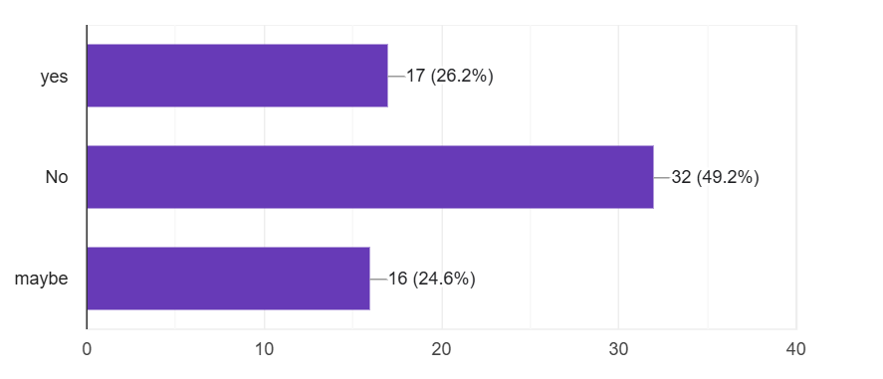

Fig 5.The survey of evaluate equity in resource distribution and student experience
To be fare, although both campuses offer MBa programs, Zhuhai runs a two-year program that focuses on practical training, industry links, and hands-on projects, while Beijing offers a shorter program with more focus on policy research and access to government and international organizations. Because the length of study, learning methods, and daily experiences are different, the needs and expectations of students at each campus are also different.

Challenges and Recommendations

Given that the Belt and Road school has been in existence for a couple of years, the school has in this time identified and tackled most of the challenges that come with the teaching model, as well as created significant international partnerships with other universities and organizations worldwide. Over the years however, despite the efforts of the administration in managing international students in both the BRS campuses to the best of their ability under the "One and Two Wings" model, there are a couple of challenges which hinder collaboration. Some of these challenges come from the fact that both Campuses have different course structures, teaching schedules, and administrative policies. Also, owing to the fact that, facilitating student movements and activities between campuses necessitates effective communication, strategic planning and most importantly funds.

Recommendations
Stemming from notes gotten from the students when it comes to communication between both campuses, it is safe to say that there is need for a centralized communication platform for students from both campuses where Job opportunities, Seminars, workshops, exchange visit programs and likes can be announced. This will prompt clarity, regularity, and accessibility of communication channels such as newsletters, centralized platforms, or real-time updates. In addition, the establishment of a student liaison organization between campuses in order to facilitate communication that is both more open and responsive could be of assistance.

When the students were asked if ever they felt disadvantaged compared to students from the other campus in terms of grading, participation, or academic recognition, 26% said “Yes” while 24% said “Maybe”. It is essential that students are guaranteed equitable access to resources, teacher assistance, extracurricular engagements, and job prospects in other to prevent students on one school from perceiving themselves as disadvantaged relative to their peers. To that regard, the research of Australian multi- campus universities by Geoff Scott proposed that, just as the Australian multi-campus universities require corresponding budget allocation and fair assessments to maintain consistent performance across campuses, the BRS be provided with the resources and support it needs to thrive on both campuses and that a fair review of the school's operations be integrated in government or international financing schemes to guarantee that campuses get enough financial support, thereby allowing the school to accomplish its educational goals without compromising on quality of education.

Conclusion
The Belt and Road School's "One and Two Wings" strategy provides a unique method to managing international students across many campuses. While the model effectively promotes collaboration, cultural diversity, and adaptable learning experiences, there are certain areas for development. Enhancing virtual engagement technologies, streamlining communication between campuses, and guaranteeing fair access to academic resources can all help to improve the success of this management style. Furthermore, structured exchange programs and interactive competition-based activities may enhance student interaction and engagement. By solving these issues, BRS can improve its cross-campus management model, providing a scalable framework for other international institutions to use to improve global education and student experiences.

COMPETING INTERESTS DISCLAIMER:
Authors have declared that they have no known competing financial interests OR non-financial interests OR personal relationships that could have appeared to influence the work reported in this paper.

References
- Beijing Normal University. (n.d.). Belt and Road School. Retrieved from https://www.bnu.edu.cn/
- Gallifa, J., & Batalle, P. (2002). Student perceptions of service quality in a multi-campus higher education system in Spain. Quality Assurance in Education, 10(2), 72–82.
- Hargrave, T. J., & Van De Ven, A. H. (2006). A collective action model of institutional innovation. Academy of Management Review, 31(4), 864–888.
- Kavanagh, M. H., & Taysom, S. V. (1999). Multi-campus university in operation: Perception of staff and students. Journal of Institutional Research in Australasia, 8(2), 22–35.
- Scott, G., Grebennikov, L., & Johnston, K. (2007). Study of Australian multi-campus universities. Journal of Institutional Research, 13(1), 1–13.
- Tinto, V. (1975). Dropout from higher education: A theoretical synthesis of recent research. Review of Educational Research, 45(1), 89–125.
- Usher, A. (2013). Centralization and decentralization in campus services. Higher Education Strategy Associates.
- Yuan, G., & Jin, L. (2020). International student recruitment campaign: Experiences of selected flagship universities in China. Higher Education, 80(4), 733–749.
- Hrastinski, S. (2008). Asynchronous and synchronous e-learning. Educause Quarterly, 31(4), 51-55.
- Kolb, D. A. (1984). Experiential learning: Experience as the source of learning and development. Prentice-Hall.
- Gallifa, J., & Batalle, P. (2002). Strategies for multi-campus universities: A comparative approach. Higher Education in Europe, 27(3), 267–276. https://doi.org/10.1080/0379772022000011830
- Kavanagh, M., & Taysom, S. (1999). Multi-campus universities: Managing the risks. Journal of Higher Education Policy and Management, 21(2), 187–198. https://doi.org/10.1080/1360080990210207
- Scott, G., Grebennikov, L., & Johnston, S. (2007). Students’ perceptions of the multi-campus university experience: A case study. Higher Education Research & Development, 26(1), 17–34. https://doi.org/10.1080/07294360601165719

