3D Bioprinting as a Tool for Tailored Medical Solutions

Abstract
In this review article, we have discussed Three-dimensional bioprinting and its role in Personalized treatments. Bioprinting is 3D printing technology in which live 3D objects like tissues as well as organs are created by using 3D printers, cells, biomaterials, and scaffolds. The organs are printed by superimposing the material by using these tools. Some of the commonly used bioprinters are Inkjet printers, Extrusion-based printers, and Laser-assisted bioprinting. Further, we have discussed, Personalized medicine or precision medicine. It has the ability to treat diseases by integrating information about a patient’s genetic factors. Various personalized treatments involve the application of bioprinting few of them are briefly discussed in this review article such as Tailored design and fabrication, Organ transplant, Personalized cancer models, and Personalized prosthetics and implants. This Bioprinting technology is emerging rapidly and it also faces some challenges like regulatory and ethical issues. As many scientists and researchers are working hard in this technology there is a high chance that in the future, bioprinting will overcome all the obstacles and challenges occurring in a process.
Keywords: 3D Bioprinting, Personalized treatments.
1. Introduction
Bioprinting technology has appeared as the most potent instrument in the field of tissue engineering. As we know the word “Bio” means “life” so the term bioprinting is the printing of biological structures using biochemicals, live cells, bio-inks, and biomaterials. It is also designated as “Three-dimensional bioprinting” (3D Bioprinting). This technology almost completely changed the scope of medicine and healthcare while adding an extremely powerful positive effect to the improvement of people's life quality (Yaneva et al., 2023). Bioprinting is the technique of settling biological material that is superimposed to build a 3D bioprinted structure. The part of Additive Manufacturing indicated as “Bioprinting” is the accumulation of material that is applied to a substrate to form a 3D subject required for use by industries (Javaid & Haleem, 2020; Sultana et al., 2024). The main target of this technology is to originate 3D living structures for the restoration of organs and tissue functioning (Aljohani et al., 2018; Dey & Ozbolat, 2020; Systems, 2024; Vijayavenkataraman et al., 2018). Several techniques are involved in bioprinting such as the selection of bioinks, biomaterials, and bioprinter-type, cell-type, nozzle-type, and different dimensional imaging of organs or models. Platelet-rich plasma (PRP) based bioinks have been under long-term study as an origin of biological factors for growth and have an asset that might be drawn from certain donors to minimize the host immunological response (Faramarzi et al., 2019). The designing and making bioprinted structure along with the microenvironment for proper culture must be selected to get a better print of tissue (Parihar et al., 2022). Several bioprinting approaches have been introduced in past years, including inkjet-like printers, extrusion devices, and laser-assisted devices (Skardal, 2015). Bioprinting with AI, has changed the concept of organ transplantation. Using bioprinting, personalized therapy can be attained with making tissues for an individual patient. The efficiency and safety do improve because it is tailored according to the needs of each patient (Herrera et al., n.d.). Spritam® (Levetiracetam), the world's first 3D-printed pill, was approved by the U.S. Food and Drug Administration for use in epilepsy treatment in 2015. This marked a significant achievement in the use of 3DP in the medical business (Ullah et al., 2023).
Here are some bioprinting methods that are currently in use-
1.1 Inkjet bioprinting: The type of bioprinting method by which 3D bioprinted structures can be formed and is somehow similar to cell patterning technologies. Basic cell patterning puts down a 2D pattern of cells while adding a hydrogel or another cell-friendly biomaterial together with drop-by-drop techniques allows the shaping of 3D cellularized structures (Guillotin & Guillemot, 2011; Skardal, 2015).
1.2 Extrusion-based printing: Extrusion-based bioprinting works by expelling bioinks through nozzles to build three-dimensional constructs. Bioink entails living cells, which carry biological importance in emerging applications such as tissue scaffolds, organs-on-a-chip, regenerative medicine, and drug delivery mechanisms. Another method that has also been studied to increase resolution in printing and allow the formation of layered structures is co-extrusion or thermoplastic reinforcement (Fonseca et al., 2020; Seol et al., 2014) Extrusion-based bioprinting (EBB) incorporated with cell-loaded bio-inks is reportedly the repeatedly practiced technique for skin wound care mainly due to its comfort of access, cost-effectiveness, and capacity to replicate tissue complexity (Y. Wang et al., 2022). Any extrusion-based 3D bioprinter can directly use the PRP-based bioink. Moreover, the PRP (Platelet-rich plasma) based bioinks may also be employed for customized and autologous treatments (Faramarzi et al., 2019).
1.3 Laser-assisted bioprinting- It is also known as Laser Induced Forward Transfer (LIFT) in this process the deposition of biomaterial onto a surface with the help of a laser as a source of energy. Initially, this bioprinting method was utilized for transferring metals only but after modification, it is currently used to function with biological materials such as DNA and peptides (Systems, 2024). There are many advantages of laser-assisted bioprinting. It also prevents the bio-ink and dispenser nozzle from coming into contact together, which favors better cell viability of more than 95% (Lam et al., 2023; Mandrycky et al., 2016; Murphy & Atala, 2014).
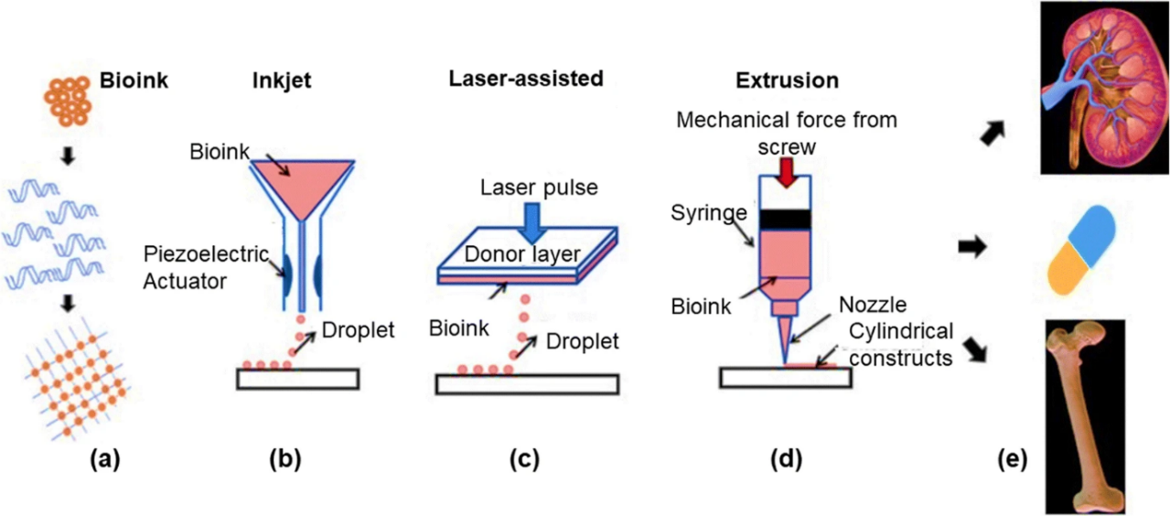
Figure 1. (a) Bioink which contains live cells as well as biomaterial. (b) Inkjet bioprinting (c) Laser-assisted bioprinting (d) Extrusion bioprinting (e) Construction of an in-vitro study model for illness detection (Parihar et al., 2022).
2. Application of bioprinting
2.1 Personalizes Medicines
Personalized Medicine has become a notable driving force over the last few years. It is a new way of advancing healthcare that deliberate each person’s unique information such as genes and environment(Dobhal et al., 2025). This information is important to prevent diseases and begin treatments early. The main aim of Precision medicine is to improve medical attention and to ensure optimum medical care and outcomes for each individual. This produced unchanged customization of care for patients (Chan & Ginsburg, 2011). Personalized medicine works toward identifying individuals vulnerable to diseases and carrying out some preventive measures or early interventions. Treatments that depend on individual special qualities are guaranteed to be much more effective than traditional “One-size-fits-all” approaches. Various technologies like advanced imaging, DNA sequencing, and proteomics have permitted a deep knowledge of individual variation in the disease process.(Verma et al., 2023) The progress made in precision medicine includes the growth of Targeted therapies such as immunotherapies and specific gene therapy, which has shown assurance in treating diseases depending on the molecular profile of a person (Goetz & Schork, 2018).
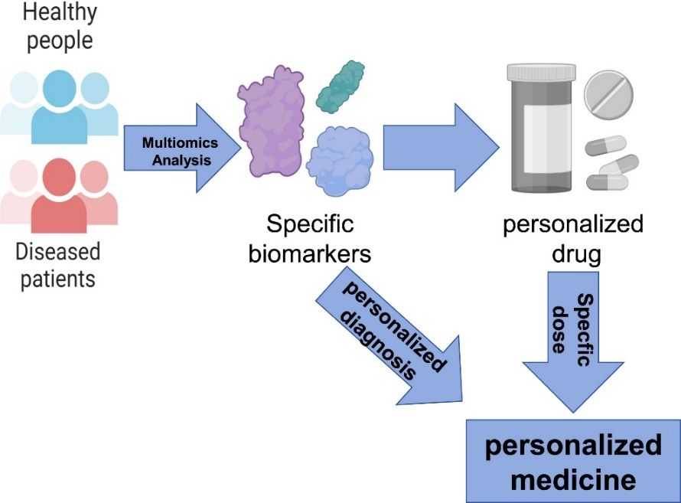
Figure 2. development of personalized medicine (Su et al., 2024).
The most remarkable opportunities that led to personalized medicine as well as Bioprinting came from the fast development of Artificial Intelligence (AI). Different AI technologies such as Machine learning, Natural language processing, and Deep learning have encouraged progress in individual health (Krishnababu et al., 2023). AI can aggregate; and analyze vast, complex datasets such as genomics, medical history, and lifestyle to recognize patterns and generate insights that traditional methods might miss. AI has major roles including disease diagnosis and risk satisfaction, treatment selection, optimization, and patient monitoring and management (Potter, 2024).
2.2 Tailored Design and Fabrication
Bioprinting can unfold a new approach to Personalized therapy. This means medical solutions are prepared from implants for the administration of drugs, all tailored to the individual for maximum efficacy with minimum complications. Medical Imaging, such as MRI and CT-Scan provide detailed 3D anatomy models. The images provide personalized blueprints for bioprinting (Radenkovic et al., 2016; Zhang et al., 2017). Tissue engineering is multidisciplinary and aims to print a biological substitute for damaged structures. The key problem in tissue engineering remains the choice of an appropriate biomaterial that provides a scaffold, mimics in vivo extracellular matrix, and guides resident stem cells to rebuild functional tissue.(Amit et al., 2022)
2.3 Organ transplantation
Organ transplantation plays a vital role in prolonging the lives of patients suffering from organ failure conditions. However, due to the deficiency of organs (like kidneys, liver, and heart), the count of patients increases on the transplant waiting list, and patient deaths (Parihar et al., 2022). Major advances and developments in bioprinting technology made it possible to rebuild organs like the Heart(H. Wang, 2024), Lungs(Shrestha et al., 2019) , Kidneys(Denizet et al., 2019), Skin(Varpe et al., 2024), Bones, Liver(Yoon No et al., 2015), Blood vessels or Vascular organs(Zheng et al., 2024) , etc it will help in neglecting organ shortage (Huang et al., 2024).
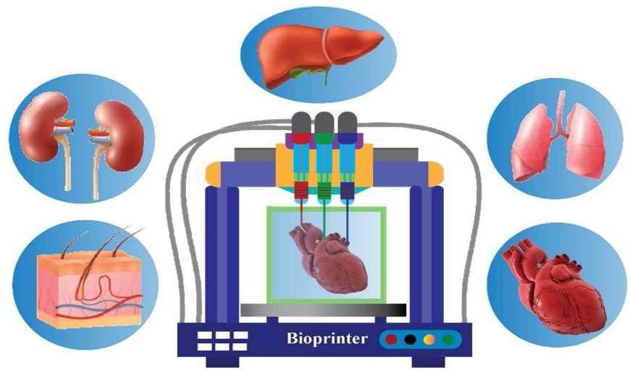
Figure 3. Organs like the liver, kidneys, skin, heart, and lungs can produced by using bioprinter and suitable bioinks (Reddy et al., 2023).
The fabrication of tubular-shaped tissues and organs such as trachea, blood vessels, and oesophageal tissue generally presents challenges when using conventional fabrication methods, like electrospinning, cell-sheet engineering, and mold-casting. These several processes are the cause of these challenges. Moreover, these tubular-shaped objects also show unique designs that require particular properties (Saksena-et-al-2016-Tubular-Organ-Epithelialisation, n.d.). It has a well-known application in bioprinting, as it can customize such complex structure, for instance, implantation substitutes for damaged or lost tissue (Systems, 2024). This area of technology remains in an infant stage; however, it has excellent prospects for development and success (Rana Khalid et al., 2019).
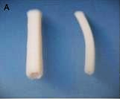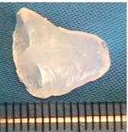
Figure 4. (a) Bioprinted blood capillaries (Manuscript, 2008). (b) Bioprinted heart tissue (Xu et al., 2009).
2.4 Personalized cancer models
The bioprinted cancer models lend great possibility for new anticancer drugs. In cancer treatment, development suffered with very poor success over many decades; more than 95% of candidate medications failed to come into the market. Therefore, through bioprinting, it is now workable to form highly biologically and physically appropriate models of cancer. It is also used in the development of biomimetic models of normal tissues; thereby, there is a chance for the combined system's simultaneous assessment of aftereffects and efficacy (Bhuskute et al., 2021; Liu et al., 2019). A scaffold-based and self-organizing model has demonstrated potential and usefulness in cancer microenvironment research to reduce differences between animal models and cell culture in two dimensions (Butola et al., 2023). Most recent breakthroughs in tissue engineering have demonstrated that an in vitro model can be established to map an accurate in vivo niche of cancerous tissues, which will prove helpful to researchers to know the disease far better and generate new treatment strategies (Augustine et al., 2021; Barbosa et al., 2022; Behera et al., 2024; Marques et al., 2023). These customized models enhance drug screening, cancer metastasis, and prognosis studies, ensuring that treatment is efficient enough using custom-made devices, implants, and dosage forms (Bhuskute et al., 2021). Also, these 3D-printed patient-specific models are useful for better anatomical knowledge and for planning surgery in complex organs (Mercader et al., 2019).
2.5 Personalized prosthetics and implants
A prosthesis or prosthetic implant is a man-made, artificial replacement that substitutes a missing or damaged body part. Prostheses are formed to displace the normal functioning of the missing or damaged part(Tripathi et al., 2024). This type of 3D printed prostheses allows the treatment of choice, good anatomical and functional results, early recovery with less difficulty, and high patient satisfaction with the right indications (Safali et al., 2023; Trace et al., 2016). Computerized software packages, and medical imaging like CT scan and MRI are used in designing specific implants. The images of damaged parts of the patients are combined with the software of the appropriate systems for implants (STRUCTURAL ANALYSIS OF ARTICULAR CARTILAGE OF THE HIP JOINT, 2016). Customized 3D-printed prosthetics will also help in further surgical treatments of bone deformities in other anatomical sites (Aimar et al., 2019; Toso et al., 2015).
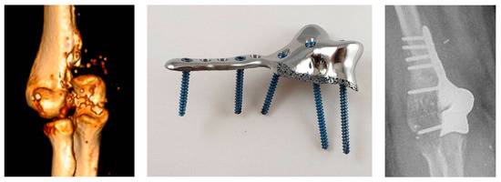
Figure 5. CT reconstruction of the damaged humerus with the bone defect (left), the prosthetic (middle), and the implantation x-ray (right) (Safali et al., 2023).
The silver ions are applied on the implant which may help in reducing infections but will vary from patient to patient (Safali et al., 2023; Tse et al., 2021). Thus, customized implants can easily implanted inside the body by the surgical process which is pretty simple and restores function that has been seriously compromised. Regarding this, the intervention lasts for a relatively short time and prevents complications (Citak et al., 2017). The biocompatibility and lightweight of materials for prosthetics are aimed at making them pleasant and long-lasting. Prosthetics formed by this technology are very durable and can withstand normal wear and ,tear, thus giving long-lasting options to patients. The materials that are used in Prosthetics and implants are lighter, the patients experience more comfort while wearing and utilizing these prosthetics (Alqadi et al., 2024; Generalova et al., 2024).
3. Future directions and some challenges in bioprinting
The bioprinting approach requires cells, bio-inks, and suitable bioprinters which initiate the biological, technical, and ethical challenges along with those problems regarding cost and clinical efficacy (Gardner et al., 2017). The early detection and identification of various issues such as Ethical, Legal, and Societal Aspects, related to this particular technology, issues are important both for responsible development in their respect and for fulfilling our wider obligations and duties in society (Vijayavenkataraman et al., 2016). Apart from standardization and validation, some specific criteria are required along with regulatory approval for the bioprinting procedures (Mihaylova et al., 2024; Mladenovska et al., 2023). There are challenges in selecting materials because some bioactive and biocompatible materials are used efficiently for drug printing (Y. Wang et al., 2022).
Another key challenge for bioprinted organs is the durability of their functionalities over time and biocompatibility. In all such complex processes of printing where there is an interaction of different biological materials and cells, each step should be closely monitored and make sure, materials that participate in printing will survive without loss of functionality throughout the procedure (H. Wang, 2024).
This technology will soon become remarkably easy, quick, and friendly to use for greatly enhancing healthcare practices. It will probably become the most precise and rapid technique used on-site in clinics and, hence, will be applied positively to many other medical practices with significantly greater support to individuals on both sides. It develops by further progress in research; successful integration and advancement of several scientific disciplines; and overcoming numerous scientific challenges these have been an obstacle to such progress (H. Wang, 2024).
4. Conclusion
Bioprinting technology has the great ability to build 3dp structures and generate personalized treatments. Bioprinting may also bring an absolute end to organ donation as these activities are preferred by patients; therefore, will aim to reduce waiting periods for patients. The impacts of such discoveries in different scientific fields are going to be huge. They can offer proper custom-fit medical treatment to patients and will further brighten their survival prospects and a better life. As of now, new opportunities and chances born out of this modern technology are still in a severe imbalance with problems and associated issues. For instance, a few issues include how to select appropriate cells, bioinks, or other constituents needed to effectively produce a bioink, legal issues, regulatory issues, and ethical issues. As more advanced research is going on, researchers and scientists will find out the way to get control over these issues.

COMPETING INTERESTS DISCLAIMER:
Authors have declared that they have no known competing financial interests OR non-financial interests OR personal relationships that could have appeared to influence the work reported in this paper.

Reference
Aimar, A., Palermo, A., & Innocenti, B. (2019). The Role of 3D Printing in Medical Applications: A State of the Art. Journal of Healthcare Engineering, 2019. https://doi.org/10.1155/2019/5340616
Aljohani, W., Ullah, M. W., Zhang, X., & Yang, G. (2018). Bioprinting and its applications in tissue engineering and regenerative medicine. International Journal of Biological Macromolecules, 107(PartA), 261–275 https://doi.org/10.1016/j.ijbiomac.2017.08.171
Alqadi, L., Issa, A., & Nasralla, A. (2024). Integrating 3D printing technology in Surgical Planning and Prosthetic Development : Current Application and Future Prospects. 1(1), 34–39. https://archivesofmedicalreports.com/index.php/amr/article/view/10
Amit, S., Shilpa, S., Sarswati Prakash, B., Mamta, B., Rohit Kumar, T., & Vikash, J. (2022). Evaluation of the cookies formulated with finger millet plant material for antidiabetic property. International Journal of Pharmaceutical Sciences and Developmental Research, 8(1), 064–070. https://doi.org/10.17352/ijpsdr.000044
Augustine, R., Kalva, S. N., Ahmad, R., Zahid, A. A., Hasan, S., Nayeem, A., McClements, L., & Hasan, A. (2021). 3D Bioprinted cancer models: Revolutionizing personalized cancer therapy. Translational Oncology, 14(4). https://doi.org/10.1016/j.tranon.2021.101015
Barbosa, M. A. G., Xavier, C. P. R., Pereira, R. F., Petrikaitė, V., & Vasconcelos, M. H. (2022). 3D Cell Culture Models as Recapitulators of the Tumor Microenvironment for the Screening of Anti-Cancer Drugs. Cancers, 14(1), 1–30. https://doi.org/10.3390/cancers14010190
Behera, S. A., Nanda, B., & Achary, P. G. R. (2024). Recent advancements and challenges in 3D bioprinting for cancer applications. Bioprinting, 43, e00357. https://doi.org/10.1016/j.bprint.2024.e00357
Bhuskute, H., Shende, P., & Prabhakar, B. (2021). 3D Printed Personalized Medicine for Cancer: Applications for Betterment of Diagnosis, Prognosis and Treatment. AAPS PharmSciTech, 23(1), 8. https://doi.org/10.1208/s12249-021-02153-0
Butola, M., Bhatt, V., Nainwal, N., Jakhmola, V., Dobhal, K., & Ale, Y. (2023). Preparation and Evaluation of Polymer Fused Metformin Hydrochloride Sustained Release Tablet. Indian Journal of Pharmaceutical Education and Research, 57(3), 711–717. https://doi.org/10.5530/ijper.57.3.86
Chan, I. S., & Ginsburg, G. S. (2011). Personalized medicine: Progress and promise. Annual Review of Genomics and Human Genetics, 12, 217–244. https://doi.org/10.1146/annurev-genom-082410-101446
Citak, M., Kochsiek, L., Gehrke, T., Haasper, C., Suero, E. M., & Mau, H. (2017). Preliminary results of a 3D-printed acetabular component in the management of extensive defects. HIP International, 28(3), 266–271. https://doi.org/10.5301/hipint.5000561
Denizet, G., Calame, P., Lihoreau, T., Kleinclauss, F., & Aubry, S. (2019). 3D multi-tissue printing for kidney transplantation. Quantitative Imaging in Medicine and Surgery, 9(1), 101–106. https://doi.org/10.21037/qims.2018.10.16
Dey, M., & Ozbolat, I. T. (2020). 3D bioprinting of cells, tissues and organs. Scientific Reports, 10(1), 10–12. https://doi.org/10.1038/s41598-020-70086-y
Dobhal, K., Rautela, J., Joshi, N. C., & Jakhmola, V. (2025). Fabrication of silver nanocomposite of azithromycin and tulsi against in vitro Pseudomonas inhibition. Indian Journal of Pharmacology, 57(3), 120–125. https://doi.org/10.4103/ijp.ijp_284_23
Faramarzi, N., Innovation, B., Hospital, M. G., Yazdi, I. K., Innovation, B., Nabavinia, M., Innovation, B., Gemma, A., Innovation, B., Fanelli, A., Innovation, B., Caizzone, A., & Innovation, B. (2019). HHS Public Access. 7(11), 1–17. https://doi.org/10.1002/adhm.201701347
Fonseca, A. C., Melchels, F. P. W., Ferreira, M. J. S., Moxon, S. R., Potjewyd, G., Dargaville, T. R., Kimber, S. J., & Domingos, M. (2020). Emulating Human Tissues and Organs: A Bioprinting Perspective Toward Personalized Medicine. Chemical Reviews, 120(19), 11128–11174. https://doi.org/10.1021/acs.chemrev.0c00342
Gardner, J., Higham, R., Faulkner, A., & Webster, A. (2017). Promissory identities: Sociotechnical representations & innovation in regenerative medicine. Social Science and Medicine, 174, 70–78. https://doi.org/10.1016/j.socscimed.2016.12.018
Generalova, A. N., Vikhrov, A. A., Prostyakova, A. I., Apresyan, S. V, Stepanov, A. G., Myasoedov, M. S., & Oleinikov, V. A. (2024). Polymers in 3D printing of external maxillofacial prostheses and in their retention systems. International Journal of Pharmaceutics, 657, 124181. https://doi.org/10.1016/j.ijpharm.2024.124181
Goetz, L. H., & Schork, N. J. (2018). Personalized medicine: motivation, challenges, and progress. Fertility and Sterility, 109(6), 952–963. https://doi.org/10.1016/j.fertnstert.2018.05.006
Guillotin, B., & Guillemot, F. (2011). Cell patterning technologies for organotypic tissue fabrication. Trends in Biotechnology, 29(4), 183–190. https://doi.org/10.1016/j.tibtech.2010.12.008
Herrera, C., Ueno, S., Mendes, R., Jhuly, M., Paiva, M. De, Junior, B., Holanda, F. D. S., Pedreira, L. E., & Lima, M. G. De. (n.d.). CHAPTER 9 The use of Artificial Intelligence and 3D bio-printing for organ transplants. https://doi.org/10.56238/sevened2024.001-009
Huang, G., Zhao, Y., Chen, D., Wei, L., Hu, Z., Li, J., Zhou, X., Yang, B., & Chen, Z. (2024). Applications, advancements, and challenges of 3D bioprinting in organ transplantation. Biomaterials Science, 12(6), 1425–1448. https://doi.org/10.1039/d3bm01934a
Javaid, M., & Haleem, A. (2020). 3D printed tissue and organ using additive manufacturing: An overview. Clinical Epidemiology and Global Health, 8(2), 586–594. https://doi.org/10.1016/j.cegh.2019.12.008
Krishnababu, K., Kulkarni, G. S., R, Y., & Paarakh, P. M. (2023). Revolutionizing the Pharmaceutical Industry with Artificial Intelligence. Journal of Artificial Intelligence, Machine Learning and Neural Network, 34, 26–37. https://doi.org/10.55529/jaimlnn.34.26.37
Lam, E. H. Y., Yu, F., Zhu, S., & Wang, Z. (2023). 3D Bioprinting for Next-Generation Personalized Medicine. International Journal of Molecular Sciences, 24(7), 1–21. https://doi.org/10.3390/ijms24076357
Liu, T., Delavaux, C., & Zhang, Y. S. (2019). 3D bioprinting for oncology applications. Journal of 3D Printing in Medicine, 3(2), 55–58. https://doi.org/10.2217/3dp-2019-0004
Mandrycky, C., Wang, Z., Kim, K., & Kim, D. H. (2016). 3D bioprinting for engineering complex tissues. Biotechnology Advances, 34(4), 422–434. https://doi.org/10.1016/j.biotechadv.2015.12.011
Manuscript, A. (2008). 基因的改变NIH Public Access. Bone, 23(1), 1–7.
Marques, J. R. O. F., González-Alva, P., Yu-Tong Lin, R., Fernandes, B. F., Chaurasia, A., & Dubey, N. (2023). Advances in tissue engineering of cancer microenvironment-from three-dimensional culture to three-dimensional printing. SLAS Technology, 28(3), 152–164. https://doi.org/10.1016/j.slast.2023.03.005
Mercader, C., Vilaseca, A., Moreno, J. L., López, A., Sebastià, M. C., Nicolau, C., Ribal, M. J., Peri, L., Costa, M., & Alcaraz, A. (2019). Role of the three-dimensional printing technology in complex laparoscopic renal surgery: A renal tumor in a horseshoe kidney. International Braz J Urol, 45(6), 1129–1135.
Mihaylova, A., Shopova, D., Parahuleva, N., Yaneva, A., & Bakova, D. (2024). (3D) Bioprinting—Next Dimension of the Pharmaceutical Sector. Pharmaceuticals, 17(6), 1–19. https://doi.org/10.3390/ph17060797
Mladenovska, T., Choong, P. F., Wallace, G. G., & O’Connell, C. D. (2023). The Regulatory Challenge of 3D Bioprinting. Regenerative Medicine, 18(8), 659–674. https://doi.org/10.2217/rme-2022-0194
Murphy, S. V., & Atala, A. (2014). 3D bioprinting of tissues and organs. Nature Biotechnology, 32(8), 773–785. https://doi.org/10.1038/nbt.2958
Parihar, A., Pandita, V., Kumar, A., Parihar, D. S., Puranik, N., Bajpai, T., & Khan, R. (2022). 3D Printing: Advancement in Biogenerative Engineering to Combat Shortage of Organs and Bioapplicable Materials. Regenerative Engineering and Translational Medicine, 8(2), 173–199. https://doi.org/10.1007/s40883-021-00219-w
Potter, K. (2024). AI for Personalized Medicine. May.
Radenkovic, D., Solouk, A., & Seifalian, A. (2016). Personalized development of human organs using 3D printing technology. Medical Hypotheses, 87(December), 30–33. https://doi.org/10.1016/j.mehy.2015.12.017
Rana Khalid, I., Darakhshanda, I., & Rafi a, R. (2019). 3D Bioprinting: An attractive alternative to traditional organ transplantation. Archive of Biomedical Science and Engineering, 5(1), 007–018. https://doi.org/10.17352/abse.000012
Reddy, V. S., Ramasubramanian, B., Telrandhe, V. M., & Ramakrishna, S. (2023). Contemporary standpoint and future of 3D bioprinting in tissue/organs printing. Current Opinion in Biomedical Engineering, 27, 100461. https://doi.org/10.1016/j.cobme.2023.100461
Safali, S., Berk, T., Makelov, B., Acar, M. A., Gueorguiev, B., & Pape, H. C. (2023). The Possibilities of Personalized 3D Printed Implants—A Case Series Study. Medicina (Lithuania), 59(2), 1–12 https://doi.org/10.3390/medicina59020249
Seol, Y. J., Kang, H. W., Lee, S. J., Atala, A., & Yoo, J. J. (2014). Bioprinting technology and its applications. European Journal of Cardio-Thoracic Surgery, 46(3), 342–348. https://doi.org/10.1093/ejcts/ezu148
Shrestha, J., Ghadiri, M., Shanmugavel, M., Razavi Bazaz, S., Vasilescu, S., Ding, L., & Ebrahimi Warkiani, M. (2019). A rapidly prototyped lung-on-a-chip model using 3D-printed molds. Organs-on-a-Chip, 1, 100001. https://doi.org/https://doi.org/10.1016/j.ooc.2020.100001
Skardal, A. (2015). Bioprinting essentials of cell and protein viability. In Essentials of 3D Biofabrication and Translation. Elsevier Inc. https://doi.org/10.1016/B978-0-12-800972-7.00001-3
STRUCTURAL ANALYSIS OF ARTICULAR CARTILAGE OF THE HIP JOINT. (2016). 10(31), 240–246. https://doi.org/10.12913/22998624/64064
Su, J., Yang, L., Sun, Z., & Zhan, X. (2024). Personalized Drug Therapy: Innovative Concept Guided With Proteoformics. Molecular and Cellular Proteomics, 23(3), 100737. https://doi.org/10.1016/j.mcpro.2024.100737
Sultana, N., Ali, A., Waheed, A., & Aqil, M. (2024). 3D Printing in pharmaceutical manufacturing: Current status and future prospects. Materials Today Communications, 38(9), 763–784. https://doi.org/10.1016/j.mtcomm.2023.107987
Systems, H. C. (2024). 3D BIOPRINTING AS GROUNDBREAKING TECHNOLOGY IN PHARMA AND 3D BIOPRINTING AS GROUNDBREAKING PHARMA AND HEALTH CARE SYSTEMS TECHNOLOGY. April.
Toso, S. M., Menzel, K., Motzkus, Y., Adolphs, N., Hoffmeister, B., & Raguse, J. D. (2015). Patient-specific implant in prosthetic craniofacial reconstruction: First report of a novel technique with far-reaching perspective. Journal of Craniofacial Surgery, 26(7), 2133–2135. https://doi.org/10.1097/SCS.0000000000002142
Trace, A. P., Ortiz, D., Deal, A., Retrouvey, M., Elzie, C., Goodmurphy, C., Morey, J., & Hawkins, C. M. (2016). Radiology’s Emerging Role in 3-D Printing Applications in Health Care. Journal of the American College of Radiology, 13(7), 856-862.e4. https://doi.org/10.1016/j.jacr.2016.03.025
Tripathi, N. K., Trivedi, R. K., Sambmoorthy, U., Mishra, S., Dharmalingam, S., Bagde, M. P., Aijaz, M., & Verma, G. (2024). BIOMEDICAL APPLICATIONS OF MAGNETIC NANOPARTICLES: CURRENT TRENDS AND FUTURE PERSPECTIVES. BIOCHEMICAL AND CELLULAR ARCHIVES, 24(1). https://doi.org/10.51470/bca.2024.24.1.413
Tse, I., Jay, A., Na, I., Murphy, S., Niño-Martínez, N., Martínez-Castañon, G. A., Magrill, J., & Bach, H. (2021). Antimicrobial activity of 3d-printed acrylonitrile butadiene styrene (Abs) polymer-coated with silver nanoparticles. Materials, 14(24). https://doi.org/10.3390/ma14247681
Ullah, M., Wahab, A., Khan, S. U., Naeem, M., ur Rehman, K., Ali, H., Ullah, A., Khan, A., Khan, N. R., Rizg, W. Y., Hosny, K. M., Alissa, M., Badr, M. Y., & Alkhalidi, H. M. (2023). 3D printing technology: A new approach for the fabrication of personalized and customized pharmaceuticals. European Polymer Journal, 195, 112240. https://doi.org/https://doi.org/10.1016/j.eurpolymj.2023.112240
Varpe, A., Sayed, M., & Mane, N. S. (2024). A Comprehensive Literature Review on Advancements and Challenges in 3D Bioprinting of Human Organs: Ear, Skin, and Bone. Annals of Biomedical Engineering. https://doi.org/10.1007/s10439-024-03580-3
Verma, S., Singh, A., Kukreti, G., Bharkatiya, M., Dobhal, K., Parashar, T., Suyal, J., & Jakhmola, V. (2023). Nanoparticles – A Booming Drug Delivery System in Chemotherapy. Biomedical and Pharmacology Journal, 16(3), 1785–1790. https://doi.org/10.13005/bpj/2757
Vijayavenkataraman, S., Lu, W. F., & Fuh, J. Y. H. (2016). 3D bioprinting – An Ethical, Legal and Social Aspects (ELSA) framework. Bioprinting, 1–2, 11–21. https://doi.org/https://doi.org/10.1016/j.bprint.2016.08.001
Vijayavenkataraman, S., Yan, W. C., Lu, W. F., Wang, C. H., & Fuh, J. Y. H. (2018). 3D bioprinting of tissues and organs for regenerative medicine. Advanced Drug Delivery Reviews, 132, 296–332. https://doi.org/10.1016/j.addr.2018.07.004
Wang, H. (2024). Progress of 3D bioprinting of heart tissue. Academic Journal of Medicine & Health Sciences, 5(6), 37–44. https://doi.org/10.25236/ajmhs.2024.050606
Wang, Y., Yuan, X., Yao, B., Zhu, S., Zhu, P., & Huang, S. (2022). Tailoring bioinks of extrusion-based bioprinting for cutaneous wound healing. Bioactive Materials, 17(January), 178–194. https://doi.org/10.1016/j.bioactmat.2022.01.024
Xu, T., Baicu, C., Aho, M., Zile, M., & Boland, T. (2009). Fabrication and characterization of bio-engineered cardiac pseudo tissues. Biofabrication, 1(3), 1–12. https://doi.org/10.1088/1758-5082/1/3/035001
Yaneva, A., Shopova, D., Bakova, D., Mihaylova, A., Kasnakova, P., Hristozova, M., & Semerdjieva, M. (2023). The Progress in Bioprinting and Its Potential Impact on Health-Related Quality of Life. Bioengineering, 10(8), 1–22. https://doi.org/10.3390/bioengineering10080910
Yoon No, D., Lee, K.-H., Lee, J., & Lee, S.-H. (2015). 3D liver models on a microplatform: well-defined culture, engineering of liver tissue and liver-on-a-chip. Lab on a Chip, 15(19), 3822–3837. https://doi.org/10.1039/C5LC00611B
Zhang, Y. S., Yue, K., Aleman, J., Mollazadeh-Moghaddam, K., Bakht, S. M., Yang, J., Jia, W., Dell’Erba, V., Assawes, P., Shin, S. R., Dokmeci, M. R., Oklu, R., & Khademhosseini, A. (2017). 3D Bioprinting for Tissue and Organ Fabrication. Annals of Biomedical Engineering, 45(1), 148–163. https://doi.org/10.1007/s10439-016-1612-8
Zheng, K., Chai, M., Luo, B., Cheng, K., Wang, Z., Li, N., & Shi, X. (2024). Recent progress of 3D printed vascularized tissues and organs. Smart Materials in Medicine, 5(2), 183–195. https://doi.org/10.1016/j.smaim.2024.01.001

