PfDHFR Resistance Mutations in Mali: Impact on Protein Structure and Identification of Novel Natural Inhibitors

Abstract
Malaria is parasitosis transmitted to humans by a protozoan that belongs to the genus Plasmodium. Drug resistance remains one of the greatest challenges to the malaria control program in Mali. The protein PfDHFR (Plasmodium falciparum Dihydrofolate Reductase) plays a vital role in the folate biosynthesis pathway, which is responsible for producing purines, pyrimidines, and various amino acids, which are essential for the growth and proliferation of parasite cells. This enzyme is the primary target of antifolate drugs. The appearance of point mutations in the gene encoding for PfDHFR induces resistance to pyrimethamine and Proguanil. Previous studies have identified four key mutations—N51I, C59R, S108N, and I164L—associated with antifolate resistance. Thus, in this study, we aim to characterize effects of resistance-associated mutations from three sentinel sites in Mali (Dioro, Missira, and Sélingué) on the structure of the PfDHFR protein, and identify potential inhibitors effective against mutant PfDHFR variants through virtual screening of African natural compound libraries.
To achieve these objectives, we analyzed Pfdhfr genes sequenced from 47 individuals from the three study sites to identify Single-Nucleotide Polymorphisms (SNPs) and assess their impact on protein function using Geneious Prime, PRIMO server, and UCSF Chimera. Of the 47 PfDHFR sequences analyzed, 22 presented the triple mutations N51I, C59R, and S108N. Notably, the I164L mutation was absent in all samples across the three sentinel sites. Structural modeling of these mutants revealed restricted access and crowding within the active site for rigid antifolate molecules, consistent with known resistance mechanisms. Virtual screening identified several promising drug candidates, with SANC00747 exhibiting exceptional binding affinity (–14.046 kcal/mol), underscoring the untapped potential of African natural products for developing resistance-breaking antimalarial therapies.
Keywords: Pfdhfr gene, Malaria Resistance, folate biosynthesis pathway, Molecular modeling, Mali.

Introduction
Malaria, also known as “marsh fever”, is an infectious disease caused by a parasite of the Plasmodium genus, transmitted through the bite of infected female Anopheles mosquitoes. The parasite first infects the liver cells of the host and then circulates in the blood, colonizing and destroying red blood cells [1].
Among the 123 known species of Plasmodium, five are known to infect humans: Plasmodium falciparum, responsible for many deaths, and the four others that typically cause less severe forms of malaria; Plasmodium vivax, Plasmodium ovale, Plasmodium malariae, and Plasmodium knowlesi, the latter being originally a simian parasite that has increasingly been recognized in human infections [2].
Globally, according to the World Health Organization (WHO) 2024 World Malaria Report, Africa remains the continent most affected by this disease [3]. Worldwide, malaria-related deaths were estimated at 608,000 in 2022, with children under 5 years old being the most vulnerable group, accounting for 78% of malaria deaths in Africa [4]. The WHO African Region recorded 95% of all malaria cases and 96% of malaria-related deaths worldwide in 2022 [5]. In Mali, over 3.1 million confirmed malaria cases were reported in 2023, with 1,920 deaths. National surveys indicate that the most affected groups continue to be pregnant women and children under 5 years of age [6].
Many drugs have been developed to combat malaria. The most used classes of antimalarial compounds include quinolines (chloroquine, quinine, mefloquine, amodiaquine, primaquine), antifolates (pyrimethamine, proguanil, and sulfadoxine), artemisinin derivatives (artemisinin, artesunate, artemether, arteether), and hydroxynaphthoquinones (atovaquone) [7], [8], [9].
Recently, malaria vaccines (RTS, S/AS01 and R21/Matrix-M) have been introduced in 12 African countries as additional preventive tools [10], [11], [12].
Despite these interventions, the resistance of P. falciparum to antimalarials remains a major concern. Resistance is primarily driven by single-nucleotide polymorphisms (SNPs) in genes such as Pfdhfr, Pfdhps, Pfcrt, and Pfmdr1 [13], [14]. Artemisinin partial resistance (ART-R), characterized by delayed parasite clearance, has now been confirmed in 21 countries. Resistance to sulfadoxine-pyrimethamine (SP), first reported at the Thailand-Cambodia border in the 1960s, continues to spread across malaria endemic regions, with mutations in Pfdhfr (particularly at codons 51, 59, and 108) and Pfdhps being major contributors [15], [16].
In Mali, there is particular concern that the widespread use of SP as part of the Seasonal Malaria Chemoprevention (SMC) and intermittent Preventive Treatment during pregnancy (IPTp) may accelerate the emergence and spread of resistant strains [17], [18].
To elucidate the mechanistic basis of resistance, computational approaches like molecular modeling and docking are indispensable. These methods predict how mutations alter protein structure, stability, and drug binding affinity, providing atomistic insights into resistance mechanisms that inform drug design and policy updates [19],[20],[21], [22]. Given the urgent need for novel antimalarials, we further extend this approach by incorporating virtual screening of African natural product databases, a promising yet underutilized resource for drug discovery against resistant strains [23],[24]. Thus, in this study, we aim to : (i) identify resistance associated mutations from recurrent and reinfection cases collected from three sentinel site in Mali (Dioro, Missira, and Sélingué); (ii) characterize their effects on the structure and function of the PfDHFR protein; and (iii) perform virtual screening of African natural compound libraries to identify potential inhibitors effective against mutant PfDHFR variants, providing crucial data for malaria treatment policy and drug development in the region.

Methods
Genomic DNA sequences of the Plasmodium falciparum dihydrofolate reductase (PfDHFR) gene were generated, trimmed, and imported into Geneious Prime (version 2020.0.5). Sequences were aligned to the PfDHFR reference sequence (NCIBI accession: NC_004318.2) using the “Map to Reference” function. Variant calling was performed to identify single-nucleotide polymorphisms (SNPs), and identified mutations were analyzed based on the physicochemical properties of the substituted amino acids, with emphasis on steric and electrostatic effects to assess their potential structural impact.
Protein models of the mutant PfDHFR variants were generated using the PROMO (Protein Interactive Modeling) server, employing the crystal structure with PDB ID 3DGA as a template for homology modeling. The modeling workflow included template identification, sequence alignment, and model building using MODELLER, resulting structural models were visualized and analyzed in UCSF Chimera (version 1.15) to evaluate conformational changes, hydrogen bonding patterns, and steric clashes introduced by the mutations.
For molecular docking studies, ligand structures were sourced from the South African Natural Compounds Database (SANCDB) and AfroDB. Compounds were energy-minimized and converted to PDPQT format. Protein Structure, including both the wild type and the mutant forms, was prepared using AutoDock MGL Tools version 1.5.7, which included adding polar hydrogens, calculating Gasteiger charges, and defining rotatable bonds where applicable. Docking simulations were conducted with AutoDock Vina, defining the binding site using a grid box centered at coordinate (33.220, -0.907, 58.357) Å and dimension of 40×40×40 Å to fully encompass the active site. Docking parameters included an exhaustiveness value of 8 to ensure comprehensive conformational sampling, generation of up to 9 binding modes per ligand (num_modes), and an energy range of 3 Kcal/mol to capture relevant low-energy alternative poses. Predicted binding affinities and binding modes were analyzed to characterize potential protein-ligand interactions and to support prioritization of candidate compounds for further study.

Results
3.1 Identification of SNPs on the Pfdhfr gene
Out of the 47 sequences, 38 were of good quality and nine (09) were not usable. Among the exploitable sequences, 22 carried the triple mutation (N51I, C59R, and S108N); eight (08) carried a single mutation, four (04) carried the double mutation (N51I/C59R or C59R/S108N), and four were wild type. Among the 22 samples with the triple mutation, only two (02) sequences covered position 164 of the Pfdhfr gene and were wild type (S164). We were able to identify variants at codons 51, 59, and 108, all of which are non-synonymous mutations, meaning that the nucleotide changes lead to an amino acid (AA) substitution. These missense mutations are, respectively, for each codon: N51I, C59R, and S108N, where the letters N, I, R, and S are the symbols of the amino acids involved (N= Asparagine, I = Isoleucine, C = Cysteine, R = Arginine, and S = Serine). Non-synonymous substitutions were identified at codons 51, 59, and 108, resulting in amino acids changes N51I, C59R, and S108N, respectively.
Table 1. Number and frequency of SNPs identified on the Pfdhfr gene
SNPs | N51I, C59R, & S108N | 51I,59R or 108N | 51I/59R or 59R/108N | Wild Type | Non exploitable | Total
Number  Frequency (%) | 22  46,81 | 8  17,02 | 4  8,51 | 4  8,51 | 9  19,15 | 47  100

Table I summarizes the distribution of single nucleotide polymorphisms (SNPs) identified in the Pfdhfr gene across 47 analyzed sequences. Of these, 38 were exploitable while 9 (19.15%) were not. Among the exploitable sequences, the majority, 22 (46.81%), carried the triple mutation N51I, C59R, and S108N. In addition, 8 sequences (17.02%) harbored a single mutation (N51I, C59R or S108N), and 4 sequences (8.51%) exhibited a double mutation N51I/C59R or C59R/S108N), and 4 sequences (8.51%) were of the wild-type genotype.
3.2 Structural comparison
Fig. 1 below represents superimposition of the structural combined impact of the three resistance mutations (N51I, C59R, and S108N) identified in twenty-two (22) clinical isolates from the Dioro, Missira and Sélingué sites.

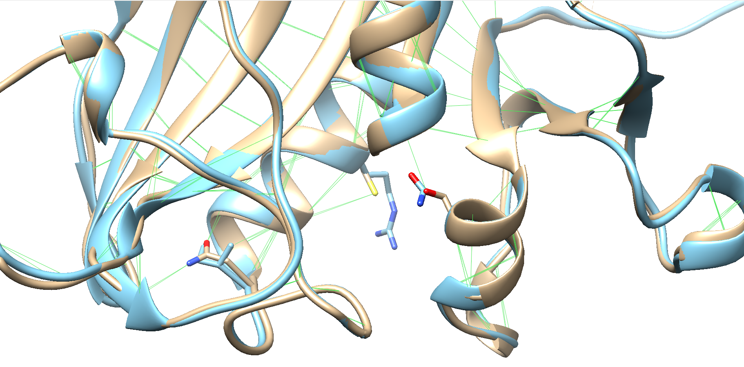
Fig. 1. Structural superposition of wild-type PfDHFR (brown) and triple mutant (cyan).
108N
S108
59R
C59
N51
51I
Belong the structural analysis, the N51I substitution is positioned distally from the active site and may contribute to allosteric effects, while C59R and S108N are located closer to the ligand binding pocket. The S108N mutation directly alters ligand binding within the active site, whereas C59 creates steric hindrance that restricts access to antifolate antimalarials. Together, these mutations significantly reduce both ligand accessibility and binding affinity.
3.3 Virtual screening
Fig. 2 below shows the distribution of binding affinities of the compounds from SANCDB and AfroDB with the PfDHFR protein.
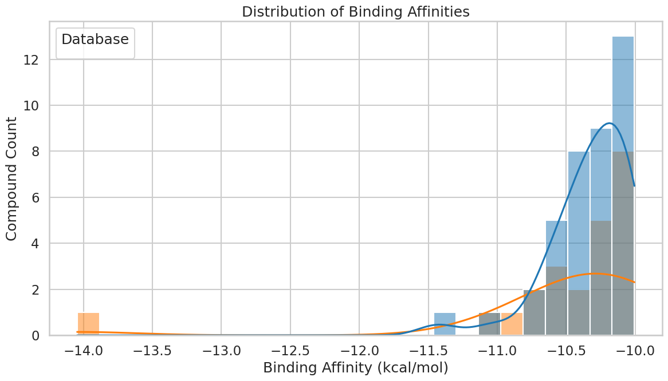
Fig. 2. Distribution of Binding affinity of SANCDB (orange) and AfroDB (blue)
The analysis revealed that AfroDB contains significantly more compounds with strong binding affinities, showing a concentration of compounds in -10.5 to -10.0 kcal/mol range, while SANCDB exhibits a much smaller and more dispersed distribution with only few compounds showing binging affinities around -14.0 kcal/mol. AfroDB contains few compounds with strong binding affinities of -11.4 to -11.0 kcal/mol.

Table 2 and 3 below shows the top 10 promising inhibitors of PfDHFR from AfroDB and SANCDB.

Table 2. Top 10 promising inhibitors of PfDHFR from AfroDB
ID | Docking Score (Kcal/mol) | Mw (g/mol) | LogP | HBD | HBA | TPSA
BMC_00086 | -11.427 | 470.43 | 1.6114 | 5 | 10 | 0
EA_0112 | -11.031 | 396.395 | 2.7428 | 1 | 7 | 0
EA_0147 | -10.725 | 336.391 | 2.4123 | 0 | 4 | 0
WA_0045 | -10.695 | 363.457 | 4.8302 | 3 | 4 | 0
BMC_000100 | -10.626 | 363.457 | 4.8302 | 3 | 4 | 0
SA_0088 | -10.583 | 448.519 | 2.6011 | 1 | 6 | 0
AN_UY_034 | -10.549 | 422.477 | 4.4543 | 3 | 6 | 0
EA_0149 | -10.549 | 352.39 | 1.3831 | 1 | 5 | 0
NPR_0009 | -10.494 | 379.456 | 4.5358 | 4 | 5 | 0
SA_179 | -10.481 | 352.386 | 4.2915 | 1 | 5 | 0

Out of 842 compounds from the AfroDB database, 39 complied fully with Lipinski’s rule of five.
Table 3. Top 10 promising inhibitors of PfDHFR from SANCDB
ID | Docking score (Kcal/mol) | MW (g/mol) | LogP | HDonors | HAcceptors | Violations Lipinski
SANC00747 | -14.046 | 446.628 | 3.7996 | 3 | 5 | 0
SANC00414 | -11.046 | 407.271 | 4.3374 | 3 | 3 | 0
SANC00733 | -10.821 | 414.542 | 4.2817 | 1 | 5 | 0
SANC00907 | -10.77 | 372.505 | 3.5244 | 2 | 4 | 0
SANC00413 | -10.75 | 421.254 | 4.7384 | 4 | 3 | 0
SANC00416 | -10.582 | 488.183 | 4.676 | 4 | 2 | 0
SANC00352 | -10.538 | 436.46 | 4.1298 | 3 | 7 | 0
SANC00347 | -10.5 | 434.444 | 3.942 | 2 | 7 | 0
SANC00456 | -10.423 | 430.585 | 4.1181 | 2 | 5 | 0
SANC00312 | -10.335 | 438.071 | 4.6041 | 2 | 4 | 0

Out of a total of 1,013 compounds from the SANCDB database, 23 exhibited no violations of Lipinski’s rule of five.

Fig. 3 shows the 3D model of PfDHFR protein in complex with the best compounds with the highest docking score from SANCDB and AfroDB respectively.
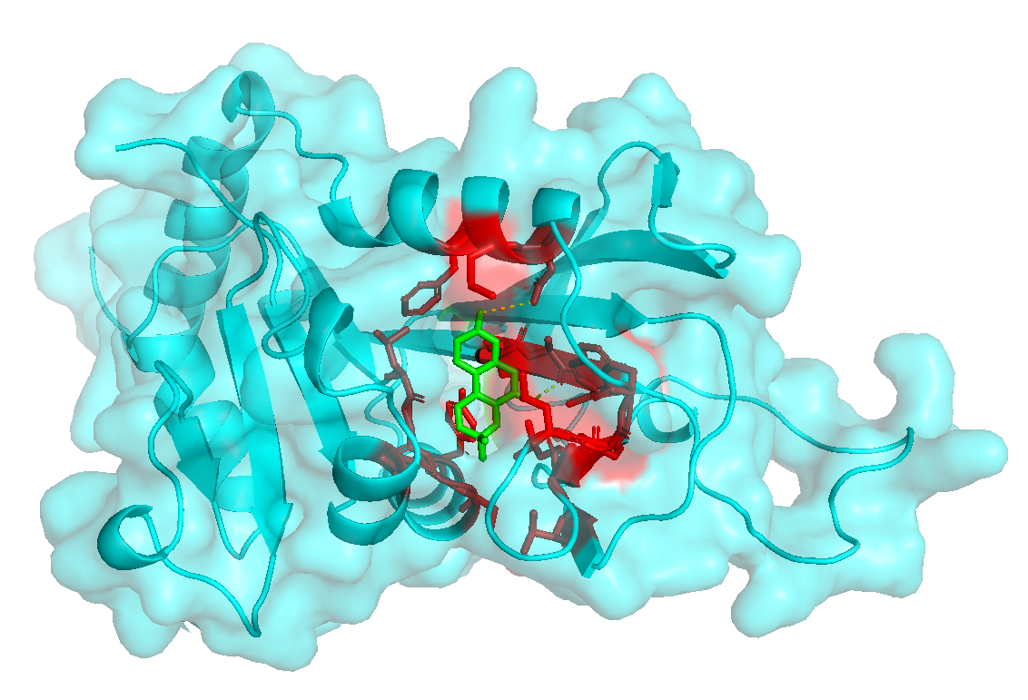
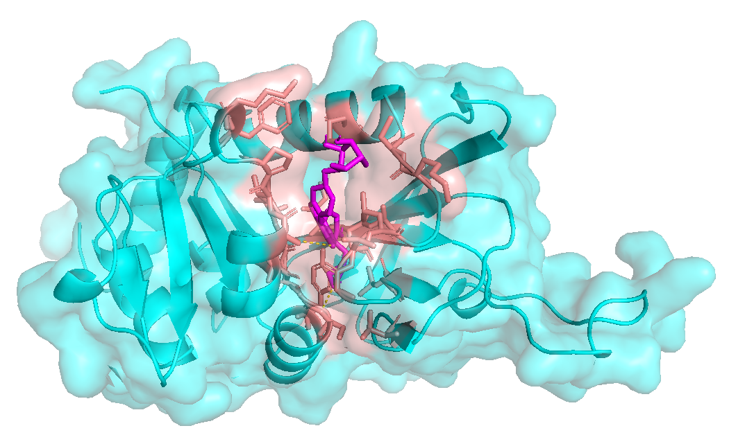
SANC00747
BMC_00086

Fig. 3. 3D model of PfDHFR complex with SANC00747 (left) and BMC_00086 (right). The protein is shown on Surface representation while the ligand molecules are represented in Licorice.
Both ligands SANC00747 and BMC_00086 exhibited the highest docking scores, respectively -14.046 and -11.427 Kcal/mol indicating strong predicted binding affinities. Notably, their binding modes overlap with the active site of PfDHFR, forming key stabilizing interactions that are essential for enzyme inhibition.

Discussion
The present study reveals a concerning prevalence of triple mutations (N51I, C59R, and S108N) in the Pfdhfr gene, occurring in 22 out of 47 samples (46.81%) from three sentinel sites in Mali (Dioro, Missira, and Sélingué). These high-frequency mutations (S108N + N51I + C59R) have been reported in various African populations, with studies showing prevalence rates ranging from 63.6% to over 70% in West Africa and different regions [25],[26]. The mutation N51I, C59R, or S108N in Pfdhfr has been independently associated with in vitro resistance to Pyrimethamine (odds ratio = 42.34) [27], representing a significant threat to the efficacy of antifolate-based antimalarial interventions. The S108N, C59R, and N51I mutations confer resistance to pyrimethamine and are common in Africa, while the I164L mutation confers high level resistance, is rarely seen. The absence of the I164L mutation in our study population is consistent with the typical evolutionary pathway of antimalarial resistance in sub-Saharan Africa [28], where this super resistance mutation has not yet emerged despite being present in Southeast Asian populations.
The observed mutation pattern follows the established evolutionary sequence described in the literature: CNCSI → CNCNI → CNRNI → CIRNI (amino acid positions 50, 51, 59, 108, and 164, respectively) [29], with S108N appearing first, followed by C59R, then N51L, and finally I164L [30]. This stepwise accumulation of mutations represents a progressive increase in resistance levels, with the triple mutant conferring high level pyrimethamine resistance while the absent I164L mutation would confer super resistance to sulfadoxine-pyrimethamine (SP) combination therapy, the fact that only two sequence could be examined at position 164 and were of wild type (I164) suggests that the I164L mutation has not yet emerged in these Malian Populations, which corresponds to the situation in many sub- Saharan countries and aligns with the relative resistance patterns observed in the region [31], [32].
The molecular modeling analysis provides crucial insights into the mechanistic basis of resistance, confirming previous in vitro and in vivo studies on the impact of Pfdhfr gene SNPs on antifolate resistance [33]. The structural comparison between wild-type and mutant PfDHFR proteins reveals that the mentioned mutations result in restricted access and crowding of the active site for rigid molecules such as antifolates used as antimalarials [34]. The N51I substitution, located distally from the active site, likely contributes to resistance through allosteric effect rather than direct interference with drug binding. The C59R mutation creates steric hindrance that restricts access to the active site, while the S108N mutation directly alters ligand binding within the binding pocket. Our modeling results consolidate and corroborate other study demonstrating the steric and electrostatic effects of these mutations on protein function [35].
Interestingly, while our prediction confirmed the steric and electrostatic effects of the N51I and C59R SNPs on the protein, it did not fully justify the conclusion that the most significant effect on resistance would come from the S108N mutation, as indicated by this study [36]. This suggests that additional modeling parameters beyond steric and electrostatic effects, such as dynamic factors and protein flexibility under physiological conditions, may be necessary to completely elucidate the mechanism of S108N mediated resistance. It should be noted that these point mutations do not completely block the alternatives to SP [37],[38],[39].
The virtual screening of African natural compounds databases (SANCDB and AfroDB) reveals promising candidates for drug development against resistant strains. The South African Natural Compounds Database (SANCDB) is a curated and fully referenced database containing compounds information for natural products and has become an important resource for in silico screening of African natural products for drug discovery purposes. AfroDB represents a select, highly potent and diverse natural product library from African medicinal plants covering the entire continent of Africa. Computer aided drug design (CADD) often involves virtual screening (VS) of large compounds datasets, and the availability of such databases is vital for drug discovery protocols. The African natural compounds databases (SANCDB and AfroDB) have been tested and proven to have a wide range of biological activities, making them promising resources for antimalarial drug discovery, AfroDB compounds showed a pool of promising molecules in the range of -11.43 to -10.0 kcal/mol, with 39 out of 842 compounds complying with Linpiski’s rule of five. SANCDB compounds exhibited fewer but stronger individual binders, with SANC00747 showing exceptional binding affinity (-14.046 kcal/mol) and 23 out of 1,013 compounds meeting drug-likeness criteria. The identification of compounds with strong binding affinities to mutant PfDHFR variants suggests potential for developing novel antimalarials effective against resistant strains, leveraging the rich biodiversity of African flora which has been underexplored for antimalarial discovery.
The 46.81% prevalence of triple mutations raises significant concerns for current malaria control strategies in Mali, particularly given the widespread use of SP for intermittent preventive treatment in pregnant women (IPTp) and seasonal malaria chemoprevention (SMC). Studies have shown that Seasonal Malaria Chemoprevention consisting of monthly administration of amodiaquine/sulfadoxine-pyrimethamine to children aged 3-59 months during the transmission season could promote SP resistance [18],[37]. The evolution of Pfdhps and Pfdhfr mutations before and after adopting seasonal malaria chemoprevention has been documented in neighboring Burkina Faso [38], highlighting the need for continuous monitoring. This high frequency of residence mutations may accelerate the emergence and spread of resistant strains, potentially compromising the effectiveness of these critical interventions. The continued evolution of resistance patterns necessitates enhanced surveillance of genotypic resistance markers and large-scale testing of SP treatment efficacy by relevant stakeholders, as the modeling approach has become essential for discovering new antimalarial drugs effective against resistant strains and understanding their mechanisms of action [20].
This study demonstrates several advantages of the bioinformatics approach, namely the ability to obtain detailed and accurate results in record time and reduced cost compared to traditional experimental methods. Computational approaches like molecular modeling and docking are indispensable for predicting how mutations alter protein structure, stability, and drug binding affinity, providing atomistic insights into resistance mechanisms that inform drug design and policy updates [39]. However, several limitations warrant consideration, including the need to optimize sequencing methods to cover entire Pfdhfr gene and identify all SNPs, as well as the requirement for molecular dynamics simulations to provide additional information on the effects of these mutations under physiological conditions.
Future research should focus on molecular dynamics studies of wild-type and mutant proteins in the presence of antifolates used as antimalarials in environment close to physiological conditions, Additionally, continued sequencing of field samples with improved techniques to cover the entire Pfdhfr gene and include other genotypic resistance markers, notably the Pfdhps gene, will be essential for comprehensive resistance monitoring. The integration of resistance surveillance data with innovative drug discovery approaches will be critical for maintaining effective malaria control in endemic regions where drug resistance continues to evolve.

Conclusion
This study demonstrates a critical threshold of antimalaria resistance in Mali, with 46.81% prevalence of triple Pfdhfr mutations (N51I, C59R, S108N) threatening current sulfadoxine-pyrimethamine interventions. Molecular modeling reveals distinct resistance mechanisms: N51I acts through allosteric effects, C59R creates steric hindrance, and S108N directly alters drug binding, collectively restricting antifolate access to the protein active site. The absence of I164L mutation indicates Mali remains in the pre-super-resistance phase, providing a critical window for intervention. Virtual screening of African natural compounds databases identified promising drug candidates, with SANC00747 showing exceptional binding affinity (-14.046 kcal/mol), highlighting untapped potential for resistance breaking therapeutics.

References
[1] M. P. Nelder, R. Schats, H. N. Poinar, A. Cooke, et M. B. Brickley, « Pathogen prospecting of museums: Reconstructing malaria epidemiology », Proc. Natl. Acad. Sci. U. S. A., vol. 121, nº 15, p. e2310859121, doi: 10.1073/pnas.2310859121.
[2] S. Sato, « Plasmodium—a brief introduction to the parasites causing human malaria and their basic biology », J. Physiol. Anthropol., vol. 40, p. 1, janv. 2021, doi: 10.1186/s40101-020-00251-9.
[3] A. L. M. Laura Anderson, « World malaria report 2024: addressing inequity in the global malaria response », 2024. https://www.who.int/publications/i/item/9789240104440
[4] H.-I. Shin et al., « 2023 World Malaria Report (Status of World Malaria in 2022) », vol. 17, nº 32, p. 1351‑1377, août 2024, doi: 10.56786/PHWR.2024.17.32.1.
[5] E. Sakwa, « World Malaria Report 2022 underscores the need for increased investments in research and development to address rising threats », African Institute for Development Policy - AFIDEP. Consulté le: 11 juillet 2025. [En ligne]. Disponible sur: https://afidep.org/world-malaria-report-2022-underscores-the-need-for-increased-investments-in-research-and-development-to-address-rising-threats/
[6] « Mali pioneers novel hybrid vaccine delivery approach to combat malaria ». Consulté le: 11 juillet 2025. [En ligne]. Disponible sur: https://www.unicef.org/mali/en/press-releases/mali-pioneers-novel-hybrid-vaccine-delivery-approach-combat-malaria
[7] E. G. Tse, M. Korsik, et M. H. Todd, « The past, present and future of anti-malarial medicines », Malar. J., vol. 18, nº 1, p. 1‑21, déc. 2019, doi: 10.1186/s12936-019-2724-z.
[8] I. of M. (US) C. on the E. of A. Drugs, K. J. Arrow, C. Panosian, et H. Gelband, « Antimalarial Drugs and Drug Resistance », in Saving Lives, Buying Time: Economics of Malaria Drugs in an Age of Resistance, National Academies Press (US), 2004. Consulté le: 11 juillet 2025. [En ligne]. Disponible sur: https://www.ncbi.nlm.nih.gov/books/NBK215631/
[9] E. R. Watkins et S. R. Meshnick, « Drugs for malaria », Semin. Pediatr. Infect. Dis., vol. 11, nº 3, p. 202‑212, juill. 2000, doi: 10.1053/pi.2000.6232.
[10] M. O. Oduoye et al., « Unlocking the potential of novel RTS, S/AS01, and R21/Matrix‐MTM malaria vaccines in African nations », Health Sci. Rep., vol. 7, nº 1, p. e1797, janv. 2024, doi: 10.1002/hsr2.1797.
[11] A. L. Duga et al., « Malaria vaccine rollout begins in Africa: the need to strengthen regulatory and safety surveillance systems in Africa », BMJ Glob. Health, vol. 9, nº 10, oct. 2024, doi: 10.1136/bmjgh-2024-015445.
[12] O. Ngou, R. Nzoumbou-Boko, P. Bakamba, et Y. Boum, « R21/Matrix-M malaria vaccine: a vital tool in the arsenal against malaria, not a silver bullet », Lancet Infect. Dis., vol. 24, nº 5, p. 438‑439, mai 2024, doi: 10.1016/S1473-3099(24)00010-0.
[13] I. Zeile et al., « Molecular markers of Plasmodium falciparum drug resistance in southern highland Rwanda », Acta Trop., vol. 121, nº 1, p. 50‑54, janv. 2012, doi: 10.1016/j.actatropica.2011.09.009.
[14] A. Martín Ramírez et al., « Mutational profile of pfdhfr, pfdhps, pfmdr1, pfcrt and pfk13 genes of P. falciparum associated with resistance to different antimalarial drugs in Osun state, southwestern Nigeria », Trop. Med. Health, vol. 53, nº 1, p. 49, avr. 2025, doi: 10.1186/s41182-025-00732-6.
[15] B. Andagalu et al., « Global assessment of partial artemisinin resistance: Multicenter trial across Kenya, Peru, and Thailand in patients with uncomplicated Plasmodium falciparum malaria », Int. J. Infect. Dis., vol. 0, nº 0, juill. 2025, doi: 10.1016/j.ijid.2025.107971.
[16] N. Noreen, A. Ullah, S. M. Salman, Y. Mabkhot, A. Alsayari, et S. L. Badshah, « New insights into the spread of resistance to artemisinin and its analogues », J. Glob. Antimicrob. Resist., vol. 27, p. 142‑149, déc. 2021, doi: 10.1016/j.jgar.2021.09.001.
[17] H. Maiga et al., « Assessing of Pfdhps Gene of Sulfadoxine after Five Years of Seasonal Malaria Chemoprevention Implementation at Two Rural Sites in Mali: The Quantitative Method », Fortune J. Health Sci., vol. 8, nº 2, p. 479‑490, juin 2025. https://doi.org/10.26502/fjhs.298
[18] S. Nikiema et al., « Seasonal Malaria Chemoprevention Implementation: Effect on Malaria Incidence and Immunity in a Context of Expansion of <em>P. falciparum</em> Resistant Genotypes with Potential Reduction of the Effectiveness in Sub-Saharan Africa », Infect. Drug Resist., vol. 15, p. 4517‑4527, août 2022, doi: 10.2147/IDR.S375197.
[19] F. E. T. Bohissou et al., « Evolution of Pfdhps and Pfdhfr mutations before and after adopting seasonal malaria chemoprevention in Nanoro, Burkina Faso », Sci. Rep., vol. 14, nº 1, p. 24224, oct. 2024, doi: 10.1038/s41598-024-75369-2.
[20] L. P. Hastuti, F. Hermawan, M. R. Iresha, T. Ernawati, et Firdayani, « In-silico studies of hydroxyxanthone derivatives as potential pfDHFR and pfDHODH inhibitor by molecular docking, molecular dynamics simulation, MM-PBSA calculation and pharmacokinetics prediction », Inform. Med. Unlocked, vol. 47, p. 101485, 2024, doi: https://doi.org/10.1016/j.imu.2024.101485.
[21] A. Manhas, M. Y. Lone, et P. C. Jha, « Multicomplex-based pharmacophore modeling in conjunction with multi-target docking and molecular dynamics simulations for the identification of PfDHFR inhibitors », J. Biomol. Struct. Dyn., vol. 37, nº 16, p. 4181‑4199, nov. 2019, doi: 10.1080/07391102.2018.1540362.
[22] S. S. Duay, R. C. Y. Yap, A. L. Gaitano, J. A. A. Santos, et S. J. Y. Macalino, « Roles of Virtual Screening and Molecular Dynamics Simulations in Discovering and Understanding Antimalarial Drugs », Int. J. Mol. Sci., vol. 24, nº 11, p. 9289, janv. 2023, doi: 10.3390/ijms24119289.
[23] E. Y. Mao, S. W. Page, B. E. Sleebs, M. R. Gancheva, et D. W. Wilson, « A review of natural products as a source of next-generation drugs against apicomplexan parasites », Npj Antimicrob. Resist., vol. 3, nº 1, p. 51, juin 2025, doi: 10.1038/s44259-025-00119-x.
[24] D. R. Bharti et A. M. Lynn, « QSAR based predictive modeling for anti-malarial molecules », Bioinformation, vol. 13, nº 5, p. 154, mai 2017, doi: 10.6026/97320630013154.
[25] H. Quan et al., « High multiple mutations of Plasmodium falciparum-resistant genotypes to sulphadoxine-pyrimethamine in Lagos, Nigeria », Infect. Dis. Poverty, vol. 9, nº 1, p. 91, juill. 2020, doi: 10.1186/s40249-020-00712-4.
[26] Z. L et al., « Widespread resistance mutations to sulfadoxine-pyrimethamine in malaria parasites imported to China from Central and Western Africa », Int. J. Parasitol. Drugs Drug Resist., vol. 12, avr. 2020, doi: 10.1016/j.ijpddr.2019.11.002.
[27] B. S et al., « The F423Y mutation in the pfmdr2 gene and mutations N51I, C59R, and S108N in the pfdhfr gene are independently associated with pyrimethamine resistance in Plasmodium falciparum isolates », Antimicrob. Agents Chemother., vol. 56, nº 5, mai 2012, doi: 10.1128/AAC.05618-11.
[28] O. E et al., « Plasmodium falciparum strains harboring dihydrofolate reductase with the I164L mutation are absent in Malawi and Zambia even under antifolate drug pressure », Antimicrob. Agents Chemother., vol. 52, nº 11, nov. 2008, doi: 10.1128/AAC.00431-08.
[29] M. T, « Origins and spread of pfdhfr mutant alleles in Plasmodium falciparum », Acta Trop., vol. 114, nº 3, juin 2010, doi: 10.1016/j.actatropica.2009.07.008.
[30] D. T et al., « Exploiting structural analysis, in silico screening, and serendipity to identify novel inhibitors of drug-resistant falciparum malaria », ACS Chem. Biol., vol. 4, nº 1, janv. 2009, doi: 10.1021/cb8002804.
[31] G. C et al., « Substantial increase in mutations in the genes pfdhfr and pfdhps puts sulphadoxine-pyrimethamine-based intermittent preventive treatment for malaria at risk in Burkina Faso », Trop. Med. Int. Health TM IH, vol. 19, nº 6, juin 2014, doi: 10.1111/tmi.12305.
[32] P. Chauvin et al., « Prevalence of Plasmodium falciparum parasites resistant to sulfadoxine/pyrimethamine in pregnant women in Yaoundé, Cameroon: emergence of highly resistant pfdhfr/pfdhps alleles », J. Antimicrob. Chemother., vol. 70, nº 9, p. 2566‑2571, sept. 2015, doi: 10.1093/jac/dkv160.
[33] S. Ci, W. Jm, Q. Ik, S. W, et S. Ch, « Pyrimethamine-resistant dihydrofolate reductase enzymes of Plasmodium falciparum are not enzymatically compromised in vitro », Mol. Biochem. Parasitol., vol. 154, nº 1, juill. 2007, doi: 10.1016/j.molbiopara.2007.03.009.
[34] A. S, J. V, et B. Pv, « Origins of the specificity of inhibitor P218 toward wild-type and mutant PfDHFR: a molecular dynamics analysis », J. Biomol. Struct. Dyn., vol. 33, nº 9, sept. 2015, doi: 10.1080/07391102.2014.979231.
[35] S. W, S. T, S. R, Y. Y, et S. Dv, « Antifolate-resistant mutants of Plasmodium falciparum dihydrofolate reductase », Proc. Natl. Acad. Sci. U. S. A., vol. 94, nº 4, févr. 1997, doi: 10.1073/pnas.94.4.1124.
[36] B. B, S. K, P. P, P. A, M. Pk, et M. J, « In silico screening of antifolate based novel inhibitors from Brucea mollis Wall. ex kurz against quadruple mutant drug resistant PfDHFR », Comb. Chem. High Throughput Screen., vol. 17, nº 8, 2014, doi: 10.2174/1386207317666140521153305.
[37] M. T, L. T, K. Sl, H. Im, et P. Ma, « Seasonal malaria chemoprevention and the spread of Plasmodium falciparum quintuple-mutant parasites resistant to sulfadoxine-pyrimethamine: a modelling study », Lancet Microbe, vol. 5, nº 9, sept. 2024, doi: 10.1016/S2666-5247(24)00115-0.
[38] K. S. Millogo et al., « Seasonal malaria chemoprevention and mutations in Pfdhfr and Pfdhps genes in children in the health district of Nanoro, Burkina Faso », MalariaWorld J., vol. 16, p. 5, 2025, doi: 10.5281/zenodo.15039792.
[39] H. R, B. Dk, G. M, et T. B. Ö, « PRIMO: An Interactive Homology Modeling Pipeline », PloS One, vol. 11, nº 11, nov. 2016, doi: 10.1371/journal.pone.0166698.

