Short Research Article
Assessment of effect of green biomass from Tithonia diversifolia (Hemsl.) A. Gray and Chromolaena odorata L. as organic fertilizer on the growth and yield of broccoli (Brassica oleracea var. italica) in the Haut Sassandra Region, Daloa (Côte d’Ivoire)

Abstract
Soil degradation and declining fertility are major constraints to vegetable production, particularly in the Haut-Sassandra region. This study evaluated the effects of green biomasses of Tithonia diversiflora and Chromolaena odorata on the growth of broccoli (Brassica oleracea var. italica). The experiment was conducted using a randomized complete block design with four replications and four treatments: Tithonia diversiflora alone, Chromolaena odorata alone, their combination, and an unfertilized control. Observations focused on plant height, stem circumference, leaf number, leaf length and width, and soil chemical properties. Results showed that the application of green biomasses enhanced vegetative growth and improved soil organic matter, cation exchange capacity, and exchangeable bases. Plants fertilized with Tithonia diversiflora or Chromolaena odorata individually performed better than the control, while their combination did not exhibit a marked synergistic effect. These findings indicate that the use of these biomasses is a promising organic fertilization strategy for sustaining soil productivity and promoting sustainable agriculture.
Keywords: Tithonia diversiflora, Chromolaena odorata, broccoli, organic fertilization, Haut-Sassandra, soil fertility.

Introduction
In Côte d’Ivoire, agriculture plays a central role in the national economy, accounting for approximately 22% of the Gross Domestic Product (GDP) and employing over 60% of the active population (FAO, 2021). It represents a key pillar for ensuring food security, combating poverty, and strengthening the resilience of rural communities (Pawlak and Kołodziejczak, 2020). Ivorian agriculture is traditionally dominated by cash crops such as cassava, yam, and rice (Kouakou et al., 2023) as well as export crops such as cocoa and coffee, this agriculture now finds itself at a crossroads, facing the need to innovate, diversify, and make its production systems more sustainable (Coulibaly et al., 2022). Driven by population growth, rapid urbanization, and changing food preferences, the demand for fresh vegetables is experiencing a significant increase in the national market (Adour et al., 2017). Thus, market gardening is emerging as a high-potential sector (Monde et al., 2023). Among the promising crops, broccoli (Brassica oleracea var. italica) is attracting increasing attention.
Native to the Mediterranean basin, broccoli is a plant of the Brassicaceae family, highly prized for its rich content of vitamins (C, K, and A), dietary fiber, essential minerals, and antioxidant compounds (Adour et al., 2017). Regular consumption is associated with the prevention of many chronic diseases, such as certain cancers, cardiovascular disorders, and diabetes (World Cancer Research Fund, 2018). This nutritional value makes it a strategic food in public health policies, while also representing an economic opportunity for agricultural producers seeking to diversify their income (2020; FAO, 2021). It is also one of the most important foods grown worldwide (Martins et al., 2022;). Although this vegetable is of particular interest due to its remarkable nutritional qualities and economic profitability, its cultivation is still not widespread in several regions of Côte d'Ivoire, particularly in the Haut-Sassandra region (Koné et al., 2021).
Local producers face several obstacles, including low soil fertility, depleted by years of continuous cultivation, and a lack of knowledge about cultivation practices suited to this demanding species (FAO, 2020). Broccoli requires significant inputs of nutrients, nitrogen, phosphorus, and potassium to fully express its agronomic potential (FAO, 2020). Faced with these constraints, the use of mineral fertilizers is often considered a quick fix.
However, their high cost, irregular availability, and environmental impacts such as soil acidification, loss of biodiversity, and water pollution limit their long-term effectiveness (FAO, 2021). These limitations reinforce the need to identify agroecological alternatives that are more accessible, economical, and sustainable (Pretty et al., 2018). With this in mind, the use of green biomass from local plants represents an innovative and promising avenue. Certain wild species, such as Tithonia diversifolia (Mexican sunflower) and Chromolaena odorata (king grass), are notable for their rapid growth, natural abundance, and high nutrient content (Groga et al., 2018). When incorporated into the soil as green biomass, they can effectively contribute to fertility regeneration, soil structure improvement, and organic matter enrichment (FAO, 2020).
Previous studies have demonstrated the fertilizing potential of these two plants on various food crops and vegetables in particular, thanks to their ability to quickly restore the mineral elements essential for plant growth (Groga et al., 2018). However, their combined use in broccoli cultivation remains poorly documented, particularly in Côte d'Ivoire, where empirical knowledge of their synergistic effect is virtually non-existent (Koné et al., 2021). The overall objective of this study is to improve broccoli production using green biomass from Tithonia diversifolia and Chromolaena odorata. Specifically, it aims to measure the effect of green biomass from Tithonia diversifolia and Chromolaena odorata on the growth of broccoli plants and to compare the agronomic performance of broccoli according to different biomass combinations.

2.1. Methodology
2.1.1. Study Site
The study was conducted during the first rainy season at the experimental farm of Jean Lorougnon Guédé University. This university is located in the northeast of Daloa, at 6°52’38’’ N latitude and 6°27’0’’ W longitude (Figure 1). Daloa is part of the Haut-Sassandra region, located in the central-western part of Côte d’Ivoire, between 6° and 7° North latitude and 7° and 8° West longitude (Koffie-Bikpo and Kra, 2013). The Haut-Sassandra region is predominantly covered by dense forest vegetation. Soil studies conducted in the area reveal that the soils are generally moderately leached ferralitic soils, which are well-suited for all types of agricultural crops (Zro et al., 2016). The relief is slightly contrasted and not very varied, mostly consisting of plateaus ranging from 200 to 400 meters in altitude (Avenard, 1971).
The climate is characterized by two rainy seasons. The first, from March to July, is irregular, while the second runs from July to September. Annual temperatures range from 24.65 °C to 27.75 °C (N’Guessan et al., 2014). June marks the peak of the main rainy season, and September that of the minor rainy season. According to Brou (2010), the landscape ranges from semi-deciduous humid dense forest to cleared mesophilic forest.
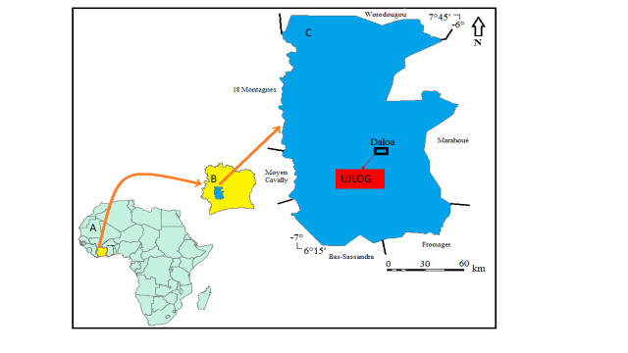

Figure 1: Location of the Daloa Experimental Site
A: Map of Africa; B: Map of Côte d’Ivoire; C: Map of Daloa highlighting the study area (UJLOG)

2.1.2. Materials
2.1.2.1. Biological Material
The plant material consists of broccoli seedlings from the hybrid variety Isabela F1, supplied by the seed company SEMIVOIRE. This variety is known for its heat resistance and tolerance to foliar diseases such as downy mildew. It is well-suited to tropical regions, with a preference for the cool and dry season at low altitudes, but can also be cultivated year-round in high-altitude areas. Harvesting takes place 75 to 85 days after transplanting. The seeds are small, spherical, dark brown to black in color, with a smooth and hard texture (Figure 2).
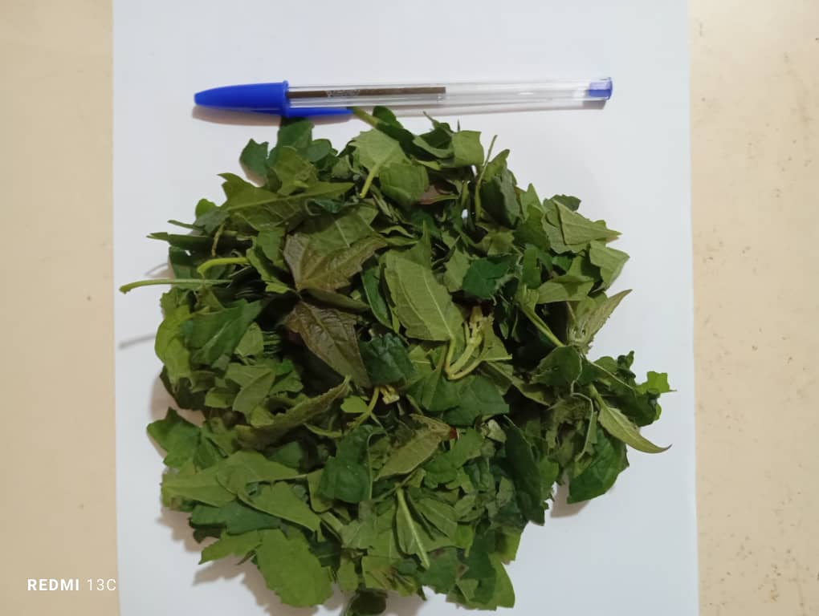
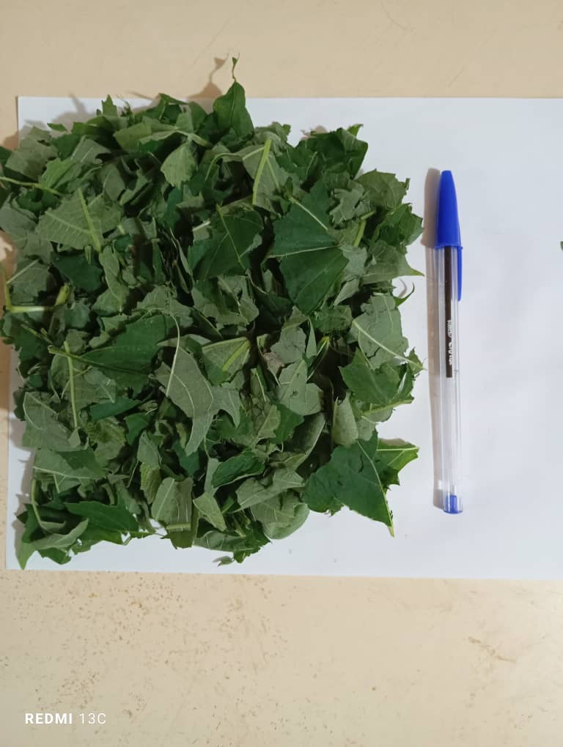
B
A

Figure 2: Broccoli seeds from the hybrid variety Isabela F1

2.1.2.2. Fertilizing Material
The fertilizing material consists of organic fertilizers made from the green biomass of Tithonia diversifolia and Chromolaena odorata L. Each of these fertilizers was previously chopped and placed in a black plastic bag for a period of two months before being used (Figure 3).
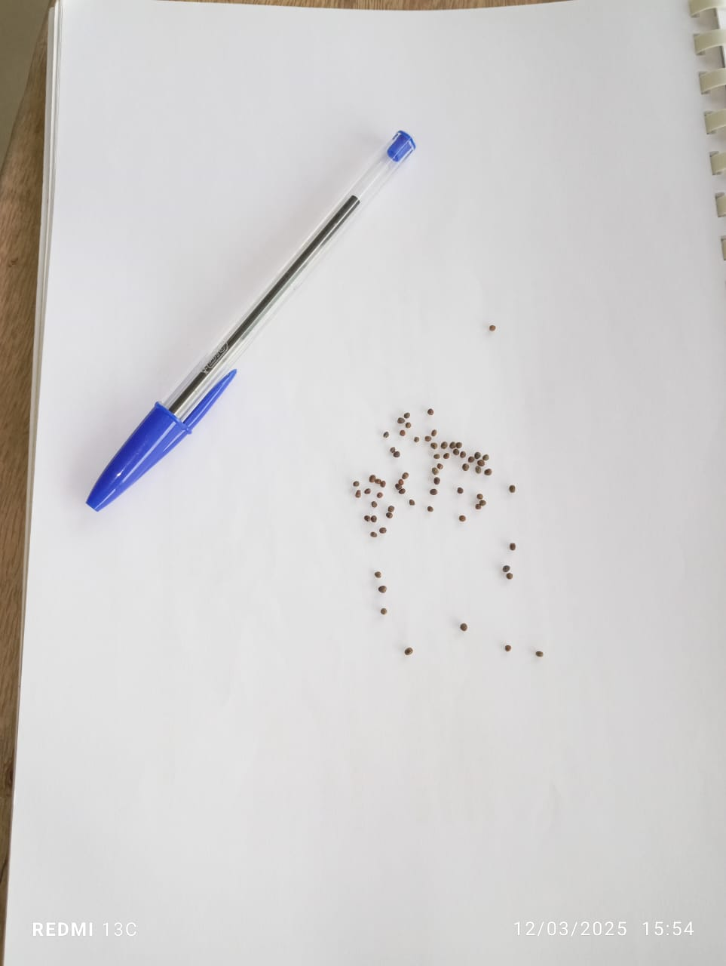

Figure 3: Fertilizers from Tithonia diversifolia (A) and Chromolaena odorata (B)

2.1.2.3. Technical equipment
The technical equipment used for setting up and managing the experiment includes:
- Machetes and hoes for weeding and tilling the soil;
- A field notebook to record all observations;
- A digital pocket scale (Digital Pocket Scale 200 g, 0.01 g precision) for weighing different doses of organic fertilizers;
- A measuring tape for setting up the experimental design while respecting spacing requirements, and for measuring the length and width of the leaves as well as the height of broccoli plants.
- A digital camera for taking pictures;
- An electronic hanging scale (Model 14191-744) with a maximum capacity of 5 kg and a precision of 5 g for measuring the biomass weight of C. odorata and T. diversifolia (Figure 4);
- A caliper for measuring the stem circumference of broccoli plants (Figure 5);

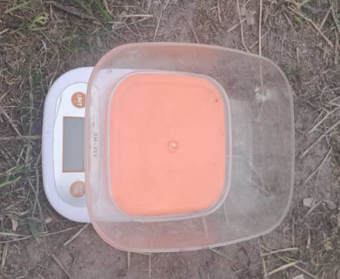

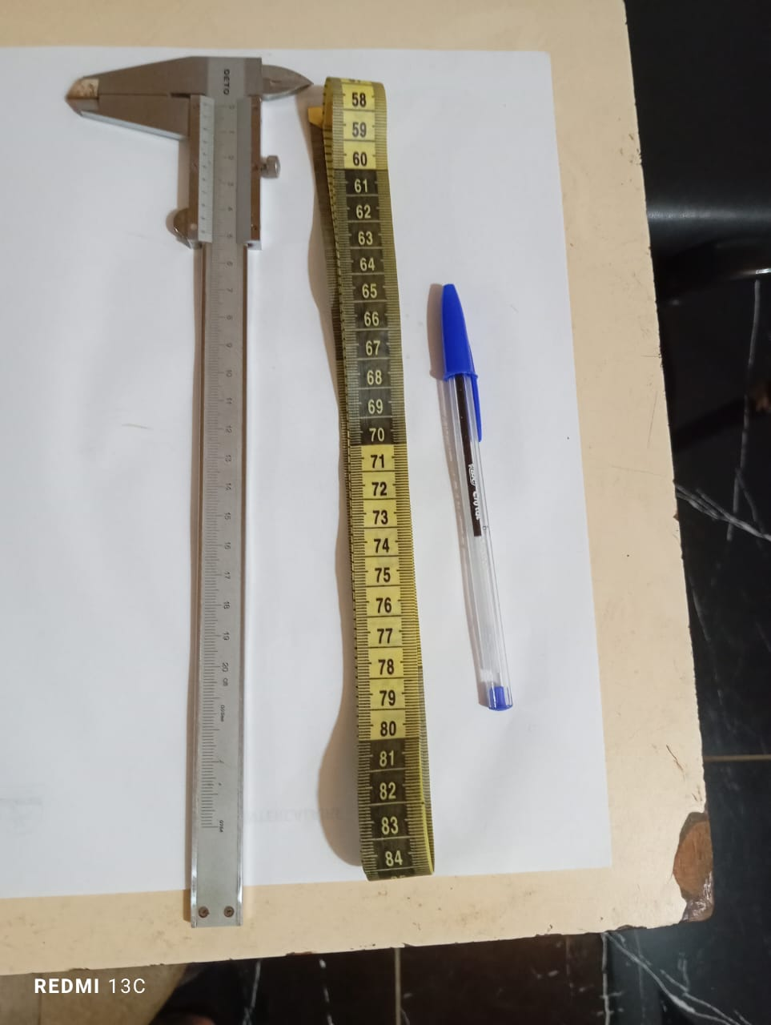

Figure 4 : An electronic hanging scale (Model 14191-744) for measuring the biomass weight

Figure 5 : A caliper for measuring the stem circumference of broccoli plants

2.2. Methods
2.2.1. Experimental Design
The experimental design used is a Fisher randomized block design with four treatments and four replications in total, randomly distributed across the mini-plots composing the setup (Figure 6). The four blocks are spaced 0.5 m apart, and the individual plots are separated by 1 m each to avoid block effects. Each of the four mini-plots per block has an area of 10 m², measuring 5 m in length and 2 m in width. The treatments are as follows:
- Treatment with Chromolaena odorata L.: Ch.od;
- Treatment with Tithonia diversifolia: Ti.di;
- Treatment with Chromolaena odorata L. + Tithonia diversifolia: Ch.od + Ti.di;
- Control treatment: Co.
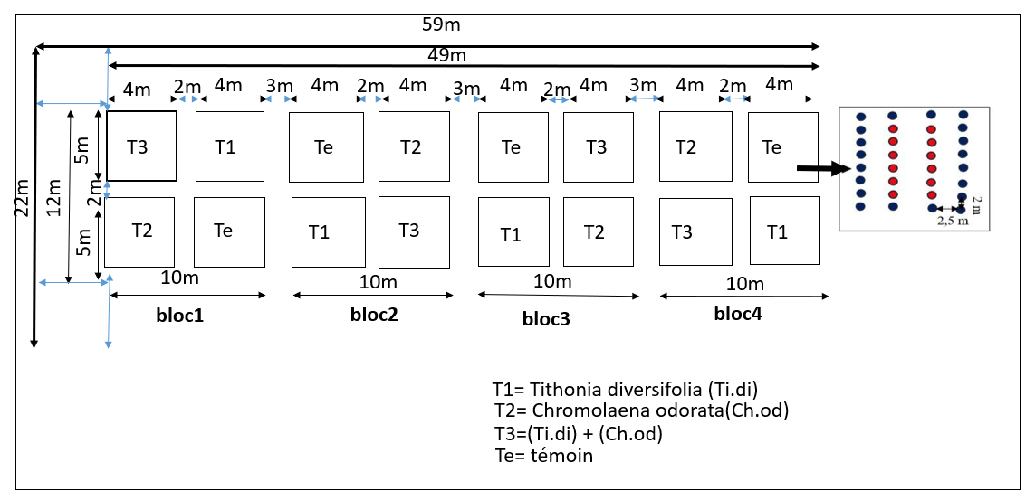
Figure 6: Experimental setup

2.2.2. Soil Preparation and Sowing
Soil preparation began with clearing, followed by manual tilling to remove plant residues and loosen the topsoil. This operation improved soil aeration and facilitated the rooting of future broccoli seedlings (Brassica oleracea var. italica). The land was then leveled using a hoe to create a uniform surface and ensure even moisture distribution. A nursery was set up for the production of young plants. The germination substrate, composed of fine soil and well-decomposed compost, was sieved to enhance porosity and water retention. A total of 50 seeds were sown on April 26, 2025, in trays made from recycled drums and in cell trays, at a depth of 0.5 to 1 cm. The experiment was conducted off-ground. To protect the seedlings from pests and unfavorable climatic conditions, the nursery was covered with a fine mosquito net, creating a favorable microclimate. After 3 to 4 weeks, vigorous plants at the 4 to 5 leaf stage were transplanted into bags filled with a mixture of fine soil, sand, and compost. Spacing of 50 cm between rows and 40 cm between plants was used, ensuring good aeration and reducing competition for resources. Regular watering was done after transplanting, then continued regularly according to climatic conditions. The green biomass of Tithonia diversifolia and Chromolaena odorata was used as fertilizer. These biomasses were applied separately to evaluate their individual effects, then combined to study their synergistic action on broccoli growth and production. No treatments were applied in the nursery. Measurements were taken one week after transplanting, including height, circumference, number of leaves, leaf width, and leaf length (Figure 7).
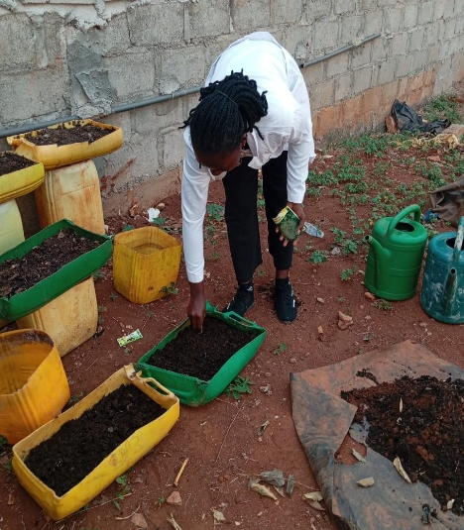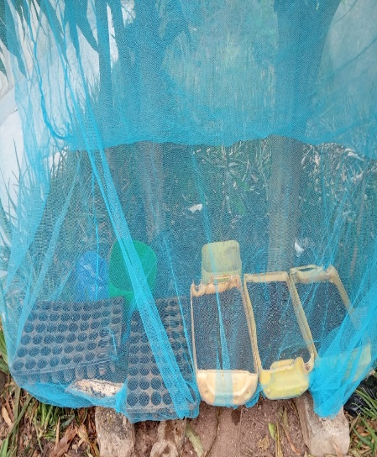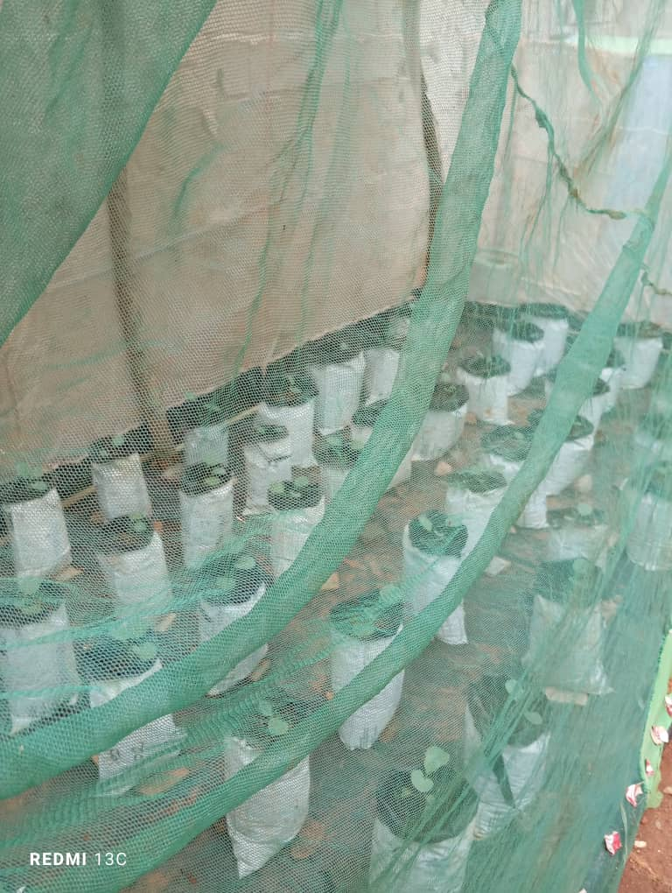
Figure 7 : Establishment of the nursery and transplanting of broccoli
A: Sowing seeds in the nursery; B: Setting up the broccoli nursery; C: Young broccoli seedlings transplanted into growing bags and protected by a net.

2.2.3. Measurement and Observation
2.2.3.1. Data Collection on Broccoli Growth Parameters
The growth monitoring of broccoli plants was carried out on the two central rows of each experimental plot, consisting of 8 plants, following a specific order:
- The height of the broccoli plants, measured with a measuring tape from the ground to the insertion point of the last fully expanded leaf;
- The number of leaves, determined by counting;
- The circumference of the broccoli plants, measured using a caliper;
- The length and width of the leaves were measured using a measuring tape;
- The leaf area index was determined by estimating the total upper surface area of all the leaves of a plant or vegetation stand divided by the ground area covered by that plant or stand.
$$IF= \frac{Sp}{Sa}$$
With:
Sp: upper surface area of all the leaves of a plant.
Ss: ground surface area covered by the plant.

This accelerated plant growth is due to "fertilization" by carbon dioxide (accounting for 70% of leaf growth), followed by increased nitrogen deposition causing eutrophication (9%), climate change (8%), and land-use change (4%) (Zaichun et al., 2016).
In botany and agronomy, specific leaf area (SLA) is defined as the ratio of leaf area to leaf dry mass (expressed in m²·kg⁻¹) (Vile et al., 2005).

2.2.3.2. Data collection related to production parameters
On the selected broccoli plants for growth parameter evaluation, the heads were measured precisely. The length of the heads was recorded using a graduated ruler, while their diameter was determined with a caliper. The heads were weighed on an electronic scale with a precision of 0.01 g to determine their mass. This mass was used to calculate the yield. The yield was calculated using the formula below and expressed in tons per hectare (t/ha).
$$R= \frac{P}{S}$$
With:
P = Production (in tons), S = Cultivated area (in hectares), and R = Yield (t/ha).

2.2.4. Statistical Analysis
The data collected during the experiment were analyzed using STATISTICA 7.1 software. Growth parameters, development, leaf area index, as well as broccoli production parameters were subjected to statistical analyses. The Kruskal-Wallis test was used to evaluate significant differences between treatments, at a 5% significance level.
For a given variable and effect, means sharing the same letter are not significantly different at the 5% level, according to the Kruskal-Wallis test. 0 kg/ha (To) = control without fertilizer application; Ti.di 5g = T1; Ch.od 5g = T2; Ti.di + Ch.od 5g = T3; SAS: Weeks After Sowing.
S = Week. P (k-w) = Significance according to the Kruskal-Wallis test at the 5% level.
Within the same row, means with different letters are significantly different at the 5% level according to the Mann-Whitney test.

3.1 RESULTS
3.1.1 Effect of green biomass of Tithonia diversifolia and Chromolaena odorata on the growth of broccoli plants
3.1.1.1 Plant height
Sowing was done on February 26, 2025; the heights of broccoli plants were recorded weekly (from week 1 to week 8 after sowing). The graph below (Figure 8) illustrates the influence of the different treatments on the height growth of broccoli plants, showing a progressive increase over time and notable differences between treatments. The overall trend of the curves indicates that plant height increased steadily throughout the experimental period. Analysis of variance revealed statistically significant differences between treatments starting from the fourth week (W4). Plants fertilized with Chromolaena odorata (24.7 cm) and those treated with Tithonia diversifolia (24.0 cm) showed the greatest heights until the end of the experiment. The combined treatment Ti.di + Ch.od also promoted growth, reaching 23.6 cm, indicating a positive response, although slightly lower than that observed with Ch.od alone. The unfertilized control plants showed the lowest height values from the start of the trial up to week 8, with a final height of only 9.0 cm.
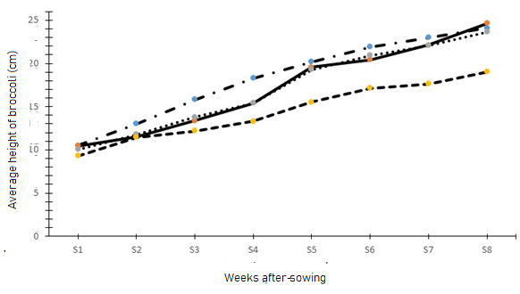
Figure 8: Influence of different treatments on broccoli height growth according to treatments.
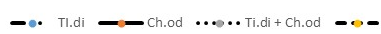
Control

3.1.1.2. Plant Circumference
The evolution of the average circumference of broccoli plants over the eight weeks of monitoring shows clear differences between treatments (Figure 9). The Ti.di treatment induced the greatest growth, reaching an average circumference of about 1.45 cm by the seventh week, followed by a stabilization phase. The Ch.od treatment also promoted growth, but more moderately, with a final value close to 1.25 cm. The combination Ti.di + Ch.od did not show a notable synergistic effect and was limited to an average circumference of about 0.95 cm at the end of the experiment. The control group remained significantly low, with a maximum growth of approximately 0.7 cm.
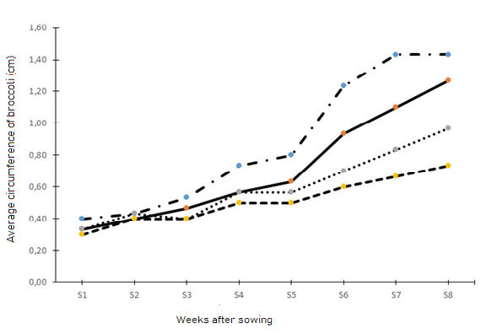
Figure 9: Influence of different treatments on the growth in circumference of broccoli plants according to days after sowing (DAS).
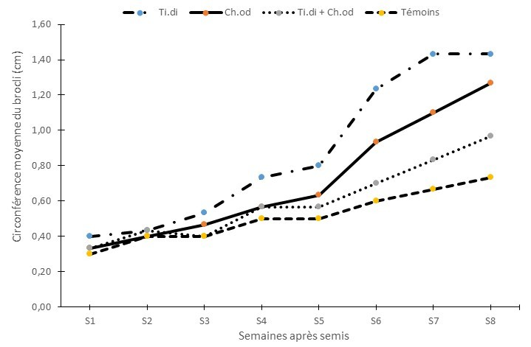
Control

3.1.1.3. Average Number of Broccoli Leaves
The average number of broccoli leaves increased steadily over the eight weeks for all treatments. From the fourth week onward, significant differences appeared between the groups. The Ti.di treatment recorded the highest growth, reaching about 20 leaves by the eighth week. The Ch.od treatment showed a similar trend, with a final leaf count around 19 to 20. The combined Ti.di + Ch.od treatment showed intermediate performance, stabilizing at around 18 leaves at the end of the experiment, without a marked synergistic effect. The control group showed the weakest growth, not exceeding 15 leaves by the eighth week. These results, shown in Figure 10, clearly indicate that the Ti.di and Ch.od treatments, when applied individually, significantly stimulate broccoli leaf production, while their combination does not provide additional benefit compared to individual applications (Figure 10).
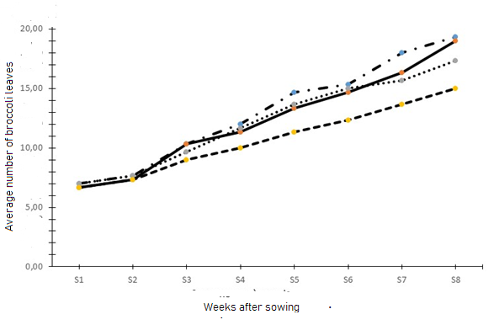
Figure 10: Influence of different treatments on the growth in average number of leaves according to weeks after sowing (WAS).
Control

3.1.1.4. Average Leaf Length
The average leaf length of broccoli progressively increased across all treatments during the eight weeks of observation. From the fourth week onward, noticeable differences emerged between treatments. The Ti.di treatment recorded the highest growth, reaching approximately 25.6 cm by the eighth week. The Ch.od treatment followed a similar trend, with a final average leaf length of about 24.1 cm. The combined Ti.di + Ch.od treatment showed intermediate growth, stabilizing around 23.8 cm at the end of the cycle, without any marked synergistic effect. The control group displayed the lowest values, not exceeding 21.3 cm by the eighth week. These results, shown in Figure 11, confirm that the Ti.di and Ch.od treatments, when applied individually, significantly promote leaf elongation in broccoli, whereas their combination does not yield any notable improvement over the individual applications (Figure 11).
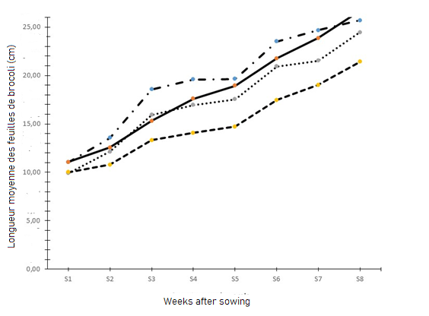
Figure 11: Influence of different treatments on the growth of average broccoli leaf length according to weeks after sowing (WAS).
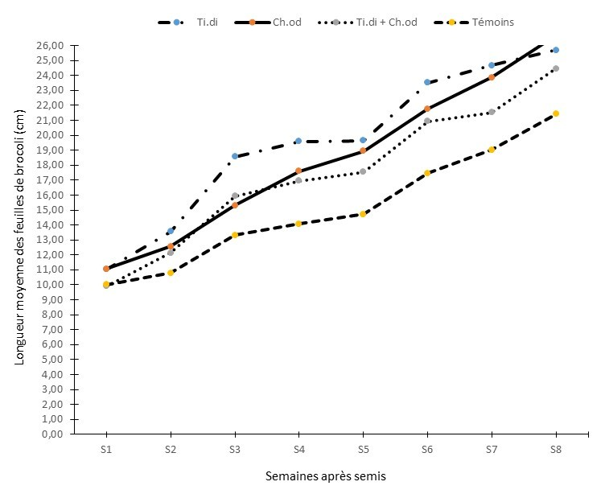
Control

3.1.1.5. Average Leaf Width
The average leaf width of broccoli showed a steady increase across all treatments throughout the eight weeks of the experiment (Figure 12). From the fourth week onward, noticeable differences between treatments became apparent. The Ti.di treatment recorded the highest values, reaching approximately 17.2 cm by the eighth week. The Ch.od treatment followed a similar trend, with an average final width of about 16.8 cm. The combined treatment Ti.di + Ch.od showed an intermediate progression, stabilizing around 16.5 cm by week eight, with no marked synergistic effect. The control group consistently exhibited the lowest values throughout the observation period, increasing from approximately 7.8 cm in the first week to 14.5 cm in the eighth week—about 3 cm less than the Ti.di treatment.
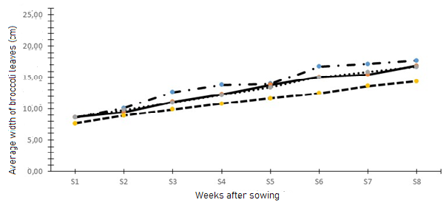
Figure 12: Influence of Different Treatments on the Growth of Average Broccoli Leaf Width Over Time After Sowing (WAS).
Control

3.1.2. Agronomic Performance of Broccoli According to Different Biomass Combinations
3.1.2.1. Effect of *Chromolaena odorata and Tithonia diversifolia on Average Number of Leaves and Leaf Area Index*
Table I shows that the analysis of variance does not reveal any significant difference in the leaf area index between treatments.

Table I: Leaf Area Index of Broccoli According to Treatments
Treatments | Leaf Area Index
Control | 0, 30a
Ti.di | 0,31a
Ch.od | 0,45a
Ti.di + Ch.od | 0,46a
P value | 0,1229
For a given variable and effect, means sharing the same letter are not significantly different at the 5% level, according to the Kruskal-Wallis test.
0 kg/ha (Te) = control without fertilizer application,
Ti.di 5g = T1, Ch.od 5g = T2, Ti.di + Ch.od 5g = T3; SAS: Weeks After Sowing.

3.1.2.2. Effect of biofertilizers on broccoli growth parameters
3.1.2.2.1 Plant height
Table II presents the average height of broccoli plants according to treatments over the weeks. During the study, a progressive increase in broccoli plant height was observed. Analysis of variance showed no significant difference between treatments from week 1 to week 2. However, from the third week onwards, fertilized treatments exhibited significantly greater growth than the control (p < 0.05), with no notable differences between T1, T2, and T3. This trend intensified until the eighth week, where the control remained significantly lower (p = 0.001).

Table II: Evolution of the average height of broccoli plants according to treatments
 |  | Treatments
Measurement time | Ti.di | Ch.od | Ti.di + Ch.od | Controls | p (K-W)
W1 | 10,5 ± 0,30a | 10,4 ± 2,42a | 10,06 ± 1,60a | 9,33 ± 1,20a | 0,61
W2 | 13,00 ± 1,1a | 11,5 ± 2,50a | 11,76 ± 0,75a | 11,46 ± 0,65a | 0,42
W3 | 15,83 ± 0,5b | 13,36 ±1,19b | 13,80 ± 0,59b | 12,20 ± 0,98a | 0,04
W4 | 18,33 ± 0,76b | 15,40 ± 1,40b | 15,40 ± 0,43b | 13,30 ± 0,7a | 0,02
W5 | 20,20 ± 0,30b | 19,56 ± 1,27b | 19,30 ± 0,26b | 15,53 ± 0,85a | 0,04
W6 | 21,90 ± 1,51b | 20,43 ± 1,10b | 20,93 ± 0,64b | 17,13 ± 0,70a | 0,002
W7 | 23,03 ± 1,19b | 22,13 ± 1,05b | 22,06 ± 1,53b | 17,63 ± 0,64a | 0,001
S8 | 24,06 ± 0,6b | 24,63 ± 1,01b | 23,63 ± 1,72b | 19,03 ±1,15a | 0,001

3.1.2.2.2 Plant Circumference
From week 1 (W1) to week 5 (W5), the Kruskal-Wallis test showed no significant difference in plant circumference between treatments (p > 0.05). The values remained low and similar regardless of the treatment. The effect of the fertilizers became evident starting from week 6 (W6) (p = 0.006) and continued at weeks 7 and 8 (W7 and W8) (p = 0.002) (Table III). During this period, T1 showed the largest circumferences (1.43 ± 0.11 cm), followed by T2 and then T3. The control (Te) lagged behind significantly, with a maximum circumference of (0.73 ± 0.05) cm at W8 (Table III).
Table III: Evolution of the average circumference of broccoli plants according to treatments
 |  | Treatments
Measurement time | Ti.di | Ch.od | Ti.di + Ch.od | Controls | p (KW)
W1 | 0,4 ± 00a | 0,33 ± 0,05a | 0,33 ± 05a | 0,3 ± 00a | 0,11
W2 | 0,43 ± 0,5a | 0,40 ± 0,0a | 0,43 ± 0,05a | 0,4 ± 0,00a | 0,53
W3 | 0,53 ± 0,57a | 0,46 ± 0,01a | 0,4 ± 0,00a | 0,4 ± 0,00a | 0,06
W4 | 0,73 ± 0,05a | 0,56 ± 0,11a | 0,56 ± 0,11a | 0,50 ± 0,00a | 0,08
W5 | 0,80 ± 0,00a | 0,63 ± 0,23a | 0,56 ± 0,05a | 0,50 ± 0,00a | 0,12
W6 | 1,23 ± 0,20c | 0,93 ± 0,23bc | 0,7 ± 0,10ab | 0,6 ± 0,00a | 0,006
W7 | 1,43 ± 0,11c | 1,10 ± 0,26b | 0,83 ± 0,15ab | 0,67 ± 0,05a | 0,002
W8 | 1,43 ± 0,11b | 1,27 ± 0,23b | 0,96 ± 0,15ab | 0,73 ± 0,05a | 0,002

3.1.2.2.3 Number of Leaves
Analysis of the average number of broccoli leaves shows that from the first to the fourth week after sowing, no significant differences were observed between treatments (p > 0.05). A divergence appeared at week 5 (p = 0.04) and was confirmed at week 6 (p = 0.04), with a higher number of leaves in the fertilized plots, particularly under T1. At weeks 7 and 8, differences persisted but were no longer statistically significant (Table IV).

Table IV: Evolution of the average circumference of broccoli plants according to treatments
 |  | Treatments
Measurement time | Ti.di | Ch.od | Ti.di + Ch.od | Controls | p (K-W)
W1 | 7,0 ± 10a | 6,66 ± 0,57a | 7,0 ± 00a | 6,66 ± 57a | 0,81
W2 | 7,67 ± 0,57a | 7,33 ± 0,57a | 7,66 ± 0,57a | 7,33 ± 0,57a | 0,47
W3 | 10,33 ± 0,57a | 10,33 ± 1,52a | 9,66 ± 1,52a | 9,00 ± 1,0a | 0,45
W4 | 12,00 ± 0,00a | 11,33 ± 0,57a | 11,66 ± 1,15a | 10,00 ±1,00a | 0,09
W5 | 14,66 ± 1,15b | 13,33 ± 0,57b | 13,66 ± 1,15b | 11,33 ±1,15a | 0,04
W6 | 15,33 ± 0,88b | 14,67 ± 0,33b | 15,00 ± 0,57b | 12,34 ±0,66a | 0,04
W7 | 18,00 ± 3,46a | 16,33 ± 1,15a | 15,66 ± 1,52a | 13,67 ±1,52a | 0,17
W8 | 19,33 ± 3,21a | 19,00 ± 2,64a | 17,33 ± 1,15a | 15,00 ±1,01a | 0,14

3.1.2.2.4 Leaf Length
The average leaf lengths show a tendency to increase over the weeks (Table V). The Kruskal-Wallis test indicates no significant difference between T1, T2, T3, and the control (Te) during the first two weeks (p > 0.05). Differences appear from week 3 (S3) (p = 0.03) and persist thereafter. From S3 to S8, leaves of fertilized plants are significantly longer than those of the control, with a marked advantage for treatments based on T1 and T2. From S6 onwards, the superiority of the treatments becomes particularly evident (p = 0.006 at S6; p = 0.004 at S7; p = 0.002 at S8).

Table V: Evolution of the average leaf length of broccoli plants according to treatments
Measurement time |  | Treatments
Measurement time | Ti.di | Ch.od | Ti.di + Ch.od | Témoins | p (K-W)
W1 | 11,03 ± 1,05a | 11,06 ± 1,89a | 9,9 ±1,3a | 10,0 ± 0,4a | 0,6
W2 | 13,56 ± 0,89a | 12,56 ± 2,29a | 12,13 ±0,85a | 10,8 ± 0,80a | 0,16
W3 | 18,56 ± 1,06c | 15,3 ±2,33bc | 15,93 ± 1,00bc | 13,33 ± 0,40a | 0,03
W4 | 19,60 ±0,36b | 17,60 ±2,35b | 16,97 ± 0,96b | 14,06 ± 0,60a | 0,05
W5 | 19,63 ±1,34b | 18,93 ±1,65b | 17,53 ± 0,55b | 14,73 ± 0,83a | 0,04
W6 | 23,53 ±1,76b | 21,76 ±1,61b | 20,93 ± 0,64b | 17,46 ± 1,70a | 0,006
W7 | 24,67 ± 0,73c | 23,86 ± 1,27c | 21,53 ± 0,05b | 19,03 ± 1,45a | 0,004
W8 | 25,70 ± 1,3b | 26,7 ± 1,3c | 24,47 ± 1,12b | 21,43 ± 0,9c | 0,002

3.1.2.2.5. Leaf Width
From week 1 to week 7, the Kruskal-Wallis test showed no significant difference in average leaf width between treatments (p > 0.05). Values increased steadily, but the three fertilized treatments (T1, T2, T3) remained close to each other and slightly higher than the control. A clear difference appeared only at week 8 (p = 0.02): fertilized broccoli leaves had significantly greater width than the control. Means reached (17.63 ± 1.17) cm for T1, (16.86 ± 0.32) cm for T2, and (16.66 ± 0.57) cm for T3, compared to (14.36 ± 0.83) cm for the control (Table VI).

Table VI: Evolution of the Average Leaf Width of Broccoli According to Treatments
Measurement time |  | Treatments
Measurement time | Ti.di | Ch.od | Ti.di + Ch.od | Controls | p (K-W)
W1 | 8,6 ± 0,87a | 8,63 ± 1,97a | 8,64 ± 1,01a | 7,7 ± 0,43a | 0,49
W2 | 10,13 ± 0,05a | 9,46 ± 1,93a | 9,83 ± 0,58a | 8,9 ± 0,36a | 0,26
W3 | 12,66 ± 0,51a | 11,13 ± 2,41a | 10,96 ± 0,68a | 9,9 ± 0,72a | 0,15
W4 | 13,8 ± 0,60a | 12,30 ± 2,30a | 12,20 ± 0,98a | 10,80 ± 0,40a | 0,12
W5 | 13,96 ± 1,20a | 13,80 ± 1,22 | 13,40 ± 0,52a | 11,67 ± 0,30a | 0,09
W6 | 16,73 ± 2,85a | 15,06 ± 1,73a | 15,03 ± 1,19a | 12,5 ± 0,91a | 0,08
W7 | 17,10 ± 2,38a | 15,46 ± 1,38a | 15,90 ± 0,43a | 13,60 ± 1,01a | 0,1
W8 | 17,63 ± 1,17b | 16,86 ± 0,32b | 16,66 ± 0,57b | 14,36 ± 0,83a | 0,02

3.2. Discussion
The application of green biomass from Tithonia diversifolia and Chromolaena odorata significantly promoted greater plant height compared to the unfertilized control. This trend may be explained by the gradual release of essential nutrients—such as nitrogen, phosphorus, and potassium—which support cell elongation and stem development, thereby enhancing vegetative vigor. Plants treated individually with Tithonia diversifolia or Chromolaena odorata reached the greatest heights. These observations have already been made elsewhere. Indeed, in Zambia, Kaonga et al. (2015) also reported improved height growth in leafy vegetables and cabbages fertilized with these biomasses. Furthermore, the results of Mucheru-Muna et al. (2007) in Kenya on vegetable crops confirm that the application of nitrogen-rich green biomasses enhances vegetative growth, particularly plant height, by enriching the soil with organic matter and nutrients. Our results showed that the combination of Tithonia diversifolia and Chromolaena odorata had a slightly lower effect compared to each fertilizer applied individually. This result indicates the absence of a marked synergistic effect. This outcome is not unique to these two plants. Indeed, some studies, such as those conducted by Osei et al. (2018) in Ghana, have shown that combining multiple biomasses does not systematically produce a synergistic effect, which is consistent with the lack of a pronounced effect observed in our study. These differences may be related to the specific mineralization rate of each biomass, the availability of nutrients over time, as well as local soil and climate conditions. The improvement in plant height observed in our study confirms the agronomic value of these biomasses as organic amendments capable of supporting the vegetative development of broccoli. It also highlights the importance of continuing research over multiple cropping cycles to assess the cumulative effect of organic inputs.
The stem circumference of plants fertilized with green biomass was significantly greater than that of the control, indicating enhanced structural development. This improvement can be attributed to the gradual release of essential nutrients, the enhancement of soil structure, the stimulation of microbial activity, and the formation of the clay-humus complex, which promotes nutrient retention and uptake by the roots. These processes directly contribute to stem thickening and improved plant robustness. These results are similar to those obtained in other studies, such as those by Kaonga et al. (2015), conducted respectively in Zambia, also confirm that the application of green biomasses improves structural growth and the resilience of vegetable crops in poor soils. It is worth noting that the absence of a synergistic effect observed in some cases aligns with the findings of studies conducted in Ghana by Osei et al. (2018). According to these authors, the combination of different biomasses does not necessarily result in an additional increase in stem circumference. These results demonstrate the agronomic value of green biomass as effective organic amendments for enhancing the structural vigor of crops and supporting sustainable agriculture. However, stem growth can be influenced by the initial nutrient availability in the soil, the dry season, and local agroecological conditions, which limits the generalization of the findings. These observations suggest that monitoring over multiple cropping cycles would be useful to better assess the cumulative effect of organic inputs on the structural development of the plants.
The application of green biomass from Tithonia diversiflora and Chromolaena odorata significantly increased the number, length, and width of leaves, indicating better nutrient availability and more efficient photosynthesis. This improvement can be attributed to the gradual release of essential nutrients and the stimulation of microbial activity, which enhances root absorption and leaf development. These effects are typical of slow-release organic amendments that continuously supply the nutrients needed for foliar biomass growth. These results are consistent with those reported by Osei et al. (2018) in Ghana. Indeed, these authors showed that the application of Tithonia diversifolia and Chromolaena odorata increases leaf area and biomass in leafy vegetables and cabbages. Other studies, such as those by Chikowo et al. (2014) in Zimbabwe, confirmed that the incorporation of organic biomass enhances leaf development, photosynthetic capacity, and dry matter production in vegetable crops. The increase in leaf surface area promotes the production of sugars and organic compounds essential for the growth and potential yield of broccoli plants, highlighting the practical value of these biomasses for sustainable organic fertilization. These observations confirm the agronomic and scientific value of green biomass as local nutrient sources and effective organic amendments. However, leaf growth may be influenced by factors such as the duration of the experiment, water availability, climatic conditions, and the initial properties of the soil. These limitations suggest that continuous monitoring throughout the entire cropping cycle is necessary to fully assess the impact of these biomasses on plant productivity and health.
The incorporation of green biomass from Tithonia diversiflora and Chromolaena odorata significantly improved the chemical properties of the soil, notably through the increase of organic matter, cation exchange capacity (CEC), and exchangeable bases (Ca²⁺, Mg²⁺, K⁺), as well as a slight reduction in initial soil acidity. The gradual release of cations during the mineralization of organic residues exerted a buffering effect, enhancing nutrient availability for broccoli plants. These results are similar to those of Bationo et al. (2012) who demonstrated that Tithonia diversifolia enhances cation exchange capacity (CEC) and the availability of nutrients in ferruginous soils in Burkina Faso. Other studies, such as those by Chikowo et al. (2018) in Zimbabwe, showed that local organic biomasses strengthen soil structure and improve the gradual release of essential elements for vegetable crops. The improvement in soil chemical properties observed in this study highlights the relevance of using local biomass to sustainably regenerate soil fertility and optimize crop nutrition. However, initial soil variability, the limited duration of the experiment, and climatic conditions may influence the extent of the observed effects, indicating that longer-term monitoring would be necessary. These results pave the way for further research on the cumulative effect of organic inputs over multiple cropping cycles and their potential impact on the productivity and organoleptic quality of broccoli.

Conclusion
At the end of this study, it is clear that the application of green biomass from Tithonia diversifolia, Chromolaena odorata and their combination significantly improved the growth and yield of broccoli (Brassica oleracea var. italica) in the Haut-Sassandra region (Daloa). Treated plants showed greater heights, stronger stems, an increased number of leaves, and better leaf length and width compared to the control. Among the treatments tested, Tithonia diversifolia produced the best performance, followed by Chromolaena odorata, then their combination. These results are attributed to the gradual release of essential nutrients and the stimulation of microbial activity in the soil, promoting optimal vegetative development and increased inflorescence yield.The use of these biomasses therefore represents an ecological and economical alternative to mineral fertilizers, helping to reduce production costs, limit dependency on chemical inputs, and preserve long-term soil fertility. Beyond agronomic observations, this study highlights the potential of local resources to enhance the sustainability of agricultural systems. It underscores the importance of valuing abundant, nutrient-rich wild plants to support vegetable production and improve food security in the region.

COMPETING INTERESTS DISCLAIMER:
Authors have declared that they have no known competing financial interests OR non-financial interests OR personal relationships that could have appeared to influence the work reported in this paper.

Reference
- Adour P., Koffi E. & N’Guessan K. (2017). Nutritional intake and vegetable consumption in Ivorian cities. Journal of Food and Nutrition Research, 5(4), 112–120.

- Ali S., Farooq M. & Rehman H. (2019). Root and leaf growth dynamics of broccoli under varying soil fertility. Journal of Agronomy and Crop Science, 205(4), 351–360.
- Avenard J.M. (1971). Geomorphological aspects. In: The natural environment of Côte d’Ivoire. ORSTOM Paris Memoir, 50, Paris (France): 7–72.

- Chikowo R., Zingore S., Snapp S. & Johnston A. (2014). Farm typologies, soil fertility variability and nutrient management in smallholder farming in Sub-Saharan Africa. Nutr Cycl Agroecosyst, 100: 1-18.
- Coulibaly M., Traoré S. & Konaté B. (2022). Innovations and diversification in Ivorian agriculture: challenges and perspectives. Revue Ivoirienne d’Agronomie, 15(2), 45–59.
- FAO. (2020). Soil Fertility and Fertilizers in West Africa: Best Practices and Recommendations. Rome: FAO. Technical Guide, 98 p.

- FAO. (2021). Agriculture in Côte d’Ivoire: Statistical Bulletin. Rome: FAO. Report, 112 p.

- Farooq M., Hussain M. & Rehman, H. (2019). Climate stress and management strategies in Brassica vegetables. Horticultural Plant Journal, 5(3), 123–132.

- Groga N., Diomandé M., Beugré, G. A. M., Ouattara Y. & Akaffou D. S. (2018). Comparative study of the quality of the symbiosis (Anabaena azollae, Azolla caroliniana), compost, and NPK on vegetative growth and yield of tomato (Lycopersicon esculentum Mill., Solanaceae) in Daloa (Côte d’Ivoire). Journal of Applied Biosciences, 129, 13004–13014.

- Kaonga C. C., Takeda K. and Sakugawa H. (2015). Diuron, Irgarol 1051, and Fenitrothion contamination in a river passing through an agricultural and urban area in Higashi, Hiroshima City, Japan. Science of the Total Environment, 518–519: 450–458.
- Koffi-Bikpo C.Y. Kra K.S. (2013). The Haut-Sassandra region in the distribution of agricultural food products in Côte d’Ivoire. Revue de géographie tropicale et d’environnement, 9 p.

- Koné B., Kouadio Y. & Traoré S. (2021). Development of market gardening in the Haut-Sassandra region: challenges and perspectives. Revue Ivoirienne d’Agriculture et Environnement, 12(1), 65–78.
- Kouakou B. A., Yao K. A. & Kouassi K. (2022). Dynamics of fungal diseases in tropical market gardening systems. African Journal of Plant Science, 16(4), 98-109.
- Kouakou A. M., Chair H., Dibi K. E. B., Dossa K., Arnau G., Ehounou A. E., Cornet D., (2023). Advancing breeding for climate-resilient yam production in Côte d'Ivoire. Plants People Planet, 1–12.
- Martins A., Silva J. & Pereira R. (2022). Global cultivation and nutritional value of broccoli. International Journal of Vegetable Science, 28(5), 372–385.
- Mucheru-Muna M., Mugendi D., Kung’u J., Mugwe J. and Bationo A., (2007). Effects of organic and mineral fertilizer inputs on maize yield and soil chemical properties in a maize cropping system in Meru South District, Kenya. Agroforest Syst, 69:189 – 197.
- Monde, M.A., Ahouangninou, C., Abdoulaye, D., Kiki, L.D.Y., Massede, S., Tente, B. (2023). Analysis of the foundations of market gardening activity in the Commune of Athiémé (Benin). International Journal of Agriculture, Environment and Food Sciences, 7 (1), 107-116.
- N’guessan A.H., Nguessan K.F., Kouassi K.P., Kouame N.N. & N’guessan P.W. (2014). Population dynamics of the cocoa stem borer, Eulophonotus myrmeleon felder (Lepidoptera: Cosidae) in the Upper Sassandra region of Côte d’Ivoire, 9 P 13.
- Osei T., Danso I., & Amoako E. (2018). Effect of combined application of green manures on growth and yield of cabbage (Brassica oleracea var. capitata). Journal of Agricultural Science and Food Research, 9(3), 1–7.
- Pawlak K. & Kołodziejczak M. (2020). The role of agriculture in ensuring food security in developing countries: considerations in the context of the problem of sustainable food production. Sustainability, 12: 2–20.
- Pretty J., Benton T., Bharucha Z. & Dicks L. (2018). Global assessment of agricultural sustainability. Nature Sustainability, 1, 1–12.
- Vile D., Garnier E., Shipley B., Laurent G., Navas M. L., Roumet C. & Lavorel S. (2005). Specific leaf area and dry matter content estimate thickness in laminar leaves. Annals of Botany, 96(6), 1129–1136.
- Zaichun Zhu, Shilong Piao, Ranga B. Myneni & Mengtian Huang. (2016). “Greening of the Earth and its drivers,” Nature Climate Change, 6(8): 791–795.
- Zro B.G.F., Guéi A.M., Nangah K.Y., Soro D. & Bakayoko S. (2016). Statistical approach to the analysis of the variability and fertility of vegetable soils of Daloa (Côte d’Ivoire). African Journal of Soil Science, 4(4): 328-33.

