Landslide Susceptibility and Rural Vulnerability Assessment in the Gavarud basin, Western Iran

Abstract
Landslides are among the most significant geomorphological hazards in mountainous regions and are influenced by various natural and human-induced factors. These events can cause extensive damage to infrastructure, agricultural lands, and human settlements. Given that the Gavarud basin in western Iran lies within the tectonically active Zagros geological unit, identifying landslide-prone areas and assessing the vulnerability of rural settlements is crucial for risk reduction and proper land-use planning. In this study, a 30-meter SRTM digital elevation model, a 1:100,000 geological map, MODIS satellite imagery, and several spatial thematic layers—including slope, aspect, elevation, distance from faults, rivers, and roads, lithology, and vegetation cover—were used to evaluate landslide susceptibility. The thematic layers were standardized in ArcGIS and weighted using the Analytic Hierarchy Process (AHP) implemented in Expert Choice software. The fuzzy gamma operator was applied to integrate the weighted layers and produce the final susceptibility map. The results indicate that the western and northern parts of the basin exhibit the highest landslide potential. Spatial analysis of rural settlements showed that 52 villages fall within the high-risk zone, 64 villages within the moderate-risk zone, and 186 villages within the low-risk category. The findings provide essential information for risk management, land-use planning, and implementing preventive measures in the Gavarud basin.
Keywords: Landslide, AHP, Fuzzy Gamma, GIS, Gavarud Basin, Rural Vulnerability

1-Introduction
Landslides are among the most significant natural hazards worldwide, causing substantial human, economic, and environmental losses (Guzzetti et al, 2006., Highland & Bobrowsky, 2008., Sui et al, 2022). This phenomenon occurs when soil and rock masses move downward along a slope, typically under the influence of gravitational forces and reduced material strength (Bezerra et al, 2020., Arrogante-Funes et al, 2021., Dai et al, 2025). Landslides can occur suddenly or as slow, gradual movements, and their intensity is influenced by multiple factors. Key natural factors include slope gradient, rock and soil type, geological structures, presence of faults and fractures, vegetation cover, and hydrological conditions (Cruden & Varnes, 1996).
In addition to natural factors, human activities can also increase the likelihood of natural hazards, especially landslides (Negahban et al, 2019., Salari et al, 2020). The increasing population trend and human interventions in the natural environment are among these activities (Salari et al, 2017., Nayyeri et al, 2017., Mohammadkhan et al, 2019., Negahban et al, 2021). Practices such as overexploitation of soil and mineral resources, land-use changes, construction of roads and infrastructure, and vegetation removal can reduce slope stability and create favorable conditions for landslides (Roccati et al, 2021., Yang et al, 2023., Paliaga et al, 2025., Yi et al, 2025). Moreover, climatic changes, heavy rainfall events, increased groundwater levels, and temporary floods may trigger landslide occurrences (Dai et al, 2002., Lin et al, 2024., Wu et al, 2024).
The impacts of landslides are often extensive and multifaceted. Economically, they can damage infrastructure, buildings, roads, and communication networks, and reduce agricultural productivity. Environmentally, landslides can lead to vegetation loss, river course alterations, habitat destruction, and decreased biodiversity (Saleem et al, 2019., Dikshit et al, 2023., Jafari & Khodaei Suárez, 2024., Domínguez-Cuesta, 2024). Socially, landslides pose direct threats to human lives and can result in population displacement and humanitarian crises (Haneberg et al, 2007., Palety, 2012).
Studying and identifying landslide-prone areas is crucial for risk management and mitigation. Modern geomatic tools, such as digital elevation models (DEMs), satellite imagery, geographic information systems (GIS), and fuzzy decision-making models, allow for precise analysis and identification of high-risk areas (Marinos et al, 2019., Psomiadis et al, 2020., Tran et al, 2024., Sadeghi & Javan, 2025., Sajid et al, 2025). Such information serves as a basis for preventive measures, urban and rural planning, natural resource protection, and reduction of landslide-related damages (Van Westen et al, 2008., Alam et al, 2020., Kiani et al, 2021., Segoni & Caleca, 2021., Wang et al, 2021., Abedini et al, 2025., Yousefi et al, 2025). In summary, understanding the contributing factors, identifying susceptible areas, and predicting landslide risks play an essential role in minimizing damages and protecting human life and property. Scientific studies in this field provide critical guidance for management strategies and hazard prevention (Guzzetti et al, 2012., Chen et al, 2022).
Different regions around the world exhibit varying levels of vulnerability to landslides due to differences in natural conditions, including geology, topography, and climate (Ganjaeian, 2020., Gilanipoor et al, 2025). These variations in landslide potential mean that some areas are consistently at higher risk and require careful planning and management to reduce hazards. The Gavarud basin, located within the Zagros mountain range in western Iran, is one such vulnerable area. This region, besides having steep slopes and unfavorable geological conditions, is also tectonically active and subject to earthquakes (Ganjaeian et al, 2024). Therefore, tectonic activity significantly contributes to increasing the probability of landslide occurrences in this basin (Ganjaeian et al, 2021).
The Gavarud basin has a high population density, and a large portion of its area is covered by agricultural lands and orchards. Consequently, landslide events in this area could result in extensive economic and social impacts. The lack of accurate data and scientific analysis of high-risk areas poses challenges to risk management and preventive planning. Many villages and settlements are located near steep slopes, faults, and river channels, which further increases the likelihood of landslide hazards in these locations.
Furthermore, the interaction between natural and human-induced factors complicates the analysis. Human activities, such as land-use changes, road development, and vegetation removal, can exacerbate landslide hazards. On the other hand, natural factors—including steep slopes, weak geological formations, heavy rainfall, floods, and tectonic and seismic activity—also increase landslide susceptibility. Therefore, a comprehensive assessment considering all these factors is essential for risk reduction and preventive planning.
This study aims to identify landslide-prone areas within the Gavarud basin. In addition to mapping high-risk zones, the research evaluates the vulnerability of villages to landslide hazards, providing practical information for managerial decisions and preventive actions. The results can serve as a foundation for designing risk reduction strategies, sustainable resource management, and protection of both the population and infrastructure in the basin.
In conclusion, the main issue addressed in this research is the lack of precise and scientific data on the locations and contributing factors of landslides in the Gavarud basin. The combination of natural characteristics, human activities, and tectonic conditions makes detailed analysis and preventive planning crucial to reducing financial, environmental, and social losses and promoting sustainable development in the region.

2. Study Area
The study area of the present research encompasses the Gaverud drainage basin located in western Iran. Politically, this basin is situated within the boundaries of the Hamadan, Kermanshah, and Kurdistan provinces (Figure 1). According to hydrological classifications, the Gaverud basin is considered one of the significant sub-basins of the Persian Gulf and the Gulf of Oman drainage system. From a morphotectonic perspective, the basin lies within the Zagros structural unit, which results in a substantial portion of its area being covered by mountainous terrains with relatively steep slopes (Ganjaeian et al, 2020). These geomorphological characteristics play a crucial role in shaping the regional drainage patterns, erosion processes, and hydrological dynamics. In terms of elevation, the basin ranges from approximately 1,263 to 3,245 meters above sea level, and its dominant landscape consists of steep hillslopes, rugged topography, and high mountain ridges. Climatically, the region experiences an average annual temperature of about 14°C and an average annual precipitation of nearly 450 mm, indicating a semi-humid to semi-arid climate with predominantly winter precipitation.

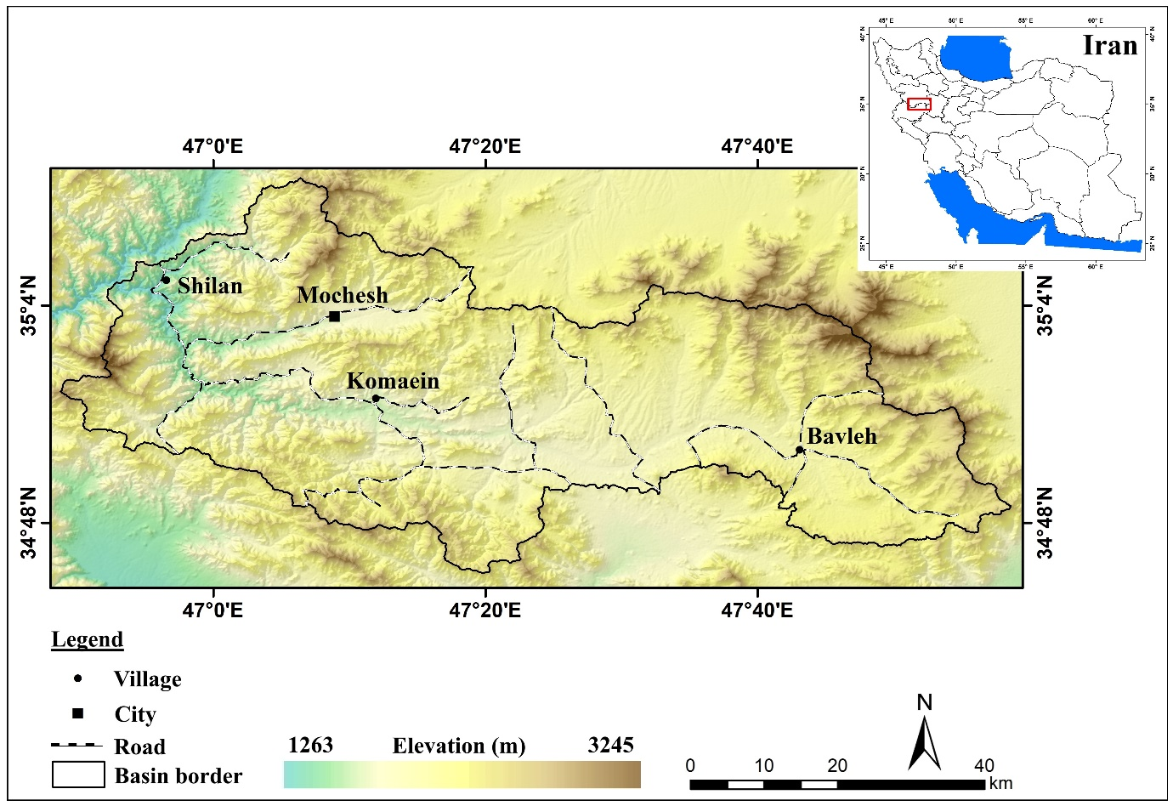
Figure 1. Location map of the study area

3. Materials and methods
MODIS satellite images, and various other informational layers were used as the primary data sources. The main tools employed in this research were ArcGIS and Expert Choice; ArcGIS was used for fuzzification and map preparation, while Expert Choice was applied for weighting the parameters and informational layers. Considering the objectives of the study, the research was conducted in several main stages, which are described below.
Stage 1: Preparation of Information Layers: Based on literature reviews and expert opinions, eight influential parameters were selected to identify landslide-prone areas. The informational layers corresponding to each parameter were then prepared. For generating layers of elevation, slope, slope aspect, and rivers, the 30-meter SRTM DEM was used. Lithology and fault layers were derived from the 1:100,000 geological map. Road and transportation network layers were extracted using Google Earth imagery, and vegetation density was obtained using MODIS images and the capabilities of Google Earth Engine (Zahabnazouri et al, 2025).
Stage 2: Standardization of Information Layers: In this stage, all layers were standardized using ArcGIS. Areas prone to landslides were assigned values close to 1, while areas with low susceptibility were assigned values close to 0. For example, regions with high elevation and slope, north-facing aspects, proximity to rivers and roads, faults, weak lithology, and low vegetation density were given values close to 1, whereas areas with low elevation and slope, south-facing aspects, distant from rivers and roads, resistant lithology, and dense vegetation were assigned values close to 0.
Stage 3: Weighting of Information Layers: Since the importance of the layers is not equal, the weight of each layer was determined based on expert opinions using Expert Choice and the Analytic Hierarchy Process (AHP). In this method, layers were compared in pairs, and the final weight of each layer was calculated.
Stage 4: Preparation of the Final Map and Result Analysis: After standardization and weighting, the layers were integrated using the fuzzy gamma operator to produce the final landslide susceptibility map. Following the preparation of this map, the vulnerability of villages against landslide hazards was evaluated, and the distribution of villages across different vulnerability classes was analyzed.
4. Results and discussion
4.1. Description of the Parameters Used
In this study, eight influential parameters including elevation, slope, slope aspect, distance from rivers, distance from faults, lithology, vegetation density, and distance from roads were used to identify and classify landslide-prone areas in the Gavarud basin Each of these parameters was analyzed individually and then standardized for integration in the final landslide susceptibility map. The following sections describe each parameter in detail.
1) Elevation: Elevation is one of the key factors affecting the occurrence of landslides. Generally, high-elevation areas are more susceptible due to higher rainfall, increased moisture, steeper slopes, and greater erosion intensity (Pireh & Ganjaeian, 2024). Examination of the Gavarud basin indicates that its northern parts have the highest elevations and, consequently, greater landslide potential. To standardize the elevation layer, higher elevations were assigned values close to one, while lower elevations received values close to zero, reflecting their relative sensitivity within the model (Figure 2).

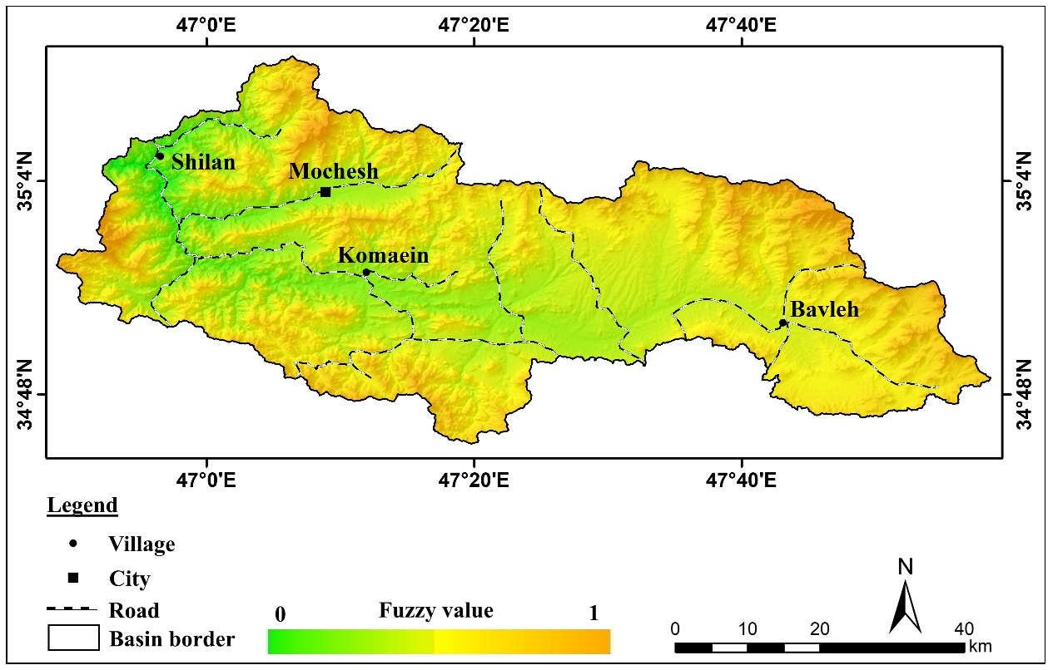
Figure 2. Standardized elevation layer of the study area

2) Slope: Slope is among the most critical factors determining the likelihood of mass movements. Increasing slope gradient generally leads to reduced slope stability and therefore increases the probability of landslides (Ganjaeian et al, 2021). In the study area, regions with steeper slopes face a higher risk. For the standardization process, high-slope classes were assigned values close to one, while low-slope classes received values close to zero, ensuring accurate representation of this parameter’s influence on the final analysis (Figure 3).

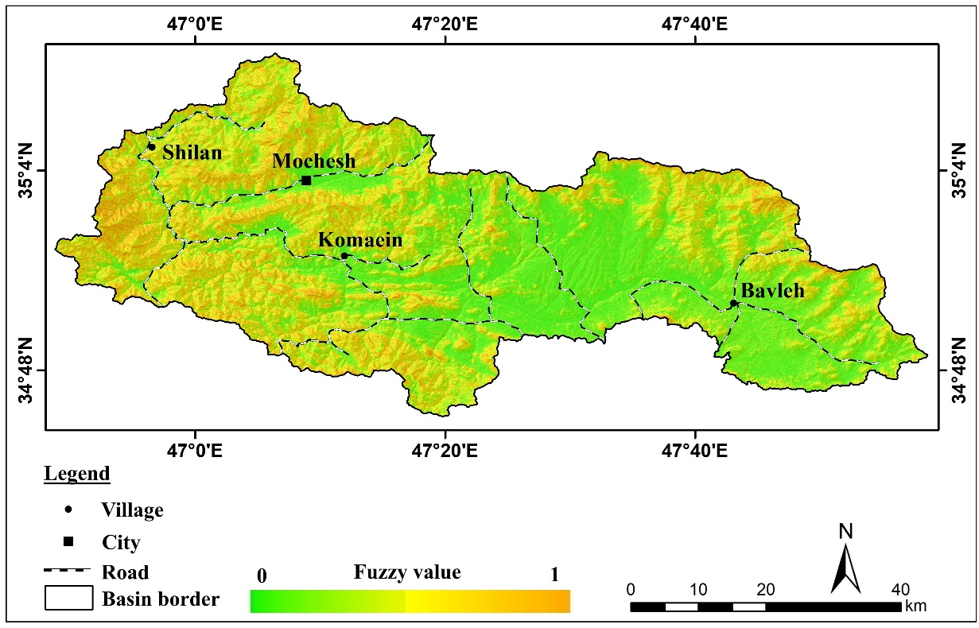
Figure 3. Standardized slope layer of the study area

3) Aspect: Slope aspect is an important parameter influencing the amount of solar energy received by a surface. In general, north-facing slopes receive less solar radiation and therefore tend to have higher moisture content, denser vegetation, and intensified weathering, all of which contribute to reduced slope stability and an increased likelihood of landslides. Accordingly, in the standardization process, north-facing aspects were assigned values close to one, while other aspects received lower values (Figure 4).

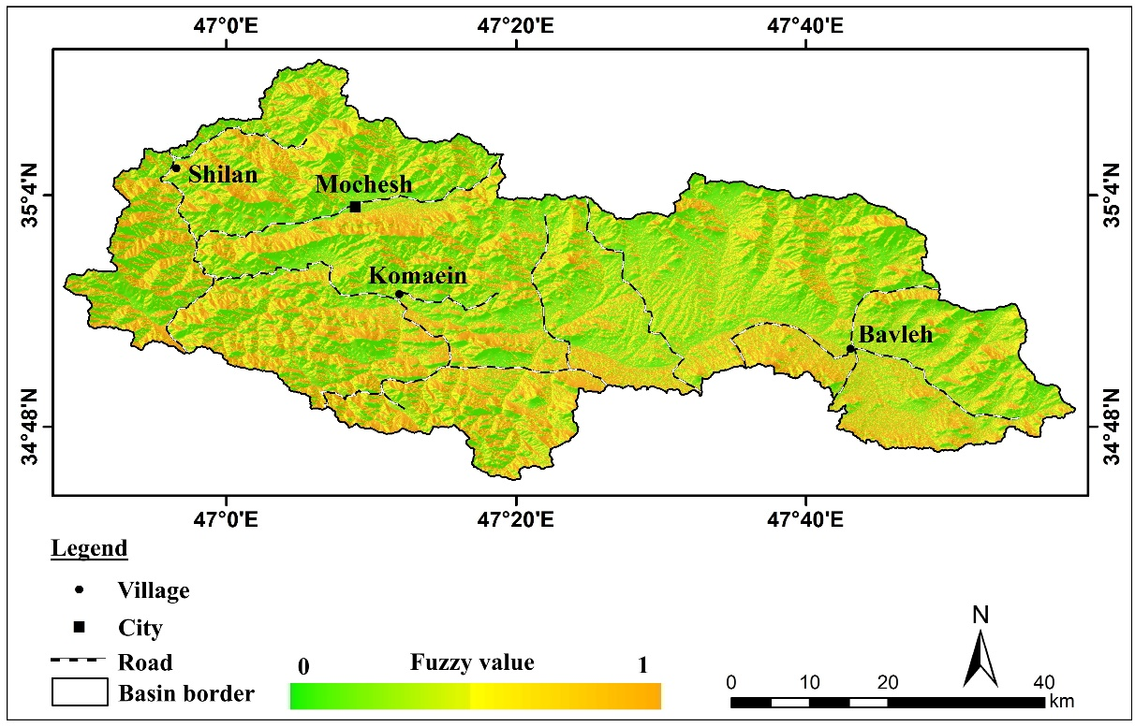
Figure 4. Standardized slope aspect layer of the study area

4) Distance from River: Rivers play a crucial geomorphological role by contributing to erosion, undercutting of slope bases, and the reduction of slope stability (Ganjaeian et al, 2025). Proximity to rivers generally increases landslide susceptibility due to continuous erosion and destabilization of adjacent slopes. Therefore, in the standardization of this layer, areas closest to the rivers were assigned values close to one, while more distant areas received lower values (Figure 5).

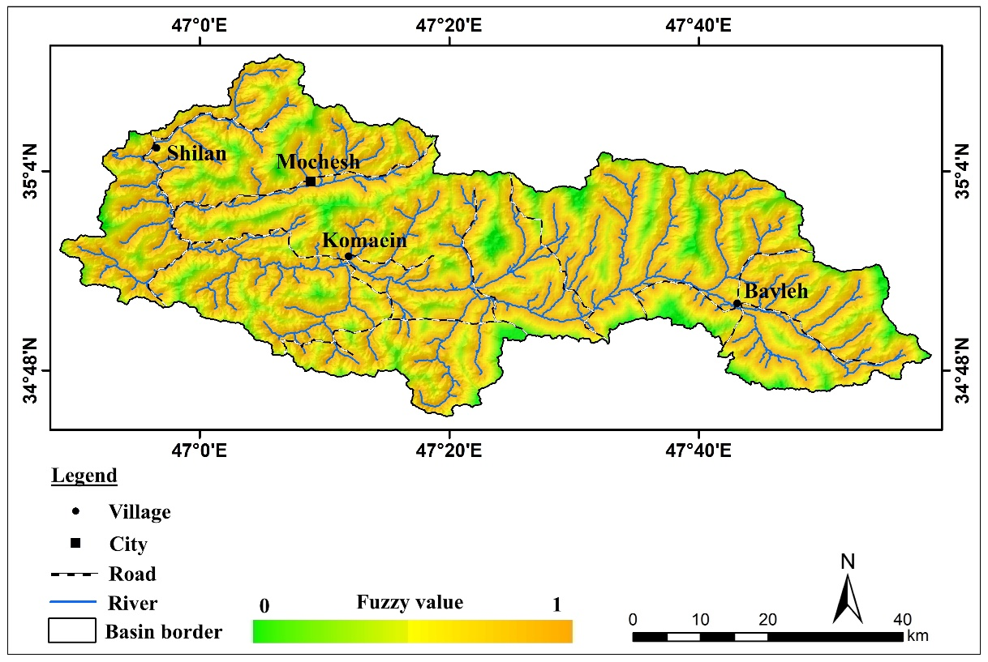
Figure 5. Standardized river-distance layer of the study area

5) Distance from Fault: Faults create fractures, joints, and structural discontinuities that significantly weaken rock and soil masses. Areas near fault lines usually exhibit greater permeability, intensified weathering, and decreased structural integrity, making them more susceptible to landslides. Based on this, the standardization process assigned values close to one to areas nearest the faults, with decreasing values for greater distances (Figure 6).

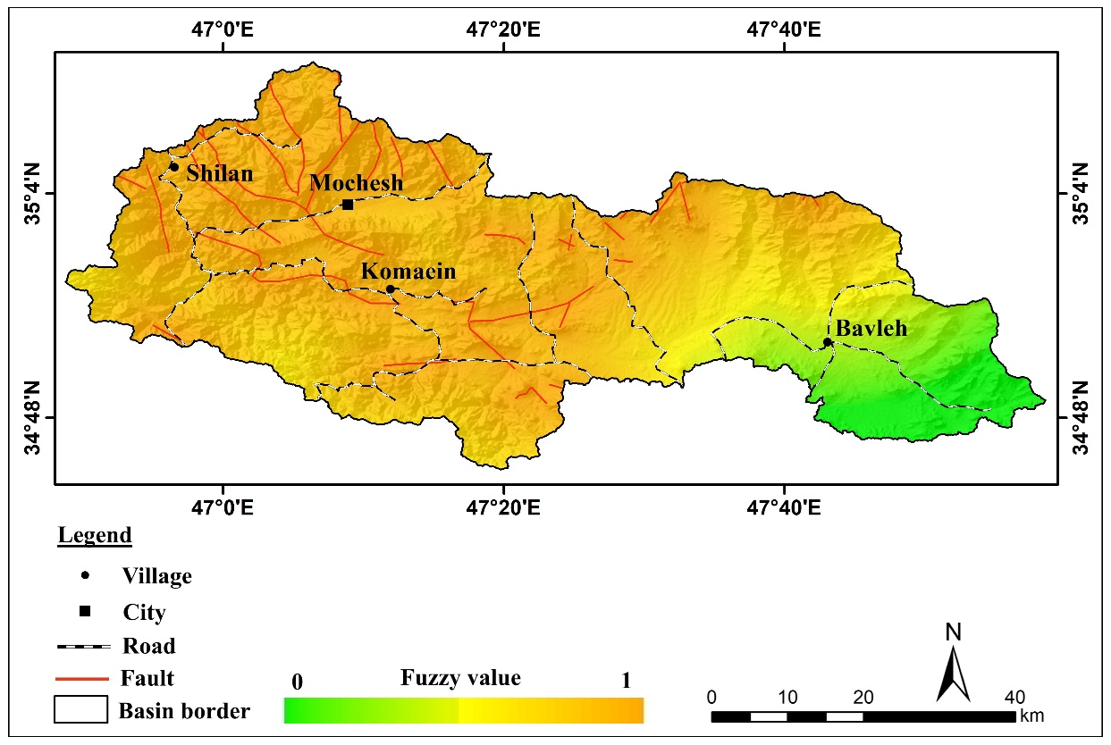
Figure 6. Standardized fault-distance layer of the study area

6) Lithology: Lithology is one of the most influential parameters in determining landslide susceptibility, as the geological composition of each unit controls its strength, permeability, weathering rate, and mechanical stability. Typically, resistant rock units such as andesite and basalt exhibit lower susceptibility due to their high strength, whereas unconsolidated and weak materials—such as alluvial deposits—tend to have a significantly higher potential for landslides. Accordingly, in the standardization process, andesitic and basaltic units were assigned values close to zero (indicating lower susceptibility), while alluvial units were assigned values close to one (indicating higher susceptibility) (Figure 7).

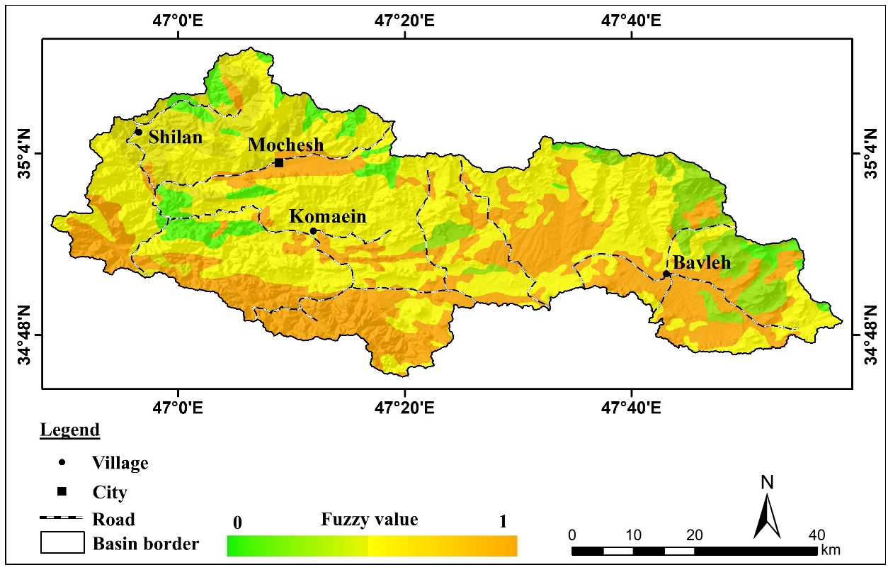
Figure 7. Standardized lithology layer of the study area

7) Vegetation Density: Vegetation cover is a key factor in slope stabilization, erosion reduction, and increasing soil cohesion. Slopes with higher vegetation density generally face a lower risk of landslides due to enhanced soil binding and reduced surface runoff. In this study, vegetation density was mapped using Google Earth Engine and satellite imagery from MODIS. The results showed that the central parts of the basin have the highest vegetation density. Since these areas exhibit lower landslide susceptibility, values close to zero were assigned to them during the standardization process (Figure 8).
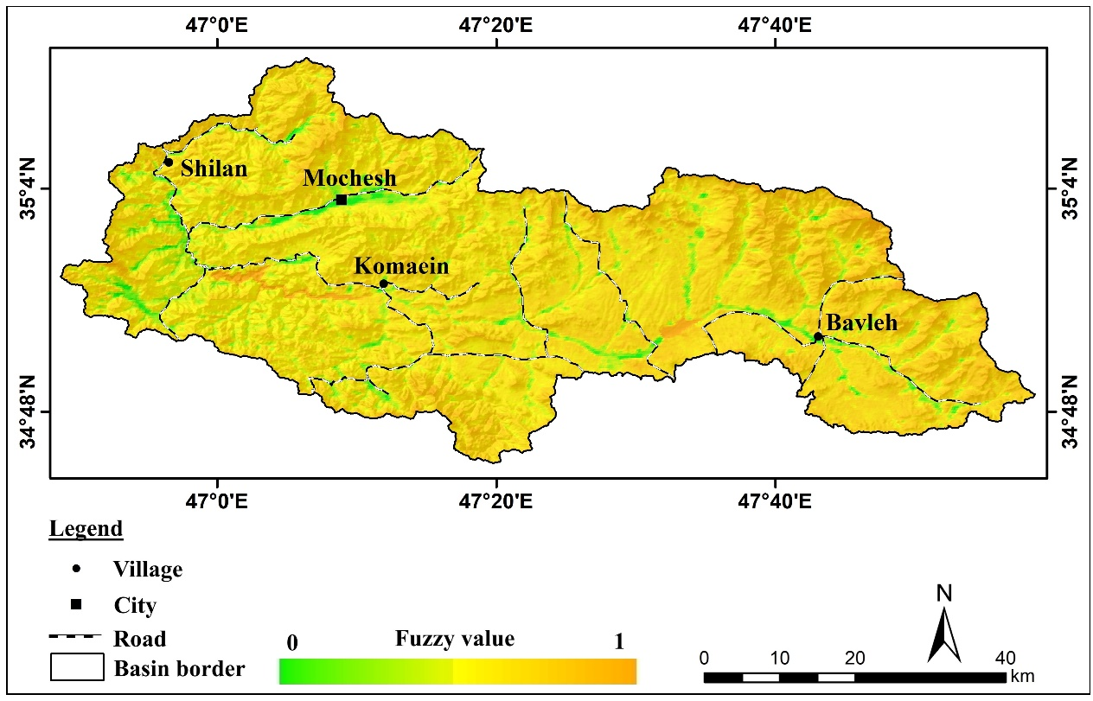
Figure 8. Standardized vegetation density layer of the study area

8) Distance from Road: Transportation networks are another important factor influencing landslide occurrence. Road construction often results in slope undercutting, disturbance of natural equilibrium, increased water infiltration, and alteration of drainage patterns, all of which contribute to slope instability. Based on this understanding, in the standardization process, areas closest to the roads were assigned values close to one, while more distant areas received lower values (Figure 9).

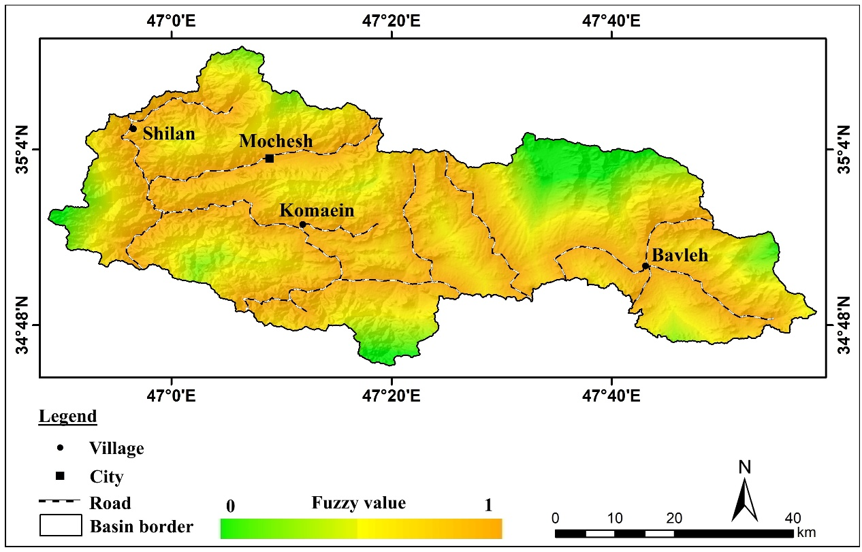
Figure 9. Standardized road-distance layer of the study area

4.2. Weighting of Parameters
In this study, the Analytical Hierarchy Process (AHP), combined with expert judgment, was employed to determine the relative importance of the parameters influencing landslide occurrence. The results of the weighting process indicate that slope, with a weight of 0.212, has the highest influence on landslide susceptibility—an outcome that aligns with the geomorphological characteristics of the area and the inherent instability of steep terrains. Following slope, distance from rivers (weight: 0.178) and distance from roads (weight: 0.150) rank second and third in importance. These findings highlight the significant role of river erosion and the impact of human activities—particularly road construction—in reducing slope stability (Table 1).

Table 1. Final weights of the parameters based on the AHP model
Row | Parameter | Weight
1 | Elevation | 0.106
2 | Slope | 0.212
3 | Aspect | 0.063
4 | Distance from River | 0.178
5 | Distance from Fault | 0.075
6 | Lithology | 0.126
7 | Vegetation Density | 0.089
8 | Distance from Road | 0.150

4.3. Integration of Information Layers and Identification of Landslide-Prone Areas
After standardizing the information layers and assigning appropriate weights to each layer, the various layers were combined using the fuzzy gamma operator to produce the final landslide susceptibility map for the study area (Figure 10). The combination of layers using the fuzzy gamma method allows for consideration of the nonlinear interactions among factors influencing landslides, thereby improving the accuracy of the final map. According to the resulting map, the western and northern parts of the Gavarud basin exhibit the highest potential for landslide occurrence. These results indicate a concentration of landslide-promoting factors such as high elevation, steep slopes, low vegetation cover, high fault density, and the presence of transportation networks in these areas.

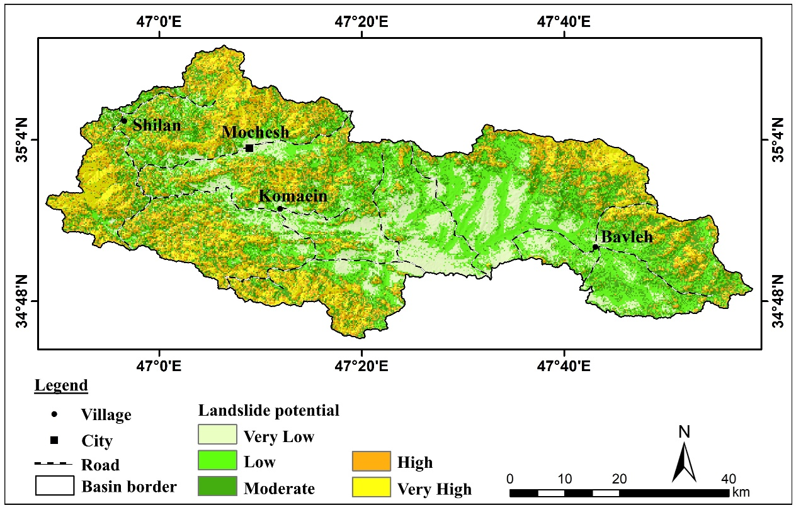
Figure 10: Landslide susceptibility map of the Gavarud basin

The assessment of the area and percentage of different susceptibility classes shows that approximately 900 km² of the study area, equivalent to 31.8% of the total basin area, is mainly located in the western and northern parts and has a high potential for landslides due to topographic and geological conditions. In contrast, about 1,255 km² of the basin, representing 44.4% of the total area, is mostly located in the central regions and exhibits a low potential for landslide occurrence (Table 2 and Figure 11). These analyses provide valuable information for hazard management and regional planning and can serve as a basis for preventive measures and risk reduction strategies in the Gavarud basin.

Table 2: Area and percentage of each susceptibility class
Row | Class | Area (km²) | Percent area
1 | Very Low | 425 | 15
2 | Low | 830 | 29.3
3 | Moderate | 673 | 23.8
4 | High | 385 | 13.6
5 | Very High | 516 | 18.2
6 | Total | 2928 | 100

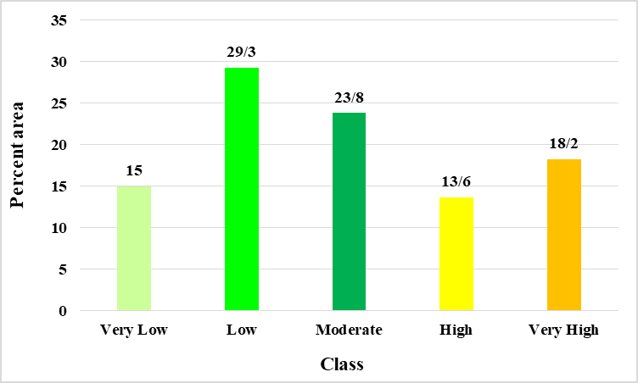
Figure 11: Percentage area diagram of susceptibility classes

After assessing the landslide susceptibility of the study area, this section focuses on evaluating the vulnerability of villages within the region. For this purpose, the landslide susceptibility map was categorized into three vulnerability classes: low, medium, and high. The distribution of village locations across these classes was then analyzed (Figure 12). According to the results, 186 villages, accounting for 61.6% of the total villages in the basin, fall into the low vulnerability class and are relatively located in safer areas in terms of landslide risk. Additionally, 64 villages, representing 21.2% of the basin's villages, belong to the medium vulnerability class and require limited preventive measures. Furthermore, 52 villages, equivalent to 17.2% of the villages, are in the high vulnerability class and, due to their location in high-risk areas, require immediate preventive and management interventions (Table 3). These analyses can assist planners and local authorities in prioritizing risk reduction measures for villages and implementing effective preventive actions in high-risk areas.

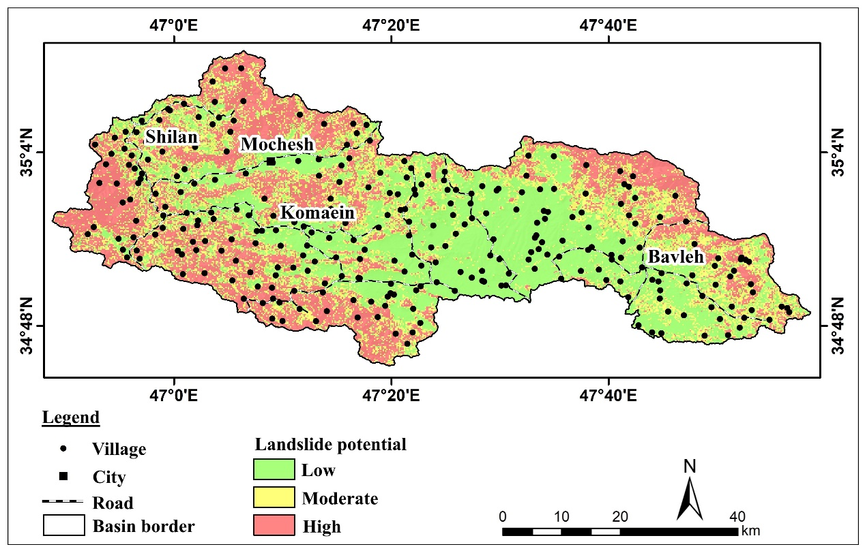
Figure 12: Distribution map of villages based on vulnerability classes

Table 3: Number and percentage of villages in each landslide vulnerability class
Class | Low | Moderate | High
Number of villages | 186 | 64 | 52
Percentage of villages | 61.6 | 21.2 | 17.2

5. Conclusion
Based on the analyses conducted in the Gavarud basin, it can be concluded that the western and northern parts of the basin have the highest landslide susceptibility, which is closely related to topographic conditions such as steep slopes, high elevation, low vegetation cover, and high density of faults and transportation networks. Assessment of the area and percentage of different susceptibility classes showed that approximately 31.8% of the basin falls into the high landslide potential category, while the majority of the area exhibits low to medium susceptibility. Evaluation of village vulnerability indicated that 17.2% of the villages are located in high-risk areas and require immediate preventive measures. The results of this study provide a valuable tool for landslide risk management, regional planning, and prioritization of mitigation measures, serving as a scientific basis for managerial and protective decision-making within the basin. To reduce landslide risk in the Gavarud basin, it is recommended to implement preventive measures including slope stabilization and vegetation enhancement in susceptible areas, establish early warning systems, and strengthen monitoring networks in high-potential zones; additionally, urban and rural planning should limit development in high-risk areas and encourage construction in safer locations; educating and informing residents of vulnerable villages about safe behavior during emergencies and protective measures is also crucial; constructing alternative routes and reinforcing critical infrastructure, along with implementing soil engineering and surface water control projects, can mitigate landslide impacts; finally, it is advised that risk management policies and programs be continuously reviewed and updated to adapt to climatic changes and evolving geological conditions, ensuring long-term resilience and protection of communities and infrastructure in the basin.

Reference
- Abedini, M., Pirouzi, E., & Aghayary, L. (2025). Investigating and identifying areas prone to landslides in the Nobaran Basin of Markazi Province. Quantitative Geomorphological Research, 14(1), 177-195. https://doi.org/10.22034/gmpj.2025.491670.1538
- Alam, E. (2020). Landslide Hazard Knowledge, Risk Perception and Preparedness in Southeast Bangladesh. Sustainability, 12(16), 6305. https://doi.org/10.3390/su12166305
- Arrogante-Funes, P., Bruzón, A. G., Arrogante-Funes, F., Cantero, A. M., Álvarez-Ripado, A., Vázquez-Jiménez, R., & Ramos-Bernal, R. N. (2022). Ecosystem Services Assessment for Their Integration in the Analysis of Landslide Risk. Applied Sciences, 12(23), 12173. https://doi.org/10.3390/app122312173
- Arrogante-Funes, P., Bruzón, A. G., Arrogante-Funes, F., Ramos-Bernal, R. N., & Vázquez-Jiménez, R. (2021). Integration of Vulnerability and Hazard Factors for Landslide Risk Assessment. International Journal of Environmental Research and Public Health, 18(22), 11987. https://doi.org/10.3390/ijerph182211987
- Bezerra, L., Neto, O. d. F., Santos, O., Jr., & Mickovski, S. (2020). Landslide Risk Mapping in an Urban Area of the City of Natal, Brazil. Sustainability, 12(22), 9601. https://doi.org/10.3390/su12229601
- Chen, Y., He, X., Xu, C., Huang, Y., Zhang, P., Luo, Z., & Zhan, T. (2022). Development Characteristics and Causes of a Fatal Landslide Occurred in Shuicheng, Guizhou Province, China. ISPRS International Journal of Geo-Information, 11(2), 119. https://doi.org/10.3390/ijgi11020119
- Cruden, D. M., & Varnes, D. J. (1996). Landslide types and processes. In A. K. Turner & R. L. Schuster (Eds.), Landslides: Investigation and Mitigation (pp. 36–75). National Research Council. https://onlinepubs.trb.org/Onlinepubs/sr/sr247/sr247.pdf.
- Dai, F. C., Lee, C. F., & Ngai, Y. Y. (2002). Landslide risk assessment and management: An overview. Engineering Geology, 64(1), 65–87. https://doi.org/10.1016/S0013-7952(01)00093-X
- Dai, X., Chen, J., Zhang, T., & Xue, C. (2025). Integrated Landslide Risk Assessment via a Landslide Susceptibility Model Based on Intelligent Optimization Algorithms. Remote Sensing, 17(3), 545. https://doi.org/10.3390/rs17030545
- Dikshit, A., Sarkar, R., Pradhan, B., Acharya, S., & Alamri, A. M. (2020). Spatial Landslide Risk Assessment at Phuentsholing, Bhutan. Geosciences, 10(4), 131. https://doi.org/10.3390/geosciences10040131
- Ganjaeian, H. (2020). Geomorphological hazards of urban areas, study methods and control strategies. Entekhab Publication. https://www.gisoom.com/book/11628118
- Ganjaeian, H., Hosseini, S. J., Azeredo, G. A., Ebrahimi, A., Shahjamali, M., & Akbarian, M. (2025). Assessment of the physical development trends of residential areas in natural hazard-prone regions of Kurdistan Province, Western Iran. Journal of Geography, Environment and Earth Science International, 29(11), 220–239. https://doi.org/10.9734/jgeesi/2025/v29i11977
- Ganjaeian, H., Hosseini, S. J., Hamidi Kermanshahi, H., Shahjamali, M., Mirakhorli, A., & Zahabnazouri, S. (2025). Geospatial assessment of suitable areas for residential development along the Makran coastal strip, Southern Iran. Asian Journal of Geographical Research, 8(4), 247–264. https://doi.org/10.9734/ajgr/2025/v8i4333
- Ganjaeian, H., Nosrati, M., Ebrahimi, A., & Ghisarian, S. S. (2025). Assessing the vulnerability of villages in mountainous areas to natural hazards (Case study: Villages of Oraman region). Journal of Environmental Research in Mountainous Regions, 1(2), 57–70. https://doi.org/10.22034/ermr.2024.63510
- Ganjaeian, H., Rezaei Arefi, M., Peysoozi, T., & Emami, K. (2021). Zonning susceptible areas of landslide using WLC and OWA methods -A case study in Mountain cliff Khan, Iran. Sustainable Earth Trends, 1(2), 35–43. https://doi.org/10.52547/sustainearth.1.2.43
- Ganjaeian, H., Yamani, M., Goorabi, A., & Maghsoudi, M. (2020). Analyzing tangible and intangible effects of Kermanshah Ezgeleh earthquake on landforms. Geography and Environmental Sustainability, 10(2), 89–103. https://doi.org/10.22126/ges.2020.5571.2274
- Ganjaeian, H., Yamani, M., Goorabi, A., & Maghsoudi, M. (2021). Adaptation of morphotectonic indices with seismic centers in Zagros Northwest (Sirvan and Qarahsu Basins). Geography and Environmental Planning. https://doi.org/10.22108/gep.2021.124247.1335
- Gilanipoor, A., Motevalli, S., & Derafshi, K. (2025). Assessment of landslide sensitivity and determination of effective factors in its occurrence using the random forest algorithm (Case study: Glandrood watershed). Journal of Geography and Environmental Hazards, 14(1), 247-274. https://doi.org/10.22067/geoeh.2025.89542.1514
- Guzzetti, F., Galli, M., Reichenbach, P., Ardizzone, F., & Cardinali, M. (2006). Landslide hazard assessment in the Collazzone area, Umbria, Central Italy. Natural Hazards and Earth System Sciences, 6, 115–131. https://doi.org/10.5194/nhess-6-115-2006
- Guzzetti, F., Mondini, A. C., Cardinali, M., Fiorucci, F., Santangelo, M., & Chang, K. T. (2012). Landslide inventory maps: New tools for an old problem. Earth-Science Reviews, 112(1–2), 42–66. https://doi.org/10.1016/j.earscirev.2012.02.001
- Haneberg, W. C. (2007). Landslides: Processes, Prediction, and Land Use. Environmental & Engineering Geoscience, 13(1). https://doi.org/10.2113/gseegeosci.13.1.90
- Highland, L. M., & Bobrowsky, P. (2008). The landslide handbook—A guide to understanding landslides. U.S. Geological Survey. https://doi.org/10.3133/cir1325
- Jafari, G. H., & Khodaei, R. (2024). Zoning Land Surfaces of Shahroud Basin against the Occurrence of Landslides Using the Shannon Model. Journal of Geography and Environmental Hazards. https://doi.org/10.22067/geoeh.2022.75401.1183
- Kiani, S., Karimkhani, A., & Mazidi, A. (2021). Landslide Risk Zoning using Logistic Regression and Anfis Models in Hashtjin Catchment Area in Ardabil Province. Geography and Environmental Sustainability, 11(2), 55-73. https://doi.org/10.22126/ges.2021.6461.2391
- Lin, S., Chen, S.-E., Tang, W., Chavan, V., Shanmugam, N., Allan, C., & Diemer, J. (2024). Landslide Risks to Bridges in Valleys in North Carolina. GeoHazards, 5(1), 286-309. https://doi.org/10.3390/geohazards5010015
- Marinos, V., Stoumpos, G., & Papazachos, C. (2019). Landslide Hazard and Risk Assessment for a Natural Gas Pipeline Project: The Case of the Trans Adriatic Pipeline, Albania Section. Geosciences, 9(2), 61. https://doi.org/10.3390/geosciences9020061
- Mohammadkhan, S., Ganjaeian, H., Shahri, S., & Abbaszade, A. (2019). Predicting the trend of urban development toward hazardous areas using multi-temporal images (Case study: Marivan City). Scientific-Research Quarterly of Geographical Data (SEPEHR), 28(110), 107–117. https://doi.org/10.22131/sepehr.2019.36615
- Nayyeri, H., Salari, M., Ganjaeian, H., & Amani, K. (2017). Geomorphological assessment of land suitability for the physical expansion of Sanandaj city applying restricted areas. Geographical Urban Planning Research (GUPR), 5(1), 127–145. https://doi.org/10.22059/jurbangeo.2017.63213
- Negahban, S., Ganjaeian, H., Ebrahimi, A., & Emami, K. (2019). Monitoring and predicting the trend of changes in residential areas using multi-timed images (Case study: Songhor city). Journal of the Earth and Space Physics, 45(2), 343–354. https://doi.org/10.22059/jesphys.2019.275076.1007084
- Negahban, S., Ganjaeiyan, H., Feraydooni Kordestani, M., & Cheshmeh Sefidi, Z. (2019). Assessing the physical development of cities and extending to geomorphological prohibited areas Using LCM (Case Study: Sanandaj City). Journal of Natural Environmental Hazards, 8(20), 39–52. https://doi.org/10.22111/jneh.2018.21943.1317
- Negahban, S., Peysoozi, T., Ganjaeian, H., & Norozi, M. (2021). Identifying areas prone to landslide and vertical displacement using radar images (Case study: Lavasan urban area and urban margin). Journal of Geography and Environmental Hazards, 10(3), 1–18. https://doi.org/10.22067/geoeh.2021.71728.1094
- Paliaga, G., Terrone, M., Bazzurro, N., Marchese, A., & Faccini, F. (2025). Rainfall-Induced Shallow Landslide Susceptibility for Risk Management of Underground Services in a Mediterranean Metropolitan City. Land, 14(11), 2118. https://doi.org/10.3390/land14112118
- Petley, D. N. (2012). Global patterns of loss of life from landslides. Geology, 40(10), 927–930. https://doi.org/10.1130/G33217.1
- Pireh, M., & Ganjaeian, H. (2025). Analysis of landslides occurred in connection with environmental factors (Case study: Sanandaj County). Geography and Human Relationships, 7(3), 262–278. https://doi.org/10.22034/gahr.2025.458065.2135
- Psomiadis, E., Charizopoulos, N., Efthimiou, N., Soulis, K. X., & Charalampopoulos, I. (2020). Earth Observation and GIS-Based Analysis for Landslide Susceptibility and Risk Assessment. ISPRS International Journal of Geo-Information, 9(9), 552. https://doi.org/10.3390/ijgi9090552
- Roccati, A., Paliaga, G., Luino, F., Faccini, F., & Turconi, L. (2021). GIS-Based Landslide Susceptibility Mapping for Land Use Planning and Risk Assessment. Land. https://doi.org/10.3390/land10020162
- Sadeghi, H., & Javan, F. (2025). Vulnerability of Iranian tourism villages in terms of Landslide hazard using GIS. Geography, 23(84), 153-170. https://doi.org/10.22034/jiga.2025.2055364.1385
- Sajid, T., Maimoon, S. K., Waseem, M., Ahmed, S., Khan, M. A., Tränckner, J., Pasha, G. A., Hamidifar, H., & Skoulikaris, C. (2025). Integrated Risk Assessment of Floods and Landslides in Kohistan, Pakistan. Sustainability, 17(8), 3331. https://doi.org/10.3390/su17083331
- Salari, M., Nayeri, H., Amani, K., & Ganjaeian, H. (2017). Locating suitable directions for Kamyaran urban development through a hazardology approach based on the application of geomorphologically restricted areas. Environmental Management Hazards. https://doi.org/10.22059/jhsci.2018.252694.341
- Salari, M., Nayyeri, H., Ganjaeian, H., & Amani, K. (2020). Assessment and Prediction of the process of expansion of residential areas with Geomorphological Approach and Environmental Management (Case Study: Paveh City). Quantitative Geomorphological Research, 9(1), 86–101. https://doi.org/10.22034/gmpj.2020.109536
- Saleem, N., Huq, M. E., Twumasi, N. Y. D., Javed, A., & Sajjad, A. (2019). Parameters Derived from and/or Used with Digital Elevation Models (DEMs) for Landslide Susceptibility Mapping and Landslide Risk Assessment: A Review. ISPRS International Journal of Geo-Information. https://doi.org/10.3390/ijgi8120545
- Segoni, S., & Caleca, F. (2021). Definition of Environmental Indicators for a Fast Estimation of Landslide Risk at National Scale. Land, 10(6), 621. https://doi.org/10.3390/land10060621
- Suárez, G., & Domínguez-Cuesta, M. J. (2024). Physical Vulnerability and Landslide Risk Assessment in Tegucigalpa City, Honduras. Applied Sciences, 14(19), 9114. https://doi.org/10.3390/app14199114
- Sui, H., Su, T., Hu, R., Wang, D., & Zheng, Z. (2022). Study on the Risk Assessment Method of Rainfall Landslide. Water, 14(22), 3678. https://doi.org/10.3390/w14223678
- Tran, T. X., Liu, S., Ha, H., Bui, Q. D., Nguyen, L. Q., Nguyen, D. Q., Trinh, C.-T., & Luu, C. (2024). A Spatial Landslide Risk Assessment Based on Hazard, Vulnerability, Exposure, and Adaptive Capacity. Sustainability, 16(21), 9574. https://doi.org/10.3390/su16219574
- Van Westen, C. J., Castellanos, E., & Kuriakose, S. L. (2008). Spatial data for landslide susceptibility, hazard, and vulnerability assessment: An overview. Engineering Geology, 102(3–4), 112–131. https://doi.org/10.1016/j.enggeo.2008.03.010
- Wang, Y., Wen, H., Sun, D., & Li, Y. (2021). Quantitative Assessment of Landslide Risk Based on Susceptibility Mapping Using Random Forest and GeoDetector. Remote Sensing, 13(13), 2625. https://doi.org/10.3390/rs13132625
- Wu, H., Ye, C., Pei, X., Oguchi, T., He, Z., Yang, H., & Huang, R. (2024). Incorporating Effects of Slope Units and Sliding Areas into Seismically Induced Landslide Risk Modeling in Tectonically Active Mountainous Areas. Remote Sensing, 16(18), 3517. https://doi.org/10.3390/rs16183517
- Yang, F.-Y., Zhuo, L., Xiao, M.-L., Xie, H.-Q., Liu, H.-Z., & He, J.-D. (2023). A Statistical Risk Assessment Model of the Hazard Chain Induced by Landslides and Its Application to the Baige Landslide. Applied Sciences, 13(6), 3577. https://doi.org/10.3390/app13063577
- Yi, X., Shang, Y., Meng, H., Meng, Q., Shao, P., & Ahmed, I. (2025). Regional Landslide Hazard and Risk Assessment Considering Landslide Spatial Aggregation and Hydrological Slope Units. Applied Sciences, 15(14), 8068. https://doi.org/10.3390/app15148068
- Yousefi, S., Jokar Sarhangi, E., & Esmaili, R. (2025). Analysis of the Relationship Between Landslide Susceptibility and the Intensity of Soil Erosion and Sediment Yield (Case Study: Darabkola Watershed, Mazandaran Province). Journal of Geography and Environmental Hazards, 14(2), 245-265. https://doi.org/10.22067/geoeh.2025.92683.1560
- Zahabnazouri, S., Belmont, P., David, S., Wigand, P. E., Elia, M., & Capolongo, D. (2025). Detecting Burn Severity and Vegetation Recovery After Fire Using dNBR and dNDVI Indices: Insight from the Bosco Difesa Grande, Gravina in Southern Italy. Sensors. https://doi.org/10.3390/s25103097
- Zahabnazouri, S., Belmont, P., David, S.R., Wigand, P.E., & Capolongo, D. (2025). Geomorphic impacts of wildfire on soil erosion: pre- and post-fire RUSLE modeling in Bosco Difesa Grande, Southern Italy, using Google Earth Engine. Geomorphology, 494. https://doi.org/10.1016/j.geomorph.2025.110109

