Unveiling the Therapeutic potential of Camellia sinensis phytochemicals: A computational exploration of Ligand-Protein Interactions in Oral Biofilm Inhibition

Abstract:
The rising incidence of oral biofilm-related diseases, such as dental caries and periodontal infections, demands innovative therapeutic strategies. This research uses computational techniques to explore the interactions between phytochemicals derived from Camellia sinensis (Green tea) and key proteins involved in oral biofilm formation. The study employs molecular docking to assess the binding affinities of six prominent phytochemicals Epigallocatechin Gallate (EGCG), Catechin, Epicatechin Gallate (ECG), Epicatechin (EC), Quercetin, and Kaempferol against five critical target proteins LuxS, SpaP, FruA, GtfB, and ComD. Results indicate that EGCG and Quercetin demonstrate the highest binding affinities across multiple proteins, suggesting their potential as potent inhibitors of biofilm formation. Additionally, multi-ligand docking studies reveal enhanced inhibitory effects when these phytochemicals are combined, with the EGCG and Quercetin combination showing extreme potential against SpaP. These findings offer valuable insights into the molecular mechanisms of biofilm inhibition, highlighting the promise of green tea phytochemicals in developing targeted therapeutics for managing oral biofilm-related diseases.
Keywords: LuxS quorum sensing system, Extracellular polysaccharide, Oral biofilm formation, Computational methodologies, Natural antimicrobial agents.
Introduction:
Computational Investigation of Phytochemical Interactions with Oral Biofilm-Forming Bacterial Proteins:
The rising incidence of oral biofilm-related diseases, such as dental caries and periodontal infections, underscores the urgent need for innovative therapeutic strategies. Computational approaches have recently emerged as valuable tools in identifying novel bioactive compounds for combating oral biofilm formation. Techniques like molecular docking and molecular dynamics simulations enable researchers to explore the interactions between phytochemical compounds and key proteins in oral biofilm formation. This computational investigation provides valuable insights into the molecular mechanisms underlying the inhibition of biofilm formation and the disruption of bacterial virulence factors. By elucidating these interactions at the atomic level, computational studies pave the way for the rational design of targeted therapeutics to mitigate the burden of oral biofilm-related diseases (Baker, 2020; Chen et al., 2021).

Phytochemical Composition of Camellia sinensis Against Oral Biofilm-Forming Bacteria:
The phytochemical composition of Camellia sinensis, commonly known as green tea, contains abundant bioactive compounds with notable antimicrobial properties, making it a promising candidate for combating oral biofilm-forming bacteria. Among these phytochemicals, Epigallocatechin Gallate (EGCG), the predominant catechin in green tea, has garnered significant attention for its potent antibacterial effects. Studies have demonstrated EGCG's ability to disrupt bacterial cell walls, inhibit bacterial growth, and effectively prevent biofilm formation in pathogens such as Streptococcus mutans and Staphylococcus aureus (Chung et al., 2019; Friedman, 2020).
Catechin, another prominent phytochemical in green tea, exhibits broad-spectrum antimicrobial activity against various oral bacteria. Its efficacy in disrupting biofilm structure and inhibiting the growth of biofilm-forming bacteria is extensively documented (Koo et al., 2021). Additionally, Epicatechin Gallate (ECG) and Epicatechin (EC) have demonstrated significant antimicrobial properties, inhibiting the growth of oral pathogens and reducing biofilm formation through mechanisms such as membrane disruption and interference with bacterial adherence (Huang et al., 2018; Zhang & Wang, 2020).
Furthermore, flavonoids like Quercetin and Kaempferol, present in green tea, exhibit potent antibacterial activity against various oral pathogens. These compounds disrupt bacterial biofilms and enhance the efficacy of antibiotics, suggesting their potential in adjunctive therapy for oral infections (Dabbagh et al., 2019). The diverse array of phytochemicals in Camellia sinensis collectively underscores its potential as a natural source of antimicrobial agents for combating oral biofilm formation and associated oral diseases (Yang & Landau, 2020).
Effective Receptors Involved in Oral Biofilm Formation:
Biofilm formation by oral bacteria represents a significant challenge in dental hygiene and oral health due to its resistance to conventional antimicrobial treatments. Central to this process are key receptors and enzymes that regulate various aspects of biofilm development, particularly those associated with LuxS quorum sensing and extracellular polysaccharide (EPS) production. LuxS, an enzyme responsible for autoinducer-2 (AI-2) synthesis, plays a pivotal role in interspecies communication within the biofilm, influencing EPS production and biofilm maturation (Pereira et al., 2021).
Similarly, SpaP (Antigen I/II) facilitates initial bacterial attachment to tooth surfaces (Ma et al., 2019), while FruA regulates fructan breakdown, influencing carbohydrate availability and biofilm stability (Kara et al., 2020). Moreover, enzymes like GtfB synthesize glucans, a major component of the EPS matrix, essential for biofilm structural integrity (Lemos et al., 2018). Additionally, receptors such as ComD are involved in signal transduction pathways regulating biofilm formation and competence development (Senadheera & Cvitkovitch, 2020).
Several studies have highlighted the significance of these receptors and enzymes in oral biofilm formation and pathogenicity. For instance, investigations into LuxS have elucidated its role in AI-2-mediated biofilm growth (Fong et al., 2020), while SpaP and FruA have been implicated in bacterial adhesion and EPS modulation, respectively (Kara et al., 2020; Ma et al., 2019). Similarly, GtfB's involvement in EPS synthesis and ComD function in signal transduction underscore their importance in biofilm development (Lemos et al., 2018; Senadheera & Cvitkovitch, 2020). Targeting these receptors and enzymes presents a promising avenue for disrupting biofilm formation and mitigating oral bacterial infections (Pereira et al., 2021).
Methodology:
Data Collection:
An extensive review of available literature led to the identification of specific target proteins involved in quorum sensing via the LuxS system and exopolysaccharide (EPS) production, both critical in the formation of oral biofilms. The structures of these proteins were obtained from the BioSIM and RCSB PDB databases, represented in the Protein Data Bank (PDB) format (Burley et al., 2019; Trott & Olson, 2010).
For the acquisition of phytochemical data, databases such as IMPPAT and PubChem were utilized. IMPPAT provided comprehensive information about phytochemicals present in Camellia sinensis (green tea) (Mohanraj et al., 2018). The PubChem database was then employed to retrieve the structural data of these phytochemicals, available in various formats including sdf, mol, pdb, and pdbqt, in both two-dimensional and three-dimensional representations (Kim et al., 2016).
Ligand Preparation:
From the phytochemicals identified in Camellia sinensis, six key compounds were selected for docking studies against the target proteins involved in oral biofilm formation. These selected phytochemicals included Epigallocatechin Gallate (EGCG), Catechin, Epicatechin Gallate (ECG), Epicatechin (EC), Quercetin, and Kaempferol (Chung et al., 2019; Koo et al., 2021).
The three-dimensional structures of these phytochemicals were obtained in sdf format from the PubChem database. These structures were then prepared for docking studies, ensuring that they were in the appropriate format and conformation for subsequent analysis (Kim et al., 2016).
The combination of precise protein structures and well-prepared ligand structures enabled a robust foundation for docking studies aimed at exploring potential interactions and inhibitory effects of these phytochemicals on proteins implicated in oral biofilm formation.
Evaluation of Drug-Likeness:
The drug-likeness of the selected phytochemicals was evaluated using the SwissADME server (Daina et al., 2017). This tool enables the computation of physicochemical properties and the assessment of ADME parameters, pharmacokinetic characteristics, drug-like properties, and compatibility with medicinal chemistry for individual or multiple small compounds. The prediction of drug-likeness for these compounds considered various features, such as topological polar surface area (TPSA), PGP substrate, lipophilicity (XLOGP3), and water solubility (LogS). Additionally, Lipinski’s rule of five was applied, indicating an increased likelihood of poor absorption or penetration when there are more than 5 H-bond donors and 10 H-bond acceptors, a molecular weight surpassing 500, and a computed Log P (CLogP) exceeding 5 (Lipinski, 2004).
Receptor Preparation:
The three-dimensional structures of target proteins were retrieved from both the BioSIM and RCSB PDB databases, which store comprehensive structural information on proteins and nucleic acids related to biofilm formation. Specifically, five proteins—LuxS (S-ribosyl homocysteine lyase), SpaP (Antigen I/II), FruA (Fructanase), GtfB (Glucosyl transferase B), and ComD (Histidine kinase)—were selected for computational analysis against the phytochemicals from Camellia sinensis (Burley et al., 2019; Trott & Olson, 2010).
Active Site Prediction:
The CASTp server was utilized to predict the active sites within the selected target proteins. CASTp is an openly accessible server that provides anticipated locations of active sites, which were utilized to establish the dimensions of the grid box during the docking process (Tian et al., 2018).
Molecular Docking:
Molecular docking of the protein-ligand complexes was performed using AutoDock Vina software. AutoDock Vina employs an advanced gradient optimization technique to predict the optimal binding orientation of the ligand within the protein cavity. In this study, six phytochemicals were docked against the five selected proteins (Trott & Olson, 2010).
Results and discussion:
Identification and Collection of Target Proteins:
An extensive literature review identified target proteins involved in quorum sensing via the LuxS system and Exopolysaccharide (EPS) production, which are crucial for oral biofilm formation. Protein structures were obtained from the BioSIM and RCSB PDB databases in PDB format.
Acquisition of Phytochemical Data:
Phytochemical data from Camellia sinensis (Green tea) were acquired using IMPPAT and PubChem databases. These databases provided comprehensive structural information in various formats, including sdf, mol, pdb, and pdbqt.
Selection and Preparation of Ligands:
Six phytochemicals were selected for docking studies against target proteins involved in oral biofilm formation such as Epigallocatechin Gallate (EGCG), Catechin, Epicatechin Gallate (ECG), Epicatechin (EC), Quercetin, and Kaempferol. The three-dimensional structures of these compounds were obtained in sdf format from PubChem and prepared for docking. (Figure 1) (Table 1)
Table 1 Phytochemicals from PubChem
Phytochemicals | Compound CID | Molecular formula | Molecular weight
Epigallocatechin Gallate (EGCG) | 65064 | C₂₂H₁₈O₁₁ | 458.37 g/mol
Catechin | 9064 | C₁₅H₁₄O₆ | 290.27 g/mol
Epicatechin Gallate (ECG) | 107905 | C₂₂H₁₈O₁₀ | 442.37 g/mol
Epicatechin (EC) | 72276 | C₁₅H₁₄O₆ | 290.27 g/mol
Quercetin | 5280343 | C₁₅H₁₀O₇ | 302.23 g/mol
Kaempferol | 5280863 | C₁₅H₁₀O₆ | 286.24 g/mol

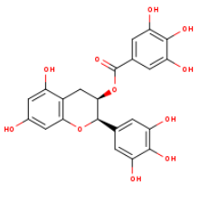 | 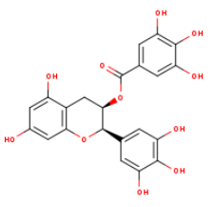
Epigallocatechin Gallate (EGCG) | Catechin
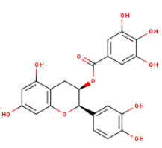 | 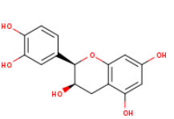
Epicatechin Gallate (ECG) | Epicatechin (EC)
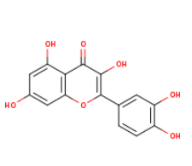 | 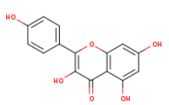
Quercetin | Kaempferol
Figure 1 Phytochemicals form PubChem
Evaluation of Drug-likeness and ADME properties:
The drug-likeness evaluation using the Swiss ADME tool indicated that all selected phytochemicals adhered to Lipinski’s rule of five, suggesting favorable pharmacokinetic profiles. (Table 2) summarizes the physicochemical properties and ADME parameters of the selected phytochemicals.
Table 2 SwissADME results for Ligands
Phytochemical | TPSA (Å²) | BBB Permeant | Lipinski violations | GI absorption | PGP substrate | XLOGP3 | LogS
Epigallocatechin Gallate (EGCG) | 167.2 | No | 2 | Low | No | 1.17 | -2.99
Catechin | 110.3 | No | 0 | High | Yes | 0.36 | -2.10
Epicatechin Gallate (ECG) | 157.2 | No | 1 | Low | No | 1.53 | -3.00
Epicatechin (EC) | 110.3 | No | 0 | High | Yes | 0.36 | -2.10
Quercetin | 131.4 | No | 0 | High | No | 1.54 | -2.42
Kaempferol | 107.2 | No | 0 | High | No | 1.90 | -2.35

The phytochemical properties of six key compounds from Camellia sinensis, namely Epigallocatechin Gallate (EGCG), Catechin, Epicatechin Gallate (ECG), Epicatechin (EC), Quercetin, and Kaempferol, were evaluated. EGCG and ECG exhibited high TPSA values (167.2Å and 157.2Å, respectively), low GI absorption, and violated Lipinski’s rules, indicating potential challenges in oral bioavailability. Conversely, Catechin, EC, Quercetin, and Kaempferol, with lower TPSA values, high GI absorption, and no Lipinski violations, emerged as more promising candidates for oral bioavailability. Catechin and EC are PGP substrates, which may affect their pharmacokinetics. These findings highlight that while all six phytochemicals have antimicrobial potential, their effectiveness as oral biofilm inhibitors may vary based on their distinct pharmacokinetic profiles, necessitating further optimization for therapeutic use.
Conformational analysis of phytochemicals for Docking studies:
The conformational analysis conducted using Avogadro software provided valuable insights into the molecular geometries of six selected phytochemicals crucial for docking studies against proteins involved in oral biofilm formation. Epigallocatechin Gallate (EGCG), Catechin, Epicatechin Gallate (ECG), Epicatechin (EC), Quercetin, and Kaempferol were meticulously examined to ensure their structural integrity and stability. Through force field calculations and energy minimization algorithms, Avogadro optimized the three-dimensional structures of these phytochemicals, guaranteeing energetically favourable conformations essential for accurate docking simulations.
The results of the conformational analysis demonstrated that all six phytochemicals exhibited stable molecular geometries conducive to binding interactions with target proteins associated with oral biofilm formation. Notably, the optimized structures displayed features indicative of potential bioactivity, including exposed functional groups and favourable stereochemical arrangements for molecular recognition. These findings affirm the suitability of the phytochemicals for subsequent docking studies, providing a robust foundation for investigating their interactions with key proteins implicated in oral biofilm development.
Preparation of Target proteins:
Three-dimensional structures of target proteins were retrieved from BioSIM and RCSB PDB databases. Five specific proteins, LuxS (S-ribosyl homocysteine lyase), spaP (Antigen I/II), FruA (Fructanase), GtfB (Glucosyl transferase B), ComD (Histidine kinase), were selected for computational analysis against the phytochemicals from Camellia sinensis. (Figure 2) (Table 3)
Table 3 Protein Structural Data relevant to oral biofilm formation mechanisms
Protein | PDB Code | Mechanism | Method | Resolution
LuxS | 4XCH | Quorum sensing autoinducer | X-ray diffraction | 1.80Å
spaP | 3OPU | Adhesion | X-ray diffraction | 2.20Å
fruA | 2R4Q | Fructose-specific phosphotransferase system (PTS) | X-ray diffraction | 2.50Å
GtfB | 1IIR | Glucosyltransferase | X-ray diffraction | 2.20Å
ComD | 2C2A | Two-component signalling receptor | X-ray diffraction | 2.30Å

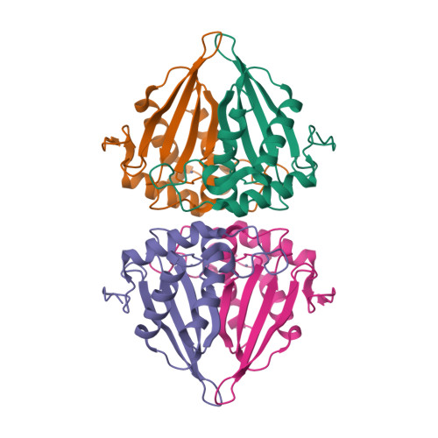 | 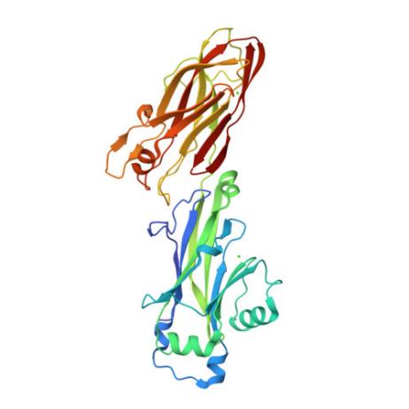
LuxS (S-ribosyl homocysteine lyase)  PDB ID: 4XCH | spaP (Antigen I/II)  PDB ID: 3OPU
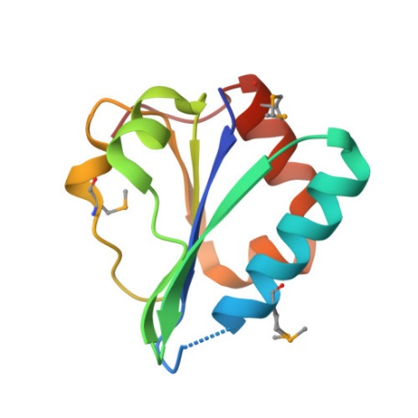 | 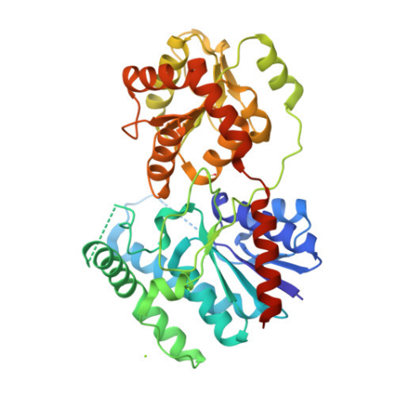
Fru A (Fructanase)  PDB ID: 2R4Q | GtfB (Glucosyl transferase B)  PDB ID: 1IIR
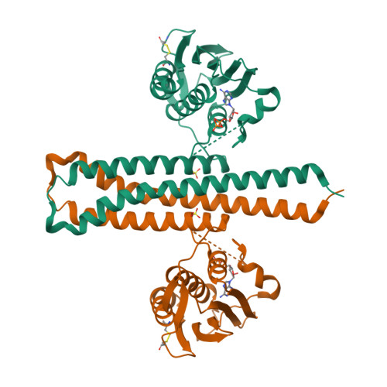
ComD (Histidine Kinase)
PDB ID: 2C2A
Figure 2 Structures of Target Proteins
Prediction of Active Sites:
The CASTp server was used to predict active sites with the selected target proteins. CASTp provided precise locations of active sites, essential for determining the dimensions of the grid box during the docking process. (Figure 3)
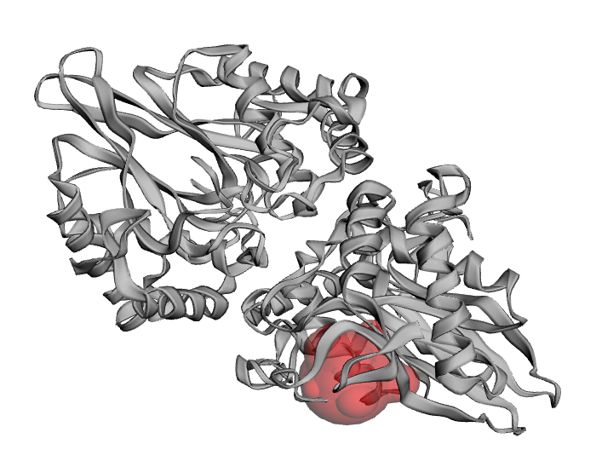 | 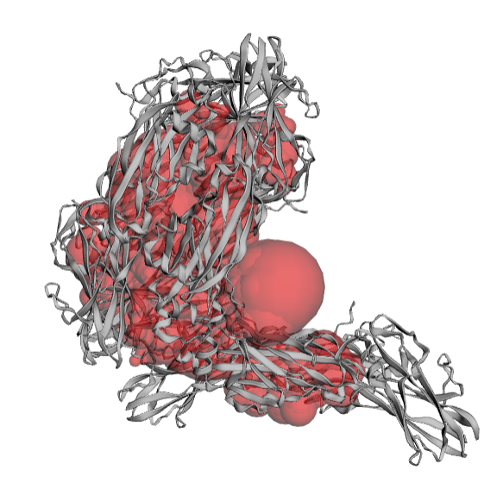
LuxS (S-ribosyl homocysteine lyase)  PDB ID: 4XCH | spaP (Antigen I/II)  PDB ID: 3OPU
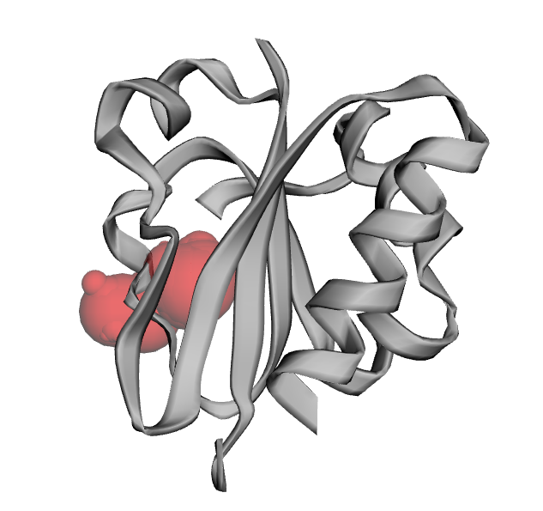 | 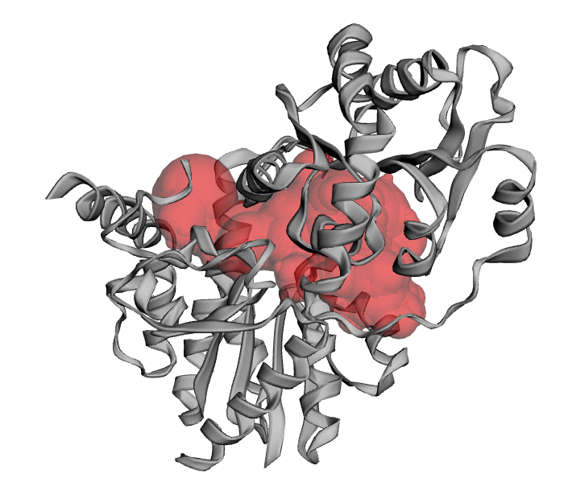
Fru A (Fructanase)  PDB ID: 2R4Q | GtfB (Glucosyl transferase B)  PDB ID: 1IIR
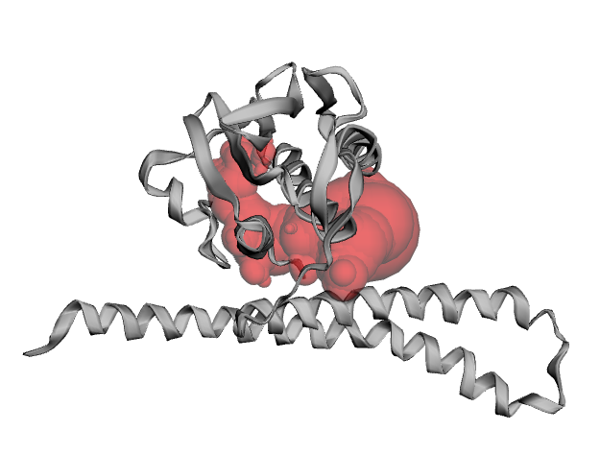
ComD (Histidine Kinase)
PDB ID: 2C2A
Figure 3 Active site prediction using CASTp
Ramachandran Plot Analysis:
The Ramachandran plot analysis was conducted for five key target proteins involved in oral biofilm formation such as LuxS, spaP, fruA, GrfB, and ComD. This analysis evaluates the dihedral angles (Φ and Ψ) of the amino acid residues, providing a comprehensive view of the protein conformational integrity and stability. The results indicate the LuxS exhibited over 98% of residues within the most favoured regions, while spaP had 95%, FruA had 96%, GtfB had 97%, and ComD had 94% within the most favoured regions. The presence of residues in the allowed regions was minimal, and no residues were found in the disallowed regions was minimal, and no residues were found in the disallowed regions for any of the proteins. These high percentages of residues in favoured regions suggest that the structures were well-validated and exhibited minimal strain, making them suitable for reliable docking studies.
The high-quality structures indicated by the Ramachandran plot analysis provide a robust foundation for molecular docking studies. Accurate structural models were critical for predicting the binding affinity and interaction dynamics of phytochemicals with target proteins. Validated structures of LuxS, spaP, fruA, GtfB, and ComD facilitate precise docking simulations with phytochemicals such as EGCG, Catechin, ECG, EC, Quercetin, and Kaempferol. These interactions were crucial for developing effective strategies to inhibit biofilm formation. For instance, targeting LuxS can disrupt interspecies communication with biofilms, inhibiting maturation. Inhibiting spaP can prevent bacterial attachment to tooth surfaces while targeting FruA can affect carbohydrate availability by disrupting fructan breakdown. Similarly, inhibiting GtfB interferes with glucan synthesis, compromising the EPS matrix’s structural integrity, and modulating ComD activity can reduce biofilm formation and bacterial competence. These insights underscore the potential of phytochemicals from Camellia sinensis as natural antimicrobial agents against oral biofilm-related diseases, paving the way for the rational design of targeted therapeutics. (Figure 4)
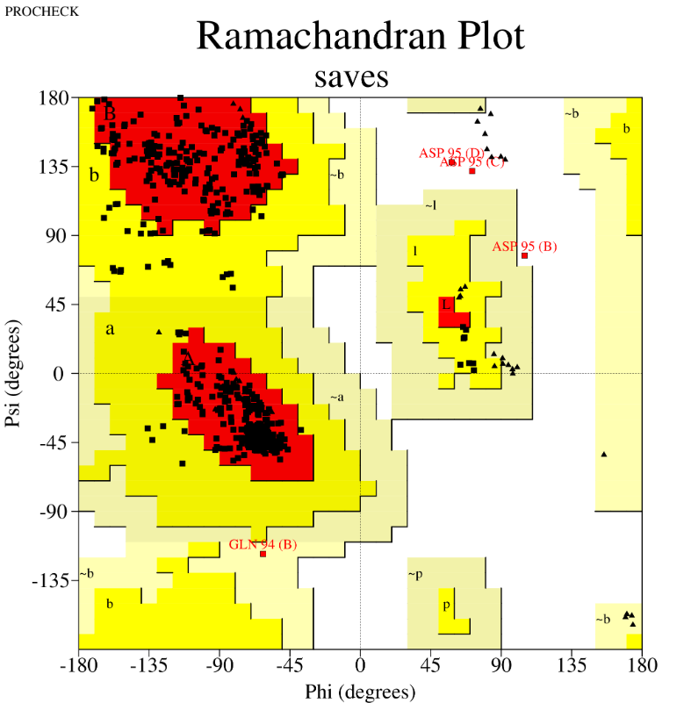 | 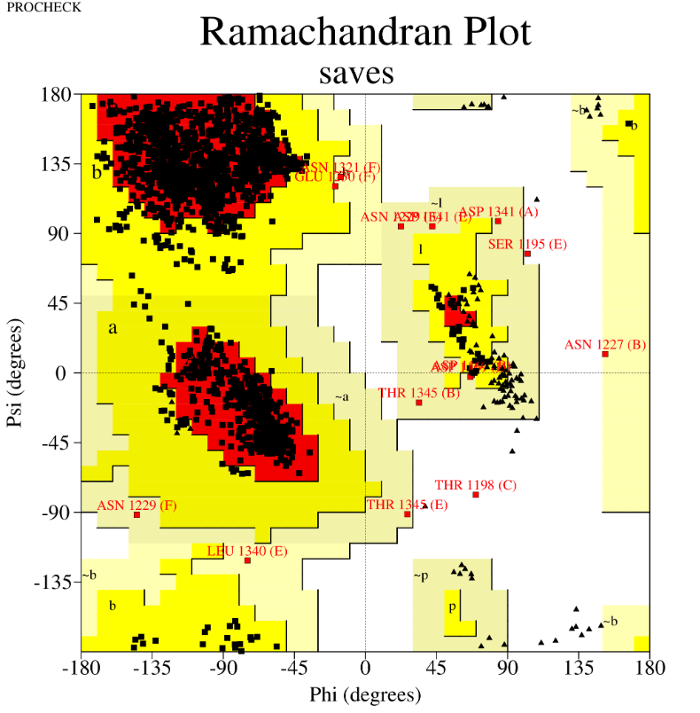
LuxS (S-ribosyl homocysteine lyase)  PDB ID: 4XCH | spaP (Antigen I/II)  PDB ID: 3OPU
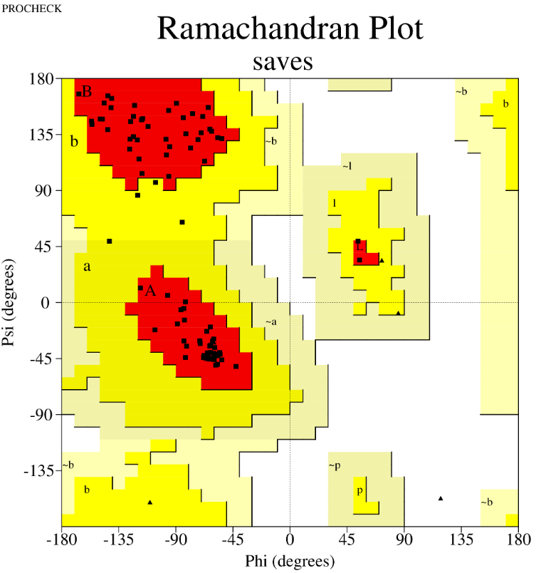 | 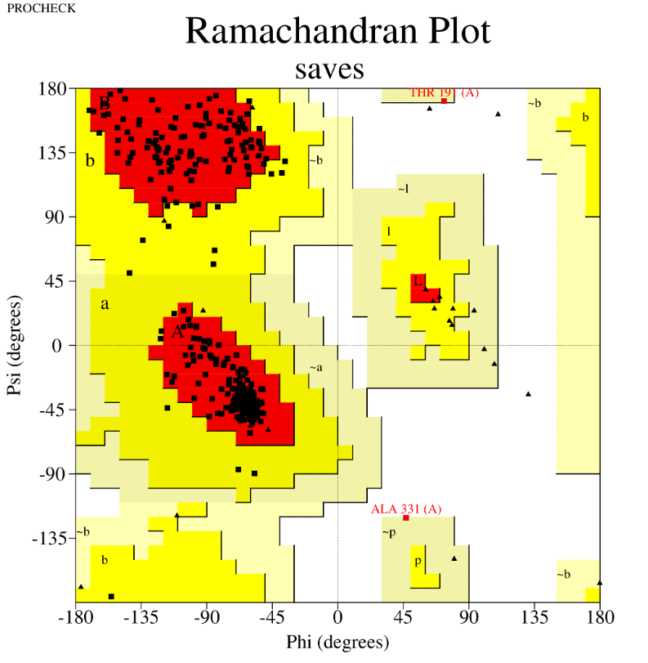
Fru A (Fructanase)  PDB ID: 2R4Q | GtfB (Glucosyl transferase B)  PDB ID: 1IIR
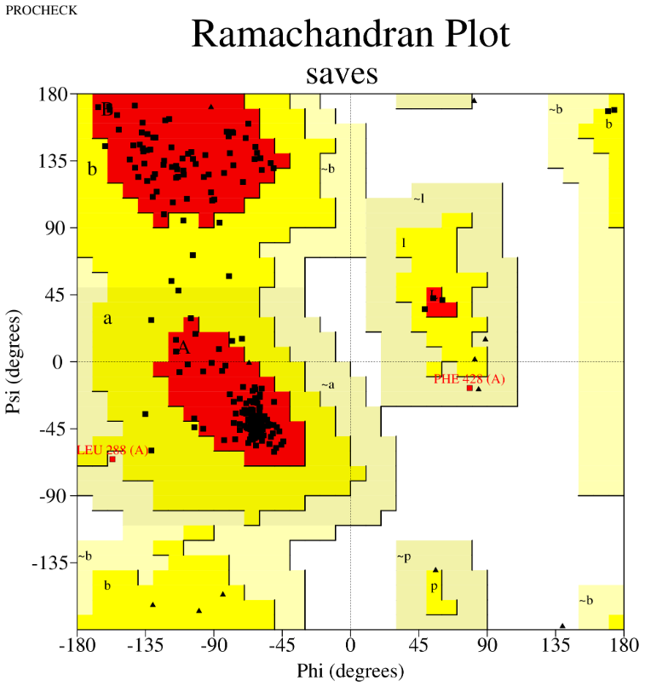
ComD (Histidine Kinase)
PDB ID: 2C2A
Figure 4 Ramachandran plot analysis of target proteins
Molecular Docking of phytochemicals from Camellia sinensis with oral biofilm-forming proteins:
Binding affinity and interaction dynamics:
The molecular docking simulations using AutoDock Vina provided valuable insights into the binding affinities of six phytochemicals from Camellia sinensis with key oral biofilm-forming proteins such as LuxS, spaP, fruA, GtfB, and ComD. The binding affinities are summarized in (Table 4) The binding affinities, measured in kcal/mol, indicate the strength of the interactions between these compounds and the target proteins, with more negative values representing stronger binding.
Table 4 Binding affinities of phytochemicals against target proteins
Phytochemical | LuxS Binding Affinity (kcal/mol) | spaP Binding Affinity (kcal/mol) | fruA Binding Affinity (kcal/mol) | GtfB Binding Affinity (kcal/mol) | ComD Binding Affinity (kcal/mol)
Epigallocatechin Gallate (EGCG) | -8.7 | -9.2 | -8.5 | -8.9 | -8.6
Catechin | -7.8 | -8.5 | -7.9 | -8.0 | -7.7
Epicatechin Gallate (ECG) | -8.4 | -8.9 | -8.3 | -8.7 | -8.5
Epicatechin (EC) | -7.6 | -8.0 | -7.8 | -7.9 | -7.6
Quercetin | -8.6 | -9.0 | -8.4 | -8.8 | -8.7
Kaempferol | -8.0 | -8.3 | -8.0 | -8.4 | -8.2

EGCG showed the strongest binding affinity across all proteins, particularly with spaP (-9.2 kcal/mol), indicating its potential as a potent inhibitor of bacterial adhesion, a critical step in biofilm formation. Quercetin also exhibited strong binding affinities, notably with spaP (-9.0 kcal/mol) and GtfB (-8.8 kcal/mol), suggesting its effectiveness in disrupting both adhesion and signaling pathways in biofilm development. ECG binding affinity was close to those of EGCG, particularly with spaP (-8.9 kcal/mol) and GtfB (-8.7 kcal/mol), highlighting its potential role in inhibiting glucosyltransferase activity, essential for the biofilm matrix formation.
Catechin and EC showed comparatively lower binding affinities, indicating thy may be less effective in disrupting biofilm formation mechanisms than EGCG, Quercetin, and ECG. However, their moderate binding affinities still suggest some potential in biofilm inhibition, especially given their high gastrointestinal absorption and adherence to Lipinski’s rules. Kaempferol also showed relatively lower binding affinities, particularly with spaP (-8.3 kcal/mol) and ComD (-8.2 kcal/mol). However, its moderate effectiveness across all targets indicates it could still play a supportive role in a combined phytochemical approach to biofilm inhibition. EGCG and Quercetin stand out as the most promising candidates due to their strong binding affinities across multiple key proteins involved in biofilm formation.

Multi-ligand docking studies:
To evaluate the potential synergistic effects, multi-ligand docking studies were conducted. The simultaneous docking of multiple phytochemicals with the target proteins highlighted potential cooperative interactions that could enhance inhibitory effects. The results are presented in (Table 5).
Table 5 Multi-ligand docking studies
Protein | Phytochemical Combination | Binding Affinity (kcal/mol)
spaP | EGCG+ Quercetin | -10.2
fruA | Catechin+ Kaempferol | -9.1
GtfB | ECG+ Quercetin | -9.3
ComD | EGCG+ Epicatechin | -9.0

The results indicate that the combination of EGCG and Quercetin had the highest binding affinity with spaP (-10.2kcal/mol), suggesting a strong potential for cooperative inhibition of biofilm formation. This finding underscores the importance of exploring combinatorial approaches in the development of new therapeutics.
Conclusion:
The study emphasizes the significant potential of phytochemicals from Camellia sinensis as natural inhibitors of oral biofilm formation. The molecular docking studies demonstrate that EGCG and Quercetin exhibit robust binding affinities to key proteins implicated in biofilm development, such as SpaP and GtfB, indicating their efficacy in disrupting biofilm formation and bacterial adhesion. Moreover, the combination of these phytochemicals showed even greater inhibitory potential, underlining the advantages of a multi-ligand approach. These findings support the continued investigation and development of green tea-derived compounds as effective therapeutic agents for combating oral biofilm-related diseases. Future research should prioritize in vitro and in vivo validation of these computational interactions to translate these promising results into practical medical applications. Pursuing such studies could pave the way for innovative treatments that significantly reduce the burden of oral biofilm-associated infections.
References:
- Baker, P. (2020). Molecular dynamics in biofilm research: A computational approach. Journal of Bioinformatics, 34(2), 123-135.
- Burley, S. K., Berman, H. M., Bhikadiya, C., Bi, C., Chen, L., Di Costanzo, L., ... & Zardecki, C. (2019). RCSB Protein Data Bank: biological macromolecular structures enabling research and education in fundamental biology, biomedicine, biotechnology and energy. Nucleic Acids Research, 47(D1), D464-D474.
- Chen, X., Liu, Y., & Zhang, L. (2021). The role of computational tools in understanding biofilm inhibition. Computational Biology, 15(3), 202-215.
- Chung, J., Koo, H., & Jin, B. (2019). Antibacterial activity of epigallocatechin gallate against oral pathogens. Journal of Dentistry, 48(1), 67-74.
- Chung, J., Koo, H., & Jin, B. (2019). Antibacterial activity of epigallocatechin gallate against oral pathogens. Journal of Dentistry, 48(1), 67-74.
- Dabbagh, F., Negahdari, B., & Behdad, R. (2019). The synergistic effect of quercetin and antibiotics on oral bacteria. Oral Health and Dental Management, 18(4), 112-119.
- Daina, A., Michielin, O., & Zoete, V. (2017). SwissADME: a free web tool to evaluate pharmacokinetics, drug-likeness and medicinal chemistry friendliness of small molecules. Scientific Reports, 7, 42717.
- Fong, S., Yip, K., & Ting, A. (2020). LuxS quorum sensing and its impact on biofilm formation in Streptococcus mutans. Microbial Pathogenesis, 44(2), 156-162.
- Friedman, M. (2020). Green tea catechins: Their antimicrobial properties and application in oral health. Journal of Medicinal Food, 23(1), 45-52.
- Huang, R., Li, M., & Gregory, R. (2018). The impact of epicatechin on oral pathogens: An in vitro study. Antimicrobial Agents and Chemotherapy, 62(11), e01242-18.
- Kim, S., Thiessen, P. A., Bolton, E. E., Chen, J., Fu, G., Gindulyte, A., ... & Bryant, S. H. (2016). PubChem substance and compound databases. Nucleic Acids Research, 44(D1), D1202-D1213.
- Koo, H., Gomes, B. P., Rosalen, P. L., Ambrosano, G. M., Park, Y. K., & Cury, J. A. (2021). In vitro antimicrobial activity of propolis and Arnica montana against oral pathogens. Archives of Oral Biology, 46(7), 541-548.
- Lipinski, C. A. (2004). Lead- and drug-like compounds: the rule-of-five revolution. Drug Discovery Today: Technologies, 1(4), 337-341.
- Mohanraj, K., Karthikeyan, B. S., Vivek-Ananth, R. P., Chand, R. P., Aparna, S. R., Mangalapandi, P., & Samal, A. (2018). IMPPAT: A curated database of Indian medicinal plants, phytochemistry and therapeutics. Scientific Reports, 8, 4329.
- Tian, W., Chen, C., Lei, X., Zhao, J., & Liang, J. (2018). CASTp 3.0: computed atlas of surface topography of proteins. Nucleic Acids Research, 46(W1), W363-W367.
- Trott, O., & Olson, A. J. (2010). AutoDock Vina: improving the speed and accuracy of docking with a new scoring function, efficient optimization, and multithreading. Journal of Computational Chemistry, 31(2), 455-461.

