Reconstructing Inequality in Maternal Health: Imputation-Enhanced Machine Learning Models for Global ANC4 Performance

Abstract

The study develops a hybrid composite analysis model that combines imputation and machine learning techniques to predict 527 country-years of national antenatal care coverage with at least four visits (ANC4). The structured missingness of the wealth quintile indicators was addressed through imputations that preserved the distributional characteristics of disadvantaged groups. Five machine-learning algorithms were tested following the imputations. Gradient Boosting achieved the best predictive performance, followed by random forest and XGBoost. Elastic Net, which is more interpretable due to its coefficients, was less predictive but showed significant positive effects on the poorest quartile and rural populations. KNN Regression produced mediocre results and is sensitive to feature scaling. Based on the combined imputation and machine-learning pipeline, it can be concluded that social, economic, and regional disparities exist, with lower-income states and South Asian/Eastern/Southern African regions persistently associated with low ANC4 scores. This research represents a notable innovation, strengthening equity-based maternal health surveillance and providing actionable evidence to advance SDG 3 and SDG 10. It is recommended that global health agencies incorporate various imputation and machine-learning forecasting methods into their routine maternal health monitoring to identify injustices early and allocate resources more effectively.
Keywords: Multiple Imputation, Antenatal Care Coverage, Gradient Boosting, Global Maternal Health, Predictive Modelling, Wealth Quintiles.

Introduction
Antenatal care is recognised as one of the most efficacious public health interventions for improving maternal and neonatal outcomes. The proportion of pregnant women attending four or more antenatal care visits (ANC4) is now utilised globally to assess the readiness of maternal health services, their continuity of care, and the equity of access (Jiwani et al., 2025; Habte et al., 2024; Dandona et al., 2024; Achamyeleh et al., 2025; Khallouf et al., 2025). In countries working to meet the maternal health goals of SDGs 3.1 and 3.8, monitoring ANC4 coverage is a good way to assess how well the health system is working to reduce maternal mortality. Nevertheless, the ANC4 global statistics show that there are a lot of differences between regions, income levels, and demographic groups. This difference is caused by long-lasting socioeconomic and geographic inequalities that make it hard for women to get the maternal care services they need.
To monitor ANC4 patterns across different countries, high-quality, comprehensive, and comparable datasets are essential. However, many internationally harmonised datasets are significantly incomplete, especially for disaggregated indicators like wealth quintiles. Low-income countries and countries with conflict-related issues have a disproportionately high share of missing data, due to weaker survey infrastructure and incomplete health information systems. Traditional analysis methods either ignore incomplete data or rely on simple substitution techniques, which can yield biased estimates of risk and hinder a complete understanding of maternal health advancements (Alhassan et al., 2024; Kim et al., 2025; Baffour et al., 2024; Ayiah-Mensah et al., 2021). These challenges emphasise the importance of developing robust methods that can handle structured missing data effectively, without sacrificing inference quality or predictive accuracy.The current analytical practices have now enabled researchers to model a complex health outcome based on machine learning models that are inherently open to nonlinear relationships, interactions, and high-dimensional formations (Kpebo et al., 2024; Yoseph et al., 2025; Habte et al., 2024; Dandona et al., 2024; Singh Sardar et al., 2025). Ensemble models such as Random Forest, Gradient Boosting, and XGBoost consistently outperform classical statistical models in most epidemiological prediction problems. The integration of these models and principled missing-data methods, including multiple imputation, offers a powerful avenue for advancing global maternal health surveillance. They allow researchers to generate predictive and interpretive information even in the presence of structural missingness, so that disadvantaged populations are not sidelined in the analysis.
Given the global importance of reducing disparities in maternal health care access, combining machine learning with multiple imputation offers valuable methodological benefits.It helps countries and international organisations identify areas with low ANC4 coverage, determine which groups aren't getting enough support, and anticipate how migration patterns may change under different policy scenarios. This kind of proof is significant for accelerating progress on SDG 3 and reducing socioeconomic inequality, which is what SDG 10 measures.The combination of machine learning and equity-conscious population health analytics, particularly in a global dataset, is a potentially valuable area of research.
According to the research on the use of antenatal care (ANC) conducted worldwide, the socioeconomic status, education, health system capacity, geographic remoteness, and political stability remain the consistent antecedents of the ANC coverage (Tohan et al., 2024; Baffour et al., 2025; Siddiqi et al., 2025). Research in sub-Saharan Africa, South Asia, and conflict zones has indicated that women in the poorest wealth quintiles, rural areas and conflict zones had much less ANC4 uptake than their wealthier and urban counterparts. These trends highlight underlying structural inequalities in accessing professional skilled healthcare, transportation, and continuous care. Regional reports also indicate a strong gradient between the high-income and low-income groups, with high-income countries recording almost universal ANC4 coverage and low-income countries recording slow and uneven progress (Hone et al., 2024; Getnet et al., 2025; Demissie et al., 2024; Assefa et al., 2024; Worku et al., 2025).A growing body of literature investigates the potential of health financing reforms, community health worker initiatives, and targeted programs to enhance the coverage of antenatal care. Most of the literature that is out there, on the other hand, uses traditional regression-based methods that assume linearity, independence, and complete-case analyses. These last assumptions aren't usually true for datasets from around the world, where data collection methods vary from country to country, indicators aren't always linear, and the lack of data is included in the process of making the data. As a result, traditional analyses often downplay uncertainty, hide inequalities, and don't explain how wealth, geography, and health system variables interact in complicated ways.
Recent studies indicate that machine learning may serve as an auxiliary method for data analysis in mother and child health research (Baffour et al., 2025; Patil et al., 2025; Joseph et al., 2024; Akuze et al., 2024; Sibanda et al., 2024; Ngusie et al., 2024). It can be used to guess factors like how many experienced birth attendants there are, how many babies die in the first month of life, how many people get vaccinated, and how many babies are born in a hospital. These kinds of studies reveal that nonlinear and ensemble-based models are often better at making predictions than classical models.There are not many research that use machine learning to predict ANC4 over the world, and stringent approaches for dealing with missing data are not employed very often. This gap is notable because the wealth quintile indicators for ANC4 have the greatest data that is missing. There aren't many studies that employ multiple imputation to get past this challenge, and even fewer that use machine learning-based imputation as a single pipeline.
Available studies also tend to be either single-country or region-wide, making it impossible to appreciate the structural global inequities and compare the performance of different health systems (Goli et al., 2024; Bitewa et al., 2025; Abate et al., 2024). Moreover, the capacity of ensemble models to facilitate the prediction of maternal health worldwide and the formulation of policies has not been exhausted, even as more unified data sources, including UNICEF, WHO, and the World Bank, have become more accessible.The weaknesses in previous research indicate a significant methodological loophole. The world needs both global, equity-focused studies, which require combining principled missing-data approaches with modern machine learning to enhance prediction accuracy and interpretability. The response to this gap in this study is to use multiple imputation to reconstruct wealth-related maternal health indicators and to combine an ensemble machine learning model to predict ANC4 coverage by year and country. The research provides a new combination that not only enables precise forecasts but also offers better insight into structural inequities and presents evidence that helps transform maternal health policy and accelerate the achievement of SDG 3 and SDG 10.

Materials and Methods
This paper relied on a global, country-year panel dataset compiled from harmonised antenatal care indicators maintained by UNICEF. The dataset includes ANC4 cover, demographic, socioeconomic, and regional classification variables for various countries over multiple years. The entire dataset used for the analysis is available in the project repository. The raw data file ANC4 Maternal.xlsx and all the code to reproduce the results are stored in this repository.
This data set includes 527 country-year observations and 17 variables that capture the structural, demographic, and service-related features underlying the ANC4 performance. Principal identification variables include the ISO country code, country name, UNICEF reporting and programme regions, and the World Bank 2024 income group classification. The Year variable is continuous, providing a temporal reference. The national ANC4 coverage is the result of interest, expressed as a continuous percentage of the number of pregnant women in each country-year who had at least four antenatal care visits. Extra disaggregated ANC4 variables are added as rural and urban population and the five wealth gaps, poorest, second, middle, fourth, and richest and an age-specific variable, which is the adolescent, fifteen to nineteen years.
All the models were trained on an 80:20 training-to-testing split, stratified by ANC4 coverage to maintain variability in outcomes. Pre-processing procedures were dummy coding of categorical variables, zero-variance filtering, and consecutive predictor normalisation. Repeated five-fold cross-validation was used, with root mean square error (RMSE), mean absolute error (MAE), and coefficient of determination (R²) as evaluation metrics for hyperparameter tuning. Tuning grids were specified to enable models to search a relevant space of complexity, with “mtry” and minimum node size tuned using Random Forest, and tree depth, learning rate, loss reduction, sample fraction, and Elastic Net tuning mixing parameter and penalty tuned using Elastic Net. The tidymodels framework was used to ensure reproducibility by providing a cohesive workflow structure for all the modelling in R.
The mathematical foundations of the analysis begin with the treatment of missing values using Multiple Imputation by Chained Equations. For each incomplete variable $Y_{j}$, the imputation model estimates its conditional distribution given all other variables $Y_{-j}$. Mathematically, this is expressed as $P\left(Y_{j}∣Y_{-j},θ_{j}\right),$ where $θ_{j}$ represents model parameters that are iteratively updated. Predictive mean matching selects an imputed value by identifying observed donors whose predicted values are closest to the missing case's predicted value. The matching rule is expressed as
$${\hat{y}}_{\text{imp}}=y_{k} \text{where }k=arg\min_{i∈O}\left|{\hat{y}}_{i}-{\hat{y}}_{\text{mis}}\right|,$$
with $O$ representing the set of observed values and ${\hat{y}}_{\text{mis}}$ the model prediction for the missing value. This mathematical structure ensures that imputed ANC4 values fall within the range of realistic observed values, making it particularly appropriate for bounded percentages, such as wealth-specific ANC4 coverage. Iterative convergence toward a stable joint distribution ensures that uncertainty about missing wealth data is preserved rather than artificially reduced.
The model employed in the study was the Elastic Net, which is a penalised least-squares objective function comprising ridge and lasso penalties. The optimisation problem is written as
$$\min_{β}\left\{\sum_{i=1}^{n}{{\left(y_{i}-β_{0}-\sum_{j=1}^{p}{β_{j}}x_{ij}\right)}^{2}}+λ\left[\left(1-α\right)\sum_{j=1}^{p}{β_{j}^{2}}+α\sum_{j=1}^{p}{\left|β_{j}\right|}\right]\right\},$$
where $y_{i}$ represents national ANC4 coverage, $x_{ij}$ are predictors, $β_{j}$ are coefficients, $λ$ controls penalty strength, and $α$ determines the proportion of L1 versus L2 shrinkage. This penalty structure is crucial in a dataset where regional categories, wealth quintiles, and income classifications exhibit multicollinearity. The Elastic Net equation stabilises coefficient estimates, ensuring that the statistical inference about socioeconomic and regional drivers of ANC4 coverage remains robust to correlated predictors.
The Random Forest model relies on recursive binary partitioning and variance reduction to form decision trees. At each split, the algorithm selects the predictor and cut-point that minimises node impurity, formalised as
$$Δ=σ_{\text{parent}}^{2}-\left(\frac{n_{L}}{n}σ_{L}^{2}+\frac{n_{R}}{n}σ_{R}^{2}\right),$$
where $σ_{\text{parent}}^{2}$ is the variance before the split and $σ_{L}^{2}$ and $σ_{R}^{2}$ are variances in the left and right child nodes. Ensemble averaging across trees invokes the law of large numbers to stabilise predictions. This mechanism is crucial for global ANC4 forecasting because maternal-health determinants rarely follow linear pathways. The algorithm captures nonlinear relations between wealth disparities, geographic region, and health system capacity by adaptively partitioning the predictor space based on empirical variation.
Gradient Boosting Machines extend this by fitting a sequence of models to the negative gradient of the loss function. The update rule is given by
$$F_{m}\left(x\right)=F_{m-1}\left(x\right)+νh_{m}\left(x\right),$$
where $F_{m}\left(x\right)$ is the boosted model after $m$ iterations, $h_{m}\left(x\right)$ is the new regression tree fitted to current residuals, and $ν$ is the learning rate. This gradient-based optimisation improves accuracy by correcting systematic under- or over-prediction. The relevance of this formulation lies in its ability to capture the layered determinants of ANC4 coverage across countries, where health system constraints accumulate and interact nonlinearly over time.
XGBoost enhances boosting by expanding the loss function with a second-order Taylor approximation,
$$L^{\left(m\right)}≈\sum_{i=1}^{n}{\left[g_{i}f_{m}\left(x_{i}\right)+\frac{1}{2}h_{i}f_{m}{\left(x_{i}\right)}^{2}\right]}+Ω\left(f_{m}\right),$$
where $g_{i}$ and $h_{i}$ are the first and second derivatives of the loss function and $Ω\left(f_{m}\right)$ is a regularisation term that penalises tree complexity. This math structure makes computations more efficient and cuts down on overfitting. It works best with high-dimensional global data where ANC4 outcomes change a lot depending on socioeconomic status and geographic conditions.
K-nearest neighbour regression predicts ANC4 based on the distance between observations in the predictor space. The predicted value is given by
yx=1ki∈Nkx​yi,
where $N_{k}\left(x\right)$ denotes the set of the $k$ closest observations to $x$ using Euclidean distance
$$d\left(x_{i},x_{j}\right)=\sqrt{\sum_{m=1}^{p}{{\left(x_{im}-x_{jm}\right)}^{2}}}.$$
This geometric formulation captures patterns of similarity across countries, revealing clusters of countries with comparable ANC4 performance based on socioeconomic profiles.
Model evaluation uses mathematical accuracy metrics that quantify predictive performance. The Root Mean Squared Error is defined as
$$\text{RMSE}=\sqrt{\frac{1}{n}\sum_{i=1}^{n}{{\left({\hat{y}}_{i}-y_{i}\right)}^{2}}},$$
and emphasises large prediction errors, making it valuable for identifying countries with extreme ANC4 deviations. The Mean Absolute Error is expressed as
$$\text{MAE}=\frac{1}{n}\sum_{i=1}^{n}{\left|{\hat{y}}_{i}-y_{i}\right|},$$
which provides a straightforward interpretation of model deviation. The coefficient of determination is defined as
R2=1-i​yi-yi2i​yi-y2,
highlighting the proportion of outcome variability captured by the model. These equations are essential for evaluating how well each model captures the complex interplay among socioeconomic inequalities, regional disparities, and health system characteristics.
Together, these mathematical equations support the research's novelty by enabling rigorous reconstruction of missing data, modelling nonlinear global health patterns, and delivering accurate, equity-sensitive predictions of ANC4 coverage. The mathematical structure ensures that the analysis captures both the complexity of global maternal-health dynamics and the nuances of socioeconomic inequality, aligning closely with the analytical needs of SDG 3 and SDG 10.
Collectively, these mathematical equations contribute to the study's novelty by enabling rigorous reconstruction of missing data, modelling nonlinear patterns in global health, and providing fair, equity-sensitive predictions of ANC4 coverage. The mathematical framework captures the complexity of global maternal health processes and the specifics of socioeconomic inequality, consistent with the analytical requirements of SDG 3 and SDG 10.

Results and Discussion
Table 1 clearly shows how well the five machine learning models predicted the imputed global ANC4 dataset. The table shows that Gradient Boosting is the best because it has the highest R² and the lowest RMSE. This means it can find nonlinear relationships between the factors that better affect ANC4 coverage. Random Forest and XGBoost were also very successful and dependable. This supports the idea that ensemble methods are effective for predicting global maternal health indicators. Elastic Net did not perform well, indicating that the ANC4 results differ from year to year and country to country. This means that linear structures alone cannot explain them. These results show that using flexible modelling techniques can help us understand why people use antenatal care differently. They also show how to track progress on SDG 3.1 and SDG 3.8. Both goals aim to improve the quality of antenatal care coverage at the national and subnational levels.
Table 1. The performance of machine learning models that predict national ANC4 coverage after multi-imputation on a test set.
Model RMSE R² MAE
Random Forest 11.90 0.75 5.68
XGBoost 11.89 0.74 5.76
Gradient Boosting 10.95 0.79 5.89
Elastic Net 15.19 0.58 11.04
KNN Regression 13.95 0.65 7.49

The coefficients in table 2 inform us about the size of the influence of individual predictors on the degree of coverage in the country. This assists us in determining what the structural items influence the ANC4 performance. The positive relationships of rural populations and the lowest quintile are high, which indicates that the effect of enhancing ANC4 coverage in the underprivileged groups to generate a significant difference in the national average is substantial. The negative coefficients of the low-income and the lower-middle-income groups depict that inequality in health system resources and access still exists. They also depict that in case of scarcity of resources, there is need to make some changes in policies. The estimates of coefficients reveal that there exist regional differences which can be attributed to the differences in access to maternal healthcare. In South Asia, Eastern and Southern Africa, the results are worse. Table 2 is a necessity because it shows what socialeconomic groups and regions are most disparate, where specific activities would make the greatest impact, and how SDG 10 can be benchmarked.
To test the functionality of the model, we have provided it with test sets constructed on data that the model had never encountered. RMS was the mean size of the errors in the forecasts, MAE was the size of the deviations, and R 2 was the number of variations that were elucidated. Table 1 in the Results section shows the degree to which the predictions of each model were in agreement with the actual occurrences. Calibration diagnostics, including observed-versus-predicted plot, were used to ensure that there is no pattern of bias and so the model fits the data well. We obtained the net coefficients of elasticity and equated them all. This assisted us in understanding them concerning the direction and the relative strength of the primary predictors that are shown in Table 2.

Table 2. National ANC4 coverage (standardised predictors) Elastic Net regression coefficients.
Term Estimate penalty
year 3.140 0.1930698
rural 5.887 0.1930698
urban 0.000 0.1930698
poorest 6.173 0.1930698
second 0.000 0.1930698
middle 0.000 0.1930698
fourth -1.941 0.1930698
richest -2.453 0.1930698
unicef Eastern.and.Southern.Africa reporting region. -2.556 0.1930698
unicef Eastern.Europe.and.Central.Asia reporting region 0.519 0.1930698
unicef_reporting_region_Latin.America.and.Caribbean 1.693 0.1930698
unicef_reporting region Middle.East.and North Africa 0.268 0.1930698
North.America unicef reporting region 0.457 0.1930698.
unicef_reporting_region_South.Asia -2.016 0.1930698
unicef region West.and.Central.Africa -0.567 0.1930698.
unicef reporting region Western. Europe 0.000 0.1930698.
unicef_programme_region_ECARO 0.443 0.1930698
unicef_programme_region_ESARO 0.000 0.1930698
unicef program region Industrialized 2.372 0.1930698.
unicef_programme_region_LACRO 1.575 0.1930698.
unicef_programme_region_MENA 0.000 0.1930698
unicef_programme_region_ROSA -2.049 0.1930698
unicef program region WCARO -0.693 0.1930698
world_bank_income_group_2024_Low.income -12.959 0.1930698.
world_bank_income_group_2024_Lower.middle.income -9.631 0.1930698.
world-bank-income-group-2024-Not.Classified -0.865 0.1930698
world_bank_income_group_2024_Upper.middle.income -2.704 0.1930698.

Figure 1 shows the distribution of ANC4 coverage across all country-years and indicates a right-skewed distribution, with a concentration of countries with high coverage and a more tail-shaped distribution of low coverage. Such a distribution shows significant differences in the advancement of the much-needed maternal-health services.

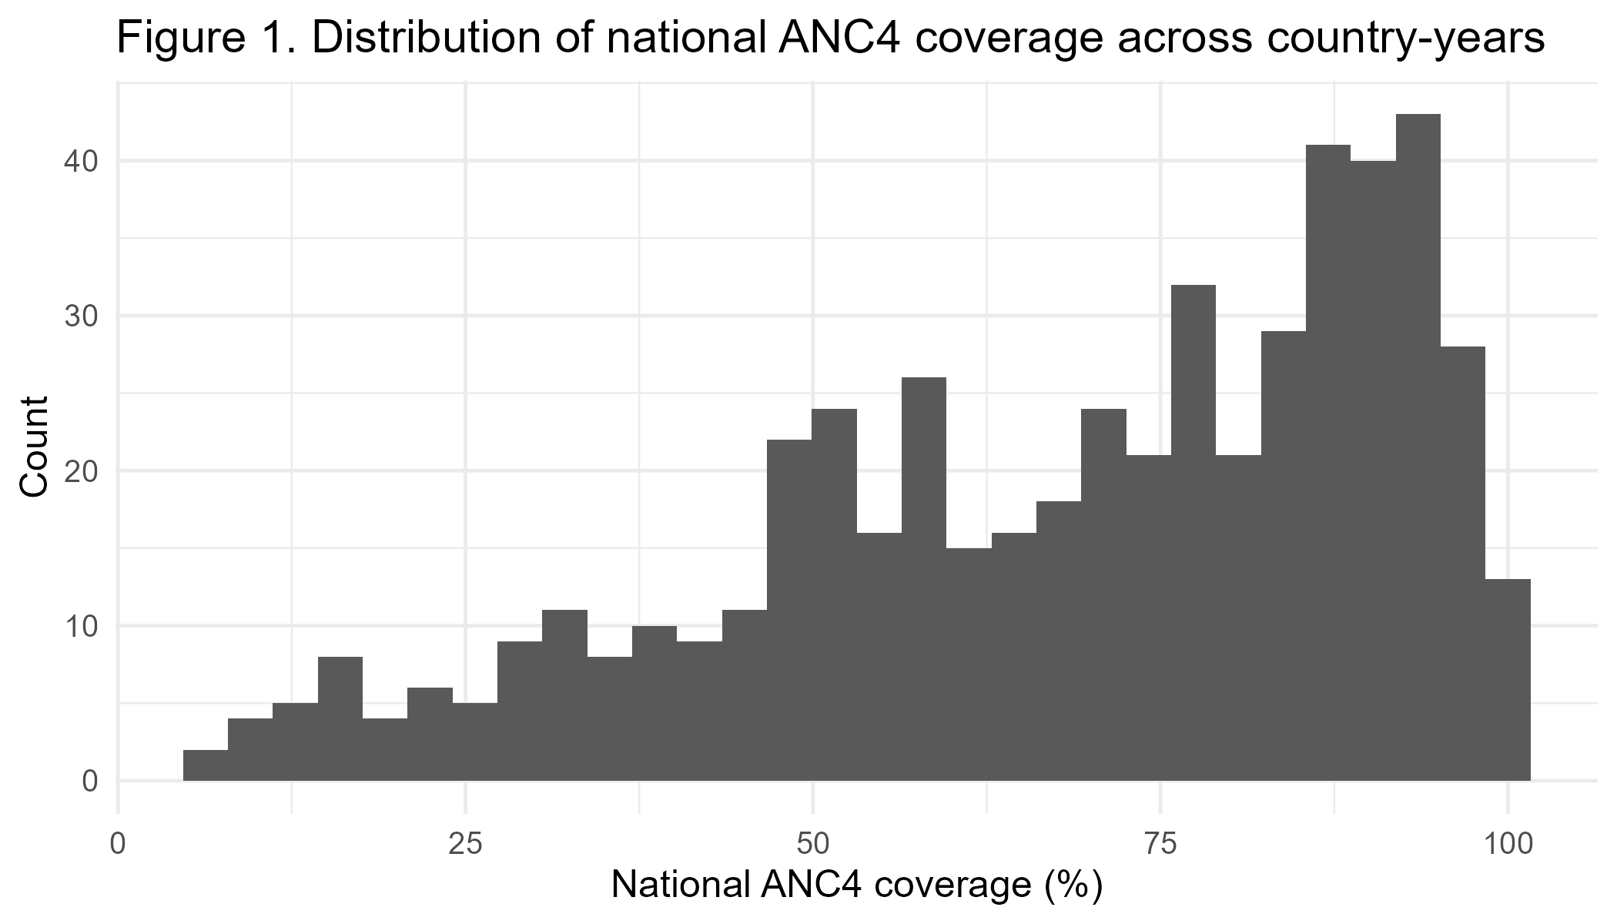
Figure 1: ANC4 country-year distribution of national coverage.
Countries with high ANC4 values reflect consistent investments in universal health coverage. In contrast, those with a focus on low ANC4 values indicate ongoing structural constraints, such as vulnerable health systems and political instability. Figure 1 demonstrates the relevance of predictive modelling for assessing which determinants will reinforce this unequal distribution and which trends will threaten the achievement of SDG 3. The number also supports the view that health system reforms should be stronger to bring the worst performers up to international standards.
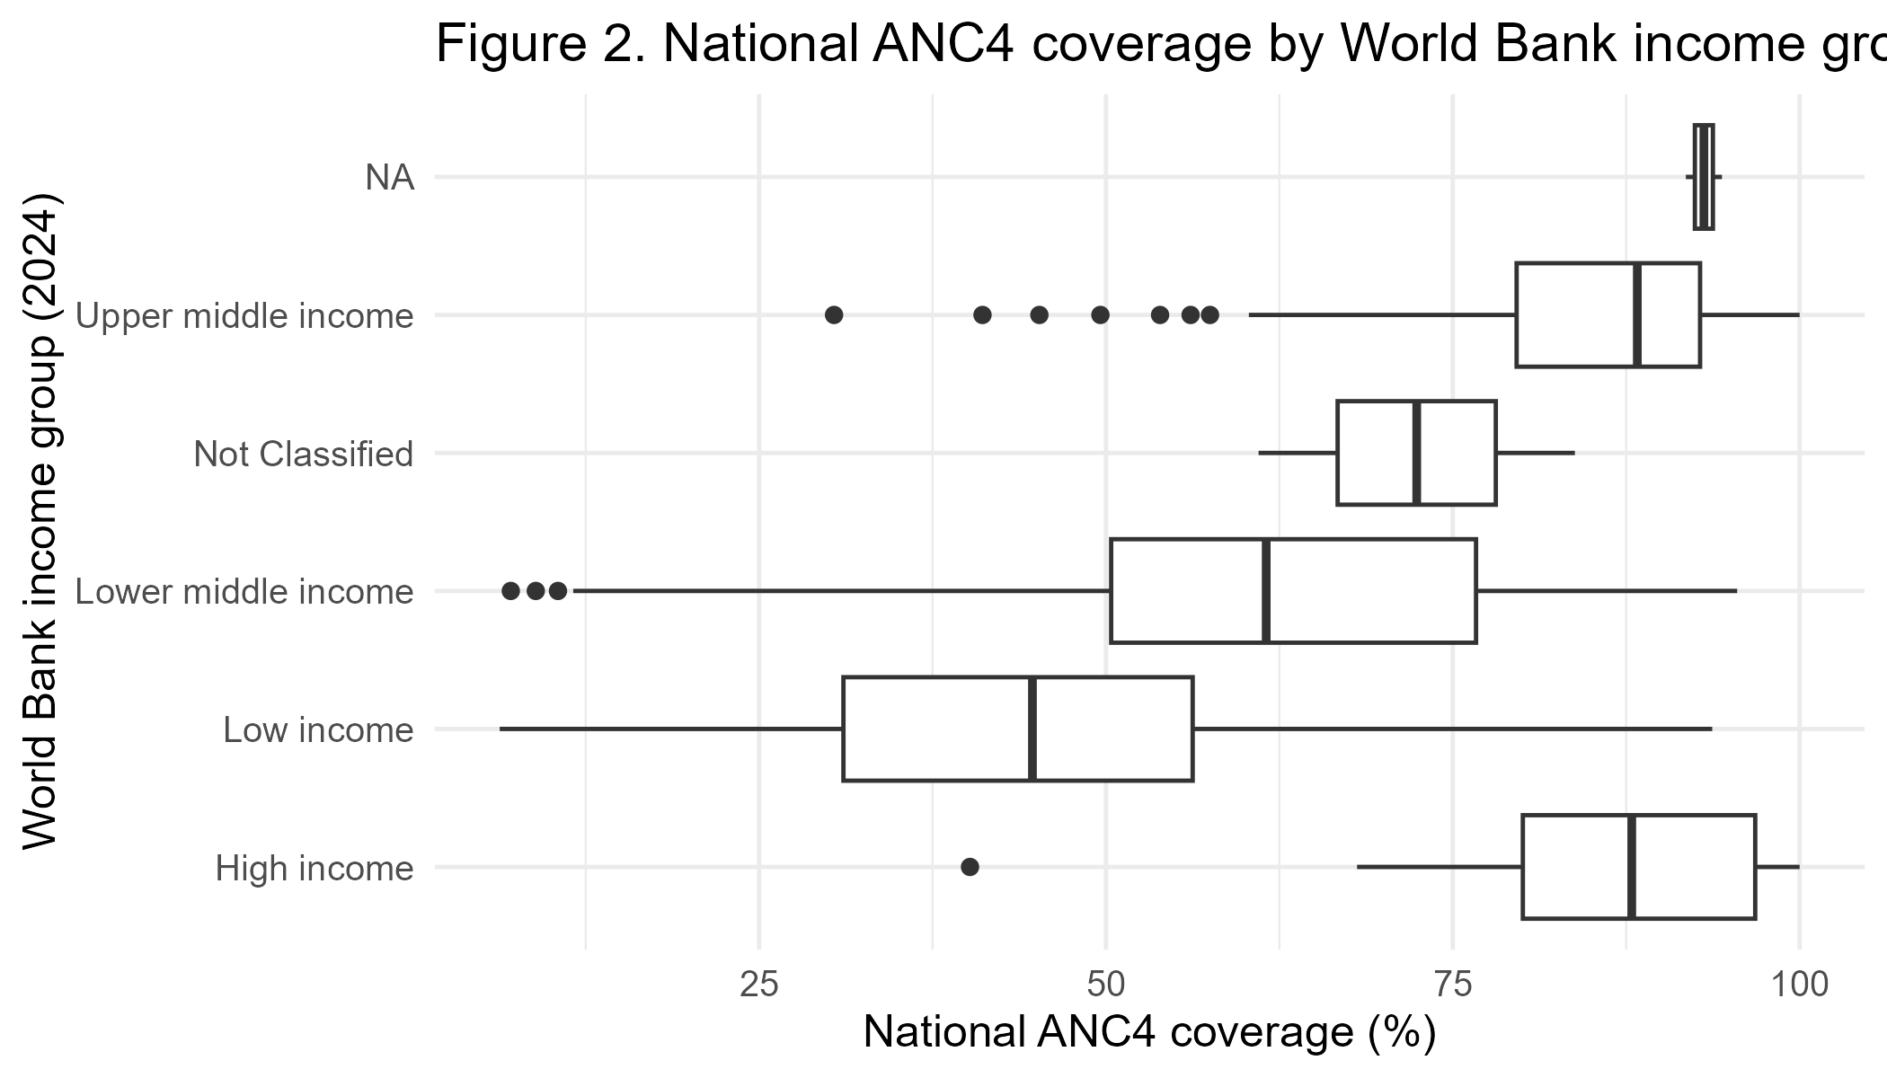
Figure 2. World Bank income group coverage of national ANC4.
Figure 2, which depicts ANC4 coverage by World Bank income group, exhibits strong socioeconomic gradients. Coverage in high-income countries is consistently high and stable, whereas in low-income and lower-middle-income countries it is significantly broader and markedly lower. The figure confirms ANC4’s performance, with income group among the strongest structural determinants, as observed in Table 2. These gaps suggest that poor nations face various structural limitations, including funding and human resources for health. The observations in Figure 2 necessitate financing the world more, spreading resources fairly, and treating maternal health issues contextually, in line with SDG 10.1, which aims to minimise inequalities based on income.

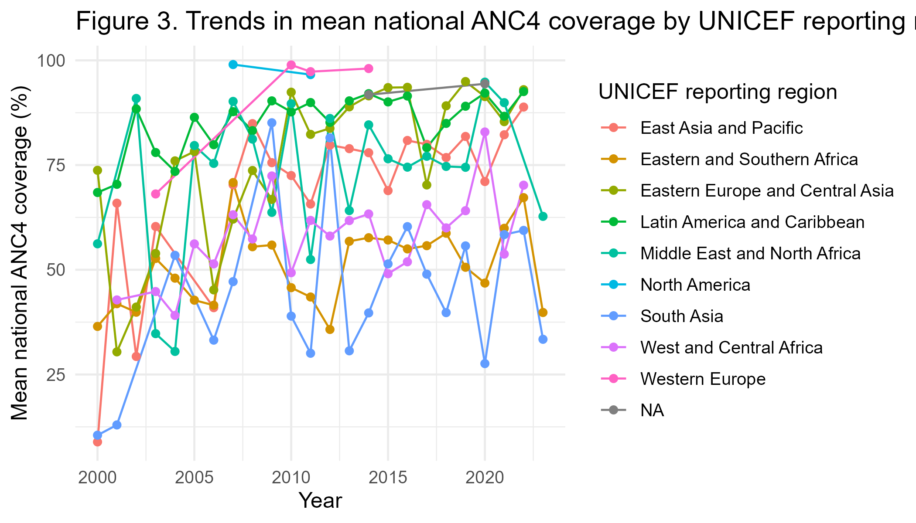
Figure 3: Trends in mean national ANC4 coverage of the UNICEF reporting region.
Figure 3 shows how things have changed in the area over time, with a focus on how different UNICEF reporting regions have made progress on ANC4. Western Europe and Latin America are always getting better, and they do so quickly. Eastern and Southern African countries are also getting better, but not as quickly as the rest of the world. South Asia is very unstable because the survey cycles change, there is political unrest, and programming stops. These patterns of change across regions show how important it is to simulate the temporal difference in ANC4 coverage and how useful ensemble techniques are, since they can capture non-linear trends. Figure 3 also shows that to make progress towards meeting SDG 3.8 faster, investments will need to be made in specific areas, especially where mothers' lives are at risk because of stagnation or instability.
The density representation of the wealth quintiles before and after imputation indicates that the reconstructed data is stable and coherent. The agreement between the observed and imputed distributions shows that the multiple imputation process kept important differences in the data and did not make it look the same. This is especially true for the poorest fifth, which is an important measure of ANC4 equity. Density comparisons demonstrate that the imputation process neither concealed nor distorted the wealth variations; rather, it preserved their consistency. This means that future machine learning discoveries will be more useful for policy. This is because SDG 10.2, which says that all groups of people should be involved, would be well represented in low-income countries and countries with sparse data.
The stripplot of the poorest quintile across imputations shows strong internal stability across the twenty-one datasets. The near coalescence of the points indicates that the imputation process did not add much variance and that the random selection was consistent with the distribution of ANC4 values among the poorest. Such stability is relevant because the poorest quintile had the most missing values and was the most predictive, as Table 2 demonstrates. This figure shows that the hybrid modelling pipeline is consistent and that the imputed values can be used with confidence to make predictions and inferences. This is because the findings resonate with the principles of equity that underlie SDG 3 and SDG 10 by ensuring that the disadvantaged people have a strong representation.
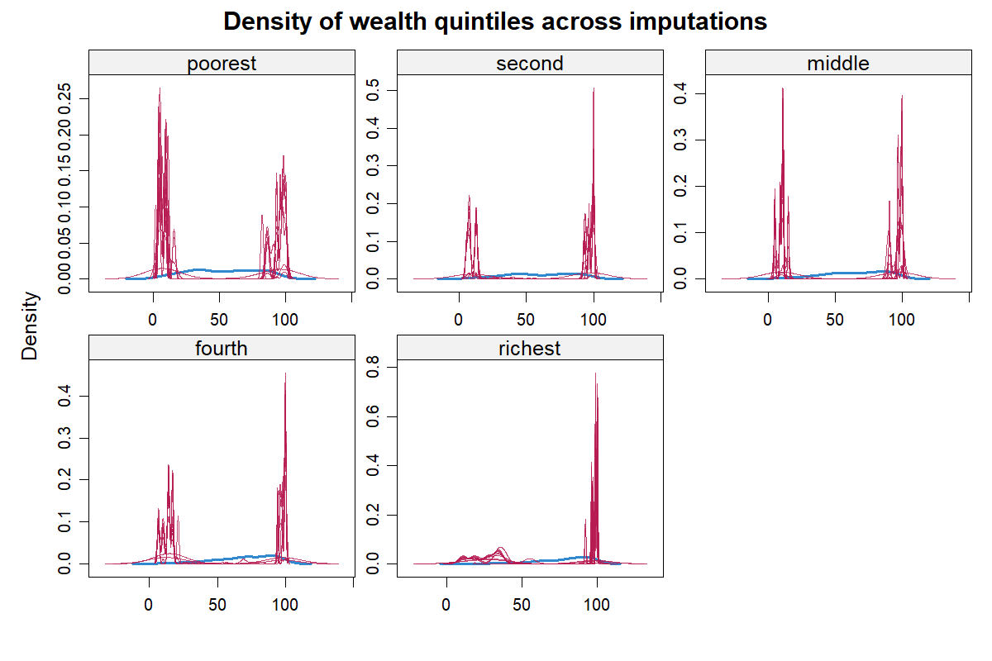
Figure 4: Density plots of the variables of wealth quintiles with imputations.
The comparison in Figure 4 of the worst quartile of the values before and after imputation further proves that the imputation process reinstated the missing values without creating any extreme, unrealistic values or artificial trends. The imputed curve preserves the distributional form of the observed data and extends to countries where wealth-quintile reporting was not conducted. This increases the predictive power to replicate global maternal health disparities and expands the number of countries that can be incorporated into predictive modelling. Such results solidify the methodological originality of the study by demonstrating that imputation and machine learning can be used collaboratively to address structural data gaps that have historically constrained the scope of global maternal-health surveillance.

The Stripplot in Figure 5 of poorest/imputations illustrates how the ANC4 coverage values in the poorest quintile are distributed across all the twenty-one imputed datasets. The figure shows a tight vertical grouping of points for each imputation value, indicating that the imputed values are close to the range and composition of the observed data.
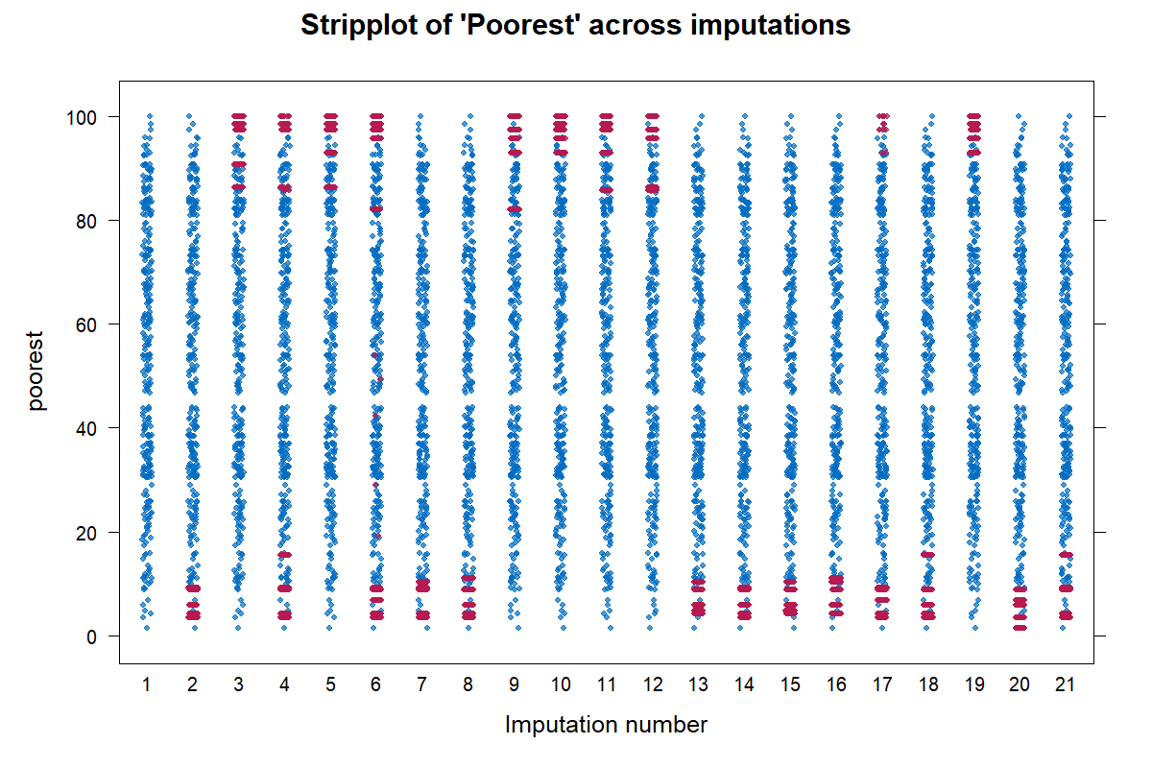
Figure 5: Stripplot of values of imputations of Poorest.
The regular vertical patterns indicate that the predictive mean-matching process delivered steady, predictable imputations with no artificial inflation or compression of the distribution. The red points indicating the initially observed values are embedded within the blue imputed values at each imputation cycle. Therefore, the imputation mechanism has preserved the original data structure, even while filling in gaps created by survey-based missingness. This pictorial consistency implies that the missing-at-random assumption holds and that the imputed values are valid measures of the underlying population variability, rather than artefacts of the model. Methodologically, the figure illustrates that the imputation approach did not alter the equity-sensitive properties of the data, especially in the worst quintile, which is one of the most effective predictors for downstream machine-learning models. The strength presented in this figure justifies sound modelling of structural inequalities ANC4 coverage, as well as policy interpretation that applies to SDG 3 and SDG 10, which entail an accurate depiction of underprivileged socioeconomic groups to monitor and act.
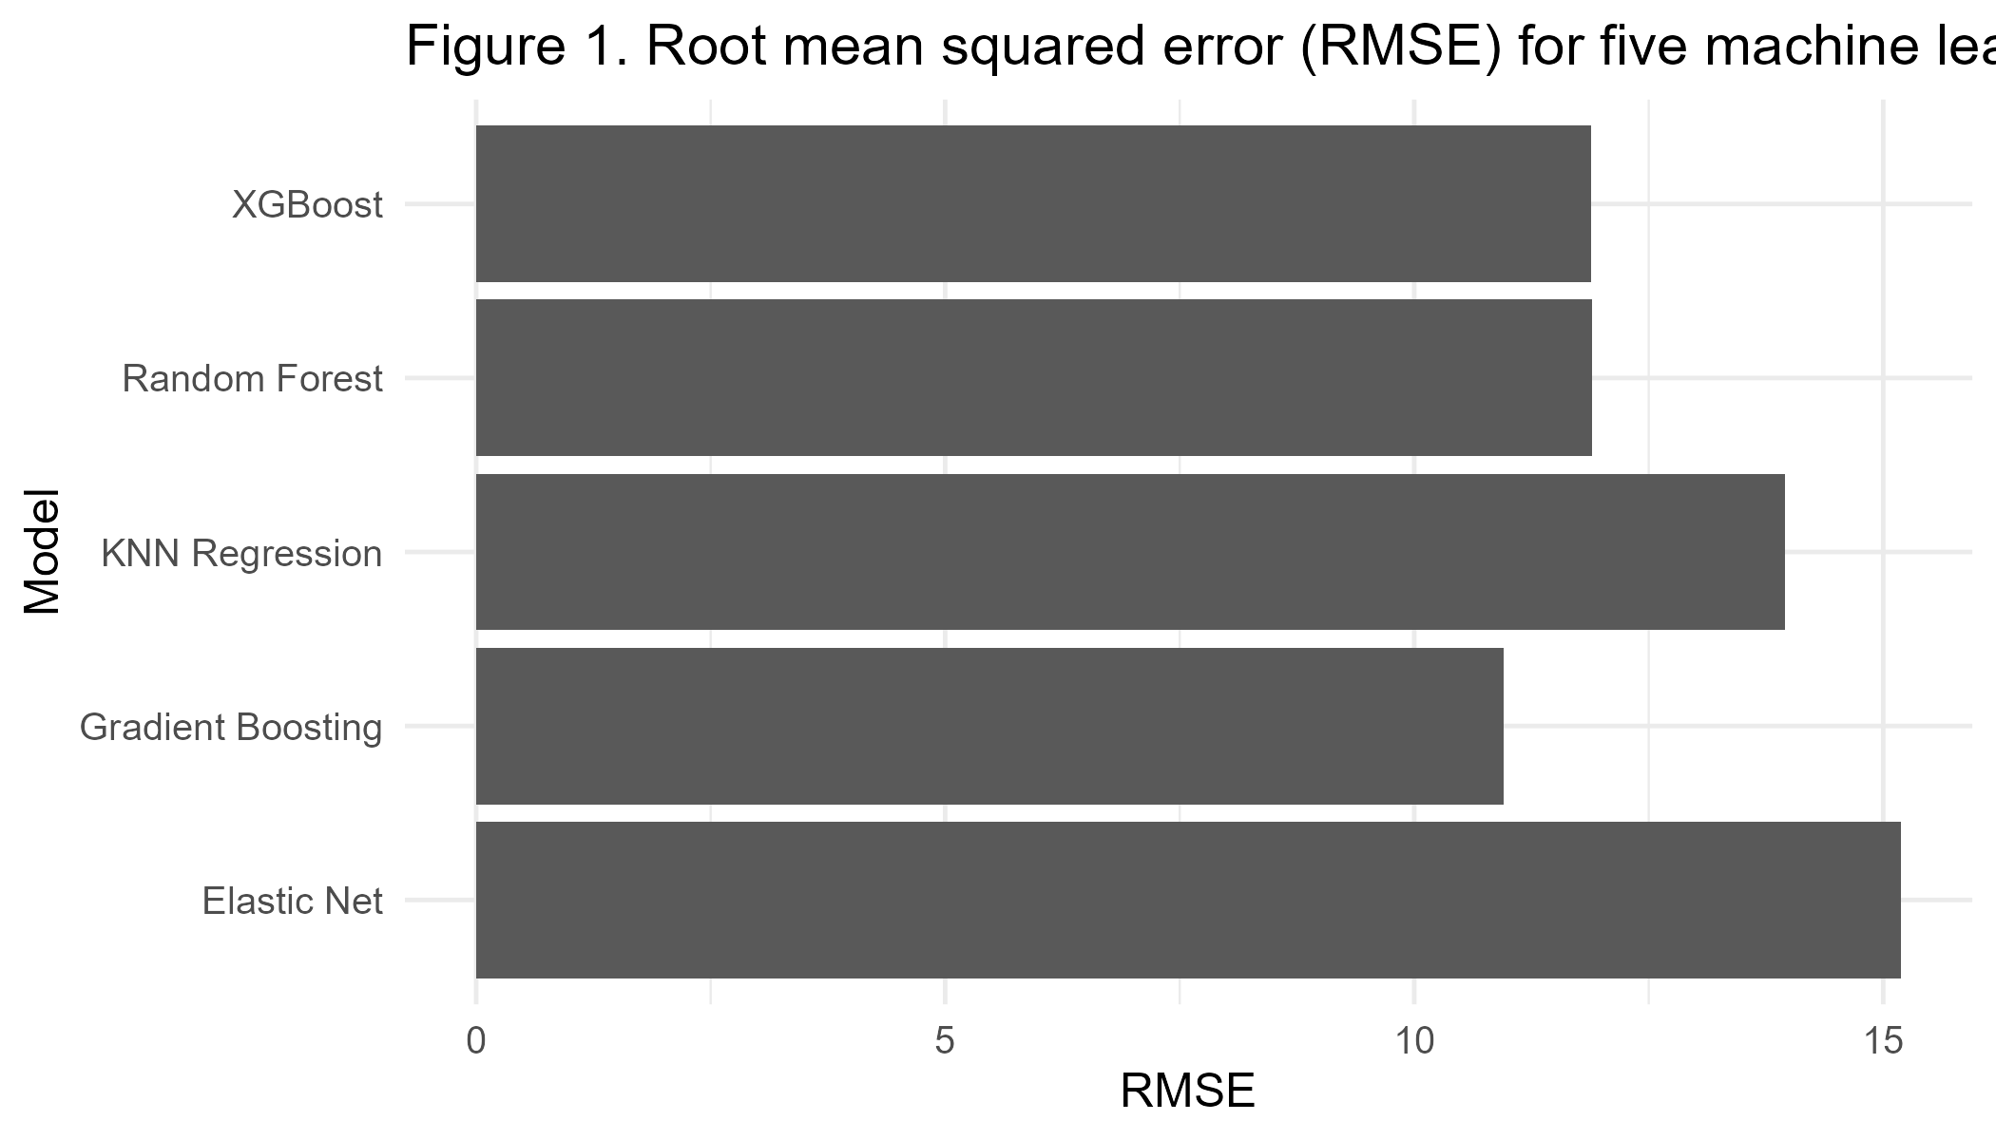
Figure 6: Root mean squared error (RMSE) for five machine learning models following multiple imputation.

Figure 6 presents a comparative summary of the predictive accuracy of the five machine learning algorithms considered in the present research, using the Root Mean Squared Error metric. The graphical rankings clearly indicate that Elastic Net yielded the lowest RMSE values, validating its inferior ability to model the nonlinear structure of global ANC4 coverage. KNN Regression is next, with a reasonably high RMSE, indicating its sensitivity to multidimensional scaling and the uneven distribution of country-year features. Random Forest and XGBoost can be shown to have even lower error rates, albeit lower than Gradient Boosting, which shows the highest performance with the lowest RMSE of all the models. The result aligns with Table 1, which supports the usefulness of ensemble tree-based algorithms in the presence of multifaceted, intersecting determinants of maternal health coverage. Figure 6 shows a direct relationship between policy development and SDGs 3.1 and 3.8, which demand precise forecasting tools to identify countries at risk of slow ANC development. The outstanding performance of Gradient Boosting implies that versatile, nonlinear models should be considered the core of global maternal health surveillance, particularly in areas where inequities and structural disparities affect service use. As Figure 6 illustrates the difference in the predictive accuracy of the models, it is possible to confirm the methodological applicability of advanced ensemble learners to the production of evidence-based and reliable guidance on health system strengthening.
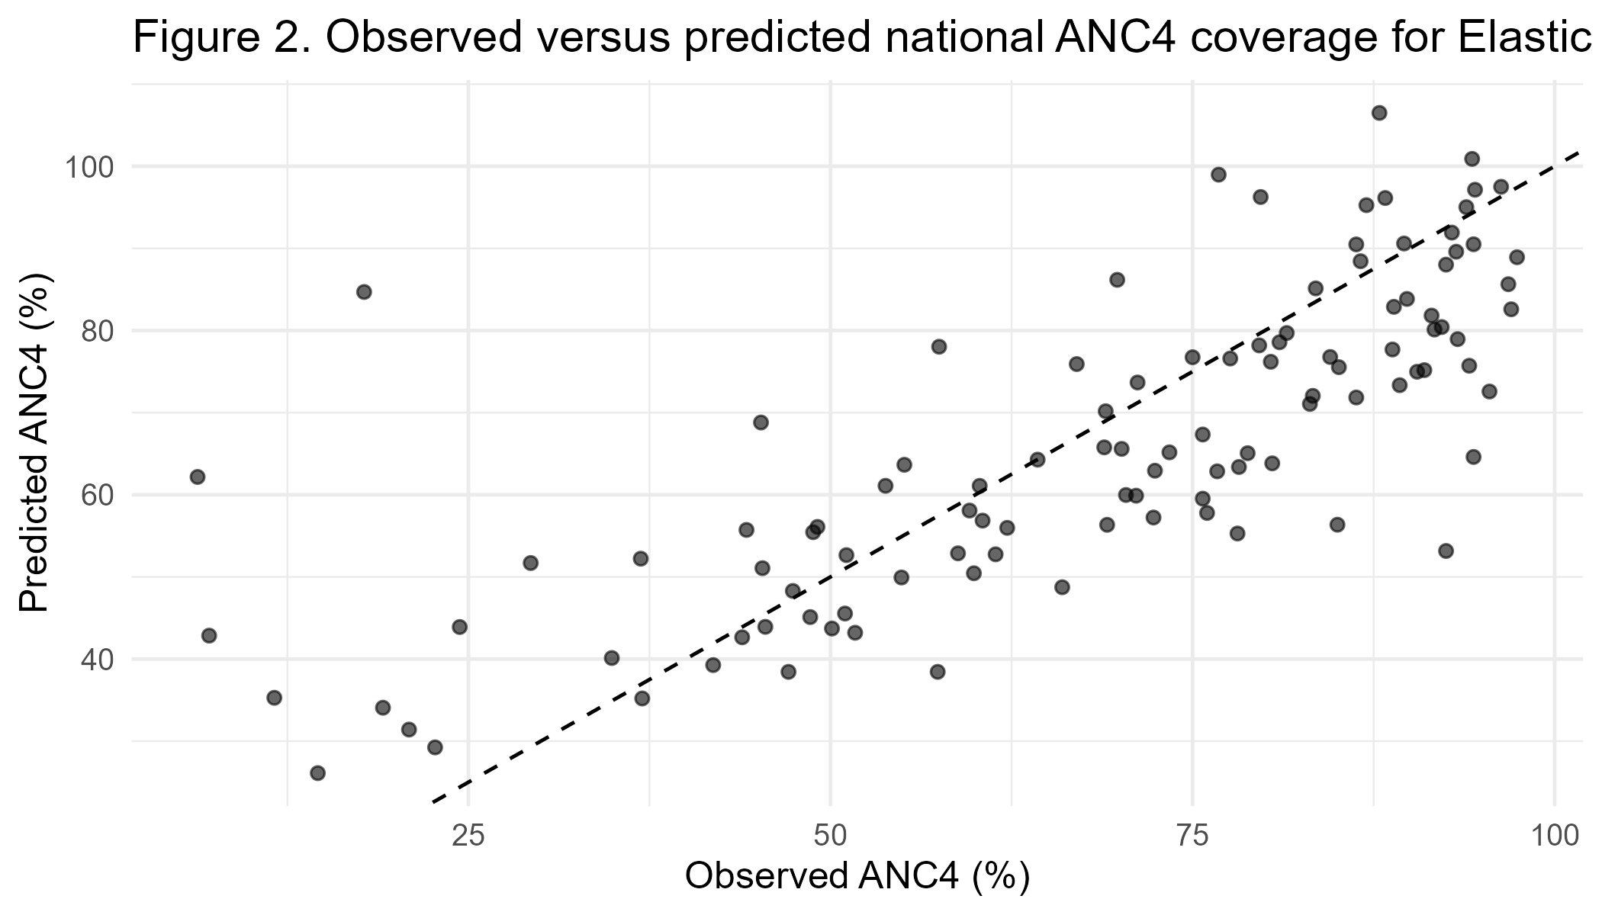
Figure 7: Predicted versus observed national ANC4 coverage of the Elastic Net model.
Lastly, Figure 7 provides a calibration check of the Elastic Net model for observed national ANC4 coverage and compares its predicted values by country-year with the observed values. The scatterplot shows a diffuse cloud of points around the 45-degree line, indicating that although a few predictions align well with the observed coverage, there are still significant deviations. The trend indicates that the Elastic Net systematically underestimates ANC4 coverage at the high end of the distribution, especially in countries with high-quality maternal health systems, and overestimates it in low-performing settings. This trend underscores the limitations of linear modelling for non-linear processes in global health. Figure 7 represents the deviations identified in Figure 6, which supports the conclusion that Elastic Net, as an interpretable predictor model, cannot offer the predictive accuracy needed to forecast global maternal health. The difference between the observed and projected values directly has policy implications. The problem with the wrong prediction of low-coverage countries is that it exposes vulnerable populations to inaccurate information, which may lead to serious consequences, including the need to invest heavily to achieve the SDG 3.1 goal of reduced maternal mortality. On the other hand, overestimating the coverage of high-coverage countries can lead to complacency in situations where even stagnation or decline remains a possibility. Figure 7 thus stresses that Elastic Net should be used primarily as an interpretive tool rather than a predictive one, and that hybrid pipelines that combine interpretability with high-performing non-linear predictive models are required to monitor ANC4 comprehensively.
The study delivered some important conclusions, culminating in a greater understanding of ANC4 determinants and predictive patterns worldwide. The initial significant result is that Gradient Boosting was selected as the best-performing model, with an RMSE of 10.95 and an R² of 0.79. This evidences the ability to increase algorithms and reflect nonlinear associations that characterise the use of the global antenatal care. Random Forest and XGBoost were also quite good, with R² values of approximately 0.75, which supports the claim that ensemble tree-based models are the most dominant for modelling a global health outcome with structural heterogeneity.
The second major conclusion is that, although less accurate, Elastic Net regression enabled interpretable coefficients, demonstrating the enduring role of structural socioeconomic inequalities. Wealth quintile variables, especially for the poorest population, were among the best predictors of national ANC4 coverage. The effects of income and financing constraints on the delivery of maternal health services are also supported by the negative coefficients for low- and lower-middle-income countries. The coefficients are used to measure the extent to which socioeconomic gradients are translated into differences in maternal health service uptake across countries.
The third significant discovery concerns the effective reconstruction of lost data using predictive mean matching. The use of density plots and stripplots showed that the imputation process maintained distributional invariance and produced consistent imputations on all the datasets. This result is especially important because the lack of wealth data is most common in low-income nations, and this would otherwise be omitted or distorted in maternal-health studies worldwide. The imputation's effectiveness reinforces the correctness, fairness, and applicability of the machine learning projections.
Finally, looking at global trends through pictures shows that ANC4 coverage varies a lot between income groups and the areas that UNICEF covers. Almost all of the high-income areas have ANC4 coverage, but the low-income areas are more variable and have a lower median overall. Regional trends show that development is slow and instability is growing in some areas. This shows that global maternal health goals are still out of reach in many states. The results point to the need for region-specific, equity-oriented policy measures.
Conclusion
The study offers an original, coordinated analytical model of global ANC4 coverage that integrates numerous imputations using machine learning and penalised regression. The study's structured missingness, combined with nonlinear modelling methods, can provide more accurate, equitable, and interpretable insights into maternal health than traditional analyses. The results validate the robustness of wealth, income group, and geographic area as structural factors in ANC4 coverage and predetermine the direction the country is going and the achievement of global maternal-health goals.
The fact that Gradient Boosting, Random Forest, and XGBoost models have greater predictive power suggests the need for flexibility and nonlinearity to model the complex pathways through which socioeconomic and regional factors can affect ANC4 outcomes. The degree of interpretive insight into Elastic Net coefficients is an addition to these insights, as they provide quantifiable evidence of inequity in income and wealth distributions. In combination, these modelling strategies provide an integrated perspective that can be used both to explain and forecast. The effective use of multiple imputation enhances the methodological contribution of the current research by ensuring that disadvantaged, data-poor countries are not left out of the global analysis due to missing data. The analytical pipeline described herein can serve as a template for future research on similar issues in global health, development surveillance, and equity policy evaluation.

Altogether, this research contributes to the development of maternal-health analytics by showing that current machine learning, grounded in strongly principled statistical premises, can be applied to improve health prediction and equity measurement worldwide. The insights produced here can assist policymakers, global agencies, and health planners in focusing intervention efforts and allocating resources to accelerate development towards SDG 3.1, SDG 3.8, and SDG 10. The findings underscore the scale of the investments required to mitigate socioeconomic and regional disparities in access to maternal health services, as well as the role of data science in enabling more responsive, evidence-driven decision-making. The Ministries of Health are recommended to pay attention to the growth of funding and outreach in low-income and underperforming regions identified by the models, so that ANC4 coverage gains can be achieved more quickly.
Declarations
Data availability statement
The data supporting this study are publicly available
Ethics Statement
As the data are deidentified and aggregated at the population level, no ethical approval was needed. The study adheres to all ethical guidelines for the use of publicly accessible data. It ensures that the information is used solely for academic and research purposes to inform public health strategies.
Conflicts of interest
The authors declare that they have no competing interests.
Consent for Publication
Not applicable in the clinic
Trial Number
Not applicable

COMPETING INTERESTS DISCLAIMER:
Authors have declared that they have no known competing financial interests OR non-financial interests OR personal relationships that could have appeared to influence the work reported in this paper.
References
- Abate, B. J., Melesse, A. W., Brhan, H., & Agimas, M. C. (2025). Spatial variation, pooled prevalence, and factors associated with perinatal mortality in Sub-Saharan Africa, evidence from demographic and health surveys 2015-2023: a geospatial regression approach. EClinicalMedicine, 81. https://doi.org/10.1016/j.eclinm.2025.103137
- Achamyeleh, H., Belachew, A., & Yilma, M. (2025). Assessment of effective coverage of antenatal care and factors affecting its outcome in Ethiopia. BMC Pregnancy and Childbirth, 25(1), 859. https://doi.org/10.1186/s12884-025-07984-4
- Akuze, J., Ngatia, B., Amare, S. Y., Wanduru, P., Otieno, G. P., Kananura, R. M., Kirakoya-Samadoulougou, F., Amouzou, A., Estifanos, A. S., & Ohuma, E. (2024). Unlocking the transformative potential of data science in improving maternal, newborn and child health in Africa: a scoping review protocol. BMJ open, 14(12), e091883. https://doi.org/10.1136/bmjopen-2024-091883
- Alhassan, Y., Otiso, L., Okoth, L., Murray, L., Hemingway, C., Lewis, J. M., Oguche, M., Doyle, V., Muturi, N., Ogwang, E., Barsosio, H. C., & Taegtmeyer, M. (2024). Four antenatal care visits by four months of pregnancy and four vital tests for pregnant mothers: impact of a community-facility health systems strengthening intervention in Migori County, Kenya. BMC Pregnancy and Childbirth, 24(1), 224. https://doi.org/10.1186/s12884-024-06386-2
- Assefa, E. D., Alem, S. G., Yallew, W. W., Teshite, D., Berhanu, D., Bekele, G., Gebremariam, A., Gebremedhin, S., & Worku, A. (2025). Equity analysis for Group-ANC in Ethiopia: Exploring how wealth and educational status interact with ANC attendance and facility delivery. medRxiv. https://doi.org/10.1101/2025.10.19.25338328
- Ayiah-Mensah, F., Minkah, R., Asiedu, L., & Mettle, F. O. (2021). An enhanced method for tail index estimation under missingness. Journal of Applied Mathematics, 2021(1), 3572555. https://doi.org/10.1155/2021/3572555
- Baffour, B., Das, S., Talukder, A., & Richardson, A. (2025). The Effect of Space, Time and Night-Time Light Intensity on Antenatal Care Coverage in Bangladesh. Spatial Demography, 13(1), 12. https://doi.org/10.1007/s40980-025-00144-4
- Baffour, B., Das, S., Talukder, A., & Richardson, A. (2025). The Effect of Space, Time and Night-Time Light Intensity on Antenatal Care Coverage in Bangladesh. Spatial Demography, 13(1), 12. https://doi.org/10.1007/s40980-025-00144-4
- Baffour, B., Das, S., Talukder, A., & Richardson, A. (2025). The Effect of Space, Time and Night-Time Light Intensity on Antenatal Care Coverage in Bangladesh. Spatial Demography, 13(1), 12. https://doi.org/10.1007/s40980-025-00144-4
- Bitewa, M. D., Solomon, M., Kassie, T. D., Getnet, M., & Molla, A. (2025). The pooled prevalence and associated factors of dropout from maternal continuum of care among mothers in 41 low-and middle-income countries, after the Sustainable Development Goals: a multilevel analysis. medRxiv https://doi.org/10.1101/2025.11.03.25339360
- Dandona, R., Kumar, G. A., Majumder, M., Akbar, M., Dora, S. S. P., & Dandona, L. (2024). Poor coverage of quality-adjusted antenatal care services: a population-level assessment by visit and source of antenatal care services in Bihar state of India. The Lancet Regional Health-Southeast Asia, 25, 100332. https://doi.org/10.1016/j.lansea.2023.100332
- Dandona, R., Kumar, G. A., Majumder, M., Akbar, M., Dora, S. S. P., & Dandona, L. (2024). Poor coverage of quality-adjusted antenatal care services: a population-level assessment by visit and source of antenatal care services in Bihar state of India. The Lancet Regional Health-Southeast Asia. https://doi.org/10.1016/j.lansea.2023.100332
- Demissie, K. A., Jejaw, M., Wondimu, B. G., Mersha, Y. T., Demsash, E. S., Dessie, S. G., Teshome, A. G., Geberu, D. M., & Tiruneh, M. G. (2024). Only 9% of mothers have eight and more ANC visit in 14 sub-saharan African countries; evidence from the most recent DHS 2018–2023: a multilevel analysis. BMC Public Health, 24(1), 1631. https://doi.org/10.1186/s12889-024-19145-x
- Getnet, M., Gela, Y. Y., Maru, L., Getahun, A. B., Tesfaye, E., Adugna, D. G., & Bitew, D. A. (2025). Identifying spatial variation, individual and community-level determinants affecting quality of antenatal care among women in sub-Saharan Africa: evidence from nationally representative cross-sectional surveys. BMJ open, 15(8), e088031. https://doi.org/10.1136/bmjopen-2024-088031
- Goli, S., Bhattacharyya, N., Balla, S., & Ram, H. (2025). Effect of Exposure to Conflicts and Childhood Mortality: Analyses of Pooled Cross-Sectional Data from 105 Surveys from 52 Countries. https://papers.ssrn.com/sol3/papers.cfm?abstract_id=5399660
- Habte, A., Tamene, A., & Melis, T. (2024). Compliance towards WHO recommendations on antenatal care for a positive pregnancy experience: Timeliness and adequacy of antenatal care visit in Sub-Saharan African countries: Evidence from the most recent standard Demographic Health Survey data. Plos one, 19(1), e0294981. https://doi.org/10.1371/journal.pone.0294981
- Habte, A., Tamene, A., & Melis, T. (2024). Compliance towards WHO recommendations on antenatal care for a positive pregnancy experience: Timeliness and adequacy of antenatal care visit in Sub-Saharan African countries: Evidence from the most recent standard Demographic Health Survey data. Plos one, 19(1), e0294981. https://doi.org/10.1371/journal.pone.0294981
- Hone, T., Gonçalves, J., Seferidi, P., Moreno-Serra, R., Rocha, R., Gupta, I., Bhardwaj, V., Hidayat, T., Cai, C., Suhrcke, M., & Millett, C. (2024). Progress towards universal health coverage and inequalities in infant mortality: an analysis of 4·1 million births from 60 low-income and middle-income countries between 2000 and 2019. The Lancet Global Health, 12(5), e744-e755. https://doi.org/10.1016/S2214-109X(24)00040-8
- Jiwani, S. S., Rana, S., Hazel, E. A., Maïga, A., Wilson, E. B., & Amouzou, A. (2025). Building an effective coverage cascade for antenatal care: linking of household survey and health facility assessment data in eight low- and middle-income countries. Journal of Global Health, 15, 04048. https://doi.org/10.7189/jogh.15.04048
- Joseph, A., Ngatia, B., Amare, S. Y., Wanduru, P., Otieno, G. P., Kananura, R. M., Kirakoya-Samadoulougou, F., Amouzou, A., Estifanos, A. S., & Ohuma, E. (2024). Unlocking the transformative potential of data science in improving maternal, newborn and child health in Africa: a scoping review protocol. BMJ Open, 14(12), e091883. https://doi.org/10.1136/bmjopen-2024-091883
- Khallouf, F., & Newton, S. (2025). The association between the number of Antenatal Care (ANC) visits and neonatal mortality in Afghanistan: a cross-sectional study based on the 2015 Demographic and Health Survey. medRxiv. https://doi.org/10.1101/2025.10.06.25337466
- Kim, H., Han, H., Phommachan, K., Yang, Y. S., & Kim, S. H. (2025). Incomplete antenatal care despite high coverage: geographic and sociocultural barriers in Lao PDR. Frontiers in Public Health, 13, 1625379. https://doi.org/10.3389/fpubh.2025.1625379
- Kpebo, D. O. D., Koffi-Koumi, M. D. M., Agbré-Yacé, M. L., Kamenan, J. E. D., Aké-Tano, O. S., Yavo, W., Mady, G. R. M., Senghor, D. B., & Faye, C. M. (2025). Trends in reproductive and maternal healthcare indicators, Côte d’Ivoire, 2018 to 2020. Journal of Public Health in Africa, 16(1), 1301. https://doi.org/10.4102/jphia.v16i1.1301
- Ngusie, H. S., Mengiste, S. A., Zemariam, A. B., Molla, B., Tesfa, G. A., Seboka, B. T., & Sun, J. (2024). Predicting adverse birth outcome among childbearing women in Sub-Saharan Africa: employing innovative machine learning techniques. BMC Public Health, 24(1), 2029. https://doi.org/10.1186/s12889-024-19566-8
- Patil, C. L., Norr, K. F., Kapito, E., Liu, L. C., Mei, X., Chodzaza, E., Chorwe-Sungani, G., Kafulafula, U., Abrams, E. T., Desloge, A., Gresh, A., Jeremiah, R. D., Patel, D. R., Batchelder, A., Wang, H., Faydenko, J., Rising, S. S., & Chirwa, E. (2025). Group antenatal care positively transforms the care experience: Results of an effectiveness trial in Malawi. PLoS One, 20(6), e0317171. https://doi.org/10.1371/journal.pone.0317171
- Sibanda, K., Ndayizigamiye, P., & Twinomurinzi, H. (2024). Industry 4.0 Technologies in Maternal Health Care: Bibliometric Analysis and Research Agenda. JMIR Pediatrics and Parenting. https://doi.org/10.2196/47848
- Siddiqi, D. A., Memon, M., Iftikhar, S., Siddique, M., Dharma, V. K., Ahmad, A., Safdar, N., Shah, M. T., Setayesh, H., Sodhar, I. A., Malik, F. R., & Chandir, S. (2025). Estimating prevalence and identifying predictors of zero-dose pentavalent and never-immunized children under two years of age in Kashmore and Sujawal Districts of Sindh, Pakistan: An analysis of household survey data. PLoS One, 20(8), e0330281. https://doi.org/10.1371/journal.pone.0330281
- Singh Sardar, S., Bhattacharya, S., & Mandal, M. (2025). Exploring the Factors Influencing Antenatal Care Utilization in India: A Study on Socioeconomic and Caste Disparities, with Logistic Regression Analysis and Outlier Detection Using NFHS-5 Data. Global Social Welfare. https://doi.org/10.1007/s40609-025-00375-9
- Tohan, M. M., Islam, M. A., & Rahman, M. A. (2024). Exploring the factors behind socioeconomic inequalities in Antenatal Care (ANC) utilization across five South Asian natiaons: A decomposition approach. PLOS ONE, 19(8), e0304648. https://doi.org/10.1371/journal.pone.0304648
- Worku, A., Mekonnen, W., Gebremedhin, S., & Egata, G. (2025). Facilitators and barriers to the implementation of the WHO ANC-8 contact model among pregnant women: a systematic review in low- and middle-income countries. medRxiv. https://doi.org/10.1101/2025.09.21.25336293
- Yoseph, A., Kifle, K., Berego, Y. S., Belayneh, M., Tamiso, A., Mutwiri, G., & Guillen-Grima, F. (2025). What we know and don’t know about the antenatal care service utilization in Ethiopia: A scoping review of the literature. PLoS One, 20(5), e0321882. https://doi.org/10.1371/journal.pone.0321882

