Global Research Landscape of Human-Wildlife Conflict: A Bibliometric Perspective (1989-2025)

.
ABSTRACT

Aims: To provide a comprehensive bibliometric analysis of Human-Wildlife Conflict (HWC) research from 1989 to 2025, with specific objectives to analyze publication trends, influential authors, leading journals, thematic evolution and collaboration networks in the field.
Study design: This study employs a quantitative bibliometric research design focusing on published literature indexed in the Scopus database within the subject domains of Economics, Econometrics, Finance, Social Sciences, and Agricultural and Biological Sciences.
Place and Duration of Study: The analysis was conducted at the College of Agriculture, Vellayani in September 2025, using data extracted from Scopus covering the period between 1989 and 2025.
Methodology: The dataset comprised 2,916 Scopus-indexed documents related to HWC. Data were analyzed using Biblioshiny (version 4.3.3) within RStudio and VOSviewer for network visualization. Analytical dimensions included annual publication trends, citation analysis, leading journals, authors, institutional affiliations, bibliographic coupling among countries, and keyword clustering to map conceptual and thematic structures of HWC research over time.
Results: Findings revealed exponential growth in HWC publications, with a distinct surge post-2010 and peak years around 2021-2023. Journal articles accounted for 2,563 documents (88 per cent), with Biological Conservation, Oryx, and Human Dimensions of Wildlife emerging as key publication outlets. Collaborative authorship increased globally, with 39 per cent of publications involving international co-authorship led by the United States, United Kingdom, India, South Africa, and Australia. Thematic mapping identified transition from species-specific conflict studies toward interdisciplinary frameworks integrating coexistence, socioecological governance, and policy research.
Conclusion: This bibliometric evaluation highlights the expanding and diversifying nature of global HWC research while underscoring regional and disciplinary imbalances. Strengthening research capacity in biodiversity rich developing regions and promoting interdisciplinary, evidence driven approaches are essential for developing equitable, community centered strategies that foster sustainable human-wildlife coexistence.

Keywords: human-wildlife conflict, bibliometric analysis, conservation, collaboration networks, research trends

1. INTRODUCTION

Human-Wildlife Conflict (HWC) represented one of the most pressing challenges at the interface of biodiversity conservation and human development (Madden, 2004; Nyhus, 2016). As human population expanded and land use patterns intensified, natural habitats were increasingly fragmented, forcing wildlife to coexist within human dominated landscapes (Nyhus, 2016; Sharma et al., 2021). This interaction often resulted in detrimental outcomes for both humans and animals manifesting as crop raiding (Schley and Roper, 2003; Hill, 2004; Kagoro-Rugunda, 2004), livestock depredation (Woodroffe et al., 2005; Inskip & Zimmermann, 2009; Asaye et al., 2024), property destruction ( Schell et al., 2021), transmission of zoonotic diseases (Magouras et al., 2020; Debnath et al., 2021; Fauziah et al., 2024), and, in extreme cases, human and wildlife fatalities ( Sharma et al., 2021; Baral et al., 2022; Yazezew et al., 2022). Such conflicts not only undermined conservation goals (Woodroffe & Ginsberg, 1998; Treves et al., 2006; Messmer, 2009) but also threatened the livelihoods, food security, and socioeconomic stability of rural and agrarian communities that depended heavily on natural resources (Salerno et al., 2016; Braczkowski et al., 2023).
The growing importance of understanding HWC stemmed from its dual impact on ecological sustainability and human wellbeing. On the ecological front, frequent conflicts triggered retaliatory killings and habitat degradation, leading to population decline of threatened species and loss of ecosystem services (Braczkowski et al., 2023; Wangchuk et al., 2025). On the socioeconomic front, wildlife induced damages could perpetuate poverty cycles, reduce agricultural productivity, and erode local support for conservation programs (Paudel et al., 2024; Malate et al., 2025). For instance, in Himalayan and sub-Saharan regions, recurrent crop and livestock losses had shown to significantly reduce household income and food self-sufficiency (Ferdin et al., 2024; Malate et al., 2025). These intertwined consequences illustrated how HWC extended beyond a conservation concern, becoming a multidimensional governance and developmental issue (Xu et al., 2019; Abas et al., 2025).
The relevance of studying HWC had become even more critical in the current global scenario. Anthropogenic drivers such as habitat fragmentation, rapid urbanization, and climate change had intensified human-wildlife interactions, altering animal movement patterns and increasing competition for diminishing natural resources (Mahakata et al., 2025). Simultaneously, expanding agricultural frontiers and infrastructure projects invading wildlife habitats, amplifies the frequency and severity of conflict incidents (Ma et al., 2024; Xu et al., 2019). Climate variability intensified the problem by altering the availability of natural resources, compelling wildlife to adjust their habitats and shift into agricultural lands or peri-urban regions. Consequently, HWC had emerged as an environmental and humanitarian crisis that demands interdisciplinary and evidence driven responses (Braczkowski et al., 2023; Abas et al., 2025).
In this context, a bibliometric analysis on HWC becomes highly relevant. It would also provide a thematic evolution, which maps collaboration networks, analysis into how the field had progressed over time and where critical knowledge gap remained (Ridwan et al., 2023; Abas et al., 2025). Understanding publication trends, citation networks, and geographic pattern of research in this field could reveal the balance between ecological and social perspectives within HWC studies (Abas et al., 2025). It also helps to identify underrepresented taxa and regions, guiding future investigations toward more inclusive and context specific research agendas (Ridwan et al., 2023; Abas et al., 2025). Moreover, bibliometric mapping supports policy formulation by highlighting which mitigation strategies such as compensation schemes, livelihood diversification, or community based management receives the most academic attention and where practical translation of research findings are limited (Paudel et al., 2024; Malate et al., 2025).
Thus, in an era of accelerating global change, analyzing trends and patterns in HWC literature is not merely an academic exercise but a necessary step toward sustainable coexistence between humans and wildlife (Ridwan et al., 2023; Abas et al., 2025). A systematic bibliometric evaluation could help researchers, practitioners, and policymakers understand how HWC discourse evolves, assess its global reach, and align future research and conservation policies with emerging socio-ecological realities (Braczkowski et al., 2023; Abas et al., 2025).
More specifically, this article aimed to: (1) analyze the annual trend in publications and citations on HWC research from 1989-2025; (2) identify the most relevant journals publishing HWC related studies; (3) identify the most influential authors and leading institutions in the field of HWC research; (4) investigate collaboration networks among authors, institutions, and countries in publications on HWC; (5) identify the most frequently used keywords and core research themes on HWC research topic; (6) identify the most globally cited documents on HWC; and (7) explore the major thematic clusters, research hotspots, and intellectual structure of HWC literature from 1989-2025.

2. material and methods

2.1 DATA EXTRACTION

Scopus, developed by Elsevier, is one of the most comprehensive and curated abstract and citation database, indexing more than 76 million records across 39,000 journals, 120,000 conferences, and over 200,000 books spanning various disciplines (Thelwall, 2020; Maddi et al., 2025). It provides advanced search features allowing users to filter results by author, keyword, journal, or institution, thus supporting precise literature retrieval (Maddi et al., 2024). The platform’s quality assurance is maintained by the independent Content Selection and Advisory Board (CSAB), which ensures rigorously peer reviewed content (Thelwall, 2020). Scopus also uphold high data accuracy, achieving around 99.9 per cent precision and 98.3 per cent recall in citation linking (Maddi et al., 2024). The analytical tools employed by Scopus enabled users to measure research trend and citation impact at author, journal, or institutional levels, making it a preferred source for bibliometric analysis (Abas et al., 2025). Continuous quality monitoring further ensures that unreliable or predatory sources are excluded, preserving the scholarly integrity of Scopus as a data source for academic evaluation (Thelwall, 2020).
These features made it an ideal database for bibliometric analysis of HWC. The present research study was selected between 1989 to 2025 span of time. The search was conducted on September 28, 2025, using "human wildlife conflict" as the keyword, and a total of 2,916 articles were identified within the subject area of economics, econometrics, and finance.

2.2 BIBLIOMETRIC METHODOLOGY

Bibliometric analysis utilized quantitative methods to examine patterns and relationships within extensive scientific literature (Karantali & Panagiotidis, 2024). It served as a valuable approach for evaluating research quality, identifying major thematic areas, and forecasting future research trajectories. Among the analytical tools, VOSviewer was highly regarded for its ability to visualize and map bibliometric data effectively (Yu et al., 2020). Similarly, Biblioshiny, an R-based application, facilitated the identification of prominent authors, key institutions, influential countries, and recurring keywords through network visualization outputs (Abas et al., 2025).
In this study, bibliometric analysis was carried out using Biblioshiny version 4.3.3 within RStudio, which provided a wide range of statistical and visualization tools for evaluating performance and conceptual structure in research field. Data analysis involved a combination of VOSviewer, Biblioshiny, and Microsoft Excel. Specifically, VOSviewer was applied to visualize bibliographic coupling between countries and to assess keyword co-occurrence pattern, while Biblioshiny was used to analyze publication and citation trend, leading journals, influential authors, contributing institutions, major countries, and to generate visual representations such as word clouds and tree maps.

3. results and discussion

3.1. ANNUAL PUBLICATION TREND

The annual publication trend revealed a consistent and exponential growth in HWC research from 1989 to 2025, demonstrating the increasing global attention to this conservation challenge. Fig. 1 showed distinct phases of growth, with minimal publications during the early period (1989-2000), followed by gradual acceleration in the 2000s, and a marked surge after 2010. The peak publication year appeared to be around 2021-2022, reflecting heightened research interest during this period.

Fig. 1. Annual publication trend from 1989 to 2025

This upward trajectory aligned with findings from previous bibliometric studies, where Sharma et al. (2021) observed a 57 per cent increase in HWC publications in the Hindu Kush Himalaya region during the last decade, while Woolaston et al. (2021) noted that climate change and habitat fragmentation intensified conflict scenarios globally. Su et al. (2022) further indicated that this publication surge reflected multiple factors including increased human encroachment into wildlife habitats, escalating conservation concerns, and growing recognition of HWC as a critical barrier to biodiversity conservation and sustainable development. Ridwan et al. (2023) reported an annual growth rate of 5.16 per cent in HWC publications from 1991 to 2023, and Abas et al. (2025) documented 4,822 articles in their comprehensive review. The trend also suggested that HWC had evolved from a peripheral conservation issue to a central research priority.

3.2. AVERAGE CITATIONS PER YEAR

The annual average citation pattern demonstrated the research impact and knowledge diffusion within the HWC domain over time, as shown in figure 2. The citation trajectory typically showed lower averages in early years (1989-2000), followed by peaks during the mid-2000s to 2010s, with potential declining trends in recent years. This pattern was characteristic of citation dynamics where older publications accumulated citations over extended periods, while recent publications had shorter citation windows. The declining average citations in recent years did not necessarily indicate reduced research quality but rather reflected the time lag effect inherent in academic citation practices. This phenomenon was well documented in bibliometric literature, where publications required several years to accumulate substantive citations.

Fig. 2. Annual average citation pattern from 1989 to 2025

Ridwan et al. (2023) noted similar patterns in their HWC bibliometric analysis, emphasizing that citation metrics had to be interpreted considering publication age. The citation patterns also revealed which research periods produced the most influential work, with peak citation averages likely corresponding to seminal publications on HWC mitigation strategies, ecological modeling, and policy frameworks. High impact publications from the 2010s period often addressed emerging themes such as community based conflict management (Treves et al., 2006) and human-wildlife coexistence frameworks (König et al., 2020), and interdisciplinary approaches integrating social and ecological dimensions. The citation dynamics underscored the evolution of HWC research from purely biological and ecological perspectives to more holistic frameworks incorporating socioeconomic, psychological, and governance dimensions (Abas et al., 2025).

3.3. MOST RELEVANT JOURNALS

The distribution of publications across journals (Figure 3) revealed the multidisciplinary nature of HWC research and identified the primary academic outlets for this field. The leading journals included specialized conservation journals such as Biological Conservation, Oryx, Human Dimensions of Wildlife, and broader ecological journals like Conservation Biology and Biodiversity and Conservation. Ridwan et al. (2023) identified Biological Conservation as the most productive journal, followed by Oryx and Human Dimensions of Wildlife, reflecting the field's strong roots in conservation biology and human-wildlife interactions. Su et al. (2022) similarly reported that HWC publications spanned 320 journals, indicating widespread academic interest across multiple disciplines.

Fig. 3: Top contributing journals in HWC research

The presence of multidisciplinary journals in the top contributors list demonstrates the field's expansion beyond traditional conservation science into social sciences, economics, and policy studies. Abas et al. (2025) found that HWC publications covered 24 subject categories in Scopus, with Environmental Science, Agricultural and Biological Sciences, and Social Sciences being most prominent. The journal distribution also reflects evolving research paradigms, with increasing representation from interdisciplinary outlets addressing complex socioecological systems. Journals focusing on wildlife management, sustainability, and environmental policy have emerged as important platforms for HWC scholarship, reflecting the field's integration of technical mitigation approaches with community engagement and policy implementation frameworks. The diversity of publishing outlets suggested that HWC research reaches varied academic audiences, from ecological modelers to social scientists, policy makers, and conservation practitioners, facilitating knowledge transfer across disciplinary boundaries essential for holistic conflict resolution.

3.4. LEADING AUTHORS IN HWC RESEARCH

The analysis of leading authors (Figure 4) identified the key researchers driving HWC scholarship and revealed collaboration patterns within the field. The most productive authors typically demonstrated sustained research programs that focused on specific taxa, geographical regions, or methodological approaches to conflict assessment and mitigation. Author productivity metrics revealed both individual excellence and the collaborative nature of HWC research, where multiauthor publications were increasingly common (Mnzava et al., 2022). The geographical distribution of leading authors reflected the global nature of HWC, with significant contributions from researchers based in biodiversity rich regions experiencing acute conflict situations, including Africa, Asia, and Latin America, as well as substantial contributions from researchers in developed countries with advanced research infrastructure (Su et al., 2022). Previous bibliometric analyses had shown that while individual author productivity varied, the field was characterized by distributed contribution patterns rather than dominance by a few prolific researchers (Ridwan et al., 2023). Abas et al. (2025) identified 4,065 authors contributing to HWC research globally, with most studies originating from the United States, indicating widespread international participation.

Fig. 4. Leading authors in HWC research

The leading authors often specialized in particular conflict contexts, such as large carnivore-human interactions, elephant-agriculture conflicts, or primate depredation issues, bringing deep domain expertise to the field. The co-authorship patterns among leading authors demonstrated the evolution of research networks, with increasing international collaborations addressing transboundary conservation issues and comparative studies across different conflict contexts. The prominence of certain authors also reflected their role in developing influential theoretical frameworks, innovative methodological approaches, or long term field studies that had shaped the discipline's direction, particularly in areas such as compensation schemes, community based conservation, and conflict prediction modeling.

3.5. DISTRIBUTION OF AFFILIATIONS HAVING HWC RESEARCH FROM 1989 TO 2025

The institutional affiliation distribution revealed the global academic infrastructure supporting HWC research and highlighted the role of universities, research institutes, and conservation organizations in advancing this field (Figure 5). The analysis likely showed concentration of HWC research in institutions located in both biodiversity hotspots experiencing direct conflict and academic centers in developed countries with strong conservation science programs. Abas et al. (2025) found that HWC research was widely distributed across institutions globally, with universities in the United States, United Kingdom, and Australia being particularly productive. The presence of institutions from diverse geographical contexts demonstrated the universality of HWC challenges and the global commitment to addressing them through research (Su et al., 2022). Universities in countries such as Kenya, Tanzania, South Africa, India, and Brazil featured prominently in HWC research, reflecting the acute nature of conflicts in these biodiversity rich developing nations where rural communities bore disproportionate costs of living with wildlife (Braczkowski et al., 2023).

Fig. 5. The distribution of different affiliations having HWC research from 1989 to 2025

The affiliation patterns also revealed the role of specialized research centers, wildlife conservation organizations, and government agencies in contributing to HWC scholarship, extending research beyond traditional academic institutions. International research partnerships were evident in the affiliation data, with many publications showing collaborations between institutions in developed and developing countries, facilitating knowledge exchange, capacity building, and resource sharing (Mnzava et al., 2022). The institutional distribution also reflected evolving research priorities, with newer institutions in emerging economies increasingly contributing to HWC literature as their research capacity developed and local conflict issues demanded evidence based solutions. The presence of interdisciplinary research centers and institutes focusing on sustainability, ecosystem management, and socioecological systems indicated the field’s maturation and integration into broader environmental research agendas addressing human-nature relationships.

3.6. MOST GLOBALLY CITED DOCUMENTS

The bibliographic coupling network (Fig.6) visualized in the image highlighted key papers and authors that had strong commonalities in their cited references within the field of HWC research. Central nodes such as Dickman (2010), Barua (2013), Soulsbury (2015), Nyhus (2016), and Van Eeden (2018) represented foundational works, each forming the nucleus of distinct clusters of related articles. The clusters, indicated by different colors, demonstrated interconnected scholarly communities, revealing both the prominent literature and the collaborative structure of the research landscape. The size of each node corresponded to the bibliographic coupling strength, illustrating the influence and degree of interrelatedness of each document within the network.
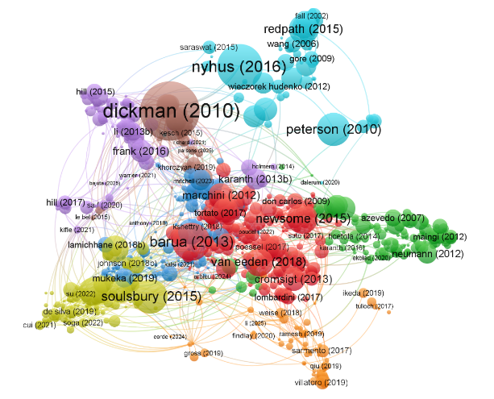
Figure 6: Most cited documents from 1989 to 2025

This visualization demonstrated the interdisciplinary and interconnected nature of research on HWC, where certain papers acted as bridges across thematic clusters. Works by Dickman (2010) and Nyhus (2016) not only anchored their respective clusters but also showed significant interconnections with other nodes, emphasizing their impact in shaping discussions and methodologies in the field. The colored clusters reflected specific research themes or schools of thought, while linkages across clusters indicated cross-thematic influences and the flow of ideas between different research domains. Such a map is invaluable for identifying both influential research and emerging trends, helping scholars navigate literature by revealing both well-cited hubs and intellectual linkages within the scholarly community.

3.7. COUNTRIES WITH MOST PUBLICATIONS
The geographical distribution of publications highlighted global research capacity and regional priorities in HWC research. Leading contributors included the United States, United Kingdom, India, Australia, South Africa, Kenya, Tanzania, Canada, Germany, and China, representing both developed and developing nations (Figure 7). Su et al. (2022) reported U.S. leadership with research contributions from 128 countries, while Ridwan et al. (2023) also identified the U.S. as having the highest publication frequency. U.S contributing 27.9 per cent of global HWC publications (1,819 articles), reflected its strong academic infrastructure, conservation funding, and established wildlife management tradition (Abas et al., 2025).

Fig. 7. Countries with top publications from 1989 to 2025

The prominence of UK was linked to its conservation policies, historical ties to biodiversity rich regions, and leadership in global research networks (Fiasco & Massarella, 2022). High outputs from African nations such as Kenya, Tanzania, and South Africa corresponded to the severity of HWC issues involving large megafauna and informed national wildlife management strategies (Mnzava et al., 2022). India’s significant share reflected its dense populations coexisting with species like tigers, elephants, and leopards, necessitating conflict mitigation research (Sharma et al., 2021). Australia’s research stemmed from its unique fauna and interactions with both native and introduced species. Overall, while emerging economies were increasing their research output, developed nations continued to dominate, underscoring persistent disparities in global research capacity.

3.8. BIBLIOMETRIC COUPLING OF COUNTRIES
Bibliographic coupling analysis (Figure 8) uncovered the collaborative and intellectual linkages between countries in HWC research through shared references, revealing common thematic and methodological orientations. According to Dwivedi et al. (2023), bibliographic coupling occurred when two documents cited the same sources, indicating topical similarity and intellectual alignment. In HWC research, strong coupling patterns often signified international collaborations, shared conservation challenges, and the adoption of similar analytical frameworks across regions (Biscaro et al., 2014). The United States and United Kingdom typically emerged as central nodes with extensive linkages, reflecting their role as global research hubs producing widely cited foundational literature. Regional clusters, such as those among East African or Southeast Asian nations, indicated localized networks addressing common conflict scenarios driven by similar ecological and socioeconomic contexts (Mnzava et al., 2022).
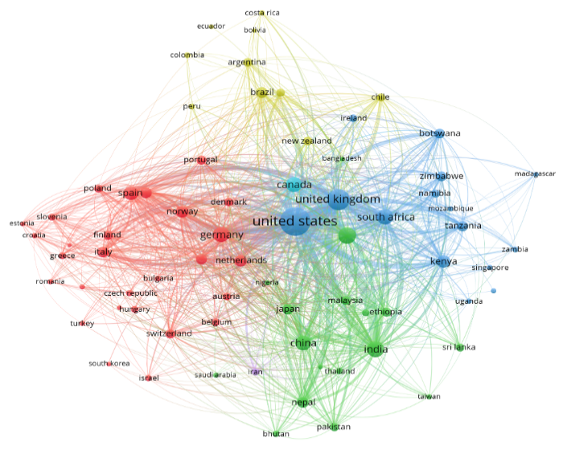
Fig. 8. Bibliographic coupling of countries

These coupling patterns also highlighted North-South collaborations, where developed countries partnered with biodiversity rich developing nations through capacity building and joint field research. Notably, countries like Kenya and the Netherlands, though contributing fewer publications, demonstrated high citation impacts due to targeted research and strong collaborative ties (Abas et al., 2025). The strength of bibliographic coupling thus reflected not only direct cooperation but also conceptual and methodological exchange, as nations adapted established tools and frameworks to local realities. Overall, the network structure exposed both the integrative and fragmented aspects of global HWC research, underscoring opportunities to strengthen underrepresented regions and enhance knowledge sharing for more comprehensive conflict management.

3.9. EMERGING THEME IN HWC RESEARCH: KEYWORD ANALYSIS

The word cloud visualization (Figure 9) offered a clear depiction of the dominant themes in HWC research, with keyword size reflecting occurrence frequency. Prominent terms such as “human-wildlife conflict,” “conservation,” “wildlife management,” “coexistence,” “carnivore,” “elephant,” and “livestock” illustrated the field’s conceptual core (Ridwan et al., 2023). The frequent appearance of taxon specific keywords like “carnivore”, “elephant”, and “primate” emphasized research attention on conflicts involving large and charismatic species that threatened human livelihoods (Sharma et al., 2021). Similarly, keywords such as “crop damage,” “livestock predation,” and “economic loss” indicated a strong focus on quantifying and understanding the socioeconomic impacts of conflict.
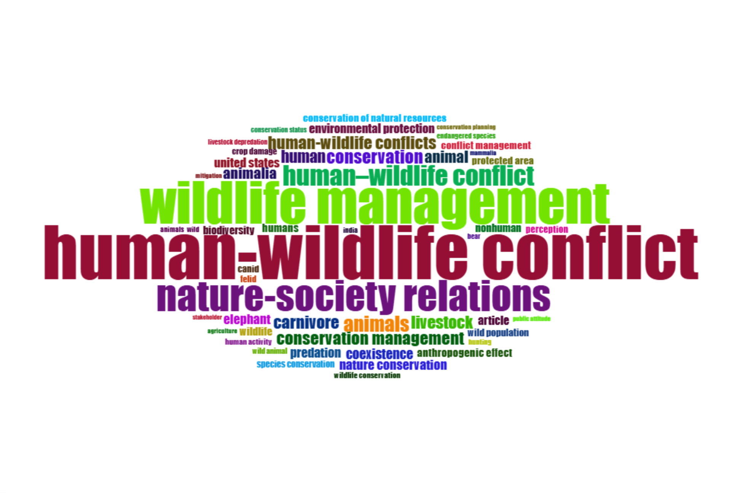
Fig. 9. Word cloud of keywords

Equally significant were management related terms like “mitigation”, “compensation”, “community based conservation”, and “policy”, underscoring growing attention to practical conflict resolution and governance mechanisms (Abas et al., 2025). The prominence of social science terms “attitude”, “perception”, “tolerance”, and “acceptance” reflected a disciplinary shift toward integrating human dimensions into conflict analysis (Hoare, 1999; Treves et al., 2006; Graham et al., 2010; Dickman et al., 2011). This blend of ecological, socioeconomic, and policy oriented keywords suggested that HWC research had evolved from a primarily biological focus to a more interdisciplinary field, addressing both ecological realities and community based solutions within diverse geographical contexts.

3.10. NETWORK VISUALIZATION OF KEYWORDS
The keyword co-occurrence network, typically visualized as a graph where nodes represented keywords and edges represented their co-occurrence, illustrated the conceptual and thematic structure of HWC research (Figure 10). Cluster formation within the network highlighted distinct subfields such as human-wildlife management, human-animal physiology, human-carnivore conflict, and conservation and policy, reflecting the field’s thematic diversity (Abas et al., 2025). Central keywords like “human-wildlife conflict” acted as conceptual anchors, connecting diverse studies across taxonomic and geographical contexts. Strong linkages between ecological terms (e.g., habitat, distribution, behaviour) and management related terms (e.g., mitigation, strategy, intervention) emphasized evidence based management strategies.
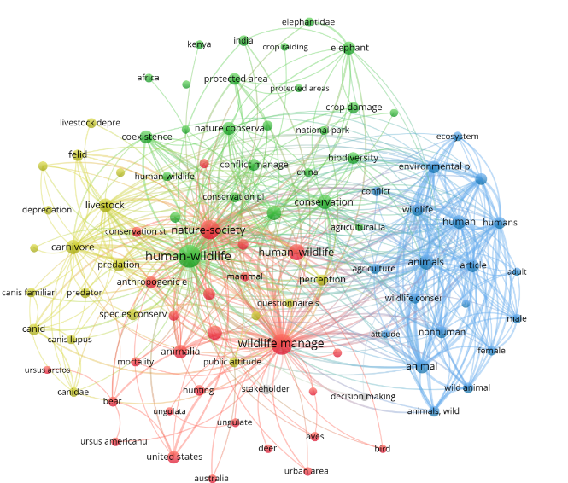
Fig. 10. Keyword distribution pattern

Additionally, co-occurrence patterns revealed growing interdisciplinarity, with social science terms forming interconnected yet distinct clusters. This integration bridged biological, ecological, and socioeconomic research, while also highlighting lingering disciplinary divides (Ridwan et al., 2023). Emerging keywords such as climate change, technology, and landscape management suggested new research directions focusing on environmental change, innovation in conflict mitigation, and large scale conservation planning. Overall, the network reflected HWC research’s progression toward a comprehensive socioecological paradigm.

3.11. THEMATIC EVOLUTION IN HWC RESEARCH
The thematic map, generated using Callon’s centrality and density metrics, offered a strategic visualization of the structure and maturity of HWC research. It categorized themes into four quadrants: motor themes (high centrality and density) that were both well developed and influential; niche themes (high density but low centrality) that were specialized yet peripheral; emerging or declining themes (low in both metrics) representing nascent or fading areas; and basic or transversal themes (high centrality but low density) that were foundational but underdeveloped (Figure 11) (Cobo et al., 2011). In HWC studies, motor themes typically included large carnivore conflicts, compensation mechanisms, and community attitudes toward wildlife topics supported by robust theories and empirical depth (Treves et al., 2006). Niche themes encompassed specialized research such as primate crop-raiding or bear-apiary conflicts, and methodological advances like machine learning based conflict prediction (Su et al., 2022).
Basic or transversal themes often reflected growing interdisciplinary interests, including climate change impacts on HWC, human tolerance psychology, and policy effectiveness evaluation areas crucial for progress but requiring deeper exploration. Emerging themes highlighted evolving directions such as coexistence frameworks (König et al., 2020). These developments signaled the transition toward integrated socioecological approaches. The thematic map thus not only identified research maturity and interconnections but also guided future priorities encouraging investment in underexplored social, economic, and policy dimensions while sustaining innovation in established ecological themes (Abas et al., 2025).
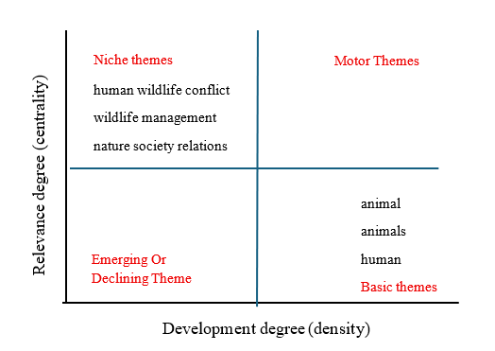
Fig. 11. Thematic map of key research area in HWC studies

Overall, the discussion highlighted that HWC research had evolved from a niche focus into a globally significant domain of conservation science. While the rapid growth in publications demonstrated increasing academic engagement, the uneven citation and collaboration patterns called for more inclusive, regionally grounded, and interdisciplinary research to effectively address the complexities of coexistence between humans and wildlife.

4. Conclusion

HWC represented a critical and increasingly complex global challenge that demanded urgent scholarly and policy attention, as was evidenced by the substantial and growing body of research spanning 1989 to 2025. The persistent documentation and analysis of conflict incidents, mitigation strategies, and coexistence frameworks across diverse geographic and ecological contexts underscored the universality of this phenomenon and its profound implications for biodiversity conservation, rural livelihoods, and sustainable development. The expanding research landscape revealed emerging dimensions of HWC including climate induced habitat displacement, technological interventions, and the integration of indigenous knowledge systems, yet significant gaps remained in understanding context specific drivers and developing equitable, locally appropriate solutions. The concentration of research outputs from developed nations highlighted the critical need for strengthened research capacity and documentation in underrepresented regions experiencing acute conflict pressures, particularly in agricultural communities where economic losses threatened both human welfare and conservation goals. Addressing HWC effectively required multidisciplinary collaboration that bridged ecological and social science perspectives, strengthened international research partnerships, and generated evidence based interventions that simultaneously protected farming livelihoods and safeguarded ecosystem integrity. Moving forward, the field had to prioritize the development of context specific, community centered solutions that fostered genuine coexistence while acknowledging the economic, ecological, and social complexities inherent in managing human-wildlife interactions in an era of unprecedented environmental change and anthropogenic pressures.

DISCLAIMER (ARTIFICIAL INTELLIGENCE)
Author(s) hereby declare that generative AI technologies such as large language models, etc have been used during writing or editing of this manuscript. This explanation will include the name, version, model, and source of the generative AI technology and as well as all input prompts provided to the generative AI technology.

Details of the AI usage are given below:

1. Artificial intelligence tool Perplexity is only used for paraphrasing

References

Abas, A., Rahman, A. H. A., Md Fauzi, T. A. H. T., & Yusof, A. H. M. (2025). A bibliometric review of global research on the human-wildlife conflicts. Frontiers in Environmental Science https://doi.org/10.3389/fenvs.2024.1517218
Asaye, B., Tekalign, W., & Dobamo, T. (2024). Livestock predation, crop raiding, and community attitudes towards sustainable wildlife conservation in and around Mankira Forest, Southwest Ethiopia. BMC Ecol Evol. https://doi.org/10.1186/s12862-024-02279-2
Baral, K., Bhandari, S., Adhikari, B., Kunwar, R. M., Sharma, H. P., Aryal, A., & Ji, W. (2022). Anthropogenic mortality of large mammals and trends of conflict over two decades in Nepal. Ecology and Evolution, 12(10), e9381. https://doi.org/10.1002/ece3.9381
Biscaro, C., & Giupponi, C. (2014). Co-Authorship and Bibliographic Coupling Network Effects on Citations. PLoS ONE. https://doi.org/10.1371/journal.pone.0099502
Braczkowski, A. R., O’Bryan, C. J., Lessmann, C., Rondinini, C., Crysell, A. P., Gilbert, S., Stringer, M., Gibson, L., & Biggs, D. (2023). The unequal burden of human-wildlife conflict. Communications Biology. https://doi.org/10.1038/s42003-023-04493-y
Cobo, M. J., López-Herrera, A. G., Herrera-Viedma, E., & Herrera, F. (2011). An approach for detecting, quantifying, and visualizing the evolution of a research field: A practical application to the Fuzzy Sets Theory field. J. Informetr., 5(1), 146-166. https://doi.org/10.1016/j.joi.2010.10.002
Debnath, F., Chakraborty, D., Deb, A. K., Saha, M. K., & Dutta, S. (2021). Increased human-animal interface & emerging zoonotic diseases: An enigma requiring multi-sectoral efforts to address. Indian Journal of Medical Research, 153, 577-584. https://doi.org/10.4103/ijmr.IJMR_2971_20
Dickman, A. J., Macdonald, E. A., & Macdonald, D. W. (2011). A review of financial instruments to pay for predator conservation and encourage human-carnivore coexistence. Proc. Natl. Acad. Sci. U.S.A., 108(34), 13937-13944. https://doi.org/10.1073/pnas.1012972108
Dwivedi, R., Nerur, S., & Balijepally, V. (2023). Exploring artificial intelligence and big data scholarship in information systems: A citation, bibliographic coupling, and co-word analysis. International Journal of Information Management Data Insights, 2(3), 100185. https://doi.org/10.1016/j.jjimei.2023.100185
Fauziah, I., Nugroho, H. A., Yanthi, N. D., Tiffarent, R., & Saputra, S. (2024). Potential zoonotic spillover at the human–animal interface: A mini-review. Veterinary World, 17(2), 289-302. https://doi.org/10.14202/vetworld.2024.289-302
Ferdin, A. E. J., Aryal, U. C., Dhungana, N., Lamichhane, B. R., Chook, J. W., & Lee, C.-H. (2024). Prioritizing human-wildlife conflict management strategies through importance-performance analysis: Insights from Chitwan National Park, Nepal. Journal for Nature Conservation, 81, 126675. https://doi.org/10.1016/j.jnc.2024.126675
Fiasco, V., & Massarella, K. (2022). Human-wildlife coexistence: Business as usual conservation or an opportunity for transformative change? Conservation and Society, 20(2), 167-178. https://doi.org/10.4103/cs.cs_26_21
Graham, M. D., Notter, B., Adams, W. M., Lee, P. C., & Ochieng, T. N. (2010). Patterns of crop-raiding by elephants, Loxodonta africana, in Laikipia, Kenya, and the management of human–elephant conflict. Systematics and Biodiversity, 8(4), 435-445. https://doi.org/10.1080/14772000.2010.533716
Hill, C. M. (2004). Farmers’ perspectives of conflict at the wildlife-agriculture boundary: Some lessons learned from African subsistence farmers. Human Dimensions of Wildlife. https://doi.org/10.1080/10871200490505710
Hill, C. M. (2015). Perspectives of “Conflict” at the Wildlife–Agriculture Boundary: 10 Years On. Hum. Dimens. Wildl., 20(4), 296-305. https://doi.org/10.1080/10871209.2015.1004143
Hoare, R. E. (1999). Determinants of human-elephant conflict in a land-use mosaic. Journal of Applied Ecology, 36, 689-700. https://doi.org/10.1046/j.1365-2664.1999.00437.x
Inskip, C., & Zimmermann, A. (2009). Human-felid conflict: A review of patterns and priorities worldwide. Oryx, 43(1), 18-34. https://doi.org/10.1017/S003060530899030X
Kagoro-Rugunda, G. (2004). Crop raiding around Lake Mburo National Park, Uganda. Afr. J. Ecol., 42(1), 32-41. https://doi.org/10.1111/j.0141-6707.2004.00444.x
Karantali, M., & Panagiotidis, T. (2024). A bibliometric analysis of a top field journal in the economics of education. Education for Information, 40, 89-111. https://doi.org/10.3233/EFI-230059
König, H. J., Kiffner, C., Kramer-Schadt, S., Fürst, C., Keuling, O., & Ford, A. T. (2020). Human-wildlife coexistence in a changing world. Conserv. Biol., 34(4), 786-794. https://doi.org/10.1111/cobi.13513
Ma, D., Abrahms, B., Allgeier, J., Newbold, T., Weeks, B. C., & Carter, N. H. (2024). Global expansion of human-wildlife overlap in the 21st century. Science Advances, 10, eadp7706. https://doi.org/10.1126/sciadv.adp7706
Madden, F. (2004). Creating coexistence between humans and wildlife: Global perspectives on local efforts to address human-wildlife conflict. Human Dimensions of Wildlife. https://doi.org/10.1080/10871200490505675
Maddi, A., Maisonobe, M., & Boukacem-Zeghmouri, C. (2025). Geographical and disciplinary coverage of open access journals: OpenAlex, Scopus, and WoS. PLoS One, 20(4), e0320347. https://doi.org/10.1371/journal.pone.0320347
Magouras, I., Brookes, V. J., Jori, F., Martin, A., Pfeiffer, D. U., & Dürr, S. (2020). Emerging zoonotic diseases: Should we rethink the animal-human interface? Frontiers in Veterinary Science, 7, 582743. https://doi.org/10.3389/fvets.2020.582743
Mahakata, I., Mapolisa, A., Rusinga, O., & Mango, L. (2025). Exploring the dynamics of human-wildlife conflicts in the Sai communal area adjacent to Sengwa wildlife research area, Zimbabwe. European Journal of Wildlife Research, 71, 36. https://doi.org/10.1007/s10344-025-01915-6
Malate, J. Y., Fierravanti, A., Sitoe, A. A., Tibério, M. L., & Lopes, L. F. G. (2025). Analyzing the sustainability of the environmental and socio-economic externalities of the Limpopo National Park (Mozambique) since its institution. Frontiers in Conservation Science, 6, 1645489 https://doi.org/10.3389/fcosc.2025.1645489
Messmer, T. A. (2009). Human–wildlife conflicts: emerging challenges and opportunities. Human–Wildlife Interactions, 3(1), 10-17. https://doi.org/10.26077/rkhx-xe84
Mnzava, E. E., & Sirima, A. A. (2022). A bibliometric analysis of human-wildlife conflicts in East Africa. International Journal of Conservation Science, 13(1), 213-220. https://www.ijcs.ro/download/ijcs-13-1-2022-213-220.pdf
Nyhus, P. J. (2016). Human–wildlife conflict and coexistence. Annual Review of Environment and Resources, 41, 143-171. https://doi.org/10.1146/annurev-environ-110615-085634
Paudel, U., KC, R. B., Kadariya, R., Karki, A., Shrestha, B. P., Shah, S. K., Subedi, N., & Thapa, S. K. (2024). Human–wildlife conflict in Bardia—Banke Complex: Patterns of human fatalities and injuries caused by large mammals. Ecology and Evolution, 14(10), e70395. https://doi.org/10.1002/ece3.70395
Ridwan, Q., Wani, Z. A., Anjum, N., Bhat, J. A., Hanief, M., & Pant, S. (2023). Human-wildlife conflict: A bibliometric analysis during 1991-2023. Regional Sustainability, 4(3), 309-321. https://doi.org/10.1016/j.regsus.2023.08.008
Salerno, J. D., Borgerhoff Mulder, M., Grote, M. N., Ghiselli, M., & Packer, C. (2016). Household livelihoods and conflict with wildlife in community-based conservation areas across northern Tanzania. Oryx, 50(4), 702-712. https://doi.org/10.1017/S0030605315000393
Schell, C. J., Stanton, L. A., Young, J. K., Angeloni, L. M., Lambert, J. E., Breck, S. W., & Murray, M. H. (2021). The evolutionary consequences of human-wildlife conflict in cities. Evolutionary Applications, 14(1), 178-197. https://doi.org/10.1111/eva.13131
Schley, L., & Roper, T. J. (2003). Diet of wild boar Sus scrofa in Western Europe, with particular reference to consumption of agricultural crops. Mammal Review, 33(1), 43-56. https://doi.org/10.1046/j.1365-2907.2003.00010.x
Sharma, P., Chettri, N., & Wangchuk, K. (2021). Human–wildlife conflict in the roof of the world: Understanding multidimensional perspectives through a systematic review. Ecol Evol. https://doi.org/10.1002/ece3.7980
Sisodia, K. (2017). Urbanization and impacts on wildlife. Int. J. Eng. Res. Manag. Technol. https://doi.org/10.34291/ijermt 04.6/218723
Su, K., Zhang, H., Lin, L., Hou, Y., & Wen, Y. (2022). Bibliometric analysis of human-wildlife conflict: From conflict to coexistence. Ecological Informatics, 68, 101531. https://doi.org/10.1016/j.ecoinf.2021.101531
Thelwall, M., & Sud, P. (2022). Scopus 1900–2020: Growth in articles, abstracts, countries, fields, and journals. Quantitative Science Studies. https://doi.org/10.1162/qss_a_00177

Treves, A., Wallace, R. B., Naughton-Treves, L., & Morales, A. (2006). Co-Managing Human–Wildlife Conflicts: A Review. Human Dimensions of Wildlife. https://doi.org/10.1080/10871200600984265

Wangchuk, K. (2025). Frontliners’ tales of human-wildlife interactions in the Himalayan mid-hills: A workshop report. Research Ideas and Outcomes https://doi.org/10.3897/rio.11.e171643

Woodroffe, R., & Ginsberg, J. R. (1998). Edge effects and the extinction of populations inside protected areas. Science. https://doi.org/10.1126/science.280.5372.2126

Woodroffe, R., Thirgood, S., & Rabinowitz, A. (2005). The impact of human–wildlife conflict on natural systems. In R. Woodroffe, S. Thirgood, & A. Rabinowitz (Eds.), People and Wildlife: Conflict or Coexistence? (pp. 1-12). Cambridge University Press. https://doi.org/10.1017/CBO9780511614774

Woolaston, K., Flower, E., van Velden, J., White, S., Burns, G. L., & Morrison, C. (2021). A review of the role of law and policy in human-wildlife conflict. Conservation and Society https://doi.org/10.4103/cs.cs_176_20

Xu, J., Wei, J., & Liu, W. (2019). Escalating human-wildlife conflict in the Wolong Nature Reserve, China: A dynamic and paradoxical process. Ecology and Evolution, 9, 7273-7283. https://doi.org/10.1002/ece3.5299

Yazezew, D. (2022). Human-wildlife conflict and community perceptions towards wildlife conservation in and around Wof-Washa Natural State Forest, Ethiopia. BMC Zoology, 7, 53. https://doi.org/10.1186/s40850-022-00154-5

Yu, Y., Li, Y., Zhang, Z., Gu, Z., Zhong, H., Zha, Q., Yang, L., Zhu, C., & Chen, E. (2020). A bibliometric analysis using VOSviewer of publications on COVID-19. Annals of Translational Medicine. https://doi.org/10.21037/atm-20-4235

