Original Research Article

Evaluation of Antifungal Activity of Cow Urine Based Mancozeb Formulation against Fungal Infection Affecting Wheat Seed Germination

Abstract:
The constraints of output in any agricultural system are determined by the seed. Consequently, in recent years, farmers have grown more aware of seed health. The identification of seed-borne pathogens is a crucial step for seed health and the treatment of crop diseases. This research was conducted to prepare stable cow urine-based mancozeb suspension concentrate formulation and evaluate its effectiveness against the presence of seed-borne diseases in wheat seeds. The effectiveness of seed treatment with standard mancozeb fungicides and cow urine-based mancozeb formulation in mitigating seed-borne fungus was examined using two methodologies. The petri dish technique and the rolled paper towel method were used to assess germination and the presence of fungal infection around the seed. 1 gm/kg dose of cow urine-based mancozeb formulation showed an effect equivalent to the standard mancozeb dose (2.5 gm/kg), which significantly reduces standard dosages thereby reducing environmental pollution and improving seed germination.
Keywords: Antifungal Activity, Cow Urine, Mancozeb, Fungicides, Fungal Infection, and Seed Germination.
Graphical Abstract:
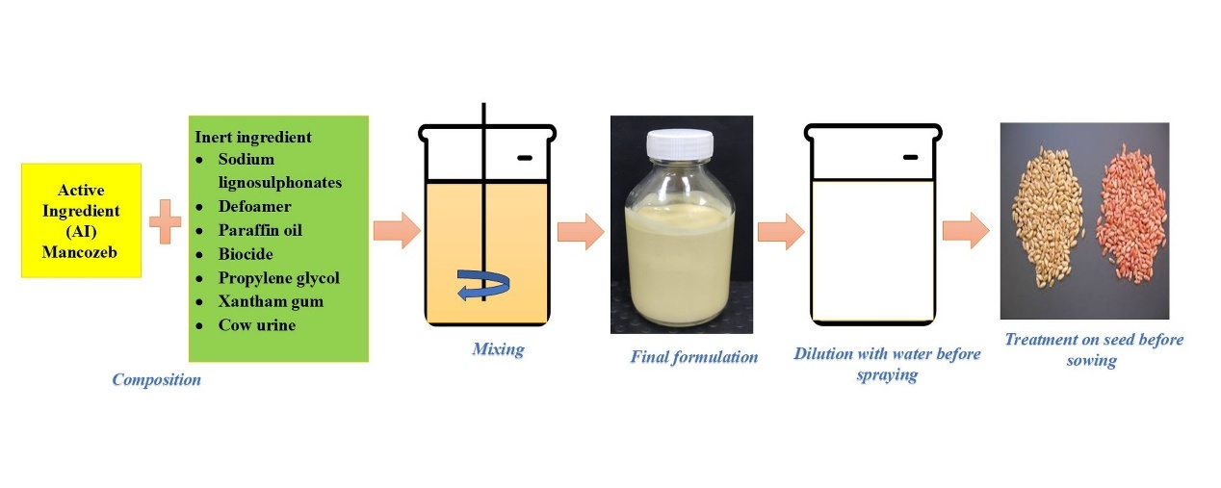

INTRODUCTION
One of the most significant and long-lived cereal crops is wheat (Fig. 1). Among the many identified varieties of wheat, club wheat (T. compactum) stands out. Cakes, biscuits, crackers, pastries, and flours are made from this softer kind. Pasta, especially spaghetti and macaroni, made from durum wheat (Triticum durum), is an essential ingredient in many popular dishes. To make bread, they utilize common wheat (T. aestivum). Malt, dextrose, starch, alcohol, gluten, and paste are all made from wheat by this industry (The Food and Agriculture Organization. 2016). One major obstacle that limits wheat output is the several illnesses that influence seed germination. Alternaria species, Rhizoctonia species, wilt, Protomyces macrosporus, stem gall, and Erysiphe polygoni DC are among the most common fungal diseases. Because it reduces yield and damages seed quality, powdery mildew is the most destructive disease (Ingrao et al., 2018; Vinci et al., 2022).
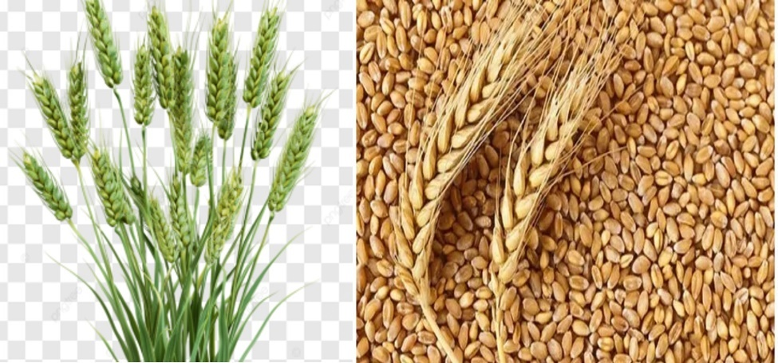
Fig. 1 Triticum aestivum
In addition to drastically lowering wheat seed quality, it may cause losses of 15–40%. In the absence of suitable control measures, losses in favorable conditions can surpass 50%. The selective use of conventional fungicides for disease management has many negative consequences, including contamination of the environment, persistence of residues, and the development of resistance in plant disease. In light of these challenges, the efficacy of phytoextracts in in vitro disease control was investigated (Aruna et al., 2019; Randhawa et al., 2015). Plants protect themselves against harmful pathogenic germs by producing a variety of aromatic secondary metabolites, including phenols, phenolic acids, quinones, flavones, flavonoids, tannins, and coumarins. These metabolites also have antibacterial properties. Urea, creatinine, aurum hydroxide, carbolic acid, phenols, calcium, and manganese are some of the components in cow urine that give it germicidal and antibacterial characteristics. As a result, mancozeb formulations made from cow urine may effectively suppress hazardous microorganisms. The act of a seed germinating into a plant is known as seed germination. At this point in its life cycle, the plant is very important. Reduced plant populations and crop yields are the results of fungal infections, which drastically reduce seed germination rates. Infected seeds might cause abnormally stunted or weak seedlings. Aside from rapid fungal colonization that generates growth-inhibiting toxins, insufficient storage, mechanical injury, and contaminated soil are other potential causes of seed infection. Crop production-related financial losses have a significant impact on agricultural systems. An important method for determining whether bio-based treatments are successful is seed germination testing (Kekuda et al., 2016; Ruchira et al., 2016; Mosquera et al., 2021). These studies not only measure the formulations' effects on seed germination rates, but they also provide concrete evidence of the formulations' antifungal effectiveness. It is crucial to visually assess antifungal activity in order to understand how these formulations prevent fungal development and protect seedlings from illness. The degree of fungal infection on and around the seeds, as well as the look of the seedlings, are all part of these evaluations (Vishunavat et al., 2016). To evaluate the efficacy of bio-based formulations in preventing and treating fungal infections in seeds, these results are essential. Using seed germination experiments in cow urine, this work aims to assess the visual antifungal efficiency of several mancozeb formulations at varied doses. This study aims to evaluate traditional mancozeb formulations for their effectiveness in reducing synthetic fungicide dose, which might lead to more sustainable farming methods (Kumar et al., 2020).

MATERIAL AND METHODS

Materials
The Mancozeb 75 WP with the brand name Abic from Syngenta Limited was purchased from a local supplier in Chalisgaon (Fig. 2). Sodium lignosulfonate was obtained from Borregaard, while paraffin oil and propylene glycol were sourced from Sigma-Aldrich. The defoamer used in the formulation was acquired from Momentive Industries, and a biocide, was procured from Excel Industries. Cow urine was collected from local goshalas for use in the study, Wheat seed specimens (HI-8759) and germination paper were acquired from a local vendor of Chalisgaon.
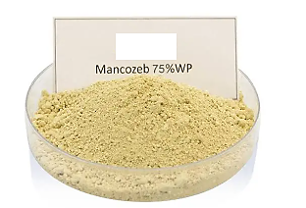
Fig. 2 Fungicide Mancozeb

Collection and preparation of cow urine based formulation
The study focused on a seven-year-old Gir heifer that was in excellent condition and got timely vaccinations. Standard filter paper was used to cleanse cow urine before its inclusion in the composition (11). The suspension concentrate was first prepared by dissolving sodium lignosulfonate in cow urine, then propylene glycol and defoamer were added with continuous stirring. The active ingredient, Mancozeb 75 WP, was then slowly added to the aqueous phase, ensuring uniform dispersion. A biocide was added to prevent microbial contamination. The mixture was homogenized by adding xantham gum to obtain a stable suspension. Then finally paraffin oil was added and mixed well (Table I). The final product was filtered to remove any impurities, then packed in sealed containers (Fig. 3). Product then kept for 14 days at 54°C in incubator for accelerated heat stability and 7 days for 0°C cold stability study. This formulation complies with all physicochemical parameters in stability studies according standard guidelines (Table II). Subsequent to the production procedure, these combinations are administered to seeds by spraying.
Table I % W/W Compositions of cow urine-based Mancozeb 10 % SC formulation
Mancozeb WP | 13.65
Sodium lignosulfonate | 1.0
2 % Xantham gum | 8.0
Cow urine | 65.05
Paraffin oil | 10
Defoamer | 0.2
Propylene glycol | 2.0
Biocide | 0.1
Total | 100

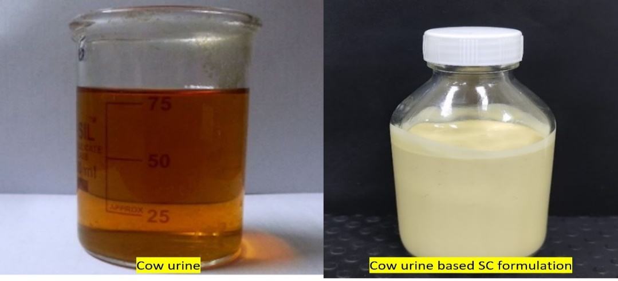
Fig. 3 Cow urine and Cow urine based mancozeb SC
Table II Physicochemical parameters of cow urine-based Mancozeb 10 % SC formulation
Sr. No | Parameters | Ambient | 7 days Cold MT 39.3 | 14 Days AHS  MT 46.3 | CIPAC Methods
1 | Appearance | Yellow colour suspension concentrate | Yellow colour suspension concentrate | Yellow colour suspension concentrate | Visual
2 | Active content % w/w | 10.01 | 9.98 | 9.85 | CIPAC Ep.116
3 | % Suspensibility | 93.34 | 94.41 | 94.87 | MT 184
4 | % Spontaneity of dispersion | 96.95 | 97.12 | 97.64 | MT 160
5 | 1% aqueous PH | 7.74 | 8.03 | 8.13 | MT 75.3
6 | Persistent foam (standard water D) | Nil | Nil | Nil | MT 47.3
7 | Wet sieve % | 0.10 | 0.10 | 0.12 | MT 185
8 | Density @ 20 °C in gm/L | 1.0856 | 1.0855 | 1.0858 | MT 3.3
 | Specific gravity | 1.0875 | 1.0874 | 1.0877 | MT 3.3
9 | Viscosity in Centipoise (cP) | 349 | 339 | 300.5 | MT 192
10 | Particle size distribution µ D10 | 2.15 | 1.03 | 2.15 | MT 187
10 | D50 | 8.96 | 4.90 | 9.64 | MT 187
10 | D90 | 20.3 | 14.4 | 22.9 | MT 187
10 | D95 | 23.9 | 17.5 | 27.0 | MT 187
10 | D98 | 28.2 | 21.0 | 31.9 | MT 187
10 | D100 | 40.0 | 31.1 | 45.5 | MT 187
10 | D (4,3) Mean | 10.3 | 6.50 | 11.2 | MT 187

Germination test by using petri dish method
To assess the severity of fungal infection in wheat seeds, they underwent many treatments (T1 to T8). Each treatment used three replicates of twenty seeds (Fig. 4). The germination paper was cut into 9 cm circles, and the seeds were positioned in petri dishes between two layers of moist germination paper. The seeds were kept in plant growth chamber at 25°C and 85% humidity for seven days, with 20 seeds per plate. The assessment of seed viability and germination potential is aided by the enumeration of infected seeds per treatment (Kumar et al., 2017; ISTA. 2018).
Treatments given:
- UTC T1 – Untreated control
- T2 – Treated with cow urine
- T3 – Standard mancozeb dose 2.5 gm/kg
- T4 – Cow urine based 10% Mancozeb formulation (0.2 gm/kg)
- T5 – Cow urine based 10% Mancozeb formulation (0.4 gm/kg)
- T6 – Cow urine based 10% Mancozeb formulation (0.6 gm/kg)
- T7 – Cow urine based 10% Mancozeb formulation (0.8 gm/kg)
- T8 – Cow urine based 10% Mancozeb formulation (1 gm/kg)
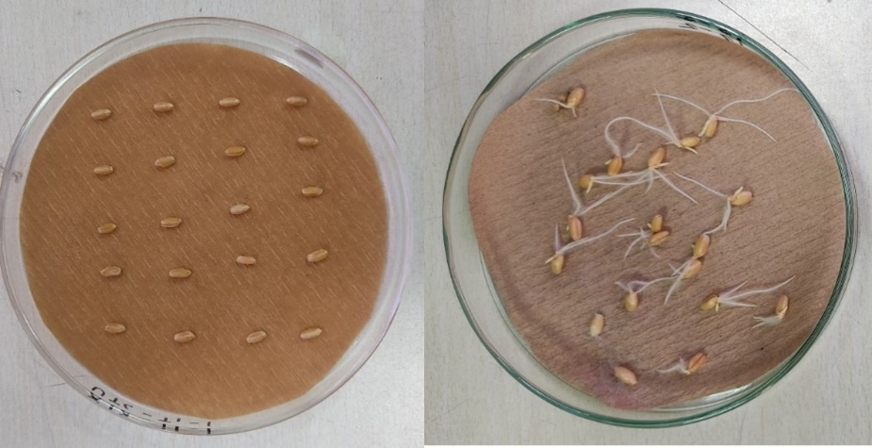
Fig. 4 Germination test by using Petri dish method

Germination test by using paper towel method
In 1990, Warham established a method for identifying seed-borne diseases. Several treatments (T1 to T4) were applied to wheat seedlings to measure the degree of fungal infection and its effect on root and shoot length. Each treatment had three replicates, with twenty seeds per treatment. Twenty seeds were evenly distributed on each towel over the top half of a paper towel (Dinesh et al., 2015). The towel was folded in half to ensure that the seeds were covered on both sides by the wet towel (Figure 5). The paper towel was given a cylindrical shape and placed in a plant growth chamber at 25°C and 85% humidity. After seven days, the germination percentage and infected seeds were recorded (Kumar et al., 2017; Singh et al., 2017).
Treatments given:
1) UTC T1 – Untreated control
2) T2 – Treated with cow urine
3) T3 – Standard mancozeb dose 2.5 gm/kg
4) T4– Cow urine based 10 % mancozeb SC formulation (1 gm/kg)
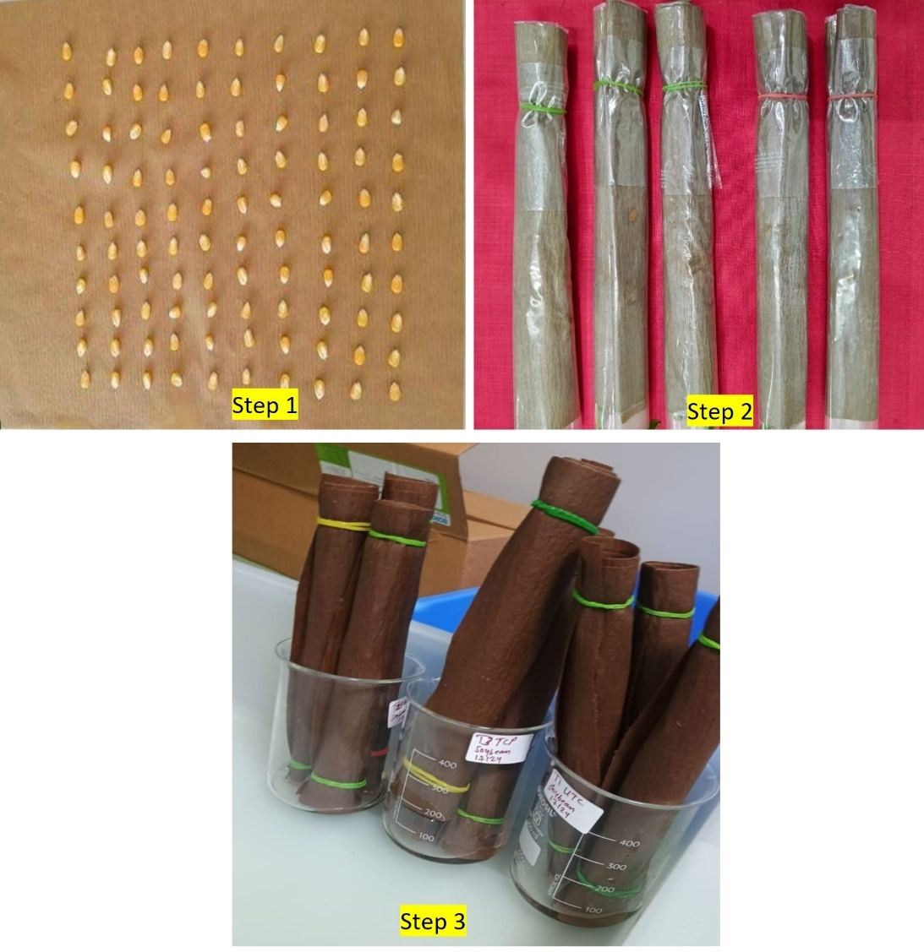
Fig. 5 Steps involved in Paper Towel method

Germination parameters
Germination percentage, Infected seed percentage, and vigor index were assessed under different treatments, applying methodologies described by Benech-Arnold et al. (1991), Sarma et al. (2014), and Abdul-Baqi and Anderson (1973) to evaluate seed germination performance.

Germination % = (Germinated seeds)/ (Total number of seeds) × 100

Seed fungal infection % = (Number of infected seeds)/ (Total number of seeds) × 100

Seed Vigour Index SV-I= Seedling length (cm) × Germination %

Seed Vigour Index SV-II= Seedling dry weight (gm) × Germination %

Statistical Analysis
The one-way Anova was caried out by using Microsoft excel 2021. Duncan's multiple range test (DMRT) p ˂ 0.05 was used to determine the significant difference between means. standard deviation was calculated from obtained values.

RESULT AND DISCUSSION

Germination and infection assessment of petri dish method:
After a period of seven days, the seeds were assessed for fungal infection and germination (Fig. 6). The ratio of seeds displaying visible fungal growth or damage was used to evaluate fungal infection.
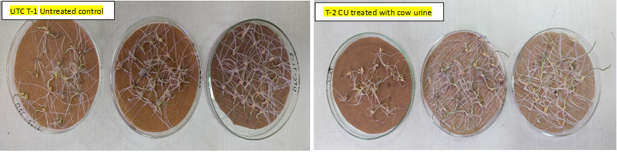
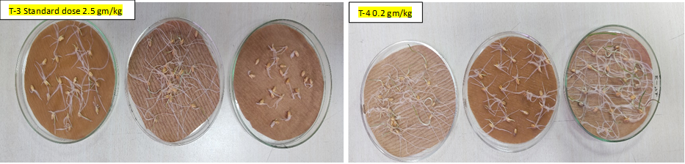
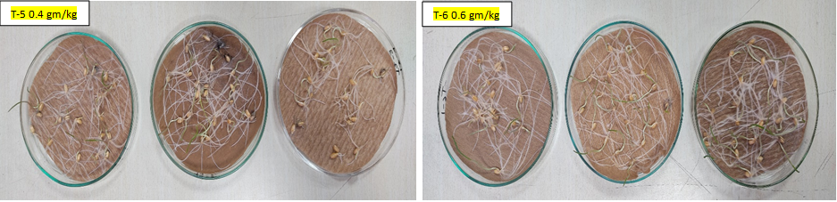
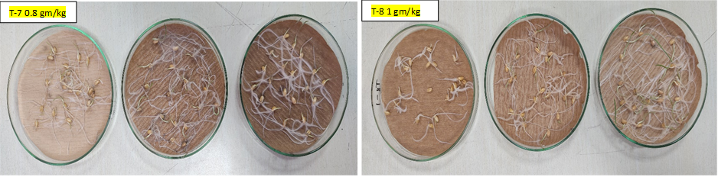
Fig. 6 Germination photographs of different concentration treatment of formulation
Table III delineates the efficacy of various cow urine-based formulation treatments (T1 to T8) in combating fungal infections. The findings of the current investigation indicated that mancozeb formulations combined with cow urine exhibited superior antifungal efficacy compared to standard mancozeb formulations. This results in a reduction in the use of synthetic fungicides, therefore encouraging the adoption of sustainable agricultural practices.
Table III Seed germination % fungal infection chart
Treatment | Germination (%) | % Seeds Fungal infection
T1 | 96.67± 5.77 | 65.00± 5.00
T2 | 100.0± 0.00 | 53.33± 5.77
T3 | 95.00± 0.00 | 13.33± 2.89
T4 | 98.33± 2.89 | 31.67± 7.64
T5 | 98.33± 2.89 | 21.67± 0.00
T6 | 100.0± 0.00 | 20.00± 2.89
T7 | 91.67± 5.77 | 18.33± 2.89
T8 | 96.67± 2.89 | 11.67± 2.89

The largest prevalence of fungal infection occurs in T1 (65.00%) and T2 (53.33%), indicating significant fungal contamination. These treatments are expected to significantly influence seed germination and overall crop health. T4 (31.67%) and T5 (21.67%) have moderate infection levels. These levels may still influence seed viability and germination rates, but to a lesser extent than T1 and T2. The comparatively low fungal infection rates of T6 (20.00%) and T7 (18.33%) indicate a diminished still significant effect on seed health. Among all treatments the fungal infection rate was found to be low in the standard dose of T3 (11.67%), while the fungal infection rate was lowest in T8, with an infection rate as low as 10%, which did not significantly affect seed viability and probably also showed better germination efficiency compared to other treatments. This indicates that T3 and T8 show comparable results with low fungal infection and represent optimal conditions for seed germination and seedling growth (Fig. 7).

Fig. 7 % Seed germination and fungal Infection among wheat seed germination.

Germination and infection assessment of paper towel method
After seven days, the seeds were examined for fungal infection and germination (Fig. 8). The proportion of seeds exhibiting discernible fungal growth or damage was used to assess fungal infection.
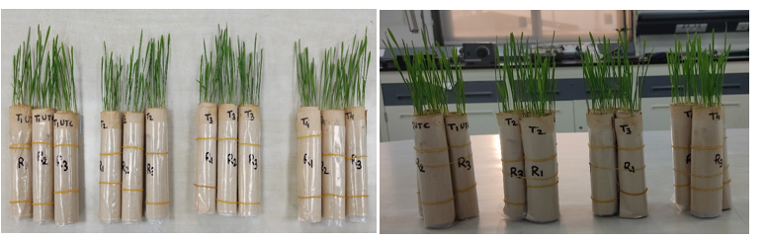
Fig. 8 Germination test by using Paper towel method
The ideal treatment combination for wheat seedlings was established by assessing several mixtures of fungicides and cow urine by the rolled paper towel detection technique.
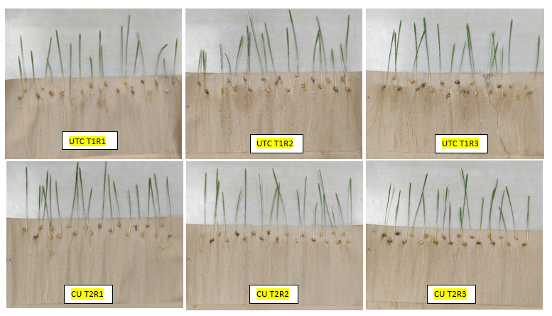
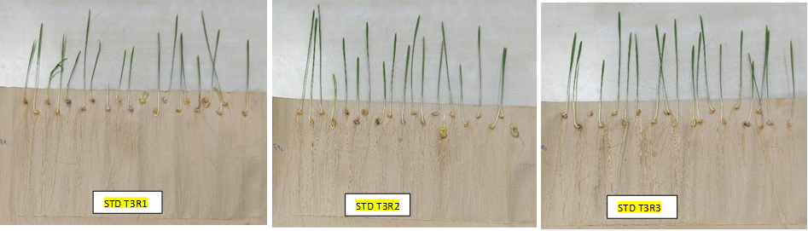
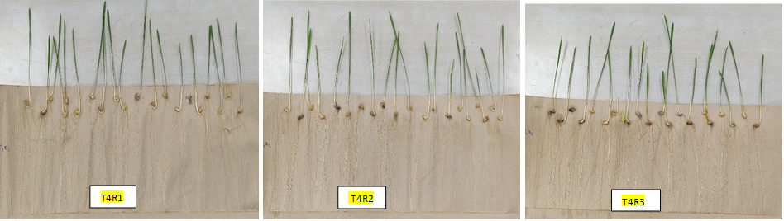
Fig. 9 Effect of different treatment of formulation on seed infection
The technique of seed-borne detection known as the rolled paper towel method was used in order to discover seed-associated infections in wheat that had been treated with a various dosage of fungicide and cow urine (Fig. 9). When compared to other treatments, the administration of the cow urine-based 10 % mancozeb formulation (T4) was shown to be the most effective treatment for lowering the number of seed-borne illnesses that occurred during the germination of wheat seeds (Table IV).
Table IV Seed germination % fungal infection chart (±= Standard deviation)
Treatment | Germination (%) | % Seeds Fungal infection | Shoot length (cm) | Root length (cm) | Mean Seedling Length (cm) | Mean Seedling Dry Weight (gm) | Seedling Vigor Index-I (%·cm) | Seedling Vigor Index-II (%·gm)
T1 | 95±0.00 | 71.66± 5.77 | 10.47±2.57 | 14.80± 1.84 | 25.27±3.72 | 0.843±0.02 | 2401.6±0.56 | 80.1±1.98
T2 | 98.33±2.89 | 45.00± 8.66 | 9.68± 3.00 | 15.08± 1.64 | 24.76±3.70 | 0.796±0.03 | 2393.3±0.57 | 76.94±2.37
T3 | 98.33±2.89 | 18.33± 2.89 | 10.69±2.25 | 15.08± 1.21 | 25.77±2.89 | 0.900±0.02 | 2533.9±0.49 | 88.50±2.60
T4 | 96.66±2.89 | 16.66± 7.64 | 11.14±1.78 | 15.48± 1.21 | 26.62±2.44 | 0.840±0.03 | 2573.1±0.25 | 81.19±2.57

The untreated control (T1) had the greatest prevalence of fungal infection (71.66%) among all treatments, indicating its vulnerability to illness without therapeutic intervention. Although the infection rate remained very high, the Cow urine Treatment (T2) demonstrated a significant reduction in fungal infection relative to T1, with a fungal infection rate of 45%. The fungal infection rate for the Standard Dose (T3) is 18.33%. This therapy was the most effective in diminishing fungal infection, demonstrating robust antifungal activities and a significant enhancement in plant vitality. The incidence of fungal infections linked to T4 treatment is 16.66%. This therapy yielded outcomes equivalent to T3 and significantly decreased the frequency of infection relative to T1 and T2 (Fig. 10).

Fig. 10 % Fungal Infection among wheat seed germination.

The untreated control (T1) showed an average seedling length of 25.2 cm, along with a mean dry weight of 0.843 grams (Table IV). The Cow Urine Treatment (T2) led to a decreased seedling length of 24.76 cm and a dry weight of 0.796 grams. The Standard Dose (T3) recorded a seedling length of 25.77 cm and a dry weight of 0.900 grams, while a dosage of 1 gm/kg (T4) exhibited the highest seedling length of 26.62 cm and a dry weight of 0.840 grams, marking it as the most effective treatment, indicating enhanced growth (Fig. 11)

Fig. 11 Mean seedling length and Mean seedling dry weight
The seed vigor index SV-I (2573 %. gm) was found to be highest in T4 and seed vigor index SV-II (88.50 %.gm) was found highest in standard dose T3, indicating superior seedling vigor and enhanced physiological performance. whereas lowest seed vigor index was recorded in SV-I (2393.3 %.gm) and SV-II (76.94%.gm) cow urine treatment T2. suggesting relatively reduced seedling strength and slower growth growth (Fig. 12).

Fig. 12 Seed Vigor I and Seed Vigor II
The untreated control (T1) exhibited a shoot length of 10.47 cm and a root length of 14.80 cm (Table IV). The Cow urine Treatment (T2) resulted in a reduced shoot length of 9.68 cm, while demonstrating an augmented root length of 15.08 cm relative to T1. The Standard Dose (T3) had the highest shoot length at 10.69 cm and a 15.08 cm in root length relative to T2, and A dose of 1 gm/kg (T4) demonstrated the maximum shoot length of 11.14 cm and a root length at 15.48 cm, establishing it as the most efficacious treatment. signifying improved growth (Fig. 13).

Fig. 13 Effect of different treatment on their shoot and root length
The findings show that the choice of treatment significantly affects plant health and disease resistance. Although seed viability as indicated by germination rate remained high and showed minimal variation among treatments, disease resistance and seedling development were significantly increased, especially in T3 and T4. Statistical analysis shows that the reduction in fungal infection of seeds in T3 and T4 is associated with improved vigor and increased biomass. The reduced infection rates indicate potential antifungal benefits or improved seed protection, which may contribute to increased plant height and dry weight. Duncan’s test additionally verifies that T3 and T4 can outperform other treatments. The increase in shoot and root length, along with the overall health of plants in T3 and T4, underlines their promise for field success and disease management. The ANOVA results confirmed by Duncan’s grouping provide strong statistical evidence for these findings. Consequently, T3 and T4 prove to be the most efficient treatments, showing increased seedling vigor and significant disease management under the conditions evaluated.

SUMMARY AND CONCLUSION
Seed treatment is an important part of the pesticide industry that plays a vital role in enhancing crop health and productivity. The basic factor that increases agricultural production and profitability is seeds. Seed treatment and disease control practices have a significant impact on crop yield and quality; therefore, early management of the disease is important. In the current situation, the use of synthetic chemicals for seed treatment is increasing uncontrollably, causing serious damage to the environment. In such a situation, keeping in mind the sustainability of the soil and environment, we should reduce the use of synthetic agrochemicals and adopt eco-friendly agricultural practices for food production. This study proposes a hybrid approach that combines both organic and synthetic materials to achieve sustainable agriculture. The results of this study indicate that cow urine-based formulations effectively control seed-borne phytopathogenic fungi. 1 gm/kg dose of cow urine-based mancozeb formulation showed an effect equivalent to the standard mancozeb dose (2.5 gm/kg), which significantly reduces standard dosages thereby reducing environmental pollution and improving soil health. Therefore, these results prove that cow urine could be utilized for development of the pesticides formulation in agrochemical industries.
Data Availability: Data are contained within the article.
Conflict of interest: Author declares that they have no competing interests.

REFERENCES
- Food and Agriculture Organization of the United Nations. (2016). FAOSTAT online database. http://faostat.fao.org/site/291/default.aspx
- Ingrao, C., Licciardello, F., Pecorino, B., Muratore, G., Zerbo, A., & Messineo, A. (2018). Energy and environmental assessment of a traditional durum-wheat bread. Journal of Cleaner Production, 171, 1494-1509. https://doi.org/10.1016/j.jclepro.2017.09.283
- Vinci, G., Ruggieri, R., Ruggeri, M., & Zaki, M. G. (2022). Application of Life Cycle Assessment (LCA) to cereal production: an overview. IOP Conference Series: Earth and Environmental Science, 1077(1), 012004. https://doi.org/10.1088/1755-1315/1077/1/012004
- Aruna, R., & Spadmapriya, S. (2016). Evaluation of antimicrobial activity of indigenous cow urine against bacterial fish pathogens. *International Journal of Zoology Studies*, *1*(4), 29–31. https://zoologyjournals.com/archives/2016/vol1/issue4/1-4-10.pdf
- Randhawa, G. K., & Sharma, R. (2015). Chemotherapeutic potential of cow urine: A review. Journal of Intercultural Ethnopharmacology, 4(2), 180–186. https://doi.org/10.5455/jice.2015022210032
- Kekuda, P. T. R., Akarsh, S., Nawaz, A. S. N., Ranjitha, M. C., Darshini, S. M., & Vidya, P. (2016). In vitro antifungal activity of some plants against Bipolaris sorokiniana (Sacc.) Shoem. International Journal of Current Microbiology and Applied Sciences, 5(6), 331-337. https://doi.org/10.20546/ijcmas.2016.506.037
- Tiwari, R., Tewari, A. K., Bisht, B., Singh, P., & Pande, M. (2016). Role of cow urine in beekeeping and crop protection in Uttarakhand, India. Research Journal of Recent Sciences, 5, 100-107. http://www.isca.in/RJRS/Archive/vol5/issue(ISC-2015)/100-107.pdf
- Mosquera Losada, M. R. (2021). Seed pathology definition and importance. Journal of Agricultural Science & Botany. https://www.alliedacademies.org/articles/seed-pathology-definition-and-importance.html
- Vishunavat K. (2016) Fundamental of seed pathology. Edn 2. Kalyani publishers, New Delhi, 1-15.
- Kumar, R., Gupta, A., Srivastava, S., Devi, G., Singh, V. K., Goswami, S. K., Gurjar, M. S., & Aggarwal, R. (2020). Diagnosis and detection of seed-borne fungal phytopathogens. In R. Kumar & A. Gupta (Eds.), *Seed-borne diseases of agricultural crops: Detection, diagnosis & management* (pp. 107-142). Springer Singapore. https://doi.org/10.1007/978-981-32-9046-4_5
- Gupta, A., Kumar, R., & Maheshwari, V. K. (2015). Integration of seed treatments, seedling dip treatments and soil amendments for the management of Bakanae disease in paddy variety Pusa Basmati 1121. Plant Pathology Journal, 14(4), 207–211. https://doi.org/10.3923/ppj.2015.207.211
- Kumar, R., Sinha, A., Srivastava, S., & Mahajan, G. (2017). Evaluation of biocontrol potential of some fungal decomposers of Sesbania aculeata L. green manure against some soil-borne plant pathogens. Journal of Environmental Biology. https://www.jeb.co.in/
- International Seed Testing Association. (2018). The International Seed Testing Association. http://www.seedtest.org
- Kumar G, Maharshi A, Patel JS et al (2017) Trichoderma: a potential fungal antagonist to control plant diseases. SATSA Mukhapatra Ann Tech Issue 21:206–218
- Singh, S., Sinha, A., Yadav, S. M., Singh, B. K., Singh, H., Srivastava, S., & Kumar, R. (2017). Antagonistic behavior of different bioagents against dominant seed borne fungi of mungbean seeds under in vitro condition. *Proceedings of the National Academy of Sciences, India - Section B: Biological Sciences*, *87*(2), 599–602. https://doi.org/10.1007/s40011-015-0604-z
- Benech Arnold, R. L., Fenner, M., & Edwards, P. J. (1991). Changes in germinability, ABA content and ABA embryonic sensitivity in developing seeds of Sorghum bicolor (L.) Moench. induced by water stress during grain filling. New Phytologist, 118(2), 339–347. https://doi.org/10.1111/j.1469-8137.1991.tb00986.x
- Sarma, B., Devi, P., Gogoi, N., & Devi, Y. M. (2014). EFFECTS OF COBALT INDUCED STRESS ON TRITICUM AESTIVUM L. CROP. Asian Journal of Agriculture and Biology, 2(2), 137–147. https://doi.org/10.35495/ajab.2014.2.02.10
- Abdul-Baki, A. A., & Anderson, J. D. (1973). Vigor Determination in Soybean Seed by Multiple Criteria. Crop Science, 13, 630–633. https://doi.org/10.2135/cropsci1973.0011183X001300060013x
- Dinesh, R., Anandaraj, M., Kumar, A., Bini, Y.K., Subila, K.P., & Aravind, R. (2015). Isolation, characterization, and evaluation of multi-trait plant growth promoting rhizobacteria for their growth promoting and disease suppressing effects on ginger. Microbiological Research, 173, 34–43. https://doi.org/10.1016/j.micres.2015.01.014

