Taro (Colocasia esculenta) as a Super Plant: A Review of the Supporting Scientific Data

Abstract: Taro (Colocasia esculenta) is a root vegetable, characterized by its large, heart-shaped leaves and starchy, edible corms (underground stems) which, has become well-known as a super plant in recent years. As a result, it appears on numerous lists of the healthiest vegetables in popular culture. It is undeniably supported by scientific evidence that root vegetables are sources of various nutrients, can improve human health and well-being, however it is still unknown why taro is deemed superior to other root vegetables. It is debatable if this claim regarding taro is supported by scientific data or by other considerations. In order to identify the factors contributing to taro's enormous appeal, this paper reviews the plant's botanical traits, nutritional, phytochemical profile, as well as, its bioactive compounds and potential health benefits.

Keywords: Taro; super plant; nutritional; edible corms; phytochemical profile

- INTRODUCTION
Modern methods that extract, identify, quantify, and analyze a large number of chemicals exhibiting purported pharmacological properties are currently revaluing several crops (vegetables) that have been neglected over the years. By taking into account the crucial role that these vegetables play in supporting diets as well as in promoting and treating populations' health, the study of its composition has prompted the recognition and re-evaluation of so-called "orphan" crops, reinforcing the knowledge that traditional communities have used since ancient times. In most cases, neglected or underutilized species have been substituted by those cultures in huge demand, although sometimes, those crops are poorer not only in nutritional aspects but mainly in bioactive compounds (1).
Vegetables are a vital part of a healthy diet, offering a wide range of nutrients like vitamins, minerals, fiber, calories, fat, and bioactive compounds that can regulate metabolic processes, exhibit antioxidant properties, and influence various physiological functions. The unique therapeutic index of leafy vegetables attributed to their bioactive compounds has been highlighted by various researchers (2).
Taro (Colocasia esculenta) is the common name for edible aroids which are important staple foods in many parts of the world, particularly in Asia and the Pacific Islands. It is an annual herbaceous plant belonging to the Araceae family. It is known by several other names in different parts of the world such as eddoe, cocoyam, dasheen or tannia (3). Nigeria, Cameroon, Ghana, Ethopia and China are the largest producers of taro, accounting for 81.9 % of total taro production. It is a staple food crop grown for its underground corms and cormels, leaves, petiole/stem (4, 5), and inflorescence across a large geographical area (6). It can thrive in sub merged or flooded and swamps as well as in dry areas with high rain fall (7).
The leaves of Colocasia are heart-shaped, with or without lines, blotches, and spots, and range in colour from light green to dark purple, depending on the genotype. Setting them apart from Xanthosoma sagittifolium is the peltate structure at the centre of the leaf. The leaf size varies with maturity and environmental conditions.
Taro is a healthy alternative of carbohydrate source, as the cooking process does not interfere with its nutritional composition, causing only minimal modifications in nutrient contents, according to Food Data Central from the United States Department Agriculture (8). The proximate composition of crude, cooked, and baked taro is quite similar regarding vitamins and minerals, except for niacin and calcium levels, as well as protein and total fat amounts, which were lowered by thermal processing.
Additionally, taro is a rich source of antioxidants, mainly phenolic compounds, distributed in its edible portion. In addition to its antioxidants, taro phytochemicals display immunomodulatory, antitumoral, antimetastatic, antimutagenic, anti-hyperglycemic, and anti-hypercholesterolemic bioactivities. Moreover, taro is a potential alternative staple source, with a lower glycemic index than potato, and its consumption may decrease the incidence and prevalence of several diseases, including certain types of cancers (9).
The review aims to examine the botanical traits, nutritional, phytochemical profile, as well as, bioactive compounds and potential health benefits of taro (Colocasia esculenta) using a comprehensive examination of existing literature. It will provide a thorough understanding of the supporting scientific evidences of taro (Colocasia esculenta) as a super plant. Finally, it aims to add to the body of information on taro (Colocasia esculenta) supporting their usage for improved health outcomes.
2. Literature Review
2.1. Botanical description of taro
Taro (Colocasia esculenta) is a member of the Araceae family. Two species that are today known as Colocasia esculenta and Colocasia antiquorum of the cultivated plants were first described by Linnaeus. Like Xanthosoma and Caladium, which are frequently planted as ornamentals, taro is also sometimes referred to as elephant ear. Taro is made up of at least 100 genera and more than 1500 species (10). Other genera of Araceae include Alocasia, Amorphophallus, and Xanthosoma, which are also grown for their underground tubers. All of these are commercially propagated through vegetative means. Taro tubers, leaves and plant are presented in figures 1-3 respectively. Table 1 shows the botanical classification of taro.

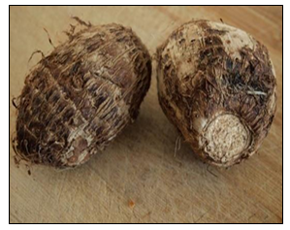
Fig. 1: Taro tubers
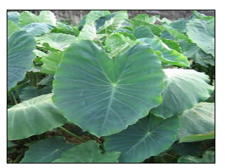
Fig. 2: Taro leaves
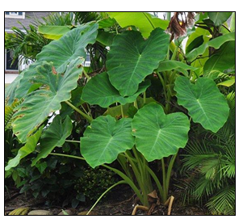
Fig. 3: Taro plant

Table 1: Botanical classification of taro (Colocasia esculenta)
Rank Scienticfic Name
Kingdom Plantae (Plants)
Subkingdom Tracheobionta (Vascular plants)
Super division Spermatophytes (Seed plants)
Division Magnoliophyta (Flowering plants)
Class Liliopsida (Monocotyledons)
Subclass Arecidae
Order Arales
Family Araceae (Arum family)
Genus Colocasia Schott (colocasia)
Species Colocasia esculenta (L.) Schott (Coco yam)

2.2. Morphology of taro
Taro (C. esculenta) is a tall herb having tuberous or a stout short caudex, leafing and flowering together. Leaves are simple and have a stout petiole, ovate-cordate or sagittate-cordate, lamina peltate. Spadix is shorter than the petiole and much it is shorter than the spathe rather than slender. Appendix much shorter than the inflorescence, style very short; stigma discoid. It is erect, elongateconical or fusiform, subulate or abbreviate. Erect petiole is up to 1.2 m in length, with a dull and non-polished surface above, coloured or paler beneath. They are rarely glaucous. The leaf peduncle is shorter than the petiole. Spathe is pale yellow and measures 15 to 35 cm in length; tube greenish, oblong. The lamina is narrowly lanceolate, convolute, acuminate and curved slightly backwards in flower. Female inflorescence is short but male inflorescence is long, cylindrical and usually interposed neuters between the two.
Taro is naturally a perennial monocotyledonous herb, but for practical purposes is harvested after 5-12 months of growth (11). It grows to a height of 1-2 m consisting of a central corm, lying just below the soil surface, from which leaves grow upwards, roots grown downwards, while cormels, daughter corms and runners grow laterally (12). It has heart-shaped green or purple leaves together with long petioles, fibrous roots and cylindrical or often irregular nutrient storage organ (corm) and the nature of flowering, fruiting and seed production by wild or cultivated taros (Colocasia esculenta ) has not been fully understood (13).

3. Methodology
This review examined taro (Colocasia esculenta) as a super plant using a comprehensive examination of existing literature. The search was developed to enable a thorough and systematic review of a diverse range of relevant studies in English, Spanish, French, and Portuguese. Key databases used included Science Direct, Web of Science, Medline, BVS Regional Portal, Embase, and Google Scholar. The primary keywords used in the search were “taro,” “Colocasia esculenta,” “bioactive compounds,” “phytochemical profile,” and “health benefits.” To ensure scientific rigour, only peer-reviewed research was considered. The review method included a comprehensive study of titles and abstracts, followed by a thorough examination of chosen full-text papers. Key data were rigorously retrieved and classified according to substances, research extraction type, bioactive procedures, and documented therapeutic effects. The emphasis was on the supporting scientific data of taro (Colocasia esculenta) as a super plant.

4. Results and Discussion
4.1. Nutritional value of taro
In addition to various phytochemicals with a range of biological activities, nutritional and antinutritional components are among the fundamental food consistency properties of taro. Phytochemicals that promote health are referred to as nutritional factors, and those that have repressing effects are referred to as antinutritional factors (14). Taro is a significant source of starch, dietary fibres, sugars, and ash, offering greater energy, carbs, and vitamin A compared to potatoes and sweet potatoes. Compared to other corms, shoots, and other tuber crops, taro leaves are also higher in vitamin A. Compared to other tubers crops, taro leaves corms have substantially higher levels of calcium, magnesium, and potassium. Its leaves also have the highest concentrations of zinc, copper, manganese, and selenium (15). The nutrient content is slightly changed by cooking, but the dietary composition remains unchanged.

Table 2
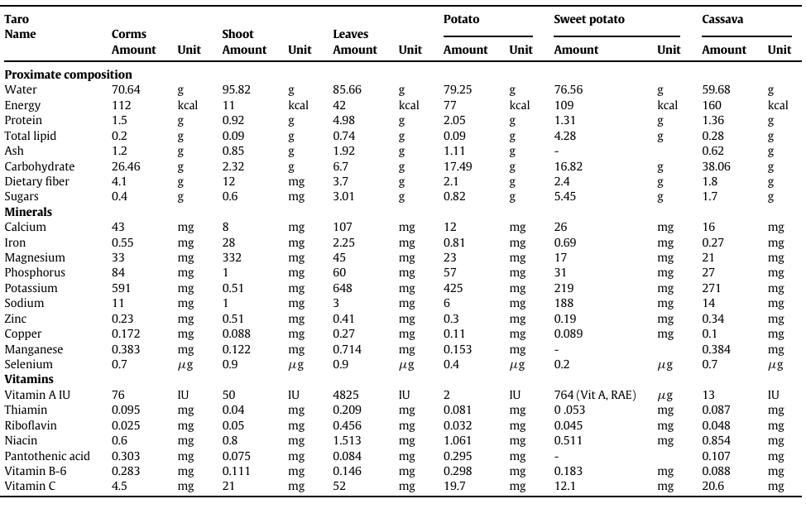
The main carbohydrate present in taro is starch found in polygonal and small granules, averaging 1.3–2.2 µm in diameter, although granules measuring 5 µm can be observed (16). As a starchy vegetable, taro presents part of the starch in resistant form, which can escape small intestine digestion and be directed to colon fermentation. This resistant-starch results in several health effects, including the augmented absorption of minerals, contribution in controlling blood glycemia, and reduction in plasma triglycerides and cholesterol (9).
Taro composes high protein than other root crops because of the presence of symbiotic soil. Bacteria in the root and rhizome part of taro. These bacteria fix atmospheric bacteria and increase nitrogen occurrence in the corm and leaf more over the bacteria used as plant growth enhancer due to release of growth hormone to root and distributed to the whole part of the plant. The free-living nature of these soils bacterial also helps the taro crop to grow at different environmental and ecologic conditions. These properties have economic and ecologic important to the environment.
Taro contains fairly high amount of ash. From which it can be inferred. It contain good mineral contents. The ash contents of taro ranged from 3.54 - 7.78%.
Consuming taro can help people with dietary restrictions, such as those who present with allergies, especially in children and gluten-intolerant individuals, and lower their risk of obesity and type II diabetes because it is gluten-free, has a low protein and calorie content, and has a low fat content. Furthermore, dietary fibres, both soluble and non-soluble, can enhance intestinal transit and perhaps help prevent colorectal cancer. As a result of its gluten-free nature, taro flour has arisen as a promising substitute for wheat flour, boosting the Brazilian market for gluten-free derivatives.

4.2. Anti-nutritional compounds in taro
Taro is high in antinutritional compounds such as oxalate and tannin. Oxalates are categorized as antinutritional components due to their ability to bind to dietary calcium and generate calcium oxalate crystals. This process prevents the body from absorbing and making use of calcium, which can lead to conditions such as osteomalacia and rickets (17). Tannins have long been known to reduce the bioavailability of proteins, minerals, and especially iron (18). Fermentation reduce tannin concentration by 43.52%, whereas boiling reduce it by 6.69%. The largest reduction of tannin caused by taro flour fermentation could potentially be ascribed to enzyme action. Because tannin precipitate proteins, hinder digestive enzymes and iron absorption, decrease the use of vitamins and minerals from meals, and foods high in tannins are regarded to be of low nutritional value (19).

4.3. Phytochemistry
Flavonoids and triterpenoids are the two pharmacologically active groups of compounds mainly present in the C. esculenta leaf extracts. The flavonoids that are present in the leaf extracts are vicenin-2, iso-vitexin, iso vitexin 3’-O-glucoside, vitexin X’-Oglucoside, iso-orientin, orientin, orientin 7-O-glucoside, and leteolin 7-Oglucoside (20). The leaves of the plant also contains fibres, calcium oxalate, minerals, starch, vitamin A, B, and C (21). Phytochemical investigations on the extracts have shown the presence of anthocyanins namely cyanidin-3-rhamnoside, cyanidin-3-glucoside and pelargonidin-3-glucoside. These anthocyanins have antioxidant activities as evident from previous studies (22). It is due to these anthocyanins that the C. esculenta plant leaves showcases hepatoprotective as well as anti-lipid peroxidative activity.

Table 3: Phytochemical compounds in taro (Colocasia esculenta)
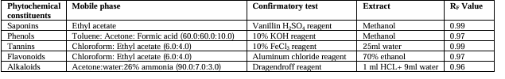

4.4. Pharmacological properties of taro
The use of taro to treat multiple unhealthy conditions and diseases such as diabetes, hemorrhage, diarrhea, arterial hypertension, alopecia, among others, dates from ancient times. Taro’s health-promoting potentials has been confirmed by in-vitro and in-vivo preclinical assays, by assaying raw or cooked corms and its derivatives in the form of flour or extracts.

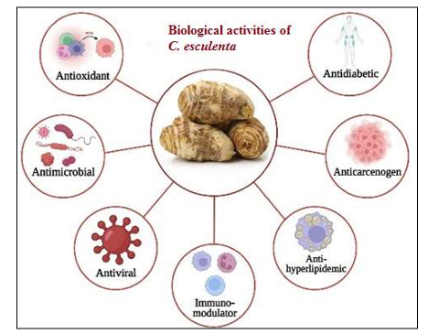
Fig. 4: The biological activities of various active molecules present in taro
4.4.1. Taro antioxidants
Antioxidants, under appropriate concentrations, protect, prevent, or delay the oxidation of biomolecules such as nucleic acids (DNA and RNA), protein, and lipids (23). Foods enriched in antioxidants may contribute to health maintenance, especially concerning comorbidities caused by oxidative stress elicited by an excess of oxygen/nitrogen reactive species (24).
Reactive species may be produced in physiological conditions, through aerobic metabolism and macrophage activation, or in pathological states following exposure to xenobiotics, such as toxins, pollutants, cigarettes, pesticides, and radiation. To counterbalance oxidative stress, phytochemicals with antioxidant activity found in foods such as fruits, vegetables, cereals, and tubers, are noteworthy as a relevant diet intervention topic. Evaluating the total antioxidant capacity (TAC) of foods is useful to improve functional diet quality and assist in health maintenance (25).
Many phytochemicals found in taro display the potential to reduce oxidative stress. The H-ORAC (Hydroxyl Radical Antioxidant Capacity), ABTS (2,2′-Azino-bis[3-ethylbenzothiazoline-6-sulfonic acid] diammonium salt), FRAP (Ferric Reducing Antioxidant Power), and DPPH (2,2′-diphenyl-1-picrylhydrazyl) radical assay methods have been applied to evaluate the total antioxidant capacity of taro extracts or taro-food derivatives. Flavonoids, tannins, saponins, alkaloids, carotenoids, phenols, vitamins, and fatty acids seem to contribute to overall taro antioxidant capacity.
4.4.2. Taro protection against mutagenic and carcinogenic agents
The protective mechanism of dietary fibers depends on their composition, and it can be attributed to the reduced time of intestinal tissue exposure to carcinogens and short-chain fatty acids generated from fermentation by gut microbiota (26).
Dietary fibers found in crude taro are mainly composed of neutral monosaccharides, uronic acid, galacturonic acid, glucuronic acid, and neglectable concentrations of lignin and no starch, and they seem to be involved in protection against chemical and physical mutagenic agents. Crude taro extract, rich in dietary fibers, can adsorb the hydrophobic compound 1,8 dinitropyrene (DNP), which is a mutagenic and carcinogenic pollutant found in the environment, making it ineffective in intestinal cells (27). Certainly, absorbing mutagenic compounds can reduce the risk of gastrointestinal tract cancers. Nevertheless, cancer risk reduction by dietary fiber intake can be extended to several organs, i.e., breast, pancreas, and prostate (28).
Other evidence do not ascribe antimutagenic activity to taro dietary fibers, attributing it to different compounds in taro. A heptane extract from cooked taro prevented the deleterious mutations caused by the heterocyclic amine, 2-amino-3-methylimidazo(4,5-f) quinoline, which is a potent mutagenic and carcinogenic agent formed during meat and fish cooking (29). Similarly, an aqueous extract from crude taro obtained from two different cultivars, a traditional one and the Ebi-taro from Kyoto (JPN), displayed antimutagenic effects against physical agents when assayed in E. coli cells exposed to UV radiation (30).

4.4.3. Anti-Diabetic activity of taro (31)
It was reported that the ethanolic extract of Colocasia esculenta leaves were exposed to phytochemical screening and were assessed to check for anti-diabetic activity on blood glucose level as per weight of alloxan induced diabetic rats. Ethanolic extract of Colocasia esculenta (100, 200 and 400mg/kg) and metformin (450mg/kg) were given orally to alloxan (120mg/kg,) induced diabetic rats. During the study of acute oral toxicity, injecting with ethanolic extract of Colocasia esculenta resulted in no death and the start of decrease in blood glucose level was seen at [4 h (96mg/dl)], and its peak at [6 h (120mg/dl)]. In the study of sub-acute toxicity, maximum decrease in blood glucose was observed (174.34mg/dl) at the dose of (400mg/kg) on the 14th day of experimentation. Ethanolic extract of Colocasia esculenta then showed lowering of blood glucose levels (p<0.001).
Phytochemical screening showed the existence of flavonoids, saponins, tannins and alkaloids as part of major constituent in the ethanol extract of taro which are responsible for this activity. This shows that they have anti hypoglycemic effect in alloxan-induced diabetic rats. Taro is the food crop used in the Caribbean and also used as an ancient medicinal food for the therapeutics of diabetes mellitus.

4.4.4. Anti-microbial activity of taro (32)
Constituents like glycosides, alkaloids, phenols, terpenoids, resins, flavonoids, saponins and amino group were found in Colocasia esculenta leaf extract. The antimicrobial activity was done against four bacterial strains –Staphylococcus aureus, Pseudomonas aeruginosa, Escherichia coli and Candida albicans. The antimicrobial activity of the leaf was evaluated by using 1, 1-diphenyl-2-picrylhydrazyl (DPPH). The results showed are 86.5% lowest when compared with standard ascorbic acid of 87.5%. Even Thin Layer Chromatography (TLC) tests were conducted revealing their Retention-Factor (RF) values of constituents in the leaves such as alkaloid, tannin, flavonoid, saponin and phenolare [0.95, 0.97, 0.96, 0.97, and 0.96] respectively.
Hence, it was concluded that taro leaves possess antimicrobial activity against given strains and the presence of phytochemical constituents used as antimicrobial agents helps in the treatment of burns and wounds.

5. Conclusion
The review suggests that taro (Colocasia esculenta) has significant potencies and clinical benefits. It has been determined that every portion of taro is extremely important and has unique requirements. Thus, the plant has a lot of physiologically active phytoconstituents, including flavonoids, glycosides, tannins, and anthraquinones. Also, it contains various minerals and vitamins which are important in the normal functioning of the body. The results of various clinical studies endorse its various biological and pharmacological aspects. However, further research is needed to determine its toxicity and adverse side effects. Additionally, there has been little progress in its industrial formulation into various products using advanced technology, which could increase its economic value. Therefore, this could be a good invention for developing numerous dietary products from it.

Conflict of interest
All authors hereby declare that, there is no conflict of interest.

References
- Yesuph DS, Dalka DD, Baye MT. Underutilized and neglected crop species and their role in enhancing household food security amid climate change, Wolaita Zone, Ethiopia. Heliyon. 2025; 11: 42345.

- Mehmood A, Zeb A. Effects of different cooking techniques on bioactive contents of leafy vegetables. International Journal of Gastronomy and Food Science. 2020; 22: 100246.

- Dilek NM, Bilgicli N. Effect of Taro [Colocasia esculenta (L.) Schott] Flour and Different Shortening Ratio on Physical and Chemical Properties of Gluten-sFree Cookie. Journal of Food Processing and Preservation. 2021; 45:15894.

- Ahmed I, Lockhart PJ, Agoo E, Naing KW, Nguyen DV, Medhi DK, Matthews PJ. Evolutionary origins of taro (Colocasia esculenta) in Southeast Asia. Ecology and Evolution. 2020; 10: 13530–13543. Doi.org/10.1002/ece3.6958.

- Matthews PJ, Ghanem ME. Perception gaps that may explain the status of taro (Colocasia esculenta) as an orphan crop. Plants, People, Planet. 2020; 3: 99–112. Doi.org/10.1002/ppp3.10155.

- Okechukwu KE, Lawretta PI, Eberechukwu AC, Stanley OK, Egbuta KC, Joel NC. Nutritive and anti-nutritive evaluation of cocoyam (Colocasia esculenta L. Schott) inflorescence. Am. J. Food Sci. Technol. 2020; 8: 42–48.

- Chair H, Traore RE, Duval MF, Rivallan R, Mukherjee A, Aboagye LM, Van Rensburg WJ, Andrianavalona V, Pinheiro de Carvalho MA, Saborio F, Sri Prana M, Komolong B, Lawac F, Lebot V. Genetic diversification and dispersal of Taro (Colocasia esculenta (L.) Schott). PLOS One. 2016; 11, 0157712. Doi.org/10.1371/journal.pone.0157712.

- USDA. Food Data Central (Internet). (2020, Feb. 17). Available from: https://fdc.nal.usda.gov/

- Simsek S, El SN. Production of resistant starch from taro (Colocasia esculenta L. Schott) corm and determination of its effects on health by in vitro methods. Carbohydr. Polym. 2012; 90: 1204–1209.

- Mandal R, Mukherjee A, Mandal N, Tarafdar J, Mukherjee A. Assessment of genetic diversity in Taro using morphometrics. Current Agriculture Research Journal. 2013; 1: 79-85.

- Mwenye OJ. Genetic diversity analysis and nutritional assessment of Cocoyam genotypes in Malawi: An M.Sc. Thesis presented to University of Free State, Bloemfontein, South Africa. 2009.\

- Ubalua AO, Ewa F, Okeagu OD. Potentials and challenges of sustainable taro (Colocasia esculenta) production in Nigeria. J. Appl. Biol. Biotechnol. 2016; 4: 53-59.

- Matthews PJ, Agoo EMG, Madulin DA, Tandang DN. Ethnobotany and ecology of wild Taro (Colocasia esculenta) in the Philippines: Implications for domestication and dispersal. Senri. Ethnol. Stud. 2012; 78, 307-340.
- Padhan B, Panda D. Potential of neglected and underutilized yams (Dioscorea spp.) for improving nutritional security and health benefits. Front. Pharmacol. 2020; 11: 496. Doi.org/10.3389/fphar.2020.00496.

- USDA. Food data central [Internet]. [Cited 2021 Mar. 04]. Available from: https://fdc.nal.usda.gov/

- Tattiyakul J, Asavasaksakul S, Pradipasena P. Chemical and physical properties of flour extracted from taro (Colocasia esculenta (L.)) Schott grown in different regions of Thailand. Sci. Asia. 2006; 32: 279–284.

- Mitharwal S, Kumar A, Chauhan K, Taneja NK. Nutritional, phytochemical composition and potential health benefits of taro (Colocasia esculenta L.) leaves: A review. Food Chemistry. 2022; 383: 132406.

- Robinson GHJ, Balk J, Domoney C. Improving pulse crops as a source of protein, starch and micronutrients. Nutrition Bulletin. 2019; 44: 202-215.

- Adane T, Shimelis A, Negussie R, Tilahun B, Haki GD. Effect of processing method on the proximate composition, mineral content and antinutritional factors of Taro (Colocasia esculenta, L.) growth in Ethiopia. African Journal of Food, Agriculture, Nutrition and Development. 2013; 13: 7383-7395.

- Iwashina T, Konishi T, Takayama A, Fukada M, Ootani S. Isolation and identification of the flavonoids in the leaves of taro. Annals of the Tsukuba Botanical Garden. 1999; 18: 71-74.

- Sheth AK. The Herbs of Ayurveda. AK Sheth Publishers, Ahmedabad, India; 2005.

- Noda Y, Kaneyuki T, Mori A, Packer L. Antioxidant activities of pomegranate fruit extract and its anthocyanidins: Delphinidin, cyanidin and pelargonidin. Journal agricultural and food chemistry. 2002; 50: 166-171.

- Halliwell B, Gutteridge JM. Free Radicals in Biology and Medicine. Oxford University Press, New York, NY, USA; 2015.
- Pisoschi AM, Pop A. The role of antioxidants in the chemistry of oxidative stress: A review. Eur. J. Med. Chem. 2015; 97: 55–74. Doi: 10.1016/j.ejmech.2015.04.040.

- Sharifi-Rad M, Anil Kumar NV, Zucca P, Varoni EM, Dini L, Panzarini E, Rajkovic J, Tsouh Fokou PV, Azzini E, Peluso I. Lifestyle, Oxidative Stress, and Antioxidants: Back and Forth in the Pathophysiology of Chronic Diseases. Front. Physiol. 2020; 11: 694. Doi: 10.3389/fphys.2020.00694.

- Capuano E. The behavior of dietary fiber in the gastrointestinal tract determines its physiological effect. Crit. Rev. Food Sci. Nutr. 2017; 57, 3543–3564. Doi: 10.1080/10408398.2016.1180501.
- Brister MM, Piñero-Santiago LE, Morel M, Arce R, Crespo-Hernández CE. Photochemical Relaxation Pathways in Dinitropyrene Isomer Pollutants. J. Phys. Chem. A. 2017; 121: 8197–8206. Doi: 10.1021/acs.jpca.7b04769.

- Veronese N, Solmi M, Caruso MG, Giannelli G, Osella AR, Evangelou E, Maggi S, Fontana L, Stubbs B, Tzoulaki I. Dietary fiber and health outcomes: An umbrella review of systematic reviews and meta-analyses. Am. J. Clin. Nutr. 2018; 107: 436–444. Doi: 10.1093/ajcn/nqx082.

- Botting K, Young M, Pearson A, Harris P, Ferguson L. Antimutagens in food plants eaten by Polynesians: Micronutrients, phytochemicals and protection against bacterial mutagenicity of the heterocyclic amine 2-amino-3-methylimidazo [4, 5-f] quinolone. Food Chem. Toxicol. 1999; 37: 95–103. Doi: 10.1016/S0278-6915(98)00121-5.

- Nakamura Y, Suganuma E, Kuyama N, Sato K, Ohtsuki K. Comparative bio-antimutagenicity of common vegetables and traditional vegetables in Kyoto. Biosci. Biotechnol. Biochem. 1998; 62: 1161–1165. Doi: 10.1271/bbb.62.1161.

- Muthakumaran P, Solomi S, Umamaheshwari R. In-vitro Anti 132 oxidant activity of Premnaserratifolia Linn. Asian J. Res. Pharm. Sci. 2013; 3: 15-18.

- Khobragade CN, Bodade RG, Manwar AV. Synthesis and antioxidant activity of some flavone derivatives. Asian J. Res. Chem. 2010; 3: 139-141.

