Review Article
HYDROGELS-A WATER WISE PARADIGM FOR SOIL RESILIENCE: A Review

.
ABSTRACT

Hydrogels are three-dimensional crosslinked polymeric networks with remarkable water absorption and retention capacity. Their agricultural use has gained prominence as a strategy to mitigate water scarcity, improve soil properties, and enhance crop productivity. This review synthesizes current knowledge on the historical development, synthesis, and physicochemical properties of hydrogels, while critically examining their effects on soil physical, chemical, and biological functions. Their role in improving crop performance, remediating heavy metals, and contributing to soil resilience is highlighted. Biodegradability, environmental safety, practical applications, limitations, and future perspectives are also discussed. Hydrogels represent a promising tool in sustainable agriculture, but further research is necessary to optimize their use across soil types and cropping systems.

Keywords: Hydrogel, soil conditioner, water retention, crop productivity, soil resilience

1. INTRODUCTION

“Water, water everywhere, not any drop to drink” is a line from the poem ‘The Rime of the Ancient Mariner’ by Samuel Taylor Coleridge, which depicts the unavailability of water for human consumption, even though plentily available around. According to the data given by Water aid, 2018, just ten countries account for 60% of world population without access to clean water, where a significant share (20%) is contributed by India. At current consumption rates, two-thirds of the world’s population may face water shortages by 2025. When compared to others, irrigation sector utilizes more than 80% of total per capita water supply in India (Central Water Commission, 2015) but have lower net returns. The rising demands for water in various sectors often come at the expense of vital irrigation systems, creating a delicate balance that challenges the sustainability of agriculture.
The water drawn for irrigation is not fully embraced by the crops, as much of it is lost through leaching, runoff, and deep percolation, a consequence of poor water holding capacity of soil. Hydrogel acts as an ideal soil conditioner, capable of absorbing water and releasing it precisely when the plants thirst for, nurturing their growth with each drop (Akhter et al., 2004). It is a network of hydrophilic crosslinked polymeric chains that do not dissolve, but swell in water. Hydrogel is amorphous and biodegradable polymer which can absorb and hold water about 400 times than its original weight and at least 95 % of absorbed water is made available to the crop within the 15bar tension which is permanent wilting point (PWP) (Johnson and Veltkamp, 1985). Hence, in soil, hydrogel is considered as "miniature water reservoirs".

2. History of hydrogel

Hydrogel was initially introduced as ‘hydrophilic gels’ for biological use in the manufacture of contact lenses by Wichterle and Lim (1960). Due to the biocompatible nature, hydrogel further revolutionized medical field enabling a wide array of transformative applications. In 1960, an American enterprise Union Carbide introduced the super absorbents for agricultural use in to the markets which were manufactured from the chemically altered starch and cellulose, and from other polymers like polyvinyl alcohol or polyethylene oxide (Wallace and Wallace, 1986). Because of high cost and toxic properties, it did not achieve significant popularity. The 'Super-slurper' was a superabsorbent polymer (SAP) developed by the United States Department of Agriculture in 1973 by grafting acrylonitrile onto a starch backbone, and it was primarily used as a soil conditioner to enhance water retention in soil. Afterward, several companies developed hydrogels for agricultural use.

3. SYNTHESIS OF HYDROGEL
The hydrogels are mostly synthesized through cross-linking polymerization process and it can be done either by physical or chemical process. Physical cross-linking is characterised by absence of any chemical bonding and proceeds through a simple and convenient method to avoid the use of any cross-linking agent (Radwan et al., 2017). Such hydrogels produced are reversible in nature because of temporary junctions and reversible interactions that can be distorted by making a minor change in any condition or applying stress to the reacting conditions. Whereas in chemical crosslinking, there is involvement of covalent bonding in polymer chain. SC/HSRF is a urea reinforced hydrogel synthesised by crosslinking the monomers acrylic acid and acrylamide in the presence of crosslinking agent MBA (methylene bisacrylamide) on the backbone of sawdust cellulose. When applied to soil, it significantly improved the soil water retention by 52% (Rizwan et al., 2021).
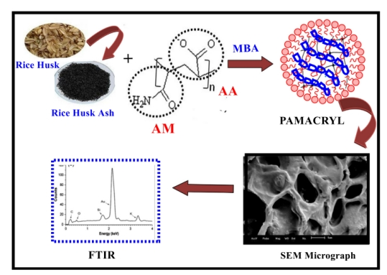
Figure1. The process of synthesis of SC-HSRF hydrogel (Rizwan et al., 2021)
3. PROPERTIES OF HYDROGEL
The physical, chemical and mechanical properties of hydrogel depend upon the type of cross-linking process needed for its formation. The key characteristics of hydrogel include its swelling ability, porosity, permeability, and biocompatibility which can be influenced by the structure, size, and chemical nature of the cross-linking agent, as well as temperature, pH, and the type of solvent used. Water permeability through hydrogel is due to its highly porous structure, with these pores developing during the phase separation process of hydrogel synthesis. The average pore size, the pore size distribution and the pore interconnections are essential factors of a hydrogel matrix (Sweta and Ashish, 2017). For hydrogels to be suitable for field applications, they must be biocompatible and non-toxic. Most polymers intended for this purpose must undergo cytotoxicity and in vivo toxicity assessments (Fu and Mar, 2019).
Hydrogels stand out from conventional absorbents due to their high swelling capacity. This property arises from the hydrophilic groups in the polymer chain, such as acrylamide, acrylic acid, and carboxylic acid, which facilitate water absorption. When these polymers interact with water, osmosis allows water to penetrate the hydrogel, causing hydrogen atoms to dissociate as positive ions. This reaction results in numerous negative ions distributed along the polymer chain. The repulsion between these negative charges causes the polymer chain to unwind and expand, attracting and binding water molecules through hydrogen bonding. As a result, hydrogels can absorb water exceeding 400 to 1500 times their dry weight during the swelling process (Patra et al., 2022).

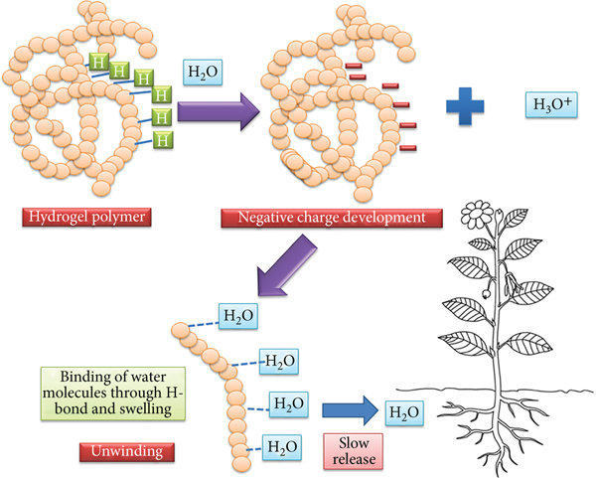

Figure 2. Mechanism of swelling of hydrogel (Patra et al., 2022).

4. MECHANISM OF RELEASE OF WATER FROM SWOLLEN HYDROGEL
The swollen hydrogel acts as a slow- release source of water in soil (miniature water reservoir). Water will be removed from these reservoirs upon the root demand through osmotic pressure difference. Potential benefit of hydrogel on water storage mainly depends on the soil texture. Coarse textured soils with large pores retain less water than fine textured soils. The amount of water that may be retained by incorporating the superabsorbent polymer would be greater in coarse textured soil than in fine textured soil.

5. EFFECT OF HYDROGEL ON DIFFERENT SOIL PROPERTIES
Hydrogel acts as ideal soil conditioner by improving the physical, chemical and biological properties of soil, resulting in higher crop growth and productivity.
5.1. Effect of hydrogel on physical properties of soil
In a study by Thombare et al. (2018), it was found that swollen hydrogel particles effectively reorganize the surrounding soil particles, leading to a reduction in bulk density and an increase in soil porosity. Additionally, these hydrogels obstruct drainage pore spaces, which limits the pathways for water to percolate, ultimately decreasing the soil's hydraulic conductivity. Applying hydrogel at a rate of 5 kg per hectare increased the soil's water holding capacity from 38.3% to 167.9% (Patel et al., 2023). However, overdose of hydrogel might completely clog the pores, leading to decreased aeration.

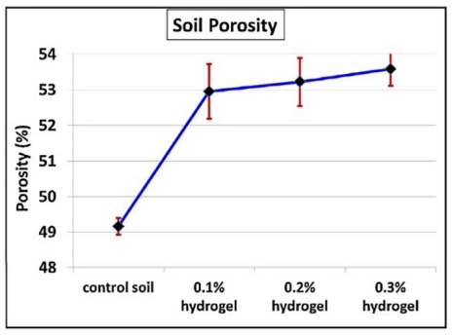

Figure 3. Effect of hydrogel on bulk density and porosity of soil (Thombare et al., 2018)

Due to enhanced water retention in soil treated with hydrogel, crops exhibit higher water use efficiency even in deficit irrigation conditions, as indicated by Abdelghafar et al. (2024). The study found that hydrogel can alleviate the adverse effects of deficit irrigation (at 85% of ETc) without compromising the fresh weight of the crops. Consequently, the need for frequent irrigation may be reduced with the use of hydrogel.

5.2. Effect of hydrogel on chemical properties of soil

The impact of hydrogel on soil reaction largely hinges on the chemical composition of the monomers used in its synthesis. At a moderate application rate of 2 grams per decimeter cube of soil, hydrogel has been shown to positively influence the soil's electrical conductivity, likely due to the release of salt ions from the hydrated hydrogel particles. However, applying higher doses can lead to a decrease in electrical conductivity, as the salts become diluted (Patel et al., 2023). In addition, functional groups such as carboxyl (-COOH), amine (-NH₂), hydroxyl (-OH) etc. present within the hydrogel chains acts as cation exchange sites which can minimize leaching loss of soil nutrients.
De Oliveira et al. (2024) investigated the interaction between a hydrogel made from potassium polyacrylate copolymer and fertigation levels to examine its impact on soil nutrient retention and, in turn, its influence on the growth and yield of tomato crops. Their findings indicated that the highest value of potassium (0.70 cmol dm⁻ ³), phosphorus (3 g dm⁻ ³), calcium (4.07 cmol dm⁻ ³) and sodium (0.49 cmol dm⁻ ³) content in soil was obtained at hydrogel concentration of 1.92 g dm⁻ ³, 1.76 mg dm⁻ ³, 1.84 g dm⁻ ³ and 1.56 g dm⁻ ³ respectively at 100% fertigation. However, nutrient concentrations in soil declined when 120% fertigation was applied. This decline is attributed to the reduced effectiveness of the polymer due to the added salt. The additional salt in the soil interacts with the negative charges on the hydrogel chains, which diminishes electrostatic repulsion and leads to a decreased swelling capacity of the hydrogel. In short, hydrogel application allows for the reduction in fertigation recommendation by 20 %.

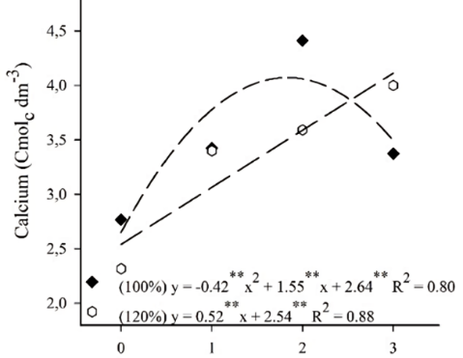
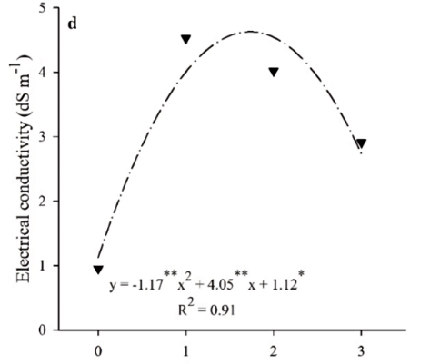

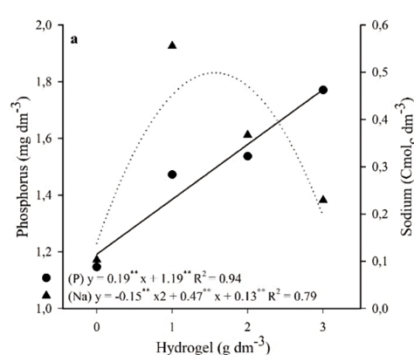
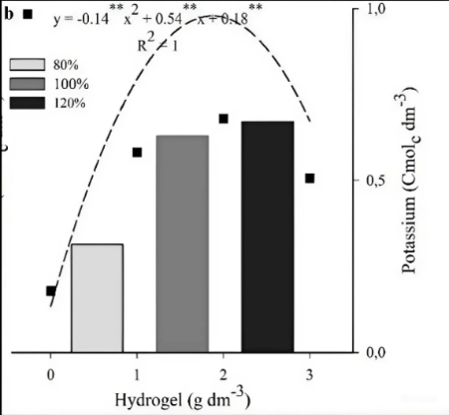

Figure 4. Effect of different rates of hydrogel on soil electrical conductivity, calcium, potassium, phosphorus and sodium (De Oliveira et al., 2024)

5.3. Effect of hydrogel on biological properties of soil

Hydrogel application has been shown to significantly enhance both soil microbial counts and microbial enzyme activity. Saied et al. (2016) studied the effect of two hydrogels with slightly different chemical compositions, created by grafting ferrous ammonium sulphate and acrylonitrile onto rice straw, on the soil biological properties. Their findings revealed that both the hydrogels boosted microbial enzyme activity by 54% and 43%, respectively. Additionally, Bokharaei et al. (2021) found that hydrogel acted as a slow-release nutrient source, leading to increases in soil microbial populations-bacteria by 64%, fungi by 57.3%, and actinomycetes by 45.3% when applied at 0.6% w/w. Li et al. (2013) found that the same rate of super absorbent polymers (SAPs) had varying effects on soil microbial properties depending on water levels. In conditions of high water deficit, the addition of SAPs increased soil microbial biomass carbon from 22 mg/kg to 24 mg/kg. Conversely, in low water deficit conditions, the increase was more substantial, rising from 22 mg/kg to 34 mg/kg. Similar results were recorded by John et al. (2005). According to Goebel et al. (2005), super absorbent polymers (SAPs) can help retain soil organic matter by integrating it into aggregates, which protects it from decomposition. Overall, the impact of hydrogel on soil microbial activity was more pronounced under non-stress and mild water-deficit conditions. As a result of enhanced soil biological fertility due to hydrogel application, crop parameters were also positively affected.

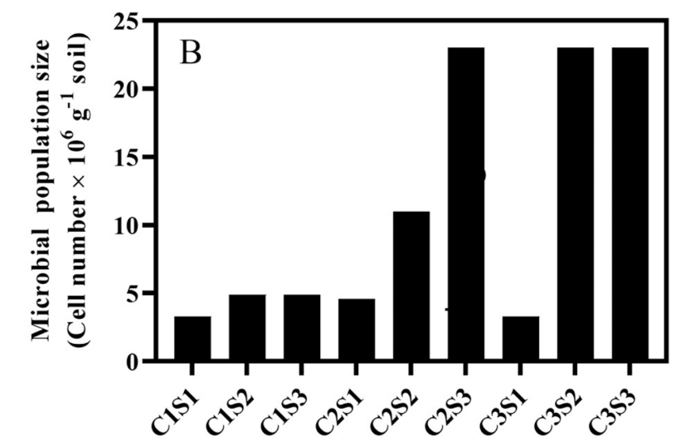

Figure 5. Effect of hydrogel on soil microbial population; levels of hydrogel- c1- 0%w/w, c2- 0.3%w/w and c3- 0.6% w/w; water levels - s1- 50% of water holding capacity, s2- 75% of water holding capacity and s3 - 85% water holding capacity (Bokharaei et al., 2021)

5.4. Effect of hydrogel on crop productivity
The application of hydrogels enhances soil properties and nutrient availability, ultimately leading to increased crop productivity. This approach could be a practical solution for boosting agricultural productivity, even in water-scarce conditions. Lower application rate of hydrogel (2.5kg/ha–5.0 kg/ha) is ideal for nearly all the crops, considering the diverse soil types and climatic conditions across India (Kalhapure et al., 2016). In a study by Jeevan et al. (2023), the application of Pusa hydrogel at a rate of 11.2 kg/ha resulted in greater plant height (103.8 cm), an increased number of branches per plant (15), more leaves per plant (135.8), a higher fruit yield (73.3 t/ha), and improved NPK use efficiency (70.2%, 11.8%, and 76.1%, respectively), all significantly outperforming the control treatments. Similarly, a field experiment conducted as part of a Farmer’s field demonstration by ICAR (2015) in various wheat-growing zones of India found that applying hydrogel at the rate of 5 kg/ha had significantly increased grain yield under different irrigation regimes. Remarkably, the yield achieved with four irrigations without hydrogel was equivalent to that with two irrigations with hydrogel (5 kg/ha). Rehman et al. (2011) reported that compared to control, application of 2.5 kg of hydrogel per hectare area enhanced growth and yield traits in aerobic rice, regardless of land type.
Under water stress conditions, any reduction in the number of days required to reach various phenophases of crops can significantly impact its yield potential. This was demonstrated in a study where wheat in plots treated with Pusa hydrogel took notably longer number of days to reach anthesis (93 days) compared to plots without hydrogel (89 days). Thus, Pusa hydrogel promoted better wheat growth by improving soil moisture conditions and enhancing the root attributes of the crops (Rajanna et al., 2022).

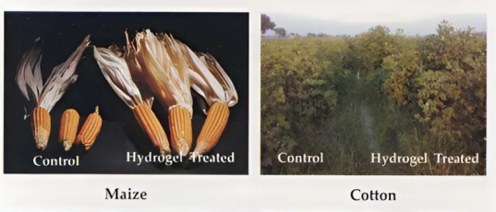

Figure 6. Growth of different crops with and without hydrogel (IARI, 2012)

6. Hydrogel as a solution for heavy metal remediation in soil

Several studies have shown that hydrogels can immobilize heavy metals like cadmium, lead, arsenic etc. in soil, effectively reducing their toxicity symptoms in plants. Du et al. (2023) found that a novel composite hydrogel, reinforced with peanut shell biochar, effectively removes cadmium in soil, achieving a maximum adsorption capacity of 164.83 mg g⁻¹, which also reduces toxicity levels in tobacco seedlings. Tobacco seedlings exposed to cadmium stress without hydrogel treatment lost their ability to close stomata when faced with additional stress from high temperature and light intensity. In contrast, the hydrogel-treated seedlings were able to mitigate the negative effects of cadmium stress, allowing them to effectively close their stomata. The presence of functional groups and a three-dimensional network structure enables hydrogels to be effective adsorbents for the removal of heavy metal ions from soil (Sarmah et al., 2020).

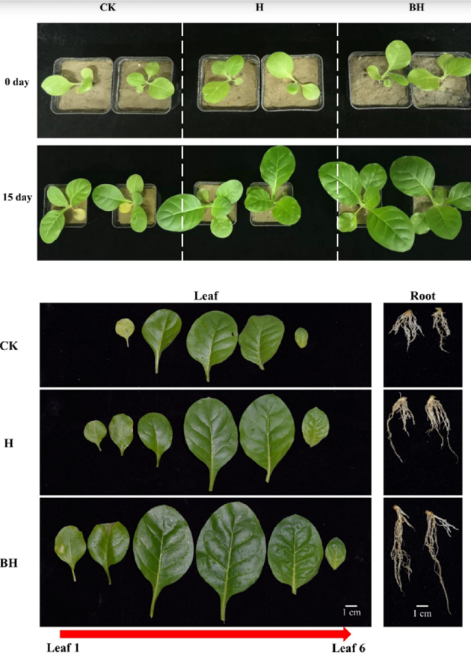
a)

b)

Figure 7. Growth index of tobacco under cadmium stress for 15 days in absence (a) and presence (b) of hydrogel (Du et al., 2023)

7. Biodegradability of hydrogel
Within the polymeric chains of hydrogel and inside the cross-links used to prepare hydrogel possess labile bonds. Theses labile bonds can be easily degraded enzymatically or chemically over a period of time. Co₂, water and ammonia are the end-products after degradation. The monomer used in hydrogel synthesis (acrylamide) is neurotoxic. But, polyacrylamide is not toxic in nature and it cannot reform back to its monomer. Even after hydrogel degradation, acrylamide residue was not determined in the soil, particularly when cellulose was selected as backbone during hydrogel synthesis. Besides, the crop products which were grown with hydrogel were also free from acrylamide residue. Hence, most of the hydrogels are environmentally safe for use. (adjuik et al., 2022)

8. Method and rate of hydrogel application
The rate and method of application of hydrogel varies with the crop cultivation methods. For field crops, dry soil and hydrogel are mixed up in the ratio of 10:1 and applied in the opened furrows before sowing or along with the seeds/fertilizers. For better results, hydrogel should be in close contact with the seeds. For nursery beds, 2 g of hydrogel (or the standard rate) is applied uniformly per square metre of nursery bed in the upper 2 inches of the bed before sowing. In case of experiments, 3–5 g of hydrogel is mixed per kilogram of soil before planting. For transplanted crops, 2 g of hydrogel is diluted with one litre of water. After settling for about 30 minutes, roots of plants are dipped in the solution and then transplanted in the field (Kalhapure et al., 2016).

9.Disadvantages of using hydrogel in agriculture

- Hydrogels are very costly (Rs.1400/kg), which might reduce the profitability of farmers
- Hydrogel is less effective in acidic soils due to its reduced swelling capacity
- If hydrogel is not applied in correct rates, it might negatively affect the soil health, especially the microbial population
- Hydrogel does not function uniformly under varying water stress conditions

10. Conclusion

In the scenario of water scarcity, hydrogel acts as a miniature water reservoir when applied at correct rate and method. Along with improving the soil properties and increasing crop yield, it also removed toxic heavy metals from the soil, thus acting as a stress medicine for crops. No reports up to date had reported any residual effects of hydrogel in either soil or crop. But further studies are required to study the time period of conversion of polyacrylamide into its toxic monomer (acrylimade). Low-cost methods of hydrogel synthesis has to be developed for increasing the profit earned by farmers. The best method of hydrogel application in acidic soils has to the determined. Standardisation of optimum rate of hydrogel application for various purpose is essential to avoid any possibility of crop yield reduction.

COMPETING INTERESTS
Authors have declared that no competing interests exist.
REFERENCES

Abdelghafar, R., Abdelfattah, A., & Mostafa, H. 2024. Effect of super absorbent hydrogel on hydro-physical properties of soil under deficit irrigation. Sci. Rep. 14(1): 7655. https://doi.org/10.1038/s41598-024-57786-5

Adjuik, T.A., Nokes, S.E., & Montross, M.D. 2023. Biodegradability of bio‐based and synthetic hydrogels as sustainable soil amendments: A review. J. Appl. Poly. Sci. 140(12): 53655. https://doi.org/10.1002/app.53655
Akhter, J., Mahmood, K., Malik, K. A., Mardan, A., Ahmad, M., & Iqbal, M. M. 2004. Effects of hydrogel amendment on water storage of sandy loam and loam soils and seedling growth of barley, wheat and chickpea. Plant Soil Environ. 50(10): 463-469. https://doi.org/10.17221/4059-PSE

Annual report 2015-2016, Central Water Commission: https://cwc.gov.in/sites/default/files/annual-report-cwc-2015-16.pdf

Bokharaei, S., Motesharezedeh, B., Etesami, H., & Motamedi, E. 2021. Effect of hydrogel composite reinforced with natural char nanoparticles on improvement of soil biological properties and the growth of water deficit-stressed tomato plant. Ecotoxicology Environ. Saf. 223: 112576. https://doi.org/10.1016/j.ecoenv.2021.112576

de Oliveira Neto, E. D., Lima, C. J. D. S., da Silva Junior, G. B., Dutra, A. F., Junior, C. R. B., Barros, P. E. D. O., Assuncao, D. D. S., & Briozo, M. E. 2024. Hydrogel application alters physical and chemical properties of soil, reducing fertirrigation needs in tomato crop. Sci. Hortic. 334: 13305. https://doi.org/10.1016/j.scienta.2024.113305

Du, F., Liu, L., Pan, Y., Wu, C., Wang, R., Zhao, Z., Fan, W., Song, H., Shi, Y., & Wang, J. 2023. A novel biochar-based composite hydrogel for removing heavy metals in water and alleviating cadmium stress in tobacco seedlings. Sci. Rep. 13(1): 15656. https://doi.org/10.1038/s41598-023-41946-0

Fu, Q. & Mar, H. 2019. Biodegradable, anti‐adhesive and tough polyurethane hydrogels crosslinked by triol crosslinkers. J Biomedical. Mater. Res. Part A. 107(10): 2205-2221. https://doi.org/10.1002/jbm.a.36730

Goebel M.O., Bachmann, J., Woch,e S.K., & Fischer, W.R. 2005. Soil wettability, aggregate stability, and the decomposition of soil organic matter. Geoderma. 128: 80-93. https://doi.org/10.1016/j.geoderma.2004.12.016

Jeevan, R. J., Ananthakumar, M. A., Kadalli, G. G., Thimmegowda, M. N., &Asha, N. N. 2023. Influence of hydrogel on growth, yield and soil properties at varied moisture regimes under drip fertigation of tomato (Solanum lycopersicum L.). Pharma Innov. 12: 1483-1488. https://www.thepharmajournal.com/vol12issue2

John, B., Yamashita, T., Ludwig, B., & Flessa, H. 2005. Storage of organic carbon in aggregate and density fractions of silty soils under different types of land use. Geoderma. 128: 63-79. https://doi.org/10.1016/j.geod.2005.04.001

Johnson, M. S. & Veltkamp, C. J. 1985. Structure and functioning of water storing agricultural polyacrylamides. J. Sci. Food Agric. 36: 789-793. https://doi.org/10.1002/jsfa.2740360905

Kalhapure, A., Kumar, R., Singh, V.P., & Pandey, D.S., 2016. Hydrogels: a boon for increasing agricultural productivity in water-stressed environment. Curr. Sci. 773-1779. https://doi.org/10.18520/cs/v111/i11/1773-1779

Li, Y., Huang, G., Zhang, X., Li, B., Chen, Y., Lu, T., Lu, T.J., & Xu, F., 2013. Magnetic hydrogels and their potential biomedical applications. Adv. Funct. Mater. 23(6): 660-672. https://doi.org/10.1002/adfm.201201708

Patel, K. K., Shah, A.K., & Latare, A. M. 2023. Effects of Hydrogel on Physical and Chemical Properties of Soil. Int. J. Plant Soil Sci. 35(8): 129-135. https://doi.org/10.9734/ijpss/2023/v35i82889

Patra, S. K., Poddar, R., Brestic, M., Acharjee, P.U., Bhattacharya, P., Sengupta, S., Pal, P., Bam, N., Biswas, B., Barek, V., & Ondrisik, P. 2022. Prospects of hydrogels in agriculture for enhancing crop and water productivity under water deficit condition. Int. J. Polym. Sci. 2022(1): 4914836. https://doi.org/10.1155/2022/4914836

Radwan, M. A., Al-Sweasy, O. H., & Elazab, H. A. 2017. Preparation of hydrogel based on acryl amide and investigation of different factors affecting rate and amount of absorbed water. Agric. Sci. 8(2): 161-70. https://doi.org/10.4236/as.2017.82011

Rajanna, G. A., Manna, S., Singh, A., Babu, S., Singh, V. K., Dass, A., Chakraborty, D., Patanjali, N., Chopra, I., Banerjee, T., & Kumar, A. 2022. Biopolymeric superabsorbent hydrogels enhance crop and water productivity of soybean–wheat system in Indo-Gangetic plains of India. Sci. Rep. 12(1):11955. https://doi.org/10.1038/s41598-022-16049-x

Rehman, A., Ahmad, R., and Safdar, M. 2011 Effect of hydrogel on the performance of aerobic rice sown under different techniques. Plant Soil Environ. 57(7): 321–325. https://doi.org/10.17221/81/2011-PSE

Rizwan, M., Gilani, S. R., Durani, A. I., & Naseem, S. 2021. Materials diversity of hydrogel: Synthesis, polymerization process and soil conditioning properties in agricultural field. J. Adv. Res. 33: 15-40. https://doi.org/10.1016/j.jare.2021.03.007

Saied, H., El-Hady, O. A., Basta, A. H., El-Dewiny, C.Y., & Abo-Sedera, S. A. 2016. Bio-chemical properties of sandy calcareous soil treated with rice straw-based hydrogels. J. Saudi Soc. Agric. Sci. 15(2): 188-194. https://doi.org/10.1016/j.jssas.2014.11.004

Sarmah, D. & Karak, N. 2020. Double network hydrophobic starch based amphoteric hydrogel as an effective adsorbent for both cationic and anionic dyes. Carbohydr. Polym. 242: 116-120. https://doi.org/10.1016/j.carbpol.2020.116320
Swetha, G. and Ashish, G. 2017. Hydrogel: Classification, properties, preparation and technical features. Asian J. Biomater. Res. 2(6): 163-170.

Thombare, N., Mishra, S., Siddiqui, M.Z., Jha, U., Singh, D., & Mahajan, G.R. 2018. Design and development of guar gum based novel, superabsorbent and moisture retaining hydrogels for agricultural applications. Carbohyd. Polym. 185:.169-178. https://doi.org/10.1016/j.carbpol.2018.01.018

Wallace, A & Wallace, G.A. 1986. Effects of polymeric soil conditioners on emergence of tomato seedlings. Soil Sci. 141: 321-323. https://doi.org/10.1097/00010694-198605000-00004

Water Aid, 2018. Water Financing Partnership Facility Annual Work Program.

Wichterle, O. & Lim, D. 1960. Hydrophilic gels for biological use. Nat. 185(4706): 117-118. https://doi.org/10.1038/185117a0

