Assessment of Spatial Variability of soil chemical properties, available Sulphur and Micronutrients status of Soils in Palghar district of Maharashtra, India.

ABSTRACT
Georeferenced surface soil samples from six tehsils in Palghar district of Maharashtra were collected using Global Positing System (GPS) to study the variability in availability of major and micro nutrients. The stratified random sampling method was used to locate the sampling villages in each tehsils.The fertility maps were prepared using Geographical Information System for each nutrient. This investigation was carried out at All India Co-ordinated Research Project on Micro and Secondary Nutrients and Pollutant Elements in Soils and Plant under Department of Soil Science, Dr. Panjabrao Deshmukh Krishi Vidyapeeth, Akola, Maharashtra to assess the chemical properties, major and micronutrients status in soils of palghar district in the year 2021-2022.GPS based one hundred and seventy nine (179) soil samples at the depth of (0-20 cm) were collected from 06 tehsils across the Palghar district of Maharashtra at 5 kms grid were collected and analysed in the laboratory. The results revealed that pH, EC, CaCO₃ and OC of soils collected across different tehsils of Palghar district varied from 5.49 to 8.16,0.05 to 1.29 dS m⁻¹,0.63 to 13.25 % and 2.20 to 10.7 g kg⁻¹ respectively. Whereas available S in soils ranged 7.26 to 31.89 mg Kg⁻¹ respectively. The DTPA -Zn, Fe, Cu and Mn in soil of Palghar district ranged from 0.35 to 7.14 mg Kg⁻¹ ,5.42 to 77.32 mg Kg⁻¹ ,0.88 to 14.88 mg Kg⁻¹ and 8.53 to 79.84 mg Kg⁻¹ respectively. The CaCl₂-B in soils of all the tehsils ranged from 0.23 to 0.69 mg Kg⁻¹. The low nutrient indices were found in respect to boron (1.39), medium for Sulphur (1.75) high for zinc (2.37),iron (2.81),copper (3.0) and manganese (3.0).The results obtained in the present study clearly showed a large variability in physio-chemical properties of soil across the Palghar district. This information could aid in decision making for application of plant nutrients and selection of cropping sequence for higher monetary returns to the farmers and extension functionaries.

INTRODUCTION
Information technology has provided tools viz. Global Positioning System (GPS) which helps in collecting a systematic set of georeferenced soil samples and generating the spatial data about the distribution of nutrients through Geographical Information System (GIS). Understanding of spatial variability and distribution of soil properties is critical for farmers attempting to increase nutrients use efficiency and crop productivity.
Green revolution has triggered to achieve higher production and nutritional security in the country. However, intensive cultivation of high yielding varieties, increased imbalanced use of fertilizers devoid of secondary and micronutrients, decreased use of organic manures and lack of crop residue recycling have let to depletion of native nutrient fertility and resulted in wide spread deficiencies of all nutrients. Application of fertilizers on the basis of soil characteristics associated with fertilizers recommendation may aid in minimizing the fertilizers input without any yield loss (Yadav et al., 2018).The information about spatial variability in physio- chemical properties of soil had great importance in the selection of crops and cropping system and also extent the ideas about prevailing management practices (Weindorf and Zhu, 2010 and Liu et al ., 2013).
Spatial variability in pH, organic carbon, available Sulphur and micronutrients has been studied by various researchers under contrasting soil and management systems to refine and implement the site-specific management (Li et al., 2011). The deficiency of micronutrients has become major constraint in sustainable crop productivity of soils and hence here is need to know the spatial variability of nutrients of the soil (Katkar et al.,2018).
Increasing population pressure and overexploitation of productive lands creates serious problem of lowering the fertility status of soil and it leads to deterioration of soil. The deficiency of nutrients directly effects on the growth of crops and crop response become poor (Jagtap et al., 2018).Hence, for sustainability of the present agricultural system and for management of our soil resources, database regarding the fertility status of soils is required.
The soil factors viz., texture, pH, organic matter content, type of clay minerals and interactions among the nutrients markedly regulate the availability of nutrients in soils (Malewar 2005).Imbalanced and inadequate use of fertilizers coupled with poor use efficiency of other inputs led to decline in the response efficiency of chemical fertilizer nutrients under intensive agriculture in recent years.
Keeping this in view, the present investigation was undertaken to assess the status of major and micronutrients in soils and to identify and delineate areas of nutrient deficiencies in Palghar district of Maharashtra, India.
MATERIAL AND METHODS
The present investigation was carried out at All India Co-ordinated Research Project on Micro and Secondary Nutrients and Pollutant Elements in Soils and Plant under Department of Soil Science, Dr. Panjabrao Deshmukh Krishi Vidyapeeth, Akola, Maharashtra to assess the chemical properties, major and micronutrients status in soils of Palghar district in the year 2021-2022.GPS based one hundred and seventy nine (179) soil samples at the depth of (0-20 cm) were collected from 06 tehsils across the Palghar district of Maharashtra at 5 kms grid were collected and analysed in the laboratory.
Description of the study area
The survey has been carried out in Palghar district. The district and tehsils were divided by grids at 5 Km and samples were collected from each grid squares.From each block in the district about 20-30 villages were selected for surface soil samples (0-20 cm).
Palghar district of Maharashtra is situated between 19⁰ 41' 49'' N to 72⁰ 46' 16'' E.The total geographical area of the district is 5,34,400 ha and is divided into six tehsils (Mokhada, Jawhar- Vikramghad, Dahanu, Talasari, Palghar and Wada).
The GPS data (Latitude, Longitude and Altitude) was recorded at each sampling site distributed over the entire district. one hundred and seventy nine (179) samples were collected. The collected georeferenced soil samples were dried in shade and processed. The processed soil samples were used for analysis of pH, EC, CaCO₃, organic carbon, S and micronutrients (Zn, Fe, Cu, Mn and B).
Soil sampling and analysis
GPS based one hundred and seventy nine surface soil samples (0-20 cm) were collected from 06 tehsils across the Palghar district. The samplings were selected using stratified random method. The soil samples were processed and analyzed for pH and EC in soil:water suspensions (1:25 w/v) as described by Jackson (1973). Organic carbon was determined by wet oxidation method described by Walkley and Black (Nelson and Sommers,1982) and free CaCO₃ was determined by Rapid method (Piper, 1966) and available S was estimated by turbidimetric method (Chesnin and Yien,1951). Soil samples were extracted with 0.005M diethylenetriamine pentaacetic acid (DTPA) for estimation of available Zn, Fe, Cu and Mn using Atomic Absorption Spectrophotometer (Lindsay and Norvell, 1978). Available boron was determined by 0.01 M CaCl₂ extract with Azo-methine method (Berger and Troug, 1939). The nutrient indices were calculated by using the formula given by Parker et al.(1951) and categorized into low (<1.66), medium (1.66-2.33) and high (>2.33).

Per cent samples low x 1+ per cent samples medium x 2
+ per cent sample high x3
Nutrient index = ………………………………………………….
100

The major and micronutrients were categorized as low, medium and high which in Maharashtra state. (Table 1).
Table 1. Categorization of soil parameters and nutrients.
Sr.No. | Parameters | Low | Medium | High
1 | pH (1:2.5) | <6.5 (Acidic) | 6.5-7.5 (Neutral) | >7.5 (Alkaline)
2 | EC (dS m⁻¹) | <1.0 | 1-2 | >2.0
3 | O.C. (g kg⁻¹) | <4.0 | 4-8 | >8.0
4 | CaCO₃ (%) | <3.0 | 3-8 | >8.0
5 | S (mg kg⁻¹) | <10.0 | 10-20 | >20
6 | Zn (mg kg⁻¹) | <0.60 | 0.60-1.80 | >1.80
7 | Fe (mg kg⁻¹) | <4.50 | 4.50-18.0 | >18.0
8 | Cu (mg kg⁻¹) | <0.20 | 0.20-0.80 | >0.80
9 | Mn (mg kg⁻¹) | <2.0 | 2.0-8.0 | >8.0
10 | B (mg kg⁻¹) | <0.50 | 0.50-1.0 | >1.0

(Source: Dr. DPKV, Akola)

Chemical properties
Sr No | Name of Tehsil | No. of samples | pH (1:2.5) |  | EC (dS m⁻¹) |  | CaCO₃ (%) |  | Org. carbon  (g kg⁻¹)
Sr No | Name of Tehsil | No. of samples | Range | Mean | Range | Mean | Range | Mean | Range | Mean
1 | Mokhada | 33 | 7.38 - 7.92 | 7.59 | 0.05 - 0.80 | 0.18 | 1.13-13.25 | 5.13 | 2.20 – 10.4 | 7.38
2 | Javhar | 34 | 7.34 - 7.76 | 7.54 | 0.10 - 0.90 | 0.23 | 1.50-10.25 | 5.13 | 2.24 – 10.2 | 6.92
3 | Dahanu | 36 | 6.23 - 7.78 | 7.43 | 0.13 - 1.29 | 0.34 | 0.63 - 5.0 | 2.67 | 5.74 – 9.81 | 8.28
4 | Talasari | 16 | 6.27 - 8.14 | 7.11 | 0.13 - 0.47 | 0.25 | 2.00 - 5.50 | 3.12 | 7.20 – 10.7 | 9.12
5 | Palghar | 30 | 5.87 - 8.16 | 6.83 | 0.10 - 0.38 | 0.20 | 0.75-11.25 | 3.85 | 2.60 – 10.3 | 8.56
6 | Wada | 30 | 5.49 - 7.83 | 6.83 | 0.09 - 0.58 | 0.22 | 2.12 - 7.62 | 5.21 | 5.56 – 10.7 | 8.61
Palghar district |  | 179 | 5.49-8.16 | 7.29 | 0.05 - 1.29 | 0.24 | 0.63-13.25 | 3.98 | 2.20 – 10.7 | 8.01
Table 2. Chemical properties of soils in Phalghar district

Table 3. Micronutrients status (mg kg⁻¹) of soil in Palghar district
Sr.  No | Tehsil | Available S |  | DTPA-Zn |  | DTPA-Fe |  | DTPA-Cu |  | DTPA-Mn |  | Cacl₂ ₋ B
Sr.  No | Tehsil | Range | PSD | Range | PSD | Range | PSD | Range | PSD | Range | PSD | Range | PSD
1 | Mokhada | 8.29 - 21.40 | 33.33 | 0.35 – 5.11 | 9.09 | 7.78 – 69.52 | 0 | 0.91 –10.23 | 0 | 15.28 - 79.84 | 0 | 0.35 – 0.66 | 60.61
2 | Javhar | 8.46 – 19.55 | 41.18 | 0.88 – 6.83 | 0 | 8.03 – 55.26 | 0 | 0.88 – 6.85 | 0 | 18.11 -79.60 | 0 | 0.32 – 0.57 | 55.88
3 | Dahanu | 7.26 – 31.89 | 41.67 | 0.45 – 3.00 | 11.11 | 6.30 – 66.24 | 0 | 1.26 –10.52 | 0 | 10.98 - 79.32 | 0 | 0.39 – 0.60 | 69.44
4 | Talasari | 8.03 – 14.34 | 31.25 | 0.47 – 2.11 | 6.25 | 10.81 – 49.98 | 0 | 1.55 – 7.98 | 0 | 20.28 - 54.52 | 0 | 0.39 – 0.59 | 56.25
5 | Palghar | 8.53 – 18.14 | 13.33 | 0.55 – 3.57 | 6.67 | 5.42 – 71.68 | 0 | 2.27 –14.88 | 0 | 8.53 – 18.14 | 0 | 0.35 – 0.56 | 56.67
6 | Wada | 8.74 – 23.58 | 16.67 | 1.65 – 7.14 | 0 | 22.24 – 77.32 | 0 | 2.72- 14.60 | 0 | 38.96 - 78.12 | 0 | 0.23 – 0.69 | 63.33
Palghar district |  | 7.26-31.89 | 30.17 | 0.35-7.14 | 5.59 | 5.42-77.32 | 0 | 0.88-14.88 | 0 | 9.11-79.84 | 0 | 0.23-0.69 | 60.89

Table 4. Nutrient index values of soil available nutrients in different tehsils of Palghar district
Sr.No | Name of the  Tehsils | No. of Samples | S | Zn | Fe | Cu | Mn | B
1 | Mokhada | 33 | 1.73 | 2.27 | 2.82 | 3.00 | 3.00 | 1.39
2 | Javhar | 34 | 1.59 | 2.38 | 2.85 | 3.00 | 3.00 | 1.44
3 | Dahanu | 36 | 1.67 | 2.14 | 2.58 | 3.00 | 3.00 | 1.31
4 | Talasari | 16 | 1.69 | 2.06 | 2.94 | 3.00 | 3.00 | 1.44
5 | Palghar | 30 | 1.87 | 2.37 | 2.77 | 3.00 | 3.00 | 1.43
6 | Wada | 30 | 1.97 | 2.93 | 3.00 | 3.00 | 3.00 | 1.37
Palghar district |  | 179 | 1.75 | 2.37 | 2.81 | 3.0 | 3.0 | 1.39

Table 5. Nutrient index value Fertility rating of soil available nutrients in different tehsils of Palghar district
Sr.No | Name of the  Tehsils | No. of Samples | S | Zn | Fe | Cu | Mn | B
1 | Mokhada | 33 | M | M | H | H | H | L
2 | Javhar | 34 | L | H | H | H | H | L
3 | Dahanu | 36 | M | M | H | H | H | L
4 | Talasari | 16 | M | M | H | H | H | L
5 | Palghar | 30 | M | H | H | H | H | L
6 | Wada | 30 | M | H | H | H | H | L
Palghar district |  | 179 | M | H | H | H | H | L

RESULTS AND DISCUSSION
Soil properties:
The pH of soils in Palghar district was recorded slightly acidic to alkaline (5.49-8.16) (Table 2). The highest pH was observed in Palghar tehsil (8.16) and lowest in wada (5.49) with mean of 7.29. Maximum soil samples were found slightly to moderately alkaline in nature. All the soils were non-saline (0.05-1.29 dS m⁻¹) in nature and suitable for healthy plant growth with a mean value of 0.24 dS m⁻¹ which was in normal range (<1 dS m⁻¹). The organic carbon content in soils ranged from 2.20 to 10.7 g kg⁻¹.The highest organic carbon content found in Palghar tehsil (10.7) and lowest in Mokhada tehsil (2.20).Maximum soil samples were found low to medium organic carbon content. Calcium carbonate content in soils of the district varied from 0.63 to 13.25 percent, which indicated, the soils are slightly calcareous in nature. High calcium carbonate is harmful; it reduces the concentration of micronutrients cations in soils to such a level that the sensitive plant suffers from the deficiency of micronutrients (Deb et al. 2009). The highest calcium carbonate content was noticed in Javhar, Palghar and Mokhada tehsil
Available Sulphur status
The available Sulphur (Table 3)varied from low to high in the range from (7.26 to 31.89) and indicating 30.17 percent deficiency.The highest (31.89) and lowest (7.26) in Dahanu tehsil only. The intensive cultivation of crops and application of fertilizers devoid of sulphur might be depleting the sulphur from soil. The application of balanced nutrition to the crops under intensive cultivation is essential for maintaining the soil fertility and sustainable productivity.
Micronutrients status
Data pertaining to DTPA- Zn in soils of Palghar district showed in (Table 3) that DTPA- Zn of Palghar district as a whole varied from 0.35 to 7.14 mg kg⁻¹ the highest value in Wada tehsil (7.14) and lowest in Mokhada tehsil (0.35) and indicating 5.59 percent deficiency, whereas 51.40 percent samples of available Zn were noticed in medium category. The highest deficiency was showed in Mokhada followed by Dahanu. The availability of micronutrients cations is generally low in alkaline soils and crops grown on these soils suffer from hidden hunger (Malewar,2005).The deficiency of nutrients creates imbalance in soils which results into nutritional stress in plants. High pH and high contents of CaCO₃ can fix Zn in the soil and results in reduction of available zinc (Hafeez et al ., 2013)
Under alkaline soil condition (pH higher then 7.0) the micronutrient cations are changed largely to their oxides and hydroxides which ultimately reduced their availability (Deb et al., 2012).DTPA-Fe content showed wide variation (5.42 to 77.32 mg kg⁻¹) and highest in Wada tehsil (77.32) and lowest in Palghar tehsil(5.42) and indicating no deficiency.
The DTPA -Cu in the soils of the study area ranged from (0.88 to 14.88) and highest in Palghar tehsil (14.88) and lowest in Javhar tehsil (0.88) and indicating zero (0) deficiency. All the soils in Palghar district were found sufficient in Copper content. Patil and Sonar (1994) reported that in swell-shrink soils of Maharashtra.
The DTPA -Mn in the soils of the study area ranged from (9.11 to 79.84) and highest range in Mokhada tehsil (79.84) and lowest range in Palghar tehsil (8.53) and indicating zero (0) deficiency and all soils in the Palghar district were founded well sufficient in Mn- content.
CaCl₂ -B the available boron in soils of Palghar district ranged from (0.23 to 0.69 mg kg⁻¹) and highest range (0.69) and lowest (0.23) in wada tehsil only and indicating 60.89 percent deficiency. (Das,2007) who reported that available phosphorous and potassium exhibited a positive correlation with Boron and there by availability of Boron getting increased with NPK additions.
Nutrient indices
The nutrient indices in (Table 4) across the Palghar district ranged from 1.59-1.97 for S ,2.06-2.93 for Zn, 2.58-3.0 for Fe,3.0 for Cu, 3.0 for Mn and 1.31-1.44 for B. Notably low fertility rating was recorded for B and high in Zn, Fe, Cu, Mn, and for medium in S.In nutshell, overall fertility rating in (Table 5) for nutrients in the soils of Palghar district revealed low B , marginal in S and high in Zn, Fe, Cu status . The area where the status of nutrients are medium may show deficiency in near future if the due care is not taken for addition of organic manures, inorganic fertilizers and micronutrients fertilizers based on soil testing by the cultivators in the districts of intensive cultivation of different crops (Malewar,2005).
CONCLUSION
The information technology based GPS-GIS technique has been found useful for systematic mapping of spatial variability of sulphur and micro nutrients. Among the major nutrients of sulphur (30.17 per cent). The micronutrients viz., zinc (5.59 percent) and boron (60.89 per cent) showed deficiency. Deficient nutrients have to be restored through chemical fertilizers and /or organic manures to maintain soil health. The current status of spatial variability of micronutrients in soils of Satara district will be helpful to suggest the efficiency ways and methods of balanced nutrient application for enhancing the yields by using recommended quantities of organic manures and inorganic fertilizers in the areas of major and micro- nutrients deficiency.
Reference
Berger KC and Truog E.Boron determination in soils and plants. Industrial and Engineering Chemistry Analytical Edition.1939;11:540-544.
Chesnin L and Yein CH. Turbidimetric determination of available sulphates. Soil Science Society of America Proceedings.1951;15:149-157.
Das KK. Boron: In Micronutrients: Their Behavious in Soils and Plants. Kalyani Publishers, Ludhiana.2007;Pp:151-189.
Deb DL, LR Sakal and SP Datta. Micronutrients in fundamental of soil science. Journal of Indian Soc.Soil Science.2009;441-490.
Deb DL, Sakal LR and Datta SP. Micronutrients: In: Fundamental of Soil Science. Indian Society of Soil Science.2012;461-490.
Hafeez B, YM Khanif and M Saleem. Role of zinc in plant nutrition-A Review American J. Experimental Agric.2013;3(2):374-391.
Jackson ML. Soil Chemical Analysis (Eds.) Prentice Hall of India, Pvt. Ltd New Delhi.1973.
Jackson ML. Soil Chemical Analysis Prentice Hall of India, Pvt. Ltd New Delhi.1967.
Jagtap Mayuri, Chaudhari Ramesh, Thakare Ritu and Patil Tulshidas. Mapping of soil micronutrient status based on GPS-GIS and biological properties of Ajang village of Dhule tehsil of Dhule district Maharashtra. Journal of Pharmacognosy and Phytochemistry.2018;7 (5): 3270-3275.
Katkar RN, Lakhe SR, Kharche VK, Magare PN and Laharia GS. Spatial variability of major and micro nutrients in soils of Bhandara District, Maharashtra. Agropedology.2018; 27 (01):56-62.
Li SF, ZB Chen, GB Chen and ZQ Chen. Spatial distribution of soil nutrients and their response to land use in eroded area of South China. Proc. Environmental Science.2011;10:14-19.
Lindsay WL and Norvell WA. Development of a DTPA soil test for zinc, iron, manganese and copper. Soil Science Society of America Journal.1978; 42: 421-428.
Liu ZP, MA Shao and YQ Wang.Spatial patterns of soil total nitrogen and soil total phosphorus across the entire Loess Plateau region of China. Geoderma.2013:197–198:67–78.
Malewar, G. U., 2005. Micronutrient stresses in soils and crops: Serious sickness and clinical approaches for sustainable agriculture. Journal of Indian Society of Soil Science 53 (4), 484-499
Nelson, D. W. and Sommers, L. E. 1982. In: Methods of Soil Analysis, Part II, Chemical and Microbiological Methods by Page, A. L., R. H. Miller and D. R. Keeney (eds.) Agronomy Monograph No. 9 (2nd edition) American Society of Agronomy and Soil Science Society of America, Madison, Wisconsin, USA : 570-572.
Parker, F. W., Nelson, W. L, Winters E. and Miles, I. F. 1951. The broad interpretation and application of soil test information. Agronomy Journal 43, 105-112.
Patil YM, and KR sonar. Status of major and micronutrients in swell-shrink soils of Maharashtra Agricultural Universities.1994; 19(2):169-172.
Piper, C. S. (1966). Soil and Plant Analysis, Hans. Pub. Bombay. Asian Ed. 368- 374.
Sharama VK and Anil Kumar. Characterization and classification of soil of upper Maul Khad catchment in wet temperature zone of Himachal Pradesh .2003;13:39-49.
Subbiah, B. V. and G. L. Asija, 1956. A rapid procedure for the estimation of available nitrogen in soils. Current Sci. 25: 259-260.
Watanabe, F. S. and S. R. Olsen, 1965. Test of ascorbic acid method for determining phosphorus in water and sodium bicarbonates extracts of soils. Proc. Soil. Sci. Soc. Am. 29:677-678.
Weindorf DC and Y Zhu. Spatial variability of soil properties at Capulin Volcano, New Mexico, USA: Implications for sampling strategy.Pedosphere.2010;20(2): 185-197.

Yadav Tikam Chand, H. K. Rai, G. S. Tagore, Dayanindhi Chaubeyand R. Dhakad. (2018).Assessment of spatial variability in physio-chemical properties of soils in Alirajpur district of Madhya Pradesh using Geo-statistical approach. Journal of Soil and Water Conservation,17(4):317-324.

Fig 1. Spatial variability of available Sulphur in soils of Palghar district of Maharashtra
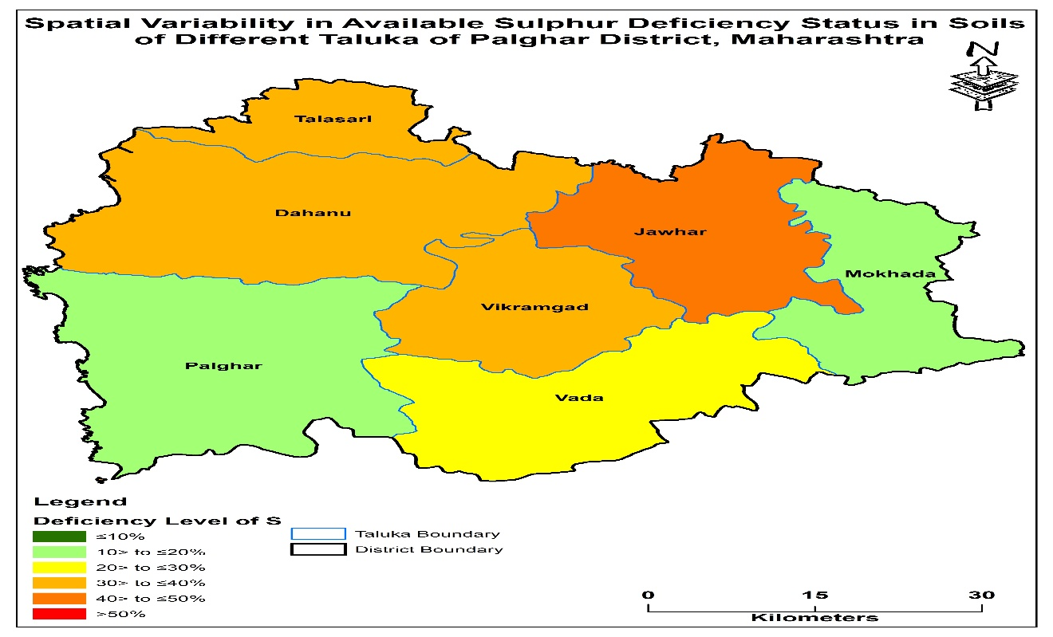
Fig 2. Spatial variability of available Zinc in soils of Palghar district of Maharashtra
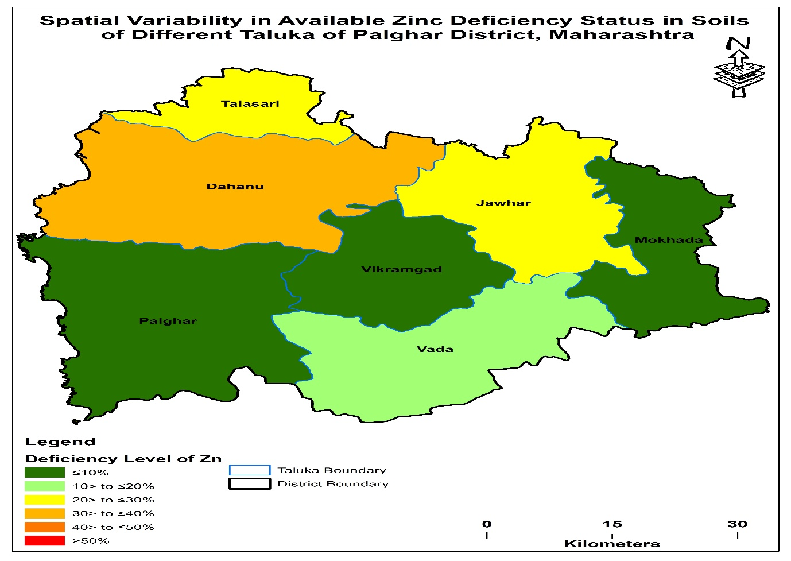

Fig 3. Spatial variability of available Fe in soils of Palghar district of Maharashtra.
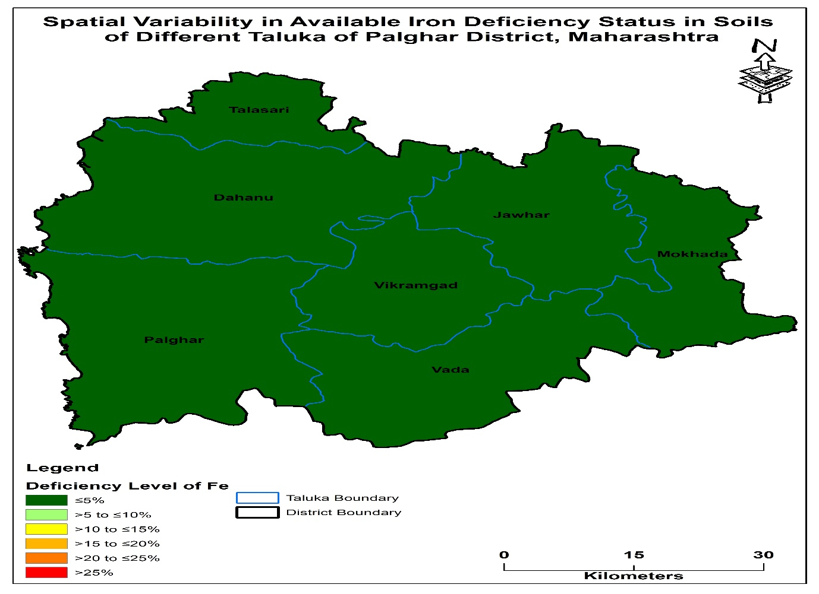Fig.4. Spatial variability of available Cu in soils of Palghar district of Maharashtra
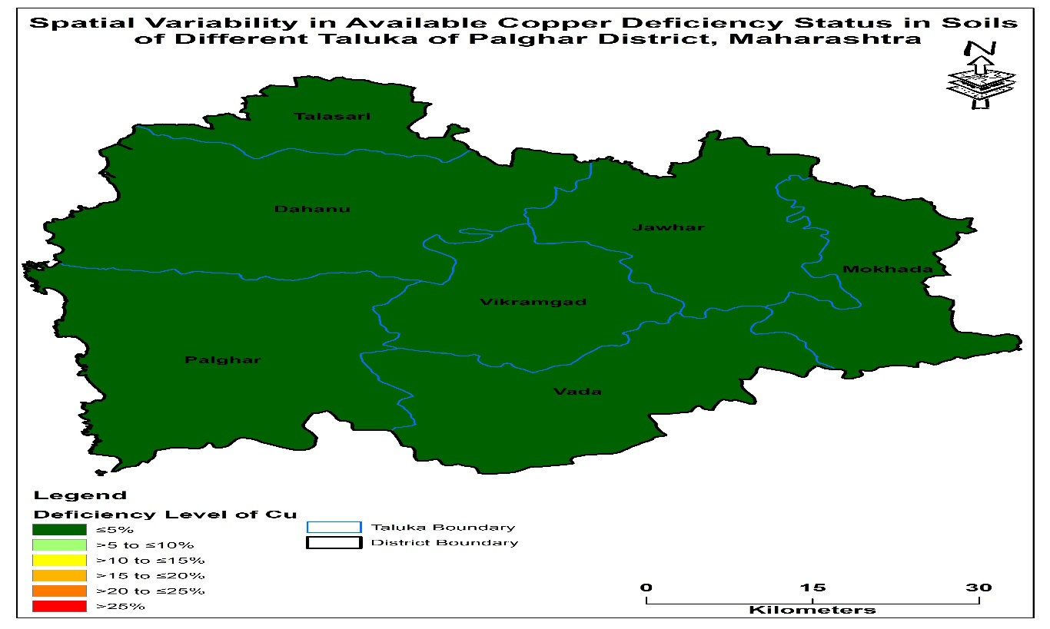

Fig.5. Spatial variability of available Mn in soils of Palghar district of Maharashtra
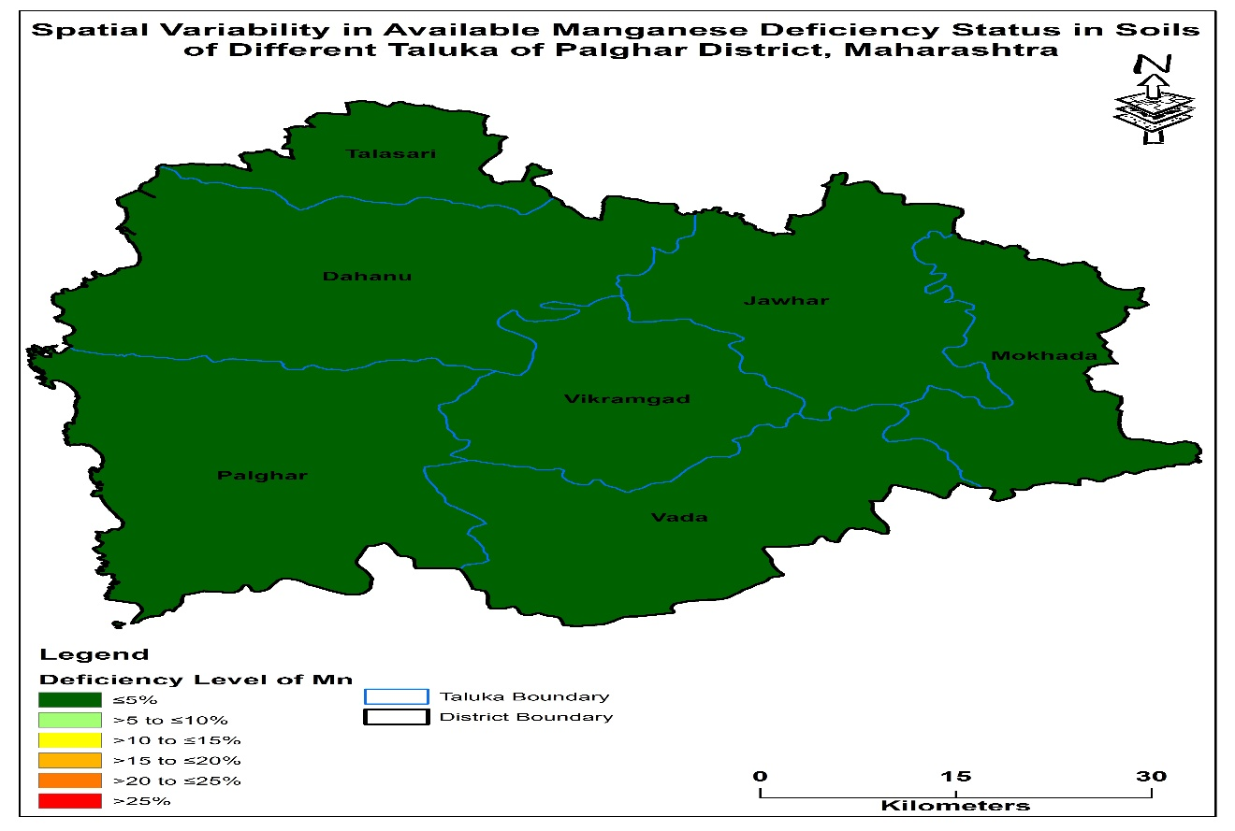

Fig.6. Spatial variability of available B in soils of Palghar district of Maharashtra
