Case report
Hydronephrosis Presenting as Abdominal Distension: An Unusual Case

ABSTRACT:
Hydronephrosis is a urological condition that most commonly occurs in the pediatric population and is not a common finding in the adult population. A study conducted in Nagpur, India has shown that ureteric calculus as the most common cause of unilateral hydronephrosis accounting for 2/3rd of the cases followed by pelviureteric obstruction in 25% of the cases. A 27year old male patient presented to the OPD with complains of left flank pain since 20 days. He had associated abdomen distention since 6 months but hadn’t seen a doctor until the pain started. The patient was diagnosed with Non-functional left kidney secondary to pelviureteric junction obstruction. The patient was diagnosed with Non-functional left kidney secondary to pelviureteric junction obstruction. The patient underwent a left open nephrectomy with a left flank incision. Intra-operatively an obstruction at the left pelviureteric junction was noted and 5 liters of clear fluid was drained from the left kidney. In conclusion, this case can be presented for its rarity and emphasizes that a pelviureteric obstruction can also be a rare cause of an acute abdomen in adults. Early diagnosis and effective surgical treatment can help prevent complications.
INTRODUCTION:
Hydronephrosis is defined as dilatation of the renal pelvis and calyces resulting from intermittent and incomplete obstruction to the flow of urine anywhere in the urinary tract (1). Hydronephrosis is a urological condition that most commonly occurs in the pediatric population and is not a common finding is adult population (2). The obstruction to urinary flow occurs due to various secondary causes that can be classified as intrinsic or extrinsic.
Depending on the site of obstruction to the urinary flow the hydronephrosis may be unilateral or bilateral. In unilateral hydronephrosis, the obstruction is present above the level of the bladder.
A study conducted in Nagpur, India has shown that ureteric calculus as the most common cause of unilateral hydronephrosis accounting for 2/3rd of the cases followed by pelviureteric obstruction in 25% of the cases(1). The incidence of pelviureteric junction obstruction is 1 in 1000 to 1500 live birth but the incidence in adults is not well defined(3). The male to female ratio for a unilateral hydronephrosis is 2:1 and most commonly occurs on the right side.
Herein we present a case of a left sided giant hydronephrosis in an adult male patient.
CASE PRESENTATION:
A 27year old male patient presented to the OPD with complains of left flank pain since 20 days. He had associated abdomen distention since 6 months but hadn’t seen a doctor until the pain started. The abdomen distention was insidious onset and gradually progressed to the current size to occupy most of the abdomen. There was no associated fever, dysuria, discoloration of urine or other urinary symptoms. No history of constipation, nausea, vomiting, weight loss and anorexia.
He had no history of similar complaints in the past and no history of any urological problems.
On physical examination, his abdomen was non-uniformly distended involving the left lumbar, left iliac, umbilical and hypogastric area with tenderness present in the left flank.
The patient was advised a USG of abdomen and pelvis which shows a large multiloculated thin-walled cystic lesion with internal echogenic debris, predominantly of retroperitoneal origin with no calcifications or definite solid components in the central and left lumbar abdominal region associated with significant mass effect.
CT abdomen and pelvis shows left kidney measurement of 22.4cm x 13.9cm. Markedly enlarged with gross hydronephrosis (renal pelvis measures 10cm) and severe thinning of cortex (3mm). Mass effect and displacement of left adrenal gland, adjacent small bowel loops, transverse and descending colon seen. Anteriorly, the dilated renal pelvis abuts the anterior abdominal wall and posteriorly, there is mild compression of abdominal aorta (figure 1 and 2)
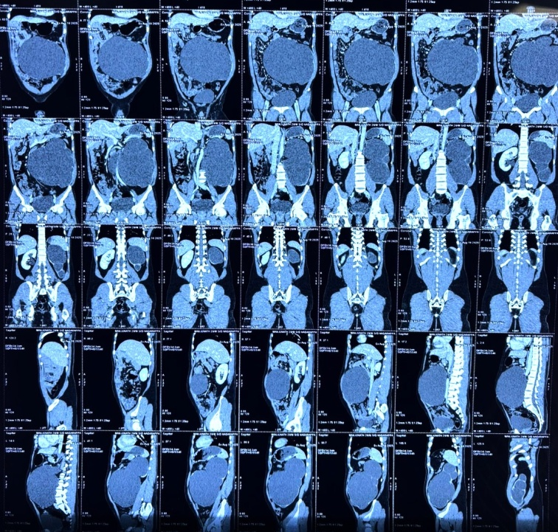
Figure 1: CT ABDOMEN AND PELVIS
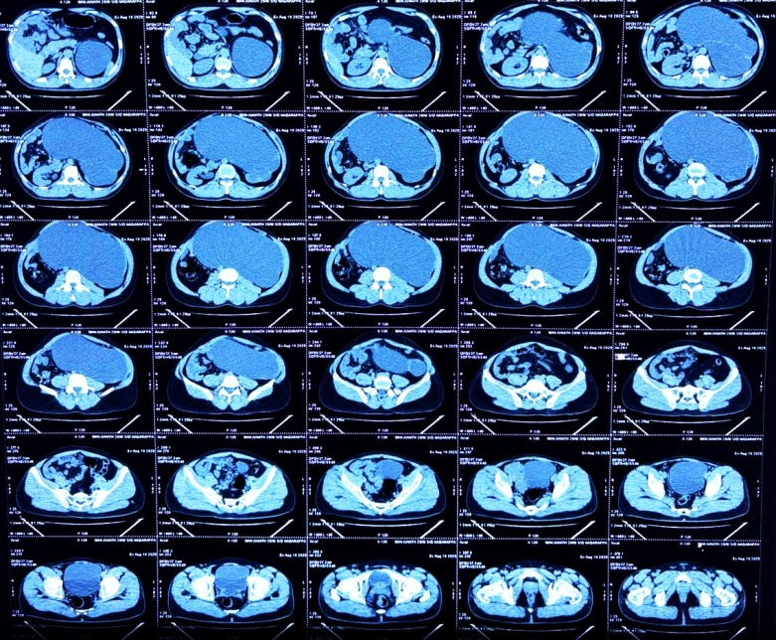
Figure 2: CT ABDOMEN AND PELVIS

The patient’s blood tests were all normal with RFT showing blood urea 17.5mg/dl (13-45mg/dl), serum creatinine 1.2 (0.70-1.40mg/dl) and serum uric acid 5.8mg/dl (3.6-8.2mg/dl).
The patient was diagnosed with Non-functional left kidney secondary to pelviureteric junction obstruction
The patient underwent a left open nephrectomy with a left flank incision (figure 3). Intra-operatively an obstruction at the left pelviureteric junction was noted and 5 liters of clear fluid was drained from the left kidney. A simple nephrectomy was done and a drain was placed. The patient was given IV Piperacillin + Tazobactam 4.5g for 5 days postoperatively. The drain contained 15ml of serosanguinous fluid on POD1 and was clear on day 2 and was removed. The patient had significant reduction in abdomen size was discharged after 1 week of hospital stay.

Figure 3: LEFT FLANK INCISION WITH DRAIN PORT
The left kidney specimen was sent for histopathological examination which measured 15cmX11cm with distorted, grey brown external surface. Microscopic examination showed renal tissue composed of few sclerosed glomeruli with periglomerular fibrosis. Atrophy and thyroidisation of tubules noted and intestitum showed fibrosis with moderate lymphoplasmacytic infiltrate (figure 4).
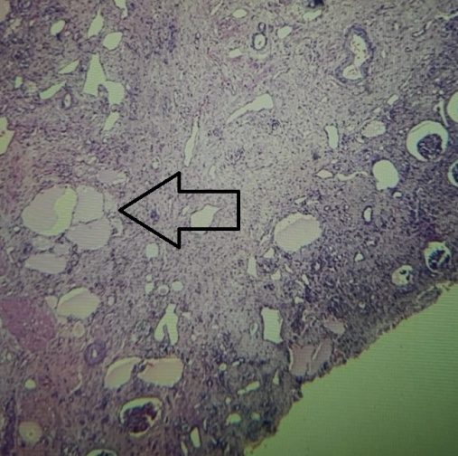
Figure 4: HISTOPATHOLOGICAL PICTURE SHOWING THYROIDISATION OF TUBULE

DISCUSSION:
This is a case of a Giant hydronephrosis. A Giant hydronephrosis is a rare condition defined as the presence of more than 1L of fluid in the collecting system.it has been radiologically defined as the kidney occupying hemi-abdomen along with crossing of the midline and/or that equals to height of five vertebral bodies. Uteropelvic junction obstruction is the most common cause of a giant hydornephrosis and other causes include urinary stone, renal ectopia, trauma, ureterovesicale junction obstruction and rarely malignancy (2).
The symptoms of a giant hydronephrosis can vary from mild abdomen pain, nausea, vomiting, fever, urinary tract infection and hematuria to asymptomatic abdomen distention until later stages of life. Most of the cases are identified during childhood and infancy. If left untreated this can lead to hypertension, renal failure, ruptured kidney or malignant transformation.
While CT is the gold standard for a patient presenting with a lower back pain, USG is preferred in children and infants due to its low cost, easy administration and non-ionizing radiation exposure.
The differential diagnosis for a GH include multicystic, dysplastic kidney, ectopic ureter, megacalycosis, simple renal cyst, urachal cyst, ovarian cyst, hydrocolops, sacrococcygeal teratoma, bowel duplication, duodenal atresia, anterior meningocele, and prune belly syndrome (5).
The treatment options for a giant hydronephrosis depends on the functioning status and the etiology of the hydronephrosis. Nephrectomy is the procedure of choice for nonfunctioning kidney and pyeloplasty is used for the management of PUJO with good differential function. a percutaneous nephrostomy can be placed as a temporary procedure.
CONCLUSION
This case can be presented for its rarity and emphasizes that a pelviureteric obstruction can also be a rare cause of an acute abdomen in adults. A differential of a giant hydronephrosis should always be kept in mind while dealing with any abdominal cystic lesion. Early diagnosis and effective surgical treatment can help prevent complications.
Reference
- Dare G, Akhtar M, Chaudhary S. Unilateral hydronephrosis in adults: etiology, clinical presentations and management. International Surgery Journal. 2019 May 28;6(6):2028.

- Hassen SM, Issack FH, Mummed FO, Hassen IK. Giant hydronephrosis secondary to ureteropelvic junction obstruction, a rare occurrence, case report. Urology Case Reports. 2021 Nov;39:101803.

- O’Sullivan NJ, Anderson S. Pelviureteric junction obstruction in adults: A systematic review of the literature. Current Urology. 2022 Sep 27;Publish Ahead of Print.

- H. G. V. Giant Hydronephrosis Due to Ureteropelvic Junction Obstruction in A 53-Year-Old Male: A Case Report. Journal of Clinical Surgery and Research. 2024 Dec 27;5(9):01–3.

- Joseph M, Darlington D. Acute Presentation of Giant Hydronephrosis in an Adult. Cureus [Internet]. 2020;12(6):e8702. Available from: https://pubmed.ncbi.nlm.nih.gov/32699698/

