case report
An atypical choroidal melanoma : case report and literature review

Abstract
Choroidal melanoma is an intraocular tumor that develops from melanocytes in the choroid. It is a very rare tumor, especially in young people. Its poor prognosis and inaccessibility to biopsy often leads to enucleation. In addition, it can be masked by intraocular inflammation, which could delay treatment. Increasingly powerful multimodal imaging techniques will be very useful in diagnosing and treating it as early as possible.

Keywords: masquerade syndrome, choroidal melanoma, evisceration

Introduction
Choroidal melanoma is the most common malignant intraocular tumor in adults, but its diagnosis in young patients remains very rare [1]. This observation highlights the importance of performing a complete examination in the presence of inflammatory signs, which may mask more serious, life-threatening conditions.
case presentation
Observation
We report the case of a 30-year-old patient with a history of amblyopia in the right eye who presented with progressive visual acuity loss in the left eye. Ophthalmological examination revealed a painless white eye on the left side with visual acuity limited to finger movement. the annexes and anterior segment were unremarkable, intraocular pressure was 17 mmHg, and the fundus (Image 1) showed moderate hyalitis discreetly concealing a heterogeneous superior temporal mass, lifting the entire upper part of the retina. Examination of the right eye was unremarkable.
B-mode ultrasound (Image 2) of the left eye revealed a heterogeneous dome-shaped choroidal mass with retinal detachment, strongly suggesting a medium-sized choroidal melanoma. Orbital brain MRI (Image 3) revealed a choroidal melanoma in the left eye, with no locoregional spread, and the thoracoabdominal pelvic CT scan showed no distant tumor spread. After consultation in a multidisciplinary meeting, enucleation was proposed given the size and location of the tumor. The procedure was performed without complications and the surgical specimen (Image 4) was sent for histological confirmation. Pathological analysis confirmed the diagnosis of mixed-type choroidal melanoma. One month later, the silicone ball was spontaneously expelled, requiring a second procedure.

Discussion
Choroidal melanoma is a malignant intraocular tumor that develops from melanocytes located in the choroid. It is a tumor with metastatic potential, which makes it particularly dangerous. It is the most common malignant eye tumor in adults [2]. Risk factors include being over the age of 50, male, Caucasian, light-colored eyes, sun exposure, occupational/toxic exposure, family history of cancer, not wearing UV glasses, congenital melanocytosis, choroidal nevus, and genetic factors: GNAQ, GNAQ11, BAP1, and CYSLTR2 mutations [3].
The patient may present with visual field loss, pain, decreased visual acuity, phosphenes, myodesopsia, or be completely asymptomatic. The diagnosis is strongly suspected clinically and then confirmed by various additional tests [4]. At the back of the eye, it appears as a pigmented subretinal mass protruding into the vitreous cavity, or as an achromatic, indurated lesion. It may be discovered following intraocular inflammation, which can initially obscure the diagnosis, as was the case with our patient, known as masquerade syndrome [5].
On B-mode ultrasound, it appears as a dome, mushroom, multilobular, or flat and diffuse [6], of varying dimensions, hypoechoic, and homogeneous. A thickness greater than 3 mm is highly suspicious for malignancy. The mushroom shape is pathognomonic of choroidal melanoma. In our patient, the appearance is heterogeneous with hyperechoic areas, which could be due to intra-tumoral hemorrhage or necrosis. B-mode ultrasound also allows associated signs to be detected, such as retinal detachment in our patient. The multilobular shape, detectable on ultrasound, is associated with a higher risk of metastasis and mortality, regardless of the initial tumor size. Fluorescein angiography reveals double circulation and a pinpoint appearance. On orbital MRI, choroidal melanoma shows hyperintensity on T1-weighted images and hypointensity on T2-weighted images with gadolinium enhancement, and also allows for the assessment of locoregional spread [7,8]. Thoracoabdominal-pelvic CT is used to assess distant spread, or even PET scan if there are warning signs.
The characteristics observed in optical coherence tomography (OCT) of subretinal fluid associated with choroidal melanoma vary according to tumor size: large tumors show a greater extent of subretinal fluid, small tumors show less alteration of the ellipsoid zone, while medium-sized tumors more frequently show detachment of the bacillary layer [9].
Histological confirmation is crucial in oncology [3]. In some cases, such as ours, it was only performed after enucleation. Cell types (spindle, epithelioid, mixed), rare variants (diffuse, clear cell, balloon cell), as well as essential immunohistochemical biomarkers (HMB45, S-100, Melan-A, MITF, tyrosinase) [10]
The differential diagnosis includes benign tumors such as choroidal nevus, hemangioma, schwannoma, osteoma, retinal pigment epithelial hypertrophy, melanocytoma, choroidal detachment, and malignant tumors such as metastases
The natural progression is toward invasion of intraocular tissues, then spread to orbital structures and distant extension with metastases [11], mainly to the liver [12].
Increasingly conservative treatments are being attempted in the early stages of the disease, including brachytherapy, proton therapy, choroidectomy, and thermotherapy [2, 13,14]. Enucleation still has its place, especially in advanced stages (diameter > 20 mm, thickness > 12 mm), and is sometimes used in combination with other treatments. , and thermotherapy [2, 13,14]. Enucleation is still used, especially in advanced stages (diameter > 20 mm, thickness > 12 mm), secondary painful glaucoma or total vision loss, and cases with orbital invasion [15].
This case illustrates the importance of early diagnosis in order to avoid radical surgery. Treatment is often enucleation, given the location and aggressive nature of this tumor. Conservative treatments such as proton therapy, brachytherapy, or phototherapy may be offered for small lesions.
Conclusion
It is important to know how to detect melanoma at an early stage. The management of choroidal melanoma in young adults must be individualized. This case highlights the importance of early diagnosis and treatment to optimize visual and vital prognosis.

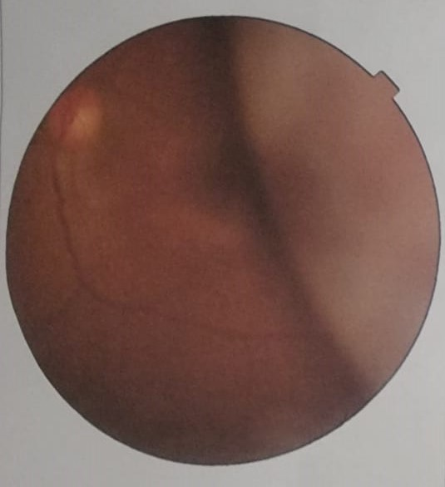  A | 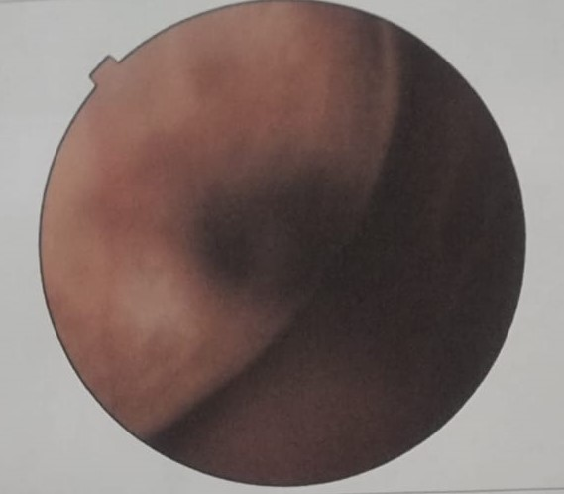  B
Image 1 (A and B): Retinophotograph of the left eye, showing the superotemporal tumor mass lifting the retina associated with hyalitis.

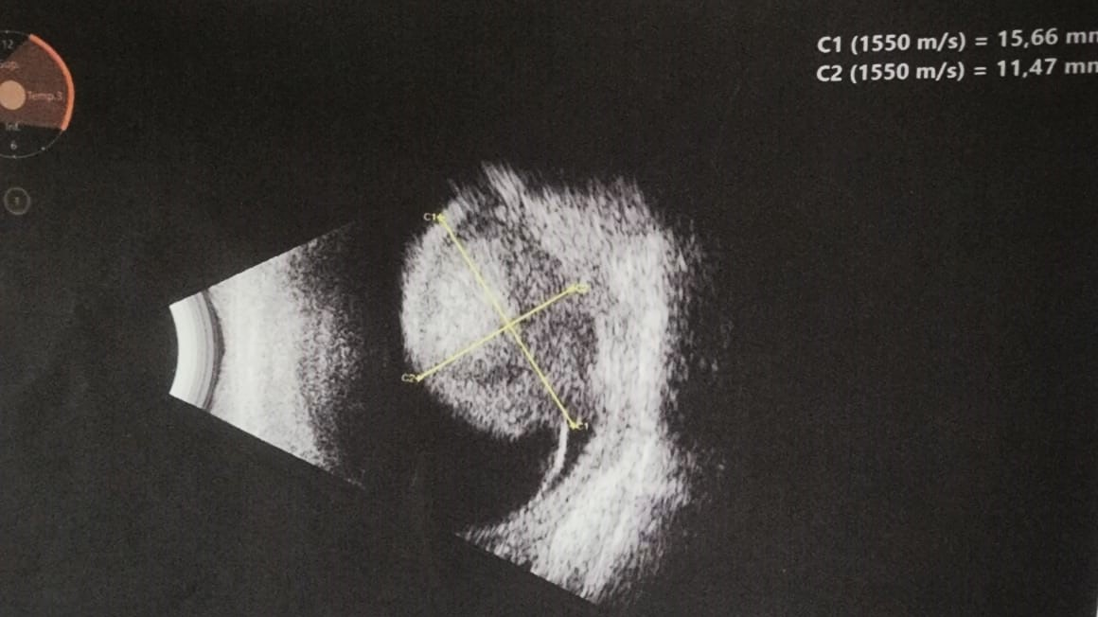
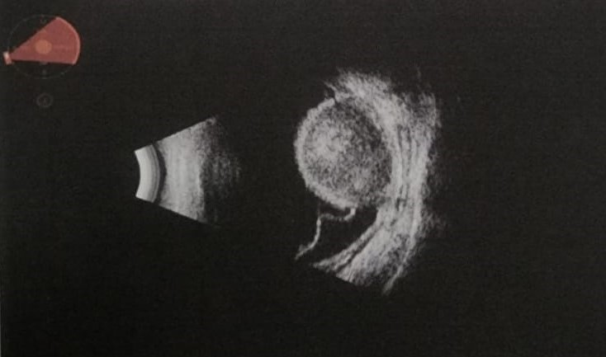
Image 2 : B-mode ocular ultrasound of the left eye showing a dome-shaped, heterogeneous, oval mass with choroidal insertion, measuring 15.66 mm at its base and 11.47 mm thick, lifting the retina (blue arrow).

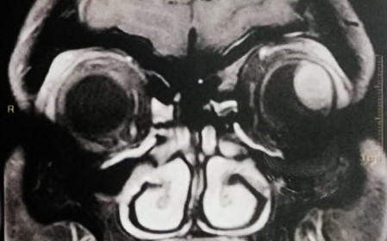  A1 | 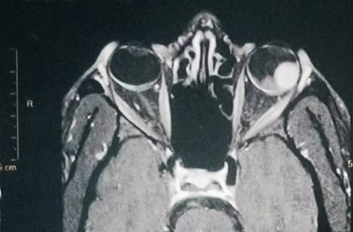  B2  B1
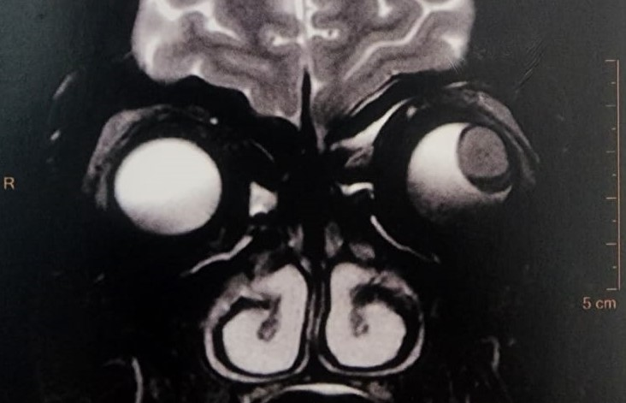  A2 | 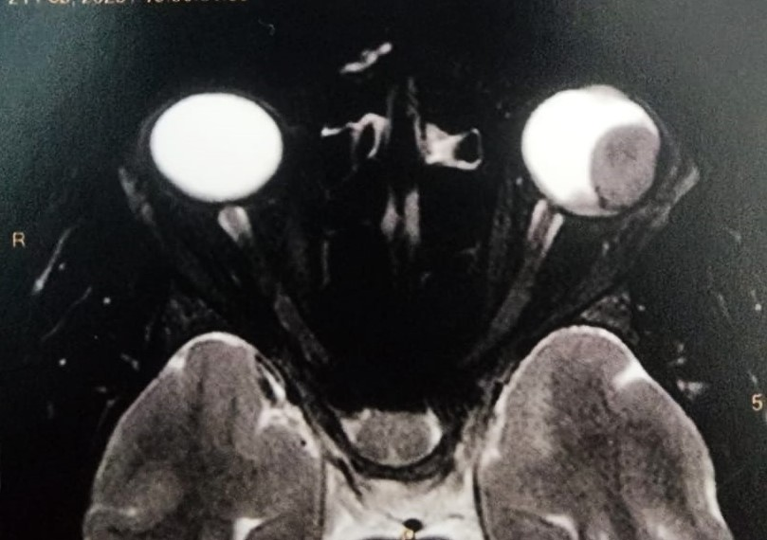
Image 3 : Coronal (A) and transverse (B) MRI scans of the brain: Left posteromedial intraocular mass, well defined, T1 hypersignal (A1, B1) and T2 hyposignal (A2, B2) with post-injection enhancement, measuring approximately 15 mm at the base, with no signs of extraocular extension, consistent with choroidal melanoma. No invasion of the optic nerve or orbital tissues. Right globe without abnormality.

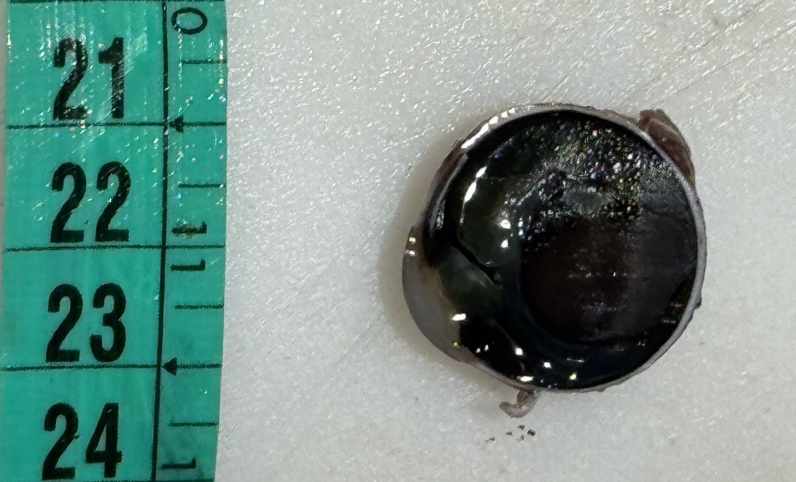
Image 4: Cross-section of the left eye after enucleation showing a homogeneous black lesion (orange arrow) measuring 1.8 cm along its longest axis. The very dark, almost black appearance is characteristic of melanin-rich melanocytic proliferation. The sclera behind is intact and there is no extrascleral extension (blue arrow).

Bibliography
[1] Zako C, Nisanova A, Weinberg V, Scholey J, Swason C, Afshar AR, Quivey J, Daftari IK, Tsai T, Park SS, Seider M, Johnson RN, Char DH, Mishra KK. Long-term clinical outcomes for adolescent and young adult uveal melanoma patients treated with proton-beam and helium-ion radiation. Ophthalmology. 2025;132(5):1012-1020.
[2] Solnik M, Paduszyńska N, Czarnecka AM, Synoradzki KJ, Yousef YA, Chorągiewicz T, et al. Imaging of uveal melanoma – current standard and methods in development. Cancers (Basel). 2022;14(13):3147. doi: 10.3390/cancers14133147.
[3] Nisanova A, Park SS, Amin A, Zako C, Wilson MD, Scholey J, Afshar AR, Tsai T, Char DH, Mishra KK. Novel Risk Factors for Uveal Melanoma in Adolescent and Young Adult Patients: A Comprehensive Case-Control Analysis. Ophthalmol Sci. 2024 Dec 24;5(4):100687. doi: 10.1016/j.xops.2024.100687. PMID: 40242369; PMCID: PMC12002997.
[4] Soliman N. Choroidal Melanoma: A Mini Review. Cureus. 2023;15(5):e39085.

[5] Dutta Majumder P, Khetan V, Biswas J. Masquerade syndrome: A review of uveitic imposters. Asia Pac J Ophthalmol (Phila). 2024 Mar-Apr;13(2):100054. doi: 10.1016/j.apjo.2024.100054. Epub 2024 Apr 5. PMID: 38583526.
[6] Ramos-Dávila EM, Dalvin LA, et al. Clinical Implications of Ultrasound-Based Morphology in Choroidal Melanoma. Ophthalmology Retina, avril 2025.
[7] Ferreira TA, Jaarsma-Coes MG, Marinkovic M, et al. MR imaging characteristics of uveal melanoma with histopathological validation. Neuroradiology. 2022;64(1):171-184.
[8] Boussif M, Benbouzid S, Akesbi Y, Elalami I, Elbenaye J, Boudhas A, et al. Radiologic assessment in choroidal melanoma: Integrating MRI and ultrasonography correlations. Sch J Med Case Rep. 2025;13(5):1171-4
[9] Guner, Melis Kabaalioglu MD; Ferenchak, Kevin MD; Olsen, Timothy W. MD; Dalvin, Lauren A. MD. OPTICAL COHERENCE TOMOGRAPHY FINDINGS IN CHOROIDAL MELANOMA-ASSOCIATED SUBRETINAL FLUID. Retina 42(11):p 2159-2168, November 2022. | DOI: 10.1097/IAE.0000000000003578
[10] Broggi G, Russo A, Reibaldi M, Russo D, Varricchio S, Bonfiglio V, Spatola C, Barbagallo C, Foti PV, Avitabile T, Longo A, Caltabiano R. Histopathology and genetic biomarkers of choroidal melanoma. Applied Sciences (Basel). 2020;10(22):8570. doi:10.3390/app10228081.
[11] Gkiala A, Sevas V, Mitropoulos P, Androudi S. Uveal Melanoma: Comprehensive Review of Its Pathophysiology, Diagnosis, Treatment, and Future Perspectives. Biomedicines. 2024 Aug 5;12(8):1758. doi:10.3390/biomedicines12081758. PMID: 39177729; PMCID: PMC11352094.
[12] Diener-West M, Reynolds SM, Agugliaro DJ, Caldwell R, Cumming K, Earle JD, Green DL, Hawkins BS, Hayman J, Jaiyesimi I, Kirkwood JM, Koh WJ, Robertson DM, Shaw JM, Thoma J; Collaborative Ocular Melanoma Study Group Report 23. Screening for metastasis from choroidal melanoma: the Collaborative Ocular Melanoma Study Group Report 23. J Clin Oncol. 2004 Jun 15;22(12):2438-44. doi: 10.1200/JCO.2004.08.194. PMID: 15197206.
[13] Weis E, Surgeoner B, Salopek TG, Cheng T, Hyrcza M, Kostaras X, et al. Management of uveal melanoma: Updated Cancer Care Alberta clinical practice guideline. Curr Oncol. 2024;31(1):24–41. doi: 10.3390/curroncol31010002.
[14] Ou Y, Li Y, Cao X, Kuang G. The surgical effect and safety of a novel intraocular choroidal melanoma resection. Front Med (Lausanne). 2025 May 30;12:1554581. doi:10.3389/fmed.2025.1554581
[15] Bai Y, Yin H, Hou JJ. Current management of uveal melanoma: a review. Clin Exp Ophthalmol. 2023;51(2):164–175. doi:10.1111/ceo.14214.

Déclarations
Declaration of patient consent: The authors certify that they have obtained all appropriate patient consent forms. The patient has consented for his images and other clinical information to be reported in the journal.
Conflicts of interest: There are no conflicts of interest

