Hemodialysis in Older Adults: Clinical Considerations and Outcomes

ABSTRACT

Aims It is well known worldwide that the lifespan of the people has increased and that patients undergoing dialysis are getting elderly. In countries such as the US and the UK, the cost of treating these patients has already been raised, as much of the health budget is spent on dialysis.
Methodology and Material The survival of 69 elderly patients (> 80 years old), aged 80-96 years old, at the beginning of dialysis, who were treated in a hemodialysis unit from 2004-2019, was studied prospectively.
Results Initially it is worth noting that the overall survival of patients was very good [those over 85 at the beginning of hemodialysis had a median survival of 12 months (range 1-75 months), while those under 85 had a survival of 18.5 months (range 1-120 months)]. Patients under the age of 85 showed statistically significantly lower serum C-reactive protein levels in comparison to those over the age of 85, without this fact playing any role in survival. Over fifty two percent (52.2%) of patients under 85 years old described their quality of life as good, while the corresponding percentage in the group over 85 was only 21.7%. Smoking, hypertension and diabetes mellitus were not found to affect survival, while cardiovascular disease as cause of chronic kidney disease was positively correlated with the risk of death.
Conclusions Our study shows that the survival of the elderly dialyzed patients is very good, with a good quality of life in a very large percentage of them. Perhaps in the future there should be no discussion about whether to start hemodialysis to the elderly, as they increase progressively and it is not making sense to deprive life of someone who can live with dignity, sometimes for too many years.

Key Words:
Hemodialysis, elderly, survival, c-reactive protein, quality of life, dialysis catheter

1. INTRODUCTION

Hemodialysis is not suitable for all patients with end-stage renal disease (ESRD). The decision to start or not this treatment should be made mainly by the patient himself and his relatives. It is difficult and the patients should be informed about the potential benefit (in terms of quality and duration of life), but also about its consequences (discomfort, pain, and suffering) (Tattersall, 2005).
It has been challenged whether the elderly patients with ESRD, who often have multiple comorbidities, are likely to benefit from renal replacement therapy (e.g., hemodialysis). Because it has significant differences in the patients, compared to the younger ones and the knowledge of these differences is crucial for their efficient care.
Bibliographically the expectancy of life for dialysis patients is significantly reduced, compared to that of the general population. Thus a 40-year-old dialysis patient has a median survival of 8 years, compared to 50 years for a person of the same age group of the general population. Similarly in the elderly, the impact of dialysis on expected survival is relatively smaller. Thus, in individuals > 80 years old, the average expected survival on dialysis is less than 2 years, compared to 8 years in younger individuals on dialysis (Chanda et al., 1999). Thus, the chance of survival for 1 and 2 years, in those who started dialysis after the age of 80 in the US is 58% and 37%, respectively, compared to 78% and 62% for all patients undergoing dialysis.
In this study, all patients over 80 years old at the beginning of hemodialysis were prospectively recorded, to determine the survival rate and the factors that affect it, as well as their quality of life.

2. MATERIAL AND METHODS

Patients
This retrospective study included 69 elderly patients over 80 years old who underwent chronic hemodialysis, during the period 1/1/2004 - 1/6/2019. During their inclusion in the study, anthropometric and clinical features, data from their medical history and results from biochemical serum tests were recorded. The study was conducted in accordance with the Helsinki Declaration of Human Rights and all patients signed a consent form.
In addition to age and sex, the primary cause of chronic kidney disease (CKD), co-morbidity (coexistence of hypertension, diabetes mellitus, cardiovascular disease and malignancy), the type of vascular access (fistula, central venous dialysis catheter) and various laboratory parameters (averages of two measurements per year during the hemodialysis period were used, for serum albumin, parathormone and C-reactive protein [CRP]).

Monitoring Period and Endpoint
Patient follow-up and endpoint data were obtained from the monthly tests until their death or the final date of the study (June 2019). At the same time the total number of their hospitalizations, the causes of their hospitalization and the causes of death were recorded.

Statistical analysis
The statistical analysis was performed with SPSS program (IBM Statistical Package for Social Sciences, 18.0 for Windows, Chicago, IL, USA). The Kolmogorov-Smirnov test was used to examine the distribution of each variable. Variables were expressed as mean and standard deviation (mean ± SD) if they follow a normal distribution and as a median with minimum range (median-minimum / maximum value) if they do not follow a normal distribution. The differences between the groups were calculated by the non-parametric Mann-Whitney test method for continuous variables and by the chi-square test method for bisected variables. The Kaplan-Meier curve and the log-rank test for comparison with survival curves were used to estimate total mortality. Cox's single-factor and multifactorial survival analysis was used to assess the adjusted Hazard Ratio-HR, with the corresponding Confidence Interval (CI) for correlation with risk factors and endpoint of the study. At first, all variables were considered as continuous and bisected in Cox single-factor analysis and only variables that were statistically significantly related to total mortality were included in the multifactorial analysis. Statistical significance was defined as p <.05.

3. RESULTS

The study included 69 elderly patients with ESRD who underwent hemodialysis, with a median age of 83 years (80-96) at the beginning of the dialysis, while 23 were over 85 years old. Over fifty two percent (52.2%) of patients were male, 43.5% had arterial hypertension (AH), 36.2% had diabetes mellitus (DM), 10.1% had neoplasmatic disease and 69.6% had cardiovascular disease (CVD). About twenty-one percent (21.7%) of patients smoked, while 85.5% had a permanent double lumen central venous dialysis catheter. The mean hemoglobin concentration was 10.64 ± 1.29 gr/dl, the mean serum albumin was 36 ± 4 gr/L, the mean serum parathormone levels was 24.5 pmol/L (normal range 1.6-126.3) and the mean CRP mean was 1.33 nmol/L (normal range 0-62.8) (mean value found from two values per year [June-December] in years undergoing hemodialysis]). The cause of ESRD was recorded in the patients: 6 had obstructive uropathy, 8 AH, 23 DM, 8 heart failure and 24 unknown causes.
Table 1 contains the differences in anthropometric, clinical and laboratory data between patients over and lower of 85 years old. Compared to those over 85 years old, with them under the age of 85 was noted statistically significantly lower serum CRP levels (0.88 vs 1.58, p = .021, Kruskal Wallis test), lower hemoglobin levels (10.9 vs 10, p =.006, Kruskal Wallis test) and higher serum parathormone levels (321 vs 207, p =.002, Kruskal Wallis test). 52.2% of patients under 85 years old described their quality of life as good, while the corresponding percentage in the group over 85 was only 21.7% (p=.04, chi-square test). Serum albumin levels, sex, smoking, AH, DM, CVD and hospitalizations did not differ significantly between the two groups. Patients over 85 at the beginning of hemodialysis (23/69) had a median survival of 12 months (1-75), in contrast to those under 85 who had median survival of 18.5 months of median survival (1-120).

Table 1: Differences in anthropometric, clinical and laboratory data between patients over and lower 85 years old (PTH=parathormone)
 | Patients with age ≥85 years old at the beginning of hemodialysis | Patients with age <85 years old at the beginning of hemodialysis | p=
Age (y) | 88 (85-96) | 81 (80-84) | .001
CRP (nmol/L) | 0.88 (0-4.5) | 1.58 (0-6.6) | .021
Hb (gm/dl) | 10±1.5 | 10.9±1.1 | .006
PTH (pmol/L) | 34 (3.07-126.3) | 21.9 (1.6-67.5) | .002
Quality of life (% of good) | 21.7% | 52.2% | .04

It is worth noting that from our patients one 84-year-old at the beginning of hemodialysis lived 240 months, three 81-year-old patients at the beginning of hemodialysis lived 91, 64 and 61 months respectively (the last one continued to live at the end of the study), two patients aged 82 at the beginning of hemodialysis lived 61 and 63 months, a 85-year-old patient at the beginning of hemodialysis lived for 75 months, another one 86-year-old at the beginning of dialysis liver 68 months, and an 88-year-old patient at the beginning of dialysis lived for 64 months.
During the median follow-up period of 18 months (1-120), 32 patients died (13 over 85) and 48 were hospitalized (29 for one time, 8 for two, 6 for three, 1 for five, 2 for seven and 1 for 8 times), most because of CVD (33/48). Kaplan-Meier curves (p =.04, log-rank test, Figure 1) showed that patients with lower median CRP had a higher risk of overall mortality: of the 32 deaths, 20 were noted in the group with lower CRP (20/34 patients) and 12 in the high CRP group (12/35 patients).
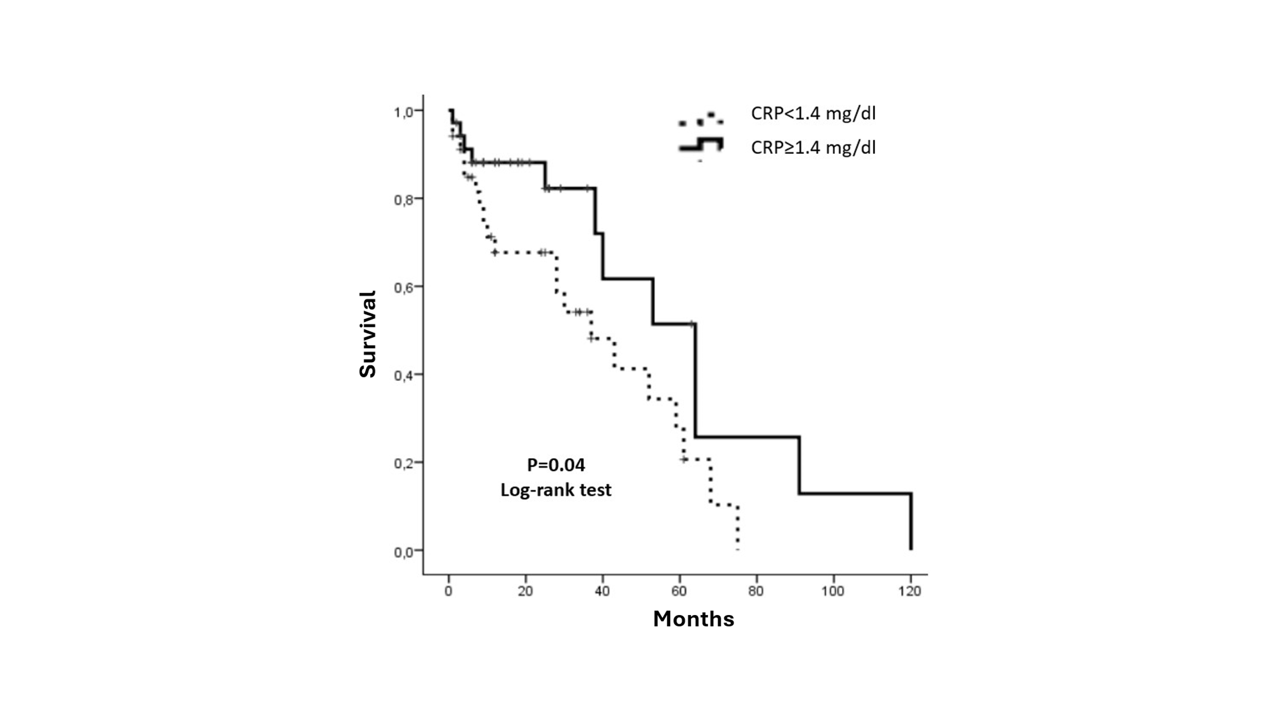
Figure 1: Kaplan-Meier survival curve for total mortality in elderly patients undergoing hemodialysis with low and high CRP (median 1.33 nmol/L)

When comparing the groups according to their age, Kaplan-Meier curves (p = .06, log-rank test, Figure 2) was noted that patients older than 85 years had a higher risk of total mortality, but marginally statistically significant (p = .06).
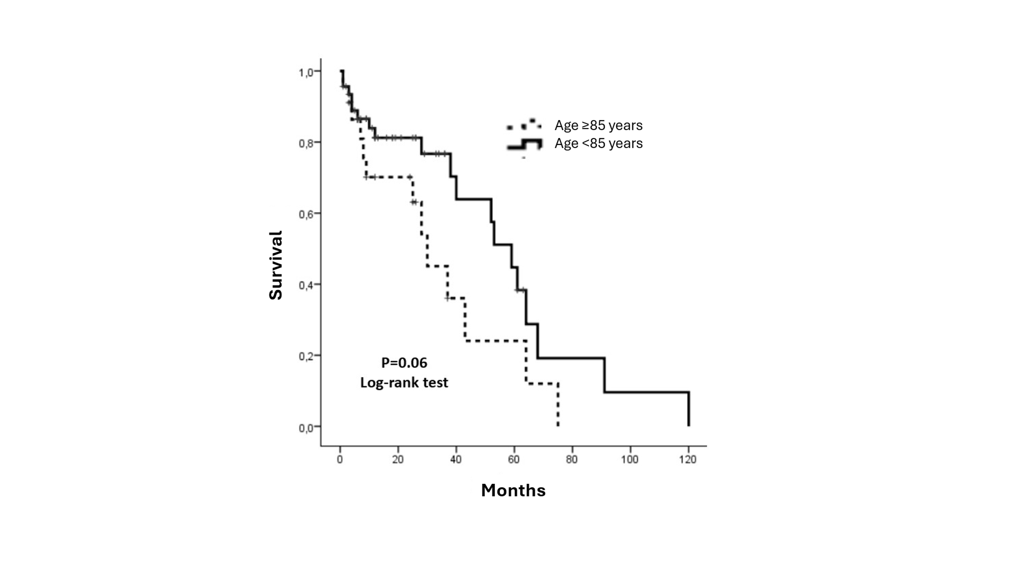
Figure 2: Kaplan-Meier survival curve for total mortality in elderly patients undergoing hemodialysis over and lower 85 years old

The Kaplan-Meier curves showed that comparing to the causes of ESRD, patients who had heart disease as the primary cause had a higher risk of mortality (4 deaths in 8 patients, p = .03, log-rank test), while lower those with obstructive uropathy as cause of renal disease (1 death in 6 patients).
Cox single-factor analysis showed that age (p = .013, HR = 1.13, 95% CI: 1.03-1.24) and the lowest CRP (p = .047, HR = 2.17, 95% CI: 1.01-4.66), were associated with the total mortality of the patients. Hemoglobin, serum parathormone and albumin, sex, smoking, type of vascular access, hospitalizations, DM, AH, CVD and cancer were not associated with the endpoint of the study. Cox multivariate analysis was then performed by placing in the same model only the variables related to mortality in the single-factor analysis (age, low CRP and causes of ESRD) and it was found that only age remained an independent prognostic factor of total mortality in elderly patients under hemodialysis (Table 2).

Table 2: Single-factor and multifactorial Cox analysis for total mortality in elderly patients over 80 years old under hemodialysis (CRP=C-reactive protein)
Total mortality
 | Hazard Ratio | 95% CI | p=
Model 1: Single factor
Age | 1.13 | 1.03 – 1.24 | .013
Lower CRP | 2.17 | 1.01 – 4.66 | .047
Model 2: Multivariate analysis
Age | 1.11 | 1.01 – 1.22 | .033
Lower CRP | 1.94 | 0.9 – 4.23 | .10

4. DISCUSSION

Elderly patients are nowadays the rule and not the exception in dialysis units. This group of patients is numerically the fastest growing in dialysis, which means that the average age of all individuals will continue to increase. This rapid increase is probably accompanied by an increase in spending more money on treatment per patient. So, in Germany in 2012, 20% of all hemodialyzed patients were ≥80 years old (Leimbach et al., 2015). In Japan in 2004, 14% of all hemodialyzed patients were ≥80 years old and respectively in 2006 was 16%, in 2008 18%, in 2010 19% and in 2012 at 22% (Nakai et al., 2014) and that number shows to increase progressively each year (Hatakeyama et al., 2013).
About 7% of all patients who began dialysis in the UK in 2003 were > 80 years old, while in the US 13%. There were about 2,500 patients under dialysis > 80 years old per million population in the UK (in the US the patients > 80 years old under dialysis during the same period were 3,400). Patients > 90 years old under dialysis were in the UK 540/million population, comparable to the total number of dialyzed patients for all ages, which was 626/million population (Tattersall, 2005).
DM is an important disease that particularly affects the elderly (in our patients 36.2% had DM). These people had higher rates of premature death, functional disability, accelerated muscle loss and co-morbidity (arterial hypertension, coronary heart disease and stroke) compared to people without DM. Elderly patients with diabetes are also at greater risk than elderly adults without DM for many usual geriatric problems, such as polypharmacy, cognitive impairment, falls with concomitant bone fractures, and persistent pain. These conditions can affect the self-care skills of the elderly with DM (Kirkman et al., 2012).
It is not surprising that mortality is much higher in elderly hemodialyzed patients, compared to the elderly who don’t need dialysis. Unfortunately, the survival of elderly patients in dialysis is generally worse than most cancers (Brown et al., 2015). Kurella et al. found that in the US patients under dialysis from 80-84 years old had an average survival of 15.6 months, while the average survival for even older people (85-89 years old) was 11.6 months and for patients > 90 years old was 8.4 months (Kurella et al., 2007).
Hatakeyama et al. studied retrospectively from 1988-2013, 141 hemodialyzed patients ≥80 years old. They found an average survival of 2.6 years, when the expected survival for the group without renal failure was 7.6 years (more specifically patients aged 80-84, 85-89 and > 90 years old survived 3.0, 2.5 and 0.9 years, respectively), with the highest percentage of patients (46%) dying at the first year of dialysis (Hatakeyama et al., 2013). In another study, almost half of those with ages 80-89 and 90-99 years died in the first year from the start of dialysis (Robinson et al., 2014), as others have found for the second group (Kurella et al., 2007). Particularly, Zingerman et al. found survival in 1, 2 and 5 years, 80%, 65% and 20%, respectively, in patients > 85 years old at the beginning of dialysis (Zingerman et al., 2014). In corresponding age groups, we have found particularly very high survival, both in those who were 81-84 years old (120 months) and those who were > 85 years old (> 70 months).
It is worth noting that survival is significantly influenced by comorbidity. Elderly patients even have a higher prevalence of comorbidity, which greatly impairs survival on dialysis, compared to the younger dialysis patients (Byrne et al., 1994, Canaud et al., 2011). The great comorbidity, and especially the daily dependence on others from the family, are very bad prognostic factors which reduced the survival in people of these ages.
In our patients who had heart disease as a primary cause of ESRD had a higher risk of mortality (4 deaths in 8 patients), while less risk have patients with obstructive uropathy as a cause of renal disease (1 death in 6 patients). Smoking, hospitalizations, DM, AH, CVD, cancer were not related to the endpoint of our study (especially in terms of hospitalizations, most of them had very good survival, namely 120 months with 8 hospitalizations, 61 months with 7 hospitalizations and 38 months with 5 hospitalizations). This means that perhaps comorbidity did not play a particular role in the survival of our patients.
As for serum CRP, it was checked to find out whether there were often episodes of infections in our patients, as 85.5% had a central venous dialysis catheter. Indeed, it was found at elevated levels in patients over 85 years old, compared to those under 85 years old, and this may have contributed to morbidity and mortality. However, the statistical analysis found exactly the opposite results. In other words, patients with a lower CRP had a higher risk of overall mortality, which cannot be interpreted, given that infections are the second cause of death of hemodialysis patients.
Those who had good nutrition and those who had fistula as vascular access for dialysis had better survival (Sladoje-Martinovic et al., 2014). Fistula positively affects survival, which was considered by researchers to be able to create it in patients over 80 years old (Leimbach et al., 2015), while the use of central venous catheters was significantly associated with increased mortality (Zingerman et al., 2014). In our patients, however, no such correlation was found, as 85.5% had a central venous dialysis catheter as vascular access, and their survival was particularly high.
Olsha et al. studied 134 patients with ESRD over 80 years old to create vascular access. They created 128 fistulas and placed 18 arteriovenous grafts. They found that age alone should not exclude patients over 80 years old from the attempt to create internal arteriovenous anastomosis, nor should anyone be excluded due to age of "first to create a fistula" (Olsha et al., 2015). In fact, 2006 K/DOQI does not distinguish between younger and elderly patients to create internal vascular access. They also were found that most patients ≥80 years old have vessels that were suitable for creating autogenous vascular access and only 12% needed prosthetic graft. There were no significant differences between patients with and without DM (Olsha et al., 2015). Unlike these findings, of our majority of patients had a dialysis catheter because it was not possible to create fistula and not because such a choice was made arbitrarily.
Perhaps the most difficult clinical decision that nephrologists must make nowadays is whether their elderly patients, with ESRD, are likely to benefit from dialysis (Swidler et al., 2012). However, when evaluating these patients with ESRD for renal replacement therapy, several additional parameters, such as their life expectancy, which is often small due to comorbidity, including DM and generalized vascular diseases, should be considered (Reindl-Schwaighofer et al., 2017). Patients with expected poor dialysis prognosis may choose to be treated conservatively instead of dialysis (Verberme et al., 2016).
The benefit of dialysis is undoubtedly the expectation of survival in people with ESRD (Jassal & Watson, 2009). It has been found that the survival rate is reduced in dialysis patients with the advancement of age progress (the 1-year survival rate is 54% in people ≥80 years old), as there is increased comorbidity (64% with 2 or more comorbidities) (Lamping et al., 2000). In addition, in elderly patients with multiple comorbidities, the onset of dialysis does not appear to extend life compared to conservative treatment (Foote et al., 2016), while increasing the risk of hospitalization, as some investigators support (Wongrakpanich et al., 2017).
Sladoje-Martinovic et al. studied 78 patients with ESDR (from 1987-2012), aged > 80 years old at the beginning of dialysis. In this study, almost one-third of them were ≥80 years old and survived for 12-24 months and one-third of them survived from 24-60 months (Sladoje-Martinovic et al., 2014).
Kwok et al. also studied a total of 558 patients with ESRD, where 126 (22.6%) chose to start dialysis and 432 (77.4%) conservative treatment. The group that chose dialysis had better average survival (44.6 months), compared to the conservative treatment group (10 months). The advantage of the survival of the group under dialysis was lost in patients > 85 years old and to those who had high comorbidity or reduced mobility (Kwok et al., 2016). On the contrary, others found that the survival of 12 months in patients over 80 years old was not significantly greater in those who started dialysis, compared to patients who chose conservative treatment (van Loon et al., 2019). The survival of our patients was clearly greater of all and obviously there was never a matter of choice of conservative treatment, versus dialysis. Rosansky declared that "the decision to start dialysis must be common and taken by the patients themselves (and their relatives) and the nephrologists, as all possible implications and benefits are known over to not treated with dialysis” (Rosansky, 2012).
In a German study from a center, the results of the dialysis of all those who were > 80 years old were analyzed between 2001 and 2012 (n = 76). One year survival was 87%, 3 years of 52%, 5 years 27% and 10 of 9%. Thirty patients had received long-term nephrological care before the beginning of dialysis, and this seems to have been of paramount importance for the successful outcome of elderly dialysis therapy, especially those aged 80-89 and 90-99 years old (Leimbach et al., 2015).
Regardless of mortality, quality of life is an important factor in making decisions on the beginning of dialysis in elderly patients. A study found that most of them choose dialysis, basically to relief their symptoms of uremia and not just for longer survival. However, they are at higher risk of suffering from hypotensive episodes during the dialysis session (Davenport, 2006), which makes them feel very exhausted. It was probably found that timely and intensive care before starting of dialysis is the key to a successful dialysis treatment in people 80-99 years old. A study by the National Registry of Slovenia (170 patients ≥ 80 years old) confirmed these results (Gubensek et al., 2014).
Lamping et al. did not find significant differences in the quality of life between elderly patients in dialysis and people with the same age of the general population in the UK and the US (Lamping et al., 2000). 52.2% of our patients under 85 years old described their quality of life as good, while the corresponding rate in the group over 85 years old was only 21.7%.

5. CONCLUSION

Our study found that hemodialysis patients over 80 years old at the beginning of dialysis with a variety of comorbidities, had excellent survival and good quality of life. The fact that one 84-year-old patient at the beginning of dialysis lived 10 more years suggests that age cannot be a barrier to this treatment.

Competing interests

Authors have declared that no competing interests exist.

CONSENT

All procedures were in accordance with the International Ethical Guidelines and Declaration of Helsinki Declaration of 1975, as revised in 2013. Written consent has been collected and preserved by the author(s).

COMPETING INTERESTS DISCLAIMER:
Authors have declared that they have no known competing financial interests OR non-financial interests OR personal relationships that could have appeared to influence the work reported in this paper.

REFFERENCES

Brown, M.A., Collett, G.K., Josland, E.A., Foote, C., Li, Q., Brennan, F.P. CKD in elderly patients managed without dialysis: Survival, symptoms, and quality of life. Clinical Journal of the American Society of Nephrology 2015;10(2):260-268.doi: 10.2215/CJN.03330414.
Byrne, C., Vernon, P., Cohen, J.J. Effect of age and diagnosis on survival of older patients beginning chronic dialysis. JAMA 1994;271(1):34-36.
Canaud, B., Tong, L., Tentori, F., Akiba, T., Karaboyas, A., Gillespie, B., et al. Clinical practices and outcomes in elderly hemodialysis patients: Results from the Dialysis Outcomes and Practice Patterns Study (DOPPS). Clinical Journal of the American Society of Nephrology 2011;6(7):1651-1662. doi:10.2215/CJN.03530410
Chandna, S.M., Schulz, J., Lawrence, C., Greenwood, R.N., Farrington, K. Is there a rationale for rationing chronic dialysis? A hospital-based cohort study of factors affecting survival and morbidity. British Medical Journal 1999;318(7178):217-223.doi: 10.1136/bmj.318.7178.217.
Davenport, A. Intradialytic complications during hemodialysis. Hemodialysis International 2006;10(2):162-167.doi:10.1111/j.1542-4758.2006.00088.x.
Foote, C., Kotwal, S., Gallagher, M., Cass, A., Brown, M., Jardine, M. Survival outcomes of supportive care versus dialysis therapies for elderly patients with end-stage kidney disease: a systematic review and meta-analysis. Nephrology (Carlton) 2016;21(3):241-253.doi: 10.1111/nep.12586.
Gubensek, J., Ponikvar, R., Ekart, R., Buturovic-Ponikvar, J. Very old patients on hemodialysis: how they start and can we predict survival? Blood Purification 2014;38(1):74-79.doi: 10.1159/000367681.
Hatakeyama, S., Murasawa, H., Hamano, I., Kusaka, A., Narita, T., Oikawa, M., et al. Prognosis of elderly Japanese patients aged ≥80 years undergoing hemodialysis. Scientific World Journal 2013 Oct 9; 2013:693514.doi: 10.1155/2013/693514.eCollection 2013.doi:10.1155/2013/693514
Jassal, S.V., Watson, D. Dialysis in late life: Benefit or burden. Clinical Journal of the American Society of Nephrology 2009;4(12):2008-2012.doi: 10.2215/CJN.04610709.
Kirkman, S., Briscoe, V.J., Clark, N., Florez, H., Haas, L.B., Halter, J.B., et al. Diabetes in older adults. Diabetes Care 2012; 35(12): 2650-2664.doi: 10.2337/dc12-1801.
Kurella, M., Covinsky, K.E., Collins, A.J., Chertow, G.M. Octogenarians and nonagenarians starting dialysis in the United States. Annals of Internsl Medicine 2007;146(3):177-183.doi: 10.7326/0003-4819-146-3-200702060-00006.
Kwok, W-H., Yong, S-P., Kwok, O-L. Outcomes in elderly patients with end-stage renal disease: Comparison of renal replacement therapy and conservative management. Hong Kong Journal of Nephrology 2016;19:42-56. doiI:10.1016/j.hkjn.2016.04.002
Lamping, D.L., Constantinovici, N., Roderick, P., Normand, C., Henderson, L., Harris, S., et al. Clinical outcomes, quality of life, and costs in the North Thames dialysis study of elderly people on dialysis: a prospective cohort study. Lancet 2000;356(9241):1543-1550.doi: 10.1016/S0140-6736(00)03123-8.
Leimbach, T., Kron, J., Czerny, J., Urbach, B., Aign, S., Kron, S. Hemodialysis in patients over 80 years. Nephron 2015;129(3):214-218.doi: 10.1159/000375501.
Nakai, S., Hanafusa, N., Masakane, I., Taniguchi, M., Hamano, T., Shoji, T, et al. An overview of regular dialysis treatment in Japan (as of 31 December 2012). Therapeutic Apheresis Dialysis 2014;18(6):535-602.doi: 10.1111/1744-9987.12281.
Olsha, O., Hijazi, J., Goldin, I. Shemesh, D. Vascular access in hemodialysis patients older than 80 years. Journal of Vascular Surgery 2015;61(1):177-183.doi: 10.1016/j.jvs.2014.07.005.
Reindl-Schwaighofer, R., Kainz, A., Kammer, M., Dumfarth, A., Oberbauer, R. Survival analysis of conservative vs. dialysis treatment of elderly patients with CKD stage 5. PLoS ONE 2017;12(7):e0181345. doi.org/10.1371.
Robinson, B.M., Zhang, J., Morgenstern, H., Bradbury, B.D., Ng, L.J., McCullough, K.P., et al. Worldwide, mortality risk is high soon after initiation of hemodialysis. Kidney International 2014;85(1):158-165.doi: 10.1038/ki.2013.252.
Rosansky, S.J. The sad truth about early initiation of dialysis in elderly patients. JAMA 2012;307(18):1919-1920.doi: 10.1001/jama.2012.3522.
Sladoje-Martinovic, B., Mikolasevic, I., Bubic, I., Racki, S., Orlic, L. Survival of chronic hemodialysis patients over 80 years of age. Clinical Interventions in Aging 2014;9:689-696.doi: 10.2147/CIA.S58976.
Swidler, M.A. Geriatric renal palliative care. The Journal of Gerontology, Series A Biological Sciences and Medical Science 2012;67(12):1400-1409.doi: 10.1093/gerona/gls202.
Tattersall, J. Dialysis in the over-80s. Age and Ageing 2005;34(2):100-101.doi:10.1093/ageing/afi056
van Loon, I.N., Goto, N.A., Boereboom, F.T.J., Verhaar, M.C., Bots, M.L., Hamaker, M.E. Quality of life after the initiation of dialysis or maximal conservative management in elderly patients: a longitudinal analysis of the Geriatric assessment in OLder patients starting Dialysis (GOLD) study. BMC Nephrology 2019;20(1):108-115.doi:10.1186/s12882-019-1268-3
Verberne, W.R., Tom, Geers, A.B.M., Jellema, W.T., Vincent, H.H., van Delden, J.J.M, Bos, W.J.W. Comparative survival among older adults with advanced kidney disease managed conservatively versus with dialysis. Clinical Journal of the American Society of Nephrology 2016;11(4):633-640.doi: 10.2215/CJN.07510715.
Wongrakpanich, S., Susantitaphong, P., Isaranuwatchai, S., Chenbhanich, J., Eiam-Ong, S., Jaber, B.L. Dialysis therapy and conservative Management of Advanced Chronic Kidney Disease in the elderly: a systematic review. Nephron 2017;137(3):178-189. doi:10.1159/000477361
Zingerman, B., Korzets, A., Ori, Y., Herman-Edelstein, M., Rozen-Zvi, B., Gafter, U., et al. The very old on hemodialysis: 8 years’ experience in a single unit. Blood Purification 2014;37(1):12-17. doi:10.1159/000357016

