Original Research Article

"Assessing Knowledge and Attitudes Toward Simulation-Based Learning: A Descriptive Study Among Nursing Students in Mangalore"

Abstract
Background: Simulation-based learning is increasingly incorporated into nursing curricula to enhance clinical competence, critical thinking, teamwork, and patient-safety skills.
Objectives: To assess the level of knowledge and attitude regarding simulation-based learning among nursing students; to determine the correlation between knowledge and attitude; and to identify the association of knowledge and attitude with selected baseline variables.
Methods: A descriptive correlational design was adopted among 100 B.Sc. Nursing students (2nd- and 4th-year) were selected using convenience sampling. Data were collected using a structured knowledge questionnaire (25 items) and a Likert-type attitude scale (19 items). Descriptive statistics, Chi-square test, and Karl Pearson’s correlation were used for analysis.
Results: The majority (60%) of students had moderately adequate knowledge, while 20% had adequate and 20% had inadequate knowledge. Attitude results showed that 50% had favourable and 50% had moderately favourable attitudes. No students demonstrated unfavourable attitudes. The correlation between knowledge and attitude was weak and not significant (r = 0.19). Significant associations were found between knowledge and variables such as year of study, age, number of times the simulation was attended, and source of knowledge. Attitude was significantly associated with gender, the number of times the simulation was attended, and the source of knowledge.
Conclusion: Nursing students demonstrated moderately adequate knowledge and favourable attitudes toward simulation-based learning. Strengthening simulation exposure and structured teaching may further enhance competency.
Keywords: Simulation-based learning, nursing education, knowledge, attitude, clinical competency.
INTRODUCTION
Simulation-based education is increasingly recognised as a vital element of contemporary nursing programmes. It gives students a safe environment to learn and refine clinical skills before they provide care to real patients. As healthcare systems become more complex, nursing education must incorporate innovative methods that help students apply theoretical learning to real-world situations. Simulation supports this need by recreating clinical scenarios through high-fidelity manikins, task trainers, standardised patients and digital technologies. Such experiences help learners practice assessment, decision-making, communication and hands-on procedures without compromising patient safety.
Relying solely on classroom instruction and traditional clinical postings may not fully prepare nursing students for the fast-changing and unpredictable nature of current clinical practice. Simulation serves as a bridge between theory and practice by offering repeated exposure to realistic situations, opportunities for immediate feedback and structured reflection. This experiential learning promotes critical thinking, strengthens clinical judgement, enhances teamwork and boosts student confidence before they transition into actual care environments.
Global research indicates that simulation-based learning contributes to better skill mastery, reduced anxiety, safer patient care practices and higher learner satisfaction. For example, a meta-analysis by Kim et al. highlighted significant improvements in knowledge, skill performance and satisfaction among nursing students trained through various levels of simulation fidelity, reinforcing its value as a key instructional method.
Although the benefits are well-documented, students’ knowledge of and attitudes toward simulation may differ depending on institutional resources, curriculum structure and previous learning experiences. Assessing these aspects is essential for improving teaching strategies and advancing competency-based education.
Therefore, the present study focuses on evaluating the knowledge and attitudes related to simulation-based learning among nursing students in a selected college in Mangalore, and examines how these may be influenced by selected demographic variables.

Statement of the Problem:
A Descriptive study to assess the knowledge and attitude regarding simulation-based learning among nursing students in a selected nursing college, Mangalore.
Objectives:
- To assess the level of knowledge regarding simulation-based learning among nursing students in the selected nursing college, Mangalore.
- To assess the attitude regarding simulation-based learning among nursing students in the selected nursing college, Mangalore.
- To determine the correlation between knowledge and attitude scores regarding simulation-based learning
- To find out the association between knowledge and attitude score with baseline variables.

METHODS
Study Design: A descriptive correlational research design was used.
Study Setting: The study was conducted at the selected College of Nursing, Mangalore, Karnataka, India.
Study Population: The Study population was B.Sc. Nursing students enrolled in the 2nd and 4th years in a selected Nursing college.

Sample Size Sampling Technique
The sample for the present study consists of 100 nursing students studying in 2 nd year and 4th year BSc nursing in a selected college, Mangalore. The participants for the study were selected using a purposive sampling method. This involved deliberately choosing nursing students who met the inclusion criteria of being enrolled in either the 2nd or 4th year of the B.Sc. Nursing program at Sahyadri College of Nursing, Mangalore. Only those students who were available and willing to participate were included in the study, ensuring that the sample was relevant to the research objectives.
Inclusion Criteria
- Students present during data collection.
- Students willing to participate.
Data Collection Tools
A structured knowledge questionnaire is designed to collect relevant information from the nursing students about their knowledge on simulation-based learning.
The tool is divided into three parts,
Part I: Demographic Performa – this is designed to elicit the demographic information from respondents consists of 8 items
Part II: Structured knowledge questionnaire- 25 items regarding the knowledge of nursing students on simulation-based learning.
Part III: Attitude scale -it consists of 19 items regarding the attitude of nursing students on simulation-based learning.

Knowledge Scoring | Attitude Scoring
- 0–8: Inadequate  - 9–16: Moderate  - 17–25: Adequate | - 19–44: Unfavourable  - 45–70: Moderately favourable  - 71–95: Favourable

Data Collection Procedure
Prior permission was obtained from the concerned principal of Sahyadri college of nursing Mangalore. The research group collected the data from the sample after obtaining consent . For maximum cooperation, the investigator introduced to the respondent and willingness of participants was assured. The respondents were assured of the anonymity and confidentiality of the information provided by them. The research data were collected after obtaining informed consent from the subjects. The researchers themselves have collected data from the samples.
STEP 1: The Demographic Performa is designed to elicit the demographic information from respondents consists of 8 items
STEP 2: Assessment of knowledge was done by a structured knowledge questionnaire, and attitude by a Likert-type attitude scale. The respondents were assured the anonymity and confidentiality of the information provided by them. Data was collected on 31/07/2025. The study samples consisted of 100 nursing students. The objectives of the study were explained to the nursing students. Data were collected by administering the structured knowledge questionnaire and attitude scale, and it took participants nearly 30to 40 minutes by the participants
Data Analysis
Data were analysed using descriptive statistics such as frequency, percentage, mean and standard deviation, while inferential statistics, including the Chi-square test and Karl Pearson’s correlation coefficient, were used to determine associations and the relationship between knowledge and attitude. A significance level of p < 0.05 was considered for all analyses.

Result:
The demographic characteristics of the 100 nursing students are presented in Table 1. The majority of the participants were female (87%), while only 13% were male. Half of the students (50%) belonged to the 21–22-year age group, followed by 45% in the 19–20-year group, and only 5% were above 23 years of age. Most participants were Hindus (61%), whereas Christians accounted for 24% and Muslims for 15%. A greater proportion of students resided in urban areas (67%) compared to rural areas (33%). More than half of the participants (53%) had previously attended simulation-based sessions, and 55% reported having some pre-knowledge of simulation-based learning. The primary source of knowledge was classroom teaching (49%).

Table 1: Frequency & Percentage Distribution of Students According to the Baseline Variables
N= 100
Sl No | Particulars | Demographic Variables | Frequency | Percentage
1 | Year | 2ND Year | 50 | 50
1 | Year | 3RD Year | 0 | 0
1 | Year | 4TH Year | 50 | 50
2 | Gender | Female | 87 | 87
2 | Gender | Male | 13 | 13
3 | Age Group | 19-20 | 45 | 45
3 | Age Group | 21-22 | 50 | 50
3 | Age Group | 23 Above | 5 | 5
4 | Religion | Christian | 24 | 24
4 | Religion | Hindu | 61 | 61
4 | Religion | Muslim | 15 | 15
5 | Residential Area | Urban | 67 | 67
5 | Residential Area | Rural | 33 | 33
6 | Attended a simulation before | Yes | 53 | 53
6 | Attended a simulation before | No | 47 | 47
7 | Pre - knowledge | Yes | 55 | 55
7 | Pre - knowledge | No | 45 | 45
8 | If yes how many | 1-2 | 44 | 44
8 | If yes how many | 3-5 | 7 | 7
8 | If yes how many | More than 5 | 2 | 2
9 | Source of knowledge | Class room | 49 | 49
9 | Source of knowledge | Work shop | 3 | 3
9 | Source of knowledge | Peer | 0 | 0
9 | Source of knowledge | Articles | 2 | 2
9 | Source of knowledge | Other | 1 | 1
10 | Individual /group simulation | Individual | 4 | 4
10 | Individual /group simulation | Group | 50 | 50
10 | Individual /group simulation | Both | 46 | 46

Table 2: Frequency and percentage distribution of the level of knowledge on simulation-based learning
N=100
Knowledge  Level | Score | Number | Percentage
Adequate | 0-8 | 20 | 20
Moderate | 9-16 | 60 | 60
In Adequate | 17-25 | 20 | 20

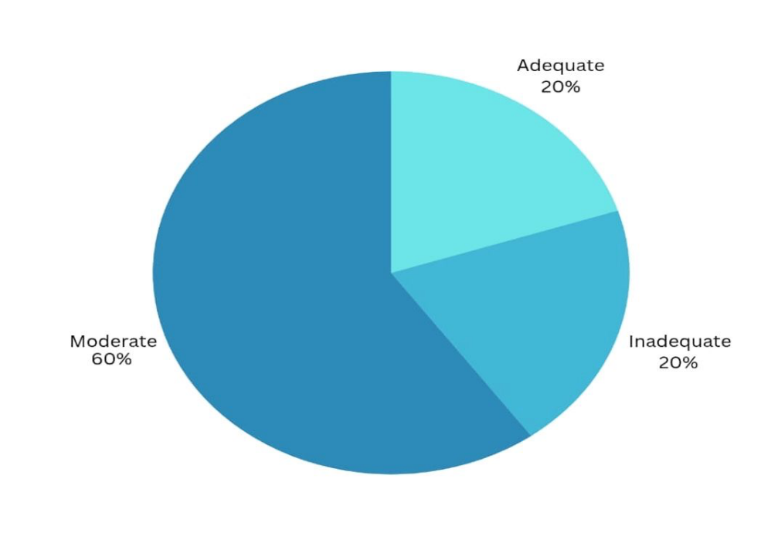
Figure 1: Diagram showing the level of knowledge on simulation-based learning
The level of knowledge regarding simulation-based learning is summarised in Table 2 and illustrated in Figure 1. The findings show that the majority of students (60%) had moderately adequate knowledge, while 20% demonstrated adequate knowledge, and another 20% had inadequate knowledge

Table 3:Frequency and percentage distribution of attitude based on simulation-based learning.
N=100
Attitude level | Score | Number | Percentage
Unfavourable | 19-44 | 0 | 0
Moderate | 45-70 | 50 | 50
Favourable | 71-95 | 50 | 50

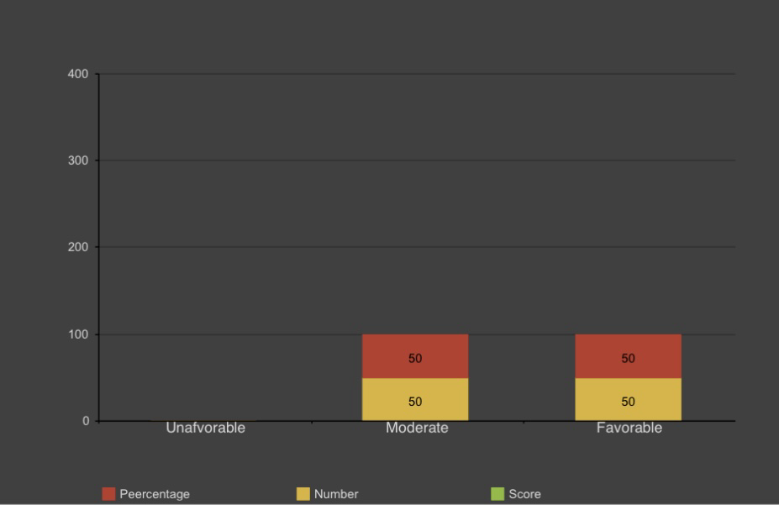

Figure 2: Diagram showing the level of Attitude on simulation-based learning

The attitudes of nursing students toward simulation-based learning are detailed in Table 3 and represented graphically in Figure 2. Exactly half of the participants (50%) showed favourable attitudes, while the remaining 50% had moderately favourable attitudes. No students reported unfavourable attitudes.

Table 4: Mean, SD, Mean percentage and correlation of knowledge and attitude of simulation-based learning

Aspect | Mean | SD | Mean percentage | Correlation coefficient
Knowledge | 12.5 | 5.40 | 12.5% | 0.1903
Attitude | 70.25 | 12.8 | 70.25% | 0.1903
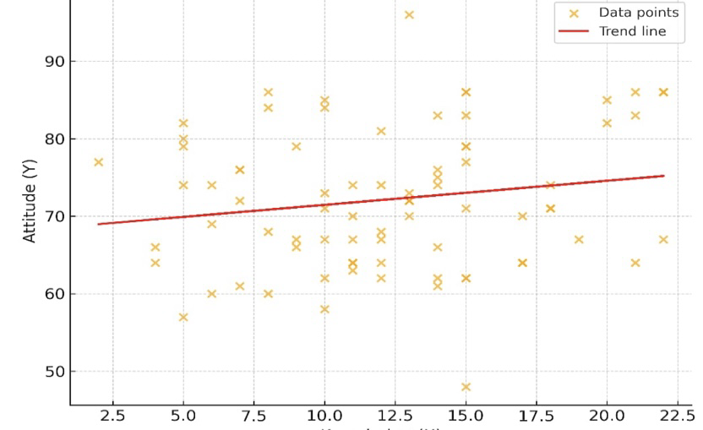

Figure 3: Diagram showing the correlation of knowledge and Attitude on simulation-based learning
The correlation between knowledge and attitude scores is depicted in Figure 3 and summarised in Table 4. The Pearson correlation coefficient (r = 0.19) indicates a weak and statistically non-significant relationship between knowledge and attitude, suggesting that higher knowledge levels did not necessarily correspond to more positive attitudes among the students.

Table 5 : Association Between Knowledge Score and Selected Demographic Variables
Chi-square test was used to test the association between knowledge on simulation-based learning and selected demographic variables.
Demographic Variables | DF | (X)2 | Table value | Inference
Year of study | 4 | 15.066 | 9.488 | S
Gender | 4 | 7.307 | 9.488 | NS
Age group | 4 | 10.905 | 9.488 | S
Religion | 6 | 2.438 | 12.592 | NS
Residential area | 2 | 3.427 | 5.992 | NS
Attended simulation (yes/no) | 2 | 1.704 | 5.991 | NS
How many times | 4 | 27.832 | 9.488 | S
Pre knowledge | 2 | 4.307 | 5.991 | N S
Source of knowledge | 8 | 27.027 | 15.507 | S
Individual /group | 4 | 4.303 | 9.488 | N S

Table 6 : Association Between Attitude Score and Selected Baseline Variables
Demographic variables | DF | (X)2 | Table value | Inference
Year of study | 4 | 1.44 | 9.488 | NS
Gender | 4 | 13.928 | 9.488 | S
Age group | 4 | 1.474 | 9.488 | NS
Religion | 6 | 2.068 | 12.592 | NS
Residential area | 2 | 5.47 | 5.991 | NS
Attended simulation (yes/no) | 2 | 0.038 | 5.991 | NS
How many times | 4 | 43.327 | 9.488 | S
Pre knowledge | 2 | 0.362 | 5.991 | NS
Source of knowledge | 8 | 26.065 | 15.507 | S
Individual/group | 4 | 0.166 | 9.488 | NS

Association analyses between knowledge scores and demographic variables revealed significant associations with year of study, age group, frequency of simulation attendance, and source of knowledge (Table 5). Meanwhile, gender, religion, residential area, prior exposure to simulation, and pre-existing knowledge were not significantly associated with knowledge levels. Regarding attitude scores, significant associations were observed with gender, frequency of simulation attendance, and source of knowledge, whereas no significant association was found with other variables such as year of study, age, religion, residence, prior knowledge, or type of simulation (Table 6).

Discussion
The present study revealed that the majority of nursing students had moderately adequate knowledge regarding simulation-based nursing education. This finding is consistent with previous studies conducted in India and abroad, where researchers have similarly reported moderate levels of knowledge among nursing students as well as faculty members. These similarities suggest that while simulation is recognized as a valuable teaching–learning method, comprehensive understanding of its concepts, technology, and implementation strategies is still developing across educational settings.
In the current study, most participants also demonstrated a moderately favourable attitude towards simulation, aligning with earlier research showing that nursing students generally perceive simulation positively due to its interactive, safe, and experiential learning environment, enhanced clinical confidence, and opportunities for skill refinement without risk to patients. Students view simulation as an innovative approach that bridges the gap between theory and practice, contributing to better preparedness for clinical situations.
However, the absence of a statistically significant correlation between knowledge and attitude in this study suggests that, although learners appreciate the usefulness of simulation, their conceptual and practical understanding may not yet be strong enough to fully transform positive attitudes into higher knowledge scores. This indicates a need for more structured exposure, continuous skill-based reinforcement, and faculty capacity-building to strengthen both cognitive and affective learning components.
Furthermore, the study demonstrated significant associations between knowledge and exposure-related variables such as prior simulation experience suggesting that greater hands-on practice enhances understanding and retention. Additionally, the observed gender-based differences in attitudes may reflect varied learning preferences, confidence levels, or social conditioning, which should be acknowledged when planning simulation instructional strategies.
Further supporting this interpretation is the study by Chauee, Yumnam, and Sngi Chyrmang, which assessed knowledge and attitude levels of B.Sc. Nursing students toward simulation-based nursing education and also found a majority of participants had moderately adequate knowledge and moderately favourable attitudes. Their descriptive survey of 146 students yielded comparable results: 27% with inadequate knowledge, 68% with moderately adequate knowledge, 5% with adequate knowledge; and 84% with moderately favourable attitude, 16% with favourable attitude. Their conclusion likewise underlined the need to strengthen simulation-based learning strategies to enhance both knowledge and positive attitudes toward this educational method.
Overall, the aggregated findings underscore the necessity of strengthening curriculum frameworks, ensuring regular and progressive simulation-based learning sessions, and improving accessibility to simulation labs and trained educators. By enhancing both knowledge and positive perceptions, nursing institutions can better prepare students for complex clinical decision-making and safe patient care through simulation-based education.

Conclusion
Nursing students exhibited moderate knowledge and favourable attitudes toward simulation-based learning. Although the correlation between knowledge and attitude was weak, exposure frequency significantly influenced both. Enhancing simulation resources and integrating structured simulation sessions may further improve competency development.

CONFLICT OF INTEREST
None declared.
REFERENCES
- Kim, J., Park, J. H., & Shin, S. (2016). Effectiveness of simulation-based nursing education depending on fidelity: a meta-analysis. BMC Medical Education, 16, 152. https://doi.org/10.1186/s12909-016-0672-7
- Aebersold, M. (2018). Simulation-based learning: No longer a novelty in undergraduate education. OJIN: The Online Journal of Issues in Nursing, 23(2). https://doi.org/10.3912/OJIN.Vol23No02PPT39
- Kim, J., Park, J., & Shin, S. (2016). Effectiveness of simulation-based nursing education depending on fidelity: a meta-analysis. BMC Medical Education. https://doi.org/10.1186/s12909-016-0672-7
- Chabchera, C., Dobrowolska, B., Jackson, C., Kane, R., Kasimovskaya, N., Kennedy, S., Lovrić, R., Palese, A., Treslova, M., & Cabrera, E. (2021). Simulation in nursing education programs: Findings from an international exploratory study. Clinical Simulation in Nursing, 59, 23–31. https://doi.org/10.1016/j.ecns.2021.05.004
- Wikipedia contributors. (2023). Nurse education. Wikipedia. https://en.wikipedia.org/w/index.php?title=Nurse_education&oldid=1196128321
- Al-Elq, A. H. (2010). Simulation-based medical teaching and learning. Journal of Family and Community Medicine, 17(1), 35–40. https://doi.org/10.4103/1319-1683.68787
- Sawaya, R. D., Mrad, S., et al. (2021). Simulation-based curriculum development: lessons learnt in Global Health education. BMC Medical Education, 21(1), 33. https://doi.org/10.1186/s12909-020-02430-9
- Sharma, K. S. (2018). Nursing research and statistics (3rd ed.). Reed Elsevier India Private Limited. https://www.medtree.co.in/nursing-research-and-statistics-3rd-edition.html
- Tamilselvan, C., Chua, S. M., Chew, H. S. J., & Devi, M. K. (2023). Experiences of simulation-based learning among undergraduate nursing students: A systematic review and meta-synthesis. Nurse Education Today, 121, 105711. https://doi.org/10.1016/j.nedt.2023.105711
- Sterner, A., Nilsson, M. S., & Eklund, A. (2023). The value of simulation-based education in developing preparedness for acute care situations: An interview study of new graduate nurses’ perspectives. Nurse Education in Practice, 67, 103549. https://doi.org/10.1016/j.nepr.2023.103549
- Koukourikos, K., Tsaloglidou, A., Kourkouta, L., Papathanasiou, I. V., Iliadis, C., Fratzana, A., & Panagiotou, A. (2021). Simulation in Clinical Nursing Education. Acta Informatica Medica. https://doi.org/10.5455/aim.2021.29.15-20
- Chang, Y. Y., Chao, L. F., Xiao, X., & Chien, N. H. (2021). Effects of a simulation-based nursing process educational program: A mixed-methods study. Nurse Education in Practice, 56, 103188. https://doi.org/10.1016/j.nepr.2021.103188
- Fawaz, M., & Alsalamah, Y. (2022). Clinical competence and self-efficacy of Lebanese and Saudi nursing students participating in simulation-based learning in nursing education. Nursing Forum. https://doi.org/10.1111/nuf.12673
- Bø, B., Husebø, A. M. L., Rokne, B., Bjørknes, A. M., & Haraldstad, K. (2022). Nursing students' experiences with simulation-based education as a pedagogic method in low-resource settings: A mixed-method study. Journal of Clinical Nursing, 31(9–10), 1362–1376. https://doi.org/10.1111/jocn.15996
- Solheim, E., & Flo, J. (2023). Nurses’ experiences of simulation-based learning, 12–18 months after the simulation: A qualitative study. Nordic Journal of Nursing Research, 43(1), 20571585211032774. https://doi.org/10.1177/20571585211032774
- Edward, M. I., & Chukwuka, L. (2020). Simulation in nursing education: Implications for nurse educators and nursing practice. African Journal of Health, Nursing and Midwifery, 3(1), 13-23. https://www.abjournals.org/african-journal-of-health-nursing-and-midwifery-ajhnm/simulation-in-nursing-education-implications-for-nurse-educators-and-nursing-practice/
- Sarı, D., & Erdem, H. (2017). The use of high fidelity simulation in nursing education: A literature review. Journal of Human Sciences, 14(4), 3690–3707. https://www.j-humansciences.com/ojs/index.php/IJHS/article/view/4882
- Lateef, F. (2010). Simulation-based learning: Just like the real thing. Journal of Emergencies, Trauma and Shock, 3(4), 348–352. https://doi.org/10.4103/0974-2700.70743
- Sengupta, M., & Tungoe, L. C. (2021). Knowledge on Simulation based learning in Nursing Education among Nursing Fraternity in selected Nursing Institutions of India. Asian Journal of Nursing Education and Research, 11(3), 409–414. https://doi.org/10.52711/2349-2996.2021.00098
- Akhter, Z., Malik, G., & Plummer, V. (2021). Nurse educator knowledge, attitude and skills towards using high-fidelity simulation: A study in the vocational education sector. Nurse Education in Practice, 53, 103048. https://doi.org/10.1016/j.nepr.2021.103048
- Torkshavand, G., Khatiban, M., & Soltanian, A. R. (2020). Simulation-based learning to enhance students’ knowledge and skills in educating older patients. Nurse Education in Practice, 42, 102678. https://doi.org/10.1016/j.nepr.2019.102678.

