Original Research Article

A Cross-Sectional Study on the Prescription Pattern Among Elderly Patients in a Tertiary-Level Hospital in Bangladesh

ABSTRACT

Background: The health care issues among the aging population in Bangladesh have their characteristics that require specific approaches regarding the medications for elderly patients. It has been discovered that identifying the trends of the prescribers that patients receive the most prescriptions from is significant in enhancing elder patient care. Objective: To identify the prescription practices for elderly patients in the tertiary care facility in Bangladesh and assess the adherence to standardized drug utilization using the WHO core indicators. Methods: This was a cross-sectional study done from April to August 2023 at the Dhaka Medical College Hospital, with the sample constituted of 110 in patients who were aged 60 years or older. Demographic information, health status, and medications were obtained by a self-completed, structured questionnaire. WHO is setting specific core drug use indicators and 2012 Beers criteria to evaluate prescribing patterns and possible PIMs. Results: The average number of drugs per prescription was 7.52, significantly higher than WHO standards. Only 10.158% of drugs were prescribed by generic name. Antibiotics were prescribed in 11.85% of encounters, while injections were used in 28.78%. Hypertension (58.19%) and diabetes (36.36%) were the most common comorbidities. 17.27% of patients received at least one PIM. Female patients received significantly more drugs than males (9.04 vs. 7.07 on average). Conclusion: The study also found prescriptions by the elderly involved high polypills, low generics, and PIMs. The implications of these findings are that specific measures to enhance prescribing practices are also required, including the use of electronic ordering systems, constant education programs for clinicians on geriatric medications, encouragement of the use of generics, and well-timed medication reconciliation for elder patients.

Keywords: Elderly, Prescribing pattern, Beers criteria, Polypharmacy.

Introduction

The increased numbers in the elderly group of people is one of the most notable trends in the world demographics. This is changing mostly within the developing nations where today, over third of the world old population are residing. Projections done indicate that the number of people over 60 years of age is bound to almost reach 2 units by 2050. 1 billion people worldwide (World Health Organization, 2024). This quick changing of demographic is a two-sided sword to the healthcare in the world and in most institutions, particularly dealing with the various and complex health conditions of the elderly. Demographic change is a phenomenon that is becoming a reality experienced by most developing nations such as Bangladesh (Osareme, Muonde, Paschal, Olorunsogo, & Omotayo, 2024). This essay argues that the healthcare sector in the country is currently grappling with the issue of ensuring that sufficient care is delivered to a soaring, and aging population. To make such a transition, one should know the condition of the elderly, medication needs, and procedures of giving prescriptions to the elderly in Bangladesh (Sarker, Zabeen, Khanam, Akter, and Ali, 2023). It is universally evident that as people grow old so do they acquire or gain more chronic diseases and numerous morbidities. Old age is a risk factor in which individuals are highly susceptible to contracting a number of diseases which include cardiovascular diseases, diabetic diseases, rheumatic diseases like arthritis, and neurological diseases like Alzheimer disease (Prasad, Sung, and Aggarwal, 2012). These disorders are normally addressed and treated using a number of drugs; therefore, most of the citizens of nations undergo various medicine.

Besides, it should be noted that older patients are more susceptible to ADRs due to the change in pharmacokinetics and pharmacodynamics with age. They have the ability to alter the uptake, distribution, biotransformation and clearance of the drug and this could lead to an abnormal or exaggerated drug response (Ngcobo, 2025). The decreased renal clearance, modifications of body structures, and hepatic metabolic changes are some of the factors that influence the behavior of medications in the elderly. Polypharmacy or a combination of multiple drugs concurrently is common in the elderly patients. Polypharmacy is risky even though it is sometimes unavoidable in the case of a combination of various chronic illnesses. These risks are drug/drug interactions, drug administration errors, and adverse drug occurrences (Alhumaidi et al., 2023). There can also be multiple and intricate dosing schedules, unrestrained doses and without of administration, special preparation, and combination of drugs, which are part of the reasons that precipitate poor adherence, influence treatment results and safety (Sarker, Zabeen, Khanam, Akter, and Ali, 2023). The medical dilemma is that the issue of administering full treatment of the patient should be balanced against the risks of the medications given. This will be a position that requires an understanding of the pharmacology of the drugs in geriatric patients and the creation of a more patient-centered attitude to drug administration (Roller -Wirnsberger, Thurner, Pucher, Lindner, and Wirnsberger, 2020). Potential Inappropriate medications (PIMs) have recently come into the limelight as far as geriatric care is concerned. PIMs are medications that possess toxic effects at therapeutic doses or medications that might not possess therapeutic worth in aged persons as compared to the youth. The results emphasized that using PIMs has a connection with the increased risk of AE, hospitalization, and mortality among the elderly. To do so a number of criteria and guidelines have been developed and this assists the caregivers in diagnosing and preventing PIMs in the elderly. Among them, Beer’s criteria developed by the American Geriatrics Society can be regarded as one of the most notoriously familiar and used filters (American Geriatrics Society, 2023).

Beers criteria provide a definite idea of which medications should be applied with high caution or selected against elderly patients due to the deleterious effect they may have (Young, 2012). Therefore, the prescription issues in the elderly are not different in any of the countries but rather increased in the developing world particularly Bangladesh. The issue of successful work with the elderly patients is associated with the lack of resources, ineffective access to the health care system, and the lack of geriatric specialists. In addition, EHR and medication database are inadequate, which can be a barrier to measuring and controlling the prescriptive practices. Even rational use of drugs, which according to WHO implies the ability of patients to receive the appropriate drug regimen to address a disease, in the most optimal doses, at the most optimal duration and at the lowest possible cost to the patient and the rest of the society is still a challenge in most developing countries (WHO, 2024). Evidence based barriers to prescribing include; access to drugs is limited, there are no resources to buy drugs, and the prescribers are not well knowledgeable. This finding of valuable prescriptive tendencies of elderly patients in developing countries has considerable implications due to various reasons (Lau, Lun, Ang, Tan, and Ding, 2020). To begin with, it can be described as a summary of the performance measure of healthcare provision as it can show the degree of adherence to best practices adopted by physicians. It assists in ensuring that the old patients under the health occasion receive high quality care. Secondly, they analyze compliance of the existing prescribing practice with the established standards of practice and identify aspects of practice that are not fully compliant to help plan the focused educational interventions (Singh & Bajorek, 2014). Besides, these trends assist in strategizing proper use of healthcare resources such as acquisition and distribution of drugs, which is essential in a resource-limited setting. In addition, the information acquired through such analyses can be used in formulating policies and protocols that would satisfy the needs of geriatric patients in the local environment. Finally, the prescription pattern will also be analyzed, thus, contributing to the identification of the possible medication safety issues and adverse drug reactions that could potentially be more common among the geriatric patients. It enables the healthcare practitioners and policymakers to enhance the standard of patient care and treatment, ramp up the efficiency and effectiveness of therapeutic interventions and care interventions of the elderly in the developing countries (Tay et al., 2021).
In order to monitor and compare the practices of rational drug use across health systems, the WHO has provided a list of core drug use indicators. These indicators provide a framework for assessing key aspects of prescription practices, including:

- Average number of drugs per encounter
- Percentage of drugs prescribed by generic name
- Percentage of encounters with an antibiotic prescribed
- Percentage of encounters with an injection prescribed
- Percentage of drugs prescribed from national essential drugs list

The indicators give quantifiable benchmarks of assessing trends in prescribing in diverse settings and periods and hence the determination of critical issues of change (Anwar, Daud, and Hussain, 2025). Bangladesh is a young old population with a switching health care system and as such, it is an ideal setting to discuss the theme of prescriptions to the aged patients. The healthcare system of the country is characterized by both the public and the private sector providing, which is rather inhomogeneous regarding the availability and quality of healthcare services across the areas that can be defined as urban and rural. The awareness of what such factors might do to the prescribing of the elderly patients would help to influence interventions and policies. All these factors make the far-reaching research on geriatric prescribing in Bangladesh highly justified because this country is characterized by numerous peculiar factors. Thus, the proposed study will address the mentioned gap in the literature by providing an in-depth understanding of the prescription practices of the elderly patients in a tertiary care center in Bangladesh.
The particular objectives of this research are to evaluate the prescription of elderly patients in a tertiary care hospital in Bangladesh considering the health care facilities in Bangladesh and the calculation of the drug utility ratios with the WHO core drug use ratio. We will suggest measuring the percent of patients who use potentially inappropriate medicines based on the Beers criteria and establish the determinants that are related to polypharmacy and the use of PIM among these patients. Besides, the paper will also propose purposeful recommendations to optimize geriatric pharmacotherapy in the Bangladeshi context. The proposed research is likely to offer a reflection of the existing knowledge about geriatric pharmacotherapy in developing nations, which will answer the set objectives. The results will be leverageable to comprehend the prevailing condition, as well as, to formulate future policies to optimize medication utilization among the older patient population, which will improve health and quality of life to the frail aged. Therefore, such a study is interesting because Bangladesh is also struggling with its demographic transition, and consequently, evidence-based healthcare policies and practices should exist. The results of this research will be capable of changing the practice in the clinical setting, educating the professionals, and assisting the organizations with their policies formulation on which areas to invest to improve the health condition of the elderly in Bangladesh and other related nations.
Methodology

Study setting: The study was conducted at the general inpatient department of Dhaka Medical College Hospital, a tertiary care center in Dhaka, Bangladesh. Study design and period: This was a cross-sectional study carried out from April to August 2023. Study population: The study included 110 inpatients aged 60 years and above.

Data collection
Sociodemographic information, medical history, and medication information were collected using a structured, pre-tested questionnaire. Data was obtained from the patient charts and from the patients themselves when feasible. The data was collected using a custom questionnaire (see Appendix)

Drug utilization evaluation
WHO core drug use indicators were used to assess prescribing practices:
- Average number of drugs per encounter
- Percentage of drugs prescribed by generic name
- Percentage of encounters with an antibiotic prescribed
- Percentage of encounters with an injection prescribed
- Percentage of drugs prescribed from the national essential drugs list

The 2012 version of the Beers criteria, developed by the American Geriatrics Society, was used to identify potentially inappropriate medications.

Data analysis
The data was recorded in Microsoft Excel 2016, and statistical analysis was done with the help of SPSS version 17. Quantitative data descriptive analyses such as mean, frequency, and percentage were computed. To determine the factors related to the number of prescribed medications, multiple linear regression analysis was conducted.

Results

This cross-sectional study was carried out from April to August 2023 in the Dhaka Medical College Hospital, Bangladesh, involving 110 inpatients, aged 60 years and above. The particulars considered for the study included an analysis of the prescription pattern among the elderly patients in a tertiary care hospital. The demographic data of the participants that formed the study population are presented in Table 1. The patients were between the ages of <60 and >70 years of age, with 43 (39.1%) within the age bracket of 65-70 years, 37 (33.6%) within the age bracket of 60-64 years, and 30 (27.3%) above 70 years of age. The gender distribution was skewed, whereby seventy-five of them were male (77.3%) and twenty-five were females (22.7%), thus giving a male-female ratio of 1:0.29. As to place of residence, 70 patients (63.6%) were from the rural areas, while 40 patients were from the urban areas (36.4%). In relation to the economic classification, the majority of patients 50 (45.5%) were classified as low income, while the rest 60 (54.5%) were classified as middle income. None of the patients were considered to be in a high-income bracket. Lifestyle-related risk factors such as smoking and betel leaf chewing habits were also taken. Among the patients, 56.36% had a previous smoking history, while 43.63% were non-smokers. Currently, 15.46% are smokers, while 84%.55% are non-smokers. For betel leaf habits, 46 commodities were detected positively. 53% were consumers only in the most basic sense of the term, and 36% of the respondents were defined as consumers/consumption contributors. 63% were non-consumers.

Table 1: Demographic Characteristics of the patients (N=110)

Demographic Variables |  | Frequency | Percent
Gender | Male | 85 | 77.3%
Gender | Female | 25 | 22.7%
Residence | Rural | 70 | 63.6%
Residence | Urban | 40 | 36.4%
Patient's age | 60-64 years | 37 | 33.6%
Patient's age | 65-70 years | 43 | 39.1%
Patient's age | >70 years | 30 | 27.3%
Economic status | Low | 50 | 45.5%
Economic status | Middle | 60 | 54.5%
Economic status | High | 0 | 0.0%
Department | Cardiology | 49 | 44.5%
Department | Medicine | 40 | 36.4%
Department | Nephrology | 13 | 11.8%
Department | Surgery | 4 | 3.6%
Department | Emergency | 4 | 3.6%
Total |  | 110 | 100%

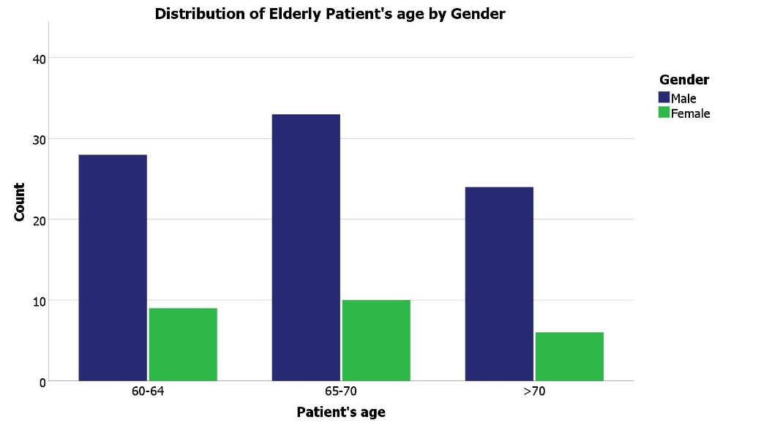
Figure 1: Distribution of Elderly patient’s age by Gender.
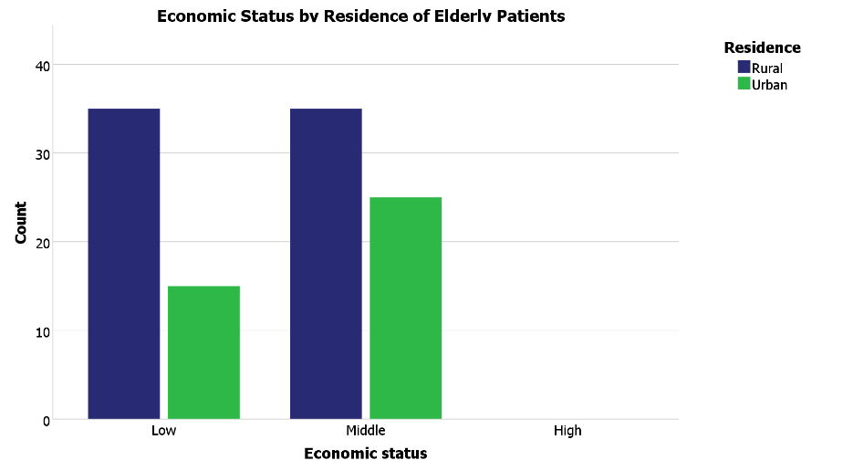
Figure 2: Economic Status by Residences of Elderly Patients.
Various prescribing indicators are described below in Table 2. In the whole year, 827 drugs were prescribed, an average of 7.52 drugs per prescription. These prescription medicines were prescribed by generic names with only 84 drugs (0.76 per prescription). Injectable drugs were frequently used, with 238 prescribed (2.16 per prescription).Important drugs that were prescribed are essential drugs and antibiotics for 177 times, whereas the average essential drugs written per prescription is 1.61 and the antibiotics were prescribed 98 times with a 0.89 average per prescription. Combination drugs were prescribed 76 times (0.69 per prescription), and topical preparations were rarely prescribed, with only 2 instances (0.02 per prescription). Syrups were prescribed 24 times with an average prescription of 0.22 per prescription.
Table 2: Values obtained for prescribing indicators
 | Sum | Average
Number of Drugs | 827 | 7.52
Number of generic drugs | 84 | .76
Number of injectables | 238 | 2.16
Number of drugs from essential list | 177 | 1.61
Number of antibiotics | 98 | .89
Number of combination Drugs | 76 | .69
Number of topical preparations | 2 | .02
Number of syrups | 24 | .22

A total of 827 drugs were prescribed to the 110 patients. Table 3 shows how the number of medicines given is spread out.The average number of drugs per prescription was 7.52, with a range of 2-14 drugs. Only 84 drugs (10.158%) were prescribed by generic name. Antibiotics were prescribed in 98 encounters (11.85%), while injections were prescribed in 238 encounters (28.78%). About 21.40% of prescribed drugs were from the national essential drugs list.
Compared to WHO standards, the average number of drugs per prescription (7.52) was significantly higher than the ideal range of 1.6-1.8. The percentage of drugs prescribed by generic name (10.158%) was much lower than the 100% WHO standard. The percentage of encounters with antibiotics prescribed (11.85%) was within the WHO range of 20-26.8%. However, the percentage of encounters with injections (28.78%) exceeded the WHO range of 13.4-24.1%. The percentage of drugs prescribed from the essential drugs list (21.40%) was far below the 100% WHO standard.
Table 3: Values obtained for prescribing indicators versus WHO standards. (N=110)
Prescribing indicator | Values obtained | WHO standard
Average number of drugs per prescription | 7.52(2-14) | 1.6-1.8
% of drugs prescribed as generics | 10.158 | 100
% of antibiotics per prescription | 11.85 | 20-26.8
% of injections per prescription | 28.78 | 13.4-24.1
% of drugs prescribed from national essential drugs list | 21.40 | 100
% calculated from a total of 110 patients.
Table 4 highlights the prescribing patterns based on age and gender. Patients aged 60-64 years received an average of 7.54 drugs per prescription, while those aged 65-70 years were prescribed slightly fewer, averaging 7.40 drugs. The highest average, 7.67 drugs per prescription, was observed in patients over 70 years of age. In terms of gender, male patients received an average of 7.07 drugs, whereas female patients had a significantly higher average of 9.04 drugs per prescription. Notably, the use of generic drugs was highest in the >70 age group, with an average of 0.83 per prescription, while females had the lowest rate, at just 0.48 per prescription. Injectable drugs were most frequently prescribed to patients over 70 years, averaging 2.47 per prescription. Antibiotics were most commonly given to patients aged 60-64 (1.08 per prescription), and combination drugs were more frequently prescribed to both the >70 age group (0.93) and female patients (0.96 per prescription).
Table 4: Prescribing indicators by Patient’s age and Gender: (Sum and Average)
 | Patient's age |  |  | Gender
 | 60-64 | 65-70 | >70 | Male | Female
Number of Drugs | 279  (7.54) | 318  (7.40) | 230  (7.67) | 601  (7.07) | 226  (9.04)
Number of generic drugs | 26  (0.70) | 33  (0.77) | 25  (0.83) | 72  (0.85) | 12  (0.48)
Number of injectables | 70  (1.89) | 94  (2.19) | 74  (2.47) | 184  (2.16) | 54  (2.16)
Number of drugs from essential list | 63  (1.70) | 69  (1.60) | 45  (1.50) | 137  (1.61) | 40  (1.60)
Number of antibiotics | 40  (1.08) | 29  (0.67) | 29  (0.97) | 83  (0.98) | 15  (0.60)
Number of combination Drugs | 25  (0.68) | 23  (0.53) | 28  (0.93) | 52  (0.61) | 24  (0.96)
Number of topical preparations | 1  (0.03) | 0  (0.00) | 1  (0.03) | 2  (0.02) | 0  (0.00)
Number of syrups | 8  (0.22) | 9  (0.21) | 7  (0.23) | 14  (0.16) | 10  (0.40)

Hypertension was the most common diagnosis, present in 64 patients (58.19%). This was followed by diabetes mellitus in 40 patients (36.36%), kidney diseases in 28 patients (25.46%), and heart diseases in 27 patients (24.55%). Other common conditions included dental problems (23 patients, 20.19%), asthma (21 patients, 19.09%), and arthritis (17 patients, 15.45%) (Table 5).
Table 5: Patient’s comorbidities Frequencies
Comorbidities | Responses |  | Percent of Cases
Comorbidities | N | Percent | Percent of Cases
Diabetes | 40 | 17.2% | 42.6%
Hypertension | 64 | 27.5% | 68.1%
Heart Diseases | 27 | 11.6% | 28.7%
Arthritis | 17 | 7.3% | 18.1%
Asthma | 21 | 9.0% | 22.3%
Liver Disease | 1 | 0.4% | 1.1%
Kidney Diseases | 28 | 12.0% | 29.8%
Haematological Disorder | 5 | 2.1% | 5.3%
Cancer | 4 | 1.7% | 4.3%
Dental | 23 | 9.9% | 24.5%
Others | 3 | 1.3% | 3.2%
Total | 233 | 100.0% | 247.9%

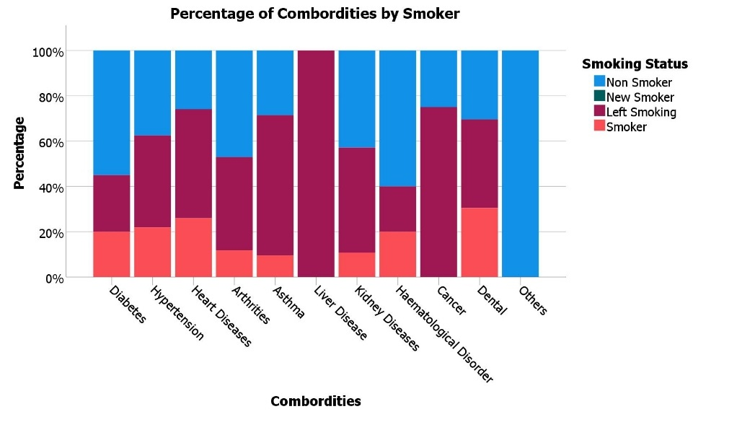
Figure 3: Percentage of Comorbidities by Smoker

Figure 3 illustrates the percentage of comorbidities by smoking status. The figure suggests a relationship between smoking status and the prevalence of certain comorbidities among the elderly patients.
Table 6 presents a regression analysis examining factors influencing the number of drugs prescribed. Gender emerged as a significant factor, with female patients receiving 1.723 more drugs on average than male patients (p = 0.005). Age, however, did not significantly impact the number of drugs prescribed. The presence of fever was associated with an increase of 0.969 drugs, but this finding was only borderline significant (p = 0.052). Similarly, a history of smoking was linked to a reduction of 1.051 drugs, another borderline result (p = 0.053). In contrast, current smoking status led to an increase of 0.851 drugs, although this relationship was not statistically significant (p = 0.220). Overall, the regression model accounted for 16.2% of the variance in the number of drugs prescribed, as reflected by the R² value of 0.162.
Table 6: Regression Analysis for Number of Drugs
 | Coefficients | Std. Error | t | Sig.
Constant | 5.405 | .970 | 5.569 | .000
Age (60-64)
65-70 | .048 | .556 | .086 | .931
>70 | .324 | .608 | .532 | .596
Gender (Male)
Female | 1.723 | .600 | 2.872 | .005
Fever | .969 | .494 | 1.962 | .052
History of Smoking | -1.051 | .537 | -1.958 | .053
Currently Smoking | .851 | .690 | 1.234 | .220
R² = 0.162, Adjusted R² = 0.113, Std. Error = 2.459

The most frequent patient complaints were related to sleeping problems (53.6%), vision issues (45.2%), and memory concerns (29.8%).
Table 7: Patients Complaints
Complaints | Responses |  | Percent of Cases
Complaints | N | Percent | Percent of Cases
Vision | 38 | 21.0% | 45.2%
Hearing | 15 | 8.3% | 17.9%
Walking | 22 | 12.2% | 26.2%
Swallowing | 9 | 5.0% | 10.7%
Sleeping | 45 | 24.9% | 53.6%
Urination | 13 | 7.2% | 15.5%
Memory | 25 | 13.8% | 29.8%
Pain | 14 | 7.7% | 16.7%
Total | 181 | 100.0% | 215.5%

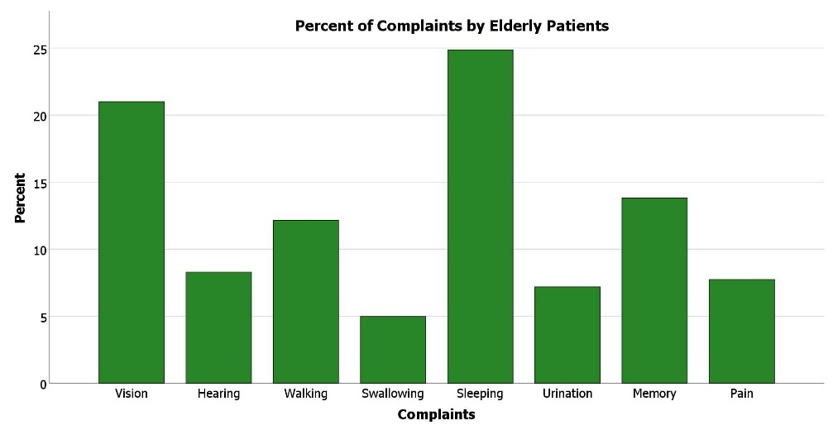
Figure 4: percents of Complaints by Elderly Patients
Antiulcerants were the most commonly prescribed drug type (76.1% of cases), followed by antibiotics (66.1%) and antihypertensives (61.5%).

Table 8: Frequency of prescribed drugs
Drug type | Responses |  | Percent of Cases
Drug type | N | Percent | Percent of Cases
Antidiabetics | 34 | 6.2% | 31.2%
Antibiotics | 72 | 13.1% | 66.1%
Antiulcerants | 83 | 15.1% | 76.1%
Anticancer | 3 | 0.5% | 2.8%
Antipsychotics | 13 | 2.4% | 11.9%
Vitamins | 12 | 2.2% | 11.0%
Anticoagulants | 39 | 7.1% | 35.8%
Hormones | 29 | 5.3% | 26.6%
Antihypertensives | 67 | 12.2% | 61.5%
Anxiolytics | 13 | 2.4% | 11.9%
Analgesics | 49 | 8.9% | 45.0%
Antianginal | 17 | 3.1% | 15.6%
Minerals | 33 | 6.0% | 30.3%
Lipid LA | 52 | 9.5% | 47.7%
Antiasthmatics | 10 | 1.8% | 9.2%
Antiemetics | 24 | 4.4% | 22.0%
Total | 550 | 100.0% | 504.6%

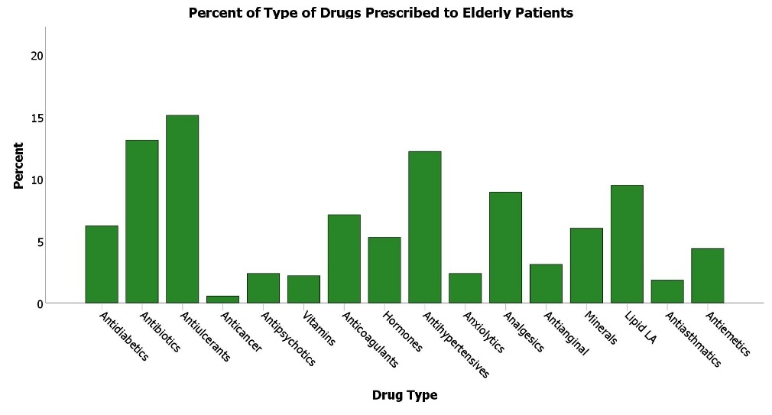
Figure 5: Type of drug Prescribed to Elderly Patients
Table 9 outlines the distribution of patients with multiple comorbidities. A significant portion, 38.19%, had one comorbid condition, while 37.28% had two. Additionally, 18.19% of patients had three comorbidities, 5.46% had four, and 0.9% had five. Overall, 61.81% of patients had multiple comorbidities, underscoring the complexity of care required for elderly individuals.
Table 9: List of patients simultaneously suffering with comorbid illness.
No of disease | No of patients (%)
1 | 38.19
2 | 37.28
3 | 18.19
4 | 5.46
5 | 0.9
Total | 100

Regarding the route of administration, oral medications were most common (68.682% of drugs), followed by parenteral (28.17%), rectal (1.82%), inhaled (1.08%), and topical (0.24%). No drugs were prescribed for vaginal or ophthalmic routes.
Table 10: Frequency of drugs dosage forms
Route of Administration | Percentage
Oral | 68.682
Parenteral | 28.17
Rectal | 1.82
Topical | 0.24
Inhaled | 1.08
Vaginal | 0
Ophthalmic | 0

Fixed-dose combinations were prescribed in 55 cases (50% of prescriptions). The most common combinations were amlodipine Olmesartan (10 prescriptions, 9.09%), olmesartan+medoxomil (9 prescriptions, 8.18%), and clopidogrel aspirin (7 prescriptions, 6.36%).
Table 11: Fixed Dose Combination used in elderly patients (% consumptions out of 110 prescriptions)
Combinations used | No of prescriptions
Amlodipine + Olmesartan | 10  (9.09%)
Frusemide + Spirolactone | 6  (5.45%)
Olmesartan + Medoxomil | 9  (8.18%)
Hydrochlorothiazide + Losartan | 1  (0.9%)
Secubitril + Valsartan | 1  (0.9%)
Pepericillin + Tazobactam | 1  (0.9%)
Cefuroxime + Clavulanic acid | 4  (3.63%)
Amoxicillin + Clavulanic acid | 5  (4.54%)
Clopidogrel + Aspirin | 7  (6.36%)
Metformin + Glimepiride | 1  (0.9%)
Carvidopa + Levodopa | 2  (1.82%)
Amlodipine + Alenolol | 1  (0.9%)
Amlodipine + Telmisartan | 2  (1.82%)
Others | 5  (4.54%)
Total | 55(50%)

Table 12 lists the 10 most frequently prescribed drugs. Omeprazole topped the list, appearing in 49.09% of prescriptions, followed by Atorvastatin in 37.27%. Ceftriaxone, an antibiotic, was prescribed in 35.45% of cases, while Aspirin was used in 32.72% of prescriptions. Paracetamol accounted for 25.45%. Other frequently prescribed drugs included Dexamethasone, Amlodipine, Pantoprazole, Frusemide, and Quetiapine.
Table 12: List of 10 most frequently prescribed drugs
Name of the drug | No of prescriptions | Percentage
Omeprazole | 54 | 49.09
Atorvastatin | 41 | 37.27
Ceftriaxone | 39 | 35.45
Aspirin | 36 | 32.72
Paracetamol | 28 | 25.45
Dexamethasone | 16 | 14.55
Amlodipine | 15 | 13.63
Pantoprazole | 14 | 12.72
Frusemide | 12 | 10.90
Quetiapine | 10 | 9.09

Based on the 2012 Beers Criteria, 19 patients (17.27%) were prescribed at least one potentially inappropriate medication (PIM). Out of the 827 drugs prescribed, 19 (2.29%) were identified as PIMs, most of which fell under Category 1, indicating medications to avoid in older adults. Spironolactone was the most common, accounting for 7 cases (36.84%), followed by Prazosin with 5 cases (26.31%) and Clonazepam with 4 cases (21.05%). Diclofenac and Ibuprofen were each prescribed once (5.26%). In Category 3, Carbamazepine was prescribed in 1 case (5.26%).

Table 13: Potentially inappropriate medication uses for the elderly based on Beers Criteria
Category | Name of the drug | Total =19 | Percentage
1 | Medications and class to avoid in older adults:
 | Diclofenac | 1 | 5.26%
 | Spironolactone | 7 | 36.84%
 | Chlorzoxazone
 | Indomethacin
 | Ibuprofen | 1 | 5.26%
 | Hydroxyzine
 | Prazocin | 5 | 26.31%
 | Amiodorone
 | Nitrofurantoin
 | Clonazepam | 4 | 21.05%
 | Diazepam
 | Gluburide
 | Piroxicam
2 | To be avoided in combination with specific comorbidity
3 | Medications to be used with caution in older adults
 | Carbamazepine | 1 | 5.26%

Discussion
This cross-sectional survey was carried out in Dhaka Medical College Hospital, in Bangladesh and provides valuable insights into the prescription of the geriatric in the tertiary care unit. Findings have pinpointed some of the important characteristics used in geriatric pharmacotherapy and have shown some of the area of concern that should be addressed in the future. The subjects of the research expressed a change in the sexed proportion where the male dominated in higher numbers than the females and the proportion stood at 1: 0.29. Nonetheless, this cannot be attributed to several other studies that have been conducted with regard to the elderly, majority of which indicated a higher incidence of female patients. An example is that a survey conducted by Giri and Khan (2020) in Nepal gave a male-to-female ratio of 1.20:1 among the elderly individuals in the population. This could be the case because men in South Asian nations such as Bangladesh can access the medicines easier and are more knowledgeable and more economically free; because healthcare seeking among this group is affected by the sociocultural determinants, the patients who gravitated to the service were mostly men. One of the most shocking observations is the very great share of polypharmacy, with an average of 7.52 drugs per prescription. This is way much higher compared to the primary level set by the WHO of 1. 6-1. Eight drugs per encounter and is higher as compared to many other related studies. For instance, Nepal (5. 56), by Sarwar et al. (2018), and Argentina (6. 1±2. 7) revealed the drugs per prescription of the elderly patients. . This result is in tandem with other research conducted in a similar context, such as Giri and Khan (2020) in Nepal, where they established an average of 8.04 drugs per prescription for elderly patients. Polypharmacy also leads to the increased risk of drug-drug interactions, side effects, and poor medication adherence, especially among elderly patients. With regards to polypharmacy, the findings presented in this study are worrisome in terms of possible drug interactions and adverse effects, especially among the elderly patients. The survey also uncovered a very low level of prescription with generic drugs at 10.158%, which is still far below the WHO set at 100%. This finding is contrasting with the study done by Atif et al. (2016) in Pakistan, where authors found only 2.6%. Consequently, about 2.6 percent of drugs were prescribed under their generic names. Many elderly patients have poor financial resources, and prescribing by the generic names would go a long way in reducing costs and therefore increasing patient compliance. The prescription of antibiotics was 11.85%; this is compared to the WHO recommended percentage of 20-26.8%; this is worth emulating. However, the overall average of injectable drugs (28.78%) was rated higher than the WHO recommended with an average of 13.4-24.1%. Such observation was also made by Sapkota et al. (2011) in a Nepalese context, where prevalence of the same ranged at 32.2%. This means that 32.2% of the prescriptions written herein were of injectable nature. In many cases, making a recommendation for an injection is contingent on the patient, the price, the prescriber’s routine, and the possibility of sickness through the parenteral method. This is a very high rate of injectable use, and the elderly are at more risk of complications or developing health care-associated infections. Untreated comorbidities included hypertension and diabetes, of which positively diagnosed 58.19% and 36.36% of patients, respectively. This is in line with other aging societies in the world. The study population corroborates with Kaur et al.'s (2019) North Indian sample, in which hypertension and diabetes were predominant comorbidities among elderly patients. Another similar study was conducted by Jyothsna et al. (2019), as well as other Indian studies like the one where the cardiovascular group of drugs was ranked one of the most frequent groups of drugs, as it may be due to the high prevalence of hypertension in elderly people. This is rather expected due to the high incidence of multiple coexisting diseases; 61. 81% of patients had two or more diseases; this brings out the rationale for complex and multiple medications (polypharmacy) as reported in this study. Although the study calls for effective management of medications to prevent a clash of drugs and their side effects. In order to establish which aspects of drug management are most significant, we used a multivariate regression analysis. Concerning the characteristics of the individuals, we used the number of medications being taken as a dependent variable while using age as the independent variable. After reviewing the 110 patients’ records, we found no significance in terms of the number of medications a patient was taking or his/her age with comorbid conditions. The most commonly prescribed drugs were omeprazole (49.09%), atorvastatin (37.27%), and ceftriaxone (35.45%). The high use of proton pump inhibitors like omeprazole is consistent with other studies on elderly populations, such as one Jyothsna et al. (2019) reported similar findings in their study of drug utilization patterns in geriatric patients in India. However, the appropriateness of such widespread PPI use in the elderly warrants further investigation, given the potential for long-term adverse effects. The frequent use of atorvastatin reflects the high prevalence of cardiovascular risk factors in this population. However, the benefits and risks of statin therapy in the very elderly (>75 years) remain a subject of debate in the medical community. The study found that 17.27% of patients were prescribed at least one PIM according to the 2012 Beers Criteria. This prevalence is lower than that reported in many other studies. The use of PIMs, such as Spironolactone and Prazocin, in a significant number of prescriptions is concerning. This aligns with the findings of Sarwar et al. (2018) in Pakistan, who reported that 48.8% of elderly patients were prescribed at least one PIM. The use of PIMs increases the risk of adverse drug reactions and hospitalizations in the elderly population. However, the frequent use of certain PIMs, such as spironolactone and prazosin, is concerning and highlights areas for potential improvement in prescribing practices for elderly patients.
An interesting finding was the significant difference in the number of drugs prescribed based on gender, with females receiving an average of 9.04 drugs compared to 7.07 for males. This gender disparity in prescribing has been observed in other studies, such as one by Alwhaibi et al. (2023) in the United States, which found that elderly women were more likely to receive inappropriate medications than men. The reasons for this disparity need further exploration and may involve factors such as differences in healthcare-seeking behavior, presentation of symptoms, or prescriber biases. The frequent use of fixed-dose combinations (FDCs) in 50% of prescriptions is noteworthy. While FDCs can improve compliance in patients with multiple comorbidities, they may also increase the risk of adverse effects and drug interactions. The appropriateness of each FDC should be carefully evaluated, especially in the context of geriatric pharmacotherapy.
Conclusion
This study identifies key concerns in prescribing practices for elderly patients in Bangladesh, particularly high levels of polypharmacy, low use of generic drugs, and the prevalence of potentially inappropriate medications (PIMs). These findings highlight the urgent need for targeted interventions to enhance prescribing practices. One approach could be implementing electronic prescribing systems equipped with alerts for potential drug interactions and inappropriate medications. Additionally, continuous education for healthcare providers on geriatric pharmacotherapy and the use of tools like the Beers Criteria is essential. Promoting generic drug use through policy reforms and patient education is another critical step. Regular medication reviews for elderly patients, especially those with multiple comorbidities, can help identify and address inappropriate prescriptions. Further research is needed to understand the gender disparities observed in prescribing patterns and to develop effective, targeted interventions. By tackling these issues, healthcare providers can improve medication management for the elderly, potentially reducing adverse drug events and improving overall health outcomes.

Limitations and Future Directions
While this study provides valuable insights, it has some limitations. The sample size is relatively small, and the study was conducted at a single tertiary care center, which may limit the generalizability of the findings. Future research should consider larger, multi-center studies to provide a more comprehensive picture of prescribing patterns among elderly patients in Bangladesh. Additionally, the study did not assess the appropriateness of prescriptions in relation to specific diagnoses or the severity of comorbidities. Future studies could incorporate these factors to provide a more nuanced understanding of prescribing quality.

COMPETING INTERESTS DISCLAIMER:
Authors have declared that they have no known competing financial interests OR non-financial interests OR personal relationships that could have appeared to influence the work reported in this paper.

References
- Alwhaibi, M., & Balkhi, B. (2023). Gender Differences in Potentially Inappropriate Medication Use among Older Adults. Pharmaceuticals (Basel), 16(6), 869. https://doi.org/10.3390/ph16060869 .
- Atif, M., Sarwar, M. R., Azeem, M., Naz, M., Amir, S., & Nazir, K. (2016). Assessment of core drug use indicators using WHO/INRUD methodology at primary healthcare centers in Bahawalpur, Pakistan. BMC Health Services Research https://doi.org/10.1186/s12913-016-1932-2
- Barikdar, A., Ahmed, T., & Lasker, S. P. (2016). The Situation of the Elderly in Bangladesh. Bangladesh Journal of Bioethics, 7(1), 27–36. https://doi.org/10.3329/bioethics.v7i1.29303
- Debén, E., Gallego, T., Perez, M., Gomez, M. A., Serra, J. M., Ramirez, E., Ibañez, A., Martinez, C., Alañon, E., & Morell, A. (2014). DI-024 Cetuximab in the treatment of advanced metastatic colorectal cancer. European Journal of Hospital Pharmacy, 21(Suppl 1), A79.2-A80. https://doi.org/10.1136/ejhpharm-2013-000436.195
- Fadare, J. O., Agboola, S. M., Opeke, O. A., & Alabi, R. A. (2013). Prescription pattern and prevalence of potentially inappropriate medications among elderly patients in a Nigerian rural tertiary hospital. Therapeutics and Clinical Risk Management, 9(1), 115–120. https://doi.org/10.2147/TCRM.S40120
- Giri, S., & Khan, G. M. (2020). PRESCRIBING PATTERN AND APPROPRIATENESS OF PRESCRIPTION AMONG ELDERLY PATIENTS IN A TERTIARY CARE HOSPITAL OF WESTERN NEPAL – A PROSPECTIVE CROSS- SECTIONAL STUDY. Asian Journal of Pharmaceutical and Clinical Research, 13(4), 126–131. https://doi.org/10.22159/ajpcr.2020.v13i4.36843 .
- Jyothsna, C. S., Nagarajaiah, B. H., & Shivakumar, K. M. (2019). Drug utilization pattern in geriatric inpatients of Medicine wards at a government tertiary care hospital. National Journal of Physiology, Pharmacy and Pharmacology. https://doi.org/10.5455/njppp.2019.9.0102607022019
- Kanagasanthosh, K., Topno, I., & Aravindkumar, B. (2015). Prevalence of potentially inappropriate medication use and drug utilization pattern in elderly patients: a prospective study from a tertiary care hospital. International Journal of Research in Medical Sciences, 3(8), 2062–2072. https://doi.org/10.18203/2320-6012.ijrms20150328.
- Kaur, G., Bansal, R., Anand, T., Kumar, A., & Singh, J. (2019). Morbidity profile of noncommunicable diseases among elderly in a city in North India. Clinical Epidemiology and Global Health. https://doi.org/10.1016/j.cegh.2017.12.004
- Mainuddin, A. K., Begum, H. A., Rawal, L. B., Islam, A., & Islam, S. M. S. (2015). Women Empowerment and Its Relation with Health Seeking Behavior in Bangladesh. Journal of Family & Reproductive Health, 9(2), 65–73. https://www.ncbi.nlm.nih.gov/pmc/articles/PMC4500817/ .
- Okoli, R., Isah, A. O., Ozolua, R. I., Ohaju-Obodo, J. O., Nwokike, O. C., & Ovienria, W. A. (2015). Drug prescribing pattern in three levels of health care facilities in the north and central senatorial districts of Edo State, Nigeria. International Journal of Herbs and Pharmacological Research, 4(3), 46–57. https://www.ajol.info/index.php/ijhpr/article/view/142378
- Rijal, S., Adhikari, K., Sigdel, D., & Mallik, S. K. (2019). Prescribing Pattern of Drugs in Geriatrics Patients Using Beers Criteria. Journal of Nepal Health Research Council, 17(2), 153–157. https://doi.org/10.33314/jnhrc.v0i0.1774
- Sapkota, S., Pudasaini, N., Singh, C., & Gc, S. (2011). DRUG PRESCRIBING PATTERN AND PRESCRIPTION ERROR IN ELDERLY: A RETROSPECTIVE STUDY OF INPATIENT RECORD. Asian Journal of Pharmaceutical and Clinical Research, 4(3), 129-132. https://innovareacademics.in/journal/ajpcr/Vol4Issue3/450.pdf .
- Sarwar, M. R., Dar, A. R., Mahar, S. Y., Riaz, T., Danish, U., & Iftikhar, S. (2018). Assessment of prescribing potentially inappropriate medications listed in beers criteria and its association with the unplanned hospitalization: A cross-sectional study in Lahore, Pakistan. Clinical Interventions in Aging. https://doi.org/10.2147/CIA.S173942
- Taskeen, M., Anitha, N., Ali, S. R., Bharath, R., & Khan, A. B. (2012). A study on rational drug prescribing pattern in geriatric patients in Hyderabad Metropolitan. Journal of Drug Delivery and Therapeutics, 2(5), 109–113. https://doi.org/10.22270/jddt.v2i5.270
- Wang, Z., Peng, W., Li, M., Li, X., Yang, T., Li, C., Yan, H., Jia, X., Hu, Z., & Wang, Y. (2021). Association between multimorbidity patterns and disability among older people covered by long-term care insurance in Shanghai, China. BMC Public Health, 21(1), 418. https://doi.org/10.1186/s12889-021-10463-y

- Alhumaidi, R. M., Bamagous, G. A., Alsanosi, S. M., Alqashqari, H. S., Qadhi, R. S., Alhindi, Y. Z., Ayoub, N., & Falemban, A. H. (2023). Risk of Polypharmacy and Its Outcome in Terms of Drug Interaction in an Elderly Population: A Retrospective Cross-Sectional Study. Journal of Clinical Medicine, 12(12), 3960. https://doi.org/10.3390/jcm12123960
- American Geriatrics Society. (2023). American Geriatrics Society 2023 updated AGS Beers Criteria for potentially inappropriate medication use in older adults. Journal of the American Geriatrics Society, 71(7) https://doi.org/10.1111/jgs.18372
- Anwar, M. F., Daud, N. A. A., & Hussain, R. (2025). From prescribing indicators to rational drug use: a medication safety perspective. Journal of Pharmaceutical Policy and Practice, 18(1). https://doi.org/10.1080/20523211.2025.2544656
- Lau, S., Lun, P., Ang, W., Tan, K. T., & Ding, Y. Y. (2020). Barriers to effective prescribing in older adults: applying the theoretical domains framework in the ambulatory setting – a scoping review. BMC Geriatrics. https://doi.org/10.1186/s12877-020-01766-7
- Ngcobo, N. N. (2025). Influence of Ageing on the Pharmacodynamics and Pharmacokinetics of Chronically Administered Medicines in Geriatric Patients: A Review. Clinical Pharmacokinetics, 64(3), 335–367. https://doi.org/10.1007/s40262-024-01466-0
- Osareme, J., Muonde, M., Paschal, C., Olorunsogo, T. O., & Omotayo, O. (2024). Demographic shifts and healthcare: A review of aging populations and systemic challenges. International Journal of Science and Research Archive, 11(1), 383–395. https://doi.org/10.30574/ijsra.2024.11.1.0067
- Prasad, S., Sung, B., & Aggarwal, B. B. (2012). Age-associated chronic diseases require age-old medicine: Role of chronic inflammation. Preventive Medicine, 54(1), S29–S37. https://doi.org/10.1016/j.ypmed.2011.11.011
- Roller-Wirnsberger, R., Thurner, B., Pucher, C., Lindner, S., & Wirnsberger, G. H. (2020). The Clinical and Therapeutic Challenge of Treating Older Patients in Clinical Practice. British Journal of Clinical Pharmacology, 86(10), 1904–1911. https://doi.org/10.1111/bcp.14074
- Sarker, A. R., Zabeen, I., Khanam, M., Akter, R., & Ali, N. (2023). Healthcare-seeking experiences of older citizens in Bangladesh: A qualitative study. PLOS Global Public Health, 3(2), e0001185. https://doi.org/10.1371/journal.pgph.0001185
- Singh, S., & Bajorek, B. (2014). Defining 'elderly' in clinical practice guidelines for pharmacotherapy. Pharmacy Practice, 12(4). https://doi.org/10.4321/s1886-36552014000400007
- Tay, Y. L., Abu Bakar, N. S., Tumiran, R., Ab Rahman, N. H., Mohd Ma’amor, N. A. A., Yau, W. K., & Abdullah, Z. (2021). Effects of home visits on quality of life among older adults: a systematic review protocol. Systematic Reviews, 10(1). https://doi.org/10.1186/s13643-021-01862-8
- World Health Organization. (2005). Promoting rational use of medicines. https://www.who.int/activities/promoting-rational-use-of-medicines
- World Health Organization. (2025). Ageing and health. https://www.who.int/news-room/fact-sheets/detail/ageing-and-health
- American Geriatrics Society 2012 Beers Criteria Update Expert Panel. (2012). American Geriatrics Society updated Beers Criteria for potentially inappropriate medication use in older adults. Journal of the American Geriatrics Society, 60(4), 616–631. https://doi.org/10.1111/j.1532-5415.2012.03923.x

Appendix
A. Patient’s Information: Name:
1.Age: 60-64 /65-70 / >70 | 2. Sex: Male / Female
3. Residence: Rural / Urban | 4. Contact No:
5.Economic status: Low / Middle / High | 6. Hospital status: Indoor / Outdoor
B. Patient Diagnosis:
7.Diseases type: Communicable / Noncommunicable
8. Comorbidities: Diabetes / Hypertension / Heart diseases / Arthrities / Asthma / Liver Disease / Kidney Diseases / Hematological Disorder / Cancer / dental problems /others
C. Clinical Findings:
BGL: _________ SBP: ________mm DBP: ________mm
Fever: Yes / No HB: ________g/dl Creatinine: ________mg/dl

Complaints: Vision / Hearing / Walking / Swallowing / Sleeping / Urination / Pain / Memory / etc
History of Smoking: Yes / No Currently Smoking: Yes / No Habits of betel leaf: Yes / No

D. Prescription Pattern:
9.Number of Drugs:__________ 10.Number of generic drugs:_______
11.Number of injectables: _______ 12. Number of drugs from essential list: _____
13.Number of antibiotics: ________ 14. Number of combination Drugs:
15.Number of topical preparations: ______ 16. Number of syrup: _____
17.Types of drugs:
Antidiabetics: ______________________ Antihypertensives: ____________________
Antibiotics: ________________________ Anxiolytics: __________________________
Antiulcerants: ______________________ Analgesics: __________________________
Anticancer: _________________________ Antiasthmatics: ______________________
Antipsychotics: _____________________ Minerals: ____________________________
Vitamins: __________________________ Antianginal: __________________________
Anticoagulants: _____________________ Lipid Lowering agents: __________________
Hormones:________________________ Others:
Antiemetics:________________________
18.Dosage forms: Oral ( ) / Topical ( ) / Rectal ( ) / Parenteral ( ) / Vaginal ( ) / Inhaled ( ) / Ophthalmic ( ) / Otic ( )
Consent forms: I agree with the terms and conditions of the above proposed research. I am giving my full consent to use my personal data. copyright to Abdullah Al Noman, DU and reproduction requires his prior permission.

