Original Research Article

Vigna unguiculata aqueous leaf extract ameliorates oxidative stress induced RBC and tissue damage via antioxidant and anti-inflammatory activities

.
ABSTRACT

Aims: Aim of the study was to characterize the phytochemicals present in Aqueous Extract of Cow pea leaves (AECPL) and evaluates its protective role in oxidative stress induced tissue damage via anti-oxidant and anti-inflammatory activities.
Study design: The experiment setup involved the phytochemical screening and characterization, assessment of antioxidant and anti-inflammatory activities. Oxidative stress markers analysis (in-vitro and in-vivo) and histopathological studies.
Methodology: the GC-MS study was carried out to enumerate the probable phytochemicals, the radical scavenging assay was conducted by DPPH (2,2-diphenyl-1-picrylhydrazyl) method, further antioxidant ability was confirmed by in-vitro and in-vivo study as an indicator of elevated level of oxidative stress markers using RBCs and animal models. The tissue protective efficiency of AECPL was enumerated in Sprague Dawley rat’s model. Anti-inflammatory activity of AECPL was identified using protein denaturation and protease inhibition assays. Non-toxic property was examined using hemolytic assay.
Results: The AECPL showed long array of phytochemicals such as, proteins, terpenoids, alcohols, phenols, tannins, saponins, flavonoids, carbohydrates and glycosides. AECPL exhibited DPPH radical scavenging ability (75 %). AECPL further normalized the oxidative stress markers such as lipid peroxidation (LPO), protein carbonyl content (PCC), total thiol (TT) and antioxidant levels such as superoxide dismutase (SOD), catalase (CAT) in both in-vivo and in-vitro models. AECPL protected Diclofenac induced tissue damage of vital organs and regulated tissue specific biochemical markers. Further, AECPL ameliorates the effect of inflammation by reducing the denaturation of BSA protein (82.77 %), and egg albumin (80 %).
Conclusion: The AECPL through its free radical quenching and anti-inflammatory activities protected oxidative stress induced red blood cells and vital organs.

Keywords: Cow pea, Oxidative stress, Anti-oxidant, Hemolysis, Inflammation, Diabetic.

1. INTRODUCTION

Reactive oxygen species (ROS) and reactive nitrogen species (RNS) are produced in greater quantities as a result of oxygen metabolism, and this causes oxidative stress by damaging key biomolecules (Toyokuni 1999). The primary pathogenic mechanism for the disruption of redox equilibrium brought on by lipid peroxidation, metabolic dysregulation, irreversible protein and DNA damage, and cellular damage is oxidative stress. In contrast, ROS is believed to function as a molecular secondary messenger in the signaling process in response to cytokines, hormones, and adenosine triphosphate (ATP) under normal oxygen metabolism, hence regulating physiological and biological processes (Revia and Zhang 2016). When oxygen metabolism is elevated, ROS and RNS cause excessive lipid peroxidation, carbonylation, and thiolation, which in turn produces other reactive species, such as superoxide anion (O2−), hydrogen peroxide (H2O2), hydroxyl radical (OH•), reactive aldehydes, malondialdehyde, and 4-hydroxynonenal (Venkataramaiah et al. 2025). Proteins and lipids are the main targets of increased oxidative assault, and altering these molecules can raise the risk of mutagenesis. Furthermore, the hepatic organs the heart, kidney, pancreas, brain, and lung can sustain harm from the coordinated beginning of oxidative stress, which seems to indiscriminately oxidize almost all molecules in tissues (Venkatappa et al. 2022; Venkataramaiah et al. 2025).
The development of inflammation is primarily caused by the sustained generation of ROS. In order to support endothelial dysfunction and tissue damage, neutrophils increased the secretion of ROS by polymorphonuclear neutrophils (PMNs), which travel across the vascular wall of infection and release pro-inflammatory and vasoactive mediators that oxidize tyrosine phosphatases like signaling proteins. Furthermore, inflammatory macrophages promote the implantation of biomaterials. macrophages' excessive secretion of inflammatory mediators and pro-inflammatory cytokines. Macrophages were typically triggered by the presence of pro-inflammatory cytokines like tumor necrosis factor-α (TNF-α) or interferon-γ (IFN-γ), as well as pathogen-associated molecular patterns like lipopolysaccharide (LPS) (Tang et al. 1998). Moreover, oxidative stress and inflammation are inherently linked processes that reinforce one another. Oxidative stress, for example, promotes the recruitment and activation of leukocytes and resident cells, which in turn causes inflammation by activating nuclear factor NF-kB, a redox-sensitive transcription factor that regulates the production of pro-inflammatory cytokines and chemokines. Since inflammation plays a significant role in various illnesses such as, vital organ damage, diabetes, cancer, cardiovascular, autoimmune and neurodegenerative disorders. Thus, addressing the inflammatory condition could be a helpful treatment approach. Steroid or non-steroidal chemical anti-inflammatory drugs make up the bulk of therapeutically meaningful drugs (Hart and Huskisson 1984). Yet their life-threatening side effects appear to be the dangerous death signal for their limited utility. Therefore, natural resources are the alternatives to manage the said pathological conditions.
The cow pea (Vigna unguiculata) has garnered interest due to its numerous pharmacological uses, including its anti-inflammatory, anti-diabetic, and antioxidant qualities. It is one of the most significant legumes cultivated in Africa, which offers a reasonably priced source of protein for the diet. People who live in the most marginalized areas benefit greatly from its cultivation in terms of food security. The grains are fed to animals as fodder because they have a high nutritional value, comprise roughly 22 % crude protein, 64 % carbs, and are a source of minerals, vitamins, and vital micronutrients. Most importantly, Cow peas are rich in phenolic compounds, such as phenol acids, flavonoids, and tannins. These bioactive substances have anti-inflammatory, anti-carcinogenic, and antioxidant properties, which help both human and animal health (Jayathilake et al. 2018). According to Carneiro Da Silva et al. (2019), cow pea leaves and green pods are used to prevent or treat a number of human illnesses, such as measles, smallpox, adenitis, burns, and ulcers. Despite the said long array of pharmacological utilities there are least studies validated its therapeutic potential on oxidative stress induced pathogenesis. Hence, current study focuses on exploring the potential therapeutic intervention of Aqueous Extract of Cow Pea Leaves (AECPL) on oxidative stress induced inflammation, tissue damage and diabetes.

2. material and methods
2.1 Reagents
Methanol, DPPH (1,1-diphenyl-2-picrylhydrazyl), NaNO2(Sodium Nitrate), EDTA (Ethylene diamine tetra acetic acid), TEMED (Tetra methyl ethylene diamine), DNPH (2,4-dinitro phenyl hydrazine), TCA(Tri chloroacetic acid), DTNB (5,5′-dithiobis-(2-nitrobenzoic acid)-Elman’s reagent, SDS (Sodium dodecyl sulphate), Acetic acid, Thiobarbituric acid, H2O2 (Hydrogen peroxide), DNS (3,5 dinitro salicylic acid), NaOH (Sodium hydroxide), Sodium potassium tartrate, Starch, PBS (Phosphate buffer saline), BSA (Bovine serum albumin), Egg albumin, α-amylase, α-glucosidase, Trypsin and P-nitrophenyl-d-glucopyranoside,The human blood samples obtained from the healthy donors for the platelet‑rich plasma (PRP).
2.2 Preparation of aqueous extract of Cow pea leaves (AECPL) and Protein estimation
Cow pea leaves were gathered from Tumkur city. The leaves were grounded into fine powder with a grinder (SHARP, Japan) and homogenized in double distilled water and centrifuged at 1500 rpm for 20 min at 15 °C. This extracted protein sample was used throughout the study. The Lowry’s method was used to quantify the protein concentration using Bovine serum albumin (BSA) as standards (Waterborg 2009).
2.3 GC-MS analysis
GC-MS analysis of samples was analyzed on quadrupole mass spectrometers in the electron-capture negative-ion chemical ionization (ECNICI) mode with capillary column (30 X 0.25 mm ID X 1EM df, composed of 100 % Dimethyl poly siloxane). Helium (99.9 %) gas was used as carrier gas at the flow rate of 1ml/min and the injection volume of 0.5 El (split ratio of 10:1). Temperature program was set as follows, injector temperature 250 °C; ion-illuminator temperature 280 °C, oven temperature 110 °C (isothermal for 3 min) with an increase in temperature of 20 °C/min to 220 °C, thereafter 5 °C/min to 300 °C. Mass spectrum was taken at 80 ev; a scan interval of 0.5 s (Abadie et al. 2022).
2.4 In-vitro anti-oxidant activity
2.4.1 DPPH assay:
The anti-oxidant activity was quantified by evaluating the In-vitro fractions of free radical scavenging capability using 1, 1-diphenyl-2-picrylhydrazyl (DPPH) assay (Gulcin and Alwasel 2023). AECPL (0-100 µg) were added and ascorbic acid was used as a positive control. The sample containing tubes was made up to 2.5 mL using methanol before being properly mixed into a 10 mM solution of DPPH in 50 % methanol. 140 µL of 10 mM DPPH reagent was added and the solution was mixed thoroughly and kept for incubation for 30 min at room temperature. After the incubation period, absorbance was recorded at 517 nm using a UV-Vis spectrophotometer. The percentage of DPPH inhibition was measured by calculated the % scavenging activity using below mentioned formula:
% Scavenging activity = OD of Control – OD of Sample × 100 / OD of Control.
2.5 Oxidative stress induction using Sodium nitrite (NaNO₂)
The oxidative stress induction on red blood cells (RBC) model using Sodium nitrite as a stress inducer (Ansari et al. 2015). Draw the blood from a healthy human being of age 22-35, and the donor should be a non-alcoholic, non-medicated, non-smoker and stress-free person. The blood drawn from the healthy donor and collected in presence of anticoagulant (Acid citrate (ACD), centrifuge the blood for 13 min at 900 rpm, after the centrifugation, the blood was separated as plasma and RBCs in the form of supernatant and pellet respectively. Collected the RBCs and washed the cells using phosphate saline buffer for 3 times at 3500 rpm for 10 min on each time, prepared the 2 % hematocrit using washed RBCs and phosphate saline buffer. For prepared hematocrit oxidative stress was induced by adding 10 mM NaNO₂.
2.6 Lipid peroxidation (LPO) assay
Lipid peroxidation was estimated by previously described method (Ohkawa et al. 1979). The reaction mixture consists different concentration of AECPL (0-100 µg) and Lysate of erythrocyte 0.02 mL (2 mg of protein). 10 mM NaNO2 induced the lipid peroxidation and it’s incubated for 30 min at 26 °C. After the incubation time add 1.5 mL acetic acid (pH 3.5), 0.2 mL of 8 % SDS, and 1.5 mL TBA (0.8 %) to the reaction mixture and it was incubated for 45 min at 45-60 °C, after butanol and pyridine was added in the ratio 2:1. The reaction was mixed thoroughly and centrifuge at 3000 rpm for 15 min and read the absorbance at 530 nm.
2.7 Estimation of protein carbonyl content (PCC)
The protein carbonyl content was determined using DNPH in accordance with a previously reported method (Levine et al. 1990). Briefly, NaNO2 (10 mM) and AECPL (0-100 µg) were added to 200 µL of RBC lysate (2 mg protein/mL) and then the mixture was incubated for 30 min. After that, equal volume of RBCs lysate 10 mM DNPH was added to series of mixture contained tubes except RBCs alone, 2 N HCl was added to the RBCs alone, and the mixture was incubated for further 1 h at room temperature while being occasionally shaken. Following incubation, the mixture was precipitated with 20 % TCA and centrifuged for 10 min at a rate of 2000 rpm. It was then left at ambient temperature for 5 min. After being thoroughly washed with acetone twice, the precipitate was dissolved in 1 mL of Tris buffer (20 mM pH 7.4 with 0.14 M NaCl, 2 % SDS), and the absorbance of the supernatant was measured at 360 nm. The number of carbonyl groups/mg of protein was used to express the carbonyl content.

2.8 Measurement of total thiols (TT)
The total thiols were determined followed by the previously described method (Zinellu et al. 2005). AECPL (0-100 µg) was mixed with 200 µL of RBC lysate (2 mg protein/mL) and treated with a NaNO2 (10 mM). Incubated the reaction mixture for 30 minutes, after the incubation time add 0.375 mL of 0.2 M Tris-HCl buffer (pH 8.2), 10 mM dithiol-bis-nitro benzoic acid (DTNB) and 1.975 mL of methanol, vertex the reaction mixture and incubated for 30 min at room temperature. Then the tubes were centrifuged at 5000 rpm. Clear supernatants from the samples were collected, and their photometric absorbance at 412 nm was determined. The amount of thiol in one mol of oxidized DTNB/mg of protein.
2.9 Superoxide dismutase (SOD)
The enzyme superoxide dismutase activity was measured followed by the previous method (Paoletti et al. 1986). AECPL (0–100 µg) were incubated with an agonist, NaNO2 (10 mmol/L), RBCs (2 mg of protein) in a clean, dry test tubes for 30 min at room temperature. Add 1 mL of the reaction mixture, which was made up of a combination of TEMED-EDTA (8 mmol/L) and phosphate buffer (PBS-16 mmol/L, pH 7.8). The decrease in absorbance was noticed at 406 nm for 1 min. U/mg of protein was used to express the results.
2.10 Catalase (CAT)
CAT enzyme activity was measured using previously measured technique (Landahl 1953). AECPL (0–100 µg) were added to RBCs (2 mg of protein) in clean, dry test tubes along with an agonist, sodium nitrate (10 mM) and incubate for 30 minutes at ambient temperature. Add hydrogen peroxide (8.8 mM/L) and sodium phosphate buffer (100 mM/L, pH 7.4) were also present in the reaction mixture. At 240 nm, the absorbance was measured for 3 min. The unit of measurement for CAT activity was U/mg of protein.
2.11 (In-vivo) studies on oxidative stress:
2.11.1 Animal grouping
The male Sprague Dawley male rat served as the animal model for the in-vivo research. The rats were bought from the Institution of Chromed Bioscience facilities in Tumkur, Karnataka, India. According to the protocol of (Venkataramaiah et al. 2025), the animals were segregated and housed in polypropylene cages that held six rodents apiece. Rats aged six to eight weeks and weighing between 75-100 g were used in the experimental studies. The experimental animals were given a typical laboratory meal of pellets and were given unfettered access to water. Each cage featured 12 h light and dark cycles, as well as a temperature of 25-32 °C and a humidity of 55-65 %. The experiment protocol and study design were approved by the Institutional Animal/Human Ethics Committee under the reference IHEC-TUT No:03/Res/2024-2025. Male Sprague Dawley rats weighing 75 to 100 g were put into seven groups of six animals each. The following methodology was used:
Group I -Control (normal saline).
Group II -Diclofenac alone.
Group III-Silymarin (25 mg/kg body weight/day) was injected intraperitonially, and after 45 min diclofenac (50 mg/kg body weight/day) was administered.
Group IV- AECPL (50 mg/kg body weight/day) was injected intraperitonially, and after 45 min diclofenac (50 mg/kg body weight/day) was administered.
Group V- AECPL (100 mg/kg body weight/day) was injected intraperitonially, and after 45 min diclofenac (50 mg/kg body weight/day) was administered.
Group VI- AECPL (150 mg/kg body weight/day) was injected intra peritoneally, and after 45 min diclofenac (50 mg/kg body weight/day) was administered.
Group VII- AECPL (150 mg/kg body weight/day) alone administered.
The rats were given medicine for seven days and then starved for twelve hrs after the last treatment. The animals were euthanized with diethyl ether on the seventh day, and heart punctures were performed to collect blood samples. Blood samples (2 mL) were collected from the aorta for biochemical parameter assessment using sterile anticoagulant-free voiles. The biochemical indicators SGOT, SGPT, albumin, globulin, total bilirubin (direct and indirect levels), and alkaline phosphatase were all measured. The liver, kidney, pancreas, and heart of the experimental animals were removed and preserved in phosphate buffer saline solution before being homogenized for biochemical analysis. The organs were also preserved in 10 % formalin to aid in histological examination.
2.11.2 Histopathological examination
The liver, kidney, pancreas, and heart samples from each group were processed and paraffin embedded for histological evaluation. Sections with thicknesses ranging from 3 to 5 µm were stained with hematoxylin and eosin stains.
2.11.3 Determination of In-vivo anti-oxidant activities
The experimental rats’ vital organs (livers, kidneys, heart and pancreas) were collected using chilled ice-cold 0.1 M PBS, the tissue samples were homogenized thoroughly, and the samples were used for the analysis of stress markers.
2.12 In-vitro Anti-inflammatory activity
2.12.1 Egg albumin and bovine serum albumin denaturation assay
The protein denaturation assay was followed by previously described method (Gunathilake et al. 2018; Paul 2018). The 0.2 mL of 1 % bovine albumin and Egg albumin mixed with a AECPL (0-100 µg) and 4.78 mL PBS. Aspirin was used as a drug controller. Incubate the reaction mixture for 15 min at room temperature before being heated in a water bath at 70 °C for 5 min. Cooled the tubes contained mixture and read the absorbance of the turbidity using spectrophotometer at 660 nm. The % of inhibition of denaturation was calculated using the formula:
% Inhibition of denaturation = 1- OD of Sample / OD of Control ×100
2.12.2 Protease inhibitory activity
The method was used to measure the protease inhibitor (Bijina et al. 2011). The AECPL (0-100 µg) were added in a clean dry test tube with a mixture of 1 mL of 20 mM Tris-HCl buffer (pH 7.4) and 0.06 mg trypsin and incubate the reaction mixture for 5 min at room temperature. 1 mL of 0.8 % (w/v) casein was added and kept the reaction for 20 min. The reaction was stopped by 2 mL of 70 % perchloric acid added to the tubes contained reaction mixture. Centrifuged the tubes for 10 min at 1500 rpm. Collected the supernatant and absorbance was measured at 210 nm. The aspirin was used as a positive drug controller. The percentage inhibition of denaturation was calculated using the formula mentioned above in the protein denaturation.
2.13 Toxicity assessment by direct hemolytic assay
According to the method of (Dobrovolskaia et al. 2008), direct hemolytic assay was conducted. Briefly, 1 mL of 2 % hematocrit was kept with various concentration of AECPL (50-150 µg/mL) About 9 mL of chilled phosphate buffered saline (10 mM/L) of pH 7.4 were added to each test tubes. For positive control double distilled water was added. The test tubes were spun at 1500 rpm for 10 min. The supernatant was collected and taken the OD at 540 nm. The RBCs were visualized under microscope to explain the non-toxic nature AECPL.
3. results

3.1 Characterization of AECPL
According to the qualitative analysis AECPL was positive for proteins, terpenoids, alcohols, phenols, tannins, saponins, flavonoids, carbohydrates, and glycosides (Table 1). GCMS data further supports the diversified phytochemicals of AECPL visualized with varied retention time (Fig. 1). For instance, compounds 2,2-Dimethoxybutane, 3,7,11,15-Tetramethyl-2-hexadecen-1-ol, 2-Phenyllactic acid, 2TMS derivative, 1,3-Dioxolane-2-acetic acid, 2-methyl- (2-Methyl-1,3-dioxolan-2-yl) acetic acid (C6H10O4), 1,3-Dioxane, 2-methyl- m-Dioxane, 2-methyl-2-Methyl-m-dioxane 2-Methyl-1,3-dioxane 2-Methyl-1,3-dioxacyclohexane (C5H10O2), 1,3-Dioxolane-2-ethanol, 2-methyl-4-Hydroxy-2-butanone ethylene ketal 2-(2-Methyl-1,3-dioxolan-2-yl)ethanol (C6H12O3), 2-Methoxy-3-methyl-butyric acid, methyl ester Methyl 2-methoxy-3-methylbutanoate (C7H14O3), 3,7,11,15-Tetramethyl-2-hexadecen-1-ol 2-Hexadecen-1-ol, 3,7,11,15-tetramethyl (C20H40O), Neophytadiene 7,11,15-Trimethyl-3-methylenehexadec-1-ene 1-Hexadecene, 7,11,15-trimethyl-3-methylene-1,3-Butadiene (C20H38), 9-Eicosyne 9-Icosyne (C20H38), 7-Octadecyne, 2-methyl-2-Methyl-7-octadecyne (C19H36), 1-Octadecyne (C18H34), 2-Phenyllactic acid, 2TMS derivative 2-Phenyl-2-trimethylsilyloxypropanoic acid, trimethylsilyl ester 2-Phenyl lactic diTMS 2-Phenyl-2 (C15H26O3Si2), 3-Phenyllactic acid, 2TMS derivative Benzenepropanoic acid, .alpha.-[(trimethylsilyl)oxy]-, trimethylsilyl ester Hydrocinnamic acid, .alph (C15H26O3Si2), Oxanilic acid, O,O'-bis(trimethylsilyl) Trimethylsilyl (2Z)-(phenylimino)[(trimethylsilyl)oxy]ethanoate (C14H23NO3Si2), Ethylene glycol, 2TMS derivative 1,2-Bis(trimethylsiloxy)ethane 3,6-Dioxa-2,7-disilaoctane, 2,2,7,7-tetramethyl- Ethylene glycol, bist (C8H22O2Si2), Acetic acid, bis[(trimethylsilyl)oxyl]-, trimethylsilyl ester and Trimethylsilyl bis[(trimethylsilyl)oxy]acetate (C11H28O4Si3).

Preliminary test | Results
Carbohydrates | _
Proteins | _
Lipids | _
Alkaloids | +
Tannins | +
Steroids | +
Flavonoids | +
Phenols | +
Glycosides | +
Triterpenoids | +
Table 1 Phytochemical analysis of AECPL
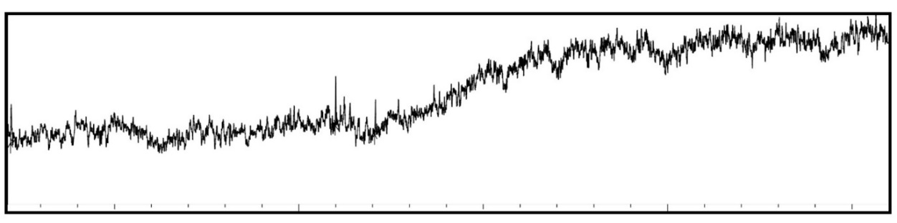
Fig. 1 GC-MS spectra for AECPL

3.2 AECPL ameliorates the Scavenging of free radicals and oxidative stress parameters in RBC model (In-vitro)
The AECPL effectively served as an anti-oxidant, limiting the scavenging of di-Phenyl-2-picryl-Hdrazyl (DPPH) free radicals in a dose-dependent manner. The anti-oxidant potential was 75 % higher than that of the positive control, vitamin C (ascorbic acid). The average IC50 value for AECPL was 36.01 µg/mL. Fig. 2 depicts the anti-oxidant activity of the AECPL. Furthermore, the antioxidant role was tested by measuring indicators such as lipid peroxidation, protein carbonyl content, and total thiol content in the RBCs model (in-vitro). Anti-oxidant enzymes such as catalase and superoxide dismutase are used to assess oxidative stress. When polyunsaturated fatty acids are exposed to high levels of free radicals, they undergo lipid peroxidation, producing compounds such as malanoldehyde (MDA), 4-hydroxy-2-nonenal, and acroline. In our tests to estimate lipid peroxidation, the amount of MDA liberation was measured in the presence of a TBA combination. Interestingly, our sample lowers the amount of MDA released in a dose-dependent manner (Fig. 3A). In addition, protein carbonylation and thiolation were done to measure the levels of protein carbonyl content and total thiol content, respectively. In comparison to the positive control ascorbic acid, the AECPL decreased PCC and TT levels in a dose-dependent manner (Fig. 3B, C). Additionally, the level of anti-oxidant enzymes was assessed in a NaNO2-induced oxidative stress RBCs model; at the time of the stress overdose, anti-oxidant enzyme activity declined; therefore, AECPL increased SOD and CAT activity and restored normal levels of these enzymes. The activity of SOD and CAT against oxidative stress caused by sodium nitrate is shown in Fig. 4A, B.
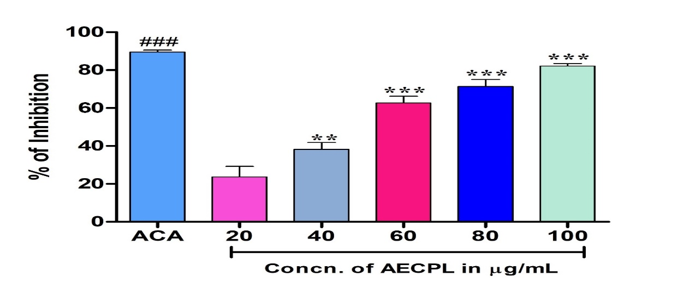
Fig. 2 Anti-oxidant activity of AECPL: the DPPH free radical scavenging potential of AECPL examined by measuring its anti-oxidant activity in comparison with ascorbic acid. Each value is given as a mean ± SD.* Significance at p≤0.05 ** at p≤0.01, and *** at p≤0.001.

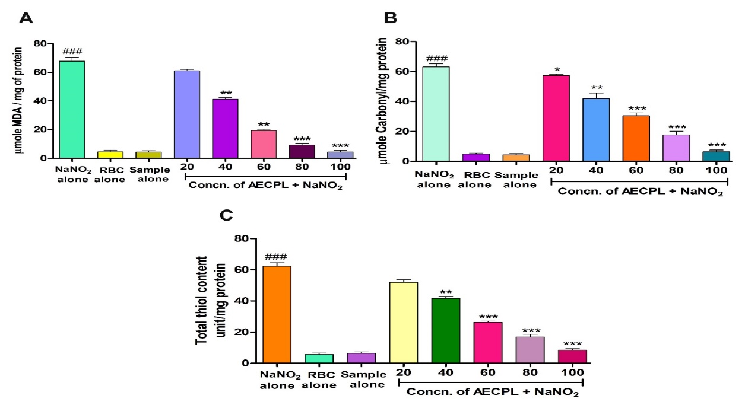
Fig. 3 Role of AECPL on NaNO₂-induced oxidative stress in red blood cells: (A) Lipid peroxidation, (B) Protein carbonyl content, and (C) Total thiol content. To identify the protective effect of AECPL against NaNO₂-induced oxidative damage, red blood cells were pre-incubated for 10 min with various concentrations (50–150 µg/mL) of AECPL at 37 °C before treatment with NaNO₂ (10 mM). The results are presented in average units/mg of protein and are expressed as mean ± SEM (n = 3). *Significance at p≤0.05, ** at p≤0.01 and *** at p≤0.001.
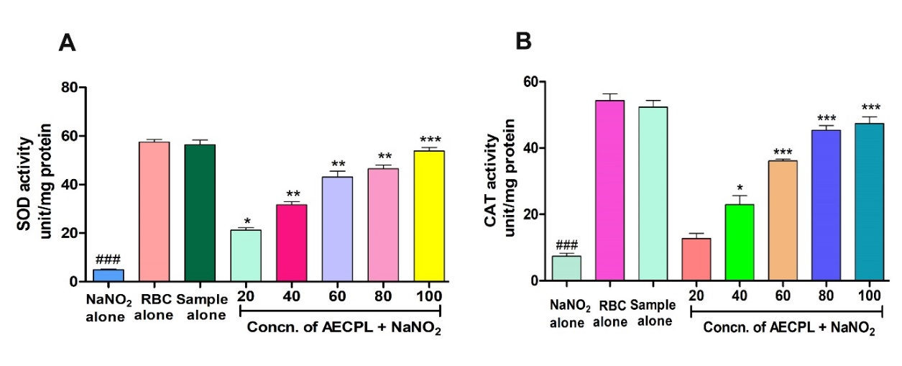
Fig. 4 Role of AECPL on NaNO₂-induced oxidative stress in red blood cells: (A) Superoxide dismutase activity, (B) Catalase. To identify the protective effect of AECPL against NaNO₂-induced oxidative damage, red blood cells were pre-incubated for 10 min with various concentrations (50–150 µg/mL) of AECPL at 37 °C before treatment with NaNO₂ (10 mM). The results are presented in average units/mg of protein and are expressed as mean ± SEM (n = 3). Significance at p≤0.05, ** at p≤0.01 and *** at p≤0.001.
3.3 AECPL ameliorates the diclofenac induced oxidative stress parameter in animal model (In-vivo):
The levels of PCC, MDA, and TT were considerably higher in the rat liver, kidney, pancreas, and heart homogenates that had been injected with 50 mg/kg of diclofenac than in the positive control silymarin. Rats with 150 mg/kg of AECPL showed significantly decreased levels of MDA, PCC, and TT in their liver, kidney, pancreas, and heart homogenates when compared to the control groups. Rat homogenates treated with AECPL alone had normal levels of MDA, PCC, and TT in comparison to control groups (Fig. 5A, B, C). Endogenous anti-oxidant enzymes (CAT and SOD) were significantly reduced in rat sample homogenates treated with DFC. The antioxidant enzyme activity was restored in the liver, kidney, pancreas, and heart homogenates of rats that received AECPL injections when DFC was pre-incubated with AECPL (150 mg/kg). In comparison to the AECPL alone-treated groups, SOD and CAT activity did not change (Fig. 6D, E).
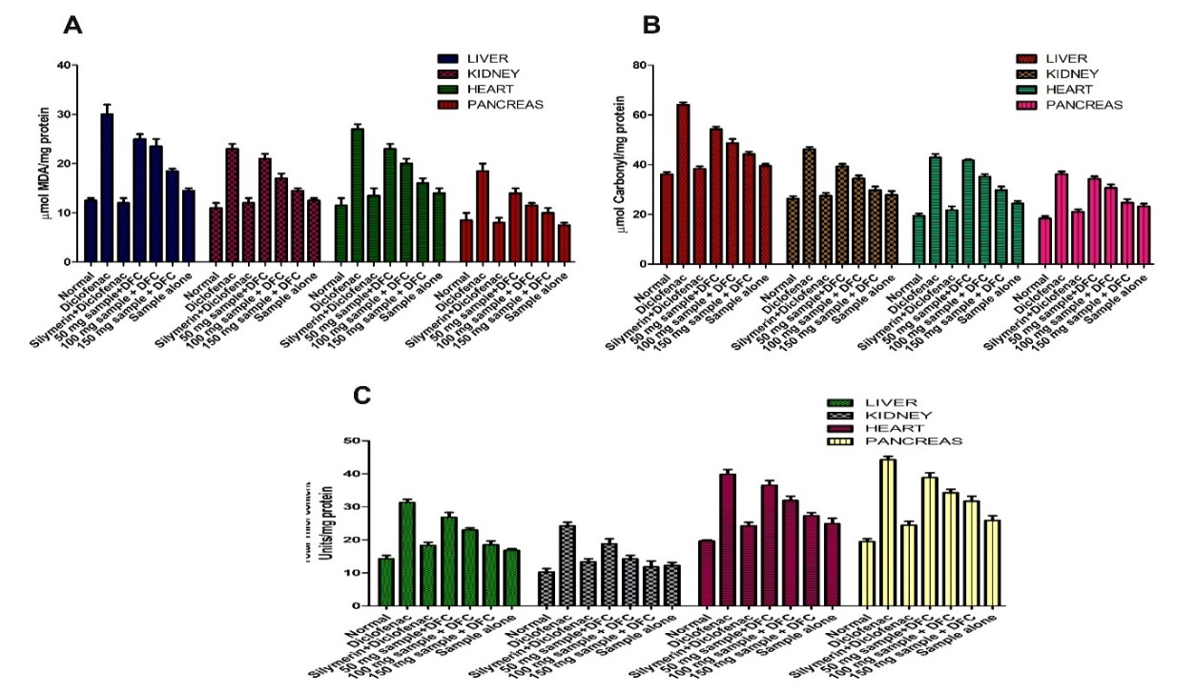
Fig. 5 The effect of AECPL on oxidative stress induced by Diclofenac in liver, kidney, pancreas and heart: (A) Lipid peroxidation. (B) Protein carbonyl content. (C) Total thiol. Normal fed with food and water; positive control-Diclofenac (50 mg/kg); protective control- Silymarin (50 mg/kg) + Diclofenac (50 mg/kg); AECPL (50 mg/kg) + Diclofenac; AECPL (100 mg/kg) + Diclofenac; AECPL (150 mg/kg) + Diclofenac and AECPL alone (150 mg/kg) in comparison to the toxicity for control group. All the samples were administered as mg/kg body weight/day. The data were represented as mean (n=3) ± SEM.
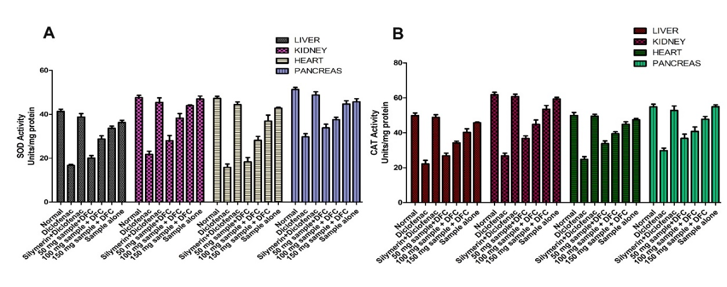
Fig. 6 The effect of AECPL on oxidative stress induced by Diclofenac in liver, kidney, pancreas and heart: (A) Superoxide dismutase. (B) Catalase. Normal fed with food and water; positive control-Diclofenac (50 mg/kg); protective control- Silymarin (50 mg/kg) + Diclofenac (50 mg/kg); AECPL (50mg/kg) + Diclofenac; AECPL (100 mg/kg) + Diclofenac; AECPL (150 mg/kg) + Diclofenac and DHLE.ZnFe2O4 NPs alone (150 mg/kg) in comparison to the toxicity for control group. All the samples were administered as mg/kg body weight/day. The data were represented as mean (n=3) ± SEM.
3.4 AECPL restores biochemical parameters In-vivo
Biochemical markers such as albumin, globulins, and total protein levels were shown to be lower in the blood samples of DFC-treated rats. While alkaline phosphatase, total bilirubin, indirect bilirubin, direct SGOT (serum glutamate oxaloacetate transaminase), bilirubin, and SGPT (serum glutamate pyruvate transaminase) levels rose dramatically. DFC pre-incubated with the AECPL-injected group of rats, the levels of the above-mentioned biochemical parameters were restored to normal in contrast to the positive control silymarin-treated group of experimental rats (Fig. 7).
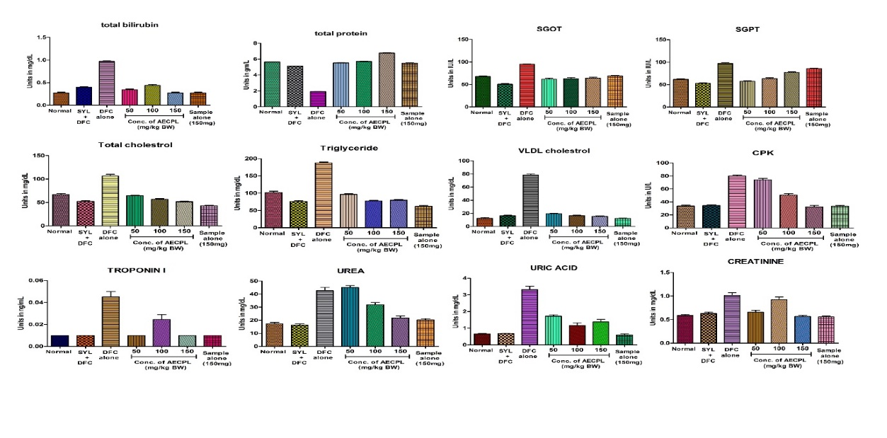
Fig. 7 Effect of AECPL on Diclofenac-induced oxidative stress biochemical parameters in rats: The data were expressed as ± SD mean (n=3); * significant at P≤0.05, **P≤0.01, ***/###P≤0.001; (#) significant compared with positive control Diclofenac.
3.5 AECPL restores liver, kidney, heart and pancreas morphology
Microscopic analysis of the liver, kidney, heart, and pancreas from the control group (Fig. 8AI, BI, CI, DI) and the AECPL treated silymarin along with DFC group (Fig. 8AIII, BIII, CIII, & DIII) revealed the absence of abnormalities in tissue morphology. However, significant tissue destruction of the liver, kidney, heart, and pancreas was shown in the Diclofenac-treated rats (Fig. 8AII, BII, CII &DII). Liver histology revealed hepatocellular deterioration due to elevated cell infiltration. Kidney tubular degeneration was observed. Necrosis of the heart muscle and injury from gallstones to the pancreatic muscle were noticed. Its interesting note is that AECPL healed the damaged liver, kidney, heart, and pancreas from oxidative stress caused by Diclofenac in a dose-dependent pattern (Fig. 8AIV, V, VI, BIV, V, VI, CIV, V, VI, & DIV, V, VI).
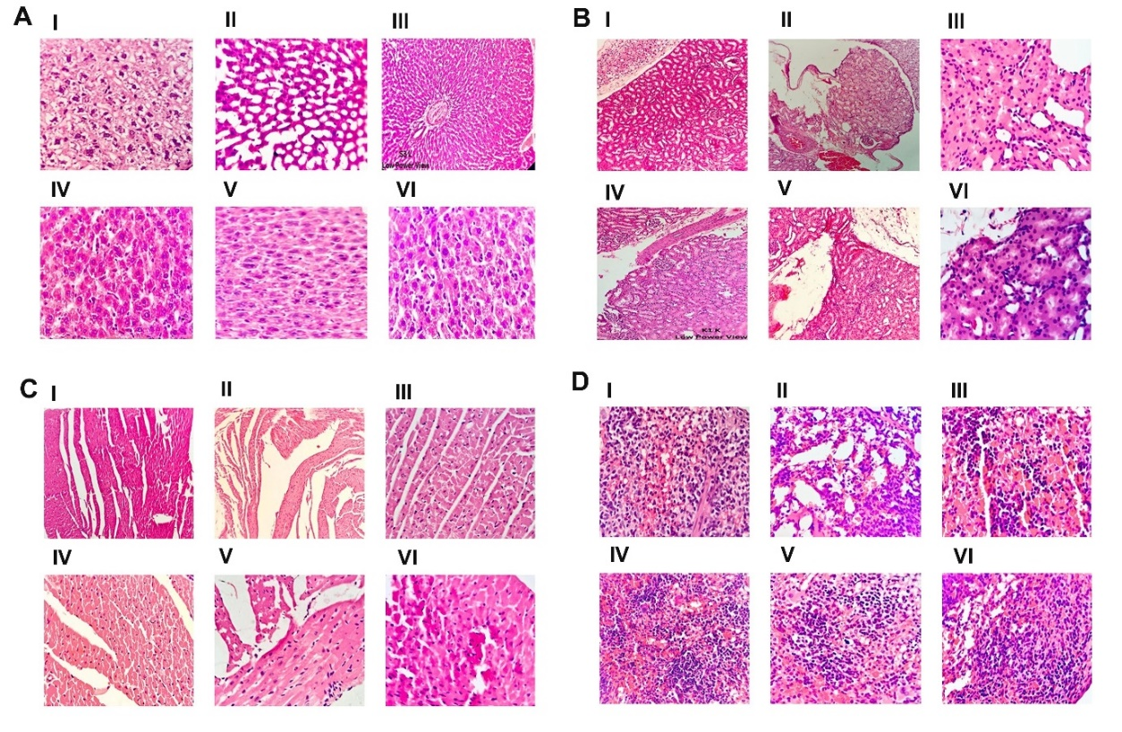
Fig. 8 Effect of AECPL on histology of Liver, kidney, Heart and Pancreas: (A) Histopathological study of liver. (A. I) The liver tissue showing normal centrilobar area and hepatic parenchyma in normal control group; (A. II) Diclofenac administered (50 mg/kg) groups showed necrosis of centrilobar area and hepatic parenchyma and infiltration of inflammatory cells; (A. III) Diclofenac (50 mg/kg) pre-incubated with silymarin (50 mg/kg) groups showed normal tissue architecture; (A. IV) Diclofenac (50 mg/kg) pre-incubated with AECPL (50 mg/kg) restored to normal architecture; (A. V) Diclofenac (50 mg/kg) pre-incubated with AECPL (100 mg/kg) groups showed normal liver histology; (A. VI) Diclofenac (50 mg/kg) pre-incubated with AECPL (150 mg/kg) groups showed almost normal liver histology.
(B) Histopathological study of kidney. (B. I) The kidney tissue showing normal renal tubules, bowman’s capsule and renal parenchyma in normal control group; (B. II) Diclofenac administered (50 mg/kg) groups showed tubular degeneration and necrosis with infiltration of inflammatory cells; (B. III) Diclofenac (50 mg/kg) pre-incubated with silymarin (50 mg/kg) groups showed normal tissue architecture; (B. IV) Diclofenac (50 mg/kg) pre-incubated with AECPL (50 mg/kg) restored to normal architecture; (B. V) Diclofenac (50 mg/kg) pre-incubated with AECPL (100 mg/kg) groups showed normal kidney histology; (B. VI) Diclofenac (50 mg/kg) pre-incubated with AECPL (150 mg/kg) groups showed almost normal kidney histology.
(C) Histopathological study of heart. (D. I) The heart tissue showing normal myocardium, no vacuolated fibers and no hemorrhage in normal control group; (D. II) Diclofenac administered (50mg/kg) groups showed small cluster of myocardial fibers with small to large cytoplasmic vacuoles and inflammatory infiltration; (D. III) Diclofenac (50 mg/kg) pre-incubated with silymarin (50 mg/kg) groups showed normal tissue architecture; (D. IV) Diclofenac (50 mg/kg) pre-incubated with AECPL (50mg/kg) restored to normal architecture; (D. V) Diclofenac (50 mg/kg) pre-incubated with AECPL (100 mg/kg) groups showed normal heart histology; (D. VI) Diclofenac (50 mg/kg) pre-incubated with AECPL (150 mg/kg) groups showed almost normal heart histology.
(D) Histopathological study of pancreas. (C. I) The pancreas tissue showing normal Islets of langerhans cells in normal control group; (C. II) Diclofenac administered (50 mg/kg) groups showed necrosis of Islets of langerhans cells; (C. III) Diclofenac (50 mg/kg) pre-incubated with silymarin (50 mg/kg) groups showed normal tissue architecture; (C. IV) Diclofenac (50 mg/kg) pre-incubated with AECPL (50 mg/kg) restored to normal architecture; (C. V) Diclofenac (50 mg/kg) pre-incubated with AECPL (100 mg/kg) groups showed normal pancreas histology; (C. VI) Diclofenac (50 mg/kg) pre-incubated with AECPL (150 mg/kg) groups showed almost normal pancreas histology.
3.6 Anti-inflammatory activity of AECPL (In-vitro)
AECPL exhibited significant anti-inflammatory activity by inhibiting BSA protein denaturation dose-dependently (82.77 %) as compared to aspirin (85.17 %), a positive control (Fig. 5A). Additionally, AECPL has an anti-inflammatory impact by reducing protein denaturation in a dose-dependent manner and inhibiting the denaturation of egg albumin. In comparison to aspirin (90 %) as a typical medication, AECPL had the highest suppression of denaturation, which was seen to be 80 % in egg albumin (Fig. 5B). Additionally, the inhibitory activity of serine protease was used to further analyzes the anti-inflammatory impact. Trypsin and other serine proteases, which are key enzymes in inflammation and tissue destruction, are released by neutrophils. Interestingly, in a trypsin inhibition study, AECPL strongly inhibited trypsin in a dose-dependent manner when compared to positive control aspirin (Fig. 5C). It was noticed that aspirin and AECPL inhibited trypsin by 84 % and 94 %, respectively.
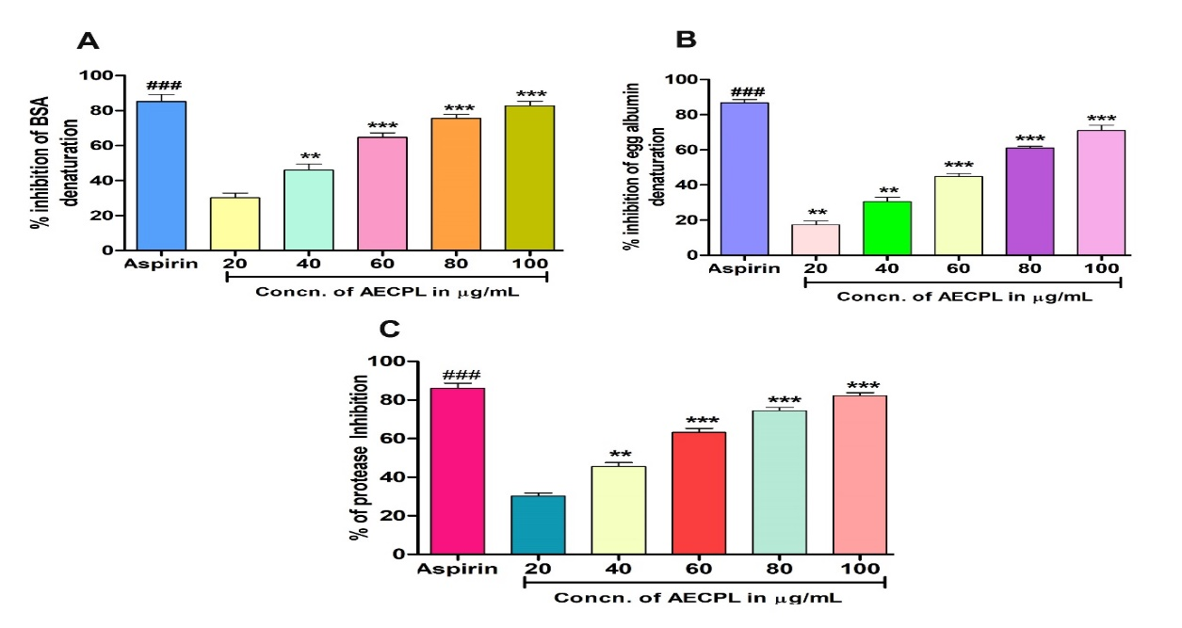
Fig. 9 Effect of AECPL on protein denaturation: (A) Percentage inhibition of BSA denaturation, (B) Percentage inhibition of egg albumin denaturation, and (C) Percentage inhibition of proteinase. The results are presented in average units/mg of protein and are expressed as mean ± SEM (n = 3). * Significance at p≤0.05, ** at p≤0.01 and *** at p≤0.001.

3.7 Toxicity analysis of AECPL
Direct hemolytic analysis was used to assess the toxicity of AECPL in a dose-dependent manner by administering 2 % hematocrit. The fact, RBCs maintains their normal shape, which indicates that they are non-toxic and noteworthy in application towards red blood cells models (Fig. 5F-H).
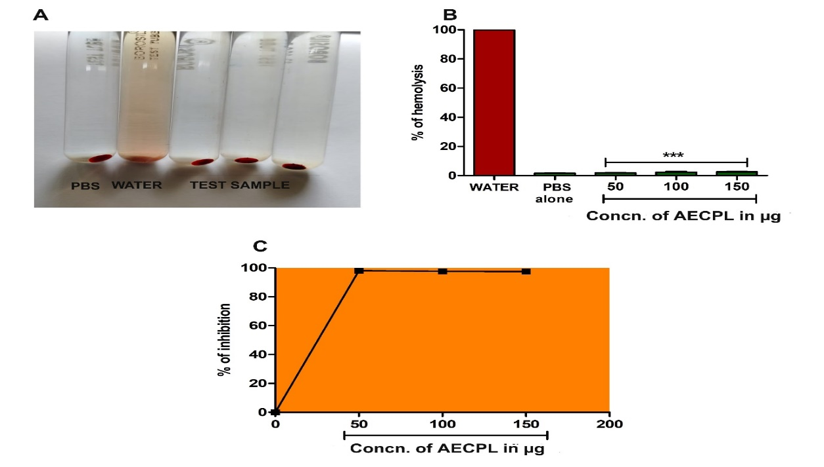
Fig. 10 (A) Direct Hemolytic assay of AECPL: The different concentration of AECPL (50-150 µg) was incubated independently for 1 h at 37 °C with the 1 mL of suspension made with packed human erythrocytes and phosphate buffered saline (PBS) 1:9 v/v and view the non-hemolyzed RBC viewed under microscope. (B) The amount of hemoglobin released in the supernatant was measured at 540 nm and percentage of hemolysis was calculated. (C) Percentage inhibition of hemolysis.
3.8 Statistical analysis
Results are expressed as means value of three independent experiments ± standard deviations. Statistical difference between the compounds was tested by one-way analysis of variance (ANOVA) using the GraphPad Prism 5. The P value less than 0.05 was considered to be statistically significant.

4. Discussion
Oxidative stress has primarily affected on the cellular mechanisms and cell processing by inducing ROS through free radicals. Aqueous extract of AECPL leaf extract showed anti-oxidant assets by scavenging DPPH free radicals in a dose-dependent manner with an IC50 value of 75.21 µg/mL. The free radical quenching ability of AECPL was further gauged using sodium nitrite-induced oxidative stress in the RBCs model. The measurement of oxidative stress has been enumerating the products of lipid peroxidation, protein carbonylation, thiolation. The oxidation products produced from the reaction between oxygen and unsaturated lipids generates secondary products of Lipid peroxidation such as malondialdehyde (MDA), 4-hydroxynonenal (4- HNE), propanol and hexanal. While 4-HNE is the most harmful by-product of lipid peroxidation, MDA seems to be the most mutagenic (Schaur et al. 2015). Because of its simple reaction with thiobarbituric acid (TBA), MDA has been utilized extensively for many years as a handy biomarker for lipid peroxidation of omega-3 and omega-6 fatty acids. However, the protein carbonylation is a frequent oxidative alteration that can lead to structural or functional loss because of aggregation, polymerization, unfolding, and conformational changes. Aggregates of oxidized protein build up and damage the cells, most involves carbonyls of proteins. The carbonylation of lysine, cysteine, and histidine occurs as a result of their reaction with reactive carbonyl groups produced during the oxidation of carbohydrates (e.g., glyoxal (GO), methylglyoxal (MGO) and lipids (e.g., HNE, MDA, or acrolein (ACR). This carbonyl production process is known as glycoxidation, the formation of advanced glycation end-products (AGEs) and lipoxidation (Aldini et al. 2013). By derivatizing the carbonyl group with dinitrophenylhydrazine (DNPH), which creates a stable dinitrophenylhydrazone (DNP) product that can be studied spectrometrically or by immunoblotting, it is possible to regulate the number of carbonyls in specific proteins. Compared to other amino acids, cysteine residues are extremely infrequent in proteins, accounting for only 2.3 % of the human proteome (Marino and Gladyshev 2010). A variety of post-translational oxidative changes result from reactions between ROS or RNS species and thiol (sometimes referred to as mercaptan or sulfhydryl) -SH side chain of cysteine. The ability of thiols in a sample to chemically decrease Ellman's reagent 5, 5’-DiThiobis-2-Nitro Benzoic acid (DTNB), which has a reactive disulfide bond has to be reduced. In a stoichiometric reaction, DTNB is reduced by free thiols via an exchange reaction that produces a mixed disulfide and a yellow-colored 5-Thio-2-NitroBenzoic acid (TNB) (Tsiasioti and Tzanavaras 2023). AECPL significantly diminished the level of oxidative stress by reducing the markers like LPO, PCC and TT in sodium nitrite induced RBCs damage. In additionally it restores the stress markers level and tissue damage in Diclofenac induced rat organs homogenates like liver, kidney, pancreas and heart. Over the previous reports documented some medicinal plants (Kenaf seed, Pomegranate and Decalepis hamiltonii leaves) showed good effect on anti-oxidant, anti-inflammatory, anti-cancer and anti-microbial activities. Furthermore, our study also reports the AECPL normalized the level of endogenous anti-oxidant enzymes SOD and CAT activity in sodium nitrite stress induced RBCs model.
Researchers showed that, higher levels of ROS/RNS tend to initiate the inflammatory process by producing more of the pro-inflammatory cytokines, nuclear protein kappa B/active protein −1 and tumor necrosis factor alpha responsible for numerous chronic diseases including cancer (Shukla et al. 2019). The RBCs membrane is similar to the lysosomal membrane since the stabilization of the lysosomal membrane plays a key role in the inflammatory response by preventing the release of neutrophils in specific bacterial proteins and proteases that damage upon extracellular discharge, resulting in chronic and acute inflammation. Protein denaturation is concerned with arthritic responses and tissue damage progression during inflammation. Our results disclose that AECPL was effective in inhibiting the denaturation of protein (egg and bovine serum albumin) in all tested doses, showing the capability of controlling the protein denaturation involved in the inflammatory process. At the time of inflammation, serine protease an enzyme released from neutrophils and it plays a crucial role in tissue damage during the inflammatory response. AECPL inhibited trypsin compared to the positive control aspirin, supporting its observed anti-inflammatory potential. Recent advances in understanding the activity of intestinal enzymes helped in the development of newer pharmacological agents (Koppel et al. 2017). The α-glucosidase inhibitors reduce intestinal absorption of polysaccharides (starch, dextrin, and disaccharides) by inhibiting the action of α-glucosidase in the intestinal brush border. Inhibition of this enzyme slows the absorption of carbohydrates from the GI tract and decreases the rate of rise of postprandial glucose (PP hyperglycemia). This interrupt digestion and breakdown of starch may have beneficial effects on insulin resistance and glycemic index control in people with diabetes. Acarbose is known α-glucosidase inhibitor which reduces digestion of complex carbohydrates and slows their absorption from the gut (Smith et al. 2021). These drugs also increase the release of the glucoregulatory hormone glucagon-like peptide-1 into the circulation, which may contribute to their glucose-lowering effects. However, they may cause side effect such as malabsorption, abdominal pain, flatulence, and diarrhea which lead to a high discontinuation rate. Acarbose and miglitol should not be prescribed in individuals with renal impairment, acarbose should be used with caution in patients with hepatic diseases because it may cause reversible elevation of hepatic enzymes (Kihara et al. 1997). Experimental results showed that aqueous extracts of AECPL significantly inhibited the α-glucosidase and α-amylase enzymes.

4. Conclusion

Our study demonstrated that, the AECPL showed good antioxidant property by inhibiting DPPH generated radicals and also found to reduce sodium nitrite as well as Diclofenac induced oxidative stress by regulating oxidative stress markers such as LPO, PCC, TT and antioxidant enzyme levels. Besides it brings back the aborted tissue architecture caused by Diclofenac by regulating serum marker levels. Interestingly AECPL showed good effect against inflammation a primary mechanism by inhibiting the denaturation of proteins and protease. Further it inhibited the alpha amylase and glucosidase gives insight role towards diabetic disorder.

Consent

All authors have read and approved the final version of the manuscript and consent to its submission for publication.

Ethical approval

All the experimentations were conducted under ethical guidelines and were approved by the Institutional Human Ethical Committee (IHEC-TUT No: 03/Res/2024-2025), Tumkur University, and Tumkur. Ethical clearance was taken for this study from Chromed Bioscience. The Institutional Animal Ethical Committee (LBLIAEC) – Tumkur, with a protocol number LBPL-IAEC-47-05-2019.

COMPETING INTERESTS DISCLAIMER:
Authors have declared that they have no known competing financial interests OR non-financial interests OR personal relationships that could have appeared to influence the work reported in this paper.

References

Abadie C, Lalande J, Tcherkez G (2022) Exact mass GC‐MS analysis: Protocol, database, advantages and application to plant metabolic profiling. Plant Cell Environ 45:3171–3183. https://doi.org/10.1111/pce.14407
Aldini G, Vistoli G, Stefek M, et al (2013) Molecular strategies to prevent, inhibit, and degrade advanced glycoxidation and advanced lipoxidation end products. Free Radic Res 47:93–137. https://doi.org/10.3109/10715762.2013.792926
Ansari FA, Ali SN, Mahmood R (2015) Sodium nitrite-induced oxidative stress causes membrane damage, protein oxidation, lipid peroxidation and alters major metabolic pathways in human erythrocytes. Toxicol In Vitro 29:1878–1886. https://doi.org/10.1016/j.tiv.2015.07.022
Bijina B, Chellappan S, Krishna JG, et al (2011) Protease inhibitor from Moringa oleifera with potential for use as therapeutic drug and as seafood preservative. Saudi J Biol Sci 18:273–281. https://doi.org/10.1016/j.sjbs.2011.04.002
Dobrovolskaia MA, Clogston JD, Neun BW, et al (2008) Method for Analysis of Nanoparticle Hemolytic Properties in Vitro. Nano Lett 8:2180–2187. https://doi.org/10.1021/nl0805615
Gulcin İ, Alwasel SH (2023) DPPH Radical Scavenging Assay. Processes 11:2248. https://doi.org/10.3390/pr11082248
Gunathilake K, Ranaweera K, Rupasinghe H (2018) Influence of Boiling, Steaming and Frying of Selected Leafy Vegetables on the In Vitro Anti-inflammation Associated Biological Activities. Plants 7:22. https://doi.org/10.3390/plants7010022
Hart FD, Huskisson EC (1984) Non-Steroidal Anti-Inflammatory Drugs: Current Status and Rational Therapeutic Use. Drugs 27:232–255. https://doi.org/10.2165/00003495-198427030-00004
Jayathilake C, Visvanathan R, Deen A, et al (2018) Cowpea: an overview on its nutritional facts and health benefits. J Sci Food Agric 98:4793–4806. https://doi.org/10.1002/jsfa.9074
Kihara Y, Ogami Y, Tabaru A, et al (1997) Safe and effective treatment of diabetes mellitus associated with chronic liver diseases with an alpha-glucosidase inhibitor, acarbose. J Gastroenterol 32:777–782. https://doi.org/10.1007/BF02936954
Koppel N, Maini Rekdal V, Balskus EP (2017) Chemical transformation of xenobiotics by the human gut microbiota. Science 356:eaag2770. https://doi.org/10.1126/science.aag2770
Landahl HD (1953) Calorimetric Estimation of Catalase Activity. Exp Biol Med 84:74–79. https://doi.org/10.3181/00379727-84-20545
Levine RL, Garland D, Oliver CN, et al (1990) [49] Determination of carbonyl content in oxidatively modified proteins. In: Methods in Enzymology. Elsevier, pp 464–478
Marino SM, Gladyshev VN (2010) Cysteine Function Governs Its Conservation and Degeneration and Restricts Its Utilization on Protein Surfaces. J Mol Biol 404:902–916. https://doi.org/10.1016/j.jmb.2010.09.027
Ohkawa H, Ohishi N, Yagi K (1979) Assay for lipid peroxides in animal tissues by thiobarbituric acid reaction. Anal Biochem 95:351–358. https://doi.org/10.1016/0003-2697(79)90738-3
Paoletti F, Aldinucci D, Mocali A, Caparrini A (1986) A sensitive spectrophotometric method for the determination of superoxide dismutase activity in tissue extracts. Anal Biochem 154:536–541. https://doi.org/10.1016/0003-2697(86)90026-6
Paul S (2018) In-Vitro Studies of Bio-Silver Nanoparticles in Cytotoxicity and Anti- Inflammatory. J Complement Med Altern Healthc 7:. https://doi.org/10.19080/JCMAH.2018.07.555719
Revia RA, Zhang M (2016) Magnetite nanoparticles for cancer diagnosis, treatment, and treatment monitoring: recent advances. Mater Today 19:157–168. https://doi.org/10.1016/j.mattod.2015.08.022
Schaur R, Siems W, Bresgen N, Eckl P (2015) 4-Hydroxy-nonenal—A Bioactive Lipid Peroxidation Product. Biomolecules 5:2247–2337. https://doi.org/10.3390/biom5042247
Shukla R, Pandey V, Vadnere GP, Lodhi S (2019) Role of Flavonoids in Management of Inflammatory Disorders. In: Bioactive Food as Dietary Interventions for Arthritis and Related Inflammatory Diseases. Elsevier, pp 293–322
Smith DL, Orlandella RM, Allison DB, Norian LA (2021) Diabetes medications as potential calorie restriction mimetics—a focus on the alpha-glucosidase inhibitor acarbose. GeroScience 43:1123–1133. https://doi.org/10.1007/s11357-020-00278-x
Tang L, Jennings TA, Eaton JW (1998) Mast cells mediate acute inflammatory responses to implanted biomaterials. Proc Natl Acad Sci 95:8841–8846. https://doi.org/10.1073/pnas.95.15.8841
Toyokuni S (1999) Reactive oxygen species‐induced molecular damage and its application in pathology. Pathol Int 49:91–102. https://doi.org/10.1046/j.1440-1827.1999.00829.x
Tsiasioti A, Tzanavaras PD (2023) Determination of glutathione and glutathione disulfide using liquid chromatography: A review on recent applications. Microchem J 193:109157. https://doi.org/10.1016/j.microc.2023.109157
Venkatappa MM, Udagani C, Hanumegowda SM, et al (2022) Effect of Biofunctional Green Synthesized MgO-Nanoparticles on Oxidative-Stress-Induced Tissue Damage and Thrombosis. Molecules 27:5162. https://doi.org/10.3390/molecules27165162
Venkataramaiah S, Venkatappa MM, Rangappa R, et al (2025) Green fabricated bimetallic zinc ferrite nanoparticles mitigate oxidative stress-induced pathogenesis. Anal Biochem 115767. https://doi.org/10.1016/j.ab.2025.115767
Waterborg JH (2009) The Lowry Method for Protein Quantitation. In: Walker JM (ed) The Protein Protocols Handbook. Humana Press, Totowa, NJ, pp 7–10
Zinellu A, Sotgia S, Usai MF, et al (2005) Thiol redox status evaluation in red blood cells by capillary electrophoresis-laser induced fluorescence detection. ELECTROPHORESIS 26:1963–1968. https://doi.org/10.1002/elps.200400042

