Original Research Article
Studies on Phytochemical Screening and Their Biological Activities of Balanites roxburghii Planch

ABSTRACT:
The present investigation examines the chemical composition and their biological activities of Balanites roxburghii Planch. Using different solvents. The qualitative phytochemical evaluation reveals the presence of various phytoconstituents, such as saponins, proteins, steroids, alkaloids, tannins, flavonoids, and glycosides. The antibacterial activity of (Escherichia coli) and antifungal activity (Rhizopus sps). Both ethanolic and distilled water extracts showed significant antibacterial activity, whereas the aqueous extract showed no inhibition against the tested fungal pathogen. The in-vitro cytotoxicity by MTT assay against A549 lung cancer cell line shows a significant result with an IC₅₀ value of 139.96 µg/ml ethanol extract. These results imply that Balanites roxburghii Planch. Leaf has potential functional uses in pharmaceutical applications.

Aim: To comprehensively evaluate the phytochemical profile of Balanites roxburghii Planch. leaf extracts obtained using different solvents and to assess their biological activities—including antibacterial, antifungal, and in-vitro cytotoxic effects—to determine their potential relevance and applicability in pharmaceutical and therapeutic research.
Study design: The study involved solvent extraction and phytochemical screening of Balanites roxburghii leaves, followed by evaluation of their antibacterial, antifungal, and cytotoxic activities.
Biological assays were performed to determine the therapeutic potential of the extracts.
Place and Duration of Study: sample collected from the Chitradurga district, near Jogimatti forest. Research work carried out in the P.G. Department of Botany. Government Science College, Chitradurga and Department of Studies in Botany, Davangere University, Davangere. The duration of work is September 2024 to October 2025.

Methodology: the phytochemical estimation was carried out by the preliminary phytochemical tests and antibacterial activity carried out against Escherichia coli and antifungal activity against Rhizopus sps. Both ethanolic and distilled water extracts. The in-vitro cytotoxicity by MTT assay against the A549 lung cancer cell line.
Results: The phytochemical tests revealed the presence of saponins, proteins, steroids, alkaloids, tannins, flavonoids, and glycosides. Both ethanolic and distilled water extracts showed significant antibacterial activity, whereas the aqueous extract showed no inhibition against the tested fungal pathogen. The in-vitro cytotoxicity against the A549 lung cancer cell line shows a significant result with an IC₅₀ value of 139.96 µg/ml ethanol extract.
Conclusion: The findings demonstrate that Balanites roxburghii Planch. leaf extracts contain valuable phytochemicals and exhibit notable antibacterial and cytotoxic activities, particularly in the ethanolic extract. Although the aqueous extract showed no antifungal effect, the overall results highlight the plant’s potential as a promising source of bioactive compounds for future pharmaceutical applications.

Keywords: Antimicrobial, Anticancer (A549), Balanites roxburghii Planch, phytochemicals.

1. INTRODUCTION
Plants are a major source of food and medicine throughout the world. The World Health Organisation suggests choosing a plant-based diet over food from animal sources to lower the risk of non-transmissible diseases, even though a significant portion of the population consumes animal products (Murthy et al., 2023).. Balanites consists of nine species, indigenous to Africa. And spread to disticnt regions of the world and found in subtropical and tropical regions, including Oman, Zimbabwe in the south, Somalia and Senegal in the west, Palestine, Yemen, Saudi Arabia, Syria, Jordan, Iran, and India. The plants can be found growing in the semi-arid states of Maharashtra, Karnataka, Andhra Pradesh, Rajasthan and Gujarat. Due to its extensive phytochemical composition, which includes saponins, protein, carbohydrates, flavonoids, alkaloids, lipids, and organic acids, the genus Balanites has long been used to cure a variety of ailments (Shinde et al., 2025). Balanites Delile (Zygophyllaceae): the genus includes many underutilised species, used for centuries as food and to cure many ailments. Mejority of the Balanites species are distributed on the African continent. The well-known species in the genus, Balanites aegyptiaca, has many conventional applications. And the species are rich in carbohydrates and proteins and are a good source of minerals. The fruits are regarded as nutritionally significant and are consumed raw or processed to make a variety of cuisines. B. aegyptiaca, B. rotundifolia, and B. wilsoniana Dawe & Sprague are examples of the genus's high seed oil content, which may be utilised to produce biodiesel (Yadav et al., 2022). Balanites species are utilised as traditional medicine in India and Africa. In addition to treating malaria, vaccinating livestock, treating swelling, indigestion, and vomiting, the roots and this plants bark also utilised as a purgative and a parasitic agent. In Sudan, some species' fruits are used to treat jaundice. Seed oil is used to cure bleeding disorders as a laxative (Habieballa et al., 2021). Balanites roxburghii Planch. Is a little, prickly, evergreen tree that produces fruit. Found in India's arid regions. Its fruit pulp, seed oil, stem bark, and roots are used for a variety of therapeutic uses for conventional applications. In certain parts of Southern India, the leaves and pulp are also used as emergency food. Due to its two main components, seed oil and diosgenin, this species has substantial economic potential. With an outstanding oil content of up to 60.99% and no cytotoxic effects, the seed kernels appear promising as a potential dietary oil source (Yadav et al., 2025). Malaria, syphilis, jaundice, liver issues, epilepsy, dysentery, constipation, diarrhoea, haemorrhoids, spleen issues, and yellow fever all are treated. Traditionally, the tribal population used the aqueous juice of B. roxburghii's pericarpium to treat discomfort. In several regions of Southern India, the underutilised species Balanites roxburghii Planch. leaves are consumed as a source of energy during times of food scarcity. Additionally, the plant has molluscicidal, antihelminthic, antifeedant, insecticidal, analgesic, purgative, antidysenteric, and contraceptive properties. And also antioxidant, anticancer, antidiabetic, anti-inflammatory, antimicrobial, and hepatoprotective activity. Local traditional healers employ the antifeedant active saponins are extracted from the dried fruits of this plant as an abortifacient. Human carcinoma cell lines in the lung, liver, and brain showed anticancer activity from the oil. Saponins are abundant in the pulp of fruits, seeds, leaves, stems, and root bark (Murthy et al., 2020) (Arora et al., 2013) and (Padmashali et al., 2006). However, there aren't enough research, Balanites roxburghii is used in both modern pharmacology and the old Indian Ayurvedic pharmacopoeia. The present investigation was to study the phytochemical composition and antimicrobial and anticancer (A549) activities.
2. MATERIALS AND METHODS:
2.1 Collection and Preparation of Plant Material
Fresh samples of Balanites Roxburghii Planch. The plant was collected from the Chitradurga District, near Jogimatti Forest. The leaves are washed with running tap water to remove adhered dust particles and extraneous matter. Leaves are shade dried for about 20-30 days, and the leaves powdered using a grinder, subjected to the hot continuous method of extraction (Soxhlet extraction). About 25 grams of plant sample was packed with the help of No. 1 Whatman filter paper, with 250 ml of Ethanol and Distilled water. After extraction, the crude extract was collected and stored in glass vials at -4ºC for further analysis.

Fig 1: B. roxburghii. A. Habit, B. Stem, C. Leaves, D. Flower, E. Fruit.
2.2 Qualitative phytochemical analysis
The qualitative phytochemical screening of the plant extracts was carried out to determine the major groups of chemicals (proteins, carbohydrates, alkaloids, phenols, tannins, flavaonoids, steroids, glycosids) contained in the extracts (Dubale et al., 2023) (Praveen et al., 2025)
2.3 Antimicrobial activity
Antimicrobial activity by the disc diffusion method in accordance with the standard procedure by (Zaidan et al., 2005). The nutrient medium was prepared as per the requirement according to the number of plates, with and small amount of agar added as a solidifying agent, and the pH was adjusted to seven. Media was autoclaved at 121°C for 15min to sterilize. After sterilization, NA medium was transferred into sterile petriplates under aseptic conditions and let it to solidify. Then it is used for subculturing. 1ml of sterilised distilled water was taken in a clean test tube. To this, a loop full of cultured bacterium was suspended & shaken well. From this, 0.1ml of the sample is inoculated into the plates. After the inoculation of the inoculum, it is spread uniformly over the medium. Sterile discs of 0.1 mm diameter loaded with specific plant extracts (0.1ml) were placed onto the plates, along with standard drug tetracycline (10mg) was also impregnated onto separate discs, which would serve as the positive control in determining the antimicrobial activity. The plates are incubated at 37°C overnight. After incubation, the zone of inhibition is to be measured (Ngamsurach et al., 2022). Czapek-Dox agar is used for fungal Rhizopus species. From a sub-cultured broth solution, one loop of the inoculum is placed in a clean sterile test tube, filled with sterile distilled water to 1ml volume and shaken well. From this, 0.1ml of inoculum is inoculated into the plates. After inoculation, the inoculum is spread uniformly over the medium using an L-shaped glass rod. Sterile discs of 0.1 mm diameter were placed onto the plates. Selected plant extracts were impregnated onto the discs along with standard drug Azithromycin, and were prepared (μg/1ml) was also loaded onto separate discs, which would serve as the standards in determining the antimicrobial activity. The plates were then incubated at room temperature for 48 hrs. The inhibition zone was evaluated in diameters (Praveen et al., 2025).
2.4 Cytotoxic evaluation
The MTT assay was performed to determine the IC₅₀ value. In which about 1×10⁵ cultivated cells were planted in a 96-well plate, 200 μl of cell suspension was added, and at 37°C the plates are incubated in a 5% CO₂ incubator for 24 h. Following a 48-hour incubation period, the monolayer was cleaned with media, 100 µL of various test concentrations of samples were added, and after then the cells were kept under exactly the same conditions. After taking out of cultivated media and adding 100 µL of the MTT solution to each well, the incubate the mixture at 37°C for almost four hours. After the liquid residue was removed, 100 µL of DMSO was transferred to each well, and the formazan crystals were allowed to dissolve for 10 minutes (Praveen et al., 2025).
3. RESULTS AND DISCUSSION:
3.1 Qualitative phytochemical analysis

The phytochemical evaluation of Balanites roxburghii. Show the presence of alkaloids, phenols, proteins, saponins, carbohydrates, glycosides and steroids in the distilled water extract; flavonoids and tannins are absent. Phenols, flavonoids, glycosides, steroids, saponins, proteins, tannins and carbohydrates in ethanol extract; alkaloids are absent. As illustrated in Table 1. Balanites aegytiaca. The phytochemical evaluations reveal the existence of volatile oils, flavonoids, steroids, alkaloids, cardiac glycosides, tannins and reducing sugars are reported from the kernel of the plant (Alhassan et al., 2018). The fruit pulp of Balanites aegytica reported the presence of polyphenols, flavonoids and a good source of sugars (Abdelaziz et al., 2020).
Table 1: Qualitative phytochemical analysis of Balanites roxburghii leaf extract
Sl. No | Phytochemical test | BRE | BRDW
1 | Alkaloids | - | +
2 | Falvonoids | + | -
3 | Phenols | + | +
4 | Gycosides | + | +
5 | Tannins | + | -
6 | Saponins | + | +
7 | Steroids | + | +
8 | Protiens | + | +
9 | Carbohydrates | + | +
Note: “+” = Present, “-’’ = Absent, BRE = Balanites roxburghii ethanol extract, BRDW = Balanites roxburghii distilled water extract
3.2 Antimicrobial activity
Both extracts exhibit significant antibacterial activity at the tested concentrations. The most significant inhibition against E-coli shown by ethanol about 14 mm in diameter at 100 µg. Moreover, the distilled water extract showed a 12 mm diameter zone of inhibition at the same volumes (Fig. 2). Tetracycline was used as a standard, as shown in Table 2. B. aegytica reported the methanol leaf extract showed the zone of inhibition 15.4 ± 0.25 mm, 15.3 ± 0.20 mm, 15.2 ± 0.25 mm and 0 ± 0.00 mm against E. coli, S. aureus, P. aeruginosa and S. typhi, and the aqueous extract with 12.5 ± 0.25 mm, 13.1 ± 0.21 mm, 12.3 ± 0.25 mm and 0 ± 0.00 mm. there was no action from either extract against S. aureus (Abdulhamid et al., 2016). Balanites roxburghii evaluated that the ethanol and aqueous extracts of stembark showed antibacterial activity as 3.8±0.1, 4.0±0.5, 4.0±0.3 and 3.0±0.6 by ethanol extract and 5.60 mm, 5.09 mm, 4.76 mm and 6.20 mm by aqueous extract against E. coli, Staph. Aureus, Sal. typhi and K. pneumoniae bacterial strains. The ethanol extract exhibits a highest inhibition zone (Singh et al., 2009). Balanites roxburghii did not exhibit any inhibition against the tested fungi, Rhizopus species, by both ethanol and aqueous extracts, at tested concentrations (Table 2). Balanites aegyptiaca reported that methanol and n-hexane extracts of callus and seed extracts exhibited minimum zones of inhibition for the n-hexane callus extract of 15 ± 0.46 mm, 09 ± 0.57 mm, 17 ± 0.69 mm, and 11 ± 0.94 mm, and the methanol extract exhibited significant zones of inhibition. Likewise, the methanol seed extract shows the maximum zone of inhibition with 15 ± 0.34 mm and 10 ± 0.62 mm, and x-hexane shows the minimum zone of inhibition, 12 ± 0.51 mm and 09 ± 0.23 mm, against Candida albicans (Abaka et al., 2020).
Table 2: Antimicrobial activity of Balanites roxburghii against E. coli
Sl. No | Sample name | Concentration (mg) | Inhibition zone (mm)
1 | BRE | 100 | 12
2 | BRDW | 100 | 14
3 | E. coli | 10 | 18
Note: BRE = Balanites roxburghii ethanol extract, BRDW = Balanites roxburghii distilled water extract
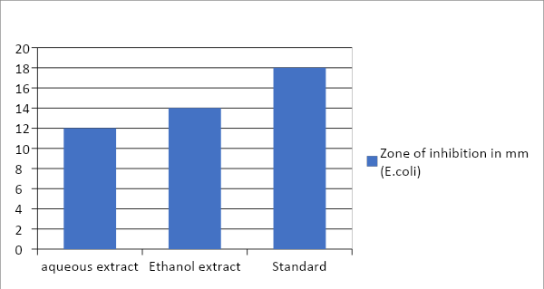
Fig 2: Antibacterial activity of B. roxburgii

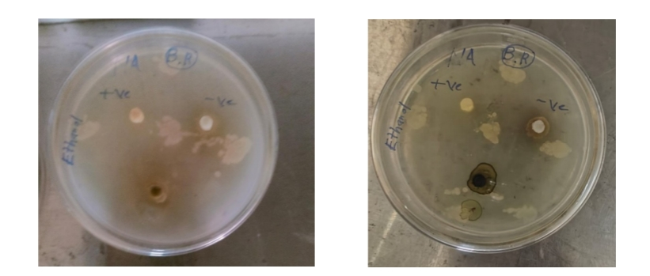
Fig 3: Antibacterial activity of B. roxburghii against E. coli

3.3 Cytotoxicity by MTT Assay
The A549 cancer cell line is used to evaluate the IC₅₀ value. The ethanol extract exhibited a good percentage of inhibition with an IC₅₀ value of 139.96 µg/ml at volumes of 50, 100, 150, 200 and 250 µg/ml, with percentages of inhibition of 73%, 59%, 45%, 34% and 24%. Ethanol extract exhibits a good percentage of inhibition when compared to the standard cisplatin. It is reported that, for Balanites aegyptiaca, the methanolic fruit extract tested different four cell lines, the evaluated IC₅₀s are 569.51 µg/ml, 112.31 µg/ml, 92.47 µg/ml and 87.33 µg/ml, respectively. B. aegyptiaca exhibits a high percentage of inhibition when compared to standard doxorubicin (Ibrahim et al., 2022). Balanites aegyptiaca reveals that the stem bark extracts of chloroform, water, and hexane. Against various cancer cell lines, HUVECs, HCT-116, K562, U97 and MCF-7 all express a dose-dependent percentage of inhibition with IC₅₀ values of 72.86 µg/ml, 26.11 µg/ml, 15.55 µg/ml and 19.75 µg/ml, respectively. However, aqueous and hexane extracts exhibit a minimum zone of inhibition (Hassan et al., 2016).
Table 3: anticancer activity of Balanites roxburghii
Sl. No | Sample | A549 (IC₅₀ µg/ml)
1 | BRE | 139.96 µg/ml
Note: BRE = Balanites roxburghii ethanol extract
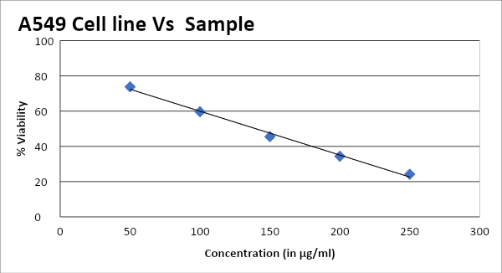

Fig 4: Percentage of cytotoxicity of Balanites roxburghii Ethanol extract
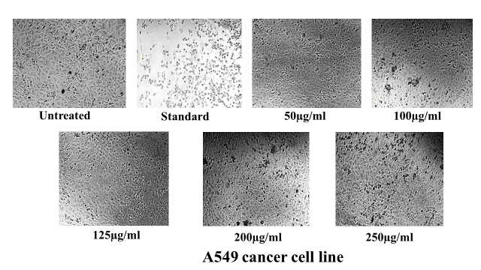

Fig 5: Microscopic images showing the cytotoxic effects (% cell viability) of ethanol extract of Balanites roxburgii

4. Conclusion
Balanites roxburgii is an important plant having a variety of ethnomedicinal applications from the ancient period. They are rich in bioconstituents, and some are isolated by researchers. All the plant parts are medicinally important with antiaging, antioxidant, antiproliferative, antimicrobial and antitumor properties. The leaves and fruits are consumed as a nutritive source in many parts of the world. The present study evaluated the bioactive compounds present in the plant and its antimicrobial and cytotoxicity assay.good antimicrobial activity with successive zones of inhibition and showed the maximum cytotoxicity against the A549 cancer cell line. Hence this needs much more investigation that may help in the pharmaceutical industry. This plant gained more attention towards nutraceuticals. Numerous substances have been identified from different parts of the plant; they performed good biological activity. Further investigation is needed to isolate the pure compound and determine the pharmacological activities of compounds.

COMPETING INTERESTS DISCLAIMER:
Authors have declared that they have no known competing financial interests OR non-financial interests OR personal relationships that could have appeared to influence the work reported in this paper.

REFERENCES
Abaka, A. K., Ishaku, G. A., Haruna, A., & Ardo, B. P. (2020). Phytochemicals screening and antifungal activity of Balanites aegyptiaca Seed and Callus Extract against Candida albicans. Asian Plant Research Journal, 4(4), 9-16. https://doi.org/10.9734/APRJ/2020/v4i430091
Abdelaziz, S. M., Lemine, F. M. M., Tfeil, H. O., Filali-Maltouf, A., & Boukhary, A. O. M. S. (2020). Phytochemicals, antioxidant activity and ethnobotanical uses of Balanites aegyptiaca (L.) Del. fruits from the arid zone of Mauritania, Northwest Africa. Plants, 9(3), 401. https://doi.org/10.3390/plants9030401
Abdulhamid, A., & Sani, I. (2016). Preliminary phytochemical screening and antimicrobial activity of aqueous and methanolic leave extracts of Balanites aegyptiaca (L.). International Research Journal of Pharmaceutical and Biosciences. https://www.researchgate.net/publication/324900000_Preliminary_Phytochemical_Screening_and_Antimicrobial_Activity_of_Aqueous_and_Methanolic_leave_extracts_of_Balanites_aegyptiaca_L
Alhassan, A. J., Muhammad, I. U., Idi, A., Danagmbo, M. A., Ramatu, Y., Mohammad, A., Nasir, A., Yaradua, A. I., Adamu, S. M., & Alexander, I. (2018). Phytochemical screening and proximate analysis of Balanites aegyptiaca Kernel. Food Science and Quality Management, 74, 37-41. https://www.iiste.org/Journals/index.php/FSQM/article/view/43099
Arora, A., & Tak, L. (2013). Balanites roxburghii: Physico-chemical properties and composition of fatty acid from arid zone of Rajasthan. International Journal of Basic and Applied Chemical Sciences. http://www.cibtech.org/jcs.htm
Dubale, S., Kebebe, D., Zeynudin, A., Abdissa, N., & Suleman, S. (2023). Phytochemical screening and antimicrobial activity evaluation of selected medicinal plants in Ethiopia. Journal of experimental pharmacology https://doi.org/10.2147/JEP.S379805
Habieballa, A. G., Alebead, H. E., Koko, M. K., Ibrahim, A. S., & Wady, A. F. (2021). Antimicrobial activity and physicochemical properties of Balanites aegyptiaca seed oil. European Journal of Chemistry, 12(4), 450-453. https://doi.org/10.5155/eurjchem.12.4.450-453.2142
Hassan, L. E. A., Dahham, S. S., Saghir, S. A. M., Mohammed, A. M., Eltayeb, N. M., Majid, A. M. S. A., & Majid, A. S. A. (2016). Chemotherapeutic potentials of the stem bark of Balanite aegyptiaca (L.) Delile: an antiangiogenic, antitumor and antioxidant agent. BMC complementary and alternative medicine, 16(1), 396. https://doi.org/10.1186/s12906-016-1369-5
Ibrahim, O. H. M., Al-Qurashi, A. D., Asiry, K. A., Mousa, M. A. A., Alhakamy, N. A., & Abo-Elyousr, K. A. M. (2022). Investigation of Potential In Vitro Anticancer and Antimicrobial Activities of Balanites aegyptiaca (L.) Delile Fruit Extract and Its Phytochemical Components. Plants, 11(19), 2621. https://doi.org/10.3390/plants11192621
Murthy, H. N., Yadav, G. G., Dewir, Y. H., & Ibrahim, A. (2020). Phytochemicals and biological activity of desert date (Balanites aegyptiaca (L.) Delile). Plants, 10(1), 32 https://doi.org/10.3390/plants10010032
Murthy, H. N., Yadav, G. G., Kadapatti, S. S., Pote, A. H., Jagali, R., Yarashi, V., & Dewir, Y. H. (2023). Evaluation of the nutritional, phytochemical, and antioxidant potential of Rourea minor fruits: an underutilized species. Horticulturae, 9(5), 606. https://doi.org/10.3390/horticulturae9050606
Ngamsurach, P., & Praipipat, P. (2022). Antibacterial activities against Staphylococcus aureus and Escherichia coli of extracted Piper betle leaf materials by disc diffusion assay and batch experiments. RSC advances, 12(40), 26435-26454. https://doi.org/10.1039/D2RA04611C
Padmashali, B., Vaidya, V. P., Vagdevi, H. M., & Satyanarayana, N. D. (2006). Antifertility efficacy of the plant Balanites roxburghii (balanitaceae) in female rats. Indian journal of pharmaceutical sciences, 68(3). https://doi.org/10.4103/0250-474X.26674
Praveen, T., Shreyas, B., Prashanth, K., Darshan, R. C., & Siddappa, B. K. (2025). Phytochemical Screening, GCMS Studies of Amorphophallus paeoniifolius (Dennst) Nicolson, and its Antimicrobial Activity. *Bulletin of Environment, Pharmacology and Life Sciences*, *14*(2), 15-23. https://www.researchgate.net/publication/374390000_Phytochemical_Screening_GCMS_Studies_of_Amorphophallus_paeoniifolius_Dennst_Nicolson_and_its_Antimicrobial_Activity
Praveen, T., & Kakkalameli, S. B. (2025). Studies on phytochemical, GC-MS analysis in vitro cytotoxic assay and their biological Activities of Cynarospermum asperrimum (Nees) Vollesen. (Acanthaceae). Journal of Medicinal Plants Studies, 13(5), 142-152. https://www.plantsjournal.com/archives/2025/vol13issue5/partB/
Praveen, T., & Kakkalameli, S. B. (2025). Phytochemical Profiling and Biological Activities of Strobilanthes urens (B. Heyne ex Roth) J.R.I. Wood. Leaf Extract (Acanthaceae). Sciences of Phytochemistry, 4(2), 107-115. https://doi.org/10.58920/sciphy0402372
Shinde, A. S., Ingole, V. V., Rasale, S. P., & Katade, S. R. (2025). Balanites aegyptiaca (L.) Delile: A review of its Traditional uses, Phytochemistry and Biological activities. Phytomedicine Plus. https://doi.org/10.1016/j.phyplu.2025.100848.
Singh, V., Patel, J. R., Tyagi, L. K., Gaur, K., & Kori, M. L. (2009). Antimicrobial activity and phytochemical analysis of stem bark of Balanites roxburghii Planch. Academic Journal of Plant Sciences, 2(2), 109-112.
Yadav, G. G., & Murthy, H. N. (2022). Analysis of phenotypic variation and selection of superior genotypes of Balanites roxburghii Planch. from South India. Genetic Resources and Crop Evolution, 69(5), 1993-2009. https://doi.org/10.1007/s10722-022-01366-x
Yadav, G., & Murthy, H. N. (2025). Genetic Diversity of Balanitis roxburghii Planch., and Sustainable Utilization. In H. N. Murthy (Ed.), Genetic Diversity of Fruits and Nuts (pp. 227-239). CRC Press. https://doi.org/10.1201/9781003492207
Zaidan, M. R. S., Noor Rain, A., Badrul, A. R., Adlin, A., Norazah, A., & Zakiah, I. (2005). In vitro screening of five local medicinal plants for antibacterial activity using disc diffusion method. Tropical Biomedicine, 22(2), 165-170. https://msptm.org/tropical-biomedicine/

