Case report
Cefixime induced cutaneous hypersensitivity vasculitis: A case report

ABSTRACT
Cutaneous hypersensitivity vasculitis (CHV) is a small-vessel inflammatory condition often triggered by medications. Although antibiotics are common culprits, Cefixime, a third-generation cephalosporin, is rarely associated with CHV. This case describes the initiation of palpable purpura and ulcerative skin lesions following a short course of Cefixime. Therefore, identifying the cause, withdrawing the causative agent, and providing supportive care are essential to improve the patient's condition. It also highlights the need for clinician awareness regarding rare but significant cutaneous adverse reactions to Cefixime and other cephalosporins.
KEYWORDS: Cefixime, Cutaneous hypersensitivity vasculitis, Drug induced vasculitis, Cephalosporin adverse reaction
1.INTRODUCTION
Cutaneous vasculitis, also termed hypersensitivity vasculitis, is a condition causing inflammation and damage to the blood vessels, especially within the skin. It presents with cutaneous symptoms such as clinically evident palpable purpura predominantly on the lower extremities in symmetrical fashion and may occasionally involve bullae, vesicles, and ulcerations (Alpsoy E., 2022; Tang W et al., 2022). It affects males and females equally and has an annual incidence rate of about 30 cases per million (Almasoudi AA et al., 2022). This condition occurs due to numerous etiologies, including infections, carcinomas, autoimmune diseases, and drugs. Drug-induced cutaneous vasculitis reactions occur where antibiotics like penicillins, trimethoprim-sulfamethoxazole and diuretics like hydrochlorothiazide play a major role, whereas the incidence of cephalosporin-induced adverse reactions is less frequently reported (Tang W et al., 2022, Kumar J et al., 2025). Here we report a case of cutaneous hypersensitivity vasculitis in a patient induced by cefixime, a third-generation cephalosporin, which is rarely associated with this condition as a trigger.
2.CASE PRESENTATION
A 46-year-old male reported to the department of dermatology with the complaints of multiple purpuric lesions, ulceration with pain, mild itching and burning sensation over both lower extremities from the past 15 days, as shown in figure 1. The patient had no history of swelling, infections, discharge of pus or fluids from the skin lesions, fever, joint pains, systemic symptoms, or previous similar episodes. 5 days prior to the onset of symptoms, cefixime 200 mg twice daily was prescribed for an upper respiratory tract infection. Clinical examination showed multiple erythematous to violaceous palpable purpura and crusted ulcers over the bilateral lower limbs (pretibial region), and the laboratory data during admission is shown in Table 1. The patient consumed cefixime 200 mg for 5 days (total dose of 2 g) and lactulose 15 ml once daily for constipation. No lymphadenopathy was observed. Vital signs were stable.

Table 1. Laboratory tests (on admission)
Lab Parameters | Values | Reference range | Interpretation
WBC | 12.9 K/Cummª (mild leucocytosis) | 4,000– 11,000/Cumm | Mild elevation
Monocytes | 10.6% | 2–8% | elevated
Basophils | 0.1% | <1% | normal
ESR | 20 mm/hr^{b} | 0 – 15 mm/hr | elevated
CRP | 18.1 mg/L^{c} | < 5 mg/L | elevated
TSH | 9.15 µIU/mL^{d} | 0.4 – 4.0 µIU/mL | elevated
HDL | 30mg/dLe | > 40 mg/dL | reduced
LDL | 104mg/dL^{f} | < 100 mg/dL | Mild elevated
Total cholesterol / HDLC | 5.4 | < 3.5 | elevated
ªWBC- White blood cells, ^{b}ESR- Erythrocyte sedimentation rate, ^{c}CRP- C- reactive protein, ^{d}TSH- Thyroid stimulating hormone, ^{e}HDL- High density lipoproteins, ^{f}LDL- Low density lipoproteins.
Figure 1. Multiple purpuric lesions during first Visit.
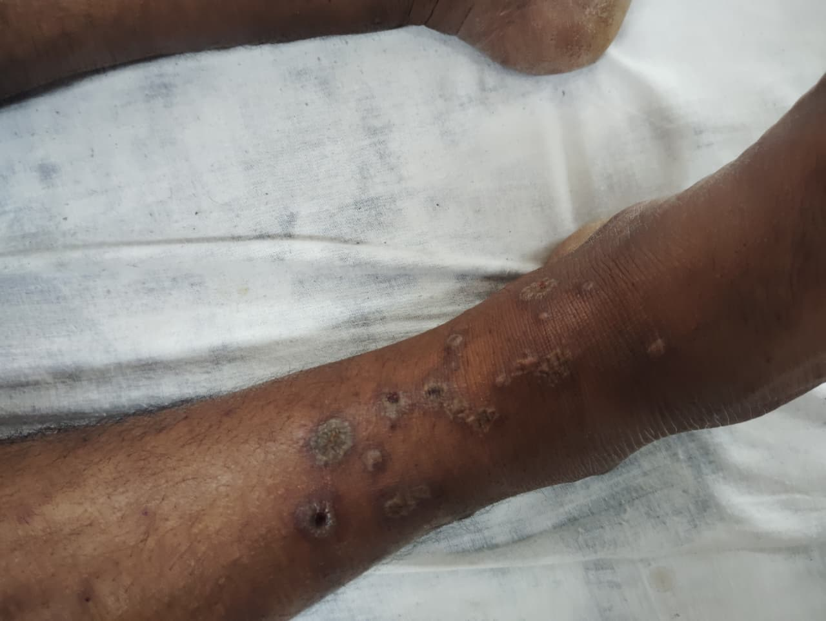
Legend 1 - Multiple palpable purpuric lesions were observed on the lower limbs, consistent with cutaneous vasculitis
A diagnosis of cutaneous hypersensitivity vasculitis associated with cefixime was determined based on clinical features and a temporal correlation with cefixime intake, which was confirmed with the Causality Assessment: Naranjo scale.
The patient discontinued cefixime one day prior to the hospital visit. Upon hospital admission, the patient was managed with Inj Dexamethasone 8 mg and Inj Pheniramine Maleate 22.75 mg (2 ml), including local wound care. However, rechallenge was not performed. Over one week, the patient showed significant resolution of symptoms with no new lesions (Figure 2).
Figure 2 - Multiple purpuric lesions improvement after treatment.
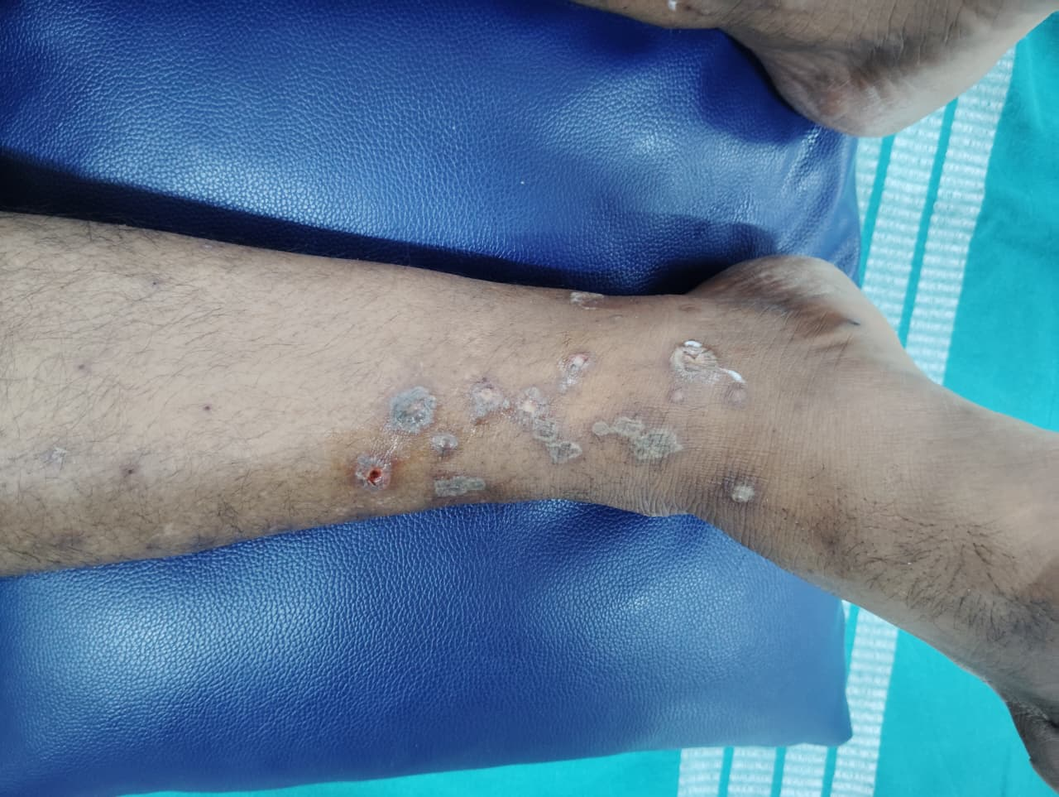
Legend 2- Multiple palpable purpuric lesions over the lower extremities demonstrating significant resolution following treatment, consistent with clinical improvement in drug-induced vasculitis.
3.DISCUSSION
Cutaneous hypersensitivity vasculitis (CHV) is a kind of small-vessel vasculitis predominantly involving the skin, which is commonly triggered by an illness or medication. An immune complex-mediated mechanism is thought to be responsible for the majority of the cases of hypersensitivity vasculitis (Type III hypersensitivity reaction) (MacLeod B et al., 2021; Imboden JB et al., 2013; Princess J. G. et al., 2024). Clinically, it manifests as palpable purpura, which is localized to the lower limbs.
However, drug-induced cutaneous hypersensitivity vasculitis contributes to a major portion of reported cases; reports of cephalosporin-induced hypersensitivity reactions remain infrequent and underreported (Kumar J et al., 2025). Cefixime inhibits bacterial cell wall synthesis, causing cell death. It is usually well-tolerated, but in some people, it can act as a hapten, forming antigenic complexes that settle in small blood vessels and cause an immune response that leads to inflammation and vasculitis (Pichler WJ et al., 2011). As of the current scenario, reports of cefixime-induced cutaneous hypersensitivity vasculitis are rare.
Symptoms appearing days to weeks after cefixime align with our patient’s timeline. Mild leukocytosis and monocytosis suggest a nonspecific inflammatory response. Normal neutrophil levels do not rule out leukocytoclastic vasculitis, which primarily affects small skin vessels.
In clinical practice, a diagnosis of cutaneous vasculitis can be made in most cases based on clinical presentation, supportive laboratory evidence, and a time-dependent link with drug exposure.
Cefixime has been identified as the causative agent in this case by the strong temporal correlation between cefixime consumption and symptom onset, the lack of other alternative causes, and a Naranjo adverse drug reactions probability scale score, which indicates a probable drug reaction (TABLE 2). This diagnosis is further strengthened by the patient's significant clinical improvement after withdrawal of cefixime and starting systemic corticosteroids.
TABLE 2: Naranjo Adverse Drug Reaction Probability Scale
Naranjo Adverse Drug Reaction Probability Scale

Question | Yes | No | Do Not Know | Score
1. Are there previous conclusive reports on this reaction? | +1 | 0 | 0 | 0
2. Did the adverse event appear after the suspected drug was administered? | +2 | ‐1 | 0 | +2
3. Did the adverse reaction improve when the drug was discontinued or a specific antagonist was administered? | +1 | 0 | 0 | +1
4. Did the adverse event reappear when the drug was re‐administered? | +2 | ‐1 | 0 | 0
5. Are there alternative causes (other than the drug) that could on their own have caused the reaction? | ‐1 | +2 | 0 | +2
6. Did the reaction reappear when a placebo was given? | ‐1 | +1 | 0 | 0
7. Was the drug detected in blood (or other fluids) in concentrations known to be toxic? | +1 | 0 | 0 | 0
8. Was the reaction more severe when the dose was increased or less severe when the dose was decreased? | +1 | 0 | 0 | 0
9. Did the patient have a similar reaction to the same or similar drugs in any previous exposure? | +1 | 0 | 0 | 0
10. Was the adverse event confirmed by any objective evidence? | +1 | 0 | 0 | +1
TOTAL SCORE: |  |  |  | 6
Legend 2: Score ≥9 = Definite drug reaction, 5–8 = Probable drug reaction, 1–4 = Possible drug reaction, and ≤0 = Doubtful drug reaction. Modified from: Naranjo CA et al. A method for estimating the probability of adverse drug reactions. Clin Pharmacol Ther 1981; 30: 239­245.
This case contributes to the limited but growing evidence showing cephalosporin-induced CHV, particularly caused by cefixime. Early recognition and withdrawal of the offending drug are critical to prevent progression and complications. As demonstrated by this patient's favorable outcome, supportive treatment and corticosteroids are usually prescribed in these situations.
4.CONCLUSION
Cutaneous Hypersensitivity Vasculitis is a rare but important adverse reaction to cephalosporins like cefixime. Early recognition, withdrawal of the offending drug, and corticosteroid treatment can lead to rapid clinical improvement and prevent complications. Pharmacovigilance and clinical judgment are necessary in such situations. Awareness of such drug reactions is essential for early diagnosis and effective patient care.
DISCLAIMER (ARTIFICIAL INTELLIGENCE): Authors hereby declare that any use of AI assistance was limited to language editing and authors retain full responsibility for the accuracy and integrity of the manuscript.
CONSENT: All authors declare that ‘written informed consent was obtained from the patient for publication of this case report and accompanying images. A copy of the written consent is available for review by the Editorial office/Chief Editor/Editorial Board members of this journal.
ETHICAL APPROVAL: not applicable.
REFERENCES
- Alpsoy, E. (2022). Cutaneous vasculitis; An algorithmic approach to diagnosis. Front Med (Lausanne). https://doi.org/10.3389/fmed.2022.1012554.
- Tang, W., & Tan, J. (2022). Cephalexin-Induced Leukocytoclastic Vasculitis. Cureus, 14(7), e26545. https://doi.org/10.7759/cureus.26545.
- Almasoudi, A. A., Bablghaith, E. S., Alaauldeen, S. I., Falemban, A. M., Sherbeeni, A. A., & Bulkhi, A. A. (2022). Ceftriaxone-induced leukocytoclastic vasculitis: a case report and literature review of antibiotic-induced leukocytoclastic vasculitis. Journal of International Medical Research, 50(5). https://doi.org/10.1177/03000605221097768
- Kumar, J., & Prakash, M. (2025). Hydrochlorothiazide induced cutaneous vasculitis – a case report. South Eastern European Journal of Public Health. https://doi.org/10.70135/seejph.vi.5426
- MacLeod, B., & Koponen, M. (2021). Educational Case: Hypersensitivity Vasculitis. Academic Pathology. https://doi.org/10.1177/23742895211030650
- Stone, J. H. (2013). Hypersensitivity vasculitis. In J. B. Imboden, D. B. Hellmann, & J. H. Stone (Eds.), CURRENT Diagnosis & Treatment: Rheumatology (3rd ed., Chapter 37). McGraw-Hill. https://accessmedicine.mhmedical.com/content.aspx?bookid=506&sectionid=42584923
- Princess, J. G., Bhushan, A., & Naikwad, H. M. (2024). AMIKACIN- INDUCED CUTANEOUS SMALL VESSEL VASCULITIS. World Journal of Pharmaceutical Research, 13(12). https://doi.org/10.20959/wjpr202412-33122
- Pichler, W. J., Naisbitt, D. J., & Park, B. K. (2011). Immune pathomechanism of drug hypersensitivity reactions. Journal of Allergy and Clinical Immunology, 127(3 Suppl), S74–S81. https://doi.org/10.1016/j.jaci.2010.11.048
ABBREVIATIONS:
CHV - Cutaneous hypersensitivity vasculitis
WBC- White blood cells
ESR- Erythrocyte sedimentation rate
CRP- C- reactive protein
TSH- Thyroid stimulating hormone
HDL- High density lipoproteins
LDL- Low density lipoproteins

