Original Research Article
Clinician Perspectives and Treatment Preferences for Calamine-Based Combination Formulations in Dermatological Practice

.
ABSTRACT

Objective: To evaluate dermatologists’ perspectives and treatment preferences on the use of calamine lotion and its combination in the management of various dermatological conditions commonly encountered in clinical practice in India.
Methodology: The cross-sectional study was conducted among 513 dermatology experts practicing in India, and a 23-item multiple-response questionnaire was used to capture expert insights and clinical experiences regarding the use of calamine lotion and its combinations with aloe vera and liquid paraffin across different dermatological conditions, including urticaria, eczema, and other pruritic disorders. Data visualization, including pie and bar charts, was performed using Microsoft Excel 2013.
Results: Majority of clinicians (90.06%) preferred calamine as the topical agent of choice for urticaria, while 75% rarely used it as monotherapy for itchy skin. More than half of the respondents (51.46%) preferred aloe vera as a combination ingredient, and about 38% favored light liquid paraffin. Around 35% used the aloe vera-calamine combination in 26 to 50% of patients with pruritus, with almost 57% reporting extreme satisfaction with the aloe vera-calamine-liquid paraffin formulation. The combination was used by approximately 33% of clinicians in 31 to 40% of patients with miliaria and by 69% in fewer than 10% of patients with post-acne hyperpigmentation. Nearly 34% found it effective in 11–25% of diaper dermatitis cases, while 42% reported using it in fewer than 10% of patients with hand-foot-mouth disease.
Conclusion: The survey highlights that calamine remains the preferred topical agent for urticaria among Indian dermatologists, although some studies favor its use in combination rather than as monotherapy. The aloe vera-calamine-liquid paraffin combination demonstrated better perceived efficacy, condition-specific use, being more common in inflammatory conditions such as miliaria and less frequent in disorders requiring targeted therapy, such as post-acne hyperpigmentation.

Keywords: Calamine, Aloe vera, liquid paraffin, Dermatology, Pruritus

1. INTRODUCTION

Skin and subcutaneous diseases contribute substantially to global morbidity, affecting an estimated 1.8 billion individuals at any given time.^{1,2} Globally, urticaria affects up to 20% of individuals at least once in their lifetime. Females and younger individuals are disproportionately affected, and current projections suggest that its prevalence will continue to rise through 2046.³ Acne remains one of the most prevalent dermatological disorders, affecting nearly 9.4% of the global population.^{4,5} These conditions can profoundly impact patients’ overall well-being, mental health, daily functioning, and social interactions.⁶
In India, the prevalence of skin diseases such as psoriasis, urticaria, scabies, and fungal or viral infections is increasing. The rising burden of skin and subcutaneous diseases, with minimal improvement in age-standardized disability rates, is concerning, especially as many are preventable and treatable. Dermatitis and urticaria remain major contributors to this burden. According to the Global Burden of Disease (GBD) Study, skin and subcutaneous diseases accounted for 4.02% of the total years lived with disability (YLDs) in 2017. Between 1990 and 2017, there was a 53.7% increase in age-standardized YLDs attributed to these conditions, underscoring their growing public health impact in India.¹
Calamine lotion is a topical skin lotion commonly used in primary care and household settings. It typically contains calamine (a mixture of zinc oxide or carbonate and ferric oxide), zinc oxide, bentonite, glycerin, sodium citrate, and liquefied phenol. It is widely used in dermatology for its soothing properties and is a preferred topical preparation for children, including infants. Calamine lotion is also considered well-tolerated for use during pregnancy and lactation.⁷ However, contemporary dermatological practice has evolved toward combination formulations that leverage synergistic mechanisms to address the multifactorial pathophysiology of pruritus, including inflammation, barrier dysfunction, and xerosis. The incorporation of adjunctive ingredients such as aloe vera, known for its anti-inflammatory and wound-healing properties, and liquid paraffin, an effective occlusive emollient, enhances therapeutic efficacy and patient comfort.⁸⁻¹³

Despite the widespread use of these combination formulations in clinical practice, systematic data on clinician perspectives and treatment preferences with such preparations remain limited. This study aimed to assess dermatologists' preferences and perspectives regarding the use of calamine lotion and its combination, particularly with aloe vera and liquid paraffin, across various dermatological conditions in clinical practice in Indian settings.

2. materialS and methods

Study Settings
A cross-sectional study was carried out among dermatologists involved in the management of a wide range of dermatological conditions in the major Indian cities from June 2024 to December 2024. The study was conducted after getting approval from Bangalore Ethics, an Independent Ethics Committee, which was recognized by the Indian Regulatory Authority, the Drug Controller General of India.
Study Participants
An invitation was sent to leading dermatologists in managing a wide range of dermatological conditions in the month of March 2024 for participation in this Indian survey. About 513 clinicians from major cities of all Indian states, representing the geographical distribution, shared their willingness to participate and provide necessary data.
Study Procedure
The questionnaire booklet titled ELITE study was sent to the clinicians who were interested in participating in the survey. The study questionnaire comprised 23 questions that gathered expert perspectives, clinical experiences related to the use of calamine lotion and aloe vera combinations in dermatology practice, with particular focus on pediatric dermatological conditions, including urticaria, eczema, and other pruritic disorders. Reliability, as determined by a split-half test (coefficient alpha), was adequate but should be improved in future versions of the questionnaire. A study of criterion validity was undertaken to test the questionnaire and to develop methods of testing the validity of measures of Physicians' Perspectives. However, the extraneous variables in this include the clinician's experience, usage of the newer drugs, etc. The two criteria used were the doctors' perspectives from the clinical practice and the assessment of an external assessor and statistician. Clinicians had the option to skip questions as desired and were instructed to complete the survey independently, without peer consultation. Before participating in the survey, all respondents provided written informed consent.
Statistical analysis
The data were analyzed using descriptive statistics. Categorical variables were presented as percentages to provide a clear understanding of their distribution. The frequency of occurrence and the corresponding percentage were used to represent the distribution of each variable. To visualize the distribution of the categorical variables, pie and bar charts were created using Microsoft Excel 2013 (version 2409, build 16.0.18025.20030).

3. results

The survey included 513 participants. Most clinicians managed 6–10 pediatric urticaria cases per month in their clinical practice. Approximately 44% of respondents most frequently diagnosed both acute and chronic urticaria in children. A large proportion (90.06%) preferred calamine as the topical agent for urticaria (Table 1). Around 82% commonly used calamine lotion for urticaria, and about 62% specifically used it for pediatric urticaria. Nearly 75% reported rarely using calamine lotion as monotherapy for itchy skin (Fig. 1).
Table 1: Distribution of responses to preferred topical agents for urticaria in clinical practice

Topical agent | Response rate (n = 513)
Calamine | 462 (90.06%)
Crotamiton lotion | 12 (2.34%)
Menthol with aqueous cream | 32 (6.24%)
Pramoxine | 4 (0.78%)
Calamine and zinc oxide lotion/ coconut oil | 1 (0.19%)
Ceramide-based moisturizer creams | 1 (0.19%)
Aloe vera-calamine-liquid paraffin formulation | 1 (0.19%)

Fig. 1: Distribution of response to the use of calamine lotion as monotherapy for itchy skin in clinical practice
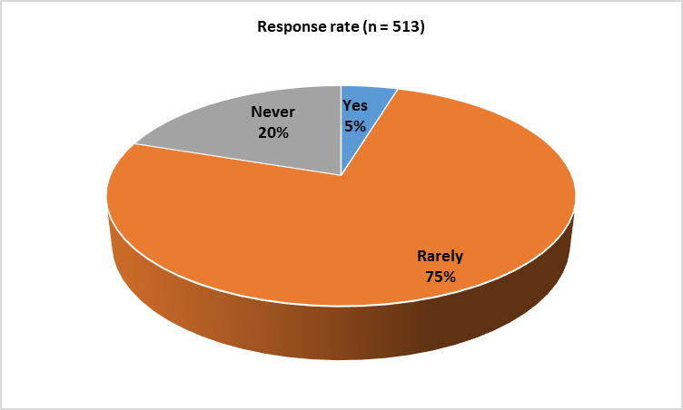

Nearly half of the clinicians (51.46%) preferred aloe vera as the combination ingredient in calamine lotion, whereas around 38% preferred light liquid paraffin in their clinical practice (Fig. 2). The majority (70.57%) occasionally used calamine lotion as an adjunctive therapy with topical steroids for infantile eczema. Approximately 40% of experts preferred topical antibiotics for the management of infantile acne. About 46% recommended calamine lotion for 21–30% of pediatric patients with urticaria. Nearly 50% preferred oral antihistamines for 10–14 days in cases of acute urticaria.

Fig. 2: Distribution of response to preferred ingredients in combination with calamine lotion in clinical practice

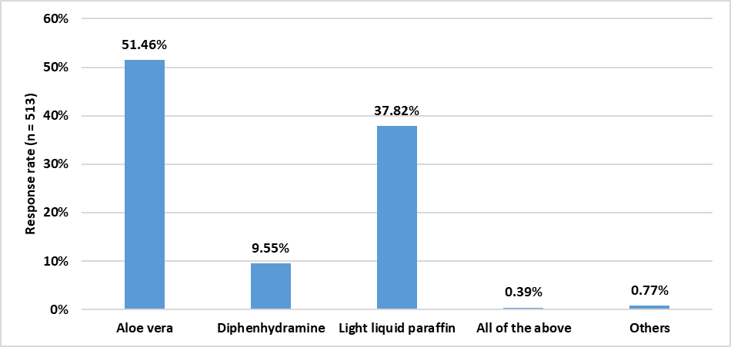

According to 47% of survey participants, levocetirizine, along with topical calamine, was preferred for the treatment of acute urticaria in their clinical practice. Around 35% of clinicians used calamine in combination with ceramides only occasionally in the management of atopic eczema. Approximately 39% preferred using calamine lotion on a need-based approach as adjunct therapy in herpes zoster. The majority of clinicians (86.55%) observed dryness as the most common side effect associated with calamine lotion. Nearly 42% of experts preferred calamine lotion as monotherapy in less than 10% of patients with insect bites, while 31% used it for post-scabetic itch in less than 10% of patients.
Around 35% of clinicians preferred the combination of aloe vera and calamine in 26–50% of patients with pruritus (Fig. 3). More than half (54.97%) were extremely satisfied with the use of aloe vera, calamine, and liquid paraffin lotion in managing pruritus (Table 2). Approximately 33% used the aloe vera–calamine–liquid paraffin combination in 31–40% of patients with miliaria, whereas the majority (68.42%) used it in less than 10% of patients with post-acne hyperpigmentation (Table 3). Nearly 34% of participants reported this combination lotion to be effective in 11–25% of patients with diaper dermatitis, while around 42% used it in less than 10% of patients with hand, foot, and mouth disease (HFMD) (Table 4).
Fig. 3: Distribution of response to proportion of patients for whom a combination of aloe vera and calamine was preferred in the management of pruritus
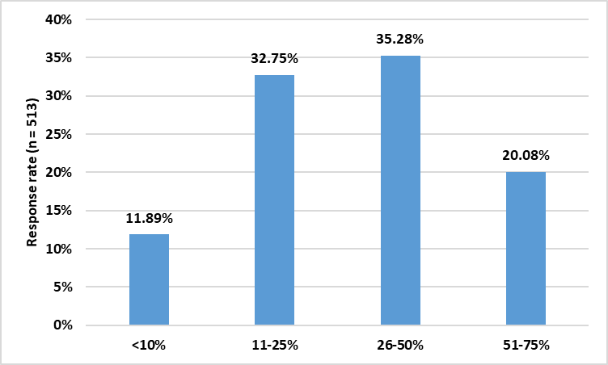

Table 2: Distribution of responses to clinicians’ opinions on the use of aloe vera, calamine, and liquid paraffin lotion in pruritus

Opinion | Response rate (n = 513)
Extremely satisfied | 282 (54.97%)
Moderately satisfied | 170 (33.14%)
Slightly satisfied | 47 (9.16%)
Neither satisfied nor dissatisfied | 5 (0.97%)
Slightly dissatisfied | 1 (0.19%)
Moderately dissatisfied | 5 (0.97%)
Extremely dissatisfied | 1 (0.19%)
Do not use this combination | 2 (0.39%)

Table 3: Distribution of responses to proportion of patients for whom a combination of aloe vera, calamine, and liquid paraffin was used in miliaria and post-acne hyperpigmentation

Proportion of patients | Response rate (n = 513)
Proportion of patients | Miliaria | Post-acne hyperpigmentation
<10% | 75 (14.62%) | 351 (68.42%)
11-20% | 122 (23.78%) | 97 (18.91%)
21-30% | 149 (29.04%) | 47 (9.16%)
31-40% | 167 (32.55%) | 18 (3.51%)

Table 4: Distribution of responses to proportion of patients for whom a combination of aloe vera, calamine, and liquid paraffin was used or found effective in diaper dermatitis and hand-foot mouth disease

Proportion of patients | Response rate (n = 513)
Proportion of patients | Diaper dermatitis | Hand-foot-mouth disease
<10% | 171 (33.33%) | 214 (41.72%)
11-25% | 173 (33.72%) | 140 (27.29%)
26-50% | 135 (26.32%) | 96 (18.71%)
51-75% | 34 (6.63%) | 63 (12.28%)

4. discussion

This survey reveals several important insights into clinicians’ preferences regarding the use of calamine and its combinations in dermatology practice. The preference for calamine as the topical agent of choice for urticaria among the majority of survey participants (90.06%) underscores its enduring relevance in clinical management. Topical lotions containing calamine serve as soothing agents and can help relieve discomfort in the management of chronic urticaria.¹⁴ In a prospective study by Kar and Chari involving patients with chronic idiopathic urticaria, calamine lotion was used as a topical adjunct to oral antihistamines, resulting in a gradual improvement in both pruritus and skin lesions. These findings collectively highlight calamine’s continued utility as a soothing and antipruritic agent, particularly when used in conjunction with systemic therapy.¹⁵

The finding that three-quarters of clinicians (75.44%) rarely use calamine as monotherapy highlights a pragmatic approach to pruritus management. Similarly, the observation that most clinicians prefer aloe vera–calamine combination for 26–50% of patients with pruritus indicates a clear preference for combination therapy over monotherapy. The tendency to combine calamine with adjunctive ingredients such as aloe vera and light liquid paraffin reflects an evolving approach in enhancing both therapeutic efficacy and patient comfort. Mixed pruritus often involves multiple underlying mechanisms, including inflammation, barrier disruption, and immune dysfunction, as seen in atopic dermatitis. Accordingly, clinicians appear to prefer combination formulations that target these diverse pathophysiological pathways. This measured approach likely reflects consideration of individual patient factors, underlying etiology, symptom severity, and concurrent treatments.^{16,17}

The high satisfaction rate (54.97% extremely satisfied) with the triple-combination formulation of aloe vera–calamine–liquid paraffin lotion observed in this survey supports its therapeutic utility and favorable clinical outcomes in dermatology practice. Calamine exerts its soothing and antipruritic effects through the evaporation of its aqueous component, which draws heat from the skin and provides a cooling sensation. The finely powdered ingredients enhance evaporation and drying, making it particularly useful for moist or oozing lesions. Its smooth texture and excellent spreadability facilitate uniform application over large surface areas, while its limited permeability to exudates provides an added advantage in managing certain inflammatory dermatoses.⁷

Aloe vera contributes anti-inflammatory, moisturizing, and wound-healing effects, helping maintain skin integrity and hydration. It has demonstrated clinical benefits in several dermatologic conditions, including psoriasis, seborrheic dermatitis, xerosis, lichen planus, genital herpes, and burns. ^{8,9,13} Liquid paraffin, a highly effective occlusive emollient, supports barrier restoration and protects against irritants. Although it has minimal effect on transepidermal water loss, its barrier-preserving properties are clinically valuable.^{11,12} In a 12-week study by Waked et al., paraffin bath therapy significantly reduced eczema severity and improved quality of life in patients with chronic hand eczema.¹⁸ The combined use of aloe vera, calamine, and liquid paraffin represents an evidence-based approach that integrates soothing, anti-inflammatory, and barrier-restorative effects, making it a valuable option for managing pruritic and inflammatory skin conditions.

The condition-specific utilization of the triple-combination formulation highlights distinct preference behaviors among dermatologists practicing in Indian settings. For miliaria, a condition caused by sweat gland obstruction commonly arising in heat and humidity, the substantial use by the majority of clinicians in 31–40% of patients supports the formulation's appropriateness. The topical agents’ cooling, anti-pruritic, and barrier-protective properties address the cardinal features of miliaria, such as pruritus and inflammation, through a multi-mechanistic approach.¹⁹

In contrast, the utilization for post-acne hyperpigmentation was markedly conservative, with the majority of clinicians (68.42%) using the formulation in fewer than 10% of such patients. This is clinically useful as post-inflammatory hyperpigmentation therapeutics focus on melanin synthesis inhibitors, such as hydroquinone and retinoids, rather than pruritus relief. Occasional application may be reserved for cases where residual inflammation causes pruritus or as adjunctive skin barrier support to minimize irritation from depigmenting agents.²⁰⁻²²

For diaper dermatitis, reported in almost every infant during early months, the bimodal utilization pattern, with approximately one-third of clinicians using it in 11–25% of patients, indicates the complex etiology involving friction, moisture, and exposure to irritants and fecal enzymes. The condition commonly leads to erythema and skin barrier impairment. Appropriate diaper dermatitis care involves frequent diaper changes, gentle cleansing, and the use of barrier creams that soothe inflammation and protect against irritants.²³ Thus, the triple-combination's emollient and anti-inflammatory properties justify its preference in uncomplicated cases.

The application of the combination formulation in HFMD was notably limited, with 42% of clinicians reporting its use in fewer than 10% of patients. This conservative use aligns with the self-limiting nature of the viral exanthem, as its mild symptoms typically resolve without specific intervention.²⁴⁻²⁶ In some cases of HFMD, calamine lotion is applied topically to papular lesions for symptomatic relief.²⁷⁻²⁹

The key strength of this study lies in the use of a carefully designed and validated questionnaire to collect expert perspectives regarding calamine and its combination, addressing the limited data available from routine clinical practice. The findings demonstrate high clinician satisfaction with triple-combination formulations and reveal condition-specific utilization that reflects judicious clinical reasoning. Several limitations of this survey warrant consideration. As a survey-based study, the findings are susceptible to recall bias. Additionally, the sample may not represent all dermatology practice settings, which could limit the generalizability of the results. Future prospective, controlled studies incorporating patient-centered outcomes are needed to establish evidence-based guidelines for the management of pruritus using combination topical formulations.
4. Conclusion

This study shows that calamine remains the preferred topical agent for urticaria among dermatologists in India, although it is predominantly used in combination rather than as monotherapy. The triple combination of aloe vera, calamine, and liquid paraffin demonstrated better perceived efficacy, condition-specific use, being more common in inflammatory conditions such as miliaria and less frequent in disorders requiring targeted therapy, such as post-acne hyperpigmentation. The findings highlight the role of synergistic combination topical agents as valuable therapeutic options in the dermatologist’s armamentarium, particularly for managing pediatric pruritic dermatoses.

COMPETING INTERESTS DISCLAIMER:
Authors have declared that they have no known competing financial interests OR non-financial interests OR personal relationships that could have appeared to influence the work reported in this paper.

References

- Kavita A, Thakur JS, Narang T. The burden of skin diseases in India: Global Burden of Disease Study 2017. Indian J Dermatol Venereol Leprol. 2023;89(3):421–5.
- WHO’s first global meeting on skin NTDs calls for greater efforts to address their burden [Internet]. Available from: https://www.who.int/news/item/31-03-2023-who-first-global-meeting-on-skin-ntds-calls-for-greater-efforts-to-address-their-burden [cited on Oct 31, 2025]
- Tan S, Chen Z, Lin T. Global, regional, and National burden of urticaria (1990–2021), its potential risk factors, and projections to 2046. BMC Public Health. 2025;25:2709.
- Qin S, Lu S, Ni X. The global, regional, and national burdens of urticaria in 204 countries and territories from 1990 to 2021: An observational epidemiological study based on the Global Burden of Disease Study 2021. Medicine (Baltimore). 2025;104(38):e44538.
- Tan JKL, Bhate K. A global perspective on the epidemiology of acne. Br J Dermatol. 2015;172 (Suppl_1):3–12.
- Seth D, Cheldize K, Brown D, Freeman EF. Global Burden of Skin Disease: Inequities and Innovations. Curr Dermatol Rep. 2017;6(3):204–10.
- Joy N. Calamine lotion. J Skin Sex Transm Dis. 2022;4(1):83–6.
- Surjushe A, Vasani R, Saple DG. Aloe vera: a short review. Indian J Dermatol. 2008;53(4):163–6.
- Feily A, Namazi MR. Aloe vera in dermatology: a brief review. G Ital Dermatol Venereol. 2009;144(1):85–91.
- Hekmatpou D, Mehrabi F, Rahzani K, Aminiyan A. The Effect of Aloe Vera Clinical Trials on Prevention and Healing of Skin Wound: A Systematic Review. Iran J Med Sci. 2019 Jan;44(1):1–9.
- Balaskas E, Szepietowski JC, Bessis D, Ioannides D, Ponticelli C, Ghienne C, et al. Randomized, Double-blind Study with Glycerol and Paraffin in Uremic Xerosis. Clin J Am Soc Nephrol. 2011;6(4):748–52.
- Fluhr JW, Muguet V, Christen-Zaech S. Restoring Skin Hydration and Barrier Function: Mechanistic Insights Into Basic Emollients for Xerosis Cutis. Int J Dermatol. 2025;64(S1):5–12.
- Long V. Aloe Vera in Dermatology—The Plant of Immortality. JAMA Dermatol. 2016;152(12):1364.
- Godse KV. Chronic urticaria and treatment options. Indian J Dermatol. 2009;54(4):310–2.
- Kar P, Chari K. A study on treatment of chronic idiopathic urticaria with cetirizine. Med J Armed Forces India. 1998;54(1):6–8.
- Rerknimitr P, Otsuka A, Nakashima C, Kabashima K. The etiopathogenesis of atopic dermatitis: barrier disruption, immunological derangement, and pruritus. Inflamm Regen. 2017;37:14.
- Kim J, Kim BE, Leung DYM. Pathophysiology of atopic dermatitis: Clinical implications. Allergy Asthma Proc. 2019;40(2):84–92.
- Waked IS, Ibrahim ZM. Beneficial Effects of Paraffin Bath Therapy as Additional Treatment of Chronic Hand Eczema: A Randomized, Single-Blind, Active-Controlled, Parallel-Group Study. J Altern Complement Med. 2020;26(12):1144–50.
- Guerra KC, Toncar A, Krishnamurthy K. Miliaria. In: StatPearls [Internet]. Treasure Island (FL): StatPearls Publishing; 2025. Available from: http://www.ncbi.nlm.nih.gov/books/NBK537176/ [cited on Oct 31, 2025]
- Lawrence E, Syed HA, Al Aboud KM. Postinflammatory Hyperpigmentation. In: StatPearls [Internet]. Treasure Island (FL): StatPearls Publishing; 2025. Available from: http://www.ncbi.nlm.nih.gov/books/NBK559150/ [cited on Oct 31, 2025]
- Moolla S, Miller-Monthrope Y. Dermatology: how to manage facial hyperpigmentation in skin of colour. Drugs Context. 2022;11:2021-11–2.
- Song JY, Kang HA, Kim MY, Park YM, Kim HO. Damage and recovery of skin barrier function after glycolic acid chemical peeling and crystal microdermabrasion. Dermatol Surg. 2004;30(3):390–4.
- Benitez Ojeda AB, Mendez MD. Diaper Dermatitis. In: StatPearls [Internet]. Treasure Island (FL): StatPearls Publishing; 2025. Available from: http://www.ncbi.nlm.nih.gov/books/NBK559067/ [cited on Oct 31, 2025]
- Guerra AM, Orille E, Waseem M. Hand, Foot, and Mouth Disease. [Updated 2023 Mar 4]. In: StatPearls [Internet]. Treasure Island (FL): StatPearls Publishing; 2025 Jan-. Available from: https://www.ncbi.nlm.nih.gov/books/NBK431082/ [cited on Oct 31, 2025]
- Sharma A, Mahajan VK, Mehta KS, Chauhan PS, Manvi S, Chauhan A. Hand, Foot and Mouth Disease: A Single Centre Retrospective Study of 403 New Cases and Brief Review of Relevant Indian Literature to Understand Clinical, Epidemiological, and Virological Attributes of a Long-Lasting Indian Epidemic. Indian Dermatology Online Journal. 2022;13(3):310-320.
- Zhu P, Ji W, Li D, Li Z, Chen Y, Dai B, et al. Current status of hand-foot-and-mouth disease. J Biomed Sci.2023;30:15.
- Kashyap RR, Kashyap RS. Hand, foot and mouth disease - a short case report. J Clin Exp Dent. 2015;7(2):e336–8.
- Faridi MMA, Kapoor S, Snigdha, Bhatnagar S. Managing hand-foot-mouth disease in children: More of counseling, less of medicines. J Family Med Prim Care. 2024;13(9):4090–3.
- Hema Nandhini H, Rajamurugan R, Jasmiya Claives R, Sasikumar P. Hand Foot and Mouth Disease – A Case Study and Patient Counselling. Int J Med Res Health Sci. 2025;14(2):1–6.

