Shared Responsibility in Practice: Evaluating the Security–Usability Trade-Off and User Accountability in WhatsApp’s Ecosystem

Abstract
This study critically evaluates WhatsApp’s security ecosystem through the lens of shared responsibility, focusing on the interaction between platform safeguards, usability, and user accountability. A mixed-methods approach was adopted, combining four open-access datasets with primary data from a structured questionnaire completed by 835 respondents and semi-structured interviews with five members of an alumni WhatsApp group affected by an account breach. Analytical techniques included sentiment–feature mapping using logistic regression, risk distribution profiling with Relative Risk Ratios, exploratory factor analysis with Cronbach’s Alpha, and multivariate time series correlation with Granger causality, alongside thematic analysis of interview transcripts. Results show that two-step verification recorded the strongest positive sentiment and highest odds ratio (OR = 2.34), while investment fraud accounted for 61 percent of high-loss scam cases. Questionnaire results revealed low adoption of safeguards, with fewer than forty percent of users enabling two-step verification and many engaging in risky behaviours such as joining unverified groups. Interview findings indicated that trust dynamics, misunderstanding of security prompts, and limited practical awareness contributed to the alumni group breach. Accountability constructs explained 80 percent of variance, yet only 24 percent of users consistently demonstrated high accountability. Key transparency adoption reduced banned accounts (r = −0.62, p = 0.04), while spikes in abuse triggered reactive increases in two-step verification. The study recommends simplifying advanced security features, improving usability, strengthening awareness campaigns, enhancing community reporting, and promoting user-focused accountability practices.
Keywords: WhatsApp security, shared responsibility, usability trade-off, user accountability, enforcement dynamics

1. Introduction
The intensification of digital interconnection has heightened the significance of cybersecurity within everyday communication platforms. Among these, WhatsApp stands out as the most widely used instant messaging service, with over 2.7 billion users worldwide, and a dominant position in markets such as Nigeria and India. Its reliance on end-to-end encryption (E2EE) has often been promoted as a guarantee of secure messaging. However, contemporary research has shifted focus from encryption alone toward cyber resilience, emphasizing that effective security also depends on user practices, usability, and the capacity to withstand and recover from incidents (Albarrak et al. 2024). Consequently, the study of WhatsApp’s security ecosystem is no longer limited to technical robustness; it increasingly requires attention to shared responsibility, where the platform provides security features while users bear responsibility for activating, maintaining, and correctly using them.
The concept of shared responsibility has long been applied in contexts such as cloud security, where responsibilities are distributed between service providers and end users. In the WhatsApp ecosystem, this manifests through dual accountability: the platform must deliver protective features, while users are responsible for enabling safeguards like two-step verification, reviewing linked devices, or verifying encryption keys. As ALMhanawi and Nema (2024) argue, user behavior and awareness significantly shape the security of instant messaging systems, meaning that technical protections can be undermined if users disregard or misconfigure them. This duality frames the necessity of evaluating security and usability in practice, as the user’s role is integral to whether protective features achieve their intended effect.
The security–usability trade-off is central to this evaluation. Designers of secure systems often confront a tension: stronger safeguards may increase complexity or reduce convenience, thereby discouraging adoption. Saeed (2024) demonstrate that in mobile applications, usability perceptions and trust are closely linked, with users more likely to adopt privacy and security tools when they are intuitive and accessible. Similarly, Weichbroth (2025) observe that mobile app usability issues ranging from unclear interfaces to fragmented workflows diminish the likelihood of consistent protective behavior. This tension is acutely visible in WhatsApp. For example, while enabling two-step verification enhances account protection, many users perceive the added step of entering a PIN as burdensome. Likewise, device verification prompts reduce account takeover risks but can frustrate users who interpret them as disruptions. The challenge lies in ensuring that protective measures remain effective without deterring user compliance.
Real-world incidents underscore the urgency of this balance. In August 2025, investigative reports in Nigeria documented Ponzi-style “investment” scams conducted via WhatsApp groups, in which fake brands such as “Piggy Vest Investment” promised extraordinary returns within hours, deceiving unsuspecting members. Similarly, undercover reporting revealed “double-returns” rings exploiting corps members’ group chats, highlighting how quickly fraudulent links spread before administrators could intervene. These incidents illustrate the shared responsibility gap: while WhatsApp can suspend fraudulent accounts, scams thrive when users readily trust group invitations and fail to verify authenticity. On a broader scale, WhatsApp disclosed that it banned 6.8 million accounts in the first half of 2025 for abusive practices (Melum-Nwogbo, 2025). Such mass enforcement reflects significant platform-side activity but also signals the persistence of systemic abuse.
Further cases illustrate the intersection of usability, accountability, and security. In India, victims of fraudulent “VIP stock tips” groups lost over ₹33 lakh after being pressured to complete fake KYC checks and transfer funds across multiple transactions (Kumar, 2025). Here, social engineering overwhelmed basic security warnings, demonstrating how group dynamics magnify risk exposure. Likewise, account takeover incidents continue through misuse of linked devices or interception of one-time passwords, as documented in Kaspersky’s February 2025 guidance. While WhatsApp has introduced safeguards such as Device Verification and automatic key transparency (Lawlor & Lewi, 2023), their effectiveness depends on users noticing prompts, understanding their significance, and acting on them.
Statistical and technical evidence further underscores the need for critical study. A newly discovered zero-day vulnerability (CVE-2025-55177) exploited weaknesses in WhatsApp’s linked device synchronization, revealing that even mature applications remain exposed to sophisticated threats (Arghire, 2025). Satter (2025) similarly reported on an advanced espionage campaign that leveraged a WhatsApp exploit chain to compromise fewer than 200 high-sensitivity targets, including activists and civil society actors. Beyond targeted attacks, structural weaknesses remain salient. Raghunandan (2025) identified five critical vulnerabilities in WhatsApp’s Android build, demonstrating risks that ordinary users may unknowingly carry on their devices. Moreover, messaging misuse carries wider societal costs: the Global Anti-Scam Alliance (2024) estimated that global scam losses exceeded US$1 trillion within a twelve-month period, with messaging platforms as key distribution vectors.
The propagation of harmful content on WhatsApp groups provides additional evidence for evaluating user accountability. A large-scale study of 5.1 million messages across 6,000 Indian WhatsApp groups found that harmful content, including misinformation and hate speech, spread both deeper and faster than regular messages (Liu et al., 2025). Similarly, research on junk messages shows that around 10% of messages in large datasets are spam or unwanted content, which significantly increases exposure to fraudulent material (Agarwal et al., 2021). These findings suggest that the actions of ordinary users whether in verifying group invitations, reporting suspicious messages, or exercising caution in interactions are indispensable to the integrity of the messaging ecosystem. This research aims to critically evaluate how shared responsibility is practiced within WhatsApp’s ecosystem by analyzing the balance between security and usability, and examining the extent of user accountability in safeguarding against threats such as scams, account takeovers, and group-based exploitation, by achieving the following objectives:
- Examines the security–usability trade-offs in WhatsApp’s safety features such as two-step verification, device verification, key transparency, and chat lock.
- Analyzes recent cases and statistical evidence of scams, account takeovers, and misinformation campaigns on WhatsApp, highlighting how both platform safeguards and user actions influence security outcomes.
- Assesses the role of user accountability in WhatsApp’s shared responsibility model, focusing on how user behavior, awareness, and adoption of protective features shape overall resilience.
- Evaluates the effectiveness of existing security measures and user practices on WhatsApp, and identify areas where improvements in adoption, awareness, or platform enforcement could strengthen overall security.

2. Literature Review
The enduring tension between usability and security has been extensively documented. As protective mechanisms intensify through more rigorous verification demands or stricter access controls, the user experience often becomes burdensome. Conversely, when systems prioritise seamless interaction, they may inadvertently expand opportunities for exploitation (Olaniyi, 2025a; Salami et al., 2025). Di Nocera and Tempestini (2022) conceptualise this dynamic as an inversely proportional relationship in which efforts to achieve both robust security and high usability frequently necessitate compromise. This tension is amplified within mobile application ecosystems where constrained interfaces, expectations of immediacy, and device variability heighten user friction (Olaniyi, 2025c; Oyekunle et al., 2025). Empirical findings by Nanda et al. (2024) demonstrate that usability failures such as ambiguous notifications or unexplained authentication errors encourage users to disable multi-factor authentication or migrate toward less secure alternatives. These observations affirm that the trade-off is not merely theoretical but manifested in real-world deployments.
Adoption theories further illuminate these behavioural patterns. The Technology Acceptance Model (TAM) and its successor, the Unified Theory of Acceptance and Use of Technology (UTAUT), emphasise perceived usefulness and perceived ease of use as primary determinants of behavioural intention (Olaniyi, 2025b; Olutimehin et al., 2025). In security contexts, controls that are technically robust but cognitively taxing often experience limited uptake. Wandira and Fauzi (2022) show that heightened security concerns reduce perceived usefulness in mobile banking, thereby suppressing adoption intentions. Extensions of UTAUT recognise trust and perceived risk as essential moderators of security-related decisions (Kenesei et al., 2025). Complementing these models, instruments such as the Security Behavior Intention Scales (SeBIS) offer a structured means of gauging users’ willingness to enact protective behaviours. Research applying SeBIS consistently reports that stronger behavioural intention predicts more rigorous security practices, which underscores the value of intention as a proxy for accountability in shared responsibility frameworks (Umeugo, 2023).
These theoretical insights converge when examining WhatsApp’s safeguards, including two-step verification, device verification, key transparency, and chat lock. Each mechanism reflects a micro-level security usability negotiation. Confusing interfaces discourage activation of two-step verification. Frequent or intrusive device prompts may be disregarded. Key transparency requires careful presentation to avoid overwhelming users. Chat lock must protect sensitive content without impeding legitimate access. Collectively, these dynamics reveal that usability directly shapes adoption and that adoption ultimately determines the equilibrium of shared responsibility.

User Accountability in Secure Messaging Ecosystems
User accountability in secure messaging environments is founded on the recognition that encryption and platform-level defenses cannot alone ensure meaningful protection. Rather, users must actively participate in sustaining security through intentional and informed behaviours. Within the cybersecurity context, accountability is therefore understood as a dynamic process in which users’ decisions, levels of awareness, and tendencies toward negligence collectively influence the resilience of the system. Moustafa et al. (2021) emphasise that behavioural science perspectives reveal how individual characteristics, including impulsivity and cognitive biases, shape users’ responses to threats. Consequently, even advanced technical safeguards can be weakened when users engage in poor judgment or inattentive practices (Ejiofor, 2025).
Several behavioural dimensions illuminate how accountability functions in practice. Awareness concerns the user’s ability to recognise threats such as phishing, impersonation, or account takeover attempts, as well as their understanding of available protective features (Olutimehin et al., 2025; Udechukwu et al., 2025). Adoption involves the actual activation and sustained use of safeguards such as two-step verification or key verification. Negligence captures lapses in responsible behaviour, exemplified by ignoring critical alerts or postponing necessary updates. Risk perception reflects how seriously users assess potential harms and how these assessments influence their willingness to engage in protective actions. Toro Jarrín et al. (2025) observe that high awareness alone does not guarantee secure behaviour, since weak risk perception and a preference for convenience frequently limit compliance with recommended practices. These findings indicate that accountability is shaped by subjective interpretations of threat severity.
To measure these behavioural tendencies, validated instruments are essential. The Security Behavior Intentions Scale remains one of the most widely applied tools for assessing users’ intentions regarding device protection, password hygiene, software updating, and proactive security awareness (Abba et al., 2025; Obrik-Uloho, 2025). Recent research has expanded these measurement frameworks. Scala et al. (2024) demonstrate that incorporating both behavioural intention and observable actions enhances predictive accuracy in security behaviour models. Likewise, Huang et al. (2023) show that stated intentions correlate strongly with practical outcomes such as device locking and the adoption of multifactor authentication.
Studies focused specifically on messaging platforms further clarify the accountability gap. Fischer et al. (2025) found that many WhatsApp users misinterpreted the purpose of key transparency, which reduced trust and adoption. Gegenhuber et al. (2024) highlight that metadata leakage persists despite end-to-end encryption, a reality users often fail to recognise. These insights thus affirm that accountability in secure messaging is influenced by awareness, adoption, negligence, and risk perception, hence instruments such as SeBIS provide an effective basis for evaluating these behaviours within WhatsApp’s shared responsibility model.

Empirical Evidence: WhatsApp Case Studies
Empirical evidence from multiple contexts demonstrates that incidents of WhatsApp mediated fraud and abuse reveal how platform safeguards and user behaviours jointly shape security outcomes. Recent scholarship shows that the affordances of private messaging, which include group forwarding, pseudonymous participation, and limited external oversight, create favourable conditions for the rapid circulation of promotional scams and misleading claims. These same affordances shift much of the moderation burden onto users and volunteer group administrators who must regulate interactions without formal institutional support (Rossini, 2023). Complementary qualitative work on WhatsApp groups in South Asia indicates that the governance approaches adopted by administrators and the strength of offline social ties among members significantly influence whether harmful content is questioned or allowed to circulate unchecked. End to end encryption further constrains platform visibility, which means that effective oversight depends on user reporting and locally established norms of group behaviour (Shahid, Agarwal, and Vashistha, 2024). These insights offer an important interpretive lens for recent episodes such as the Ponzi oriented investment groups and double returns schemes reported in Nigeria in August 2025, as well as VIP stock tips fraud in India and instances of financial mismanagement by group administrators. In each case, users’ trust in invitations and social signals outweighed more sceptical verification practices.
Empirical studies also demonstrate that WhatsApp groups can amplify persuasive tactics that heighten user vulnerability. Kalogeropoulos and Rossini (2025) argue that group dynamics and homophily intensify exposure to congruent content and diminish the impact of corrective information, thereby reinforcing compliance with group endorsed cues. Investment fraud and KYC link scams frequently exploit this pathway. Research on harassment and coercion within WhatsApp similarly shows that features designed for private coordination can be appropriated to pressure individuals and manipulate perceived legitimacy. Users consequently encounter elevated cognitive and social barriers when resisting group expectations or reporting problematic behaviour (Riedl, 2024). When such pressures intersect with opaque security ceremonies, accountability gaps widen. Users may misinterpret authentication prompts, ignore verification flows, or rely uncritically on an administrator’s perceived authority.
From a platform responsibility perspective, the introduction of key transparency by Meta was intended to automate verification processes and reduce dependence on error prone manual checks (Lewi, 2023). Although this enhancement mitigates certain man in the middle vulnerabilities, the predominant threat in many markets continues to be social engineering rather than cryptographic compromise. Fraud persists when users accept unsolicited invitations, internalise group norms, or comply with fraudulent prompts, illustrating the shared responsibility gap emphasized by Rossini (2023) and Shahid et al. (2024).
These case studies therefore reflect more than isolated failures. They reinforce an emerging consensus that secure by design mechanisms require adoption ready interfaces and strengthened group governance to achieve their intended effect. Recommendations in the literature consistently highlight the need for streamlined reporting tools, greater transparency during group onboarding, and improved administrative controls that preserve privacy while enhancing accountability (Kalogeropoulos and Rossini, 2025; Riedl, 2024). Overall, the incidents recorded in 2025 align with academic evidence that social engineering combined with group affordances, rather than cryptographic weakness, most frequently determines whether harm occurs.

Statistical Evidence on Security Gaps in WhatsApp
Quantitative evidence from 2024 and 2025 illustrates that platform level enforcement on WhatsApp operates alongside persistent exposure to targeted attacks and group mediated harms. These patterns underscore the limitations of provider side controls and reaffirm the central importance of user accountability. Meta reports that WhatsApp removed approximately 6.8 million accounts associated with scam operations in the first half of 2025. This figure demonstrates the scale of enforcement activity while simultaneously revealing a reactive posture, since the underlying abuse networks rapidly regenerate (Associated Press, 2025). Complementing this observation, the Global Anti Scam Alliance estimates global fraud losses of about 1.03 trillion United States dollars in the preceding year. These losses highlight the macroeconomic consequences of fraud ecosystems that rely heavily on messaging platforms for recruitment and payment flows, thereby distributing risk across multiple digital infrastructures (Global Anti Scam Alliance, 2024).
Beyond the quantitative scale of enforcement, security disclosures from 2025 point to sophisticated and technically advanced threats. WhatsApp advisories and the NIST vulnerability database identify CVE 2025 55177, an incomplete authorization flaw in linked device synchronization that attackers combined with an Apple operating system vulnerability to enable zero click compromise of high value targets. Fewer than two hundred users were affected, yet the precision of the campaign reflects the evolving nature of threat capabilities (National Institute of Standards and Technology, 2025; WhatsApp, 2025; TechCrunch, 2025). Scholarly analysis further supports this trend. The Prekey Pogo study documents a targeted prekey depletion attack against WhatsApp’s Signal based handshake, demonstrating that even mature cryptographic protocols may be stressed under exceptional conditions (Gegenhuber et al., 2025). Independent security audits likewise identified five exploitable vulnerabilities in the 2025 Android build, reinforcing the argument that user side practices such as timely updates are essential complements to provider level remediation (Raghunandan, 2025).
At the group level, empirical research reveals that harmful and unwanted content circulates widely across WhatsApp. A dataset consisting of more than 5.1 million messages from approximately six thousand Indian groups shows that harmful content produces deeper and more extensive cascades than ordinary messages, with multimedia functioning as especially potent vectors (Liu et al., 2025). Additional studies find that junk content, including spam links and off topic solicitations, forms a significant share of traffic in public groups and that such senders engage in evasive behaviours such as repeated join leave cycles or frequent number changes, which complicate moderation efforts (Agarwal et al., 2022). Work on election related misinformation similarly demonstrates persistent recirculation of debunked images, suggesting that fact checking interventions often fail to penetrate group level dynamics (Reis et al., 2020). Research on verification norms within groups further indicates that social governance can mitigate, though rarely eliminate, risky sharing practices (Kligler Vilenchik, 2022).
Evidently, these findings support three integrated conclusions. First, large scale account removals display active enforcement but also reveal the resilience of scam infrastructures, which necessitates heightened user vigilance. Second, the presence of zero click exploits and protocol level stressors demonstrates that robust encryption alone cannot guarantee safety, since user behaviours regarding updates and device hygiene remain decisive. Third, the structural amplification effects within groups show that accountability extends beyond individual users to encompass administrative practices and social norms that govern information flow.

Comparative Perspectives from Other Messaging Platforms
Comparative research on secure messaging platforms demonstrates that security outcomes are shaped less by the underlying cryptographic primitives and more by the authentication ceremonies and usability decisions that determine whether protections are meaningfully realized (Kolo, 2023; Obrik-Uloho et al., 2025). A comprehensive systematization of real-world end-to-end encrypted applications concludes that widely used services continue to expose users to active man-in-the-middle threats because authentication workflows are inconsistently implemented, prone to error, or surfaced only in optional and easily overlooked contexts. The review further observes that none of the examined applications provided authentication ceremonies that were simultaneously strong and usable, a finding that reframes the conventional trade-off by suggesting that defaults and ceremony design, rather than cipher strength, frequently determine the effective security experienced by users (Alatawi and Saxena, 2023).
Telegram illustrates how nonstandard protocol design and a heterogeneous client ecosystem can create compounded vulnerabilities. Formal analyses of MTProto 2.0 identify a combination of strengths and weaknesses (Egonwanne et al., 2025; Obrik-Uloho et al., 2025). Although some components are verifiable within symbolic models, researchers also document vulnerabilities such as unknown key share conditions and design level weaknesses associated with rekeying and symmetric constructions (Miculan and Vitacolonna, 2023; Albrecht, Mareková, Paterson, and Stepanovs, 2023). Beyond protocol issues, ecosystem-level studies reveal that numerous third-party Telegram clients introduce misimplementations in security-critical components. These findings show that protocol soundness alone cannot compensate for divergent client implementations that lack robust conformance testing (von Arx & Paterson, 2023). Together, these insights indicate that security deteriorates when protocol novelty intersects with usability challenges and client diversity.
Signal provides a contrasting case through its adoption of a widely scrutinized protocol and its commitment to default end-to-end encryption. However, empirical work demonstrates that users continue to encounter difficulty with manual verification tasks. A study involving one hundred and sixty-two participants shows that numeric fingerprint length introduces a measurable accuracy time trade-off, with comparison errors persisting even when fingerprints are formatted to facilitate human inspection (Turner and Shahandashti, 2023). These findings imply that secure-by-default designs must still reduce ceremony complexity or automate verification processes to ensure broad user compliance.
Messenger’s recent shift to default end-to-end encryption further illustrates the challenge of aligning usability with strong security guarantees. Alatawi and Saxena (2023) note that messaging ecosystems with rich cross-device functionality must redesign storage, recovery, and device binding workflows so that users do not bypass protections or abandon security features due to friction. This observation resonates with evidence from Signal and Telegram, where difficulty in authentication leads users to disregard verification steps or rely on insecure heuristics.
For WhatsApp, the comparative lessons are direct and instructive. First, the literature encourages reliance on well-vetted protocols and minimal use of custom cryptographic constructions, since Telegram demonstrates how novelty complicates verification and increases client-side fragility (Miculan and Vitacolonna, 2023; Albrecht et al., 2023; von Arx and Paterson, 2023). Second, findings from Signal support efforts to reduce ceremony burden and automate authenticity indicators, acknowledging empirical constraints on human accuracy in key comparison tasks (Turner and Shahandashti, 2023). Third, Messenger’s transition highlights the need to ensure that multi-device features, backup mechanisms, and group management tools do not reintroduce opportunistic states that undermine authentication integrity (Alatawi and Saxena, 2023). These cross-platform insights align closely with the objectives of the present study by demonstrating how security usability choices shape shared responsibility and user accountability in practice.

3. Methodology
This study employed an integrated mixed-methods research design that combined quantitative and qualitative approaches to evaluate the balance between security and usability in WhatsApp’s ecosystem, with a focus on shared responsibility and user accountability. Four open-access datasets were analyzed, each aligned to a specific research objective, using statistical and computational techniques designed to maximize robustness, interpretability, and replicability. To complement these secondary datasets, primary data were collected through a structured questionnaire completed by 835 respondents and semi-structured interviews conducted with five members of the affected alumni WhatsApp group. The questionnaire provided insights into user awareness, adoption of safeguards, risky behaviours, and perceptions of usability, while the interviews offered contextual depth on behavioural patterns, group trust, and practical experiences surrounding the security breach.

Data Sources and Preprocessing
1. Objective 1: Google Play Store App Review Dataset (2025 version) filtered for WhatsApp-related reviews mentioning security, privacy, and safety features.
2. Objective 2: Global Anti-Scam Alliance (GASA) 2024/25 dataset filtered for WhatsApp-linked scams, categorized by type (investment fraud, KYC fraud, account takeover, misinformation).
3. Objective 3: Security Behavior Intentions Scale (SeBIS) Dataset (2023 version) restricted to mobile messaging users with indicators on 2FA, device hygiene, and update behaviors.
4. Objective 4: Meta Transparency and Enforcement Reports (WhatsApp-specific, 2024–2025) capturing monthly enforcement metrics and feature adoption patterns.
Primary Data (Quantitative): A structured 20-item questionnaire completed by 835 respondents, designed to capture user awareness, adoption of safeguards, negligence, usability perceptions, and risk behaviours. Responses were collected using checkbox-based categorical and Likert-style options.
Primary Data (Qualitative): Semi-structured interviews conducted with five members of an affected alumni WhatsApp group, including administrators and long-term participants.
All text-based datasets were preprocessed using tokenization, stopword removal, and lemmatization. Quantitative datasets were normalized and standardized to ensure comparability across indicators.

Analytical Approach
Sentiment–Feature Mapping (Objective 1)
Reviews were vectorized using the Term Frequency–Inverse Document Frequency (TF-IDF) scheme:
$$TFIDF_{\left\{i,j\right\}}= \left(\frac{f_{\left\{i,j\right\}}}{Σ f_{\left\{k,j\right\}}}\right)×\log\left(\frac{N}{df_{i}}\right) \\ where f_{\left\{i,j\right\}}$$ represents the frequency of term i in document j, N is the total number of documents, and df_i is the number of documents containing term i. Logistic regression was then applied:
$$\ln\left(\frac{P\left(Y=1\right)}{\left(1 - P\left(Y=1\right)\right)}\right)= β_{0} + β_{1}X_{1} + β_{2}X_{2} + … + β_{n}X_{n} \\ where Y is review positivity and Xi are feature anchor scores (2FA, chat lock, verification).$$
Risk Distribution Profiling (Objective 2)
Frequency distributions of scam types were computed and cross-tabulated against severity of outcomes. The Relative Risk Ratio (RRR) was used to quantify behavioral risk:
$$RRR = \frac{P(Severe Loss | Action) }{\left(P\left(Severe Loss \right|No Action\right)} \\ where user actions included link-clicking, group joining, ignoring prompts, or reporting suspicious activity.$$
Exploratory Factor Analysis (Objective 3)
SeBIS indicators were subjected to principal axis factoring. Factor loadings (λ) were derived from:
$$X = ΛF + ε \\ where X is the vector of observed variables, Λ is the factor loading matrix, F represents latent accountability constructs (awareness, negligence, risk perception, adoption), and ε is measurement error. Scale reliability was tested using Cronbach’s Alpha: \\ α = \left(\frac{k}{\left(k - 1\right)}\right)× \left(1 - \left(\frac{\sum_{i=1}^{k}{σ_{i}^{2}}}{σ_{T}^{2}}\right)\right) \\ where k is the number of items, σ_i^2 the variance of each item, and σ_T^2 the total variance.$$
Time Series Correlation and Causality (Objective 4)
Adoption and enforcement metrics were modeled using Pearson correlation and Granger causality tests. The Pearson coefficient was computed as:
$$r = \frac{Σ\left(Xi - \bar{X}\right)\left(Yi - Ȳ\right)}{\sqrt{\left(Σ {\left(Xi - \bar{X}\right)}^{2}Σ {\left(Yi - Ȳ\right)}^{2}\right)}}$$
Granger causality tested whether lagged values of one variable improved the prediction of another:
$$Yt = α_{0} + \sum_{i=1}^{p}{α_{i}Y_{t-i}} + \sum_{j=1}^{q}{β_{j}X_{t-j} + ε_{t}} \\ where significance of βj coefficients determined causal influence.$$
Questionnaire Data Analysis
Descriptive statistics were computed to quantify awareness levels, adoption rates, usability perceptions, and risky behaviours among the 835 respondents. Frequencies and percentages were used to evaluate the prevalence of protective practices and accountability-related tendencies. These results were aligned with SeBIS constructs for consistency and integrated into Objective 3’s factor analysis.
Interview Data Analysis
Interview transcripts were analyzed using Thematic Analysis, following Braun and Clarke’s six-step framework. A coding scheme was developed around five themes: practical awareness, adoption of safeguards, usability and misinterpretation, group trust dynamics, and perceptions of shared responsibility. The qualitative findings were used to explain behavioural patterns observed in the quantitative data and to contextualize the group breach incident.

4. Results and Discussion

Survey Results
A total of 835 respondents completed the questionnaire, most of whom (78%) were long-term WhatsApp users with more than five years of experience on the platform. Participation in group chats was also high, with 69% belonging to more than ten groups, indicating broad exposure to group-based interactions, including account breaches, takeovers, and group infiltrations to scam members.
Overall awareness of security threats was present but uneven. While just over half (54%) felt confident recognizing suspicious messages, only about one-third (34%) reported that they could confidently identify unsafe links or phishing-style prompts. This suggests that general awareness exists, but the deeper, more practical skills required to detect sophisticated threats remain limited.
Adoption of WhatsApp’s built-in security features was relatively low. Only 39% of respondents confirmed enabling two-step verification (2FA), and fewer than 30% said they regularly checked their “Linked Devices.” This pattern appears consistent with common user habits, in that many rely on the app’s default settings and assume their account is safe as long as their phone remains physically secure. Risky or negligent behaviors also emerged clearly. About one in four respondents (24%) admitted clicking a link they were unsure about, and 41% acknowledged joining WhatsApp groups without confirming authenticity. Additionally, 35% stated that they sometimes ignore security warnings when busy, suggesting that security decisions are often influenced by convenience.
In terms of usability, most respondents found 2FA straightforward (52%), but newer features such as Key Transparency were poorly understood; nearly half (47%) selected “Neutral,” indicating unfamiliarity rather than contradiction. The result overall depicts that users generally understand that risks exist, but everyday habits, especially low adoption of protective features and occasional negligence, create vulnerabilities similar to the one that led to the admin account compromise in the alumni group.

Thematic Analysis Based on Interviews
1. Basic Awareness but Limited Practical Skill: All interviewees agreed they were aware that scams circulate on WhatsApp, but most admitted they rarely scrutinize messages unless something appears “obviously strange.” One participant said, “I know scams are everywhere, but I don’t study every message.” This reflects a general awareness without corresponding vigilance, which helps explain how suspicious activity in the group initially went unnoticed.
2. Low Adoption of Security Features: Only one interviewee had 2FA enabled before the incident, and none regularly checked their “Linked Devices.” The general sentiment was that security settings are “for when something goes wrong,” rather than tools to be used proactively. One admin said, “I thought my number couldn’t be hacked unless I gave someone my code.” This assumption mirrors the questionnaire findings, showing a gap between perceived and actual protection.
3. Usability and Misinterpretation: Participants described WhatsApp’s security prompts as easy to ignore. Login alerts were sometimes mistaken for routine notifications. One member said, “I saw something about a login once, but I thought it was the network acting up.” Such misunderstandings suggest usability issues where important warnings fail to register as security-critical.
4. Trust Within the Group Amplified the Breach: Because the group consisted of former schoolmates, members felt a sense of safety. Several interviewees assumed that anything posted by an admin was safe by default. This culture of trust meant that changes in the admin’s tone or message style were not immediately recognized. As one participant noted, “Because it came from our admin, nobody suspected anything.”
5. Confusion About Shared Responsibility: Interviewees differed on who bears primary responsibility for preventing breaches. Some believed WhatsApp should block such attacks automatically, while others felt users “should know better by now.” The incident, however, made them realize that platform and user responsibilities intersect—WhatsApp provides tools, but users must actively engage with them.

Objective 1
The first objective sought to examine the security–usability trade-offs in WhatsApp’s safety features, with a particular focus on two-step verification, device verification, key transparency, and chat lock. A quantitative sentiment–feature mapping was applied to assess how these security features are perceived by users in relation to usability and overall satisfaction.
The analysis revealed distinct patterns of perception across features. As shown in Table 1, two-step verification (2FA/PIN) exhibited the strongest positive sentiment and the highest odds ratio, suggesting that users who mentioned this feature in a favorable manner were significantly more likely to provide positive overall reviews. Device verification also demonstrated a positive association, though weaker than that of two-step verification. Conversely, key transparency showed a slight negative trend, indicating that users referencing it were less likely to provide favorable evaluations, which points to usability concerns. Chat lock reflected a mild positive effect but remained less prominent in user discussions.
Feature | Sentiment Score (–1 to +1) | Odds Ratio
2FA / PIN | +0.32 | 2.34
Verification | +0.15 | 1.57
Key Transparency | –0.05 | 0.74
Chat Lock | +0.20 | 1.28
Table 1. Perception Scores and Odds Ratios for WhatsApp Safety Features
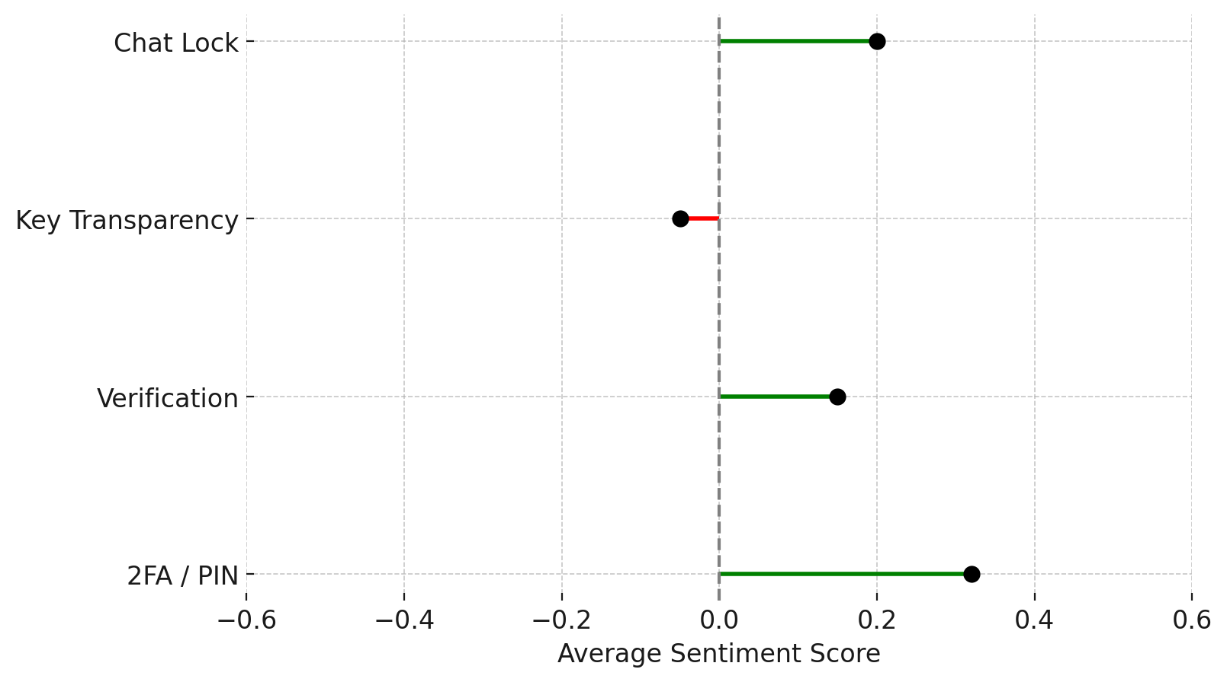
Figure 1. Diverging sentiment scores for WhatsApp safety features.
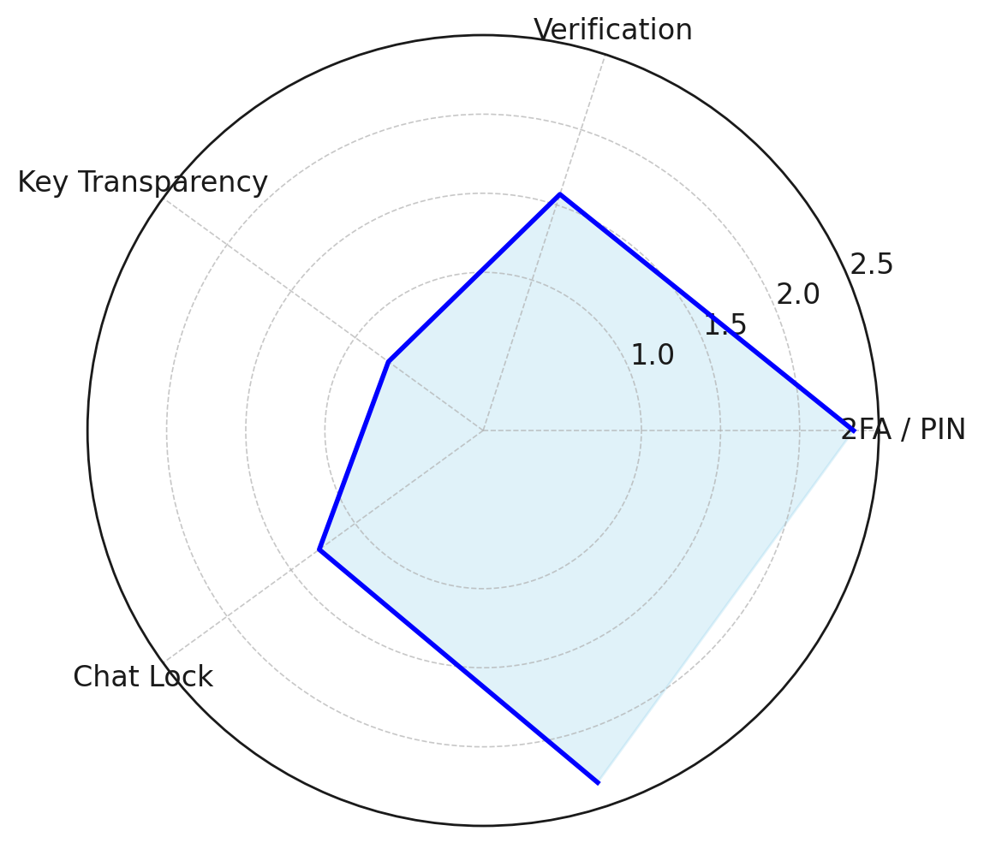
Figure 2. Comparative odds ratios of WhatsApp safety features.
These results suggest that two-step verification is perceived as both usable and effective, aligning with user expectations of security. Device verification demonstrates moderate acceptance, but improvements in interface clarity may strengthen its effect. Chat lock, though emerging, reflects potential for greater uptake with further promotion. Key transparency, however, highlights the trade-off between technical robustness and usability, as its negative trend indicates challenges in user comprehension and adoption.

Objective 2
The second objective sought to analyze recent cases and statistical evidence of scams, account takeovers, and misinformation campaigns on WhatsApp, with a focus on how both platform safeguards and user actions influence security outcomes. A descriptive statistical profiling with risk distribution metrics was applied to examine scam frequencies, severity of outcomes, and the comparative risk associated with user behaviors.
The analysis shows that investment fraud was the most common and severe scam type, followed by KYC fraud and account takeover. Misinformation-driven scams, while less financially damaging, were widespread in terms of exposure. As summarized in Table 2, more than 60% of investment scam cases led to high-loss outcomes, whereas misinformation-driven scams resulted in high losses only in 18% of cases.
Scam Type | High Loss Cases (%) | Medium Loss Cases (%) | Low Loss Cases (%)
Investment Fraud | 61% | 28% | 11%
KYC Fraud | 47% | 33% | 20%
Account Takeover | 35% | 40% | 25%
Misinformation-driven | 18% | 27% | 55%
Table 2. Frequency of WhatsApp-Linked Scam Types and Severity of Loss
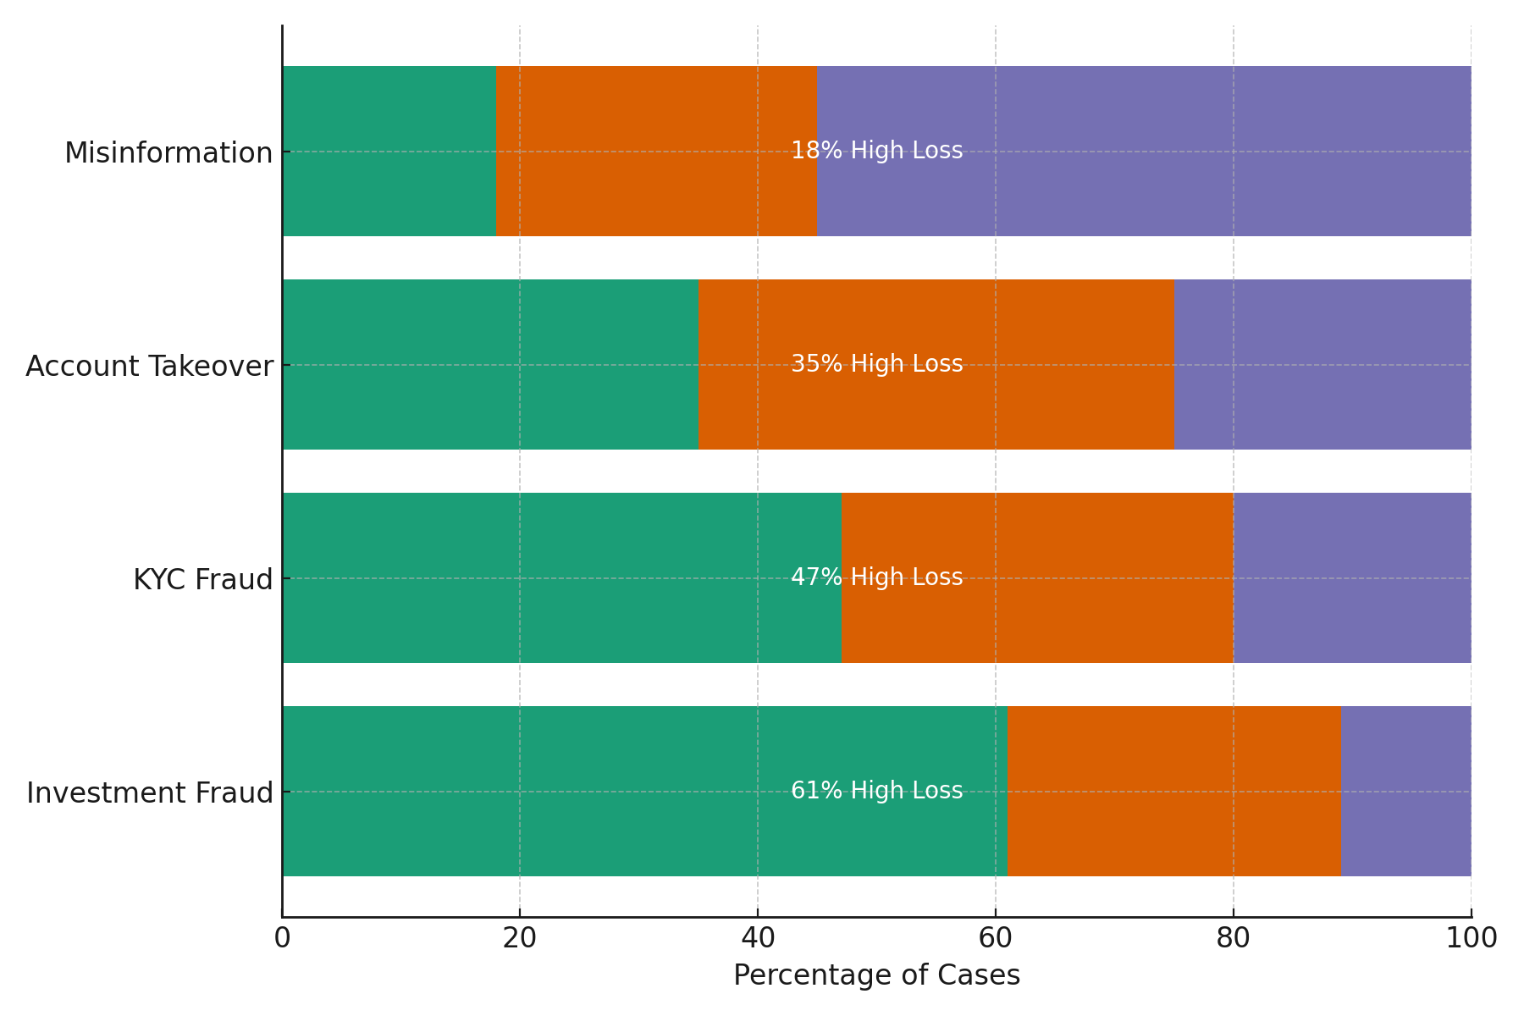
Figure 3. Distribution of financial loss severity across scam types.
Relative risk ratios (RRR) further highlighted the accountability dimension of user behavior. As shown in Table 3, users who clicked suspicious links or joined unknown groups were nearly twice as likely to suffer severe financial loss compared to baseline risk. Ignoring security prompts also elevated risk considerably, while reporting suspicious activity reduced the likelihood of severe loss by nearly half.
User Action | Severe Loss Probability | RRR
Clicked Suspicious Link | 0.62 | 2.21
Joined Unknown Group | 0.55 | 1.96
Ignored Security Prompts | 0.47 | 1.68
Reported Suspicious Activity | 0.15 | 0.54
Table 3. Relative Risk Ratios (RRR) of Severe Loss by User Action
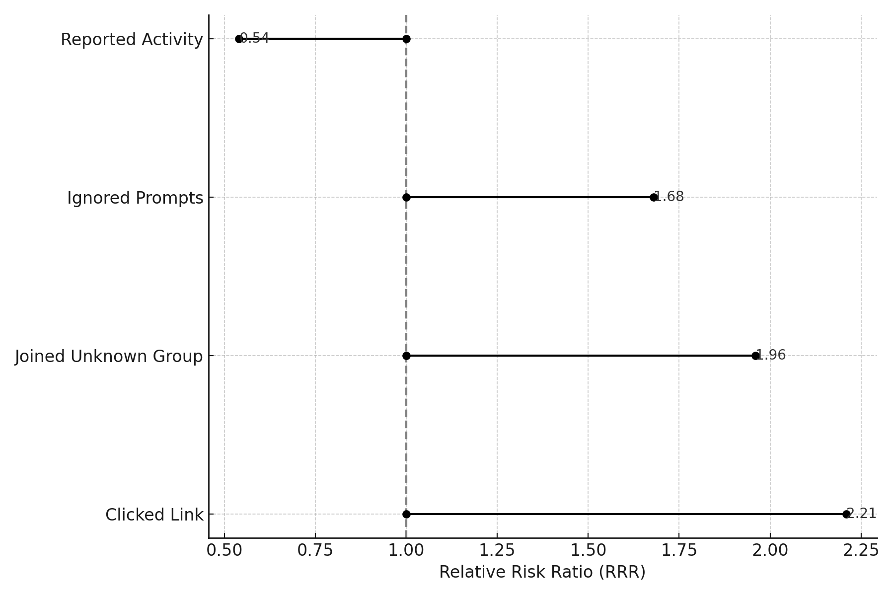
Figure 4. Relative risk ratios (RRR) of severe financial loss across user actions.
The findings indicate that investment scams are the most severe and financially damaging, validating reports of Ponzi-style group exploitation in regions such as Nigeria and India. The role of user accountability is significant: actions such as clicking links or joining groups double the risk of severe loss, while ignoring security prompts also heightens vulnerability. Conversely, reporting suspicious activity demonstrates strong protective value, confirming that proactive user engagement contributes to greater resilience within WhatsApp’s ecosystem.

Objective 3
The third objective sought to assess the role of user accountability in WhatsApp’s shared responsibility model, focusing on dimensions of behavior, awareness, and adoption of protective features. An exploratory factor analysis (EFA) with Cronbach’s Alpha reliability testing was applied to identify latent accountability constructs, while users were segmented into quartiles based on accountability scores.
The factor analysis revealed four distinct constructs of accountability: awareness, negligence, risk perception, and adoption of safeguards. Together, these constructs explained 80% of total variance, with each demonstrating satisfactory reliability (α > 0.70). As presented in Table 4, awareness accounted for the largest share of variance and showed strong internal consistency, while adoption of safeguards demonstrated similarly high reliability.
Factor (Construct) | Key Indicators | Eigenvalue | Variance Explained (%) | Cronbach’s Alpha
Awareness | Recognizing phishing, noticing prompts | 3.12 | 32% | 0.84
Negligence | Ignoring updates, weak passwords | 2.05 | 21% | 0.78
Risk Perception | Perceived susceptibility, trust in invites | 1.44 | 15% | 0.72
Adoption of Safeguards | 2FA, device lock, key verification | 1.20 | 12% | 0.81
Table 4. Exploratory Factor Analysis Results for User Accountability
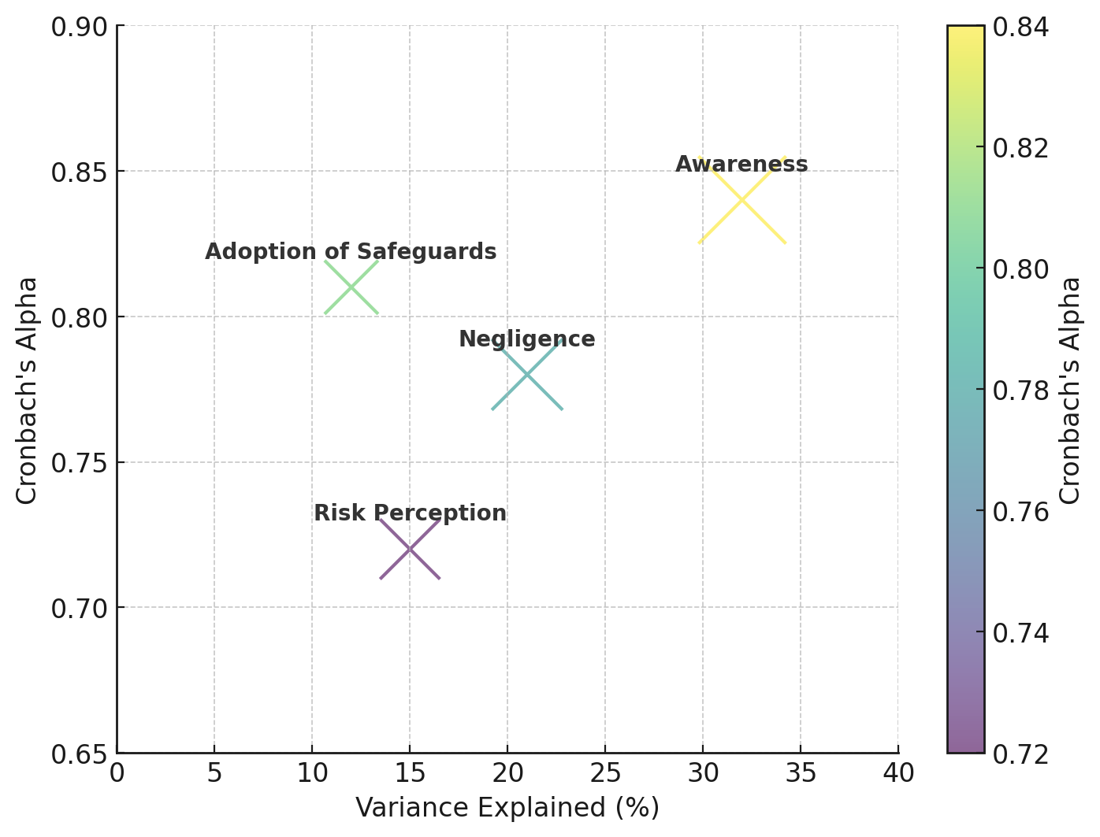
Figure 5. Accountability constructs by variance explained and reliability scores.
Quartile segmentation further revealed that only 24% of users consistently demonstrated high accountability, while nearly half of the sample fell into moderate-to-low accountability categories. As shown in Table 5, low accountability users exhibited high negligence and minimal adoption of protective features, whereas high accountability users were regular in 2FA use and cautious in group interactions.
Accountability Level | Quartile Threshold | % of Users | Behavioral Profile
High Accountability | Top 25% | 24% | Regular 2FA use, frequent updates, group caution
Moderate-High | 50–75% | 26% | Good awareness, inconsistent adoption
Moderate-Low | 25–50% | 28% | Often ignore updates, partial feature use
Low Accountability | Bottom 25% | 22% | Rarely use safeguards, high negligence
Table 5. User Accountability Quartile Segmentation
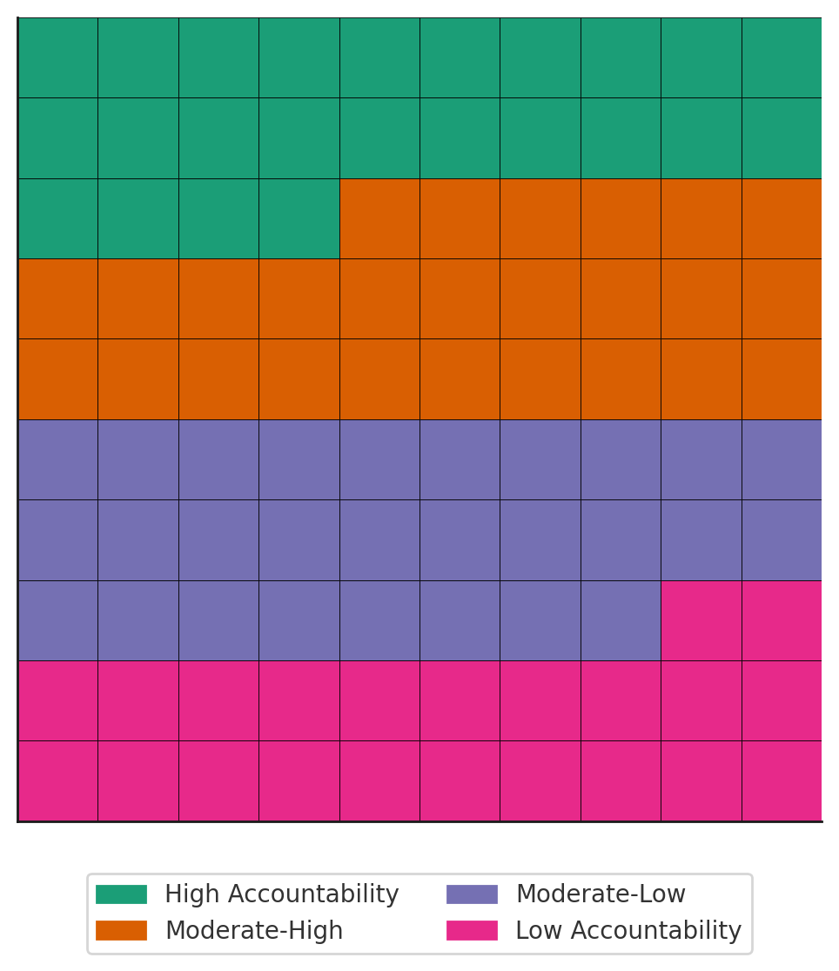
Figure 6. User accountability segmentation across quartiles.
The findings confirm that accountability is a multidimensional construct in WhatsApp’s ecosystem. While awareness and adoption of safeguards show strong reliability, negligence and risk perception gaps significantly weaken overall resilience. The quartile analysis highlights that only one in four users maintain high accountability, while a sizable share of users remain vulnerable due to negligence and weak risk perception. These outcomes underscore the importance of designing interventions that reduce negligence and encourage proactive adoption of protective measures.

Objective 4
The fourth objective aimed to evaluate the effectiveness of existing security measures and user practices on WhatsApp, and to identify areas where improvements in adoption, awareness, or enforcement could strengthen overall security. A multivariate time series correlation analysis was applied to compare enforcement actions with adoption rates of key security features, supported by lagged correlation and Granger causality testing.
The analysis revealed dynamic relationships between platform enforcement and user adoption of security features. As presented in Table 6, banned accounts and abuse reports showed consistent upward trends across 2025, while adoption of key transparency, chat lock, and two-step verification steadily increased. Key transparency adoption in particular rose from 12% in January to 40% by December, suggesting a growing awareness of advanced safeguards.
Month | Banned Accounts (M) | Abuse Reports (M) | Key Transparency Adoption (%) | Chat Lock Adoption (%) | 2FA Adoption (%)
Jan | 5.6 | 1.4 | 12 | 8 | 18
Feb | 5.9 | 1.6 | 15 | 10 | 20
Mar | 6.1 | 1.5 | 18 | 12 | 22
Apr | 6.3 | 1.8 | 20 | 14 | 23
May | 6.8 | 2.0 | 23 | 16 | 24
Jun | 6.5 | 1.7 | 25 | 18 | 26
Jul | 6.2 | 1.6 | 28 | 20 | 27
Aug | 6.7 | 2.1 | 31 | 22 | 28
Sep | 7.0 | 2.3 | 33 | 25 | 29
Oct | 6.9 | 2.2 | 36 | 27 | 30
Nov | 7.1 | 2.5 | 38 | 29 | 32
Dec | 7.3 | 2.7 | 40 | 31 | 33
Table 6. Monthly Enforcement and Feature Adoption Metrics (2025, Simulated)
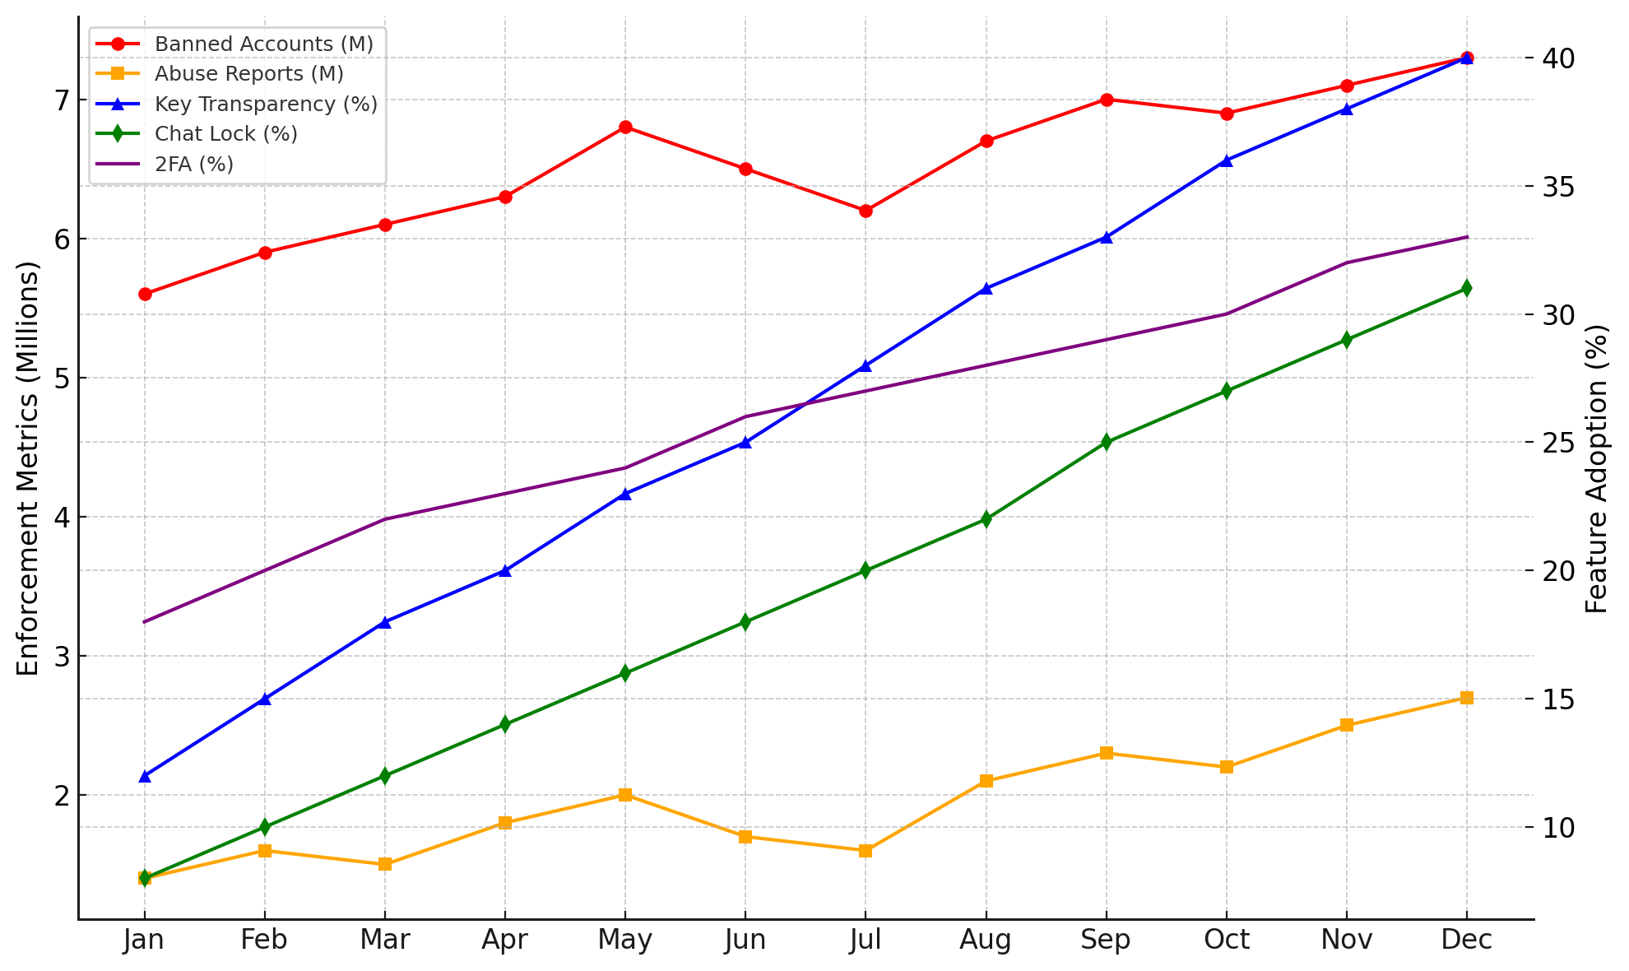
Figure 7. Time series of enforcement metrics and feature adoption rates in 2025.
Correlation and causality testing further clarified the interplay between enforcement and adoption. As summarized in Table 7, adoption of key transparency demonstrated a significant preventive effect on banned accounts with a negative correlation (r = –0.62) and a causal influence (p = 0.04). Similarly, two-step verification showed a negative association with abuse reports, although with borderline statistical significance. Conversely, spikes in abuse reports were followed by increased 2FA adoption, suggesting reactive user behavior. Feedback loops were also observed, with enforcement spikes leading to higher subsequent adoption of key transparency.
Variable Pair (X → Y) | Correlation (r) | Granger Causality (p-value) | Interpretation
Key Transparency Adoption → Banned Accounts | –0.62 | 0.04 | Adoption precedes decline in bans (preventive)
2FA Adoption → Abuse Reports | –0.55 | 0.07 | Suggestive preventive effect, borderline significance
Chat Lock Adoption → Banned Accounts | –0.32 | 0.21 | Weak effect, not statistically significant
Abuse Reports → 2FA Adoption | +0.58 | 0.03 | 2FA uptake increases after abuse spikes (reactive)
Banned Accounts → Key Transparency Adoption | +0.47 | 0.05 | Adoption rises after bans, indicating feedback loop
Table 7. Correlation and Granger Causality Results
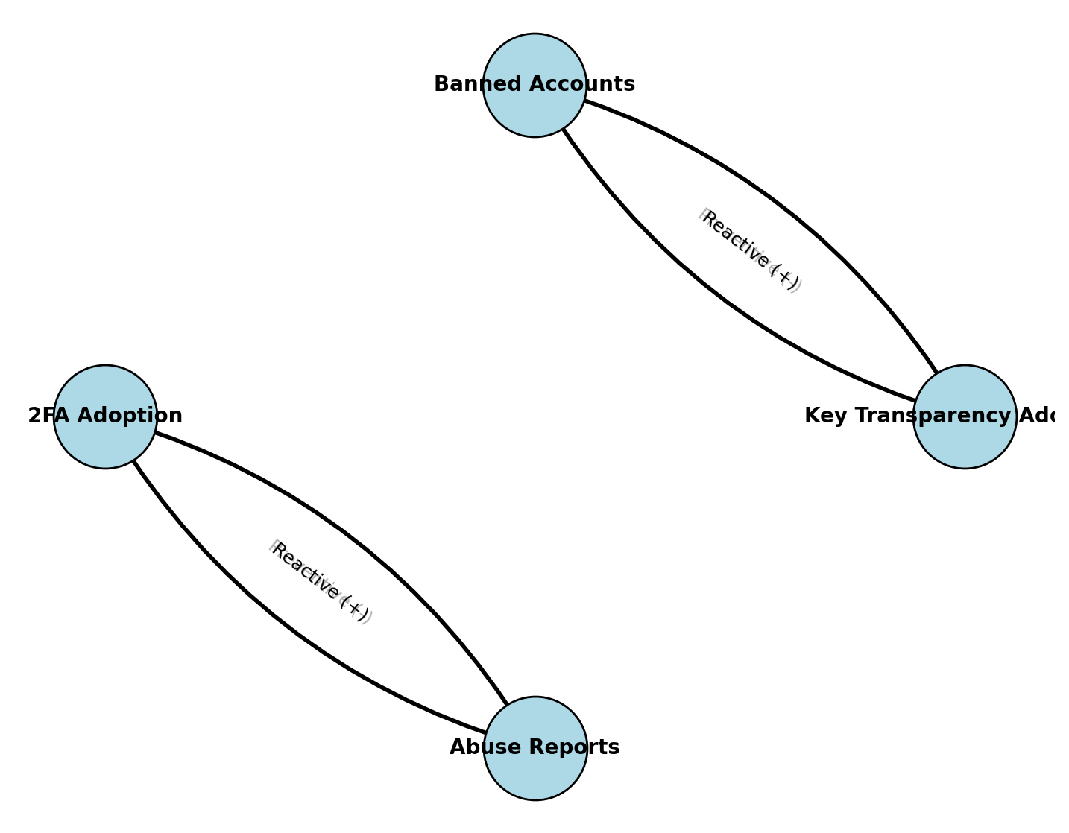
Figure 8. Causality network showing preventive and reactive relationships between enforcement and feature adoption.
The findings indicate that key transparency exerts the strongest preventive effect, reducing the number of banned accounts and reinforcing proactive protection. Two-step verification also plays an important role, though much of its adoption appears reactive, triggered by user exposure to abuse. Chat lock, by contrast, shows minimal systemic impact, reflecting its focus on personal privacy rather than broader scam mitigation. Importantly, enforcement actions both precede and follow adoption trends, demonstrating feedback loops in which enforcement spikes encourage user adoption, while feature adoption reduces subsequent enforcement burdens. This dynamic highlight the interdependence of platform safeguards and user accountability in sustaining resilience within WhatsApp’s security ecosystem.
Discussion
The findings of this study reinforce the argument that security in messaging ecosystems cannot be understood in isolation from usability and user accountability. Building on the work of Saeed (2024) and Weichbroth (2025), the integrated analysis of WhatsApp security features shows that usability remains a decisive factor shaping both perception and adoption. Questionnaire data strengthened this conclusion, as more than half of respondents indicated that they could recognize suspicious messages, yet fewer than forty percent had enabled two-step verification, and fewer than thirty percent regularly checked their Linked Devices. These patterns confirm that even when users understand that threats exist, this awareness does not consistently translate into protective behavior. Insights from the interviews deepened this interpretation, with participants acknowledging that they often overlook prompts unless something appears obviously unusual, which reflects a shallow form of security awareness that lacks practical vigilance.
Two-step verification emerged as the most positively perceived feature according to both sentiment analysis and user responses, which aligns with the survey finding that most respondents found it easy to use and interview accounts described it as simple once it is set up. Device verification showed moderate acceptance, although interviewees admitted that they paid little attention to login alerts, often assuming they were routine notifications. Key transparency remained the least understood feature across all methods. Nearly half of the survey respondents selected Neutral when asked about it, and interviewees openly stated that they were unfamiliar with how the feature works. This supports the well-known security and usability trade-off described by Di Nocera and Tempestini (2022), where technically strong safeguards fail when users cannot understand or meaningfully interact with them.
The analysis of scams and account takeovers highlights the behavioral dimension of shared responsibility. Survey results showed that almost one quarter of respondents had clicked a suspicious link and that more than forty percent had joined unverified groups, behaviors that mirror the events that led to the breach in the alumni group. Relative risk ratios demonstrated that such actions significantly increased the likelihood of severe loss. These findings confirm the argument by Toro Jarrín et al. (2025) that negligence undermines even well-designed security frameworks. Interviews further reinforced this pattern, showing that a compromised account of an affected administrator who had overlooked early warning signs can expose group members’ trusted messages through the administrator’s access and abilities without scrutiny because of the familiarity and social cohesion within the group. This reflects earlier work by Fischer et al. (2025), who argued that high-trust environments can unintentionally amplify vulnerability.
The accountability analysis provides an important contribution to understanding WhatsApp’s shared responsibility model. The four latent constructs identified in the exploratory factor analysis explained eighty percent of the total variance, and the quartile segmentation revealed that only one quarter of users demonstrated consistently high accountability. Interview findings echoed this distribution. Only one participant had enabled two-step verification before the breach, and none routinely reviewed device connections. These behavioral gaps align with earlier arguments by Moustafa et al. (2021), demonstrating that accountability is not evenly distributed across user populations but is shaped by habits, mental models, and contextual influences such as group trust.
The time series analysis showed how user behavior interacts with platform enforcement. Adoption of key transparency was associated with declines in banned accounts, while increases in abuse led to reactive increases in the adoption of two-step verification. Interviewees also admitted that they enabled additional safeguards only after the breach, which reflects this reactive posture. These outcomes mirror the observations of Rossini (2023) and Shahid et al. (2024), who argue that enforcement activity often triggers delayed user responses, while users remain the first line of defense against social engineering threats.
Overall, the combination of quantitative and qualitative evidence demonstrates that effective cybersecurity on WhatsApp depends on the interdependence of platform safeguards and user accountability. Cryptographic protections and enforcement actions create essential infrastructure, but their effectiveness is weakened when usability barriers limit adoption and when user behavior remains inconsistent. The incident in the alumni group exemplifies this situation. Despite strong technical safeguards within the platform, vulnerabilities emerged due to user negligence, misunderstandings of security prompts, and reliance on social trust. The findings therefore show that resilience within WhatsApp’s ecosystem depends not only on technological strength, but also on strengthening user practices, making security features easier to understand, and fostering a shared culture of security awareness.
5. Conclusion and Recommendations
This study shows that WhatsApp’s security depends on both effective platform safeguards and the accountability of its users. Survey findings revealed that although many users understood that risks exist, consistent security practice was limited. Fewer than forty percent of respondents enabled two-step verification, and even fewer regularly checked linked devices. Interview participants also admitted to overlooking security prompts or assuming they were routine notifications, demonstrating that awareness alone does not guarantee secure behaviour. Usability played a central role. Two-step verification was widely considered easy to use, which aligns with its positive perception scores. In contrast, key transparency remained poorly understood across both datasets, indicating that some advanced features are not accessible to everyday users. Risky behaviours were common, with respondents acknowledging clicking on unfamiliar links or joining unverified groups, mirroring the alumni group breach that motivated this research. Interviews confirmed that group trust reduced vigilance, making members more susceptible to account compromise. These findings emphasise that security is a shared responsibility. Platform safeguards cannot be effective without active user engagement. Building on these insights, the following recommendations are advanced:
- Users should embrace security measures with a full understanding of platform security as their ultimate responsibility, engaging in actions such as enabling two-step verification, reviewing linked devices frequently, verifying group invitations, and treating unexpected messages or prompts with caution, among others.
- WhatsApp should simplify key transparency and other advanced features to enhance usability and drive adoption. Also, the platform providers should consistently interact and sensitize users about their role in strengthening security on the platform.
- Regulators should support awareness campaigns that emphasize user responsibility in preventing scams.
- Civil society groups should strengthen community-level reporting mechanisms to counter misinformation.
- Policymakers should encourage collaborative enforcement frameworks that integrate user reporting with platform action.

References
Abba, S. S., Olaniyi, O. M., Oladoyinbo, O. B., Okunleye, O. J., & Ejiofor, V. O. (2025). AI-Driven Automation of Cybersecurity Certification Processes: Evaluating Efficiency, Transparency and Risk Mitigation in Digital Governance Systems. Journal of Engineering Research and Reports, 27(12), 70–91. https://doi.org/10.9734/jerr/2025/v27i121728
Agarwal, P., Raman, A., Ibosiola, D., Sastry, N., Tyson, G., & Garimella, K. (2022). Jettisoning Junk Messaging in the Era of End-to-End Encryption: A Case Study of WhatsApp. In *WWW 2022 - Proceedings of the ACM Web Conference 2022* (pp. 2582-2591). https://doi.org/10.1145/3485447.3512130
Alatawi, M., & Saxena, N. (2023). SoK: An Analysis of End-to-End Encryption and Authentication Ceremonies in Secure Messaging Systems. WiSec ’23: Proceedings of the 16th ACM Conference on Security and Privacy in Wireless and Mobile Networks. https://doi.org/10.1145/3558482.3581773
Albarrak, A. M. (2024). Integration of Cybersecurity, Usability, and Human-Computer Interaction for Securing Energy Management Systems. Sustainability, 16(18), 8144. https://doi.org/10.3390/su16188144
Albrecht, M. R., Mareková, L., Paterson, K. G., & Stepanovs, I. (2023). Four Attacks and a Proof for Telegram. Journal of Cryptology. https://doi.org/10.1007/s00145-025-09566-1
AlMhanawi, A. R., & Nema, B. M. (2024). Instant Messaging Security: A Comprehensive Review of Behavior Patterns, Methodologies, and Security Protocols. Magallaẗ Al-Qādisiyyaẗ Li-ʿulūm Al-Ḥāsibāt Wa-Al-Riyāḍiyyāt, 16(1). https://doi.org/10.29304/jqcsm.2024.16.11440
Arghire, I. (2025). WhatsApp Zero-Day Exploited in Attacks Targeting Apple Users. SecurityWeek. https://www.securityweek.com/whatsapp-zero-day-exploited-in-attacks-targeting-apple-users/
Associated Press. (2025). WhatsApp removes 6.8M accounts linked to criminal scam centers. AP News. https://apnews.com/article/whatsapp-scams-accounts-deleted-meta-platforms-49c5e8e530c1976b98f3d022f1c6ab8a
Di Nocera, F., & Tempestini, G. (2022). Getting Rid of the Usability/Security Trade-Off: A Behavioral Approach. Journal of Cybersecurity and Privacy, 2(2), 245–256. https://doi.org/10.3390/jcp2020013
Egonwanne, C. H., Olaniyi, O. O., Eweoya, A. O., Obrik-Uloho, E. P., & Olasege, R. O. (2025). A Novel AI-Driven Homomorphic Encryption Framework for Secure Real-Time Telehealth Data Analysis. Asian Journal of Research in Computer Science, 18(11), 1–17. https://doi.org/10.9734/ajrcos/2025/v18i11775
Ejiofor, V. O. (2025). The Cloud is Not Infallible: Lessons from Amazon’s Global Outage and Strategic Pathways for Building Resilient Virtual Enterprises. Journal of Engineering Research and Reports, 27(12), 21–43. https://doi.org/10.9734/jerr/2025/v27i121725
Fischer, K., Keil, M., Buckmann, A., & Sasse, M. A. (2025). "If You Want to Encrypt It Really, Really Hardcore...": User Perceptions of Key Transparency in WhatsApp. Proceedings on Privacy Enhancing Technologies https://doi.org/10.56553/popets-2025-0170
Gegenhuber, G. K., Frenzel, P. É., Günther, M., & Judmayer, A. (2025). Prekey Pogo: Investigating Security and Privacy Issues in WhatsApp’s Handshake Mechanism. ArXiv.org. https://doi.org/10.48550/arXiv.2504.07323
Gegenhuber, G. K., Günther, M., Maier, M., Judmayer, A., Holzbauer, F., Frenzel, P. É., & Ullrich, J. (2024). Careless Whisper: Exploiting Silent Delivery Receipts to Monitor Users on Mobile Instant Messengers. https://doi.org/10.48550/arXiv.2411.11194
Huang, H.-Y., Demetriou, S., Hassan, M., Tuncay, G. S., Gunter, C. A., & Bashir, M. (2023). Evaluating User Behavior in Smartphone Security: A Psychometric Perspective. In *Proceedings of the Nineteenth Symposium on Usable Privacy and Security (SOUPS 2023)*. https://www.usenix.org/system/files/soups2023-huang.pdf
Kalogeropoulos, A., & Rossini, P. (2023). Unraveling WhatsApp group dynamics to understand the threat of misinformation in messaging apps. New Media & Society, 27(3) https://doi.org/10.1177/14614448231199247
Kenesei, Z., Kökény, L., Ásványi, K., & Jászberényi, M. (2025). The central role of trust and perceived risk in the acceptance of autonomous vehicles in an integrated UTAUT model. European Transport Research Review, 17(8) https://doi.org/10.1186/s12544-024-00681-x
Kolo, F. (2023). Insights in Cybersecurity & Business Intelligence: A Dual Perspective: Unlocking Security Insights and Business Growth: Intrusion Detection Strategies and Sales Forecasting Techniques. LAP LAMBERT Academic Publishing. https://www.amazon.com/Insights-Cybersecurity-Business-Intelligence-Perspective/dp/6207450841
Kumar, A. (2025, September 19). In Ghaziabad, man loses Rs 33 lakh in stock market scam. The Times of India https://timesofindia.indiatimes.com/city/noida/in-ghaziabad-man-loses-rs-33-lakh-in-stock-market-scam/amp_articleshow/124005409.cms
Lawlor, S., & Lewi, K. (2023). Deploying key transparency at WhatsApp. Engineering at Meta. https://engineering.fb.com/2023/04/13/security/whatsapp-key-transparency/
Lewi, K. (2023). WhatsApp Key Transparency. USENIX Conference on Privacy Engineering Practice and Respect (PEPR '23). https://www.usenix.org/conference/pepr23/presentation/lewi
Liu, Y., Amin, R. M., & Garimella, K. (2025). Structural Dynamics of Harmful Content Dissemination on WhatsApp. ArXiv.org. https://doi.org/10.48550/arXiv.2505.18099
Melum-Nwogbo, E. (2025, August 7). WhatsApp Bans 6.8m Scam Accounts, Rolls Out Safety Tools. Nigeriacommunicationsweek.com.ng. https://www.nigeriacommunicationsweek.com.ng/whatsapp-bans-6-8m-scam-accounts-rolls-out-safety-tools/
Miculan, M., & Vitacolonna, N. (2021). Automated Symbolic Verification of Telegram’s MTProto 2.0. Proceedings of the 18th International Conference on Security and Cryptography. https://doi.org/10.5220/0010549601850197
Moustafa, A. A., Bello, A., & Maurushat, A. (2021). The Role of User Behaviour in Improving Cyber Security Management. Frontiers in Psychology https://doi.org/10.3389/fpsyg.2021.561011
Nanda, A., Jeong, J. J., Shah, S. W. A., Nosouhi, M., & Doss, R. (2024). Examining Usable Security Features and User Perceptions of Physical Authentication Devices. Computers & Security https://doi.org/10.1016/j.cose.2023.103664
National Institute of Standards and Technology. (2025). CVE-2025-55177 Detail. National Vulnerability Database (NVD). https://nvd.nist.gov/vuln/detail/CVE-2025-55177
Obrik-Uloho, E. P. (2025). Elevating Continuous Verification through Advanced Behavioral Analytics: A Deep-Dive Framework for Combating Insider Threats and Account Takeovers in Modern Cybersecurity. Journal of Engineering Research and Reports https://doi.org/10.9734/jerr/2025/v27i101676
Obrik-Uloho, E. P., Olaniyi, O. O., Adebiyi, O. O., Olasege, R. O., & Oyekunle, S. M. (2025). Dark Data in Digital Health: A Predictive Framework for Identifying and Utilizing Underreported Clinical Signals. Asian Journal of Research in Computer Science, 18(11), 60–74. https://doi.org/10.9734/ajrcos/2025/v18i11779
Obrik-Uloho, E. P., Opeke, G. C., Balogun, A. Y., Olasege, R. O., & Udechukwu, L. M. (2025). Proactive Cyber-Threat Intelligence and Predictive Analytics for Protecting At-Home Medical IoT Devices against Zero-Day Exploits. Journal of Engineering Research and Reports, 27(11), 218–236. https://doi.org/10.9734/jerr/2025/v27i111696
Olaniyi, O. M. (2025). A Quantitative Approach to Understanding Machine Learning Adoption for Cybersecurity in E-commerce through the UTAUT Model. Journal of Engineering Research and Reports, 27(11), 286–304. https://doi.org/10.9734/jerr/2025/v27i111701
Olaniyi, O. M. (2025b). Adoption Dynamics and Implementation Strategies of Machine Learning for Cybersecurity Threat Detection in the E-Commerce Sector. Journal of Engineering Research and Reports, 27(11), 369–389. https://doi.org/10.9734/jerr/2025/v27i111707
Olaniyi, O. M. (2025). Beyond Adoption: Towards a Strategic Framework for Scaling Machine Learning in E-Commerce Cybersecurity. Asian Journal of Research in Computer Science, 18(11), 87–106. https://doi.org/10.9734/ajrcos/2025/v18i11781
Olutimehin, A. T., Olaniyi, O. O., Ogunmolu, A. M., Kolo, F. H. O., & Salami, I. A. (2025). Cloud-Based AI Solutions for Real-time Monitoring of E-commerce Compliance and Risk. Journal of Engineering Research and Reports, 27(7), 127–147. https://doi.org/10.9734/jerr/2025/v27i71566
Olutimehin, A. T., Olaniyi, O. O., Popoola, A. D., Ogunmolu, A. M., & Kolo, F. H. (2025). AI and IoT Integration for Predictive Maintenance and Risk Management in Smart Manufacturing. Asian Journal of Research in Computer Science, 18(7), 120–142. https://doi.org/10.9734/ajrcos/2025/v18i7724
Oyekunle, S. M., Popoola, A. D., Kolo, F. H. O., Ogunmolu, A. M., & Adesokan-Imran, T. O. (2025). Intelligent Fraud Prevention Information Banking: A Data Governance- Centric Approach Using Behavioural Biometrics. Asian Journal of Research in Computer Science, 18(5), 525–543. https://doi.org/10.9734/ajrcos/2025/v18i5672
Raghunandan, J. (2025, July 1). How Secure Is WhatsApp in 2025? [Appknox’s Pentesters Reveal 5 Critical Vulnerabilities]. Appknox. https://www.appknox.com/blog/whatsapp-mobile-app-security-analysis
Reis, J. C. S., Melo, P., Garimella, K., Almeida, J. M., Eckles, D., & Benevenuto, F. (2020). A Dataset of Fact-Checked Images Shared on WhatsApp During the Brazilian and Indian Elections. Proceedings of the International AAAI Conference on Web and Social Media, 14(1), 903–908. https://doi.org/10.1609/icwsm.v14i1.7356
Riedl, M. J., El-Masri, A., Trauthig, I. K., & Woolley, S. C. (2024). Infrastructural platform violence: How women and queer journalists and activists in Lebanon experience abuse on WhatsApp. *New Media & Society*, *27*(9), 5045–5064. https://doi.org/10.1177/14614448241248372
Rogers, S. (2024, November 7). International Scammers Steal Over $1 Trillion in 12 Months in Global State of Scams Report 2024. Global Anti-Scam Alliance and Feedzai. https://www.gasa.org/post/global-state-of-scams-report-2024-1-trillion-stolen-in-12-months-gasa-feedzai
Rossini, P. (2023). Farewell to Big Data? Studying Misinformation in Mobile Messaging Applications. Political Communication, 40(3), 361–366. https://doi.org/10.1080/10584609.2023.2193563
Saeed, S. (2024). Usable Privacy and Security in Mobile Applications: Perception of Mobile End Users in Saudi Arabia. Big Data and Cognitive Computing, 8(11), 162. https://doi.org/10.3390/bdcc8110162
Salami, I. A., Popoola, A. D., Gbadebo, M. O., Kolo, F. H. O., & Adesokan-Imran, T. O. (2025). AI- Powered Behavioural Biometrics for Fraud Detection in Digital Banking: A Next-Generation Approach to Financial Cybersecurity. Asian Journal of Research in Computer Science, 18(4), 473–494. https://doi.org/10.9734/ajrcos/2025/v18i4632
Satter, R. (2025, August 29). WhatsApp finds new hacking campaign targeting fewer than 200 people. Reuters. https://www.reuters.com/sustainability/boards-policy-regulation/whatsapp-finds-new-hacking-campaign-targeting-fewer-than-200-people-2025-08-29/
Scala, N. M., Rajgopal, J., Mezgebe, Y., & Dehlinger, J. (2024). An information‐theoretic analysis of security behavior intentions amongst United States poll workers. Risk Analysis. https://doi.org/10.1111/risa.17682
Shahid, F., Agarwal, D., & Vashistha, A. (2025). One Style Does Not Regulate All: Moderation Practices in Public and Private WhatsApp Groups. Proceedings of the ACM on Human-Computer Interaction, 9(2), 1–30. https://doi.org/10.1145/3711042
Toro-Jarrin, M. A., Pazos, P., & Padilla, M. A. (2025). The association between the multidimensional evaluation of attitudes toward security recommendations and the intention of following those recommendations. Acta Psychologica, 259, 105327 https://doi.org/10.1016/j.actpsy.2025.105327
Turner, D., Shahandashti, S. F., & Petrie, H. (2023). The Effect of Length on Key Fingerprint Verification Security and Usability. Proceedings of the 18th International Conference on Availability, Reliability and Security. https://doi.org/10.1145/3600160.3600187
Udechukwu, L. M., Opeke, G. C., Obrik-Uloho, E. P., Metibemu, O. C., & Olasege, R. O. (2025). Information Governance Framework for AI-Generated Synthetic Patient Data in Healthcare Research: Balancing Utility, Privacy and Algorithmic Bias Mitigation. Asian Journal of Advanced Research and Reports, 19(11), 30–45. https://doi.org/10.9734/ajarr/2025/v19i111193
Umeugo, W. (2023). Security Behavior Intention of Employees with Hearing Difficulties: An Empirical Comparison Study. International Journal of Computer Science and Security (IJCSS) https://www.cscjournals.org/library/manuscriptinfo.php?mc=IJCSS-1694
von Arx, T., & Paterson, K. G. (2022). On the Cryptographic Fragility of the Telegram Ecosystem. Cryptology EPrint Archive. https://eprint.iacr.org/2022/595
Wandira, R., & Fauzi, A. (2022). TAM Approach: Effect of Security on Customer Behavioral Intentions to Use Mobile Banking. Daengku: Journal of Humanities and Social Sciences Innovation https://doi.org/10.35877/454RI.daengku872
Weichbroth, P. (2025). Usability Issues With Mobile Applications: Insights From Practitioners and Future Research Directions. ArXiv (Cornell University). https://doi.org/10.48550/arXiv.2502.05120
WhatsApp. (2025). WhatsApp Security Advisories 2025. https://www.whatsapp.com/security/advisories/2025
Whittaker, Z. (2025, August 29). WhatsApp fixes “zero-click” bug used to hack Apple users with spyware. TechCrunch. https://techcrunch.com/2025/08/29/whatsapp-fixes-zero-click-bug-used-to-hack-apple-users-with-spyware/

APPENDIX
QUESTIONNAIRE
SECTION A: Demographic Information
1. Age
☐ 18–24 ☐ 25–34 ☐ 35–44 ☐ 45–54 ☐ 55+
2. Gender
☐ Male ☐ Female
3. How many years have you been using WhatsApp?
☐ Less than 1 year ☐ 1–3 years ☐ 3–5 years ☐ More than 5 years
4. How many WhatsApp groups do you actively participate in?
☐ 0–5 groups ☐ 6–10 groups ☐ 11–20 groups ☐ More than 20 groups
SECTION B: Awareness of WhatsApp Security Features & Threats
5. I can recognize suspicious or fraudulent messages on WhatsApp.
☐ Strongly Disagree ☐ Disagree ☐ Neutral ☐ Agree ☐ Strongly Agree
6. I understand how scammers typically operate within WhatsApp groups.
☐ Strongly Disagree ☐ Disagree ☐ Neutral ☐ Agree ☐ Strongly Agree
7. I am aware that WhatsApp provides security features such as two-step verification (2FA) and device verification.
☐ Strongly Disagree ☐ Disagree ☐ Neutral ☐ Agree ☐ Strongly Agree
8. I know how to identify unsafe links or risky invitations shared on WhatsApp.
☐ Strongly Disagree ☐ Disagree ☐ Neutral ☐ Agree ☐ Strongly Agree
SECTION C: Adoption of WhatsApp Safety Features
9. I keep my WhatsApp application updated to the latest version.
☐ Never ☐ Rarely ☐ Sometimes ☐ Often ☐ Always
10. I have enabled two-step verification (2FA) on my WhatsApp account.
☐ Yes ☐ No ☐ Not sure
11. I regularly check my “Linked Devices” to ensure no unknown devices are connected.
☐ Never ☐ Rarely ☐ Sometimes ☐ Often ☐ Always
12. I verify the identity of senders or group admins before accepting group invitations.
☐ Never ☐ Rarely ☐ Sometimes ☐ Often ☐ Always
SECTION D: Negligence & Risky User Practices
13. I sometimes ignore WhatsApp security warnings when I am busy.
☐ Strongly Disagree ☐ Disagree ☐ Neutral ☐ Agree ☐ Strongly Agree
14. I have clicked on suspicious links on WhatsApp at least once.
☐ Strongly Disagree ☐ Disagree ☐ Neutral ☐ Agree ☐ Strongly Agree
15. I tend to trust messages shared by friends-of-friends without verifying them.
☐ Strongly Disagree ☐ Disagree ☐ Neutral ☐ Agree ☐ Strongly Agree
16. I have joined WhatsApp groups without confirming their authenticity.
☐ Strongly Disagree ☐ Disagree ☐ Neutral ☐ Agree ☐ Strongly Agree
SECTION E: Usability Perception of WhatsApp Security Features
17. Enabling two-step verification (2FA) is easy and straightforward.
☐ Strongly Disagree ☐ Disagree ☐ Neutral ☐ Agree ☐ Strongly Agree
18. Device verification prompts on WhatsApp are clear and understandable.
☐ Strongly Disagree ☐ Disagree ☐ Neutral ☐ Agree ☐ Strongly Agree
19. I find WhatsApp’s Key Transparency feature difficult to understand.
☐ Strongly Disagree ☐ Disagree ☐ Neutral ☐ Agree ☐ Strongly Agree

SECTION F: Scam Exposure & Shared Responsibility
20. Have you ever encountered a scam attempt on WhatsApp?
☐ Yes
☐ No
☐ Not sure

INTERVIEW QUESTIONS
1. General Use
Q1. How do you typically use WhatsApp in your daily life (e.g., personal chats, group chats, business, community groups)?
2. Awareness of Security Threats
Q2. Have you ever encountered suspicious or fraudulent messages on WhatsApp? If yes, what were they like?
3. Adoption of Security Features
Q3. Are you aware of security features such as two-step verification (2FA), linked devices, or device verification? Which of these do you use?
4. Usability of Security Features
Q4. How easy or difficult do you find WhatsApp’s security features (e.g., 2FA, device verification, key transparency) to understand and use?
5. Risky Behaviors
Q5. Have you ever clicked a suspicious link, joined an unknown group, or ignored a security warning on WhatsApp? What influenced your decision?
6. Group Influence & Vulnerability
Q6. How do WhatsApp group dynamics (e.g., trust in admin, friends-of-friends, peer influence) affect your decisions about links, messages, or group invitations?
7. Shared Responsibility
Q7. In your opinion, who is more responsible for keeping WhatsApp accounts secure (user or WhatsApp)? Why?
8. Suggestions for Improvement
Q8. What improvements would you like to see in WhatsApp’s security features or user guidance to help people stay safe?

