Review Article

Object Detection: Comparing the Convolutional Neural Networks (CNNs) and Vision Transformers (ViTs) Performance Review

.
ABSTRACT
Computer vision object detection, a critical area, faces challenges like occlusion, viewpoint variation, and computational efficiency. This review studies the evolution of object detection methodologies, from traditional to modern deep learning techniques, including CNNs (Convolutional Neural Networks), YOLO (You Only Look Once) variants (v1–v8), and ViTs (Vision Transformers). Through a systematic analysis of 38 studies, CNNs demonstrate robustness in small datasets and real-time applications, at the same time ViTs excel in handling complex relationships and adversarial conditions due to their self-attention mechanisms. Hybrid models combining CNNs and ViTs show promise for improved accuracy and efficiency but require further validation. Key challenges include computational demands, dataset diversity, and generalization across domains. Future research should prioritize hybrid architectures, edge deployment, and standardized benchmarking to advance crowd object detection in dynamic environments like surveillance, healthcare, quality control, inventory management, and autonomous systems.

Keywords: Computer Vision; CNNs (Convolutional Neural Networks); YOLO (You Only Look Once) YOLOv1–v8; Vision Transformers (ViTs)

1. INTRODUCTION
Object detection is a crucial area in computer vision, it finds use in different endeavors such as healthcare, finance, industries, driverless vehicles, control systems and in security and surveillance [1] and [2]. Numerous techniques and methodologies have been created over years to deal with the particular difficulties presented by crowded environment e.g (high object density, viewpoint variation, deformation, illumination condition, textured background, variety, occlusion, and different object scales) [3]. The main objectives of this research is to evaluate and examine the development of object detection methodologies, with a particular emphasis on the benefits and drawbacks of some important strategies like CNNs (convolutional neural networks), YOLO (you only look once), and ViTs (vision transformers) [3] and [4].
Object detection has been deeply impacted by (CNN) convolutional neural network quick development. CNN-based (convolutional neural network) models have shown remarkable performance in object segmentation, object localization, object detection, object identification, and feature extraction, such as R-CNN (regions with convolutional neural networks), Fast-RCNN (fast regions with convolutional neural networks), and Faster R-CNN (faster regions with convolutional neural networks). However, the processing in real-time demands of dynamic applications, such as real-time surveillance in object detection, are sometimes too much for these models to handle [5].
Moreover, under conditions with hefty occlusion, variety, and textured backgrounds, their performance may also be affected [4]. Similar to this, a pattern shift toward real-time object detection has been taken near with the development of the YOLOv1 to YOLOv8 models and vision transformers (ViTs) [3]. YOLO (you only look once) models, such as the most recent version released in 2023, YOLOv8 place an in height priority on speed without expressively sacrificing accuracy. They divide the image into a grid making them quite effective in forecasting bounding boxes and class probabilities at the same time [4]. However, you only look once (YOLO) models might have trouble identifying small objects and conduct sharp differences in object sizes in busy settings, which makes it limited compared to vision transformers (ViTs) in terms of detection of an object in a close environment [4].
Using the self-attention tool to simulate future interdependence and global context, ViTs use patches of equal size by breaking down the images to classify and predict the class of an object within the image or video and have developed a viable alternative in more recent times [3]. A particularly useful application for (ViTs) vision transformers in crowded areas is it can capture complex relationships surrounded by an image or video [4] and [6]. This method of detecting an object, however, presents problems for realistic deployment because they are frequently computationally demanding and need big datasets for efficient training to avoid under fitting [7]. The qualities and inadequacies of these main methods (CNNs and ViTs) due to some research will be systematically examined in this review. Through a critical analysis of the current literature, the research seeks to find gaps and put forward a mixture strategy that combines the advantages of convolutional neural networks (CNNs) and vision transformers (ViTs) to improve objection. By resolving the existing issues in object detection mechanism in real world and urging the boundaries of this discipline, the incorporation of these techniques aims to develop the precision, efficiency, and resilience of the crowd object detection. Our aim is to present an up-to-date research on crowd object detection, highlighting the development of approaches and their implications for applied uses. The review aims to ease the later creation of an innovative mix model, leading to more effective methods of detection of objects of interest in congested areas contained by an image or video (V. Kousik et al., 2021).
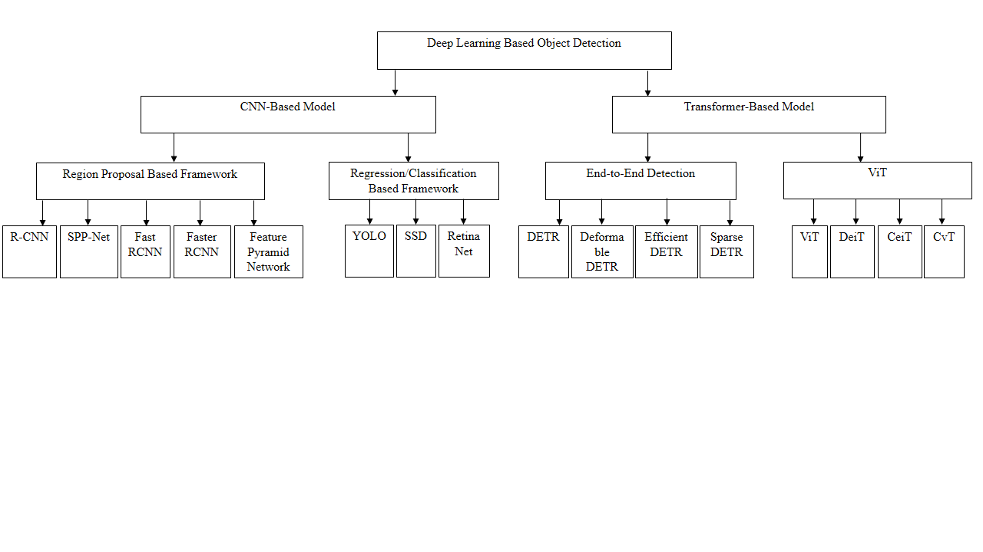
Figure 1: Classification diagram of Deep Learning Methods (V. Kousik et al., 2021)

2. TRADITIONAL METHOD
Traditional methods are predictable methods for object detection that mostly depend on physically created feature extraction and the use of out-of-date machine learning algorithms. These methods were presented in 2001. One of the first effective frameworks for real-time face identification and detection was Viola-Jones detector. Using an algorithm called AdaBoost classifier method and Hair-like characteristics used to detected faces in photos and videos [9] Nevertheless its effectiveness, the this technique has trouble with the object detection challenge of occlusions and complicated backgrounds, which are frequent in busy environment. The method HOG was created for identifying humans in digital photos and was first presented in [9]. To determine the magnitude and direction of gradients, the method applies horizontal and vertical gradient filters to the input images. The images are filtered and then divided into 8 × 8-pixel cells, which are then further be grouped into 2 × 2 cell blocks with 50% overlay. For each cell, orientation histograms are generated by quantizing gradient directions into nine bins ranging from 0° to 180°, with the corresponding gradient sizes serving as votes. A feature vector representing the Histogram of Oriented Gradients (HOG) is then formed by concatenating the histograms of all cells within a block. To account for variations in lighting and contrast, these vectors are normalized. The final HOG descriptor, comprising all normalized blocks, is input into a Support Vector Machine (SVM) to determine whether an image contains a human. Although the HOG algorithm's dense grid approach increases computational cost and performs less efficiently in the presence of occluded objects, it effectively reduces false positives compared to Haar wavelets.
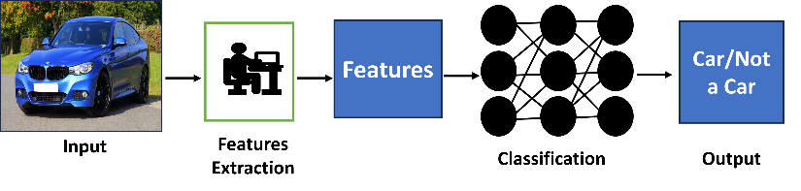
Figure 2: Traditional Object Detection Method [9]

2.1 CHALLENGES FOR TRADITIONAL METHOD
There are strong trade-offs when using traditional computer vision (CV) and deep learning based (DL) methods. Traditional algorithms are fundamentally recognized, clear, and fine-tuned for efficiency in both performance and power but there is a challenge of variability in object appearance, occlusion, limited robustness to noise and difficulty in handling complex scenes which lead to the development of more advanced object detection techniques, whereas deep learning provides enhanced accuracy and flexibility but requires more computing resources. Hybrid methods combine traditional and deep learning and offer the benefits and traits of both methodologies. These techniques are efficient in high computational systems, which need to be implemented quickly. For example, in a security and surveillance camera, a computer vision algorithm can efficiently detect faces, other moving or feature objects in the sight [9]. These detections can then be passed to a deep neural network for identity confirmation or object classification.
For saving significant computing resources, the deep neural network simply needs to be applied on a small patch of the image, training time and effort are compared to what would be required to process the entire frame [9]. The fusion of machine learning and deep networks frameworks has become very popular due to the simple fact that it can generate better models [9]. Hybrid vision processing implementations can introduce performance advantage and ‘can deliver a 130X-1,000X reduction in multiply-accumulate operations and about 10X improvement in frame rates compared to a pure deep learning solution. Furthermore, the hybrid implementation uses about half of the memory bandwidth and requires significantly lower CPU resources [9].

3. CONVOLUTIONAL NEURAL NETWORKS (CNNS)
The introduction of CNNs (convolutional neural networks), particularly effective for image and video processing tasks, led to a significant shift in object detection techniques [9]. In various computer vision applications, CNNs (convolutional neural networks) have outperformed traditional techniques due to their ability to learn hierarchical feature representations [9]. In this method, the introduction of R-CNN (regions with convolutional neural networks) was revolutionary. R-CNN generated region proposals through selective search, after which CNN was employed for classification, [10]. However, the multi-stage pipeline of R-CNN resulted in high computational costs.
Subsequent advancements of R-CNN addressed its computational inefficiencies, including Fast R-CNN and Faster R-CNN which use regional and bounding boxes to classify an object within an image or a video. The training time was greatly shortened by Fast R-CNN compared to CNN by introducing a single-stage training procedure and the use of Region of Interest (RoI) pooling [11]. By incorporating a region proposal network (RPN) that shared convolutional features with the detection network (DN), Faster R-CNN enabled nearly real-time object identification, hence improving efficiency even further compared to the Fast-RCNN method [11].
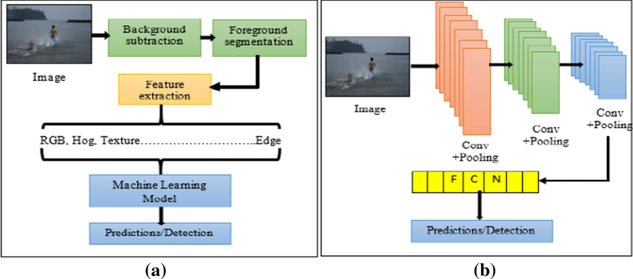
Figure 3: Convolutional Neural Network (CNN) Architecture [9]

4. ONE STAGE METHODS
The main characteristics of one-stage anchor-based detectors are their efficiency during computation and runtime [3]. Rather than employing regions of interest, these models use specified anchor boxes for direct classification and regression [3]. The SSD was the first well-known object detector in this category [3]. The imbalance between positive and negative samples is the main issue with this kind of detector [3]. To address this issue, several strategies, methods, and processes have been put in place, including multi-layer context information fusion, training from scratch ,feature enrichment and alignment, and anchor refinement and matching [12]. Additional efforts have been focused on creating new architectures and loss functions; these method of object detection involves the use of YOLO and Single Stage Methods (SSD) [3].

4.1 YOLO – YOU ONLY LOOK ONCE
YOLO (you only look once) was introduced to the computer vision community via a paper release in 2015 by Joseph Redmon [13] titled 'You Only Look Once: Unified, Real-Time Object Detection'. The research paper redefined object detection, framing it as a straightforward regression task that begins with image pixels and progresses to determining bounding box coordinates and class probabilities [13].
The proposed approach based on the ‘unified’ concept enabled the simultaneous prediction of multiple bounding boxes and class probabilities, improving both speed and accuracy compared to traditional object detection and convolutional neural networks [13]. Since its launch in 2016 up to 2023, the YOLO series has experienced rapid advancements. Although the original creator (Joseph Redmon) ceased further contributions to computer vision with YOLO-v3, multiple authors have expanded on the effectiveness and potential of the fundamental ‘unified’ concept, the most recent version to join the YOLO series is YOLO-v8. Figure 1 presents the YOLO evolution timeline [13].
It is a state-of-the-art, real-time object detection system that offers extreme levels of speed and accuracy [13]. YOLO, as the name suggests, looks at the image only once, i.e., there is only a single network evaluation, unlike the previous systems like the RCNN and its family approach which requires thousands of evaluations for a single image (2000) [13]. This is the secret to the extreme speed of a YOLO model (almost 1000x faster than RCNN 100x faster than the Fast RCNN and 10x faster than the Faster RCNN model) [13]. In this approach, the model uses a predefined set of boxes (bounding boxes) that look for objects in their regions [13]. For the SxS grid cells drawn for each image, YOLO predicts X boundary boxes each with its confidence score and each box can predict only one object [13]. YOLO also generates Y conditional class probabilities for the likeliness of each object class [6], [14] and [15].

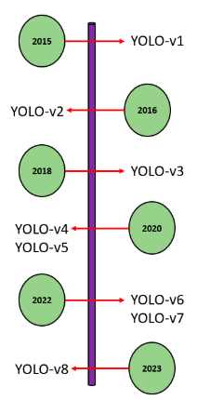
Figure 4: YOLO Evaluation [16]
In conclusion, from the review in this research, it is clear as the YOLOv1 to YOLOv4 variations have progressed, later versions in particular, YOLOv5 to YOLOv7 have focused on constrained edge deployment, a key requirement for many manufacturing and industrial applications. Because there are no copyright and patent restrictions on these techniques, research anchored around the YOLO architecture, i.e., real-time detection, lightweight, accurate detection, can be conducted by any individual or research organization in computer vision, which has also contributed to the prevalence of this variant.
With YOLO-v8 released in January 2023, showing a promising performance by the developers concerning throughput and computational load requirements within the object detection computer vision environment [16], it is planned that 2024 it see more variants released by previous or new authors focused on improving the deployment capacity of the architectures concerning constrained deployment environments [17]. As research groups like Ultralytics and Meituan Technical Team focus on the evolution of YOLO architectures designed for edge-friendly deployment [17], we can expect further advancements in the architectural footprint of YOLO. To accommodate limited deployment environments, these innovations will need to prioritize energy efficiency while ensuring high inference speeds.
Furthermore, we envision the proliferation of YOLO architectures into production facilities to help with quality inspection pipelines as well as providing stimulus for innovative products as demonstrated by [16] with an automated pallet racking inspection solution. With the ability to integrate into various hardware and IoT devices, YOLO has the potential to explore new fields where computer vision can enhance existing images, ultimately boosting the performance of a Single Shot Detector [16].

5. SSD – SINGLE SHOT DETECTION
Similar to YOLO, SSDs take only a single shot to detect all the classes in a scene that the model was trained on [2] and therefore, like YOLO, are much faster than the traditional two-stage methods that require two shots (one for generating region proposals and another for detecting objects of each proposal). SSDs implement techniques such as multi-scale features and default boxes which allow it to obtain similar levels of accuracy as that of a Faster RCNN model using lower resolution Images enhance the processing speed of a Single Shot Detector [2]. SSD uses VGG16 to extract feature maps from a scene and then uses a Conv43 convolution layer to detect objects from it [2].
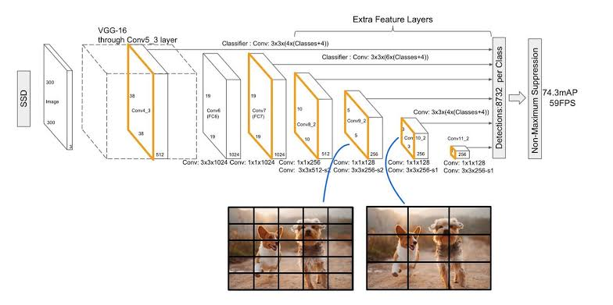
Figure 5: SSD Architecture (Alyamkin et al., 2019)

5.1 VISION TRANSFORMERS (VITS)
In computer vision object detection, ViTs splits the image into a form of patches by providing the sequence of linear embedding of these patches as an input to a Transformer [18]. The model processes the patches as a sequence of words like tokens of the same size processed in Natural Language Processing [18]. A constant latent vector is used to flatten and map the patches in to a dimension of vector size with a trainable projection in all the transformer layers. They used an multilayer perceptron (MLP) with one hidden layer during the classification during the pre-training time and one single layer at the fine-tuning time [19].
The ViTs achieved the highest performance of any object detection method when trained on larger datasets when they were first published [19]. The Vision Transformer (ViTs) document does not specify a particular loss function. However, the ViTs model outputs hidden raw states without any specific head on top. It can also be used as a building block for various computer vision tasks such as image classification [15] and [1].
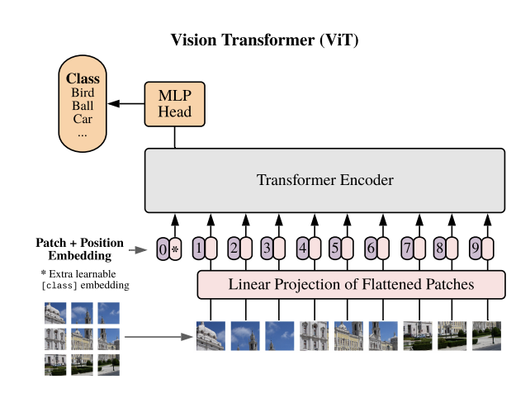
Figure 6: Vision Transformer Architecture [20]

6. REVIEW OF RELATED STUDIES
A summary of the research studies selected through the research papers is shown in Table 1. However, this evidence summarizes the authors' approach after the review has been done, and the findings, datasets, techniques, and other architectures that were used to build a comparative study between CNNs and ViTs identified.
Therefore, to address the research gaps, this unit will offer an overview of the data found, the methodology used as well as results found in the collected papers.
In the study developed in [21], the authors aimed to compare the two object detection architectures approaches (i.e., CNNs and ViTs), as well as the creation of a hybrid model that corresponded to the combination of these methods. The experiment for this research was conducted using online repository data from the ImageNet dataset and perturbations were applied to the dataset image. Based on the findings, it was determined that vision transformers (ViTs) be able to outperform and exhibit greater robustness in image classification under both natural and adverse conditions compared to convolutional neural networks (CNNs). In this research it was also revealed that merging these two object detection frameworks leads to a 10% percent improvement in accuracy.
The work done in [10] intended to compare ViTs (vision transformers) with CNNs (convolutional neural networks) for digital holography, where the goal of this research was to reconstruct amplitude. Additionally, the phase involved measuring the distance of the object from the hologram. In this research work, ViT-B/16, ViT-B32, DenseNet201, DenseNet169, EfficientNetB4, EfficientNetB7, and ViT-L/16 architectures were used to compare with a total of 3400 (three thousand four hundred) images. They separated these images into four datasets, original images without filters, original images with filters, negative images with filters, and negative images without filters. The authors also concluded that ViTs (vision transformers) despite having accuracy like CNNs (convolutional neural networks), were more robust since, due to the self-attention mechanism of the technique, it can learn the entire hologram rather than a specific area.
In the study [22] the goal was to compare vision transformers (ViTs) with state of art convolutional neural networks (CNNs) to classify UAV images that could be used to monitor weeds and crops in a farmland. The researchers compared the influence of the training dataset size on the performance of the architectures and from the results found that ViTs performed well with fewer images than CNNs in terms of F1-Score. They also concluded that ViT-B/16 was the best model to do weed and crop monitoring. In comparison with convolutional neural networks (CNNs), vision transformers (ViTs) could better learn the patterns of images in small datasets which makes them more robust than CNNs due to the its self-attention mechanism.
Similarly in the research work in [23], a comparison between CNNs and ViTs models for breast ultrasound image classification was developed from the 943 images. The investigation utilized two distinct datasets, the first comprised 780 (seven hundred and eighty) images and the second included 163 (one hundred and sixty three) images for the training and evaluation of the models. The following architectures were selected for the study: VGG-16, ResNet50, NASNET, Inception, ViT-S/32, ViT-B/32, R + ViT-Ti/16 , ViT-Ti/16, and R26 + ViT-S/16. From the results, ViTs models were found to perform better than CNNs for image classification best on the given datasets. The researcher also highlighted that ViTs models could perform better when they were trained with small datasets, because the ViTs approach via the attention mechanism, it was possible to collect more information from different patches of the same size, instead of collecting futures or information directly from the image.
A similar study in [11], compared vision transformers (ViTs )models, with the Multilayer perceptron’s (MLP) Mixer Layer architecture and with convolutional neural networks (CNNs). The goal was to evaluate which architecture between the three was more robust in image classification. The study consisted of adverse examples and generating agitations in the images from the given datasets and also understanding which of the architectures was most robust for object detection. However, this research did not only aims to analyze the causes. Therefore, the researchers concluded that ViTs (vision transformers) were more robust than CNNs (convolutional neural networks) to adversarial attacks, and from a features perspective, CNNs were more complex to high-frequency feature extractions. Similarly, the researchers also described that the shift variance property of CL (convolutional layers) may be at the origin of the lack of robustness of the network in the images classification task of that have been transformed.
In a similar study, the authors in [24] done an analysis between ViTs and CNNs models aimed by detecting deep fake image by extracting the features from the dataset. The experiment done using forgery net dataset which consisted of with about 2.9 million images and 220 thousand video clips, together with three different image manipulation techniques, where they tried to train the models with real and manipulated images. By training the EfficientNetV2 and the ViT-B model network the researchers demonstrated that the CNNs (convolutional neural network) could generalize better and obtain higher training accuracy. Nonetheless, ViTs may demonstrate improved generalization, helping to diminish the bias in anomaly detection that results from different methodologies used to introduce anomalies.
The study implemented in [25] aimed to compare their vision transformers (ViTs) model with CNNs (convolutional neural networks) and with another ViTs model to perform image classification for the detection of skin cancer in the human body. The experiment was conducted by the researchers who used a public HAM10000 dataset with clinical datasets and dermatoscopic skin cancer images collected through dermoscopy. In the research, a multi-scale image approach and an overlapping sliding window technique were implemented to serialize the images. Furthermore, contrastive learning was employed to boost the similarity among various labels while reducing the similarity within the same label. Thus, the ViTs model developed was superior for skin cancer classification. Nevertheless, the researchers also demonstrated the effectiveness of balancing the datasets on the model performance, but they did not present the F1-Score values before the dataset was balanced to verify the improvement.
In a research carried out in [26], the authors tried to find in vision transformers (ViTs) an alternate solution to convolutional neural networks (CNNs) for concrete crack and asphalt detection. The researchers concluded that ViTs, due to the self-attention mechanism, had better performance in crack detection images with strong noise compared to convolutional neural networks. CNNs in the same images suffered from a high number of FN rates (false negative rates), as well as the occurrence of biases in image classification.
The work done in [27] compared convolutional neural networks (CNNs) with vision transformers (ViTs) models for the classification of Diabetic Foot Ulcer images from diabetes datasets. For a study, the authors decided to use the architectures like EfficientNet, Big Image Transfer (BiT), ViT-base and Data-efficient Image Transformers (DeIT) upon a dataset composed of about 15,683 images. A further aim of this study is to compare the performance of deep learning (DL) models using Stochastic Gradient Descent (SGD) with Sharpness-Aware Optimization (SAM) [28]. The tools discussed are optimizers aimed at reducing the loss function's value, thereby enhancing the model’s generalization capability. However, from the study SAM minimizes the value of the sharpness loss and the loss function, looking for parameters in the neighborhood with a low loss. Consequently, this study found that the SAM optimizer led to improvements in AUC, F1-Score, Precision and Recall across all architectures utilized. Nonetheless, the researchers did not provide the training and testing metrics necessary to assess the models' generalization enhancement. As a result, the BiT-ResNetX50 model paired with the SAM optimizer achieved the highest performance in classifying Diabetic Foot Ulcer images, with an AUC of 87.68%, F1-Score of 57.71% and an Precision = 57.74% and Recall = 61.88%.
In related study, several authors [29], [30] went deeper into the investigation in object detection and aimed to understand how the learning process of vision transformers works if it could be robust, more transferable and better understand if the transform-based architecture were more robust than convolutional neural network (CNNs). In this research, the authors in [30] intended to analyze the internal representations of ViTs and CNNs structures in image classification benchmarks and found differences between them. A key distinction emerged wherein vision transformers (ViTs) exhibit a greater resemblance between high and low layers compared to convolutional neural networks (CNNs), which require additional lower layers to generate similar representations in smaller datasets. This is due to the self-attention layers implemented in vision transformers (ViTs), which allow it to combine information from other spatial locations within an image or video, vastly different from the fixed field sizes in CNNs. It was also noted that in the lower layers of self-attention, ViTs can access information from both local heads (small distances) and global heads (large distances), whereas CNNs primarily obtain local information in their lower layers.
On the other hand, the researches in [31] systematically analyzed the transfer learning techniques capacity in the two architectures. The research involved comparing the efficacy of ViTs and CNNs for both single and multi-task learning challenges, utilizing the ImageNet dataset sourced from an online repository. Over and done with this study, the authors concluded that the transform-based vision transfomer (ViTs) architecture contained more transferable representations compared to convolutional networks (CNNs) for fine-tuning, which make it presenting better performance and robustness in multi-task learning problems.
In another study carried out in [29], the goal of the authors was to verify if vision transformers (ViTs) were more robust than convolutional neural networks (CNNs) as the most recent studies have shown earlier . The authors established their work comparing the robustness of the two architectures the ViTs and CNNs using two types of approaches: argumentative samples, which consists in evaluating the robustness of deep learning architectures (CNNs) in images with human-caused perturbations (i.e., data augmentation) and out of distribution samples, which consists in evaluating the robustness of the architectures in classification images benchmarks. Through this experiment, it was demonstrated that by replacing the activation function like ReLU with the activation function of transformer-based architecture (i.e., GELU) the CNNs network was more robust than ViTs in adversarial samples. In this study, it was also demonstrated that CNNs networks were more robust than ViTs in patch-based attacks. Ultimately, the authors argued that the self-attention mechanism was critical to the robustness of transformer-based architectures in most experiments conducted.
In a similar study carried out in [32], the goal of the authors was to detect early illness, enable medical experts to deliver the best care and increase the likelihood of a full recovery. In this work, the author shows that, the proposed system is based on explainable artificial intelligence to detect COVID-19 from CXR images by using several cutting-edge this included both convolutional neural network (CNNs) models and vision transformer (ViT) models. This gives doctors and other medical professionals a second option for supportive their decisions. The proposed approach incorporates certain image preprocessing methods, such as employing a UNet model for the segmentation of the area of interest and utilizing rotation augmentation. CNNs process pixel arrays, while ViTs break down images into visual tokens; thus, one of the aims is to evaluate their performance in detecting COVID-19. For the experiments, a publicly accessible dataset (COVID-QU-Ex) was utilized. The outcomes of the experiments indicated that CNN-based and ViT-based models performed on a comparable level. The highest accuracy achieved was 99.82% with the CNN-based (EfficientNetB7) model, followed closely by the ViT-based (SegFormer).
On other hand, the authors in [33] systematically analyzed the comparison between the two object detection architectures (CNNs and ViTs). The researcch was conducted by comparing the performance of the architectures in handling complex medical dataset problems, using the X-Ray (ImageNet) dataset. Through this study, the authors concluded that the CNNs outperforms transformer-based (ViTs) architecture in terms of robustness. However, this requires a sufficient number of external test datasets during the selection process.
The work done in [34] compared CNNs with vision transformers (ViTs) models for who will win the race for action recognition in visual data. This research investigates CNNs and ViTs models for action recognition separately, as well the balance between accuracy and complexity. In addition, this paper assesses the common of relevant studies that highlight the advantages of each discussed approach and their associated results. However, the authors failed to provide the training and testing metrics that enable an assessment of the models' generalized improvements. Therefore, recognition datasets were used from ImageNet.
The work done in [35] aimed at the adversarial robustness of vision transformers versus convolutional neural networks. This work introduces a novel and systematic method to assess and compare the adversarial robustness of vision transformers (ViTs) against CNNs, specifically focusing on the image classification task. The research has performed broad experiments using state-of-the-art adversarial example attacks, such as the fast gradient sign method (FGSM), projected gradient descent (PGD), and deepfool attack (DFA). The result of this research study represents that CNNs (convolutional neural networks) are more robust against more straightforward attacks such as FGSM. Still, ViTs display remarkable resilience against more sophisticated attacks such as the PGD and DFA methods. Additionally, this research seeks to address this problem and design a network capable of excelling beyond both standard transformers and advanced convolutional architectures.
In a study carried out in [36], the researchers tried to find an alternative solution to computational cost between the vision transformers (ViTs) and convolutional neural networks (CNNs). In this research, the authors aim to address this issue and develop a network that can outperform not only the canonical transformers but also the high-performance convolutional models. The authors propose a new transformer-based hybrid network by taking advantage of transformers to capture long-range dependencies, and of CNNs to extract local information. Also, they scale it to obtain a family of models, called CMTs, obtaining a much better trade-off for accuracy and efficiency than previous CNNs-based and ViTs-based models. Specifically, our CMT-S achieves a top-1 accuracy of 83.5% on ImageNet while being 14 times and 2 times smaller in terms of FLOPs than the current DeiT and EfficientNet, respectively. The proposed CMT-S architecture also demonstrates strong generalization on dataset CIFAR10 (99.2%), CIFAR100 (91.7%), Flowers (98.7%), and other challenging vision datasets such as COCO (44.3% mAP), with significantly lower computational costs.
In a related study, [37] aimed at comparing the vision transformers (ViTs) model with CNNs (convolutional neural networks) to perform image classification for the detection of glaucoma disease. The conducted experiment was used a public HAM10000 dataset. In the research, a multi-scale image approach and overlapping sliding windows were utilized to serialize the images. The authors also implemented contrastive learning to enhance the distinction of different labels while reducing the similarity among the same label. Consequently, the authors concluded that the ViT model developed was better for glaucoma disease detection. However, the authors have not specified the number of images used in carrying out the research experiment.
Table 1. Overview of Selected studies
Reference | Datasets | Images Size | Number of  Classes | Hardware | Evaluated  Archectures | Best Architecture | Best Results
[10] | ImageNet-C benchmark | 224 × 224 | 2 | NVIDIA Quadro A6000 | ViT-L/16, CNN, hybrid model (BiT-M + ResNet152 × 4 | Hybrid model | 99.20% Acc
[11] | ImageNet-C benchmark | Not Available | 1000 | Not Available | Mixer and ViT Architecture | ViTs and MLP-Mixer | Not Available
[38] | 10,265 images collected by Pilgrim technologies UAV with Sony ILCE-7R-36 mega pixels | 64 × 64 | 5 | Intel Xeon E5-1620 V4 3.50  GHz with 8 processor, 16  GB RAM; NVIDIA Quadro M2000 | EfficientNetB , EfficientNetB1 , ViT-B/16, ViT-B/32, and ResNet50 | ViT-B/16 | 99.8% Acc
[21] | Public dataset 1 with 780 images; Public dataset2 [26] with 163 images | 224 × 224 | 3 | Not Available | ViT-S/32, ViT-B/32, ViT-Ti/16, R + Ti/16, R26 + S/16, VGG, Inception and NASNET | ViT-B/32 | 86.7% Acc and 95% AUC
[22] | ImageNet-1K (more than 1.431 M images) for training and ImageNet-C for validation | 224 × 224 | 2 | Not Available | Mixer-B/16, , ViT-B/16, ViT-L/16, RN18 and RN50 and RN18 (SWSL), RN50 (SWSL), | ViT-L/16 | 82.89% of Acc
[23] | 943 images of breast ultrasound collected from hospital | Not Available | 2 | Not Available | NASNET, ViT-S/32, ResNet50, VGG-16, Inception, ViT-B/32, ViT-Ti/16, R + ViT-Ti/16 and R26 + ViT-S/16 | ViTs | Not Available
(Coccomini  et al., 2022) | 2.9 million images and 220 thousand video clips | Not Available | 3 | Not Available | EfficientNetV2 | CNNS | Not Available
[25] | HAM10000 dataset (10,015 images); 1016 images collected by dermoscopy | 224 × 224 | 3 | Intel i7; 2x NVIDIA RTX 3060, 12 GB | InceptionV2, MobileNetV2, ResNet50, , ViT and Proposed ViT model | Proposed ViT model | 94.10% Acc, 94.10% precision and  94.10% F1-Score
[26] | CrackTree260 (260 images); Ozegenel (458 images); Lab’s on dataset (80,000 images) | 256 × 256; 448 × 448 | 2 | Not Available | TransUNet, U-Net, DeepLabv3+ and CNN + ViT | CNN  + ViT | 99.55% Acc and 99.57% precision
[27] | Dataset provided in DFUC 2021 challenge  (15,683 images) | 224 × 224 | 4 | NVIDIA GeForce RTX 3080, 10 GB memory | EfficientNetB3, BiT-ResNeXt50, ViT-B/16 and DeiT-S/16 | BiT-ResNeXt50 | 88.49% AUC, 61.53%  F1-Score, 65.59% recall and  60.53% precision
[29] | ImageNet-A; ImageNet-C and Stylized ImageNet | 224 x 224 | Not Available | Not Available | DeiT-S and ResNet50 | ViT | Not Available
[30] | ImageNet-A; ImageNet-C and Stylized ImageNet | 224 x 224 | Not Available | Not Available | ResNet50 and DeiT-S | ViT | Not Available
[31] | A total of 1130 cataract and non-cataract fundus images are collected and augmented to 4746 images | Not Available | 4746 | Not Available | , Inception-v3, and ResNet-50, MobileNet, VGG-16, VGG-19 | ViTs-CataractNet | Accuracy (99.13%), preci- sion (99.08%), recall (99.07%), specificity (99.17%), MCC (98.23%), and f1-score (99.07%).
(Nafisah  et al., 2023) | 21,165 CXR medical images | 256 × 256 | 21,165 | CPU E5-2640v3 3.00-GHz processor, 2 TB of hard disk space, 16-GB RAM, and a CUDA-enabled NVIDIA GTX 1080 Ti 11-GB graphical processing unit. | MiT-B5 and VGG16 | CNN-based model | 99.82%, obtained by the EfficientNetB7 (CNN-based) model
(Takahashi  et al., 2024) | Medical images | Not Available | Not Available | Not Available | Not Available | CNN-based model | Not Available
(Moutik  et al., 2023) | Action Recognition Dataset | Not Available | Not Available | Not Available | Not Available | Hybrid Model | Not Available
(K. Ali  et al., 2024) | CIFAR10  60,000 images | 224 x 224 | 60,000 | Not Available | MobileNet, DenseNet, ViT-b16, ViT-b32, ViT-L16, ViT-L32, ResNet50, VGG19, | CNNS | 90.00%, obtained by the DenseNet (CNN-based) model
[36] | ImageNet, dataset | 224 x 224x3 and 16×16×3 per patch | Not Available | Not Available | DeiT-S (ViT-S) and ResNet-50, and CMT-S | CNNS perform better | CIFAR10 (99.2%)
[37] | HAM10000 | 224 x 224 | Not Available | Not Available | ConVit and VGG19 | ViT-based | Not Available
* Overview of Selected studies
From the table shown above after the reviewed of the related study, the results of the review can be summarized as follows: ViTs have shown higher performance and greater resilience when dealing with images that have natural or adverse disturbances in comparison to CNNs. Authors [38], [21],[29], [30], [31] have concluded that ViTs are more robust because they can access all images rather than just a sspecific area, giving them an advantage. Additionally, ViTs have been demonstrated to exceed CNNs in the detection of pneumonia from chest X-ray images, as well as in the classification of UAV images used for monitoring crops and weeds with limited datasets [22]. However, ViTs were found to outperform CNNs in breast ultrasound image classification, especially with small datasets [23]. Another study [11] found that ViTs are more robust to adversarial attacks and that CNNs are more sensitive to high-frequency features in detecting non-helmeted personnel. The authors in [24] found that CNNs had higher training accuracy and better generalization, but ViTs showed potential to reduce bias in anomaly detection of deepfake images. In [25], the authors claimed that the ViTs model showed better performance for skin cancer classification.
In [26], the authors investigated the use of ViTs for asphalt and concrete crack detection and found that ViTs performed better due to the self-attention mechanism, especially in images with intense noise and biases, the authors found out that CNNs and ViTs have better performance.
The authors in [27] used several models for diabetic foot ulcer image classification and compared SGD and SAM optimizers, concluding that the SAM optimizer improved several evaluation metrics.

7. FUTURE RESEARCH DIRECTIONS/CONCLUSION
Future research work should focus on addressing the limitations and gaps of current object detection models from the review and exploring new algorithms that can further enhance detection accuracy and interpretability. Furthermore, there is also a need for more studies that validate these models across different contexts and datasets to ensure their generalizability and robustness.
After the review, the following gaps were found:
- Performance on Small Datasets
ViTs are known to have need of large datasets for effective training due to their self-attention mechanism, while CNNs are generally more effective with smaller datasets. However, there is limited research comparing their accuracy and efficiency on small datasets, especially in specialized domains like medical imaging, home appliances or satellite imagery.
- Dataset Diversity and Generalization
Many studies compare CNNs and ViTs on standard datasets like ImageNet or COCO, but there is limited research on their performance on diverse and specialized datasets, such as those from medical imaging, agriculture, home appliances or industrial applications.
- Efficiency in Low Computational Power Environments
CNNs are generally more computationally efficient than ViTs, but there is limited research comparing their efficiency on low computational power systems, such as edge devices or IoT systems. ViTs, in particular, are computationally demanding and may not be suitable for resource-constrained environments.
- Consistency Across Different Datasets
While CNNs and ViTs have been shown to perform well on specific datasets, there is limited research on their consistency across different datasets, especially in terms of accuracy and robustness. For example, a model that performs well on ImageNet may not generalize well to a medical imaging dataset.
- Training Efficiency on Small Datasets
ViTs typically require large datasets for effective training, but there is limited research on their training efficiency on small datasets. CNNs, on the other hand, are known to perform well with smaller datasets, but their training efficiency in such scenarios has not been thoroughly compared with ViTs.
- Accuracy in Low-Resource Scenarios
There is limited research comparing the accuracy of CNNs and ViTs in low-resource scenarios, where both computational power and dataset size are limited. This is particularly relevant for applications in developing regions or resource-constrained environments.

10. REFERENCE
[1] Han, K., Wang, Y., Chen, H., Chen, X., Guo, J., Liu, Z., Tang, Y., Xiao, A., Xu, C., Xu, Y., Yang, Z., Zhang, Y., & Tao, D. (2023). A Survey on Vision Transformer. IEEE Transactions on Pattern Analysis and Machine Intelligence, 45(1), 87–110. https://doi.org/10.1109/TPAMI.2022.3152247

[2] Khan, A., Rauf, Z., Sohail, A., Khan, A. R., Asif, H., Asif, A., & Farooq, U. (2023). A survey of the vision transformers and their CNN-transformer based variants. *Artificial Intelligence Review*, *56*, 2917–2970. https://doi.org/10.1007/s10462-023-10595-0
[3] Ali, M. A. M., Aly, T., Raslan, A. T., Gheith, M., & Amin, E. A. (2024). Advancing Crowd Object Detection: A Review of YOLO, CNN and ViTs Hybrid Approach. Journal of Intelligent Learning Systems and Applications, 16(3), 175–221. https://doi.org/10.4236/jilsa.2024.163011
[4] Jiang, P., Ergu, D., Liu, F., Cai, Y., & Ma, B. (2022). A review of Yolo algorithm developments. Procedia Computer Science, 199, 1066–1073. https://doi.org/10.1016/j.procs.2022.01.135
[5] Zhao, X., Wang, L., Zhang, Y., Han, X., Deveci, M., & Parmar, M. (2024). A review of convolutional neural networks in computer vision. Artificial Intelligence Review, 57(4). https://doi.org/10.1007/s10462-024-10721-6.
[6] Alyamkin, S., Ardi, M., Berg, A. C., Brighton, A., Chen, B., Chen, Y., Cheng, H.-P., Fan, Z., Feng, C., Fu, B., Gauen, K., Goel, A., Goncharenko, A., Guo, X., Ha, S., Howard, A., Hu, X., Huang, Y., Kang, D., Kim, J., Ko, J. G., Kondratyev, A., Lee, J., Lee, S., Lee, S., Li, Z., Liang, Z., Liu, J., Liu, X., Lu, Y., Lu, Y.-H., Malik, D., Nguyen, H. H., Park, E., Repin, D., Shen, L., Sheng, T., Sun, F., Svitov, D., Thiruvathukal, G. K., Zhang, B., Zhang, J., Zhang, X., & Zhuo, S. (2019). Low-Power Computer Vision: Status, Challenges, and Opportunities. IEEE Journal on Emerging and Selected Topics in Circuits and Systems, 9(2), 411–421. https://doi.org/10.1109/JETCAS.2019.2911899
[7] Jiao, L., Yang, F., Tang, X., Feng, Y., Li, S., Liu, Z., & Zhang, R. (2019). A survey of deep learning-based object detection. IEEE Access, 7, 128837–128868. https://doi.org/10.1109/ACCESS.2019.2939201
[8] Nalliyanna, V. K., et al. (2020). Improved Salient Object Detection Using Hybrid Convolution Recurrent Neural Network. Expert Systems with Applications, 166, 114064. https://doi.org/10.1016/j.eswa.2020.114064
[9] O' Mahony, N., Campbell, S., Carvalho, A., Harapanahalli, S., Velasco-Hernandez, G., Krpalkova, L., Riordan, D., & Walsh, J. (2020). Deep Learning vs. Traditional Computer Vision. In Advances in Computer Vision: Proceedings of the 2019 Computer Vision Conference (CVC), Volume 1 (pp. 128–144). Springer Nature Switzerland AG. https://doi.org/10.1007/978-3-030-17795-9

[10] Cuenat, S., & Couturier, R. (2022). Convolutional Neural Network (CNN) vs Vision Transformer (ViT) for Digital Holography. 2022 2nd International Conference on Computer, Control and Robotics (ICCCR 2022). https://doi.org/10.1109/ICCCR54399.2022.9790134
[11] Benz, P., Ham, S., Zhang, C., Karjauv, A., & Kweon, I. S. (2021). Adversarial Robustness Comparison of Vision Transformer and MLP-Mixer to CNNs. 32nd British Machine Vision Conference (BMVC). https://doi.org/10.48550/arXiv.2110.02797
.
[12] Ragab, M. G., Abdulkadir, S. J., Muneer, A., Alqushaibi, A., Sumiea, E. H., Qureshi, R., Al-Selwi, S. M., & Alhussian, H. (2024). A Comprehensive Systematic Review of YOLO for Medical Object Detection (2018 to 2023). IEEE Access, 12, 57815–57836. https://doi.org/10.1109/ACCESS.2024.3386826
[13] Plastiras, G., Kyrkou, C., & Theocharides, T. (2018). Efficient ConvNet-based Object Detection for Unmanned Aerial Vehicles by Selective Tile Processing. Proceedings of the 12th International Conference on Distributed Smart Cameras. https://doi.org/10.1145/3243394.3243692
[14] Ezzeddini, L., Ktari, J., Frikha, T., Alsharabi, N., Alayba, A., Alzahrani, A. J., Jadi, A., Alkholidi, A., & Hamam, H. (2024). Analysis of the performance of Faster R-CNN and YOLOv8 in detecting fishing vessels and fishes in real time. PeerJ Computer Science, 10, e2033. https://doi.org/10.7717/peerj-cs.2033
[15] Amjoud, A. B., & Amrouch, M. (2023). Object Detection Using Deep Learning, CNNs and Vision Transformers: A Review. IEEE Access, 11, 35479–35516. https://doi.org/10.1109/ACCESS.2023.3266093
[16] Hussain, M. (2023). YOLO-v1 to YOLO-v8, the Rise of YOLO and Its Complementary Nature toward Digital Manufacturing and Industrial Defect Detection. Machines, 11(7), 677. https://doi.org/10.3390/machines11070677
[17] Vijayakumar, A., & Vairavasundaram, S. (2024). YOLO-based Object Detection Models: A Review and its Applications. Multimedia Tools and Applications. https://doi.org/10.1007/s11042-024-18872-y
[18] Chen, Z., Xie, L., Niu, J., Liu, X., Wei, L., & Tian, Q. (2021). Visformer: The Vision-friendly Transformer. 2021 IEEE/CVF International Conference on Computer Vision (ICCV), 589–598. https://doi.org/10.1109/ICCV48922.2021.00063
[19] Arnab, A., Dehghani, M., Heigold, G., Sun, C., Lučić, M., & Schmid, C. (2021). ViViT: A Video Vision Transformer. Proceedings of the IEEE/CVF International Conference on Computer Vision (ICCV) https://doi.org/10.1109/ICCV48922.2021.00676
[20] Bai, Y., Mei, J., Yuille, A., & Xie, C. (2021). Are Transformers More Robust Than CNNs? Advances in Neural Information Processing Systems. https://doi.org/10.48550/arXiv.2111.05464.
[21] Filipiuk, M., & Singh, V. (2022). Comparing Vision Transformers and Convolutional Nets for Safety Critical Systems. CEUR Workshop Proceedings, 3087. http://ceur-ws.org/Vol-3087/paper_31.pdf
[22] Reedha, R., Dericquebourg, E., Canals, R., & Hafiane, A. (2022). Transformer Neural Network for Weed and Crop Classification of High Resolution UAV Images. Remote Sensing, 14(3), 592. https://doi.org/10.3390/rs14030592
[23] Gheflati, B., & Rivaz, H. (2022). Vision Transformers for Classification of Breast Ultrasound Images. Annu Int Conf IEEE Eng Med Biol Soc. https://doi.org/10.1109/EMBC48229.2022.9871809
[24] Coccomini, D. A., Caldelli, R., Falchi, F., Gennaro, C., & Amato, G. (2022). Cross-Forgery Analysis of Vision Transformers and CNNs for Deepfake Image Detection. In *Proceedings of the 1st International Workshop on Multimedia AI against Disinformation (MAD '22)*. https://doi.org/10.1145/3512732.3533582
[25] Xin, C., Liu, Z., Zhao, K., Miao, L., Ma, Y., Zhu, X., Zhou, Q., Wang, S., Li, L., Yang, F., Xu, S., & Chen, H. (2022). An improved transformer network for skin cancer classification. Computers in Biology and Medicine, 149, 105939. https://doi.org/10.1016/j.compbiomed.2022.105939
[26] Asadi Shamsabadi, E., Xu, C., Rao, A. S., Nguyen, T., Ngo, T., & Dias-da-Costa, D. (2022). Vision transformer-based autonomous crack detection on asphalt and concrete surfaces. Automation in Construction. https://doi.org/10.1016/j.autcon.2022.104316
[27] Galdran, A., Carneiro, G., & Ballester, M. A. G. (2022). Convolutional Nets Versus Vision Transformers for Diabetic Foot Ulcer Classification. In Diabetic Foot Ulcers Grand Challenge (Lecture Notes in Computer Science, vol. 13183, pp. 21–29). Springer. https://doi.org/10.1007/978-3-030-94907-5_2
[28] Foret, P., Kleiner, A., Mobahi, H., & Neyshabur, B. (2021). Sharpness-Aware Minimization for Efficiently Improving Generalization. ICLR 2021 - 9th International Conference on Learning Representations. https://openreview.net/forum?id=LzYy_b-YgD
[29] Bai, Y., Mei, J., Yuille, A. L., & Xie, C. (2021). Are Transformers More Robust Than CNNs?. *Advances in Neural Information Processing Systems, 34*, 26831–26843. https://proceedings.neurips.cc/paper/2021/file/9d99197e2ebf03fc388d09f1e94af89b-Paper.pdf
[30] Raghu, M., Unterthiner, T., Kornblith, S., Zhang, C., & Dosovitskiy, A. (2021). Do Vision Transformers See Like Convolutional Neural Networks? *Advances in Neural Information Processing Systems 34 (NeurIPS 2021)*. https://proceedings.neurips.cc/paper_files/paper/2021/hash/f3f27a324736617f8a612d630dd9677d-Abstract.html
[31] Zhou, H. Y., Lu, C., Yang, S., & Yu, Y. (2021). ConvNets vs. Transformers: Whose Visual Representations are More Transferable?. 2021 IEEE/CVF International Conference on Computer Vision Workshops (ICCVW). https://doi.org/10.1109/ICCVW54120.2021.00252
[32] Nafisah, S. I., Muhammad, G., Hossain, M. S., & AlQahtani, S. A. (2023). A comparative evaluation between convolutional neural networks and vision transformers for COVID-19 detection. Mathematics, 11(6), 1489. https://doi.org/10.3390/math11061489
[33] Takahashi, S., Sakaguchi, Y., Kouno, N., Takasawa, K., Ishizu, K., Akagi, Y., Aoyama, R., Teraya, N., Bolatkan, A., Shinkai, N., Machino, H., Kobayashi, K., Asada, K., Komatsu, M., Kaneko, S., Sugiyama, M., & Hamamoto, R. (2024). Comparison of Vision Transformers and Convolutional Neural Networks in Medical Image Analysis: A Systematic Review. Journal of Medical Systems, 48(1), 84. https://doi.org/10.1007/s10916-024-02105-8
[34] Moutik, O., Sekkat, H., Tigani, S., Chehri, A., Saadane, R., Tchakoucht, T. A., & Paul, A. (2023). Convolutional Neural Networks or Vision Transformers: Who Will Win the Race for Action Recognitions in Visual Data? Sensors, 23(2), 734. https://doi.org/10.3390/s23020734
[35] Ali, K., Bhatti, M. S., Saeed, A., Athar, A., Al-Sharafi, M. A., & Almotairi, S. H. (2024). Adversarial Robustness of Vision Transformers Versus Convolutional Neural Networks. *IEEE Access*, *12*, 105281–105293. https://doi.org/10.1109/ACCESS.2024.3435347
[36] Guo, J., Han, K., Wu, H., Tang, Y., Chen, X., Wang, Y., & Xu, C. (2022). CMT: Convolutional Neural Networks Meet Vision Transformers. 2022 IEEE/CVF Conference on Computer Vision and Pattern Recognition (CVPR). https://doi.org/10.1109/CVPR52688.2022.01186
[37] Alayón, S., Hernández, J., Fumero, F. J., Sigut, J. F., & Díaz-Alemán, T. (2023). Comparison of the Performance of Convolutional Neural Networks and Vision Transformer-Based Systems for Automated Glaucoma Detection with Eye Fundus Images. Applied Sciences, 13(23), 12722. https://doi.org/10.3390/app132312722
[38] Siebert, F. W., Riis, C., Janstrup, K. H., Lin, H., Kristensen, J., Gül, O., & Hüttel, F. B. (2024). Automated detection of bicycle helmets using deep learning. Journal of Cycling and Micromobility Research, 2, Article 100013. https://doi.org/10.1016/j.jcmr.2024.100013

