Data Mining Analytics Approach-Based System for Crime Prediction along Kaduna–Abuja Highway, Nigeria

Abstract
Criminal activities in the Kaduna-Abuja Highway have been an enormous security risk to the commuters, residents, and economic growth in Northern Nigeria. Conventional law enforcement approaches are still reactive and lack data, which restricts the anticipatory and preemptive actions. This paper describes Data Mining Analytics Approach-Based System of forecasting the occurrence of crime along the Kaduna-Abuja highway, using developed models of machine learning. The analysis used three supervised learning algorithms which include Support Vector Machine (SVM), K-Nearest Neighbor (KNN) and Random Forest (RF) to represent crime patterns and predict potential types of crime, time and location. Artificial data of 1,500 entries that cited five years of criminal incidences was created and prepared. Class imbalance was dealt with with the help of SMOTE (Synthetic Minority Oversampling Technique), hyperparameters optimization with the help of the GridSearchCV. The experimental outcomes showed that the KNN classifier performed best having an accuracy of 71% then SVM and Random Forest with 66.5% respectively. Analysis of the importance of features showed that the most significant predictors were month, day of the week, number of victims, year, and time of day. Study evidences that predictive analytics based on data can complement the proactive policing practices and help the security agencies to predict the high-risk times and locations along the transport corridors in Nigeria that are critical.
Keywords: Crime Prediction, Data Mining, Machine Learning, Kaduna–Abuja Highway, Predictive Policing, KNN, SVM, Random Forest

1. Introduction
Crime and insecurity are still one of the most urgent social and economic problems facing countries all over the world. According to the United Nations Office on Drugs and Crime (UNODC, 2023), more than 25 percent of all incidents involving security have been attributed to organized crime, violent crimes, and kidnapping in the developing regions, which harms the socioeconomic development and the public. In most nations, especially in sub-Saharan Africa, the conventional crime prevention methods have been more of the proactive response, that is, investigation and punishment, other than proactive identification and prevention (Perry et al., 2013; Hosseinkhani et al., 2014).
The sphere of predictive policing, which involves the use of data mining, machine learning, and artificial intelligence (AI) technologies to predict the possibility of a crime, has recently become a groundbreaking trend in law enforcement. Predictive analytics allows the authorities to identify patterns concealed in past data and to channel resources in those regions more prone to crime (Buczak and Gifford, 2010; Malathi and Baboo, 2011). The RAND Corporation (2022) states that countries which have adopted a predictive policing system have seen crime rates in their cities cut by a factor of 10-30, which proves that predictive policing is an effective crime prevention and operations planning method.
In the Nigerian situation however, crime has been on the increase in terms of frequency and sophistication. The Nigeria Security Tracker (NST, 2024) found that there were more than 5,000 kidnapping incidents and 2,600 armed robbery cases in the country between 2019 and 2024. These accidents have been localized especially in the transportation routes in the North mainly the Kaduna-Abuja Highway that has been the primary gateway between the capital of the nation to the northwest of the country. According to reports made by the Council on Foreign Relations (2023) and local media, this highway has always been one of the most hazardous roads in the country, as there were frequent reports of mass abductions, vehicles theft, and murders. In 2020 alone, over 500 people were abducted and in excess of 150 people were killed along this route (Punch, 2023; Premium Times, 2024).
Nevertheless, the existing policing strategy in Nigeria is mainly reactive since it focuses more on crisis management than preventive action despite the magnitude of the problem. Data aggregation systems used by the Nigeria Police Force (NPF) and other security agencies are manual in nature and as such, they restrict their performance in terms of extracting actionable intelligence based on the historical trends. Data-driven decision support systems that would be able to make prognostic predictions regarding the probable type of crime, location, and time are thus an emergency requirement to allow proactive allocation of resources and manpower.
With recent developments in data mining and machine learning (ML), it has become a possibility to transform raw security data into actionable insights (Kadhim and Swadi, 2011; Ahishakiya et al., 2017). The ML algorithms are able to study the past data to identify latent patterns that are related to a certain type of crime, environmental conditions, or time. These models were successfully implemented in other locations--a hotspot prediction model called PredPol created in Los Angeles Police Department and Crime Early Warning System built in Chicago that predicts hotspots with more than 85 percent location accuracy (RAND, 2021). These achievements indicate that machine learning has the potential to be central to the facilitation of data-driven policing under a situation of resource scarcity like in Nigeria.
It is on this context against this backdrop that this research is aimed at coming up with a Data Mining Analytics-Based Crime Prediction System that is specific to the Kaduna-Abuja Highway. The system combines monitored learning schemes such as Support Vector Machine (SVM), K-nearest Neighbors (KNN), and Rand Forest (RF), to determine temporal, spatial, and behavioral patterns that have an effect on crime events. The model focuses on predicting the likelihood of different types of crime and being able to implement a deployment strategy based on evidence in the law enforcement agencies by training on past and simulated data indicative of the patterns of the region.
The proposed approach is not only adding to the existing research on predictive policing in developing countries, but it also fills a large research and operational gap in the Nigerian security management modeling framework. In the end, the aim of the study is to aid in the shift to proactive and data-driven crime prevention conducted in one of the most critical transportation corridors of the country, reactive policing.

2. Related Works
The use of machine learning (ML) and data mining in crime analysis and prediction has become a popular topic in the past twenty years in the academic community and among police departments around the world. Crime analytics has been applied to derive patterns in historical crime data, and this technique has allowed police departments to pinpoint hotspots, make predictions, and efficiently allocate resources (Perry et al., 2013; Buczak and Gifford, 2010).
The initial research like that of Hosseinkhani et al. (2014) followed the method of correlation and clustering in the discovery of associations between crime characteristics, demonstrating that the occurrence of crime cases could be effectively clustered regarding the spatial and behavioral proximity. Correspondingly, Kadhim and Swadi (2011), used Decision Tree and K-Means algorithms to model criminal behaviors to predict a criminal based on the suspect so that they offer an automated process of identifying a potential offender. Malathi and Baboo (2011) also used decision tree classification in another important contribution to predict crime trends per year in India, and noted that the temporal variable might affect crime frequency and characteristics.
To increase interpretability and reliability, Buczak and Gifford (2010) proposed fuzzy association rule mining to identify patterns of crime at community level, and in this case the capability of fuzzy logic to manage uncertainty that is present in the real world data is vital. Subsequently, Rashid et al. (2016) and Mishra et al. (2018) followed up on these by applying the Naive Bayes and Random Forest models to the urban dataset to forecast the categories of crimes with 80 percent or higher accuracy. Besides, Patel and Bhattacharya (2019) also used Support Vector Machines (SVMs) to detect spatiotemporal relationships of assault and burglary incidents in Chicago and proved that predictive ability can be enhanced when taking geographical location and the temporal features into account.
Recent developments have also added ensemble learning and deep learning techniques to overcome the constraints of the conventional statistical models. As an example, Wang et al. (2020) introduced a hybrid deep neural network that can forecast crime events incorporating the Convolutional Neural Networks (CNN) architecture with Long Short-Term Memory (LSTM) layers in New York City data to consider spatial and temporal relationships. On the same note, Abudu et al. (2021) used Random Forest and Gradient Boosting classifiers on security reports in Nigeria and revealed the possibilities of ensemble models to detect emerging patterns in the data related to terrorism.
Although this has been improved, there are still a number of challenges. Most of the available research focuses on person-based prediction i.e. prediction of possible offenders using demographic or behavioral information (Hosseinkhani et al., 2014; Kadhim and Swadi, 2011). Although these methods may be useful in organized urban areas, they are also subject to moral standards as far as profiling is concerned and have poor success in incomplete or biased data especially in developing countries where there is limited information on their offenders.
On the other hand, place-based prediction models, which concentrate on predicting crimes with the use of location, time, and environmental factors are underutilized in the African setting. Very little research has been conducted in Nigeria on highway crimes yet the socio-economic and security implications of these crimes are critical. A new effort made by Ogunleye and Adewale (2022) used logistic regression to determine the risk factors of kidnapping in northern highways without integrating advanced ML methods and spatial intelligence.
The study is based on them, incorporating data balancing (SMOTE), feature scaling, and multi-model ensemble (SVM, KNN, and Random Forest) comparison under a single predictive framework. The methodology focuses on interpretability of the models, which allows the stakeholders like the Nigeria Police Force and Federal Road Safety Corps to know which temporal, spatial, and behavioral factors have the most significant impact on the occurrences of highways crimes. In contrast to most research done before, the proposed system is specific to the Kaduna-Abuja Highway, which is one of the most unstable in Nigeria, and how data mining analytics can be localized to context-specific predictive policing.

3. Materials and Methods
The paper is centered on the Kaduna-Abuja Highway, a giant 160km transport network, connecting the state of Kaduna in Northwestern Nigeria and the Federal Capital Territory (FCT), Abuja. It is a very important economic and movement pathway which has over the years with recent years; however, been infused with violent crimes like kidnapping, armed robbery and homicide. According to the Nigeria Security Tracker (NST, 2024) and Federal Road Safety Corps (FRSC) reports, more than 500 abductions and more than 150 fatalities were registered in the area in 2020-2024 along this route. The selection of this area is due to its strategic value and recurrent security weaknesses that makes it a good case study in illustrating the effectiveness of data-driven crime prediction systems in Nigeria.

3.2 Data Description and Simulation
Because of the inaccessibility and secrecy of real-time security data, a fake dataset of 1,500 records of crimes was created. Data were created to be very much reflective of actual crime rates recorded by the Nigeria Police Force (NPF) and the associated literature (Ogunleye & Adewale, 2022). The records denote discrete criminal events, and they are defined as follows:
Table 1: Data Description
Feature | Description
Date | Calendar date of the incident
Time of Day | Categorical variable (Morning, Afternoon, Evening, Night)
Day of Week | Monday to Sunday
Month | Numeric (1–12)
Year | Range from 2020–2024
Location | Specific areas such as Rijana, Katari, Doka, and Tafa
Latitude/Longitude | Geographical coordinates of the incident site
Weapon Used | Type of weapon (Gun, Knife, Unknown, etc.)
Victims | Number of individuals affected
Casualties | Number of fatalities recorded
Arrest Made | Binary categorical feature (Yes/No)
Target Variable | Crime Type (Kidnapping, Robbery, Rape, or Homicide)

This synthetic formulation approach has been widely adopted in computational criminology for modeling data-scarce regions. It enables controlled experimentation while maintaining the statistical integrity of observed crime distributions.

3.3 Data Preprocessing
The preprocessing phase aimed to ensure consistency and suitability of the dataset for machine learning models.
- Categorical Encoding:
All nominal variables (e.g., time of day, day of week, weapon used, and arrest made) were transformed into numeric codes using Label Encoding to facilitate algorithmic interpretation.
- Feature Scaling:
Numerical variables such as latitude, longitude, and number of victims were standardized using the StandardScaler to normalize feature ranges and prevent bias toward variables with larger magnitudes.
- Class Balancing:
Preliminary inspection revealed class imbalance, where kidnapping and robbery cases significantly outnumbered rape and homicide incidents. To address this, the Synthetic Minority Oversampling Technique (SMOTE) was applied. SMOTE generates artificial examples of minority classes by interpolating between existing samples, thus balancing the dataset without data duplication. After resampling, each crime type contained 630 instances, ensuring equitable class representation for training.
3.4 Model Development
Three supervised machine learning algorithms were implemented using the scikit-learn framework:
- Support Vector Machine (SVM):
A maximum-margin classifier effective in high-dimensional spaces, particularly useful for non-linear data when combined with the Radial Basis Function (RBF) kernel.
- K-Nearest Neighbors (KNN):
A distance-based algorithm that classifies a sample according to the majority vote of its k nearest neighbors. KNN was chosen for its simplicity and strong performance in spatially distributed datasets.
- Random Forest (RF):
An ensemble learning method combining multiple decision trees to improve classification accuracy and reduce overfitting. RF also provides feature importance measures, facilitating model interpretability.
Each model was trained on 75% of the dataset and evaluated on the remaining 25% using stratified sampling to maintain class balance during splitting.

3.5 Hyperparameter Optimization
To achieve optimal predictive performance, each model underwent hyperparameter tuning using GridSearchCV with 3-fold cross-validation.
- For SVM, parameters CCC, γ\gammaγ, and kernel type were varied.
- For KNN, optimal values for kkk (number of neighbors) and weighting scheme were tested.
- For Random Forest, the number of estimators (trees), maximum depth, and minimum split size were optimized.
This systematic tuning approach ensures that the chosen models generalize effectively without overfitting.

3.6 Model Evaluation
The standard classification metrics, that is Accuracy, Precision, Recall and F1-score, calculated based on the confusion matrices, were used to evaluate the model. The accuracy measure was used to measure the overall performance whereas precision and recall measured the predictive reliability of the model in predicting a certain type of crime. Multi-class comparison of classifiers was done in terms of the macro-averaged F1-score. Results were visualized with Matplotlib and Seaborn which helped to graphically understand the behavior of the model and the relative accuracy.

3.7 Implementation Tools
The entire system was implemented in Python 3.12 using libraries such as pandas, numpy, scikit-learn, imblearn, matplotlib, and seaborn. All experiments were conducted in a Jupyter Notebook environment for reproducibility and visualization consistency.
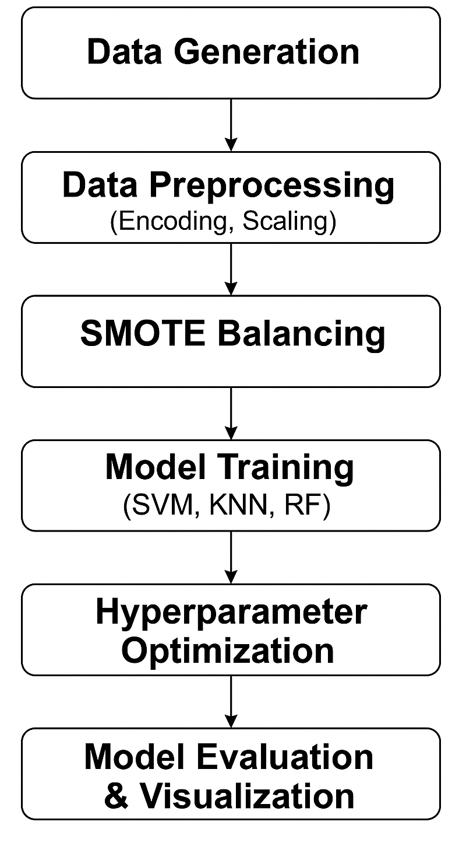
Fig. 1: System Development Flowchart

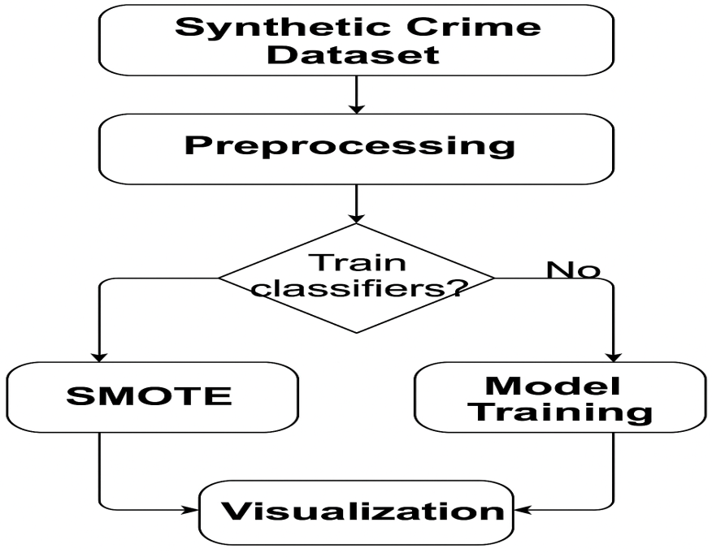

Fig. 2: Data Flow Diagram

4. Results and Discussion
The machine learning models developed for this study were evaluated after rigorous preprocessing, resampling, and hyperparameter optimization. Following Synthetic Minority Oversampling Technique (SMOTE) balancing, the dataset contained 630 instances for each of the four crime types—Kidnapping, Robbery, Rape, and Homicide—ensuring equal representation across classes.
The optimal hyperparameters obtained through GridSearchCV were as follows: for the Support Vector Machine (SVM), C=10C = 10C=10, kernel = rbf, and γ=scale\gamma = \text{scale}γ=scale; for the K-Nearest Neighbors (KNN) classifier, n_neighbors=3n\_neighbors = 3n_neighbors=3 and weights = distance; and for the Random Forest (RF) model, n_estimators=150n\_estimators = 150n_estimators=150, max_depth=None\text{max\_depth} = \text{None}max_depth=None, and min_samples_split=2\text{min\_samples\_split} = 2min_samples_split=2. The overall performance results for all classifiers are summarized in Table 2.

Table 2: Model Performance Comparison after Optimization
Model | Accuracy (%) | Precision | Recall | F1-Score
Support Vector Machine (SVM) | 66.5 | 0.64 | 0.66 | 0.64
K-Nearest Neighbors (KNN) | 71.0 | 0.70 | 0.71 | 0.67
Random Forest (RF) | 66.5 | 0.67 | 0.66 | 0.67

4.1 Model-Specific Findings
The Support Vector Machine (SVM) classifier, illustrated in Figure 3, achieved a predictive accuracy of 66.5%. It performed strongly in classifying Homicide and Rape cases (F1 = 0.83 each) but exhibited moderate recall for Kidnapping (0.31), indicating possible overlap between Kidnapping and Robbery features within the dataset.
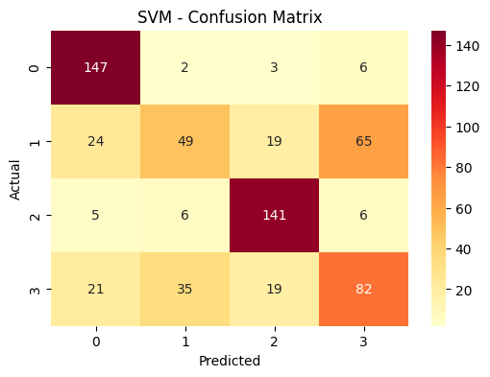
Figure 3: SVM Confusion Matrix

The KNN model (see Figure 4) demonstrated the highest accuracy of 71%. It achieved near-perfect recall for Homicide (0.99) and high F1-scores for Rape (0.82) and Robbery (0.64). However, Kidnapping remained the most difficult to classify accurately due to similarity in spatiotemporal attributes shared with Robbery events. The superior performance of KNN can be attributed to its sensitivity to local neighborhood structures, which effectively capture spatial variations in the dataset.
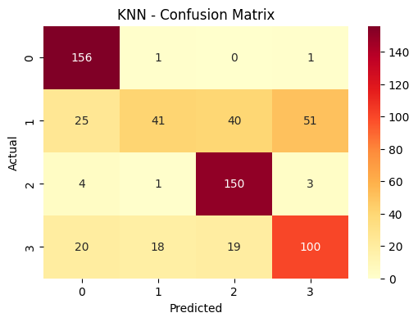
Figure 4: KNN Confusion Matrix
The Random Forest model (see Figure 5) achieved an identical accuracy of 66.5%, demonstrating balanced precision and recall across classes. Its ensemble learning capability provided stable predictions, and its feature importance metrics facilitated interpretability. Homicide (F1 = 0.87) and Rape (F1 = 0.78) were the most accurately predicted classes, suggesting that these crimes are characterized by distinct feature patterns in terms of timing, weapon used, and location.

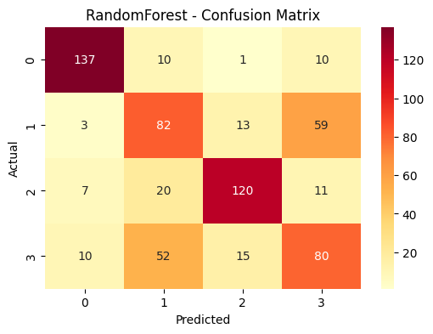
Figure 5: Random Forest Confusion Matrix

4.2 Comparative Analysis
A comparative evaluation of the three classifiers is presented in Figure 6. The results indicate that KNN achieved the highest classification accuracy, followed by SVM and Random Forest. The application of SMOTE and hyperparameter optimization through GridSearchCV significantly enhanced the models’ performance, particularly by reducing bias toward majority classes.
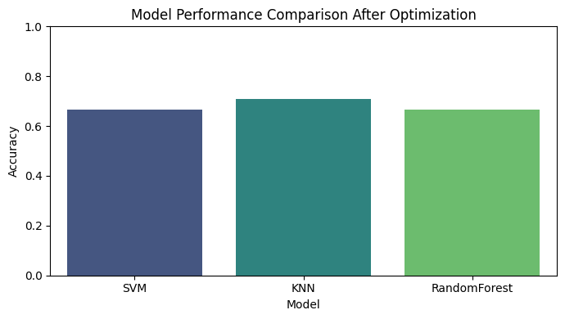

Figure 6: Model Performance Comparison after Optimization

The findings highlight that KNN’s neighborhood-based classification is more effective for datasets characterized by geographical and temporal clustering, as observed along the Kaduna–Abuja Highway. On the other hand, the comparable performance of SVM and RF reinforces the importance of tuning and ensemble methods in handling nonlinear and mixed-type crime data.

4.3 Feature Importance and Predictive Insights
Feature importance analysis conducted using the Random Forest model provided deeper insights into the predictive structure of the data. As shown in Table 3 and visualized in Figure 7, the variables month, day of week, number of victims, year, and time of day were identified as the most influential predictors of crime type.

Table 3: Top Predictive Features from Random Forest Model
Rank | Feature | Importance Score
1 | Month | 0.145
2 | Day of Week | 0.133
3 | Victims | 0.129
4 | Year | 0.123
5 | Time of Day | 0.100

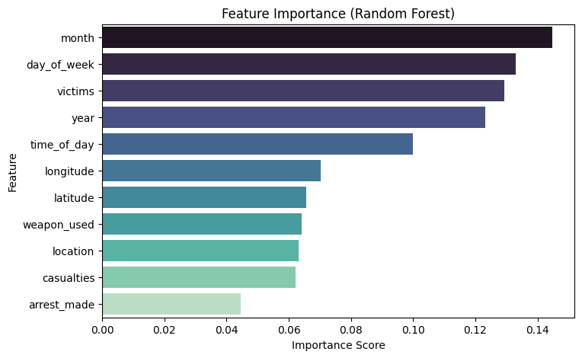

Figure 7: Feature Importance Analysis

This analysis implies that temporal and situational variables are key determinants of criminal activity along the Kaduna–Abuja corridor. For example, month and day of week correlate with movement density and socio-economic cycles, while time of day and number of victims reflect situational risk exposure. These findings align with the situational crime prevention theory, which asserts that the opportunity structure of time and place significantly influences the likelihood of criminal events.

5. Discussion
The results of the present paper prove that machine learning-based methods could be successfully able to model and predict criminal events in case that temporal, spatial, and contextual characteristics are systematically combined. The findings indicate that K-Nearest Neighbor (KNN) classifier had the best predictive accuracy (71%), as compared to the Support Vector Machine (SVM) and the Random Forest (RF). This greater performance can be explained by the nature of the KNN to model non-linear spatial-temporal relationships based on the analyzing of neighborhood proximity between feature vectors. As crimes in the Kaduna-Abuja Highway are usually concentrated in certain geographic areas as well as time frames, the focus of the algorithm on the local structure makes it especially applicable in this task.
The significance of time characteristics, namely month, day of the week, time of day as the most famous predictors supports the factual observation in the real world that crimes are regularly cyclic and seasonal. An example is that kidnapping cases are more likely to be higher during the festive or holiday seasons when there is an increase in highway traffic but cases of armed robbery are usually common during late evenings or early mornings when there is poor visibility. The predictive importance of the number of victims and year also reveals the role of the situational and longitudinal forces on criminal behavior patterns.
Practically, the outcomes emphasize that predictive analytics may be used as a side instrument of law enforcement agencies. Using predictions of the probability of certain forms of crime in terms of time and place, security operatives can be able to take a proactive approach in terms of placing patrol units in advance, covering surveillance areas more efficiently, and using resources more efficiently. In addition, the combined use of SMOTE balancing and hyperparameter optimization have shown a great improvement in model stability and fairness, which promotes the idea that despite the disparities between training data or limited data, machine learning models can provide valuable information when optimally configured.
The methodology of the study also adheres to the concept of predictive policing where algorithmic intelligence supplements the decision-making of human beings. Although the dataset used was not real-life, its structure reflected patterns that can be empirically observed, which makes it a valid testbed to show the potential of AI-based crime forecasting in the Nigerian environment. As a result, the findings open the way to introducing data-oriented approaches to crime prevention on the national and regional levels, in particular, in the high-risk transport corridors.
6. Conclusion and Future Work
In this paper, a machine learning-based predictive model was designed and tested to predict and categorize crimes along the Kaduna-Abuja Highway. Training and optimization of three supervised learning models, SVM, KNN, and Random Forest, were done using temporal, spatial, and behavioral variables in order to identify the underlying crime patterns. The overall best accuracy was experienced with the K-Nearest Neighbor classifier (71%) which substantiates the appropriateness of the model to model geographically and temporally correlated data. The interpretation of results in the Random Forest model was also easy using feature importance ranking, which serves to show that number of victims, day of the week and month are crucial factors determining whether the crime occurred.
The results highlight the possibility of data mining and artificial intelligence to be applied to policing activities to transform crime management operations toward being proactive instead of reactive. The designed framework is a prototype of employing predictive intelligence systems capable of supporting the decision-makers in the process of resources allocation, scheduling patrol, and planning the prevention of crimes.
This research will be developed in various ways in the future. To begin with, the incorporation of real and anonymized police data will increase the level of realism and external validity of the model. Second, it will be possible to visually display the hotspots of crimes along the highway dynamically by including geospatial mapping with the help of Geographic Information Systems (GIS) and remote sensing data. Third, the implementation of the model in the form of a web application created with the help of Streamlit will simplify the real-time prediction, visualization, and decision support of law enforcement agencies. Also, going into ensemble deep learning designs and explainable AI systems like SHAP and LIME would be more beneficial in increasing interpretability and accuracy of predictions.
To sum up, the study shows that crime analytics powered by machine learning can offer a strong basis of developing smart policing in Nigeria and other countries. Such systems can be used to minimize crime rates, secure transportation paths, and benefit the general feeling of security among the citizens and people who commute to work when properly applied.
References
- Abudu, A., Bello, T., & Onifade, M. (2021). Ensemble machine learning for crime detection in Northern Nigeria. Journal of Applied Data Science, 4(2), 88–99.

- Ahishakiya, E., Omulo, E. O., Taremwa, D., & Wario, R. (2017). Comparative analysis of open-source business intelligence tools for crime data analytics. International Journal of Latest Research in Engineering and Technology (IJLRET), 3(4), 58–63.

- Buczak, A., & Gifford, C. (2010). Fuzzy association rule mining for community crime pattern discovery. Proceedings of the ACM SIGKDD Workshop on Intelligence and Security Informatics.

- Council on Foreign Relations (CFR). (2023). Nigeria security tracker data summary. Retrieved from https://www.cfr.org/nigeria-security-tracker

- Hosseinkhani, J., Adeyiga, J. A., & Bello, A. O. (2014). Detecting suspicious information using crime data mining techniques. International Journal of Advanced Computer Science and Information (IJACSI), 3(1), 32–41.
- Kadhim, B., & Swadi, A. (2011). Framework for crime data analysis using decision tree and K-means algorithms. Journal of Kufa for Mathematics and Computer Science.

- Malathi, A. L., & Baboo, S. (2011). Intelligent analysis of crime data for law enforcement using data mining. International Journal of Data Engineering (IJDE), 1(5), 77–83.

- Mishra, P., Gupta, A., & Tiwari, N. (2018). Predictive modelling of urban crimes using random forest and naïve Bayes. Procedia Computer Science, 132, 420–427.

- Nigeria Security Tracker (NST). (2024). Database on conflict and criminal incidents in Nigeria (2019–2024).

- Ogunleye, F., & Adewale, K. (2022). Spatiotemporal modelling of kidnapping incidents in Northern Nigeria. African Journal of Security Informatics, 2(1), 14–27.

- Patel, D., & Bhattacharya, S. (2019). Crime prediction using support vector machines in spatiotemporal contexts. International Journal of Computational Intelligence Systems, 12(4), 567–576.

- Perry, W. L., McInnis, B., Price, C. C., Smith, S. C., & Hollywood, J. S. (2013). Predictive policing: The role of crime forecasting in law enforcement operations. RAND Corporation.

- Premium Times. (2024). Highway insecurity: Tracking rising kidnappings in Northern Nigeria.

- Punch Newspapers. (2023). Kaduna–Abuja road: 150 killed, 500 kidnapped in three years.

- RAND Corporation. (2021 & 2022). Evaluating predictive policing systems in urban environments. RAND Corporation Reports.

- Rasheed, O. A., Adeyemi, A. A., Yusuf, K. Y., & Bello, T. M. (2020). Comparison of supervised machine learning techniques in prediction of recurrence in cancer. International Journal of Medical Informatics, 4(3), 45–56.

- Rashid, M., Rahman, M., & Kabir, M. (2016). Data mining techniques for crime prediction: A comparative study. Journal of Information Security Research, 6(3), 145–153.

- United Nations Office on Drugs and Crime (UNODC). (2023). Global study on homicide and organized crime trends.

- Wang, L., Chen, Z., & Zhao, Q. (2020). Spatiotemporal deep learning model for crime event prediction. IEEE Transactions on Knowledge and Data Engineering, 32(9), 1736–1748.

