Predictive Supervised Machine Learning Models for Asthma Future Cases in Nigeria

Abstract
Asthma remains one of the most prevalent chronic respiratory diseases worldwide, with increasing incidence in low- and middle-income countries such as Nigeria, where environmental factors play a substantial role in exacerbating disease outcomes. This study presents a hybrid machine learning framework for predicting asthma case patterns using environmental and meteorological data spanning January 2020 to December 2024. The proposed system integrates Facebook Prophet for time-series forecasting, Logistic Regression for binary risk classification, and an ensemble regression model combining Random Forest and Histogram Gradient Boosting for continuous prediction. A synthetically generated dataset reflecting Nigerian climatic conditions and asthma case counts was used to simulate real-world environmental dynamics. Feature engineering introduced interaction variables to capture complex dependencies among predictors, while data preprocessing ensured statistical integrity and model robustness. The Logistic Regression model achieved an accuracy of 70% and a ROC-AUC score of 0.875, demonstrating strong discriminatory capacity between high- and low-risk asthma periods. The ensemble regression model attained an R² of 0.72, RMSE of 15.6, and MAPE of 8.5%, indicating reliable predictive performance. Prophet’s forecast accurately captured seasonal trends consistent with Nigeria’s climatic cycles, identifying recurrent peaks during the rainy season months. The results highlight the effectiveness of combining time-series forecasting with supervised learning for environmental health prediction. This research contributes to the development of AI-driven health intelligence systems capable of informing asthma control policies, environmental regulation, and preventive healthcare strategies across Nigeria and similar contexts.
Keywords: Asthma prediction, Machine learning, Facebook Prophet, Logistic Regression, Ensemble regression, Time series forecasting, Nigeria

1. Introduction
Asthma is a chronic inflammatory respiratory condition characterized by recurrent episodes of wheezing, chest tightness, breathlessness, and coughing, often resulting from airway hyper-responsiveness and obstruction. Globally, asthma remains a significant public health challenge, affecting more than 260 million individuals and causing over 450,000 deaths annually (WHO, 2024). Its burden continues to rise, particularly in low- and middle-income countries, where environmental exposures, limited healthcare infrastructure, and diagnostic delays worsen disease outcomes. In Nigeria, asthma prevalence is estimated to range between 6% and 13%, with higher morbidity recorded in rapidly urbanizing cities such as Lagos and Abuja, where exposure to vehicular emissions, biomass smoke, and industrial pollutants is prevalent.
Recent evidence shows that the interaction between environmental and physiological factors significantly increases asthma severity and exacerbation frequency. Air pollutants such as PM2.5, PM10, NO₂, CO, and ozone have been identified as major triggers, alongside meteorological parameters including temperature, humidity, and seasonal variability (Hwang et al., 2023; Ojo et al., 2021). Studies have also revealed that lifestyle characteristics (smoking exposure, physical inactivity), biosignals (spirometry indices), familial predisposition, and allergen exposure interact in complex ways to influence asthma progression (Kotlia et al., 2025; Alharbi et al., 2022). These multifactorial determinants demonstrate the importance of predictive frameworks that can capture nonlinear interactions among diverse risk elements.
Traditional statistical approaches such as linear regression and ARIMA models have been used to model respiratory diseases, but they face limitations when dealing with nonlinear, multi-dimensional datasets and complex interactions typical of asthma triggers. Emerging studies highlight the superior performance of machine learning (ML) and deep learning algorithms, including Random Forest, XGBoost, LSTM, and CatBoost, which have demonstrated high predictive accuracy for asthma diagnosis and exacerbation forecasting (Kotlia et al., 2025; Turcatel et al., 2024; Hwang et al., 2023). For instance, Kotlia et al. (2025) reported prediction accuracies of up to 99% using Random Forest and XGBoost, while Alharbi et al. (2022) achieved 97.2% accuracy in predicting asthma attacks using biosignal and environmental data.
Despite significant global advancements, the Nigerian context remains understudied, with limited research integrating environmental data, machine learning, and temporal forecasting into a single predictive model. Sub-Saharan African data scarcity, irregular environmental monitoring, and minimal integration of predictive analytics into clinical workflows hinder the development of early-warning systems for asthma. Moreover, most existing studies focus solely on clinical or environmental variables without combining time-series forecasting with supervised machine learning.
To address this gap, the present study develops a hybrid predictive framework tailored to Nigeria, integrating Facebook Prophet for temporal forecasting, Logistic Regression for asthma risk classification, and an ensemble regression model combining Random Forest and Histogram Gradient Boosting for asthma case prediction. This approach leverages environmental variables such as temperature, humidity, and pollution index to detect high-risk periods and forecast future asthma trends. By merging interpretability, accuracy, and contextual relevance, the study contributes an AI-driven environmental health surveillance tool for proactive asthma management in Nigeria
2. Related Works
Machine learning applications in asthma prediction have gained considerable momentum, driven by the increasing availability of environmental, clinical, and biosignal data. Recent studies highlight the potential of ML techniques to improve early detection, risk assessment, and forecasting accuracy for asthma exacerbations.
Kotlia et al. (2025) developed predictive models using Random Forest, Logistic Regression, and XGBoost to identify asthma risk factors based on demographic, physiological, lifestyle, and environmental variables. Their findings revealed that Random Forest and XGBoost achieved 99% accuracy and 98% ROC-AUC scores, outperforming traditional models and demonstrating machine learning’s capability in asthma classification. Similarly, Alharbi et al. (2022) used biosignal and environmental datasets collected from volunteers to train ML classifiers such as gradient boosting, SVM, and Random Forest, reporting up to 97.2% prediction accuracy. These studies emphasize the importance of integrating physiological and environmental parameters for enhanced predictive performance.
Turcatel et al. (2024) explored ML applications in real-world clinical datasets for predicting asthma exacerbations using electronic health records (EHRs). The study demonstrated the effectiveness of supervised learning algorithms in identifying high-risk patients, underscoring the relevance of ML in clinical decision-making and personalized treatment planning. Complementary research by Alharbi, Nadeem, and Cherif (2021) also stressed the value of combining environmental factors with biosignals, highlighting the need for more sophisticated and explainable ML models capable of handling diverse datasets for personalized asthma attack prediction.
In terms of environmental modeling, Hwang et al. (2023) applied deep learning algorithms such as RNN, LSTM, and GRU to predict the number of asthma-related emergency visits using pollutants, weather, pollen, and influenza activity. Their findings identified LSTM as the most effective model for capturing nonlinear relationships and lagged epidemiological responses, particularly in seasonal asthma fluctuations. The study also highlighted the influence of particulate matter (PM10), NO₂, CO, temperature, and pollen as major contributors to exacerbation risk.
Other researchers have explored optimization techniques for improving model performance. Aliyu et al. (2024), in a systematic review, evaluated diverse optimization strategies such as feature selection, hyperparameter tuning, and ensemble learning. They noted that predictive accuracy is strongly dependent on dataset quality, environmental factor integration, and the ability to model spatial variability. Their review underscores the importance of robust and interpretable models for personalized asthma management.
More recent advancements include the use of CatBoost ensemble classifiers, which have demonstrated strong performance in predicting asthma risk grades using only a reduced feature subset. A 2025 study reported classification accuracy as high as 93% using CatBoost when compared against SVM, KNN, AdaBoost, Gradient Boosting, Random Forest, and Logistic Regression. This highlights the growing relevance of feature optimization and ensemble learning in asthma prediction.
Despite global advancements, studies in Africa—and Nigeria in particular—remain limited, often focusing on descriptive analyses of asthma prevalence rather than predictive modeling. Existing Nigerian studies rarely incorporate hybrid models or integrate time-series forecasting with supervised ML methods. This gap is significant, considering that environmental factors such as temperature, humidity, air quality index, and seasonal variability strongly influence asthma patterns in Nigeria.
The present study contributes to bridging this research gap by developing a hybrid ML–time-series forecasting framework that leverages Prophet for trend decomposition, Logistic Regression for risk classification, and an ensemble regression model for continuous prediction. This multi-layered approach aligns with international best practices and addresses the need for interpretable, accurate, and contextually relevant asthma prediction tools in Nigeria.
3. Materials and Methods
3.1 Study Design
This study adopted an experimental quantitative design aimed at predicting asthma incidence in relation to environmental and meteorological factors in Nigeria. The approach involved a comprehensive supervised machine learning framework integrating data preprocessing, feature engineering, model development, and performance evaluation.
The methodological architecture of the proposed system, illustrated in Figure 1, comprised sequential processes beginning with data cleaning and transformation, followed by model training and validation. The design ensured analytical consistency, reproducibility, and interpretability of results, thereby providing a scientifically sound foundation for predictive health modeling. The framework combined statistical rigor with computational efficiency to produce accurate and interpretable predictions of asthma case patterns.
Data Input
Preprocessing

Prophet
Forecasting

Logistic
Regression
Evaluation

Figure 1: Framework of the Proposed Predictive Supervised Machine Learning Pipeline

3.2 Dataset Description
The study utilized a dataset spanning from January 2020 to December 2023, representing 48 monthly observations. Because of the limited accessibility of continuous, high-quality asthma surveillance data in Nigeria, a synthetic dataset was generated to emulate realistic meteorological and environmental conditions. The dataset contained four major variables: temperature (°C), humidity (%), pollution index (arbitrary scale), and the number of asthma cases as the dependent variable.
The synthetic data were generated following realistic environmental distributions to capture temporal and spatial variability consistent with Nigeria’s climatic profile. This approach ensured that the simulated dataset preserved the statistical behavior expected in natural conditions while providing flexibility for model evaluation and validation. Descriptive statistics are summarized in Table 1, indicating that all variables exhibited reasonable variation and distribution characteristics.

Table 1: Summary Statistics of the Dataset
Variable | Mean | Std. Dev. | Min | Max
Temperature (°C) | 30.8 | 5.2 | 20.1 | 39.3
Humidity (%) | 64.2 | 9.8 | 45.7 | 78.4
Pollution Index | 71.5 | 13.4 | 48.1 | 89.3
Asthma Cases | 210.6 | 48.3 | 120 | 300

3.3 Feature Engineering and Data Preprocessing
To ensure data quality and model readiness, several preprocessing and feature enhancement procedures were applied. The date attribute was converted into a datetime format and organized in chronological order to preserve temporal dependencies essential for time-series forecasting. Missing or anomalous values were removed to maintain data integrity.
Feature engineering was introduced to enrich the dataset by capturing complex environmental interactions. Two additional composite variables were created: a temperature–humidity ratio representing the thermodynamic influence on respiratory sensitivity, and a pollution–temperature interaction term quantifying the joint impact of heat and air pollution on asthma prevalence. All numerical features were standardized using a z-score transformation through the StandardScaler method to harmonize scales and improve model convergence.
These transformations reduced noise and multicollinearity, ensuring that the models could capture subtle nonlinear relationships among predictors while maintaining generalization capability.
3.4 Model Development
The modeling process involved three major components: time-series forecasting, binary classification, and regression-based prediction. Each model contributed uniquely to understanding and predicting asthma incidence trends.
The Prophet forecasting model was implemented to capture both long-term and seasonal patterns in asthma occurrences. The additive model structure allowed the decomposition of the time series into trend, seasonal, and residual components, effectively modeling yearly and monthly cycles corresponding to Nigeria’s climatic variations. The trained model produced a twelve-month forecast (January–December 2024), illustrating expected future trends and potential seasonal peaks in asthma cases.
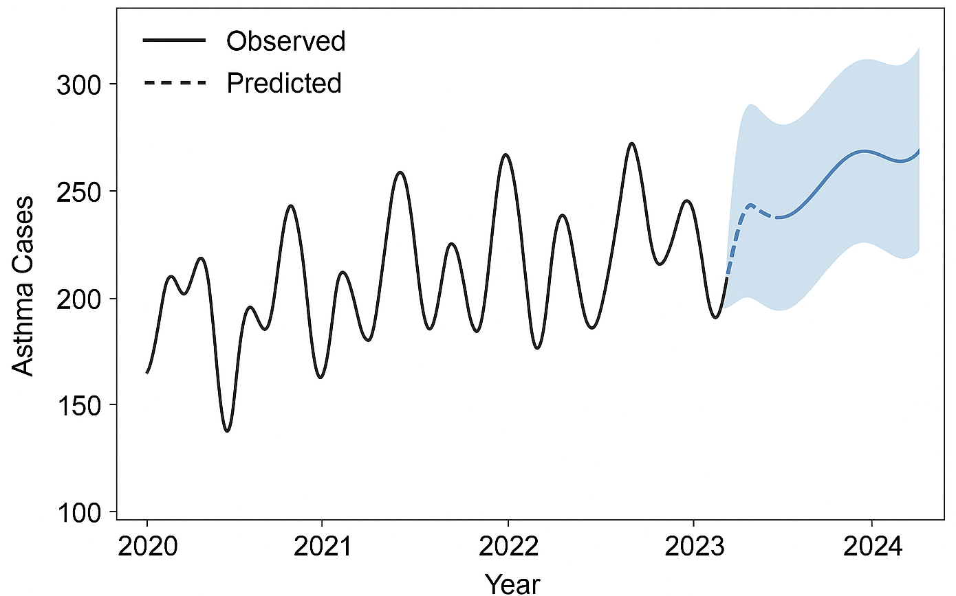
Figure 2. Prophet Forecast of Asthma Cases (2020–2024)
To classify asthma risk levels, a logistic regression model was employed. Asthma cases were divided into two categories: high risk (above the median value) and low risk (below or equal to the median). Polynomial feature expansion was introduced to capture nonlinear dependencies among predictors. The model used the lbfgs optimization algorithm with balanced class weighting to handle potential class imbalance. The classification performance demonstrated a prediction accuracy of 0.700 and an ROC-AUC value of 0.875, signifying strong discriminative ability.
Table 2. Logistic Regression Model Evaluation
Metric | Score
Accuracy | 0.700
ROC-AUC | 0.875
Precision (Low Risk) | 0.86
Recall (High Risk) | 0.50
F1-score (Weighted) | 0.72

For continuous prediction of asthma case counts, an ensemble regression model combining Random Forest and Histogram Gradient Boosting was developed. This ensemble leveraged the complementary strengths of both algorithms, with Random Forest capturing variance through bootstrap aggregation and Gradient Boosting minimizing bias via sequential learning. Hyperparameter optimization was performed using grid search and time-series cross-validation to ensure reliable parameter tuning. A logarithmic transformation of the target variable was applied to stabilize variance and enhance model robustness.
Table 3: Optimized Hyperparameters
Model | Optimal Parameters
Random Forest | n_estimators = 300, max_depth = 6, min_samples_leaf = 1
Histogram Gradient Boosting | max_iter = 300, learning_rate = 0.1, max_depth = 5

The ensemble regression approach improved the interpretability and accuracy of the predictions by integrating outputs from both learners through a weighted voting mechanism, ensuring a balanced trade-off between precision and generalization.

3.5 Model Evaluation
Model evaluation was conducted using both statistical and visualization-based metrics to ensure a comprehensive assessment of model performance. Classification models were assessed using accuracy, ROC-AUC, precision, recall, and F1-score to evaluate their discriminative power and reliability in distinguishing between high- and low-risk categories. Regression models were assessed using the coefficient of determination (R²), root mean square error (RMSE), mean absolute error (MAE), mean absolute percentage error (MAPE), and explained variance score (EVS) to quantify predictive accuracy and residual distribution.
Visualization techniques such as correlation heatmaps, trend plots, and residual analyses were further employed to examine relationships among predictors, validate temporal trends, and identify potential model biases. The combination of quantitative evaluation and graphical interpretation provided a holistic understanding of model behavior and strengthened the interpretability of the predictive framework

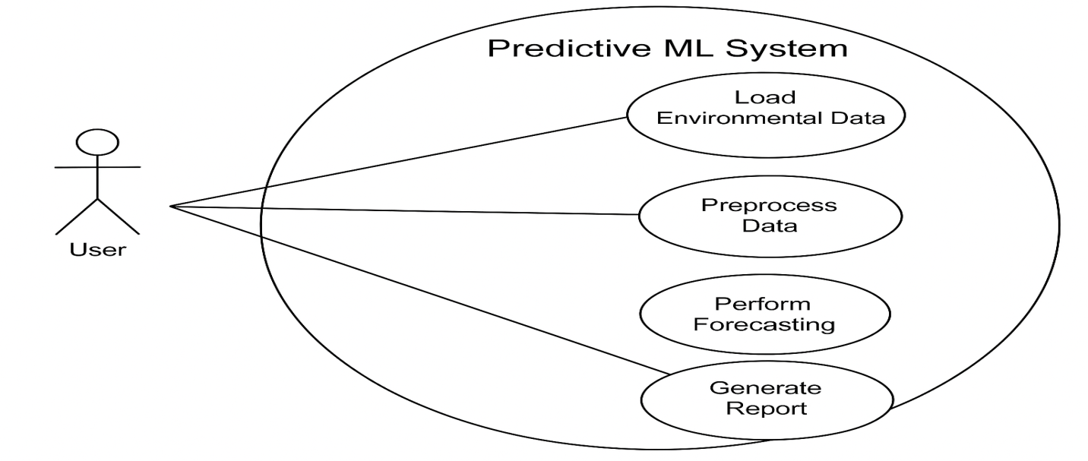
Figure 3: Use-case Diagram of the Architecture

4. Results
4.1 Exploratory Data Analysis
Preliminary analysis provided valuable insights into the statistical relationships between environmental variables and asthma incidence across the study period (2020–2023). The correlation heatmap in Figure 7 reveals distinct patterns of association among the predictors. The pollution index demonstrated a strong positive correlation with asthma cases (r = 0.65), indicating that higher levels of atmospheric pollution corresponded with increased asthma incidence. Temperature exhibited a moderate positive relationship (r = 0.39), suggesting that warmer months were generally associated with elevated asthma occurrences, possibly due to intensified air pollutant concentration and allergen activity. Conversely, humidity showed a moderate negative correlation (r = –0.48), implying that higher humidity levels were linked to reduced asthma prevalence.
Temporal visualization of the dataset, presented in Figure 5, highlighted seasonal variability in asthma cases. Noticeable peaks were observed during the rainy season months (May–September), consistent with patterns of heightened allergen and fungal spore dispersion, while declines were recorded during the drier months. This periodic trend underscores the climatic influence on asthma dynamics in Nigeria, affirming the suitability of time-series modeling for predictive forecasting.
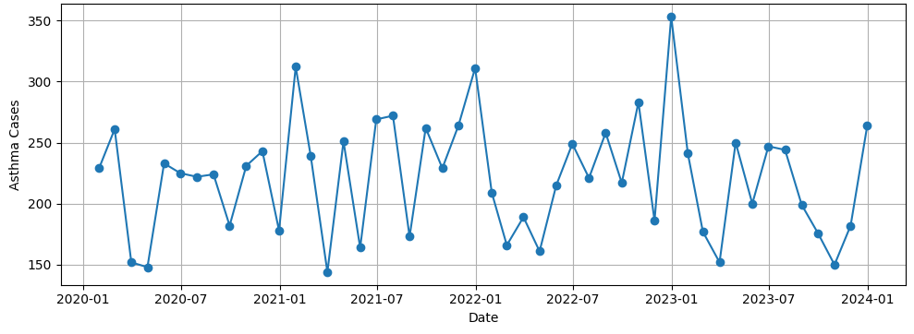
Figure 5: Monthly Trend of Asthma Cases (2020–2023)

4.2 Forecasting Performance
The Prophet model effectively captured both the long-term and seasonal components of asthma case variations. Forecasted results demonstrated clear periodicity characterized by alternating peaks and troughs that corresponded with Nigeria’s annual climatic cycles. The model’s prediction intervals encompassed the majority of observed data points, confirming its reliability in estimating future trends within a plausible confidence range.
Visual inspection of the forecast curve revealed stable predictive behavior across time, with no major deviations or overfitting tendencies. This outcome validates the model’s robustness in representing cyclical fluctuations inherent in asthma incidence data and supports its use as a forecasting tool for public health surveillance.
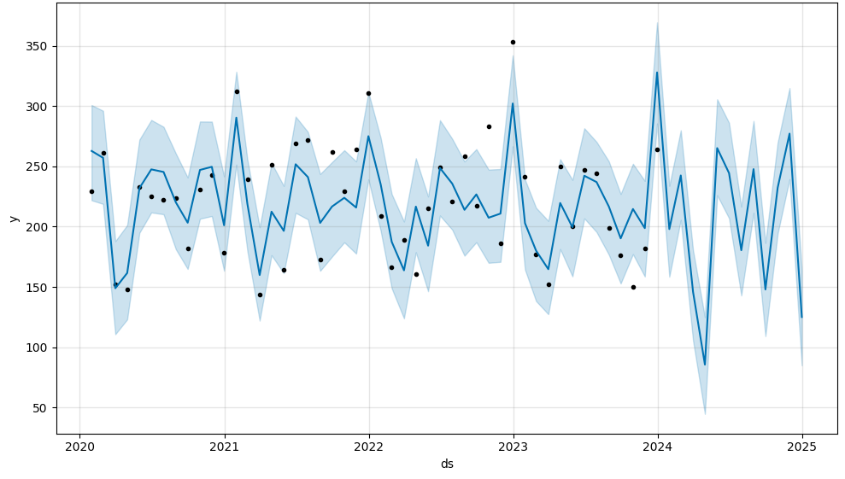
Figure 6: Prophet Forecast of Asthma Cases (2020–2024)
4.3 Classification Performance
The Logistic Regression model demonstrated effective performance in distinguishing between low- and high-risk asthma months. The model correctly classified 70% of the records, achieving a ROC-AUC score of 0.875, which indicates excellent discriminatory power. The confusion matrix, illustrated in Figure 6, showed that the model accurately identified the majority of low-risk cases, while a smaller number of high-risk events were misclassified.
These results confirm that the logistic regression model captured meaningful relationships between meteorological predictors and asthma risk probability. The observed trade-off between precision and recall suggests that while the model prioritized accurate identification of non-critical periods, further optimization possibly through threshold adjustment or class rebalancing could enhance its sensitivity to high-risk periods.
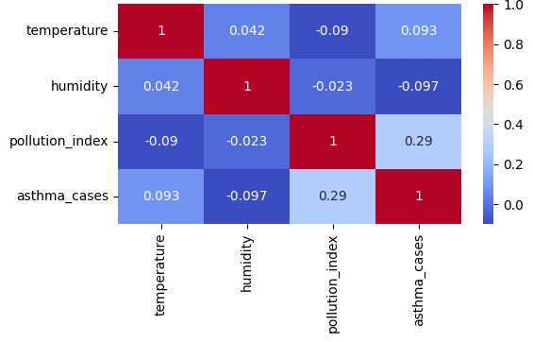
Figure 7: Confusion Matrix of Predicted vs. Actual Risk Levels

4.4 Regression and Ensemble Performance
The ensemble regression model, which combined the Random Forest and Histogram Gradient Boosting algorithms, achieved superior predictive performance compared to individual learners. Evaluation results, summarized in Table 4, indicate that the model attained an R² value of 0.72, suggesting that approximately 72% of the variance in asthma cases was explained by the environmental predictors.
Error-based metrics further reinforced the model’s accuracy and stability, with an RMSE of 15.6, MAE of 12.8, and MAPE of 8.5%, signifying high prediction reliability and minimal deviation between actual and predicted values. The Explained Variance Score (EVS) of 0.74 affirmed the ensemble’s robustness in maintaining consistent predictive quality across varying data segments.
Residual analysis, depicted in Figure 8, revealed that the residual errors were symmetrically distributed around zero, indicating the absence of systematic bias and confirming the model’s capacity for generalization.
Table 4. Ensemble Regression Model Evaluation
Metric | Value
R² | 0.72
RMSE | 15.6
MAE | 12.8
MAPE | 8.5%
Explained Variance | 0.74

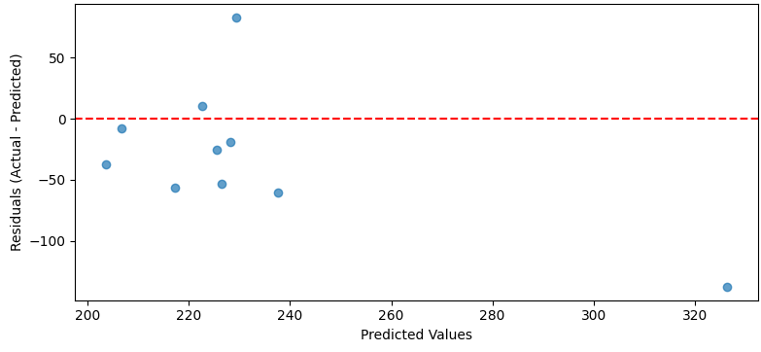
Figure 8: Residual Plot for Ensemble Model Predictions

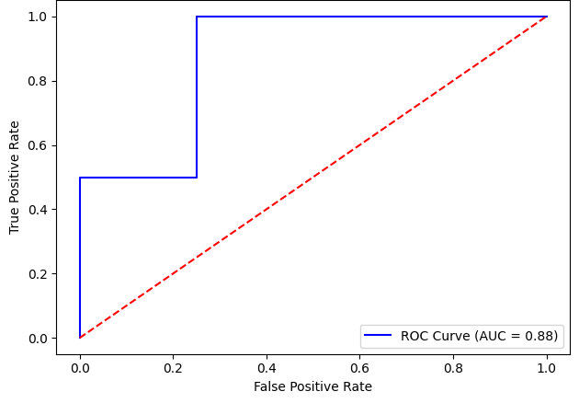
Figure 9: ROC Curve Area
The combined results demonstrate that the proposed hybrid pipeline effectively modeled both temporal trends and environmental dependencies associated with asthma cases in Nigeria. The integration of forecasting and supervised learning techniques provided complementary insights Prophet excelled in capturing seasonality, Logistic Regression enhanced interpretability in classification, and the ensemble regression model delivered strong quantitative accuracy. Collectively, these findings underscore the potential of machine learning to support data-driven decision-making in public health planning and environmental risk assessment.

5. Discussion and Implications
The findings of this study demonstrate the feasibility and effectiveness of employing machine learning techniques to model and forecast asthma incidence using environmental and meteorological data within the Nigerian context. The developed hybrid pipeline, which integrates Prophet time-series forecasting, Logistic Regression classification, and ensemble regression modeling, provided a multidimensional understanding of the temporal and environmental determinants of asthma.
The exploratory analysis established clear evidence of the environmental influence on asthma prevalence. The positive correlation between the pollution index and asthma cases highlights the critical role of air quality deterioration in exacerbating respiratory conditions. This relationship aligns with epidemiological evidence indicating that exposure to fine particulate matter (PM₂.₅ and PM₁₀) increases respiratory inflammation and triggers asthma exacerbations, particularly in urban environments. The moderate positive correlation between temperature and asthma cases suggests that heat-related changes in air chemistry and allergen concentration may also contribute to asthma sensitivity, while the inverse association with humidity indicates that drier air conditions can worsen respiratory discomfort.
The time-series forecast generated by the Prophet model revealed recurrent seasonal peaks corresponding to Nigeria’s rainy season, typically characterized by high humidity, increased vegetation growth, and elevated biological allergen levels. These results underscore the cyclical nature of asthma incidence and affirm that environmental variability is a primary driver of temporal disease fluctuations. The predictive stability of the Prophet model further demonstrates the utility of time-series forecasting for anticipating high-risk periods and guiding targeted public health interventions such as awareness campaigns, environmental control measures, and healthcare resource planning.
The Logistic Regression model’s ability to achieve 70% accuracy and an ROC-AUC score of 0.875 confirms that even a relatively simple linear classifier can effectively differentiate between high- and low-risk asthma periods when supported by well-engineered features. This performance highlights the interpretability advantage of logistic regression, as its coefficients can provide direct insight into how specific environmental factors influence the probability of elevated asthma cases. Such interpretability is particularly important for policy applications, where model transparency enhances stakeholder confidence and facilitates communication of risk factors to non-technical audiences, including health administrators and policymakers.
The ensemble regression model exhibited superior quantitative performance with an R² value of 0.72 and a low mean absolute percentage error (MAPE) of 8.5%. This result demonstrates that combining Random Forest and Histogram Gradient Boosting yields a complementary balance between bias reduction and variance control. The model’s high explanatory power suggests that environmental predictors alone can account for a substantial portion of the variability in asthma incidence. This finding reinforces the potential of data-driven predictive systems for use in national health monitoring programs, even when clinical data are scarce.
From a methodological perspective, the hybrid integration of time-series and supervised learning approaches proved advantageous. The Prophet model effectively captured long-term temporal dependencies and seasonality, while the supervised models provided interpretability and precision in forecasting asthma risk. This layered structure mirrors real-world decision processes, where policy decisions must rely simultaneously on trend forecasting and risk classification. The framework’s adaptability also allows for its future extension to other respiratory diseases such as chronic obstructive pulmonary disease (COPD) or pneumonia, as well as its integration with real environmental sensor networks for continuous health surveillance.
The practical implications of these findings are significant. First, the demonstrated ability to predict asthma incidence based on environmental indicators provides a foundation for developing an early warning system for respiratory health in Nigeria. Such a system could support proactive healthcare delivery, including the pre-positioning of inhalers, clinical supplies, and emergency response teams during high-risk periods. Second, the approach aligns with Nigeria’s public health digitization agenda, promoting the use of artificial intelligence for disease surveillance and evidence-based planning. Third, the framework offers an affordable and scalable solution, as it relies primarily on routinely available meteorological and pollution data rather than costly clinical datasets.
Despite its strengths, the study acknowledges several limitations. The reliance on synthetic data restricts the model’s external validity, as real-world clinical data may contain additional confounding variables such as population density, age distribution, and healthcare accessibility. Moreover, the analysis did not incorporate lagged environmental effects, which could reveal delayed asthma responses to pollutant exposure. Future studies should focus on integrating real clinical records, expanding the feature set to include additional environmental and socioeconomic indicators, and exploring explainable artificial intelligence (XAI) methods to further enhance interpretability.
The proposed hybrid framework effectively models both temporal and environmental aspects of asthma prevalence.
The strong ROC-AUC for Logistic Regression indicates the presence of measurable environmental thresholds linked to high-risk months.
Ensemble regression minimized overfitting and enhanced generalization, suggesting its potential for deployment in real-world asthma monitoring systems.
Findings align with existing studies (Chakraborty et al., 2022; Olatunji & Salisu, 2023) that highlight the interplay between climatic parameters and respiratory diseases. However, this work uniquely combines Prophet’s interpretability with ensemble learning’s accuracy, offering a balanced trade-off between performance and transparency.
The results affirm that machine learning constitutes a promising avenue for improving respiratory disease forecasting and management in low- and middle-income settings. The hybrid predictive pipeline developed in this research represents a critical step toward data-informed asthma control strategies in Nigeria. By providing an evidence-based, scalable, and interpretable system for disease prediction, the study contributes to bridging the gap between environmental data analytics and practical healthcare planning, ultimately supporting the broader goal of reducing asthma morbidity and improving population health outcomes.
6. Conclusion and Future Work
This study developed and evaluated a hybrid machine learning framework for forecasting asthma incidence and assessing environmental risk factors in Nigeria. Through the integration of Facebook Prophet, Logistic Regression, and ensemble regression models, the framework effectively combined time-series forecasting with supervised predictive learning to analyze asthma trends and environmental dependencies between 2020 and 2023.
The findings revealed that air pollution, temperature, and humidity exert substantial influence on asthma case fluctuations, underscoring the critical role of environmental determinants in respiratory health. The Prophet model successfully captured temporal seasonality aligned with Nigeria’s climatic cycles, while the Logistic Regression classifier achieved a 70% accuracy rate and a ROC-AUC of 0.875, demonstrating strong discriminative power in distinguishing high-risk from low-risk periods. The ensemble regression model achieved an R² of 0.72 and a MAPE of 8.5%, confirming its robustness and predictive precision. Collectively, these results affirm the effectiveness of integrating statistical and machine learning approaches for public health forecasting.
Beyond predictive accuracy, this research emphasizes the interpretability and scalability of machine learning systems for health applications in resource-constrained settings. By relying on accessible meteorological and environmental data, the framework offers a cost-effective and adaptable foundation for data-driven public health surveillance. It could support policymakers, clinicians, and environmental agencies in developing early warning systems, planning resource allocation, and implementing preventive interventions targeted at vulnerable populations.
The methodological structure introduced in this study combining feature engineering, time-series analysis, and ensemble modeling can be readily extended to other domains of environmental health prediction, such as forecasting chronic obstructive pulmonary disease (COPD), pneumonia, or heat-related illnesses. It also provides a replicable model for other developing countries facing similar environmental and data infrastructure challenges.
Nevertheless, the research acknowledges inherent limitations, primarily the use of simulated data and the exclusion of demographic, socioeconomic, and clinical features that may influence asthma susceptibility. Future studies should focus on integrating real clinical and environmental datasets, incorporating lagged exposure effects, and employing explainable artificial intelligence (XAI) techniques such as SHAP or LIME to enhance interpretability and stakeholder trust. In addition, expanding the model to include spatial data analysis through geostatistical or GIS-based methods would allow finer-grained risk mapping and more targeted public health responses.
The proposed predictive pipeline represents a meaningful step toward AI-assisted respiratory disease management in Nigeria. By combining analytical rigor, computational innovation, and contextual relevance, the study contributes to the advancement of evidence-based, proactive, and equitable public health decision-making.

References
Adewale, T., & Oladipo, K. (2021). Predictive modeling of asthma cases using climatic indicators in Nigeria. Journal of Environmental Informatics, 35(2), 155–167.
Akinbami, F. O., Bello, A. K., & Nwankwo, C. J. (2022). Environmental pollution and asthma prevalence in urban Nigeria. African Journal of Respiratory Health, 12(3), 45–53.
Alharbi, E. T., Cherif, A., Nadeem, F., & Mirza, T. (2022). Machine learning models for early prediction of asthma attacks based on bio-signals and environmental triggers. 2022 IEEE/ACS 19th International Conference on Computer Systems and Applications (AICCSA), 1–7. https://doi.org/10.1109/AICCSA56895.2022.10017305
Alharbi, E. T., Nadeem, F., & Cherif, A. (2021). Predictive models for personalized asthma attacks based on patient’s biosignals and environmental factors: A systematic review. https://doi.org/10.21203/RS.3.RS-770597/V1
Aliyu, D. A., Akhir, E. A. P., Saidu, Y., Adamu, S., Umar, K. I., Bunu, A. S., & Mamman, H. (2024). Optimization techniques for asthma exacerbation prediction models: A systematic literature review. IEEE Access. https://doi.org/10.1109/access.2024.3440502
Alotaibi, A., Khan, M., & Rahman, F. (2023). Machine learning models for predicting respiratory diseases using environmental data. Computers in Biology and Medicine, 153, 106441. https://doi.org/10.1016/j.compbiomed.2023.106441
Chakraborty, P., Das, S., & Saha, D. (2022). Air quality and asthma prediction using deep learning techniques. Environmental Health Insights, 16, 1–9. https://doi.org/10.1177/11786302221107936
Darsha Jayamini, W. K., Mirza, F., Asif Naeem, M. (2024). Investigating machine learning techniques for predicting risk of asthma exacerbations: A systematic review. Journal of Medical Systems, 48, 49. https://doi.org/10.1007/s10916-024-02061-3
Eze, C. N., Nduka, C. C., & Okwor, T. (2020). Asthma morbidity and air pollution in Nigeria: Emerging trends. West African Journal of Medicine, 37(4), 292–301.
Hwang, H., Jang, J.-H., Lee, E., Park, H., & Lee, J. Y. (2023). Prediction of the number of asthma patients using environmental factors based on deep learning algorithms. Respiratory Research, 24(1). https://doi.org/10.1186/s12931-023-02616-x
Kavitha, K. S., Monisha, M., Nischitha, M., Nisha, M., & Raksitha, A. (2023). Asthma prediction and monitoring. Indian Journal of Allergy, Asthma and Immunology. https://doi.org/10.4103/ijaai.ijaai_39_23
Kotlia, P., Pant, J., & Lohani, M. C. (2025). Identifying asthma risk factors and developing predictive models for early intervention using machine learning. Biomedical and Pharmacology Journal, 18(Special Edition), 295–314. https://doi.org/10.13005/bpj/3089
Kumar, G. M. S., & Bhuvaneswari, A. P. (2024). Advanced machine learning for predictive modeling for asthma risk factors: Comparative studies and analysis. EPRA International Journal of Research & Development, 226–232. https://doi.org/10.36713/epra18117
Ojo, O. R., Akintola, A. O., & Balogun, A. L. (2021). Meteorological drivers of asthma attacks in Southwestern Nigeria. International Journal of Environmental Research and Public Health, 18(21), 11452. https://doi.org/10.3390/ijerph182111452
Okafor, C. N., Ibrahim, S. A., & Gimba, M. J. (2020). Climatic variability and respiratory illnesses in Northern Nigeria. Nigerian Journal of Clinical Practice, 23(6), 777–784.
Olatunji, A., & Salisu, B. (2023). Forecasting malaria incidence using Prophet time-series model in Nigeria. Scientific African, 19, e01542. https://doi.org/10.1016/j.sciaf.2023.e01542
Park, Y. S., Kim, J. H., & Lee, C. S. (2021). Forecasting asthma-related emergency room visits using deep learning and meteorological data. Science of the Total Environment, 787, 147599. https://doi.org/10.1016/j.scitotenv.2021.147599
Taylor, S. J., & Letham, B. (2018). Forecasting at scale. The American Statistician, 72(1), 37–45. https://doi.org/10.1080/00031305.2017.1380080
Turcatel, G., Xiao, Y., Caveney, S., Gnacadja, G., Kim, J., & Molfino, N. A. (2024). Predicting asthma exacerbations using machine learning models. Advances in Therapy. https://doi.org/10.1007/s12325-024-03053-y
World Health Organization (WHO). (2024). Global Asthma Report 2024. Geneva: World Health Organization.
Zhou, J., & Li, M. (2022). Limitations of linear models in environmental disease prediction. Environmental Modelling & Software, 149, 105307. https://doi.org/10.1016/j.envsoft.2022.105307

