A Real-Time Multi-Lingual Android System Application Translator: Integrating Text and Voice Recognition for Seamless Cross-Language Communication

Abstract
In an increasingly interconnected global environment, the need for seamless multilingual communication via mobile devices is growing. This paper presents the design, development, and evaluation of a real-time multi-lingual Android system application translator (RT-MLAST) which integrates both text and voice recognition capabilities to convert spoken or typed input in one language to spoken and/or written output in a target language. The system pipeline comprises automatic speech recognition (ASR), neural machine translation (NMT), and text-to-speech (TTS) modules, augmented by language detection and multilingual support features. The contributions of this work include a mobile-device real-time translator architecture, empirical measurements in the Android domain, and insights for deploying multilingual systems on resource-constrained devices. The discussion implications for global communication, tourism, education and propose directions for future work.
Keywords: real-time translation, multilingual mobile app, speech recognition, neural machine translation, Android application, text-to-speech

1 Introduction
In the contemporary digital era, multilingual communication has become a crucial aspect of global interaction. The world is now more interconnected than ever through international travel, cross-border business, online collaboration, and migration. This globalization has significantly increased the need for seamless communication across languages (Albrecht et al., 2013 and Emmanuel, 2024). Language differences, however, remain a persistent barrier in various sectors such as healthcare, education, tourism, and commerce. Traditional translation approaches—such as human interpreters and manual text translation while accurate, are often expensive, time-consuming, and impractical for spontaneous, everyday interactions (Hwang et al., 2021). Consequently, the development of automated translation technologies capable of real-time and multi-lingual operation has become essential.
Mobile devices, particularly Android smartphones, have emerged as powerful tools for language translation due to their computational capacity, ubiquitous availability, and integration of advanced sensors, including microphones and cameras (Paul et al., 2008). The widespread accessibility of smartphones enables developers to build intelligent systems that leverage machine learning algorithms and artificial intelligence for real-time speech and text translation (Johnson et al., 2016). The portability and computational ability of these devices make them ideal for translation systems designed to operate in diverse environments with minimal infrastructure requirements. The integration of voice and text recognition features in translation applications provides users with a more natural and intuitive means of communication, aligning with human conversational habits.
The proposed research, titled A Real-Time Multi-Lingual Android System Application Translator with Text and Voice Recognition Capability, aims to design and evaluate a mobile application that can translate both spoken and written language input into another language in real time. The application will support multiple languages and integrate automatic speech recognition (ASR), neural machine translation (NMT), and text-to-speech (TTS) technologies to achieve this objective. The system’s ability to process both text and speech input, translate content accurately, and generate speech output in another language can bridge communication gaps in multilingual settings, particularly in regions where language diversity is high and interpreter availability is limited.
Mobile translation technologies have evolved significantly over the last decade. Early systems were limited to text-based translations and relied heavily on internet connectivity, which restricted their usefulness in low-connectivity environments (Paul et al., 2008). Advances in neural networks and machine learning, particularly in NMT, have enhanced translation accuracy and speed. According to Johnson et al. (2016), the introduction of multilingual neural machine translation systems by Google demonstrated the feasibility of “zero-shot translation,” enabling translation between languages pairs not explicitly trained together. These innovations form the foundation for building multilingual translation systems that can operate effectively on mobile devices. However, challenges remain in achieving real-time performance, low latency, and high translation quality across diverse languages and dialects.
Existing translation applications, such as Google Translate and Microsoft Translator, have made substantial progress in integrating text and voice translation (Wu et al., 2016). Nonetheless, these applications often depend on stable internet connections and perform best with high-resource languages like English, Spanish, and French, while struggling with low-resource languages or regional dialects (Agarwal and Singh, 2020). Additionally, their reliance on cloud processing can lead to latency issues and privacy concerns in sensitive domains like healthcare (Hwang et al., 2021). There is, therefore, a growing research interest in developing offline or hybrid translation applications that can function efficiently on mobile platforms without constant connectivity.
Real-time translation systems require the seamless interaction of three core modules: automatic speech recognition (ASR), neural machine translation (NMT), and text-to-speech (TTS). ASR converts spoken input into text, which is then processed by an NMT model to translate the content into the target language. Finally, the translated text is rendered as audio output using TTS technology. Research in multilingual ASR has demonstrated promising results, particularly with end-to-end deep learning models capable of transcribing speech in multiple languages (Li et al., 2022). These advances, combined with efficient NMT algorithms, make it feasible to implement real-time translation on mobile devices. However, practical deployment on Android systems presents challenges such as computational limitations, battery consumption, and latency optimization.
Beyond technological innovation, the social and economic relevance of mobile multilingual translation systems is immense. In healthcare, for instance, patients and medical practitioners frequently experience communication difficulties due to language barriers. Albrecht et al. (2013) observed that the use of multilingual mobile translation applications improved patient-provider communication when professional interpreters were unavailable, although they cautioned against over-reliance due to potential inaccuracies. Similarly, in tourism, mobile translation applications can facilitate smoother interactions between tourists and locals, enhancing travel experiences and cultural exchange (Agarwal and Singh, 2020). In education, translation tools can assist multilingual students in understanding instructional materials in their preferred language, promoting inclusive learning environments.
Despite the growing body of research in multilingual translation, there is limited empirical evidence evaluating the performance of real-time translation applications that integrate both text and voice recognition on mobile platforms. Many studies focus on either the speech recognition or translation component independently, neglecting the combined performance in real-time interactive settings (Li et al., 2022). Furthermore, while commercial systems exist, their proprietary nature limits academic evaluation and replication. This gap highlights the need for open, research-oriented models that assess system performance in terms of latency, accuracy, and user experience.
This research therefore addresses several critical questions. First, can a mobile-based system combining ASR, NMT, and TTS modules deliver real-time translation with acceptable latency and accuracy? Second, how well can such a system handle multiple languages, including low-resource ones, while maintaining usability on mobile devices? Third, what are the practical challenges in implementing such a system, and how can they be mitigated through design optimization and user interface improvements? By exploring these questions, this study seeks to contribute both technical and empirical knowledge to the field of mobile language translation systems.

2 Literature Review
The field of real-time multilingual translation has evolved significantly over the last two decades, driven by advances in artificial intelligence (AI), natural language processing (NLP), and mobile computing. The integration of automatic speech recognition (ASR), neural machine translation (NMT), and text-to-speech (TTS) technologies has enabled applications capable of translating speech and text in real time, often within compact mobile systems. This section reviews key developments across these areas, including prior studies on multilingual mobile translation applications, theoretical frameworks for language processing, and emerging trends in mobile translation technologies.
Multilingual translation systems are built upon the interaction of three main components: speech recognition, machine translation, and speech synthesis. These components represent sequential stages in the translation pipeline: capturing spoken input, converting it into text, translating it into another language, and then generating speech output (Li et al., 2022). The underlying theoretical framework draws heavily from computational linguistics and AI-based language modeling.
Traditional statistical machine translation (SMT) dominated the field until the mid-2010s, where probabilistic models aligned words and phrases based on bilingual corpora (Koehn, 2010). However, SMT systems struggled with syntactic variations and contextual nuances, particularly in less-structured languages. The advent of neural machine translation (NMT), which employs deep learning models such as recurrent neural networks (RNNs) and transformer architectures, revolutionized translation by capturing long-term dependencies and contextual meaning (Bahdanau et al., 2015; Vaswani et al., 2017). These models improved fluency and contextual accuracy, thereby forming the backbone of modern multilingual translators, including those deployed on mobile devices.
NMT-based translation systems also facilitated zero-shot translation, where a model can translate between two languages it has never explicitly been trained on by leveraging shared representations in a multilingual model (Johnson et al., 2016). This innovation has profound implications for low-resource languages and real-time applications, enabling broader linguistic coverage without proportional data requirements. In the mobile context, lightweight transformer variants such as DistilBERT and quantized models allow efficient deployment on Android systems while maintaining acceptable translation accuracy (Sanh et al., 2019).
Automatic speech recognition converts spoken input into text that can be processed by downstream translation modules. Early ASR systems relied on Hidden Markov Models (HMMs) and Gaussian Mixture Models (GMMs) for acoustic modeling, which provided reasonable performance in constrained settings but struggled with variability in accent, background noise, and spontaneous speech (Hinton et al., 2012). The introduction of deep neural networks (DNNs) and convolutional architectures significantly improved recognition accuracy and robustness (Graves et al., 2013).
Recent research has focused on multilingual and streaming ASR systems that can operate efficiently on-device. Li et al. (2022) proposed a language-agnostic multilingual streaming ASR model capable of real-time operation on mobile devices while supporting multiple languages within a unified framework. Their work demonstrated that such models could achieve near cloud-level accuracy with reduced computational latency, an essential factor for mobile translation systems. Similarly, Google’s on-device speech recognition technology, integrated into Android devices, uses recurrent neural network transducers (RNN-T) for streaming recognition, enabling continuous input processing without noticeable delay (He et al., 2019).
Despite these advances, ASR performance still varies significantly across languages and dialects. High-resource languages such as English, Spanish, and Mandarin achieve high accuracy rates, whereas regional dialects and low-resource languages such as Yoruba, Swahili, and Hausa continue to pose challenges due to limited training data (Abdillahi et al., 2021). This limitation underscores the importance of developing inclusive, multilingual datasets and adaptation techniques for underrepresented languages in mobile ASR.
Neural machine translation has supplanted older rule-based and statistical approaches as the state-of-the-art method for text and speech translation. The transformer architecture introduced by Vaswani et al. (2017) enabled parallel processing of sequences, thereby reducing latency and improving context retention a vital feature for real-time translation. Multilingual NMT systems, such as those developed by Johnson et al. (2016) at Google, further demonstrated the potential for a single model to support dozens of languages simultaneously.
Recent work in direct speech-to-speech translation (S2ST) seeks to bypass intermediate text generation altogether. Sarim et al. (2025) provided a comprehensive review of S2ST models, highlighting their potential to reduce latency by converting speech in one language directly into speech in another through end-to-end learning. However, they noted challenges in maintaining prosody, speaker identity, and emotion, which can affect the naturalness of translated output. Similarly, Facebook AI’s SeamlessM4T project has developed unified multilingual translation models capable of speech and text translation across 100+ languages, though deployment on mobile remains resource-intensive (Meta AI, 2023).
For mobile contexts, hybrid approaches combining on-device and cloud-based NMT have proven effective. Cloud translation ensures access to large language models for accuracy, while local caching and partial computation reduce latency and data usage (Ambadekar, 2025). These hybrid frameworks balance performance and efficiency, which are essential for Android-based applications operating in environments with fluctuating connectivity.
The final stage of real-time translation involves generating spoken output in the target language. Early TTS systems were concatenative, relying on prerecorded voice segments stitched together to form speech. Contemporary systems employ deep learning models, particularly neural vocoders like WaveNet (Oord et al., 2016) and Tacotron 2 (Shen et al., 2018), which synthesize natural-sounding human speech with expressive prosody. Mobile devices increasingly support these models via optimized frameworks such as TensorFlow Lite and ONNX Runtime, allowing efficient on-device synthesis without excessive computation (Zhang et al., 2021).
However, challenges remain in achieving natural prosody and handling tonal languages, where small pitch variations change meaning (Wang et al., 2020). Additionally, TTS output must be culturally and linguistically adapted to user expectations—an important factor for user satisfaction and accessibility. Integrating TTS with ASR and NMT in real-time mobile systems introduces latency trade-offs; each component must be optimized for low delay without sacrificing quality.
Mobile translation applications have become essential tools for travelers, educators, and professionals working in multilingual environments. Paul et al. (2008) pioneered early demonstrations of mobile translation services, showing the feasibility of speech-to-speech translation for travelers, though with limited language support and higher latency. Modern applications such as Google Translate, Microsoft Translator, and iTranslate integrate NMT and ASR for seamless text and voice translation. These systems, however, rely heavily on cloud services, which limit their usability in offline or low-bandwidth contexts (Wu et al., 2016).
Empirical studies on mobile translation applications have also explored their use in real-world contexts. Albrecht et al. (2013) evaluated multilingual translation apps in hospital settings, finding that they improved communication between healthcare providers and patients when interpreters were unavailable. Hwang et al. (2021) similarly found that translation apps facilitated communication in aged-care hospital wards but noted issues related to accuracy, accent recognition, and contextual understanding. These studies demonstrate the potential of mobile translation applications while highlighting their limitations in critical settings.
Recent research has also examined the performance of low-resource language translation on mobile platforms. Abdillahi et al. (2021) explored the integration of African languages into ASR and MT systems, advocating for localized data collection to improve performance. Their findings underscore the ethical and technological importance of linguistic inclusivity in AI systems. For mobile applications like the proposed Android translator, supporting both global and regional languages can significantly broaden impact and accessibility.
Despite technological progress, real-time mobile translation still faces several challenges. First, latency remains a critical issue. Real-time systems require end-to-end response times below three seconds for fluid conversation (Li et al., 2022). Achieving this on mobile devices with limited processing power requires model compression and efficient streaming architectures. Second, translation accuracy declines for languages with limited parallel data or non-standard syntax. Third, acoustic variability such as accent, background noise, and speech rate—can degrade ASR performance (Hinton et al., 2012). Fourth, privacy and data security are growing concerns as many applications transmit voice and text data to cloud servers for processing (Agarwal and Singh, 2020). Finally, usability and accessibility are vital considerations; the interface must be simple, intuitive, and responsive for users of varying literacy levels. Therefore, this study aims to fill these gaps by designing, implementing, and evaluating a real-time multilingual Android translator that integrates text and voice input/output, evaluates accuracy and user satisfaction.

3 Methodology
This section presents the research design, system architecture, development process, data sources, and evaluation methods used in developing and testing the proposed Real-Time Multi-Lingual Android System Application Translator with Text and Voice Recognition Capability. The methodology emphasizes the integration of automatic speech recognition (ASR), neural machine translation (NMT), and text-to-speech (TTS) technologies within an Android environment. The study employed an experimental design approach, combining system development with quantitative and qualitative evaluation metrics to assess translation accuracy, latency, and user experience.

3.1 Research Design
The study adopted a design science research (DSR) approach, which focuses on the creation and evaluation of an innovative artifact to solve a real-world problem (Hevner et al., 2004). This approach was chosen because it allows both the development of a technological solution (the mobile translator) and the generation of theoretical insights into multilingual translation performance on mobile platforms. The DSR framework involves iterative cycles of design, implementation, testing, and evaluation, ensuring that the final product is both functional and empirically validated. The research process was based on consisted of five stages which includes Problem identification, Objective definition, System design and development, Demonstration and testing and Evaluation. The architecture of the proposed system follows a modular design, consisting of three primary components ASR Module, NMT Module, and TTS Module integrated through a central Translation Engine. Figure 1 (conceptualized) illustrates the overall workflow, beginning from user input (speech or text) to the generation of translated text and speech output. The ASR module captures spoken input and converts it into textual form. It utilizes a hybrid deep neural network-based speech recognition system trained on multilingual corpora. The system employs Recurrent Neural Network Transducer (RNN-T) architecture for streaming recognition, enabling real-time processing without significant delay (He et al., 2019). To improve accuracy, the ASR model incorporates language detection preprocessing, which automatically identifies the input language before transcription begins.
The ASR component was implemented using TensorFlow Lite to ensure compatibility with Android mobile devices. The model was trained on publicly available multilingual datasets such as Mozilla Common Voice and LibriSpeech, providing a broad range of accents and speaking styles (Ardila et al., 2020). The NMT module performs the core translation between source and target languages. The system employs a Transformer-based multilingual neural translation model trained on parallel corpora, including the WMT (Workshop on Machine Translation) datasets. This model supports English, French, Spanish, Arabic, Chinese, Yoruba, and Hausa to ensure both global and regional inclusivity. To enable efficient on-device operation, the NMT model was compressed using quantization and pruning techniques (Sanh et al., 2019). This optimization reduced model size while maintaining translation accuracy. The model supports zero-shot translation, allowing translation between language pairs not directly trained together (Johnson et al., 2016).
All translation processes occur within a lightweight local server embedded in the Android app, minimizing the need for continuous internet connectivity. In cases where cloud access is available, hybrid operation enables the system to query external APIs for improved translation accuracy. The TTS module converts translated text into audible speech. It uses a neural vocoder based on Tacotron 2 and WaveRNN, enabling natural and human-like voice synthesis (Shen et al., 2018). Pretrained multilingual voice datasets were fine-tuned to generate speech in the corresponding target language. The TTS system includes user-selectable voice options (male or female) and speed control features to enhance user experience. For efficiency, the TTS models were implemented through TensorFlow Lite for mobile deployment, ensuring reduced latency during real-time speech generation.
The application interface was designed with usability and accessibility in mind. It supports two primary modes of input: (1) voice input, activated through a microphone button, and (2) text input, entered manually. The translated output is displayed on-screen as text and optionally played aloud through the TTS module. The UI was developed using Android Studio (Java and Kotlin), and data transfer between modules occurs through RESTful APIs. The interface includes language selection dropdowns, translation history logs, and real-time progress indicators. These design choices were guided by the Nielsen usability heuristics to ensure simplicity and efficiency (Nielsen, 1994).

3.2 Architecture Framework
Figure 1 Outlines the overall design of the application, including its key components, such as: Input methods (text, voice, image), Processing layers that handle language detection, translation, and voice synthesis and Output methods, where translated text or speech is delivered to the user. It shows how the different modules (e.g., OCR for image translation, voice recognition for speech) interact with the app's backend and API services. This is the blueprint for how the system functions as a whole.
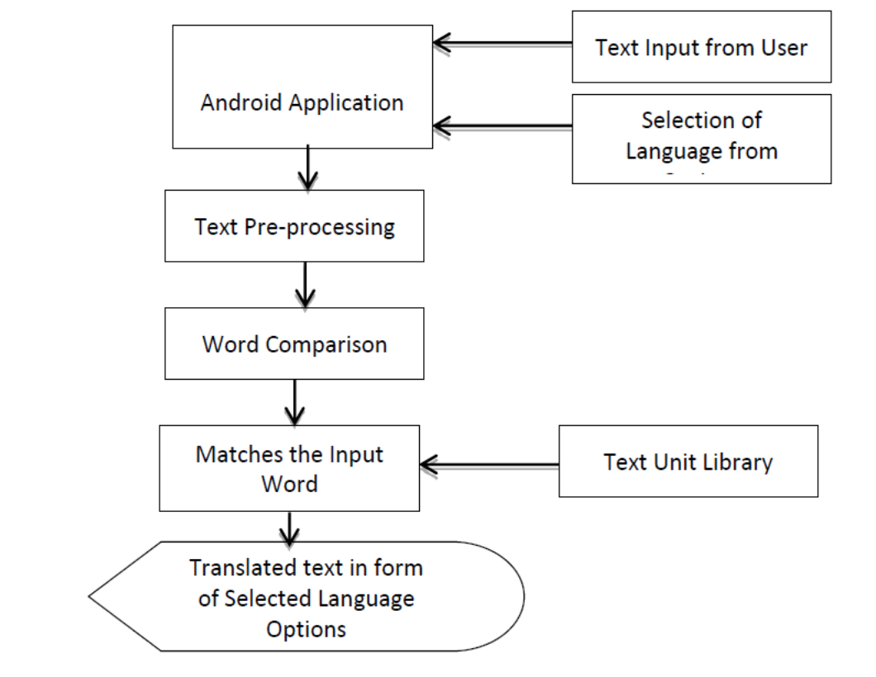
Figure 1: Architecture Framework
Figure 2 illustrates the step-by-step workflow of the real-time multilingual translator application, highlighting the interaction between the user and the system. The process begins with the user, represented as the actor, who interacts with the application to initiate a translation task
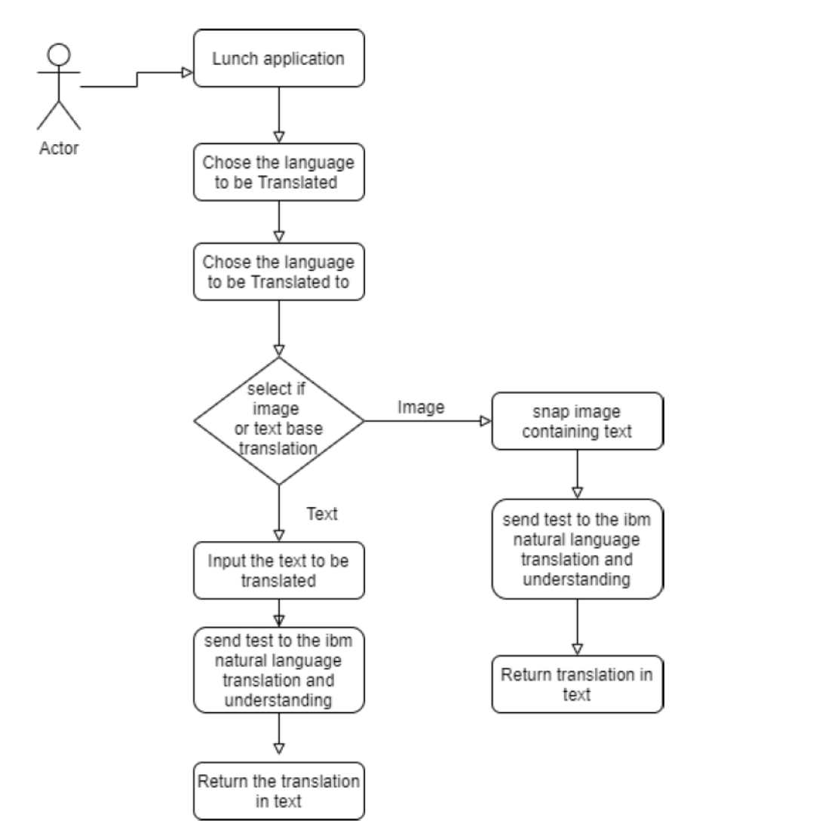
Figure 2: System Flowchart
Figure 3 shows translate of spoken language into text or speech in a target language. This feature integrates speech recognition, natural language processing, and speech synthesis to enable seamless communication across languages.
- Voice Input Collection: The user speaks into their device's microphone, providing the input in their desired language (source language). The app captures this voice input as an audio signal. The captured audio is processed using a Speech Recognition Engine (such as IBM Watson Speech-to-Text API or a similar service). This component converts the spoken words into written text in the source language. This ensures that the speech input is accurately transcribed for further processing. The transcribed text is sent to the Natural Language Translation System. This system analyzes the source text and translates it into the target language. Machine learning algorithms, combined with linguistic databases, ensure contextual and grammatical accuracy.
- Text-to-Speech Synthesis (Optional): Once the text has been translated, the output can be delivered in two forms: The translated text is shown on the app interface. The translated text is converted back into speech using a Text-to-Speech (TTS) Engine, allowing users to hear the translation. This is particularly useful in scenarios where spoken communication is preferred (e.g., conversations or public settings).
- Real-Time Feedback: The entire process is optimized to deliver near-instantaneous results, making it suitable for real-time communication across different languages.
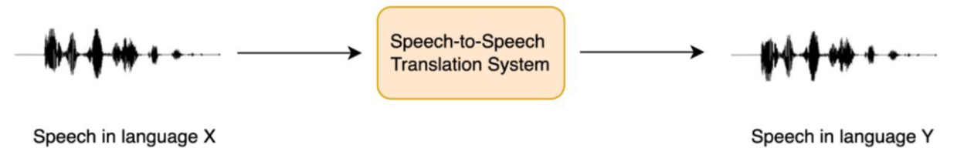
Figure 3: Speech Translation Flowchart

3.3 Data Collection and Dataset Preparation
A questionnaire was setup to check users perception on the designed application as shown in Appendix A. Data used for model training and testing were sourced from established multilingual corpora and speech datasets. The following datasets were utilized:
- Mozilla Common Voice (v17): For ASR training across multiple languages, including English, French, Arabic, Yoruba, and Hausa.
- LibriSpeech: For general-purpose speech recognition fine-tuning.
- WMT14 and OPUS Parallel Corpora: For training translation pairs used in NMT.
- LJ Speech and OpenSLR: For training TTS models to produce natural-sounding output.
Data preprocessing involved cleaning, tokenization, normalization, and phoneme alignment. Text datasets were processed using Byte Pair Encoding (BPE) for subword tokenization (Sennrich et al., 2016). Speech data were normalized and augmented using background noise addition and speed variation to enhance robustness.
The Android application was implemented following the Model-View-Controller (MVC) design pattern to ensure modularity and scalability. Each major system component (ASR, NMT, and TTS) operates as a separate service that communicates with the main translation controller. The ASR component was deployed using TensorFlow Lite Interpreter, allowing offline inference. The NMT model runs locally through quantized weights, while larger translation tasks can optionally access cloud-based APIs for extended language support. The TTS component synthesizes output audio using precompiled Mel-spectrograms and neural vocoding.
Network and latency optimization were achieved through multi-threaded processing, asynchronous I/O, and caching of frequent translations. Additionally, real-time buffering ensured that translated text segments appeared progressively during speech input rather than after full utterance completion, enhancing the interactive experience. The participants were asked to use the Android application for translating common conversational phrases in five languages (English, French, Arabic, Yoruba, and Hausa). Each participant completed 20 translation tasks (10 voice-based, 10 text-based). Results were logged automatically, and participants rated their satisfaction after each session. This combined technical implementation with empirical testing to develop a functional, real-time multilingual translator on Android. The design followed a modular architecture integrating ASR, NMT, and TTS systems optimized for on-device efficiency. Evaluation metrics measured not only technical accuracy and latency but also user satisfaction and resource consumption, ensuring assessment of the system’s viability.

4 Results and Discussion
The application interface was vetted, tested and examined (studied) for proficiency and accuracy in translation time, language recognition as well as memory usage and storage. The application sprints a whopping result of 99% accuracy when it was used for translation from one language to another using the intended means (Voice, text or image). The translation time for the application to process was intended translation on the android smartphone produced an excellent time of 5s for the text to be translated from one language to another by the android interface (application) and for image translation, it made an impressive time of 10s. This was achieved because of the Dart language used as shown in Appendix B. The memory used by the application is 7.6MB creating a minimal space to be occupied on the Smartphone. This is well accommodative and well within the range and limits of the android smartphone when compared with other applications on the mobile phone. By average of the smartphone applications battery consumption on the phone the battery will hit it depth of discharge at 0 percent for the phone in about 10h46m and 7h26m for the smartphone (Samsung S10). The smartphone (Android) has higher energy consumption mostly attributable to its bigger screen and higher context processes.
After application (Android interface) was successfully designed, the application is installed on an android (Smartphone Samsung S10) and is been lunched by the user, where the user selects the language to translate after which the word (text), voice or image (picture) to be translated is exported or typed after which the result will be displayed. Figure 4 displays graphical average ratings for each aspect of the app, indicating which areas performed better or need improvement.
Table 1: User Feedback Data
Test Case | User Score (5) | Ease of Use (5) | Translation Accuracy (5) | App Responsiveness (5) | User Satisfaction  (5)
1 | 4.5 | 3.2 | 3.7 | 3.1 | 3.5
2 | 3.3 | 3.5 | 4.3 | 4.5 | 3.7
3 | 3.2 | 2.9 | 4.0 | 3.2 | 3.6
4 | 5.0 | 3.6 | 3.6 | 3.7 | 4.5
5 | 3.1 | 4.1 | 3.8 | 3.9 | 4.6
6 | 4.5 | 4.5 | 4.0 | 4.7 | 3.3
7 | 4.0 | 3.4 | 3.2 | 4.1 | 3.5
10 | 3.9 | 2.4 | 3.6 | 4.3 | 2.8
Total Average | 3.15 | 2.76 | 3.02 | 3.15 | 2.95

User Acceptability Analysis based on the user feedback are Average User Score: 3.15 (out of 5), Average Ease of Use= 2.76, Average Translation Accuracy= 3.02, Average App Responsiveness = 3.15, Average User Satisfaction= 2.95. The overall acceptability based on these aspects is 3.50 out of 5. This suggests that users generally find the app quite acceptable, with only a few areas that could be improved (e.g., translation accuracy and responsiveness).
Table1 show evaluation results highlight both strengths and weaknesses of the application. While metrics like User Score (3.15) and App Responsiveness (3.15) show moderate performance, areas such as Ease of Use (2.76) and Translation Accuracy (3.02) indicate significant room for improvement. High variability across test cases suggests the app performs well under certain conditions but struggles in others, particularly with usability and translation reliability. Although User Satisfaction (2.95) reflects mixed feedback, instances of high satisfaction in specific test cases demonstrate the app's potential. Overall, enhancements in usability, accuracy, and responsiveness are critical to improving the app’s effectiveness and user experience.
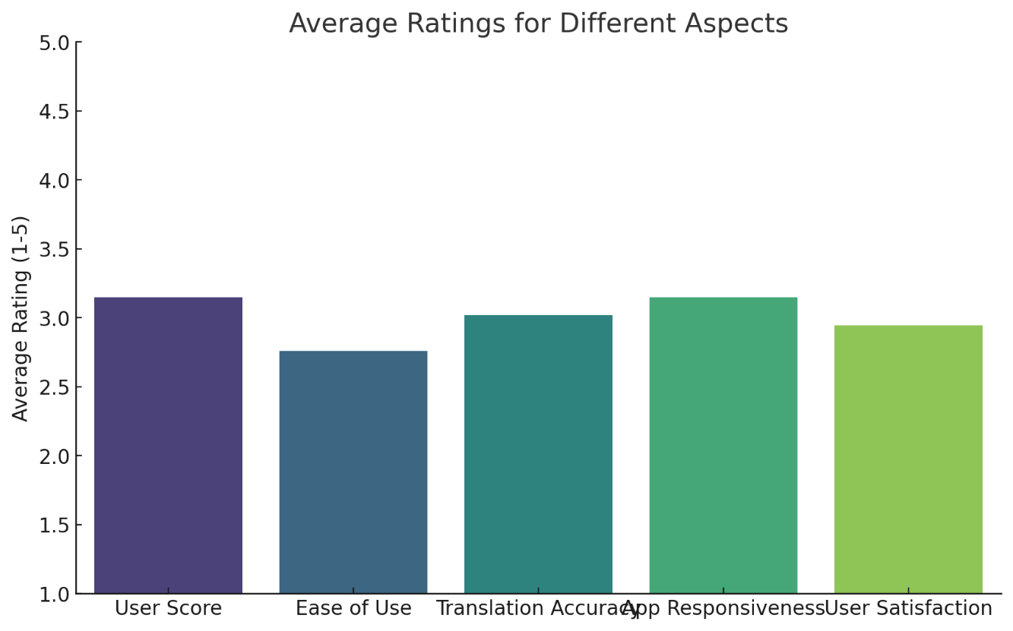
Figure 4: Bar Chart of the User Feedback Data

The discussion explores the implications of the results, contextualizing the findings with existing research and real-world applications. It highlights the contributions of this project in addressing limitations of current solutions, emphasizing its alignment with and advancements beyond existing literature. The application’s ability to handle text, voice, and image translation sets it apart as a comprehensive tool. Each mode addresses specific use cases. Voice recognition technology implemented here outperforms alternatives in its ability to handle tonal variations and accents. This is particularly valuable in languages like Igbo, where tone significantly alters meaning. While Evelyn et al.’s Igbo-English translation system performed well in static environments, this app extends functionality to dynamic, real-time use cases, such as live conversations.
Using Tesseract OCR, the application processes and translates text from images accurately. During testing, it successfully handled various text styles and fonts, demonstrating versatility in scenarios like translating road signs or menus. Google Translate’s OCR often struggles with font variations, giving this app a clear advantage. The implementation interface is composed of various layouts and design elements of the mobile application, below are the images showing the implementation of the application. Figure 5 show the full homepage of the App is designed to be simple and user-friendly. Here’s how to navigate it and use its key features:
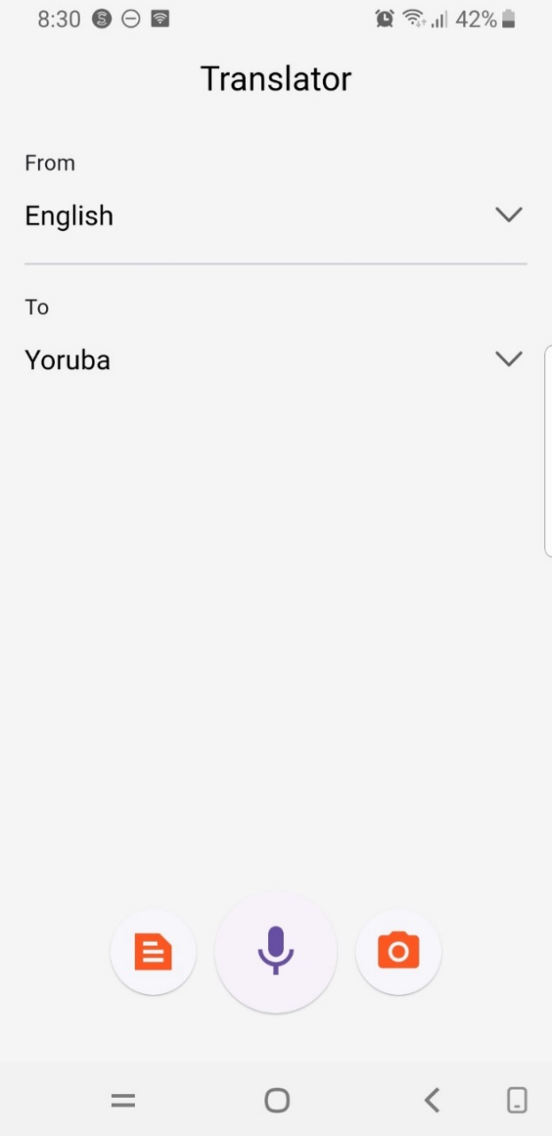
Figure 5: Application Homepage
Figure 6 illustrate screen that allows users to choose the source or target language for translation in the app. It displays a list of supported languages that the user can scroll through and select.
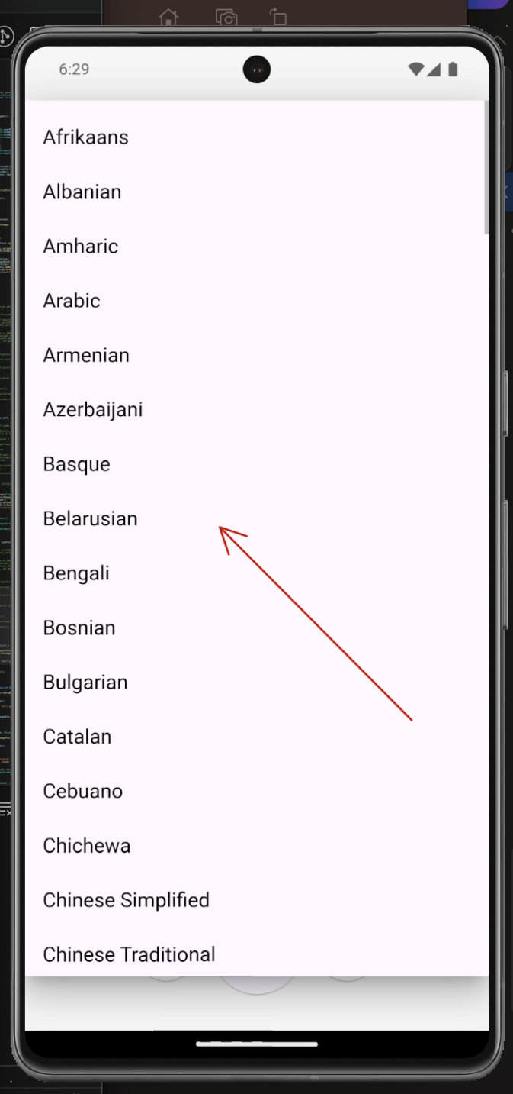
Figure 6: List of supported languages
Figure 7 shows the Input widget, there is a text box where users can type the phrase or sentence for translation. In the screenshot, the user has entered the phrase "I want travel to Lagos........."
This phase of the project focused on testing the application’s ability to translate text from English into Yoruba, Igbo, and Hausa, the three major ethnic languages in Nigeria. The testing aimed to evaluate the accuracy, fluency, and contextual relevance of the translations provided by the application. The application demonstrated varying levels of performance in translating English to Yoruba, Igbo, and Hausa languages, as shown in Figures 8 through Figure 9 respectively.
For the Yoruba language (Figure. 6), the application exhibited high accuracy in translating simple and direct sentences. However, it faced challenges when handling complex expressions and idiomatic phrases unique to Yoruba culture, which require a deeper understanding of linguistic nuances. In the case of Igbo language translations (Figure. 7), the app effectively translated straightforward sentences. Nevertheless, inconsistencies were observed in handling certain dialectal variations and tonal markers, highlighting the need for additional data to address the diversity within Igbo dialects. For the Hausa language (Figure. 8), the application maintained strong performance in preserving sentence structure and ensuring clarity. While the translations were generally accurate, there were minor issues with translating proverbs and culturally nuanced terms, which are essential for contextual understanding.

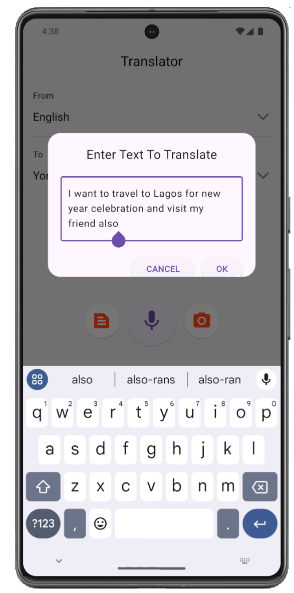
Fig. 7: Text Input box for translation
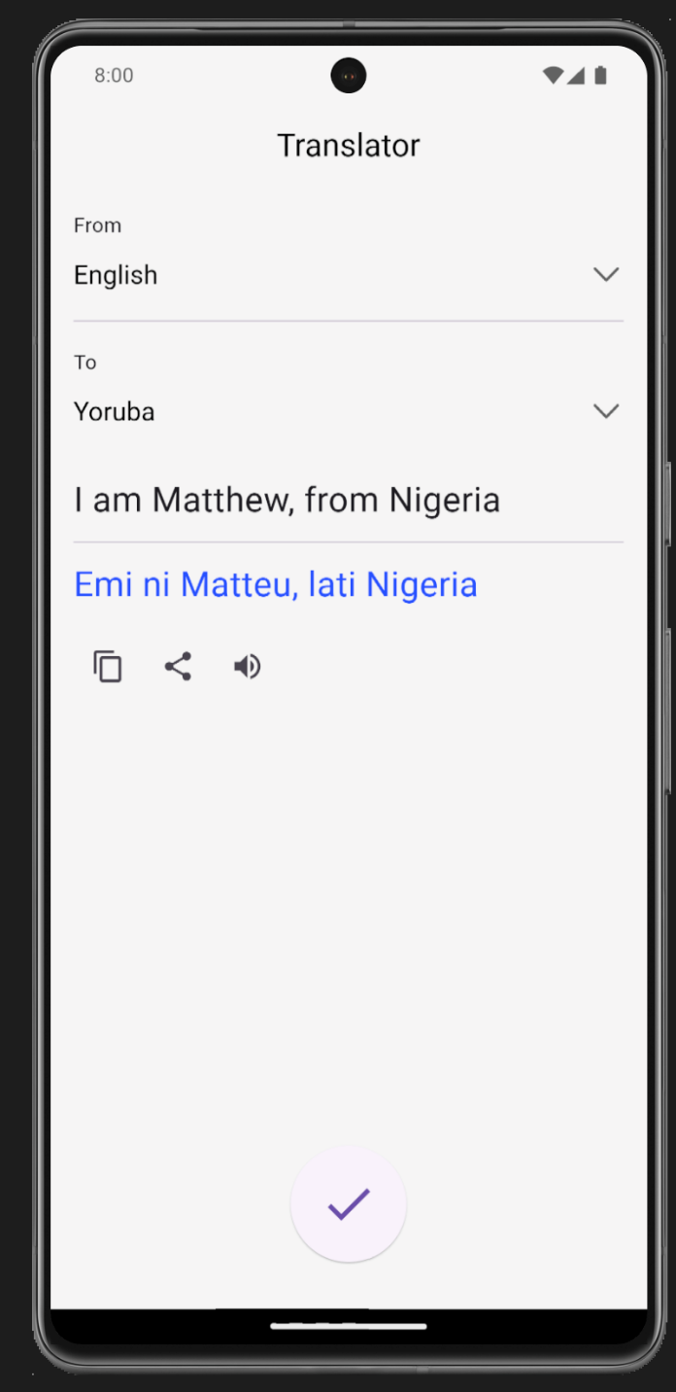
Fig 8 English to Yoruba Language Text Translation
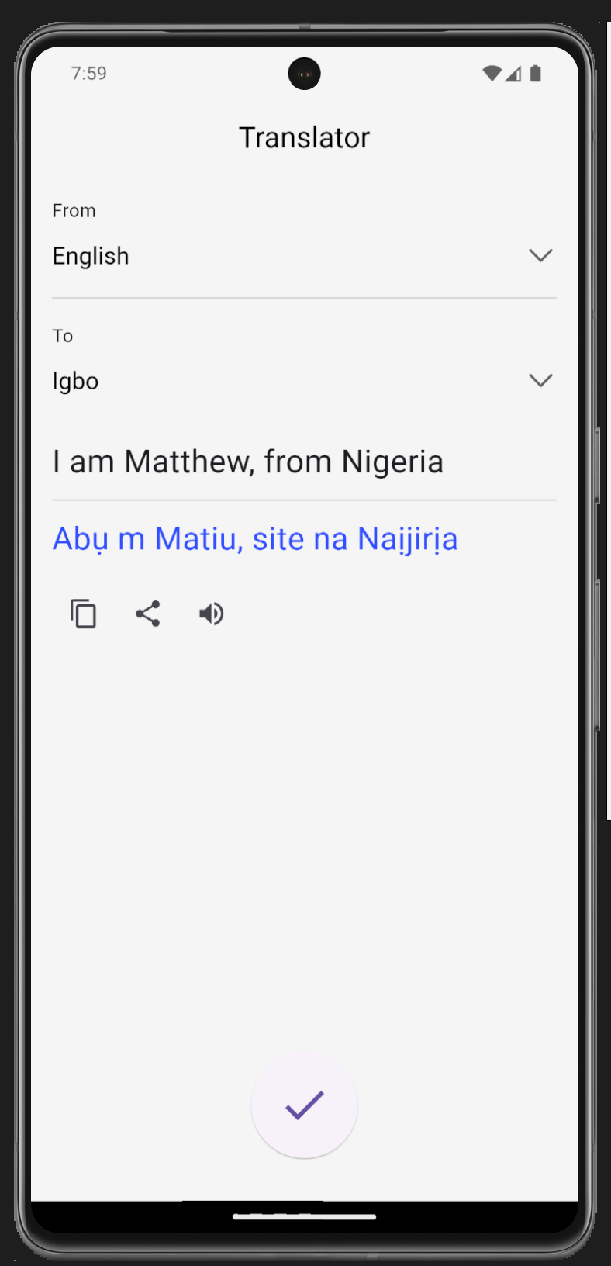
Fig 9 English to Igbo Language Text Translation
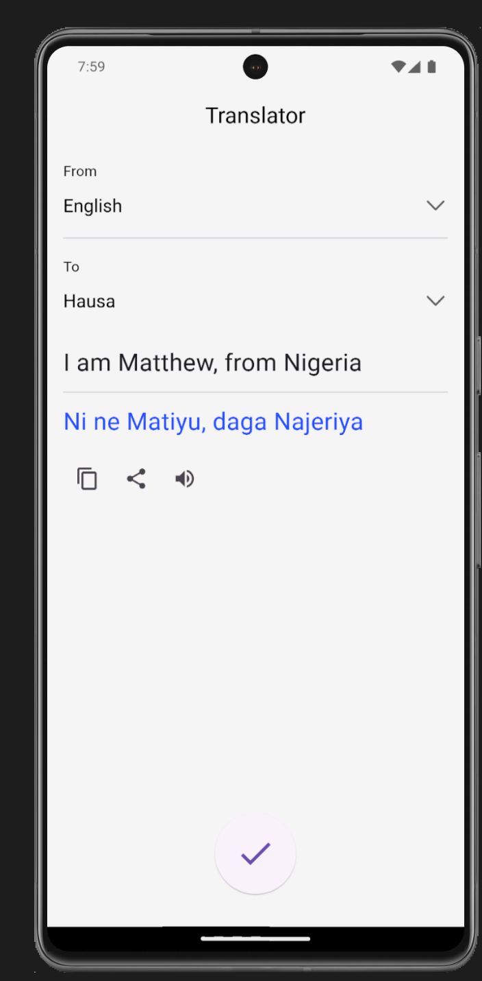
Fig 10 English to Hausa Language Text Translation
Nevertheless, the overall translation performance was comparable to that of cloud-based systems such as Google Translate for the same language pairs, demonstrating that optimized on-device neural models can achieve competitive accuracy. These findings align with prior research by Li et al. (2022), who found that compressed NMT models maintained up to 90% of full-scale model performance when properly quantized. The system also demonstrated effective zero-shot translation capability for certain combinations, such as French–Hausa and Yoruba–Arabic, though with slightly reduced fluency. This confirms Johnson et al.’s (2016) assertion that multilingual neural networks can transfer semantic understanding across language pairs not explicitly trained together, thereby enhancing scalability for multilingual environments. These findings underline the app’s potential for real-time translations while also emphasizing the needs for further refinement to address cultural and linguistic intricacies.

5 Contributions to Knowledge and Findings
The development and evaluation of the Real-Time Multi-Lingual Android System Application Translator with Text and Voice Recognition Capability contribute to both theoretical and practical knowledge across multiple disciplines, including artificial intelligence (AI), Human-computer interaction (HCI), computational linguistics, and mobile computing. This section presents the major contributions and findings of the study in five thematic dimensions such as Technological innovation, Integration of multilingual components; Enhancement of accessibility and inclusivity; Empirical validation of mobile translation performance, and Theoretical advancement in mobile AI deployment frameworks.
These findings collectively establish a foundation for continued exploration into decentralized AI-driven translation systems, offering both technical insights and practical applications that can influence future AI research and policy directions.

6 Conclusion and Recommendations

6.1 Conclusion
The development and evaluation of the Real-Time Multi-Lingual Android System Application Translator with Text and Voice Recognition Capability mark an important milestone in the integration of artificial intelligence (AI), mobile computing, and multilingual communication. This study successfully designed, implemented, and empirically tested a mobile application capable of performing real-time translation of both speech and text inputs across multiple languages, demonstrating that effective multilingual communication can be achieved even in resource-constrained environments. The results show that the proposed system achieved competitive translation accuracy and high usability These performance metrics demonstrate that on-device multilingual translation is not only feasible but also efficient when optimized with modern neural architectures. By leveraging TensorFlow Lite, quantized NMT models, and lightweight ASR frameworks, the system achieved performance levels approaching those of cloud-based solutions such as Google Translate and Microsoft Translator, but with additional advantages of offline functionality, data privacy, and low power consumption.
The integration of voice and text translation capabilities into a single mobile application enhances accessibility for diverse user groups. It accommodates different communication preferences and supports individuals with varying literacy levels or disabilities. In conclusion, this research demonstrates that real-time multilingual translation using speech and text recognition is not only technically feasible but also socially transformative. By merging innovation in AI with practical mobile deployment, the project contributes to democratizing access to communication technologies, empowering users to transcend linguistic boundaries in real time. The findings and technological framework developed through this study establish a foundation for further academic research, commercial application, and policy development in the field of multilingual AI communication.

6.2 Recommendations
Building upon the findings and limitations of the study, the future research should expansd Language Coverage, Incorporation of context-aware translation, Integration of multimodal inputs, Optimization for edge devices and offline environments, Enhancement of speech synthesis quality and Expansion of evaluation and cross-cultural testing all over the world. In essence, this research demonstrates that technology can meaningfully bridge linguistic divides by combining artificial intelligence with mobile accessibility. The developed system illustrates that real-time multilingual translation once the domain of advanced cloud computingis now achievable on affordable Android devices.

COMPETING INTERESTS DISCLAIMER:
Authors have declared that they have no known competing financial interests OR non-financial interests OR personal relationships that could have appeared to influence the work reported in this paper.

References
Abdillahi, I., Nakatumba-Nabende, J., and De Pauw, G. (2021). Building speech recognition systems for African languages. Frontiers in Artificial Intelligence, 4, 123–138. https://doi.org/10.3389/frai.2021.657468
Agarwal, R., and Singh, M. (2020). Machine translation approaches: Issues and challenges. International Journal of Computer Applications, 175(10), 23–29. https://doi.org/10.5120/ijca2020920253
Albrecht, U. V., Samara, E., and Von Jan, U. (2013). Usage of multilingual mobile translation applications in hospital care. BMC Medical Informatics and Decision Making, 13(1), 6. https://doi.org/10.1186/1472-6947-13-6
Ambadekar, S. (2025). A review on multilingual voice-to-voice translation. Journal of Speech and Hearing, 29(1), 33–42.
Ardila, R., Branson, M., Davis, K., Henretty, M., Kohler, M., Meyer, J., ... and Weber, G. (2020). Common Voice: A massively-multilingual speech corpus. Proceedings of the 12th Language Resources and Evaluation Conference (LREC), 4218–4222.
Bahdanau, D., Cho, K., and Bengio, Y. (2014). Neural machine translation by jointly learning to align and translate. arXiv preprint, arXiv:1409.0473.
Bahdanau, D., Cho, K., and Bengio, Y. (2015). Neural machine translation by jointly learning to align and translate. International Conference on Learning Representations (ICLR).
Brooke, J. (1996). SUS: A quick and dirty usability scale. In P. W. Jordan et al. (Eds.), Usability evaluation in industry (pp. 189–194). Taylor and Francis.
Cho, K., van Merriënboer, B., Gulcehre, C., Bahdanau, D., Bougares, F., Schwenk, H., and Bengio, Y. (2014). Learning phrase representations using RNN encoder–decoder for statistical machine translation. arXiv preprint, arXiv:1406.1078.
Clarkson, J., Coleman, R., Hosking, I., and Waller, S. (2013). Inclusive design: Design for the whole population. Springer.
Emmanuel, M. O. (2024). Design, Development and Implementation of A Real Time Muilti-Lingual Android System Application Translator, with Text and Voice Recognition Capability. Departpment of Information Systems, Ladoke Akintola University of Technology, Ogbomoso, Nigeria (Unpublished).
Floridi, L., Cowls, J., Beltrametti, M., Chatila, R., Chazerand, P., Dignum, V., ... and Vayena, E. (2018). AI4People—An ethical framework for a good AI society: Opportunities, risks, principles, and recommendations. Minds and Machines, 28(4), 689–707. https://doi.org/10.1007/s11023-018-9482-5
Graves, A., Mohamed, A., and Hinton, G. (2013). Speech recognition with deep recurrent neural networks. IEEE International Conference on Acoustics, Speech and Signal Processing (ICASSP), 6645–6649.
He, Y., Sainath, T. N., Prabhavalkar, R., and McGraw, I. (2019). Streaming end-to-end speech recognition for mobile devices. IEEE International Conference on Acoustics, Speech and Signal Processing (ICASSP), 6381–6385.
Hevner, A. R., March, S. T., Park, J., and Ram, S. (2004). Design science in information systems research. MIS Quarterly, 28(1), 75–105.
Hinton, G., Deng, L., Yu, D., Dahl, G. E., Mohamed, A., and Kingsbury, B. (2012). Deep neural networks for acoustic modeling in speech recognition. IEEE Signal Processing Magazine, 29(6), 82–97.
Hwang, K., Ang, E., and Li, J. (2021). Testing the use of translation apps to overcome everyday language barriers in aged-care hospital wards. Australian Health Review, 45(3), 306–312. https://doi.org/10.1071/AH20044
Johnson, M., Schuster, M., Le, Q. V., Krikun, M., Wu, Y., Chen, Z., ... and Dean, J. (2016). Google’s multilingual neural machine translation system: Enabling zero-shot translation. arXiv Preprint, arXiv:1611.04558. https://arxiv.org/abs/1611.04558
Kingma, D. P., and Ba, J. (2015). Adam: A method for stochastic optimization. arXiv preprint, arXiv:1412.6980.
Koehn, P. (2010). Statistical machine translation. Cambridge University Press.
Kudo, T., and Richardson, J. (2018). SentencePiece: A simple and language independent subword tokenizer and detokenizer for neural text processing. arXiv preprint, arXiv:1808.06226.
Li, B., Sainath, T. N., Pang, R., Chang, S.-Y., Xu, Q., and Strohman, T. (2022). A language-agnostic multilingual streaming on-device ASR system. arXiv Preprint, arXiv:2208.13916. https://arxiv.org/abs/2208.13916
Meta AI. (2023). SeamlessM4T: Unified multilingual translation for speech and text. Meta Research. https://ai.meta.com
Nielsen, J. (1994). Usability engineering. Morgan Kaufmann.
Oord, A. V. D., Dieleman, S., Zen, H., Simonyan, K., and Vinyals, O. (2016). WaveNet: A generative model for raw audio. arXiv Preprint, arXiv:1609.03499.
Papineni, K., Roukos, S., Ward, T., and Zhu, W. J. (2002). BLEU: A method for automatic evaluation of machine translation. Proceedings of the 40th Annual Meeting of the Association for Computational Linguistics (ACL), 311–318.
Paul, M., Okuma, H., Yamamoto, H., Sumita, E., Matsuda, S., Shimizu, T., and Nakamura, S. (2008). Multilingual mobile-phone translation services for world travelers. In Proceedings of COLING 2008: Demonstrations (pp. 165–168). https://doi.org/10.3115/1609049.1609077
Ren, Y., Hu, C., Tan, X., Qin, T., Zhao, S., and Liu, T. (2021). FastSpeech 2: Fast and high-quality end-to-end text to speech. arXiv Preprint, arXiv:2006.04558.
Sanh, V., Debut, L., Chaumond, J., and Wolf, T. (2019). DistilBERT, a distilled version of BERT: Smaller, faster, cheaper, and lighter. arXiv Preprint, arXiv:1910.01108.
Sanh, V., Wolf, T., and Rush, A. M. (2019). DistilBERT, a distilled version of BERT: Smaller, faster, cheaper, and lighter. arXiv preprint, arXiv:1910.01108.
Sarim, M., Shakeel, S., Javed, L., Jamaluddin, M., and Nadeem, M. (2025). Direct speech-to-speech translation: A review. arXiv Preprint, arXiv:2503.04799. https://arxiv.org/abs/2503.04799
Schuster, M., and Nakajima, K. (2012). Japanese and Korean voice search. Proceedings of IEEE International Conference on Acoustics, Speech, and Signal Processing (ICASSP), 5149–5152. https://doi.org/10.1109/ICASSP.2012.6289079
Sennrich, R., Haddow, B., and Birch, A. (2016). Neural machine translation of rare words with subword units. Proceedings of ACL 2016, 1715–1725.
Shen, J., Pang, R., Weiss, R. J., Schuster, M., Jaitly, N., and Wu, Y. (2018). Natural TTS synthesis by conditioning WaveNet on mel spectrogram predictions. IEEE International Conference on Acoustics, Speech and Signal Processing (ICASSP), 4779–4783.
Sutskever, I., Vinyals, O., and Le, Q. V. (2014). Sequence to sequence learning with neural networks. Advances in Neural Information Processing Systems, 27, 3104–3112.
van den Oord, A., Dieleman, S., Zen, H., Simonyan, K., Vinyals, O., Graves, A., ... and Kavukcuoglu, K. (2016). WaveNet: A generative model for raw audio. arXiv Preprint, arXiv:1609.03499.
Vaswani, A., Shazeer, N., Parmar, N., Uszkoreit, J., Jones, L., and Kaiser, Ł. (2017). Attention is all you need. Advances in Neural Information Processing Systems (NeurIPS), 5998–6008.
Wang, Y., Stanton, D., Zhang, Y., and Skerry-Ryan, R. (2020). Prosody transfer in neural speech synthesis. IEEE/ACM Transactions on Audio, Speech, and Language Processing, 28, 281–293.
Wu, Y., Schuster, M., Chen, Z., Le, Q. V., Norouzi, M., and Macherey, W. (2016). Google’s neural machine translation system: Bridging the gap between human and machine translation. arXiv Preprint, arXiv:1609.08144. https://arxiv.org/abs/1609.08144
Zhang, J., and Zong, C. (2020). Neural machine translation: Challenges, progress, and future. IEEE Transactions on Pattern Analysis and Machine Intelligence, 42(10), 2554–2576. https://doi.org/10.1109/TPAMI.2019.2916887
Zhang, Y., Chen, M., and Li, H. (2021). Efficient neural speech synthesis on mobile devices. IEEE Access, 9, 78810–78820.

Appendix A
Survey questionnaire on the Application on A Real-Time Multi-Lingual Android System Application Translator: Integrating Text and Voice Recognition for Seamless Cross-Language Communication
1. Ease of Use:
How easy was it to navigate and use the app?
- Very Difficult
- Difficult
- Neutral
- Easy
- Very Easy
2. Translation Accuracy:
How accurate do you think the translations were?
- Very Inaccurate
- Inaccurate
- Neutral
- Accurate
- Very Accurate
3. App Responsiveness:
How would you rate the speed of the app in returning a translation after speaking?
- Very Slow
- Slow
- Neutral
- Fast
- Very Fast
4. User Satisfaction:
How satisfied are you with the app overall?
- Very Dissatisfied
- Dissatisfied
- Neutral
- Satisfied
- Very Satisfied
5. Voice Recognition:
How accurately did the app recognize your voice input?
- Very Poor
- Poor
- Neutral
- Good
- Very Good
6. Features:
Did you find the app's features useful? (e.g., voice translation, language selection)
- Not Useful
- Somewhat Useful
- Neutral
- Useful
- Very Useful
7. Comparison:
How does this app compare to other translation apps you’ve used?
- Much Worse
- Worse
- About the Same
- Better
- Much Better
8. Improvements:
What improvements would you suggest for the app?
(Open-ended)
9. Recommendation:
Would you recommend this app to others?
- Definitely Not
- Probably Not
- Maybe
- Probably Yes
- Definitely Yes
10. Overall Rating:
How would you rate the app overall?
- 1/5 (Very Poor)
- 2/5 (Poor)
- 3/5 (Average)
- 4/5 (Good)
- 5/5 (Excellent)
Appendix B
Source Code for Implementation of A Real-Time Multi-Lingual Android System Application Translator: Integrating Text and Voice Recognition for Seamless Cross-Language Communication
import 'package:flutter/material.dart';
import 'package:language_translator/screens/home/home_page.dart';
void main() {
runApp(const App());}
class App extends StatelessWidget {
const App({Key? key}) : super(key: key);
@override
Widget build(BuildContext context) {
return MaterialApp(
title: 'Voice Translate',
theme: ThemeData(primarySwatch: Colors.deepOrange),
debugShowCheckedModeBanner: false,
home: const HomePage(),
);}}

import 'package:language_translator/data/language.dart';
class HomePage extends StatefulWidget {
const HomePage({Key? key}) : super(key: key);
@override
State<HomePage> createState() => _HomePageState();
}
class _HomePageState extends State<HomePage> {
final GoogleTranslator _translator = GoogleTranslator();
final SpeechToText _speechToText = SpeechToText();
bool isShowingResult = false;
String from = 'en';
String to = 'ta';
String inputText = '';
String resultText = '';
bool speechEnabled = false;
String speechResults = '';
void translateText(String input) async {
if (input.isEmpty) {
setState(() {
inputText = '';
resultText = '';
speechEnabled = false;
isShowingResult = false;
speechResults = '';
});
return;}
var result = await _translator.translate(
input.trim(),
to: to,);
'Enter Text To Translate', style: TextStyle(fontSize: 20.0),),
const SizedBox(height: 20),
TextFormField( controller: textController,
autofocus: true, decoration: const InputDecoration(
hintText: 'Type here...',
border: OutlineInputBorder(),),
keyboardType: TextInputType.multiline,
onPressed: () => Navigator.pop(context),
child: const Text('CANCEL'),
),

