Data Mining in Medicinal Plants Bioinformatics

Abstract: Globally, lot quantities of data exist in medical, industry and other related fields. An interested area of research in bioinformatics a case study in medicinal plants is the application and improvement of data mining techniques to solve biological problems involved. The quantity and variety of data in natural sciences enhanced quickly. Therefore, data abstraction, data manipulation and pattern discovery techniques are require in dealing with such large varieties of medicinal plants. Analyzing huge biological medicinal plants’ data sets requires making sense of the data by inferring structure or generalizations from the data. Integration among different sources of data is likewise of most important interest, as complex relations may happen. In this research paper, some basic concepts of bioinformatics, data mining and WEKA explorer tool are discussed. Therefore, the area of application of data mining in the field of bioinformatics was clearly stated in this research and the current opportunities and challenges of data mining in medicinal plants bioinformatics are discussed as well.
Keywords: Bioinformatics, Database, Data Mining, Medicinal plants, Software tool, Techniques, WEKA.
1. Introduction
In recent times, the idea of collection of biological medical plants data has been increasing at explosive rates due to developments of existing technologies and the beginning of innovative ones. The technical advancement has help greatly in the performance of huge level experiments and research programs like nanotechnology, bioinformatics and other biology related areas.
Bioinformatics plays a significant role in the development of the agricultural sector, especially in herbal industries, agricultural by-products utilization and better management of the environment medicinal plant improvement, its collection and storage of plant genetic resource and wisely application of bioinformatics help to produce stronger, insect resistant, and improve the quality of medicinal plant healthier in production (Kumlachew, 2015).
Bioinformatics involves the Solving problems arising from biology using methodology from computer science (Boa, 2022). Bioinformatics, or computational biology, is the interdisciplinary science of understanding biological data via information technology and information systems or computer science (Fu et al., 2020). Therefore, data mining extracts information from gigantic quantity of data being stored in various heterogeneous databases when information is needed from the database thereby transmitted directly or indirectly. Formerly limited to scientific research and medical analysis, but these techniques are suitable to other fields such as artificial intelligence, biotechnology, and multimedia system (Tripathi, 2015 and Ogirima et al 2024). Currently data mining is an emerged field of machine learning that help in technical advancement that focuses on developing and applying computationally intensive techniques (Ibiam and Ekwe, 2012). Predictable data analysis procedures are not always easy to develop large amounts of data efficiently (Han and Kamber, 2012).
In essence data mining is indeed needed as an evolutionary procedure ahead of demonstration of data access and navigation to approaching and practical information delivery. Data mining devises its name from the resemblance between searching for valuable business information in a massive database (Vishnu and Krishnaswari, 2015). Its performance is the result of an extended approach of research and output improvement. Therefore, the goal of this research paper is to showcase the data mining models, techniques and bioinformatics sequences involved that will enhance the interaction between data mining and bioinformatics (Kumar, et al; 2014). The main goal of this research is aimed at providing the knowledge of bioinformatics and its application on medicinal plant with objectives of:
- Development of database containing all Medicinal plant information.
- Highlight better tools for its data designing, annotation and mining.
- Design and development of herbs (drugs) and validity by using simulation software to:
- find the action of herb on human
- find the relative potency of a new herb with respect to a standard drug
- efficacy of a herb is being compared with the orthodox ones
- identify signs and symptoms of a disease
- documentation of medicinal plant history of diseases
- conduction of laboratory studies on the herb
- provision of the mode of herbal production
- study of genetic modification of medicinal plants
- The list of software tools needed for protein structure prediction function, annotation and docking analysis.
- Creation of software to improve tools for storage and analysing sequences for its function and similarity with other sequences
2. Related Work
Bioinformatics plays an essential role in today’s plant pathology with regards to the development of new plant diagnostic tools. Pathogen is among the traits considered in the primary interest of plant bioinformatics. The contribution of bioinformatics advances made possible the mapping of the entire genomes of many organisms in just over a decade. These discoveries, along with current efforts to determine gene and protein functions, have improved the ability to understand the root causes of plant diseases and find new cures (Kumlachew, 2015). Data Mining and Gene expression analysis in bioinformatics mainly focus on issues related to data mining and relevance of these data base sequences and gene expression in bioinformatics. It is also deals with an overall understanding of data mining techniques and their application and usage in bioinformatics (Santhaiah and Reddy. 2014).
Applications of data mining within the field of bioinformatics deals with clarify the applying of information mining in bioinformatics and emphasize the databases of bioinformatics. It also deals with Biological data analysis and the link between data mining and bioinformatics (Li,et al; 2005). WEKA explorer is needed to compare dissimilar solution strategies based on the similar assessment procedure and identifies the one that is mainly appropriate for the problem at hand (Eibe Frank et al; 2004). Investigating is an ongoing research execution of data mining applications on a shared memory in parallel machine. The inquiry is to maintain the generating and integrating the huge quantities of genomic, proteomic and other data (Raza, 2015).
This has helps in investigating on how to development a high throughout sequencing techniques and computational procedures that requires application of computer system (Santhaiah and Reddy, 2014 and Rajkumar and Sivagamasundari, 2017).

3. Research Approach
This section focuses on the method and source of information gathering process realizing the stated objectives. The procedures are discussed diagrammatically in Figure 1.

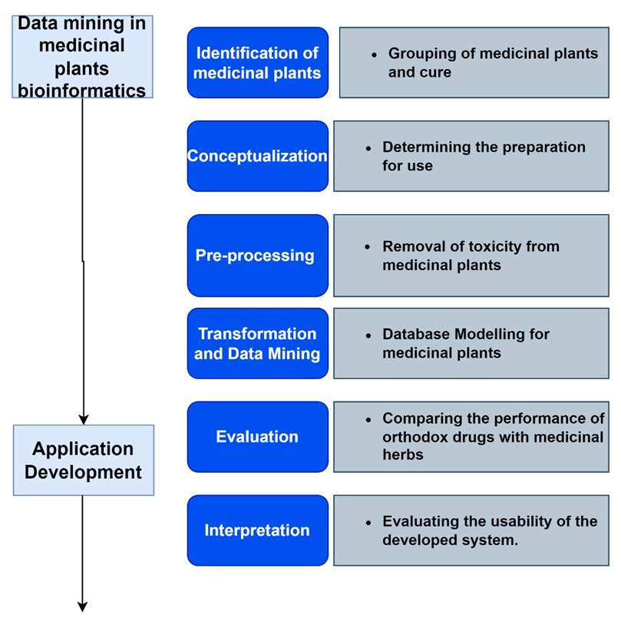
Figure 1: The research Approach Block Diagram
3.1 Data mining in medicinal plant bioinformatics: This is the first phase comprise of identifying medicinal plants, conceptualization, pre-processing, transformation and data mining modeling to house medicinal plants.
3.1.1 Identification of medicinal plants: This is the concepts in identifying the medicinal plant from the field and the treatment it is meant for. Identification by herbal medicine providers of the potentially heterogeneous data sources and dataset needed to identify cases, interventions, outcomes measures and any comparator group. These herbal providers or herbal industries might be drawn from primary and secondary care, informatics, social care, workforce planning and other branches of management, academia and guideline developers; ideally with access to or knowledge of relevant routine data in their domain.
3.1.2 Conceptualization: A well designed top-down approach was implemented to determine concepts and relationships in medicinal plant bioinformatics to categories the ailments is meant for. The concept of semantic can be used as a measure of the process or outcome of care to determine the preparation of medicinal to be used for.
3.1.3 Pre-processing: This is the process herbal industries used to remove toxicity from the medicinal plants before transformation into use.
3.1.4 Transformation and data mining: This is the conceived database model with the dataset hierarchical structure in the algorithm below:
FUNCTION (Medicinal plants: practitioners or industries)
Selection: Choosing relevant data to be analysis from the database
Preprocessing: Eliminating toxicity; merging various data sources
Transformation: Data transforming into suitable forms to data mining
Data mining: Derive an algorithm appropriate pattern in the data.
Interpretation: Interpreting / evaluating the patterns into knowledge.
PROCESS (Medicinal plants into herbal products)
Ailments (the diseases)
Treatments (considered medicinal herbs to use)
3.2 Application development: This is the second phase that comprises of the development of a web and WEKA environment editor and usability evaluation assessment and interpretation of the bioinformation application. A WEKA-based application was developed in the C# programming environment with WEKA interface editor. This application can be used in many herbal practitioners to infer the adequate herbal treatment according to patients’ ailments. This provides necessary information about ailments, herb preparation and prescription. The application portal can easily be navigated by practitioners and interact with the system, detail in section 4.3.
3.2.1 Evaluation: This is the evaluation comparism of medicinal plants product (herbs) to orthodox medicine (modern drugs) on it effectiveness, efficacy and standard.
3.2.2 Interpretation: The evaluation is the outcomes on its implementation in accordance with certain metrics. The results obtained from the evaluation are based on the capabilities of its application, reliability and validity index (Ogirima et al, 2014).
3.3 Data Mining Application in Medicinal plant
The extraction of unknown analytical information from huge databases is an authoritative possible technology needed to facilitate companies to focus on the most essential information in herbal industry data warehouses. This development commence when business data was first stored on computers, continued with perfections in data access, and more recently, produced technologies that permit clients to navigate through their data in real time. Data mining consists of more than a group and organizing a data which consists of analysis and prediction. Analyzing or creating relationships between various features based on Figure 2, the Knowledge Discovery Process consists of iterative sequence methods as follows:
- Selection: Choosing relevant data to be analysis from the database
- Preprocessing: Eliminating toxicity and inconsistent data; merging various data sources
- Transformation: Data transforming into suitable forms for the data mining
- Data mining: Data mining algorithm appropriate to pattern in the data.
- Interpretation: Interpreting and evaluating the patterns into knowledge.
Herbal medicines and its preparations have been globally used for many years back in countries like China, Korea, Japan, Nigeria and host of others. The process of transforming medicinal plant extracts into use as shown in Figure 3. The preparations either single herb or as collection of herbs in composite formulae is extracted drying or boiling water during the decoction process or through other means in accordance with quality control of oriental herbal drugs as presented in “General Guidelines for Methodologies on Research and Evaluation of Traditional Medicines” (World Health Organization, 1976).

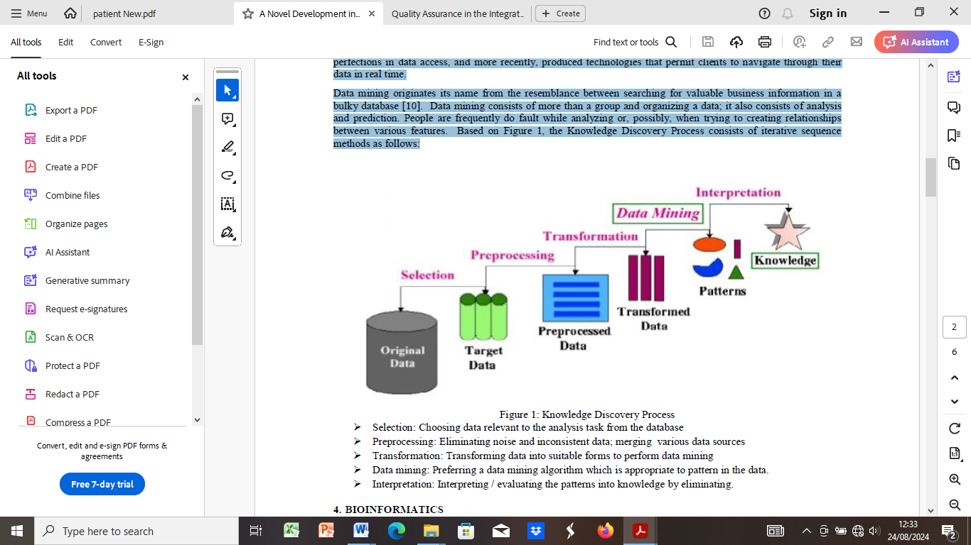
Figure 2: Knowledge Discovery Process

A new innovative feature has been added to WEKA as shown in Figure 9, which includes an XML format. An algorithm was adopted to determine the concepts of data mining for grouping and organizing a data prediction when trying to create entity relationships between various features for the knowledge discovery process which consists of iterative sequence methods as follows:
class data_mining_algorithm (for the Bioinformatics in medicinal plant) {
Selection (Choosing data relevant to the analysis task from the database)
Preprocessing (Eliminating noise and inconsistent data; merging various data sources
Transformation (Transforming data into suitable forms to perform data mining
Data mining (Preferringdata mining algorithm appropriate to pattern in the data
{
Input: A database of proteins, an experimental spectrum S, a set of ion types X,
a parent mass m and a parameter k capping the number of modifications.
Output: A protein of mass m with the best match to spectrum S that is most k
modifications away from an entry in the database.
}
Interpretation (Interpreting / evaluating the patterns into knowledge
}
Algorithm for the capturing of medicinal plants into the database in developed application (See Ogirima et al., 2023)
Implementation was done with aid of C# programming coding editor shows the Medicinal plant used, Ailments, Treatment and dosages as below:
using System;
using System.Collections.Generic;
using System.ComponentModel;
using System.Data;
using System.Drawing;
using System.Linq;
using System.Text;
using System.Windows.Forms;
using System.Data.SqlClient;
namespace Medicinal plant bioinforfmatics;
{
public partial class Form1 : Form
{
public Form1()
{
InitializeComponent();
}

private void button1_Click(object sender, EventArgs e)
{
try{
string query = "SELECT Name FROM Table1 WHERE (Name='" + textBox1.Text + "' AND Password='" + textBox2.Text + "')";
SqlCommand cmd = new SqlCommand(query, conn);
SqlDataReader dr = cmd.ExecuteReader();
string see = "";
while (dr.Read())
{
see = dr[0].ToString();
}
dr.Close(); cmd.Dispose(); dr.Dispose();
if (see == "") MessageBox.Show("Invalid Login", "Medicinal plant Management System");
else
{
groupBox2.Visible= true;
menuStrip1.Visible = true;
}
}
private void button6_Click(object sender, EventArgs e)
{
try
{
string query = "INSERT INTO HerbInfo(ScientificName,CommonName) VALUES('" + textBox10.Text + "','" + textBox7.Text + "')";
SqlCommand cmd = new SqlCommand(query, conn);
cmd.ExecuteNonQuery();
textBox7.Clear(); textBox10.Clear();
}
catch { MessageBox.Show("Error! Check your input."); }
}
private void deleteToolStripMenuItem_Click(object sender, EventArgs e)
{
if (dataGridView1.SelectedRows.Count > 0)
{
dataGridView1.Rows.RemoveAt(dataGridView1.SelectedRows[0].Index);
string q = "delete from table2";
SqlCommand cmd = new SqlCommand(q, Form1.conn);
cmd.ExecuteNonQuery();
for (int k = 0; k < dataGridView1.Rows.Count; k++)
{
dataGridView1.Rows[k].Cells[0].Value = (k + 1).ToString();
q = "INSERT INTO Table2(Disesase,RequestID,Treatment,Prescription) VALUES('" + dataGridView1.Rows[k].Cells[1].Value + "','" + dataGridView1.Rows[k].Cells[2].Value + "','" + dataGridView1.Rows[k].Cells[3].Value + "','" + dataGridView1.Rows[k].Cells[4].Value + "')"; cmd.CommandText = q;
cmd.ExecuteNonQuery();
}
}
}
namespace herbal
{
public partial class WebForm1 : System.Web.UI.Page
{
SqlConnection conn;
protected void Page_Load(object sender, EventArgs e)
{
conn=newSqlConnection(@"Data Source=.\SQLEXPRESS;AttachDbFilename=C:\Users\OGIRIMA\Desktop\latestcode\Dr ogirima\Herbal.mdf;Integrated Security=True;Connect Timeout=30;User Instance=True");
conn.Open();
}
protected void DropDownList1_SelectedIndexChanged(object sender, EventArgs e)
{
string q = "select treatment,prescription from table2 where ailment='" +
DropDownList1.Items[DropDownList1.SelectedIndex].ToString().Trim() + "'";
SqlCommand cmd = new SqlCommand(q, conn);
SqlDataReader dr = cmd.ExecuteReader();
while (dr.Read())
{
Label2.Text = "Treatment : " + dr[0].ToString().Trim() +
". Prescription : " + dr[1].ToString().Trim();
}
dr.Close(); cmd.Dispose(); dr.Dispose();
}
}
}

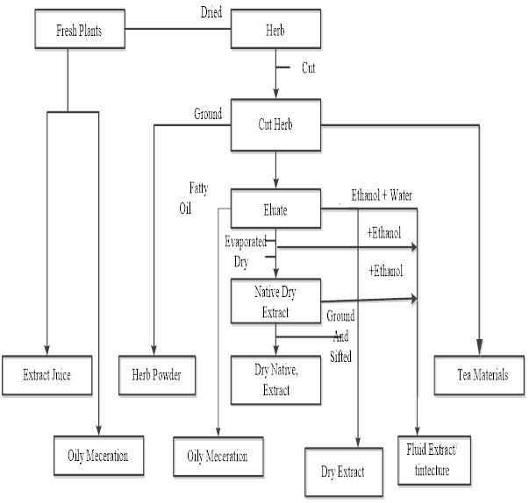
Figure 3: The process of transforming freshly harvested plant (Ogirima et al., 2014)
3.4 Bioinformatics
Bioinformatics was created by Paulien Hogeweg in 1979 for the study of informatic procedures in biotic systems as an interdisciplinary field that develops method and software tools for understanding biological data (Raza, 2015 and Rajkumar and Sivagamasundari, 2017). Bioinformatics has since grown to be an essential part of many areas of biology. Bioinformatics is a science field that is parallel to but different from biological computation, while it is frequently considered one and the same to computational biology. Biological computation applies bioengineering and biology to make biological computers. The field occupies the analysis of biological data, particularly DNA, RNA and protein sequences that focuses on DNA sequencing and mapping techniques with aim of enhancing the biological processes.
3.4.1 Bioinformatics in Medicinal plant
Plant life plays important and diverse roles in our society, our economy, and our global environment. Especially Medicinal plant is the most important plants to us. Feeding the increasing world population is a challenge for modern plant biotechnology. The accumulation of sequence data allows detailed genome analysis by using friendly database access and information retrieval. This information enables new strategies to study gene expression patterns in plants. Available information from news technologies, as the database stored DNA microarray expression data, will help plant biology functional genomics. Plant networks collections of databases and bioinformatics resources for medicinal plants genomics have been built to harness the extensive work in genome mapping.
This resource facilitates the identification of ergonomically important genes, by comparative analysis between medicinal plants and model species, allowing the genetic engineering of medicinal plant plants selected by the quality of the resulting products. Bioinformatics resources have evolved beyond expectation, developing new nutritional genomics biotechnology tools to genetically modify and improve food supply, for an ever-increasing world population. Therefore, bioinformatics can now be leveraged to accelerate the translation of basic discovery to medicinal plant. Satellite based remote sensing technique combined with limited field survey provide valuable information in rapid time. The information provided by the data which has been generated on the status of medicinal plants under observation at any particular date can be processed quickly.
This advantage provides a synoptic view, making it possible to analyse the status and trend of transplantation, medicinal plant growth and harvesting throughout the study area. Application of remote sensing and GIS will be used for creating a systematic and sharable database on plant related subject and answer the unanswered questions of different stakeholders. Therefore, bioinformatics techniques have been applied to explore various steps in this process.
3.4.2 Web tools and resources of bioinformatics
The World Wide Web (www) provides a mechanism for unprecedented information sharing amongst researchers, scientists and academicians’ research findings tools on the web or comparing discoveries with previous search results, often spurring innovation and further discovery. The value of accessing data from other institutions and the relative ease of disseminating this data has increased the opportunity for multi-institution in collaborations, which produce melodramatically larger data sets than were previously available and require advanced data management techniques for full utilization. Bioinformatics.net is an online catalogue biology resource that specializes in bioinformatics tools. There are numerous bioinformatics resources (software tools) which many biologists used in finding bioinformatics data.
Some of these include Bioinformatics.net, such as BLAST, Fasta, Emboss, Clustalw, RasMol, Prospect, Pattern Hunter, Copia, etc. Any scientists can post research findings regarding the medicinal plants on the Web for the discoveries of herbs spurring innovation. Some software which is useful in bioinformatics research is show in table 1. More can be found at: http://www.kernel-machines.org/,http://www.bioinf.jku.at/software/psvm/, http://www.researchindex.org/, http://www.ncbi.nlm.nih.gov/entrez/query.fcgi?db=PubMed and http://scholar.google.com/. There are a number of common bioinformatics analyses one can perform at other sites, such as European Bioinformatics Institute (EBI), Bio Web Pasteur and Canadian Bioinformatics Resource. Some of these tools are used to query the Protein Function, Structural, and sequence analysis from the database to measure the homologous sequences.
SOAP and REST-based interfaces are web services in bioinformatics was developed for a wide variety of bioinformatics applications allowing an application running on one computer in one part of the world to use algorithms, data and computing resources on servers in other parts of the world. The main advantages derive from the fact that end users do not have to deal with software and database maintenance overheads. The bioinformatics services are categories as sequence search Services, multiple sequence alignment, and biological sequence analysis depends on availability of these service-oriented bioinformatics resources web-based interface.
Table 1: Some Bioinformatics Research Software
Software | Application | URL
EMBOSS | Toolbox | http://emboss.sourceforge.net
BLAST | homology search | http://www.ncbi.nlm.nih.gov/BLAST/
PHRAP | shotgun DNA | http://www.phrap.org/
BioPerl | toolbox perl | http://www.bioperl.org/
Rasmol | fast viewer | http://www.umass.edu/microbio/rasmol/
Prospect | Threading | http://compbio.ornl.gov/structure/prospect/
Babel | converts formats | http://openbabel.sourceforge.net/wiki/Main_Page
ClustalW | multiple alig. | ftp://ftp-igbmc.u-strasbg.fr/pub/ClustalW/
FASTA | Sequence alignment | www.ebi.ac.uk/fasta33
BLOCKS | Protein Domain Analysis | http://blocks.fhcrc.org/
SLAM | Genomic Analysis | http://bio.math.berkeley.edu/slam/
PHD | sec. struc. | https://www.rostlab.org/papers/1996_phd/paper.html
DALI | struc. alig. | http://www.ebi.ac.uk/dali/
Molscript | nice images | http://www.avatar.se/molscript/obtain_info.html
ProsaII | struc. verf. | https://prosa.services.came.sbg.ac.at/prosa.php
Biodesigner | mol. dynamics | http://www.pirx.com/biodesigner/download.html

3.4.3 Implementation of data mining in bioinformatics for medicinal plants
This comprises of the development of a web-based application and usability evaluation or assessment of the application. Areas in which bioinformatics can be applied are gene therapy, drug designing, medicine biotechnology, evolutionary studies, veterinary science, waste cleanup, weather analysis, forensic analysis, drought resistance, crop development and antibiotic resistance as shown in Figure 4. The applications of data mining and bioinformatics include protein function domain detection, protein function inference, disease diagnosis, and disease treatment optimization. There are bioinformatics programming languages that can be used for the implementation depends on the software availability and hardware capability. Programming languages such C#, Java, Perl, PHP, Erlang, R, CORBA, XML, Ensembl, Mysql, and python are mostly programming used in bioinformatics. In this research C# was embed with WEKA interface for the implementation as shown in Figures 5 through 7.

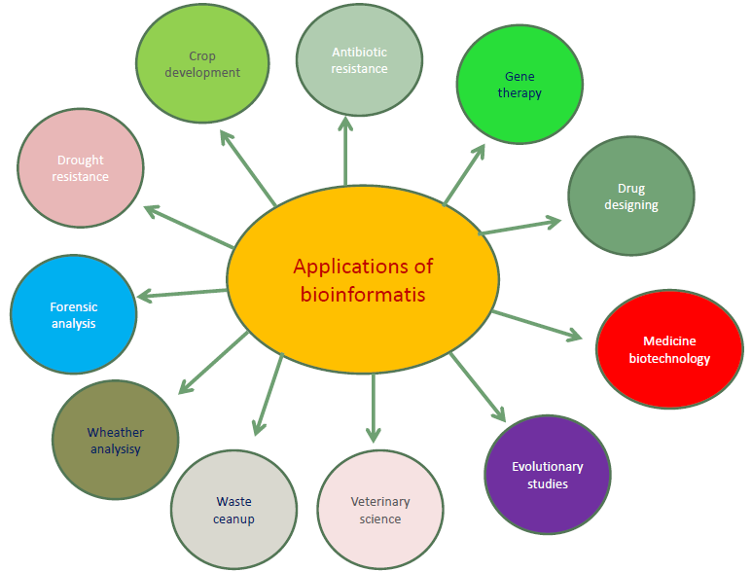
Figure 4: Applications areas of bioinformatics
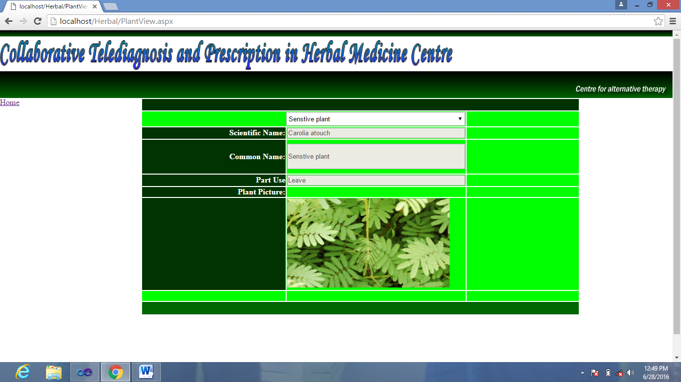
Figure 5: Navigation for Viewing Medicinal plant from database

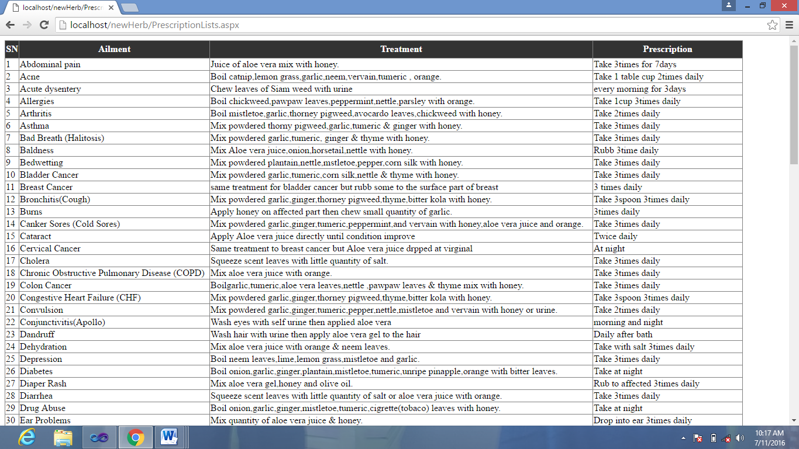
Table 2: Navigation showing Ailments, treatment and prescription

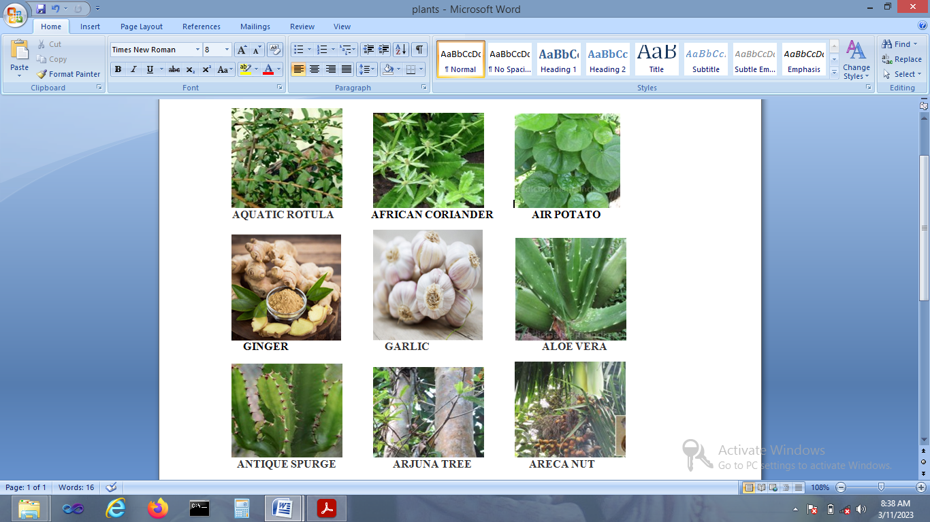
Figure 6: Medicinal plant materials


Figure 7: Medicinal plant products ready for Consumption
3.4.4 Challenges in the Area of Bioinformatics
The major drawbacks faced by scientists from biology background in the area of bioinformatics are:
• Design of small drug-like molecule,
• Inability to development of a quantitative model for signal transduction pathway,
• Inaccurate prediction of protein secondary and tertiary structure using amino acid sequence,
• Understanding the evolution of protein,
• Understanding the speciation event,
• Understanding gene ontology
Besides, there are many challenges faced by Information Systems and Computer science scientists working in the area of bioinformatics, such as:
• Management of big data in biology,
• Information management,
• Improve the accuracy of software, and
• Programmability (solvable task).

4. Using WEKA Explorer in Data mining
The Waikato Environment for Knowledge Analysis (WEKA) is a familiar landmark system or workbench in data mining and machine learning that would authorize researchers for easy access. It is a collection of machine learning algorithms for data mining assignments (Aksenova, 2004). WEKA contains filters for normalization, sampling, attribute selection, transformation and combination of attributes to analyze the data with WEKA explorer using various learning schemes as shown in Figures 8 and 9.
Figure 8: WEKA Startup Screen

Figure 9: WEKA Explorer
The data can be preprocessed by means of WEKA’s filtering tools. It contains occurrence (rows) in the data for which a certain element (column) with an exacting value. The Preprocess panels illustrate a histogram of the attribute that is presently preferred and some statistics about it. Histograms for each and every attributes can be shown concurrently in a separate window as reported (Aksenova , 2004).
5. Contribution to Knowledge and Findings
Data Mining in Medicinal Plants Bioinformatics contributes to academic knowledge in the following ways:
- Integration of Data Mining and Bioinformatics – It explores how data mining techniques can be applied to medicinal plants' bioinformatics, improving biological data analysis and discovery.
- Development of medicinal plant database – The Research proposes a structured approach to collecting, organizing, and mining medicinal plant data, which is valuable for researchers, herbal medicine practitioners, and industry professionals.
- Application of WEKA in herbal medicine research – The research demonstrates the use of the WEKA explorer tool for analyzing medicinal plant data, offering a methodological approach to identifying patterns and relationships within bioinformatics.
- Enhancing medicinal plant utilization – The research outlines techniques for the identification, pre-processing, and transformation of medicinal plants for therapeutic use, improving traditional medicine through digital means.
- Bridging the gap between traditional and modern medicine – This helps in comparing herbal treatments with orthodox medicine, that provides insights into the efficacy, potency, and reliability of medicinal plants in healthcare.
- Technological innovation in bioinformatics – The research discusses the development of web-based applications and software tools that facilitate medicinal plant data storage, retrieval, and predictive analysis.
- Challenges and opportunities in bioinformatics – The research highlights the challenges in bioinformatics, including data management, accuracy of predictive models, and the development of computational tools, offering recommendations for future research.
In a nutshell, the research provides a significant contribution to the field of medicinal plant bioinformatics by introducing data mining methodologies, computational tools, and frameworks that enhance the understanding, classification, and utilization of herbal medicine in modern healthcare.
6. Conclusion
The research demonstrates that data mining and bioinformatics can enhance medicinal plant research, improving the accuracy and effectiveness of herbal treatments. By developing computational tools, databases, and machine learning models, the study contributes to modernizing herbal medicine and integrating it with contemporary healthcare solutions. Data mining in bioinformatics is an aspect of biological databases, together with its size, number, diversity and heterogeneous data. WEKA was tool used to analyze the data during the preprocessing, and classification in the database in accordance with the associated rule. An application of data mining to bioinformatics contains disease diagnosis, data cleaning, gene finding, and disease treatment optimization.

COMPETING INTERESTS DISCLAIMER:
Authors have declared that they have no known competing financial interests OR non-financial interests OR personal relationships that could have appeared to influence the work reported in this paper.

REFERENCES
Aksenova, S. S. (2004). “Machine Learning with WEKA – Tutorial”, School of Engineering and Computer Science, California State University, Sacramento, California.

Bao, H. T. (2022). “An Introduction to Bioinformatics”. Japan Advanced Institute of Science and Technology (JAIST) pp 1- 62

Eibe Frank et al., (2004). “Data Mining in Bioinformatics using WEKA”, Bioinformatics, Oxford University Press, Vol. 20, No. 15, pp. 2479 – 2481.

Fu, Y., Ling, Z., Arabnia, H. and Deng, Y. (2020). “Current trend and development in bioinformatics research”. BMC Bioinformatics, 21(Suppl 9):538
Han, J. and Kamber, M. (2012). Data Mining: Concepts and Techniques. 3rd.ed. Boston: Morgan Kaufmann Publishers.

Ibiam O. F. A. and Ekwe A. (2012). Bioinformatics and scientific research. International Research Journal of Biotechnology (ISSN: 2141-5153) Vol. 3(9) pp. 141-151.Available online http://www.interesjournals.org/IRJOB

Kemkar, O. S. and Dahikar, P. B. (2012). “Bioinformatics: A revolutionary way of using Computer technology for evidence based medicine”. International Journal of Advanced Research in Computer and Communication Engineering Vol. 1, Issue 9.

Kumar, K., Kumar, B. C. and Pandy, (2014). “Data Mining and its Applications: A Review”, International Journal of Scientific and Engineering Research, Vol. 5, Issue 6.
Kumlachew, A. (2015). “The Role and Application of Bioinformatics in Plant Disease Management Advances in Life Science and Technology” ISSN 2224-7181Vol.28.
Li, J.; Wong, L. and Yang, Q.,(2005) “Data Mining in Bioinformatics”, IEEE Intelligent System, IEEE Computer Society. 2005.

Ogirima, S.A.O., Arulogun, O.T., Awode T.R. and Adigun, E. B. (2023). “An Ontology Model for Herbal healthcare Delivery in Southwestern Nigeria”. Acta Scientific Computer Sciences. Volume 5, Issue 10, pp 14-25.

Ogirima, S.A.O., Awode, R. T. and Akande, N. O.(2024). Digital transformation and artificial intelligence strategies for Herbal industry in Nigeria: Applications, Opportunities and Challenges. Global Journal of Engineering and Technology [GJET]. Volume 3 Issue 6, PP: - 08-15

Ogirima, S.A.O., Olabiyisi, S.O., Omidiora, E.O., Okediran, O.O. and Awode,T.R.(2014). “Web-based and Mobile Oriented Herbal Information System in Nigeria”. International Journal of Computer Information Systems and Industrial Management Applications. ISSN 2150 -7988 Volume 6 pp. 535-548.

Rajkumar, G. and Sivagamasundari, T. (2017). A Novel Development in Research by Data Mining in Bioinformatics. International Journal of Engineering and Information Systems (IJEAIS), Vol. 1 Issue 10, Pp. 52-57

Raza, K. (2004). “Application of Data Mining in Bioinformatics”, Indian Journal of Computer Science and Engineering”, Vol. 1, No. 2, pp. 114 – 118.

Santhaiah, C. and Reddy, R. M. ( 2014). “Role of computers in bioinformatics by using different biological datasets”, IOSR Journal of Computer Engineering, Vol. 16, Issue 2.
Tripathi, V. (2015). “ Combination of Proteomics and Bioinformatics in Life science Research”, Journal of Global Research in Computer Science, Vol. 6, No. 1, January 2015.

Vishnu, P. A. and Krishnaswari. K., (2015). “A Survey – based on methods and techniques of data mining”, International Journal on Engineering Technology and Sciences, Vol. II, Issue. 10.

World Health Organisation (1976). “African Traditional Medicine”. Afro-tech Rep. Series 1. Pp.3-4. WHO Brazaville.

