Patterns of Malware Awareness and Security Practices: A Clustering Analysis of
College Faculty and Students

ABSTRACT

Despite the growing digitalization of education, insufficient malware awareness and poor digital practices among students and faculty pose significant risks. The study investigates the application of Educational Data Mining (EDM) techniques to improve educational outcomes and efficiency within institutions. The student and faculty data were analyzed to identify trends, which assist in strategic decision-making and improving education. The objectives are: (1) to assess awareness levels on different types of malwares among students and faculty and their demographic characteristics; (2) evaluate malware awareness and security practices; (3) cluster analysis for identifying typical patterns as well as discrepancies related to malware awareness and security practice; (4) establish whether there exist significant differences in terms of malware awareness and security practices across identified clusters. Data collected through questionnaires followed by extensive data cleaning, preprocessing, clustering analysis (K-Means). This was carried out using google collab and python programming to check the significant difference between the clusters of malware and security measures employed. The findings indicate different patterns of malware awareness and safety practices among diverse demographics; thus, this demonstrates where the awareness is lacking and the need for improvements in practice. This research supports the development of targeted interventions and resources to enhance educational quality and cybersecurity as per Sustainable Development Goals on Quality Education and Industry, Innovation, and Infrastructure. The study underscores the importance of tailored educational programs and continuous training to address gaps in malware knowledge and promote effective security practices. These recommendations involve personalized education initiatives, regular updates on cyber threats to improve malware awareness and security practices, thereby enhancing the overall educational and institutional environment.

Keywords: clustering, cybersecurity, demographics, educational data mining, malware awareness, pattern, security practices.

1. INTRODUCTION

In the contemporary digital world, mobile devices have turned into an essential part of our daily lives both in personal and professional capacities. Owing to this, they are facing increasing danger from malware attacks. Mobile malware as a malicious software that is specifically designed to exploit vulnerabilities in the operating systems of mobile devices has become a growing threat for individuals and organizations (Dwivedi et al., 2022). As mobile technology progresses, so does the number and complexity of malware directed at these gadgets increase (Gill et al., 2022). This calls for deep exploration into trends in mobile malware, user awareness, and prevention mechanisms vis-à-vis changes in cyber threats that come with technological advancements (Dwivedi, Hughes, et al., 2021)(Singh & Gautam, 2022). One major area of concern has been the recent surge in mobile malwares particularly with respect to such types as malwares applications or phishing incidents (Gupta, Abdelsalam, Khorsandroo, Mittal, 2020). Some common ways through which smart phones can be infected by malware include downloading suspicious apps from untrusted app stores or clicking on unknown links sent via text messages (Charfeddine, Kammoun, Hamdaoui, Guizani, 2024).

Such mitigation strategies will help improve overall cybersecurity posture. The lack of awareness by the people about mobile malware even as there continue to be more dangers associated with it has become a great concern. Most people have general knowledge on cyber threats but they are not specific on information regarding mobile malware and how to prevent it (Shaukat et al., 2020). To bridge this gap, there is a need for an intensive educational campaign that will enlighten individuals about the issue of mobile malware and promote safe practices (Sundaram, 2017). Accordingly, this study looks into educational data mining (EDM) at San Jose Campus of Occidental Mindoro State College. It aims at improving learning outcomes in education while enhancing institutional efficiency through student and faculty data analysis. The research therefore seeks to expose the trends and patterns that can help make smart decisions towards better teaching methods. This study complies with Sustainable Development Goals (SDGs), specifically SDG 4: Quality Education which promotes an inclusive and equitable system of education at all levels as well as support lifelong learning opportunities for all (United Nations, 2023).

As technology continues to evolve at an unprecedented pace, there is a need for institutions of higher learning to go beyond mere rhetoric about the potential of technology in transforming education (Jandrić et al., 2020). The paper also applies data mining techniques with an aim of determining what influences students’ performance or progress hence supporting targeted interventions in efforts towards improving quality and equity in education (Dwivedi et al., 2022) United Nations, 2023). The paper further supports SDG 9: industry, innovation and infrastructure which focuses on promoting innovation and building resilient infrastructure (UN, 2023). For this reason, the study employs modern data mining methods to demonstrate how technological innovations can enhance universities thereby creating a platform for future development of studies. (Dwivedi, Ismagilova, et al., 2021). San Jose Campus attempts through these means to deliver sophisticated analytical frameworks that confront today’s challenges while keeping focused on technology-enabled transformative change in educational outcomes (Aronowitz et al., 2017).

Additionally, it is crucial to examine awareness and prevention strategies associated with mobile malware among faculty as well as students. Hence their mixed cultural backgrounds offer valuable insights into the efficacy of current cyber security initiatives and identifying areas requiring support (Budhwar et al., 2023). Therefore, this research seeks to reveal how common malwares are known within the subject population or age group; what levels of awareness exist presently and suggest possible targeted solutions designed for such groups’ needs (Singh et al., 2022). The purpose of the present research is to give a comprehensive insight into how malware threats are being perceived and mitigated by students and teachers. It will concentrate on threat trends, user awareness, and preventive measures (Makhdoom et al., 2019). This method is meant to bridge the gap between knowledge and real security practices so as to come up with better strategies for handling malware in educational settings (Christen et al., 2022).

This research examines mobile malware behavior with regard to the college faculty and students, looking specifically at their knowledge and reactions towards some of the malware types. It seeks to describe sociological variables responsible for probability of malware’s exposure and awareness, investigate existing levels of malware-related knowledge and security behavior, and K-Means clustering to examine differences in malware awareness and practices on security. Also, this study seeks to test if significant differences exist across the identified clusters with respect to the knowledge of malware as well as knowledge on security measures practices which can assist in understanding how useful these security measures are and where there is a need for educational focus.

2. material and methods

2.1 Research Paradigm

The diagram in Figure 1 presents a planned way of carrying out educational data mining (EDM) research, which includes the important stages of data collection, preparation, analysis and interpretation. These aim at investigating student performance as well as other related variables within the context of a study (Alyahyan & Düştegör, 2020). Data collection entails administering surveys and questionnaires to students to obtain extensive information about their performance, involvement and demographic attributes (Lu et al., 2019). The gathered data is analyzed for significant relationships and differences using Correlation Analysis that reveal how various factors interact and influence student outcomes (Rajabalee & Santally, 2021). Data preparation involves the cleaning and preprocessing processes to ensure accuracy and readiness for analysis while Clustering (K-Means) is applied to group similar data points thus improving the analytical process (Sen, 2021).

EDM techniques are used within the framework to reveal patterns and insights which is data analysis’ core (Yang et al., 2022). Clustering can also help in identifying different student profiles within the dataset by performance and participation, which reveals underlying groups (Sedrakyan et al., 2020). When viewing this model in light of being able to analyze academic life through its various components, it supports targeted analysis as well (Dwivedi, Hughes, et al., 2021). This framework is used in formulating questions that leverage data for research purposes triggering actionable insights since it enables rigorous data collection, preparation, analysis and interpretation (Couture et al., 2023). In addition, such structured processes provide insights that are valuable for improving education or decision making (Kung et al., 2023).
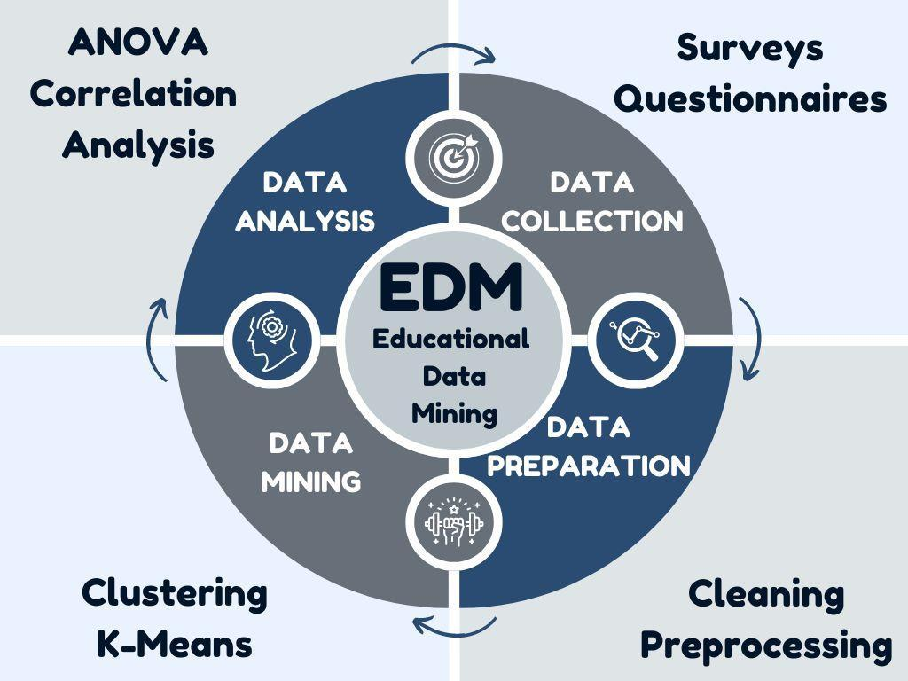
Figure 1: Research Paradigm.

2.2 Respondents of the Study

The Research was done at San Jose Campus of Occidental Mindoro State College. This group’s diversity gave it unique insights into malware awareness, educational security practices, methodologies and institutional predicaments (Sithole, Chiyaka, McCarthy, Mupinga, Bucklein, & Kibirige, 2017). Thus, student evaluation was shared on learning processes and academic support views that helped to understand the entire school environment as a whole (Mohajan, 2018). In this way, it was possible to carry out complex analysis of factors influencing student awareness on malware (Pham et al., 2020).

2.3 Survey Design

A well-ordered survey was set up to collect detailed data on types and frequency of malware encountered by students and their teachers. The questionnaires, which was used in the study, entailed the description of various types of malwares such as rogue security software, Trojan horses as well as adware among others (Paste & Wadkar, 2021). The Mobile Malware awareness level tested student and faculty understanding about different malwares (Beaman et al., 2021). Questions were asked to assess knowledge regarding preventive measures like antivirus software and safe surfing practices; it also involved regular updates (Lopes et al., 2024). Background information is based on demographic and behavioral factors such as; age, gender, mobile device used and operating system (Wang & Deng, 2021).

2.4 Data Collection

For ease and penetration purposes this tool was done through Google Forms which is an online platform. Thus, for effective campaigns deans and departmental heads had to be coordinated beforehand. So as to reach out to many students and comply with school rules regarding this kind of study permission was sought via an official correspondence letter (Ronimus et al., 2019). Doing it electronically allowed for easier management of data and easier review before analysis could commence (Zou et al., 2016).

2.5 Data Analysis

Descriptive statistics were used to evaluate the demographic characteristics of the respondents the level of awareness and security practices. This included notifications from antivirus and manual detection (Jain et al., 2021). The frequency analysis and percentage were employed to the data to assess the general trend of occurrences of specific pool types of malwares and the interaction between various pools of malware and users’ behavior (Page et al., 2021). Correlation was conducted in order to search for any relationship between the users and malwares’ encounters that had a link with the respondent’s security factors (Figueras-Alvarez et al., 2020). K-Means clustering was employed to categorize the respondents with respect to their levels of awareness and security practices (Hancock & Khoshgoftaar, 2020). As for data processing and visualization, these activities were performed with the assistance of Google-Colab and Python. The numerous tasks included in the analysis cover estimation of the types and frequency of malware environments, construction of bar charts and other illustrations to characterize the security practices. Moreover, other internal and external analyses were performed, including a correlation matrix, K-Means clustering (using the elbow method to establish the best number of clusters) as well as heatmap for further understanding of the data.

2.6 Data Interpretation

The analysis offered an understanding of the relationship between certain factors and the probability of the appearance of different malware. Such behavioral patterns as user activity, security measures applied and some demographic factors were investigated for malware occurrence patterns. The research bypassed the traditional analysis tools of Microsoft Excel and SPSS adopting statistical packages such as Google Colab and Python for data analysis and visualization (Petrů et al., 2020). With the use of frequency analysis, correlation tests, and K-Means clustering, other areas of the relationship between malware incidences and user practices were explored. However, the study also found the certain behaviors among users’ specific calculating security protection appliances and recognition of phishing attacks increase the chances of malware infection. As a result of this activity, the study provided aimed at enhancing the mobile device security awareness of students and staff using pattern recognition. These results demonstrate the need to not only change the security technologies embedded in the systems and software but also to invest in targeted awareness programs such as those against common malware threats (İçen, 2022).

3. results and discussion

Types and Frequency of Malware Encounters
Table 1 analyzed the frequency and types of malware encounters reported by participants, categorized by age, gender, mobile device use, operating system, and malware type. The majority of malware encounters were reported by individuals aged 18-24, with 282 instances (76.6%). Females reported 212 malware encounters (57.6%), while males reported 152 (41.3%). A small proportion of participants preferred not to disclose their gender, suggesting a higher prevalence of malware encounters among females. Mobile device usage was highest among those using their devices for more than 6 hours per day, with 136 (37.0%) encounters. Android users experienced 322 encounters (87.5%), while iOS users reported 46 (12.5%). Adware was the most frequently encountered type, with 118 (32.1%) instances. Phishing attacks followed with 87 (23.6%) instances. Trojan malware was reported 86 times (23.4%), spyware 54 times (14.7%), and ransomware 23 times (6.3%). This distribution highlights adware and phishing as the most prevalent types of malware encountered by the participants. Malware encounters are most common among younger users, particularly females, and those who use their mobile devices extensively. Additionally, Android users face a higher incidence of malware compared to iOS users. The findings also indicate that adware and phishing are the most frequent types of malwares encountered.

Table 1 Types and Frequency of Malware Encounters by Faculty and Students.
Category | Frequency | Percentage
Age
18-24 | 282 | 76.6
25-34 | 18 | 4.9
35-44 | 18 | 4.9
45 and above | 6 | 1.6
Under 18 | 44 | 12.0
Gender
Female | 212 | 57.6
Male | 152 | 41.3
Prefer not to say | 4 | 1.1
Mobile Device Use
1-3 hours per day | 106 | 28.8
4-6 hours per day | 102 | 27.7
Less than 1 hour per day | 24 | 6.5
More than 6 hours per day | 136 | 37.0
Mobile OS
Android | 322 | 87.5
iOS | 46 | 12.5
Malware Type
Adware | 118 | 32.1
Phishing | 87 | 23.6
Ransomware | 23 | 6.3
Spyware | 54 | 14.7
Trojan | 86 | 23.4

Malware Awareness of Faculty and Students
Figure 2 presents an assessment of the average knowledge of malware types among faculty and students in relation to their awareness of different types of malwares. The y-axis corresponds to the average score in the ‘malware awareness’ section on a 0 to 3.5 scale with the higher numbers indicating the better level of understanding of the particular type of the cybercrime. The x-axis depicts the different categories of segregation of the malware types as per the legend coloration which includes, adware, phishing, ransomware, smishing, spyware, trojans, vishing, man in the middle attacks, zero-day exploits, and types of malwares. The chart also indicates the two groups which have been used in the survey, faculty members (indicator Respondent Type 1) and students (indicator Respondent Type 2). Faculty members usually attitudinal aspects of between 2.5 and 3.0 do not change for most of the types of malwares from one faculty to another with respect to Adware, Spyware, and other higher classes of malware being most familiar. In contrast, the Phishing alertness for the image-clicking faculty’s members falls approximately at a mean of 2.0.
However, the students managed to record slightly higher awareness levels, with the score reaching to a level of 3.5. Vishing, Zero-day exploits and general Types of Malware are the most known types of threats among the students. This is not however the case with Phishing and Ransomware which are still on the lower end in terms of awareness for students, but they always have a better understanding of these threats than the faculty. In other words, malware awareness is found to be moderate to high for both the faculty and the students, but the students possess better comprehension levels than the faculty especially regarding advanced threats such as Zero-day exploits and Vishing. On the other hand, the Phishing awareness in both groups was lower compared to other types of malwares, similar to the Russian student’s group, it may be possible to enhance the security training on this type in both groups.

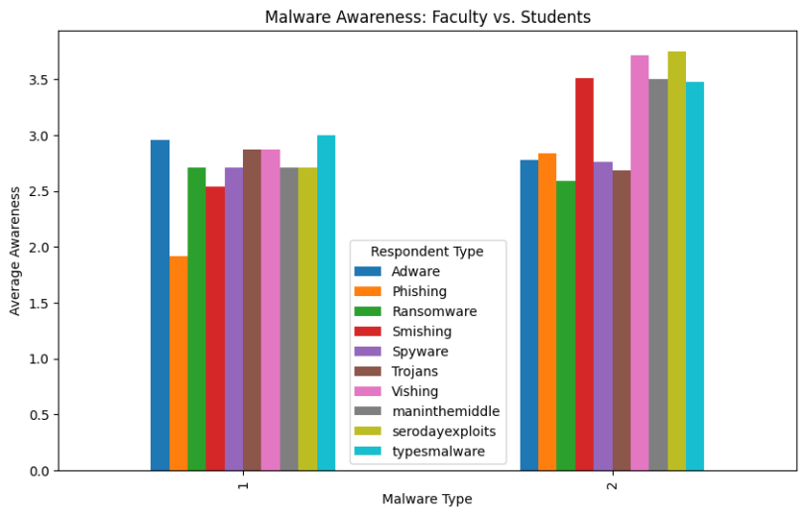
Figure 2 Malware Awareness of Faculty and Students
3.1 Security Practices of Faculty and Students

Table 2 presents a comprehensive analysis of security practices by faculty and students, focusing on their use of preventive measures against malware. The majority of respondents, including 222 individuals, use preventive measures against malware, with a slightly higher percentage of faculty members. Antivirus software is also widely used, with 178 respondents using it, with a slight advantage for faculty. Safe browsing practices are followed by 176 respondents, with 20 faculty members (47.6%) and 156 students (54.2%) practicing this. Regular updates to software and systems are performed by 186 respondents, with faculty members (61.9%) and students (55.6%) participating. Both groups show a strong adherence to keeping their software up-to-date, with faculty members slightly leading in this practice. Lastly, avoiding unknown app sources is reported by 160 respondents, with 18 faculty members (42.9%) and 142 students (49.3%), with students having a marginally higher percentage. This table shows that both faculty and students are proactive in their approach to security; although, the faculty use antivirus software, regular updates and a committed number of preventive measures more than students. However, it should be noted that students are more engaged in safe browsing practices as well as staying away from unknown app sources. Clearly, there is commitment by both categories of people though there are different methods prioritized.
Table 2 Security Practices of Faculty and Students
Security Measures |  | Faculty | Students | Total
Preventive Measures | % within respondents | 0.0% | 3.5%
 | Count | 30 | 192 | 222
Antivirus software | % within respondents | 71.4% | 66.7%
 | Count | 26 | 152 | 178
Safe browsing | % within respondents | 61.9% | 52.8%
Practices | Count | 20 | 156 | 176
Regular updates | % within respondents | 47.6% | 54.2%
 | Count | 26 | 160 | 186
Avoiding unknown | % within respondents | 61.9% | 55.6%
app sources | Count | 18 | 142 | 160

Figure 3 compares the average security practices of faculty members and students. The y-axis or vertical axis gives the underestimate average score in respect to the investigation criterion based on a scale of 0-7 thus representing how often or how effective common security practices used by each group where faculty members belong are. The x-axis in the graph gives the two groups of respondents in this case type 1 is respondents type 1 is faculty members while type 2 is respondents type 2 is students. Each of the charts features about five security practices namely: Antivirus, Regular Updates, Safe Browsing, Security Measures, and Unknown Applications. Most of the practices such as Antivirus, Regular Updates, Safe Browsing, and Anonymous Unknown Application Recognition have a low average score of around 2 in the case of faculty members. Yet, a very high score is attributed to their compliance with an ambiguous term noted as red in the chart ‘Security Measures’ where faculty members again scored 7 out of a possible 7 for this part indicating that they understand or practice general security measures.

In the same vein, some students have been found to achieve rather low average scores (2-3) with regards to the extent of implementation of specific security related practices such as the use of Antivirus, updating the software regularly, and being careful while dealing with unknown applications. Still, as with faculty, students also show a significant shift in their scores for Security Measures (7) indicating that the overall security postures and procedures are more naturally adapted by the students vis-a-vis such practices. In short, it can be said both faculty members and students follow basic security rules rather strictly but do not pay much attention, nor do they perform many specific security-related tasks like antivirus install or regular updates. Which means, it appears that an emphasis on the overall securing approaches is being applied to both groups although specific groups may some advantages from the use of specific measures or an approach to training or campaign to make better use of specific actions.

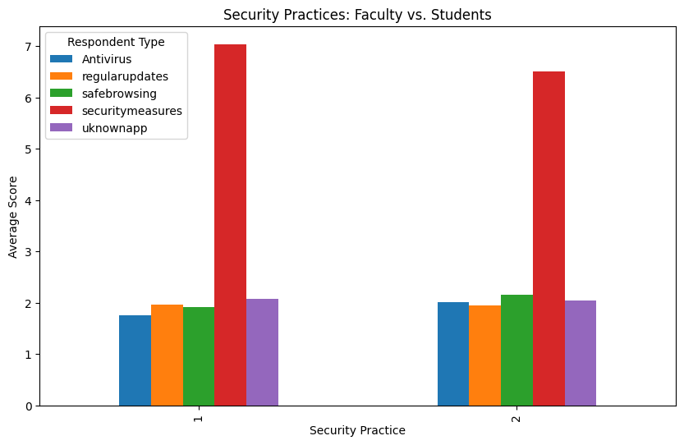
Figure 3 Security Practices

3.2 Correlation Analysis of Malware Awareness and Security Practices

Figure 4 investigates the relationship between the different malware awareness types and security practices in detail, which has been depicted in the correlation matrix. Each cell in the matrix represents the correlation coefficient from -1 to +1 measuring the extent and the character of relation between the two variables. In this case as positive means attention or practice of the other variable also increases as the focus is critical in the inverse case. The interpretation is enhanced with the help of the color gradation: dark red corresponds to strong positive correlations, dark blue to negative ones and light color means no correlation. It can be seen that there is a strong correlation with Phishing awareness (0.77) and Smishing also known as SMS phishing, which indicates that if one particular threat is known to an individual, then it is likely that others are too. Likewise, zero-day exploits account for 0.73 while Man-in-the-middle is also on account, which shows some level of awareness of these advanced threats to security. There exists moderate correlation such as that of Antivirus usage and Safe Browsing at 0.58 that emphasizes the fact that there are users who practice safe browsing who will most likely have antivirus software. Likewise, Regular Updates correlate with Safe Browsing at a coefficient of 0.52, which shows that those who practice frequent updates are often safe browsers.

There are also some negative correlations. For instance, the relationship between Phishing and Man-in-the-middle attacks carried out by someone (-0.24) or Phishing and Vishing (-0.22) instances prove that one comprehension of phishing is not inclusive of the other ears’ phishing comprehension. There also are negative correlations that may apply within more nuanced areas of this spectrum. Phishing practiced and Adware awareness had low negative correlation of - .26 suggesting not knowing differentiation of these malware. Quite fascinating is that almost no correlation (0.08) of antivirus usage with security behavior was found implying that possession of antivirus does not enforce other security habits. Other malware that are Trojans also revealed weak or no positive relationship with several security practices showing that knowledge of trojans does not relate with the overall security practices. The critical points in the correlation matrix portray that, even though at least one common underlying consensus exists with respect to the awareness of some threats like phishing & smishing, the recognition and understanding of more advanced threats like Man-in-the-middle or Vishing remains elusive. It was also observed that even basic security measures such as Antivirus, Safe Browsing & Regular Updates are clustered together while more advanced measures or awareness towards say zero-day attacks, is likely to be rare among the laymen. In this regard, this study calls for focused security awareness programs aimed at addressing these gaps and nurturing a complete understanding of malware threats and necessary measures.

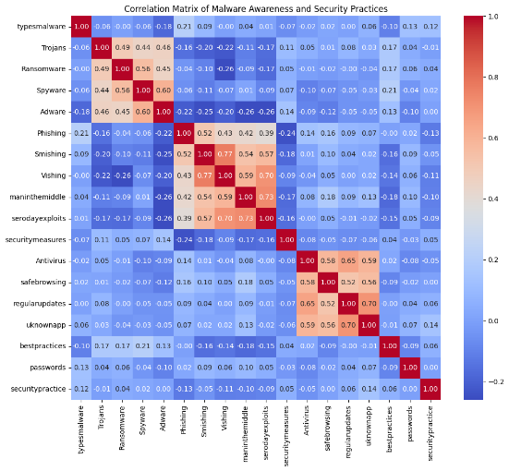
Figure 4 Correlation Analysis of Malware Awareness and Security Practices
3.3 Discussion

This study revealed distinct patterns in malware awareness and digital security practices between faculty and students at Occidental Mindoro State College, offering important implications for cybersecurity education within academic institutions. The clustering analysis demonstrated that students tend to have a higher awareness of advanced threats such as zero-day exploits and vishing, while faculty members showed slightly better adherence to basic security practices like regular software updates and antivirus usage. These results highlight a crucial gap: awareness does not always translate into safe behavior and following simple protective guidelines does not always reflect a deeper knowledge of changing cyber threats.

The study challenges the prevailing assumption that cybersecurity awareness and practices are uniformly distributed among users in educational settings. Instead, the study implies exposure to malware and the probability of taking preventative action are mostly influenced by demographic elements; age, gender, mobile use patterns, and operating systems. Moreover, the low correlation of some protective behaviors, such as general security behavior and antivirus use, makes one question the efficiency of passive security policies. This finding emphasizes the need of educational intervention to addresses behavioral gaps and digital malpractice.

The implications of these results are substantial evidence for current models of cybersecurity training. Educational institutions should reconsider the generalized approaches and instead adopt personalized, data-informed strategies that target the unique needs of different user groups. Additionally, faculty may learn more from hands-on training which focuses on new threats such as phishing and smishing. On the other hand, students may require reinforcement in maintaining steady, proactive security habits even though they are quite aware of the potential threats.

Future research should expand on this work by implementing and evaluating targeted cybersecurity education programs. This should be within the identified clusters and tracking their impact over time. Carrying out longitudinal studies is essential to determine if enhancements in awareness lead to enduring changes in behavior. Moreover, the integration of behavioral simulations, such as mock phishing attempts, could enhance the validation of self-reported practices and provide a clearer insight into user behavior. It is essential to carry out controlled experiments that juxtapose tailored training interventions against more generalized programs to effectively validate the efficacy of targeted approaches.

In summary, this research highlights the importance of educational data mining in revealing behavioral insights and informing the development of effective cybersecurity awareness initiatives. By pinpointing and tackling particular weaknesses in both understanding and application, educational establishments can enhance their digital security measures and play a significant role in advancing overarching objectives in cybersecurity and digital literacy.

4. Conclusion

This research has the aim of evaluating mobile malware threats in a more general manner by considering user awareness and security measures taken by teachers and students as well. This is rather frightening yet covert, especially when considering all forms of mobile malware including adware, phishing and trojan horses as a long-standing threat within education. As technology advanced, so did the level of sophistication of malware, however, students and faculty managed to vary in awareness levels, students especially seem to be more aware of more complex attacks such as zero-day attacks while faculty seem to be more basic in terms of security measures stereotypically. However, some of the conclusions derived from the analysis indicate that knowledge of general threats such as phishing and smishing is beneficial and that there remain some discrepancies on knowledge of attack vectors such as man in the middle attack. Despite users’ perceptions of the importance of these activities, both groups still have some room for improvement regarding the practice of security implementation such as the use of malware protection software and updating of applications regularly.

The need for specific educational programs was clearly demonstrated in both K-Means clustering and correlation matrix analysis. When schools and universities focus on improving specific weaknesses in malware awareness, such as faculty phishing or student ransomware, and promote better compliance with security policies such as updates or safe browsing, institutions will be able to build a strong barrier for malware threats. To conclude, although the attitude to security issues within a student-faculty body is reasonable, the data obtained develops the view regarding the maintenance of preventive education in regards to potential threats of mobile devices abuse. Concentrating on the mentioned points through appropriate education and awareness will help users in not only using their strategies efficiently but also defending themselves and their institutions from the ever-growing mobile malware threats.

References

Alqahtani, M. A. (2022). Factors Affecting Cybersecurity Awareness among University Students. Applied Sciences (Switzerland), 12(5). https://doi.org/10.3390/app12052589
Alyahyan, E., & Düştegör, D. (2020). Predicting academic success in higher education: literature review and best practices. International Journal of Educational Technology in Higher Education, 17(1). https://doi.org/10.1186/s41239-020-0177-7
Aronowitz, T., Aronowitz, S., Mardin-Small, J., & Kim, B. R. (2017). Using Objective Structured Clinical Examination (OSCE) as Education in Advanced Practice Registered Nursing Education. Journal of Professional Nursing, 33(2), 119–125. https://doi.org/10.1016/j.profnurs.2016.06.003
Beaman, C., Barkworth, A., Akande, T. D., Hakak, S., & Khan, M. K. (2021). Ransomware: Recent advances, analysis, challenges and future research directions. Computers and Security, 111, 102490. https://doi.org/10.1016/j.cose.2021.102490
Buckner, C. A., Lafrenie, R. M., Dénommée, J. A., Caswell, J. M., Want, D. A., Gan, G. G., Leong, Y. C., Bee, P. C., Chin, E., Teh, A. K. H., Picco, S., Villegas, L., Tonelli, F., Merlo, M., Rigau, J., Diaz, D., Masuelli, M., Korrapati, S., Kurra, P., …
Mathijssen, R. H. J. (2016). We are IntechOpen , the world ’ s leading publisher of Open Access books Built by scientists , for scientists TOP 1 %. Intech, 11(tourism), 13. https://www.intechopen.com/chapters/17746
Budhwar, P., Chowdhury, S., Wood, G., Aguinis, H., Bamber, G. J., Beltran, J. R., Boselie, P., Lee Cooke, F., Decker, S., DeNisi, A., Dey, P. K., Guest, D., Knoblich, A. J., Malik, A., Paauwe, J., Papagiannidis, S., Patel, C., Pereira, V., Ren, S., … Varma, A. (2023). Human resource management in the age of generative artificial intelligence: Perspectives and research directions on ChatGPT. Human Resource Management Journal, 33(3), 606–659. https://doi.org/10.1111/1748-8583.12524
Chandarman, R., & Niekerk, B. Van. (2017). Students ’ Cybersecurity Awareness at a Private Tertiary Educational. The African Journal of Information and Communication (AJIC), 20, 133–155.
Christen, M., Gordijn, B., & Loi, M. (2022). The Ethics of Cybersecurity. In CrimRxiv. https://doi.org/10.21428/cb6ab371.d27262ff
Couture, F., Jarzabkowski, P., & Le, J. K. (2023). Triggers, Traps, and Disconnect: How Governance Obstacles Hinder Progress on Grand Challenges. Academy of Management Journal, 66(6), 1651–1680. https://doi.org/10.5465/amj.2020.1716
Dwivedi, Y. K., Hughes, L., Baabdullah, A. M., Ribeiro-Navarrete, S., Giannakis, M., Al-Debei, M. M., Dennehy, D., Metri, B., Buhalis, D., Cheung, C. M. K., Conboy, K., Doyle, R., Dubey, R., Dutot, V., Felix, R., Goyal, D. P., Gustafsson, A., Hinsch, C., Jebabli, I., … Wamba, S. F. (2022). Metaverse beyond the hype: Multidisciplinary perspectives on emerging challenges, opportunities, and agenda for research, practice and policy. International Journal of Information Management, 66(July), 102542. https://doi.org/10.1016/j.ijinfomgt.2022.102542
Dwivedi, Y. K., Hughes, L., Ismagilova, E., Aarts, G., Coombs, C., Crick, T., Duan, Y., Dwivedi, R., Edwards, J., Eirug, A., Galanos, V., Ilavarasan, P. V., Janssen, M., Jones, P., Kar, A. K., Kizgin, H., Kronemann, B., Lal, B., Lucini, B., … Williams, M. D. (2021). Artificial Intelligence (AI): Multidisciplinary perspectives on emerging challenges, opportunities, and agenda for research, practice and policy. International Journal of Information Management, 57(July), 0–1. https://doi.org/10.1016/j.ijinfomgt.2019.08.002
Dwivedi, Y. K., Ismagilova, E., Hughes, D. L., Carlson, J., Filieri, R., Jacobson, J., Jain, V., Karjaluoto, H., Kefi, H., Krishen, A. S., Kumar, V., Rahman, M. M., Raman, R., Rauschnabel, P. A., Rowley, J., Salo, J., Tran, G. A., & Wang, Y. (2021). Setting the future of digital and social media marketing research: Perspectives and research propositions. International Journal of Information Management, 59(July 2020), 102168. https://doi.org/10.1016/j.ijinfomgt.2020.102168
Erendor, M. E., & Yildirim, M. (2022). Cybersecurity Awareness in Online Education: A Case Study Analysis. IEEE Access, 10, 52319–52335. https://doi.org/10.1109/ACCESS.2022.3171829
Figueras-Alvarez, O., Cantó-Navés, O., Cabratosa-Termes, J., Roig-Cayón, M., Felipe-Spada, N., & Tomàs-Aliberas, J. (2020). Snoring intensity assessment with three different smartphones using the SnoreLab application in one participant. Journal of Clinical Sleep Medicine, 16(11), 1971–1974. https://doi.org/10.5664/jcsm.8676
Gill, S. S., Xu, M., Ottaviani, C., Patros, P., Bahsoon, R., Shaghaghi, A., Golec, M., Stankovski, V., Wu, H., Abraham, A., Singh, M., Mehta, H., Ghosh, S. K., Baker, T., Parlikad, A. K., Lutfiyya, H., Kanhere, S. S., Sakellariou, R., Dustdar, S., … Uhlig, S. (2022). AI for next generation computing: Emerging trends and future directions. Internet of Things (Netherlands), 19, 1–43. https://doi.org/10.1016/j.iot.2022.100514
Hancock, J. T., & Khoshgoftaar, T. M. (2020). CatBoost for big data: an interdisciplinary review. Journal of Big Data, 7(1). https://doi.org/10.1186/s40537-020-00369-8
İçen, M. (2022). The future of education utilizing artificial intelligence in Turkey. Humanities and Social Sciences Communications, 9(1), 1–10. https://doi.org/10.1057/s41599-022-01284-4
Jain, A. K., Sahoo, S. R., & Kaubiyal, J. (2021). Online social networks security and privacy: comprehensive review and analysis. Complex and Intelligent Systems, 7(5), 2157–2177. https://doi.org/10.1007/s40747-021-00409-7
Jandrić, P., Hayes, D., Truelove, I., Levinson, P., Mayo, P., Ryberg, T., Monzó, L. D., Allen, Q., Stewart, P. A., Carr, P. R., Jackson, L., Bridges, S., Escaño, C., Grauslund, D., Mañero, J., Lukoko, H. O., Bryant, P., Fuentes-Martinez, A., Gibbons, A., … Hayes, S. (2020). Teaching in the Age of Covid-19. Postdigital Science and Education, 2(3), 1069–1230. https://doi.org/10.1007/s42438-020-00169-6
Kung, T. H., Cheatham, M., Medenilla, A., Sillos, C., De Leon, L., Elepaño, C., Madriaga, M., Aggabao, R., Diaz-Candido, G., Maningo, J., & Tseng, V. (2023). Performance of ChatGPT on USMLE: Potential for AI-assisted medical education using large language models. PLOS Digital Health, 2(2), e0000198. https://doi.org/10.1371/journal.pdig.0000198
Lopes, A., Mamede, H. S., Reis, L., & Santos, A. (2024). Common Techniques, Success Attack Factors and Obstacles to Social Engineering: A Systematic Literature Review. Emerging Science Journal, 8(2), 761–794. https://doi.org/10.28991/ESJ-2024-08-02-025
Lu, L., Cai, R., & Gursoy, D. (2019). Developing and validating a service robot integration willingness scale. International Journal of Hospitality Management, 80(July 2018), 36–51. https://doi.org/10.1016/j.ijhm.2019.01.005
Makhdoom, I., Abolhasan, M., Lipman, J., Liu, R. P., & Ni, W. (2019). Anatomy of Threats to the Internet of Things. IEEE Communications Surveys and Tutorials, 21(2), 1636–1675. https://doi.org/10.1109/COMST.2018.2874978
Nyagwencha, J. (2024). An Information Security Awareness Model For Bring Your Own Devices : Case Study of a University in Kenya. 1–13. Page, M. J., Moher, D., Bossuyt, P. M., Boutron, I., Hoffmann, T. C., Mulrow, C. D., Shamseer, L., Tetzlaff, J. M., Akl, E. A., Brennan, S. E., Chou, R., Glanville, J., Grimshaw, J. M., Hróbjartsson, A., Lalu, M. M., Li, T., Loder, E. W., Mayo-Wilson, E., Mcdonald, S., … Mckenzie, J. E. (2021). PRISMA 2020 explanation and elaboration: Updated guidance and exemplars for reporting systematic reviews. The BMJ, 372. https://doi.org/10.1136/bmj.n160
Paste, D., & Wadkar, T. (2021). Malware: Detection, Classification and Protection. International Research Journal of Engineering and Technology. www.irjet.net
Petrů, N., Kramoliš, J., & Stuchlík, P. (2020). Marketing tools in the era of digitization and their use in practice by family and other businesses. E a M: Ekonomie a Management, 23(1), 199–214. https://doi.org/10.15240/tul/001/2020-1-014
Rajabalee, Y. B., & Santally, M. I. (2021). Learner satisfaction, engagement and performances in an online module: Implications for institutional e-learning policy. In Education and Information Technologies (Vol. 26, Issue 3). Education and Information Technologies. https://doi.org/10.1007/s10639-020-10375-1
Ronimus, M., Eklund, K., Pesu, L., & Lyytinen, H. (2019). Supporting struggling readers with digital game-based learning. Educational Technology Research and Development, 67(3), 639–663. https://doi.org/10.1007/s11423-019-09658-3
Sedrakyan, G., Malmberg, J., Verbert, K., Järvelä, S., & Kirschner, P. A. (2020). Linking learning behavior analytics and learning science concepts: Designing a learning analytics dashboard for feedback to support learning regulation. Computers in Human Behavior, 107, 105512. https://doi.org/10.1016/j.chb.2018.05.004
Sen, J. (2021). Machine Learning Algorithms, Models and Applications Edited by Jaydip Sen (Vol. 7). http://dx.doi.org/10.5772/intechopen
Shaukat, K., Luo, S., Varadharajan, V., Hameed, I. A., & Xu, M. (2020). A Survey on Machine Learning Techniques for Cyber Security in the Last Decade. IEEE Access, 8, 222310–222354. https://doi.org/10.1109/ACCESS.2020.3041951
Singh, R., Gehlot, A., & Buddhi, D. (2022). Comparative Analysis of Different Machine Learning Classifiers for the Prediction of Chronic Diseases. 1–380. https://doi.org/10.13052/rp-9788770227667
Sundaram, A. (2017). Understanding and Protecting Yourself against Threats in the Internet. Asian Social Science, 13(12), 201. https://doi.org/10.5539/ass.v13n12p201
Wang, M., & Deng, W. (2021). Deep face recognition: A survey. Neurocomputing, 429, 215–244. https://doi.org/10.1016/j.neucom.2020.10.081
Yang, G., Ye, Q., & Xia, J. (2022). Unbox the black-box for the medical explainable AI via multi-modal and multi-centre data fusion: A mini-review, two showcases and beyond. Information Fusion, 77(May 2021), 29–52. https://doi.org/10.1016/j.inffus.2021.07.016
Zou, Y., Zhu, J., Wang, X., & Hanzo, L. (2016). A Survey on Wireless Security: Technical Challenges, Recent Advances, and Future Trends. Proceedings of the IEEE, 104(9), 1727–1765. https://doi.org/10.1109/JPROC.2016.2558521

