Case report

A 45 Year Old male Intravenous Drug abuser with chronic limb ischemia- a challenging case managed successfully.

Abstract
Complications arising as from intravenous drug abuse have traditionally posed a unique challenge to vascular surgeons. Due to its easy accessibility, the femoral artery is the most commonly abused injection site for drug users. Pseudoaneurysm of the femoral artery is the most common complication among IV drug abusers who inject drugs in groin. A 45 years old male intravenous drug abuser presented to the Department of Cardiovascular Surgery of Dhaka Medical College and Hospital with rest pain and dry gangrene in his left lower limb for 6 months following surgical management of ruptured Pseudoaneurysm of femoral artery in National Institute of Cardiovascular Surgery two months back. On clinical examination he had features of chronic lower limb ischemia on left side including absent peripheral pulses, cold periphery, diminished sensation and blackening of great and 2nd toes. He also had a hypertrophic T shaped scar in his groin from previous surgery. His Doppler and CT angiography report revealed 40% narrowing of left external iliac artery with thrombotic occlusion in left common and up to mid part of superficial femoral artery with reconstituted flow in lower superficial femoral artery, popliteal, anterior and posterior tibial artery. He underwent left ilio-popliteal bypass by extraperitoneal approach. His post-operative period was uneventful with establishment of distal blood flow.
Key words: Pseudoaneurysm, chronic lower limb ischemia, ilio-popliteal

Introduction:
A pseudoaneurysm (also known as false aneurysm) is a haematoma that communicates with an artery through a disruption in the arterial wall. Its outer wall usually lacks a true epithelial lining and is made up of a layer of compressed surrounding tissue.¹
Complications arising as a result of intravenous drug abuse have traditionally posed a unique challenge to vascular surgeons. Due to its easy accessibility, the femoral artery is one of the most commonly abused injection site for drug users.² The most common arterial complication is pseudoaneurysm of femoral artery in IV drug abusers.² Patients usually present late with complications like bleeding, sepsis, and limb ischemia.³ Ruptured pseudoaneurysm can not only be limb-threatening, but also be life-threatening and poses a difficult management problem for vascular surgeons all over the world.
Excision and ligation of affected artery along with local debridement is traditional treatment of choice.⁴ Limb salvage procedures in patients with ruptured infected pseudoaneurysms of the groin are challenging and often require special technical considerations. Simple ligation of the external iliac or common femoral artery without revascularization represents the most common treatment approach. However, such management carries considerable risk of severe claudication, critical ischemia, and subsequent amputations. Therefore, some vascular surgeons, advocate a more aggressive approach including concomitant revascularization using synthetic

or autogenous vein grafts.⁵ On the other hand, some vascular surgeons have adopted a more conservative approach towards revascularization as a delayed procedure.⁵
Here we present a case of a 45 year old male intravenous drug abuser presented with chronic limb ischemia following ruptured Pseudoaneurysm of femoral artery.

Case Summary:
A 45 years old male intravenous drug abuser presented to the Department of Cardiovascular Surgery of Dhaka Medical College and Hospital with rest pain and dry gangrene in his left lower limb for 6 months following surgical management of ruptured Pseudoaneurysm of femoral artery in National Institute of Cardiovascular Surgery two months back. On clinical examination he had features of chronic lower limb ischemia on left side including absent peripheral pulses, cold periphery, diminished sensation and blackening of great and 2nd toes.(Fig-1)
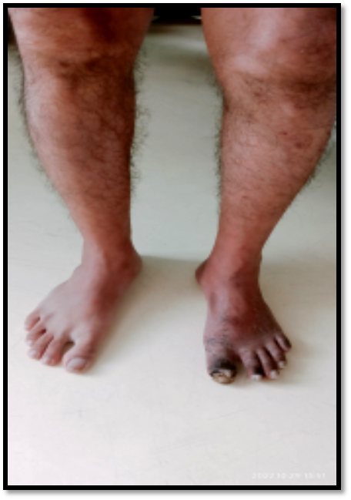

Fig-1 showing gangrene over the left foot of the patient

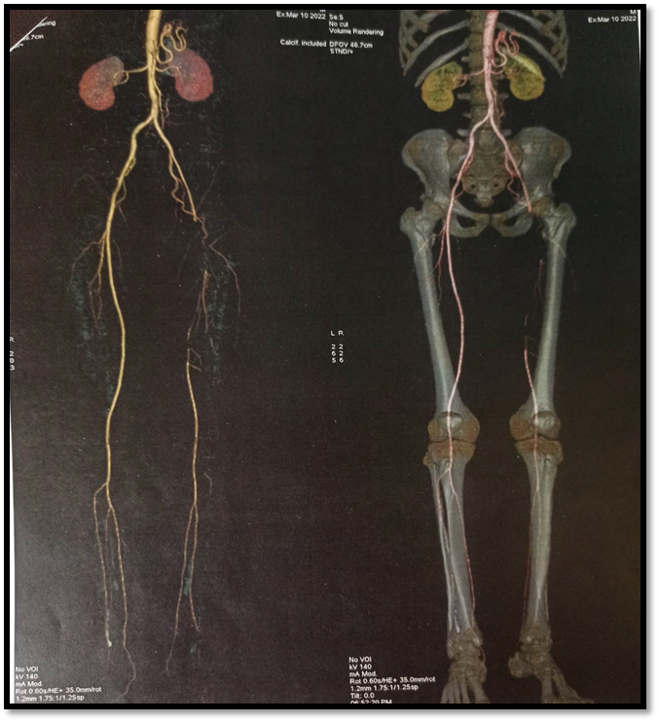
He also had a hypertrophic T shaped scar in his groin from previous surgery. There was another scar mark in left iliac fossa from his previous surgery. His right limb was apparently normal. His vital signs were within normal limit. Other systemic examinations revealed normal findings.His blood reports including complete blood count, renal liver function tests, electrocardiogram and chest x-ray demonstrated normal findings. Doppler and CT angiography report revealed 40% narrowing of left external iliac artery with thrombotic occlusion in left common and up to mid part of superficial femoral artery with reconstituted flow in lower superficial femoral artery, popliteal, anterior and posterior tibial artery.(Fig-2)

Fig-2 showing CT angiogram of the patient

With all aseptic precaution, abdomen was opened by left iliac incision. Then External iliac artery was exposed through retroperitoneal approach & proximal portion of external iliac artery was found patent. Controls were taken over the left common iliac, external illiac & internal iliac artery.(Fig-3)
There was a scar mark over the anterior aspect of left thigh & this scar region was avoided & a separate incision was given laterally to the scar tissue & then common femoral artery was exposed. Then tunneling of the PTFE graft in thigh region was done by excising & removing scar tissue of the surroundings. Initially we thought a single graft will adequate. But as the landing zone was unfavorable, so graft lengthening was done by end to end anastomosis with a part of another PTFE graft.(Fig-4) Then popliteal artery was exposed & ilio-popliteal bypass was done & distal flow was established.(Fig-5) Two drains were kept, one in abdomen & another one in the thigh. Wound was closed in layers.
Post-operative period was uneventful. Periphery was warm and ADP pulse was palpable. Patient’s symptoms were improved. Drains were removed on 3rd post-operative day. Patient was discharged on 8th post-operative day.

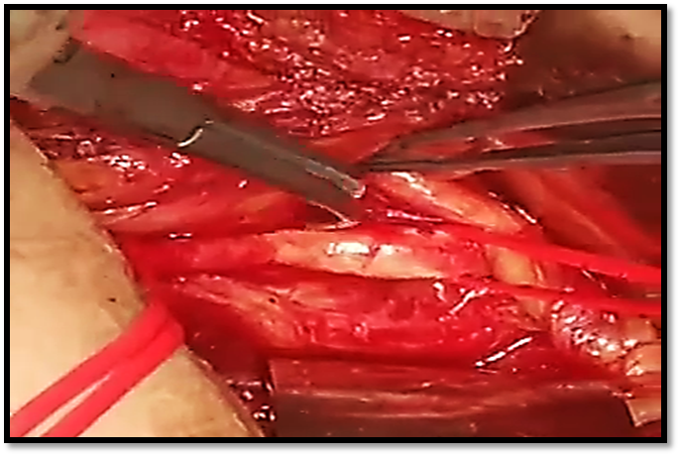
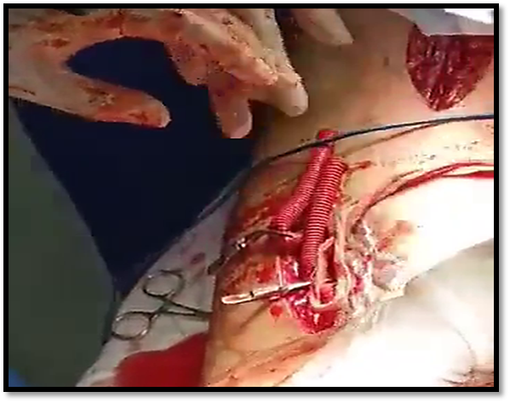
(A) (B)
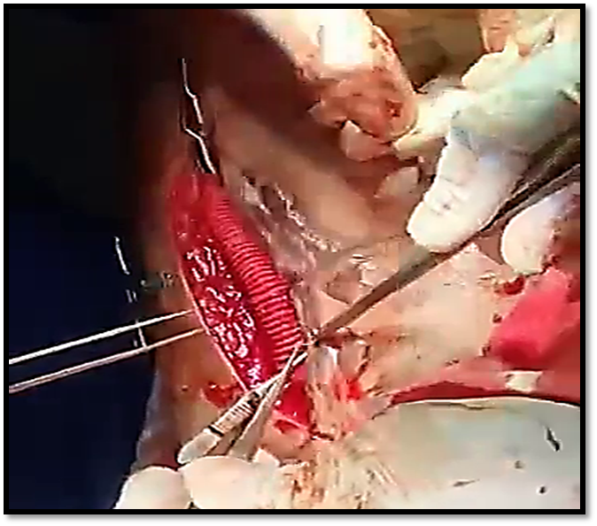
(C)

Fig-3 Showing per-operative view of the patient (A) Identification of left common iliac and external iliac artery (B) Graft Lengthening (C) Post anastomotic view

Discussion:
Intravenous drug abuse represents a worldwide social and medical problem. Various vascular complications, such as infectious pseudoa-neurysms, deep venous thrombosis (DVT), gangrene, and arterial embolization, can occur in drug addicts, frequently requiring prompt management.⁶ The incidence of infected pseudoaneurysms of the femoral or external iliac artery in this subgroup of patients is quite high and various procedures for limb salvage have been described.
In the event of postoperative limb ischemia after pseudoaneurysm surgery, angiographic evaluation with revascularization should be done whenever feasible.⁷ In our case, the patient underwent CT angiogram for proper evaluation and planning of surgery. The surgical treatment of these pseudoaneurysms remains challenging and controversial. Current treatment options include excision and debridement of infected pseudoaneurysms with ligation of affected artery without revascularization or extensive debridement of infected pseudoaneurysms with routine revascularization.^{8,9}
This revascularization can be achieved with an autogenous or synthetic graft . Excision of pseudoaneurysm without arterial reconstruction has been reported by several authors as a viable option.^{10,11} In a study by Arora at al.simple arterial ligation without reconstruction was done without any associated amputation and only mild claudication.¹² Reddy carried out arterial ligation in 39 patients with two (5%) postoperative amputations.¹³

Bashar at al. showed as for the surgical outcome, both ligation and arterial reconstruction were effective in treating the bleeding aneurysm although restoration of arterial continuity was more effective in preventing acute and chronic limb ischemia.¹⁴ In our case we successfully managed the case where delayed revascularization was done by PTFE graft for chronic limb ischemia following ruptured pseudoaneurysm surgery.
In cases where arterial reconstruction is done, surgeons must be judicious in choosing the graft material. Pseudoaneurysms in drug abusers almost always have some degree of infection and the use of prosthetic graft in infected sites is hardly recommendable. Therefore autologous vein graft should be used whenever possible.¹⁵ In our case we used a PTFE graft as saphenous vein of both leg was not favorable for graft. Besides we administered pre-operative antibiotics for one week to reduce the burden of infection. Besides in the post-operative period there was no evidence of graft infection even after 3 months of follow-up.

Conclusion:
Management of ruptured pseudoaneurysms in intravenous drug abusers is a difficult task. . Simple ligation and debridement without revascularization was a safe and effective treatment for such patients. But patients may present with features of chronic limb ischemia in the long run which should be managed meticulously to provide a better outcome. Special attention should also be directed during follow-up for rehabilitation from intravenous drug abuse.
Consent:
Patient’s informed written consent was taken to publish his case for academic purpose.
Ethical approval:
As per international standards or university standards written ethical approval has been collected from Institutional ethical committee and preserved by the authors.
References:
- Klonaris, C., Katsargyris, A., Papapetrou, A., Vourliotakis, G., Tsiodras, S., Georgopoulos, S., Giannopoulos, A., & Bastounis, E. (2007). Infected femoral artery pseudoaneurysm in drug addicts: The beneficial use of the internal iliac artery for arterial reconstruction. Journal of Vascular Surgery, 45(3), 498–504. https://doi.org/10.1016/j.jvs.2006.11.014
- Scheuerlein, H., Ruff, S., Haage, P., Zirngibl, H., Fraunhofer, S., & Settmacher, U. (2008). Groin Abscesses and Vascular Catastrophes in Intravenous Drug Users--Strategy and Results. Zentralblatt für Chirurgie, 133(1), 55-60. https://doi.org/10.1055/s-2008-1004658
- Yegane, R. A., Salehi, N. A., Ghaseminegad, A., Bahrami, F., Bashashati, M., Ahmadi, M., & Hojjati, M. (2006). Surgical approach to vascular complications of intravenous drug abuse. European Journal of Vascular and Endovascular Surgery, 32(4), 397-401. https://doi.org/10.1016/j.ejvs.2006.02.014
- Peirce, C., Coffey, J. C., O'Grady, H., Aly, S., O'Malley, K., & O'Donohoe, M. (2009). The management of mycotic femoral pseudoaneurysms in intravenous drug abusers. Annals of Vascular Surgery, 23(3), 345–349. https://doi.org/10.1016/j.avsg.2008.08.013
- Chan, Y. C., & Burnand, K. G. (2006). Management of septic groin complications and infected femoral false aneurysms in intravenous drug abusers. British Journal of Surgery, 93(7), 781–782. https://doi.org/10.1002/bjs.5452
- Mousavi, S. R., Saberi, A., Tadayon, N., Zeynalzadeh, M., & Kavyani, A. (2010). Femoral artery ligation as treatment for infected pseudo-aneurysms, secondary to drug injection. Acta Chirurgica Belgica. https://doi.org/10.1080/00015458.2010.11680597
- Hu, Z. J., Wang, S. M., Li, X. X., Li, S. Q., & Huang, X. L. (2010). Tolerable hemodynamic changes after femoral artery ligation for the treatment of infected femoral artery pseudoaneurysm. Annals of Vascular Surgery, 24(2), 212–218. https://doi.org/10.1016/j.avsg.2009.06.006
- Tan, K. K., Chen, K., Chia, K. H., Lee, C. W., & Nalachandran, S. (2009). Surgical management of infected pseudoaneurysms in intravenous drug abusers: single institution experience and a proposed algorithm. World Journal of Surgery. https://doi.org/10.1007/s00268-009-0123-2
- Schneider, J. R., Oskin, S. I., & Verta, M. J. (2009). Superficial Femoral Vein Graft Interposition In Situ Repair for Femoral Mycotic Aneurysm. Annals of Vascular Surgery, 23(1), 147–149. https://doi.org/10.1016/j.avsg.2007.12.023
- Matoussevitch, V., Aleksic, M., Gawenda, M., & Brunkwall, J. (2007). Primary extraanatomical revascularization for groin infections in drug addicts. Vasa, 36, 210–214. https://doi.org/10.1024/0301-1526.36.3.210
- Klonaris, C., Katsargyris, A., Papapetrou, A., Vourliotakis, G., Tsiodras, S., Georgopoulos, S., Giannopoulos, A., & Bastounis, E. (2007). Infected femoral artery pseudoaneurysm in drug addicts: The beneficial use of the internal iliac artery for arterial reconstruction. Journal of Vascular Surgery, 45(3), 498–504. https://doi.org/10.1016/j.jvs.2006.11.014
- Arora, S., Weber, M. A., Fox, C. J., Neville, R., Lidor, A., & Sidawy, A. N. (2001). Common femoral artery ligation and local debridement: A safe treatment for infected femoral artery pseudoaneurysms. Journal of Vascular Surgery, 33(5), 990-993. https://doi.org/10.1067/mva.2001.114212
- Reddy, D. J., Smith, R. F., Elliott, J. P., Jr., Haddad, G. K., & Wanek, E. A. (1986). Infected femoral artery false aneurysms in drug addicts: Evolution of selective vascular reconstruction. Journal of Vascular Surgery, 3(5), 718–724. https://pubmed.ncbi.nlm.nih.gov/3517387/
- Bashar, A. H. M., Sabah, M. N., Hossain, M. F., Azad, Q. A., Alam, Q. M., & Hossain, G. M. M. (2010). Surgical Management of Vascular Complications in Intravenous Drug Abusers: Experience at the National Institute of Cardiovascular Diseases (NICVD), Bangladesh. Cardiovascular Journal, 3(1), 45–49. https://doi.org/10.3329/cardio.v3i1.6426
- Cheema, M. A., & Shafique, A. (2005). Presentation and management of pseudoaneurysms of femoral artery. Journal of the College of Physicians and Surgeons Pakistan, 15(3), 162–164. https://pubmed.ncbi.nlm.nih.gov/15808096/

