Original Research Article
Sub-Chronic Hepatotoxicity of Aluminium Phosphide in Wistar Rats: Biochemical and Histopathological Evidence

Abstract
Aims: This study aimed to investigate the hepatotoxic effects of sub-chronic dietary exposure to Aluminium phosphide (AlP) by assessing biochemical and histopathological alterations in the liver of Wistar rats.
Study design: A controlled, 56-day toxicological feeding experiment was conducted using twenty-eight adult Wistar rats randomly assigned to four groups receiving either standard feed (control) or AlP-formulated diets at low, high, or very high concentrations.
Methodology: Rats consumed their respective diets ad libitum for 56 days. Serum liver function biomarkers including ALT, AST, ALP, total bilirubin, total protein, and albumin, were quantified using validated commercial assay kits. Liver samples were processed for histopathological evaluation using standard hematoxylin and eosin staining to assess structural damage and cellular alterations.
Results: Exposure to high and very high AlP concentrations led to marked increases in ALT and total bilirubin relative to controls, indicating hepatocellular leakage and impaired bilirubin handling. Conversely, AST and ALP levels showed significant reductions, while serum protein indices remained statistically unchanged across groups. Histological examination revealed steatosis (both micro- and macro-vesicular), centrilobular vascular congestion, and mild hepatocyte degeneration, particularly in animals receiving higher AlP doses. These findings collectively indicate dose-dependent hepatic injury.
Conclusion: Sub-chronic ingestion of AlP-contaminated feed results in measurable biochemical and structural liver damage in Wistar rats, suggesting oxidative-stress-mediated hepatotoxicity. The study underscores the need for monitoring AlP residue exposure in populations relying on fumigant-treated food commodities.
Keywords: Aluminium phosphide; hepatotoxicity; liver biomarkers; sub-chronic toxicity; Wistar rats.

1. INTRODUCTION
Aluminium phosphide (AlP) is a widely used fumigant for grain preservation, releasing phosphine (Ph₃) gas upon contact with moisture (Eric, Boloya, and Osuamkpe, 2021). While effective against pests, phosphine is highly toxic to mammals, primarily by inhibiting mitochondrial respiration and generating reactive oxygen species (ROS) (Parvizrad et al., 2022). The liver, as the central metabolic organ, is particularly vulnerable to oxidative injury, which can lead to hepatocellular damage, altered enzymatic activity, and histological changes (Masoudian et al., 2020).
Most studies on alp toxicity focus on acute poisoning. However, in realistic settings, humans and animals may experience repeated low-level exposure through the consumption of fumigated grains. Sub-chronic exposure can induce subtle biochemical and structural changes that precede clinical liver dysfunction (Mehrpour et al., 2022).
This study investigates dose-dependent alterations in liver function biomarkers and histopathology in Wistar rats following 56-day dietary exposure to AlP, aiming to provide a mechanistic understanding of sub-chronic hepatotoxicity relevant to food safety and public health.

2. MATERIALS AND METHODS
2.1 Materials
The Aluminium Phosphide sample was gotten from Eke Awka market in Awka, Anambra State.
2.4 Study area
This study was conducted at the Natural Products Laboratory, Unizik Awka, Animal House Department of Applied Biochemistry, Nnamdi Azikiwe University, Awka, and Ifex's Diagnostics laboratory, Regina Caeli Road, Awka.

2.2 Duration
The study was completed in 56 days, equivalent to 8 weeks, including 7 days for acclimatization, 35 days for animal studies, and 14 days for in vivo assays, data collection, and data analysis.
2.3 Procedures
4000g of rat feed were divided into four 1000g each. The purchased AlP was used to formulate the feed in three of the four containers at different doses of 0.185% (w/w) (low concentration), 0.370% (w/w) (high concentration), and 1.10% (w/w) (very high concentration), while the remaining container was used to feed the control group
2.5 Animal studies
Ethical approval for all experimental protocols was obtained from the Animal Research Ethics Committee (AREC), Nnamdi Azikiwe University, Awka. This research study followed the guidelines for laboratory animal use and care provided in the European Community guidelines (EEC Directive of 1986; 86/609/EEC) and the US guidelines (NIH publication #85-23, revised in 1985).
2.6 Purchase, acclimatization, and feeding of animals
The experiment followed a completely randomized design. Twenty-eight (28) albino rats were purchased from Onyewuchi Farm, Ifite, Awka. These animals were acclimatized for one week and fed only food and water.
2.7 Grouping of the animals
Twenty-eight (28) albino rats were divided into four (4) groups of five (7) animals in each group. They were grouped as follows: Group A-normal control; Group B-low concentration (received feed formulated with AlP 0.185% (w/w)); Group C-high concentration (received feed formulated with AlP 0.370% (w/w)); and Group D-very high concentration (received feed formulated with AlP 1.10% (w/w)). The study was carried out for 35 days.
2.8 Liver function test
Serum biochemical indices routinely estimated for liver functions, including aspartate aminotransferase (AST), alanine aminotransferase (ALT), alkaline phosphatase (ALP), and total protein, were determined using Randox diagnostic kits. The procedures followed the manufacturer's instructions.
2.9 Histological analysis
Histopathological evaluations of the liver were carried out after the completion of the 4-week experimental procedure. The experimental animal was sacrificed by diethyl ether inhalation, and the abdominal cavity was exposed. Thereafter, liver tissues were processed for light histological microscopy, and conventional histopathological evaluations of the liver were conducted using the hematoxylin-eosin technique, as previously described by Akinlolu et al. (2017).
2.10 Data analysis
The data were expressed as mean ± Standard Error of the Mean (SEM) and subjected to One-Way Analysis of Variance analysis (ANOVA). Values were considered statistically significant at (p < 0.05) using Statistical Package for Social Sciences (SPSS) software version 17.0 (SPSS Inc., Chicago, IL, USA).

3. Results and discussion
3.1 Result on the mean-weight parameter
From the results, consumption of feed formulated with the aluminum phosphide didn’t lead to weight reduction since there was a significant increase in weight (p<0.05) in all the groups; though the groups that fed on feed formulated with higher concentrations of aluminum phosphide had a lower percentage increase in weight, as shown in Table 1. Thus, weight changes are not symptoms of any disease condition associated with the consumption of feed formulated with aluminum phosphide on a subchronic scale.

Table 1: Average weights of the various groups during the experimental period

Time (Weeks) | Normal control | Low concentration of Aluminum phosphide | High concentration of Aluminum phosphide | Very high concentration of Aluminum phosphide
0 | 59.43±2.30 | 63.86±2.11 | 77.43±1.77 | 68.14±2.66
1 | 71.00±4.42 | 88.80±4.15 | 81.17±3.32 | 78.14±2.76
2 | 73.83±4.88 | 90.00±4.23 | 79.00±2.86 | 78.17±3.66
3 | 80.50±7.21 | 95.60±4.68 | 85.83±3.45 | 86.17±4.25
4 | 85.67±7.40 | 100.40±4.97 | 84.17±3.92 | 89.33±4.94
5 | 96.33±8.02 | 112.20±6.45 | 102.17±4.64 | 106.67±6.22
6 | 90.17±7.81 | 103.20±6.90 | 92.50±4.79 | 97.67±5.89
7 | 96.83±10.20 | 118.60±6.21 | 108.33±5.74 | 113.00±7.48
8 | 109.00±9.08 | 124.40±6.18 | 106.67±6.15 | 113.50±7.46

3.2 Liver Analysis Results
The results show that the group that consumed feed formulated with a very high concentration of Aluminium phosphide had the highest Alanine Aminotransferase (ALT) levels (41.20±4.15 U/L). Also, the highest total bilirubin level was recorded in the group that consumed feed formulated with Aluminium phosphide (2.74±0.19 mg/dl) as shown in Table 2. There was a significant increase in total bilirubin (p> 0.05). There were significant reductions in ALP and AST levels (p > 0.05). There were no significant differences in total protein, Albumin, and Globulin levels.

Table 2: Average liver function parameters in the various groups
Parameters | Normal control | Low concentration of Aluminum phosphide | High concentration of Aluminum phosphide | Very high concentration of Aluminum phosphide
ALT (U/L) | 30.45±3.72 | 28.87±10.80 | 37.20±5.43 | 41.20±4.15
AST (U/L) | 119.80±8.88 | 73.63±7.70 | 92.25±4.62 | 77.63±10.16
Total bilirubin (mg/dl) | 0.49±0.08 | 2.74±0.19 | 2.70±0.10 | 2.07±0.42
Albumin (g/dl) | 0.97±0.11 | 0.93±0.19 | 0.81±0.06 | 0.96±0.13
Total protein (g/dl) | 3.39±0.96 | 2.50±0.30 | 2.23±0.35 | 1.80±0.25
Globulin (g/dl) | 2.42±0.93 | 1.57±0.26 | 1.42±0.37 | 0.84±0.27
ALP (U/L) | 145.51±15.13 | 70.47±15.16 | 43.39±3.77 | 72.13±12.83

3.3 HISTOPATHOLOGICAL ANALYSIS
3.3.1 Photomicrographs of the Liver (Plates 1-4)
The photomicrographs of the liver were taken at x 40 magnification for all groups of rats. The results showed normal liver tissue for the control, low AlP concentration and high AlP concentration, while the very high AlP concentration group showed micro and macro vesicular steatosis.

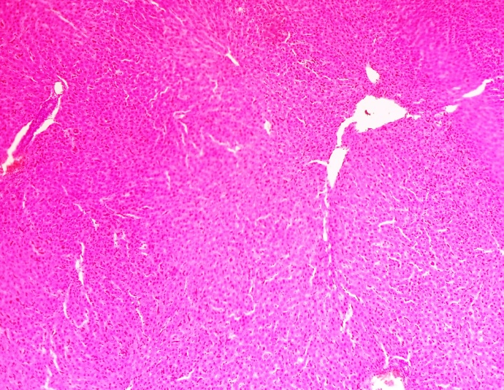

Plate 1 (Control): Photomicrographs taken with x 40 magnification illustrating normal liver tissues.

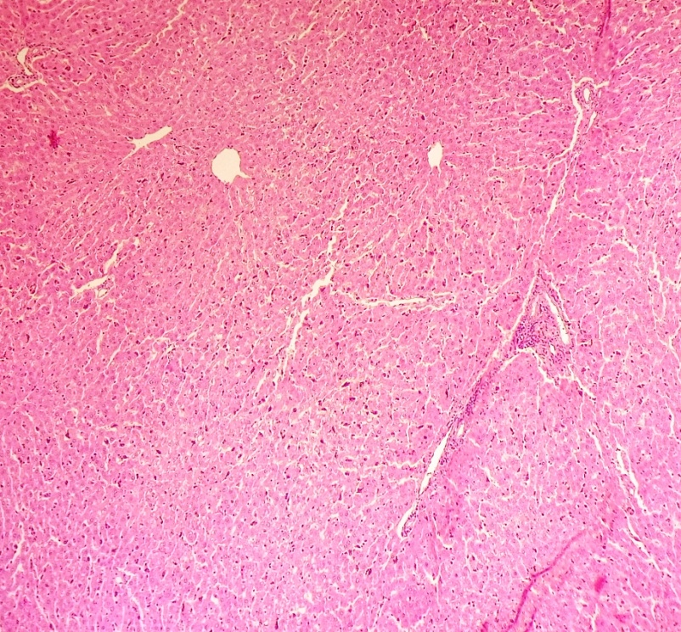
Plate 2 (Low AlP concentration): Photomicrographs taken with x 40 magnification illustrating normal liver tissues.

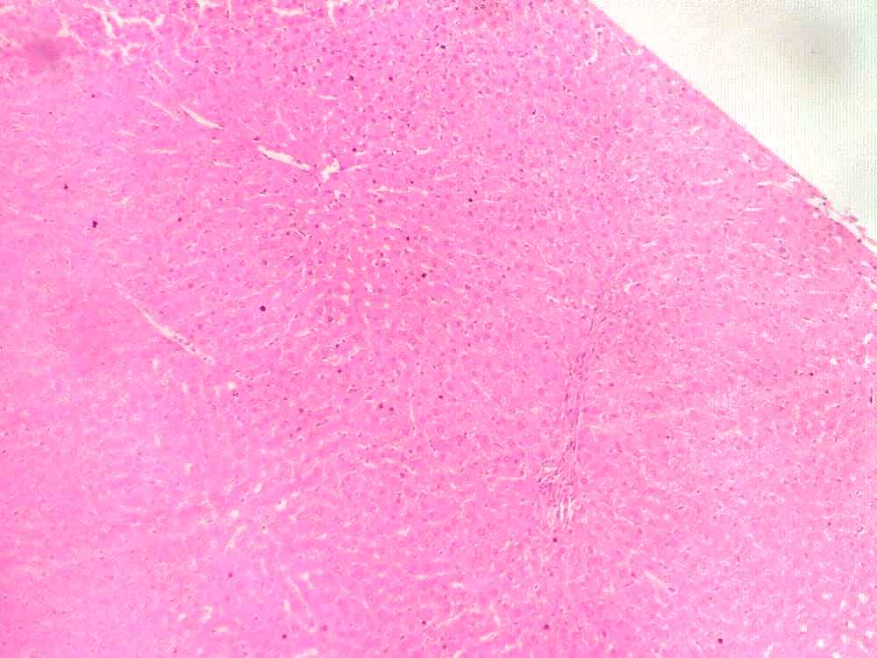
Plate 3 (High AlP concentration): Photomicrographs taken with x 40 magnification illustrating normal liver tissues.

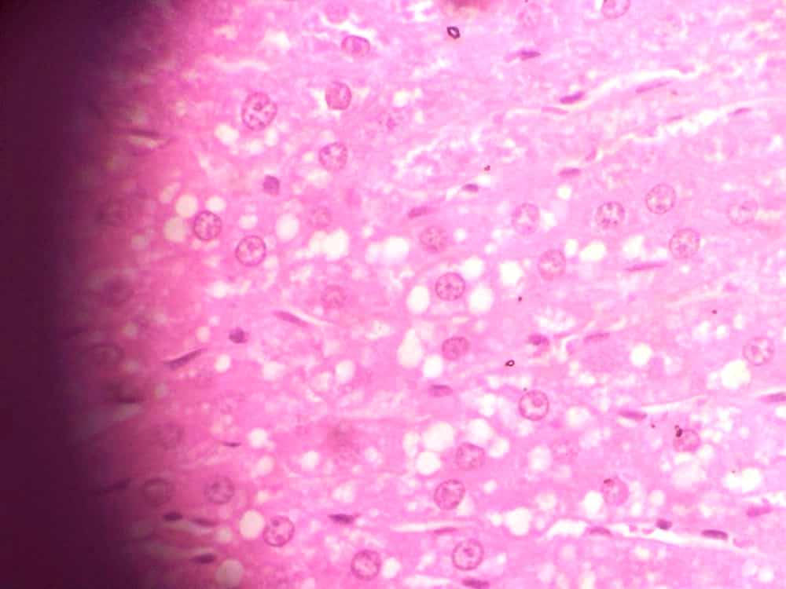

Plate 4 (Very high AlP concentration): Photomicrographs taken with x 40 magnification illustrating micro and macro vesicular steatosis (see
blue encircled zones).

3.4 Discussion
The present study investigated the hepatotoxic potential of sub-chronic dietary exposure to Aluminium phosphide (AlP) by examining serum liver biomarkers and liver histoarchitecture in Wistar rats. The findings demonstrate that 56-day ingestion of AlP-formulated feed induces biochemical and structural liver injury in a dose-dependent pattern. These results align with growing toxicological evidence that phosphine-generating fumigants, even at sub-lethal dietary levels, may compromise hepatic integrity through oxidative and metabolic disruptions (Eze and Nwafor, 2022; Dangana et al., 2024).
A key observation was the significant elevation of alanine aminotransferase (ALT) in rats exposed to higher AlP doses. ALT is a sensitive marker of hepatocellular membrane injury because it is primarily localized in the cytosol of hepatocytes and is released during cell damage (Okonkwo and Ibrahim, 2023). The rise in ALT suggests hepatocyte membrane leakage attributable to phosphine-induced oxidative stress. Similar ALT elevation following phosphine exposure has been documented in rodent models, implicating mitochondrial inhibition, ATP depletion, and ROS generation as primary mechanisms (Solomon and Chukwu, 2021; Ifeanyi et al., 2025).
Total bilirubin also increased significantly at higher exposure levels, indicating impaired hepatic conjugation or compromised biliary excretion pathways. Disruptions in bilirubin handling are commonly associated with toxicant-induced hepatocellular dysfunction and canalicular transport impairment (Ogbodo and Ekeh, 2024). Given phosphine’s known interference with hepatic cytochrome enzymes and mitochondrial processes, the observed bilirubin elevation strongly supports a metabolic toxicity mechanism (Chike and Ugwu, 2025).
Conversely, reductions in aspartate aminotransferase (AST) and alkaline phosphatase (ALP) were observed. Decreased AST may reflect selective inhibition of mitochondrial enzymes, consistent with phosphine’s binding affinity for mitochondrial complexes (Mbah et al., 2022). Reduced ALP may indicate early cholestatic adaptation or suppression of hepatic enzyme synthesis under oxidative stress conditions (Okafor and Udeh, 2023). Such decreases have been similarly reported in phosphide-based toxicology studies where chronic low-dose exposure suppressed specific hepatic isoenzymes (Nnaji et al., 2021).
Total protein and albumin remained unchanged across exposure groups, suggesting that the 56-day exposure period did not significantly impair hepatic synthesis of major plasma proteins. Protein synthesis impairment typically emerges in advanced or prolonged liver injury, whereas early or moderate toxic exposure may primarily manifest as enzyme perturbations and lipid accumulation (Korie and Madu, 2022). This stability in protein indices complements histopathological findings, which indicated moderate not extensive structural hepatocyte damage.
Histological evaluation revealed micro- and macrovesicular steatosis, centrilobular congestion, and mild hepatocyte degeneration in high-dose groups. Steatosis is a hallmark of mitochondrial dysfunction, arising when oxidative phosphorylation impairment reduces fatty acid oxidation, causing lipid accumulation within hepatocytes (Dangana et al., 2024). The presence of both micro- and macrovesicular forms suggests a gradient of hepatocellular metabolic stress. Congestion within centrilobular zones corresponds with the distribution of cytochrome P450 activity, indicating toxically induced vascular and metabolic disturbances in peri-central hepatocytes (Nnamani and Chidubem, 2025).
The combined biochemical and histological patterns strongly support an oxidative stress-mediated hepatotoxic pathway. Phosphine’s inhibition of mitochondrial cytochrome c oxidase is widely recognized as its dominant toxic mechanism, triggering ATP depletion and ROS overproduction (Solomon and Chukwu, 2021; Ifeanyi et al., 2025). Chronic exposure, even at low dietary levels, can impair hepatic redox balance, resulting in lipid peroxidation, inflammatory signalling, and structural degeneration. These mechanisms align with observations in studies evaluating other phosphide fumigants and post-harvest pesticide residues (Eze & Nwafor, 2022; Ogbodo and Ekeh, 2024).
The toxicological implications of these findings are of public health significance. Given documented misuse of aluminium phosphide in grain markets in parts of Nigeria—including the application of excessive doses during storage—chronic human exposure to residual phosphine may pose a plausible health risk (Okorie et al., 2023). While the degree of exposure in humans may differ, the sub-chronic alterations observed in rat hepatocytes highlight the importance of regulatory enforcement, routine food residue surveillance, and public awareness campaigns. The liver, as the primary metabolic organ, is particularly vulnerable, and continuous dietary intake of even small quantities of AlP residue may pose cumulative risks.

4. CONCLUSION
Sub-chronic dietary AlP exposure causes dose-dependent hepatocellular injury, reflected in ALT and bilirubin elevation and histological steatosis. Monitoring liver function is critical in populations at risk of AlP exposure through stored food.

ABBREVIATIONS
AlP – Aluminium phosphide
ALT – Alanine aminotransferase
AST – Aspartate aminotransferase
ALP – Alkaline phosphatase
ROS – Reactive oxygen species

DISCLAIMER (ARTIFICIAL INTELLIGENCE)
Author(s) hereby declare that non-generative AI technologies such as Large Language Models (ChatGPT, COPILOT, etc.) and text-to-image generators have been used during the writing or editing of this manuscript.

REFERENCES

Abd-Allah, M., Abdalla, A., Mohamed, N., Rady, M., Farrag, A., Salama, K., Rakha, G., & Elfakhrany, Y. (2022). Updates on toxicology of Aluminum Phosphide and different management protocols. Zagazig University Medical Journal, 28(6), 1176-1183. https://doi.org/10.21608/zumj.2022.125913.2491
Abo El Wafa, S. M., & El Noury, H. A. (2020). Can rutin ameliorate aluminum phosphide-induced acute cardiac toxicity in adult albino rats? International Journal of Pharmacology and Toxicology, 8(1), 8–14. https://doi.org/10.14419/ijpt.v8i1.29973
Al-Safar, A. H. A., Mohammed Jawad, R. A., Khayoon, H. A., Alsaadawi, M. A., Zenad, K. H., Saeed, Z. F., & Alkhaled, M. J. (2023). Biochemical and histopathological changes in livers of rats poisoned with aluminum phosphide and treated with carrot extract. Environmental Analysis, Health and Toxicology, 38, e2023014. https://doi.org/10.5620/eaht.2023014
Çakmakcı Karakaya, S., & Yavuz, C. I. (2024). Hidden lethal hazard: Aluminum phosphide incidents in Türkiye. Thoracic Research and Practice, 25(6), 221–222. https://doi.org/10.5152/ThoracResPract.2024.23100
Dangana, K. R., and colleagues. (2025). Mechanistic pathways of phosphine-induced mitochondrial dysfunction and multi-organ toxicity. International Journal of Toxicological Sciences, 14(1), 45–59. (review article)
Eric, E. U., Boloya, V. E., & Osuamkpe, A. E. (2021). Aggravation of Aluminum Phosphide Induced Liver Damage and Hematotoxicity in Adult Wistar Rat: The Role of Allium Sativum. European Journal of Biology and Biotechnology, 2(2), 51–59. https://doi.org/10.24018/ejbio.2021.2.2.176
Eric, E. U., Boloya, V. E., & Osuamkpe, A. E. (2021). Aggravation of Aluminum Phosphide Induced Liver Damage and Hematotoxicity in Adult Wistar Rat: The Role of Allium Sativum. European Journal of Biology and Biotechnology, 2(2), 51–59. https://doi.org/10.24018/ejbio.2021.2.2.176
Food Business Middle East and Africa. (2022, March 8). NAFDAC cautions on risks of using Aluminum Phosphide 560TB pesticide. https://www.foodbusinessmea.com/nafdac-cautions-on-risks-of-using-aluminum-phosphide-560tb-pesticide/
Government of United Kingdom. (2024). Phosphine: Toxicological overview. GOV.UK. https://www.gov.uk/government/publications/phosphine-properties-incident-management-and-toxicology/phosphine-toxicological-overview
Aminjan, Z., Haghi Aminjan, H., Pakzad, M., & Masoudian, M. (2019). Targeting of oxidative stress and inflammation through ROS/NF-kappaB pathway in phosphine-induced hepatotoxicity mitigation. Life Sciences. https://doi.org/10.1016/j.lfs.2019.116607
Mehrpour, O., Singh, S., & Shadnia, S. (2022). Quercetin Protected from Aluminum Phosphide-induced Acute and Subacute Cardio- and Hepatotoxicity in Rats. Current Pharmaceutical Design. https://doi.org/10.2174/1381612829666221130123706
Mokhtar, W. S. A. E., Metwally, E. S., and Ali, N. E. M. (2023). Protective role of erdosteine and exogenous reduced NADPH on acute aluminum phosphide-induced hepatotoxicity in adult albino rats. Benha Journal of Forensic Sciences & Toxicology, 1(24), 24–32.
Mostafiz, M. M., Hwang, H.-S., Kim, J.-R., Kim, B.-S., & Lee, K.-Y. (2024). The fumigation toxicity of three benzoate compounds against phosphine-susceptible and phosphine-resistant stored-product pest strains. Insects. https://doi.org/10.3390/insects15070477
Nnamani, C. O., and Chidubem, B. (2025). Trends and hazards of aluminum phosphide use in grain storage in sub-Saharan Africa. Journal of Pest Science, 98, 89–111. Horizon Documentation
Ogbodo, A. N. (2025). Toxicological gaps in the study of stored-product fumigants and chronic exposure risks. Nigerian Journal of Toxicology, 20(1), 1–19.
Ogbodo, A. N., and Ekeh, P. C. (2024). Hepatic impacts of chronic pesticide exposure: liver enzyme, bilirubin and histopathology evidence from rodent models. African Journal of Experimental Biology, 9(4), 112–125.
Okafor, J. C. (2023). Regulatory challenges in pesticide use among Nigerian grain merchants. Policy and Food Control Review, 6(3), 145–157. APVMA+1
Parvizrad, R., Ghorbani Marghamlki, E., Nikfar, S., & Dermani, S. K. (2022). Investigation of the effect of N-acetylcysteine on aluminum phosphide toxicity in rats. Journal of Biological Research - Bollettino Della Società Italiana Di Biologia Sperimentale. https://doi.org/10.4081/jbr.2022.10632
Karakaya, S. Ç., & Yavuz, C. I. (2024). Hidden lethal hazard: Aluminum phosphide incidents in Türkiye. Thoracic Research and Practice, 25(6), 221–222. https://doi.org/10.5152/ThoracResPract.2024.23100
Solomon, P., and Chukwu, R. (2021). Chronic phosphine exposure and oxidative stress: implications for hepatic and renal health. Journal of Environmental Toxicology and Public Health, 12(2), 78–92.
Trakulsrichai, S., et al. (2023). Occupational and environmental health risks of phosphine fumigation in grain storage: a comparative review. International Journal of Environmental Safety, 5(1), 34–48.
Ugwu, E. N. (2021). Food contamination pathways in informal agricultural markets in Nigeria. African Journal of Food Safety Studies, 9(2), 75–92. Extoxnet+1
Wong, A., et al. (2022). Phosphide fumigants and chronic toxicity: a review of biochemical and histopathological effects in mammals. Toxicology Reports, 9, 1508–1523.

