Original Research Article

Prevalence of Tick-Borne Hemoparasites and Associated Ectoparasite Vectors in Dairy Cattle in Githunguri Sub-County, Kenya

.
ABSTRACT

Aims: This study examined the occurrence of tick-borne hemoparasites (TBPs) affecting dairy cattle in Githunguri sub-county, Kenya.
Study design: This was a cross-sectional study conducted between August and November 2024. Blood samples were obtained from 402 dairy cattle randomly selected from 113 farms, and thin blood smears were microscopically examined to detect TBPs.
Place and Duration of Study: Department of Veterinary Pathology, Microbiology and Parasitology, Faculty of Veterinary Medicine, University of Nairobi.
Methodology: Farm and dairy cattle were selected through simple random sampling. Each animal underwent physical examination, after which jugular blood was drawn into EDTA tubes. Thin smears were fixed, stained with Giemsa, and screened for TBPs. Attached ticks were removed, preserved in ethanol, and identified using established morphological keys. Biting flies were trapped on sixty-three farms using sweep nets and baited traps, then sorted and classified by morphological features. All data were recorded and later summarized to determine parasite and vector occurrence.
Results: Of the 402 cattle sampled, 129 (32.1%) carried at least one TBP. Anaplasma spp. were found in all positive samples. A. marginale occurred as a single infection in 90 (22.4%) animals, while A. centrale alone was seen in 11 (2.7%). Mixed A. marginale and A. centrale infections were found in 25 (6.2%), and A. marginale with Babesia spp. in 3 (0.7%). Tick attachment was noted on 11 animals (2.7%). From the 47 ticks collected, 45 (95.7%) were Rhipicephalus (Boophilus) decoloratus. A total of 441 biting flies were identified, dominated by Stomoxys calcitrans (63.3%), S. niger (23.8%), and S. sitiens (8.2%). Musca domestica accounted for 4.8%.
Conclusion: Anaplasma infections are widespread in Githunguri cattle, and the presence of both tick and fly vectors emphasizes the need for broad, sustained vector control to protect herd health and productivity.

Keywords: Cattle, Tick-borne hemoparasites (TBPs), Rhipicephalus spp, Haemaphysalis spp, Stomoxys spp., Anaplasma and Babesia

1. INTRODUCTION

1.0 INTRODUCTION
Tick-borne diseases continue to represent a major health concern for cattle worldwide, with an estimated eighty percent of the world's cattle population being afflicted by tick-borne hemoparasites, particularly in Africa. These diseases are caused by a variety of pathogens, including bacteria, protozoa, and viruses, which are transmitted to cattle through the bites of infected ticks (Rosenberg et al., 2018). Ticks are ectoparasites that thrive in diverse environments, making TBDs a widespread issue in both temperate and tropical regions. Beyond their economic burden, several tick-borne infections also pose zoonotic risks, with their incidence and distribution expanding due to changing environmental and anthropogenic factors (Djiman et al., 2024).
In sub-Saharan Africa (SSA), ticks and the pathogens they carry remain a substantial threat to livestock health and productivity. The region’s conducive climate, shifting ecosystems, cross-border livestock trade, and increased animal movements have promoted the proliferation of diverse tick species and altered the epidemiology of tick-borne pathogens (TBPs) (Githaka et al., 2021; Ouedraogo et al., 2021). More than nine tick genera have been identified across SSA, with species from Rhipicephalus, Amblyomma, and Hyalomma being the most prevalent (Ndeereh et al., 2017; Peter et al., 2021). These ticks play key roles in transmitting zoonotic and non-zoonotic diseases, including rickettsiosis, ehrlichiosis, babesiosis, borreliosis, and anaplasmosis, as well as various viral infections that undermine livestock productivity (Wanzala, 2023).
In Kenya, TBDs remain a significant problem to livestock development, an essential component of national food security and the economy. Numerous tick species and tick-borne pathogens have been identified as causative agents of major livestock diseases. Among the most commonly reported are East Coast fever (Theileria parva: Rhipicephalus appendiculatus), bovine babesiosis (Babesia bigemina: Rh. decoloratus), anaplasmosis (Anaplasma marginale: Rh. decoloratus), and heartwater (Ehrlichia ruminantium: Amblyomma variegatum) (Peter et al., 2020; Githaka et al., 2022). The distribution of these vectors largely determines the occurrence of TBDs. Shifts in their epidemiology and diversity across Kenya are influenced by variable climatic conditions, population pressure, land-use changes, and evolving livestock husbandry systems (Keesing et al., 2018; Peter et al., 2021). Several Kenyan studies have reported the prevalence and risk factors associated with these diseases (Wesonga et al., 2017; Okal et al., 2020; Chiuya et al., 2021); however, complete information on the diversity and dynamics of tick-borne pathogens in the country remains limited.
Whereas TBPs are biologically transmitted by ticks, mechanical transmission by blood-sucking flies is also possible. Stable flies (Stomoxys species and Haematobia species) are of special interest as they have been shown to act as efficient mechanical vectors for TBDs and other pathogens due to their high cosmopolitan abundance (Battilani et al., 2017; Duvallet et al., 2023). Globally, studies have indicated that Stable fly parasitism has a great effect on the livestock sector with economic losses estimated to be over 1 billion USD in the United States (Moreki et al., 2022) and Mexico amounting to US$ 231 million both direct and indirectly (Rodríguez-Vivas et al., 2017). In Africa, particularly in Kenya (Muita et al., 2024), and South Africa (Makhahlela et al., 2022) these biting flies have been shown to have a wide range of host species from livestock to wildlife (reservoirs host). This interaction has been connected to the spread and maintenance of rickettsia, viral, bacterial, and protozoa diseases. However, studies on stable flies in Kenya remain limited, while data concerning the pathogens they spread, host diversification, and the role they play remains finite.
In Kenya, TBDs are of great concern in various regions including Githunguri sub-county. With the increasing population of smallholder dairy farms in the area there is an urgent need for extensive research on the status of TBPs and diversify of ectoparasites to inform control measures and guide treatment. The current study investigated the diversity of ectoparasites and the prevalence of associated hemoparasites among dairy cattle in Githunguri Sub-County, Kenya.

2.0 material and methods

2.1 Study area
The study was carried out in Githunguri Sub-county located in Kiambu County, Kenya. Kiambu is among the 47 administrative counties in Kenya and is approximately 1600m in altitude and lies within latitudes 00 25‘and 10 20‘South of the Equator and Longitude 360 31‘and 370 15‘covering a total area of 2,543.5 Km². The county receives an average rainfall of 1,200mm annually with a temperature ranging between 22.4ºC- 27.6ºC. Githunguri Sub-county has five administrative wards namely: Githunguri, Ikinu, Githiga, Ngewa, and Komothai and spans an area of 174.4 km². According to the 2019 Kenya National Bureau of Statistics (KNBS) census, the sub-county hosts a human population of approximately 165,232 residents (KNBS, 2019). Agriculture forms the backbone of the local economy, supported by fertile volcanic soils that favor crop and livestock production. Dairy farming is the predominant agricultural activity, with semi-intensive systems being the most common method of cattle rearing. The area is home to over 20,000 smallholder dairy farmers, collectively producing an estimated 100,000 liters of milk daily (Tahlil, 2023). Githunguri was selected as the study site due to its dense dairy cattle population and the increasing reports of tick-borne pathogen infections in recent years.
2.2 Study design
This was a cross-sectional study conducted between August and November 2024. Databases kept by the Sub-county veterinary office served as sampling frame from which farms were random selected. Additionally, a list farmers obtained from dairy cooperative society was used to supplement the selection process. Random sampling was used at the farm level to identify cattle that were included in the study. Overall, 402 cattle from 113 dairy farms were recruited in the study. Each animal was restrained in a crush for sampling and physically examined for the presence of ticks.
2.3 Sample size determination
The sample size for this study was calculated using the method outlined by Thrusfield (2007). Specifically, the formula n = [1.96² × Pexp × (1 − Pexp)] / d² was applied, where n represents the required sample size, Pexp is the expected prevalence (38.9%) as reported by Chiuya et al., (2021), and d denotes the desired precision at a 95% confidence level (0.05). The sample size calculated was 365 dairy cattle samples. Approximately 402 dairy cattle were selected and included in the study from 113 farms (with > 4 lactating). The distribution of the farms was done based on the proportion of dairy farms in the five wards and the farmer's willingness to participate in the survey thus, 72,71,77,85 and 97 cattle in Ngewa, Komothai, Githunguri, Githiga, and Ikinu wards, respectively were sampled.
2.4 Data Collection
2.4.1 Blood sample collection, storage, and processing
Using disposable sterile needles, blood was collected from the jugular vein of each selected animal into 4 ml plain EDTA vacutainer tubes (Vacsure® vacutainer blood tubes, India). The tubes were labeled to indicate the unique individual dairy cattle identification number and farm location. Cool boxes were used to store the blood samples and to transport them to the Veterinary Parasitology Laboratory, University of Nairobi, for further examination. In the laboratory, blood smears were prepared on microscope slides, fixed with methanol, and stained with Giemsa as described by Hossain et al., (2023) and Patra et al., (2020). The slides were examined under oil immersion to determine the hemo-parasites present.
2.4.2 Tick, collection, and morphological identification
Ticks attached to cattle were carefully removed using forceps, ensuring that the mouthparts remained intact during collection. Each specimen was placed in a labeled container with 70% ethanol and later transported to the Veterinary Parasitology Laboratory at the University of Nairobi for further examination. Morphological identification was carried out to the species level using standard taxonomic keys, considering characteristics such as body coloration, capitulum shape and size, eye presence, festoons, scutal or conscutal grooves, surface punctuations, and the presence or absence of an adanal shield. Identification procedures followed the descriptions provided by Walker et al., (2014) and were conducted under a microscope. After identification, each tick specimen was preserved in an individually labeled tube containing 70% ethanol.
2.4.3 Biting flies, collection and morphological identification
A total of 441 biting flies were collected from dairy farms where samples for tick-borne pathogens were done. Sixty-three farms were recruited randomly from the five wards of Githunguri subcounty. On the farms, biting flies present on the dairy cattle were collected using a swipe net and placed separately in envelopes labeled with farm details and delivered to the Parasitology laboratory. The flies were identified using a standard key according to their morphological characteristics like mouth parts, thoracic patterns, wing venation, abdomen pattern, size, and general colour description as described by (Masmeatathip et al., 2006; Makhahlela et al., 2022).
2.5 Data analysis
The data obtained from the ward level on the prevalence of tick-borne hemoparasites, ticks, and biting flies present was entered into the Microsoft excel 2016 version (Hussain et al., 2021) and later exported to Statistical Software Program (SPSS) version 20 (Borsan et al., 2021) for further analysis. The data was analyzed using descriptive statistics providing frequency and percentiles.

3. results

3.1 Prevalence of tick-borne hemoparasites
Of the 402 blood samples collected and examined 129, (32.1%) were found to have one or more species of hemoparasites. Anaplasma species were the dominant (32.1%) TBPs in the samples. Among the Anaplasma species, A. marginale (Fig 1) was recorded at 22.4% and A. centrale (Fig 2) at 2.7%. Anaplasma marginale was recorded in 90, (22.4%) samples, while A. centrale was recorded as such in 11, (2.7%) samples. A co- infection of A. marginale and A. centrale was recorded in 25, (6.2%) samples and A. marginale alongside Babesia bovis (Fig 3) in 3, (0.7%) samples.

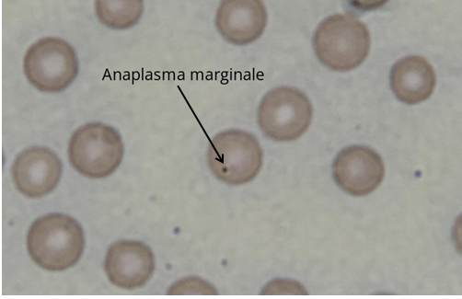

Fig 1: Shows image of Anaplasma marginale (above) 1000 × under an oil immersion magnification mounted to a light microscope (Olympus CX21FS1, Tokyo, Japan).

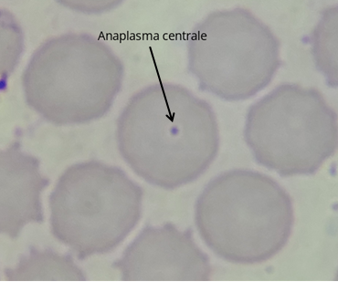

Fig 2: Shows image of Anaplasma centrale (above) light microscope (Magnification X 1000, Olympus CX21FS1, Tokyo, Japan).

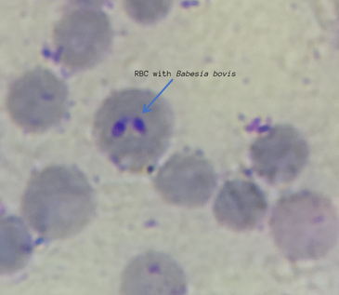

Fig 3: Shows image of Babesia bovis (above) in red blood cells of bovine obtained at 1000 × under an oil immersion magnification mounted to a light microscope (Olympus CX21FS1, Tokyo, Japan) showing bovine Babesia spp. Intraerythrocytic forms of Babesia bovis.
Githunguri ward rcorded the highest prevalence of hemo- parasite at 42.9% followed by Komothai ward (42.3%), Githiga ward (41.2%), Ngewa ward (22.2%) and Ikinu ward (15.5%) respectively (Table 1).
Table 1: Prevalence of tick borne pathogens across administrative wards.
TBP Observed | Githunguri (n=77) | Ikinu (n=97) | Githiga (n=85) | Ngewa (n=72) | Komothai (n=71) | Total (N=402)
Anaplasma marginale | 21 (27.3%) | 12 (12.5%) | 22 (25.9%) | 11 (15.3%) | 24 (35.2%) | 90 (22.4%)
Anaplasma centrale | 2 (2.6%) | 1 (1.0%) | 5 (5.9%) | 2 (2.8%) | 1 (1.4%) | 11 (2.7%)
A. marginale and A. centrale | 9 (11.7%) | 2 (2.1%) | 7 (8.2%) | 3 (4.2%) | 4 (5.6%) | 25 (6.2%)
Babesia bovis and A. marginale | 1 (1.3%) | 0 (0%) | 1 (1.2%) | 0 (0%) | 1 (1.4%) | 3 (0.7%)
No parasites detected | 44 (57.1%) | 82 (84.5%) | 50 (58.8%) | 56 (77.8%) | 41 (57.7%) | 273 (67.9%)
3.2 Prevalence of ticks and biting flies
Of the 402 animals examined, only 11, (2.7%) were found to have one or more ticks, and all were from Githunguri ward. A total of 47 adult ticks were collected from sampled cattle. Of these, 46 belonged to the genus Rhipicephalus, while 1 was Haemaphysalis. Within the 46 Rhipicephalus group, Rh. (boophilus) decoloratus accounted for 45 specimens, and only 1 being Rh. appendiculatus.
Of the 441 flies collected, the majority (63.3%) were identified as Stomoxys calcitrans (Fig 4), followed by S. niger (23.8%) (Fig 5), and S. sitiens (8.2%) (Fig 6). Twenty-one (4.8%) of the recovered flies were the non-biting fly Musca domestica (Fig 7).
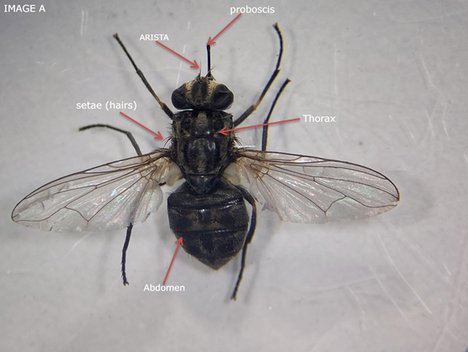 | 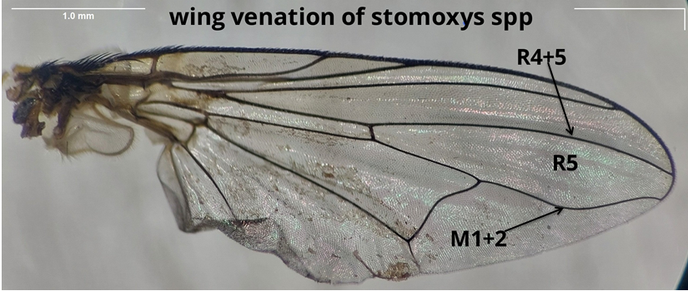

Fig 4: Above description of Stomoxys calcitrans Dorsal view labeled to highlight key features. The proboscis is clearly visible, and the thorax displays two pairs of dark, broad longitudinal stripes, with the outermost stripes appearing shorter and colored grey to brown. The presence of setae is also noted. The abdomen features one central spot and two parallel round spots on the dorsal side of the second and third segments. Wing venation is illustrated with arrows; R4+5 is located anterior to vein M1+2, which curves gently forward at its distal end. Additionally, the first posterior cell, R5, is open.
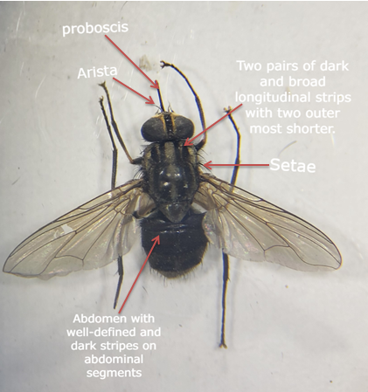

Fig 5: This image (above) shows a dorsal view of Stomoxys niger, characterized by its long proboscis and the presence of an arista. The thorax features two pairs of dark, broad longitudinal stripes, along with two shorter outermost stripes. The coloration of the thorax ranges from yellow to brown and includes the presence of setae (short hairs). In addition, the abdomen displays a grey coloration with clearly defined dark stripes across its segments.

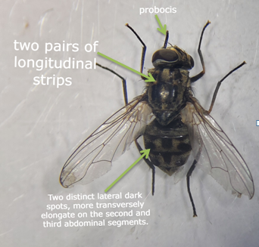

Fig 6: This illustration (above) presents a dorsal view of Stomoxys sitiens. The proboscis is shiny and black, broad at the base, and narrows towards the tip. The thorax features two pairs of dark, broad longitudinal stripes, with the outermost stripes being shorter. Additionally, there are two distinct lateral dark spots on the second and third abdominal segments, which are more elongated in a transverse direction. The Figure also depicts wing venation for Stomoxys sitiens, highlighting the R4+5 vein, which is located anterior to the M1+2 vein. The M1+2 curves gently forward at its distal end, while the first posterior cell, R5, remains open.

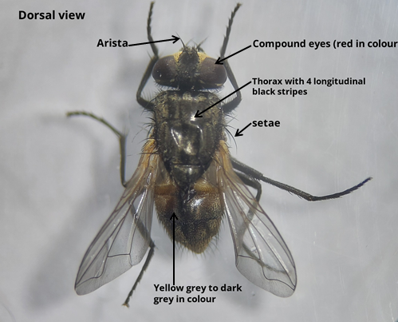 | 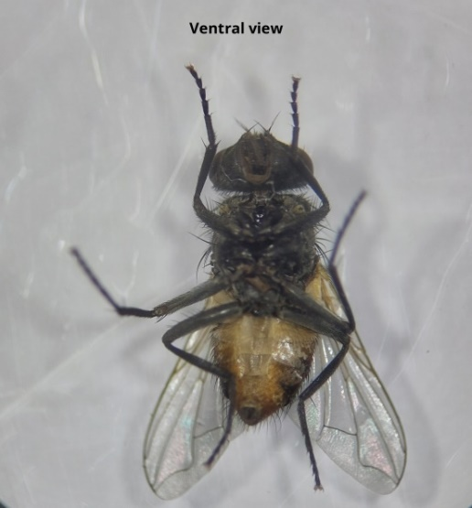
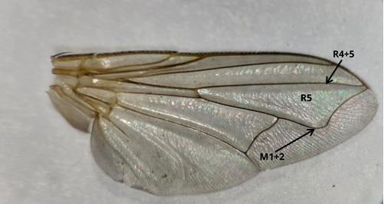
Fig 7: (above) Dorsal and ventral images of Musca domestica, which exhibits a color range from yellowish grey to dark grey. This species is characterized by four longitudinal dark stripes, the presence of setae on both the thorax and abdomen, and an arista on its head. Additionally, vein M1+2 curves forward near its distal end, and the first posterior cell (R5) is closed
Ward level prevalence recorded that Githiga ward had the most prevalent (30.2%) flies followed by Ikinu (22%), then Komothai (17.2%), Ngewa (15.4%), and Githunguri ward (15.2%), respectively (Table 2).
Table 2: Prevalence of biting fly species across administrative wards (N= 441)
Fly Species | Githunguri | Komothai | Ikinu | Githiga | Ngewa | Total
Stomoxys calcitrans | 7.5% (33) | 9.8% (43) | 14.1% (62) | 20.2% (89) | 11.8% (52) | 63.3% (279)
Stomoxys niger | 5.2% (23) | 3.6% (16) | 5.7% (25) | 7.0% (31) | 2.3% (10) | 23.8% (105)
Stomoxys sitiens | 1.8% (8) | 3.4% (15) | 0.5% (2) | 1.4% (6) | 1.1% (5) | 8.2% (36)
Musca domestica | 0.7% (3) | 0.5% (2) | 1.8% (8) | 1.6% (7) | 0.2% (1) | 4.8% (21)

4.0 discussion
The objective of this research was to assess tick-borne hemoparasite prevalence and identify associated vectors in dairy cattle in Githunguri Sub-county, Kenya. Ticks and hemoparasites of economic importance namely Rh. (boophilus) decoloratus, Rh. appendiculatus; Anaplasma marginale and Babesia bovis were identified respectively. These ticks and tick-borne pathogens have serious economic impacts that can have direct effects resulting in reduced productivity, damage to the skin or hide, anemia, and suppression of the immune function leading to mortality. For indirect losses they are linked to the cost of treatment, expenses incurred in the control of ticks, and trade restrictions (Railey et al., 2021; Hurtado et al., 2018).
In the present study, the prevalence of tick-borne pathogens (TBPs) was lower than figures reported by Adjou et al., (2015) in Kajiado and Machakos counties using nPCR, Wesonga et al., (2017) in Machakos County using ELISA, and Okal et al., (2020) from the wildlife–livestock interface in Lambwe Valley, who applied nested PCR. However, it was higher than the prevalence reported by Masiga et al., (2022) in Kenya’s coastal region using PCR. Studies employing microscopy methods (Debbarma et al., 2020; Hailemariam et al., 2017; Gboeloh et al., 2022), comparable to the current approach, have shown variable infection rates, with prevalence values of 34.8%, 17.1%, and 62.5%, respectively.
The prevalence of Anaplasma species in the present study was 32.1%, which was higher than previously reported figures from Kenya, including 15.8% in Machakos (Adjou et al., 2015), 19.7% in Western Kenya (Chiuya et al., 2021), and 10.9% in the coastal region (Masiga et al., 2022). Conversely, the findings of this study were lower than those of Gachohi et al., (2010), who reported a prevalence of 58% in Mbeere District, and Wesonga et al., (2017), who observed 53.4% in Machakos County. The prevalence of co-infection between Babesia bovis and Anaplasma marginale (0.7%) was notably lower than previously documented rates in Kenya, where Wesonga et al., (2017) reported 37.1% in rural Western Kenya and 40.6% in Machakos. Comparable patterns of mixed infections have also been documented in other sub-Saharan African countries, where high co-infection rates have been observed (Kanduma et al., 2020; Salih et al., 2009). Such variations in prevalence are likely attributed to differences in the distribution and abundance of tick species across regions, as many of these vectors occupy overlapping habitats and ecological niches. Furthermore, cattle frequently harbor multiple tick species capable of transmitting several pathogens simultaneously (Kanduma et al., 2020). The tick-borne pathogens identified in this study may contribute to significant morbidity, mortality, and reduced productivity in dairy cattle, resulting in considerable economic losses if effective control measures are not implemented.
Ticks belonging to the genus Rhipicephalus were identified in the present study, consistent with previous reports from Kenya (Peter et al., 2021), Tanzania (Magesa et al., 2023), Uganda (Etiang et al., 2024), and Ethiopia (Mideksa et al., 2017). Their presence in the study area is likely influenced by favorable climatic conditions that support the survival and proliferation of tick vectors (Keesing et al., 2018). Among the identified species, Rhipicephalus (Boophilus) decoloratus was the most prevalent. This species is of particular epidemiological importance as it is known to transmit several tick-borne pathogens, including Babesia, Anaplasma marginale, and Anaplasma centrale, posing a potential health risk to dairy cattle. Similar findings have been documented in Burundi (Nyabongo et al., 2021), Kenya (Kanduma et al., 2020; Peter et al., 2021), Egypt (Senbill et al., 2022), and Ethiopia (Ahmed et al., 2024; Abdela et al., 2018). Heavy infestations involving three major tick genera Rhipicephalus, Amblyomma, and Hyalomma have also been reported in other studies (Mideksa et al., 2017; Bibi et al., 2020; Etiang et al., 2024), largely influenced by conducive climatic conditions and management practices. In contrast, tick infestation rates in the current study were relatively low, with ticks recovered from only 11 (2.7%) dairy cattle within a single ward (Githunguri). This low prevalence may be attributed to the regular use of acaricides and limited tick exposure due to the widespread adoption of zero-grazing systems among smallholder dairy farmers in the region.
In this study three species of the biting fly Stomoxys including Stomoxys calcitrans, S. sitiens, and S. niger that varied in frequency were identified. Stomoxys calcitrans (63.3%) were the most prevalent flies on the study farms, followed by S. niger (23.8%) and S. sitiens (8.2%) with (4.8%) of the recovered flies being Musca domestica, a non-biting fly. The biting flies inflict pain on the animals, causeing severe irritation and act as mechanical vectors of various parasites such as Anaplasma. The non-biting fly Musca domestica transmits various pathogens such as the bacteria that cause mastitis and eye infections in cattle. Species of Musca have also been incriminated in the transmission of the eye worms (Thelazia) in cattle. Most farms in the study were considered tick-free because they had no cases of tick infestation despite cases of TBPs being identified in the herds there by indicating the possibility of another diverse transmitter of the pathogens. The high prevalence rate of these stable flies on the dairy farms could be attributed to ample conditions for breeding, host diversity and to lack of targeted control measures. Transmission of Anaplasma species in cattle is not completely dependent on tick vectors. Several studies have indicated that the presence of biting flies is strongly linked to an increased occurrence of Anaplasma spp. infections, even in herds where ticks are absent (Makhahlela et al., 2022; Oliveira et al., 2011; Bautista et al., 2018). Experimental investigations have shown that Stomoxys flies, notably S. calcitrans, are capable of mechanically transmitting A. marginale. The likelihood of transmission is largely influenced by the concentration of the pathogen in the host’s bloodstream and the duration between consecutive feeding interruptions (Makhahlela et al., 2022). The biting fly species identified in this study may therefore contribute significantly to the spread of these pathogens, highlighting the necessity of implementing integrated vector management strategies that encompass both mechanical and biological vectors to curb the prevalence of tick-borne diseases and related infections.
A limitation of this study is that sampling was conducted during the dry season, which may not fully capture the diversity of tick species, biting flies, and their associated pathogens present in the study area throughout the year. Future investigations incorporating both dry and wet seasons would provide a more comprehensive understanding of the seasonal dynamics of blood-sucking arthropod vectors and the pathogens they transmit.

5.0 CONCLUSION
The present study indicated that dairy cattle in Githunguri Sub-county are infected with Anaplasma and Babesia blood parasites. Vector ticks mainly Rhipicephalus (boophilus) species and biting flies in the Genus Stomoxys were also identified and may be linked to the occurrence of the infections in the dairy cattle posing a threat to their health status. There is need for the farmers to adopt integrated vector control programs for both the ticks and biting flies. Further studies on the blood parasites in both the cattle and biting flies are required using more robust procedures such as DNA analysis, to confirm identity of the pathogens and the role of the vectors in their transmission.

Ethical approval
Ethical clearance for this study was granted by the Biosafety, Animal Use, and Ethics Committee (BAUEC) of the Faculty of Veterinary Medicine, University of Nairobi, Kenya (Reference: FVM BAUEC/2024/555). In addition, the study received authorization from the Director of Veterinary Services (Reference: MOALF/SDL/DVS/DSVR&ZS/GENVOL.III/59). Prior to inclusion in the study, farmers were informed about the purpose and procedures of the research, and their verbal consent was obtained before participation.

References

Rosenberg, R. (2018). Vital signs: trends in reported vectorborne disease cases—United States and Territories, 2004–2016. MMWR. Morbidity and mortality weekly report, p.67. https://doi.org/10.15585/mmwr.mm6717e1
Djiman, T. A., Biguezoton, A. S., and Saegerman, C. (2024). Tick-Borne Diseases in Sub-Saharan Africa: A Systematic Review of Pathogens, Research Focus, and Implications for Public Health. Pathogens, 13(8), 697. https://doi.org/10.3390/pathogens13080697
Githaka, N., Kanduma, E., and Bishop, R. (2021). Role of climate and other factors in determining the dynamics of tick and tick-transmitted pathogen populations and distribution in western, central and eastern Africa. In Climate, ticks and disease (pp. 486–491). Wallingford UK: CABI. https://doi.org/10.1079/9781789249637.0070
Ouedraogo, A. S., Zannou, O. M., Biguezoton, A. S., Kouassi, P. Y., Belem, A., Farougou, S., and Lempereur, L. (2021). Cattle ticks and associated tick-borne pathogens in Burkina Faso and Benin: Apparent northern spread of Rhipicephalus microplus in Benin and first evidence of Theileria velifera and Theileria annulata. Ticks and Tick-borne Diseases, 12(4), 101733. https://doi.org/10.1016/j.ttbdis.2021.101733
Ndeereh, D., Muchemi, G., Thaiyah, A., Otiende, M., Angelone-Alasaad, S., and Jowers, M. J. (2017). Molecular survey of Coxiella burnetii in wildlife and ticks at wildlife–livestock interfaces in Kenya. Experimental and Applied Acarology, 72: 277–289. https://doi.org/10.1007/s10493-017-0146-6
Peter, S. G., Kariuki, H. W., Aboge, G. O., Gakuya, D. W., Maingi, N., and Mulei, C. M. (2021). Prevalence of Ticks Infesting Dairy Cattle and the Pathogens They Harbour in Smallholder Farms in Peri‐Urban Areas of Nairobi, Kenya. Veterinary Medicine International: 2021(1), 9501648. https://doi.org/10.1155/2021/9501648
Wanzala, W. (2023). Distribution of Ticks and Tick-Borne Pathogens, Hosts, Habitat and Diseases in Kenya and Some Parts of Africa: A Mini Review. J. Anim. Res. Nutr, 8. https://doi.org/10.36648/2572-5459.8.2.066
Peter, S. G., Aboge, G. O., Kariuki, H. W., Kanduma, E. G., Gakuya, D. W., Maingi, N., and Mainga, A. O. (2020). Molecular prevalence of emerging Anaplasma and Ehrlichia pathogens in apparently healthy dairy cattle in peri-urban Nairobi, Kenya. BMC Veterinary Research, 16: 1-12. https://bmcvetres.biomedcentral.com/articles/10.1186/s12917-020-02584-0
Githaka, N. W., Kanduma, E. G., Wieland, B., Darghouth, M. A., and Bishop, R. P. (2022). Acaricide resistance in livestock ticks infesting cattle in Africa: Current status and potential mitigation strategies. Current research in parasitology and vector-borne diseases, 2, 100090. https://doi.org/10.1016/j.crpvbd.2022.100090
Keesing, F., Ostfeld, R. S., Young, T. P., and Allan, B. F. (2018). Cattle and rainfall affect tick abundance in central Kenya. Parasitology, 145(3): 345–354. https://doi.org/10.1017/s003118201700155x
Wesonga, F. D., Gachohi, J. M., Kitala, P. M., Gathuma, J. M., and Njenga, M. J. (2017). Seroprevalence of Anaplasma marginale and Babesia bigemina infections and associated risk factors in Machakos County, Kenya. Tropical animal health and production, 49: 265–272. https://doi.org/10.1007/s11250-016-1187-2
Okal, M. N., Odhiambo, B. K., Otieno, P., Bargul, J. L., Masiga, D., Villinger, J., and Kalayou, S. (2020). Anaplasma and Theileria pathogens in cattle of Lambwe valley, Kenya: a case for pro-active surveillance in the wildlife–livestock interface. Microorganisms, 8(11),1830. https://doi.org/10.3390/microorganisms8111830
Chiuya, T., Villinger, J., Masiga, D. K., Ondifu, D. O., Murungi, M. K., Wambua, L., and Falzon, L. C. (2021). Molecular prevalence and risk factors associated with tick-borne pathogens in cattle in western Kenya. BMC Veterinary Research, 17: 1–17. https://doi.org/10.1186/s13071-021-04944-7
Battilani, M., De Arcangeli, S., Balboni, A., and Dondi, F. (2017). Genetic diversity and molecular epidemiology of Anaplasma. Infection, Genetics and Evolution, 49, 195–211. https://doi.org/10.1016/j.meegid.2017.01.021
Duvallet, G., and Hogsette, J. A. (2023). Global diversity, distribution, and genetic studies of stable flies (Stomoxys sp.). Diversity, 15(5), 600. https://doi.org/10.3390/d15050600
Moreki, J. C., Tjinyeka, K., Makore, J., Tlotleng, K., and Moseki, M. I. (2022). The impact of stable flies (Stomoxys calcitrans L.) on small stock production in Bodibeng, Bothatogo and Sehithwa in the North West district, Botswana; a survey study. Online Journal of Animal and Feed Research, 12(2). https://doi.org/10.51227/ojafr.2022.10.
Rodríguez-Vivas, R. I., Grisi, L., Pérez de León, A. A., Villela, H. S., Torres-Acosta, J. F. D. J., Fragoso Sánchez, H., and García Carrasco, D. (2017). Potential economic impact assessment for cattle parasites in Mexico. Review. Revista mexicana de ciencias pecuarias, 8(1): 61–74. https://doi.org/10.22319/rmcp.v8i1.4305
Muita, J. W., Bargul, J. L., Makwatta, J. O., Ngatia, E. M., Tawich, S. K., Masiga, D. K., and Getahun, M. N. (2024). Stomoxys flies (Diptera, Muscidae) are competent vectors of multiple livestock hemopathogens. bioRxiv, 2024–10. https://doi.org/10.1101/2024.10.07.611962
Makhahlela, N. B., Liebenberg, D., Van Hamburg, H., Taioe, M. O., Onyiche, T., Ramatla, T., and Thekisoe, O. M. (2022). Detection of pathogens of veterinary importance harboured by Stomoxys calcitrans in South African feedlots. Scientific African, 15, e01112. https://doi.org/10.3390/v15081622
KNBS, 2019. Kenya National Bureau of Statistics, 2022. Economic survey 2022. Government of Kenya, Nairobi, Kenya. htt://goo.gl/E2NC8R
Tahlil I Guled, (2023). Assessment of Readiness of Adopting Quality-Based Milk Payment System (QBMPS): A Case Study of Githunguri Dairy Farmers Cooperative Society in Kiambu County-Kenya.Van Hall Larenstein University of Applied Science Velp, Gelderland, The Netherlands. https://erepository.uonbi.ac.ke/bitstream/handle/11295/12981/Kihanya%20limited%281%29.pdf?sequence=3
Hossain, M. J., Raut, S., Singh, R. P., Mishra, P., Hossain, M. S., Dey, A. R., and Shahiduzzaman, M. (2023). Molecular detection of Babesia and Theileria from crossbred cattle in Sirajganj and Rangpur districts of Bangladesh. Veterinary Medicine and Science, 9(2): 899–906. https://doi.org/10.1002/vms3.989
Patra, G., Sahara, A., Ghosh, S., Behera, P., Borthakur, S. K., Biswas, P., and Sahanawaz Alam, S. (2020). Prevalence of tick-borne pathogens in domestic dogs in North-Eastern region of India. Biological Rhythm Research, 51(2), 184–193. https://doi.org/10.1080/09291016.2018.1526495
Walker, A. R., Bouattour, A., Camicas, J. L., Estrada-Peña, A., Horak, I. G., Latif, A. A., and Preston, P. M. (2014). Ticks of Domestic Animals in Africa: A Guide to Identification of Species, 2nd Edition. ed. Bioscience Reports, Edinburgh Scotland, UK. https://doi.org/10.1016/j.actatropica.2022.106438
Masmeatathip, R., Ketavan, C., and Duvallet, G. (2006). Morphological studies of Stomoxys spp. (Diptera: Muscidae) in central Thailand. Agriculture and Natural Resources, 40(4): 872–881. https://doi.org/10.1016/j.anres.2017.07.002
Hussain, S., Hussain, A., Ho, J., Li, J., George, D., Rehman, A., and Sparagano, O. (2021). An epidemiological survey regarding ticks and tick-borne diseases among livestock owners in Punjab, Pakistan: A one health context. Pathogens, 10(3): 361. https://doi.org/10.3390/pathogens10030361.
Borșan, S. D., Trif, S. R., and and Mihalca, A. D. (2021). Recreational behaviour, risk perceptions, and protective practices against ticks: a cross-sectional comparative study before and during the lockdown enforced by the COVID-19 pandemic in Romania. Parasites and Vectors, 14: 1–15. https://doi.org/10.1186/s13071-021-04944-7
Railey, A. F., and Marsh, T. L. (2021). Economic benefits of diagnostic testing in livestock: Anaplasmosis in cattle. Frontiers in Veterinary Science, 8, 626420. https://doi.org/10.3389/fvets.2021.626420
Hurtado, O. J. B., and Giraldo-Ríos, C. (2018). Economic and health impact of the ticks in production animals. In Ticks and tick-borne pathogens. Published: 09 November 2018. IntechOpen. https://doi.org/10.5772/INTECHOPEN.81167
Adjou Moumouni, P. F., Aboge, G. O., Terkawi, M. A., Masatani, T., Cao, S., Kamyingkird, K., and Xuan, X. (2015). Molecular detection and characterization of Babesia bovis, Babesia bigemina, Theileria species and Anaplasma marginale isolated from cattle in Kenya. Parasites and vectors, 8: 1–14. https://doi.org/10.1186/s13071-015-1106-9
Masiga, D., Ten Bosch, Q., Villinger, J., Koenraadt, C. J., and Kalayou, S. (2022). Epidemiology of tick-borne pathogens of cattle and tick control practices in coastal Kenya. Preventive Veterinary Medicine, 209, 105777. https://doi.org/10.1016/j.prevetmed.2022.105777
Debbarma, A., Pandit, S., Jas, R., Baidya, S., Chandra Mandal, S., Sarathi Jana, P., and Das, M. (2020). Prevalence of tick-borne haemoparasitic diseases in cattle of West Bengal, India. Biological Rhythm Research, 51(2): 310–317. https://doi.org/10.1080/09291016.2018.1528693
Hailemariam, Z., Krücken, J., Baumann, M., Ahmed, J. S., Clausen, P. H., and Nijhof, A. M. (2017). Molecular detection of tick-borne pathogens in cattle from Southwestern Ethiopia. PLoS One,12(11), e0188248. https://doi.org/10.1371/journal.pone.0188248
Gboeloh, L. B., and Araka, A. D. (2022). Prevalence of tick-borne haemoparasitic infections in Zebu cattle slaughtered in Yenagoa, Bayelsa State. International Journal of Biological and Pharmaceutical Sciences Archive, 3(1): 24–30. https://doi.org/10.53771/ijbpsa.2022.3.1.0023
Gachohi, J. M., Ngumi, P. N., Kitala, P. M., and Skilton, R. A. (2010). Estimating seroprevalence and variation to four tick-borne infections and determination of associated risk factors in cattle under traditional mixed farming system in Mbeere District, Kenya. Preventive veterinary medicine 95: (3–4), 208-223. https://doi.org/10.1016/j.prevetmed.2010.03.015
Kanduma, E. G., Emery, D., Githaka, N. W., Nguu, E. K., Bishop, R. P., and Šlapeta, J. (2020). Molecular evidence confirms occurrence of Rhipicephalus microplus Clade A in Kenya and sub-Saharan Africa. Parasites & Vectors, 13: 1–15. https://doi.org/10.1186/s13071-020-04266-0
Salih DA, Abdel Rahman MB, Mohammed AS, Ahmed R, Kamal S, El Hussein AM (2009). Seroprevalence of tick-borne diseases among cattle in the Sudan. Parasitol Res. 104:845–50 https://doi.org/10.1007/s00436-008-1265-0
Magesa, W. S., Haji, I., Kinimi, E., Nzalawahe, J. S., and Kazwala, R. (2023). Distribution and molecular identification of ixodid ticks infesting cattle in Kilombero and Iringa Districts, Tanzania. BMC Veterinary Research, 19(1): 121. https://doi.org/10.1186/s12917-023-03652-x
Etiang, P., Musoba, A., Nalumenya, D., Ndekezi, C., Bbira, J., Ochwo, S., and Muhanguzi, D. (2024). Distribution and prevalence of ixodid tick species (Acari: Ixodidae) infesting cattle in Karamoja region of northeastern Uganda. BMC Veterinary Research, 20(1): 50 https://doi.org/10.1186/s12917-023-03802-1
Mideksa, K., Haile, G., Mekonnen, N., and Furgasa, W. (2017). Prevalence and identification of bovine ixodide tick in dandi district, west shoa zone, oromia region, Ethiopia. SOJ Veterinary Sciences, 3(5): 1–8. https://doi.org/10.15226/2381-2907%2F3%2F5%2F00144
Nyabongo, L., Kanduma, E. G., Bishop, R. P., Machuka, E., Njeri, A., Bimenyimana, A. V., and Pelle, R. (2021). Prevalence of tick-transmitted pathogens in cattle reveals that Theileria parva, Babesia bigemina and Anaplasma marginale are endemic in Burundi. Parasite and Vectors, 14: 1–15. https://doi.org/10.1186/s13071-020-04531-2
Senbill, H., Tanaka, T., Karawia, D., Rahman, S., Zeb, J., Sparagano, O., and Baruah, A. (2022). Morphological identification and molecular characterization of economically important ticks (Acari: Ixodidae) from North and North–Western Egypt. Acta Tropica, 231, 106438. https://doi.org/10.1016/j.actatropica.2022.106438
Ahmed, M., Ahmed, C., and Abdalla, D. (2024). Prevalance and Identification of Camel Hard Ticks in East and West Hararghe Zones, Oromia Regional State, Ethiopia. Journal of Veterinary Medicine and Animal Sciences, 7: 1143.
Abdela, N., Ibrahim, N., and Begna, F. (2018). Prevalence, risk factors and vectors identification of bovine anaplasmosis and babesiosis in and around Jimma town, Southwestern Ethiopia. Acta tropica, 177: 9–18. https://doi.org/10.1016/j.actatropica.2017.09.010
Bibi, S., Rafique, N., Kareem, A., Taj, M. K., Iqbl, K., Bibi, A., and Ijaz, A. (2020). 15. Prevalence and taxonomic identification of hard ticks (Ixodidea) found in livestock of Harnai District, Balochistan, Pakistan. Pure and Applied Biology (PAB), 2020, 9(4): 2330–2338. https://dx.doi.org/10.19045/bspab.2020.90247
Oliveira, J. B., Montoya, J., Romero, J. J., Urbina, A., Soto-Barrientos, N., Melo, E. S. P., and Araújo, F. R. (2011). Epidemiology of bovine anaplasmosis in dairy herds from Costa Rica. Veterinary Parasitology,11, 177(3-4): 359–365. https://doi.org/10.1016/j.vetpar.2010.12.006
Bautista, C. R., Rodríguez, T., Rojas, C., Lira, J. J., Álvarez, J. A., and Polanco, D. (2018). Molecular detection of Anaplasma marginale in stable flies Stomoxys calcitrans (Diptera: Muscidae) feeding on a tick-free bovine herd. Veterinaria México OA, 5(1): 1–7. https://doi.org/10.21753/vmoa.5.1.436

