Identification of Stable and Rust-Resistant Bread Wheat Genotypes through Multi-Environment Trial Analysis in Ethiopia

Abstract
Bread wheat (Triticum aestivum L., 2n = 6x = 42) is a globally important crop, with projected production of nearly 793 million metric tons in 2024/2025. In Ethiopia, yields have increased from 1.18 t/ha in 2000 to 3.1 t/ha by 2022, yet production remains threatened by rust diseases and other stresses. This study evaluated 378 genotypes from the national breeding pipeline across multiple locations in 2024 to identify high-yielding, rust-resistant, and stable lines. Genotypes were tested in stage-gated trials: 318 in the Observation Nursery, 37 in the Preliminary Variety Trial, 16 in the 1st-Year National Variety Trial, and 5 in the 2nd-Year National Variety Trial, with Boru and Deka as checks. Multi-environment trial analyses using linear mixed models revealed contrasting stability and yield performance. EBW202471 showed consistent superiority with moderate fluctuations, EBW202472 exhibited high responsiveness but poor stability, and EBW202473 performed stably, though not always at the highest yield. Based on combined performance, EBW202471, EBW202472, and EBW202473 were identified as promising candidates for advancement.
Keywords: Bread Wheat, Rust resistance, Yield stability, MET, Linear Mixed model, Wheat Breeding Pipeline

Introduction
Wheat is a cereal grain that belongs to the genus Triticum, within the larger Poaceae (grass) family. It is a polyploid species with a nuclear genome characterized by seven homologous chromosome groups (Colasuonno et al., 2013). There are many wheat species, including Bread wheat, also known as Common wheat (Triticum aestivum), Durum wheat (Triticum turgidum ssp. Durum), and Emmer wheat (Triticum dicoccon Schrank). Bread wheat is a hexaploid species (6n = 42) that is widely used throughout the world.
Global wheat production in the 2024/2025 cropping season is projected to reach nearly 793 million metric tons (Statista, 2024), while the harvested area in the 2023/2024 marketing year was approximately 222–223 million hectares (Kozyrytskyi & Serebriakova, 2023). Wheat is the world’s most important food crop, serving as a staple for about 35% of the global population (Grote et al., 2021; International Development Research Centre, 2010). It plays a vital role in meeting global food demand, contributing about 20% of the daily caloric and protein intake (Erenstein et al., 2022).
Ethiopian Agroecology is favorable for wheat production (Tadesse et al. 2019). Wheat is a strategic crop for food security. It is a staple food for millions of people in the country. In Ethiopia, wheat production has increased significantly due to the expansion of irrigation into lowland regions, the release and rapid adoption of high-yielding, rust-resistant, and heat-tolerant wheat varieties, as well as the wider availability of quality seeds and improved agronomic practices (Tadesse et al., 2022; Thegaye Moreda, 2017). These advances are underpinning a strategic shift from heavy dependence on wheat imports toward national self-sufficiency—and potentially full exporter status (ICARDA, 2020; ENA, 2023; Donley, 2025).
Wheat productivity in Ethiopia has increased significantly over the past two decades, with average yields rising from approximately 1.18 t/ha in 2000 to around 3.1 t/ha by 2022 (Abate & Walelign, 2023). Nevertheless, production remains highly vulnerable to both biotic and abiotic stresses. The major biotic constraints are wheat rust diseases. They can cause severe damage, potentially resulting in total crop loss in epidemic years (Sanders, R., 2011; Hodson, D., 2016; Hailu A et al., 2015). Particularly, Stem rust and yellow rust disease are the most devastating diseases of wheat in Ethiopia. The country experienced a major yellow rust disease epidemic in 2010 on the widely grown popular variety Kubsa, and the stem rust disease in 2014 on the popular variety Digelu (Olivera, P et al., .2015; Meyer, M et al., 2021), which causes loss of 10s of millions of US dollars per year (M et al., 2021; Hayes, M., 2021).
To address wheat production constraints, it is essential to develop and release widely adaptable bread wheat varieties that can thrive across diverse ecologies, including those prone to challenges such as rust diseases and other stresses. Multi-environment trial (MET) evaluations across diverse locations are essential in crop breeding, as they enable the identification of superior and stable genotypes (Qiao et al., 2000; Smith et al., 2001, 2002; Burgueño et al., 2000).
The objective of this study was to identify elite bread wheat genotypes that combine wide adaptation, wheat rust disease resistance, and high grain yield potential.

Material and Method

Material, design, and Description of the study area
A total of 378 bread wheat genotypes from the National Wheat Research breeding pipeline were evaluated across different locations in 2024. The evaluation covered all stage gates of the pipeline, including the early-stage Observation Nursery (ON), the Preliminary Variety Trial (PVT), and the advanced National Variety Trials (NVTs). Specifically, 318 genotypes were tested in the Observation Nursery, 37 in the Preliminary Variety Trial, 16 in the 1st-Year National Variety Trial, and 5 in the 2nd-Year National Variety Trial. Additionally, two released bread wheat varieties, Boru and Deka, were included as checks.
The Ethiopian National Wheat Research Program carried out this study as part of multi-environment trial (MET) activities across mid-altitude sites, including Asasa (AA), Kulumsa (KU), Sinana (SN), Debreziet (DZ), Areka (AR), Adet (AD), and Ambo (AB). The early-generation Observation Nursery (ON) followed a partially replicated design to accommodate the large number of genotypes and improve precision in early trials (Piepho et al., 2011). The Preliminary Variety Trial (PVT) and National Variety Trial (NVT) were established using row–column designs to account for spatial field variability (Butler & Cullis, 2022). The 2nd-Year NVT in 2024 consisted of genotypes that had advanced from the 1st-Year NVT in 2023, the PVT in 2022, and the ON in 2021; hence, data from 2021 to 2024 were included in the MET analysis. Each trial–location–season combination was considered a distinct site, resulting in a total of 33 sites analyzed.
Table 1. Description of the study sites
Location | Altitude (m) | Representing agro-ecology | Soil type | Annual rainfall (mm) | Temperature (°C, Max/Min)
Kulumsa | 2,200 | Mid-altitude | Clay soil (Luvisols) | 820 | 23.0 / 11.0
Asasa | 2,340 | Terminal drought stress area | Clay loam (Gleysols) | 620 | 24.0 / 5.8
Sinana | 2,400 | Waterlogged Vertisol zone | Heavy clay (Vertisols) | 812 | 21.0 / 9.5
Debre Zeit | 1,900 | Tepid to cool sub-moist zone | Alfisols / Mollisols | 851 | 28.0 / 8.9
Adet | 2,216 | Highland agro-ecology | Heavy black soil (Vertisols) | 1,250 | 25.5 / 9.0
Areka | 1752 | Humid tropical climate | Nitisols | 1,500 | 127.93,2/
Ambo | 2,223 | Warm humid climate | Clay to silty clay | 1,036 | 26.4 / 10.3

Table 2. Description of thirty-three bread wheat trials evaluated across seven locations from 2021 to 2024 in Ethiopia
No | Designated Trial Name | Description
1 | 21BWOMAA | Bread Wheat Observation Nursery mid-maturity group planted at Asasa in 2021
2 | 21BWOMKU | Bread Wheat Observation Nursery mid-maturity group planted at Kulumsa in 2021
3 | 21BWPMAA | Bread Wheat Preliminary Variety Trial mid-maturity group planted at Asasa in 2021
4 | 22BWNMKU | Bread Wheat National Variety Trial mid-maturity group planted at Kulumsa in 2022
5 | 22BWPMKU | Bread Wheat preliminary Variety Trial mid-maturity group planted at Kulumsa in 2022
6 | 22BWOMAA | Bread Wheat Observation Nursery mid-maturity group planted at Asasa in 2022
7 | 22BWPMAA | Bread Wheat preliminary Variety Trial mid-maturity group planted at Asasa in 2022
8 | 22BWOMKU | Bread Wheat Observation Nursery mid-maturity group planted at Kulumsa in 2022
9 | 24BWOPNMKU | Bread Wheat Observation Nursery, Preliminary Variety Trial, and National Variety Trial planted at Kulumsa in 2024
10 | 21BWPMKU | Bread Wheat Preliminary Variety Trial mid-maturity group planted at Kulumsa in 2021
11 | 24BWPMNMSN | Bread Wheat Preliminary Variety Trial and National Variety Trial planted at Sinana in 2024
12 | 22BWNMAA | Bread Wheat National Variety Trial mid-maturity group planted at Asasa in 2022
13 | 23BWPMSN | Bread Wheat Preliminary Variety Trial mid-maturity group planted at Sinana in 2023
14 | 23BWNMSN | Bread Wheat National Variety Trial mid-maturity group planted at Sinana in 2023
15 | 21BWPMDZ | Bread Wheat Preliminary Variety Trial mid-maturity group planted at Debreziet in 2021
16 | 22BWNMAR | Bread Wheat National Variety Trial mid-maturity group planted at Areka in 2022
17 | 23BWNMAA | Bread Wheat National Variety Trial mid-maturity group planted at Asasa in 2023
18 | 23BWPMAA | Bread Wheat Preliminary Variety Trial mid-maturity group planted at Asasa in 2023
19 | 21BWPMAD | Bread Wheat Preliminary Variety Trial mid-maturity group planted at Adet in 2021
20 | 22BWNMDZ | Bread Wheat National Variety Trial mid-maturity group planted at Debreziet in 2022
21 | 23BWNMDZ | Bread Wheat National Variety Trial mid-maturity group planted at Debreziet in 2023
22 | 23BWPMDZ | Bread Wheat Preliminary Variety Trial mid-maturity group planted at Debreziet in 2023
23 | 24BWOPNMAA | Bread Wheat Observation Nursery, Preliminary Variety Trial, and National Variety Trial planted at Asasa in 2024
24 | 22BWNMAD | Bread Wheat National Variety Trial mid-maturity group planted at Adet in 2022
25 | 22BWPMAD | Bread Wheat Preliminary Variety Trial mid-maturity group planted at Adet in 2022
26 | 23BWNMAB | Bread Wheat National Variety Trial mid-maturity group planted at Ambo in 2023
27 | 23BWOPNMKU | Bread Wheat Observation Nursery, Preliminary Variety Trial, and National Variety Trial planted at Kulumsa in 2023
28 | 23BWOMAA | Bread Wheat Observation Nursery mid-maturity group planted at Asasa in 2023
29 | 22BWOMAB | Bread Wheat Observation Nursery mid-maturity group planted at Ambo in 2022
30 | 24BWPNMAD | Bread Wheat Preliminary Variety Trial and National Variety Trial planted at Adet in 2024
31 | 24BWPNMAB | Bread Wheat Preliminary Variety Trial and National Variety Trial planted at Ambo in 2024
32 | 24BWPNMDZ | Bread Wheat Preliminary Variety Trial and National Variety Trial planted at Debreziet in 2024
33 | 22BWPMAB | Bread Wheat Preliminary Variety Trial mid-maturity group planted at Ambo in 2022

Data Collection:
Days to heading, which is the number of days from planting to 50% of the plant has fully emerged head from the flag; Days to maturity, which is the number of days between planting and 50% of the plant physiologically mature; Plant height; yellow rust disease, and stem rust diseases were recorded on the field. Yellow rust and stem rust severity were assessed in the field using the 0–9 scale, where 0 = immune; 1= resistant (R); 2= resistant to moderately resistant (RMR); 3= moderately resistant (MR); 4=moderately resistant to moderately susceptible (MRMS); 5= moderately susceptible (MS);6= moderately susceptible to susceptible (MSS); 7=susceptible (S); 8= susceptible to very susceptible (SVS); and 9= very susceptible (VS). This scale is adapted from Zhang et al. (2014) and McNeal et al. (1971).Yellow rust severity was scored three times at Bekoji and Meraro, and stem rust three times at Debre Zeit, each at 7–10 day intervals. For selection, the maximum severity (third round, Yr_3 and Sr_3) was used, representing the peak disease expression. Post-harvest traits, including thousand-kernel Weight (TKW), Hectoliter Weight (HLW), and Grain Yield (GYLD), were measured in the laboratory following standard procedures.
Data analysis
The Multi-Environment Trial (MET) analysis was performed in collaboration with the MERCI project team from the University of Queensland, Australia. The analysis performed for trials evaluated at mid altitude from 2021 to 2024. Genetic variance, error variance, heritability, and genotype stability across sites were estimated using Advanced statistical approaches, including linear mixed models and genotype-by-environment interaction analyses implemented in ASReml (Gilmour et al., 1997) and the metan R package (Olivoto et al., 2023). Selection for stability and disease resistance was carried out following the stage-gate criteria developed by the National Wheat Research Program.

Selection Criteria
These criteria ensure that advanced genotypes meet essential standards of adaptation, disease resistance, and grain quality before being considered for further advancement or candidate variety release.
Table 3. Selection criteria used by the Ethiopian National Wheat Research Program at the 2nd Year National Variety Trial (NVT2) stage.
Trait | Selection Criteria
Days to Heading (DTH) | Within –10 to +5 days relative to the check variety at a well-managed site
Days to Maturity (DTM) | Within –10 to +5 days relative to the check variety at a well-managed site
Plant Height (PHT) | Between –10 cm and +5 cm relative to the check variety at a well-managed site
Yellow Rust (Yr) | Severity ≤ 4 (0–9 scale) when the susceptible check scores >7; evaluated against at least two of the most virulent, current pathotypes
Stem Rust (Sr) | Severity ≤ 4 (0–9 scale) when the susceptible check scores >7; evaluated against at least two of the most virulent, current pathotypes
Thousand Kernel Weight (TKW) | Equal to or greater than that of the relevant check
Hectoliter Weight (HLW) | Equal to or greater than that of the relevant check

Result and Discussion
The yield trial pipeline of the national wheat research program is illustrated below. Comprehensive datasets from Observation Nursery (ON), Preliminary Variety Trial (PVT), and National Variety Trial (NVT) were analyzed to estimate genotype-by-environment (G×E) interactions, heritability, genetic variance, and error variance. Utilizing large, multi-year, and multi-location datasets enhances the precision of estimating G×E interactions, heritability, and genetic parameters, while also improving the reliability of selecting stable genotypes across diverse environments.
The path of selection and advancement of genotypes using the Stage Gate approach
1 year
  Observation Nursery (ON)
1 year | Preliminary Variety Trial (PVT) |  |  |  |  |  | Fast Track Variety Development
 |  |  |  |  |  |  | if a very outstanding genotype is found
1 year | 1st Year National Variety Trial (1NVT)
1 year
 | 2nd Year National Variety Trial (2NVT)
Chart 1- Crop Variety Development and Evaluation Pipeline

At each stage of the breeding pipeline, defined selection criteria are applied across key traits, and only genotypes that meet these thresholds are advanced to the next stage. Candidate varieties are identified from the second-year National Variety Trial (NVT) based on stage-gate criteria. In addition to yield performance, a candidate variety may be considered for release if it possesses other significant merits that compensate for equivalent yield under production environments. In addition, wheat rust disease resistance is obligatory to propose for release.
Heat Map for Grain Yield
The heat map revealed the genetic correlation matrix for grain yield evaluated at mid-altitude wheat-producing areas of the country from 2021 to 2024. It grouped the thirty-three sites (trials) into nine distinct groups. The red color showed a high correlation between sites. Sites (Trials) within the same cluster (Box) showed a higher correlation, indicated by a yellow to red color. Between clusters, the genetic correlations for grain yield are relatively low, as shown by the green to blue colors (Figure 1).

Figure1. Genetic correlation matrix of bread wheat varieties evaluated at mid altitude

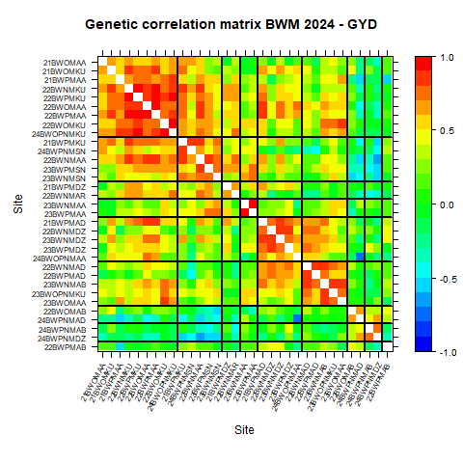
G4
G3
G2
G1
G5
GG
G6
G9
C8
G1= Group 1; G2= Group 2; G3=Group3; G4=Group4; G5=Group5; G6=Group6; G7=Group7; G8=Group8; G9= Group9
Note: The heat map shows the clustering of 33 test sites (trials). Details of the sites included in this analysis are presented in Table 2

Figure 2. Hierarchical clustering of 33 wheat testing environments based on genetic correlation of grain yield
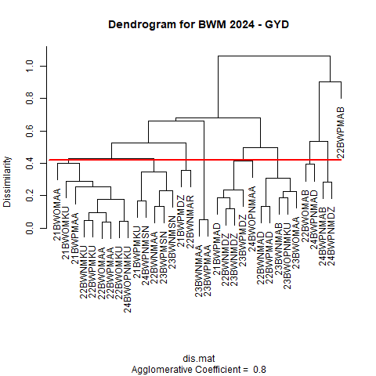
Note: Dendrogram showing the clustering of 33 test sites (trials). Details of the sites included in this analysis are presented in Table 1
The red line at 0.4 represents the threshold (cut point) for clustering grain yield performance across medium-altitude environments in Ethiopia. Sites that cluster below this threshold are more similar in terms of grain yield performance, indicating that the genotypes evaluated at these sites responded in a relatively comparable manner. In contrast, sites that merge above the 0.4 level are more dissimilar in yield performance. The dendrogram from hierarchical clustering of the given genotypes based on the grain yield data set across thirty-three environments was truncated at the nine-cluster level. Genotypes perform relatively similarly across the sites that fall under the same group. About nine trials (sites) were clustered together in the first group, which fell to trials evaluated in different years across the Kulumsa and Asasa sites. These two experimental sites are optimum areas for wheat production.

Table 3. Performance of Advanced Bread Wheat Genotypes in the Second-Year National Variety Trial across Clustered Environments

Genotypes/Varieties | GYDGxEGroup1 | GYDGxEGroup2 | GYDGxEGroup3 | GYDGxEGroup4 | GYDGxEGroup5 | GYDGxEGroup6 | GYDGxEGroup7 | GYDGxEGroup8 | GYDGxEGroup9 | Bekoji_Yr__3 | Meraro_Yr__3 | DZSr__3 | Rank-GYDGxEGroup1 | Rank-GYDGxEGroup2 | Rank-GYDGxEGroup3 | Rank-GYDGxEGroup4 | Rank-GYDGxEGroup5 | Rank-GYDGxEGroup6 | Rank-GYDGxEGroup7 | Rank-GYDGxEGroup8 | Rank-GYDGxEGroup9 | GYLD >5% than the check selection | Target Bekoji_Yr__3 selection | Target Meraro_Yr__3 selection | Target DZSr__2 selection
Boru | 1.58 | 0.35 | 0.58 | -0.88 | -0.03 | 0.31 | 0.46 | -0.76 | 0.17 | 6.9 | 6.9 | 6.5 | 4 | 6 | 2 | 7 | 6 | 6 | 1 | 5 | 1 | NS | S | S | S
Deka | 0.67 | 0.33 | 0.06 | -0.87 | -0.24 | 0.10 | -0.11 | -1.09 | 0.06 | 5.5 | 4.9 | 6.8 | 7 | 7 | 7 | 6 | 7 | 7 | 3 | 6 | 3 | NS | S | R | S
EBW202020 | 1.25 | 0.81 | 0.20 | 1.09 | 0.16 | 0.51 | -0.53 | 0.29 | -0.43 | 4.7 | 3.7 | 5.7 | 5 | 4 | 6 | 3 | 4 | 3 | 6 | 1 | 7 | SL | R | R | R
EBW202436 | 1.02 | 0.71 | 0.21 | 1.79 | 0.44 | 1.08 | -0.25 | -0.15 | -0.16 | 4.3 | 3.2 | 6.8 | 6 | 5 | 5 | 2 | 1 | 1 | 5 | 4 | 4 | SL | R | R | S
EBW202471 | 1.99 | 1.45 | 0.55 | 1.92 | 0.23 | 0.54 | 0.05 | 0.02 | 0.07 | 3.3 | 1.7 | 6.4 | 2 | 2 | 3 | 1 | 3 | 2 | 2 | 3 | 2 | SL | R | R | S
EBW202472 | 2.25 | 2.28 | 0.91 | 0.83 | 0.30 | 0.43 | -1.70 | -2.36 | -0.39 | 3.1 | 1.5 | 6.5 | 1 | 1 | 1 | 5 | 2 | 5 | 7 | 7 | 6 | SL | R | R | S
EBW202473 | 1.96 | 1.14 | 0.38 | 0.94 | 0.05 | 0.43 | -0.15 | 0.11 | -0.22 | 3.1 | 1.5 | 5.8 | 3 | 3 | 4 | 4 | 5 | 4 | 4 | 2 | 5 | SL | R | R | R

GYDGXEGroup1= Grain Yield from GXE interaction in Group 1; GYDGXEGroup2= Grain Yield from GXE interaction in Group 2;GYDGXEGroup3= Grain Yield from GXE interaction in Group 3;GYDGXEGroup4= Grain Yield from GXE interaction in Group 4;GYDGXEGroup5= Grain Yield from GXE interaction in Group 5;GYDGXEGroup6= Grain Yield from GXE interaction in Group 6;GYDGXEGroup7= Grain Yield from GXE interaction in Group 7; GYDGXEGroup8= Grain Yield from GXE interaction in Group 8;GYDGXEGroup9= Grain Yield from GXE interaction in Group 9;Bekoji_Yr_3= Bekoji yellow rust score Round 3; Meraro_Yr_3= Meraro yellow rust score Round 3; DZSr_3= Debreziet stem rust score round 3; NS=Not Selected; SL= Selected; S=susceptible; R= resistant

Five advanced bread wheat genotypes and two released check varieties were evaluated in the second-year National Variety Trials. The table was derived from the multi-environment trial analysis, as candidate varieties were selected at this stage of the breeding pipeline. A total of seven genotypes were assessed for grain yield (t/ha) and rust resistance across nine environmental clusters. EBW202472 and EBW202471 consistently showed positive deviations from cluster mean yields, indicating broad adaptability, while Boru and Deka exhibited moderate to below-average performance in several clusters. Maximum yellow rust severity at Bekoji and Meraro and stem rust at Debre Zeit (third-round scores) revealed variation in resistance. EBW202471, EBW202472, and EBW202473 showed resistance (R) to moderately resistant (MR) responses to yellow rust at both hotspot locations (Table 3). Stem rust severity at Debre Zeit was very high for all genotypes in 2024, a year highly favorable for disease development, and no genotypes exhibited full resistance. Nonetheless, EBW202472 and EBW202471 combined high yield with acceptable rust resistance. Selection integrated both yield advantage (>5% over the check) and disease response, identifying EBW202472, EBW202471, and EBW202473 as promising candidates for further evaluation (Table 3).

Fig 3. Advanced Genotypes’ Performance in Multi-Environment Trials Estimated by BLUP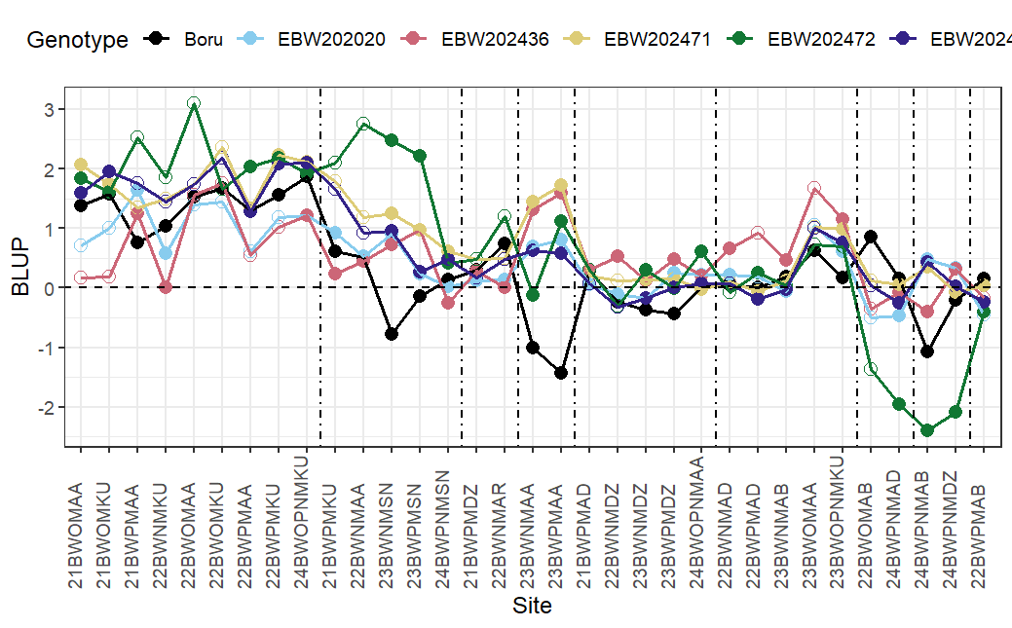

Figure 3. The BLUP graph illustrates the stability and performance of advanced genotypes relative to the best check variety Boru. The Y-axis represents BLUP values, where zero corresponds to the overall mean grain yield across testing environments. Positive BLUP values indicate above-average performance at a site, while negative values indicate below-average performance. Genotype × environment (G×E) interactions are reflected in the crossover patterns across sites on the X-axis. The check Boru (black line) showed high instability, with negative values in several environments. EBW202472 (green) exhibited very high positive BLUP values in some sites (up to +3) but large declines in others (below –2), indicating high responsiveness but poor stability. EBW202020 (light blue) and EBW202436 (pink) were more moderate and relatively stable, though EBW202436 showed occasional upward spikes. EBW202471 (yellow) remained mostly above zero with moderate fluctuation, suggesting stable and consistently superior performance. EBW202473 (purple) displayed relatively consistent values with smaller fluctuations, indicating stability, though not always the highest yield.

Conclusion
The Debrezeit experimental site is a major hotspot for wheat stem rust, making it an ideal location for evaluating disease response. Among the tested genotypes, EBW202020 and EBW202473 exhibited moderate susceptibility to stem rust, with EBW202020 further constrained by poor grain yield stability across nine clustered environments. In contrast, EBW202471 and EBW202472 showed moderately susceptible to susceptible reactions to stem rust, and EBW202471 demonstrated high yield stability across environments. Notably, both were resistant to yellow rust at the hotspot locations, Bokoji and Meraro. EBW202472 had high yield potential in favorable environments. Based on their combined disease resistance and yield performance, EBW202471, EBW202472, and EBW202473 were identified as promising candidate varieties for advancement.

References

Piepho, H.-P., Williams, E. R., & Cullis, B. R. (2011). Partially replicated designs for early generation variety trials. Biometrical Journal, 53(1), 19–27.

Butler, D. G., & Cullis, B. R. (2022). Optimal row-column designs for multi-environment trials. Euphytica, 218(5), 1–13.

Olivoto, T., et al. (2023). metan: An R package for multi-environment trial analysis. Methods in Ecology and Evolution, 14(8), 1562–1573.

Gilmour, A. R., et al. (1997). ASReml: A general framework for statistical analysis of mixed models. Biometrics, 53(4), 1447–1464.
Zhang, D., Bowden, R.L., Yu, J., Carver, B.F., & Bai, G. (2014). Association analysis of stem rust resistance in U.S. winter wheat. PLOS ONE, 9(7), e103747. https://doi.org/10.1371/journal.pone.0103747

McNeal, F.H., Konzak, C.F., Smith, E.G., & Tate, W.S. (1971). A uniform system for recording and processing cereal rust ratings. U.S. Department of Agriculture, Agricultural Research Service, Technical Bulletin No. 1449.
Tadesse W, Bishaw Z, Assefa S. Wheat production and breeding in Sub-Saharan Africa: Challenges and opportunities in the face of climate change. Int J Clim Chang Strateg Manag. 2019;11(5):696-715.
Statista. (2024). Production volume of wheat worldwide from 2008/2009 to 2023/2024. Statista Research Department. https://www.statista.com/statistics/263977/world-grain-production-by-type
Colasuonno, P., Maria, M. A., Blanco, A., & Gadaleta, A. (2013). Description of durum wheatlinkage map and comparative sequence analysis of wheat mapped DArT markers withrice and Brachypodium genomes. BMC Genetics, 14, Article 114. https://doi.org/10.1186/ 1471-2156-14-114
Kozyrytskyi, Y., & Serebriakova, C. (2023, December 13). Global wheat crop-2024 could fall on lower acreage in Ukraine and Canada. Miller Magazine. Retrieved on August 29, 2025, from https://millermagazine.com/blog/global-wheat-crop-2024-could-fall-on-lower-acreage-in-ukraine-and-canada-5463
Grote U, Fasse A, Nguyen TT and Erenstein O (2021) Food Security and the Dynamics of Wheat and MaizeValue Chains in Africa and Asia.Front. Sustain. Food Syst. 4:617009. doi: 10.3389/fsufs.2020.617009
International Development Research Centre. (2010, December 23). Facts & figures on food and biodiversity. Retrieved on August 29, 2025, from https://idrc-crdi.ca/en/research-in-action/facts-figures-food-and-biodiversity
Erenstein, O., Jaleta, M., Mottaleb, K.A., Sonder, K., Donovan, J., Braun, HJ. (2022). Global Trends in Wheat Production, Consumption and Trade. In: Reynolds, M.P., Braun, HJ. (eds) Wheat Improvement. Springer, Cham. https://doi.org/10.1007/978-3-030-90673-3_4
Tadesse W, Zegeye H, Debele T, Kassa D, Shiferaw W, Solomon T, Negash T; Geleta N; Bishaw Z; Assefa S. Wheat Production and Breeding in Ethiopia: Retrospect and Prospects. Crop Breed Genet Genom. 2022; 4(3):e220003. https://doi.org/10.20900/cbgg20220003
Tsegaye Moreda (2017). Large-scale land acquisitions, state authority and indigenous local communities: insights from Ethiopia. Third World Q., 38 (3) (2017), pp. 698-716
ICARDA Communication Team. (2022, February 24). Ethiopia paves the way to wheat self-sufficiency. ICARDA. Retrieved September 1, 2025, from https://icarda.org/media/news/ethiopia-paves-way-wheat-self-sufficiency
Ethiopian News Agency. (2023, October 31). Ethiopia attains self-sufficiency in wheat for the first time in its history, says ADB President. ENA. https://www.ena.et/web/eng/w/eng_3520864
Donley, Arvin. "Ethiopia becoming more self-sufficient in wheat." *World Grain*, 5 Sept. 2025, https://www.world-grain.com/articles/21377-ethiopia-becoming-more-self-sufficient-in-wheat.
Abate Feyissa Senbeta, Walelign Worku, Ethiopia’s wheat production pathways to self-sufficiency through land area expansion, irrigation advance, and yield gap closure, Heliyon,Volume 9, Issue 10,2023,e20720,ISSN 2405-8440,https://doi.org/10.1016/j.heliyon.2023.e20720.(https://www.sciencedirect.com/science/article/pii/S2405844023079288 )
Easterling WE, Aggarwal PK, Batima P, Brander KM. Food, Fibre, and Forest
Products. Available from: https://ensembleseu.metoffice.gov.uk/IPCC/rev_archive/SOD/Ch05.pdf. Accessed 2022 Jul 13.
Lobell DB, Field CB. Global scale climate—crop yield relationships and theimpacts of recent warming. Environ Res Lett. 2007;2(1):014002.
Huber B, Rosegrant M, Martinus A, Ortiz R. The future of Food: Scenario for
2050. Crop Sci. 2010;50(S1):S-33-50
Sanders R (2011) Strategies to reduce the emerging wheat stripe rust disease. International wheat stripe rust symposium. Aleppo.
Hodson D (2016) Building Plant Pathogen Surveillance Networks in Sub Saharan Africa. AAAS 2016 Annual Meeting, Washington DC.
Hailu A, Woldeab G, Dawit W, Hailu E (2015) Distribution of wheat stem rust (Puccinia Graminis F. Sp. Tritici) in West and Southwest Sh
Olivera, P., Newcomb, M., Szabo, L. J., Rouse, M., Johnson, J., Gale, S., et al. (2015). Phenotypic and genotypic characterization of race TKTTF of Puccinia graminis f. sp. tritici that caused a wheat stem rust epidemic in southern Ethiopia in 2013–14. Phytopathology, 105(7), 917–928. https://doi.org/10.1094/PHYTO-11-14-0302-FI
Meyer, M., Bacha, N., Tesfaye, T., Alemayehu, Y., Abera, E., Hundie, B., … Gilligan, C. A. (2021). Wheat rust epidemics damage Ethiopian wheat production: A decade of field disease surveillance reveals national-scale trends in past outbreaks. PLOS ONE, 16(2), Article e0245697. https://doi.org/10.1371/journal.pone.0245697
Hayes, M. (2021, February 4). 13-year analysis sheds new light on wheat crop disease patterns in Ethiopia. Borlaug Global Rust Initiative. Retrieved [Month Day, Year], from https://bgri.cornell.edu/13-year-analysis-sheds-new-light-on-wheat-crop-disease-patterns-in-ethiopia/
Qiao CG, Basford KE, DeLacy IH, Cooper M. Evaluation of experimental designs andspatial analyses in wheat breeding trials.Theoretical and Applied Genetics. 2000;100:9–16.
Smith A, Cullis B, Thompson R. Exploring variety-environment data using random effects AMMI models with adjustments for spatial field trend: Part 1: Theory. InQuantitative genetics, genomics,and plant breeding. Wallingford UK: CABI Publishing.2002;323-335.
Burgueño J, Cadena A, CrossaJ, Banziger M, Gilmour AR, Cullis B. User’s guide for spatial analysis of field variety trials using ASREML.CIMMYT; 2000.
Smith A, Cullis B, Thompson R.Analyzing variety by environment data using multiplicative mixed models and adjustingments for spatial field trend.Biometrics. 2001;57:1138–47. DOI: 10.1111/j.0006-341x.2001.01138.x
Smith AB, Cullis BR, Thompson R. The analysis of crop cultivar breeding and evaluation trials: An overview of current mixed model approaches.The Journal of Agricultural Science.2005;143(6):449-462.Available:https://ro.uow.edu.au/infopapers/2076

