Short Research Article

ANALYSING RATIONALITY OF PRESCRIPTION WITH ANTIMICROBIALS IN PAEDIATRIC DEPARTMENT DIAGNOSED WITH RESPIRATORY TRACT INFECTION

ABSTRACT

Respiratory tract infections (RTIs) remain one of the leading causes of paediatric morbidity in South India and are frequently associated with inappropriate antibiotic use.
Objective: To evaluate the rationality of antibiotic prescriptions among paediatric inpatients diagnosed with RTIs using the Modified Kunin’s Criteria in a tertiary care hospital in South India.
Methodology: This was a prospective cross-sectional study conducted over six months, including 150 paediatric inpatients aged 0–12 years diagnosed with RTIs. Prescription patterns were assessed using the Modified Kunin’s Criteria. Data regarding demographic characteristics, clinical diagnosis, and antimicrobial use were analysed.
Results: Children aged 9–12 years constituted the majority of the study population, with a male predominance. Pneumonia was the most frequently diagnosed RTI, followed by tonsillitis and bronchiolitis. Antibiotics were prescribed to 76.67% of patients, with Ceftriaxone–Sulbactam and Amoxicillin–Clavulanate being the most commonly used agents. Antiviral drugs accounted for 23.33% of prescriptions. Based on Modified Kunin’s Criteria, 75.4% of prescriptions were appropriate, while 24.7% were inappropriate. The major causes of inappropriate use included empirical therapy without culture confirmation and selection of suboptimal antibiotics.
Conclusion: Although most prescriptions adhered to rational antimicrobial use, nearly one-fourth were inappropriate. These findings highlight the need for continuous prescription audits, strict adherence to antimicrobial stewardship principles, and increased utilization of culture-sensitivity testing to improve antibiotic prescribing practices in paediatric RTIs.

Keywords: {Pediatric respiratory infections; Antimicrobial rationality; Antibiotic resistance; Kunin’s criteria; Prescription audit; Antimicrobial stewardship}

1. INTRODUCTION

Respiratory tract infections (RTIs) are among the most common infectious diseases encountered in paediatric clinical practice, ranging from mild upper respiratory illnesses to severe lower respiratory conditions requiring hospitalization, in developed as well as developing countries. In contrast to just 3% in developed nations, they account for 20% of under-five deaths in India. About 1.7 million children under the age of five died worldwide in 2010, with India accounting for 23% of those deaths ¹.
Respiratory tract infections affecting paediatric population include wide range of pathological conditions like bronchiolitis, pneumonia, bronchitis, laryngotracheobronchitis (Croup), acute sinusitis, otitis media, rhinitis etc. They may originate from bacteria (H. influenzae, Streptococci, pneumococci, etc.) or viruses (adenovirus, rotavirus, rhinovirus, etc.) ². Among all infectious diseases, lower respiratory tract infections (LRTIs) are the greatest cause of death worldwide. They are common and linked to notable rates of morbidity and mortality in children ³. Pneumonia and bronchitis are the most frequent LRTIs. Pneumonia is the primary infectious cause of paediatric mortality globally, making up 15% of all paediatric fatalities under the age of five ⁴.
Majority of these infections has underlying viral etiology, which hardly needs an antibiotic prescription. Despite this, antibiotics are prescribed irrationally for even nonspecific symptoms such as sore throat, common cold, and rhinitis for which therapeutic benefit is meagre. But these unfounded antibiotic prescriptions can lead to emergence of resistance patterns which threatens effective therapy ^{6,7}.
Given this context, the objective of the study was to evaluate the rationality of treatment for respiratory tract infections in children and to examine the prescription patterns of medications using the Modified Kunin's rationality criteria ^{5,8}.

2. methodology

2.1. Study design and ethical considerations

2.1.1. Study design
This prospective, cross-sectional, descriptive study was conducted over a period of six months, from January to June 2024, in the Paediatrics Department of a tertiary care research centre in South India.

2.1.2. Ethical approval and consent
Ethical clearance was obtained from the Institutional Ethics Committee prior to study initiation (IERB No: 83-2024). Written informed consent was obtained from parents or legal guardians of all enrolled children, and assent was also obtained from children aged seven years and above, in accordance with institutional ethical guidelines.

2.2. Study population and sample size

Considering an acute respiratory infection (ARI) prevalence in India of 0.3%–5.6%, the minimum required sample size was calculated as 103 ⁹; however, a total of 150 paediatric inpatients aged 0–12 years, of either gender, who were clinically diagnosed with respiratory tract infections (RTIs) and prescribed antimicrobial therapy during hospitalisation, were enrolled.
Patients with incomplete or unreliable prescription records, those with significant comorbid conditions, children managed exclusively on an outpatient basis, and those whose caregivers declined participation were excluded.
The final sample size of 150 was based on feasibility and the average monthly admission rate of paediatric RTIs in the preceding year, ensuring an adequate number of participants for meaningful analysis.

2.3. Data collection and study variables

Data collection was carried out using a structured proforma designed to capture demographic details, history of illness, clinical diagnosis, antimicrobial prescriptions, and the use of ancillary or adjuvant medications. Information was obtained from patient case records, treatment charts, and caregiver interviews to ensure accuracy and completeness.
The primary outcome variable was the appropriateness of antimicrobial prescriptions, assessed using the Modified Kunin’s Criteria (Categories I–VI), which classify antimicrobial use from “appropriate therapy” to “inappropriate” or “unassessable.” Prescriptions under Criteria I and II were considered rational, while those under Criteria III–VI were deemed inappropriate ^{5,6}.
Other variables included patient age, sex, type of RTI diagnosed, type of antimicrobial prescribed (antibiotic or antiviral), and prescription pattern (monotherapy or polytherapy).

2.4. Sampling and data analysis

To minimise selection bias, consecutive sampling was employed, and only patients with complete prescription records were included. Data were entered into Microsoft Excel and analysed descriptively. Frequencies and percentages were calculated for categorical variables, while the prevalence of prescribing patterns and rationality assessment across Kunin’s categories was reported with corresponding 95% confidence intervals (CIs).

3. results

A total of 150 paediatric patients diagnosed with respiratory tract infections were enrolled in the study, with a participation rate of 100%. Among them, 92 (61.3%) were male and 58 (38.7%) were female, as depicted in Figure 1.

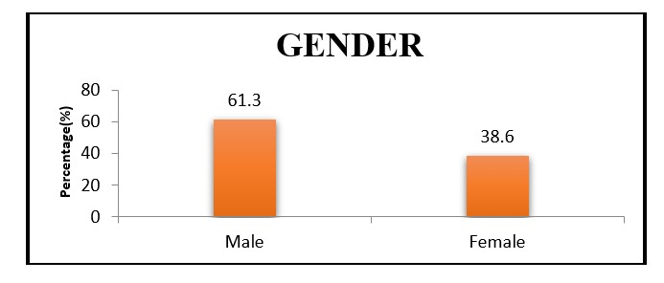
Figure 1. Patient distribution based on gender

Age-wise distribution showed that 26 patients (17.3%) were less than one year old, 37 (24.7%) were between 1–4 years, 35 (23.3%) were between 5–8 years, and 52 (34.7%) belonged to the 9–12 years age group, with the highest representation observed in the 9–12 years category (Figure 2).

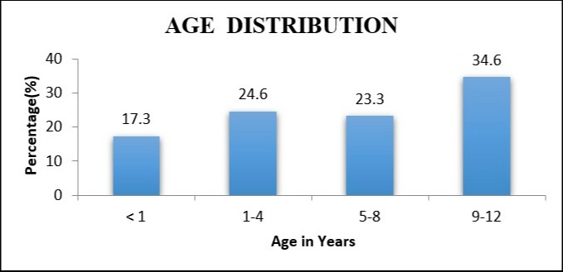

Figure 2. Patient distribution based on age group

The distribution of respiratory tract infections revealed that pneumonia was the most common diagnosis, accounting for 88 cases (58.7%), followed by tonsillitis (11.3%), bronchiolitis (6.7%), viral fever (6%), pharyngitis (5.3%), and bronchitis (4.7%). Less common conditions included croup (4%), tracheitis (1.3%), influenza (1.3%), and sinusitis (0.7%), as shown in Figure 3.

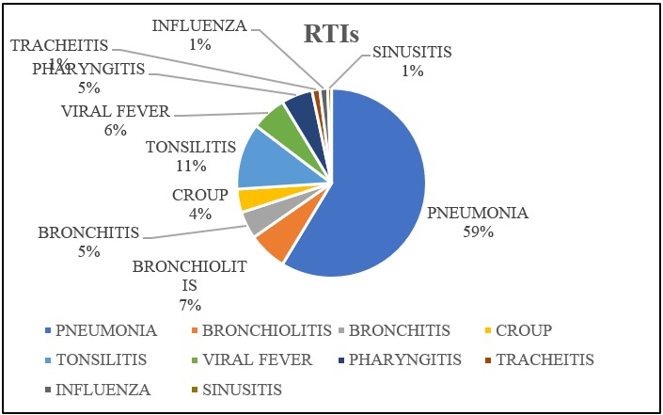

Figure 3. Patient distribution based on various respiratory tract infections
Regarding prescribing patterns, monotherapy was observed in 124 children (82.7%), while polytherapy involving two or more antimicrobials was administered in 26 children (17.3%) (Figure 4).

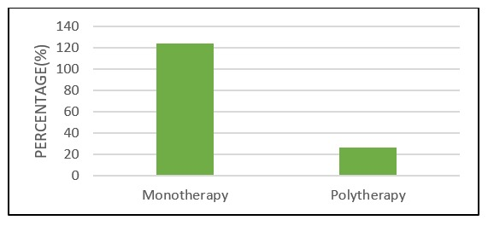
Figure 4. Patient distribution based on monotherapy & polytherapy of antimicrobials

Antibiotics were prescribed more frequently than antivirals, with 115 patients (76.7%) receiving antibiotics and 35 patients (23.3%) receiving antivirals (Figure 5).

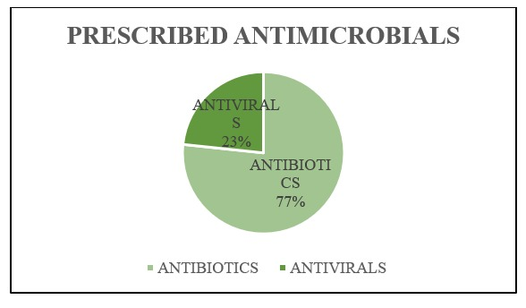
Figure 5. Patient distribution based on prescribed antimicrobials

Among the antibiotics, Ceftriaxone with Sulbactam was the most commonly prescribed (51.3%), followed by Amoxicillin with Potassium Clavulanate (38%), Azithromycin (21.3%), and Amikacin (10.7%). Other antibiotics such as Piperacillin–Tazobactam, Cefepime, Vancomycin, Metronidazole, Cephalexin, and others were used in smaller proportions, as detailed in Table 1.

Table 1. Antibiotics used in Respiratory tract infections

NAME OF ANTIBIOTICS | FREQUENCY  n=150 | PERCENTAGE (%)
CEFTRIAXONE + SULBACTAM | 77 | 51.33
AMOXICILLIN + POTASSIUM CLAVULANATE | 57 | 38
AZITHROMYCIN | 32 | 21.33
AMIKACIN | 16 | 10.67
PIPERACILLIN + TAZOBACTUM | 8 | 5.33
CEFEPIME | 6 | 4
VANCOMYCIN HCl | 5 | 3.33
METRONIDAZOLE | 3 | 2
CEPHALEXIN | 2 | 1.33
CEFOTAXIME | 2 | 1.33
BENZATHINE PENICILLIN G | 2 | 1.33
LEVOFLOXACIN | 2 | 1.33
DOXICYCLINE | 2 | 1.33
CEFUROXIME | 1 | 0.67
AZTREONAM | 1 | 0.67

Among antivirals, Oseltamivir phosphate was the most commonly used (19.3%), followed by Acyclovir (3.3%) and Zanamivir (0.7%) (Table 2).

Table 2. Antivirals used in Respiratory tract infections

ANTIVIRAL DRUGS | FREQUENCY  (n=150) | PERCENTAGE (%)
OTHERS | 115 | 76.7
ACYCLOVIR | 5 | 3.3
OSELTAMIVIR PHOSPHATE | 29 | 19.33
ZANAMIVIR | 1 | 0.7
TOTAL | 150 | 100.0

Ancillary medications such as Acetaminophen (88.7%), Guaifenesin–Terbutaline–Bromhexine combinations (33.3%), and inhaled Budesonide (10.7%) were also frequently prescribed, as shown in Table 3.

Table 3. Ancillary medications used in respiratory tract infections

ANCILLARY MEDICATIONS | FREQUENCY  (n=150) | PERCENTAGE (%)
ACETAMINOPHEN | 133 | 88.67
AMBROXOL HCl | 15 | 10
GUAIFENESIN+TERTBUTALINE+BROMHEXANE | 50 | 33.33
XYLOMETAZOLINE | 2 | 1.33
LEVOCETRIZINE | 4 | 2.67
AMBROXOL+LEVOSALBUTAMOL+GUAIFENESIN | 6 | 4
CHLORPHENIRAMINE MALEATE+PHENYLEPHRINE | 10 | 6.67
SALINE NASAL DROPS | 10 | 6.67
DEXTROMETHORPHAN +CHLORPHENIRAMINE | 7 | 4.67
SALBUTAMOL | 14 | 9.33
BUDESONIDE | 16 | 10.67
FORMOTEROL FUMARATE+BUDESONIDE | 2 | 1.33
IPRATROPIUM BROMIDE | 3 | 2
DEXAMETHASONE | 6 | 4
METHYL PREDNISOLONE | 4 | 2.67

Rationality assessment according to the Modified Kunin’s Criteria indicated that appropriate antimicrobial therapy was given in 113 patients (75.4%), while 37 patients (24.7%) received inappropriate therapy. Most appropriate prescriptions were classified under Criteria I (64.7%) and Criteria II (10.7%). Inappropriate prescriptions included those falling under Criteria III (15.3%), Criteria IV (4.7%), and Criteria VI (4.7%). Notably, none of the prescriptions were completely unjustified (Criteria V). The distribution of prescriptions across Kunin’s categories is presented in Table 4.

Table 4. Assessment of rationality of antimicrobials using Kunin’s criteria

RATIONALITY ASSESSMENT (KUNINS CRITERIA) | (n=150) | (%)
Criteria I: Agree with the use of antimicrobial therapy, the protocol is appropriate | 97 | 64.7
Criteria II: Agree with the use of antimicrobial therapy/prophylaxis, but a potentially fatal bacterial infection cannot be ruled out or prophylaxis is probably appropriate, (a microbiology report is missing to classify the protocol in another category) | 16 | 10.7
Criteria III: Agree with the use of antimicrobial therapy/prophylaxis, but a different (usually less expensive or toxic) antimicrobial is preferred. | 23 | 15.3
Criteria IV: Agree with the use of antimicrobial therapy/prophylaxis, but a modified dose interval, duration, or route of administration as preferred | 7 | 4.7
Criteria V: Disagree with the use of antimicrobial therapy/prophylaxis , administration is unjustified | 0 | 0.0
Criteria VI: Data cannot be judged because of missing information. | 7 | 4.7

4. DISCUSSION

In the study we estimated the overall population consisting of 150 paediatric patients ranging from age groups 0-12, and the participants were divided into 4 groups based on their age as <1 year, 1-4 years, 5-8 years and 9-12years, of which majority of the patients belonged to the age group of 9-12 years demonstrating a higher incidence of Respiratory tract infections among preferred age group.
Within the study population it also demonstrates that the occurrence of RTIs was higher among male participants (61.3%) than that of females (38.7%). This result was found to be similar to the study conducted by Biniyam Sahiledengle et al ^{10,14}. in which male participants (55,4%) were higher than females (44.6%). This conveys that incidence of RTIs are higher among males than females. Among the paediatric respiratory tract infections, incidence of LRTI (70%) was more compared to URTI (30%), in which Pneumonia (58.7%) was mostly diagnosed. A study by Kailash Thapaliya et al ^{11,13}. reported a similar result in which Pneumonia accounted for 22.5%, which was the common cause for hospitalization in paediatric patients, whereas Mahajan H M et al ¹² reported contrasting results showing URTI (60%) was more compared to LRTI (40%).
In the context of our findings, we observed that antibiotics accounted for 76.67% and antivirals for 23.33% of the total antimicrobials prescribed, aligning with the findings of Varsha P. Gajbhiye et al ⁹. In addition, Ceftriaxone + Sulbactum (n=77) followed by Amoxicillin+ Potassium Clavulanate (n=57) emerged as the most commonly prescribed antibiotics in our study. Azithromycin(n=32) and Amikacin (n=16) were the next most widely prescribed antibiotics, whereas in the same study conducted by Varsha P. Gajbhiye et al ⁹ identified Amoxicillin (52.34%) as the predominant choice, likewise Mahajan H M et al ^{12,15} reported Azithromycin (23.9%) as the most frequently prescribed antibiotics. This implies that various studies report differing antibiotics as the most frequently utilized.
Irrational or inappropriate prescribing of antimicrobials is a significant factor contributing to antimicrobial resistance. Therefore, evaluating the rationality of prescriptions is essential, which can be assessed using Kunin’s criteria. In our study, 24.7% of patients received inappropriate antimicrobial prescriptions, while 75.4% were deemed appropriate according to Kunin’s criteria. Although a similar study by Devang Ashwinkumar Rana et al ⁶. reported a higher rate of inappropriate prescriptions, our findings indicated a greater proportion of appropriate antimicrobial prescriptions.
Here, appropriate therapy was given in 75.4% of patients and they were categorized under Criteria I& II. Among the cases under Criteria II, 10.7% received empirical therapy with right antimicrobial agent, but culture sensitivity testing was not done to confirm the diagnosis. The cases under Criteria III were 15.3 % and they received more than one antimicrobial agent which is not preferred. Among the cases, 4.7% were categorized under the Criteria IV as the antibiotics were swapped from Inj Ceftriaxone to Amoxicillin +potassium clavulanate, Inj Piperacillin -tazobactam to Vancomycin and Inj. Ceftriaxone to Amikacin. This shift in antimicrobial agents was needed as the patients were not responding to the prescribed treatment. 7cases were included in the Criteria VI, as the data couldn’t be assessed because of missing information in the prescription chart. All patients were prescribed with drugs from the essential medication list (100%) ⁷.
Despite these positive trends, the reliance on empirical therapy without culture sensitivity remains a concern, as it can fuel antimicrobial resistance. This underscores the importance of strengthening antimicrobial stewardship programs and promoting microbiological confirmation whenever feasible. Our study has some limitations, including its relatively small sample size, single-centre setting, incomplete documentation in a few cases, and the absence of routine microbiological confirmation, all of which may have introduced bias and limit the generalisability of the findings. In addition, patient outcomes were not assessed, restricting evaluation of the clinical impact of rational versus irrational prescriptions. Despite these constraints, the study provides valuable insight into antimicrobial prescribing practices in paediatric RTIs in a tertiary care hospital. Larger multicentric studies incorporating culture sensitivity testing, outcome assessment, and real-time prescription audits are needed to strengthen stewardship efforts and guide rational antibiotic use more effectively.
5.CONCLUSION

While the majority of antimicrobial prescriptions in paediatric RTIs were appropriate according to Kunin’s criteria, a notable proportion still fell into inappropriate categories. These findings highlight the importance of continuous prescription audits and strict adherence to antimicrobial stewardship protocols to promote rational prescribing. Wider use of culture sensitivity testing and minimisation of empirical therapy will be crucial to preserve antibiotic effectiveness and improve paediatric respiratory care outcomes.

Consent
All authors declare that ‘written informed consent was obtained from the patient (or other approved parties) for publication of this short research study.

Ethical approval

All authors hereby declare that all experiments have been examined and approved by the appropriate ethics committee and have therefore been performed in accordance with the ethical standards laid down in the 1964 Declaration of Helsinki.

DECLARATION ON THE USE OF GENERATIVE AI IN SCIENTIFIC WRITING
During the preparation of this work, the author(s) used ChatGPT to improve the language and readability of the manuscript. The author(s) reviewed and edited the output as necessary and accept full responsibility for the content of the final manuscript.

References

- Mrinali Thakur, Rima Shah, Darshan Dave, J G Buch. Analysis of Prescribing Patterns in Paediatric Respiratory Tract Infections with the Focus on Antimicrobial Use, Adverse Effects and Cost Of Drug Therapy. Journal of Pharmacy and Pharmacology Research 4 (2020): 001-014.a
- Iyer GS, Patel PP, Panchal JR, Dikshit RK. An analysis of the pharmacological management of respiratory tract infections in pediatric in-patients at a tertiary care teaching hospital. International Journal of Medicine and Public Health. 2013;3(3).
- Chang AB, Chang CC, O’Grady K, Torzillo PJ. Lower respiratory tract infections. Pediatr Clin North Am 2009;56: 1303-21
- Grant CC, Scragg R, Tan D, Pati A, Aickin R, Yee RL. Hospitalisation for pneumonia in children in Auckland, New Zealand. Journal of paediatrics and child health. 1998 Aug;34(4):355-9.
- Kunin CM, Tupasi T, Craig WA. Use of antimicrobials. A brief exposition of the problem and some tentative solutions. Ann Intern Med. 1973;79: 555–60
- Rana DA, Malhotra SD, Patel VJ. Inappropriate surgical chemoprophylaxis and surgical site infection rate at a tertiary care teaching hospital. The Brazilian Journal of Infectious Diseases. 2013 Jan 1;17(1):48-53.
- Nair SG, Poonnen SS, Kuriachan S, Palatty PL. Analysis of Prescription of medications used in Lower Respiratory tract infections in children. Medica Innovatica. 2024 Jan 1;13(1).
- World Health Organization. How to investigate drug use in health facilities : selected drug use indicators. In: Action Programme on Essential Drugs and Vaccines [Internet]. Geneva PP - Geneva: World Health Organization; 1993. (DAP research series;no. 7). Available from: https://apps.who.int/iris/handle/10665/60519
- Gajbhiye VP, Kale RS, Vilhekar KY, Bahekar SE. Drug utilization study on antimicrobials use in lower respiratory tract infection in Pediatric Intensive Care Unit of Rural Tertiary Care Hospital. Journal of Medical Society. 2016 Sep 1;30(3):146-8.
10. Sahiledengle B, Seyoum F, Abebe D, Geleta EN, Negash G, Kalu A, Woldeyohannes D, Tekalegn Y, Zenbaba D, Quisido BJ. Incidence and risk factors for hospital-acquired infection among paediatric patients in a teaching hospital: a prospective study in southeast Ethiopia. BMJ open. 2020 Dec 1;10(12):e037997.
11. Thapaliya K, Shrestha S, Bhattarai S, Basnet D, Chaudhary RK. Prescribing pattern of antibiotics in pediatric hospital in Chitwan district in Nepal. World J Phar Pharm Sci. 2015 Sep 14;4(11):1631-41.
12. Mahajan HM, Date AP, Badwaik RT, Borkar AS, Wanmali SS, Gohad GV. Analysis of Pattern of Antimicrobial use in Respiratory Tract Infections in a Tertiary Care Hospital of Central India-A Drug Utilization Study. J Cont Med A Dent. 2014;2(3):59-64.
13. Donà D, Luise D, Da Dalt L, Giaquinto C. Treatment of Community‐Acquired Pneumonia: Are All Countries Treating Children in the Same Way? A Literature Review. International journal of pediatrics. 2017;2017(1):4239268.
14. Andersen CT, Langendorf C, Garba S, Sayinzonga-Makombe N, Mambula C, Mouniaman I, Hanson KE, Grais RF, Isanaka S. Risk of community-and hospital-acquired bacteremia and profile of antibiotic resistance in children hospitalized with severe acute malnutrition in Niger. International Journal of Infectious Diseases. 2022 Jun 1;119:163-71.
15. Rauniyar R, Mandal RK, Joshi R, Chaudhary R, Bansal S, Sood AK, Singh T. Drug Utilization Evaluation in Upper Respiratory Infection in Pediatric Population in North Indian Tertiary Hospital. Journal of Young Pharmacists. 2025;17(1):206.

Abbreviations

RTI / RTIs | Respiratory Tract Infection(s)

LRTI / LRTIs | Lower Respiratory Tract Infection(s)

URTI / URTIs | Upper Respiratory Tract Infection(s)

ARI | Acute Respiratory Infection

IEC | Institutional Ethics Committee

IERB | Institutional Ethics Review Board (IERB No: 83-2024)

CI | Confidence Interval

HCl | Hydrochloride

