Machine-Learning Implications on Global Antenatal Care Improvement and Equity Disparities: The Wealth Effect, Regional Dynamics, and Model-Based

Abstract
The study evaluated the progress of antenatal care worldwide using records from the UNICEF Maternal Health Dataset and determined the correlation between prosperity and improvements in antenatal care coverage. Mean coverage of antenatal care rose by 61.9 in 2013 to 71.6 in 2023, and the best-performing quartile improved by the greatest margin of +14.50 percentage points, with the best performance being in rural areas, which improved by +12.73 points. The relationship between wealth and baseline coverage change was found to be significantly affected by wealth, with main effects of wealth and the interaction. This was further confirmed by a nonparametric mediation statistic, which showed a positive correlation between wealth and baseline coverage, but the indirect effect of wealth was not significant; therefore, wealth does not mediate the change. Among the six machine learning models, the XGBoost model had the best predictive accuracy, followed by LightGBM and Multivariate Adaptive Regression Splines (MARS). The hot spot mapping showed that South Asia and East and Southern Africa had the highest rates of pro-poor progression. The findings offer a novel way to holistically assess changes in antenatal care, providing evidence-based interventions to hasten pro-equity developments towards achieving the third Sustainable Development Goal of Good Health. All the respective National Programs should employ machine-learning-focused early warning analytics to detect geographic regions with stagnation, and offer direct outreach services and preparedness of the Community and Services.

Keywords: maternal health; global health equity; wealth gradient; moderation analysis; mediation analysis; health coverage change;

Introduction
Antenatal care (ANC) has been a fundamental access point towards preventing maternal and neonatal morbidity and mortality, and realising Sustainable Development Goals in maternal and child survival are now monitored globally with at least one ANC visit (ANC1) and at least four ANC contacts (ANC4) (Mekonne et al., 2025; Melesse et al., 2024; Offosse et al., 2025). It supports health system readiness, continuity of care, and equitable access (Alemu et al., 2025; Habte et al., 2024; Patil et al., 2025; Yallew et al., 2025). According to estimates from the United Nations Children's Fund (UNICEF), ANC coverage has been steadily increasing in most low- and middle-income regions. However, significant disparities persist between and within regions, particularly by residence and household wealth. Urban and rural women, as well as women in the wealthiest quintile, are consistently more likely to attain ANC4 than poorer women, and adolescents remain the least covered group.
The global and regional studies continue to report significantly high disparities in ANC coverage (Marthias et al., 2025; Aboagye et al., 2024; Rodriguez-Lopez et al., 2025; Hone et al., 2024; Roberts et al., 2024). Demographic and Health Surveys, as well as other nationally representative data, multi-country studies reveal that women living in the wealthiest quintiles are frequently twice as likely as those living in the poorest quintiles to report receiving recommended ANC contacts and other Reproductive, Maternal, Newborn and Child Health (RMNCH) contacts (Mahamud Tohan et al., 2024; Tegegne et al., 2024; Tohan et al., 2024; Phillips et al., 2025). Poor, rural, and less educated women have long experienced deficits in ANC visits and quality due to educational, residential, and geographic differences, which are exacerbated by the fact that these differences persist and are increasing over time (Le et al., 2024; Aboagye et al., 2025).
Another line of research treats ANC as part of the continuum of maternal, new-born, and child health care (Anyanwu et al., 2024; Ghosal et al., 2025; Hermans et al., 2025; Pandey et al., 2025; Oyugi et al., 2024; Mengesha et al., 2025). Research conducted in Ghana, Ethiopia, and other low and middle-income environments indicates that the continuum between ANC and skilled birth attendance to postnatal care is not well achieved with some substantial socio-economic and geographic disparities (Hailemariam et al., 2024; Kebede et al., 2024; Tegegne et al., 2024; Ahmed et al., 2024; Lateef et al., 2024). Wealth, education, media exposure, and proximity to services and drop-off are likely to differ between ANC and delivery, or between delivery and the newborn postnatal examination. These are usually based on logistic or multinomial regression and concentration index analytical methods, which describe inequalities and the contributions of covariates such as prosperity and education. Structural models explicitly considering wealth as a mediator or moderator of service paths over time are less common, particularly at the global or regional scale.
ANC trends and determinants are also the subjects of regression-based studies (Biswas et al., 2024; Agegnehu et al., 2025; Orimadegun et al., 2025; Wang et al., 2025). Although country-specific and regional analyses often estimate the relationship between ANC utilisation and maternal age, parity, education, wealth index, residence, and health system factors, more infrequently are those studies that follow the changes in ANC coverage over a period of at least 10 years and correlate this change with baseline levels of service. There is inconsistent evidence on whether wealth gradients increase with or decrease with expansion of coverage, with some reports of pro-rich effects across the continuum and others of pro-poor benefits when national coverage has reached specific targets.
Furthermore, there has been an increasing interest in machine learning and artificial intelligence in maternal health in the last few years. Reviews and empirical applications indicate the use of random forests, gradient boosting, XGBoost, and deep learning to predict adverse pregnancy outcomes, maternal mortality risk, optimal ANC use, early ANC initiation, skilled birth attendance, and home delivery after ANC. The uses mainly depend on individual-level facility or survey data and emphasise binary outcomes, such as early and late ANC, optimal and sub-optimal ANC, or facility- and home-delivery. Application of machine learning to forecast changes in population-level coverage indicators across regions or equity stratifiers is also sparsely utilised in the peer-reviewed literature.
Materials and methods
This research paper utilised the UNICEF global maternal and newborn health coverage data. This database provides harmonised estimates of coverage across the following key reproductive, maternal, newborn, and child health indicators by country, region, and equity stratifier choices. The database is built on Demographic and Health Surveys, Multiple Indicator Cluster Surveys, and other nationally representative household and administrative surveys, and is released as an open-source dataset for SDG monitoring on the UNICEF data portal. To be transparent and reproducible, the particular extract analysed here, along with global and regional aggregates for 2013 and 2023, was deposited in a public repository.
The sample data comprised 1,102 records across nine variables. The following variables were saved after cleaning column labels to lower-case names, category (type of UNICEF aggregation, character), region and region name (categorical identifiers of global, income or UNICEF programme regions), indicator (ANC1, ANC4, skilled attendance at birth, institutional delivery, caesarean section and postnatal contacts to mothers and new-borns), stratifier (dimension of equity disaggregation, national, area of residence, wealth quintile, or age), level (specific subgroup within each stratifier, such as rural, urban, poorest). Each indicator is expressed as the percentage of women or newborns who received a given service when they should have; for example, the proportion of women with a recent live birth who had at least four antenatal contacts (ANC4).
A continuous change outcome was defined for each record as the difference in coverage between 2023 and 2013, $Δ_{i}=y_{i,2023}-y_{i,2013},$ where $y_{i,t}$ denotes the coverage percentage for the record $i$ in year $t$. Positive values of $Δ_{i}$Correspond to gains in coverage over the decade, and negative values correspond to declines. For analyses focused on wealth-related inequalities, the data were restricted to rows where the stratifier equalled wealth index quintile (WIQ). Within this subset, the level variable took values “Poorest”, “Second”, “Middle”, “Fourth”, and “Richest”. An ordered wealth index $W_{i}$Was created by mapping these categories onto the integers 1 to 5, with 1 representing the poorest quintile and five the richest. For residence-based analyses, levels “Rural” and “Urban” were retained within the area stratifier. The resulting analytic sample used for moderation, mediation, and machine learning models comprised complete cases on indicator, region, stratifier, level, x2013, and x2023.
Descriptive statistics were used to characterise the distribution of coverage in 2013 and 2023 and to highlight change across key stratifiers. Means, standard deviations, medians, and interquartile ranges were calculated for x2013, x2023, and $Δ$ overall and within levels of age, area, national status, and wealth quintile. Box plots compared the marginal distributions of coverage in 2013 and 2023, while bar charts displayed the mean change by region and stratifier-level combinations. A hotspot map was constructed to visualise spatial patterns of equity change. For each region $r$ and wealth quintile $q,$he means change
Hrq=1nrqi∈r,q​Δi
was calculated, where $n_{rq}$ is the number of records in the region $r$ and quintile $q$, moreover, plotted as a heatmap. Darker tones corresponded to larger gains, allowing rapid identification of regional hotspots of pro-poor progress and cold spots of stagnation. This descriptive layer served both as a diagnostic for modelling choices and as a policy-relevant summary of equity-sensitive ANC performance in relation to SDG targets 3.1, 3.2, and 3.8.
To assess whether the association between baseline coverage and subsequent change varied across the wealth gradient, a moderation model was specified using ordinary least squares regression. For records within the WIQ subset, the following linear model was estimated:
$$Δ_{i}=β_{0}+β_{1}x_{i,2013}+β_{2}W_{i}+β_{3}\left(x_{i,2013}×W_{i}\right)+ε_{i},$$
where $x_{i,2013}$Is baseline coverage in 2013, $W_{i}$ is the ordered wealth index and $ε_{i}$ is a mean-zero error term. The coefficient $β_{1}$ captures the association between baseline coverage and change for the reference wealth level, $β_{2}$ represents the main effect of wealth index at zero baseline coverage, and the interaction term $β_{3}$ indicates whether the slope of change in baseline coverage differs across wealth quintiles. Model residuals were examined graphically to assess linearity, homoscedasticity and approximate normality. Although coverage proportions are bounded, the use of continuous linear regression is justified by the mid-range values observed and the focus on marginal effects rather than extrapolation to extremes, a practice consistent with previous ANC equity analyses.
A mediation framework was used to test whether wealth index functioned as a mediator of the relationship between baseline coverage and change. A single-mediator structural equation model was estimated using the robust maximum-likelihood (MLR) estimator, which provides standard errors and test statistics that are robust to mild departures from multivariate normality. The model specified wealth index as a function of baseline coverage,
$$W_{i}=a x_{i,2013}+e_{1i},$$
and change as a function of both baseline coverage and wealth index,
$$Δ_{i}=c'x_{i,2013}+bW_{i}+e_{2i}.$$
The indirect effect of baseline coverage on change through wealth index was defined as
$$\text{indirect}=ab,$$
while the total effect was
$$\text{total}=c'+ab.$$
Standardised path coefficients, indirect and total effects, and model fit indices including the comparative fit index (CFI), Tucker–Lewis index (TLI), root mean square error of approximation (RMSEA) and standardised root mean square residual (SRMR) were reported. This mediation approach extends earlier decomposition analyses of ANC inequalities by explicitly quantifying the causal pathway from baseline coverage to change via the population's wealth structure, rather than decomposing inequalities at a single time point.
To complement the causal regression and structural models, a suite of supervised machine learning algorithms was trained to predict change in coverage using baseline and contextual variables. The outcome variable was $Δ_{i}$. Predictor variables included x2013, category, region, region_name, indicator, stratifier, and level, with categorical variables encoded as sets of indicator (dummy) variables. The dataset was randomly split into a training set (80%) and an independent test set (20%), stratified by region to preserve regional representation. The following models were fitted: random forest regression (an ensemble of decision trees via bootstrap aggregation), gradient boosting machines, Extreme Gradient Boosting (XGBoost), Light Gradient Boosting Machine (LightGBM), multivariate adaptive regression splines (MARS), and elastic net regression. In general form, tree-based ensemble predictors can be written as $\hat{f}\left(x\right)=\sum_{m=1}^{M}{γ_{m}}T_{m}\left(x\right),$
where $T_{m}\left(x\right)$ are regression trees grown on subsets of the data and features, and $γ_{m}$ are weights learned through bagging or boosting. Elastic net regression estimates coefficients $β$ by minimising
$$\frac{1}{2n}\sum_{i=1}^{n}{{\left(y_{i}-β_{0}-x_{i}^{T}β\right)}^{2}}+λ\left[\left(1-α\right)\frac{∥β∥_{2}^{2}}{2}+α∥β∥_{1}\right],$$
where $λ$ controls overall penalty strength and $α$ balances ridge and lasso penalties. Hyperparameters for each algorithm, such as number of trees, learning rate, tree depth and regularisation parameters, were tuned using repeated cross-validation on the training set.
Predictive performance was evaluated on the held-out test set using the root mean squared error (RMSE), mean absolute error (MAE), and coefficient of determination (R²). These metrics were defined as
$\text{RMSE}=\sqrt{\frac{1}{n}\sum_{i=1}^{n}{{\left(y_{i}-{\hat{y}}_{i}\right)}^{2}}}, \text{MAE}=\frac{1}{n}\sum_{i=1}^{n}{\left|y_{i}-{\hat{y}}_{i}\right|},$ $R^{2}=1-\frac{\sum_{i=1}^{n}{{\left(y_{i}-{\hat{y}}_{i}\right)}^{2}}}{\sum_{i=1}^{n}{{\left(y_{i}-\overset{‾}{y}\right)}^{2}}},$
where $y_{i}$ and ${\hat{y}}_{i}$ are observed and predicted changes, respectively, and $\overset{‾}{y}$ is the mean observed change. The model with the lowest RMSE and highest R² on the test set was deemed best performing and used to generate predicted changes and observed–predicted scatter plots. In line with emerging practice in maternal health machine learning, model interpretability can be further enhanced using SHapley Additive exPlanations to quantify the marginal contribution of each predictor to individual predictions. However, this work focuses on aggregate performance comparisons.

Results and Discussion
The distributional changes in ANC coverage illustrated in Figure 1, Distribution of coverage in 2013 and 2023, demonstrate that the distributional feature of the coverage is an upward movement of the total coverage distribution, with the median and upper quartile shifting outward into higher coverage ranges, leaving some small tail of very low values of coverage. This trend attests to the fact that worldwide interventions to scale ANC and other RMNCH services are targeting a wide range of women, which is in line with findings in Ethiopia, Benin and other low and middle income environments that report increasing adequate coverage of ANC and facility delivery over the past ten years (Aboagye et al., 2024; Biswas et al., 2024; Mekonnen et al., 2025). Their presence at very low levels of coverage suggests that there are areas of extreme service deprivation that cannot be fully reflected in national averages, in line with recent evidence on left-behind districts and subpopulations (Marthias et al., 2025; Hone et al., 2024). Policy-wise, this number can be used to substantiate SDG targets 3.1 and 3.8 by demonstrating that global coverage is on the rise, and can also indicate the need for policies that are more focused on the small proportion of settings where basic ANC access levels remain below the target.
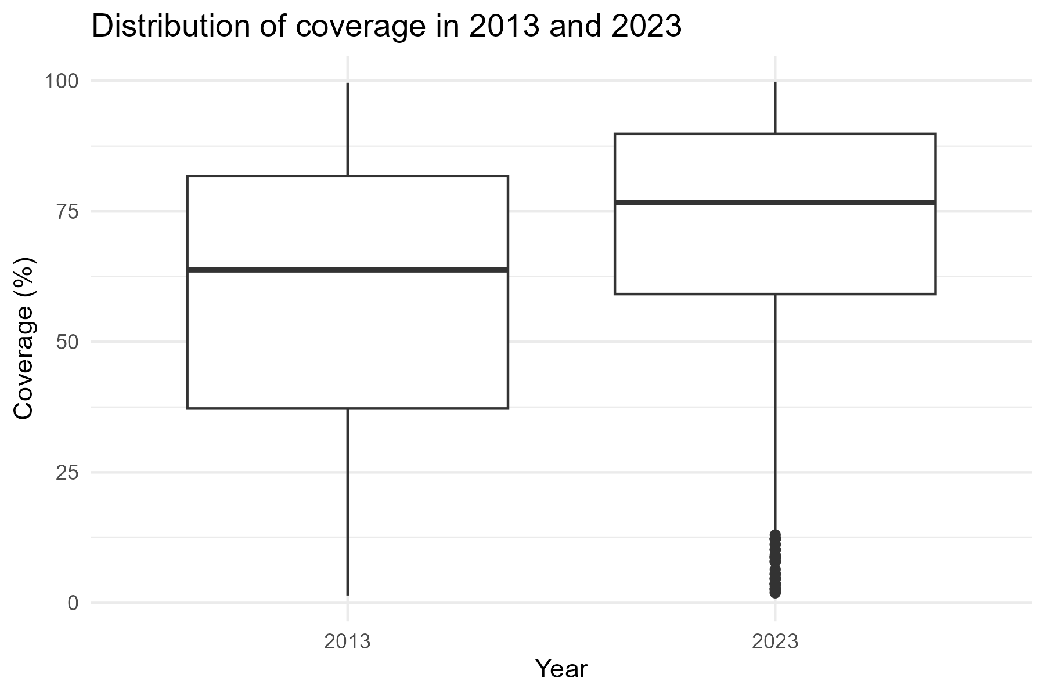

Figure 1: Distribution of coverage in 2013 and 2023.

The regional trend in change, as shown in Figure 2, Changes in coverage (2023 -2013) by region, shows that South Asia, the Regional Office for South Asia and Eastern and Southern Africa, experienced the most significant changes in mean coverage. In contrast, Western Europe and industrialised regions experienced minimal changes. This heterogeneity aligns with analyses indicating greater improvement in RMNCH indicators in countries with lower initial coverage and in those with significant investments in the health system (Lee et al., 2024; Melesse et al., 2024). This study is novel in its use of explicit comparisons of regional change within a single framework, with common UNICEF aggregates used to identify dynamic catch-up developmental patterns rather than a static list of gaps. The sharp increases in historically low-performing areas indicate that the SDG 3.1 and 3.2 targets can be achieved once coverage rates and the number of interventions in the health system are increased, and the improving numbers in the industrialised regions demonstrate that the agenda of quality and content of care has become a priority.
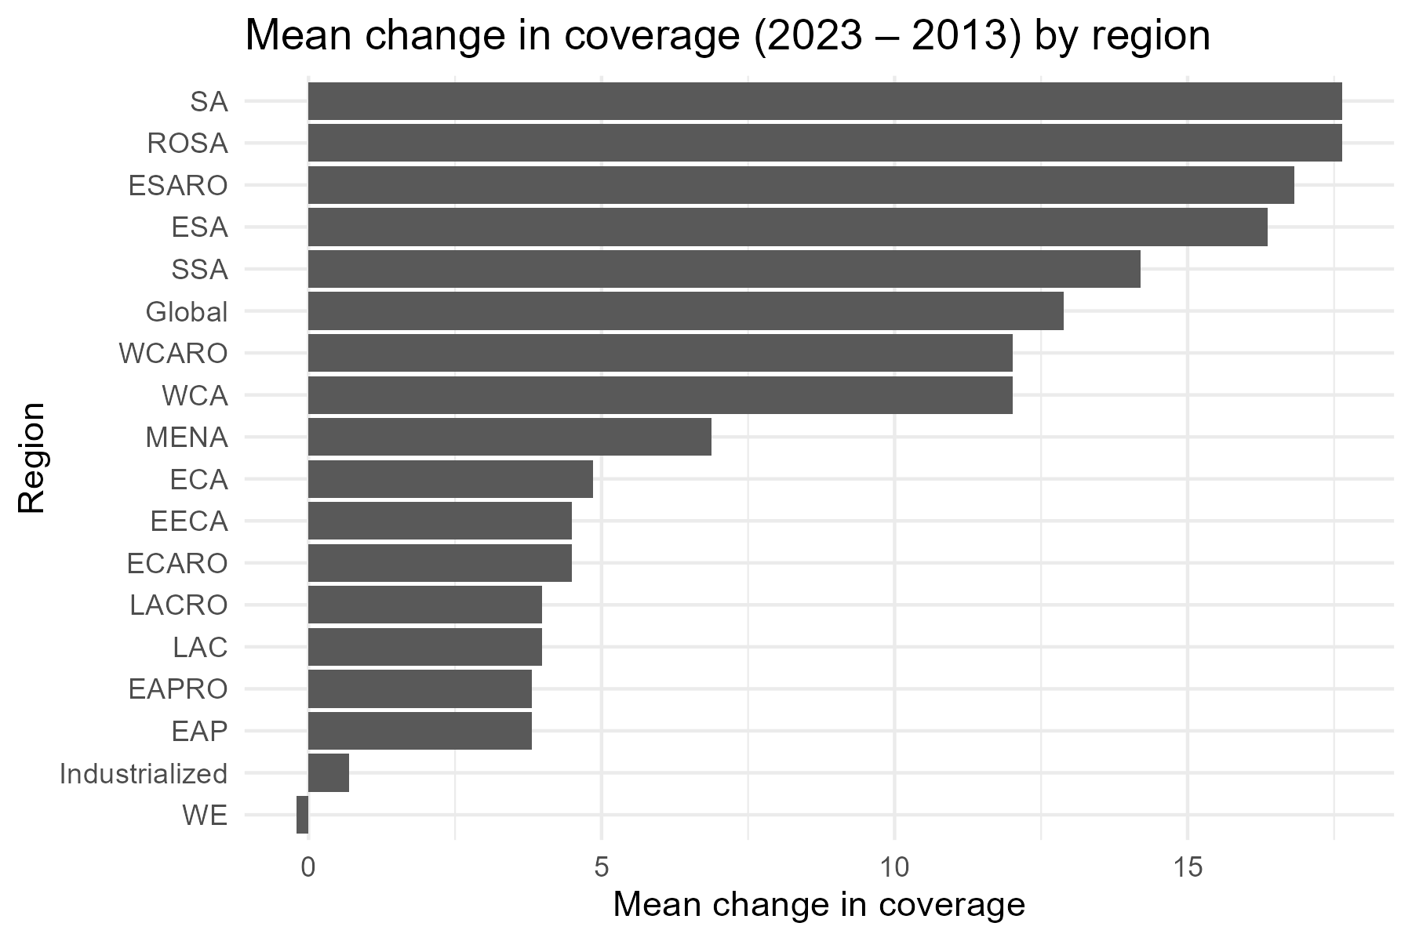

Figure 2: Mean change in coverage (2023 - 2013) by region.

Table 1: Mean coverage by stratifier and level.
Stratifier | Level | n | Mean coverage, 2013 | Mean coverage, 2023 | Mean change
Age | 15-19 | 116 | 58.83 | 69.04 | 10.21
Area | Rural | 119 | 55.17 | 67.90 | 12.73
Area | Urban | 105 | 72.81 | 80.17 | 7.36
National | National | 130 | 61.88 | 71.63 | 9.76
WIQ | Fourth | 98 | 63.06 | 75.02 | 11.96
WIQ | Middle | 98 | 56.23 | 69.94 | 13.71
WIQ | Poorest | 98 | 42.22 | 56.72 | 14.50
WIQ | Richest | 98 | 71.52 | 81.41 | 9.89
WIQ | Second | 98 | 49.64 | 64.54 | 14.90

A further breakout of the equity-related change is supplied in Table 1, “Mean coverage by stratifier and level, and indicates that each group of stratifiers reported positive change between 2013 and 2023, with the highest absolute changes taking place in the poorest and second wealth quintiles. The rural areas had an increase of 12.73 percentage points over 7.36 percentage points in the urban area, and the adolescents between the ages of 15-19 years had a percentage increase of more than 10 percentage points with a very low base. These findings contrast with previous studies, which frequently find persistent or growing pro-rich and urban biases in ANC utilisation (Mahamud Tohan et al., 2024; Aboagye et al., 2025; Biswas et al., 2024). The trend in Table 1 shows that a new pro-poor acceleration is about to unfold across multiple layers, which could mean that health systems and social policies can begin delivering to a disproportionately marginalised group. This discovery has direct implications for SDG 10 on reducing inequality and SDG 3.8 on universal health coverage. It helps to argue in favour of further investment into outreach, policies on community health workers and financial protection, which maintain gains among the poorest and ensure that high rates of cover are maintained among the richest quintile.
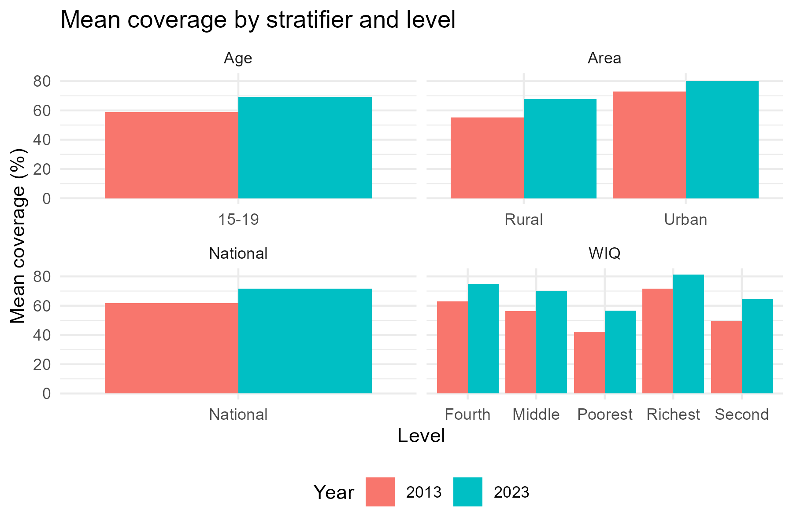

Figure 3: Mean coverage by stratifier and level in 2013 and 2023.

The visualisation of trends summarised in Table 1 in Figure 3, Stratifier and Level makes the pro-poor acceleration more intuitive. In rural and urban regions and between the five wealth quintiles, 2023 bars are always greater than the 2013 bars, but the relative difference will be maximal between the poorest and second quintiles. The figure also demonstrates that national averages conceal dissimilar gains within and between stratifiers. The continuum-of-care studies that have been conducted previously often depict the gaps at 1 point in time or apply odds ratios to compare groups (Ghosal et al., 2025; Ahmed et al., 2024; Lateef et al., 2024). This study makes a contribution in that it demonstrates the absolute percentage-point improvement by subgroup in ten years and indicates the areas of convergence. To policy-makers aiming to eliminate equity gaps, the number implies that implementing universal ANC quality enhancement alongside targeted pro-poor interventions can produce simultaneous upward increases in coverage as well as reduction of wealth and residence differentials.

Table 2: Frequency of indicators in the dataset.
Indicator | Frequency
SAB | 179
ANC4 | 178
PNCMOM | 134
ANC1 | 129
INSTDEL | 129
CSEC | 103
PNCNB | 88
BIRTH18 | 20

The composition of indicators used to reflect the continuum of RMNCH in the UNICEF aggregates reflected in Table 2, Frequency of indicators in the dataset, is indicative of the breadth of the continuum. The most significant number of observations is made when attendance at birth and ANC4 are used, followed by postnatal contacts with mothers and newborns, and delivery in institutions. The focus on integrated packages, rather than stand-alone ANC visits, is reflected in this structure in current maternal and newborn health policies (Anyanwu et al., 2024; Hermans et al., 2025; Pandey et al., 2025). The innovation of this work is the combined examination of various continuum indicators as a single multivariate outcome space of change, unlike most studies, which separate a single outcome like ANC4 or facility delivery. To monitor SDGs this multidimensionality is important as it is not only ANC contact but successful coverage of skilled birth attendance and early postnatal care that determines progress towards SDG 3.1 and 3.2, and the structure of the dataset in Table 2 will be a platform upon which future extensions of the modelling framework to other dimensions of the continuum can be added.
Figure 4, Hotspot map of mean change in coverage by region and wealth quintile, provides a new synthesis of the visual representation of equity and geography by displaying the mean coverage change as a heat map of regions and wealth quintiles. Hotspots of the poorest and middle quintiles are intense in regions like South Asia and the lower-middle-income groupings, which are indicative of rapid improvements in pro-poor areas, whilst high-income and some middle-income areas are lighter in colour, indicating slower improvement, particularly in the richest deciles. This representation goes beyond conventional concentration-index or slope-index methods by plotting change rather than stagnant inequality, and it also uses the joint dimension of region and wealth. The policy implication is that global and regional stakeholders will be able to quickly see the focus of pro-poor dynamics at any given point, and where cold spots among the poorest are located and require greater intensity. This type of information directly helps achieve the SDG 3.1, SDG 3.8, and SDG 10 targets, as it is used to focus geographically and socio-economically specific investments.
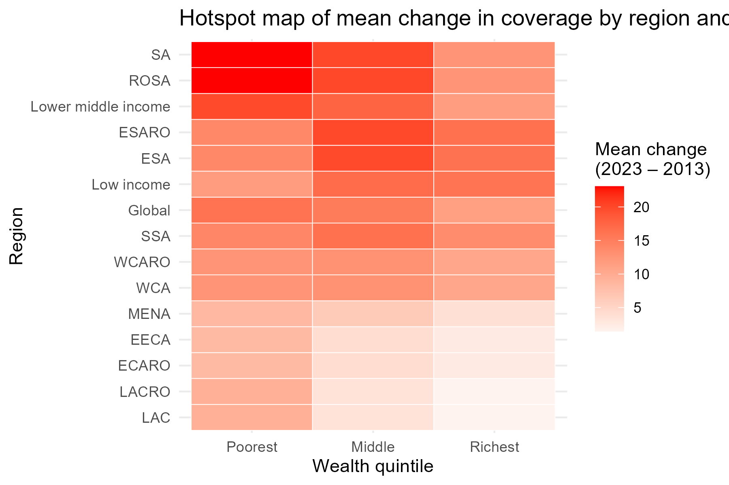

Figure 4: Hotspot map of mean change in coverage by region and wealth quintile

Table 3: Regression coefficients for moderation model.
Predictor | b | SE | t | p | CI lower | CI upper
(Intercept) | 16.626 | 2.505 | 6.638 | 0.000 | 11.700 | 21.553
x2013 | -0.067 | 0.049 | -1.375 | 0.170 | -0.163 | 0.029
wealth_index | 2.494 | 0.826 | 3.020 | 0.003 | 0.870 | 4.118
x2013:wealth_index | -0.039 | 0.013 | -2.928 | 0.004 | -0.066 | -0.013
Table 3, the regression coefficients of the moderation model, and the interaction plot in Figure 5, Moderation of the effect of baseline coverage by wealth quintile, are the results of the moderation, which offer a new understanding of how the effect of baseline coverage and wealth interact to create further change. The change is positively related to wealth index and baseline coverage, and wealth interaction is negative and significant. The plot of interaction reveals that at low baseline coverage, the richest quintile has the steepest predicted gains. At high baseline coverage, the richest quintile's predicted gains decrease more steeply than those of the poorest quintile. Such terms of interaction are rarely examined in previous ANC and continuum-of-care studies, which often assume additional effects of wealth and baseline coverage (Tegegne et al., 2024; Biswas et al., 2024). According to the current moderation model, there will be a convergence dynamic in which better-off groups will migrate earlier when coverage is low, but marginal gains for them will decline as coverage saturates, allowing other poorer groups to gain more. In policy, this implies that the initial stages of scale-up might need to include explicit pro-poor measures to keep disparities constant. However, later stages should focus on expanding and improving the quality and coverage for the poorest as the non-poorest start to level off. This observation aligns with SDG 3 and SDG 10, as it emphasises acceleration and equity in coverage patterns.
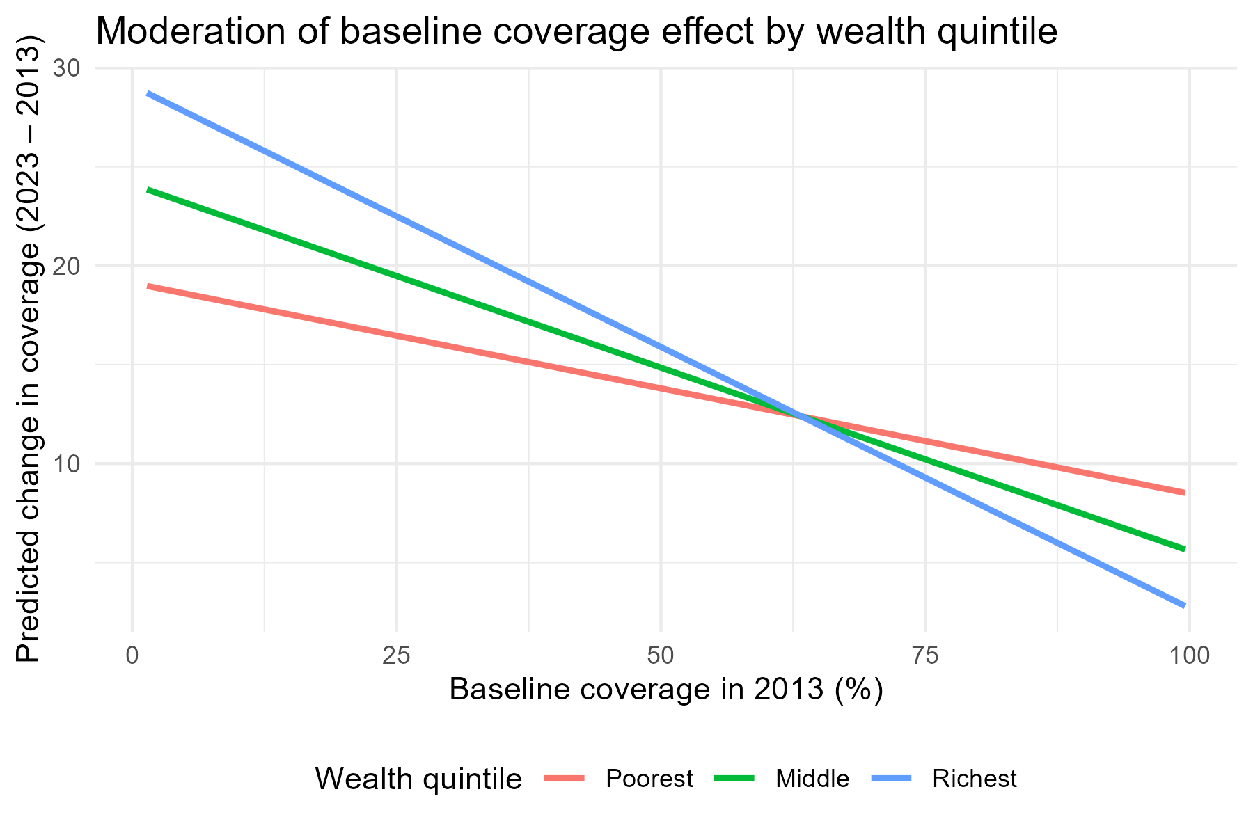

Figure 5: Predicted change in coverage by baseline coverage across selected wealth quintiles.

Table 4: Standardised path coefficients and effects for the mediation model.
Outcome |  | Predictor | Estimate | SE | z | p | Std. estimate
wealth_index |  | x2013 | 0.026 | 0.003 | 9.212 | 0.000 | 0.439
change |  | x2013 | -0.193 | 0.033 | -5.876 | 0.000 | -0.457
change |  | wealth_index | 0.357 | 0.491 | 0.726 | 0.468 | 0.050
ind_effect |  | a*b | 0.009 | 0.013 | 0.719 | 0.472 | 0.022
total_effect |  | c_prime+(a*) | -0.184 | 0.025 | -7.397 | 0.000 | -0.435

The mediation findings are summarised in Table 4, “Standardised path coefficients and effects of the mediation model and represented by Figure 6, “Illustrative mediation pattern across deciles of baseline coverage agrees on the causal front. Wealth index is closely related to baseline coverage, both of which have significant residual variance, but the indirect impact of baseline coverage on change is small and not significant, whereas the direct impact of baseline coverage on change is large and negative. It means that wealth is not a significant mediator between the initial service environments and subsequent gains, as is the case in the UNICEF aggregates, some country-specific analyses indicate that wealth is a great predictor of differences in continuum completion (Kebede et al., 2024; Ahmed et al., 2024). This interpretation is supported by the empirical trend in Figure 6, in which the mean change is largest at the middle of the range of baseline coverage and only increases with the increase of the wealth index at the baseline. The novelty in this regard is that a formal mediation framework is applied to the change in global ANC coverage, which shows that the differences in structural position of health system starting points, as opposed to the change in wealth composition, are the primary driver of subsequent gains. This result indicates that facility readiness policies, outlined in recent facility readiness assessments (Alemu et al., 2025; Offosse et al., 2025), could be more decisive to hasten ANC gains than short-term shifts in the socio-economic structure, though both are significant to SDG development.
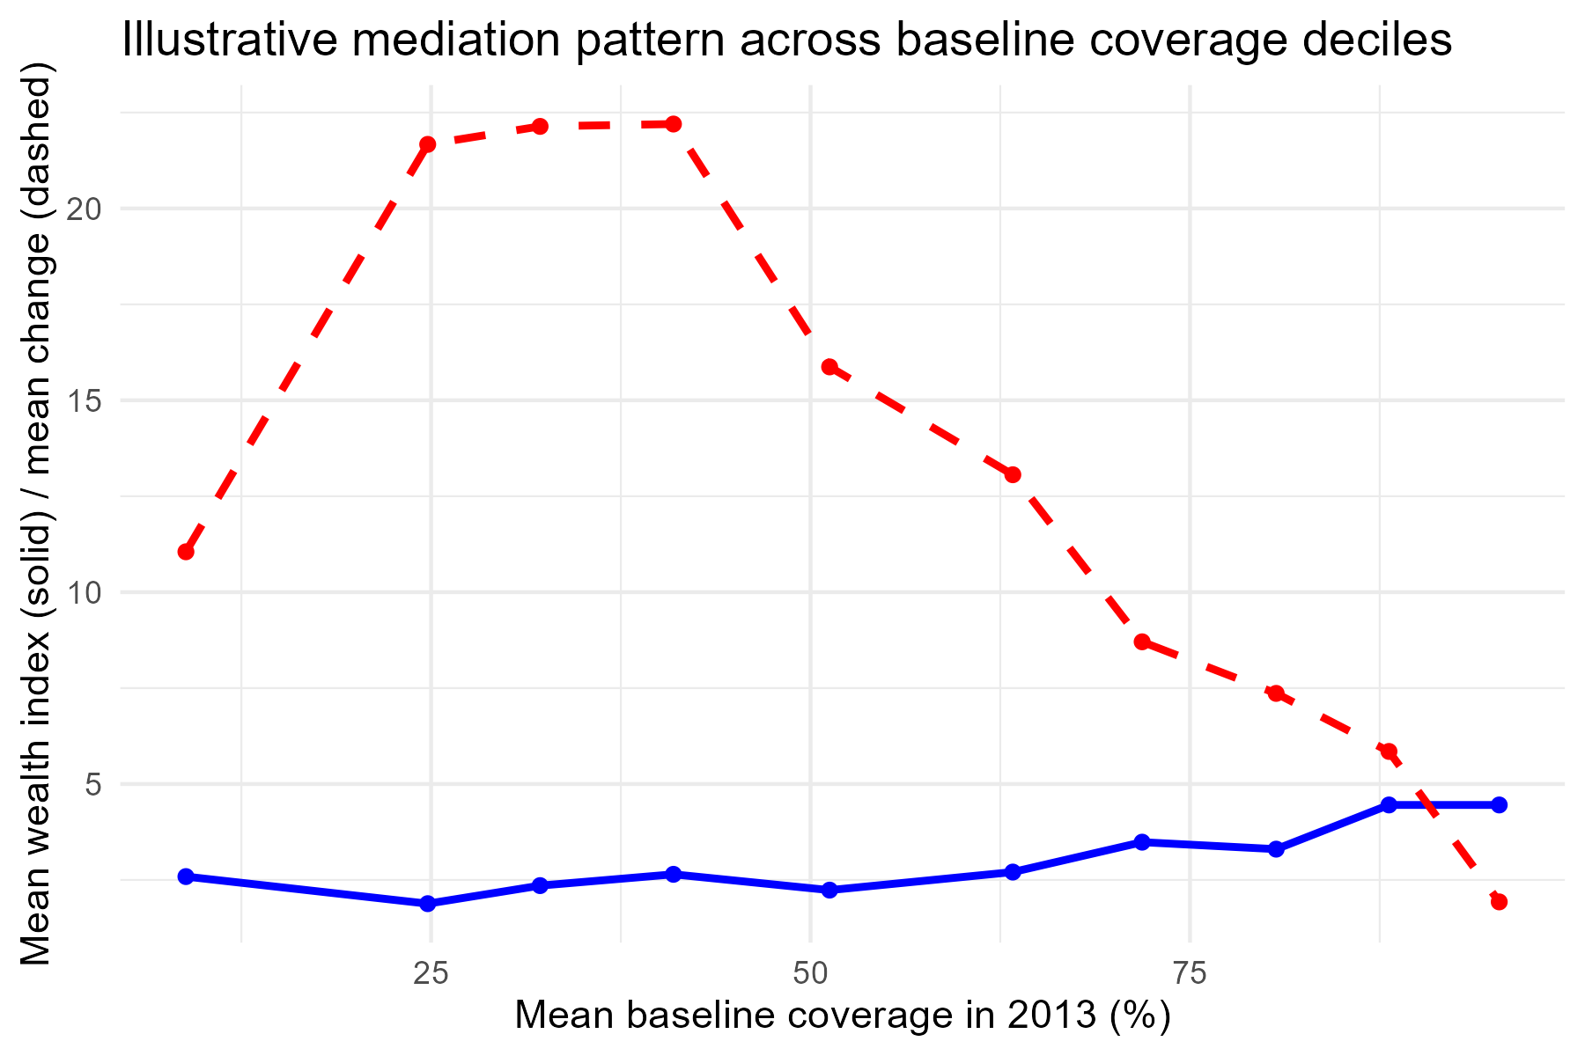

Figure 6: Illustrative pattern of wealth index and coverage change across baseline coverage deciles.

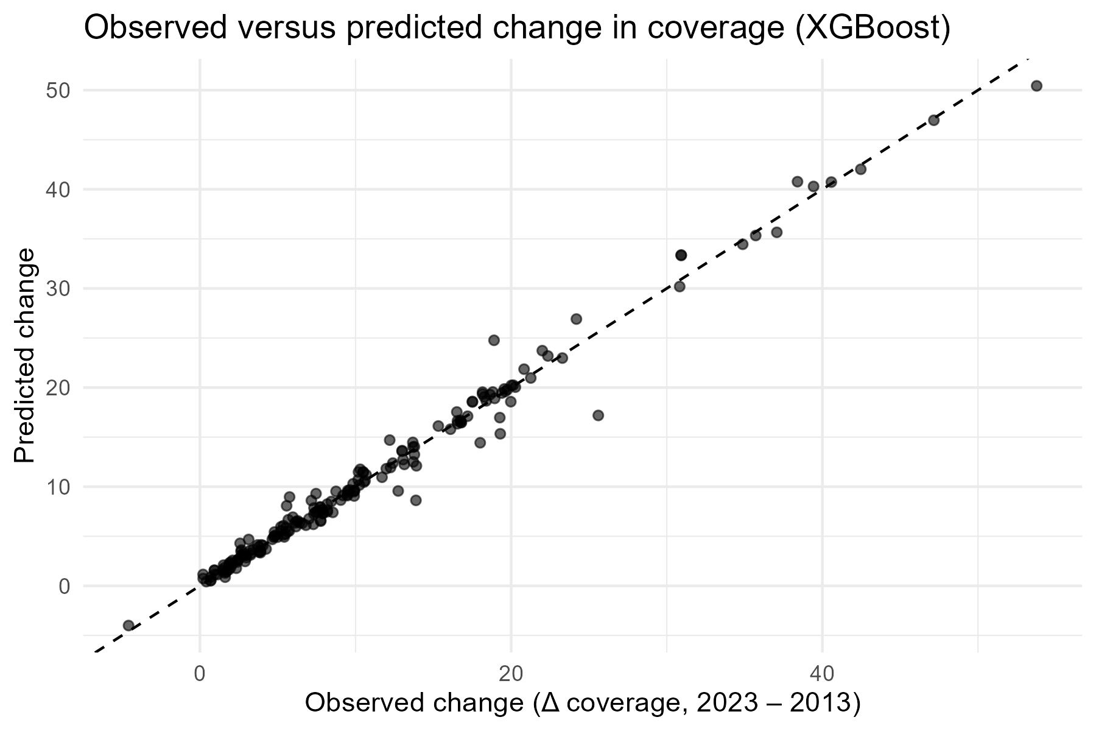

Figure 7: Observed versus predicted change in ANC coverage for the XGBoost model.

As shown in Table 5, Predictive performance of machine learning models on test data, and in the corresponding scatter plot in Figure 7, Observed versus predicted change in coverage (XGBoost), the feasibility and value addition offered by advanced predictive analytics in monitoring ANC coverage is possible. XGBoost has the lowest possible prediction error and over 98 per cent variance in coverage change, which is better than LightGBM, MARS, random forest, gradient boosting and elastic net regression. The fact that the values in Figure 7 are very close to the predicted value demonstrates that tree-based ensemble models have captured complex nonlinear relationships among baseline coverage, region, stratifiers, and indicator type. Although machine learning has been used more frequently to predict individual-level maternal and neonatal outcomes, its application to predict alterations in population-level coverage indicators is not common. The current analysis indicates that these models can be trained using regularly updated UNICEF aggregate data to make high-fidelity predictions of what regions and equity groups are likely to achieve gains or stagnate in the future. This can predict potential resource allocation, support scenario planning, and provide early warning on shortfalls in SDG 3 and SDG 10, particularly when combined with interpretable tools, such as SHAP values, to identify the most significant predictors.

Table 5: Predictive performance of machine learning models on test data.
Model | RMSE | MAE | R²
XGBoost | 1.258 | 0.709 | 0.983
LightGBM | 1.680 | 0.987 | 0.969
MARS | 2.590 | 1.950 | 0.927
Random forest | 3.285 | 2.358 | 0.883
Gradient boosting (GBM) | 3.373 | 2.242 | 0.877
Elastic net (glmnet) | 4.361 | 3.221 | 0.794

All in all, the synthesised explanation of Tables 1 to 5 and Figures 1 to 7 highlights the originality of using equity-based descriptive statistics, theoretical frameworks for moderation and mediation, hotspot mapping, and state-of-the-art machine learning within one global ANC monitoring platform. The findings indicate positive pro-poor speed-up in coverage, region-dependent convergence, and the preeminence of initial service set-ups in conditioning subsequent gains, as well as that sophisticated forecasting models may both aggregate and forecast intricate dynamics in ANC coverage. These lessons can offer practical advice to international and national actors who strive to improve the processes for achieving SDG 3 on maternal and neonatal health, SDG 3.8 on universal health coverage, and SDG 10 on reducing inequalities. These lessons can also help open the door to the routine adoption of causal and predictive analytics within the global RMNCH monitoring framework.
Moreover, the findings present a vivid and logical depiction of the development of antenatal care coverage worldwide during 2013-2023, highlighting both the positive changes and the current inequities at the socio-economic and regional levels. The coverage levels increased across almost all stratifiers, and the change was evident in the distribution's overall shape. As the Figure 1 boxplot comparison revealed, the 2023 distribution shifted higher across the entire range, with higher medians and a more compressed upper tail, reflecting that most regions have been progressing toward universal ANC access. The improvement was over 10 percentage points across several population groups, signalling that progress was important.
The pro-poor changes showed high summary values, as indicated in Table 1. Coverage grew to 67.90 per cent in rural areas, up from 55.17 per cent, and the coverage of the lowest quintile of the population rose by 14.50 percentage points. The most significant increase of almost 15 percentage points was observed in the second quintile, indicating that nations with high levels of inequality may be at a stage of convergence where underserved populations are starting to catch up. Although these gains happened, the urban and richest quintiles remained at the highest absolute coverage levels, which supports the fact that improvement does not mean parity.
Figure 2 shows significant variation in improvement across regional patterns. The largest mean increases were documented in South Asia and the Regional Office of South Asia (ROSA), and in Eastern and Southern Africa, respectively. Conversely, the increases were marginal in the industrialised regions and Western Europe, which is consistent with saturation at high baseline levels. The results are consistent with the existing literature on high development rates in specific low- and middle-income contexts resulting from increased health financing, community outreach, and policy changes aimed at universal coverage.
The equity dimensions were also noted in disaggregated comparisons depicted in Figure 3. The overall expansion of bars between 2013 and 2023 shows increases across age cohorts, living status, and income levels, but indicates persistent structural differences in baseline levels. Inequalities in wealth were still evident, but the extent of change seemed greater among poorer populations, corroborating new findings of pro-poor growth as national coverage reaches important preparedness levels.
A more proximate view was formed using the hotspot heatmap in Figure 4, which showed changes in mean by region and wealth quintile. There were notable hotspots of the poorest quintile in South Asia and in ROSA, and numerous regions in Africa that improved strongly in the middle quintile. These trends support the policy significance of defining the areas where equity gradients are narrowing and where focused intervention is still needed.
The moderation analysis provided significant insights into how wealth influences ANC development. The relationship between baseline coverage and wealth index reported in Table 3 was negative and significant. This means that, with low base rates, the richer groups obtain more, but the rate of gain is slower as base rates increase. This crossover trend is explained by the predicted lines in Figure 5. This result indicates a convergence dynamic throughout the wealth distribution, such that, as national service coverage increases, the improvements become more homogeneous.
Mediation analysis, by contrast, revealed that wealth is not a significant mediator of the relationship between baseline coverage and subsequent change. The low, statistically non-significant indirect effect in Table 4 confirms that wealth does not mediate the impact of baseline levels on the direction of change. Instead, wealth is a modifying culture, which shapes the gradient of change but does not alter its direction. This pattern can also be illustrated by a pattern displayed in Figure 6, which reveals differences in wealth with no transparent mediating gradient between deciles at the base.
The machine learning models offered a predictive outlook for progress in ANC. XGBoost has emerged as the most successful algorithm, with an R2 of 0.983 and the lowest RMSE in Table 5. Figure 7 shows that the scatter plot is centred around the 45-degree reference line, indicating that the model successfully captures the non-linear, multi-dimensional nature of ANC change. LightGBM and MARS also performed well, whereas random forests and elastic nets performed worse. The predictive rankings show that modern boosting algorithms can efficiently learn change dynamics using aggregated equity-stratified indicators, opening opportunities to predict progress and likely future hotspots.
On the whole, the results indicate that there is a general advancement in the world, pro-poor gains continue to increase in most areas, and there remain absolute inequalities and significant opportunities for using improved analytic tools to facilitate policy targeting.
Conclusion
The paper relied on an exceptionally designed UNICEF global aggregate database that measures change in antenatal care coverage across socio-economic and regional stratifiers over 10 years. The findings indicate an upward trend in ANC coverage from 2013-2023, with suggestive indicators of convergence, with poorer and rural populations making significant gains relative to richer and urban groups. However, there are still significant gaps in the absolute levels of services, which proves the necessity of specific investments to fulfil SDG 3.
The analysis also revealed a significant dynamic relationship. Wealth played a crucial role in moderating the effects of baseline coverage on later gains: richer groups received higher gains under low baseline conditions than under high baseline conditions. This demonstrates a transitory trend: inequalities can decrease as systems mature. The mediation analysis showed that wealth does not mediate between the baseline and the change. Thus, policy interventions should target structural inequalities directly rather than assume that coverage gains will trickle down the socio-economic ladder. The machine learning aspect demonstrated that more sophisticated boosting strategies yield high-quality tools for forecasting regional and equity-specific changes in ANC coverage. These approaches may be used to supplement causal models by enabling early identification of areas where evidence-based health resource allocation can be made, as well as where progress is stagnant or can be accelerated.
Collectively, this study makes a contribution to the research by uniting equity-conscious statistical modelling, causal theories, and predictive analytics in a single global study. The results highlight that global progress is an actual and substantial phenomenon, but the SDG targets will not be achieved without a long-term focus on sub-national and socio-economic inequalities. Enhancing health system preparedness, increasing outreach to the poor and rural populations, and predictive intelligence to inform investment will be critical to achieving universal and equitable ANC access. To enhance the equity monitoring process, governments are also encouraged to adopt a stronger approach by regularly introducing baseline-wealth interaction indicators into ANC performance indicators to inform resource allocation for SDG 3 indicators.

Data Availability
The data used to develop this study is freely available through the UNICEF Data Portal. The processed data and codes to be analyzed are stored in an open repository and can be provided on demand.
Ethical Approval
No ethical approval was needed since the study will be based on publicly available aggregated data and will not involve the use of human subjects.
The authors confirm that they do not have any recognized competing financial interests or personal relations that might have manifested themselves to affect the work presented in this paper.
Consent for Publication
The publication of this manuscript was fully agreed upon by all the authors.

COMPETING INTERESTS DISCLAIMER:

Authors have declared that they have no known competing financial interests OR non-financial interests OR personal relationships that could have appeared to influence the work reported in this paper.

References:
Aboagye, R. G., Okyere, J., Ackah, J. A., Ameyaw, E. K., Seidu, A. A., & Ahinkorah, B. O. (2024). Trends and inequalities in antenatal care coverage in Benin (2006–2017): an application of World Health Organization’s Health Equity Assessment Toolkit. BMC Health Services Research, 24(1), 1026. https://doi.org/10.1186/s12913-024-11261-z
Aboagye, R. G., Osborne, A., Anyasodor, A. E., Yikindi, S. V., Adnani, Q. E. S., & Ahinkorah, B. O. (2025). Utilisation of eight or more antenatal care visits and its associated socio-economic-related inequalities in sub-Saharan Africa: A decomposition analysis. Plos one, 20(3), e0312412. https://doi.org/10.1371/journal.pone.0312412
Agegnehu, A. W., & Arero, B. G. (2025). Alpha Power Transformed Beta Regression with Application on Antenatal Care Visit Proportions Among Ethiopian Women. Journal of Statistical Theory and Applications, 1-59.
Ahmed, R., Gebre, S., Demelash, M., Belachew, T., Mohammed, A., Musema, A., & Sultan, M. (2024). The continuum of care for maternal health in Africa: A systematic review and meta-analysis. Plos one. https://doi.org/10.1371/journal.pone.0305780
Alemu, A. A., Welsh, A., Getachew, T., & Khajehei, M. (2025). Assessment of healthcare facilities’ readiness to provide antenatal care in Ethiopia: facility based study using service provision assessment data. Archives of Public Health, 83(1), 14. https://doi.org/10.1186/s13690-024-01464-5
Anyanwu, E. C., Maduka, C. P., Ayo-Farai, O., Okongwu, C. C., & Daraojimba, A. I. (2024). Maternal and child health policy: A global review of current practices and future directions. World Journal of Advanced Research and Reviews, 21(2), 1770-1781.
Biswas, B., Kumar, N., Rahaman, M. M., Das, S., & Hoque, M. A. (2024). Socioeconomic inequality and urban-rural disparity of antenatal care visits in Bangladesh: A trend and decomposition analysis. Plos one, 19(3), e0301106. https://doi.org/10.1371/journal.pone.0301106
Ghosal, J., Nanda, A., Behera, P., Som, M., Bal, M., Ranjit, M., Kanungo, S., Kadam, S. M., Pati, S., & Dutta, A. (2025). Coverage of continuum of Maternal, Newborn and Child Health (MNCH) care in a nationally representative sample of 40,687 mother–child dyads of India: a report from NFHS-5. BMC Public Health, 25(1), 2727. https://doi.org/10.1186/s12889-025-23697-x
Habte, A., Tamene, A., & Melis, T. (2024). Compliance towards WHO recommendations on antenatal care for a positive pregnancy experience: Timeliness and adequacy of antenatal care visit in Sub-Saharan African countries: Evidence from the most recent standard Demographic Health Survey data. Plos one, 19(1), e0294981. https://doi.org/10.1371/journal.pone.0294981
Hailemariam, T., Atnafu, A., Gezie, L. D., & Tilahun, B. (2024). Effect of short message service reminders in improving optimal antenatal care, skilled birth attendance and postnatal care in low-and middle-income countries: a systematic review and meta-analysis. BMC Medical Informatics and Decision Making, 25(1), 1. https://doi.org/10.1186/s12911-024-02836-1
Hermans, A. C. M., Boertien, S., van den Berg, L. M. M., de Jonge, A., Janssen, D. E. M. C., Franx, A., van der Kooy, J., & de Kroon, M. L. A. (2025). Parent’s Perspective on Continuity of Care in the Maternity Care and Child Health Services Continuum: A Qualitative Systematic Review. International Journal of Integrated Care, 25(1), 4. https://doi.org/10.5334/ijic.8645
Hone, T., Gonçalves, J., Seferidi, P., Moreno-Serra, R., Rocha, R., Gupta, I., Bhardwaj, V., Hidayat, T., Cai, C., Suhrcke, M., & Millett, C. (2024). Progress towards universal health coverage and inequalities in infant mortality: An analysis of 4·1 million births from 60 low-income and middle-income countries between 2000 and 2019. The Lancet Global Health, 12(5), e744-e755. https://doi.org/10.1016/S2214-109X(24)00040-8
Kebede, A. S., Wana, G. W., Tirore, L. L., & Boltena, M. T. (2024). Determinants of dropout from the maternal continuum of care in Ethiopia, multilevel analysis of the 2016 demographic and health survey. PLOS Global Public Health, 4(9), e0003641. https://doi.org/10.1371/journal.pgph.0003641
Lateef, M. A., Kuupiel, D., Mchunu, G. G., & Pillay, J. D. (2024). Utilization of antenatal care and skilled birth delivery services in Sub-Saharan Africa: A systematic scoping review. International Journal of Environmental Research and Public Health, 21(4), 440. https://doi.org/10.3390/ijerph21040440
Lee, Y., Bolongaita, S., Sato, R., Bump, J. B., & Verguet, S. (2024). Evolution in key indicators of maternal and child health across the wealth gradient in 41 sub-Saharan African countries, 1986–2019. BMC medicine, 22(1), 21. https://doi.org/10.1186/s12916-023-03183-0
Mahamud Tohan, M., Islam, M. A., & Rahman, M. A. (2024). Exploring the factors behind socioeconomic inequalities in Antenatal Care (ANC) utilization across five South Asian natiaons: A decomposition approach. PLoS One, 19(8), e0304648. https://doi.org/10.1371/journal.pone.0304648
Marthias, T., Anindya, K., Saputri, N. S., Putri, L. P., Atun, R., & Lee, J. T. (2025). Effective coverage for reproductive, maternal, neonatal and newborn health: An analysis of geographical and socioeconomic inequalities in 39 low- and middle-income countries. BMJ Global Health, 10(2). https://doi.org/10.1136/bmjgh-2024-016549
Mekonnen, Y., Wolde, E., Hagos, T., Yared, K., Bekele, A., Mehari, Z., & Girma, S. (2025). Improved antenatal care services in rural Ethiopia’s public health centers through the Enhancing Nutrition and Antenatal Infection Treatment (ENAT) intervention. BMC Health Services Research, 25(1), 662. https://doi.org/10.1186/s12913-025-12789-4
Melesse, D. Y., Tadele, A., Mulu, S., Spicer, N., Tadelle, T., Wado, Y. D., Gajaa, M., Arja, A., Blumenberg, C., Manaye, T., Gonfa, G., du Plessis, E., Hamilton, E., Mihretu, A., Usamael, A., Mengesha, M., Gelaw, S. K., Worku, A., Woldie, M., Abate, B., Getachew, T., Wondirad, N., Zelalem, M., Tollera, G., & Boerma, T. (2024). Learning from Ethiopia’s success in reducing maternal and neonatal mortality through a health systems lens. BMJ Global Health, 9(Suppl 2). https://doi.org/10.1136/bmjgh-2023-011911
Mengesha, M. B., Chekole, T. T., Abraha, H. E., Tsegay, E. W., Atsbaha, A. H., Gebreslassie, M., & Gufue, Z. H. (2025). Feasibility, acceptability, and effectiveness of group antenatal care on the continuum of care and perinatal outcomes in Sub-Saharan Africa: A systematic review and meta-analysis protocol. PloS one, 20(4), e0311473. https://doi.org/10.1371/journal.pone.0311473
Offosse, M. J., Cissé, K., Somda, D., Gage, A., Haakenstad, A., & Banke-Thomas, A. (2025). Availability and readiness of health facilities in Burkina Faso to provide antenatal care: trend analysis from 2012 to 2020. Reproductive health, 22(1), 133. https://doi.org/10.1186/s12978-025-02072-4
Orimadegun, A. E., Jegede, A. S., Gaffey, M. F., Olufadewa, I., Confreda, E., Somaskandan, A., Islam, M., Keats, E. C., Ataullahjan, A., Amzat, J., Okonta, P. I., Ezeome, I. V., Farouk, Z., Hamza, A., Adepoju, O. T., Lawanson, A. O., Osungbade, K. O., Akinyemi, J. O., Grange, A., & Bhutta, Z. A. (2025). A mixed-methods study of the drivers of stunting reduction among children under five in Nigeria, 2008–2018. The American Journal of Clinical Nutrition, 121, S86-S94. https://doi.org/10.1016/j.ajcnut.2025.02.022
Oyugi, B., Audi-Poquillon, Z., Kendall, S., & Peckham, S. (2024). Examining the quality of care across the continuum of maternal care (antenatal, perinatal and postnatal care) under the expanded free maternity policy (Linda Mama Policy) in Kenya: a mixed-methods study. BMJ open, 14(5), e082011. https://doi.org/10.1136/bmjopen-2023-082011
Pandey, A. R., Adhikari, B., Sangroula, R. K., Sapkota, P. M., Regmi, S., Sharma, S., Dulal, B., Lamichhane, B., Kc, S. P., Dhakal, P., & Baral, S. C. (2025). Continuum of care for maternal and newborn health services in Nepal: An analysis from demographic and health survey 2022. *PloS one*, *20*(3), e0319033. https://doi.org/10.1371/journal.pone.0319033
Patil, C. L., Norr, K. F., Kapito, E., Liu, L. C., Mei, X., Chodzaza, E., Chorwe-Sungani, G., Kafulafula, U., Abrams, E. T., Desloge, A., Gresh, A., Jeremiah, R. D., Patel, D. R., Batchelder, A., Wang, H., Faydenko, J., Rising, S. S., & Chirwa, E. (2025). Group antenatal care positively transforms the care experience: Results of an effectiveness trial in Malawi. PLoS One, 20(6), e0317171. https://doi.org/10.1371/journal.pone.0317171
Phillips, E., Zobrist, S., Milner, E. M., Kung'u, J. K., Heidkamp, R. A., & Benedict, R. K. (2025). Nutrition Intervention Coverage and Inequities Along the Continuum of Care: Results From the Eighth Demographic and Health Survey in Six Sub‐Saharan African Countries. Maternal & Child Nutrition, e70085. https://doi.org/10.1111/mcn.70085
Roberts, J. M., Abimbola, S., Bale, T. L., Barros, A. J. D., Bhutta, Z. A., Browne, J. L., Celi, A. C., Dube, P., Graves, C. R., Hollestelle, M. J., Hopkins, S., Khashan, A. S., Koi-Larbi, K., Lackritz, E., Myatt, L., Redman, C. W. G., Tunçalp, Ö., Vermund, S. H., & Gravett, M. G. (2024). Global inequities in adverse pregnancy outcomes: what can we do?. AJOG Global Reports, 4(3), 100385. https://doi.org/10.1016/j.xagr.2024.100385
Rodriguez-Lopez, M., Jaramillo, D. B., Prada, S., Merlo, J., & Leckie, G. (2025). Social and geographical inequalities in prenatal care coverage in Colombia: a multilevel analysis of individual heterogeneity and discriminatory accuracy (MAIHDA). BMJ Global Health, 10(8). https://doi.org/10.1136/bmjgh-2025-019608
Tegegne, A. M., Habitu, Y. A., Ferede, Y. A., & Fentie, E. A. (2024). Completion of maternal and child health continuum of care and associated factors in West Gondar Zone, North West Ethiopia, 2023: a community based cross sectional study. BMC Pregnancy and Childbirth, 24(1), 734. https://doi.org/10.1186/s12884-024-06949-3.
Tegegne, B. A., Alem, A. Z., Amare, T., Aragaw, F. M., & Teklu, R. E. (2024). Multilevel modelling of factors associated with eight or more antenatal care contacts in low and middle-income countries: findings from national representative data. Annals of Medicine and Surgery, 86(6), 3315-3324. https://doi.org/10.1097/MS9.0000000000002034
Tohan, M. M., Islam, M. A., & Rahman, M. A. (2024). Exploring the factors behind socioeconomic inequalities in Antenatal Care (ANC) utilization across five South Asian nations: A decomposition approach. PLoS One, 19(8), e0304648. https://doi.org/10.1371/journal.pone.0304648
Wang, J., Wang, J., Guan, Y., Liang, J., Tang, D., Yin, T., & Diao, L. (2025). Trends and regional disparities in maternal hypertensive disorders among women of childbearing age: a global burden of disease analysis from 1990 to 2021. BMC Pregnancy and Childbirth, 25(1), 812. https://doi.org/10.1186/s12884-025-07926-0
Yallew, W. W., Fasil, R., Berhanu, D., Wolde, K., Teshite, D., Sethi, R., Yenokyan, G., Woldemariam, Y., Suhowatsky, S., Hyre, A., Noguchi, L., & Worku, A. (2025). Evaluation of the feasibility, acceptability, and impact of Group Antenatal Care at the health post level on continuation in antenatal care and facility based delivery in Ethiopia using a cluster randomized stepped-wedge design: Study protocol. Gates Open Research. https://doi.org/10.12688/gatesopenres.15190.3

