Privacy-Preserving Machine Learning Algorithms – A Survey

ABSTRACT
This survey reviews research on privacy-preserving mechanisms for machine learning (ML) algorithms. As ML technologies become more pervasive, the need for reliable, secure, and privacy-preserving models becomes critical. Numerous real-world incidents have shown that ML systems can leak private or sensitive information about individuals whose data was used for training or evaluation. Even when raw data is not directly exposed, trained models can be vulnerable to attacks that infer membership, attributes, or other hidden properties about the training data.

We first outline the main privacy threats in ML, including de-anonymization and linkage attacks, membership inference, attribute inference/model inversion, model extraction, and property inference attacks. We then review key families of privacy-preserving techniques such as 𝑘-anonymity and its variants, differential privacy and its relaxations, federated learning, cryptographic approaches (including secure multi-party computation and homomorphic encryption), and widely used tools and libraries that implement these ideas in practice. For each category we highlight typical threat models, core ideas, and known limitations and trade-offs with model utility.

Finally, we discuss open challenges and future research directions in privacy-preserving ML, including improving formal guarantees, understanding the impact of composition, defending against increasingly adaptive attacks, enhancing fairness and privacy together, and making privacy-preserving techniques more practical and usable in real-world deployments.

KEYWORDS
privacy in machine learning, privacy-preserving machine learning, differential privacy, federated learning, membership inference attacks, secure multi-party computation

INTRODUCTION
The increasing availability of large data sets and high computational power has facilitated the widespread adoption of Artificial Intelligence (AI)–enabled technologies. Over the years, AI has progressed from simple rule-based systems to more complex Deep Learning and Foundation Models [2]. ML-based applications have already infiltrated various parts of our lives, from entertainment to health-care, personal assistants, financial advising, and more. For instance, ML systems are utilized in loan approvals, job candidate filtering, insurance sanctions, and treatment recommendations, among other areas. Given the profound social and economic implications of ML on people’s lives, it is essential to ensure that these ML models are robust, efficient, reliable, secure, and transparent, and that they are unbiased and make explainable decisions.

In this study, we focus on the privacy aspects of ML algorithms. ML models make decisions and predictions based on their training data. In order to build accurate and efficient ML models for people-oriented tasks, these systems are often trained using real data that may contain private or sensitive information about individuals. While these systems should deliver meaningful predictions, they must not compromise the confidentiality of any private and/or sensitive information (PSI) pertaining to participants (or proprietary information related to an institution).

Privacy concerns related to ML algorithms and their impact on model utility have been extensively studied. A large body of work has formalized privacy threats, proposed attack models, and designed defenses for both centralized and distributed learning settings. In particular, researchers have examined: (i) how much information about individuals can be inferred from trained models; (ii) how to limit this information leakage using formal privacy notions such as differential privacy; and (iii) how to design privacy-preserving training and inference protocols that are compatible with practical deployment constraints.

Survey Methodology
We conducted a comprehensive systematic literature search across multiple databases such as IEEE Xplore, ACM Digital Library, Google Scholar, and arXiv using keywords such as “privacy in machine learning”, “privacy-preserving machine learning”, “membership inference attacks”, “differential privacy”, and “federated learning”. Our search was further refined using appropriate synonyms, acronyms, and variations of these terms to ensure a thorough exploration of relevant studies.

We initially screened papers based on titles and abstracts to assess their relevance to privacy in ML. For the shortlisted papers, we examined the introduction, methodology, key findings, and conclusions to gain a deeper understanding of their contributions. We ranked the papers based on their relevance, quality, and significance, assigning greater weight to highly cited survey papers in privacy-preserving ML and to influential original research articles they cited. We then organized the selected papers by their primary focus: (i) privacy attacks on ML models, (ii) formal privacy notions and guarantees, and (iii) privacy-preserving mechanisms and systems (including differential privacy, federated learning, cryptography-based approaches, and tools). For each category, we analyzed the threat models, techniques, and reported results, and synthesized common themes and open problems.

The remainder of this paper is structured as follows. Section 2 introduces key privacy threats in ML and the main classes of privacy-preserving mechanisms. Section 3 concludes the survey and outlines promising directions for future research.

PRIVACY IN MACHINE LEARNING
The advent of databases, networks, the internet, and cloud technology has led to the collection, storage, distribution, sharing, and analysis of vast amounts of data including PSI. While these advancements have improved our quality of life, they have also brought about multiple incidents of significant privacy breaches in the past. Consequently, protecting privacy has emerged as a critical priority for individuals, institutions, and research communities alike. Governments have responded by establishing legal frameworks and ethical guidelines, such as the Health Insurance Portability and Accountability Act (HIPAA), to regulate the collection, storage, transfer, and dissemination of private data. Despite the regulations controlling the data owners sharing private and sensitive information in a raw identifiable format, early research has demonstrated that original data may be easily recovered by linking multiple databases using pseudo-identifiers (or proxies) [30]. Pseudo-identifiers or proxies are variables that may not be a sensitive/protected attribute (e.g., race, gender) themselves but are highly correlated with it.

In the era of big data, data mining, and ML applications, complex and distinct privacy challenges emerge. Significant computing power, efficient ML algorithms, and massive amounts of data (both structured and unstructured) generated from conventional and unconventional sources, including online transactions, social media, and Internet of Things (IoT) devices, offer the potential to extract valuable insights across various domains. This capability enables individuals and businesses to make well-informed predictions and decisions. Unlike traditional databases, which are explicitly designed to store and retrieve individual records, deployed ML models typically expose only a learned mapping from inputs to outputs through their internal parameters (e.g., weights, tree structures, or support vectors), rather than direct access to raw training records. However, these parameters can still implicitly encode and leak information about specific training examples, especially in high-capacity models—such as deep neural networks with many layers and parameters—when privacy-preserving training is not used. Certain algorithms, such as k-nearest neighbors or retrieval-augmented models, are explicitly “data-storing”: they retain (possibly transformed) copies of training examples to answer future queries, which makes their privacy risks more similar to those of traditional databases. Although the raw training data is not retained, research has demonstrated that ML models can still inadvertently expose PSI present in the original training data. The subsequent section outlines some key types of privacy breaches observed on ML models. For more information, readers are referred to the following studies: Overview of Privacy in ML [5], Privacy in Deep Learning – Survey [22].

Privacy Protection – Threats and Challenges in ML
Typically, four distinct roles are involved in the process of creating and using machine learning (ML) models: data creators/owners, data holders/curators, model creators/owners, and model users. Figure 1 shows the potential threats involved in each of these roles [29].
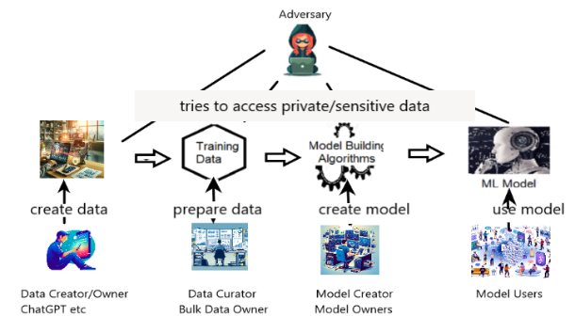
Figure 1: Potential Threats during ml life cycle: adapted from [29]
Data creators/owners are individuals who provide data, such as online shoppers or ChatGPT users. Privacy concerns arise at this stage since the data may include private and/or sensitive information, potentially without over-the-wire encryption. Techniques like RAPPOR [8] are used to enforce Local Differential Privacy (LDP) at this stage (see [4] for more information). Data holders/owners/curators are institutions or organizations that possess the collected data. They may use it internally or share it with external entities for ML model creation. Privacy breaches can occur during data handling, storage, or sharing at this stage.

Model creators/owners are individuals who build and train the model. They may also need to perform preprocessing steps. Privacy breaches can occur at this level if the data used in training is not appropriately protected. Model users are the general public or professionals who use the final ML model for making predictions or decisions. In the federated learning workflow (Section 2.2.3), partially trained models may need to be transferred between model creators. At this stage, privacy breaches may occur if the model’s output inadvertently reveals sensitive information about individuals.

As previously discussed, trained ML models typically do not directly store or expose the raw data used during training. However, privacy breaches are still possible because ML algorithms can capture and retain hidden patterns, or even memorize aspects of individual training examples. In this section, we focus specifically on privacy breaches in ML models, excluding linkage attacks, which we discuss separately for completeness. For more details, we refer the interested reader to Rigaki et al.’s comprehensive survey on privacy attacks against ML models [26] and Mireshghallah et al.’s survey on privacy in deep learning [22]. Below, we discuss how adversaries may attempt to breach the privacy of data owners at different stages of ML model development and deployment.

2.1.1 De-anonymization or Linkage Attacks.
In traditional data management, data owners employ anonymization techniques to ensure compliance with legal and ethical regulations and to prevent privacy breaches when sharing private and/or sensitive information (PSI) with external entities. Anonymization can be achieved through various techniques, including suppression (removing or partially redacting PSI), generalization (grouping data to reduce granularity), randomization (adding noise or swapping categorical data), perturbation (statistical alteration), and masking (replacing with alternate values). These techniques aim to balance protecting privacy with maintaining the statistical properties and utility of the original data. However, they are not infallible, and research has shown that privacy breaches can still occur despite anonymization efforts [30].

Sweeney et al. [30] demonstrated a re-identification or linkage attack, where the identity and sensitive information of individuals may be revealed by combining anonymized data with other non-anonymized data (see Figure 2: the medical data is anonymized but by linking with the anonymized voter list, the patient’s identity may be revealed). In addition, the same paper discusses a formal technique called 𝜅-Anonymization (introduced in [27]) and the necessary policies to safeguard against linkage attacks. 𝜅-Anonymization and its variations are discussed in Section 2.2.1.
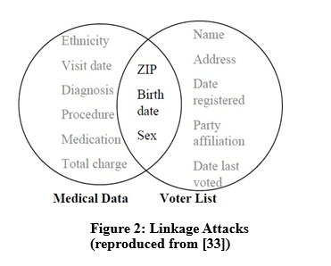

2.1.2 Member-Inference Attack (MIA)
The Member-Inference Attack (MIA) is a widely studied attack on privacy in ML models and aims to determine whether a particular data point was used for training an ML model. Shokri et al. [29] created an attack model to estimate the potential privacy risk for an individual if they allow their data to be used for training an ML model (assuming the data is secure otherwise). To demonstrate the attack, [29] created ML models (target models) using Google Prediction API, AWS-ML API, and their own implementation. They used five publicly available datasets to train their models. MIA is a black-box attack since the adversary can only supply valid inputs and observe the models’ prediction outputs and confidence levels. However, the attacker must know the formats and ranges of input and output data. This attack exploits the fact that a typical ML model’s predictions are often more confident or accurate for data points in the training set than for unseen data points. Successful MIA indicates that the ML system is vulnerable to broader privacy breaches and can serve as a first step toward other attacks such as model inversion.
The main steps in designing Shokri et al.’s [29] attack model are given below (see Figure 3).

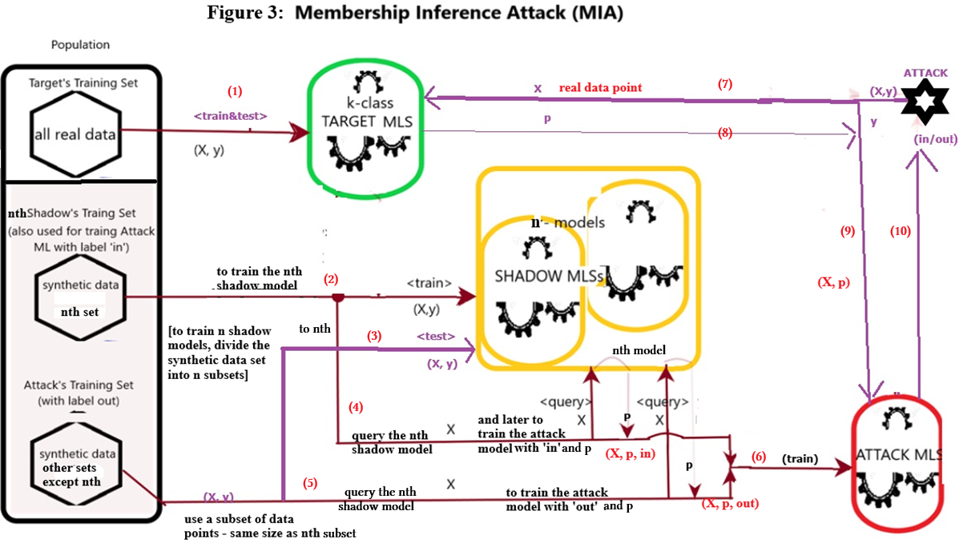

- Create a target ML model: A target model is created for a multi-class classification problem (e.g., 10 classes in MNIST) using a private training data set. Since this is supervised learning, the training data point’s format is (𝑋, 𝑦), where 𝑋 is the input vector and 𝑦 is the label (for example, if we want to create an MIA attack model to attack an ML system (target model) which used a subset of MNIST dataset for training: input 𝑋 is a 784-pixel image vector of a handwritten digit (say 8) and the label 𝑦 is the corresponding digit (8).
- Create an attack ML model: Our aim is to create an attack ML model to perform membership inference attack on the above target model. This binary classifier should predict whether a given data point (including the true label) was used in the training set of the target ML model- that is, if the data point was used in training the target model, the attack model should predict “in” otherwise “out”. For example, the input format of the attack model is [784-pixel image vector of a handwritten digit – say 8, and the corresponding digit 8], and the output label is “in” or “out”.
The challenge is creating suitable training data set to train the attack model (since the training set of the target model is unknown to the attacker).
- Towards creating a training dataset for the attack model: Finding a suitable set of data points to train the attack model is challenging. Some of these data points should resemble typical data points in the target’s training data (labeled “in”), and the other data points should be drawn from the same population but be different from the data points in the target’s training set (labeled “out”). In general, we assume that none of the data points in the target’s training set is used directly to train the attack model.
- Construct shadow models: To generate the data points for training the attack model, A number of shadow ML models (the more, the better) are created. These ML models are called shadows of the target, since they are built using the same configuration as the target (if available) and are trained using data points similar to the target’s training data- that has the same format and a similar distribution – but disjoint.
- Towards creating a training dataset for the shadow models: The data points in the training sets for the shadow models should be typical data points from the population. That means the target model should be able to make predictions on these data points with high confidence. In general, the attacker would not have real data points, and the training set for the shadow models must be generated from scratch.
- Generate synthetic data points to train shadow models: To generate a data point to train a shadow model, a local search algorithm (hill-climbing) may be used. For a particular class, a random data point is generated and then continuously improved in each iteration until the target’s prediction for that point reaches an acceptable confidence level for a class c. Sufficient data points will be generated for each class c. Divide the datapoints into K sets.
- Train K shadow models: After sufficient training datapoints are generated, k shadow models will be trained using these data, with the final prediction of the target as the label. The shadow models are tested using another set of disjoint data poins of the same size.
- Train the attack (binary) model: The training set of the attack model is constructed by querying the shadow models with synthetic data. A training data point of the attack model has the form [(𝑋, p), label], where 𝑋 is the synthetic data point, p is the shadow model’s prediction vector for 𝑋 , and the label is “in” if 𝑋 was used to train a shadow model and “out” otherwise.
- Evaluation: After training the attack model as a binary classifier, the target’s training data points and corresponding output vectors (expected output “in”) and other data points and corresponding output vectors (expected output “out”) are input to the attack model, and its accuracy can be evaluated.
- Attack: To attack the Target, that is to determine whether a data point X was used in the training set of the Target, query target with the data point X, get the output vector p, and then query the attack model with query (X, p); if the output is ‘in’, the datapoint was used for traing the target model, otherwise it was not used

In their best-case scenarios, Shokri et al. [29] report attack accuracies above 90%. They show that attack accuracy is inversely proportional to the number of classes. They use the accuracy difference between training and testing sets (generalization error) to quantify overfitting and the normalized Shannon entropy to quantify uncertainty in the predictions. They argue that overfitted models tend to be more vulnerable to membership inference attacks than well-generalized models, but overfitting is not a necessary condition for MIA to succeed. Several variations of MIA and mitigation techniques are discussed in [13, 14].

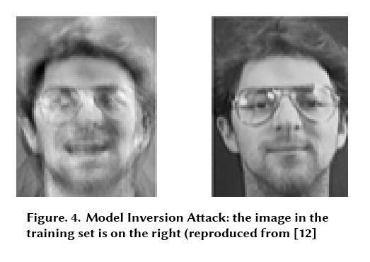

2.1.3 Attribute Inference / Model Inversion Attacks.
Membership status in a training set may not always be considered highly sensitive. Attribute inference attacks go one step further and aim to reveal sensitive attributes of a training data point. Attribute inference attacks and their subtle variations are often referred to as model inversion attacks or data reconstruction attacks. Fredrikson et al. [11] first introduced a black-box model inversion attack on a linear regression model designed for predicting drug dosage. Their study demonstrated that a patient’s sensitive attributes (genome) can be revealed based on a model’s predictions and other publicly available non-sensitive data about the patient.
Later, Fredrikson et al. [10] reported a white-box model inversion attack on a face recognition ML model (persons’ names were used as labels). They demonstrated that an identifiable version of a face image used in the training set could be reconstructed from the model using the victim’s name and the model’s confidence scores (see Figure 4). In another variation, instead of identifying individual attributes, attacks may aim to group attributes into classes. More information about attacks in this category can be found in [26].

2.1.4 Model Extraction Attack.
The model extraction attack (or parameter inference attack) is a black-box attack that aims to extract information about the architecture of the target model (such as the number of layers in a neural network, hyperparameters, activation function, etc.) and/or to construct a substitute model that behaves similarly to the target [31, 32]. In the worst case, sensitive information (such as trade secrets, proprietary features, or IDs) may be exposed if the target model has learned them during training.

2.1.5 Property Inference Attack.
This attack aims to infer properties of the training set of an ML model that were not directly used for training that model. A dataset may be used to train an ML model to predict certain labels, but the model may also unintentionally learn other patterns in the dataset [3]. For example, when the MNIST dataset is used for training, a model may learn differences in how left-handed and right-handed people write digits, even though handedness is not an explicit label. Adversaries may exploit such behavior to construct malicious attack models.

Privacy-Preserving Mechanisms in ML
Over the years, a substantial body of research has proposed various privacy-preserving mechanisms. This section outlines some key mechanisms discussed in the literature.

2.2.1 𝜅-Anonymization.
To prevent de-anonymization attacks discussed in Section 2.1.1, 𝜅-anonymization [27] and various variants such as ℓ-diversity [19] and 𝑡-closeness [16] were proposed. A dataset 𝐷 is said to be 𝜅-anonymized if, for every record in 𝐷, there exist (𝜅 − 1) other records in 𝐷 such that all 𝜅 records have the same values for at least a set of features that can be used for linkage attacks (called quasi-identifiers). Research shows that 𝜅-anonymity and related variants are not sufficient for privacy protection (e.g., composition attacks [12] and the Netflix attack [24]). Differential privacy, discussed next, is widely considered a more robust and rigorous privacy standard.

2.2.2 Differential Privacy.
Differential privacy (DP) was introduced by Dwork et al. in 2006 [6] and has become a de facto formal framework for privacy-preserving data analysis. DP ensures that the statistical properties of a dataset remain largely unaffected even if any individual’s data is modified or removed [7]. In ML, DP sets an upper bound on how much private information about an individual can be inferred from a trained model and its predictions.
In the context of ML, the basic form of DP (pure 𝜀-DP) is defined as follows (rearranged from [6] to highlight the role of 𝜀). Suppose 𝑀: 𝑋 → 𝑌 is a randomized algorithm (e.g., a training procedure or prediction mechanism) with input domain 𝑋 and output range 𝑌. Let 𝑥, 𝑥′ ∈ 𝑋 be neighboring inputs (differing in exactly one individual’s record) and 𝑦 ∈ 𝑌. Then 𝑀 satisfies 𝜀-DP if
Pr[𝑀 (𝑥) = 𝑦] ≤ 𝑒𝜀 · Pr[𝑀 (𝑥′) = 𝑦]
or equivalently
ln (Pr[𝑀 (𝑥) = 𝑦] / Pr[𝑀 (𝑥′) = 𝑦]) ≤ 𝜀 whenever Pr[𝑀 (𝑥′) = 𝑦] ≠ 0.

The privacy loss parameter (or privacy budget) 𝜀 > 0 controls the level of privacy protection. It bounds how much the presence or absence of a single individual’s data can change the output distribution. Smaller values of 𝜀 provide stronger privacy. As 𝜀 increases, more information about individuals can potentially be inferred from the model.
A widely used relaxation is approximate DP [7], or (𝜀, 𝛿)-DP, where a small probability 𝛿 ≤ 1 of an additional privacy breach is tolerated:
Pr[𝑀 (𝑥) = 𝑦] ≤ 𝑒𝜀 Pr[𝑀 (𝑥′) = 𝑦] + 𝛿.

The parameter 𝛿 should be small (e.g., 𝛿 ≪ 1/𝑛, where 𝑛 is the dataset size). DP satisfies several important properties that make it attractive for ML [4]:
- Post-processing property: If 𝑀 satisfies 𝜀-DP, then for any (possibly randomized) function 𝑇, the composition 𝑇 ◦ 𝑀 also satisfies 𝜀-DP. Post-processing cannot worsen privacy.
- Group privacy: If 𝑀 satisfies 𝜀-DP for changes in a single record, then changes in up to 𝑘 records are bounded by 𝑘𝜀.
- Composition: If mechanisms 𝑀1 and 𝑀2 with parameters 𝜀1 and 𝜀2 are applied to the same data, then the combined mechanism satisfies (at most) (𝜀1 + 𝜀2)-DP (sequential composition). Under certain conditions, if the mechanisms operate on disjoint subsets, the privacy loss is max(𝜀1, 𝜀2) (parallel composition).

Perturbation mechanisms in DP-ML
In ML, DP can be achieved by adding carefully calibrated noise or perturbations to the training data, to intermediate computations, or to the output of the model [6]. From a lifecycle perspective, noise can be injected before, during, or after training, depending on where the privacy concerns arise. When privacy must be enforced at the point of data collection, each user perturbs their own record before transmission, yielding a local DP setting and motivating many local-DP or federated learning protocols (see next section) in which users retain ownership of their raw data. If privacy has to be ensured after central collection but before training, input perturbation is applied directly to the training dataset. While conceptually simple, this approach often incurs a nontrivial utility loss, especially in high-dimensional or data-scarce regimes. Modern ML practice therefore frequently injects noise during training. In gradient perturbation, noise is added to (clipped) gradients at each optimization step, as in differentially private stochastic gradient descent (DP-SGD) [1], which is particularly suitable for large-scale, non-convex models such as deep neural networks. The PATE framework [25] instead uses an ensemble of teacher models and a noisy aggregation of their votes to produce differentially private labels for training a student model. An alternative is objective perturbation, which adds a random term directly to the loss function [28, 33]. Objective perturbation methods usually rely on convexity assumptions to obtain strong theoretical guarantees. Intuitively, a convex loss surface has no “bad” local minima: any local minimum is also a global minimum. Many classical models such as linear and logistic regression have convex objectives, for which objective perturbation provides clean privacy–utility guarantees, whereas gradient-perturbation methods like DP-SGD are designed to handle the non-convex objectives that arise in deep learning. Finally, when a model has already been trained and retraining is infeasible or access to the original data is restricted, privacy can only be provided via output perturbation, in which noise is added to model parameters or predictions before release. In summary, local or input perturbation is appropriate when the data collector is untrusted, gradient or objective perturbation is preferred when training can be modified and utility is critical, and output perturbation is the only option when only a trained model is available.

Laplace vs. Gaussian mechanisms. Two fundamental building blocks for DP mechanisms are the Laplace and Gaussian mechanisms. The Laplace mechanism adds noise drawn from a Laplace distribution with scale proportional to the function’s 𝐿1-sensitivity and provides pure 𝜀-DP [6]. It is particularly suitable for one-shot or low-dimensional numeric outputs such as counts, histograms, or simple model parameters when stringent privacy guarantees are required. The Gaussian mechanism instead adds zero-mean Gaussian noise with variance calibrated to the function’s 𝐿2-sensitivity and typically yields (𝜀, 𝛿)-DP [7]. This relaxation allows a small failure probability 𝛿 and tends to provide better utility in high-dimensional or iterative settings because Gaussian noise behaves more favorably under composition and concentration bounds. As a result, Laplace noise is often used for releasing static statistics or outputs where pure DP is desired, while Gaussian noise has become standard in DP-SGD and related training algorithms, where approximate DP is acceptable and repeated access to the mechanism is required.

𝐿1 vs. 𝐿2 sensitivity and suitability. The amount of noise required for DP is governed jointly by the privacy budget 𝜀 and the sensitivity of the mechanism to changes in a single individual’s data. For a randomized algorithm 𝑀, the 𝐿1-sensitivity 𝑆 (𝑀, 1) is defined as
𝑆 (𝑀, 1) = max 𝑥, 𝑥′ ∥𝑀(𝑥) − 𝑀(𝑥 ′) ∥₁,
where the maximum is taken over neighboring inputs 𝑥, 𝑥′.
When Laplace noise with scale 𝑆 (𝑀, 1)/𝜀 is added, 𝑀 achieves 𝜀-DP [6].
Analogously, the 𝐿2-sensitivity 𝑆 (𝑀, 2) is defined using the Euclidean norm ∥·∥2, and Gaussian noise calibrated to 𝑆 (𝑀, 2) is often used in the approximate DP setting, where (𝜀, 𝛿)-DP is acceptable [7].
In practice, 𝐿1-sensitivity is attractive for simple queries or low-dimensional outputs where tight worst-case bounds are feasible, but it can require large noise in high dimensions. 𝐿2-sensitivity, by contrast, is better suited to gradient-based training and other vector-valued computations, where it provides smoother behavior under composition and leads to more favorable utility–privacy trade-offs in complex, iterative ML pipelines. This distinction motivates the prevalent use of Laplace mechanisms for static queries and Gaussian mechanisms for large-scale DP-ML training algorithms.
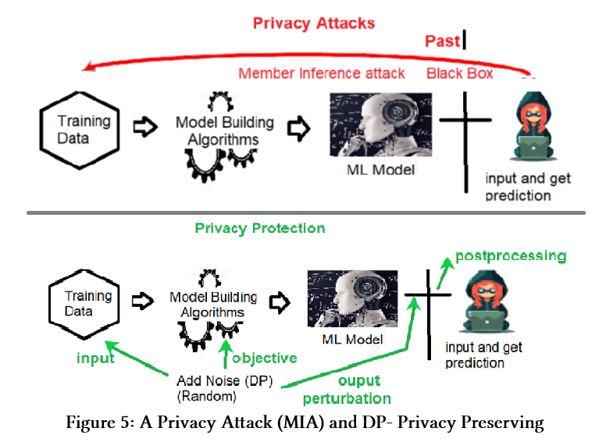
The exponential mechanism [21] extends DP to non-numeric outputs using a utility function and sampling proportional to an exponential of the utility. Mironov [23] introduced Rényi DP as another relaxation, arguing that it can simplify the analysis of Gaussian mechanisms and composition.

2.2.3 Federated Learning (FL).
Many modern applications, such as mobile services and IoT deployments, generate sensitive data on user devices. Transferring all such data to a central server for training can violate privacy regulations and incur large communication overhead. Federated learning (FL), introduced by McMahan et al. [20], is a decentralized learning paradigm where local models are trained on-device and only model updates (e.g., gradients or parameters) are sent to a central server that aggregates them into a global model.
In FL, raw data remains on local devices or edge servers, which helps reduce the risk of centralized data breaches and can align better with regulatory constraints. However, FL is not inherently private: model updates can still leak information about local data, and FL is vulnerable to attacks such as poisoning and membership inference. As a result, many works combine FL with DP or cryptographic techniques to strengthen privacy.
FL has been widely studied and deployed in mobile and IoT scenarios, as well as in distributed domains such as healthcare and supply chain management. Surveys such as [15, 17, 18] provide comprehensive overviews of FL algorithms, applications, and privacy attacks.

2.2.4 Cryptographic Approaches.
Leveraging cryptography for preserving privacy has also been widely studied. According to Evans et al. [9], fully homomorphic encryption (FHE) and secure multi-party computation (MPC) are two main families of secure and verifiable computation techniques relevant to ML.
FHE is suitable when heavy computations on private data must be outsourced to an untrusted server. The client encrypts the data using a secret key and sends the ciphertexts to the server. All computations are performed on encrypted data, and the resulting ciphertext is returned to the client, who decrypts it to obtain the clear output. Many partially homomorphic schemes exist, and practical full FHE remains an active research area.
MPC is well suited when multiple independent parties need to jointly compute a function over their inputs without revealing their private data to each other or to any third party. MPC protocols allow parties to obtain the result while preserving privacy for all participants. Evans et al.’s book [9] provides a detailed treatment.

Tools for Privacy-Preserving ML.
Several tools and libraries support privacy-preserving machine learning in practice. IBM’s privacy tools (including data privacy management suites) provide end-to-end support for handling private data. TensorFlow Privacy (TFP) offers DP optimizers and utilities for TensorFlow models. The ML Privacy Meter measures the privacy risk of trained models under membership inference attacks. Opacus is a PyTorch library that enables differential privacy in PyTorch models via DP-SGD and related mechanisms. These tools help practitioners incorporate formal privacy guarantees into real systems.

CONCLUSION AND FUTURE DIRECTION
This survey has examined key privacy threats in machine learning and the main families of privacy-preserving mechanisms proposed to address them. We reviewed attacks such as linkage, membership inference, attribute inference/model inversion, model extraction, and property inference, and highlighted how they exploit information about the training data encoded in model parameters or outputs. We then summarized important defense techniques, including 𝑘-anonymity and related anonymization schemes, differential privacy and its relaxations, federated learning, cryptographic approaches such as FHE and MPC, and widely used software tools that implement these ideas. Despite substantial progress, privacy-preserving ML remains an active and challenging research area. Important gaps include a deeper understanding of the privacy–utility trade-off in realistic, large-scale models; the interaction between privacy guarantees and group or individual fairness (e.g., when DP noise disproportionately harms minority groups or shifts attack vulnerability); and principled ways to allocate and explain privacy budgets. Shapley-value-based data valuation offers a promising tool for reasoning about how individual data points contribute to both model performance and privacy risk, but scalable, privacy-aware Shapley approximations are still largely unexplored. Addressing these questions at the intersection of privacy, utility, fairness, and data valuation is crucial for building ML systems that are not only formally private, but also practically trustworthy and equitable.

REFERENCES

[1] Abadi, M., Chu, A., Goodfellow, I., McMahan, H. B., Mironov, I., Talwar, K., & Zhang, L. (2016). Deep Learning with Differential Privacy. In Proceedings of the 2016 ACM SIGSAC Conference on Computer and Communications Security https://doi.org/10.1145/2976749.2978318
[2] Bommasani, R., Hudson, D. A., Adeli, E., Altman, R., Arora, S., von Arx, S., Bernstein, M. S., Bohg, J., Bosselut, A., Brunskill, E., Brynjolfsson, E., Buch, S., Card, D., Castellon, R., Chatterji, N., Chen, A., Creel, K., Davis, J. Q., Demszky, D., ... Liang, P. (2021). On the opportunities and risks of foundation models. https://doi.org/10.48550/arXiv.2108.07258
[3] Carlini, N., Liu, C., Kos, J., Erlingsson, Ú., & Song, D. (2018). The Secret Sharer: Evaluating and Testing Unintended Memorization in Neural Networks. CoRR abs/1802.08232. https://doi.org/10.48550/arXiv.1802.08232
[4] Chang, J. M., Zhuang, D., & Samaraweera, G. D. (2023). Privacy-Preserving Machine Learning. Manning Publications. http://mng.bz/z05a
[5] De Cristofaro, E. (2020). An Overview of Privacy in Machine Learning. CoRR abs/2005.08679. https://doi.org/10.48550/arXiv.2005.08679
[6] Dwork, C., McSherry, F., Nissim, K., & Smith, A. (2006). Calibrating Noise to Sensitivity in Private Data Analysis. In S. Halevi & T. Rabin (Eds.), Theory of Cryptography (pp. 265–284). Springer Berlin Heidelberg. https://doi.org/10.1007/11681878_14
[7] Cynthia Dwork, Guy N. Rothblum, and Salil Vadhan. 2010. Boosting and Differential Privacy. In 2010 IEEE 51st Annual Symposium on Foundations of Computer Science. 51–60. https://doi.org/10.1109/FOCS.2010.12
[8] Erlingsson, Ú., Korolova, A., & Pihur, V. (2014). RAPPOR: Randomized Aggregatable Privacy-Preserving Ordinal Response. Proceedings of the 2014 ACM SIGSAC Conference on Computer and Communications Security. https://doi.org/10.1145/2660267.2660348
[9] Evans, D., Kolesnikov, V., & Rosulek, M. (2018). A pragmatic introduction to secure multi-party computation. Foundations and Trends in Privacy and Security, 2(2-3), 70-246. https://doi.org/10.1561/3300000019
[10] Fredrikson, M., Jha, S., & Ristenpart, T. (2015). Model Inversion Attacks That Exploit Confidence Information and Basic Countermeasures. Proceedings of the 22nd ACM SIGSAC Conference on Computer and Communications Security https://doi.org/10.1145/2810103.2813677
[11] Fredrikson, M., Lantz, E., Jha, S., Lin, S., Page, D., & Ristenpart, T. (2014). Privacy in Pharmacogenetics: An End-to-End Case Study of Personalized Warfarin Dosing. In Proceedings of the 23rd USENIX Security Symposium (SEC’14). https://doi.org/10.5555/2660267.2660270
[12] Ganta, S. R., Kasiviswanathan, S. P., & Smith, A. D. (2008). Composition Attacks and Auxiliary Information in Data Privacy. *Proceedings of the 14th ACM SIGKDD International Conference on Knowledge Discovery and Data Mining*, 265–273. https://doi.org/10.1145/1401890.1401926
[13] Del Grosso, G., Pichler, G., Palamidessi, C., & Piantanida, P. (2021). Bounding Information Leakage in Machine Learning. CoRR abs/2105.03875. https://doi.org/10.48550/arXiv.2105.03875
[14] Jayaraman, B., Wang, L., Evans, D., & Gu, Q. (2020). Revisiting Membership Inference Under Realistic Assumptions. CoRR abs/2005.10881 https://doi.org/10.48550/arXiv.2005.10881
[15] Jere, M., Farnan, T., & Koushanfar, F. (2021). A Taxonomy of Attacks on Federated Learning. IEEE Security & Privacy, 19(2), 20–28. https://doi.org/10.1109/MSEC.2020.3039941
[16] Li, N., Li, T., & Venkatasubramanian, S. (2007). t-Closeness: Privacy Beyond k-Anonymity and l-Diversity. 2007 IEEE 23rd International Conference on Data Engineering https://doi.org/10.1109/ICDE.2007.367856
[17] Zengpeng Li, Vishal Sharma, and Saraju P. Mohanty. 2020. Preserving Data Privacy via Federated Learning: Challenges and Solutions. IEEE Consumer Electronics Magazine 9(3) (2020), 8–16. https://doi.org/10.1109/MCE.2019.2959108
[18] Liu, Y., Zhang, L., Ge, N., & Li, G. (2020). A Systematic Literature Review on Federated Learning: From A Model Quality Perspective. CoRR abs/2012.01973 https://doi.org/10.48550/arXiv.2012.01973
[19] Machanavajjhala, A., Gehrke, J., Kifer, D., & Venkitasubramaniam, M. (2006). L-diversity: Privacy Beyond k-Anonymity. In *22nd International Conference on Data Engineering (ICDE’06)* (p. 24). https://doi.org/10.1109/ICDE.2006.1
[20] McMahan, B., Moore, E., Ramage, D., Hampson, S., & Aguera y Arcas, B. (2017). Communication-efficient learning of deep networks from decentralized data. In A. Singh & J. Zhu (Eds.), Proceedings of the 20th International Conference on Artificial Intelligence and Statistics (Proceedings of Machine Learning Research, Vol. 54) (pp. 1273–1282). PMLR. https://proceedings.mlr.press/v54/mcmahan17a.html
[21] Frank McSherry and Kunal Talwar. 2007. Mechanism Design via Differential Privacy. In Proceedings of the 48th Annual IEEE Symposium on Foundations of Computer Science (FOCS ’07). IEEE Computer Society, USA, 94–103. https://doi.org/10.1109/FOCS.2007.41
[22] Mireshghallah, F., Taram, M., Vepakomma, P., Singh, A., Raskar, R., & Esmaeilzadeh, H. (2020). Privacy in Deep Learning: A Survey. CoRR, abs/2004.12254. https://doi.org/10.48550/arXiv.2004.12254
[23] Mironov, I. (2017). Rényi Differential Privacy. 2017 IEEE 30th Computer Security Foundations Symposium (CSF). https://doi.org/10.1109/CSF.2017.11
[24] Narayanan, A., & Shmatikov, V. (2008). Robust De-anonymization of Large Sparse Datasets. 2008 IEEE Symposium on Security and Privacy (SP 2008) https://doi.org/10.1109/SP.2008.33
[25] Papernot, N., Abadi, M., Erlingsson, Ú., Goodfellow, I., & Talwar, K. (2017). Semi-supervised Knowledge Transfer for Deep Learning from Private Training Data. https://arxiv.org/abs/1610.05755
[26] Rigaki, M., & Garcia, S. (2020). *A survey of privacy attacks in machine learning*. CoRR abs/2007.07646. https://doi.org/10.48550/arXiv.2007.07646
[27] Samarati, P., & Sweeney, L. (1998). Protecting privacy when disclosing information: k-anonymity and its enforcement through generalization and suppression. In IEEE Symposium on Research in Security and Privacy (S&P). https://www.csl.sri.com/users/sri/papers/k-anonymity-sri-csl-98-04.pdf
[28] Chaudhuri, K., Monteleoni, C., & Sarwate, A. D. (2009). Differentially Private Empirical Risk Minimization. http://arxiv.org/abs/0912.0071
[29] Shokri, R., Stronati, M., Song, C., & Shmatikov, V. (2017). Membership Inference Attacks Against Machine Learning Models. In 2017 IEEE Symposium on Security and Privacy (SP) (pp. 3–18). https://doi.org/10.1109/SP.2017.41
[30] Sweeney, L. (2002). K-Anonymity: A Model for Protecting Privacy. International Journal of Uncertainty, Fuzziness and Knowledge-Based Systems, 10(5), 557–570. https://doi.org/10.1142/S0218488502001648
[31] Tramèr, F., Zhang, F., Juels, A., Reiter, M. K., & Ristenpart, T. (2016). Stealing Machine Learning Models via Prediction APIs. 25th USENIX Security Symposium (USENIX Security 16) https://www.usenix.org/conference/usenixsecurity16/technical-sessions/presentation/tramer
[32] Wang, B., & Gong, N. Z. (2018). Stealing Hyperparameters in Machine Learning. CoRR abs/1802.05351 https://doi.org/10.48550/arXiv.1802.05351
[33] Zhang, J., Zhang, Z., Xiao, X., Yang, Y., & Winslett, M. (2012). Functional Mechanism: Regression Analysis under Differential Privacy. Proceedings of the VLDB Endowment, 5(11), 1364-1375. https://doi.org/10.14778/2350229.2350253

