Relationship Between Population and Agriculture: A Regression Model for Forecasting Dependency

Abstract
A sizable section of the population still relies heavily on agriculture for their living, particularly in developing nations. For planning, policymaking, and resource allocation to be successful, it is essential to comprehend how population changes affect agricultural reliance. In order to forecast the number of individuals reliant on agriculture, this study creates a regression model based on population growth and other socioeconomic factors. The model determines how strongly and in which direction population size and agriculture dependency are related using historical population and agricultural workforce data. Based on the data, there is a strong positive correlation, indicating that the agricultural sector is still under significant pressure from population expansion. For the purpose of creating sustainable agricultural plans and promoting rural development, the predictive model provides insightful information to academics, planners, and politicians.
Keywords: Workforce forecasting, population expansion, agricultural reliance, regression analysis, and agricultural planning.

- Introduction
Many nations' economies rely heavily on agriculture, which gives a sizable section of the populace jobs, food security, and revenue. Agriculture is the foundation of rural lives in areas where urbanization and industrialization are still in their infancy. The number of people reliant on agriculture tends to rise with population growth, putting strain on productivity, water availability, and land resources. Designing successful agricultural and rural development programs requires an understanding of the connection between population expansion and agricultural dependency. Descriptive statistics have been used in traditional techniques of studying this connection, but their predictive power is limited. Conversely, regression modeling offers a methodical approach to estimating and predicting the ways in which population changes impact the agricultural. Conventional analytical techniques, like descriptive statistics, offer a summary of current and historical patterns but are not predictive. Regression analysis, on the other hand, provides a strong and methodical way to model and predict connections between variables. It is feasible to measure the impact of population size variations on agricultural reliance and make more accurate predictions about future trends by using linear and multiple regression models. In order to estimate the number of people reliant on agriculture as a function of population growth and other pertinent factors, this study focuses on creating a regression-based prediction model. The study determines the direction and strength of the population-agricultural workforce link by looking at historical data. The findings should aid academics, development planners, and policymakers in predicting shifts in the demand for agricultural jobs, allocating resources as efficiently as possible, and creating policies that support sustainable agricultural growth.
When taken as a whole, these studies offer a comprehensive picture of India's population-agriculture relationship. Their findings support the use of linear and exponential regression models to forecast future dependency as they show a steady long-term trend of population expansion coupled with a slow decline in the proportion of the workforce employed in agriculture. The literature emphasizes that agriculture remains the foundation of rural subsistence and national food security, despite the fact that economic and demographic changes have diversified employment. The relationship between population dynamics, agricultural development, and rural employment has long been a central focus of research in India and other developing countries. Early foundational studies such as Mehra (1966) highlighted the concept of surplus labour in Indian agriculture, noting that high population pressure created disguised unemployment and low productivity. Dayal (1984) further demonstrated how spatial variations in agricultural productivity were shaped by population density, irrigation, and technological disparities across regions. These early contributions laid the groundwork for understanding how demographic factors influence agricultural performance. Bhalla (1987) added to this discourse by showing how employment trends in agriculture shifted in response to land distribution and mechanisation, providing deeper insights into labour transitions within rural economies. By the 1990s, researchers increasingly focused on the interplay between population characteristics, labour diversification, and rural non-farm employment. Singh (1996) investigated gender wage disparities among agricultural workers, revealing how demographic factors and cultural norms influenced labour markets and agricultural growth. Parthasarathy and Reddy (1998) analysed determinants of rural non-agricultural employment, showing how landholdings, education, and demographic attributes shaped household decisions to diversify away from agriculture. As economic reforms progressed, Lanjouw and Murgai (2009) documented a significant decline in rural poverty between 1983 and 2004, accompanied by rising agricultural wages and the gradual shift of the labour force into the non-farm sector. More recent studies have incorporated econometric modelling to quantify demographic influences on agricultural labour and productivity. Sharma et al. (2016) applied robust regression techniques to examine the number of agricultural workers in India, revealing how structural and demographic variables interact to influence labour availability. Meanwhile, major institutional reports have provided comprehensive evidence on shifting rural dynamics. NITI Aayog’s (2017) report on the changing structure of the rural economy highlights declining agricultural employment and increasing non-farm opportunities, driven partly by demographic transition and migration. Similarly, the National Statistical Office’s PLFS report (2019) revealed declining participation in agricultural occupations, illustrating how demographic and employment patterns are undergoing rapid transformation. Demographic projections from MoHFW (2020) further underscore the significance of population growth and urbanisation in shaping future agricultural challenges. The report predicts sustained population increase, rising dependency ratios, and greater urban pressure, all of which will affect food demand and agricultural resource allocation. At the same time, the FAO’s (2020) global report on water challenges emphasizes that population growth will intensify water scarcity, severely constraining agricultural production unless efficiency improves. Climate-related pressures on agriculture are highlighted in Birthal’s (2022) work, which calls attention to increasing climatic risks faced by Indian farmers and stresses the need for adaptive strategies.
The COVID-19 pandemic introduced new complexities to rural and agricultural labour markets. Tandon et al. (2022) documented changing work structures in urban India, including rising informality and temporary employment, which indirectly impact rural labour mobility and agricultural workforce availability. Recent research provides more nuanced empirical perspectives. Jana and Goli (2023) identified an inverted U-shaped relationship between population growth and agricultural land use, indicating that early phases of population growth expand cultivation, but later phases intensify land pressure. Kumar and Moharaj (2023) explored the farm size–productivity relationship, showing that land fragmentation continues to shape agricultural efficiency. At the global level, Miladinov (2023) and Islam et al. (2025) demonstrated how population growth influences food security outcomes in low- and middle-income countries. For India specifically, Yasir et al. (2025) showed using ARDL models that population growth and urbanisation significantly reduce agricultural land availability, emphasizing the growing demographic pressure on agricultural systems. In order to predict the agricultural workforce, this study presents a novel integrated analytical method that combines regression-based modeling with both linear and exponential population forecasting. By combining these complementary approaches, the study offers a more precise, data-driven, and thorough evaluation of India's future reliance on agriculture, allowing for a deeper understanding of long-term demographic pressures, labor demand, and structural changes within the rural economy.

- Models and Methods
In this study, a comprehensive quantitative analytical framework is employed, integrating both regression modeling and time-series forecasting techniques. These methods enable a systematic assessment of historical data and support evidence-based projections for future demographic and workforce trends. The analysis begins with the application of linear and exponential growth models to estimate future population levels. The linear model helps in understanding steady, constant-rate changes over time, whereas the exponential model captures accelerated or compound growth patterns. Using both models allows for a more robust comparison and provides insights into which pattern better represents the long-term population dynamics of the study region. Following the population projection, regression analysis is utilized to examine the statistical relationship between the total population and the number of agricultural laborers. This step is essential for identifying whether changes in population size significantly influence the agricultural workforce and to what extent. The regression model helps quantify this relationship, providing coefficients that indicate the direction and strength of association.

Description of the Model
(a) Linear Population Growth Model
The population is estimated as a function of year using a straightforward linear regression model:
$$\hat{P_{t}}=β_{0}+β_{1}+\hat{P_{t}}$$Where: $\hat{P_{t}}$= Population prediction at time t
t = Year
$β_{0},β_{1}$= Least squares estimation of the intercept and slope parameters.

(b) Model of Exponential Population Growth
To account for non-linear tendencies in population expansion, an exponential growth model is used:
$$lnP_{t}=a_{0}+a_{1}×t$$
$$\hat{P_{t}}=e^{a_{0}+a_{1}t}$$
Where: $P_{t}$= The population at t
$a_{0},a_{1}$= Coefficients of regression
e = Natural logarithm base
We may use linear regression techniques to an exponential model by taking the population's natural logarithm.
An overview of the methodology
Step 1: Compile past census information.
Step 2: Fit population models using linear and exponential methods.
Step 3: Regress the population by the number of agricultural laborers.
Step 4: Project the workforce and population for 2021–2051.
Step 5: Examine the proportion of the population that depends on agriculture in the two models.

- Applications

The present research applies population and workforce forecasting models using data sourced from the Agriculture Survey 2018, which provides comprehensive information on demographic characteristics, agricultural workforce participation, and long-term labour availability in the rural sector. In order to forecast future population size and the percentage of the labor force involved in agriculture for the years 2021–2051, this dataset serves as the foundation for both linear and exponential growth models. Using the 2018 agricultural labour statistics as the starting reference, the study generates comparative forecasts to understand how changing demographic trends may influence the availability of agricultural workers in the coming decades.

Table 1 : Population and Workforce Forecasts Using Exponential and Linear Growth Models (2021–2051)
Year | Linear Model — Predicted Population | Linear Model — Predicted Workers | Workers (% of Population) | Exponential Model — Predicted Population | Exponential Model — Predicted Workers | Workers (% of Population)
2021 | 1306.4 | 286.3 | 21.92 % | 1534.3 | 329.6 | 21.48 %
2031 | 1450.2 | 313.7 | 21.63 % | 1885.2 | 396.3 | 21.02 %
2041 | 1594.0 | 341.0 | 21.39 % | 2316.4 | 478.2 | 20.64 %
2051 | 1737.8 | 368.3 | 21.19 % | 2846.2 | 578.8 | 20.34 %

- Results and discussion
Both the linear and exponential growth models' conclusions provide important new information about India's population-agriculture link. The entire population is expected to rise at a steady and moderate rate, from 1,210.9 million in 2011 to around 1,737.8 million by 2051, according to the linear growth model. In line with this, it is anticipated that there would be 368.3 million agricultural workers by 2051, up from 263.1 million in 2011. A slow but continuous transition away from reliance on agricultural employment is indicated by the progressive drop in the proportion of agricultural workers to the overall population, which went from 21.9% in 2021 to 21.2% in 2051, despite an increase in the absolute number of agricultural workers over time.
The exponential growth model, on the other hand, predicts a greater rate of population expansion, with an estimated 2,846.2 million people by 2051. The number of agricultural workers rises more dramatically as a result, rising from 329.6 million in 2021 to 578.8 million in 2051. The proportion of agricultural workers in the overall population, however, decreases more quickly—from 21.5% in 2021 to 20.3% in 2051—despite this greater rise in absolute numbers. According to this pattern, a decreasing number of individuals will eventually make agriculture their primary employment, despite the fact that the labor force and general population are still growing.
Overall, both models indicate that although population growth is still occurring, reliance on agriculture as a source of income is declining, which suggests that the economy is undergoing structural changes and that workers are gradually shifting to non-agricultural industries. While the exponential model depicts an accelerated development scenario and is helpful for comprehending possible high-growth outcomes, the linear model offers a more cautious estimate appropriate for moderate growth assumptions. When combined, these models offer policymakers useful predictive information for predicting future employment patterns, planning for rural development, and diversifying sources of income.

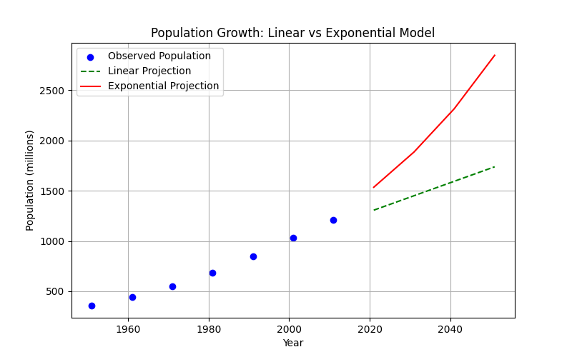
Figure 1: Graphical representation of Population Forecasts Using Exponential and Linear Growth Models (2021–2051)

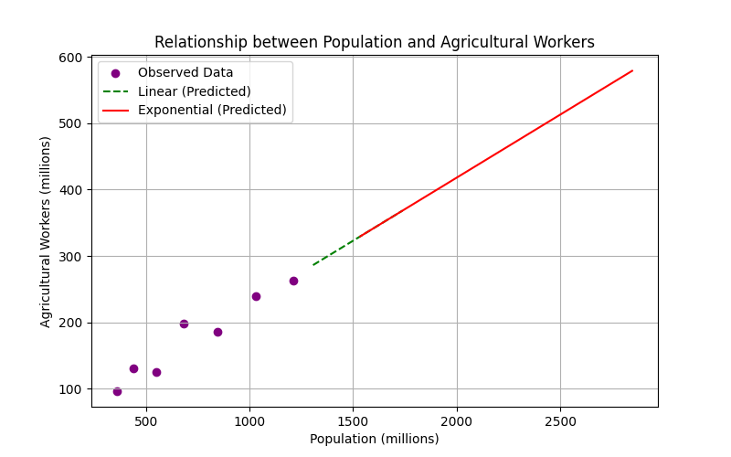
Figure 2: Graphical representation of Agriculture workers Forecasts Using Exponential and Linear Growth Models (2021–2051)

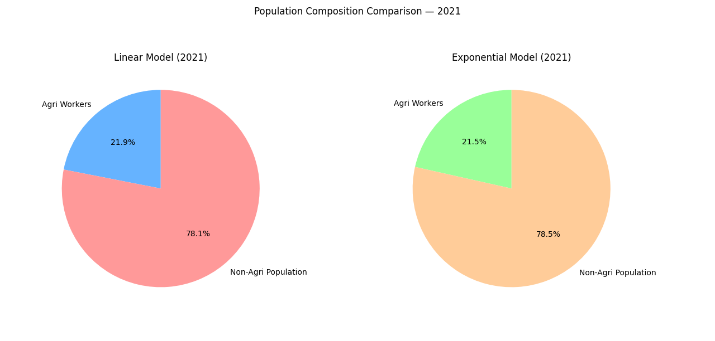
Figure3: Population and Workforce Forecasts Using Exponential and Linear Growth Models 2021

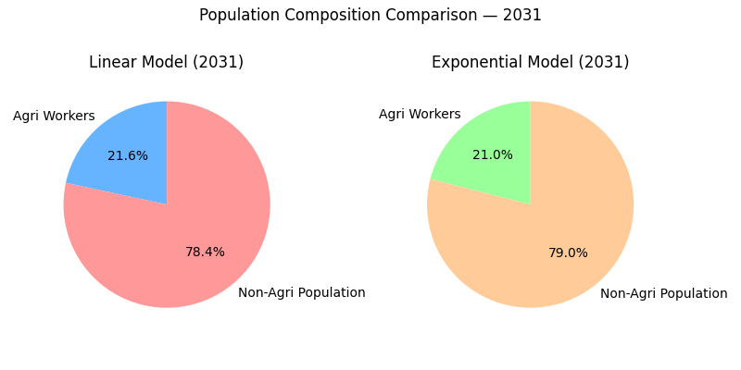
Figure 4: Population and Workforce Forecasts Using Exponential and Linear Growth Models 2031
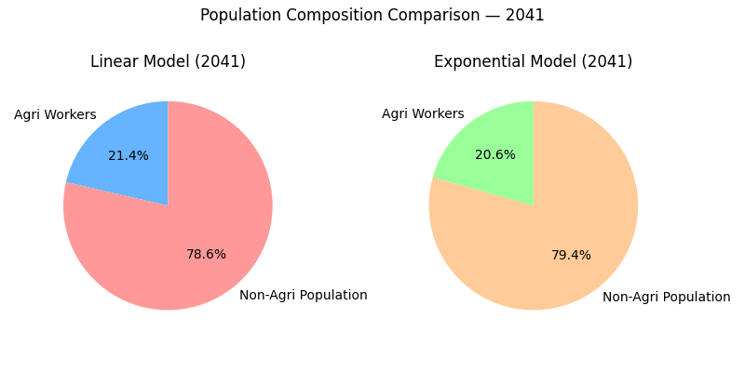
Figure 5: Population and Workforce Forecasts Using Exponential and Linear Growth Models 2041

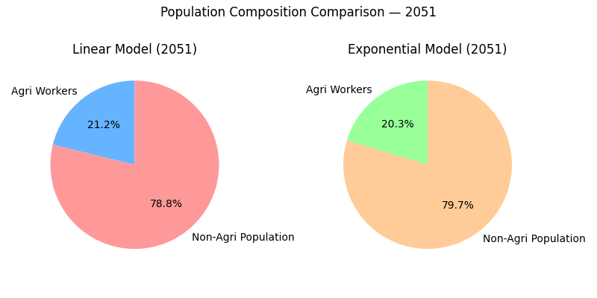
Figure 6: Population and Workforce Forecasts Using Exponential and Linear Growth Models 2051

- Conclusion
Important insights into India's long-term demographic and occupational transition may be gained from the regression-based study of the population-agriculture link. According to both the linear and exponential models, India's population will continue to grow over the ensuing decades, but the proportion of people employed in agriculture will gradually fall. The percentage of individuals who are directly dependent on agriculture is predicted to decline from around 22% in 2021 to about 21% or less by 2051, even though the population is predicted to reach 1.7 billion by that time.
As education, technology, and urbanization rise, India's economy is moving from agriculture to industry and services, reflecting a larger structural shift. Even though there are more people working overall, agriculture's proportion of all jobs is declining, which suggests that the rural economy is continuing to diversify and that there are more options outside of farming.
From a societal point of view, these findings point to both possibilities and difficulties. On the one hand, less reliance on agriculture points to the possibility of increased agricultural output, mechanization, and modernization. However, in order to guarantee that excess rural labor can be efficiently absorbed in non-agricultural sectors without exacerbating unemployment or income inequality, it highlights the necessity of social and governmental reforms.
The results highlight how crucial it is for governments to promote this transformation by bolstering rural industrialization, skill development, and education. Since agriculture continues to be a major source of income for a sizable portion of the rural population, efforts must be made to increase its sustainability and profitability at the same time.
In summary, both the exponential and linear regression models predict that while India's population will keep increasing, the share of the population that depends on agriculture would gradually fall. A significant turning point in India's socioeconomic development, this demographic transition both signals modernizing progress and serves as a reminder of the ongoing need to sustain the rural labor, which is the foundation of the country's agricultural economy.

Reference
National Commission on Population, Ministry of Health & Family Welfare. (2020). Population projections for India and states 2011–2036: Report of the technical group on population projections. https://main.mohfw.gov.in/sites/default/files/Population%20Projection%20Report%202011-2036%20-%20upload_compressed_0.pdf
FAO. (2020). The state of food and agriculture 2020. Overcoming water challenges in agriculture. Food and Agriculture Organization of the United Nations. https://www.fao.org/publications/sofa/2020/en/
Chand, R., Srivastava, S. K., & Singh, J. (2017). Changing structure of rural economy of India implications for employment and growth. National Institution for Transforming India, Government of India. https://www.niti.gov.in/changing-structure-rural-economy-india-implications-employment-and-growth
National Statistical Office, India. (2019). Periodic Labour Force Survey (PLFS) – Annual Report (July 2017-June 2018). Government of India. https://dge.gov.in/assets/upload/Annual%20Report,%20Periodic%20Labour%20Force%20Survey%20(PLFS),%202017%20-%2018.pdf
Birthal, P. S. (2022). Climate Change and Risk Management in Indian Agriculture. NABARD Research and Policy Series, Department of Economic Analysis and Research, NABARD. https://www.nabard.org/auth/writereaddata/tender/2007223845Paper-4-Climate-and-Risk-Management-Dr.-Birthal.pdf
Tandon, N., Basu, P., Krishnan, O., & R.V., B. (2022). Emerging Work Trends in Urban India: COVID-19 and Beyond. Routledge India. https://doi.org/10.4324/9781003264194
Dayal, E. (1984). Agricultural productivity in India: a spatial analysis. Annals of the Association of American Geographers, 74(1), 98-123. https://doi.org/10.1111/j.1467-8306.1984.tb01437.x
Sharma, M. S., Kumar, B. K., Bhat, A. B., Bhat, I. J., & Mahajan, S. M. (2016). Robust regression model to study the number of Indian agricultural workers. Indian Journal of Ecology, 43(Special Issue 1), 599-601. https://indianecologicalsociety.com/indian-journal-of-ecology/
Parthasarathy, G., & Reddy, B. S. (1998). Determinants of rural non-agricultural employment: the Indian case. Indian Journal of Agricultural Economics, 53(2), 139-154.
Singh, R. D. (1996). Female agricultural workers' wages, male-female wage differentials, and agricultural growth in a developing country, India. Economic Development and Cultural Change, 45(1), 89-123. https://doi.org/10.1086/452259
Lanjouw, P., & Murgai, R. (2009). Poverty decline, agricultural wages, and nonfarm employment in rural India: 1983–2004. Agricultural Economics, 40(2), 243-263. https://doi.org/10.1111/j.1574-0862.2009.00373.x
Bhalla, S. (1987). Trends in employment in Indian agriculture, land and asset distribution. Indian Journal of Agricultural Economics https://doi.org/10.22004/ag.econ.271868
Mehra, S. (1966). Surplus labour in Indian agriculture. Indian Economic Review, 1(1), 111-129.
Jana, A., & Goli, S. (2024). Gazing at long-term linkages between agricultural land use and population growth in India: an inverted “U-shape” relationship. Journal of Demographic Economics. https://doi.org/10.1017/dem.2024.20
Kumar, K. K., & Moharaj, P. (2023). Farm size and productivity relationship among the farming communities in India. Outlook on Agriculture, 52(2), 212-227. https://doi.org/10.1177/00307270231176578
Miladinov, G. (2023). Impacts of population growth and economic development on food security in low-income and middle-income countries. *Frontiers in Human Dynamics*, *5*, 1121662. https://doi.org/10.3389/fhumd.2023.1121662
Islam, M., Marei, G. A., & Shehzad, F. (2025). Comparative Analysis of Global Food Security Index Components with Population Growth: A Focus on Pakistan and China. Population and Economics, 9(4), 102-114. https://doi.org/10.3897/popecon.9.e127228
Yasir, M., Kour, S., & Sehgal, S. (2025). Impact of Population Growth and Urbanization on Agricultural Land Use: Evidence from India. Advances in Consumer Research, 2(3), 327-339. https://acr-journal.com/

