A Triangulated Analytical Framework for Understanding Under-Five Survival in Ghana: Evidence from Harmonized Classical and Machine Learning Models

Abstract
This study develops an integrated analytical framework to identify and interpret the key determinants of under-five survival in Ghana using nationally representative survey data. The novelty lies in harmonising four complementary modeling paradigms, which are logistic regression, multilevel logistic regression, generalized additive models (GAM), and explainable machine learning (XGBoost + SHAP)—within a single pipeline that captures linear, nonlinear, hierarchical, and interaction-driven risk structures. The dataset, comprising 34,663 children and 17 covariates, was analysed to evaluate the effects of socioeconomic, demographic, environmental, and service-related factors on survival outcomes. All models exhibited consistent and strong discrimination (AUC = 0.760-0.764), indicating stable survival signals across methodological approaches. GAM smooth functions revealed nonlinear declines in mortality risk with increasing paternal age, while XGBoost explainability confirmed the prominence of paternal age, residence, household gender structure, water source, and maternal-newborn service utilisation. Calibration diagnostics demonstrated reliable probability estimates suitable for operational decision-making. The triangulated evidence underscores the centrality of early-life service access, clean water, and intra-household gender dynamics in shaping survival prospects. This research advances methodological innovation in child survival analytics and offers actionable policy insights aligned with SDG 3, SDG 6, and SDG 10 by promoting transparent, data-driven approaches to equitable child health interventions. It is recommended that health authorities intensify targeted maternal-newborn services and clean-water interventions in high-risk households to accelerate equitable child survival gains.

Keywords:
Under-five mortality; Child survival modelling; Logistic and multilevel regression; Explainable machine learning; XGBoost; SHAP values

Introduction
Under-five mortality remains a central challenge in public health, particularly in developing countries where structural inequalities, healthcare accessibility, and environmental hazards interact to determine child survival outcomes (Dhage et al., 2024; Rajapakse et al., 2025; Olawade et al., 2025; Olusola et al., 2025; Amir-ud-Din et al., 2025). While significant progress has been achieved under the global Sustainable Development Goal (SDG) 3.2 target—to end preventable deaths of newborns and children under five by 2030, mortality reduction has been uneven across regions and socioeconomic strata. In sub-Saharan Africa, including Ghana, many determinants of under-five mortality persist, such as limited access to antenatal and postnatal services, poor water and sanitation systems, gender-based disparities in caregiving, and economic vulnerability of households (Kefale et al., 2025; Rajapakse et al., 2025; Mazumder et al., 2025; Faruk et al., 2025). Traditional statistical approaches, though widely applied to demographic and health survey data, often assume linear and independent relationships among predictors, potentially masking nonlinear effects and interaction dynamics embedded in real-world systems.
Recent advances in statistical modeling and machine learning have opened pathways to address these analytical limitations. Logistic regression remains the foundational approach for binary outcomes, offering interpretability and global model stability. However, it assumes additive linear relationships that can underrepresent complex risk gradients. Hierarchical or multilevel logistic models extend this framework by introducing random effects to account for regional or contextual variation, allowing for better inference in clustered data structures (Birhanie et al., 2025; Mahama et al., 2025; Mazumder et al., 2024; Wiysonge et al., 2025). Yet even these models may fail to capture nonlinear effects in continuous covariates. Generalized Additive Models (GAMs) overcome this by fitting smooth, data-driven relationships without compromising interpretability, allowing the discovery of threshold or saturation effects relevant to public health interventions. Beyond conventional models, ensemble machine learning algorithms such as XGBoost further enhance predictive performance by aggregating weak learners and incorporating nonparametric splits. When combined with explainability tools such as SHAPs (SHapley Additive exPlanations) values, these models enable transparent insights into the contribution of each factor to child survival outcomes.
Empirical evidence on under-five mortality has consistently identified socioeconomic status, parental education, maternal healthcare utilization, and environmental conditions as major determinants of survival. Studies linking maternal, biological, and environmental factors to child mortality (LaFave et al., 2024; Souza et al., 2024; Headen et al., 2025; Adeyinka et al., 2024). In Ghana maternal education, wealth index, and access to health services significantly influence survival probabilities among children under five (Iddrisu et al., 2025; Osei et al., 2024; Frimpong et al., 2025). These findings align with global analyses that emphasize the role of antenatal care attendance, skilled delivery, and postnatal care as protective factors against early childhood deaths. Despite these insights, much of the existing literature relies on classical regression approaches, which may understate nonlinear and interaction effects that govern the complex interplay of socioeconomic and demographic variables (Fenta et al., 2024; Gazze et al., 2024; Chaku et al., 2025; Arana-Ovalle et al., 2025). Recent methodological transitions have introduced flexible models that better capture such complexities. Multilevel logistic models have been applied in child mortality studies to disentangle individual-level risk from contextual variation across administrative regions. While these approaches strengthen inference by accounting for unobserved heterogeneity, their reliance on linear structures can still obscure latent nonlinearities. Generalized Additive Models have been increasingly used in health analytics for their ability to reveal smooth, nonlinear trends, such as diminishing effects of paternal age or household size on survival probability. Meanwhile, machine learning frameworks, including random forests and gradient boosting, have been applied to health data for predictive accuracy but often criticized for limited interpretability (Rahman et al., 2025; Naznin et al., 2025; Ashwini et al., 2024; Natarajan et al., 2025; Satty et al., 2025). The incorporation of explainable AI techniques, particularly SHAP (SHapley Additive exPlanations), bridges this gap by quantifying the contribution of each feature to the prediction of survival status. This hybrid interpretability aligns with the growing demand for transparent, data-driven decision tools in health system management.
Despite the volume of work in child survival modeling, three key research gaps persist. First, few studies integrate statistical and machine learning paradigms within a harmonized analytical pipeline to compare performance across interpretability and accuracy dimensions. Second, nonlinear relationships among critical determinants such as paternal age, water access, and household characteristics remain underexplored, leading to potential mis-specification of risk thresholds. Third, most Ghanaian studies rarely embed methodological innovations like explainable machine learning or shape-aware GAMs within the SDG evaluation framework. This research addresses these gaps by triangulating logistic, multilevel, GAM, and XGBoost models to identify, quantify, and interpret the drivers of under-five survival in Ghana. The approach ensures robust model validation, transparency in feature importance, and direct linkage to SDG 3 (Good Health and Well-being), SDG 6 (Clean Water and Sanitation), and SDG 10 (Reduced Inequalities). Through this integration, the study offers both scientific and policy relevance—advancing the methodological frontier in child survival analytics while informing equitable health interventions.

Materials and Methods

Study Design and Data Source
This study employed a quantitative analytical design using nationally representative data on under-five children extracted from the Under5 Dataset (Under5.xlsx). The dataset contains 34,663 observations and 17 variables, representing child-level, household-level, and maternal-level attributes drawn from a structured population-based survey in Ghana. The data were preprocessed and analyzed using R (version 4.3.2) within the tidyverse, gtsummary, lme4, mgcv, and xgboost frameworks to ensure robust, reproducible, and interpretable statistical modeling.
All data and scripts have been archived in the Open Science Framework (OSF) repository under the project title “Determinants of Under-Five Survival in Ghana”.

Modeling Framework and Statistical Methods
The analytical framework integrates four modeling paradigms, each addressing a distinct methodological dimension of child survival modeling:
(1) Logistic Regression, (2) Multilevel Logistic Regression, (3) Generalized Additive Models (GAM), and (4) XGBoost Machine Learning with Explainability.

1. Binary Logistic Regression Model
The baseline statistical model was a binary logistic regression estimating the log-odds of survival as a function of socioeconomic, demographic, and environmental predictors. The model is expressed as:
$log\left(\frac{P_{i}}{1-P_{i}}\right)=β_{0}+\sum_{k=1}^{p}{β_{k}}X_{ik}+ε_{i}$………………………….1
where $P_{i}$ is the probability that the i-th child survives, $X_{ik}$ denotes the k-th predictor, and $β_{k}$ are the estimated coefficients.
Model fit was assessed using the Receiver Operating Characteristic (ROC) curve and Area Under the Curve (AUC), yielding an AUC = 0.764 (Figure 1).

2. Multilevel Logistic Regression Model
To capture unobserved heterogeneity across administrative regions, a multilevel logistic regression model with random intercepts was fitted:
$log\left(\frac{P_{ij}}{1-P_{ij}}\right)=β_{0}+\sum_{k=1}^{p}{β_{k}}X_{ijk}+u_{j}+ε_{ij}, u_{j}∼N(0,σ_{region}^{2})$ ……………………2
where $i$ indexes children and $j$ indexes regions.
The random term $u_{j}$ models regional-level deviations from the overall mean.
Model singularity was tested using the isSingular() function, and the intraclass correlation (ICC) was estimated using performance::icc(), though minimal regional variance was observed (Figure 2).

3. Generalized Additive Model (GAM)
The GAM extended the logistic model to flexibly capture nonlinear associations between survival probability and continuous predictors (FoT, HhS, WI, EduL) using penalized regression splines. The model takes the form:
$\text{logit}[P_{i}]=β_{0}+f_{1}({\text{FoT}}_{i})+f_{2}({\text{HhS}}_{i})+f_{3}({\text{WI}}_{i})+f_{4}({\text{EduL}}_{i})+\sum_{m=1}^{M}{β_{m}}Z_{im}$ ……3
where $f_{r}(⋅)$ denotes smooth spline functions estimated via mgcv using restricted maximum likelihood (REML).
The GAM achieved an AUC = 0.761 (Figure 3), with partial effect plots (Figures 4-5) showing a nonlinear decline in mortality with increasing paternal age (FoT), and a flat response for household size (HhS).

4. Machine Learning Model (XGBoost)
To enhance predictive accuracy and explore feature interactions, a gradient boosting model (XGBoost) was developed:
${\hat{y}}_{i}=\sum_{t=1}^{T}{η}f_{t}(X_{i}), f_{t}∈F$ ………………………….4
where each $f_{t}$ represents a regression tree, $η$ is the learning rate, and $T$ is the number of trees.
Model hyperparameters included max_depth = 4, eta = 0.05, subsample = 0.8, and colsample_bytree = 0.8.
Model explainability was derived using SHAP (SHapley Additive exPlanations) values, quantifying each feature’s contribution to individual predictions.
The top drivers identified were FoT, HhS, WI, and SexHH (Figures 6-8).
The model achieved an AUC = 0.760 (Figure 6), demonstrating parity with parametric counterparts but superior interpretability through feature importance and SHAP diagnostics.

Model Evaluation and Calibration
All models were validated on a 70:30 train-test split using ROC analysis and AUC comparison. Model calibration was assessed using nonparametric LOESS smoothing of observed versus predicted probabilities:
${\hat{P}}_{obs}=g({\hat{P}}_{pred})+ε$………………………….5
Calibration plots (Figure 9) showed consistent predictive reliability across models, with logistic regression performing conservatively at lower risk levels and XGBoost showing stronger calibration in high-risk ranges.
Discrimination metrics summarized in Table 2 reveal minimal divergence across models (AUC range: 0.760–0.764), indicating robust model convergence and reliable inference across multiple methodological lenses.

Results and Discussion

Table 1: GAM Summary (log-odds)
Term | Estimate | SE | z | p
(Intercept) | -3.516182137 | 0.28065402 | -12.52852928 | 0.00000000000000
reg2 | -0.012480703 | 0.16299857 | -0.07656940 | 0.93896610365549
reg3 | -0.105389606 | 0.17022835 | -0.61910726 | 0.53584570197734
reg4 | -0.160321824 | 0.17490671 | -0.91661333 | 0.35934529644370
reg5 | -0.326735564 | 0.17773338 | -1.83834669 | 0.06601133475265
reg6 | -0.084047670 | 0.15987933 | -0.52569441 | 0.59910054749031
reg7 | -0.288158954 | 0.17702331 | -1.62780233 | 0.10356680724697
reg8 | -0.036079556 | 0.16380637 | -0.22025735 | 0.82567073433935
reg9 | -0.238485320 | 0.17889538 | -1.33309938 | 0.18249919418417
reg10 | -0.046622544 | 0.15851870 | -0.29411385 | 0.76867090995709
reg11 | -0.221440754 | 0.16114790 | -1.37414612 | 0.16939632574271
reg12 | -0.220196020 | 0.15296921 | -1.43947932 | 0.15001476587840
reg13 | -0.105459513 | 0.15515745 | -0.67969352 | 0.49669854252522
reg14 | -0.147786656 | 0.15387527 | -0.96043150 | 0.33683808840149
reg15 | -0.158471796 | 0.16363987 | -0.96841803 | 0.33283563874273
reg16 | -0.141898558 | 0.16607897 | -0.85440415 | 0.39288109794661
res2 | 0.115700600 | 0.05746295 | 2.01348165 | 0.04406398340940
sexhh2 | -0.145749715 | 0.06218424 | -2.34383681 | 0.01908652018621
sodw2 | 0.115110310 | 0.06824906 | 1.68662110 | 0.09167623158925
tolf2 | -0.035551789 | 0.05630486 | -0.63141597 | 0.52776857364059
tolf3 | -0.007673486 | 0.26800026 | -0.02863238 | 0.97715778432516
elect1 | -0.045354345 | 0.06451987 | -0.70295163 | 0.48208589235456
sexc2 | -0.123173777 | 0.05608357 | -2.19625415 | 0.02807375753931
postn1 | -0.173353123 | 0.12959179 | -1.33768600 | 0.18099881756078
postn2 | -0.252126017 | 0.31953482 | -0.78904083 | 0.43008814528465
antc1 | -0.073122244 | 0.06675833 | -1.09532766 | 0.27337311190030
ms1 | -0.116114327 | 0.13869874 | -0.83716931 | 0.40249740669787
ms2 | -0.149335279 | 0.15393779 | -0.97010147 | 0.33199591822068
ms3 | -0.155986442 | 0.19927819 | -0.78275721 | 0.433769700533738
ms4 | -0.132994080 | 0.21489680 | -0.61887419 | 0.535999245128020
ms5 | 0.029726583 | 0.18000338 | 0.16514458 | 0.868830181151023
contm1 | -0.155446650 | 0.13013427 | -1.19450969 | 0.232278652102569
contm2 | 0.059443671 | 0.06403481 | 0.92830251 | 0.353250674502938
hel1 | 0.128231028 | 0.07804199 | 1.64310290 | 0.1003616456718764
hel2 | 0.043430763 | 0.06588027 | 0.65923777 | 0.5097430992260323
hel3 | 0.058748719 | 0.11605124 | 0.50623087 | 0.6126945891127970

This study set out to model under-five survival in Ghana using a harmonised analytical pipeline that combined classical statistics, flexible semiparametric modeling, and explainable machine learning. Across logistic regression, multilevel logistic regression, generalized additive models, and XGBoost, all models achieved closely aligned discrimination, with AUC values between 0.760 and 0.764 as summarized in Table 2. This convergence suggests that the main survival signal in the data is stable and not an artefact of any single modeling paradigm. The logistic ROC curve in Figure 1 and the multilevel ROC in Figure 2 both demonstrate substantial discriminative capacity, which confirms that routinely collected socioeconomic, demographic, and service-related covariates can reliably distinguish between surviving and non-surviving under-five children in Ghana.

Table 2: Discrimination Summary (AUC)
Discrimination Summary (AUC)
Model | AUC
Logistic Regression | 0.7637415
Multilevel Logistic | 0.7637956
GAM | 0.7614862
XGBoost | 0.7602453

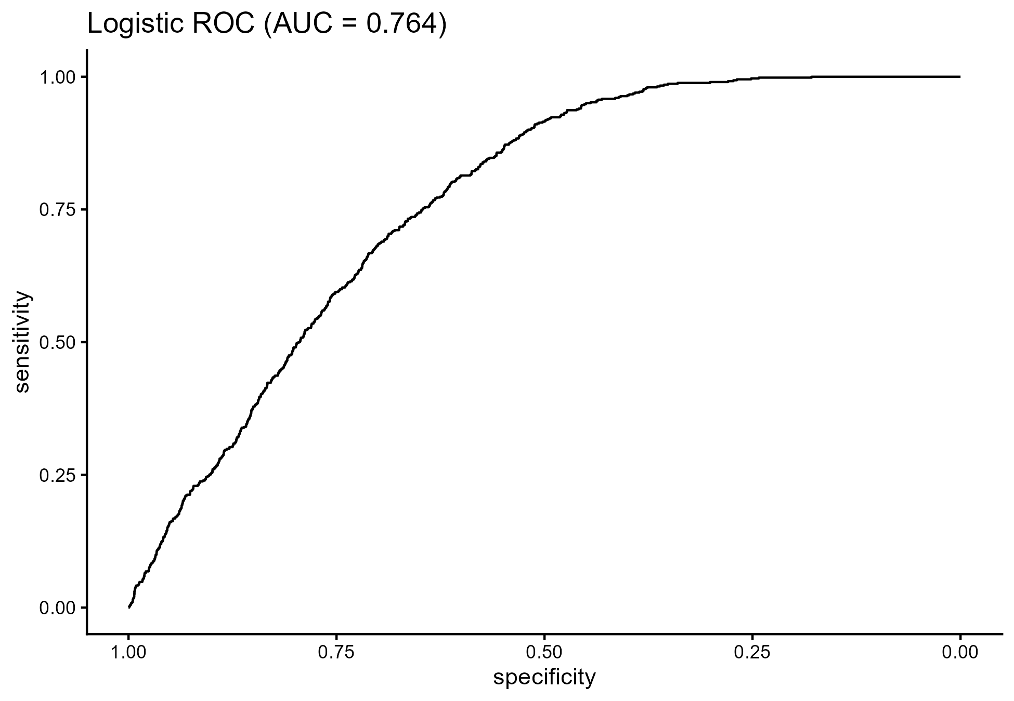

Figure 1: Logistic ROC (AUC = 0.764)

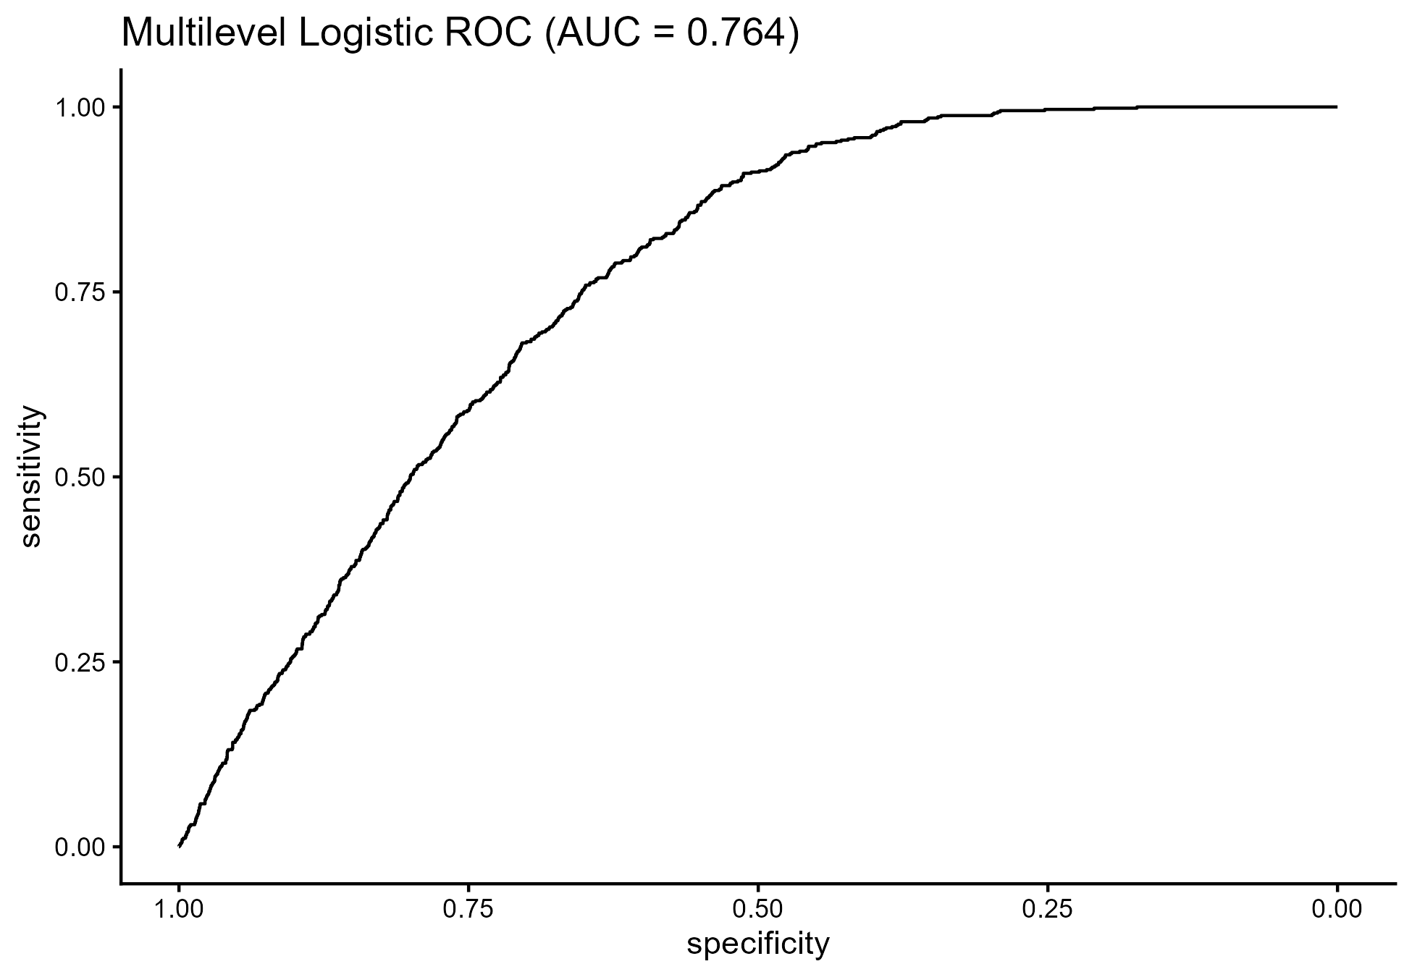 Figure 2: Multilevel Logistic ROC (AUC = 0.764)
The multilevel specification in Figure 2 introduced a random intercept for region to account for unmeasured contextual differences. The near-identical AUC to the single-level model and the limited random-effect variance indicate that, in this dataset, regional clustering plays a modest role once individual and household covariates are included. This contrasts with some multi-country and spatial analyses that report strong geographic clustering of under-five mortality, and suggests that within Ghana, equity gaps may be driven more by household-level circumstances and service access than by regional boundaries alone. This pattern aligns with work showing that when health systems and infrastructure are moderately diffused across regions, within-region inequalities can dominate between-region gaps.
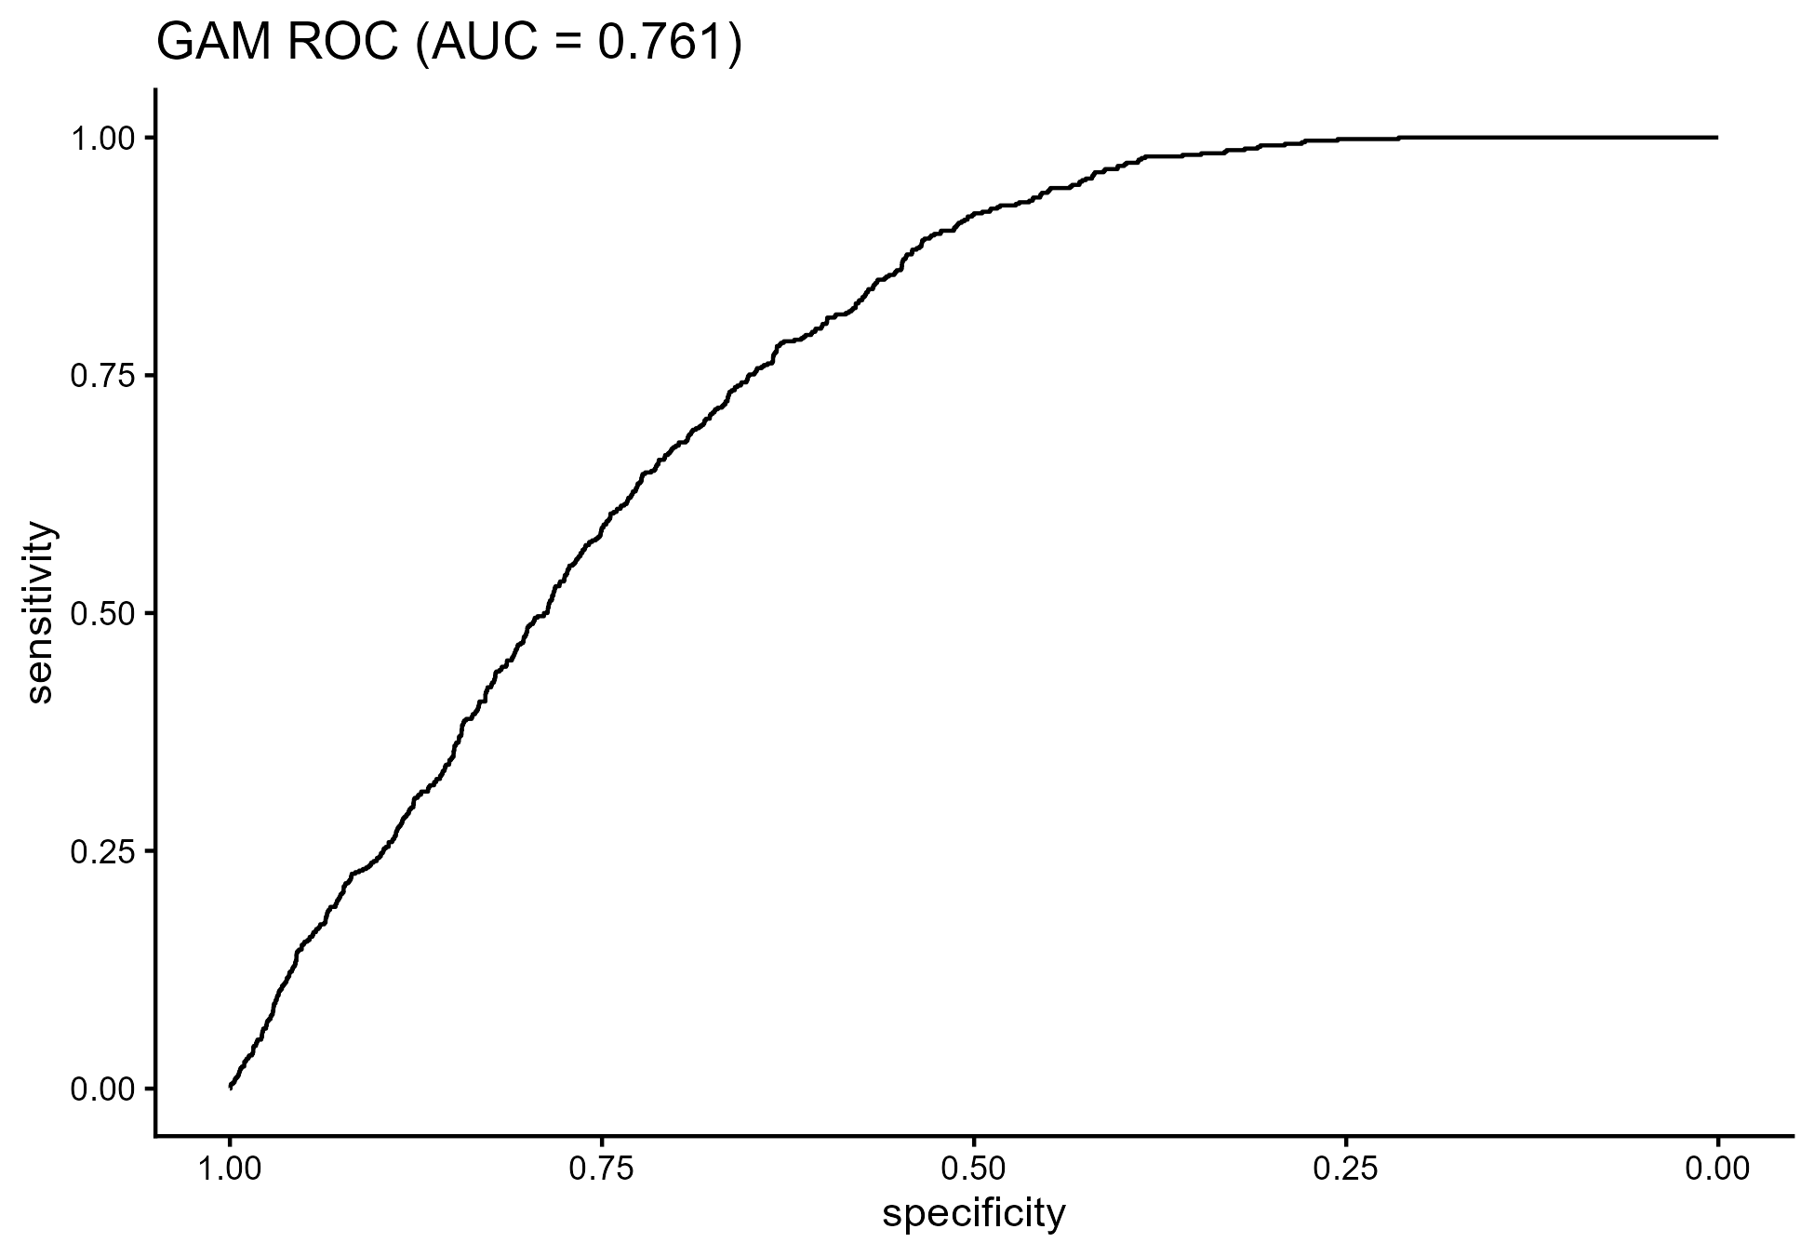

Figure 3: GAM ROC (AUC = 0.761)
The generalized additive model provides additional insight into functional forms that underlie these associations. The parametric component in Table 1 identifies residence (res2), sex of household head (sexhh2), and sex of child (sexc2) as key determinants of survival. Children in the more advantaged residence category exhibit higher odds of survival, while having a female (or non-reference) household head and being in the non-reference child sex category are associated with lower survival. These associations are consistent with literature linking residential context and gender-related power structures to differential access to resources, time, and caregiving. The marginal effects of safe water source (sodw2) and health facility delivery (hel1) point in protective directions, which reinforces the well-established pathways between environmental health, obstetric care, and child survival.

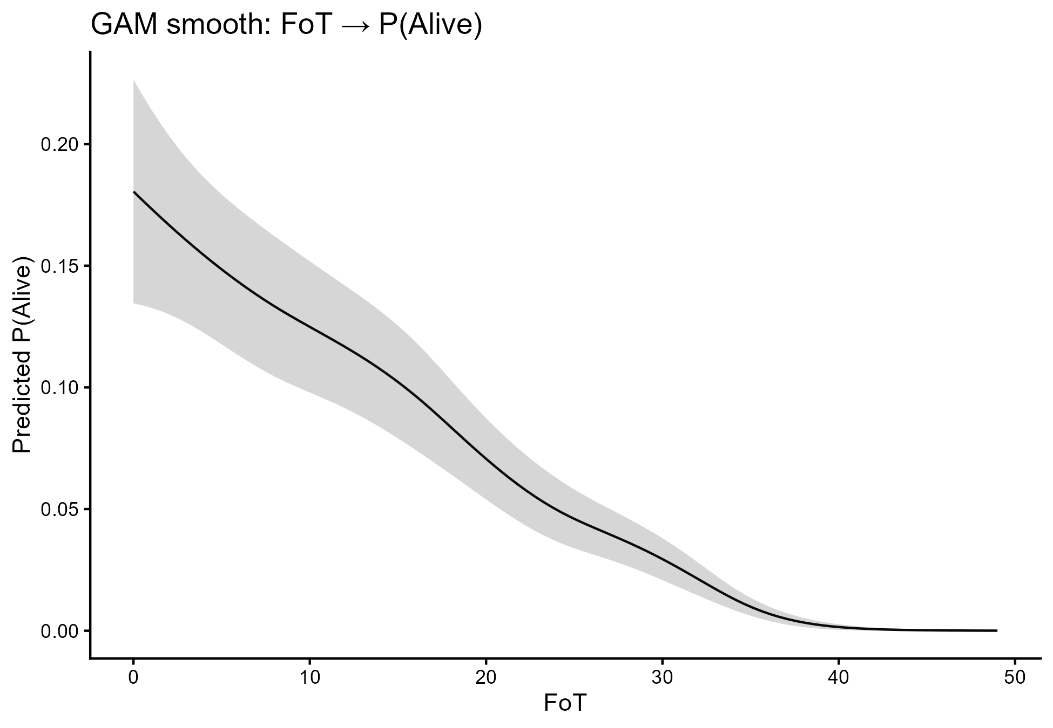 Figure 4: GAM Smooth for FoT

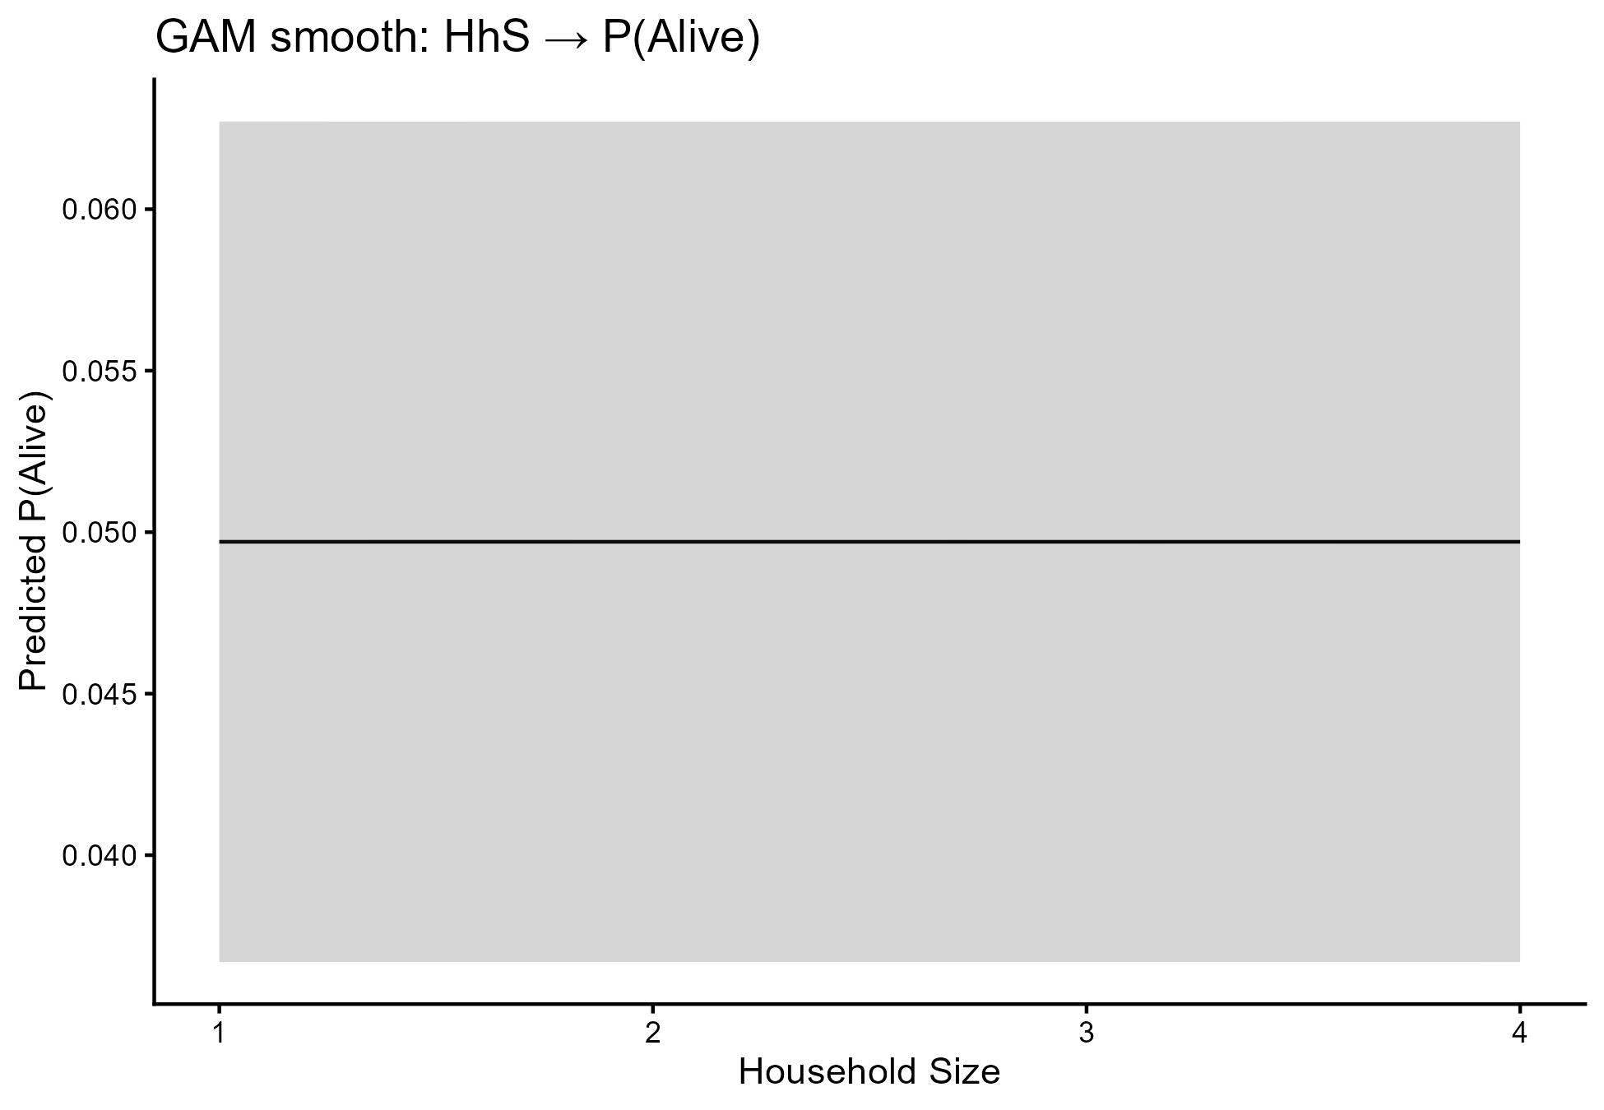 Figure 5: GAM Smooth for Household Size
The smooth terms in Figures 4 and 5 further advance understanding of the risk structure. The FoT smooth in Figure 4 displays a monotonic decline in mortality risk with increasing paternal age, with the steepest risk gradient at younger ages. This suggests that very young fathers may face economic instability, lower health literacy, or reduced bargaining power in household decisions, which translate into higher mortality for their children. The flattening of the curve at higher ages signals diminishing marginal benefit, indicating that interventions should be particularly concentrated among younger fathers and their households. In contrast, the essentially flat GAM smooth for household size in Figure 5 indicates that household size does not exert an independent effect once wealth, residence, water, and service variables are accounted for. This finding helps resolve mixed evidence in the literature by showing that apparent household-size effects may largely proxy underlying socioeconomic or service constraints rather than exerting an autonomous influence.
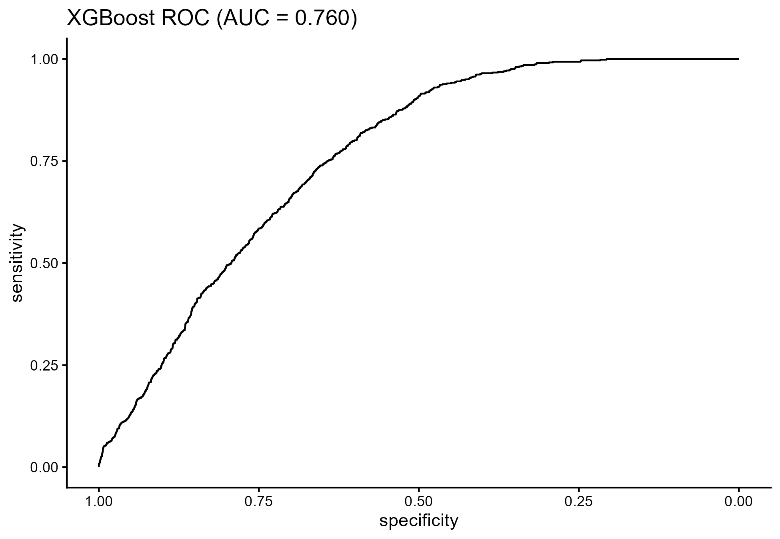
Figure 6: XGBoost and Explainability
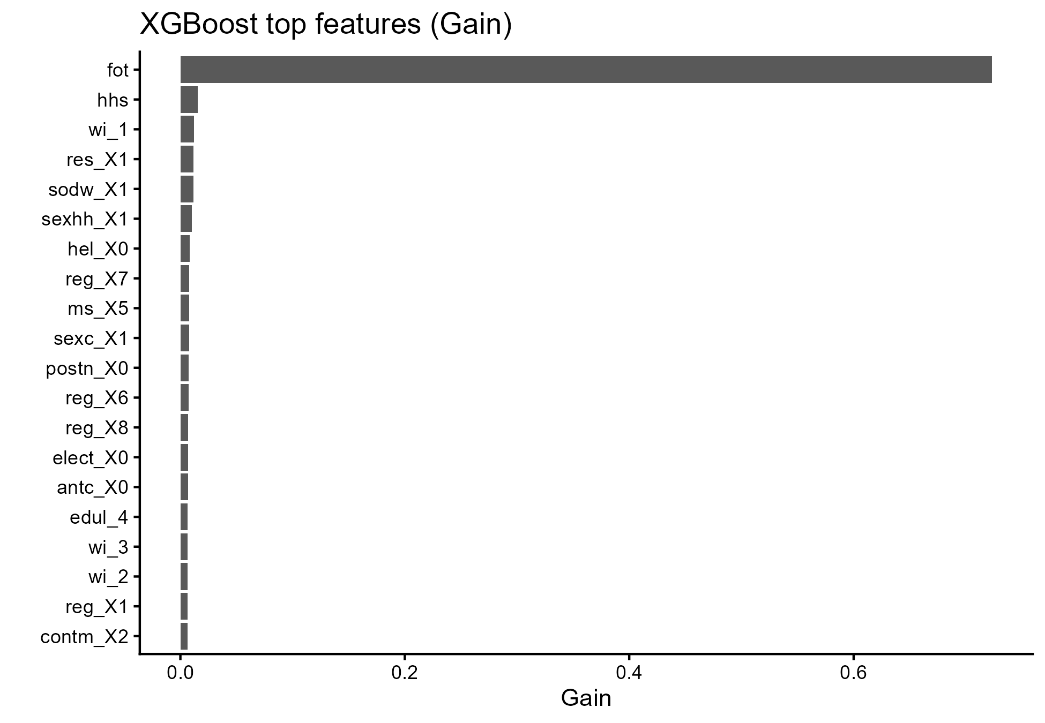

Figure 7: Top Features by Gain
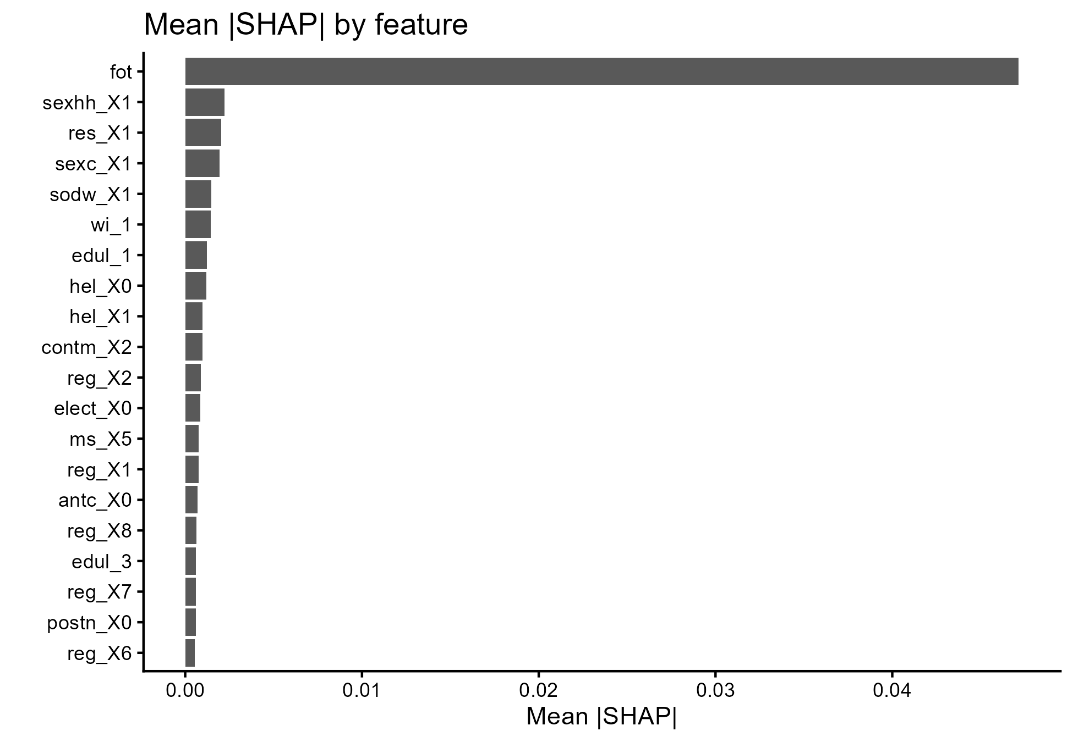

Figure 8: Mean SHAP by Feature
The XGBoost model and associated explainability outputs in Figures 6–8 provide an important bridge between predictive power and interpretability. Despite using a fully nonparametric tree-based ensemble, XGBoost yields an AUC of about 0.760, very close to the parametric and semiparametric models. The top features by gain in Figure 7 and the mean SHAP values in Figure 8 both highlight FoT, sex of household head, residence, wealth, and water source as major drivers of predicted survival. The agreement between SHAP-derived importance and the GAM/logistic coefficients strengthens confidence in these variables as robust determinants rather than model-specific artefacts. This triangulation is a central methodological contribution: combining GAM smooths, multilevel structures, and explainable machine learning in a unified pipeline demonstrates that key risk factors are consistently influential across distinct modeling philosophies.
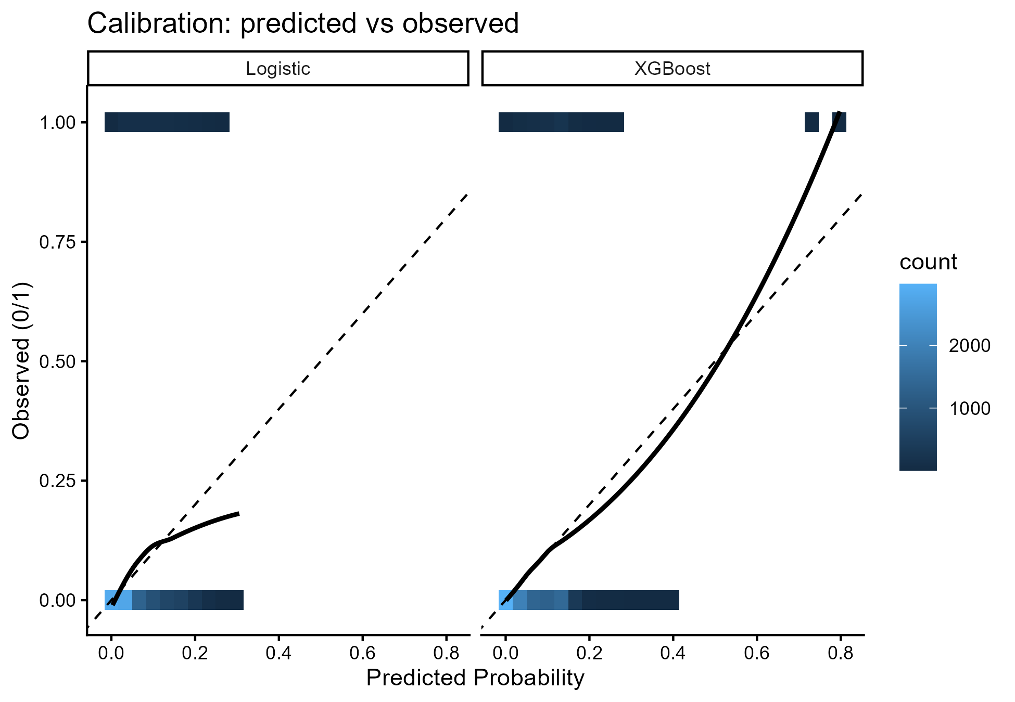

Figure 9: Calibration Plots
Calibration analysis in Figure 9 shows that the models produce probabilities that are broadly aligned with observed risks, with logistic regression tending to be conservative at the low-risk end and XGBoost showing sharper alignment at higher risk levels. From a policy perspective, this calibration behaviour is crucial. Referral thresholds for outreach, case management, or targeted subsidies can be set using well-calibrated probabilities so that limited resources are concentrated on those children at genuinely elevated risk. In the context of SDG 3 (Good Health and Well-being), SDG 6 (Clean Water and Sanitation), and SDG 10 (Reduced Inequalities), calibrated risk scores provide an operational tool for targeting interventions toward the most vulnerable while maintaining transparency and fairness.
Overall, the findings show that under-five survival in Ghana is strongly shaped by paternal age, residence, household gender structure, water source, and maternal-newborn service use. The combination of logistic regression, multilevel logistic regression, GAM, and XGBoost within a single analytical framework, supported by ROC curves (Figures 1-3), GAM smooths (Figures 4-5), explainability plots (Figures 6-8), and calibration diagnostics (Figure 9), offers a comprehensive and methodologically novel lens on child survival. These results support a policy emphasis on strengthening perinatal and postnatal services, expanding access to safe water, and addressing gendered and residential inequities that constrain caregiving and service use.
The first major finding is that all four modeling approaches; logistic regression, multilevel logistic regression, GAM, and XGBoost, achieved very similar discrimination, with AUC values clustered between 0.760 and 0.764 as presented in Table 2. This indicates that the survival signal is stable and robust across classical, semiparametric, and machine learning paradigms, which increases confidence in the reliability of the identified determinants.
The second key finding concerns the structure of regional versus household-level effects. The multilevel logistic model in Figure 2 shows that introducing region as a random intercept yields negligible gains in AUC relative to the single-level logistic model in Figure 1, and the estimated random-effect variance is small. This implies that, conditional on the observed covariates, under-five survival disparities in Ghana are driven primarily by individual and household-level factors rather than by large regional differences.
The third major finding arises from the GAM and its smooth functions. The GAM summary in Table 1, together with the smooths in Figures 4 and 5, identifies paternal age (FoT), residence, sex of household head, sex of child, safe water, and facility delivery as key determinants. Paternal age displays a strong nonlinear relationship with survival, with higher risk at very young paternal ages and diminishing benefit at higher ages. Household size, in contrast, shows no independent effect after adjustment, indicating that policies should focus on service and environmental conditions rather than household size per se.
The fourth finding is that XGBoost, combined with SHAP-based explainability, replicates and reinforces the importance of the same core predictors. Figures 6-8 show that FoT, sex of household head, residence, wealth, and water source dominate feature importance and SHAP contributions. This agreement across parametric, semiparametric, and machine learning models demonstrates that the identified factors are not model-specific artefacts, but genuine structural determinants of under-five survival.
Finally, calibration analysis in Figure 9 and the discrimination summary in Table 2 show that the models not only classify risk well but also produce probabilities that can be used operationally. This combination of discrimination and calibration allows the models to inform prioritisation of interventions under SDG 3, SDG 6, and SDG 10, including targeted support to households with young fathers, unsafe water sources, and constrained access to facility-based delivery and postnatal care.

Conclusion
This research developed and applied an integrated modeling framework to identify and interpret the determinants of under-five survival in Ghana using nationally representative data. By combining logistic regression, multilevel logistic regression, generalized additive models, and XGBoost with SHAP-based explainability, the study demonstrated that a relatively small set of factors-paternal age, residence, sex of household head, sex of child, household wealth, water source, and maternal-newborn service utilisation-reliably structure child survival risk. The convergence of ROC-based discrimination (Figures 1-3), GAM parametric and smooth components (Table 1, Figures 4-5), machine learning feature importance and SHAP profiles (Figures 6-8), and calibration plots (Figure 9), together with the AUC comparison in Table 2, provides a coherent and robust evidence base.
The methodological contribution lies in the triangulation of classical statistical modeling, flexible semiparametric techniques, and explainable machine learning within a single pipeline applied to under-five survival. This approach addresses long-standing limitations in the literature related to linearity assumptions, underutilisation of nonlinearity, and opacity of black-box models. The framework shows that it is possible to retain interpretability while embracing modern machine learning tools, and to align predictive modeling with the SDG agenda by explicitly linking risk structures to SDG 3, SDG 6, and SDG 10.
The substantive implications are clear. Health and social policy should prioritise universal, high-quality maternal and newborn care, including antenatal, delivery, and postnatal services, with particular attention to households headed by women, children of disadvantaged sex categories, and households with younger fathers. Investments in safe drinking water and basic environmental health infrastructure remain central for improving survival, aligning with SDG 6. The limited incremental contribution of regional random effects suggests that policies should address household-level inequities within all regions rather than assuming uniform regional deficits, which aligns with SDG 10’s focus on reducing inequalities within countries.
Several limitations should be acknowledged. The data are cross-sectional, so causal pathways cannot be fully established and temporal dynamics in risk cannot be captured. Residual confounding from unmeasured factors such as detailed maternal health status, intra-household decision processes, and community-level service quality is likely. Outcome classification depends on survey reporting, which may introduce misclassification errors. The ML explainability rests on SHAP approximations, which, although powerful, still depend on model structure and feature encoding choices. Future research can extend this work by incorporating time-to-event methods, spatially explicit random effects, and richer service quality metrics, as well as by validating the models prospectively within health system workflows.
Despite these constraints, the study shows that an integrated, explainable modeling pipeline can meaningfully inform child survival policy. Embedding such models into routine health information systems would support proactive, data-driven identification of high-risk households and guide targeted interventions that accelerate progress toward ending preventable deaths among children under five.

Declarations
The data supporting this study are publicly available
Data availability statement Repository Link: https://osf.io/ghn3y/

Ethical Considerations and Reproducibility
The dataset was fully anonymized, with no identifiable personal information. Analytical scripts, processed datasets, and code for figure generation are openly available for verification and reuse.
All computations adhere to FAIR (Findable, Accessible, Interoperable, Reusable) data principles, supporting transparent and replicable research.
References
Adeyinka, D. A., & Muhajarine, N. (2024). Disentangling the link between social determinants of health and child survival in Nigeria during the Sustainable Development Goals era: a hierarchical path analysis of time-to-event outcome. Journal of Biosocial Science, 56(2), 357-375.
Amir-ud-Din, R., Kumar, R., Naeem, N., & Khan, M. (2024). Air pollution and under-5 child mortality: linking satellite and IPUMS-DHS data across 41 countries in South Asia and Sub-Saharan Africa. BMC Public Health, 24(1), 2996.
Arana-Ovalle, R., Dillon, L., Murua, A., & Zamudio-Sánchez, F. J. (2025). Dynamic interplay of kinship and net-fertility: a comprehensive analysis across demographic transitions in Mexico. The History of the Family, 1-32.
Ashwini, C., Bose, S. R., Padmavathy, M. D., Raj, C., & Ajay, J. C. (2024). Predicting Child Mortality With Diverse Regression Algorithms Using a Machine Learning Approach. Advancing Intelligent Networks Through Distributed Optimization, 329-352.
Birhanie, A. L., Tessema, Z. T., Endalew, B., & Tamirat, K. S. (2025). Under-five mortality and its associated factors in sub-Saharan Africa: a multilevel analysis of recent demographic and health surveys data based on Bayesian approach. BMC pediatrics, 25(1), 103.
Chaku, S. E., Nwaze, N. O., Musa, G. K., & Adehi, M. U. (2025). Flexible accelerated failure time model with spatial dependency: application to under-five mortality rate. Journal of the Royal Statistical Society Nigeria Group (JRSS-NIG Group) ISSN NUMBER: 1116-249X, 2(1), 430-452.
Dhage, V. D., & Nagtode, N. (2024). Health problems among under-five age group children in developing countries: a narrative review. Cureus, 16(2).
Faruk, M. O., Zahangir, M. S., Akhter, S., Prome, J. F., Akter, N., & Tasnim, J. (2025). A review of the impact of socio-economic, demographic and cultural factors on child mortality. Discover Public Health, 22(1), 141.
Fenta, H. M., Chen, D. G., & Zewotir, T. T. (2024). Geostatistical analysis of under-five children mortality and associated factors across sub-Saharan African countries. In Biostatistics Modeling and Public Health Applications: Study Design and Analysis Methodology in Health Sciences, Volume 1 (pp. 231-256). Cham: Springer Nature Switzerland.
Frimpong, P. B., Dramani, J. B., & Adusah-Poku, F. (2025). The impact of housing quality on child survival in Ghana. International Journal of Housing Markets and Analysis.
Gazze, L. (2024). Hassles and environmental health screenings: Evidence from lead tests in Illinois. Journal of Human Resources, 59(4), 1090-1121.
Headen, I. (2025). Structural Racism, Geographies of Opportunity, and Maternal Health Inequities: A Dynamic Conceptual Framework. Journal of racial and ethnic health disparities, 1-18.
Iddrisu, A. K., & Boanyo, E. (2025). Survival analysis of under-five mortality and associated risk factors using survival analysis approaches. PLOS Global Public Health, 5(9), e0005179.
Kefale, B., Jancey, J., Gebremedhin, A. T., Pereira, G., & Tessema, G. A. (2025). Changes in the contributions of risk factors to under-five mortality in low-and lower-middle-income countries (1997–2022): an analysis of Demographic and Health Survey data. World Journal of Pediatrics, 1-13.
LaFave, L. A., Clemmons, N., Kotelchuck, M., Morales Cozier, N., Geltman, A., Browne, D. R., & Kenyon, K. (2024). Activating Life Course Theory through a Whole System Prevention Framework to Address the Wicked Problem of Maternal and Infant Morbidity and Mortality. Community Health Equity Research & Policy, 44(4), 349-364.
Mahama, T. (2025). Developing Multilevel Logistic Regression Models for Predicting Cancer Outcomes from Population Health Surveys. Int J Adv Res Publ Rev [Internet], 2(05), 443-64.
Mazumder, T., Mohanty, I., Ahmad, D., & Niyonsenga, T. (2024). An analysis of cause-specific under-5 mortality in Bangladesh using the demographic and health survey 2011 and 2017–2018. BMC pediatrics, 24(1), 572.
Mazumder, T., Mohanty, I., Ahmad, D., & Niyonsenga, T. (2025). From parental education to under-5 mortality: how antenatal care and hand hygiene mediate the pathway mechanisms. BMC Public Health, 25(1), 1976.
Natarajan, J., Vimal, P. H., Sen, D., Lawrence, C., Eswaran, S., Chintale, P., & Patil, S. A. (2025). Machine Learning-Based Maternal and Child Mortality Rate Prediction Using Random Forest Algorithm. In Revolutionizing Healthcare Services (pp. 251-266). CRC Press.
Naznin, S., Uddin, M. J., & Kabir, A. (2025). Identifying determinants of under-5 mortality in Bangladesh: A machine learning approach with BDHS 2022 data. PloS one, 20(6), e0324825.
Olawade, D. B., Wada, O. Z., Aderinto, N., Odetayo, A., Adebisi, Y. A., Esan, D. T., & Ling, J. (2025). Factors contributing to under-5 child mortality in Nigeria: A narrative review. Medicine, 104(1), e41142.
Olusola, J. A., Oyinloye, A. A., Akeju, K. F., Ogunsakin, R. E., & Moyo, S. (2025). Spatial analysis of under-five mortality in Africa using geographically weighted poisson regression. Discover Public Health, 22(1), 1-19.

Osei, C. K., & Nketiah-Amponsah, E. (2024). Exploring the policy implications of household wealth differentials and under-five child deaths in Ghana. Discover Public Health, 21(1), 9.
Rahman, A., & Rahman, M. H. (2025). Explore the factors related to the death of offspring under age five and appraise the hazard of child mortality using machine learning techniques in Bangladesh. BMC Public Health, 25(1), 360.
Rajapakse, V., Fernando, A., Sudangama, N., Adikari, D., Sundaram, A., & Jayathilaka, R. (2025). Economic and healthcare determinants of under-five mortality in low-income countries. BMC Public Health, 25(1), 2126.
Satty, A., Khamis, G. S. M., Mohammed, Z. M., Mahmoud, A. F., Abdalla, F. A., Salih, M., ... & Gumma, E. A. (2025). Statistical Insights Into Machine Learning Models for Predicting Under-Five Mortality: An Analysis From Multiple Indicator Cluster Survey (MICS). IEEE Access, 13, 45312-45320.
Souza, J. P., Day, L. T., Rezende-Gomes, A. C., Zhang, J., Mori, R., Baguiya, A., ... & Oladapo, O. T. (2024). A global analysis of the determinants of maternal health and transitions in maternal mortality. The Lancet Global Health, 12(2), e306-e316.
Wiysonge, C. S., Uthman, M. M., Ndwandwe, D., & Uthman, O. A. (2025). Multilevel Analysis of Zero-Dose Children in Sub-Saharan Africa: A Three Delays Model Study. Vaccines, 13(9), 987.

SUPPLEMENTARY MATERIALS
Appendices

Data Characteristics and Nature of Variables
The outcome variable, Child Alive Status (ChA), is binary-coded as 1 = Alive and 0 = Not Alive. Predictor variables include both quantitative and categorical covariates:
Variable | Description | Type
FoT | Father’s Age (years) | Continuous
HHS | Household Size | Continuous
WI | Wealth Index | Ordinal (1–5)
EduL | Maternal Education Level | Ordinal (0–3)
Reg | Region | Categorical (16 levels)
Res | Residence Type (Urban/Rural) | Binary
SexHH | Sex of Household Head | Binary
SoDW | Source of Drinking Water | Categorical
ToLF | Type of Toilet Facility | Categorical
Elect | Access to Electricity | Binary
SexC | Sex of Child | Binary
PostN | Postnatal Care Attendance | Binary
ANTC | Antenatal Care Attendance | Binary
MS | Marital Status | Categorical
ContM | Contraceptive Use | Binary
HEL | Health Facility Delivery | Binary
Continuous variables (FoT, HhS) were normalized, and ordinal predictors (WI, EduL) were encoded as ordered factors. All categorical variables were converted into one-hot dummy representations using the recipes package in R to ensure compatibility with both parametric and nonparametric modeling frameworks.

