Aquifer Vulnerability Assessment near Selected Dumpsites in a Basement Complex Terrain

ABSTRACT
The risk of aquifer contamination is increasing in areas underlain by Basement Complex terrain due to continuous waste disposal. This study develops a composite aquifer vulnerability map for selected dumpsites using a modified version of the DRASTIC model, referred to as DRASTIC-L. Unlike the traditional DRASTIC framework, which evaluates seven hydrogeological parameters; depth to groundwater, net recharge, aquifer media, soil media, impact of the vadose zone, and hydraulic conductivity. The DRASTIC-L model incorporates land use as an additional factor. Vulnerability mapping was carried out in ArcGIS using inputs from Vertical Electrical Soundings (VES), remote sensing, and hydrogeological surveys. The VES campaign comprised 56 depth soundings with electrode separations up to 65 m, while remotely sensed parameters were derived from LANDSAT 7 ETM+ imagery and a Digital Elevation Model (DEM). The DRASTIC-L Vulnerability Index (DVI) was calculated by assigning ratings (1–10) and weights (1–5) to each parameter. The study classified the area into five vulnerability zones: very high, high, medium, low, and very low. Findings indicate that several dumpsites are located in high-vulnerability zones, posing significant risks to groundwater quality. Model validation using water sample analysis confirmed an accuracy of 76%, highlighting the importance of improved waste management practices for groundwater protection.
Keywords: DRASTIC-L, Groundwater, Vulnerability, DRASTIC, Dumpsites

INTRODUCTION
Groundwater is a vital component of the life support system and plays a crucial role in economic development (Saatsaz et al., 2011). In recent decades, the reliance on groundwater has significantly increased, with over 2 billion people worldwide depending on it to meet their drinking water needs (Senthilkumar et al., 2014). However, water scarcity and contamination have emerged as major global challenges, making the preservation of groundwater quality essential to ensure access to safe water for billions of people (World Wildlife Fund, 2019).
The concept of aquifer vulnerability was first introduced by Margat in 1968, and since then, various definitions have been proposed. For instance, Lobo-Ferreira (1999) defined aquifer vulnerability as the sensitivity of groundwater quality to an imposed contaminant load, determined by the intrinsic characteristics of the aquifer. Similarly, Hirata and Bertolo (2020) described groundwater vulnerability as “the property of a groundwater system that depends on the sensitivity of the material in allowing the degradation of the saturated zone by pollutants originating from human activities.” The National Research Council (1993) defined it as “the relative ease with which a contaminant applied on or near the land surface can migrate to the aquifer of interest under specific hydrogeological conditions.”
In Nigeria, improper waste disposal is a significant environmental issue in many urban areas (Agumwamba, 2003). Large volumes of waste generated daily from industrial, residential, and institutional sources pose a risk of dangerous epidemics if not managed properly. Improper waste disposal can lead to groundwater contamination, as rainwater carries contaminants from open dumps and landfills into the subsurface, forming leachate that contains both biological and chemical pollutants (Dauda and Osita, 2003; Slomczynska and Slomczynski, 2004).
Various techniques exist for evaluating aquifer vulnerability, including the Analytical Hierarchy Process (AHP), Geophysical-based Integrated Electrical Conductivity (IEC), and the Groundwater hydraulic confinement-Overlying Strata-Depth to Water Table (GOD) method. However, the most widely used technique is the DRASTIC model, an empirical model developed by the US Environmental Protection Agency (US EPA) to assess groundwater contamination potential on a regional scale. The DRASTIC model, introduced by Aller et al. (1985), evaluates seven parameters: Depth to water, Recharge, Aquifer media, Soil media, Topography, Impact of the vadose zone, and Hydraulic conductivity. It uses hydrogeological data within a Geographic Information System (GIS) environment to compute an aquifer vulnerability index (Madjid and Omar, 2013).
Despite its widespread use, the traditional DRASTIC model does not account for the impact of land use, which significantly influences how contaminants reach groundwater. This study addresses this limitation by incorporating land use as an additional parameter into the DRASTIC model. By deriving a land use map and integrating it into the model, the study aims to provide a more realistic assessment of groundwater vulnerability to contamination.
Description of the Study Area
The study area is situated in Itaogbolu, within the Akure North Local Government Area of Ondo State, Nigeria. Geographically, it lies between 814607–815607 mN (Northing) and 747205–748405 mE (Easting) in the Universal Transverse Mercator (UTM) coordinate system, based on the WGS 84 datum. Covering approximately 2.2 km², the area is bordered to the north by Iju and Ikere Ekiti, to the south by Akure, and to the west and east by villages extending toward Ijare and Ogbese, respectively. The base map of the study area is presented in Figure 1.

Geology of the Study Area
Several researchers, including Rahaman (1976), Odeyemi (1976), and Owoyemi (1996), have conducted geological mapping and related studies in the Akure Metropolis and its surrounding areas. However, the specific study area, located within the Akure environment, is underlain by undifferentiated granite of the Basement Complex, as illustrated in Figure 2. Granitic rock outcrops are present in some parts of the area, exhibiting fine to medium grain textures, likely rich in biotite, feldspar, and quartz. Overall, the geological composition of the area can be described as monolithic.
METHODOLOGY
The data used in this research encompass the obtained hydro-geologic data, remotely sensed data analysis and Vertical Electrical Sounding (VES). The flowchart adopted methodology is presented in Figure 3 and the data acquisition map for the VES and the hydro-geological data is presented in Figure 4. The field geophysical data acquisition and layer parameter modelling was carried out; the potential of GIS technique modelling application was explored. This was followed by implementing the theory and principle of modified DRASTIC i.e. (DRASTIC-L) model. Details of each segment are highlighted in the following subsection.
Geophysical Investigation
A total of 56 Vertical Electrical Sounding (VES) data points were acquired in the study area using the Schlumberger array, with half-current electrode spacing (AB/2) ranging from 1 to 65 meters. Data acquisition was conducted using an Omega Resistivity Meter, while the locations of the VES stations were recorded in the Universal Transverse Mercator (UTM) coordinate system using a Geographic Positioning System (GPS) unit. The sounding data were acquired along roads, between houses and other available open spaces

(a) (b)
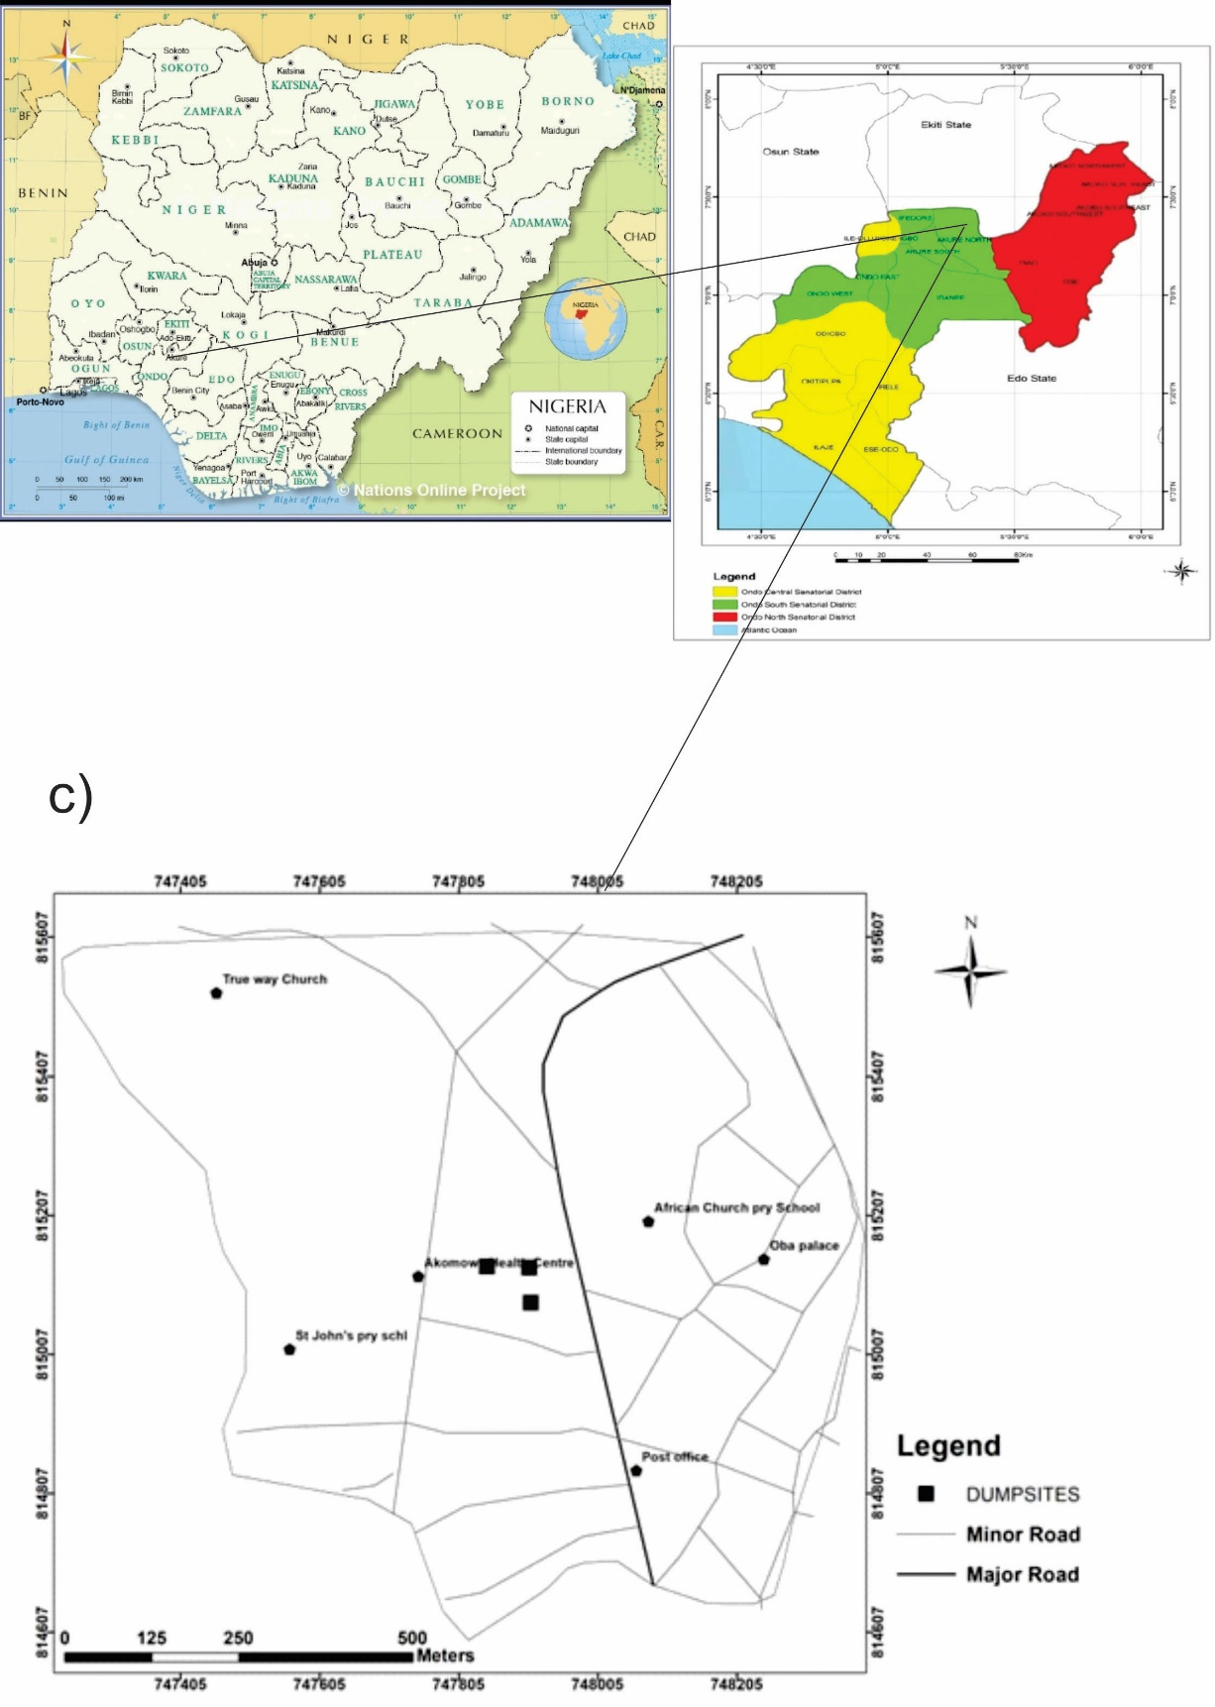
Figure 1: (a) Map of Nigeria; (b) Map of Ondo State; (c) Base Map of the Study Area
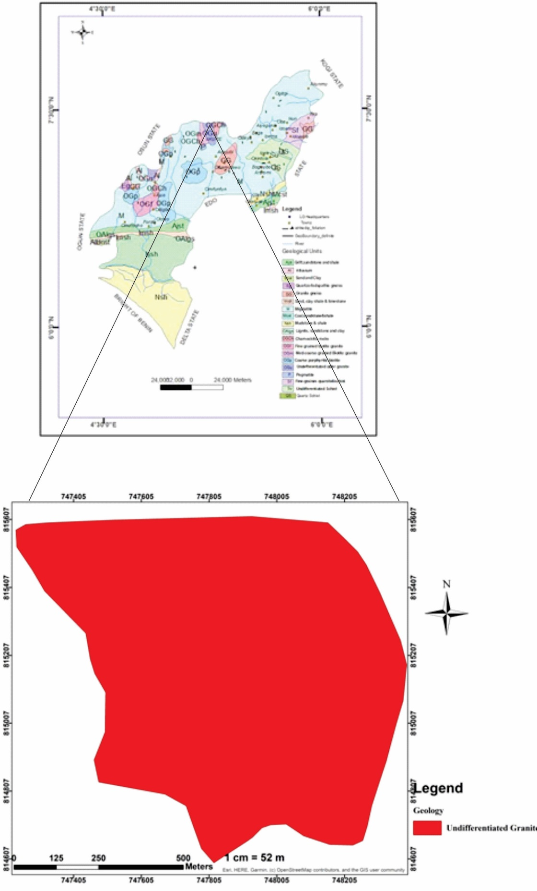

Figure 2: Geological Map of the Study Area

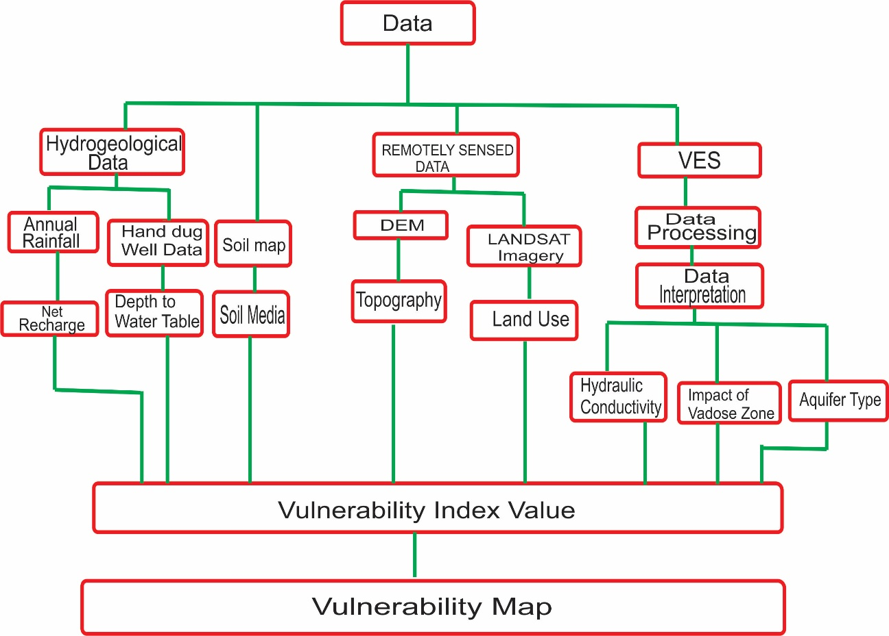

Figure 3: Methodology Flowchart for Groundwater Vulnerability Evaluation

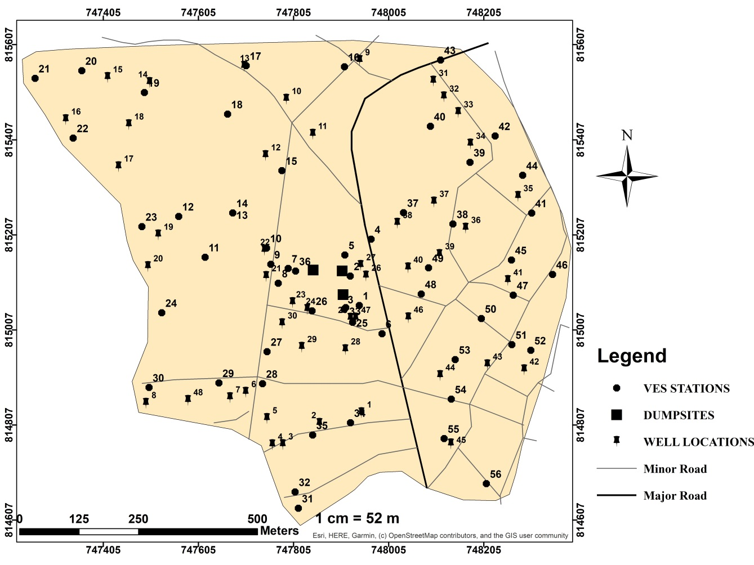
Figure 4: Data Acquisition Map of the Study Area showing the VES Stations and the Well Locations

Geophysical Data Processing and Interpretation
The Vertical Electrical Sounding (VES) data were processed by calculating the apparent resistivity (ρₐ) values, derived from the product of the measured resistance (R) and the geometric factor (G) corresponding to each electrode separation. The calculated apparent resistivity (ρₐ) values for each VES station were plotted against electrode spacing (AB/2) on a bi-logarithmic graph sheet. The resulting curves were qualitatively analyzed through visual inspection to determine subsurface layer characteristics. For quantitative interpretation, partial curve matching was performed on the field curves. The resistivity and thickness values obtained from curve matching were then used as initial model parameters in iterative forward modeling process, conducted using WinResist software (Vander Velpen, 2004). The derived geoelectric parameters; resistivity, thickness, and depth were instrumental in identifying aquifer thickness and aquifer resistivity, both of which are critical factors in groundwater vulnerability assessment.
Remotely Sensed Data Processing
The remotely sensed parameters for the study area were obtained using the Landsat 7 Enhanced Thematic Mapper Plus (ETM+) sensor and a Digital Elevation Model (DEM). These parameters were processed and converted into a compatible digital format, calibrated using the WGS84-UTM coordinate system, and integrated into the Geographic Information System (ArcGIS) software. The data were then visualized as maps to illustrate their spatial distribution across the study area. Interpolation was performed using ArcGIS analytical tools to enhance the accuracy and representation of the parameters.

Background sources and preparation of DRASTIC-L Parameters
(a) Depth to Water Table (D)
The depth to the groundwater table, which is the vertical distance between the land surface and the water table, is a critical factor in assessing an area's vulnerability to contamination. Generally, deeper water tables result in longer travel times for contaminants, reducing the likelihood of groundwater pollution. Conversely, areas with shallow water tables are more susceptible to contamination, as pollutants can easily percolate through runoff and recharge, reaching groundwater sources more quickly (Jaroslav and Zaporozec, 1994). In this study, the depth to the water table was measured directly in 48 randomly distributed wells across the study area using a measuring tape. The collected data were then interpolated using ArcGIS analytical tools to create a spatial map representing the depth to the water table across the region.
(b) Net Recharge (R)
Net recharge is a critical factor in the movement of contaminants, as it represents the amount of water that infiltrates the ground surface and reaches the aquifer. Water acts as a carrier for contaminants, meaning that higher volumes of recharge increase the likelihood of transporting pollutants into groundwater systems. In this study, groundwater recharge from rainfall was estimated using the norms established by the Groundwater Estimation Committee (1997). The committee developed specific guidelines for calculating recharge based on rainfall infiltration, which vary depending on the geological characteristics of the area. These norms are outlined as follows:
- Alluvial Areas:
  - Sandy areas: Recharge is estimated at 20–25% of rainfall.
  - Areas with high clay content (over 40% clay): Recharge is estimated at 10–20% of rainfall.
- Semi-Consolidated Sandstones:
  - Recharge is considered to be 10–15% of rainfall.
- Hard Rock Areas:
  - Granitic Terrain:
    - Weathered and fractured rocks: Recharge is 10–15% of rainfall.
    - Un-weathered rocks: Recharge is 5–10% of rainfall.
  - Basaltic Terrain:
    - Weathered and fractured rocks: Recharge is 10–15% of rainfall.
    - Un-weathered basalt: Recharge is 4–10% of rainfall.
These guidelines provide a framework for estimating groundwater recharge based on regional rainfall and geological conditions, aiding in the assessment of contaminant migration potential. The Recharge Coefficient (Rₐₒₑff) is defined as the ratio of recharge to effective rainfall, representing the portion of effective rainfall that contributes to groundwater aquifers. It is expressed as a percentage (Allocca et al., 2014; Muteraja, 1986) and is calculated using the following formula:
${ R}_{coeff}=\frac{R}{P_{e}}$ (1)
Where $R_{coeff}$ is the recharge coefficient, R is the net-recharge and $P_{e}$ is effective rainfall.
$R=$ $R_{coeff}×P_{e}$ (2)
Equation 2 was utilized to estimate the net recharge by analyzing the annual rainfall and the recharge coefficient derived from the soil map of the study area. The recharge coefficient (Rₐₒₑff) for the study area is 1805.9 mm/year (Olujumoke et al., 2016). For sandy areas (including sandy-clay and clayey-sand), the percentage estimate (Pₑ) ranges from 20% to 25%, with an average of 22.5%. The recharge (R) is calculated as follows:
$R= \frac{22.5}{100}×1805.9=406 mm/year$
Percentage estimate $(P_{e})$for Hard rock (Granitic terrain) = 5-10% with an average of 7.5%, R is calculated thus:
$R= \frac{7.5}{100}×1805.9=135 mm/year$
Percentage estimate $(P_{e})$for area with high clay content (about 40% clay) = 10-15% with an average of 12.5% calculated thus;
$R= \frac{12.5}{100}×1805.9=225 mm/year$
(c) Aquifer Type
The aquifer media refers to the consolidated or unconsolidated materials that form the water-bearing subsurface hydrogeological environment. This saturated zone plays a crucial role in controlling the attenuation of pollutants as they move through the groundwater system. In this study, the nature of the aquifer media was determined using resistivity values obtained from interpreted Vertical Electrical Sounding (VES) data. These resistivity values were cross-referenced with Table 1 to identify the specific characteristics of each aquiferous unit.
Table 1: Lithological Rating in terms of Resistivity Values, (Idornigie et al., 2006)
Apparent resistivity Value (Ohm-m) | Lithology
<100 | Clay
100-350 | Sandy clay
350-750 | Clay sandy
>750 | Sand/Lateritic/Bedrock

(d) Soil Media
The uppermost weathered portion of the unsaturated zone is referred to as the soil media. The characteristics of the soil significantly influence the movement of recharge water infiltrating into the aquifer, as well as the downward migration of contaminants into the vadose zone. This parameter was determined using the soil map of the study area, which was developed by collecting soil samples from various locations. The sampling points were recorded using a Geographic Positioning System (GPS), and each location was classified based on its corresponding soil type.
(e) Topography (Slope)
Slope has an inverse relationship with groundwater vulnerability. In hilly terrains with steep slopes, runoff is high, reducing the time available for water to infiltrate into the aquifer. Conversely, areas with gentler slopes retain water for longer periods, increasing the potential for pollutant infiltration into the groundwater. The topography of the study area was analyzed using a Digital Elevation Model (DEM), with slope estimation performed through spatial analysis. The slope tool in ArcGIS software calculates the maximum rate of elevation change between a given cell and its neighboring cells, identifying the steepest downhill descent.
(f) The Vadose Zone
The vadose zone is the unsaturated layer above the water table, playing a crucial role in determining groundwater contamination potential. Its ability to attenuate contaminants depends on the material composition within this zone, which influences the reduction of pollutants before they reach the aquifer. The vadose zone characteristics were determined using the apparent resistivity values of the lithologic layers above the aquifer. Based on Table 1, aquifers were classified into different units according to their resistivity values: layers with apparent resistivity of less than 100 Ωm were identified as clay, 100–350 Ωm as sandy clay, 350–750 Ωm as clayey sand, and values exceeding 750 Ωm as lateritic material or bedrock.
(g) Hydraulic Conductivity
Hydraulic conductivity refers to the ability of water-bearing subsurface layers, whether confined or unconfined aquifers, to transmit water, thereby regulating the rate of groundwater flow under a given hydraulic gradient (Theis, 1935; Singh & Gupta, 1986). In this study, the hydraulic conductivity of the aquifer was determined using the established relationship between hydraulic conductivity (K) and aquifer resistivity (ρ), as expressed in Equation 3.
$K=\frac{1}{ρ}$ (3)
Where K is the formation hydraulic conductivity and ρ is the aquifer layer resistivity.
(g) Land Use (L)
This process involves the management and modification of the natural environment to support various economic and cultural activities, such as agriculture, residential development, mining, industry, and recreation. Groundwater susceptibility to pollution is significantly influenced by different land use types and the associated activities involved in land development. Various land use patterns—such as urban, commercial, industrial, and agricultural—affect the concentration and distribution of contaminants (Ahsen et al., 2020). Key sources that alter hydrogeological properties include urban and industrial waste disposal, pesticide application, and seepage from septic tanks and waste dumping sites. The land use map of the study area was generated from a LANDSAT image (Figure 5), illustrating structural developments such as buildings and roads, as well as areas covered by vegetation and shrubs.
Modified DRASTIC modelling
DRASTIC is an empirical model designed to evaluate the potential for groundwater pollution by analyzing a weighted combination of seven hydrogeological factors: depth to water, net recharge, aquifer media, soil media, topography, impact of the vadose zone, and hydraulic conductivity of the aquifer (Aller et al., 1985). To improve the model's accuracy, the impact of land use was integrated, transforming the original seven-parameter DRASTIC model into an eight-parameter system known as DRASTIC-L, where "L" signifies land use. This modification was introduced to better reflect the critical role land use plays in influencing the movement of contaminants into groundwater systems.
Preparation of DRASTIC-L Vulnerability Map
The eight parameters were digitized into a compatible format and converted into raster data using ArcGIS, calibrated with the WGS84-UTM coordinate system. Each parameter was classified according to its relative ratings and weights to facilitate overlay analysis.
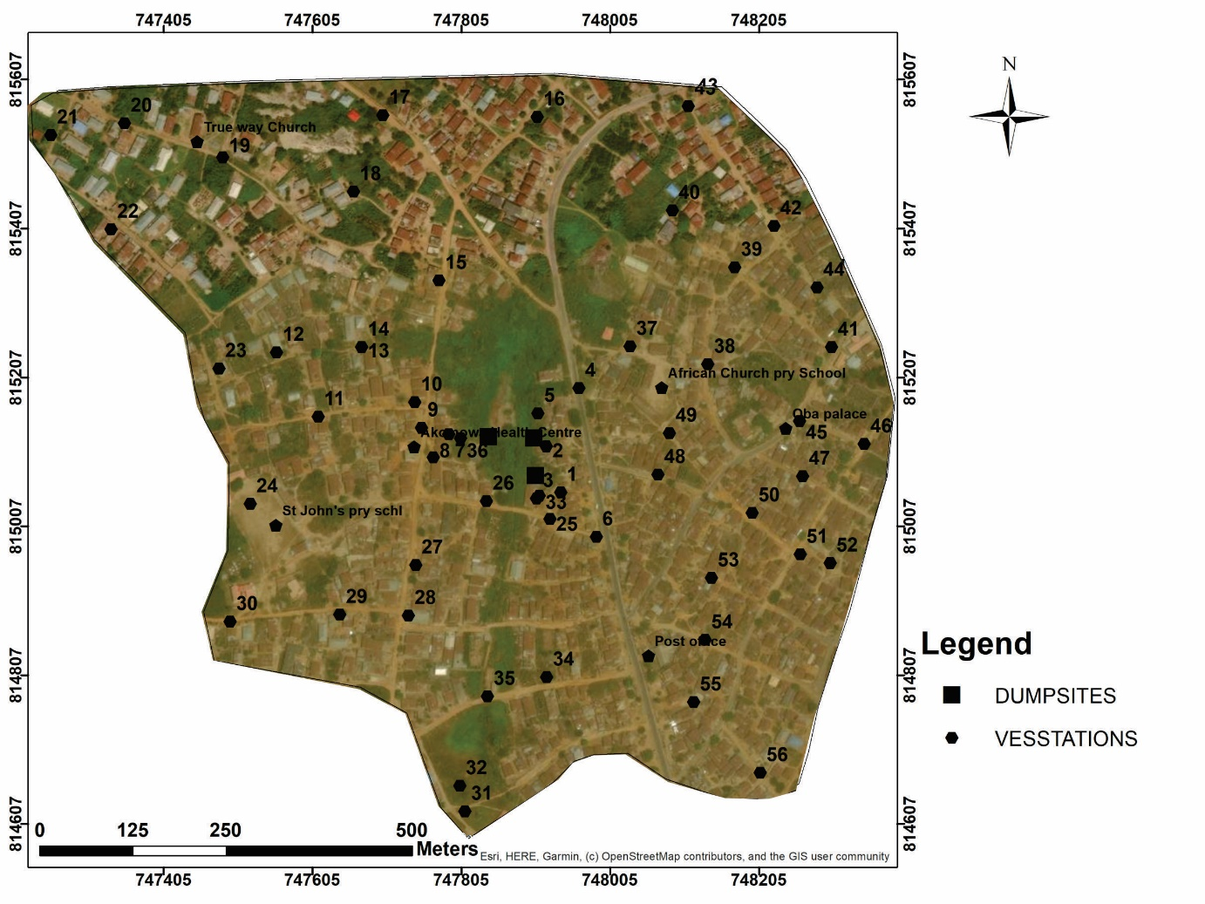
Figure 5: Satellite Image of the Study Area
Ratings and weights were assigned to each of the eight parameters for the vulnerability assessment. The parameters were categorized on a scale of 1 to 10, with 1 indicating the least vulnerable areas and 10 representing the most vulnerable areas. These ratings were further weighted based on the relative significance of each parameter in affecting the aquifer's susceptibility to contamination. The weighting scale ranged from 1 to 5, where 1 signifies the least important and 5 denotes the most critical parameters. Detailed information on the assigned weights and ratings for each parameter is provided in Table 2 and Table 3, offering a thorough overview of the vulnerability assessment framework.
Table 2: Weights and Ratings allocated to Various Factors used in the Groundwater Vulnerability Assessments (Modified after Aller et al., 1987).
DRASTIC Parameters | Range |  | Rating |  | Weight | Total Weight
Depth to Water Table (m) | 0 – 1.5  1.5-4.6  4.6-9.1  9.1-15.2  15.2-22.8  >30.4 |  | 10  9  7  5  3  1 |  | 5 | 50  45  35  25  15  5
Net Recharge (mm/year) | <50  50-100  100-175  175-250  >250 |  | 1  3  6  8  9 |  | 4 | 4  12  24  32  36
Aquifer Type | Massive Clay  Sand and Clay  Clay, Gravel and Sand  Sandy Gravel |  | 1  2  4  8 |  | 3 | 3  6  12  24
Soil Media | Absent  Gravel-sand  Sandy loam  Sandy Clay  Clay  Laterite |  | 10  9  8  3  2  1 |  | 2 | 20  18  16  6  4  2
Slope (◦) | 0 to 2  2 to 6  6 to 12  12 to 18  >18 | 10  9  5  3  1 |  | 1 |  |  | 10  9  5  3  1
Impact of Vadose zone | Sand-Gravel  Gravel-sandy-clay  Sandy Clay | 8  7  6 |  | 5 |  |  | 40  35  30
Hydraulic Conductivity | $$8.3×{10}^{-5}-4×{10}^{-5}$$  $$4×{10}^{-5}-2.5×{10}^{-4}$$  $$2.5×{10}^{-4}-4×{10}^{-4}$$  $$4×{10}^{-4}-8×{10}^{-3}$$  $$8×{10}^{-3}-3×{10}^{-2}$$ | 2  4  6  8  10 |  | 3 |  |  | 6  12  18  24  30

Table 3: Weights and Ratings Allocated to Land use Impact (Salaj et al., 2018 and Ahsen Maqsoom et al., 2020).
 | Range | Rating | Weight | Total Weight
Land Use | Built up Area  Agriculture and Plantation  Fallow land  Barren/ Rocky  Vegetation (Forest/ Shrub)  River/ Water bodies | 10  8  6  4  2  1 | 5 | 50  40  30  20  10  5

The DRASTIC-L Vulnerability Index (DVI) was calculated by performing a linear summation of the weights and ratings assigned to each parameter. The formula used for this computation is provided in Equation 4:
𝐷𝑉𝐼=𝐷𝑟𝐷𝑤+𝑅𝑟𝑅𝑤+𝐴𝑟𝐴𝑤+𝑆𝑟𝑆𝑤+𝑇𝑟𝑇𝑤+𝐼𝑟𝐼𝑤+𝐶𝑟𝐶𝑤+LrLw (4)
Where,
Dr = Rating for depth to the water table
Dw = Weight assigned to depth to the water table
Rr = Rating for aquifer recharge
Rw = Weight assigned to aquifer recharge
Ar = Rating for aquifer media
Aw = Weight assigned to aquifer media
Sr = Rating for soil media
Sw = Weight assigned to soil media
Tr = Rating for topography (slope)
Tw = Weight assigned to topography
Ir = Rating for the impact of the vadose zone
Iw = Weight assigned to the vadose zone impact
Cr = Rating for hydraulic conductivity
Cw = Weight assigned to hydraulic conductivity
Lr = Rating for land use
Lw = Weight assigned to land use
This formula was used to compute the vulnerability index, which in turn was utilized to generate the groundwater vulnerability map.

RESULTS AND DISCUSSION
Result Presentation
The findings of this study are illustrated through maps, tables, and sounding curves. The results of the Vertical Electrical Sounding (VES) interpretation are summarized in Table 4. For the modified DRASTIC (DRASTIC-L) model, eight thematic maps were integrated to develop the vulnerability map of the study area.
Discussion of Results
Depth to Water Table (D)
The depth-to-water table map, derived from measurements in hand-dug wells, is displayed in Figure 6. The results reveal significant spatial variations in water table depth across the study area, particularly from the western to the eastern regions. The depth to water ranged from 0.6 to 7.4 meters and was categorized into four classes. Deeper water levels were observed in the western part of the area, indicating a lower potential for contamination. In contrast, the central part, where dumpsites are located, exhibited shallower water levels of less than 3 meters, making it more susceptible to surface contamination. The southwestern region showed moderate vulnerability, with water table depths ranging between 2.7 and 7.4 meters. The depth data were divided into four classes: 0.6–2 meters, 2.1–2.6 meters, 2.7–3.3 meters, and 3.4–7.4 meters.
Net Recharge (R)
The effective net recharge was calculated to vary across the study area based on soil composition. Areas with granitic outcrops had a recharge rate of 135 mm/year, regions with high clay content showed a recharge rate of 225 mm/year, and sandy areas (including sandy clay and clayey sand) exhibited the highest recharge rate of 406 mm/year, as illustrated in Figure 7.

Table 4: VES Interpretation Results
VES | Layer Thickness(m) |  |  |  | Layer Resistivity(ohm-m) |  |  |  | Curve Type | Hydraulic Conductivity | Aquifer Type
VES | h₁ | h₂ | h₃ | h₄ | ρ₁ | ρ₂ | ρ₃ | ρ₄ | Curve Type | Hydraulic Conductivity | Aquifer Type
1 | 0.9 | 4.1 |  |  | 266 | 88 | 677 |  | H | 0.01254938 | Clay
2 | 0.9 | 2.5 |  |  | 133 | 63 | 1875 |  | H | 0.019025771 | Clay
3 | 1 | 1.7 | 12.8 |  | 260 | 215 | 801 | 891.2 | H | 0.001535968 | Sandy clay
4 | 1.1 | 2.2 |  |  | 72 | 173 | 601 |  | A | 0.003071442 | Sandy clay
5 | 1.3 | 5.1 |  |  | 138 | 37 | 188 |  | H | 0.029181141 | Clay
6 | 1.8 | 5.2 |  |  | 154 | 29 | 1254 |  | H | 0.033375077 | Clay
7 | 1 | 12 |  |  | 166 | 126 | 6889 |  | H | 0.006639605 | Sandy clay
8 | 1 | 2.2 |  |  | 177 | 125 | 741 |  | H | 0.006739416 | Sandy clay
9 | 1.3 | 3.5 |  |  | 263 | 30 | 1411 |  | H | 0.032989997 | Clay
10 | 1.1 | 2.7 |  |  | 172 | 99 | 1294 |  | H | 0.010422749 | Clay
11 | 0.7 | 1.7 |  |  | 233 | 81 | 9304 |  | H | 0.013977267 | Clay
12 | 0.9 | 9.5 |  |  | 240 | 468 | 17368 |  | A | 0.000023086 | Clay sandy
13 | 1 | 7.4 |  |  | 169 | 398 | 17698 |  | A | 0.000000368 | Clay sandy
14 | 1.1 | 9.8 |  |  | 400 | 26 | 1108 |  | H | 0.034729799 | Clay
15 | 1.1 | 2.5 |  |  | 56 | 18 | 2012 |  | H | 0.040184843 | Clay
16 | 2 | 15 |  |  | 428 | 144 | 6413 |  | H | 0.004910235 | Sandy clay
17 | 1.5 | 7.9 |  |  | 509 | 128 | 8452 |  | H | 0.006498038 | Sandy clay
18 | 0.6 | 8.7 |  |  | 254 | 454 | 11849 |  | A | 0.000028924 | Clay sandy
19 | 0.9 | 2.1 |  |  | 567 | 361 | 20114 |  | H | 0.00013494 | Clay sandy
20 | 0.6 | 1 |  |  | 241 | 106 | 666 |  | H | 0.009296132 | Sandy clay
21 | 0.9 | 9.9 |  |  | 264 | 421 | 1409 |  | H | 0.000050403 | Clay sandy
22 | 0.8 | 2.3 | 7.5 |  | 91 | 376 | 125 | 3846 | AH | 0.006739416 | Clay sandy
23 | 1.7 | 1.5 |  |  | 88 | 74 | 767 |  | H | 0.015723248 | Clay
24 | 0.8 | 11 |  |  | 429 | 740 | 19395 |  | A | 0.0000002.5406 | Clay sandy
25 | 0.9 | 2.6 |  |  | 440 | 111 | 13849 |  | H | 0.008528296 | Sandy clay
26 | 1 | 2.7 |  |  | 310 | 58 | 8376 |  | H | 0.020635846 | Clay
27 | 3.4 | 4.1 |  |  | 198 | 272 | 23169 |  | A | 0.000595035 | Sandy clay
28 | 1.6 | 4.5 |  |  | 411 | 53 | 1611 |  | H | 0.022308084 | Clay
29 | 1.5 | 7.7 |  |  | 344 | 370 | 6387 |  | A | 0.000117398 | Clay sandy
30 | 2.3 | 4.5 |  |  | 197 | 212 | 11113 |  | A | 0.001608949 | Sandy clay
31 | 2.2 | 6 |  |  | 431 | 156 | 9233 |  | H | 0.004064642 | Sandy clay
32 | 1.6 | 4.7 |  |  | 725 | 139 | 8162 |  | H | 0.005414798 | Sandy clay
33 | 1 | 5.7 |  |  | 249 | 185 | 3640 |  | H | 0.002513172 | Clay
34 | 1 | 2.4 |  |  | 476 | 65 | 5179 |  | H | 0.018313961 | Clay
35 | 1.8 | 3.3 |  |  | 217 | 186 | 12618 |  | A | 0.002475952 | Sandy clay
36 | 1 | 13 |  |  | 334 | 48.9 | 350.9 |  | H | 0.023916756 | Clay
37 | 1.7 | 8 |  |  | 447 | 38 | 10044 |  | H | 0.028748969 | Clay
38 | 1.5 | 3.7 |  |  | 200 | 36 | 1645 |  | H | 0.029521762 | Clay
39 | 1.4 | 9.2 |  |  | 126 | 570 | 7463 |  | A | 0.000004241 | Clay sandy
40 | 1 | 16 |  |  | 140 | 350 | 1225 |  | H | 0.000162473 | Sandy clay
41 | 1.7 | 37 |  |  | 204 | 559 | 982 |  | H | 0.0000051152 | Clay sandy
42 | 0.9 | 6.6 |  |  | 124 | 186 | 8276 |  | A | 0.002471851 | Sandy clay
43 | 0.9 | 6.9 |  |  | 87 | 216 | 865 |  | A | 0.001495761 | Sandy clay
44 | 1 | 19 |  |  | 202 | 534 | 680 |  | A | 7.71653E-06 | Clay sandy
45 | 1.1 | 3.7 |  |  | 164 | 63 | 4105 |  | H | 0.01905734 | Clay
46 | 0.8 | 1.4 |  |  | 77 | 36 | 242 |  | H | 0.029570746 | Clay
47 | 2.7 | 3.4 |  |  | 95 | 27 | 257 |  | H | 0.034443103 | Clay
48 | 1 | 9 |  |  | 91 | 49 | 3617 |  | H | 0.023719322 | Clay
49 | 1.4 | 4.9 |  |  | 100 | 41 | 318 |  | H | 0.027444939 | Clay
50 | 1.3 | 13 |  |  | 59 | 93 | 3888 |  | A | 0.011608665 | Clay
51 | 1.3 | 13 |  |  | 70 | 86 | 935 |  | A | 0.012886717 | Clay
52 | 1 | 10 |  |  | 125 | 104 | 442 |  | H | 0.009641448 | Sandy clay
53 | 0.9 | 4.7 |  |  | 247 | 53 | 1014 |  | H | 0.022345099 | Clay
54 | 1.2 | 3.1 |  |  | 104 | 49 | 1264 |  | H | 0.023719322 | Clay
55 | 0.9 | 3.9 |  |  | 125 | 50 | 1665 |  | H | 0.023640806 | Clay
56 | 0.8 | 5.4 |  |  | 99 | 55 | 267 |  | H | 0.021544791 | Clay

The eastern part of the study area, with a recharge value of 225 mm/year, was classified as moderately vulnerable. In contrast, the western part, which covers the largest area and has a recharge value of 406 mm/year, was identified as the most vulnerable zone.

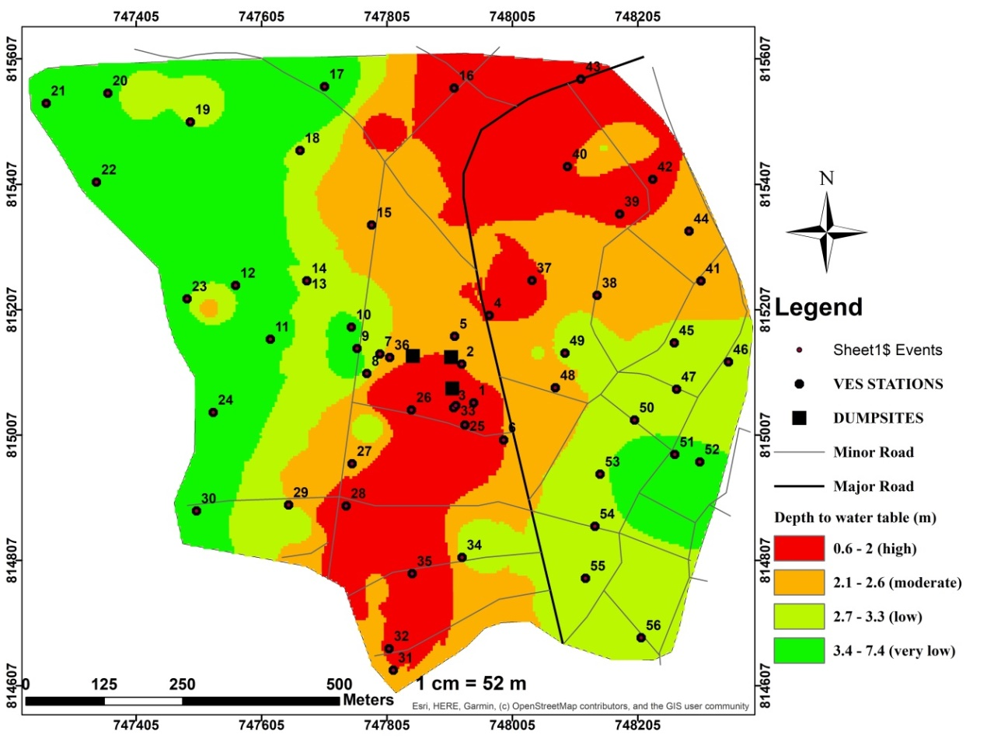

Figure 6: Depth to Water Table Map of the Study Area
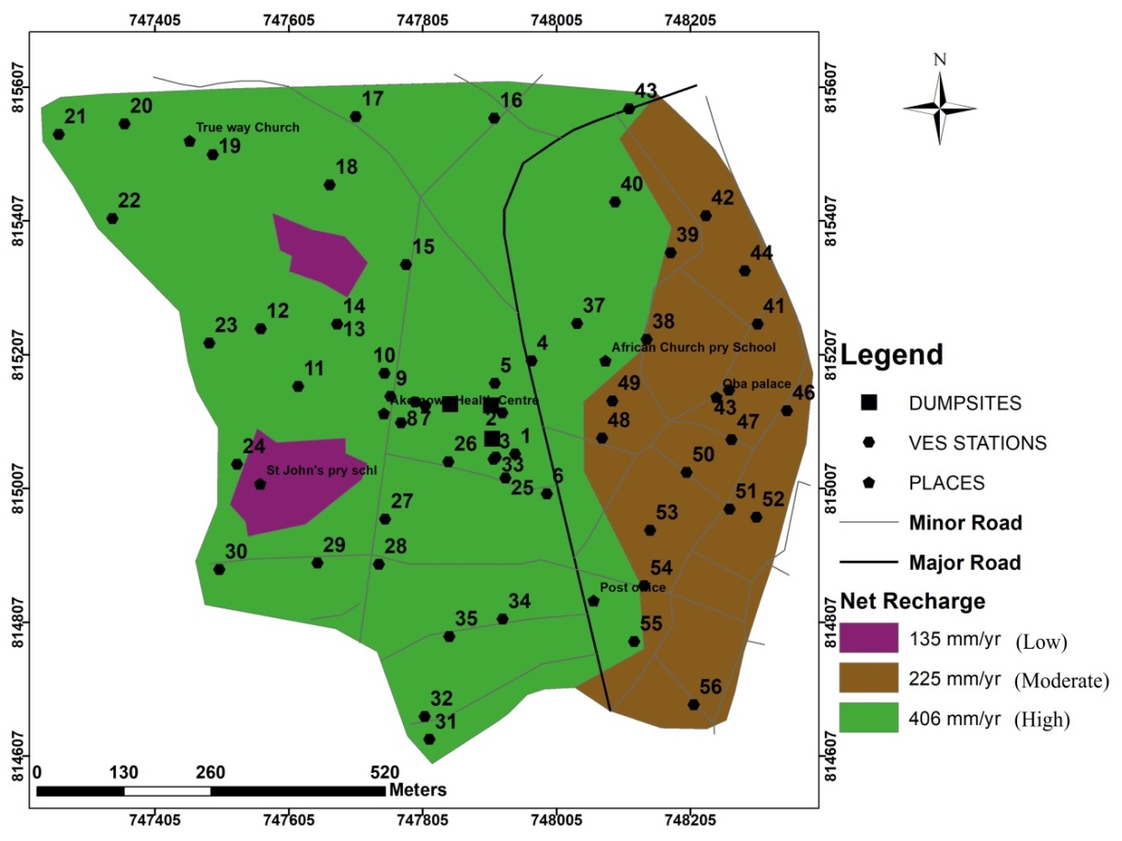
Figure 7: Net Recharge Map of the Study Area
Aquifer Type (A)
Based on the interpreted Vertical Electrical Sounding (VES) data presented in Table 4, the geologic configuration of the aquifers consists of clay, sandy clay, and clayey sand. Among these, clayey sand exhibits the highest permeability, allowing greater water infiltration and, consequently, more contaminants to enter the aquifer. In contrast, clay, with its low permeability, restricts the movement of contaminants. The aquifer type map, illustrating these variations, is shown in Figure 8.
Soil Media (S)
The study area consists of three soil types: clay, sandy soil, and clayey sand, as depicted in Figure 9. The western part is characterized by clayey sand, which has a medium texture and high porosity, facilitating higher permeability. In contrast, the eastern part is dominated by clay, which is less permeable, reducing the infiltration rate. Areas with sandy clay exhibit moderate vulnerability. The central part of the study area, where all three dumpsites are located, is covered with sandy clay soil, which has moderate permeability.
Topography / Slope (T)
The western part of the study area features steep slopes ranging from 4.58° to 10.52°, resulting in high runoff and reduced water contact time, leading to lower infiltration and vulnerability. Conversely, the eastern part has gentler slopes ranging from 0° to 2.27°, allowing water to remain in contact with the surface for longer periods, increasing infiltration and vulnerability. Two of the dumpsites are situated on slopes of 2.27°–3.20°, while the third is located on a slope of 0°–2.70°. The slope of the area is categorized into four classes: 0°–2.27°, 2.27°–3.26°, 3.26°–5.80°, and 4.58°–10.52°. The slope map of the study area, ranging from 0° to 10.52°, is presented in Figure 10.

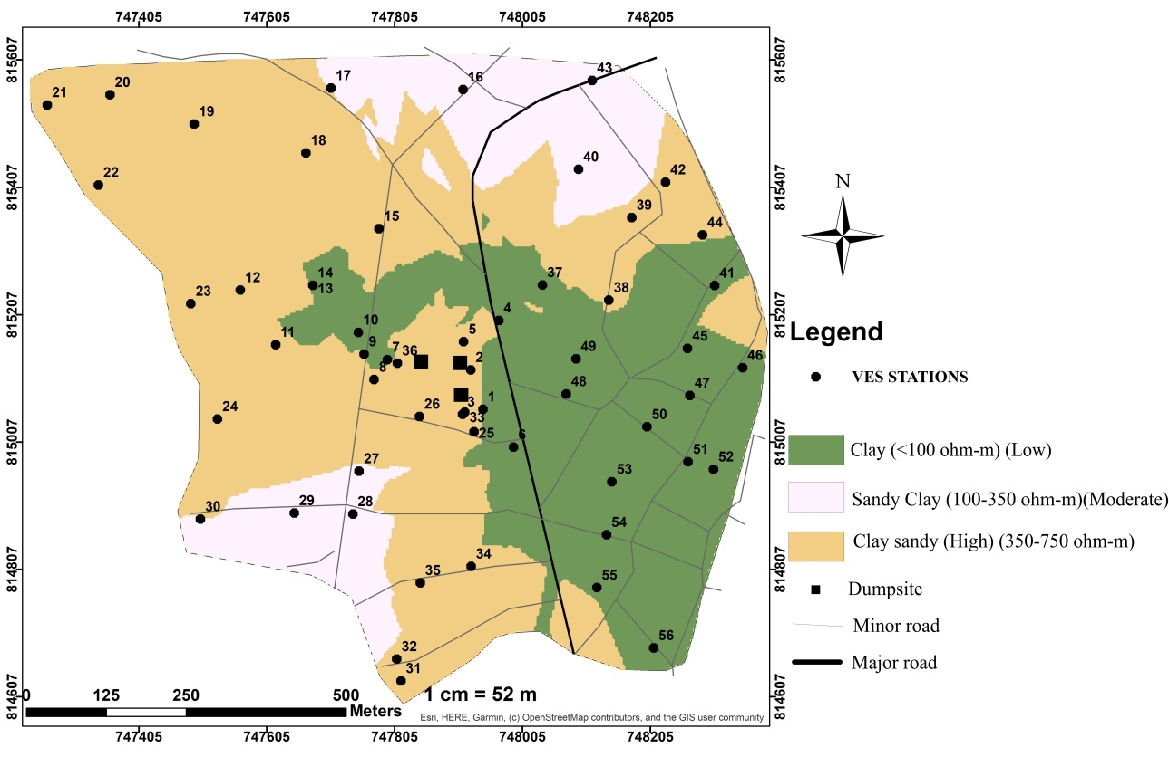
Aquifer type
Figure 8: Aquifer Type Map of the Study Area
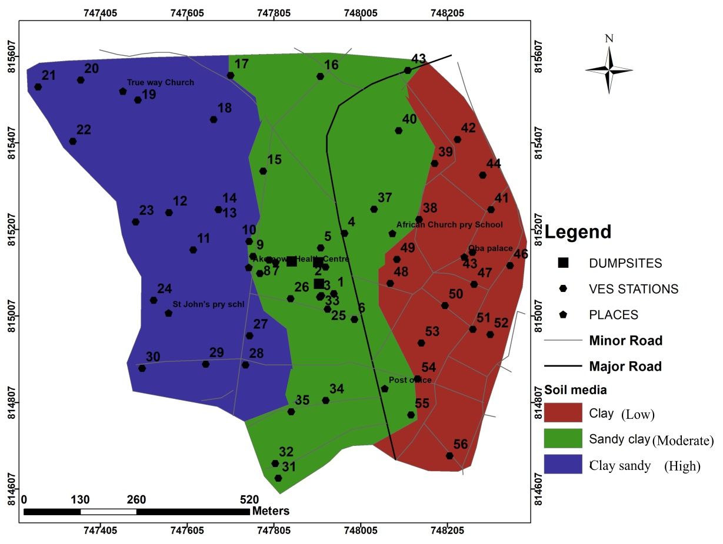
Figure 9: Soil Media Map of the Study Area

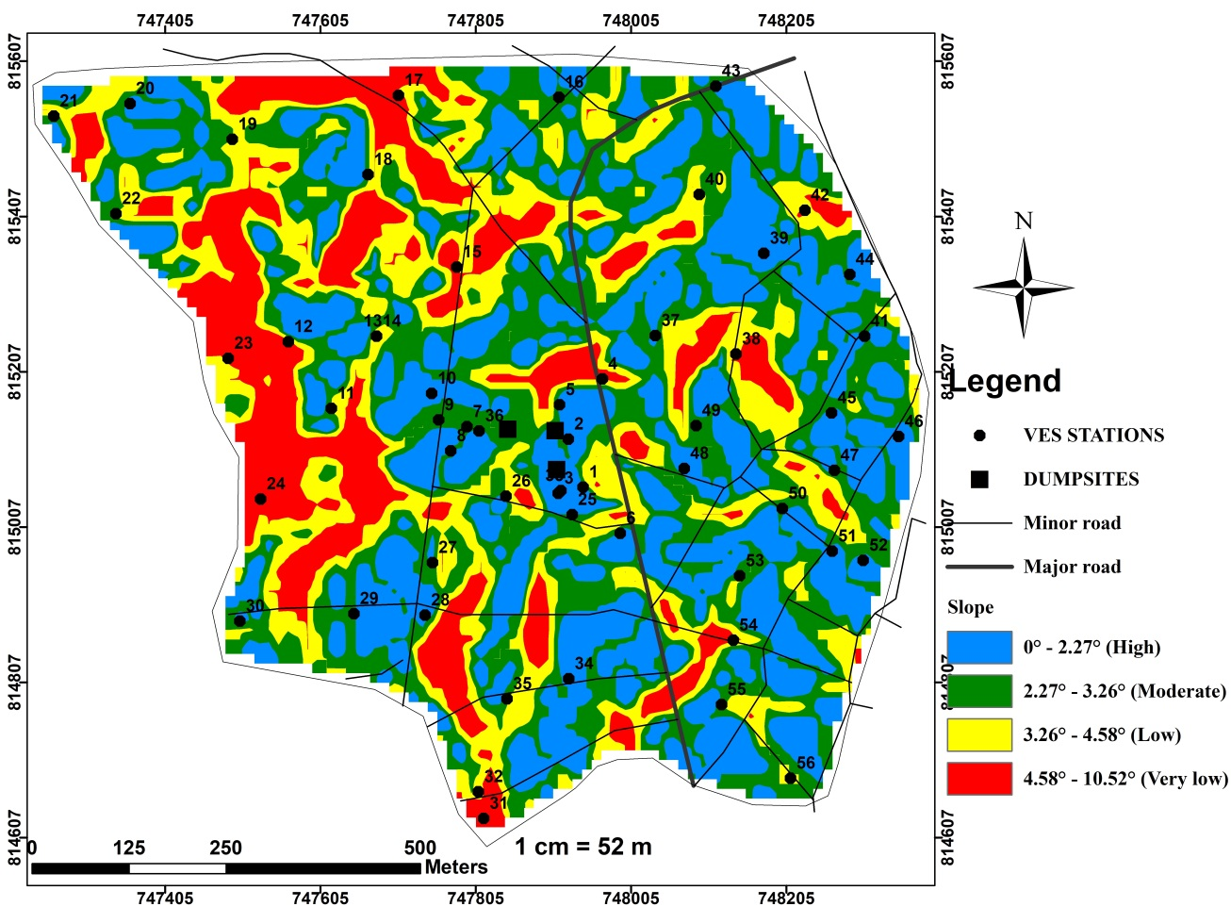
Figure 10: Topography (Slope) Map of the Study Area
Impact of Vadose zone (I)
The vadose zone map of the study area is presented in Figure 11. The vadose zone materials include clay, sandy clay, clay-sandy, and sand. The eastern part of the area is predominantly composed of clay, which has a low potential for contaminant movement into the aquifer. In contrast, the northwestern and southwestern regions consist mainly of sand, which has high permeability, making it more susceptible to groundwater contamination. The central part of the area features a mix of clay-sand and sandy clay as vadose zone materials. Regarding the dumpsites, two are located in areas with clay-sand, while the third is situated within a sandy clay vadose zone.

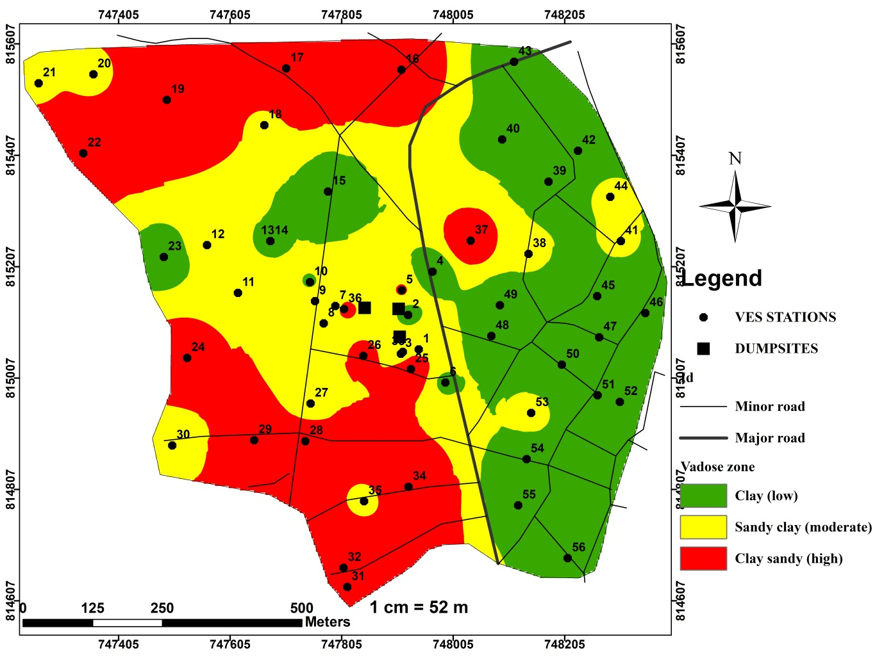
Figure 11: Vadose Zone Map of the Study Area
Hydraulic conductivity (C)
The hydraulic conductivity values for each aquifer are presented in Table 4. The study area is classified into four hydraulic conductivity ranges: 0.0056–0.01 m/s, 0.011–0.015 m/s, and 0.016–0.019 m/s. The western part of the study area has the lowest hydraulic conductivity, making it less vulnerable to pollution. In contrast, the southeastern region exhibits higher hydraulic conductivity values (0.016–0.019 m/s), increasing its susceptibility to contaminants. The central part of the area shows a mix of high and low hydraulic conductivity values. The spatial distribution of hydraulic conductivity is illustrated in Figure 12.

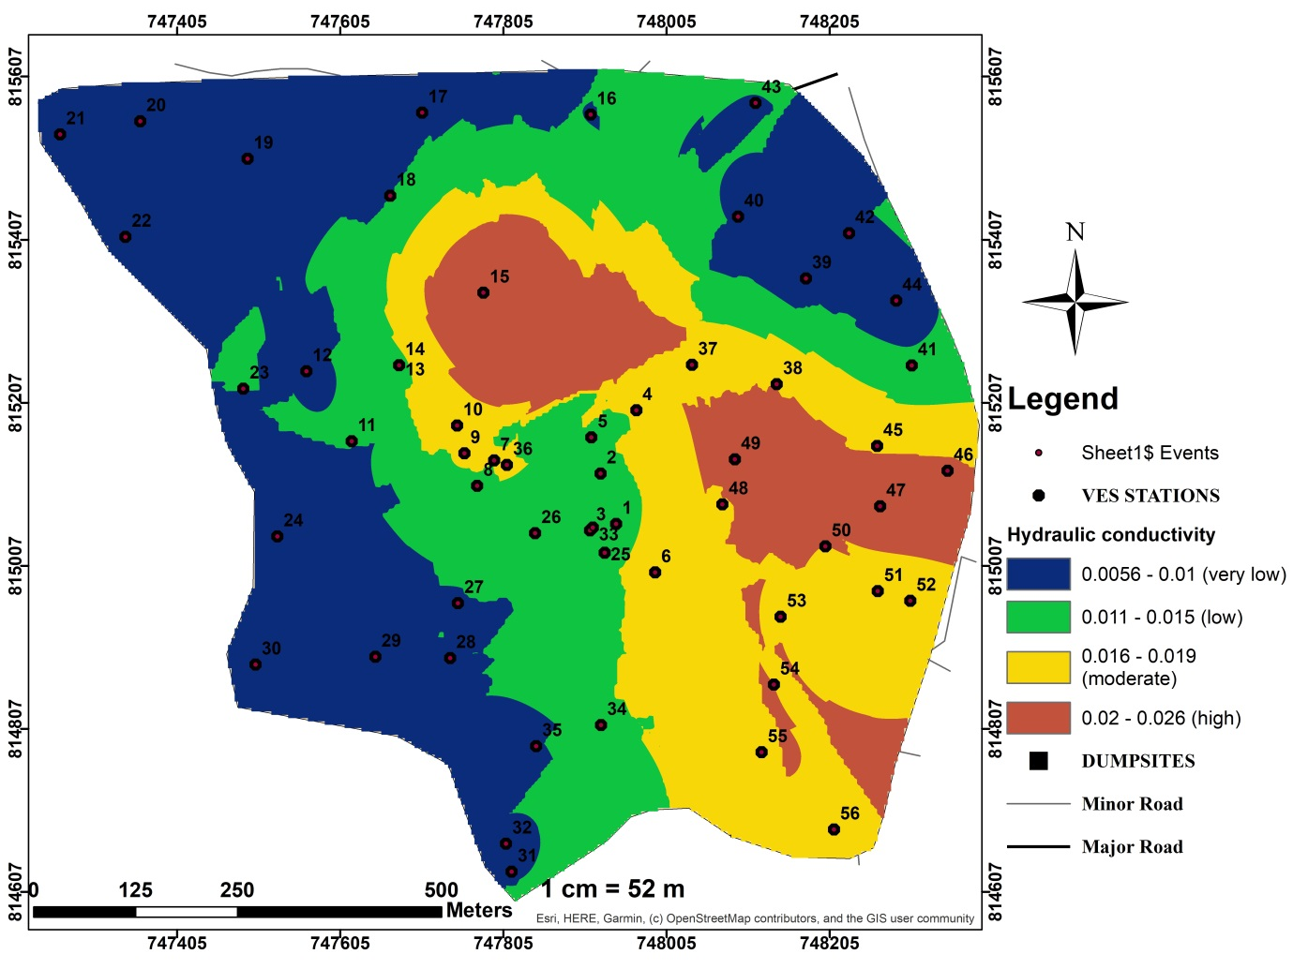
(M/S)

Figure 12: Hydraulic Conductivity Map of the Study Area.
Land Use Impact (L)
The land use map of the study area (Figure 13) is categorized into two classes: built-up areas and vegetation (forest and shrubs). The area is predominantly characterized by built-up zones, where waste generated from households and small factories significantly increases the potential contaminant load on groundwater. As a result, groundwater in the built-up regions of the study area is considered more vulnerable compared to areas covered by vegetation.
Composite Aquifer Vulnerability Map
The composite vulnerability map (Figure 14) delineates five vulnerability classes: very low, low, moderate, high, and very high. The map reveals that the central part of the study area is highly vulnerable to contamination, while the western part exhibits a very low vulnerability index. The eastern part shows low to moderate vulnerability values.
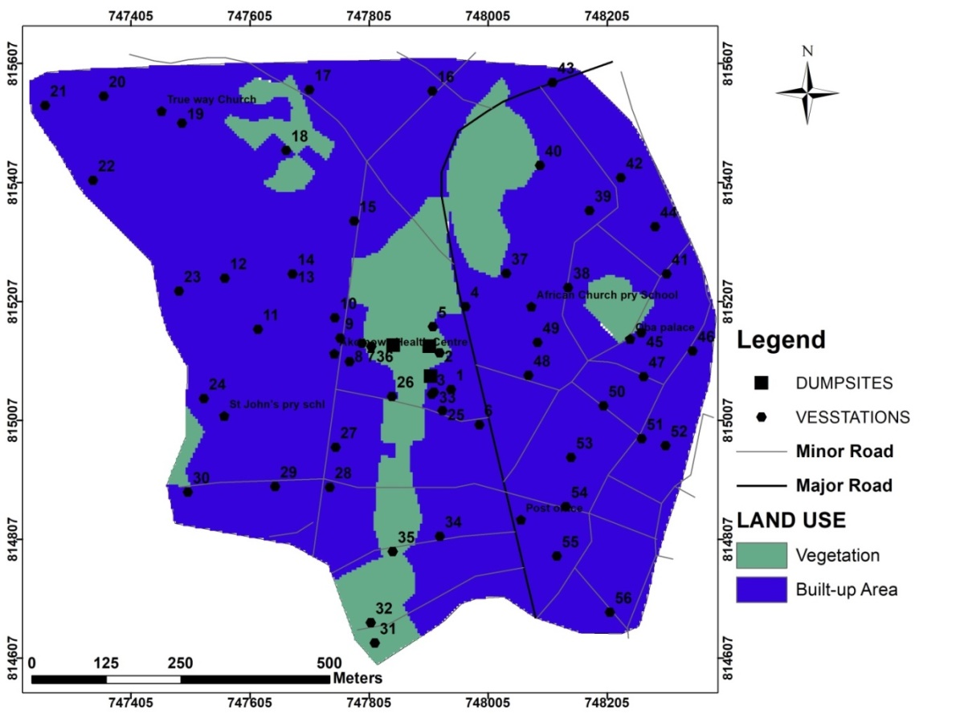
VES STATIONS
Figure 13: Land Use Map of the Study Area
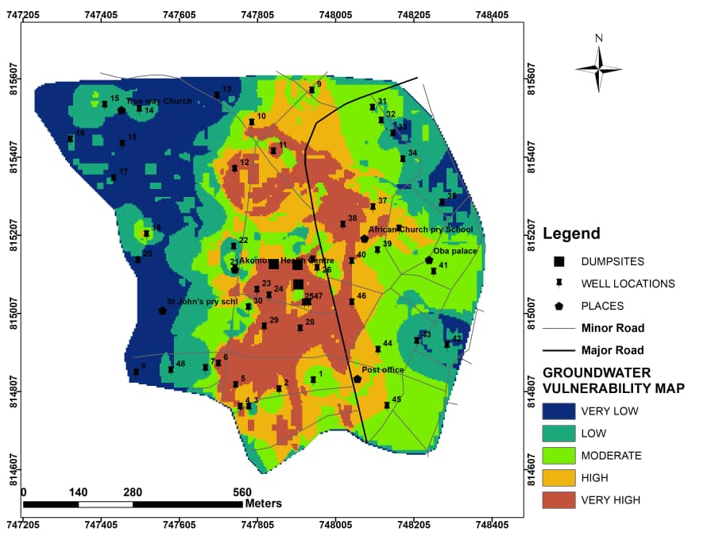
Figure 14: DRASTIC-L Vulnerability Map of the Study Area

Among the three dumpsites in the area, one is located in a high vulnerability zone, and the other two are situated in areas with very high vulnerability. The results indicate that 18% of the area falls under very high vulnerability, 16% under high vulnerability, 23% under moderate vulnerability, 22% under low vulnerability, and 21% under very low vulnerability (Figure 15).
Figure 15: DRASTIC-L Vulnerability Area Percentage
Validation of Model
The model was qualitatively validated by comparing the predicted vulnerability index values with the chemical properties of water samples collected from monitoring wells. Chemical parameters such as Lead, Manganese, and Zinc were not detected in the water samples, whereas Nitrate and Iron were present. Nitrate, as a key pollution indicator, was used to assess the evolution of groundwater quality and its changes over time (Twana et al., 2015). Specifically, Nitrate (NO₃⁻) was employed to validate the model's effectiveness. A summary of the results is presented in Table 5.
The prediction accuracy of the model was evaluated based on its ability to correctly identify low vulnerability areas corresponding to low Nitrate (NO₃⁻) concentrations and high vulnerability areas associated with high Nitrate concentrations in the water samples. The predicted Nitrate concentrations and the model's vulnerability predictions are detailed in Table 5. Groundwater quality was assessed using the World Health Organisation (2017) criteria, which sets the maximum allowable Nitrate concentration in drinking water at 50 mg/L (Low: < 25 mg/L, Medium: 26–49 mg/L, and High/Hazardous: > 50 mg/L). Accuracy was calculated using binary values, where True = 1 and False = 0. As shown in Figure 16, the DRASTIC-L model demonstrated a prediction efficiency of 72%, with 19 out of 25 samples tested for Nitrate concentration aligning with the model's predictions, while 6 did not. This indicates that the DRASTIC-L model is an effective tool for estimating aquifer vulnerability.
Table 5: DRASTIC-L Model Qualitative Validation Results
Serial Number | Well Number | Nitrate ${(NO}_{3}^{-}$)  Concentration(Mg/L) | DRASTIC Model  Predicted Vulnerability | Accuracy (True=1, False=0)
1 | 1 | 120 | High | 1
2 | 7 | 40 | Low | 0
3 | 8 | 23 | Low | 1
4 | 10 | 80 | High | 1
5 | 11 | 42 | High | 0
6 | 13 | 19 | Low | 1
7 | 14 | 20 | Low | 1
8 | 16 | 18 | Low | 1
9 | 17 | 23 | Low | 1
10 | 18 | 22 | Low | 1
11 | 20 | 24 | Low | 1
12 | 23 | 80 | Low | 0
13 | 26 | 31 | Moderate | 1
14 | 28 | 106 | High | 1
15 | 29 | 97 | High | 1
16 | 31 | 29 | Moderate | 1
17 | 35 | 111 | Low | 0
18 | 37 | 92 | High | 1
19 | 38 | 162 | High | 1
20 | 39 | 30 | Moderate | 1
21 | 40 | 178 | High | 1
22 | 41 | 38 | Moderate | 1
23 | 42 | 72 | Low | 0
24 | 43 | 73 | Low | 0
25 | 45 | 34 | Moderate | 1
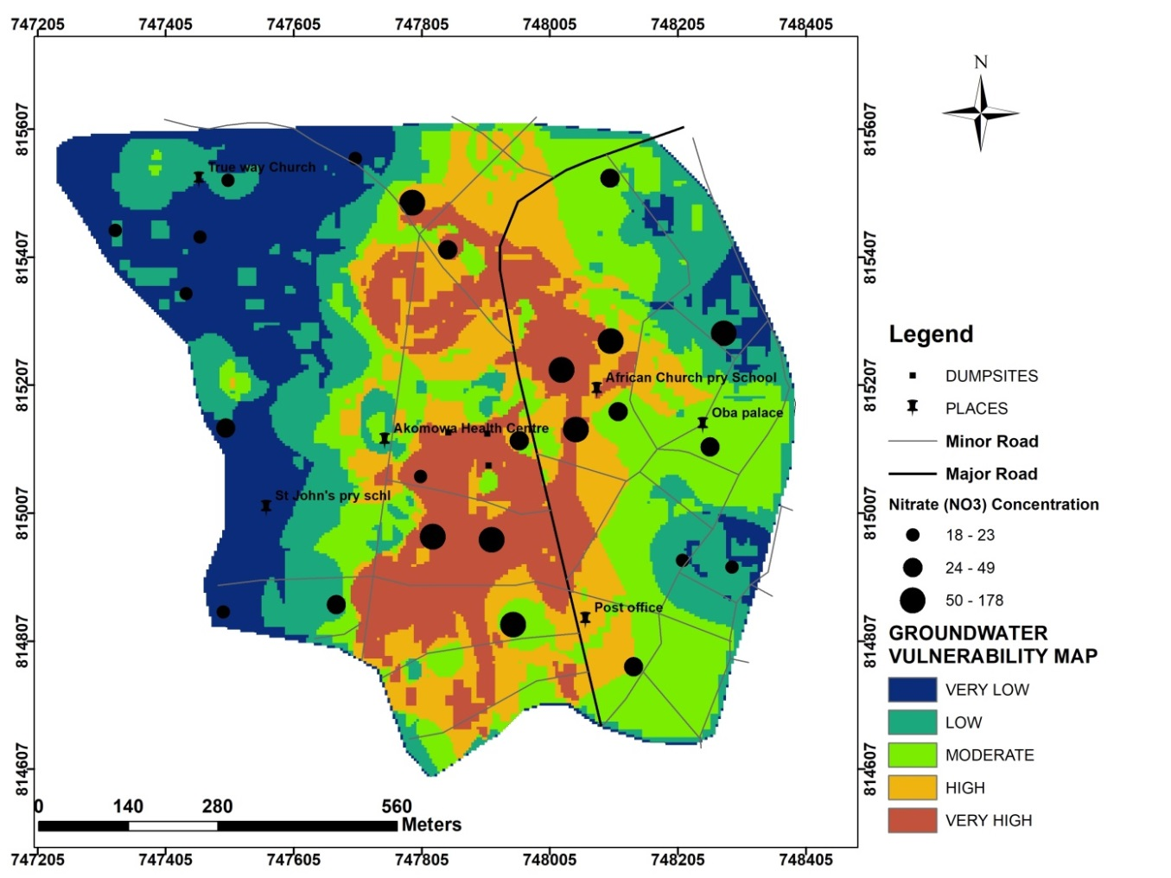
Figure 16: Validation of DRASTIC-L Groundwater Vulnerability Model with Nitrate Concentration (Mg/L)

Conclusion
In this study, a GIS-based modified DRASTIC model (DRASTIC-L) was employed to assess groundwater vulnerability in an area surrounding several dumpsites. This approach incorporated multiple parameters, including depth to the water table, recharge rate, aquifer media, soil media, topography, vadose zone impact, hydraulic conductivity, and land use, to classify groundwater vulnerability zones.
Using ArcGIS software, rated and weighted thematic layers were integrated within the GIS environment to compute aquifer vulnerability classes. The DRASTIC-L vulnerability map identified five vulnerability levels: very high, high, medium, low, and very low, with area distributions of 18%, 20%, 20%, 21%, and 21%, respectively. Two of the dumpsites are located in very high vulnerability zones, while the third is in a moderately vulnerable area.
Chemical analysis of groundwater near the dumpsites revealed that some wells still maintain fair water quality, while others exhibit poor water quality. The investigation showed that the wells are relatively far from the dumpsites, with the closest located approximately 50 meters away. This distance may explain why some contaminants were not detected in the sampled wells. Validation of the DRASTIC-L model, using Nitrate concentration data, demonstrated a 76% accuracy rate, confirming its effectiveness in groundwater vulnerability assessment. Given these findings, the implementation of proper waste and water management policies in the study area is essential.

Recommendations
The GIS-based DRASTIC-L model has proven to be a highly reliable tool for groundwater vulnerability mapping and can be successfully applied to similar studies with appropriate site-specific modifications. The findings of this study will be valuable for urban planners, developers, and decision-makers in designing safe waste disposal sites and managing groundwater resources.
To prevent further groundwater contamination, it is strongly recommended that the existing dumpsites be relocated to areas classified as having a very low vulnerability index before contaminants from the dumpsites fully migrate into the groundwater system.

Data Availability
The geophysical data used for tis research are primarily acquired by O.J. and O. within the case study area, while other data are secondary. The datasets used and/or analysed during the current study available from the corresponding author on reasonable request.

REFERENCES
- Agunwamba, J. C. (2003). Analysis of scavengers’ activities and recycling in some cities of Nigeria. Environmental Management, 32(1), 116-127. https://doi.org/10.1007/s00267-002-2874-5
- Maqsoom, A., Aslam, B., Khalil, U., Ghorbanzadeh, O., Ashraf, H., Faisal Tufail, R., Farooq, D., & Blaschke, T. (2020). A GIS-based DRASTIC Model and an Adjusted DRASTIC Model (DRASTICA) for Groundwater Susceptibility Assessment along the China–Pakistan Economic Corridor (CPEC) Route. ISPRS International Journal of Geo-Information. https://doi.org/10.3390/ijgi9050332
- Aller, L., Bennett, T., Lehr, J. H., & Petty, R. J. (1985). DRASTIC: A standardized system for evaluating ground water pollution potential using hydrogeologic settings. U.S. Environmental Protection Agency. EPA/600/2-85-018. https://hdl.handle.net/2027/osu.32435029447070
- Aller, L., Bennett, T., Lehr, J. H., & Petty, R. J. (1985). DRASTIC: A standardized system for evaluating groundwater pollution potential using hydrogeologic settings. U.S. EPA, Robert S. Kerr Environmental Research Laboratory. https://nepis.epa.gov/Exe/ZyPDF.cgi?Dockey=20001T01.PDF
- Allocca, V., Manna, F., & De Vita, P. (2014). Estimating annual groundwater recharge coefficient for karst aquifers of the southern Apennines (Italy). Hydrology and Earth System Sciences, 18(2), 803–817. https://doi.org/10.5194/hess-18-803-2014
- Dauda, M., & Osita, O. O. (2003). Solid waste management and reuse in Maiduguri, Nigeria. In 29th WEDC International Conference towards the Millennium Development Goal, Abuja. http://wedc.lboro.ac.uk/knowledge/conference_papers.html?cid=29
- Fernandes, D., & Rudolph, A. (2001). The influence of Cenozoic tectonics on the groundwater production capacity of fractured zones: A case study in São Paulo, Brazil. Hydrogeology Journal, 9, 151-167. https://doi.org/10.1007/s100400000103
- Groundwater Estimation Committee (GEC). (1997). Detailed guidelines for implementing the groundwater estimation methodology. Central Groundwater Board, Ministry of Water Resources, Government of India.
- Hirata, R., & Bertolo, R. (2009). Groundwater vulnerability in different climatic zones. In Encyclopedia of Life Support Systems (EOLSS), Groundwater—Vol. II. EOLSS Publications. https://www.eolss.net/Sample-Chapters/C07/E2-09-04-06.pdf
- Idornigie, A. A., Olorunfemi, M. O., & Omitogun, A. A. (2006). Electrical Resistivity Determination of Subsurface Layers, Subsoil Competence and Soil Corrositivity at an Engineering Site Location in Akungba-Akoko, South Western Nigeria. Ife Journal of Science, 8(2), 159-177 https://doi.org/10.4314/IJS.V8I2.32216
- Vrba, J., & Zaporozec, A. (1994). Guidebook on mapping groundwater vulnerability. International Contributions to Hydrogeology, 16. Verlag Heinz Heise. https://unesdoc.unesco.org/ark:/48223/pf0000098000
- Lobo-Ferreira, J. P. (1999). The European Union experience on groundwater vulnerability assessment and mapping. COASTIN: A Coastal Policy Research Newsletter, 1, 8–10.
- Boufekane, A., & Saighi, O. (2013). Assessment of groundwater pollution by nitrates using intrinsic vulnerability methods: A case study of the Nil valley groundwater (Jijel, North-East Algeria). African Journal of Environmental Science and Technology, 7(10), 949-960. https://doi.org/10.5897/AJEST2013.1428
- Margat, J. (1968). *Vulnérabilité des nappes d'eau souterraine à la pollution: Bases de sa cartographie*. BRGM. https://infoterre.brgm.fr/rapports/68-SGL-198-HYD.pdf
- Maxey, G. B., & Eakin, T. E. (1949). Groundwater in White River Valley, White Pine, Nye, and Lincoln Counties, Nevada.
- Muteraja, K. N. (1986). Applied Hydrology. Tata McGraw-Hill, New Delhi, India.
- National Research Council. (1993). Ground water vulnerability assessment: Predicting relative contamination potential under conditions of uncertainty. National Academy Press. https://www.nap.edu/catalog/2050/ground-water-vulnerability-assessment-predicting-relative-contamination-potential-under-conditions-of-uncertainty
- Nigerian Meteorological Agency. (2008). Nigeria Climate Review Bulletin 2007. NIMET-No. 001.
- Odeyemi, I. B. (1976). Preliminary report on the field relationships between the basement complex rocks in Igarra, Midwestern Nigeria. In C. A. Kogbe (Ed.), *Geology of Nigeria* (pp. 59-63). Elizabeth Publishing Company. https://books.google.com/books/about/Geology_of_Nigeria.html?id=2_4bAAAAMAAJ
- Ogunrayi, O. A., Akinseye, F. M., Goldberg, V., & Bernhofer, C. (2016). Descriptive analysis of rainfall and temperature trends over Akure, Nigeria. Journal of Geography and Regional Planning, 9(11), 195-202. https://doi.org/10.5897/JGRP2016.0583
- Ogunrayi, O. A., Akinseye, F. M., Goldberg, V., & Bernhofer, C. (2016). Descriptive analysis of rainfall and temperature trends over Akure, Nigeria. Journal of Geography and Regional Planning, 9(11), 195-202. https://doi.org/10.5897/JGRP2016.0583Rahaman, M. A. (1976). Review of the basement geology of Southwestern Nigeria. In Geology of Nigeria. Elizabethan Publishing Company, Nigeria, 41–58.
- Revelle, R. (1941). Criteria for recognition of seawater in groundwater. Transactions of the American Geophysical Union, 22, 593-597.
- Revelle, R. (1941). Criteria for recognition of sea water in ground-waters. Eos, Transactions American Geophysical Union, 22, 593-597. https://doi.org/10.1029/TR022i003p00593
- Saatsaz, M., Chitsazan, M., Eslamian, S., & Sulaiman, W. N. A. (2011). The application of groundwater modelling to simulate the behaviour of groundwater resources in the Ramhormooz Aquifer, Iran. International Journal of Water, 6(1/2), 29-42. https://doi.org/10.1504/IJW.2011.043315
- Salaj, S. S., Ramesh, D., Suresh Babu, D. S., & Kaliraj, S. (2018). Impacts of urbanization on groundwater vulnerability along the Kozhikode coastal stretch, Southwestern India using GIS based modified DRASTIC-U Model. Journal of Coastal Sciences, 5(2), 1-27. https://www.researchgate.net/publication/327940000_Impacts_of_urbanization_on_groundwater_vulnerability_along_the_Kozhikode_coastal_stretch_Southwestern_India_using_GIS_based_modified_DRASTIC-U_Model
- Singh, V. S., & Gupta, C. P. (1986). Hydrogeological parameter estimation from pumping tests on large diameter wells. Journal of Hydrology, 87, 223-232.
- Singh, V. S., & Gupta, C. P. (1986). Hydrogeological parameter estimation from pump test on a large diameter well. Journal of Hydrology, 87, 223-232. https://doi.org/10.1016/0022-1694(86)90015-6
- Simmers, I. (Ed.). (1997). Recharge of Phreatic Aquifers in (Semi-)Arid Areas: IAH International Contributions to Hydrogeology 19. Routledge. https://doi.org/10.1201/9780203741191
- Slomczynska, B., & Slomczynski, T. (2004). Physico-Chemical and Toxicological Characteristics of Leachates from MSW Landfills. Polish Journal of Environmental Studies, 13(6), 627-637. https://pjes.eu/archive/volume-13-2004/issue-6/physico-chemical-and-toxicological-characteristics-of-leachates-from-msw-landfills/
- Theis, C. V. (1935). The relation between the lowering of the piezometric surface and the rate and duration of discharge of a well using groundwater storage. Transactions of the American Geophysical Union, 16(2), 519-524. https://doi.org/10.1029/TR016i002p00519
- VanderVelpen, B. P. A. (2004). Resist Version 1.0. M.Sc. Research Project, ITC, Delft, Netherlands.
- World Health Organization. (2017). Nitrate and Nitrite in Drinking Water: Background Document for Development of WHO Guidelines for Drinking-Water Quality. https://www.who.int/water_sanitation_health/dwq/chemicals/nitrate-nitrite-background-jan17.pdf
- World Wildlife Fund. (2019). Freshwater. https://www.worldwildlife.org/initiatives/fresh-water

