DFT, MOLECULAR DOCKING, AND ADMET STUDIES ON ACID HYDRAZIDES AND THEIR VO(IV), CO(II), AND NI(II) COMPLEXES WITH ANTIBACTERIAL AND SPECTROSCOPIC INSIGHTS

ABSTRACT
Aims: To use computational methods to examine the spectroscopic characteristics and potential antibacterial activities of twelve previously synthesized acid hydrazides, as well as to explore how their electronic properties and molecular interactions relate to their biological activity.
Study Design: An in silico approach, utilizing Density Functional Theory (DFT) calculations, molecular docking simulations, and ADMET profiling, was employed to evaluate novel acid hydrazide-based metal complexes for their antibacterial potential.
Place and Duration of Study: The study was conducted at the Department of Chemistry, Faculty of Science, Federal University, Lokoja, from June to September 2025.
Methods: DFT was used to model and optimize the molecular structures of the metal complexes. The spectroscopic and electronic properties were also calculated using DFT, while molecular docking of complexes against five bacterial protein targets was conducted using MOE. The drug-likeness and pharmacokinetic properties of the most active complexes were evaluated via ADMET simulations using the SwissADME platform.
Results: Five complexes, [VO(4-ABAH)₂]²⁺ (C₁), [VO(IBAH)₂]²⁺ (C₃), [Ni(IBAH)₂]²⁺ (C₉), [Ni(4-CBAH·H₂O)₂]²⁺ (C₁₁), and [Ni(IBAH·H₂O)₂]²⁺ (C₁₂) demonstrated notable antibacterial activity as they were specifically active against Klebsiella pneumoniae (PDB ID: 1OSM) and Pseudomonas aeruginosa (PDB ID: 3ZMB).
Conclusion: A strong correlation was observed between the experimental data and calculated spectroscopic properties of the metal complexes and their antibacterial activities, indicating that computational methods can be predictive of biological efficacy.
Keywords: DFT, Molecular Docking, Hydrazide, Metal (II) complexes
INTRODUCTION

The continuous emergence of microbial resistance to existing drugs has posed a persistent challenge to pharmaceutical and medicinal chemists in the development of novel therapeutic agents. In response, research institutions worldwide have increasingly devoted significant resources toward combating microbial pathogens, leading to the exploration of new strategies for drug discovery. Hydrazine (H₂N-NH₂), hydrazides (-CONHNH₂), and hydrazones (-CONHN=CH-) represent a related class of compounds that have demonstrated remarkable pharmacological potential. Hydrazides are derivatives of hydrazine, while hydrazones are further derived from hydrazides. Numerous biological activities of hydrazone analogs have been reported, including analgesic, anti-inflammatory, antihypertensive, anticonvulsant, antibacterial, antitubercular, anticancer, antimalarial, and antiproliferative properties [1]. Moreover, several coupling products, such as sulfonamides, have been synthesized from hydrazones. In addition to their diverse biological applications, hydrazones also serve as valuable intermediates in the synthesis of various heterocyclic systems [2].
The synthesis and antimicrobial activities of transition metal complexes of VO(IV), Co(II), and Ni(II) obtained from reactions of these metals with isobutryl acetic acid hydrazide (IBAH), 4-aminobenzoic acid hydrazide (4-ABAH), and 4-cyanobenzoic acid hydrazide (4-CBAH) were reported in previous literature [3-5]. The structural elucidation of the metal complexes was performed using elemental analysis, infrared (IR) spectroscopy, and UV-visible spectroscopy, and the proposed structures are illustrated in Figure 1. For the antimicrobial screening, filter papers were impregnated with the complex solutions and placed on petri dishes inoculated with five bacterial strains: Staphylococcus aureus, Streptococcus lactis, Pseudomonas aeruginosa, Escherichia coli, and Klebsiella pneumoniae. The results revealed varying degrees of antibacterial activity, categorized as highly active (+++, inhibition zone > 12 mm), moderately active (++; 9-12 mm), slightly active (+; 6-9 mm), and inactive (---; < 6 mm), as summarized in Table 1.
Despite the availability of experimental data on these systems, limited information exists regarding the correlation between their structural and biological activities, particularly in relation to their electronic properties and binding mechanisms. Although advanced spectroscopic techniques have been employed to elucidate their structures [6], computational approaches offer deeper insights. Methods such as density functional theory (DFT), molecular docking, and in silico ADMET analysis provide valuable predictions of the structural, electronic, spectroscopic, thermodynamic, and pharmacokinetic properties of molecules, thereby elucidating structure–property–activity relationships [7,8]. Therefore, the present study aims to investigate the antibacterial activities and spectroscopic properties of VO(IV), Co(II), and Ni(II) complexes of isobutryl acetic acid, 4-aminobenzoic acid, and 4-cyanobenzoic acid hydrazides using DFT calculations, molecular docking, and ADMET studies.

Table 1: Experimental results of microbial activity for the complexes
Molecule | Klebsiella Pneumoniae | Pseudomonas Aeruginosa
C₁ | ++ | ++
C₂ | --- | +++
C₃ | +++ | ++
C₄ | --- | +
C₅ | --- | +
C₆ | --- | +
C₇ | +++ | ++
C₈ | +++ | ---
C₉ | ++ | ++
C₁₀ | ++ | ++
C₁₁ | ++ | ++
C₁₂ | +++ | ++
Highly active = +++ (Inhibition zone > 12 mm), moderately active = ++ (Inhibition zone > 9-12 mm), slightly active = + (Inhibition zone > 6 – 9 mm), inactive = --- (Inhibition zone < 6mm)
MATERIALS AND METHODS
DFT optimization and frontier energies

The modeled VO²⁺, Co²⁺ and Ni²⁺ complexes of 4-ABAH, 4-CBAH and IBAH were optimized using DFT of B3LYP (Becke’s three-parameter hybrid method using the LYP correlation functional) and 6-31G** basis set as implemented in Spartan 2014 v 1.1.4 software installed on a Dell Precision M3800 Intel(R) Core(TM) i7-4712HQ CPU @ 2.30GHz/2.30 GHz 16GB RAM size computer system based on data from previous literature [3-5]. The structures of the modeled complexes were square pyramidal for C₁ to C₃, tetrahedral for C₄ to C_{9,} and octahedral geometry for C₁₀ to C₁₂, where R = (CH₃)₂CHC=OCH₂, C₆H₅CN, C₆H₄NH₂ (Figure 1). DFT has been a very good quantum mechanical method used for the electronic structure and molecular properties calculations with reasonably high accuracy [9,10]. The DFT level calculation was based on the preliminary conformational search on all molecules using the MMFF method with the Monte Carlo search algorithm [11]. The parameters estimated from DFT calculations were frontier orbital energies (HOMO, LUMO, and energy gap, ΔEg), electronegativity (χ), chemical hardness (ⴄ) and softness (δ), chemical potential (µ), and global electrophilicity (ω) as shown in equations 1-6.
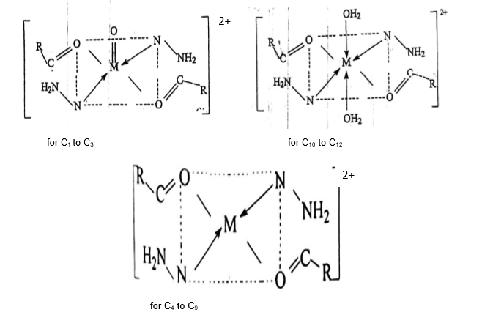

Figure 1: Proposed structure of the complexes, R = (CH₃)₂CHC=OCH₂ for C₁ to C_{3,} C₆H₅CN, C₆H₄NH₂ for C₁₀ to C₁₂ and C₆H₅CN, C₆H₄NH₂ for C₄ to C₉
ΔEg = E_{HOMO} - E_{LOMO} (1)
-χ = µ = ½ (E_{LUMO} + E_{HOMO}) (2)
ⴄ = ½ (E_{LUMO} - E_{HOMO}) (3)
IP = -E_{HOMO} (4)
EA = - E_{LOMO} (5)
δ = $\frac{1}{ⴄ}$ (6)
$ω$ = $\frac{µ2}{2ⴄ} (7)$
Molecular docking Simulation procedures

As shown in Table 1, the antibacterial efficacy test identified several complexes that exhibited significant (high and moderate) inhibitory activity against Klebsiella pneumoniae and Pseudomonas aeruginosa [3-5]. These active complexes were subsequently subjected to molecular docking simulations. The target proteins: K. pneumoniae OmpK36 (PDB ID: 1OSM) and P. aeruginosa farnesyl pyrophosphate synthase (FPP, PDB ID: 3ZMB) were retrieved from the Protein Data Bank. OmpK36 is a major outer membrane porin that forms a hydrophilic channel for the transport of nutrients, waste products, and certain drugs [12]. Its permeability is critical to antibiotic uptake and resistance mechanisms. In addition to transport functions, OmpK36 contributes to bacterial pathogenicity by enhancing the organism’s ability to infect host species [13].
Conversely, FPP (3ZMB) catalyzes the synthesis of isoprenoid precursors, including ubiquinone and possibly carotenoids [14]. Ubiquinone plays a vital role in denitrification under anaerobic conditions by reducing nitrates and nitrites to gaseous forms, enabling bacterial survival in oxygen-limited environments. This ubiquinone-dependent denitrification significantly contributes to the pathogenicity of P. aeruginosa [15]. The downloaded protein structures were refined using an online protein repair and analysis server [16] to add missing side chains and hydrogen atoms, and to assess stereochemical quality via Ramachandran plot and secondary structure classification (Figure 2). Further preprocessing in Discovery Studio [17] involved the removal of water molecules and other impurities, followed by the addition of hydrogen atoms to stabilize valence states and minimize potential interference [18].
Optimized structures of the active complexes (C₁, C₂, C₃, C₇, C₈, C₉, C₁₀, C₁₁, and C₁₂) and reference drugs (levofloxacin and penicillin), obtained from the PubChem database (pubchem.ncbi.nlm.nih.gov), were used as ligands for docking studies in the Molecular Operating Environment (MOE) 2014 software [11,19]. The docking simulations evaluated stable conformations, selecting 10 conformers from a pool of 30 ligand-receptor poses along with hydrogen bonding, van der Waals forces, and other key interactions within the proteins’ active sites, to determine binding affinity energies [11,20].

Protein | Klebsiella Pneumoniae (PDB ID: 1OSM) | Pseudomonas Aeruginosa (PDB ID: 3ZMB)
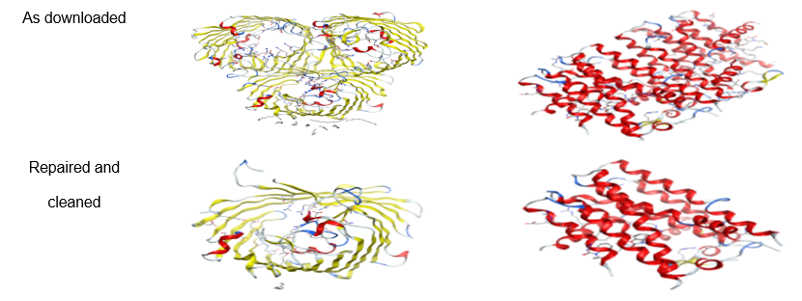
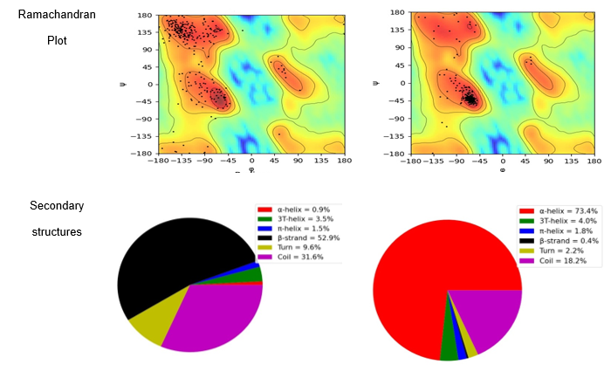
Figure 2: Pictorial view of raw and cleaned bacteria on MOE, Ramachandran plots and secondary structure classifications of the receptors
RESULTS AND DISCUSSION
The Backbone Geometries of the Complexes

Complexes [VO(4-ABAH)₂]²⁺ (C₁), [VO(C-ABAH)₂]²⁺ (C₂), and [VO(IBAH)₂]²⁺ (C₃) exhibited square planar geometry around the vanadium center, featuring a V=O double bond characteristic of vanadium(II) oxide. In each complex, the vanadium atom is coordinated by two oxygen atoms (from carbonyl groups) and two nitrogen atoms (from the hydrazide ligands), as shown in the optimized structures (Figure 3). The [Co(4-ABAH)₂]²⁺ (C₄), [Co(C-ABAH)₂]²⁺ (C₅), [Co(IBAH)₂]²⁺ (C₆), [Ni(4-ABAH)₂]²⁺ (C₇), [Ni(C-ABAH)₂]²⁺ (C₈), and [Ni(IBAH)₂]²⁺ (C₉) complexes displayed tetrahedral geometries around the Co(II) and Ni(II) metal ions. Their coordination environments are similar to those of the VO(II) complexes, except for the absence of the terminal V=O double bond (Figure 3).
Complexes [VO(4-ABAH)2]²⁺ (C1), [VO(C-ABAH)₂]²⁺ (C2), and [VO(IBAH)2]²⁺ (C3) exhibited square planar geometry around the vanadium center, featuring a V=O double bond characteristic of vanadium(II) oxide. In each complex, the vanadium atom is coordinated by two oxygen atoms (from carbonyl groups) and two nitrogen atoms (from the hydrazide ligands), as shown in the optimized structures (Figure 3). The [Co(4-ABAH)2]²⁺ (C4), [Co(C-ABAH)2]²⁺ (C5), [Co(IBAH)2]²⁺ (C6), [Ni(4-ABAH)2]²⁺ (C7), [Ni(C-ABAH)2]²⁺ (C8), and [Ni(IBAH)2]²⁺ (C9) complexes displayed tetrahedral geometries around the Co(II) and Ni(II) metal ions. Their coordination environments are similar to those of the VO(II) complexes, except for the absence of the terminal V=O double bond (Figure 3). Furthermore, the hydrated nickel(II) complexes: [Ni(4-ABAH·H₂O)₂]²⁺ (C₁₀), [Ni(C-ABAH·H₂O)₂]²⁺ (C₁₁), and [Ni(IBAH·H₂O)₂]²⁺ (C₁₂) adopted octahedral geometries, where the Ni(II) center is coordinated by two nitrogen atoms from the hydrazide ligands, two oxygen atoms from carbonyl groups, and two oxygen atoms from coordinated water molecules (Figure 3). According to Table 2, the optimized geometries of the VO(II) complexes reveal V-O1 (V-O2) and V-O3 bond lengths of 1.560 Å (1.981 Å) 1.997 Å for [VO(4-ABAH)₂]²⁺, 1.552 Å (2.013 Å) 2.013 Å for [VO(C-ABAH)₂]²⁺, and 1.552 Å (2.025 Å) 2.025 Å for [VO(IBAH)₂]²⁺. The corresponding V-N₁ (V-N₂) bond lengths are 2.155 Å (2.109 Å), 2.136 Å (2.136 Å), and 2.152 Å (2.152 Å), respectively. The bond angles between vanadium and the coordinating heteroatoms range from 63.23°-149.08° (C₁), 62.88°-150.41° (C₂), and 62.59°-144.85° (C₃) (Table 3).

CPD | OPTIMIZED | HOMO | LUMO
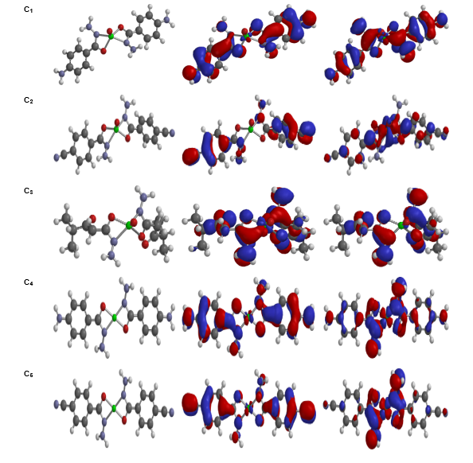
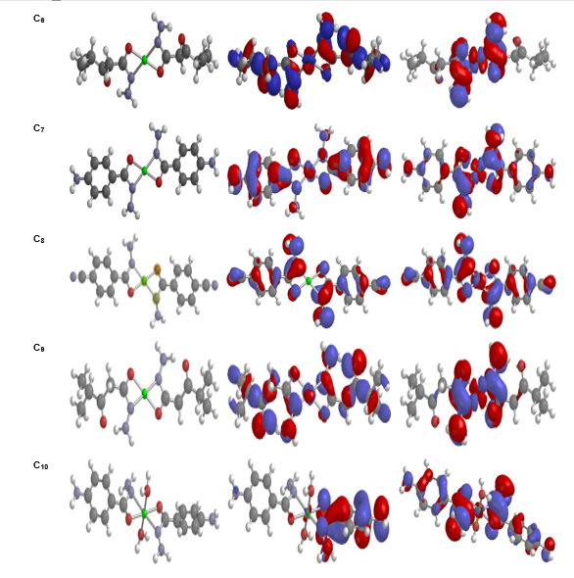
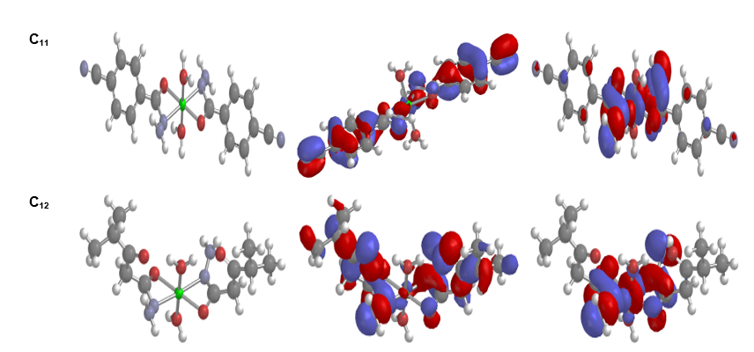

Figure 3: The optimized structure, HOMO and LUMO overlay of the M(II) complexes
Following the same order of 4-ABAH, C-ABAH, and IBAH, Table 2 shows that for the Co(II) complexes (C₄-C₆), the Co-O2/Co-O4 and Co-N4/Co-N5 bond lengths are 1.888 Å (1.901 Å), 1.915 Å (1.921 Å), and 1.932 Å (1.936 Å), respectively, with bond angles ranging from 69.32°-180.00°, 68.36°-180.00°, and 67.39°-180.00°. Similarly, for the tetrahedral Ni(II) complexes (C₇-C₉), Ni-O and Ni-N bond lengths are 1.884 Å and 1.906 Å (C₇), 1.936 Å and 1.997 Å (C₈), and 1.913 Å and 1.931 Å (C₉). Their corresponding bond angles fall within 69.27°-180.00°, 66.85°-180.00°, and 67.95°-180.00°, respectively.
Table 2: Calculated bond length (Å) for C₁ to C₁₂ complexes
C₁ |  | C₂ |  | C₃ |  | C₄ |  | C₅ |  | C₆
V-O1 | 1.560 | V-O1 | 1.552 | V-O1 | 1.552 | Co-O2 | 1.888 | Co-O2 | 1.915 | Co-O2 | 1.932
V-O2 | 1.981 | V-O2 | 2.013 | V-O2 | 2.025 | Co-O4 | 1.888 | Co-O4 | 1.915 | Co-O4 | 1.932
V-O3 | 1.997 | V-O3 | 2.013 | V-O3 | 2.025 | Co-N4 | 1.901 | Co-N4 | 1.921 | Co-N4 | 1.936
V-N1 | 2.155 | V-N1 | 2.136 | V-N1 | 2.152 | Co-N5 | 1.901 | Co-N5 | 1.921 | Co-N5 | 1.936
V-N2 | 2.109 | V-N2 | 2.136 | V-N2 | 2.152 | --- | --- | --- | --- | --- | ---
C₇ |  | C₈ |  | C₉ |  | C₁₀ |  | C₁₁ |  | C₁₂
Ni-O2 | 1.884 | Ni-O1 | 1.936 | Ni-O2 | 1.913 | Ni-O2 | 2.024 | Ni-O2 | 2.005 | Ni-O2 | 2.024
Ni-O4 | 1.884 | Ni-O4 | 1.936 | Ni-O5 | 1.913 | Ni-O3 | 2.039 | Ni-O3 | 2.005 | Ni-O3 | 2.029
Ni-N4 | 1.906 | Ni-N4 | 1.997 | Ni-N4 | 1.931 | Ni-O4 | 2.087 | Ni-O4 | 2.090 | Ni-O4 | 2.068
Ni-N5 | 1.906 | Ni-N5 | 1.997 | Ni-N5 | 1.931 | Ni-O6 | 2.086 | Ni-O6 | 2.090 | Ni-O6 | 2.068
--- | --- | --- | --- | --- | --- | Ni-N2 | 2.127 | Ni-N3 | 2.128 | Ni-N4 | 2.104
--- | --- | --- | --- | --- | --- | Ni-N6 | 2.122 | Ni-N4 | 2.128 | Ni-N5 | 2.104

As reported in [18,11], similar bond lengths were measured in Nickel (II) with octahedral geometries; the numbering of oxygen atoms around the metal ions (Ni-O) is similar but there are slightly deviated from Ni-N bond lengths. Thus, bonding in these octahedral complexes may likely involve hybridization patterns of sp³d² or d²sp³ as suggested in the literature. [11, 21]. In complexes C₁₀, C_{11,} and C₁₂, the bond length Ni-O2 is 2.024 Å, 2.005 Å, 2.024 Å, Ni-O3 is 2.039 Å, 2.005 Å, 2.029 Å, Ni-O4 is 2.087 Å, 2.09 Å, 2.068 Å, and Ni-O6 is 2.086 Å, 2.090 Å, 2.068 Å respectively. For bond angles, the ranges are from 63.09° to 177.77°, 63.83° to 180.00°, and 31.93° to 180.00° respectively.
In all, metal-oxygen bonds tend to be shorter than metal–nitrogen bonds, consistent with oxygen’s higher electronegativity and stronger donor ability. Distortion from ideal geometries is a recurring theme, likely due to chelation, ligand rigidity, or steric hindrance, while the progressive increase in bond lengths across series (e.g., C₄ → C₆) may reflect systematic changes in ligand properties or coordination environment.
Table 3: Calculated bond angle (°) for C₁ to C₁₂ complexes
C₁ |  | C₂ |  | C₃ |  | C₄ |  | C₅ |  | C₆
O1-V-O2 | 113.16 | O1-V-O4 | 115.43 | O1-V-O4 | 111.08 | O2-Co-O4 | 180.00 | O1-Co-O4 | 180.00 | O2-Co-O5 | 180.00
O1-V-O3 | 116.44 | O1-V-O5 | 115.43 | O1-V-O5 | 111.08 | O2-Co-N4 | 110.68 | O1-Co-N4 | 111.64 | O2-Co-N4 | 67.39
O1-V-N1 | 106.65 | O1-V-N3 | 104.79 | O1-V-N3 | 107.57 | O2-Co-N5 | 69.32 | O1-Co-N5 | 68.36 | O2-Co-N5 | 112.61
O1-V-N2 | 104.13 | O1-V-N4 | 104.79 | O1-V-N4 | 107.57 | O4-Co-N4 | 69.32 | O4-Co-N4 | 68.36 | O5-Co-N4 | 112.61
O2-V-O3 | 130.33 | O4-V-O5 | 150.41 | O4-V-O5 | 137.84 | O4-Co-N5 | 110.68 | O4-Co-N5 | 111.64 | O5-Co-N5 | 67.39
O2-V-N1 | 63.23 | O4-V-N3 | 103.68 | O4-V-N3 | 62.59 | N4-Co-N5 | 180.00 | N4-Co-N5 | 180.00 | N4-Co-N5 | 180.00
O2-V-N2 | 106.66 | O4-V-N4 | 62.88 | O4-V-N4 | 104.07 | --- | --- | --- | --- | --- | ---
O3-V-N1 | 99.33 | O5-V-N3 | 62.88 | O5-V-N3 | 104.07 | --- | --- | --- | --- | --- | ---
O3-V-N2 | 63.74 | O5-V-N4 | 103.68 | O5-V-N4 | 62.59 | --- | --- | --- | --- | --- | ---
N1-V-N2 | 149.08 | N3-V-N4 | 150.41 | N3-V-N4 | 144.85 | --- | --- | --- | --- | --- | ---
C₇ |  | C₈ |  | C₉ |  | C₁₀ |  | C₁₁ |  | C₁₂
O2-Ni-O4 | 180.00 | O1-Ni-O4 | 180.00 | O2-Ni-O5 | 180.00 | O2-Ni-O3 | 177.77 | O2-Ni-O3 | 180.00 | O2-Ni-O3 | 180.00
O2-Ni-N4 | 110.73 | O1-Ni-N4 | 113.15 | O2-Ni-N4 | 67.95 | O2-Ni-O4 | 89.96 | O2-Ni-O4 | 89.63 | O2-Ni-O4 | 89.82
O2-Ni-N5 | 69.27 | O1-Ni-N5 | 66.85 | O2-Ni-N5 | 112.05 | O2-Ni-O6 | 91.35 | O2-Ni-O6 | 90.37 | O2-Ni-O6 | 89.82
O4-Ni-N4 | 69.27 | O4-Ni-N4 | 66.85 | O5-Ni-N4 | 112.05 | O2-Ni-N2 | 118.87 | O2-Ni-N3 | 116.17 | O2-Ni-N4 | 86.92
O4-Co-N5 | 110.73 | O4-Ni-N5 | 113.15 | O5-Ni-N5 | 67.95 | O2-Ni-N6 | 63.90 | O2-Ni-N4 | 63.83 | O2-Ni-N5 | 86.92
N4-Ni-N5 | 180.00 | N4-Ni-N5 | 180.00 | N4-Ni-N5 | 180.00 | O3-Ni-O4 | 91.23 | O3-Ni-O4 | 90.37 | O3-Ni-O4 | 90.18
--- | --- | --- | --- | --- | --- | O3-Ni-O6 | 87.38 | O3-Ni-O6 | 89.63 | O3-Ni-O6 | 90.18
--- | --- | --- | --- | --- | --- | O3-Ni-N2 | 63.09 | O3-Ni-N3 | 63.83 | O3-Ni-N4 | 93.08
--- | --- | --- | --- | --- | --- | O3-Ni-N6 | 114.22 | O3-Ni-N4 | 116.17 | O3-Ni-N5 | 93.08
--- | --- | --- | --- | --- | --- | O4-Ni-O6 | 177.26 | O4-Ni-O6 | 180.00 | O4-Ni-O6 | 179.64

Frontier Molecular Orbitals and Chemical Reactivity Indices

To evaluate the chemical reactivity and electronic behavior of the molecules, a Frontier Molecular Orbital (FMO) analysis was performed at the DFT/B3LYP/6-31G** level of theory. The HOMO represents the highest occupied orbital and indicates electron-donating ability, while the LUMO denotes the lowest unoccupied orbital and reflects electron-accepting capacity. The energy difference between them (ΔEg) provides insights into molecular stability and reactivity.
As presented in Table 4, the HOMO energy levels of the complexes decreased in the order: C₁₀ > C₇ > C₄ > C₁ > C₈ > C₁₁ > C₃ > C₁₂ > C₅ > C₂ > C₆ > C₉, while the LUMO levels followed: C₄ > C₇ > C₁₀ > C₁₁ > C₁₂ > C₂ > C₆ > C₁ > C₅ > C₉ > C₈ > C₃. Among the ligands, L₂ exhibited the highest HOMO energy, and L4 showed the highest LUMO energy. A higher HOMO energy indicates a stronger electron-donating potential, whereas a higher LUMO energy suggests enhanced electron-accepting ability. Dipole moment analysis revealed values ranging from 0.00 to 6.04 Debye, with complex C₂ showing the highest polarity, suggesting improved solubility in polar solvents. Conversely, complexes with near-zero dipole moments are expected to exhibit minimal intermolecular interactions and hydrogen bonding.
Table 4: Frontier orbital energies and dipole moment of the Ligands and Complexes

Molecule | Code | Molecular Formula | HOMO (eV) | LUMO (eV) | ΔEg (eV) | DM (Debye)
4-ABAH | L_{I} | C₇H₉N₃O | -5.75 | -0.63 | 5.12 | 4.42
4-CBAH | L₂ | C₈H₇N₃O | -7.27 | -2.13 | 5.14 | 3.42
IBAH | L₃ | C₆H₁₂N₂O₂ | -6.72 | -0.97 | 5.75 | 2.87
Water | L₄ | H₂O | -7.95 | 1.78 | 9.73 | 2.04
[VO(4-ABAH)₂]²⁺ | C₁ | C₁₄H₁₆N₆O₃V | -11.73 | -9.82 | 1.91 | 0.64
[VO(4-CBAH)₂]²⁺ | C₂ | C₁₆H₁₂N₆O₃V | -13.34 | -9.54 | 3.80 | 6.04
[VO(IBAH)₂]²⁺ | C₃ | C₁₂H₂₂N₄O₅V | -12.82 | -12.23 | 0.59 | 4.95
[Co(4-ABAH)₂]²⁺ | C₄ | C₁₄H₁₂CoN₆O₂ | -11.69 | -8.25 | 3.44 | 0.00
[Co(4-CBAH)₂]²⁺ | C₅ | C₁₆H₁₆CoN₆O₂ | -13.30 | -9.92 | 3.38 | 0.00
[Co(IBAH)₂]²⁺ | C₆ | C₁₂H₂₂CoN₄O₄ | -13.55 | -9.82 | 3.73 | 0.00
[Ni(4-ABAH)₂]²⁺ | C₇ | C₁₄H₁₆N₆NiO₂ | -11.64 | -8.32 | 3.32 | 0.00
[Ni(4-CBAH)₂]²⁺ | C₈ | C₁₆H₁₂N₆NiO₂ | -12.63 | -11.85 | 0.78 | 0.00
[Ni(IBAH)₂]²⁺ | C₉ | C₁₂H₂₂N₄NiO₄ | -13.69 | -10.13 | 3.56 | 0.00
[Ni(4-ABAH.H₂O)₂]²⁺ | C₁₀ | C₁₄H₂₀N₆NiO₂ | -11.03 | -8.84 | 2.19 | 2.68
[Ni(4-CBAH.H₂O)₂]²⁺ | C₁₁ | C₁₆H₁₆N₆NiO₄ | -12.77 | -9.26 | 3.51 | 0.00
[Ni(IBAH.H₂O)₂]²⁺ | C₁₂ | C₁₂H₂₆N₄NiO₆ | -13.26 | -9.43 | 3.83 | 5.58

Frontier Molecular Orbital Analysis
The calculated HOMO-LUMO energy gaps for the modeled ligands and their corresponding metal complexes exhibit a progressive increase in the following order: C₉ < C₈ < C₁ < C₁₀ < C₇ < C₅ < C₄ < C₁₁ < C₉ < C₆ < C₂ < C₁₂ < L₁ < L₂ < L₃ < L₄. The HOMO–LUMO energy gap (ΔEg) provides insights into molecular stability and chemical reactivity. A larger band gap corresponds to higher kinetic stability and lower chemical reactivity. Accordingly, ligand L₄ (water), with the largest band gap (9.73 eV), is predicted to be the most stable ligand, while complex C₁₂ (3.83 eV) is the most stable among the complexes. Conversely, complex C₃, having the smallest band gap, is the most reactive, followed by C₈ and C₁. The relatively lower stability of the complexes compared to the ligands can be attributed to d-orbital participation in metal–ligand coordination, which decreases the overall energy gap.
Ionization potential (IP), the energy required to remove an electron from a molecule, and electron affinity (EA), the energy change associated with electron addition, were also evaluated (Table 6). The IP values increase in the order: L₁ < L₃ < L₂ < L₄ < C₁₀ < C₇ < C₄ < C₁ < C₈ < C₁₁< C₃ < C₁₂ < C₅ < C₂ < C₆ < C₉, whereas, the EA values follow the sequence: L₄ < L₁ < L₃ < L₂ < C₄ < C₇ < C₁₀ < C₁₁ < C₁₂ < C₂ < C₁ < C₆ < C₅ < C₉ < C₈ < C₃. Based on these results, L₁ and C10 are the most reactive among the ligands and complexes, respectively, while L₂ and C₃ exhibit the highest electron-accepting tendencies, as reflected by their higher EA values.
Absolute hardness (η) and softness (σ) are essential descriptors of molecular reactivity and stability [22]. Molecules with smaller HOMO-LUMO gaps are classified as “soft,” exhibiting higher polarizability and reactivity, whereas larger gaps indicate “hard” and kinetically stable species. The calculated hardness values increase in the following order:
L₄ < L₃ < L₂ < L₁< C₁₂ < C₂ < C₆ < C₉ < C₁₁ < C₄ < C₅ < C₇ < C₁₀ < C₁ < C₈ < C₃. These results indicate that L₁ and C₃ possess the highest hardness, correlating with enhanced stability and lower chemical reactivity, while L₄ and C₁₂ exhibit the greatest softness, suggesting higher reactivity and polarizability. The electrophilicity index (ω) is a fundamental quantum chemical property used to explain the reactivity and site selectivity of molecules while also describing their biological efficiency [23]. It measures within the range of 0.23 eV to 65.42 eV; molecules with lower values are more nucleophilic, while higher ones are electrophilic. Electronegativity (χ) values ranged from -18.73eV to -3.09eV, while chemical potential (µ) was within 3.09 eV to 18.73 eV. Thus, higher χ values for L₄ and C₁₀ indicate their stabilities [24].
Table 5: The global reactivity indices of the Ligands and Complexes
Molecule | IP (eV) | EA (eV) | ⴄ (eV) | µ (eV) | χ (eV) | δ (eV⁻¹) | ω (eV)
L_{I} | 5.75 | 0.63 | 2.56 | 3.19 | -3.19 | 0.39 | 0.50
L₂ | 7.27 | 2.13 | 2.57 | 4.70 | -4.70 | 0.39 | 1.07
L₃ | 6.72 | 0.97 | 2.88 | 3.85 | -3.85 | 0.35 | 0.64
L₄ | 7.95 | -1.78 | 4.87 | 3.09 | -3.09 | 0.21 | 0.23
C₁ | 11.73 | 9.82 | 0.96 | 10.78 | -10.78 | 1.04 | 15.13
C₂ | 13.34 | 9.54 | 1.90 | 11.44 | -11.44 | 0.53 | 8.61
C₃ | 12.82 | 12.23 | 0.30 | 12.53 | -12.53 | 3.33 | 65.42
C₄ | 11.69 | 8.25 | 1.72 | 9.97 | -9.97 | 0.58 | 7.22
C₅ | 13.30 | 9.92 | 1.69 | 11.61 | -11.61 | 0.59 | 9.97
C₆ | 13.55 | 9.82 | 1.87 | 17.49 | -17.49 | 0.54 | 20.45
C₇ | 11.64 | 8.32 | 1.66 | 18.73 | -18.73 | 0.60 | 26.42
C₈ | 12.63 | 11.85 | 0.39 | 12.24 | -12.24 | 2.56 | 48.02
C₉ | 13.69 | 10.13 | 1.78 | 11.91 | -11.91 | 0.56 | 9.96
C₁₀ | 11.03 | 8.84 | 1.10 | 9.94 | -9.94 | 0.91 | 11.22
C₁₁ | 12.77 | 9.26 | 1.76 | 11.02 | -11.02 | 0.57 | 8.53
C₁₂ | 13.26 | 9.43 | 1.92 | 11.35 | -11.35 | 0.52 | 8.39

Mulliken Charges
Mulliken atomic charges were obtained based on the equal division of electron densities within molecular orbitals among the atoms involved in bonding interactions. This approach derives the charge distribution from overlap populations between atomic orbitals in a molecule. Although Mulliken population analysis is simple and computationally efficient, it is highly sensitive to the choice of basis set used in quantum chemical calculations. The electronic charge (electron density) on selected heteroatoms provides valuable insights into variations in the vibrational spectrum, which subsequently influence several physicochemical properties of the system, including bond lengths, dipole moments, electronic structures, molecular polarizability, and acidity-basicity characteristics [25].
Table 6 presents the Mulliken charge data obtained from DFT/B3LYP/6-31G** calculations. These results provide a detailed view of the electronic environments within the metal complexes C₁-C₁₂. Complexes C₁-C₃ exhibit the highest positive metal charges, consistent with the V(IV) oxidation state and strong oxo character. Complexes C₄-C₉ show slightly lower metal charges, reflecting their +2 oxidation states and a greater degree of covalent character, while C₁₀-C₁₂ display nearly uniform metal charges (approximately +0.95), indicative of a relatively even electron distribution across the series. For oxygen atoms, O1 in C₁-C₃ shows a comparatively less negative charge (-0.38 to -0.42), likely due to strong π-bonding interactions with vanadium. The coordinated oxygen atoms (O2-O6) exhibit more negative charges (up to -0.672 in C₁₂), suggesting enhanced lone-pair donation and weaker π-bonding interactions. Notably, C₁₂ displays the most negative oxygen charges, possibly due to stronger ligand-to-metal electron donation or reduced charge delocalization.
Overall, the Mulliken charge distribution corroborates the anticipated oxidation states and coordination environments of the complexes. C₁₂ appears to possess the most polarized bonding environment, characterized by highly negative oxygen atoms and relatively less negative nitrogen atoms, indicating strong ligand-field effects or structural asymmetry. Conversely, C₁-C₃ display typical oxovanadium characteristics, with a highly charged metal center and distinct oxygen environments. Complexes C₄-C₉ (Co/Ni tetrahedral) and C₁₀-C₁₂ (Ni octahedral) exhibit consistent charge patterns, although subtle variations in atomic charges suggest the influence of ligand type and geometric configuration on electronic redistribution.
Table 6: Mulliken Charges of the complexes at DFT/B3LYP/6-31G** level
Molecule | M | O1 | O2 | O3 | O4 | O5 | O6 | N1 | N2 | N3 | N4 | N5 | N6
C₁ | 1.299 | -0.425 | -0.621 | -0.621 | --- | --- | --- | -0.466 | -0.467 | --- | --- | --- | ---
C₂ | 1.322 | -0.382 | --- | --- | -0.572 | -0.572 | --- | --- | --- | -0.456 | -0.456 | --- | ---
C₃ | 1.273 | -0.389 | --- | --- | -0.534 | -0.534 | --- | --- | --- | -0.434 | -0.434 | --- | ---
C₄ | 0.964 | --- | -0.624 | --- | -0.624 | --- | --- | --- | --- | --- | -0.48 | -0.480 | ---
C₅ | 1.002 | -0.577 | --- | --- | -0.577 | --- | --- | --- | --- | --- | -0.469 | -0.469 | ---
C₆ | 1.046 | --- | -0.525 | --- | --- | -0.525 | --- | --- | --- | --- | -0.472 | -0.472 | ---
C₇ | 0.914 | --- | -0.607 | --- | -0.607 | --- | --- | --- | --- | --- | -0.469 | -0.469 | ---
C₈ | 1.057 | -0.600 | --- | --- | -0.600 | --- | --- | --- | --- | --- | -0.47 | -0.470 | ---
C₉ | 0.948 | --- | -0.514 | --- | --- | -0.514 | --- | --- | --- | --- | -0.453 | -0.453 | ---
C₁₀ | 0.951 | --- | -0.606 | -0.607 | -0.591 | --- | -0.599 | --- | -0.439 | --- | --- | --- | -0.432
C₁₁ | 0.935 | --- | -0.567 | -0.567 | -0.6 | --- | -0.600 | --- | --- | -0.418 | -0.418 | --- | ---
C₁₂ | 0.963 | --- | -0.672 | -0.6 | -0.494 | --- | -0.494 | --- | --- | --- | -0.383 | -0.383 | ---

Simulated Spectroscopic properties.
Infrared (IR) spectroscopy is a powerful analytical technique used to identify compounds based on the absorption of infrared radiation by their chemical bonds and functional groups. It applies to both organic molecules and inorganic systems, including metal complexes. The technique provides valuable information regarding bond types within unknown compounds by examining the intensity, sharpness, and positions of absorption bands in the IR spectrum. Table 7 presents the IR spectral data comprising both experimental and DFT-calculated results. These data offer significant insights into the vibrational behavior and bonding characteristics of the ligands and their metal complexes. It is well established that DFT/B3LYP/6-31G** calculations tend to overestimate vibrational frequencies; therefore, a scaling factor was applied to improve correlation with experimental data. In this study, a scaling factor (α) of 0.9623 was employed, consistent with the recommendation in the literature [26]. The scaled frequencies exhibited good agreement with the experimental values, thereby validating the computational model and confirming the assignments of key functional groups. [26]. This factor was calculated using the equation $α= {υ_{expt}}/{υ_{cal}}$, with $υ_{expt}$ and $υ_{cal}$ representing the experimental and calculated frequencies, respectively [27]. Key vibrational modes and assignments include ʋ(OH stretch), amide I (C-O, C=O stretch), and ʋ(NH₂/NH stretch), amide II (N-H bend and C-N stretch), ʋ(M-N) and ʋ(M-O) Metal-Ligand stretches, and ʋ(C-O, C=O) and ʋ(C-N).
Vibrational Spectra (IR Analysis)
The O-H stretching vibration, ʋ(OH), was experimentally observed only in complexes C₁₀-C₁₂ within the range of 3400-3550 cm⁻¹, indicating the presence of coordinated or hydrogen-bonded hydroxyl groups. The corresponding calculated values (e.g., 3715 cm⁻¹ in C₁₀) were slightly higher, consistent with the typical overestimation of frequencies in DFT calculations. After applying the scaling factor, the computed values were reduced to 3322-3575 cm⁻¹, showing close agreement with experimental data. The Amide I band, corresponding to C=O and C-O stretching vibrations, appeared experimentally at 1608, 1631, and 1666 cm⁻¹ for ligands L₁-L₃, respectively. The scaled calculated frequencies were 1647, 1696, and 1710 cm⁻¹, derived from unscaled values of 1712, 1762, and 1777 cm⁻¹. This correspondence confirms the presence of amide or carbonyl-containing functional groups in the ligands. In their metal complexes, the Amide I stretching bands appeared at 1630-1650 cm⁻¹ (experimental) and 1653-1750 cm⁻¹ (calculated), which, after scaling, were adjusted to 1591-1684 cm⁻¹.
The ʋ(NH₂/NH) stretching vibrations were observed experimentally for the ligands and their complexes within 3281-3855 cm⁻¹ and 3090-3450 cm⁻¹, respectively. The corresponding calculated values ranged from 3443 to 3672 cm⁻¹ and 3195 to 3600 cm⁻¹, which, after scaling, appeared at 3313 to 3534 cm⁻¹ and 3075 to 3464 cm⁻¹, respectively. The close match between experimental and scaled frequencies in ligand L₁ validates the accurate modeling of N-H vibrations. The Amide II band, attributed mainly to C-N stretching, appeared experimentally within 1450-1565 cm⁻¹, while calculated (scaled) values ranged from 1517-1701 cm⁻¹ (1460-1637 cm⁻¹), supporting the structural integrity of the ligand framework.
For all metal complexes, the metal-ligand stretching vibrations, ʋ(M-N) and ʋ(M-O), were observed experimentally within 310-420 cm⁻¹ and 478-505 cm⁻¹, respectively. The corresponding calculated frequencies appeared at 373-504 cm⁻¹ for ʋ(M-N) and 501-577 cm⁻¹ for ʋ(M-O). Upon scaling, these were adjusted to 359-485 cm⁻¹ and 482-555 cm⁻¹, respectively. These bands confirm coordination between the metal ions and donor atoms.
The ʋ(V=O) vibration, representing the vanadium-oxygen double bond, appeared in complexes C₁-C₃ within the 900-1050 cm⁻¹ region. The calculated values (1027-1080 cm⁻¹) were slightly higher due to idealized computational conditions; however, after scaling, they were brought closer to the experimental results (959-985 cm⁻¹), thereby improving accuracy.
Overall, complexes C₁-C₃ exhibited consistent ʋ(OH), ʋ(NH), and metal-ligand stretches, supporting a square pyramidal geometry and strong ligand coordination. Complexes C₄-C₆, the tetrahedral Co(II) species, displayed characteristic ʋ(M-N) and ʋ(M-O) bands confirming effective metal-ligand interactions. The Ni(II) tetrahedral complexes C₇-C₉ showed slightly weaker ʋ(M-N) bands, possibly due to ligand field effects, while C₁₀-C₁₂, the octahedral Ni(II) complexes, exhibited well-defined ʋ(M-O) bands and pronounced amide features, supporting their symmetry and coordination environment. The combined experimental and theoretical IR data thus corroborate the proposed geometries and coordination modes, confirming the reliability of the DFT/B3LYP/6-31G** method for vibrational analysis.
Electronic (UV-Visible) Spectra
UV-Visible or electronic spectra provide insights into the electronic transitions and stereochemistry of transition-metal complexes. The spectra were measured within the 380-800 nm range, and theoretical calculations were performed using TD-DFT/6-31G** to analyze the corresponding molecular orbitals involved in each transition [28]. The calculated spectral data demonstrated excellent agreement with the experimental findings, as presented in Table 9. For the VO(IV) complexes (C₁-C₃), absorption bands appeared at 516-645 nm (19,366-15,504 cm⁻¹), 486-692 nm (20,574-14,454 cm⁻¹), and 485-794 nm (20,633-12,601 cm⁻¹), respectively, consistent with square-pyramidal coordination. The pronounced red shift observed for complex C3, extending to 830 nm (12,048 cm⁻¹), suggests a weaker ligand field or increased structural distortion. The corresponding electronic transitions (²B₂ → ²E and ²B₂ → ²B₁) are indicative of ligand-field splitting, with possible contributions from vibronic coupling.
Complexes C₄-C₆, assigned as tetrahedral Co(II) species, exhibited broad absorption bands between 497 and 716 nm (20,121-13,963 cm⁻¹), associated with the ⁴T₁g(F) → ⁴A₂g and ⁴T₁g(F) → ⁴T₁g(P) transitions typical of tetrahedral Co(II) ions. Minor deviations between calculated and experimental values are likely due to solvent effects, basis-set limitations, and overlapping transitions arising from distortions in the tetrahedral geometry.
The tetrahedral Ni(II) complexes (C₇-C₉) displayed absorption bands at 789/497 nm (12,667/17,825 cm⁻¹), 481 nm (20,804 cm⁻¹), and 629 nm (15,895 cm⁻¹), respectively. These were assigned to the ⁴A₂(F) → ⁴T₁g(P) transition, characteristic of tetrahedral Ni(II) systems. Strong agreement between theory and experiment was noted for complex C₇, whereas C₈ and C₉ exhibited comparatively higher deviations, potentially attributable to ligand asymmetry or model simplifications in the computational method.
The octahedral Ni(II) complexes (C₁₀-C₁₂) showed two distinct d-d transitions near 512 nm (19,529 cm⁻¹) and 795 nm (12,581 cm⁻¹), corresponding to ³A₂g(F) → ³T₁g(P) and ³A₂g(F) → ³T₁g(F) transitions, consistent with d⁸ octahedral electronic configurations. The good correlation between experimental and theoretical data further supports the proposed octahedral geometries. Slight spectral shifts may be attributed to solvent effects and intrinsic limitations of the DFT functional and basis set.
In summary, the DFT/B3LYP/6-31G** approach proved highly reliable in reproducing both vibrational and electronic spectral features. The strong agreement between calculated and experimental results validates the proposed geometries and coordination environments, confirming the suitability of this computational strategy for modeling square-pyramidal, tetrahedral, and octahedral transition-metal complexes.
Molecular Docking Analysis
Figure 2 presents the raw protein structures obtained from the Protein Data Bank (PDB; http://www.rcsb.org/pdb), their prepared forms generated using PyMOL v1.7.4.4 and Discovery Studio v2019, and the corresponding Ramachandran plots. Two target proteins were retrieved: Osmoporin (OmpK36) from Klebsiella pneumoniae (PDB ID: 1OSM) and Farnesyl Pyrophosphate Synthase from Pseudomonas aeruginosa PA01 complexed with fragment SPB02696 (PDB ID: 3ZMB).
Protein preparation involved the removal of water molecules, co-crystallized ligands, heteroatoms, and other non-essential entities, followed by the extraction of a single representative chain for each structure. The secondary structural features of the receptors were analyzed to provide insight into the stereochemical quality of the Ramachandran plots. For OmpK36 (1OSM), approximately 53.8% of residues were located in the most favored regions, corresponding to well-formed secondary structures, while 35.9% occupied additionally allowed regions indicating acceptable stereochemistry across the protein backbone. In contrast, the Farnesyl Pyrophosphate Synthase (3ZMB) displayed strong α-helical characteristics, with 79.2% of residues in the favored regions and 14.1% in allowed regions, suggesting overall excellent backbone geometry consistent with a predominantly helical protein structure.
Docking simulations were performed using Molecular Operating Environment (MOE 2015.10). Complexes C₁, C₃, C₇, C₈, C₉, C₁₀, C₁₁, and C₁₂ were docked against OmpK36 (PDB ID: 1OSM), while C₁, C₂, C₃, C₇, C₉, C₁₀, C₁₁, and C₁₂ were docked against Farnesyl Pyrophosphate Synthase (PDB ID: 3ZMB). Detailed docking scores and binding affinities are summarized in Table 9. The binding energies for the reference drugs, Penicillin and Levofloxacin, were -5.0927 and -5.4570 kcal/mol, respectively, for K. pneumoniae (1OSM), and -5.7037 and -5.8807 kcal/mol, respectively, for P. aeruginosa (3ZMB). All the investigated complexes exhibited stronger binding affinities than the standard drugs, except complex C₃, which recorded a docking score of -5.6105 kcal/mol with P. aeruginosa (3ZMB).
For 1OSM, the binding affinities followed the order: C₉ (-6.7651) > C₃ (-6.5770) > C₁₁ (-6.5043) > C₁₂ (-6.4149) > C₈ (-6.4055) > C₁ (-6.1039) > C₁₀ (-6.0704) > C₇ (-6.0254) > Levofloxacin (-5.4570) > Penicillin (-5.0927) kcal/mol. For 3ZMB, the order was: C₁ (-6.2437) > C₁₀ (-6.1825) > C₁₂ (-6.1405) > C₇ (-6.0935) > C₉ (-6.0708) > C₁₁ (-6.0410) > C₂ (-6.0315) > Levofloxacin (-5.8807) > Penicillin (-5.7037) > C₃ (-5.6105) kcal/mol. The obtained binding affinities correlated well with the experimental antibacterial inhibition data (Table 1). The higher stability of complexes C₁, C₃, C₉, C₁₁, and C₁₂, as reflected by their large HOMO-LUMO energy gaps, suggests their prominent role in interactions with both protein targets.
For 1OSM, Penicillin formed four key interactions: hydrogen bonding with ARG82 and ARG132 via thiazolidine sulfur (bond lengths: 4.23 Å and 3.50 Å, respectively), and a π-cation interaction (3.59 Å) with ARG42. Levofloxacin, in contrast, established two hydrogen donor bonds with GLN38 and GLN66 and two hydrogen acceptor bonds involving GLN66 and ARG132. Complex C₁ displayed hydrogen donor interactions through the carbonyl oxygen of ASP113 (2.68 Å) and the amino nitrogen of GLY120, along with a hydrogen acceptor interaction at ARG132 and an ionic contact involving the same residue (Figure 4). Complex C₃ formed five hydrogen bonds (one donor, four acceptors) with bond distances between 2.67-3.30 Å, primarily involving SER131, ARG42, ARG82, and ASP113. Complex C₇ exhibited five hydrogen bonds, two donors (GLU117) and three acceptors (GLN66, ARG132, ARG42) with bond distances of 2.59-3.30 Å. C₈ engaged in four hydrogen acceptor interactions with ARG132, SER131, and THR300, as well as a metal coordination with GLU117.

Table 7: IR Spectral data for the complexes: Experimental and calculated (at DFT/B3LYP/6-31G** level)

 | ʋ(OH) |  |  | AMIDE I |  |  | ʋ(NH2/NH) |  |  | AMIDE II |  |  | ʋ(M-N) |  |  | ʋ(M-O) |  |  | ʋ(M-O)
 |  |  |  | ʋ(C-O, C=O) |  |  |  |  |  | ʋ(C-N)
 | EXP. | CAL. | SCALED | EXP. | CAL. | SCALED | EXP. | CAL. | SCALED | EXP. | CAL. | SCALED | EXP. | CAL. | SCALED | EXP. | CAL. | SCALED | EXP.
L_{I} | --- | --- | --- | 1608 | 1712 | 1647 | 3420 | 3506 | 3374 | 1506 | 1562 | 1503 | --- | --- | --- | --- | --- | --- | --- | --- | ---
 |  |  |  |  |  |  | 3466 | 3615 | 3479
L₂ | --- | --- | --- | 1631 | 1762 | 1696 | 3281 | 3443 | 3313 | 1561 | 1701 | 1637 | --- | --- | --- | --- | --- | --- | --- | --- | ---
L₃ | --- | --- | --- | 1666 | 1777 | 1710 | 3460 | 3552 | 3418 | 1528 | 1545 | 1487 | --- | --- | --- | --- | --- | --- | --- | --- | ---
 |  |  |  |  |  |  | 3855 | 3672 | 3534
L₄ | --- | 3916 | 3768 | --- | --- | --- | --- | --- | --- | --- | --- | --- | --- | --- | --- | --- | --- | --- | --- | --- | ---
C₁ | --- | --- | --- | 1640 | 1716 | 1651 | 3090 | 3195 | 3075 | 1450 | 1587 | 1527 | 410 | 497 | 478 | 490 | 558 | 537 | 985 | 1080 | 1039
 |  |  |  |  |  |  | 3400 | 3517 | 3384
C₂ | --- | --- | --- | 1630 | 1679 | 1616 | 3380 | 3465 | 3334 | 1465 | 1569 | 1510 | 400 | 466 | 448 | 483 | 553 | 532 | 966 | 1027 | 998
 |  |  |  |  |  |  | 3400 | 3486 | 3355
C₃ | --- | --- | --- | 1630 | 1690 | 1626 | 3220 | 3361 | 3234 | 1450 | 1528 | 1470 | 310 | 402 | 387 | 496 | 501 | 482 | 959 | 1041 | 1002
C₄ | --- | --- | --- | 1650 | 1732 | 1667 | 3100 | 3221 | 3100 | 1477 | 1555 | 1496 | 410 | 498 | 479 | 500 | 517 | 498 | --- | ---  --- | ---  ---
C₅ | --- | --- | --- | 1640 | 1653 | 1591 | 3400 | 3493 | 3361 | 1456 | 1645 | 1583 | 330 | 434 | 418 | 499 | 548 | 527 | --- | ---  --- | ---  ---
C₆ | --- | --- | --- | 1630 | 1658 | 1595 | 3200 | 3386 | 3258 | 1486 | 1585 | 1525 | 420 | 484 | 466 | 488 | 554 | 533 | --- | --- | ---
 |  |  |  |  |  |  | 3300
C₇ | --- | --- | --- | 1630 | 1697 | 1633 | 3120 | 3293 | 3169 | 1450 | 1517 | 1460 | --- | 373 | 359 | 495 | 577 | 555 | --- | --- | ---
 |  |  |  |  |  |  | 3410 | 3600 | 3464
C₈ | --- | --- | --- | 1630 | 1684 | 1621 | 3350 | 3471 | 3340 | 1555 | 1635 | 1573 | 310 | 410 | 395 | 499 | 537 | 517 | --- | --- | ---
 |  |  |  |  |  |  | 3450
C₉ | --- | --- | --- | 1630 | 1750 | 1684 | 3250 | 3392 | 3264 | 1565 | 1660 | 1597 | 350 | 448 | 431 | 478 | 524 | 504 | --- | --- | ---
C₁₀ | 3550 | 3715 | 3575 | 1630 | 1688 | 1624 | 3120 | 3232 | 3110 | 1550 | 1592 | 1532 | 320 | 410 | 395 | 505 | 547 | 526 | --- | --- | ---
C₁₁ | 3350 | 3452 | 3322 | 1633 | 1659 | 1596 | 3410 | 3496 | 3364 | 1475 | 1545 | 1487 | 410 | 504 | 485 | 500 | 543 | 523 | --- | --- | ---
C₁₂ | 3400 | 3559 | 3425 | 1640 | 1671 | 1608 | 3280 | 3476 | 3345 | 1500 | 1534 | 1476 | 400 | 467 | 449 | 500 | 566 | 545 | --- | --- | ---
 |  |  |  |  |  |  | 3410

Table 8: Electronic Spectral data for the complexes: Experimental and calculated
(at DFT/B3LYP/6-31G** level)
 | EXP |  | CAL |  | Assignment | Proposed Geometry
 | nm | cm-¹ | nm | cm-¹ | Assignment | Proposed Geometry
C₁ | 647 | 15,456 | 645 | 15,504 | ²B₂ → ²E | Square pyramidal
C₁ | 573 | 17,452 | 619 | 16,160 | ²B₂ → ²B₁ | Square pyramidal
C₁ | 377 | 26,525 | 516 | 19,366 | ²B₂ → ²B₁ | Square pyramidal
C₂ | 647 | 15,456 | 692 | 14,454 | ²B₂ → ²E | Square pyramidal
C₂ | 573 | 17,452 | 611 | 16,367 | ²B₂ → ²B₁ | Square pyramidal
C₂ | 377 | 26,525 | 486 | 20,574 | ²B₂ → ²B₁ | Square pyramidal
C₃ | 830 | 12,048 | 794 | 12,601 | ²B₂ → ²E | Square pyramidal
C₃ | 665 | 15,038 | 701 | 14,255 | ²B₂ → ²B₁ | Square pyramidal
C₃ | 440 | 22,727 | 485 | 20,633 | ²B₂ → ²B₁ | Square pyramidal
C₄ | 643 | 15,552 | 716 | 13,963 | ⁴A₂ → ⁴T₁ (P) | Tetrahedral
C₅ | 535 | 18,692 | 497 | 20,121 | ⁴T_{1g} (F) → ⁴T_{1g} (P) | Tetrahedral
C₅ | 405 | 24,691 | 497 | 20,121 | ⁴T_{1g} (F) → ⁴A_{2g} | Tetrahedral
C₆ | 518 | 19,305 | 506 | 19,763 | ⁴T_{1g} (F) → ⁴T_{1g} (P) | Tetrahedral
C₆ | 430 | 23,256 | 506 | 19,763 | ⁴T_{1g} (F) → ⁴A_{2g} | Tetrahedral
C₇ | 726 | 13,774 | 789 | 12,667 | ⁴A₂(F)→⁴T_{1g}(P) | Tetrahedral
C₇ | 500 | 20,000 | 561 | 17,825 | ⁴A₂(F)→⁴T_{1g}(P) | Tetrahedral
C₈ | 716 | 13,966 | 481 | 20,804 | ⁴A₂(F)→⁴T_{1g}(P) | Tetrahedral
C₈ | 500 | 20,000
C₉ | 714 | 14,006 | 629 | 15,895 | ⁴A₂(F)→⁴T_{1g}(P) | Tetrahedral
C₉ | 500 | 20,000
C₁₀ | 699 | 14,306 | 758 | 13,192 | ³A_{2g} (F) → ³T_{1g} (F) | Octahedral
C₁₀ | 500 | 20,000 | 512 | 19,529 | ³A_{2g} (F) → ³T_{1g} (P) | Octahedral
C₁₁ | 714 | 14,006 | 660 | 15,163 | ³A_{2g} (F) → ³T_{1g} (F) | Octahedral
C₁₁ | 500 | 20,000 | 660 | 15,163 | ³A_{2g} (F) → ³T_{1g} (P) | Octahedral
C₁₂ | 716 | 13,966 | 795 | 12,581 | ³A_{2g} (F) → ³T_{1g} (F) | Octahedral
C₁₂ | 500 | 20,000 | 521 | 19,188 | ³A_{2g} (F) → ³T_{1g} (P) | Octahedral

Also, Complex C₉ formed three hydrogen bonds at ARG42 and ARG132 via carbonyl oxygens coordinated to the metal ion, plus one metallic interaction with ASP113. C₁₀ established eight interactions (five hydrogen bonds and three ionic contacts), involving ARG42, ARG132, GLU117, and coordinated water ligands. C₁₁ formed seven hydrogen bonds and four ionic bonds, with notable interactions at SER125, SER131, ARG42, and GLU117. Finally, C₁₂ exhibited ten total interactions, four hydrogen donors, two hydrogen acceptors, and four ionic bonds. The hydrogen donors involved LYS16, ARG42, and GLU117, while the acceptor interactions occurred at GLU117 through two water ligands.
Table 9: Binding affinities of the docked metal complexes and standard drugs (levofloxacin and Penicillin) with bacterial receptors.
K. Pneumoniae (1OSM) |  | P. Aeruginosa (3ZMB)
Penicillin | -5.0927 | Penicillin | -5.7037
Levofloxacin | -5.4570 | Levofloxacin | -5.8807
C₁ | -6.1039 | C₁ | -6.2437
C₃ | -6.5770 | C₂ | -6.0315
C₇ | -6.0254 | C₃ | -5.6105
C₈ | -6.4055 | C₇ | -6.0935
C₉ | -6.7651 | C₉ | -6.0708
C₁₀ | -6.0704 | C₁₀ | -6.1825
C₁₁ | -6.5043 | C₁₁ | -6.0410
C₁₂ | -6.4149 | C₁₂ | -6.1405

The molecular docking analysis of the 3ZMB protein complex revealed distinct binding profiles for penicillin, levofloxacin, and the synthesized vanadium-based complexes (C₁-C₁₂). These interactions were dominated by hydrogen bonds, electrostatic attractions, and π-π stacking, which are key determinants of ligand stability and affinity within the receptor binding pocket. For penicillin, three hydrogen-bond acceptor interactions were observed with ARG47: one through the thiazolidine sulfur atom (2.93 Å), another via the carboxyl oxygen (3.87 Å), and a
LIGANDS / COMPLEXES | 2D | 3D
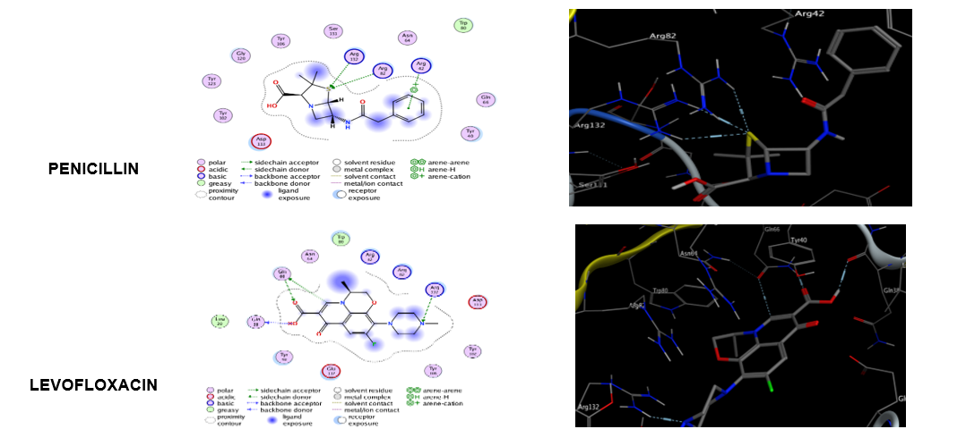
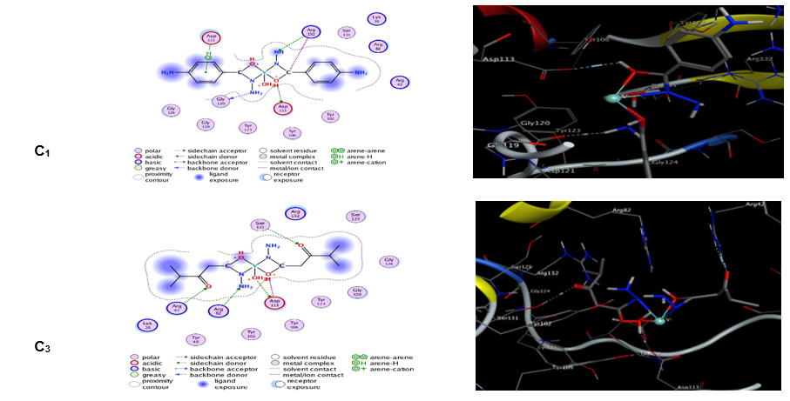

C₇ | 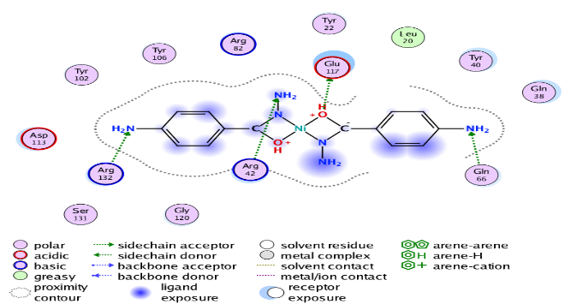 | 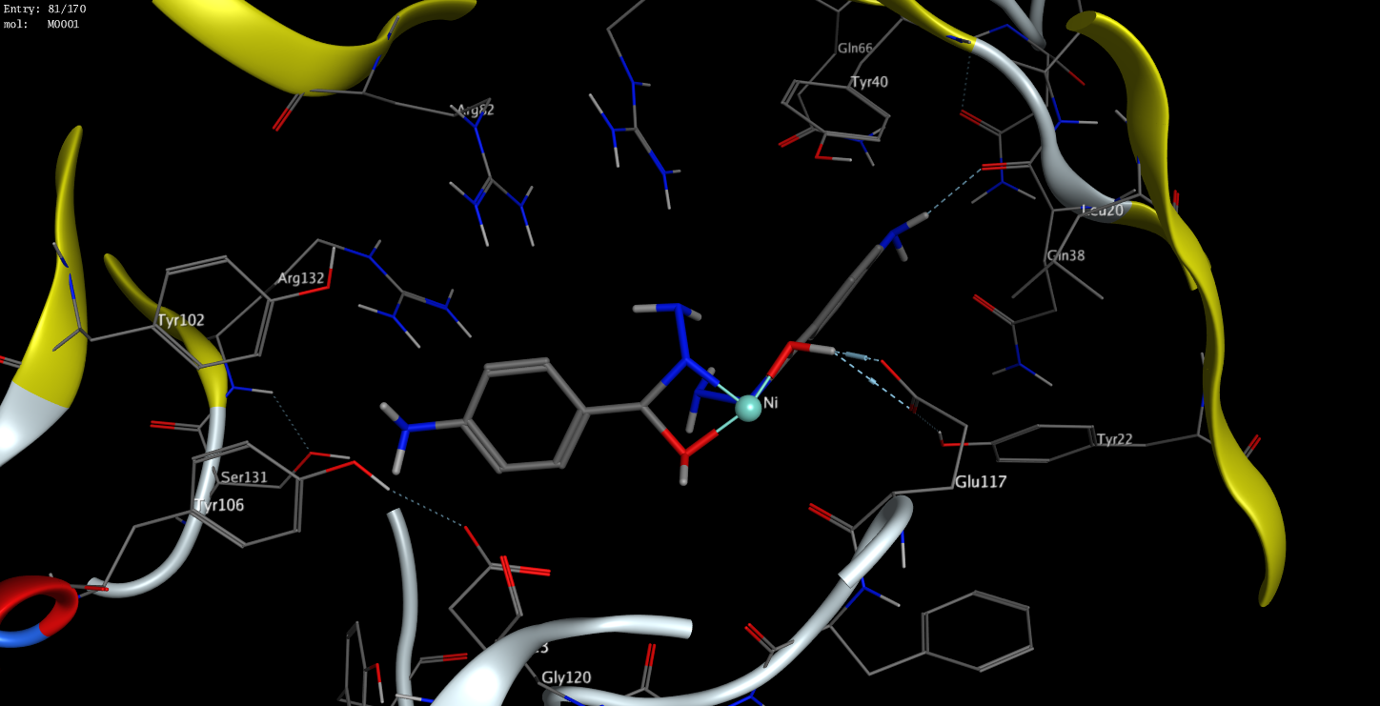
C₈ | 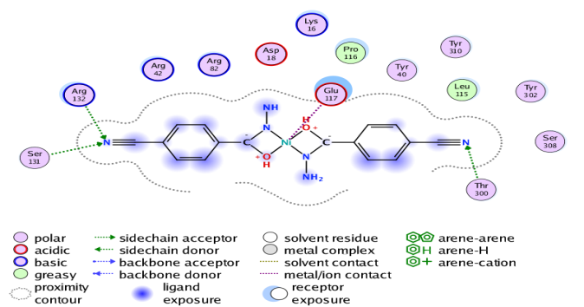 | 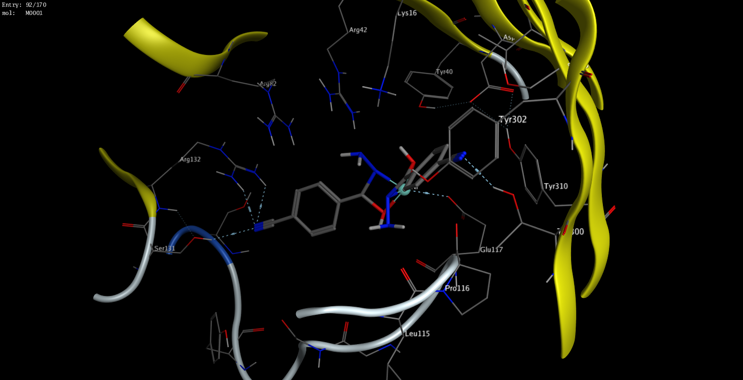
C₉ | 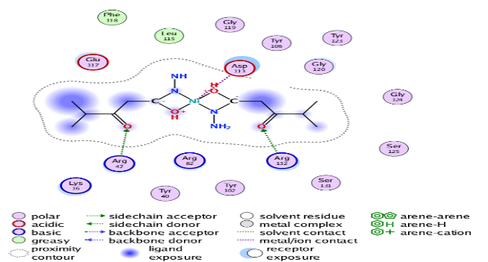 | 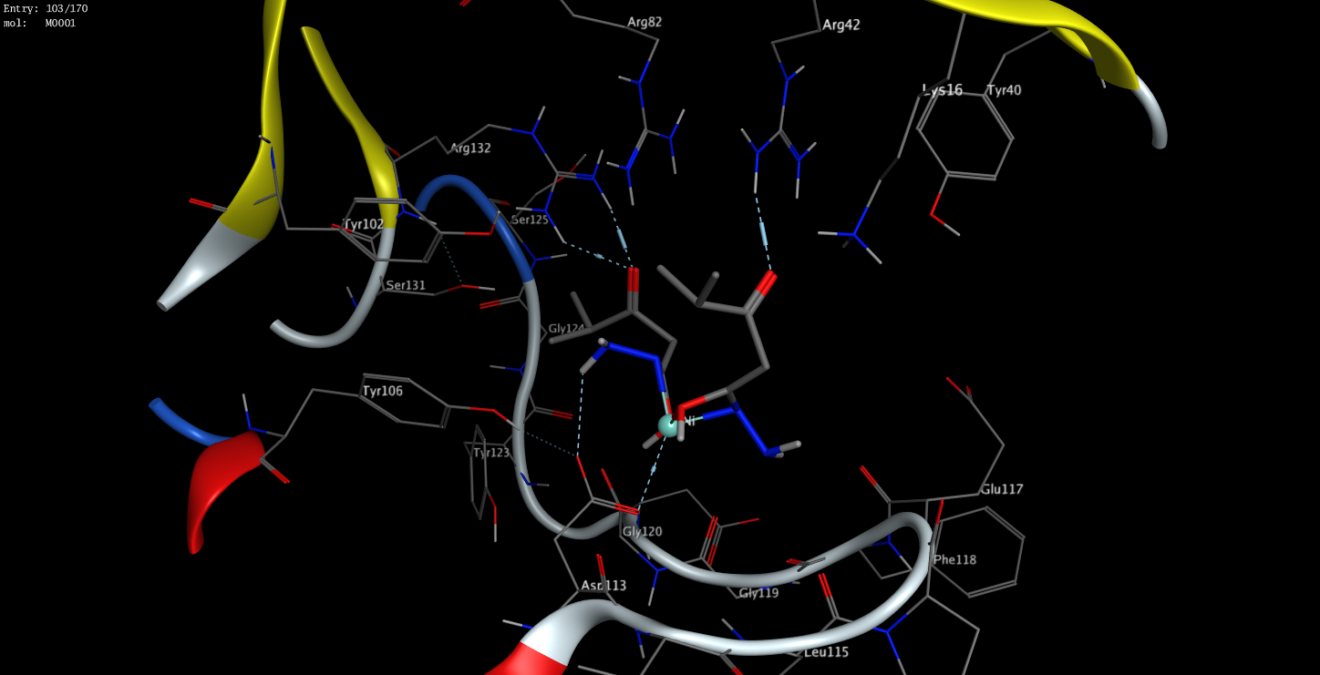
C₁₀ | 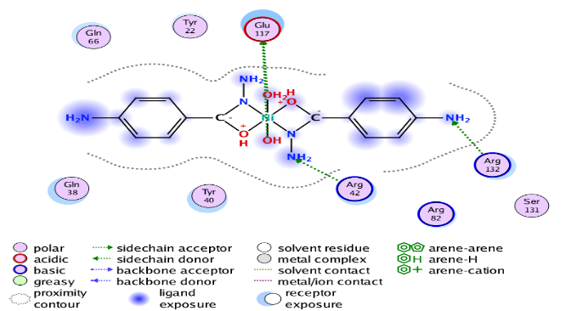 | 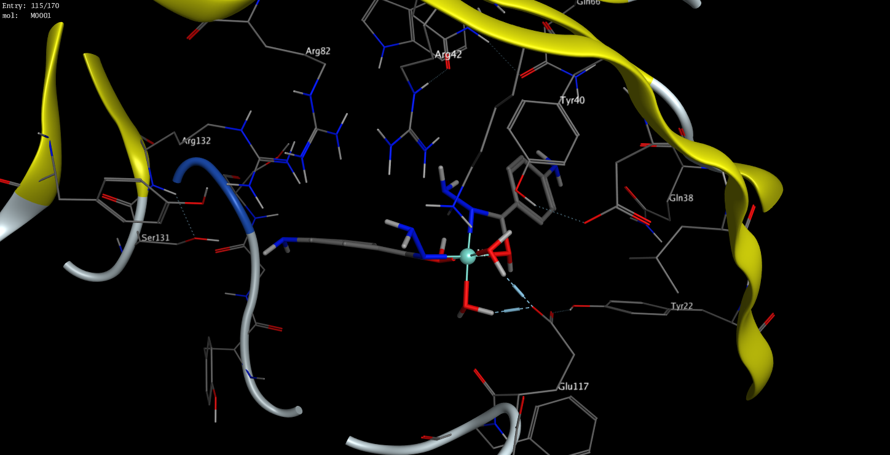
C₁₁ | 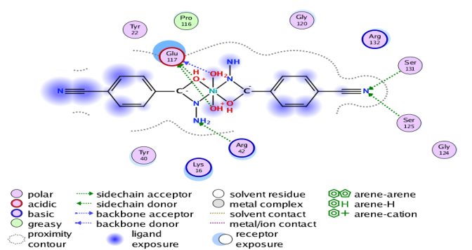 | 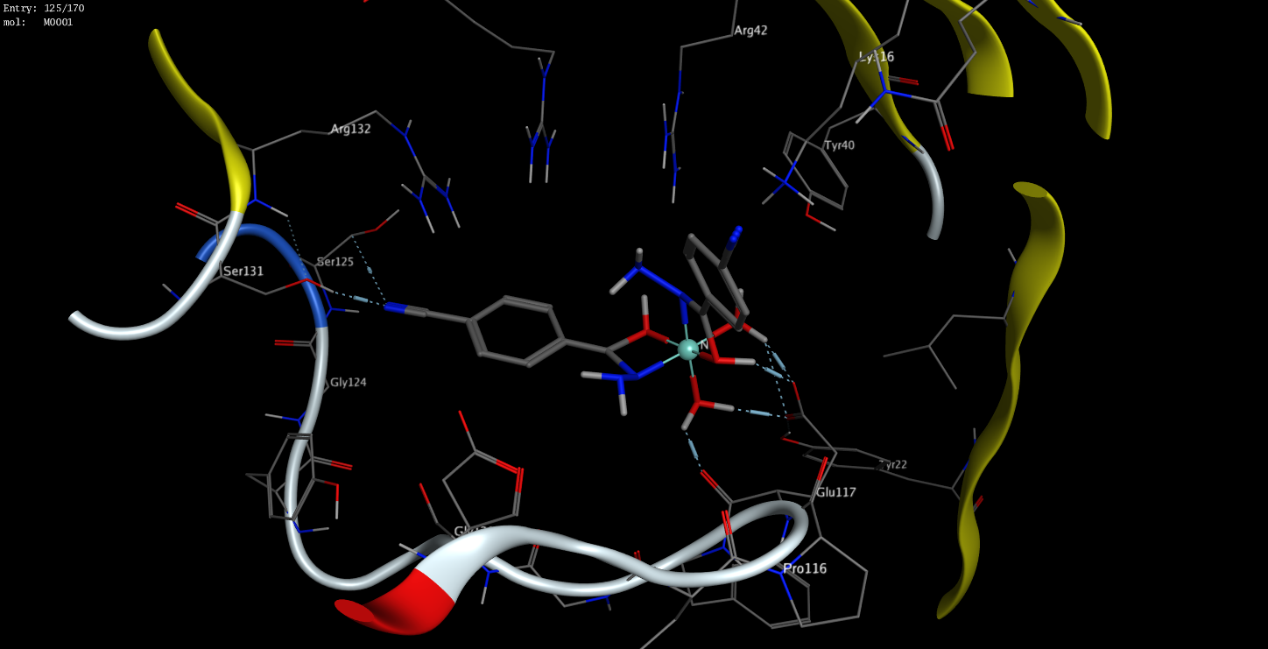
C₁₂ | 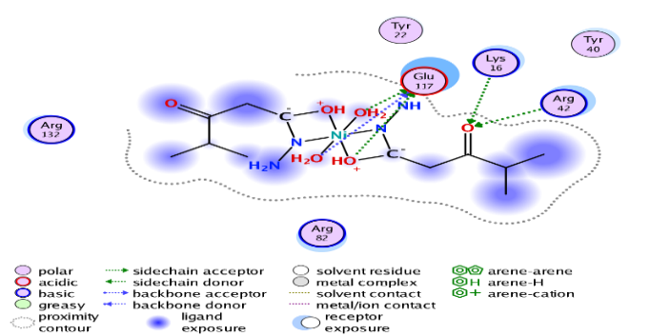 | 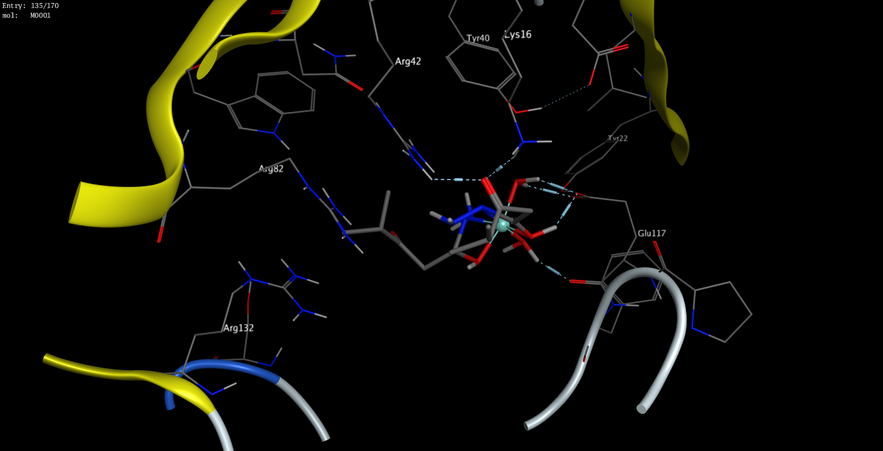
Figure 4: Interaction diagrams in two- and three-dimensions of complexes and standard drugs with receptors: Klebsiella Pneumoniae (PDB ID: 1OSM)
third through the hydrogen of the amine group (4.32 Å). In addition, penicillin exhibited a π-H interaction with VAL46 (3.85 Å) and a π-π stacking interaction with PHE218 (3.85 Å) involving its aromatic ring. These interactions suggest that ARG47 and PHE218 play crucial roles in anchoring penicillin within the 3ZMB active site, facilitating strong hydrogen and π-type bonding. The presence of multiple interaction types implies enhanced conformational stability and effective receptor recognition. Levofloxacin displayed four hydrogen-bond acceptor interactions: with ARG94 via the carbonyl oxygen of the enone group (3.01 Å), with ASN41 through the carbonyl oxygen of the carboxyl group (3.04 Å), with ARG95 via another enone carbonyl oxygen (3.43 Å), and with GLN219 through the amide nitrogen (3.45 Å). The abundance of polar contacts highlights the affinity of levofloxacin for the polar residues within the 3ZMB active pocket, which is consistent with its known broad-spectrum antibacterial activity. Such strong hydrogen bonding contributes to high specificity and stable binding within the enzyme’s catalytic cleft.
Among the synthesized complexes, C₁ exhibited a hydrogen bond with ASP226 through the hydroxyl oxygen, complemented by a vanadium-associated metallic bond. It also formed seven ionic interactions at ASP222 and ASP226 with bond lengths ranging from 2.70-3.61 Å. The combination of hydrogen and ionic interactions indicates a robust coordination between the vanadium center and the carboxylate residues, stabilizing the complex through metal–ligand synergy. C₂ formed a hydrogen bond with ASP222 via a hydroxyl oxygen and interacted with ARG47 through a cyano nitrogen, accompanied by five ionic bonds at ASP222 and ASP226. This mixed interaction pattern underscores the electrostatic complementarity between the ligand and the protein environment, contributing to high docking stability. C₃ formed three main interactions: two hydrogen-bond acceptors, one with HIS76 at a carbonyl carbon and another with ARG47 at a hydrazine nitrogen, and an additional ionic bond between ARG47 and a carbonyl carbon. The dual interaction at ARG47 suggests this residue is a recurring hotspot for ligand anchoring, enhancing the binding persistence during simulation.
Similarly, C₇ exhibited three bonding interactions: two hydrogen-bond acceptors (with ASN41 via an amine nitrogen and ARG47 via a hydrazine nitrogen) and a π-π stacking interaction involving an aromatic ring. The π-π interaction contributes additional stabilization through hydrophobic contact, implying a favorable orientation within the protein cavity. C₉ formed four hydrogen-bond acceptor interactions, three with ARG47 (two through hydrazine nitrogens and one via a carbonyl carbon; 3.38-3.85 Å) and one with HIS76 (4.22 Å). The recurrent ARG47 engagement across several complexes reinforces its role as a central residue in ligand accommodation and recognition within the 3ZMB receptor. C₁₀ exhibited nine distinct bonding interactions (2.58-3.65 Å), demonstrating the highest degree of ligand-protein contact among the studied complexes. ASP222 showed strong electrostatic and hydrogen-bonding interactions typical of carboxylate–metal coordination, while ASP226 contributed three hydrogen donor bonds (two through water ligands and one via a carbonyl oxygen) and four ionic interactions. These multiple polar contacts indicate that C₁₀ possesses a highly interactive and stable binding orientation, potentially reflecting a stronger inhibitory capacity.
Also, C₁₁ showed three interactions within 3.13-3.88 Å, including hydrogen-bond acceptor interactions at the cyano nitrogens with ASN41 and GLN219, and a π-π stacking interaction with PHE218. The involvement of aromatic stacking suggests stabilization through π-cloud overlap, complementing the polar hydrogen-bond network. Similarly, C₁₂ formed three hydrogen-bond acceptor interactions (3.03-4.03 Å): one with LYS44 via a carbonyl oxygen and two with ARG47 involving a carbonyl carbon and an adjacent amino hydrogen. These dual ARG47 contacts further highlight the importance of this residue in mediating ligand stabilization.
Hydrogen bonds play a pivotal role in stabilizing ligand-receptor interactions, ranking among the most influential non-covalent forces in molecular docking. The high frequency of hydrogen bonding observed across all complexes indicates strong and specific ligand–protein affinities. Moreover, the presence of ionic and π–π interactions in several complexes, especially C₇, C₁₀, and C₁₁, enhances overall binding stability through synergistic electrostatic and hydrophobic effects. Taken together, these results suggest that the synthesized complexes, particularly C₁, C₉, and C₁₀, exhibit superior docking stability relative to the standard drugs. Their ability to form multiple hydrogen and ionic interactions with catalytically important residues such as ARG47, ASP222, and ASP226 may account for their enhanced binding affinities. The detailed representations of these interactions are provided in Supplementary Data 1 and 2, offering visual insights into the molecular basis of receptor-ligand stabilization.
LIGANDS / COMPLEXES | 2D | 3D
PENICILLIN | 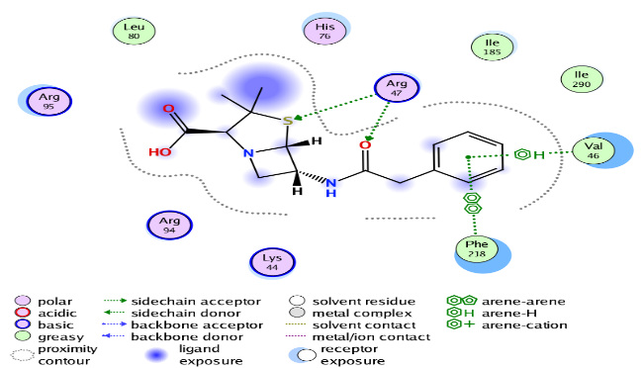 | 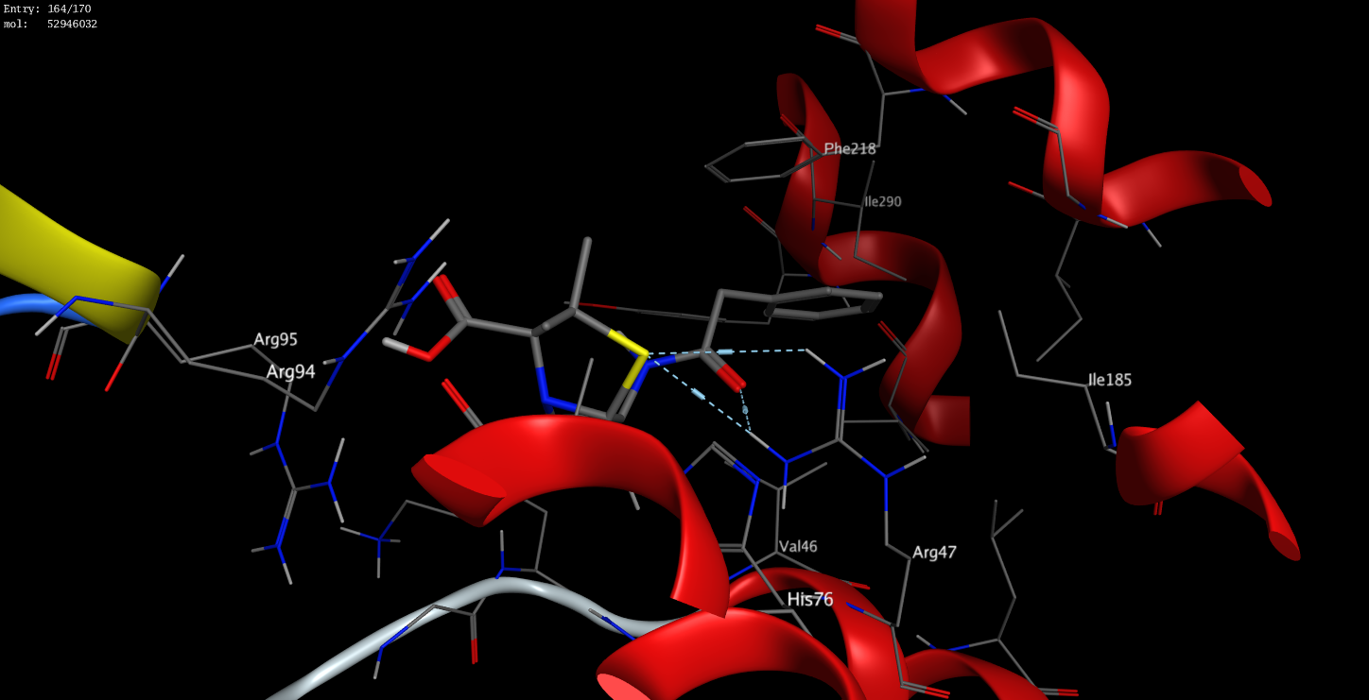
LEVOFLOCAXIN | 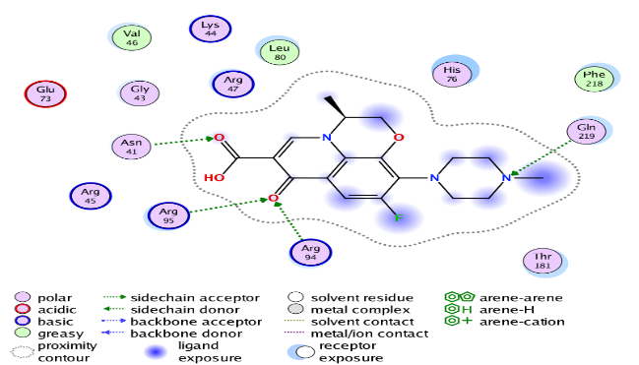 | 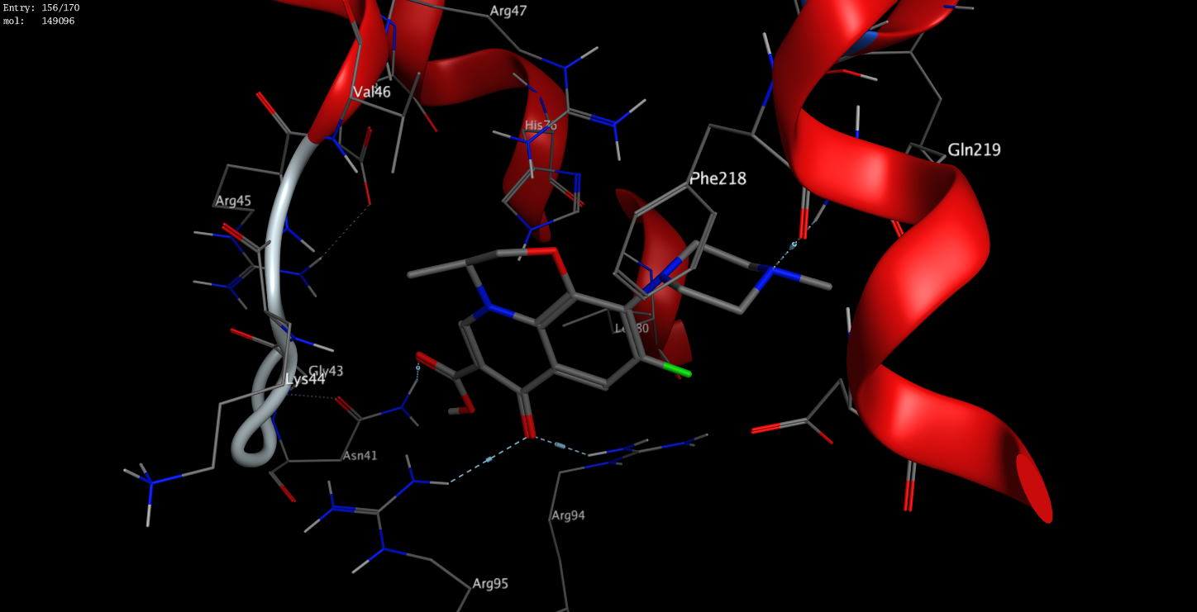
C₁ | 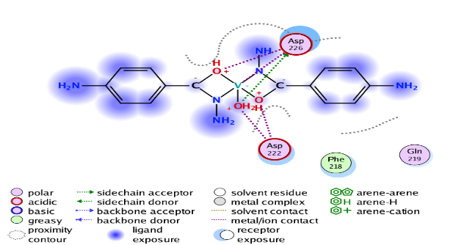 | 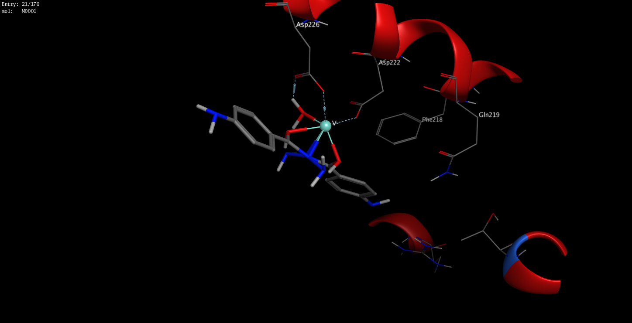
C₂ | 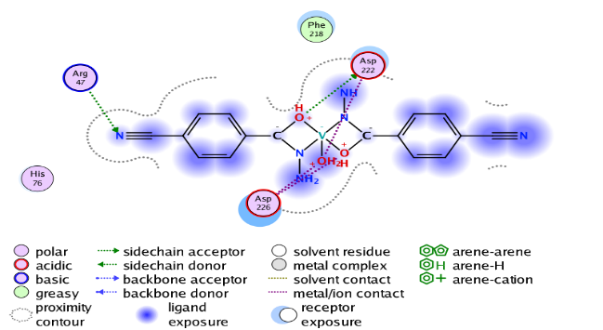 | 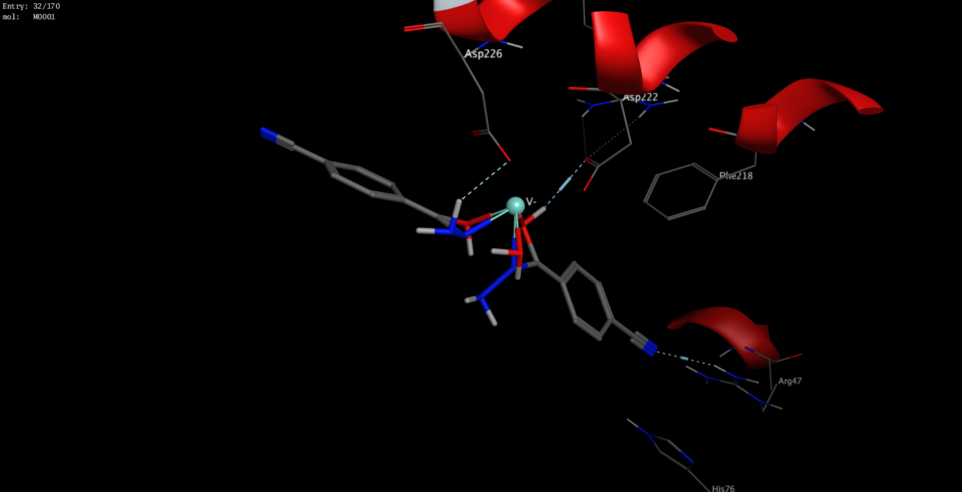
C₃ | 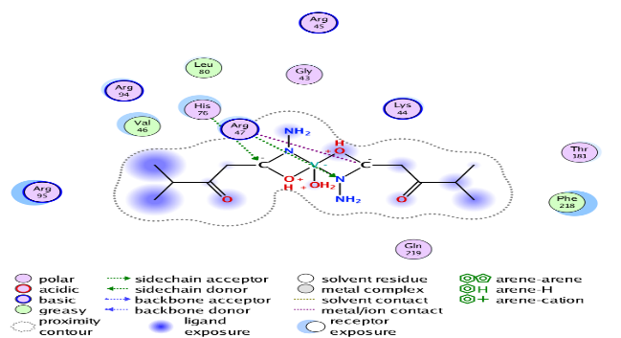 | 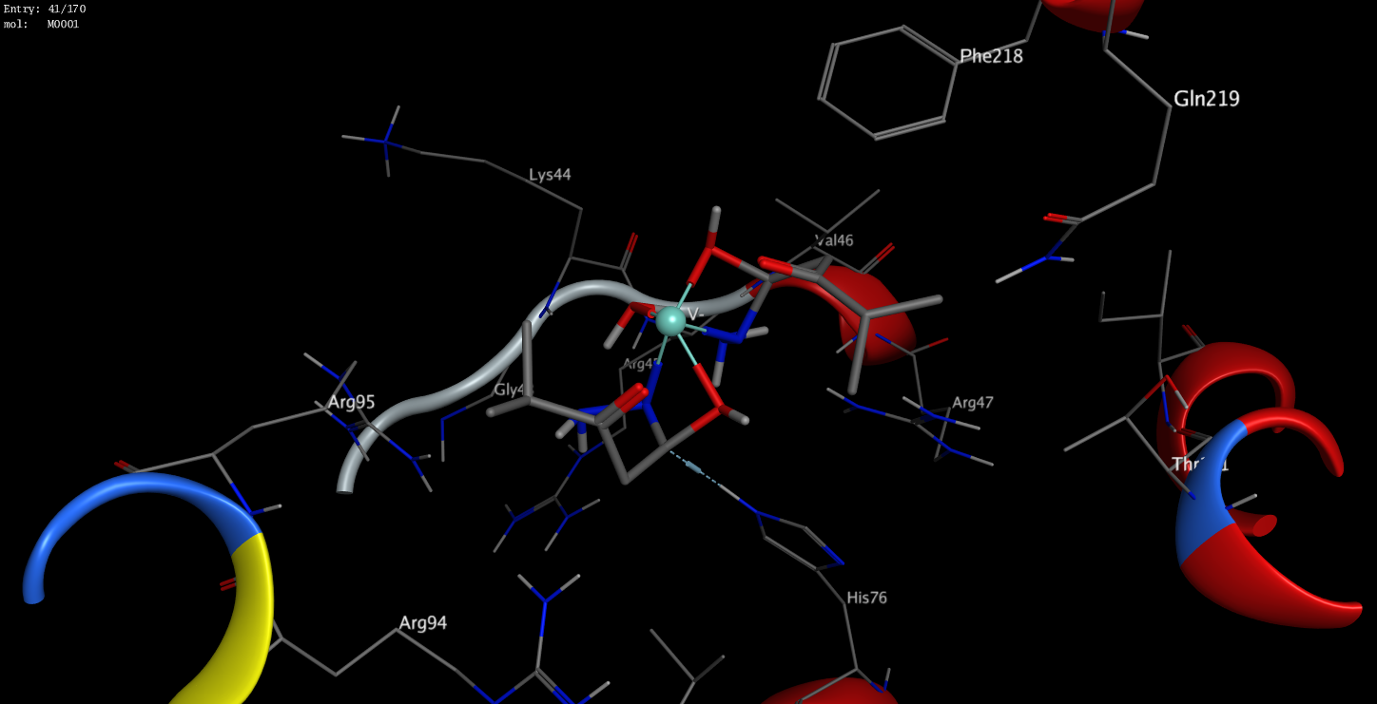
C₇ | 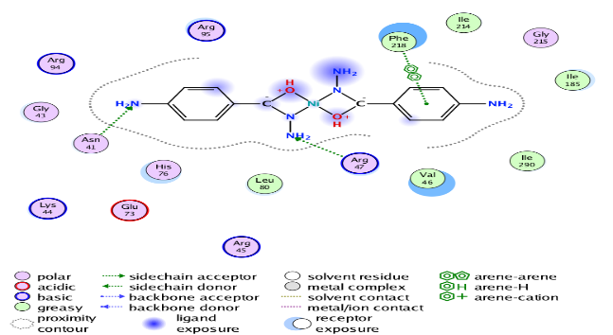 | 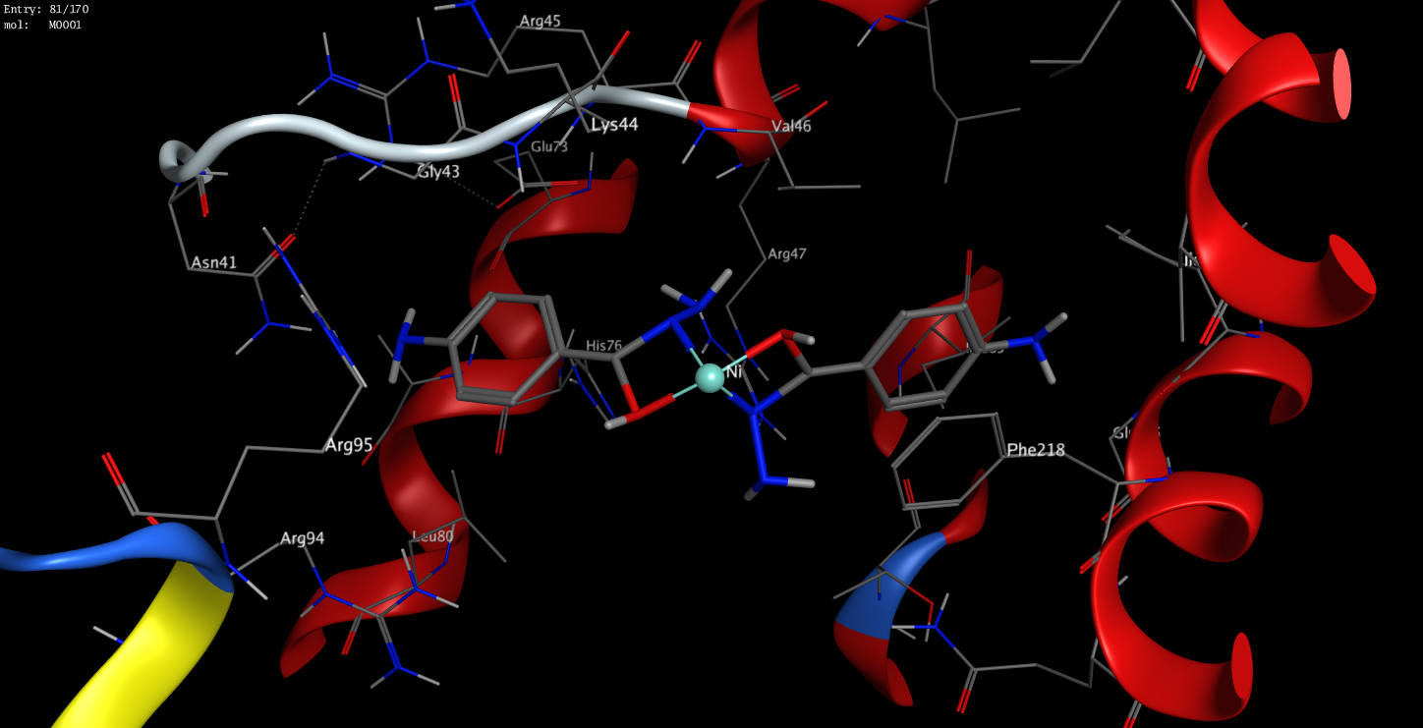
C₉ | 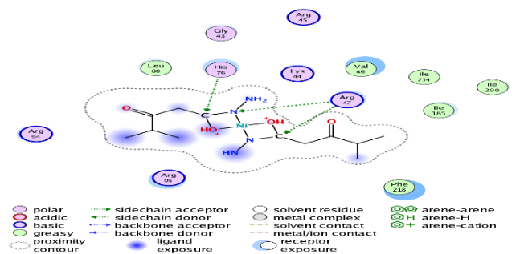 | 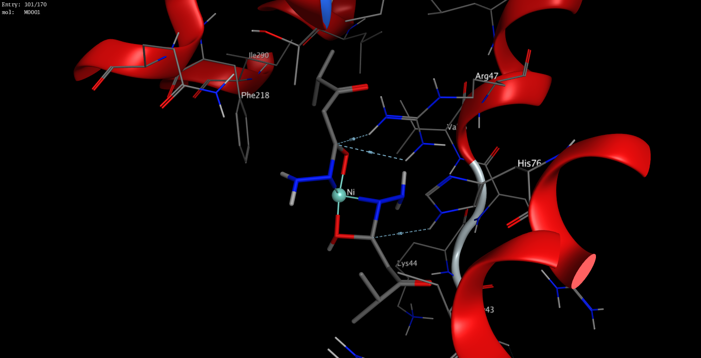
C₁₀ | 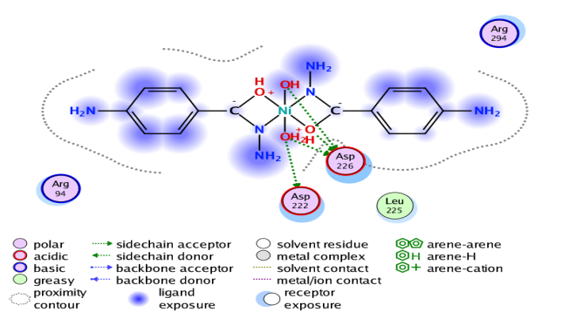 | 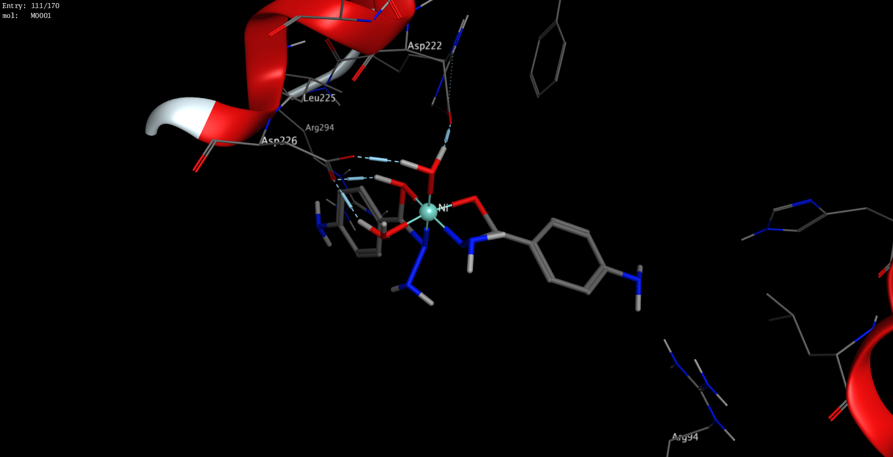
C₁₁ | 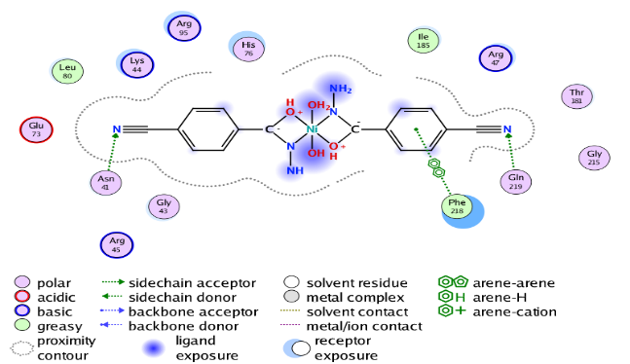 | 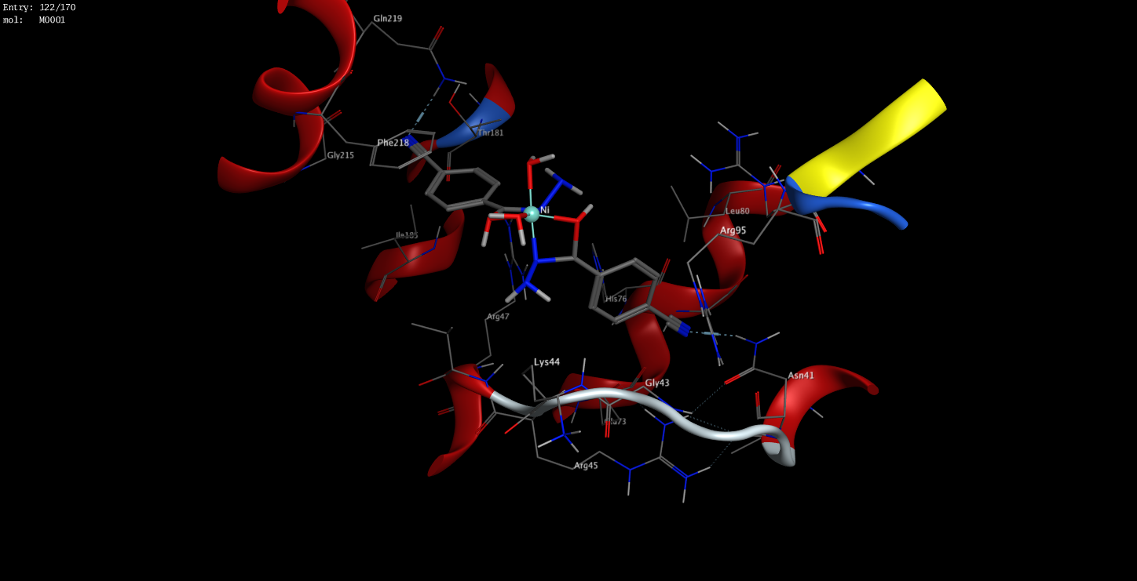

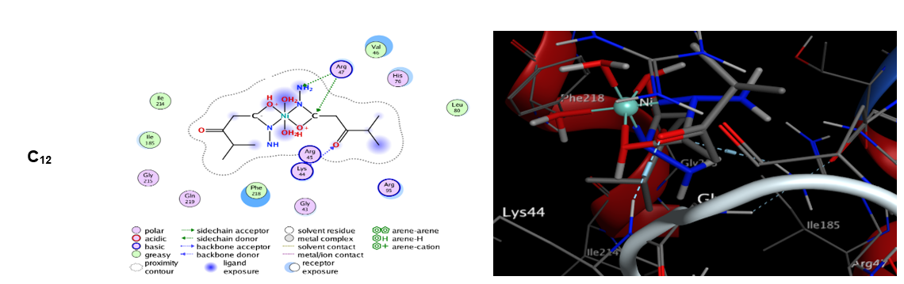
Figure 5: Interaction diagrams in two- and three-dimensions of complexes and standard drugs with receptors: Pseudomonas Aeruginosa (PDB ID: 3ZMB)
Physicochemical and ADMET properties of C₁, C_{3,} C_{9,} C₁₁ and C₁₂.

The ADMET (Absorption, Distribution, Metabolism, Excretion, and Toxicity) properties of the selected complexes were evaluated using the SwissADME web server (http://www.swissadme.ch/index.php), and the results are summarized in Table 10. The assessment of physicochemical properties was based on Lipinski’s Rule of Five (RO5), a widely used guideline for evaluating drug-likeness. Proposed by Christopher A. Lipinski and colleagues at Pfizer in 1997, the rule postulates that a compound is more likely to exhibit good oral bioavailability when it satisfies the following criteria: an octanol–water partition coefficient (log P) ≤ 5, molecular weight (MW) ≤ 500 g/mol., hydrogen bond acceptors (HBA) ≤ 10, and hydrogen bond donors (HBD) ≤ 5 (Lipinski, 2004; Sule et al., 2025) [11,29].
The reference drugs, Levofloxacin and Penicillin, exhibited log P values of 1.20 and 1.02, log Kp (cm/s) values of –8.78 and –8.56, HBA counts of 6 and 4, HBD counts of 1 and 2, and topological polar surface areas (TPSA) of 75.01 and 94.94 Å², respectively. For the tested complexes, log P values ranged from -1.93 to -0.88, while log Kp (cm/s) values varied between -8.93 and -7.84, with C12 and C9 showing the lowest and highest values, respectively. The HBA values ranged from 5 to 8, HBD values from 2 to 4, and TPSA from 126.80 to 161.77 Å.
Furthermore, all the complexes were predicted not to cross the blood–brain barrier (BBB) and were identified as non-inhibitors of Cytochrome P450 (CYP450) enzymes. Most complexes exhibited low intestinal absorption, except for C₉, which showed relatively higher absorption potential. Based on these findings, complexes C₁, C₃, C₉, C₁₁, and C₁₂ demonstrated acceptable ADME profiles, as further illustrated in the bioactivity radar plot (Figure 6).
CONCLUSION

Computational methods were used to analyze the spectroscopic (IR and Electronic) and antibacterial properties of acid hydrazides (4-ABAH, 4-CBAH and IBAH) of VO(II), Co(II) and Ni(II) complexes using DFT at the B3LYP/6-31G** level, while molecular docking simulations were conducted in consideration of in vitro studies against Klebsiella Pneumoniae (PDB 1D: 1OSM) and Pseudomonas Aeruginosa (PDB 1D: 3ZMB).
The theoretical results demonstrated strong concordance with experimental spectroscopic data and structural parameters for the hydrazide complexes. Notably, complexes [VO(4-ABAH)₂]²⁺-(C₁), [VO(IBAH)₂]²⁺-(C₃), [Ni(IBAH)₂]²⁺-(C₉), [Ni(4-CBAH.H₂O)₂]²⁺-(C₁₁) and [Ni(IBAH. H₂O)₂]²⁺-(C₁₂) exhibited superior binding affinities toward klebsiella pneumoniae and pseudomonas aeruginosa receptors, outperforming standard antibiotics such as penicillin and levofloxacin in molecular docking simulations. These findings suggest their potential as effective antibacterial agents.
Ultimately, conducting in vivo investigations would provide additional support and reinforce the computational and in vitro outcomes.
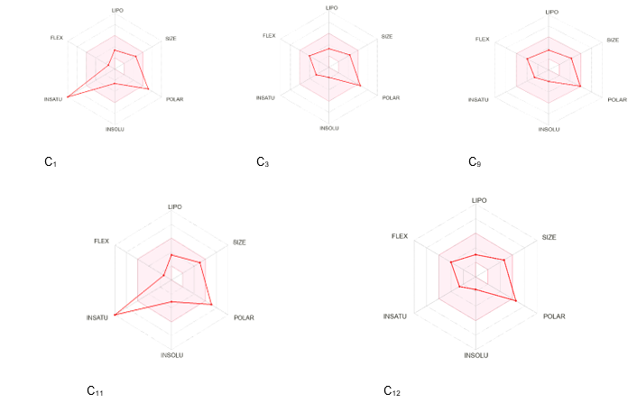

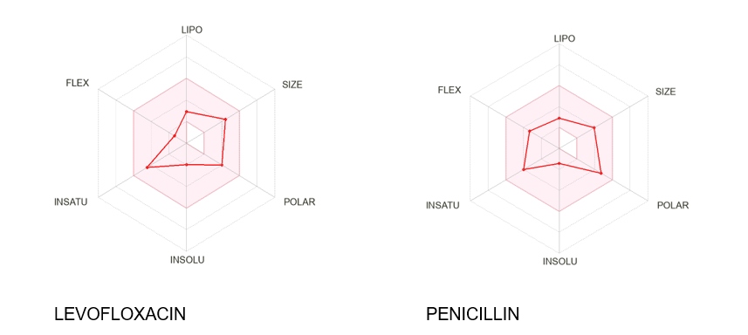
Figure 6: The bioavailability radar for the C₁, C₃, C₉, C₁₁, C₁₂ and standard drugs
Table 10: Physicochemical and ADMET properties of C₁, C_{3,} C_{9,} C₁₁and C₁₂.

Molecule | MW | HA | AHA | RB | HBA | HBD | MR | TPSA | Log P | Log Kp (cm/s) | Lipinski | BS | BBB
C1 | 367.26 | 24 | 12 | 2 | 5 | 4 | 90.08 | 161.77 | -1.05 | -8.25 | 0 | 0.55 | No
C3 | 353.27 | 22 | 0 | 6 | 7 | 2 | 80.52 | 143.87 | -1.24 | -8.28 | 0 | 0.55 | No
C9 | 345.02 | 21 | 0 | 6 | 6 | 2 | 79.63 | 126.80 | -0.88 | -7.84 | 0 | 0.55 | No
C11 | 415.03 | 27 | 12 | 2 | 8 | 4 | 96.11 | 158.70 | -1.22 | -8.25 | 0 | 0.55 | No
C12 | 381.05 | 23 | 0 | 6 | 8 | 4 | 85.73 | 145.26 | -1.93 | -8.73 | 0 | 1.55 | No
Penicillin | 320.41 | 22 | 6 | 5 | 4 | 2 | 89.66 | 94.94 | 1.02 | -8.56 | 0 | 0.55 | No
Levofloxacin | 361.67 | 26 | 10 | 2 | 6 | 1 | 101.83 | 75.01 | 1.20 | -8.78 | 0 | 0.55 | No
Molecule | GI Absorption |  | Pgp Substrate |  | CYP1A2 Inhibitor |  | CYP2C9 Inhibitor |  | CYP2D6 Inhibitor |  | CYP3A4 Inhibitor
C1 | Low |  | Yes |  | No |  | No |  | No |  | No
C3 | Low |  | No |  | No |  | No |  | No |  | No
C9 | High |  | No |  | No |  | No |  | No |  | No
C11 | Low |  | Yes |  | No |  | No |  | No |  | No
C12 | Low |  | No |  | No |  | No |  | No |  | No
Penicillin | High |  | Yes |  | No |  | No |  | No |  | No
Levofloxacin | High |  | Yes |  | No |  | No |  | No |  | No

CONSENT
None
ETHICAL APPROVAL
None
REFERENCE
- Kumar, N., & Chauhan, L. S. (2014). Analgesic and anti-inflammatory potential of hydrazones. Journal of Chemical and Pharmaceutical Research, 6(12), 916–934. http://www.jocpr.com
- Paruch, K., Popiołek, Ł., Biernasiuk, A., Berecka-Rycerz, A., Malm, A., Gumieniczek, A., & Wujec, M. (2021). Novel derivatives of 4-methyl-1,2,3-thiadiazole-5-carboxylic acid hydrazide: Synthesis, lipophilicity, and in vitro antimicrobial activity screening. Applied Sciences, 11(3), 1180. https://doi.org/10.3390/app11031180
- Nwambueze, J. N., & Salawu, O. W. (2012a). Complexes of Co(II) and Mn(II) sulphate with keto and enol forms of isobutryl acetic acid, 4-amino benzoic acid and 4-cyano benzoic acid hydrazide. The International Journal Research Publications; Research Journal of Science & IT Management, 1(9), 28–35.
- Nwambueze, J. N., & Salawu, O. W. (2012b). Complexes of Ni(II) and Cu(II) sulphate with keto and enol forms of sobutryl acetic acid, 4-amino benzoic acid and 4-cyano benzoic acid hydrazide. Advances in Pure and Applied Chemistry (APAC), 1(2), 40–48.
- Nwambueze, J. N., & Salawu, O. W. (2012c). Complexes of Zn(II) and VO(IV) sulphate with keto and enol forms of isobutryl acetic acid, 4-amino benzoic acid and 4-cyano benzoic acid hydrazide. Advances in Pure and Applied Chemistry, 1(2), 20–30.
- Shevyrin, V., Melkozerov, V., Nevero, A., Eltsov, O., Baranovsky, A., & Shafran, Y. (2014). Synthetic cannabinoids as designer drugs: New representatives of indol-3-carboxylates series and indazole-3-carboxylates as novel group of cannabinoids. Identification and analytical data. Forensic Science International, 244, 263–275. https://doi.org/10.1016/j.forsciint.2014.09.013
- Rana, K. M., Maowa, J., Alam, A., Dey, S., Hosen, A., Hasan, I., Fujii, Y., Ozeki, Y., & Kawsar, S. M. A. (2021). In silico DFT study, molecular docking, and ADMET predictions of cytidine analogs with antimicrobial and anticancer properties. In Silico Pharmacology, 9(1), 42. https://doi.org/10.1007/s40203-021-00102-0
- Deghady, A. M., Hussein, R. K., Alhamzani, A. G., & Mera, A. (2021). Density Functional Theory and Molecular Docking Investigations of the Chemical and Antibacterial Activities for 1-(4-Hydroxyphenyl)-3-phenylprop-2-en-1-one. Molecules, 26(12), 3631. https://doi.org/10.3390/molecules26123631
- van Mourik, T., Bühl, M., & Gaigeot, M. P. (2014). Density functional theory across chemistry, physics and biology. Philosophical Transactions A Math Phys Eng Sci. https://doi.org/10.1098/rsta.2012.0488
- Obiyenwa, G. K., Semire, B., Oyebamiji, A. K., Abdulsalami, I. O., Latona, D. F., Adeoye, M. D., & Odunola, O. A. (2023). TD-DFT and DFT Investigation on Electrons Transporting Efficiency of 2-Cyano-2-Pyran-4-Ylidene-Acetic Acid and 2-Cyanoprop-2-Enoic Acid as Acceptors for Thiophene-Based π-Linkers Dye-Sensitized Solar Cells. Eurasian Journal of Chemistry, 111(3), 69–82. https://doi.org/10.31489/2959-0663/3-23-9
- Sule, A. O., Obiyenwa, K. G., Salawu, O. W., & Semire, B. (2025). In silico evaluation of Co(II), Mn(II), Cu(II), and Zn(II) complexes with hydrazide ligands: DFT, spectroscopic, and molecular docking studies. International Journal of Chemical Studies, 13(3), 96–113. https://doi.org/10.22271/chemi.2025.v13.i3b.12545
- Dutzler, R., Rummel, G., Albertí, S., Hernández-Allés, S., Phale, P., Rosenbusch, J., Benedí, V., & Schirmer, T. (1999). Crystal structure and functional characterization of OmpK36, the osmoporin of Klebsiella pneumoniae. Structure, 7(4), 425–434. https://doi.org/10.1016/S0969-2126(99)80055-0
- Zhou, G., Wang, Q., Wang, Y., Wen, X., Peng, H., Peng, R., Shi, Q., Xie, X., & Li, L. (2023). Outer membrane porins contribute to antimicrobial resistance in Gram-negative bacteria. Microorganisms, 11(7), 1690. https://doi.org/10.3390/microorganisms11071690
- Schmidberger, J. W., Schnell, R., & Schneider, G. (2015). Structural characterization of substrate and inhibitor binding to farnesyl pyrophosphate synthase from Pseudomonas aeruginosa. Acta Crystallographica Section D: Biological Crystallography. https://doi.org/10.1107/S1399004715001121
- Pitton, M., Oberhaensli, S., Appiah, F., & Cameron, D. R. (2022). Mutation to ispA produces stable small-colony variants of Pseudomonas aeruginosa that have enhanced aminoglycoside resistance. Antimicrobial Agents and Chemotherapy, 66(7), e00621-22. https://doi.org/10.1128/aac.00621-22
- Nnyigide, O. S., Nnyigide, T. O., Lee, S. G., & Hyun, K. (2022). Protein Repair and Analysis Server: A Web Server to Repair PDB Structures, Add Missing Heavy Atoms and Hydrogen Atoms, and Assign Secondary Structures by Amide Interactions. Journal of Chemical Information and Modeling. https://doi.org/10.1021/acs.jcim.2c00571
- Asibor, Y. E., Oyebamiji, A. K., Latona, D. F., & Semire, B. (2024). Computational screening of phytochemicals present in some Nigerian medicinal plants against sickle cell disease. Scientific Reports, 14(1), 26368. https://doi.org/10.1038/s41598-024-75078-w
- Le, T. T. V., & Do, P. C. (2022). Molecular docking study of various Enterovirus-A71 3C proteases proteins and their potential inhibitors. Frontiers in Microbiology, 13, 987801. https://doi.org/10.3389/fmicb.2022.987801
- Oyebamiji, A. K., Akintelu, S. A., Olujinmi, F. E., Jinadu, L. A., Ebenezer, O., Aworinde, J. O., Semire, B., & Babalola, J. O. (2024). Performance prediction of polypeptide derivatives as efficient potential microbial inhibitors: a computational approach. International Journal of Biochemistry & Molecular Biology, 15(5), 127–140. https://doi.org/10.62347/YLVH4793
- Shaaban, S., Al-Faiyz, Y. S., Alsulaim, G. M., Alaasar, M., Amri, N., Ba-Ghazal, H., Al-Karmalawy, A. A., & Abdou, A. (2023). Synthesis of New Organoselenium-Based Succinanilic and Maleanilic Derivatives and In Silico Studies as Possible SARS-CoV-2 Main Protease Inhibitors. Inorganics, 11(8), 321. https://doi.org/10.3390/inorganics11080321
- Suleman, V. T., & Al-Daher, A. G. M. (2023). Synthesis, characterization, density functional theory studies and antioxidant activity of novel hydrazone ligands and their metal complexes. Oriental Journal of Chemistry, 39(6), 1629–1642. https://doi.org/10.13005/ojc/390624
- Shakdofa, M. E. M., Morsy, A. N., Rasras, J. A., Al-Hakimi, N. A., & Shakdofa, M. E. A. (2020). Applied Organometallic Chemistry, 35(2), 1–19.
- Abu-Dief, M. A., El-Khatib, M. R., Sayed, M. El. S., Alzahrani, S., Alkhatib, F., El-Sarrag, G., & Ismael, M. (2021). Journal of Molecular Structure, 1244, 131017.
- Hosny, N. M., Samir, G., & Abdel-Rhman, M. H. (2024). N′-(Furan-2-ylmethylene)-2-hydroxybenzohydrazide and its metal complexes: synthesis, spectroscopic investigations, DFT calculations and cytotoxicity profiling. BMC Chemistry, 18(1), 22. https://doi.org/10.1186/s13065-023-01098-8
- Preethi, V., Vijukumar, V. G., AnilaRaj, S., & Vidya, V. G. (2024). Synthesis, characterization, DFT studies and evaluation of the potential anti-tumour activity of nicotinic hydrazide-based Schiff base using in vitro and molecular docking techniques. Heliyon, 10(9). https://doi.org/10.1016/j.heliyon.2024.e29689
- Merrick, J. P., Moran, D., & Radom, L. (2007). An evaluation of harmonic vibrational frequency scale factors. The Journal of Physical Chemistry A, 111(45), 11683–11700. https://doi.org/10.1021/jp073974n
- Zhang, L., Zhang, Y., Tao, H., Sun, X., Guo, Z., & Zhu, L. (2002). Theoretical calculation on far-infrared spectra of some palladium(II) and platinum(II) halides: Effect of theoretical methods and basis sets. Journal of Molecular Structure: THEOCHEM, 617(1–3), 87–97. https://doi.org/10.1016/S0166-1280(02)00392-5
- Semire, B., Mutiu, O. A., & Oyebamiji, A. K. (2017). DFT and ab initio methods on NMR, IR and reactivity indices of indol-3-carboxylate and indazole-3-carboxylate derivatives of cannabinoids: comparative study. J. Phys. Theor. Chem. IAU, Iran., 13(4), 353–377. http://www.jptc.ir
- Lipinski, C. A. (2004). Lead- and drug-like compounds: the rule-of-five revolution. Drug Discovery Today: Technologies. https://doi.org/10.1016/j.ddtec.2004.11.007
APPENDIX 1: Binding affinity (∆G) and Bonding interaction of Klebsiella Pneumoniae (PDB 1D: 1OSM) with the complexes and ligands
LIGANDS/COMPLEXES | AMINO ACID | TYPE OF | DISTANCE | BINDING AFFINITY
LIGANDS/COMPLEXES | RESIDUES | INTERACTION | (Å) | (kcal/mol)
PENICILLIN | ARG 82 | H-acceptor | 4.23 | -5.0927
PENICILLIN | ARG 132 | H-acceptor | 3.50 | -5.0927
PENICILLIN | ARG 132 | H-acceptor | 3.43 | -5.0927
PENICILLIN | ARG 42 | pi-cation | 3.59 | -5.0927
LEVOFLOXACIN | GLN 38 | H-donor | 2.87 | -5.4570
LEVOFLOXACIN | GLN 66 | H-donor | 3.52 | -5.4570
LEVOFLOXACIN | GLN 66 | H-acceptor | 2.94 | -5.4570
LEVOFLOXACIN | ARG 132 | H-acceptor | 3.19 | -5.4570
C₁ | ASP 113 | H-donor | 2.68 | -6.1039
C₁ | GLY 120 | H-donor | 3.1 | -6.1039
C₁ | ARG 132 | H-acceptor | 3.34 | -6.1039
C₁ | ARG 133 | H-acceptor | 3.33 | -6.1039
C₁ | ARG 132 | ionic | 3.79 | -6.1039
C₁ | ASP 113 | ionic | 2.68 | -6.1039
C₁ | ASP 121 | pi-H | 3.61 | -6.1039
C₃ | ASP 113 | H-donor | 2.67 | -6.5770
C₃ | ARG 42 | H-acceptor | 2.99 | -6.5770
C₃ | ARG 42 | H-acceptor | 3.05 | -6.5770
C₃ | SER 131 | H-acceptor | 3.21 | -6.5770
C₃ | ARG 82 | H-acceptor | 3.30 | -6.5770
C₃ | ASP 113 | ionic | 2.67 | -6.5770
C₃ | ASP 113 | ionic | 2.96 | -6.5770
C₇ | GLU 117 | H-donor | 3.30 | -6.0254
C₇ | GLU 117 | H-donor | 2.59 | -6.0254
C₇ | GLN 66 | H-acceptor | 3.13 | -6.0254
C₇ | ARG 132 | H-acceptor | 3.10 | -6.0254
C₇ | ARG 42 | H-acceptor | 3.28 | -6.0254
C₈ | SER 131 | H-acceptor | 3.44 | -6.4055
C₈ | ARG 132 | H-acceptor | 3.16 | -6.4055
C₈ | ARG 132 | H-acceptor | 3.35 | -6.4055
C₈ | THR 300 | H-acceptor | 3.17 | -6.4055
C₈ | GLU 117 | metal | 2.34 | -6.4055
C₉ | ARG 132 | H-acceptor | 3.19 | -6.7651
C₉ | ARG 132 | H-acceptor | 2.93 | -6.7651
C₉ | ARG 42 | H-acceptor | 3.18 | -6.7651
C₉ | ASP 113 | metal | 2.51 | -6.7651
C₁₀ | GLU 117 | H-donor | 2.64 | -6.0704
C₁₀ | GLU 117 | H-donor | 2.76 | -6.0704
C₁₀ | ARG 132 | H-acceptor | 3.02 | -6.0704
C₁₀ | ARG 132 | H-acceptor | 3.15 | -6.0704
C₁₀ | ARG 42 | H-acceptor | 3.03 | -6.0704
C₁₀ | GLU 117 | ionic | 3.61 | -6.0704
C₁₀ | GLU 117 | ionic | 2.64 | -6.0704
C₁₀ | GLU 117 | ionic | 2.76 | -6.0704
C₁₁ | GLU 117 | H-donor | 2.6 | -6.5043
C₁₁ | GLU 117 | H-donor | 2.81 | -6.5043
C₁₁ | GLU 117 | H-donor | 2.64 | -6.5043
C₁₁ | GLU 117 | H-donor | 2.79 | -6.5043
C₁₁ | ARG 42 | H-acceptor | 3.11 | -6.5043
C₁₁ | SER 125 | H-acceptor | 3.41 | -6.5043
C₁₁ | SER 131 | H-acceptor | 2.98 | -6.5043
C₁₁ | GLU 117 | ionic | 3.31 | -6.5043
C₁₁ | GLU 117 | ionic | 2.81 | -6.5043
C₁₁ | GLU 117 | ionic | 2.79 | -6.5043
C₁₁ | GLU 117 | ionic | 3.24 | -6.5043
C₁₂ | GLU 117 | H-donor | 2.77 | -6.4149
C₁₂ | GLU 117 | H-donor | 2.79 | -6.4149
C₁₂ | GLU 117 | H-donor | 2.67 | -6.4149
C₁₂ | GLU 117 | H-donor | 2.69 | -6.4149
C₁₂ | LYS 16 | H-acceptor | 2.97 | -6.4149
C₁₂ | ARG 42 | H-acceptor | 2.88 | -6.4149
C₁₂ | GLU 117 | ionic | 2.83 | -6.4149
C₁₂ | GLU 117 | ionic | 3.59 | -6.4149
C₁₂ | GLU 117 | ionic | 2.79 | -6.4149
C₁₂ | GLU 117 | ionic | 2.67 | -6.4149

APPENDIX 2: Binding affinity (∆G) and Bonding interaction of Pseudomonas Aeruginosa (PDB 1D: 3ZMB) with the complexes and ligands
LIGANDS/COMPLEXES | AMINO ACID | TYPE OF | DISTANCE | BINDING AFFINITY
LIGANDS/COMPLEXES | RESIDUES | INTERACTION | (Å) | (kcal/mol)
PENICILLIN | ARG 47 | H-acceptor | 3.87 | -5.7037
PENICILLIN | ARG 47 | H-acceptor | 4.32 | -5.7037
PENICILLIN | ARG 47 | H-acceptor | 2.93 | -5.7037
PENICILLIN | VAL 46 | pi-H | 3.85 | -5.7037
PENICILLIN | PHE 218 | pi-pi | 3.70 | -5.7037
LEVOFLOXACIN | ARG 94 | H-acceptor | 3.01 | -5.8807
LEVOFLOXACIN | ARG 95 | H-acceptor | 3.43 | -5.8807
LEVOFLOXACIN | ASN 41 | H-acceptor | 3.04 | -5.8807
LEVOFLOXACIN | GLN 219 | H-acceptor | 3.45 | -5.8807
C₁ | ASP 226 | H-donor | 2.70 | -6.2437
C₁ | ASP 226 | metal | 2.53 | -6.2437
C₁ | ASP 222 | ionic | 3.55 | -6.2437
C₁ | ASP 222 | ionic | 2.96 | -6.2437
C₁ | ASP 226 | ionic | 2.70 | -6.2437
C₁ | ASP 226 | ionic | 3.61 | -6.2437
C₁ | ASP 226 | ionic | 2.99 | -6.2437
C₁ | ASP 226 | ionic | 3.25 | -6.2437
C₁ | ASP 222 | ionic | 2.97 | -6.2437
C₂ | ASP 222 | H-donor | 3.38 | -6.0315
C₂ | ARG 47 | H-acceptor | 3.69 | -6.0315
C₂ | ASP 222 | ionic | 3.81 | -6.0315
C₂ | ASP 226 | ionic | 3.18 | -6.0315
C₂ | ASP 222 | ionic | 3.38 | -6.0315
C₂ | ASP 222 | ionic | 2.66 | -6.0315
C₂ | ASP 226 | ionic | 3.46 | -6.0315
C₃ | HIS 76 | H-acceptor | 3.19 | -5.6105
C₃ | ARG 47 | H-acceptor | 3.28 | -5.6105
C₃ | ARG 47 | ionic | 3.78 | -5.6105
C₇ | ASN 41 | H-acceptor | 3.04 | -6.0935
C₇ | ARG 47 | H-acceptor | 3.19 | -6.0935
C₇ | PHE 218 | pi-pi | 3.52 | -6.0935
C₉ | ARG 47 | H-acceptor | 3.38 | -6.0708
C₉ | HIS 76 | H-acceptor | 4.22 | -6.0708
C₉ | ARG 47 | H-acceptor | 3.85 | -6.0708
C₉ | ARG 47 | H-acceptor | 3.50 | -6.0708
C₁₀ | ASP 226 | H-donor | 2.68 | -6.1825
C₁₀ | ASP 222 | H-donor | 2.58 | -6.1825
C₁₀ | ASP 226 | H-donor | 2.67 | -6.1825
C₁₀ | ASP 226 | H-donor | 2.73 | -6.1825
C₁₀ | ASP 222 | ionic | 2.58 | -6.1825
C₁₀ | ASP 226 | ionic | 3.65 | -6.1825
C₁₀ | ASP 226 | ionic | 2.67 | -6.1825
C₁₀ | ASP 226 | ionic | 2.73 | -6.1825
C₁₀ | ASP 226 | ionic | 2.99 | -6.1825
C₁₁ | ASN 41 | H-acceptor | 3.13 | -6.0410
C₁₁ | GLN 219 | H-acceptor | 3.19 | -6.0410
C₁₁ | PHE 218 | pi-pi | 3.88 | -6.0410
C₁₂ | ARG 47 | H-acceptor | 3.43 | -6.1405
C₁₂ | ARG 47 | H-acceptor | 4.03 | -6.1405
C₁₂ | LYS 44 | H-acceptor | 3.03 | -6.1405

