System Drivers of Hypertension Control in Africa: A Beta Regression and Dynamic Factor Modeling Approach

Abstract
Noncommunicable Disease (NCD) Risk Factor Collaboration supplied population-representative data detailing hypertension management in Africa for individuals aged 30 to 79 years from 1990-2019. Ten cascade indicators were analysed via both age-standardized and crude metrics. Beta regression with a logit link and a continuous function of year was used to assess the effects of sex on each outcome. A one-factor state‒space model integrated mixed temporal dynamics and enabled forecasts extending to 2030, adding policy scenario that enhances diagnosis and treatment by 10 percentage points. Compared with men, women were more likely to receive therapy and control on both metrics (odds ratios of approximately 2.2 and 2.1). Diagnosis indicated negligible benefits for females. Women presented a greater prevalence of untreated stage-2 disease, although they demonstrated superior control. A prevalent latent factor indicated significant persistence ($ϕ$ approximately 0.98). By 2030, the scenario indicated a significant increase in control, particularly for women. Findings also indicate the need for increased capacity to prevent the onset of severe uncontrolled disease. The results reveal a dual approach of treatment and management while simultaneously emphasizing diagnosis and intervention.

Keywords. Hypertension Diagnosis, Hypertension Treatment; Hypertension Forecasting; Hypertension cascade; Hypertension Sex disparities
Background
Hypertension remains the foremost modifiable risk factor for cardiovascular disease in Africa, with considerable diversity in its detection, treatment, and management across diverse contexts. Previous syntheses from Noncommunicable Disease (NCD)-RisC indicate a rising or steady prevalence in conjunction with diverse enhancements in care (Abba, 2022; Aminde et al., 2025; Kirschbaum et al., 2021; Ntaganda et al., 2025; Olowoyo et al., 2025; Perkins et al., 2024; Romo et al., 2025; Yuyun et al., 2020). Cascade frameworks indicate that the majority of loss occurs prior to the attainment of control, typically during the diagnostic phase and initial therapy steps. Studies in primary care indicate that optimized protocols, assured medication accessibility, and comprehensive registries can enhance large-scale management (Chham et al., 2022; Guthi et al., 2024; Kothavale et al., 2022; Peters et al., 2022). Men and women exhibit disparities in cardiometabolic care. For example, women are more inclined to undergo screenings and receive chronic care, whereas men exhibit greater disparities in accessing and maintaining care (Colafella & Denton, 2018; Gerdts & Regitz-Zagrosek, 2019; Ji et al., 2020; Meloni et al., 2023; Schorr et al., 2018; Šebeková et al., 2020). There is limited information regarding severe uncontrolled hypertension; however, high-risk areas persist despite improvements in average management. A systemic perspective that differentiates between common causes and outcome-specific noise can clarify a suitable path of action. This study aims to quantify the disparities between men and women in the hypertension cascade, identify a shared underlying factor that elucidates the temporal changes in the system, and examine projections and policy scenarios for 2030 that alter diagnostic and treatment approaches.
Materials and methods
Data source and demographic population. The NCD-RisC portal compiled Hypertension Africa, which provides annual indexed, country-aggregated metrics for Africa from 1990-2019 for adults aged 30-79 years, categorized by sex. Hypertension was defined as a systolic blood pressure of ≥140 mmHg, a diastolic blood pressure of ≥90 mmHg, or the administration of antihypertensive medication. The analytical file comprises 60 rows, with 30 allocated to each gender. Five age-standardized indicators and five crude indicators were analysed: prevalence, diagnosis among all individuals with hypertension, treatment among all individuals with hypertension, control among all individuals with hypertension, and untreated stage-2 hypertension among all individuals with hypertension. Indicators were considered ratios. We aggregated the numbers and coverage, thereafter calculating the mean, standard deviation, minimum, and maximum for each sex and overall.
Models used
Data scale and index set: outcomes are indexed by $i∈\left\{1,…,10\right\},$ calendar years by $t∈\left\{1990,…,2019\right\},$ and sex by $s∈\left\{Men, Women\right\}.$ Each observed indicator $Y_{i,t,s}∈\left(0,1\right)$ is a proportion. Values equal to 0 or 1 are mapped into $\left(0,1\right)$ via a standard adjustment prior to modelling, and interpretations are returned to the proportion scale via the inverse-logit.
Sex-effect model for each outcome (Beta GAM)
For each outcome $i,$ year $t,$ and sex $s,$ $Y_{i,t,s}\sim Beta\left(μ_{i,t,s}ϕ_{i},\left(1-μ_{i,t,s}\right)ϕ_{i}\right),$ with the mean linked on the logit scale through $\left(μ_{i,t,s}\right)=α_{i}+β_{i}I\left\{s=Women\right\}+g_{i}\left(t\right)$, where $g_{i}\left(t\right)$ is a smooth function of the calendar year represented with a penalized spline, $g_{i}\left(t\right)=b{\left(t\right)}^{T}γ_{i},$ penalty: $λ_{i}γ_{i}^{T}S_{i}γ_{i}.$ Sex effects are reported as $β_{i}$ on the logit scale and as odds ratios ${OR}_{i}=exp\left(β_{i}\right)$ with the Wald interval.
Dynamic factor model for joint temporal dynamics
Let $y_{i,t,s}$ denote the logit transformation of the adjusted proportion, $y_{i,t,s}=\left(Y_{i,t,s}\right).$ For each sex $s,$joint evolution is represented by a single latent factor
$f_{t,s}:\underset{logitprop}{\underbrace{y_{i,t,s}}}=\underset{intercept}{\underbrace{a_{i,s}}}+\underset{loading}{\underbrace{z_{i,s}}}+\underset{sharedfactor}{\underbrace{f_{t,s}}}+\underset{idiosyncratic}{\underbrace{ε_{i,t,s}}},$
$ε_{i,t,s}\sim N\left(0,σ_{i,s}^{2}\right), { f}_{t,s}=ϕ_{s}f_{t-1,s}+η_{t,s,}$ $η_{t,s,}\sim N\left(0,q_{s}\right)$.
An identification constraint on loadings such as ${ z}_{i,s}=1$ is imposed.
Mapping back to the proportion scale uses ${ μ}_{i,t,s}=^{-1}\left({ a}_{i,s}+{ z}_{i,s}{ f}_{t,s}\right)$.
Forecasting under the state model
Let $T$ denote the last observed year. For horizon $h≥1,$ $E\left[f_{T+h,s}|f_{T,s}\right]=ϕ_{s}^{h}f_{T,s},$ $V\left[f_{T+h,s}|f_{T,s}\right]=q_{s}\sum_{j=0}^{h-1}{ϕ_{s}^{2j}.}$ Indicator forecast follows from invlogit with $f_{T+h,s}$ replaced by its forecast or simulation draws.
Scenario projection that targets selected outcomes
Consider a future time $t$ and a subset of outcomes $S$ with targets expressed on the logit scale as $y_{i,t,s}^{*}$ for $i∈S.$ The factor value that best satisfies these targets in the least-squares sense is $f_{t,s}^{*}=\frac{\sum_{i∈S}{z_{i,s}}\left(y_{i,t,s}^{*}-a_{i,s}\right)}{\sum_{i∈S}{z_{i,s}^{2}}}.$ Scenario indicators updated as${ μ^{*}}_{i,t,s}=^{-1}\left({ a}_{i,s}+{ z}_{i,s}{ { f}^{*}}_{t,s}\right).$
Analysis
The age-standardized prevalence of hypertension was 36.7% (SD 2.0; range 31.4–40.0), although the crude prevalence was elevated and more varied at 43.7% (SD 8.9; 30.3–63.6), reflecting the effects of the demographic mix. The mean age-standardized diagnosis during the care cascade was 44.8% (SD 2.7; 40.0–50.9), whereas the mean treatment rate was 40.9% (SD 12.4; 25.9–73.7). This finding indicates that therapy is more dispersed than case finding. The age-standardized control averaged 29.8%, with considerable variability (SD 11.0; range 17.0–60.2), indicative of the fluctuations noted in therapy. The untreated stage 2 group averaged 11.6% (SD 8.0; 5.36–40.7), indicating a persistently high-risk subgroup that fluctuates with system performance. The sequence was consistent for the crude analogues, with the control at 27.5% (SD 10.7; 15.1–57.5%), diagnosis at 40.7% (SD 2.7; 36.5–48.3%), therapy at 38.3% (SD 12.6; 23.2–71.6%), and untreated stage 2 at 11.0% (SD 7.5; 4.91–38.6%). These distributions establish a robust foundation for prevalence and diagnosis, as well as an expanded array of alternatives for therapy, management, and severe uncontrolled disease. This establishes explicit objectives for program enhancement.
Table 1. Overall descriptive statistics for hypertension indicators (all years, both sexes).
Indicator | Mean (%) | SD (pp) | Min (%) | Max (%)
Age standardized prevalence of hypertension | 36.65106 | 2.001233 | 31.440818 | 39.97355
Age standardized proportion of controlled hypertension among all hypertension | 29.76040 | 10.971249 | 17.005844 | 60.21720
Age standardized proportion of diagnosed hypertension among all hypertension | 44.82693 | 2.711496 | 40.021634 | 50.89236
Age standardized proportion of treated hypertension among all hypertension | 40.87656 | 12.444380 | 25.928837 | 73.70609
Age standardized proportion of untreated stage 2 hypertension among all hypertension | 11.58841 | 8.042661 | 5.356725 | 40.69839
Crude prevalence of hypertension | 43.66221 | 8.929125 | 30.252712 | 63.57934
Crude proportion of controlled hypertension among all hypertension | 27.52699 | 10.692108 | 15.105241 | 57.45403
Crude proportion of diagnosed hypertension among all hypertension | 40.72772 | 2.730321 | 36.493665 | 48.31104
Crude proportion of treated hypertension among all hypertension | 38.32307 | 12.596468 | 23.214890 | 71.58250
Crude proportion of untreated stage 2 hypertension among all hypertension | 11.03390 | 7.497915 | 4.908718 | 38.61605
Table 2 indicates that women exhibit a greater age-standardized incidence of hypertension than men do (38.03% versus 35.28%). The dispersion is comparable, with women consistently outperforming men in the cascade: the age-standardized control averages 37.17% for women and 22.35% for men, whereas the age-standardized treatment averages 50.35% for women and 31.40% for men. Both outcomes exhibit greater variability, indicating that the program is sensitive. The diagnosis rate is marginally elevated in women, with age-standardized and crude metrics indicating 45.78% compared with 43.88% and 41.12% compared with 40.34%, respectively. This finding indicates that women possess a small advantage in identifying cases. Untreated stage-2 disease remains more prevalent in women in both categories (age-standardized 14.00% vs 9.18%; crude 13.74% vs 8.33%), indicating a concentrated high-risk group despite improved overall management. The crude prevalence is similar for both genders (43.56% for women and 43.76% for men); however, it is more dispersed among women, which is consistent with the demographic composition. These patterns indicate the necessity of prioritizing sex-disaggregated aims that safeguard women's advancements in treatment and management while employing focused intervention strategies to mitigate severe uncontrolled disease. We must enhance detection and linking to increase male participation.
Table 3 illustrates a robust common system component that accounts for nearly all variations in treatment, control, and untreated stage 2 indications for both genders. The control (men 1.047; women 1.223), treatment (men 0.921; women 1.112), and particularly untreated stage 2 (men 1.435–1.484; women 1.895–2.061) indices exhibit substantial positive loadings, with the explained variance ranging from approximately 97% to 100%. The age-standardized prevalence acts as the scale's reference point (loading fixed at 1.000 for both genders), whereas the crude prevalence has a negative loading (men −0.618; women −1.082) with minimal variance explained, indicating the impact of demographic composition on crude measures. The diagnosis shows minimal negative loadings and limited variance capture, especially in women (age-standardized loading −0.094; crude −0.023; variance explained 0.9%–16.2%), suggesting a partial disconnection from system-wide dynamics. Intercepts on the logit scale indicate that the average values for the control group are approximately zero to slightly negative, whereas those for the untreated stage-2 group are more negative. This aligns with the observed mid-range proportions following their modification. The factor structure enables the use of age-standardized controls and therapies as sensitive measures of system performance, monitoring untreated stage-2 as a significant risk counterindicator, and addressing diagnosis with customized strategies that operate outside the primary system driver.
Table 4 indicates that the autoregressive parameter is significantly elevated for both genders (φ=0.980 for men and φ=0.982 for women), but the process variance is minimal (q=0.003). This finding indicates that the shared system driver exhibits remarkable persistence and seamlessly transitions. Annual shocks diminish gradually; hence, alterations in the cascade reflect the program's effects throughout time rather than only short-term variations. The φ values for both men and women are nearly the same, indicating that their temporal mechanics are likewise comparable. This finding reinforces the notion that system-strengthening treatments should be concurrently designed for both genders. A low q indicates minimal intrinsic volatility, resulting in more reliable forecasts and narrower uncertainty bands over short to medium time horizons. The strategy must emphasize prolonged inputs that gradually alter the fundamental driver, including guaranteed medicine supply, streamlined procedures, and continuity systems, since their effects will spread and persist within these dynamics.
Table 2. Descriptive statistics for hypertension indicators by sex.
Sex | Indicator | Mean (%) | SD (pp) | Min (%) | Max (%)
Men | Age standardized prevalence of hypertension | 35.276693 | 1.517302 | 31.440818 | 36.97858
Women | Age standardized prevalence of hypertension | 38.025434 | 1.392015 | 35.678608 | 39.97355
Men | Age standardized proportion of controlled hypertension among all hypertension | 22.350783 | 6.819477 | 17.005844 | 40.73148
Women | Age standardized proportion of controlled hypertension among all hypertension | 37.170023 | 9.208183 | 29.126578 | 60.21720
Men | Age standardized proportion of diagnosed hypertension among all hypertension | 43.877339 | 3.118707 | 40.021634 | 50.89236
Women | Age standardized proportion of diagnosed hypertension among all hypertension | 45.776512 | 1.834663 | 43.399655 | 50.75633
Men | Age standardized proportion of treated hypertension among all hypertension | 31.403438 | 7.154302 | 25.928837 | 51.23762
Women | Age standardized proportion of treated hypertension among all hypertension | 50.349681 | 8.843766 | 42.616546 | 73.70609
Men | Age standardized proportion of untreated stage 2 hypertension among all hypertension | 9.175018 | 5.468431 | 5.356725 | 25.61887
Women | Age standardized proportion of untreated stage 2 hypertension among all hypertension | 14.001798 | 9.468103 | 6.984287 | 40.69839
Men | Crude prevalence of hypertension | 43.762440 | 6.814077 | 35.756705 | 57.35333
Women | Crude prevalence of hypertension | 43.561988 | 10.758968 | 30.252712 | 63.57934
Men | Crude proportion of controlled hypertension among all hypertension | 19.916186 | 6.242873 | 15.105241 | 37.10643
Women | Crude proportion of controlled hypertension among all hypertension | 35.137786 | 8.588810 | 27.917858 | 57.45403
Men | Crude proportion of diagnosed hypertension among all hypertension | 40.338970 | 3.374274 | 36.493665 | 48.31104
Women | Crude proportion of diagnosed hypertension among all hypertension | 41.116474 | 1.862244 | 39.252307 | 46.54106
Men | Crude proportion of treated hypertension among all hypertension | 28.482610 | 6.772911 | 23.214890 | 47.65342
Women | Crude proportion of treated hypertension among all hypertension | 48.163523 | 8.751780 | 40.391141 | 71.58250
Men | Crude proportion of untreated stage 2 hypertension among all hypertension | 8.331540 | 4.956489 | 4.908718 | 23.54874
Women | Crude proportion of untreated stage 2 hypertension among all hypertension | 13.736258 | 8.642923 | 7.325567 | 38.61605

Tables 1–4 collectively convey a coherent narrative regarding a system. Table 1 indicates that consistent prevalence and diagnosis correlate with an expanded operational bandwidth in treatment, control, and untreated stage-2 patients, differing by sex (Table 2). This pattern is elucidated and refined by the common factor structure (Table 3), and it evolves over time with significant durability (Table 4). The aggregate averages and limited variances for prevalence and diagnosis presented in Table 1 establish a consistent baseline. The greater variability observed in both the treatment and the control indicates the program's sensitivity, as evidenced by the continuously elevated levels for women in Table 2 and the substantial positive loadings together with nearly total variance explained for these outcomes in Table 3. The feeble, frequently adverse loadings for diagnosis in Table 3 corroborate the small differences between men and women and the tight distribution observed in Tables 1–2. This finding indicates that case identification is governed by distinct processes that require attention. The significant loadings for untreated Stage-2 in Table 3 correspond to the substantial variation and female predominance in Table 2. This indicates the existence of a high-risk group that reacts only if the system is reinforced and the likelihood of escalation increases. The AR(1) estimations presented in Table 4 indicate that the dynamics are gradual and enduring. This indicates that continuous inputs accumulate, resulting in stable projections and scenarios on the basis of this factor. The analysis suggests a twin strategy: improving the system driver to optimize treatment and management while executing a targeted diagnostic initiative and a contingency plan for severe hypertension. Table 1 emphasizes age-standardized indicators as foundational, Table 2 advocates for sex-disaggregated targets, Table 3 validates a singular lever for multi-indicator improvements and highlights diagnosis as the exception, and Table 4 justifies multiyear commitments owing to considerable persistence.
Table 3. Loadings, intercepts, and variance explained by the shared factor
Sex | Group | Indicator | Loading |  | Intercept | Variance explained (%)
Men | Age-standardized | age_standardized_prevalence_of_hypertension | 1.000 |  | 0.423 | 100.0
Men | Age-standardized | age_standardized_proportion_of_controlled_hypertension_among_all_hypertension | 1.047 |  | -0.182 | 99.5
Men | Age-standardized | age_standardized_proportion_of_diagnosed_hypertension_among_all_hypertension | -0.265 |  | -0.513 | 50.7
Men | Age-standardized | age_standardized_proportion_of_treated_hypertension_among_all_hypertension | 0.921 |  | 0.157 | 99.0
Men | Age-standardized | age_standardized_proportion_of_untreated_stage_2_hypertension_among_all_hypertension | 1.484 |  | -0.804 | 100.0
Men | Crude | crude_prevalence_of_hypertension | -0.618 |  | -0.881 | 57.0
Men | Crude | crude_proportion_of_controlled_hypertension_among_all_hypertension | 1.027 |  | -0.347 | 99.9
Men | Crude | crude_proportion_of_diagnosed_hypertension_among_all_hypertension | -0.271 |  | -0.663 | 43.8
Men | Crude | crude_proportion_of_treated_hypertension_among_all_hypertension | 0.900 |  | -0.003 | 97.2
Men | Crude | crude_proportion_of_untreated_stage_2_hypertension_among_all_hypertension | 1.435 |  | -0.947 | 99.8
Women | Age-standardized | age_standardized_prevalence_of_hypertension | 1.000 |  | 0.048 | 100.0
Women | Age-standardized | age_standardized_proportion_of_controlled_hypertension_among_all_hypertension | 1.223 |  | 0.117 | 99.5
Women | Age-standardized | age_standardized_proportion_of_diagnosed_hypertension_among_all_hypertension | -0.094 |  | -0.216 | 16.2
Women | Age-standardized | age_standardized_proportion_of_treated_hypertension_among_all_hypertension | 1.112 |  | 0.607 | 90.6
Women | Age-standardized | age_standardized_proportion_of_untreated_stage_2_hypertension_among_all_hypertension | 2.061 |  | -0.821 | 99.7
Women | Crude | crude_prevalence_of_hypertension | -1.082 |  | -0.837 | 58.4
Women | Crude | crude_proportion_of_controlled_hypertension_among_all_hypertension | 1.158 |  | -0.005 | 99.9
Women | Crude | crude_proportion_of_diagnosed_hypertension_among_all_hypertension | -0.023 |  | -0.365 | 0.9
Women | Crude | crude_proportion_of_treated_hypertension_among_all_hypertension | 1.067 |  | 0.494 | 86.8
Women | Crude | crude_proportion_of_untreated_stage_2_hypertension_among_all_hypertension | 1.895 |  | -0.909 | 99.9

Table 4. State dynamics parameters (AR φ and process variance q).
Sex | AR parameter (phi) |  | Process var (q)
Men | 0.980 |  | 0.003
Women | 0.982 |  | 0.003

The subsequent equations offer a clear, policy-focused evaluation of hypertension system efficacy in Africa. The sex-effect Beta-GAM precisely models each cascade indicator on its intrinsic (0,1) scale via a logit link and beta likelihood, differentiating a continuous calendar-time trend from a distinct contrast between women and men (βi). Given that βi exponentiates to an odds ratio and facilitates a closed-form conversion from any male baseline probability to the corresponding female probability, the estimations in Table 5 can be easily transformed into actionable gaps: the odds for women in the control and treatment groups are approximately double (OR≈2.06 and 2.23), although the odds for diagnosis are marginally elevated (OR≈1.08). The likelihood of untreated stage 2 disease is considerably elevated (OR≈1.60), indicating that detection continues to be the primary issue and that a substantial high-risk demographic of women persists. The one-factor state‒space model is relevant, as it captures the overall dynamics of all ten indicators while preserving sex-specific trajectories; a high persistence (φ≈0.98 in Table 4) suggests that shocks and improvements diminish gradually, enabling sustained investments to accumulate over time. The completed measurement equations in Table 3 indicate that the control, treatment, and untreated Stage 2 samples all exhibited substantial positive loadings. A singular latent "system factor" consistently influences these outcomes: as the factor increases, control increases, and the likelihood of severe uncontrolled disease diminishes. The inferences and implications are unambiguous. Integrate a comprehensive package that enhances the common factor—ensured drug availability, streamlined protocols, and registry-facilitated continuity—with a focused diagnostic initiative (opportunistic screening, community engagement, and expedited confirmation) to eliminate entry disparities. Establish sex-disaggregated objectives and monitor both control improvements and high-risk mitigation, recognizing that enduring change necessitates a multiyear commitment due to near-unit-root dynamics.
The sex effect Beta-GAM for each indicator$i$
Let $Y_{i,t,s}∈\left(0,1\right)$ denote the proportion of the outcome, $i$, in year $t$ and sex $s∈\left\{Men, Women\right\}.$ Define $μ_{i,t,s}=E\left[Y_{i,t,s}\right],$ $logit\left(μ_{i,t,s}\right)=α_{i}+β_{i}1\left\{s=Women\right\}+s_{i}\left(t\right),$ $Y_{i,t,s}\sim Beta\left(μ_{i,t,s}ϕ_{i},\left(1-μ_{i,t,s}\right)ϕ_{i}\right).$
where $β_{i}$ is the sex contrast (women vs men). From Table 5, examples on the age-standardized scale are as follows:
Control:${\hat{β}}_{ctrl}=0.725⇒\hat{OR}=e^{0.725}=2.064$
Treated:${\hat{β}}_{trt}=0.801⇒\hat{OR}=2.229$
Diagnosis:${\hat{β}}_{dx}=0.076⇒\hat{OR}=1.079$
Untreated Stage 2:${\hat{β}}_{uS2}=0.470⇒\hat{OR}=1.601$
Prevalence:${\hat{β}}_{prev}=0.116⇒\hat{OR}=1.123$

Reduced form (odds and probability)
Holding year fixed,
$$\frac{μ_{i,t,Women}}{1-μ_{i,t,Women}}=exp\left(β_{i}\right)\frac{μ_{i,t,men}}{1-μ_{i,t,men}}$$
Given a baseline male probability$p_{i,t}=μ_{i,t,men},$
$$μ_{i,t,Women}=\frac{exp\left(β_{i}\right)p_{i,t}}{1-p_{i,t}+exp\left(β_{i}\right)p_{i,t}}$$
This closed form maps any male baseline to the implied female probability via the estimated$β_{i}$
2) One-factor state‒space (dynamic factor) model by sex
Work on the logit scale: $y_{i,t,s}=logit\left(Y_{i,t,s}\right)$. For each sex $s$, the $n=10$ indicators are stacked into $y_{t,s}∈R^{n}$.
$\underset{series×1}{\underbrace{y_{t,s}}}=\underset{n×1}{\underbrace{A_{s}}}+\underset{n×1}{\underbrace{z_{s}}}f_{t,s}+\underset{n×1}{\underbrace{e_{t,s}}},$ ${ e}_{t,s}\sim N\left(0,R_{s}\right),$
$f_{t,s}=ϕ_{s}f_{t-1,s}+μ_{t,s}, μ_{t,s}\sim ℵ\left(0,q_{s}\right)$, where $f_{t,s}$ is the shared latent factor.
From Table 4 (state dynamics):
${\hat{ϕ}}_{Men}=0.980,$ ${\hat{q}}_{Men}=0.003$; ${\hat{ϕ}}_{Women}=0.982,$ ${\hat{q}}_{Women}=0.003$
From Table 3 (Intercept $A_{s}$ and loading $Z_{s};$ order shown below), the filled-in measurement equations for Men are as follows:
$$y_{prev,t,Men}=0.423+1.000f_{t,Men}+e_{prev,t,}$$
$$y_{ctrlA,t,Men}=-0.182+1.047f_{t,Men}+e_{ctrlA,t,}$$
$$y_{dxA,t,Men}=-0.513+-0.265f_{t,Men}+e_{dxA,t,}$$
$$y_{trtA,t,Men}=0.157+0.921f_{t,Men}+e_{trtA,t,}$$
$$y_{uS2A,t,Men}=-0.804+1.484f_{t,Men}+e_{uS2A,t,}$$
$$y_{prevC,t,Men}=-0.881+-0.618f_{t,Men}+e_{prevC,t,}$$
$$y_{ctrlC,t,Men}=-0.347+1.027f_{t,Men}+e_{ctrlC,t,}$$
$$y_{dxC,t,Men}=-0.663+ -0.271f_{t,Men}+e_{dxC,t,}$$
$$y_{trtC,t,Men}=0.003+0.900f_{t,Men}+e_{trtC,t,}$$
$$y_{uS2C,t,Men}=-0.947+1.435f_{t,Men}+e_{uS2C,t,}$$
for Women are:
$$y_{prev,t,Women}=0.048+1.000f_{t,Women}+e_{prev,t,}$$
$$y_{ctrlA,t,Women}=0.117+1.223f_{t,Women}+e_{ctrlA,t,}$$
$$y_{dxA,t,Women}=-0.216+-0.094f_{t,Women}+e_{dxA,t,}$$
$$y_{trtA,t,Women}=0.607+1.112f_{t,Women}+e_{trtA,t,}$$
$$y_{uS2A,t,women}=-0.821{+2.061f}_{t,Women}+e_{uS2A,t,}$$
$$y_{prevC,t,Women}=-0.837+-1.082f_{t,Women}+e_{prevC,t,}$$
$$y_{ctrlC,t,Women}=-0.005+1.158f_{t,Women}+e_{ctrlC,t,}$$
$$y_{dxC,t,Women}=-0.365+ -0.023f_{t,Women}+e_{dxC,t,}$$
$$y_{trtC,t,Women}=0.494+1.067f_{t,Women}+e_{trtC,t,}$$
$$y_{uS2C,t,Women}=-0.909+1.895f_{t,Women}+e_{uS2C,t,}$$
Figure 1 illustrates a unique standardized system factor that decreased throughout the 1990s, reaching a low point by the end of the decade, subsequently increasing steadily from the early 2000s, exceeding zero from approximately 2009–2010, and culminating in a significant high by 2019. The paths for men and women exhibit considerable similarity, with only minor distinctions. This finding indicates that a shared macro factor influences cascade performance for both genders. The smooth curve and prolonged upswing indicate that a consistent process is in operation, whereby cumulative program inputs—such as adopting protocols, guaranteeing a reliable drug supply, and establishing continuity systems—collectively alter outcomes. This tendency suggests that enhancing coordinated systems will disseminate advantages across therapy and control, hence reducing the incidence of severe uncontrolled diseases via shared pathways. This entails establishing long-term objectives informed by this factor, enhancing primary care capacities to adapt to community requirements, and utilizing this factor as a predictive measure for implementing changes and forecasting future developments.
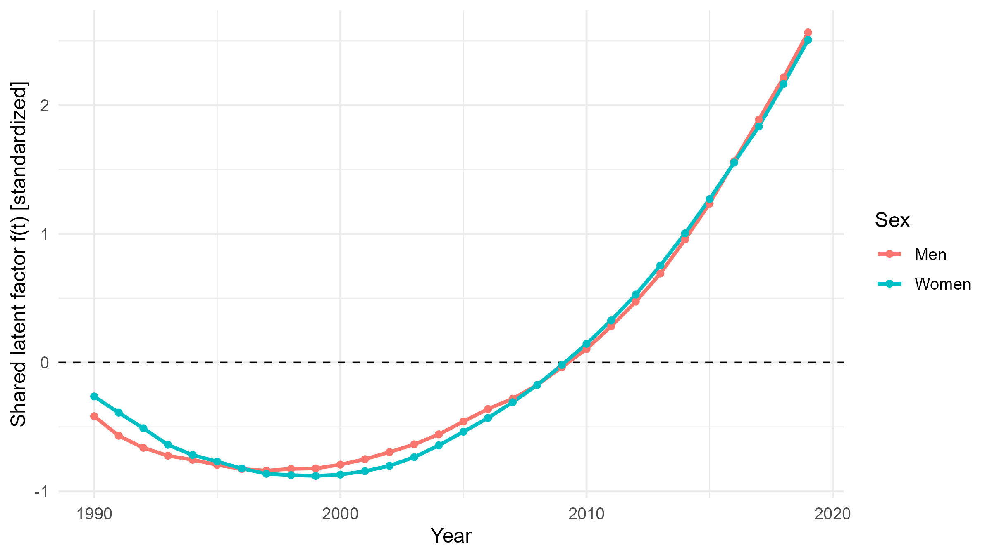
Figure 1: Standardized shared system factor by sex, 1990–2019.
Figure 2 shows that the common component closely corresponds with the observed trajectories for treatment, control, and untreated stage 2 disease across both genders, indicating that a single systemic factor accounts for the majority of the annual variation in these outcomes. The most robust alignment occurs between the control and untreated Stage 2 samples, where the peaks and troughs correspond precisely. This finding indicates that an increase in system performance correlates with an increase in control and a simultaneous decrease in severe uncontrolled disease when analysed in terms of proportions. The diagnosis deviates from this pattern, showing reduced alignment and increased variability across several periods, suggesting that detection is affected by programming and measurement factors that are less congruent with the overall system trend. Age-standardized prevalence more accurately followed the typical trend than did crude prevalence, supporting the idea that demographic composition influences crude levels. The conclusion is that altering the core system driver can yield several advantages across various indicators; however, diagnosis requires more concentrated effort. Policies should establish primary accountability metrics centered on age-standardized control and high-risk reduction, invest in capabilities that enhance the common component (ensured medications, protocol-based care, and registry-enabled continuity), and implement a concurrent case-finding initiative to address detection gaps indicated by the observed-versus-common divergence in Figure 2.
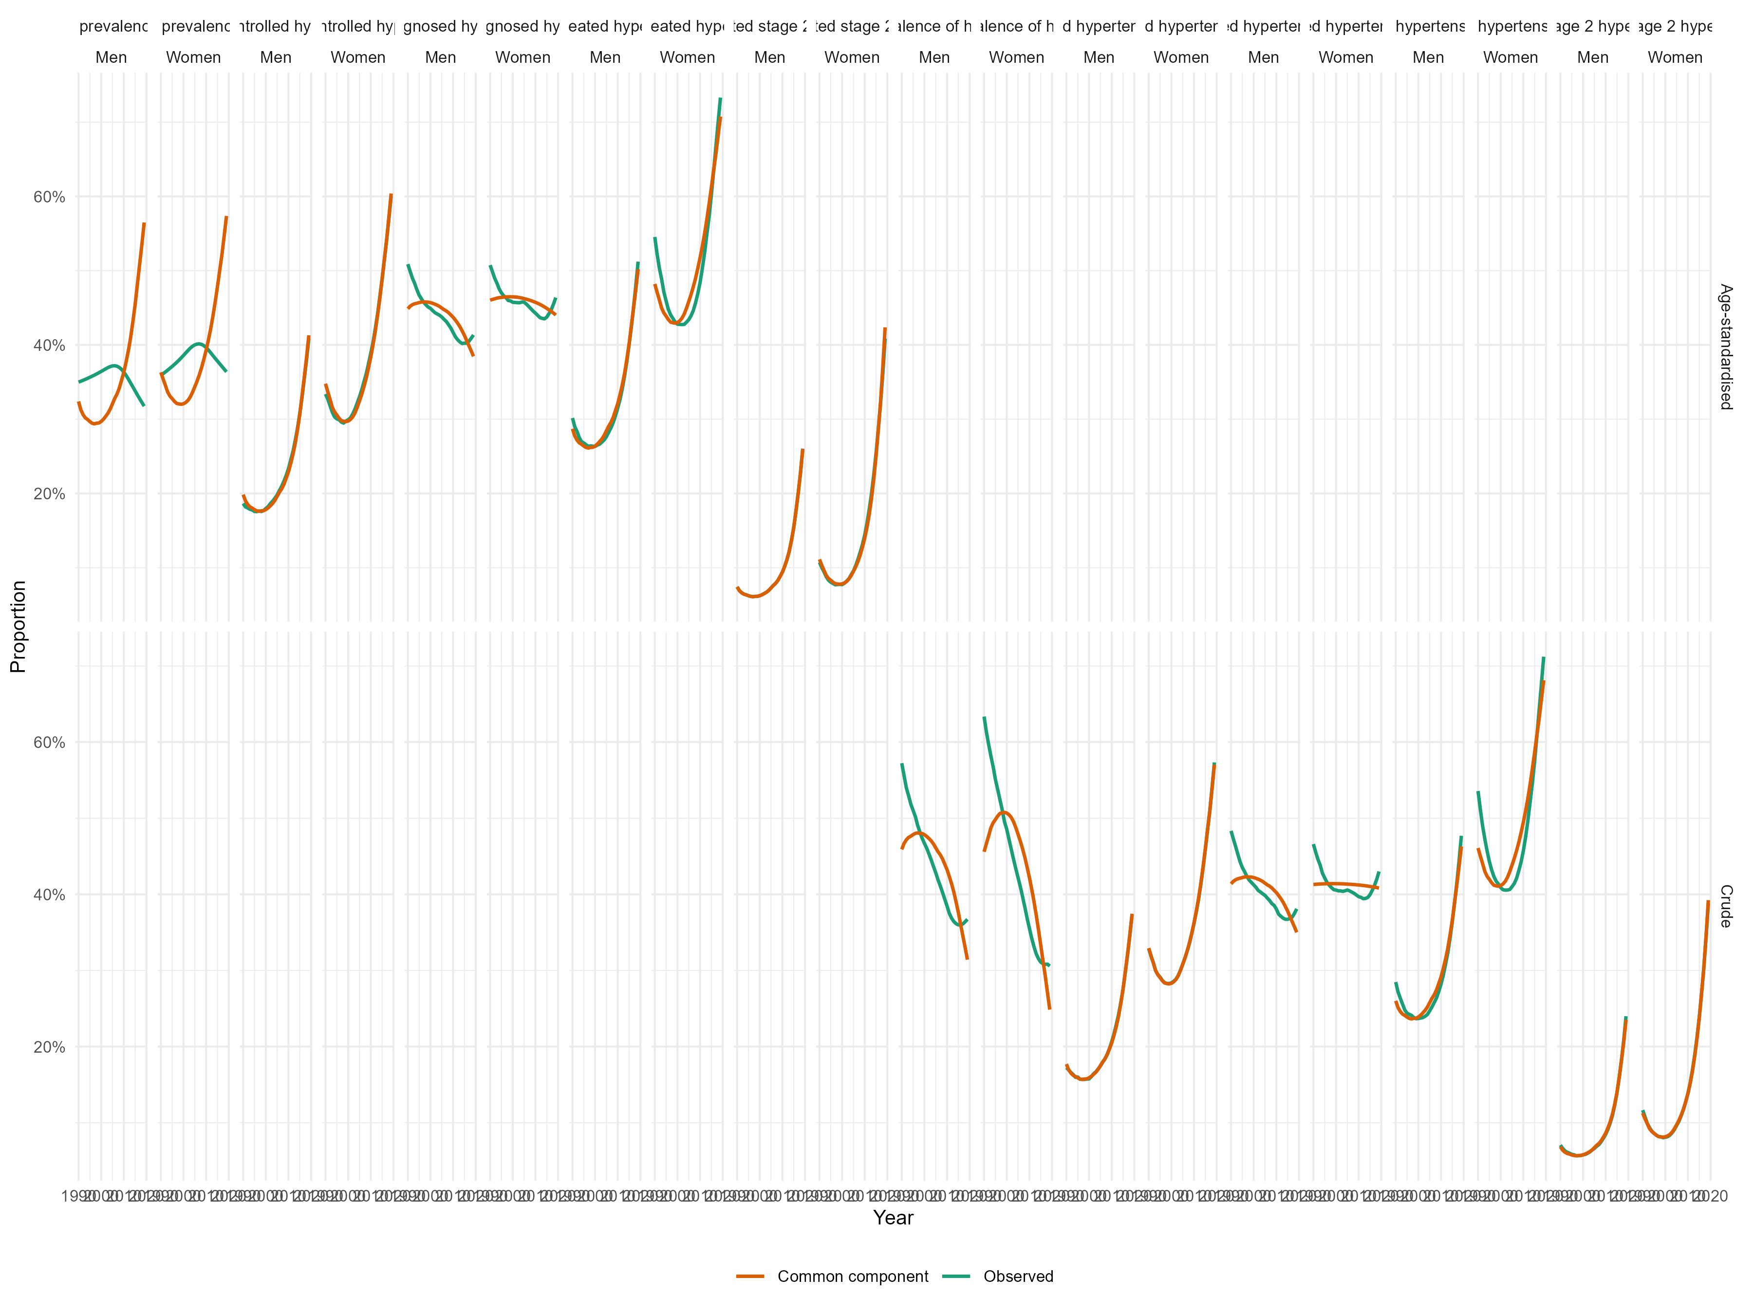
Figure 2: Observed proportions relative to the common component by indicator and gender, 1990–2019.
Table 5 demonstrates that women consistently possess an edge throughout the cascade. The therapeutic and control effects are substantial and precise, but the diagnostic effects are less yet nonetheless noteworthy. Compared with men, women had a 2.23-fold greater likelihood of receiving treatment and a 2.06-fold greater likelihood of achieving control (both p<0.001). They have a minor advantage in terms of diagnosis (OR=1.079, p<0.001) and a marginally greater prevalence (OR=1.123, p<0.001). The crude prevalence reveals no significant sex difference (OR=0.992, p=0.713); nonetheless, the crude treatment and control effects are considerable (OR=2.345 and OR=2.18, both p<0.001), confirming their robustness to standardization. Untreated stage 2 disease was more prevalent in women according to both definitions (age-standardized OR=1.601; crude OR=1.727; both p<0.001). This finding indicates that a subpopulation of women is at heightened risk of illness despite having superior average management. The analysis suggested improved advancements in care for women once recognized, including a remaining group requiring customized escalation strategies. The policy implication is to establish sex-disaggregated targets that maintain advancements in female treatment and control, bridge the diagnosis-to-treatment gap in men, and implement targeted rescue strategies for severe uncontrolled disease in high-risk women, utilizing age-standardized indicators as primary accountability metrics and crude indicators to track demographic challenges.
Figure 3 illustrates that the hypertension cascade has improved in a coordinated manner since the early 2000s. Nonetheless, challenges persist in case detection and a subsequent surge in severe, uncontrolled disease. The age-standardized prevalence increases until the mid-2000s, after which it stabilizes at a higher level for women and declines slightly for men. Conversely, treatment and control consistently increase for both genders, with a distinct benefit for women. Age-standardized diagnoses declined during the 1990s, stabilized, and subsequently showed only a marginal rebound, indicating that detection has not kept pace with the gains made downstream. The age-standardized incidence of untreated stage 2 patients declined first but then significantly increased over the past decade, predominantly among women. This indicates an increasing division within the population, where a significant number of individuals receive improved care, whereas a small group of high-risk individuals remains unchanged. The crude indicators illustrate these patterns with a more significant demographic effect: the crude prevalence decreases, whereas the crude treatment and control rates increase, although the crude diagnosis rate shows only a slight rebound. The conclusion is that enhancing the system has resulted in improved management upon patient admission to care. Nonetheless, entry into the cascade remains the most vulnerable phase. The implications involve the establishment of performance metrics utilizing age-standardized controls, the enhancement of multimonth dispensing and protocol-driven titration to sustain progress, the initiation of a diagnostic surge within routine interactions, and the incorporation of rapid escalation pathways to address severe uncontrolled disease, all guided by sex-disaggregated implementation targets.
Table 5. Outcome-specific sex effects across the hypertension cascade.
Group | Outcome | β (logit) | SE | z | p | Odds Ratio [95% CI]
Age-standardized | age_standardized_prevalence_of_hypertension | 0.116 | 0.007 | 17.83 | <0.001 | 1.123 [1.109, 1.138]
Age-standardized | age_standardized_proportion_of_controlled_hypertension_among_all_hypertension | 0.725 | 0.006 | 129.86 | <0.001 | 2.064 [2.042, 2.087]
Age-standardized | age_standardized_proportion_of_diagnosed_hypertension_among_all_hypertension | 0.076 | 0.008 | 9.01 | <0.001 | 1.079 [1.061, 1.096]
Age-standardized | age_standardized_proportion_of_treated_hypertension_among_all_hypertension | 0.801 | 0.014 | 59.00 | <0.001 | 2.229 [2.17, 2.289]
Age-standardized | age_standardized_proportion_of_untreated_stage_2_hypertension_among_all_hypertension | 0.470 | 0.022 | 21.68 | <0.001 | 1.601 [1.534, 1.67]
Crude | crude_prevalence_of_hypertension | -0.008 | 0.022 | -0.37 | 0.713 | 0.992 [0.949, 1.036]
Crude | crude_proportion_of_controlled_hypertension_among_all_hypertension | 0.779 | 0.004 | 182.64 | <0.001 | 2.18 [2.161, 2.198]
Crude | crude_proportion_of_diagnosed_hypertension_among_all_hypertension | 0.032 | 0.012 | 2.72 | 0.006 | 1.032 [1.009, 1.056]
Crude | crude_proportion_of_treated_hypertension_among_all_hypertension | 0.852 | 0.013 | 65.82 | <0.001 | 2.345 [2.286, 2.405]
Crude | crude_proportion_of_untreated_stage_2_hypertension_among_all_hypertension | 0.546 | 0.017 | 32.80 | <0.001 | 1.727 [1.672, 1.784]
Note. β is the coefficient for women relative to men on the logit (μ) scale in a beta regression with s(Year). OR = exp(β).
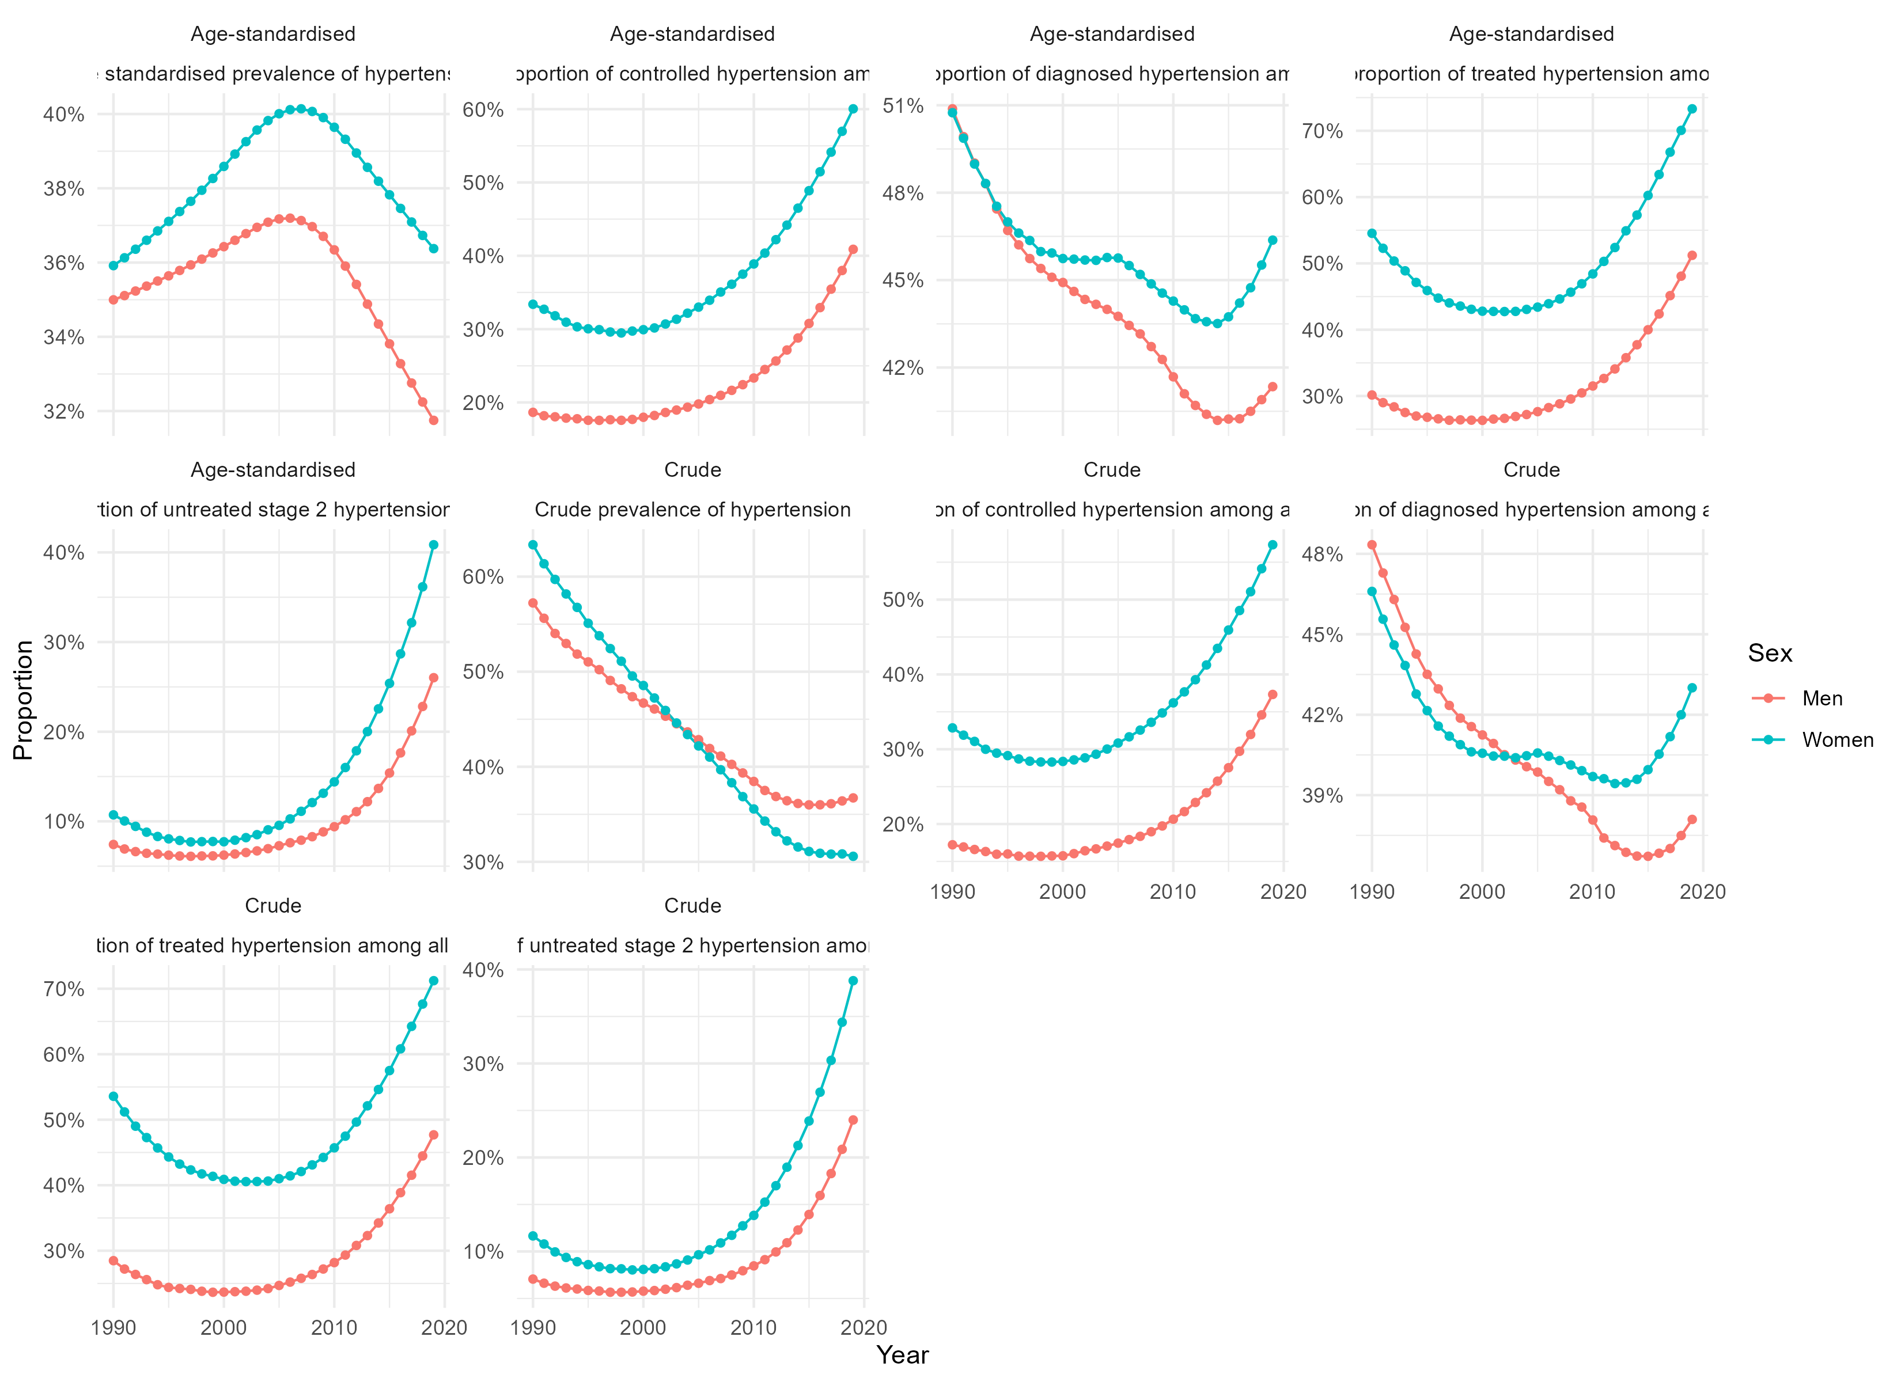
Figure 3: Age-standardized and crude metrics by sex for the hypertension cascade in Africa from 1990-2019
Table 6 indicates that by 2030, age-standardized blood pressure control will markedly increase, increasing from 42.1% to 48.8% in males and from 59.1% to 72.8% in females. This represents a definitive enhancement of 6.6 and 13.7 percentage points, respectively. The identical scenario forecasts substantial increases in the untreated stage 2, age-adjusted stage, from 27.0% to 35.1% in males and from 40.2% to 65.5% in females. This finding indicates that scale diagnosis and beginning without the capacity for enhancement may increase the incidence of individuals with severe uncontrolled disease. The conclusion is that the system is very responsive to upstream control inputs, particularly for women; nonetheless, it is susceptible to overload at the high-risk end of the cascade. The policy implication is to couple an increase in diagnosis and treatments with a safety net program that prevents severe hypertension from deteriorating. This should encompass expedited titration processes, the availability of second- and third-line combinations, rigorous follow-up for very elevated readings, and proactive engagement for missed appointments. It should also have sex-disaggregated control objectives and consistent monitoring of high-risk mitigation.
Table 6. 2030 baseline vs. scenario for age-standardized control and untreated stage-2 patients.
Sex | Indicator | Year | Baseline | Scenario | Diff (pp)
Men | Age standardized proportion of controlled hypertension among all hypertension | 2,030 | 42.1% | 48.8% | 6.6
Women | Age standardized proportion of controlled hypertension among all hypertension | 2,030 | 59.1% | 72.8% | 13.7
Men | Age standardized proportion of untreated stage 2 hypertension among all hypertension | 2,030 | 27.0% | 35.1% | 8.1
Women | Age standardized proportion of untreated stage 2 hypertension among all hypertension | 2,030 | 40.2% | 65.5% | 25.4

Figure 4 illustrates the steady rise of the shared system factor from the mid-2000s, remaining high under the scenario until 2030 for both sexes. This indicates a persistent, systemic advantage that can be enhanced by coordinated policy measures. Figure 5 shows that the lift transitions into age-standardized control. The scenario outperforms the baseline beginning in the year of intervention, achieving approximately fifty percent of males and nearly seventy-five percent of women by 2030. This finding indicates that investments in case finding and prompt initiation are effective when medications, follow-up, and protocol-driven titration are properly implemented. Figure 6 illustrates a concurrent risk: in the absence of enhanced escalation capacity, the age-standardized untreated stage-2 rate exceeds baseline levels, particularly among women. Expanded detection indicates a significant high-risk population unless rapid titration, access to second- and third-line treatments, and aggressive outreach are simultaneously enhanced. Figure 7 illustrates these net consequences for the year 2030. There will be double-digit increases in control (particularly pronounced for women) and significant increases in untreated stage 2 when precautions are not concurrently strengthened. The policy aims to align the increase in diagnosis and treatment with a comprehensive safety net package for high-risk individuals, which encompasses expedited management for elevated readings, multimonth medication dispensing, collaborative primary care, registry-supported continuity, and sex-disaggregated objectives with regular monitoring of both controlled and severely uncontrolled conditions. This ensures that the scenario fosters widespread enhancement while reducing, rather than expanding, the highest-risk pool.

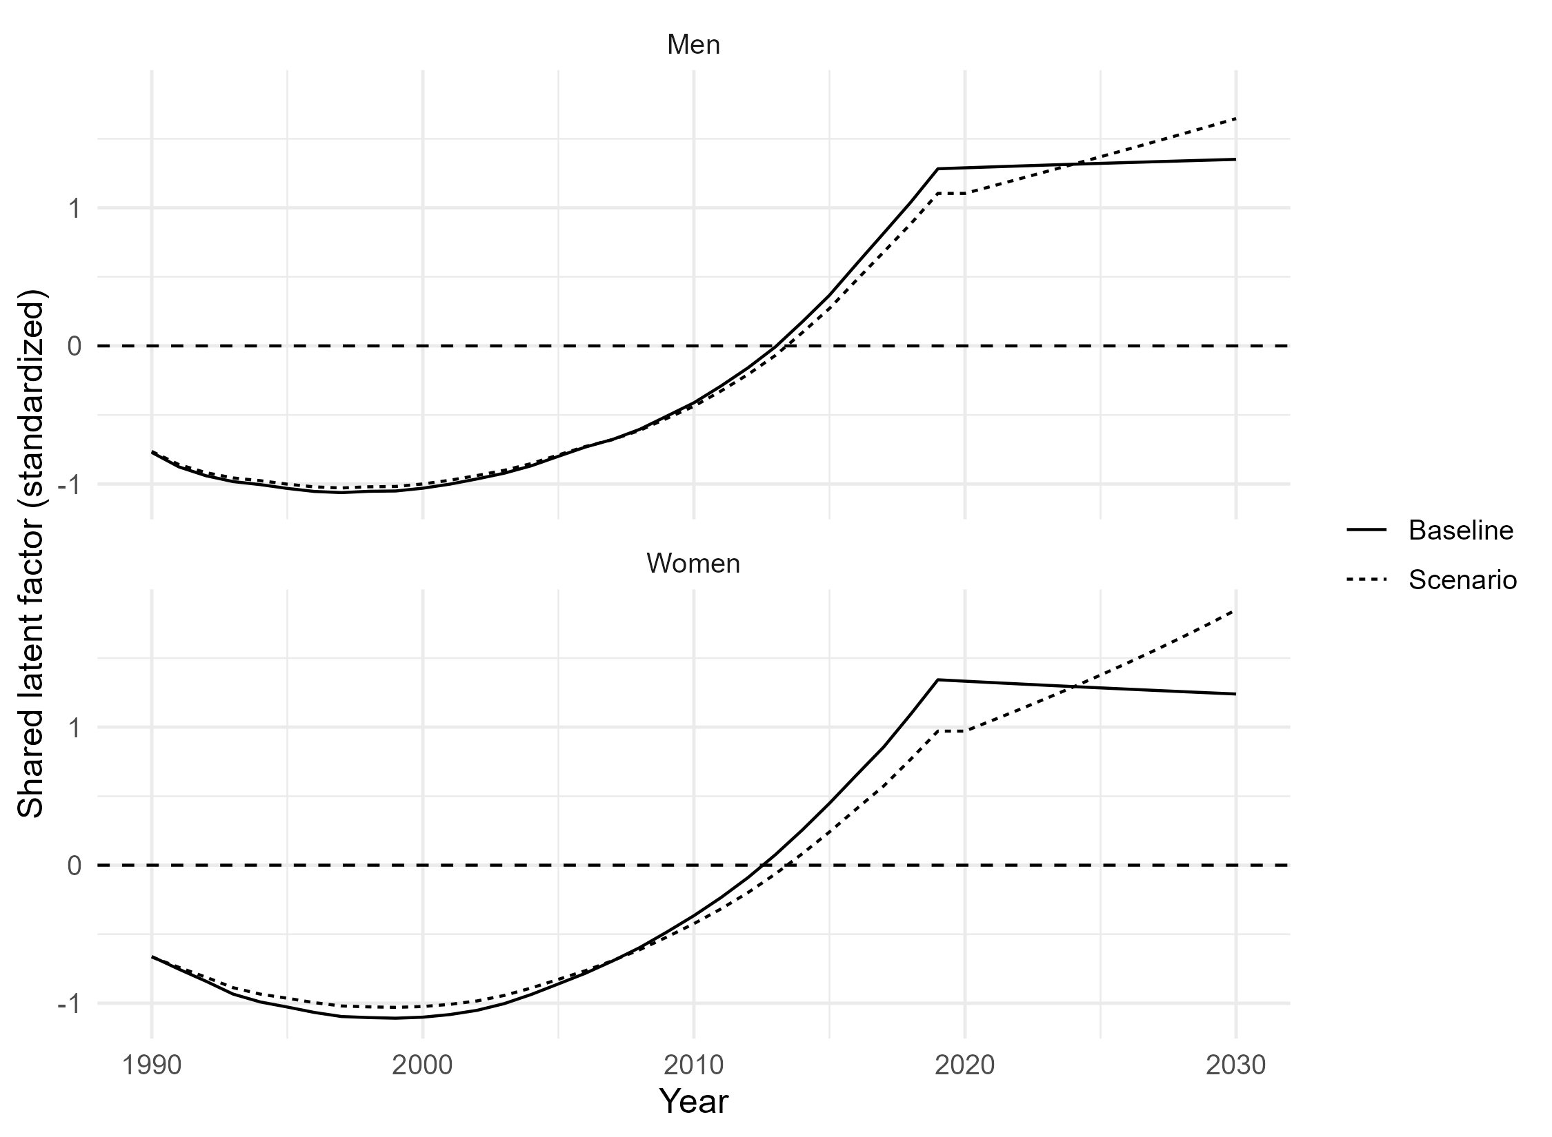
Figure 4. Shared latent system factor by sex, baseline versus scenario, 1990--2030 (standardized)
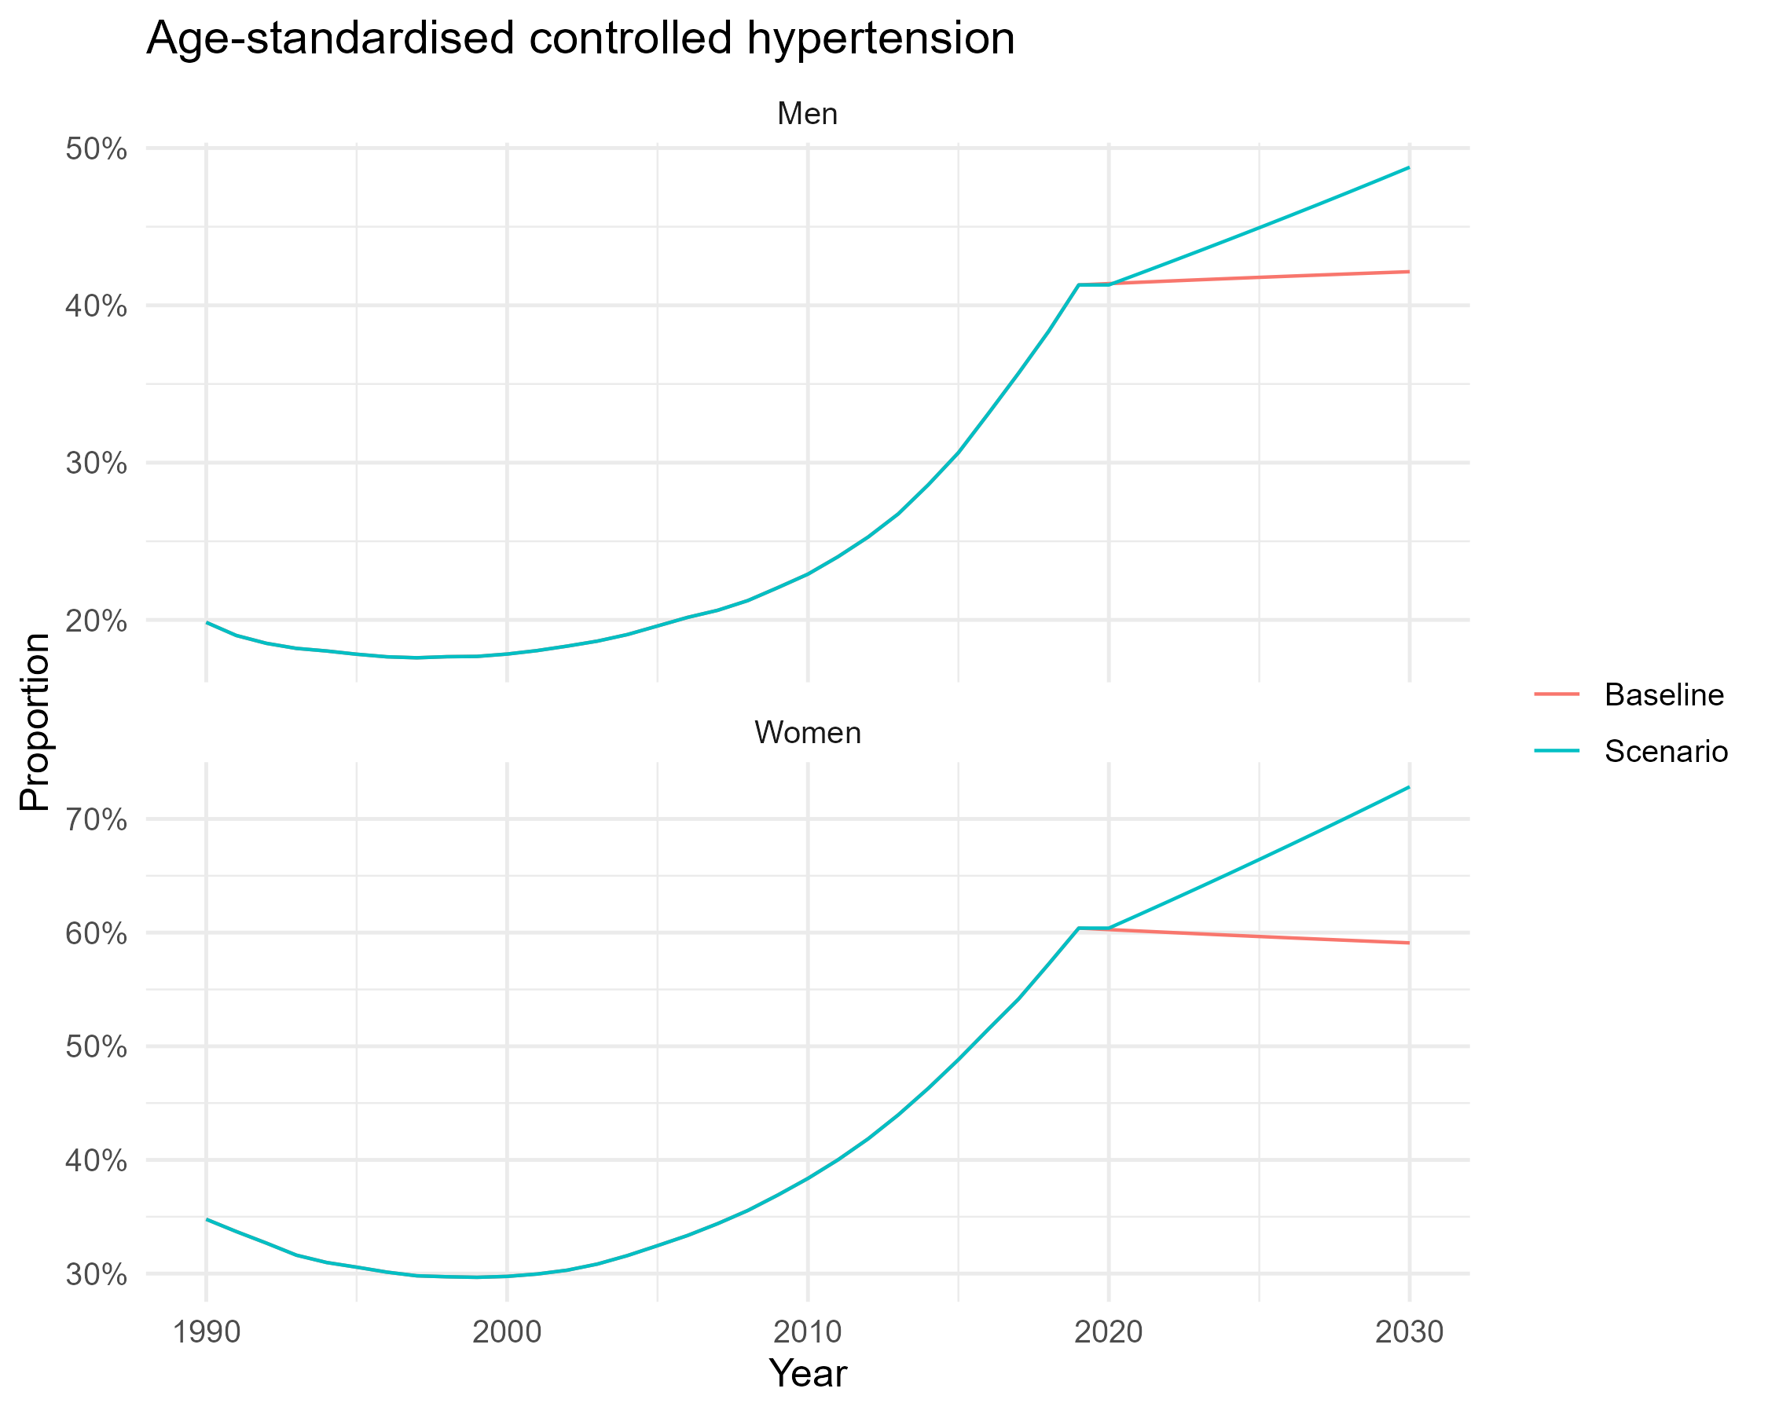
Figure 5. Age-standardized controlled hypertension by sex, baseline versus scenario, 1990–2030
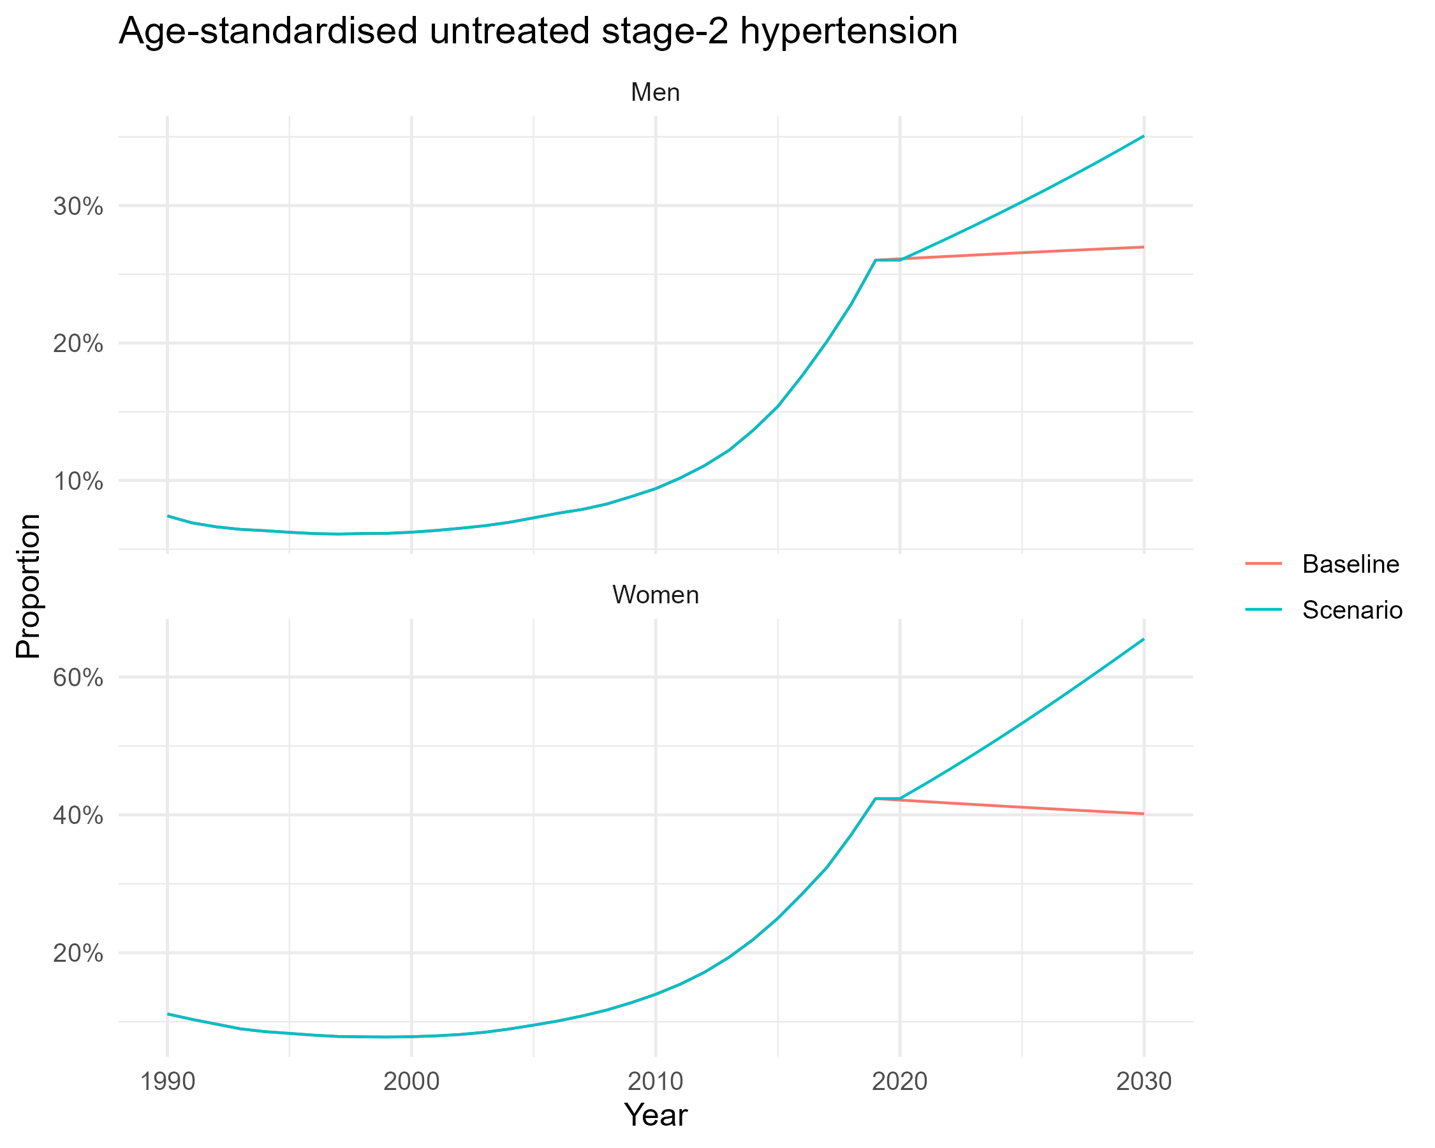
Figure6. Age-standardized untreated stage-2 hypertension by sex, baseline versus scenario, 1990–2030
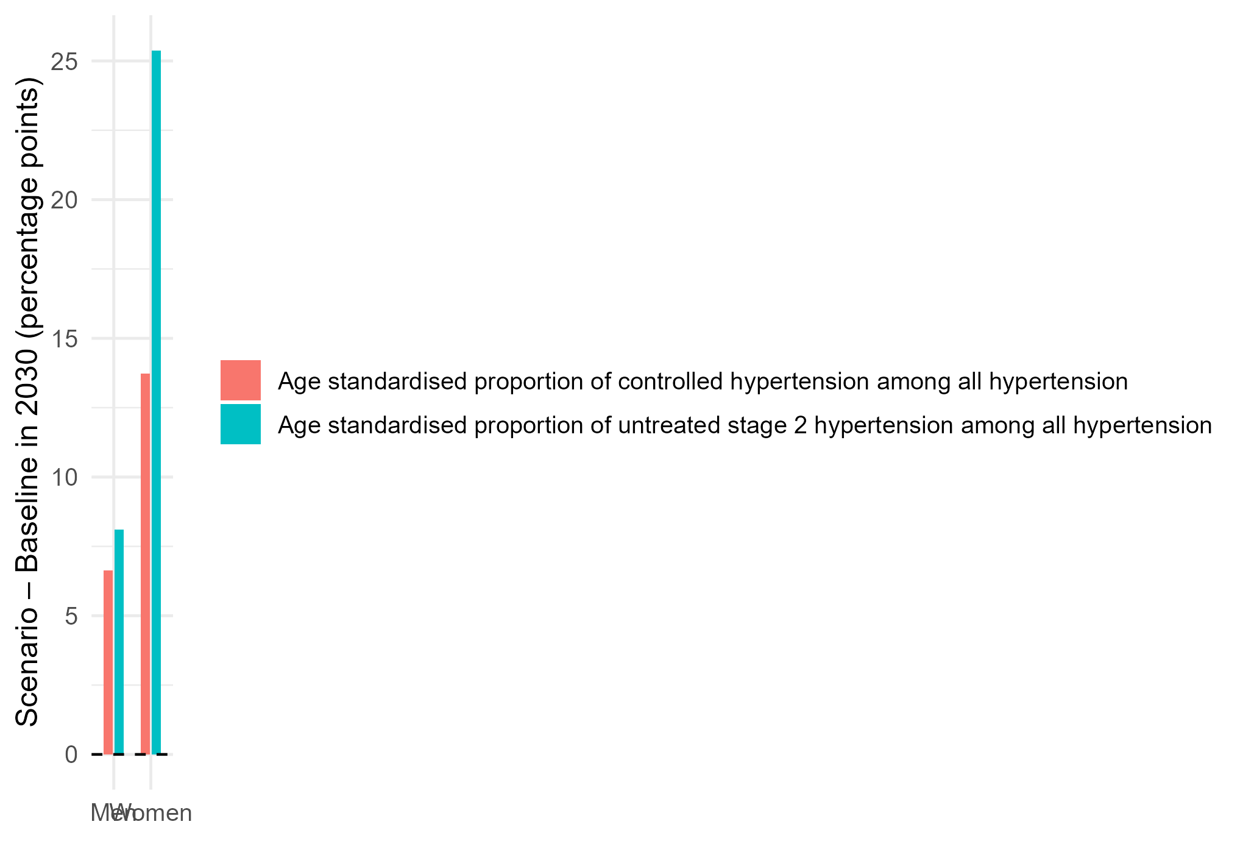
Figure 7 Scenario impact in 2030: change in age-standardized control and untreated Stage-2 disease by sex (percentage points)

Discussion
The findings demonstrate a unified hypertension framework in which a single latent factor explains most changes in treatment, management, and severe uncontrolled conditions from 1990-2019, with virtually total variance clarified for crucial cascade stages. Age-standardized indicators are strongly associated with this common component, whereas diagnosis shows slight and sometimes negative loadings, indicating some independence from the system trajectory. The advantages of therapy and control for women are substantial and precise in terms of both age-standardized and crude metrics. A substantial group of women with untreated stage-2 disease persists, highlighting a concentration of risk within subpopulations that current pathways do not adequately address. The state dynamics exhibit considerable stability, with φ approximately equal to 0.98 and negligible process variance. This aligns with gradual structural modifications, including the implementation of protocols, ensuring the reliability of medical supplies, augmenting the workforce, and maintaining the oversight of registries. Projections and scenario analyses utilizing this methodology generate coherent trajectories that respond predictably to policy alterations.
A concentrated enhancement in diagnosis and treatment results in substantial advancements in control, especially for women, but simultaneously increases the prevalence of untreated stage-2 cases when the ability to escalate does not match demand. Analysing these patterns collectively reveals two methods for effecting change: a systemic lever that elevates the common factor, enhancing conditions for all, and a focused lever that addresses the diagnostic bottleneck and the high-risk population suffering from severe uncontrolled hypertension. Age-standardized indicators provide the most accurate assessment of program efficacy, whereas crude prevalence reveals demographic challenges that necessitate long-term preventive strategies. The strengths include a comprehensive modelling approach that integrates all cascade indicators, explicit sex stratification, and a state‒space estimate that considers temporal persistence. Limitations include reliance on country-aggregated data, the absence of subnational variability, and the potential for residual confounding due to unmeasured program shocks or changes in measurement. The dynamic factor serves as a system capacity index; nonetheless, it remains a simplistic construct that cannot identify individual mechanisms without supplementary implementation data. Future studies may extend to subnational panels, incorporate covariates associated with the supply chain and service delivery, and evaluate policy interventions via quasi experimental approaches incorporated within the factor structure.
This article presents a pragmatic measurement and policy framework for the Sustainable Development Goal 3 targets related to noncommunicable diseases and universal healthcare within the context of the Sustainable Development Goals. The joint factor model generates a unique, interpretable system indicator that may be utilized as a program metric for SDG 3.4 (reducing premature mortality from noncommunicable diseases) and SDG 3.8 (coverage of critical services). The sex-disaggregated consequences directly pertain to SDG 5 on gender equality and SDG 10 on mitigating disparities by identifying areas where women gain, men fall behind, and a vulnerable grouping is overlooked. The scenario results transform the objectives of the SDGs into immediate operational targets by linking additional diagnoses and treatments to enhanced control and demonstrating the requisite capacity for escalation to halt the proliferation of severe uncontrolled diseases. The emphasis on registry-enabled continuity, reliable medications, and protocol-driven treatment aligns with SDG 9 concerning resilient systems and data infrastructure, along with the use of publicly accessible resources. Data from NCD-RisC support SDG 17 regarding collaboration and data exchange. This research provides a pragmatic framework for integrating population hypertension treatment, equality, and health system performance with the Sustainable Development Goals agenda through measurable, sex-responsive, and time-constrained activities.
Limitations
This study utilizes country-level averages for adults aged 30-79 years, obscuring subnational heterogeneity, disparities across younger and older age groups, and individual characteristics such as socioeconomic status, comorbidities, and HIV. Measurement errors in the NCD-RisC indicators may arise from the survey design, the reporting of treatments, and the standardization of age.
Conclusion
The African hypertension cascade exhibits strong system coherence in treatment, management, and severe uncontrolled disease; moderate and fragmented progress in diagnosis; and considerable advantages for females in following care, especially in persistently high-risk populations. A robust shared impetus indicates that investment in assured pharmaceuticals, collaborative primary care, protocol-guided titration, multimonth distribution, and registry-facilitated continuity over multiple years will yield cumulative enhancements. Policies must create sex-disaggregated objectives for age-standardized control and precise targets for reducing untreated stage-2 cases while launching a diagnostic surge that incorporates measurement into routine interactions and community environments. These findings indicate that enhancing diagnosis and treatment can significantly improve control by 2030, provided that the capacity to escalate care increases to halt the proliferation of severe uncontrolled disease. Coordinating financing, procurement, clinical protocols, and digital follow-up to increase the number of shared factors while safeguarding high-risk patients through expedited management is a viable technique for the rapid and sustained control of hypertension on a broad scale.
Declarations
Data availability statement
The data supporting this study are publicly available at the Noncommunicable Disease Risk Factor Collaboration (NCD-RisC) global estimates database, https://www.ncdrisc.org/data-downloads.html. Ethics Statement This study utilized publicly available data from the Noncommunicable Disease Risk Factor Collaboration (NCDRisC) global estimate database. As the data are deidentified and aggregated at the population level, no ethical approval was needed. The study adheres to all ethical guidelines for the use of publicly accessible data and ensures that the information is used solely for academic and research purposes to inform public health strategies.
Conflicts of interest
The authors declare that they have no competing interests.
Consent for Publication
Not applicable in the clinic
Trial Number
Not applicable
Reference
Abba, M. S. (2022). Novel risk factors for hypertension in low-and middle income countries: building evidence to reverse the burgeoning epidemic (Doctoral dissertation, University of Warwick).
Akl, C., Akik, C., Ghattas, H., & Obermeyer, C. M. (2020). The cascade of care in managing hypertension in the Arab world: a systematic assessment of the evidence on awareness, treatment and control. BMC Public Health, 20(1), 835.
Aminde, L. N., Agbor, V. N., Fongwen, N. T., Ngwasiri, C. A., Nkoke, C., Nji, M. A., ... & Schutte, A. E. (2025). High Burden and Trend in Nonadherence to Blood Pressure‐Lowering Medications: Meta‐Analysis of Data From Over 34 000 Adults With Hypertension in Sub‐Saharan Africa. Journal of the American Heart Association, 14(9), e037555.
Chham, S., Buffel, V., Van Olmen, J., Chhim, S., Ir, P., & Wouters, E. (2022). The cascade of hypertension care in Cambodia: evidence from a cross-sectional population-based survey. BMC Health Services Research, 22(1), 838.
Colafella, K. M. M., & Denton, K. M. (2018). Sex-specific differences in hypertension and associated cardiovascular disease. Nature Reviews Nephrology, 14(3), 185–201.
Gerdts, E., & Regitz-Zagrosek, V. (2019). Sex differences in cardiometabolic disorders. Nature Medicine, 25(11), 1657–1666.
Guthi, V. R., Kumar, D. S., Kumar, S., Kondagunta, N., Raj, S., Goel, S., & Ojah, P. (2024). Hypertension treatment cascade among men and women of reproductive age group in India: analysis of National Family Health Survey-5 (2019–2021). The Lancet Regional Health—Southeast Asia, 23.
Ji, H., Kim, A., Ebinger, J. E., Niiranen, T. J., Claggett, B. L., Merz, C. N. B., & Cheng, S. (2020). Cardiometabolic risk-related blood pressure trajectories differ by sex. Hypertension, 75(4), e6–e9.
Kirschbaum, T. K., Theilmann, M., Sudharsanan, N., Manne-Goehler, J., Lemp, J. M., De Neve, J. W., ... & Geldsetzer, P. (2021). Targeting hypertension screening in low- and middle-income countries: a cross-sectional analysis of 1.2 million adults in 56 countries. Journal of the American Heart Association, 10(13), e021063.
Kothavale, A., Puri, P., & Sangani, P. G. (2022). Quantifying population level hypertension care cascades in India: a cross-sectional analysis of risk factors and disease linkages. BMC Geriatrics, 22(1), 98.
Meloni, A., Cadeddu, C., Cugusi, L., Donataccio, M. P., Deidda, M., Sciomer, S., ... & Maffei, S. (2023). Gender differences and cardiometabolic risk: the importance of the risk factors. International Journal of Molecular Sciences, 24(2), 1588.
Ntaganda, E., El-Khatib, Z., Mugeni, R., Nsengiyumva, B., Musanabaganwa, C., Gafirita, J., ... & Kalisa, R. (2025). Assessment of Blood Pressure Control Status Among Hypertensive Patients Attending Rwandan District Hospital NCD Clinics: A Retrospective Follow-Up Study. Journal of Epidemiology and Global Health, 15(1), 13.
Olowoyo, P., Okekunle, A. P., Asowata, O. J., Atolani, S., Morsy, M. I., Caiazzo, E., ... & Owolabi, M. O. (2025). Prevalence of hypertension in Africa in the last two decades: Systematic review and meta-analysis. Cardiovascular Research, cvaf125.
Perkins, A. D., Awori, J. O., Jobe, M., Lucinde, R. K., Siemonsma, M., Oyando, R., ... & IHCoR-Africa Collaborators. (2024). Determining the optimal diagnostic and risk stratification approaches for people with hypertension in two rural populations in Kenya and The Gambia: a study protocol for IHCoR-Africa Work Package 2. NIHR Open Research, 3, 68.
Peters, M. A., Noonan, C. M., Rao, K. D., Edward, A., & Alonge, O. O. (2022). Evidence for an expanded hypertension care cascade in low- and middle-income countries: a scoping review. BMC Health Services Research, 22(1), 827.
Romo, M. L., Dear, N., Crowell, T. A., Frndak, S., Parikh, A. P., Kibuuka, H., ... & African Cohort Study (AFRICOS) Group. (2025). Gaps in hypertension and diabetes treatment among people living with and without HIV: Findings from a prospective cohort study in Kenya, Nigeria, Tanzania, and Uganda, 2013–2023. PLOS Global Public Health, 5(4), e0004464.
Schorr, M., Dichtel, L. E., Gerweck, A. V., Valera, R. D., Torriani, M., Miller, K. K., & Bredella, M. A. (2018). Sex differences in body composition and association with cardiometabolic risk. Biology of Sex Differences, 9(1), 28.
Šebeková, K., Gurecká, R., Csongová, M., Koborová, I., & Šebek, J. (2020). Sex differences in Association of Elevated Blood Pressure with variables characterizing cardiometabolic risk in young subjects with or without metabolic abnormalities. International Journal of Environmental Research and Public Health, 17(10), 3612.
Wang, J., Tan, F., Wang, Z., Yu, Y., Yang, J., Wang, Y., ... & Yin, X. (2024). Understanding gaps in the hypertension and diabetes care cascade: systematic scoping review. JMIR Public Health and Surveillance, 10, e51802.
Wozniak, G., Khan, T., Gillespie, C., Sifuentes, L., Hasan, O., Ritchey, M., ... & Wynia, M. (2016). Hypertension control cascade: a framework to improve hypertension awareness, treatment, and control. The Journal of Clinical Hypertension, 18(3), 232–239.
Yuyun, M. F., Sliwa, K., Kengne, A. P., Mocumbi, A. O., & Bukhman, G. (2020). Cardiovascular diseases in sub-Saharan Africa compared to high-income countries: an epidemiological perspective. Global Heart, 15(1), 15*.

