Original Research Article
Land Surface Temperature Assessment Using TIRS Data: A Case Study of Gorakhpur District

.
ABSTRACT

Aim
The present study aims to retrieve land surface temperature (LST) using Landsat 8 Thermal Infrared Sensor (TIRS) data and to examine its relationship with selected land surface indices in order to assess spatial thermal variability, urban heat island characteristics, and environmental conditions in Gorakhpur District, India.
Study Design
A geospatial analytical research design was employed, integrating satellite remote sensing techniques with spatial and statistical analysis to investigate interactions between surface temperature and land surface characteristics.
Place and Duration of the Study
The study was conducted in Gorakhpur District, Uttar Pradesh, India, using cloud-free Landsat 8 imagery acquired during representative periods of the study years to capture prevailing urban thermal conditions.
Methodology
LST was retrieved from Landsat 8 TIRS data through a systematic multi-step process involving radiometric calibration, atmospheric correction, and land surface emissivity estimation. Land surface emissivity was derived using vegetation-based approaches. Multispectral bands were used to compute land surface indices, including the Normalized Difference Vegetation Index (NDVI), Soil Adjusted Vegetation Index (SAVI), Built-Up Index (BUI), and Heat Load Index (HLI). Spatial mapping and correlation analyses were performed to examine relationships between LST and the derived indices and to evaluate the influence of land use/land cover patterns on surface thermal behavior.
Results
The analysis revealed considerable spatial variation in LST across Gorakhpur District. Higher surface temperatures were predominantly associated with densely built-up and impervious surfaces, while areas with greater vegetation cover exhibited relatively lower temperatures. Vegetation indices showed strong negative correlations with LST, whereas built-up indicators displayed positive associations, reflecting the presence of urban heat island effects.
Conclusion
The study confirms the reliability of Landsat 8 TIRS data for LST retrieval and urban thermal assessment. The observed relationships between LST and land surface indices highlight the significant role of vegetation and land use patterns in regulating urban surface temperatures. These findings provide valuable inputs for sustainable urban planning, environmental management, and climate change mitigation strategies in rapidly urbanizing regions.

Keywords: Land Surface Temperature, Thermal Infrared Sensor, Sustainable Urban Planning, Urban Heat Island

1. INTRODUCTION

Land surface temperature (LST) is a critical parameter in understanding the Earth's climate system and its impact on the environment. It plays a crucial role in various applications such as urban planning, agriculture, hydrology, and climate change studies. Remote sensing technology, particularly data from the Thermal Infrared Sensor (TIRS), has revolutionized the way we monitor and retrieve LST over large spatial areas. In this article, we explore the process of LST retrieval from TIRS data and investigate its relationship with land surface indices in Gorakhpur District, India. The Thermal Infrared Sensor (TIRS) is an instrument on board the Landsat 8 satellite designed to measure thermal radiation emitted by the Earth's surface. It operates in two thermal infrared bands, allowing for accurate LST retrieval. The process of LST retrieval from TIRS data involves several steps:
Firstly to calibration and Radiometric Correction: The raw TIRS data acquired by the sensor undergoes calibration and radiometric correction to convert it into radiance values. This step is essential to remove sensor-related biases and ensure data consistency. Secondly, atmospheric correction, where atmospheric effects, such as absorption and emission of thermal radiation by gases and aerosols, can significantly impact LST retrieval. Sophisticated algorithms are used to correct for these effects and estimate surface radiance. Then after emissivity correction requires. The emissivity of the land surface, which represents its ability to emit thermal radiation, varies with different materials. Emissivity correction is necessary to obtain accurate LST values. The forth critical point is LST calculation, once the above corrections are applied, the actual LST can be calculated using specialized algorithms that take into account surface emissivity, atmospheric properties, and other environmental factors.

This study focuses to compute the land surface temperature from TIRS data and its correlation with land surface indices in Gorakhpur District having the following aims;
1. To derive and compare land surface temperature (LST) data for two different timeframes using thermal infrared imagery from the Thermal Infrared Sensor (TIRS) on board the Landsat 8 satellite.
2. In conjunction with the LST analysis, this research seeks to calculate and map the Land Use and Land Cover (LULC) of Gorakhpur District using different Landsat 8 satellite imagery. The Normalized Difference Vegetation Index (NDVI) and Soil Adjusted Vegetation Index (SAVI) will be employed to quantify vegetation abundance and health in the study area.
3. By examining the derived LST data and vegetation indices, the study aims to uncover the relationship between land surface temperature and vegetation abundance in Gorakhpur District.
The analysis will help assess the impact of vegetation cover on local temperature patterns and identify areas with potential heat stress. Additionally, the research will investigate the correlation between the Soil Adjusted Vegetation Index (SAVI) and other land surface indices, providing insights into the health and vigour of vegetation in the urban environment. Understanding these relationships is crucial for sustainable urban planning, environmental management, and climate change adaptation strategies.

2. material and methods

The computation of Land Surface Temperature (LST) and the use of remote sensing data, specifically Landsat 8 satellite imagery, has been done. The study area is located in the eastern part of Uttar Pradesh, with varied climatic conditions and groundwater resources. The Landsat 8 and Landsat 9 satellites are equipped with the Operational Land Imager (OLI) and Thermal Infrared Sensor (TIRS), which have been capturing images of the Earth since February 2013. Landsat 9, launched on September 27, 2021, also carries these instruments onboard. The imaging process follows a 16-day repeat cycle, aligned with the Worldwide Reference System-2, with an 8-day offset between the acquisitions of each satellite. The scene size for these images is approximately 170 km north-south by 183 km east-west (106 mi by 114 mi).
Both Landsat 8 and Landsat 9 image data files comprise 11 spectral bands. The spatial resolution is 30 meters for bands 1-7 and bands 9-11, while the panchromatic band 8 offers a higher spatial resolution of 15 meters. In this study, imagery from path 141 and row 43 on November 18, 2015, and March 26, 2021, was downloaded in GeoTIFF format. The data underwent re-sampling to achieve uniform spatial resolutions. The imagery processing was done using ERDAS Imagine software, while the calculation of NDVI, surface emissivity (ε), and LST was performed in a GIS environment (Singh and Singh, 2021).

The factors influencing LST computation include the viewing angle of the sensor, temperature differences between vegetation canopy and soil, and biophysical characteristics of vegetation. For partially vegetated areas, soil characteristics significantly affect LST due to soil thermal properties. The normalized difference vegetation index (NDVI) plays a crucial role in inferring vegetation conditions on the land surface and is correlated to soil moisture conditions and evapotranspiration.

There are several methodologies related to the use of Landsat data for land surface temperature retrieval. Zhang et al. (2018) proposed a method for land surface temperature estimation using a combination of Landsat 8 OLI and TIRS data. They utilized the split-window algorithm and improved atmospheric correction techniques to achieve accurate and reliable temperature estimates. Li et al. (2016) developed a novel approach to retrieve land surface temperature from Landsat 8 TIRS data. Their method incorporated the use of emissivity spectra derived from OLI data to improve the accuracy of temperature estimation. Wang et al. (2019) introduced a hybrid approach that combined Landsat 8 and MODIS data for land surface temperature retrieval. They used the high spatial resolution of Landsat 8 TIRS bands along with the daily coverage of MODIS data to enhance the temporal resolution of temperature estimates. Xu et al. (2017) explored the application of machine learning algorithms, such as support vector regression, for land surface temperature retrieval using Landsat 8 TIRS data. Their results demonstrated the potential of these techniques for accurate and efficient temperature estimation (Singh and Singh, 2011). Tian et al. (2018) proposed a method that integrated Landsat 8 thermal data with auxiliary geospatial and meteorological data to improve land surface temperature mapping over urban areas. This approach accounted for the urban heat island effect and yielded more reliable temperature estimates in complex urban environments. Therefore, band 10 of Landsat 8 satellite has been selected for the thermal repossession of land surface. These studies highlight the diverse methodologies employed by researchers to extract land surface temperature information from Landsat 8 and TIRS data, contributing to a deeper understanding of the Earth's surface and its thermal characteristics. The LST extraction from thermal band have been done in the following:

1. Changing TOA (top of atmosphere) radiance (L_{λ})
2. Changing to TOA brightness temperature (T_{B})
3. Changing from at-satellite temperature to LST (T), the initial stage of changes involves transforming the digital number (DN) of the Landsat thermal band into spectral radiance (Lλ).

The second step is the change of the spectral radiance to at-sensor brightness temperature (T_{B}), and the last step is the conversion to land surface temperature (LST) (Weng et al. 2004).

The Landsat satellite has two sensor payloads, namely the Thermal InfraRed Sensor (TIRS) and the Operational Land Imager (OLI). The OLI sensor captures images in nine bands, covering the visible, near-infrared, and short-wave infrared spectrum. On the other hand, the TIRS sensor collects images in two bands, operating in the long-wave thermal spectrum (Landsat Science 2021; Li et al. 2020). Among these bands, band 8 provides a spatial resolution of 15 meters, while the remaining eight bands (band 1 to 7 and band 9) offer a spatial resolution of 30 meters. The spectral distribution of all eleven bands of Landsat 8 is summarized in table 1. Both sensors utilize a push-broom sensor design with a wide 185-kilometer swath width, allowing for broad-area coverage. Regarding radiometric characteristics, the sensors have a 12-bit quantization (4096), enhancing the accuracy of land cover characterization (Singh, 2017; Singh 2010; USGS Website 2021).

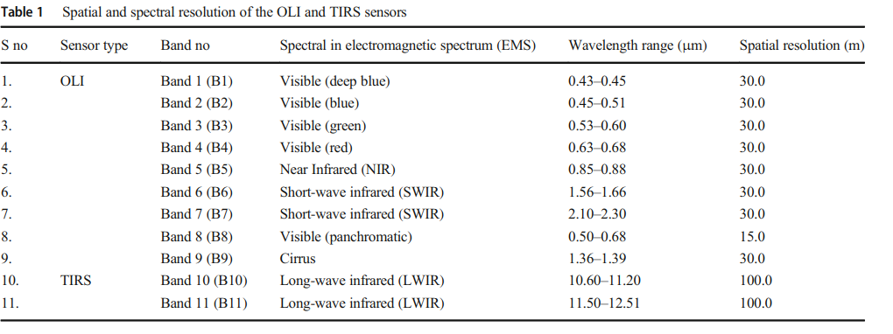
3. results and discussion

3.1 TOA spectral radiance (Lλ)
Landsat 8 satellite imagery data (OLI and TIRS band) can be changed to top of atmosphere (TOA) spectral radiance using the radiance rescaling factors given in the metadata file of the Lnadsat-8 sensor. Top of atmosphere spectral radiance (TOA- SR) was calculated by multiplying the multiplicative radio- metric rescaling factor of thermal infrared bands with its cor- responding TIR band and addition of additive rescaling factor.
$$L_{λ}= M_{x} Q_{cal }+ A_{x}$$
where$L_{λ}$is TOA spectral radiance [watts/(m² srad μm)], $M_{x}$ is band-specific multiplicative rescaling factor obtained from the metadata (where x is the band number) $A_{x}$ is band-specific additive rescaling factor obtained from the metadata and $Q_{cal }$ is quantized and calibrated standard product pixel values (DN value) its metadata details are also available from the downloaded Landsat 8 imagery.

3.2 TIRS temperature brightness (T_{B})

The imaging data was transformed into a series of brightness temperatures by considering an emissivity value of 0.96. However, this series revealed high-frequency noise that affected the entire image. The noise was suspected to be a result of slight variations in detector exposure time and sensitivity to interruptions caused by the automatic self-calibration mechanism (Singh and Singh, 2011). To address this issue, the noise signal was effectively eliminated by subtracting the mean temperature of the entire image (or a selected region) from each pixel's value. This approach can be seen as applying a high-pass filter in the time domain, resulting in a significant improvement in the image data for the practical application of time-sequential thermography.

$$T_{B}=\frac{K_{2}}{In \left(\frac{K_{1}}{L_{λ}}+1\right)}$$
Where,
$T_{B}$ is taken from top of atmosphere brightness temperature (in Kelvin) $L_{λ}$is TOA spectral radiance K₁ and K₂ band-specific thermal conversion constant from the metadata of the Landsat image and x is the band number (Table 2). This gives the $T_{B}$ value which is calculated brightness temperature in Kelvin so its further conversion in degree Celsius (°C), the data obtained from the same above formula have been subtracted from -273.15 as:
$$T_{B}=\frac{K_{2}}{In \left(\frac{K_{1}}{L_{λ}}+1\right)} -273.15$$
Table 2 Value of multiplicative rescaling factor and additive rescaling factor for Landsat 8 satellite imagery
Band serial no. | Value of $M_{x}$ | Value of $A_{x}$
Band 10 and Band 11 | 0.0003342 | 0.1000

  - Land surface temperature (LST)

Land Surface Temperature (LST) refers to the radiant skin temperature of the land, which is determined by the absorption and emission of solar radiation. LST measures the thermal radiance emitted by the Earth's surface, where solar energy interacts and warms the ground or the surface of vegetated areas, such as canopies. It has been calculated for June 2015 and June 2021 through following formula:

$$T=\frac{T_{B}}{\left(λ* \frac{T_{B}}{ρ}\right) Inε}$$
Where,
T land surface temperature (LST) (Kelvin), λ wavelength of the emitted radiance, ε surface emissivity ranges from 0.95 to 0.998, ρ a coefficient, 0.01613 mK, and it has been calculated from the equation.

  - Calculation of NDVI
NDVI, or the Normalized Difference Vegetation Index, is a commonly used vegetation index to quantify the amount of green vegetation present in a given area. It is derived from satellite or remote sensing data, particularly from multispectral sensors like those onboard the Landsat satellites. NDVI is calculated using the following formula:
$$NDVI=\left(\frac{NIR-RED}{NIR+RED}\right)$$
Where
NIR = Near-Infrared reflectance
RED = Red reflectance
Here NDVI is derived by obtaining the satellite Data. The obtained satellite images from a multispectral sensor, which typically includes bands for Red and Near-Infrared (NIR) reflectance. Perform necessary preprocessing steps, such as radiometric and atmospheric corrections, to remove noise and atmospheric interference from the images. The extracted reflectance values for the Red and NIR bands at each pixel of the image has been finally calculated.
For each pixel, the extracted Red and NIR reflectance values into the NDVI formula has been plugged, where the values ranges from -1 to +1 (Fig.1). To enhance interpretation and visualization, NDVI values are often normalized to a scale of 0 to 1 by using the formula:
NDVI_normalized = (NDVI + 1) / 2

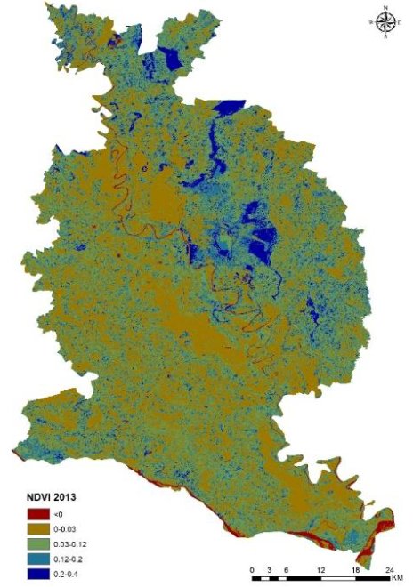
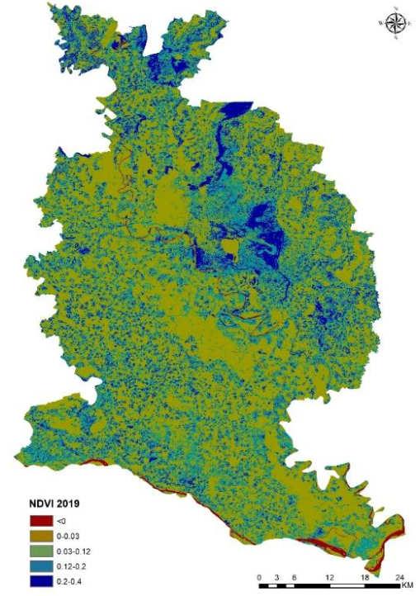

Fig. 1 Normalized Difference Vegetation Index, 2015 and 2021

Source: Computed from Landsat 8

Note: This normalization rescales the NDVI values to range between 0 and 1, where 0 represents no vegetation (e.g., water bodies or barren land) and 1 represents dense, healthy vegetation. The resulting NDVI image represents the vegetation index, with higher values indicating healthier and denser vegetation, while lower values correspond to areas with less vegetation or non-vegetated surfaces.

This study revealed a vegetation index range of <0 to 0.4. Specifically, the mean NDVI values for the years 2015 and 2021 were determined to be 0.315 and 0.198, respectively. The land surface temperature (LST) showed a consistent increasing trend over the years. In 2015, the mean LST was recorded as 19.4°C, which further rose to 21.75 °C in 2021 (Fig. 2). The data clearly demonstrates a steady rise in LST with each passing year.

3.5. Urban Heat Island Effect
The urban heat island (UHI) effect is a phenomenon where urban areas experience higher temperatures than surrounding rural areas due to human activities, land cover modifications, and reduced green spaces. By comparing LST with land surface indices such as the Normalized Difference Vegetation Index (NDVI) and the Built-Up Index (BUI) (Singh, 2010.), we can assess the intensity of the UHI effect in Gorakhpur District. High BUI and low NDVI values may indicate significant urbanization and potential heat island hotspots.

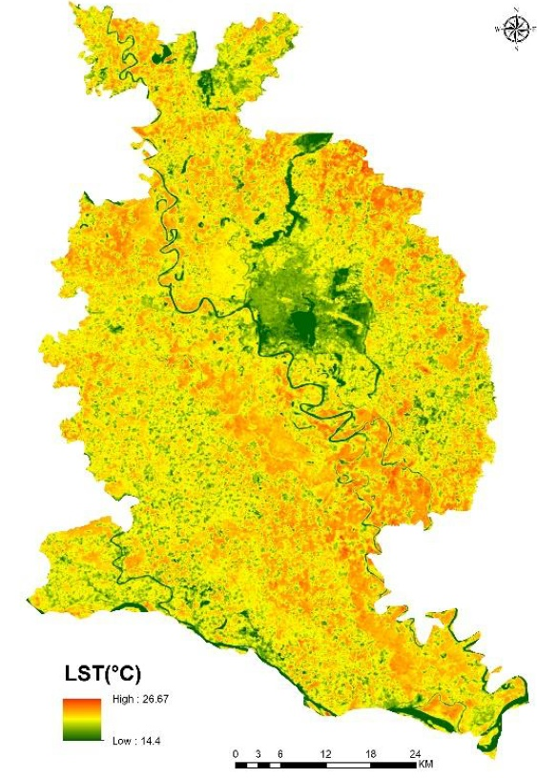
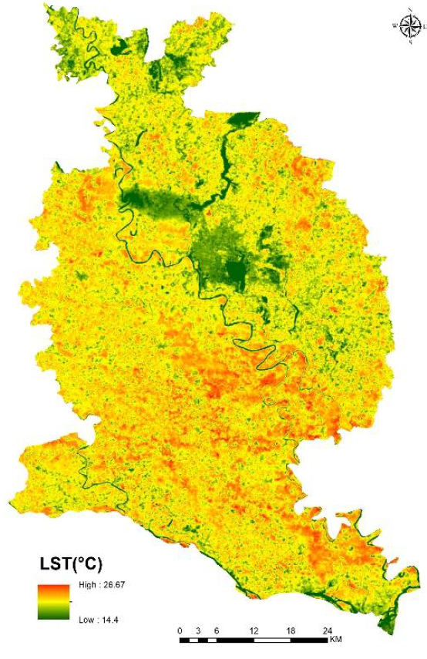

Fig. 2. Land Surface Temperature (LST) shows radiant skin temperature of the land, 2015 and 2021

Source: Computed from Landsat 5 and 8

3.6. Land Use and Land Cover Changes

LST data combined with land surface indices can also help monitor changes in land use and land cover over time. By analysing historical satellite data, researchers can detect shifts in agricultural land, urban expansion, deforestation, and reforestation efforts. This information is vital for sustainable urban planning and resource management.

3.7 Environmental Health

High LST values in certain areas can have adverse effects on public health and the environment. The relationship between LST and land surface indices, such as the Soil Adjusted Vegetation Index (SAVI) and the Heat Load Index (HLI), can provide insights into areas at risk of heat stress and environmental degradation. The study aimed to explore the relationship between Land Surface Temperature (LST) and the Normalized Difference Vegetation Index (NDVI). NDVI is commonly used to assess vegetation cover, and LST provides valuable information about the surface temperature of the Earth (Singh and Singh, 2011).

In 2015, the NDVI values fell within the range of 0.315 to 0.19, which suggests a relatively healthy and dense vegetation cover in the study area. This finding is consistent with a previous study (Singh, 2010; Alex, Ramesh, et al.,2017; Singh 2017), which reported the presence of vegetation during that time. Moreover, the mean LST for the same year was recorded at 18.66°C, indicating a moderate temperature associated with the presence of vegetation.
However, over the years, there was a noticeable change in the vegetation cover and LST. By 2019, the NDVI values dropped to a range of 0.315 to 0.198, indicating a significant reduction in vegetation cover compared to 2015. Correspondingly, the LST increased by 2.33°C in 2021, indicating a rise in surface temperature, possibly due to decreased vegetation and increased exposure to bare soil or urban surfaces (Table 3).
In 2019, the NDVI remained relatively stable at 0.191, suggesting that the vegetation cover did not change significantly compared to 2015. However, the LST increased further to 21.75°C. This rise in temperature indicates potential changes in land use, such as urbanization or alterations in land cover, which can influence surface temperature.

Table 3: The land surface temperature (°C) and NDVI indices in the mentioned year
Year | LST | NDVI
2015 | 19.42 | 0.315
2019 | 18.66 | 0.19
2021 | 21.75 | 0.198
Source: Derived from Landsat

Land Surface Temperature (LST) and its relationship with Normalized Difference Vegetation Index (NDVI)

The correlation coefficient (r) between LST and NDVI, calculated based on the data, was found to be between -0.81934 and -0.9. A negative correlation indicates that as the NDVI decreases (indicating reduced vegetation cover), the LST tends to increase. This negative correlation between LST and NDVI suggests that areas with more vegetation tend to have lower surface temperatures, while areas with less vegetation or more impervious surfaces exhibit higher surface temperatures. Overall, the study highlights the relationship between vegetation cover and surface temperature, providing valuable insights into the dynamics of the study area's environment and land use changes over time. The analysis of LST and NDVI data from 2015 to 2021 revealed interesting trends. Over this period, there was a consistent rise in LST, indicating an increase in surface temperatures. On the other hand, the NDVI values experienced significant changes. between 2015 and 2019, the NDVI values decreased from 0.315 to 0.19, indicating a decline in vegetation cover. This decrease in NDVI suggests an expansion of built-up areas and barren lands, which are typically associated with urbanization and land degradation. During this period, anthropogenic activities, such as transportation and construction, witnessed substantial growth, contributing to the reduction in vegetation cover and exacerbating land surface temperature changes. Interestingly, from 2015 to 2021, the NDVI remained relatively stable at around 0.198. This implies that the vegetation cover did not undergo significant changes during this time. However, the LST continued to increase, suggesting that factors other than vegetation cover influenced the rise in surface temperatures. The persistence of high LST values may be attributed to the intensification of urbanization and land-use changes, which can lead to the development of heat islands and increased thermal radiation absorption.
The observed rise in LST over the years is of particular concern as it contributes to global warming and climate change. Urbanization, land degradation, and anthropogenic activities are key drivers behind the increase in surface temperatures, aggravating the urban heat island effect and impacting local and regional climates. Overall, this analysis emphasizes the importance of monitoring land surface temperature and vegetation cover changes to understand the dynamics of urbanization, land-use, and their impacts on the environment. Mitigation strategies are crucial to curb the escalating effects of anthropogenic activities and alleviate climate change's adverse impacts.

.

4. Conclusion

Land surface temperature retrieval from TIRS data is a valuable tool in understanding the thermal characteristics of the Earth's surface. Its relationship with various land surface indices can provide valuable information about urbanization, land use changes, and environmental health in cities like Gorakhpur. By using this knowledge, policymakers and researchers can make informed decisions for sustainable development and mitigating the adverse effects of climate change. As technology advances and more data becomes available, the study of LST and land surface indices will continue to contribute significantly to our understanding of the planet's dynamic processes.

DISCLAIMER (ARTIFICIAL INTELLIGENCE)

The authors hereby declare that no generative AI technologies such as Large Language Models (ChatGPT, COPILOT, etc) and text-to-image generators have been used during the writing or editing of this manuscript.

Competing interests

Authors have declared that no competing interests exists.

References

Li, Y., Li, M., Li, C., & Liu, Z. (2020). Forest aboveground biomass estimation using Landsat 8 and Sentinel-1A data with machine learning algorithms. Scientific reports, 10(1), 9952. https://doi.org/10.1038/s41598-020-67024-3
Li, Y., Zhao, M., Mildrexler, D. J., Motesharrei, S., Mu, Q., Kalnay, E., Zhao, F., Li, S., & Wang, K. (2016). Potential and actual impacts of deforestation and afforestation on land surface temperature. Journal of Geophysical Research: Atmospheres, 121(24), 14372-14386. https://doi.org/10.1002/2016JD024969
Mallick, J., Kant, Y., & Bharath, B.D. (2008). Estimation of land surface temperature over Delhi using Landsat-7 ETM+. J. Ind. Geophys. Union, 12(3), 131-140. http://www.igu.in/12-3/5javed.pdf
Singh, R. B., & Singh, S. (2011). Rapid urbanization and induced flood risk in Noida, India. Asian Geographer, 28(2), 147-169. https://doi.org/10.1080/10225706.2011.629417
Singh, S., & Singh, R.B. (2021). Drivers of Climate Change Research Pathways. In Simulating Climate Change and Livelihood Security (pp. 117–175). Springer, Singapore. https://doi.org/10.1007/978-981-16-4648-5_2
Singh, S. 2017. Climate Change Policy of India. Regional Development: Theory and Practice: Development Policies, Vol 4, 283.
Singh, S., 2010. GIS Application in Urban Heat Island: A Crusading Anthropogenic Driver to Climate Change. Urban India Journal, Vol. 30, pp. 74-92, India Habitat Center, New Delhi, India.
Tian, H., Wu, M., Wang, L., & Niu, Z. (2018). Mapping early, middle and late rice extent using sentinel-1A and Landsat-8 data in the poyang lake plain, China. Sensors, 18(1), 185. https://doi.org/10.3390/s18010185
Tyagi, N., & Sahoo, S. (2022). Dynamics of land surface temperature (LST) and their relation with urban biophysical components in Gorakhpur (India) urban area: a GIS and statistical based analysis for sustainable planning. Arabian Journal of Geosciences, 15(10), 1010. https://doi.org/10.1007/s12517-022-10242-y
Wang, Y., Yuan, Q., Li, T., Shen, H., Zheng, L., & Zhang, L. (2019). Large-scale MODIS AOD products recovery: Spatial-temporal hybrid fusion considering aerosol variation mitigation. ISPRS Journal of Photogrammetry and Remote Sensing, 157, 1-12. https://doi.org/10.1016/J.ISPRSJPRS.2019.08.017
Weng, Q., Lu, D., & Schubring, J. (2004). Estimation of land surface temperature–vegetation abundance relationship for urban heat island studies. Remote Sensing of Environment, 89(4), 467-483. https://doi.org/10.1016/j.rse.2003.11.005
Xu, J., Moon, K. H., & Van Der Schaar, M. (2017). A machine learning approach for tracking and predicting student performance in degree programs. IEEE Journal of Selected Topics in Signal Processing, 11(5), 742-753. https://doi.org/10.1109/JSTSP.2017.2692560
Zhang, F., Kung, H., Johnson, V. C., LaGrone, B. I., & Wang, J. (2018). Change detection of land surface temperature (LST) and some related parameters using Landsat image: a case study of the Ebinur lake watershed, Xinjiang, China. Wetlands, 38, 65–80. https://doi.org/10.1007/s13157-017-0957-6

USGS Website (2021) https://www.usgs.gov/landsat-missions/landsat-8
Landsat Science (2021) https://landsat.gsfc.nasa.gov/

