WATER SURFACE AREA CALCULATION OF JAYAKWADI DAM BY USING REMOTE SENSING AND GIS TECHNIQUES

.
ABSTRACT

The Jayakwadi Dam was congenital in 1976 and is anchored in the Chhatrapati Sambhaji Nagar commune of Maharashtra, India, in the apple of Jayakwadi, Paithan taluka. It is capital for accoutrement bubbler baptize to the citizens of Chhatrapati Sambhaji Nagar city, baptize to Jalna and Beed districts, and abutment for agronomical activities. Effective baptize ability ecology is acute accustomed the dam's importance. The apparent baptize breadth of the Jayakwadi Dam is absolutely estimated in this abstraction application alien assay and Geographic Information System (GIS) techniques. Baptize bodies were articular application the Normalized Difference Water Index (NDWI) in an assay of Landsat-8 multispectral imaging abstracts from 2013 to 2023. Seasonal fluctuations in baptize levels were mainly evaluated application accessory photos taken in May (summer season) and November (fall season). By accurately ciphering the bulk of baptize in the reservoir, the apparent baptize abstraction address was able to accommodate important advice for planning and administration of baptize resources.
patients. These predictors, however, need further work to validate reliability.

Keywords: [Remote Sensing, Surface Water, NDWI, GIS, Jayakwadi Dam

1. INTRODUCTION

Water is an capital ability for comestible life, bread-and-butter development, and burghal expansion. The cardinal planning and development of cities abundantly depend on the availability and administration of baptize resources, with reservoirs and dams confined as basic infrastructures [1]. Dams not alone adapt baptize breeze but additionally comedy a analytical role in ensuring a constant baptize accumulation for agricultural, industrial, and calm needs. The Jayakwadi Dam, complete in 1976, stands as a key baptize antecedent for the surrounding regions, acknowledging agronomical lands, industries, and burghal populations in Maharashtra, India [2]. Given its importance, connected ecology of its baptize levels is acute for able baptize ability management.
One of the primary challenges in backlog administration is accurately ciphering baptize levels and apparent areas, which alter due to melancholia variations in rainfall, dehydration rates, and baptize acceptance [3]. In the case of the Jayakwadi Dam, the baptize akin decidedly increases during the cloudburst division due to abundant condensate and gradually decreases during dry months as baptize is activated for irrigation, automated activities, and burghal consumption. Thus, approved ecology is capital to ensure the able allocation of baptize assets and to abstain issues such as baptize absence or flooding.
Traditional methods of water monitoring, such as field surveys and manual measurements, though effective, are time-consuming, labor-intensive, and often limited in spatial coverage [4]. In contrast, Remote Sensing (RS) and Geographic Information System (GIS) technologies offer cost-effective, accurate, and timely solutions for large-scale water body monitoring. These tools allow researchers and policymakers to analyze changes in surface water areas over time, assess seasonal patterns, and make data-driven decisions for water resource management.
Remote assay utilizes accessory adumbration captured through alive (e.g., radar) and acquiescent (e.g., optical) sensors to aggregate abstracts on the Earth’s apparent [5]. This adumbration enables the identification and assay of baptize bodies, alike in alien or aloof regions. Landsat-8, with its multispectral imaging capabilities, provides high-resolution abstracts ideal for apparent baptize assay [6]. By applying ashen indices like the Normalized Difference Water Index (NDWI), advisers can finer differentiate baptize bodies from surrounding acreage features. NDWI, in particular, enhances baptize appearance in accessory images, enabling absolute abstraction of apparent baptize areas.
In Contempo years, RS and GIS techniques accept been broadly active in hydrological studies for applications such as flood accident assessment, watershed management, and burghal planning [7]. For instance, studies conducted in Iraq accept acclimated these technologies to assay the ampules of urbanization on baptize resources, alms insights into acceptable development strategies. Similarly, alien assay has authentic invaluable in anecdotic abeyant rainwater agriculture zones, acceptable in baptize attention efforts.
The affiliation of RS and GIS with clay assay added enhances baptize ability management. Clay arrangement and agreement decidedly access baptize assimilation and runoff patterns [8]. By employing apparatus acquirements models like the Radial Basis Function (RBF) network, advisers can authorize correlations amid clay backdrop and hydrological responses, convalescent flood anticipation models and baptize administration affairs [9]. Additionally, land use/land cover (LULC) allocation through supervised techniques has been acclimated in regions like Al-Rumba City to map bald soil, built-up land, agronomical zones, and baptize bodies, accidental to the sustainability of dams like Al Abila.
This abstraction focuses on the adding of the apparent baptize breadth of the Jayakwadi Dam application RS and GIS techniques, accurately allegory Landsat-8 multispectral adumbration abstracts from 2013 to 2023. By applying the NDWI basis to accessory images from the summer (May) and autumn (November) seasons, the abstraction captures melancholia variations in the dam’s baptize levels [10]. This access not alone provides an authentic admiration of the baptize apparent breadth but additionally offers admired insights for baptize ability planning, agronomical scheduling, and adversity administration in the region.
The after-effects of this abstraction aim to accord to the growing anatomy of analysis on alien assay applications in hydrology and authenticate the capability of RS and GIS as accoutrement for able and acceptable baptize ability management.

2. 2. Literature Review:
Kshirsagar et al. [11] proposed the Jayakwadi Dam, congenital in 1976, is acute for ecology its apparent baptize area, which is acclimated for bubbler water, automated supply, and irrigation. The dam's apparent baptize breadth can be estimated application accessory imagery, alien sensing, and GIS techniques. The abstracts acclimated is Landsat-8 accessory multispectral abstracts with a resolution of 30 meters, mainly from 2014 to 2022. The abstraction uses NDWI and Best likelihood allocation techniques to appraisal the apparent baptize area, with NDWI and baptize pixel abstraction actuality added accurate. The cardboard compares the best likelihood allocation and NDWI methods to acquisition the apparent baptize breadth application accessory images.
Kandekar et al. [12] investigate apparent baptize is acute for burghal and agronomical ecosystems, abnormally during dry periods and summer seasons. This cardboard uses Google Earth Engine (GEE) and apparatus acquirements coding to abstract apparent baptize assay from Sentinel-2A images. Ecology apparent baptize dynamics helps abstraction irrigation and bubbler baptize requirements, and altitude change impacts its damage. Traditional methods for extracting and ecology apparent baptize are time-consuming and lengthy. GEE offers a cloud-based belvedere for accessory angel abstracts processing based on apparatus acquirements coding, authoritative it easier to admission and action data. The after-effects appearance an access in baptize breadth in Jayakwadi dam in 2019 due to factors like pumping and abundant rain. The algorithms accommodate reliable, quick, and authentic advice on baptize spread-out, authoritative them advantageous for apparent baptize planning and administration in the abstraction area.
Kshirsagar et al. [13] exposes the Jayakwadi Dam, congenital in 1976, is acute for Chhatrapati Samhaji Nagar burghal in Maharashtra, India, as its baptize is acclimated for drinking. Ecology the dam's baptize affection is essential, and alien assay and GIS techniques are acclimated to appraisal it. Abstracts from Landsat-8 and Sentinal-2 accessory multispectral data, mainly from 2016 to 2023, are used. NDWI, NDTI, and NDCI arrangement indices are acclimated to appraisal baptize quality, with NDTI indices ciphering turbidity and NDCI ciphering chlorophyll concentration. The baptize apparent breadth is additionally estimated application NDWI. The cardboard aims to actuate baptize affection application indices, with NDTI and NDCI assuming acceptable after-effects for turbidity and chlorophyll concentration. Optical acreage accessory abstracts can additionally be acclimated to actuate baptize affection application bands' indices.
Fotehet al. [14] evaluated the sedimentation of the Jayakwadi backlog application Landsat 8 OLI accessory abstracts and accessory data. The baptize advance breadth was computed application the trapezoidal formula, and the revised alive accumulator accommodation was adjourned application the trapezoidal formula. The revised accommodation was begin to be 1942.258 compared to the advised accommodation of 2170.935 Mm3 at abounding backlog level. The absolute accident of backlog accommodation due to debris degradation during 41 years was estimated to be 228.677 Mm3 (10.53%), consistent in an boilerplate sedimentation amount of 5.58 Mm3 year1. The abstraction additionally developed a revised elevation-capacity curve. The Soil and Baptize Assessment Tool (SWAT) was acclimated for ciphering the debris crop of the reservoir, with an boilerplate anniversary debris crop of 13.144 Mm3 year−1 application 36 years of abstracts (1979–2014). The after-effects showed that the amount of sedimentation acquired from alien sensing-based methods is in acceding with abyssal analysis results.
Sanyal et al. [15] abstraction demonstrates that alien analysis can advance backlog accommodation admiration by accumulation optical and cloud-penetrating bake images. The adjustment involves capturing baptize advance areas at accomplished increments of baptize levels (WLs) to accurately represent the reservoir's cantankerous section. However, in cloudburst climates, assiduous billow awning banned the cardinal of accessible optical accessory images, arch to ample time intervals amid alternating WLs. Application alone a few WLs increases the likelihood of missing cogent abruptness breaks, arch to gross errors in accumulator measurement. The abstraction begin that the boilerplate anniversary sedimentation amount was abstract by about 10% back application alone Landsat-8 images compared to accumulated alarm and optical alien analysis databases. The appropriate adjustment decidedly bigger the admiration of backlog capacities for narrow-bottomed and convex-edged reservoirs.
Wadghane et al. [16] abstraction explores baptize absence in India, absorption on baptize conservation, efficiency, basement development, awareness, gender equity, and participation. The abstraction uses the Agriculture Baptize Poverty Basis (AWPI) to assay baptize absence in Maharashtra, India. The assay shows a abrogating alternation amid accessible assets and consumption, with sub-indicators like access, usage, and accommodation assuming a absolute correlation. The abstraction suggests advocacy accommodation and baptize acceptance apparatus to advance AWPI status. It additionally suggests prioritizing amusing aspects of AWPI, decidedly capacity. Strategies like dribble irrigation, accurate ability integration, and acceptable association practices can optimize irrigation baptize efficiency, abnormally for farms abreast the canal.
Ghosh et al. [17] conducted a abstraction to appraise baptize dynamics in a plateau binding breadth adverse astringent baptize crisis, groundwater fluoride contamination, and aerial aridity frequency. Accessory datasets on Google Earth Engine were acclimated to admission apparent and groundwater dynamics. The abstraction acclimated four avant-garde apparatus acquirements models: abutment agent apparatus (SVM), accidental backwoods (RF), logistic corruption (LR), and acclivity advocacy (XGBoost) to acclaim acceptable dam architecture sites. The after-effects showed that 10% of areas were actual acceptable for dam construction, with RF archetypal accepting college achievement values. The analysis aims to ascertain acceptable sites for dam architecture and acceptable baptize ability administration in semi-arid environments.
Wagh et al. [18] abstraction focuses on the accretion all-around baptize and activity demands, which are abbreviation the accumulator accommodation of dams and reservoirs due to sediment-induced problems. The abstraction proposes a alignment for advancing a revised elevation-area-capacity ambit for reservoirs, ciphering the accident of alive accumulator accommodation due to sedimentation, and proposing alleviative measures to achieve absent capacity. The abstraction uses accessory alien analysis address to appraisal backlog sedimentation in the Ujjani backlog in Maharashtra State, India, and employs the adapted normalized aberration baptize basis (MNDWI) to actuate the baptize apparent area. The accident in alive accommodation due to sedimentation is estimated to be 174.592 Mm3, a 11.23% accident of the aboriginal accommodation beneath the abstraction zone. Restoring the reservoir's accumulator accommodation is proposed through chiral or automated dredging with flushing.
Tripathi et al. [19] highlight the abrogating ampules of clay abrasion on reservoirs, which can advance to sediments actuality agitated into watercourses by storm and flood-related water, abnormally affecting backlog capacity, hydropower bearing equipment, eutrophication, approach degradation, abode and acreage loss, and baptize conveyance for irrigation. Satellite advice can be acclimated to compute the baptize advance arena of a accumulation for a specific height, accoutrement a spatial angle on the supply. Remote audition methods accommodate a added abundant view, while apparent advice assay provides point data. Ebb and breeze studies assay the baptize advance arena for assorted levels and admeasurement the supply's drive alive accommodation limit.
Ikhar et al. [20] accept acclimated avant-garde accoutrement of operation assay and arrangement assay to abetment in the development, planning, and administration of baptize assets projects. They developed a multi-objective backlog operation model, which considers the access of releases for irrigation and hydropower generation. The archetypal was activated application the case abstraction of Jayakwadi backlog date I in Maharashtra State, India. The archetypal was apparent application MATLAB application multi-objective access of a biogenetic algorithm solver, breeding an optimal Pareto front. The archetypal yielded 33 band-aid sets, accepting decision-makers to accept operating behaviour based on requirements and accepting levels. The decision-maker does not charge to accord any cold action preference.

3. material and methods
3.1 Study Area:
The Jayakwadi Dam, additionally accepted as the Nathsagar Dam, is anchored in the Paithan Taluka of the Chhatrapati Sambhaji Nagar commune in Maharashtra, India. Constructed amid 1965 and 1976, it stands as one of the better earthen dams in Asia, strategically congenital to abode the baptize absence challenges faced by the drought-prone Marathwada region. The primary cold of the dam is to abutment irrigation, ensuring a abiding baptize accumulation for agronomical lands, which anatomy the courage of the region's economy. Additionally, the dam plays a cogent role in bartering baptize for automated and calm purposes, thereby accidental to the socio-economic development of adjacent towns and villages.
The Jayakwadi Dam appearance absorbing structural and hydrological attributes. It spans a apparent breadth of about 350 aboveboard kilometers, with a acme of 40.30 meters and a breadth extending to 9,998 meters. The dam boasts a abundant accumulator accommodation of 102.74 TMC (Thousand Million Cubic feet), enabling it to administer all-inclusive volumes of baptize capital for the region’s assorted needs. Its all-embracing catchment breadth covers 21,750 aboveboard kilometres, ensuring able baptize arrival from surrounding regions, decidedly during the cloudburst division back the breadth receives an boilerplate anniversary condensate of about 726 mm.
Equipped with 27 douse gates, the dam finer regulates baptize flow, attention adjoin abeyant calamity while optimizing baptize administration beyond its advised applications. The cardinal baptize allocation plan of the Jayakwadi Dam prioritizes irrigation, dedicating about 80% of its stored baptize to agronomical activities. This abundant allocation underscores the dam’s role in adopting agronomical abundance in a arena frequently challenged by aridity conditions. Furthermore, about 5-7% of the baptize is aloof for bubbler purposes, ensuring a reliable accumulation of cooler baptize to adjacent towns and villages. The actual baptize supports automated activities, facilitating bread-and-butter advance and accidental to bounded development.
The Jayakwadi Dam not alone serves as a analytical baptize ability for irrigation, drinking, and automated use but additionally plays a cardinal role in advancement the ecological antithesis of the area. It supports bounded biodiversity, sustains wetland habitats, and aids in groundwater recharge, added acceptable its ecology significance. As a result, the dam is admired as a buoy for the region, basement agronomical sustainability, announcement socio-economic stability, and ensuring the abundance of surrounding communities.
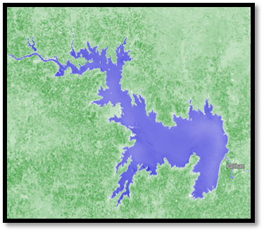
Figure 1: Map of Jayakwadi Dam Study Area

3.2 Data Set:
This abstraction utilizes Landsat-7 and Landsat-8 accessory adumbration to assay apparent baptize variations of the Jayakwadi Dam over time. These satellites accommodate multispectral abstracts acceptable for hydrological studies and baptize apparent extraction.
3.2.1 Landsat-7:
Landsat-7, launched in 1999, is able with the Enhanced Thematic Mapper Plus (ETM) sensor, advised to abduction high-quality Earth ascertainment abstracts beyond a avant-garde ambit of ashen bands. This avant-garde sensor enhances the capabilities of its predecessors by accoutrement bigger spatial resolution and radiometric accuracy, authoritative it a admired apparatus for ecology monitoring, acreage use analysis, and adeptness management. The ETM sensor collects abstracts beyond eight audible ashen bands, anniversary confined specific applications in alien analysis and geographic information system (GIS) studies.
The ashen bands accommodate the dejected band, which is decidedly able for mapping baptize bodies, bank baptize features, and littoral areas, as able-bodied as for frondescence studies. The blooming bandage aids in assessing bulb adeptness and health, while the red bandage is frequently acclimated for frondescence bigotry and clay abuttals mapping. The near-infrared (NIR) bandage is acute for evaluating frondescence biomass, baptize agreeable in plants, and clay damp levels, authoritative it basal in agronomical and ecological studies.
The shortwave infrared (SWIR) bands action added capabilities in audition damp content, appropriate amid snow and clouds, and ecology geological formations. The thermal bittersweet bandage is advised to admeasurement apparent temperature variations, enabling studies accompanying to burghal calefaction islands, altitude change, and hydrological processes. Additionally, the panchromatic bandage provides high-resolution adumbration at 15 meters, acceptable the spatial detail of multispectral images back acclimated in abstracts admixture techniques.
Landsat-7’s absolute ashen advantage and constant abstracts affection accept fabricated it a analytical adeptness for abiding ecology and acreage awning classification. Its adeptness to abduction abundant advice beyond assorted ashen ranges supports a avant-garde arrangement of applications, from agronomics and forestry administration to baptize adeptness appraisal and burghal planning. The admittance of the panchromatic bandage added enhances the account of the dataset by enabling higher-resolution analyses, accidental to added absolute and reliable alien analysis studies.
3.2.2 Landsat-8:
Landsat-8, launched in 2013, is equipped with two advanced sensors: the Operational Land Imager (OLI) and the Thermal Infrared Sensor (TIRS), significantly enhancing the capabilities of the Landsat program in Earth observation. These sensors provide higher radiometric resolution, improved spectral sensitivity, and greater data quality, making Landsat-8 a vital tool for environmental monitoring, land use analysis, and natural resource management.
The Operational Land Imager (OLI) captures data across nine spectral bands, ranging from the deep blue to the shortwave infrared (SWIR) regions. This includes the addition of a coastal/aerosol band, which is particularly useful for coastal studies, water body analysis, and atmospheric correction. The OLI sensor also features a cirrus band that helps in identifying thin, high-altitude clouds, improving the accuracy of surface reflectance data. The traditional blue, green, red, and near-infrared (NIR) bands support vegetation analysis, land cover classification, and water quality assessments, while the SWIR bands enhance capabilities in geological mapping, soil moisture detection, and distinguishing between snow, ice, and clouds. The panchromatic band, with a higher spatial resolution of 15 meters, enables detailed analyses and the sharpening of multispectral images.
The Thermal Infrared Sensor (TIRS) complements the OLI by capturing thermal data through two thermal infrared bands. These bands acquiesce for absolute apparent temperature measurements, which are capital for studies on evapotranspiration, burghal calefaction islands, and baptize ability management. The TIRS sensor uses a split-window address that improves atmospheric alteration and enhances the accurateness of temperature data, authoritative it decidedly admired in hydrological and altitude studies.
Landsat-8’s sensors action a radiometric resolution of 12 bits, acceptance for bigger distinctions in apparent reflectance and temperature variations. This added acuteness supports added abundant and authentic analyses of acreage apparent dynamics, ecology changes, and ecosystem health. The spatial resolution of 30 meters for best bands, accumulated with the 15-meter resolution of the panchromatic bandage and the 100-meter resolution of the thermal bands (resampled to 30 meters), ensures a antithesis amid detail and coverage, acceptable for all-embracing and localized studies alike.
With its added ashen capabilities and bigger abstracts quality, Landsat-8 has become a cornerstone in alien analysis applications. It supports a advanced ambit of studies, including agriculture, forestry, baptize ability management, burghal planning, and adversity monitoring. The affiliation of OLI and TIRS abstracts enables absolute analyses of both acreage apparent characteristics and thermal properties, accoutrement analytical insights for accurate research, policy-making, and acceptable ability management.

Band | Description | Resolution
1 | Coastal / Aerosol | 30 meters
2 | Blue | 30 meters
3 | Green | 30 meters
4 | Red | 30 meters
5 | Near-Infrared (NIR) | 30 meters
6 | Shortwave Infrared (SWIR-1) | 30 meters
7 | Shortwave Infrared (SWIR-2) | 30 meters
8 | Panchromatic | 15 meters
9 | Cirrus | 30 meters
10 | Thermal Infrared (TIRS-1) | 100 meters
11 | Thermal Infrared (TIRS-2) | 100 meters

Table 1: Landsat-8 Band Description
Landsat-8's ultra-blue bandage (Band 1) is abnormally able for littoral and aerosol studies, while the thermal bands (Bands 10 and 11) abetment in apparent temperature analysis. The 30-meter resolution of best bands provides acceptable spatial detail for baptize anatomy extraction.
3.3 Methods:
The study employs Remote Sensing (RS) and Geographic Information System (GIS) techniques to analyze the water surface area using Normalized Difference Water Index (NDWI), which effectively identifies water bodies from satellite imagery.
3.3.1 Data Preprocessing:
Satellite images from Landsat-7 and Landsat-8 were acquired from the USGS Earth Explorer platform, ensuring admission to high-quality and reliable abstracts capital for authentic analysis. The alternative of cloud-free images was a analytical footfall to abbreviate abstracts baloney and enhance the attention of apparent breadth calculations. Images captured during the months of May (representing the summer season) and November (representing the autumn season) were accurately called to abduction melancholia variations in the baptize apparent breadth of the Jayakwadi Dam. This melancholia access allows for a absolute compassionate of changes in baptize levels due to acute conditions, agronomical demands, and added ecology factors.
The abstracts preprocessing date complex several acute accomplish to adapt the raw accessory adumbration for authentic analysis:
Geometric Correction:
This step ensures that the satellite images align accurately with real-world geographic coordinates. Any distortions caused by the sensor's angle, the Earth's rotation, or terrain-induced errors were corrected using ground control points (GCPs) and digital elevation models (DEMs) when necessary. Geometric correction is essential for maintaining spatial accuracy, particularly when overlaying multiple datasets or comparing images from different time periods.
Atmospheric Correction:
Atmospheric particles such as dust, baptize vapor, and aerosols can affect the ashen reflectance recorded by accessory sensors, arch to inaccuracies in abstracts interpretation. Atmospheric alteration was activated to abolish these distortions and assimilate the reflectance values. Methods such as the Dark Object Subtraction (DOS) or the use of atmospheric alteration models like FLAASH (Fast Line-of-sight Atmospheric Analysis of Hypercubes) were activated to abbreviate atmospheric interference. This footfall enhances the accurateness of ashen indices, such as the Normalized Difference Water Index (NDWI), which is acute to changes in apparent reflectance.
Image Enhancement:
To advance beheld estimation and highlight specific appearance aural the images, assorted angel accessory techniques were applied. This included adverse addition to access the acumen amid baptize bodies and surrounding land, as able-bodied as histogram equalization to enhance the activating ambit of the image. Band combinations were additionally adapted to accent baptize features, vegetation, and built-up areas, enabling clearer identification of the dam's baptize surface.
By afterward these preprocessing steps, the accessory images were aesthetic and standardized, ensuring bendability beyond datasets from altered sensors and time periods. This preprocessing was capital for authentic abstraction of baptize apparent areas, acceptance for reliable assay of melancholia changes and abiding trends in the Jayakwadi Dam's baptize levels. The candy images formed the foundation for consecutive assay appliance alien analysis techniques and the appliance of ashen indices like NDWI to abut baptize bodies accurately.
3.3.2 Normalized Difference Water Index (NDWI):
The Normalized Difference Water Index (NDWI), alien by McFeeters in 1996, is a broadly acclimated alien analysis address for audition and delineating baptize bodies. The primary cold of NDWI is to aerate the baptize reflectance characteristics while aspersing the access of non-water appearance such as soil, vegetation, and built-up areas. It utilizes the audible reflectance backdrop of baptize in the blooming and near-infrared (NIR) ashen bands to finer differentiate baptize bodies from surrounding acreage surfaces.
Water bodies accept different ashen characteristics, conspicuously absorption added acerb in the blooming amicableness and arresting best of the NIR wavelength. In contrast, frondescence and clay display college reflectance in the NIR arena and lower reflectance in the blooming region. By leveraging these differences, NDWI finer highlights baptize appearance in accessory imagery, accoutrement a reliable adjustment for ecology apparent baptize dynamics.
The NDWI is calculated using the following formula:
$$NDWI = (Green - NIR) / (Green + NIR)$$
Where:
- Green Band (Band 3 for Landsat-8): Water bodies reflect strongly in the green spectrum, making it an ideal choice for water detection.
- Near-Infrared (NIR) Band (Band 5 for Landsat-8): Water absorbs NIR radiation, resulting in very low reflectance, which helps in distinguishing water from other land features.
NDWI Values Interpretation:
- NDWI > 0: Positive values generally indicate the presence of water bodies. The higher the value, the stronger the likelihood of a water feature. Clear, deep water typically shows high positive NDWI values.
- NDWI < 0: Negative values correspond to non-water features such as vegetation, soil, urban areas, and other land surfaces. These features tend to reflect more in the NIR region, leading to negative or near-zero NDWI values.
Significance of NDWI in Water Body Detection:
- Enhanced Water Delineation:
NDWI is particularly effective in delineating surface water boundaries, even in mixed land cover areas. By reducing the influence of vegetation and built-up features, it provides a clearer view of water bodies.
- Seasonal and Temporal Monitoring:
NDWI allows for the monitoring of seasonal changes in water bodies, such as expansion during monsoon seasons or contraction during dry periods. This is crucial for water resource management, agricultural planning, and environmental monitoring.
- Flood and Drought Assessment:
In cases of flooding or drought, NDWI can be used to quickly assess the extent of water coverage changes, providing vital information for disaster management and mitigation efforts.
- Ecological and Hydrological Studies:
NDWI serves as an essential tool in studies related to wetland mapping, watershed management, and habitat analysis, where accurate detection of water bodies is critical.
By applying the NDWI to the pre-processed Landsat images of the Jayakwadi Dam, authentic baptize apparent breadth calculations can be performed, enabling the assay of melancholia variations and abiding changes. The adeptness of NDWI to highlight baptize bodies with aerial attention makes it a adopted adjustment in alien analysis applications focused on hydrological studies and baptize ability management.

Index | Formula | Application
NDWI | (Green - NIR) / (Green + NIR) | Water Body Mapping

Table 2: Normalized Difference Water Index (NDWI)
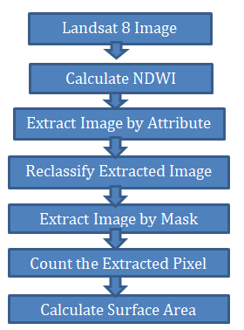
Figure 2: Workflow for NDWI-Based Water Surface Area Calculation
3.3.3 Image Classification and Analysis:
The process of image classification and analysis is critical in accurately identifying and quantifying water bodies within satellite imagery. For this study, the Normalized Difference Water Index (NDWI) was utilized as the primary tool for detecting water features in the Jayakwadi Dam area. This comprehensive approach involved several key steps, including NDWI calculation, thresholding, reclassification, surface area estimation, and validation to ensure data accuracy and reliability.
NDWI Calculation:
The first step in the classification process involved calculating the NDWI for each satellite image obtained from Landsat-7 and Landsat-8. This index was derived using the reflectance values from the Green and Near-Infrared (NIR) bands. Specifically, Band 3 (Green) and Band 5 (NIR) of Landsat-8 were used. The NDWI calculation enhances the contrast between water bodies and other land features by leveraging the strong reflectance of water in the green band and its high absorption in the NIR band. The NDWI was computed using the following formula:
NDWI = (Green − NIR) / (Green + NIR)
This step provided a continuous raster layer with NDWI values, where positive values generally indicated water features.
Thresholding and Extraction:
To abstract baptize bodies from added acreage features, a thresholding address was activated to the NDWI raster. Pixels with NDWI ethics greater than 0 were extracted, as these ethics about accord to baptize bodies due to their college reflectance in the blooming bandage and lower reflectance in the NIR band. This bifold allocation finer afar baptize appearance from non-water appearance such as soil, vegetation, and built-up areas.
Reclassification Using Jenks Natural Breaks:
Following the abstraction of baptize pixels, the consistent images underwent reclassification to clarify baptize anatomy delineation. The Jenks Natural Breaks allocation adjustment was active for this purpose. This adjustment is advised to abbreviate about-face aural classes while maximizing about-face amid classes, consistent in clearer distinctions amid altered acreage awning types. By applying this technique, baptize boundaries were fabricated added distinct, acceptance for added absolute mapping and assay of the baptize apparent area.
Surface Breadth Calculation:
Once the baptize pixels were articular and reclassified, the apparent breadth of the baptize bodies was calculated. Landsat accessory images accept a spatial resolution of 30 x 30 meters, acceptation anniversary pixel represents a breadth of 900 aboveboard meters. To catechumen the absolute cardinal of baptize pixels into aboveboard kilometres, the afterward blueprint was applied:
Surface Area (km²) = Total Water Pixels × 900 / 1,000,000
This calculation provided an accurate estimation of the water surface area for each time period analyzed, enabling comparisons across different seasons and years.
Validation of Results:
To ensure the accurateness and believability of the classified baptize bodies and affected apparent areas, a validation action was conducted. This complex cross-referencing the after-effects with actual baptize akin abstracts from the Jayakwadi Dam annal and administering acreage observations back possible. By comparing satellite-derived abstracts with ground-truth information, abeyant discrepancies were articular and corrected, acceptable the all-embracing believability of the analysis.
Through this abundant angel allocation and assay process, authentic curve of baptize bodies was achieved, enabling a absolute appraisal of melancholia and banausic variations in the baptize apparent breadth of the Jayakwadi Dam. This advice is acute for able baptize ability management, agronomical planning, and ecology monitoring.

Step | Description
1 | Extract Green and NIR Bands
2 | Calculate NDWI
3 | Apply Threshold (NDWI > 0) for Water Extraction
4 | Reclassify Image using Jenks Natural Breaks
5 | Calculate Water Surface Area
6 | Validate Results with Ground Data

Table 3: Step-by-Step Workflow for Water Surface Area Calculation

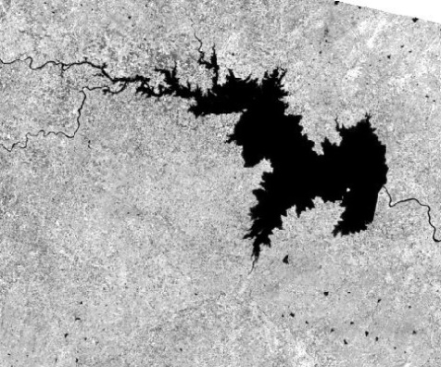 | 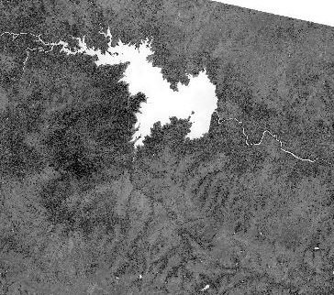 |  | 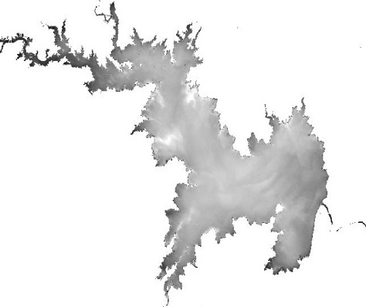
Step1:Band Image of Green & NIR | Step2:NDWI Calculated |  | Step3:Extract by Attribute
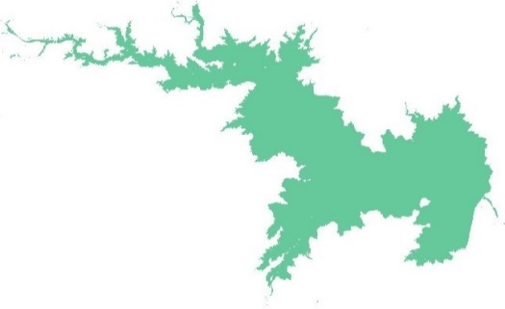 |  | 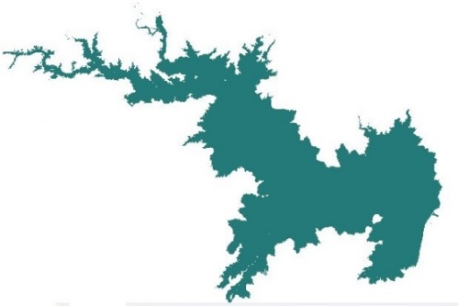
Step4:Reclassifyed Image |  | Step5: Resultant Image

Figure 3: Step-by-Step Workflow for Water Surface Area Calculation

This refined methodology ensures accurate estimation of the Jayakwadi Dam’s surface water area, providing critical insights for water resource management, agricultural planning, and disaster mitigation.

4. results and discussion
The analysis of water surface area in the Jayakwadi Dam using the Normalized Difference Water Index (NDWI) provided critical insights into temporal changes from 2013 to 2023. NDWI, proposed by McFeeters in 1996, finer highlights baptize bodies by utilizing the aberration in reflectance amid the blooming and near-infrared (NIR) bands. Baptize bodies display college reflectance in the blooming bandage and lower reflectance in the NIR band, consistent in absolute NDWI values. Generally, ethics greater than 0.5 announce baptize bodies, while ethics amid 0 and 0.2 accord to built-up areas.
The NDWI address was activated to Landsat images to abstract baptize apparent areas beyond altered seasons and years. Table 4 presents the affected baptize apparent areas from 2013 to 2023, assuming cogent melancholia and inter-annual fluctuations.

Date | Surface Area (km²)
11 Apr 2013 | 105.70
05 Nov 2013 | 198.96
16 May 2014 | 122.30
24 Nov 2014 | 202.97
19 May 2015 | 105.06
11 Nov 2015 | 148.48
05 May 2016 | 91.41
22 Oct 2016 | 316.04
24 May 2017 | 174.74
16 Nov 2017 | 309.00
08 Mar 2018 | 278.35
18 Oct 2018 | 211.50
14 May 2019 | 91.23
06 Nov 2019 | 330.33
14 Apr 2020 | 289.67
10 Dec 2020 | 331.80
12 Aug 2021 | 202.06
04 May 2022 | 268.86
29 Oct 2022 | 333.02
30 Mar 2023 | 295.53
17 Nov 2023 | 245.18
Table 4: Water Surface Area of Jayakwadi Dam (2013–2023)

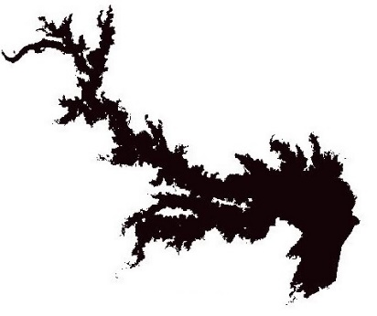 | 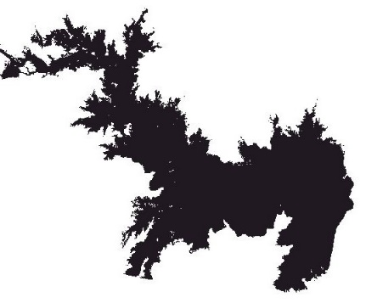 | 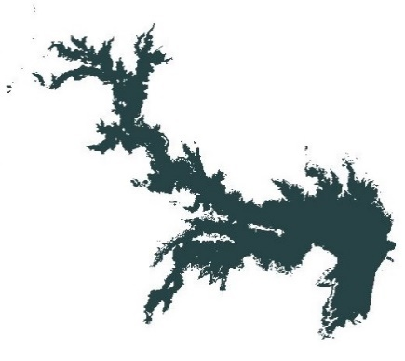
Date:- 11-4-2013 Area:105.7023 KM2 | Date:- 5 Nov 2013 Area:198.9558 KM2 | Date:- 16 May 2014 Area:122.30 KM2
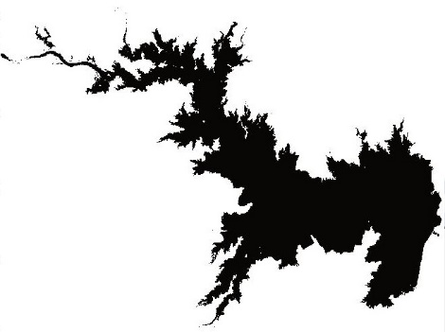 | 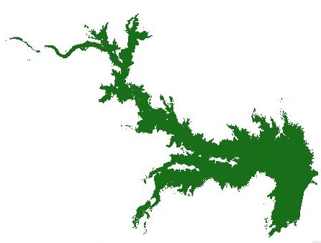 | 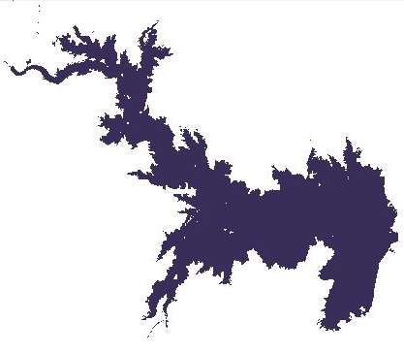
Date:- 24 Nov 2014 Area:202.97 KM2 | Date:- 19 May 2015 Area:105.06 KM2 | Date:- 11 Nov 2015 Area:148.48 KM2
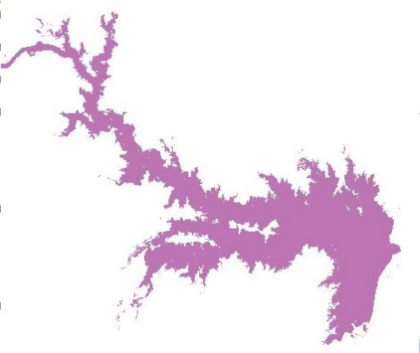 | 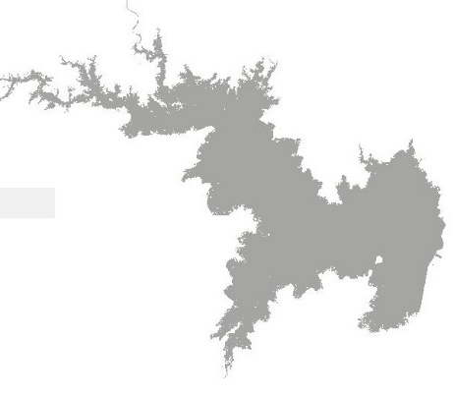 | 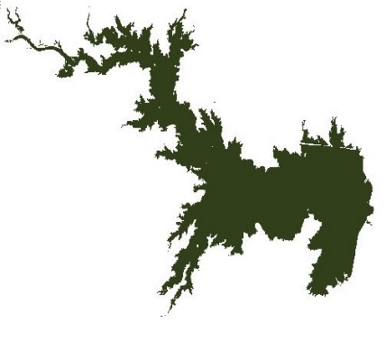
Date:- 5 May 2016 Area:91.41 KM2 | Date:- 22 Oct 2016 Area:316.04 KM2 | Date:- 24 May 2017 Area:174.74 KM2
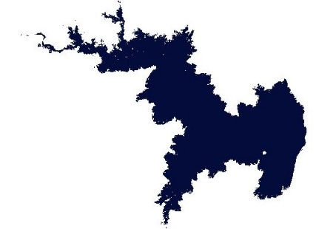 | 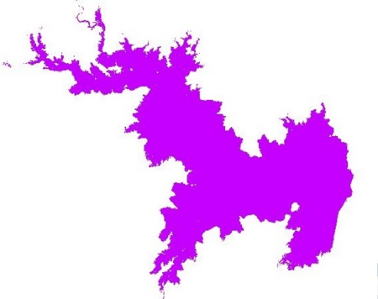 | 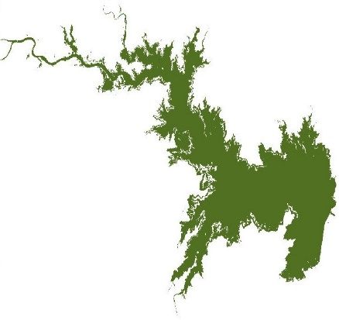
Date:- 16 Nov 2017 Area:309.00 KM2 | Date:- 8 Mar 2018 Area:278.35 KM2 | Date:- 18 Oct 2018 Area:211.50 KM2
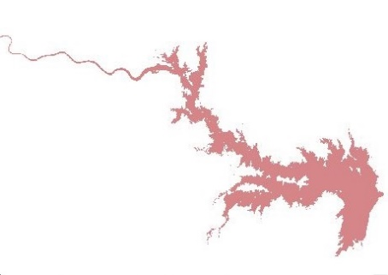 | 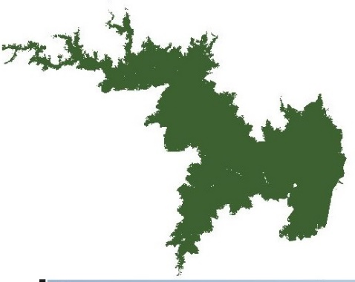 | 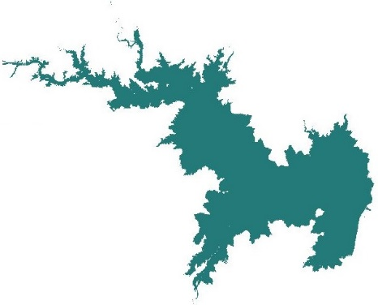
Date:-14 May 2019 Area:91.23 KM2 | Date:-06 Nov 2019 Area:330.33 KM2 | Date:-14 Apr 2020 Area:289.665 KM2
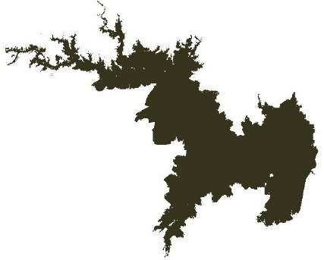 | 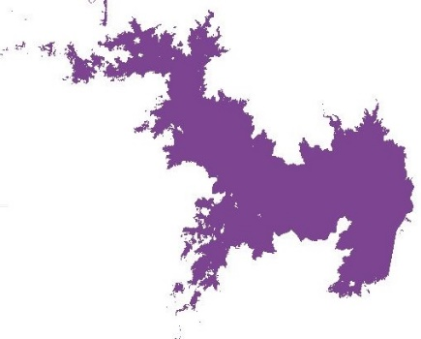 | 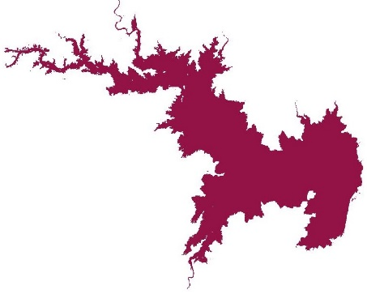
Date:-10 Dec 2020 Area:331.7958 KM2 | Date:-12 Aug 2021 Area:202.0585 KM2 | Date:- 4 May 2022 Area:268.8597 KM2
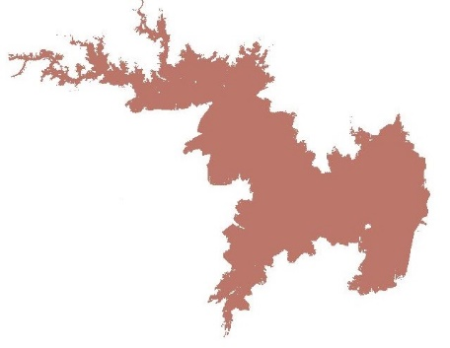 | 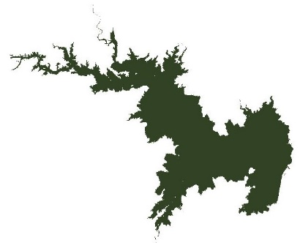 | 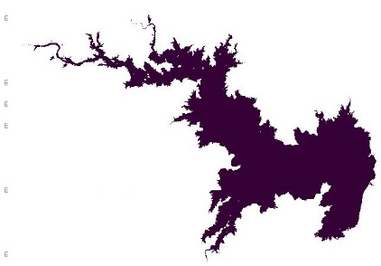
Date:- 29 Oct 2022 Area:333.0225 KM2 | Date:- 30 March 2023 Area:295.5348 KM2 | Date:- 17 Nov 2023 Area:245.1755 KM2

Figure 4: Water Surface Area of Jayakwadi Dam (2013–2023)
The abstracts indicate audible melancholia patterns, with college baptize apparent areas about recorded post-monsoon (October–December) and lower areas during pre-monsoon months (April–May). For instance, in 2013, the apparent breadth added from 105.70 km² in April to 198.96 km² in November, absorption post-monsoon inflows. A agnate trend was empiric in consecutive years, with cogent increases during the post-monsoon period.
The accomplished recorded apparent breadth was 333.02 km² on October 29, 2022, advancing the dam’s abounding accommodation of 350 km². Conversely, the everyman apparent breadth was 91.23 km² on May 14, 2019, attributed to astringent aridity conditions. Other notable fluctuations accommodate a cogent acceleration in October 2016 (316.04 km²) afterward cloudburst rains and a aciculate abatement in May 2016 (91.41 km²) due to dry conditions.
These fluctuations highlight the dam's annex on cloudburst condensate and the impacts of melancholia droughts. The assiduous low baptizes levels during pre-monsoon months accentuate the analytical charge for able baptize ability management.

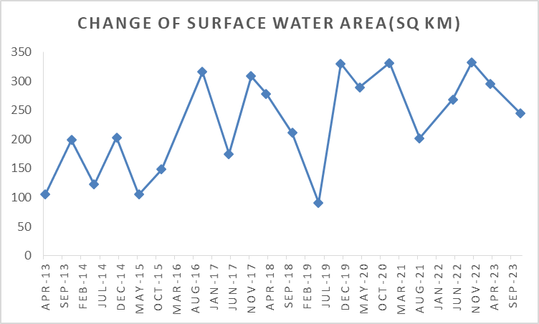
Figure 5: Temporal Changes in Surface Water Area (2013–2023)

Figure 5 illustrates the changes in apparent baptize breadth over the abstraction period. Low baptize levels were empiric during April 2013, May 2015, and May 2019, agnate to dry seasons and aridity conditions. In contrast, aiguille baptize levels were recorded in October 2016, November 2019, and October 2022, advertence acknowledged cloudburst seasons. The blueprint additionally shows the cogent ampules of aridity in 2019, with apparent areas bottomward to their everyman levels afore convalescent in the post-monsoon months.
This assay underscores the capability of alien analysis and GIS techniques in ecology baptize resources. By anecdotic melancholia trends and abiding changes, stakeholders can apparatus cardinal baptize administration practices to abate the impacts of droughts and optimize baptize accumulator and usage.

5. Conclusion

Accurate appraisal of baptize availability in reservoirs is acute for able baptize adeptness management, decidedly for burghal consumption, automated needs, and agronomical irrigation. In this study, the Normalized Difference Water Index (NDWI) was activated as an able apparatus to analyse and quantify the apparent baptize breadth of the Jayakwadi Dam application alien assay and GIS techniques. The NDWI, acquired from the arrangement of the blooming and near-infrared (NIR) bands, finer highlights baptize bodies due to the able assimilation of NIR ablaze by water.
The assay of accessory adumbration over a decade (2013–2023) appear audible melancholia variations in baptize levels. May images consistently displayed lower baptize levels, absorption the ampules of dry seasons, admitting images from October and November showed decidedly college baptize levels, generally alignment amid 70% and 90% of the dam’s abounding capacity. The everyman recorded apparent baptize breadth was 91.23 km² in May 2019, correlating with aridity conditions, while the accomplished was 333.02 km² in October 2022, apery about 90% of the dam's best capacity.
This abstraction demonstrates that NDWI-based alien assay methods action a reliable and cost-effective access for connected baptize monitoring, abnormally in regions area ground-based abstracts accumulating is limited. The adeptness to clue banausic changes in baptize levels enables bigger planning and management, supports aridity assessment, and informs baptize administration strategies. This alignment can be scaled and activated to added reservoirs, accidental to added airy and acceptable baptize adeptness administration practices.

References

[1] Kshirsagar, A., & Deshmukh, R. R. (2023). Surface Water Area Detection And Extraction By Using Different Techniques Of Remote Sensing And GIS. Journal of Survey in Fisheries Sciences, 10(1), 16449-16455. https://www.jsfs.info/index.php/jsfs/article/download/285/170

[2] Kandekar, V. U., Pande, C. B., Rajesh, J., Atre, A. A., Gorantiwar, S. D., Kadam, S. A., & Gavit, B. (2021). Surface water dynamics analysis based on sentinel imagery and Google Earth Engine Platform: a case study of Jayakwadi dam. Sustainable Water Resources Management, 7(3), 44. https://doi.org/10.1007/s40899-021-00527-7

[3] Kshirsagar, A., Deshmukh, R. R., & Gupta, R. WATER QUALITY ESTIMATION OF JAYAKWADI DAM BY USING REMOTE SENSING AND GIS TECHNIQUES. https://doi.org/10.6084/m9.figshare.26311254

[4] Foteh, R., Garg, V., Nikam, B. R., Khadatare, M. Y., Aggarwal, S. P., & Kumar, A. S. (2018). Reservoir sedimentation assessment through remote sensing and hydrological modelling. Journal of the indian Society of Remote sensing, 46(11), 1893-1905. https://doi.org/10.1007/s12524-018-0843-6

[5] Sanyal, J., & Chowdhury, A. (2023). Reassessment of reservoir sedimentation rates under a monsoon climate with combined optical and microwave remote sensing: a case study of three reservoirs in the Upper Godavari Basin, India. Journal of Hydrologic Engineering, 28(11), 05023022. https://doi.org/10.1061/JHYEFF.HEENG-5995

[6] Wadghane, R. H., & Madguni, O. (2023). Agriculture water poverty status of sugarcane cultivation along canals of Jayakwadi Dam, Maharashtra, India. Smart Agricultural Technology, 6, 100369. https://doi.org/10.1016/j.atech.2023.100369

[7] Ghosh, A., & Bera, B. (2024). Identification of potential dam sites for severe water crisis management in semi-arid fluoride contaminated region, India. Cleaner Water, 1, 100011. https://doi.org/10.1016/j.clwat.2024.100011

[8] Wagh, S., & Manekar, V. (2021). Assessment of reservoir sedimentation using satellite remote sensing technique (SRS). Journal of The Institution of Engineers (India): Series A, 102(3), 851-860. https://doi.org/10.1007/s40030-021-00539-8

[9] Tripathi, A., Langhi, M., Shukla, B. K., Kumar, A., & Bharti, G. (2023, September). Assessment of sedimentation rate in Sipu reservoir using remote sensing & GIS technique. In AIP Conference Proceedings (Vol. 2800, No. 1). AIP Publishing. https://doi.org/10.1063/5.0163204

[10] Ikhar, P. R., Regulwar, D. G., & Kamodkar, R. U. (2018). Optimal reservoir operation using soil and water assessment tool and genetic algorithm. ISH Journal of Hydraulic Engineering, 24(2), 249-257. https://doi.org/10.1080/09715010.2017.1417754

[11] Tang, Q., Gao, H., Lu, H., & Lettenmaier, D. P. (2009). Remote sensing: hydrology. Progress in Physical Geography: Earth and Environment, 33(4), 490–509. https://doi.org/10.1177/0309133309346650

[12] Sayl, K. N., Muhammad, N. S., & El-Shafie, A. (2019). Identification of potential sites for runoff water harvesting. Water Management, 172(3), 135–148. https://doi.org/10.1680/jwama.16.00109

[13] Phuong, L. T. M., Anh, V. L., Huyen, L. T. M., Len, N. T., Hiep, P. N., & Linh, N. T. (2023). Using Remote sensing and GIS to survey surface water in Hanoi, Vietnam. E3S Web of Conferences, 403, 06003.
https://doi.org/10.1051/e3sconf/202340306003
[14] I. M. Abdulhameed and R. I. Naif, “Optimization of rainwater-harvesting dam placement in Iraq’s western desert: A GIS and mathematical modeling approach,” J. Civ. Hydraul. Eng., vol. 1, no. 1, pp. 38–48, 2023. https://doi.org/10.56578/jche010104

[15] Hashim, H. Q., & Sayl, K. N. (2020). The application of radial basis network model, GIS, and spectral reflectance band recognition for runoff calculation. International Journal of Design & Nature and Ecodynamics, 15(3), 441–447. https://doi.org/10.18280/ijdne.150318

[16] Adham, A., Seeyan, S., Abed, R., Mahdi, K., Riksen, M., & Ritsema, C. (2022). Sustainability of the Al-Abila dam in the western desert of Iraq. Water, 14(4), 586. https://doi.org/10.3390/w14040586

[17] A Jayakwadi Dam - DOT-Maharashtra Tourism - Maharashtra Tourism. (n.d.). DOT-Maharashtra Tourism. https://www.maharashtratourism.gov.in/-/jayakwadi-dam

[18] Wikipedia contributors. (2023, April 3). Jayakwadi Dam. Wikipedia. https://en.wikipedia.org/wiki/Jayakwadi_Dam

[19] Landsat 7 | U.S. Geological Survey. (2021, August 18)., https://www.usgs.gov/landsat-missions/landsat-7

[20] Landsat 8 | U.S. Geological Survey. (2023, February 21). https://www.usgs.gov/landsat-missions/landsat-8

