Original Research Article
Spatial Distribution and Service Coverage Analysis of Primary Health Centres
in South West Garo Hills District, Meghalaya

Abstract

Aims: This study aims to analyze the spatial distribution and service coverage of Primary Health Centres (PHCs) in South West Garo Hills district, Meghalaya, in North East India, utilizing geospatial techniques to assess planning efficiency and accessibility.
Study Design: This is a descriptive spatial analysis employing secondary data sources, including geographic, demographic, and administrative boundary information, complemented by quantitative spatial statistical methods.
Place and Duration of Study: The research was conducted using data obtained from the Meghalaya Health Department, Survey of India,covering the district of South West Garo Hills. The study period spanned from March to September 2025.
Methodology: The location data of 11 PHCs were analyzed using Nearest Neighbor Analysis to determine their spatial pattern whether clustered, random, or dispersed. The Nearest Neighbor Index was calculated, with values greater than 1 indicating dispersal. Additionally, the Thiessen Polygon Method was employed to delineate service areas for each PHC, revealing the extent of spatial coverage and efficiency. Geographic boundary shapefiles from official sources facilitated the spatial analysis and mapping.
Results:The Nearest Neighbor Index was 1.24, indicating a dispersed distribution of PHCs across the district. The mean observed distance between centers was 5.349 km, slightly higher than the expected 4.32 km, reinforcing the dispersed pattern. Thiessen Polygon analysis showed significant variability in service area sizes, with some PHCs covering extensive regions (e.g., Salmanpara, Mellim), indicating low locational efficiency, while others (e.g., Betasing, Rangsakona) had smaller, more efficient zones. These disparities highlight uneven service accessibility, especially in remote or geographically challenging areas.
Conclusions:The spatial analysis reveals that while PHCs are moderately dispersed, there are notable gaps in service coverage, with some regions underserved due to large catchment areas. Strategic reallocation and additional facility placement, considering terrain and population distribution, are essential to improve health service accessibility and ensure equitable healthcare delivery across South West Garo Hills.
Keywords:PHC Spatial Distribution,Nearest Neighbor Analysis, Thiessen Polygon, Health Accessibility

1. INTRODUCTION
Primary Health Care (PHC) has been a cornerstone of global health initiatives since the Alma-Ata Declaration of 1978, which emphasized equitable access to essential health services through community participation and multisectoral collaboration (Danyon Dameshwa Jyrwa et al, 2025;Lori Engjaipiet al, 2025; Ramphila et al, 2025; Mate et al, 2025). Despite widespread recognition of its importance, delivering effective primary healthcare remains a significant challenge, especially in developing countries like India, where geographic, infrastructural, and socio-economic barriers limit access, particularly in remote and rural areas (Saravanabavan et al,2021;2019). Research indicates that accessibility to healthcare is influenced not only by physical distance but also by travel time and transportation availability (Agbenyo et al., 2017;Vinothini et al, 2025;2024;2022 ). Many populations depend on public health services, yet these are often unevenly distributed, leaving gaps in coverage that compel reliance on private alternatives (Kumar et al., 2004).Resource allocation efficiency of urban medical and health financial expenditure under the background of employees’ health. (Gong, & Kang, 2023) and in India, where rapid urbanization and resource constraints hinder primary healthcare development (Kumar ,2024;Kaushal Kumar 2023). Spatial analysis tools such as GIS have been employed across different regions to understand healthcare accessibility. In India demonstrated the significance of distance in healthcare utilisation among children, while highlighting how road connectivity influences access in PHC centres.(Saravanabhavan et al. 2025;2025a;2025b;2025c;2024) Similar studies in Latin America, Africa, and Asia have shown that reducing travel distances and improving transportation infrastructure can significantly enhance healthcare access (Mendoza-Gomez et al., 2022; Shaltynov et al., 2022). In high-income countries, disparities persist despite better resource distribution. For instance, measuring healthcare equity solely by doctor counts is inadequate, and remote areas still face access challenges, especially among vulnerable populations (Sheheersha&Saravanabavan,2021;Radhakrishnan, &Vaithialingam,2023; Saravanabavan, et al,2025d;2024a;2023;2006; Ryskina et al., 2021). During crises like the COVID-19 pandemic, telemedicine emerged as a vital tool to bridge access gaps, although issues of inequality and technological barriers remain (Carrillo de et al., 2022). Efforts to optimize PHC placement have involved models such as the capacitated P-median methods, which help identify optimal locations and assess accessibility more accurately in rural settings (Yanhua Gong,2023 ; Hong et al., 2023). In South Asia, stigma and lack of awareness continue to hinder mental health service utilization, but targeted awareness campaigns show promise (Devkota et al., 2021). Similarly, socio-cultural factors and systemic inefficiencies influence healthcare utilization for non-communicable diseases (Kabir et al., 2022; Vinothiniet al 2025a, 2025b). In Meghalaya’s Garo Hills, disparities are particularly stark, with some districts lacking basic healthcare infrastructure, and traditional healing practices remain integral to community health (Sangma and Jevaraaj, 2021; Lyngdoh, 2022). These disparities underscore the need for spatial analysis to better understand distribution patterns and improve service efficiency.
2. OBJECTIVES
This study aims to analyze the spatial distribution pattern of Primary Health Centers in the South West Garo Hills district of Meghalaya and assess the location efficiency of these centers. Through this, the research seeks to identify gaps in healthcare coverage and inform strategies for equitable health service delivery in the region.
3. STUDY AREA
South West Garo Hills (SWGH) is one of the smallest districts of Meghalaya, created in 2012 with Ampati as its headquarters. It covers 822 sq. km and had a population of 172,495 in 2011. The district is inhabited mainly by Garos along with Koch and Hajong communities. Its landscape includes both hills and plains along the Assam–Bangladesh border.The district has a sex ratio of 942, a literacy rate of 56.7%, and a population density of 210 per sq. km.
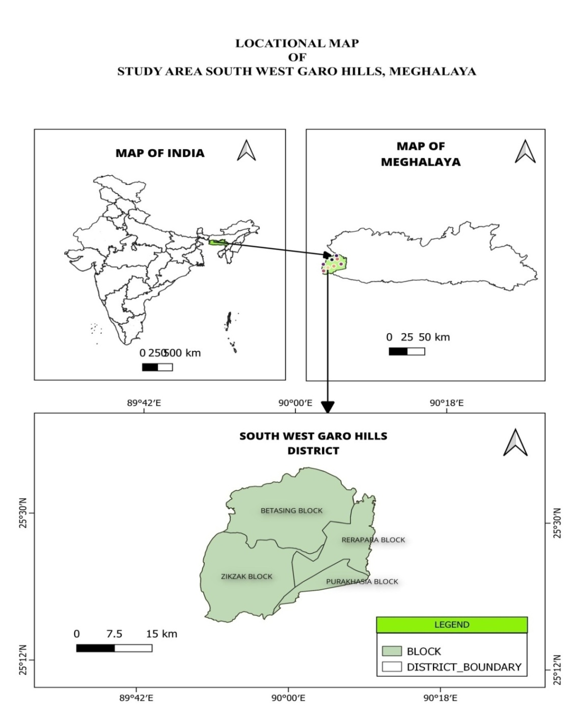
Figure 1: Location of the study area
The climate is warm, humid, and receives about 2000 mm of annual rainfall. Major rivers include the Ganol, Dilni, Rongkhai, Daru, and Muji, forming a dendritic drainage pattern.Vegetation is dominated by Tropical Moist Deciduous Forests, covering about 38% of the area. Settlement patterns are mostly dispersed. Soils are deep, loamy, well-drained, and slightly acidic. Agriculture is the main livelihood, with rice as the major crop. Health facilities include 1 district hospital, 2 CHCs, 9 PHCs, and 27 sub-centres, though accessibility remains a challenge due to terrain and connectivity issues (Figure 1).
4. SOURCES OF DATA
The data for this study were obtained from secondary sources to ensure a comprehensive spatial analysis of the distribution of Primary Health Centres (PHCs) in South West Garo Hills district. The list of Primary Health Centres (PHCs), including names and location was obtained from the official portal of Meghalaya Health Department. The data for the population has been taken from 2011 census. The administrative boundary shapefile including blocks and villages, were sourced from Survey of India and used for creating Nearest Neighbour Analysis and Thiessen Polygon map. Additionally, relevant academic literature, government reports and planning documents were also referred to for context and secondary data support.
4.1 METHODOLOGY
The location of the PHCs will be studied using Nearest Neighbor Analysis Known as RN Statistic. This method helps to understand whether PHCs are close together, random or evenly spread or cluster. If Rn = 0, the PHCs are clustered, If Rn = 1, the PHCs are random., If Rn = 2.15, the PHCs are evenly spaced. To plan the service areas of each PHCs, The Thiessen Polygon Method will be used. This method draws shape around each PHC to show that is nearest to it. It helps to make sure that all areas get proper health services.
5. RESULT AND DISCUSSION
5.1 SPATIAL DISTRIBUTIONPATTERN OF PHC IN SOUTH WEST GARO HILLS DISTRICT
The spatial distribution of Primary Health Centre (PHCs) in the South West Garo Hills shows variation in across different areas. Most of the PHCs are concentrated in the blocks of Zikzak, Betasing and Rerapara ensuring health care access in many parts of the district. However, one area,Purakhasia block appears blank on the map in terms of PHC presence. This is because the only PHC serving the Purakhasia region is administratively part of the West Garo Hills district, even though it geographically lies closer to South West Garo Hills. As per the records of the Meghalaya Health Government, Purakhasia PHC does not fall under the jurisdiction of South West Garo Hills. Primary Health Centre is the only way people from such areas get health facilities but it’s very less and sometimes itlack to meet the needs of the rural people, since the workers and nurses are very less. For such reasons, people have to travel far away for treatment, and sometimes they cannot afford to travel far places and are unable to get the treatment they need. For such reasons, the distribution of Primary Health Centre is important in South West Garo Hills to understand the efficiency of this PHC.
5.2 LOCATION OF PRIMARY HEALTH CENTRE
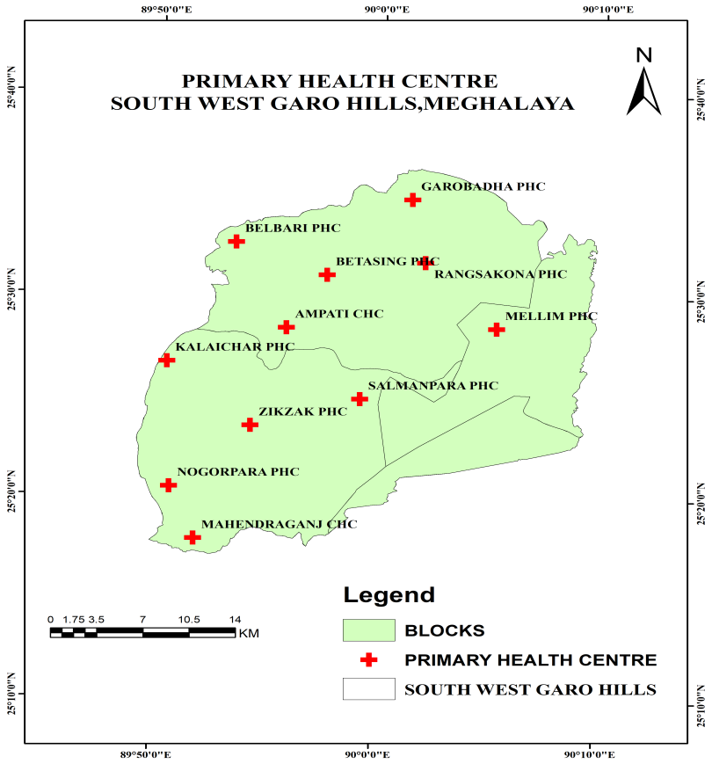
In South West Garo Hills district of Meghalaya, Primary Health Centres (PHCs) play an important role in providing basic health care to the rural population. The South West Garo Hills district is divided into four Community and Rural Development (C&RD) Blocks namely Zikzak block, Betasing block, Rerapara Block and Purakhasia block. Each block has the PHCs distributed in such a way that the health needs of the local people are met efficiently and without much travel. According to Meghalaya Health Department, there are 9 Primary Health Centres (PHCs) in the South West Garo Hills district namely Zikzak, Mellim, Betasing, Salmanpara, Garobadha, Kalaichar, Belbari, Rangsakona and Nogorpara PHC.
Figure 2: Showing the distribution of PHCs across South West Garo Hills district

5.2.1 Betasing Block
Betasing is one of the most populated blocks in district. It has 4 PHCs – Betasing PHC, Garbadha PHC, Rangsakona PHC and Belbari PHC. These PHCs are located strategically to serves the villages in the northern and central parts of the district.These health centres are located in different parts of the block and help reduce the burden on the district hospital like Civil hospital at Ampati. They provide essential services such as outpatient care, maternal and child health services, immunization and health awareness programs.
5.2.2 Zikzak Block
The Zikzak block lies in the southern part of the district having 4PHCs:Zikzak PHC, Kalaichar PHC, Nogorpara PHC, Salmanpara PHC. These health centres are crucial for providing medical services to border areas and remote villages. Due to the rural nature of the block, the role of these PHCs is very important in ensuring timely and accessible healthcare for the people. Services like immunization, basic treatment, delivery services and health checkups are regularly carried out at PHC.
5.2.3 Rerapara Block
Rerapara is located in the eastern region of South West Garo Hills district and has 1PHCs.Mellim PHC. These PHCs are situated in areas with relatively lower road connectivity. They serve tribal village and help in reducing travel time to Ampati Civil Hospital. The PHCs in Rerapara block contribute significantly to improving rural health by offering preventive and curative care to people in need.
5.2.4 Purakhasia block
Purakhasia is one of the newly created blocks in South West Garo Hills, Meghalaya. Earlier this area was under West Garo Hills district and the Purakhasia PHC was officially listed under Dalu Block in government records. However after the formation of Purakhasia C & RD block, it now falls under the administrative boundary of South West Garo Hills district. Currently the Purakhasia PHC continues to be shown under Dalu block by the Meghalaya Health Department. But on ground reality it serves the people of Purakhasia block, as it is the nearest and most accessible primary health facility in the region. Purakhasia block currently does not have a designated PHC under South West Garo Hills district. However, people from this block depends on nearby PHCs or even PHCs in West Garo Hills district like Purakhasia PHC which is geographically located under Dalu block.
5.3 NEAREST NEIGHBOR ANALYSIS
The characteristic features of spatial distribution of health care centres, which is estimated with the Nearest Neighbour Analysis.A Nearest Neighbor Analysis is a descriptive statistic that shows a pattern of locating features by comparing graphically the observed nearest neighbour distance.(Vinothini et al 2025c;2024a) That is, it describes phenomenon based on its distance from another phenomenon in space. The Nearest Neighbor Analysis do not only examine distance points, but it also examines the closest point to it.(Saravanabavan et al 2023a;2021a)The Nearest Neighbor Index (NNI) is a complicated tool to precisely measure the spatial distribution of a pattern and see if it is regularly dispersed, randomly dispersed, or clustered. The Nearest neighbor analysis an effective for quantifying distribution and decreasing distribution pattern of health care centers such as primary health center and sub centers. Which could be located and pointed on maps on a particular scale nearest neighbor statistic.
RN = Dob
Dexp
RN – Nearest Neighbor index of spacing
Dobs - The average of the observed distance between each center and itsnearest neighbor in kms
Dexp –The expected average distance between each center and its nearestneighbor in Kilometers.

Dexp= 1

2 N/A N – Number of Health Centre, A – Area.
The nearest neighbor technique involves the measurement of distance from an individual point to its nearest neighbor irrespective of any diversion (Saravanabavan,1996). A series of such distance measurement are made using all the individual points present on a randomly selected sample and the value of mean distance (Do) to nearest neighbor that would be theoretically expected if the individual of that population were randomly distributed is calculated using the formula.

Dexp.DE = 1

2 N/AT

The result is respected

Nearest neighbour: 0-Cluster, 1-Random, 2.15-Uniform.
Table 1; Nearest Neighbour Analysis
Sl. No.. | Nearest Neighbour | Distance in (CM) | Ditance in (KM)
1 | 1-2 | 02 cm | 3.50
2 | 2-3 | 03 cm | 5.25
3 | 3-4 | 3.2 cm | 5.60
4 | 3-5 | 3.3 cm | 5.78
5 | 5-6 | 3.3 cm | 5.78
6 | 6-7 | 2.1 cm | 3.68
7 | 7-8 | 2.8 cm | 4.90
8 | 7-9 | 2.8 cm | 4.90
9 | 9-10 | 2.2 cm | 3.85
10 | 9-11 | 3.0 cm | 5.25
Source: Compiled by the author
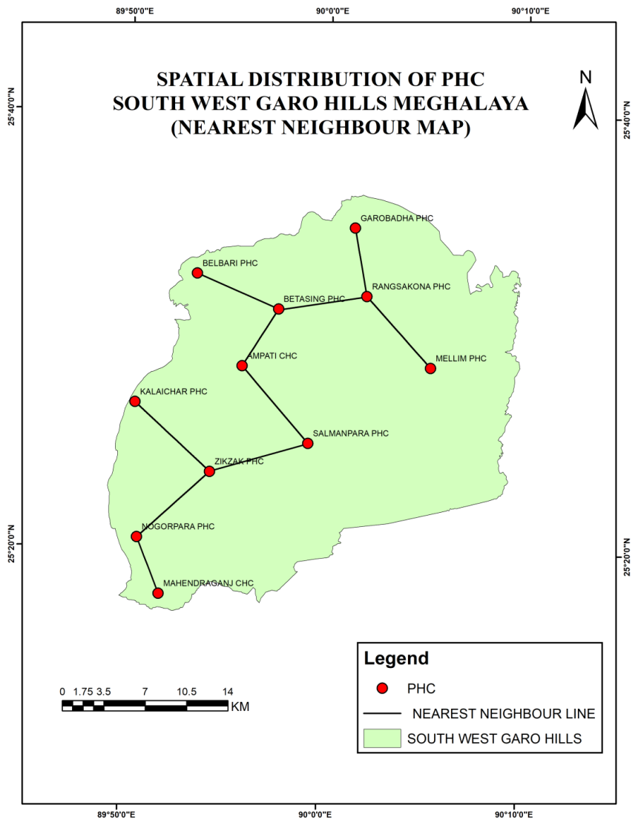
Figure 3: Map of nearest neighbor distribution in the South West Garo Hills district.
Number of PHC (n): 11; Area of study (A):822sq. km; Observed Mean Distance (dₒ): 5.349km; Expected Mean Distance (dₑ): 4.32km; NearestNeighbour Index (RΝ): 1.24

The spatial pattern of distribution of Primary Health Centre in South West Garo Hills district is dispersed (Figure 3).The nearest Neighbour Index ( R = 1.24) indicates that the Primary Health Centres (PHCs) in South West Garo Hills district exhibits a dispersed spatial distribution patern. This suggests that the health services are moderately spaced across the district, helping reduce clustering and ensuring better regional accessibility. However, minor irregularities in spacing may still exist due to physical geography, settlement patterns, or administrative priorities.

5.3.1 SPATIAL PATTERN BASED ON NEAREST NEIGHBOUR ANALYSIS
The Nearest Neighbour Analysis revealed a Nearest Neighbour Index (NNI) of 1.24 which is greater than 1, indicating a dispersed pattern spatial distribution of PHCs across the district. (Vinothini & Saravanabavan,2022;2023). Such a pattern suggests that the PHCs were planned to cover a wider geographical area so that people living in remote areas could also access health care services. The aim seems to be ensuring fair and even distribution instead of crowding services in one region.However, in terms of locational efficiency the distance between some PHCs still varies. In few places, they are closer together, while others they are far apart. This may be because of terrain, population spread or road connectivity.

5.4 SERVICE AREA DELINEATION USING THIESSEN POLYGON METHOD

To complement the findings from NNA, the Thiessen Polygon Method was used to delineate the service zones of each PHC.
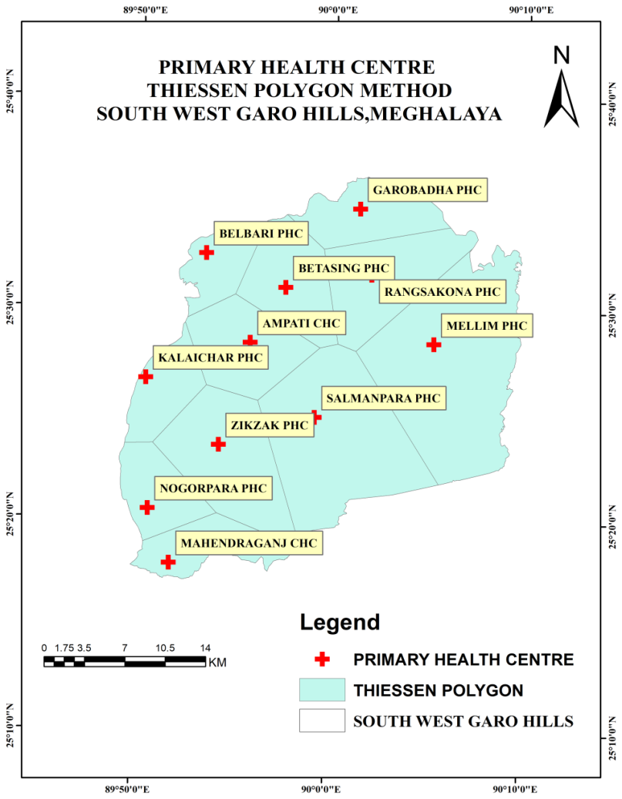
Figure 4: Thiessen Polygon map of South West Garo Hills district

This method assigns a geographical area to each PHC based on proximity, under the assumption that people will visit the nearest available health facility(Balaji & Saravanabavan,2021;2021a).The Thiessen Polygon Method reveals the spatial coverage of each Primary Health Centre (PHCs) within South West Garo Hills (Figure 4). The polygon size directly reflects the geographic area that each PHC serves. A larger polygon size indicates a wider and less accessible services area, while smaller polygons suggest better accessibility and efficient spatial coverage.

5.4.1 Low efficiency Zone

Salmanpara PHC and Mellim PHC occupy the largest polygons in the district. These centre covered broad and potentially scattered rural regions, where population density may be low but the physical distance to access is high. Such wide areas reflect low locational efficiency due to increased travel time and connectivity, especially during emergencies.

5.4.2 Moderate Efficiency Zones

PHCs like Mahendraganj CHC, Nogorpara PHC, Kalaichar PHC and Zikzak PHC show moderate sized polygons reflecting a balance distribution of services. These centres are more centrally placed within their respective catchment areas, suggesting relatively better locational efficiency.

5.4.3 High Efficiency Zones

Ampati CHC, Betasing PHC and Rangsakona PHC are located close to each other and exhibits smaller polygon sizes. This indicates high locational efficiency in these parts, where health services are accessible within shorter distances. Belbari PHC and Garobadha PHC located on the northern side, also cover smaller polygons, implying efficient coverage in the northern fringe.

5.5 OVERALL INTERPRETATION OF LOCATIONAL EFFIECIENCY
The integration of findings from the Nearest Neighbour Analysis and Thiessen Polygon Method provides a comprehensive understanding of PHC locational efficiency in South West Garo Hills:
The NNI value of 1.24 confirms that the PHCs are dispersed, which reflects moderate planning, but lacks strong alignment with population needs or spatial equity.
The Thiessen Polygon analysis reveals disparity in catchment areas, with certain regions being underserved due to wide spatial gaps between health facilities.
Together, these findings suggest that the present distribution of PHCs only partially meets the criteria for spatial efficiency. The network covers the district in a broad sense but fails to ensure uniform access to all population groups, especially those in isolated or geographically challenging areas.

6. CONCLUSION
The study assessed how Primary Health Centres (PHCs) are distributed and how effectively they serve the South West Garo Hills district. Although the PHCs show a dispersed and fairly even distribution pattern, accessibility varies across the region. Central PHCs like Ampati and Zikzak serve smaller, well-connected areas and are more efficient, while PHCs such as Mellim and Salmanpara cover large areas, making access difficult for remote populations. A major issue was found in Purakhasia Block, where outdated boundaries place its PHC under West Garo Hills, leading to administrative confusion and poor service delivery.The study concludes that updating district boundaries, improving connectivity, strengthening PHCs with large coverage areas, clarifying jurisdictional issues, and using GIS for planning can significantly improve health service accessibility. Overall, the research provides a base for further studies on health infrastructure and spatial planning in the district.
Ethical Approval
Ethical approval not required.
Human or Animal Rights
This article does not contain any studies with human participants or animals performed by any of the authors, since only the secondary data collected at various centres are used in the study.
References

- Agbenyo, F., Nunbogu, A. M., & Dongzagla, A. (2017). Accessibility mapping of health facilities in rural Ghana. Journal of Transport & Health, 6, 73-83. https://doi.org/10.1016/j.jth.2017.04.010
- Balaji, D., & Saravanabavan, V. (2021). Geo spatial variation of dengue risk zone in Madurai city using autocorrelation techniques. GeoJournal, 86(3), 1481-1501. https://doi.org/10.1007/s10708-020-10143-1
- Balaji, D., & Saravanabavan, V. (2021a). Geo spatial variation of dengue risk zone in Madurai city using autocorrelation techniques. GeoJournal, 86(3), 1481-1501. https://doi.org/10.1007/s10708-020-10143-1
- Carrillo de Albornoz, S., Sia, K. L., & Harris, A. (2022). The effectiveness of teleconsultations in primary care: systematic review. Family Practice, 39(1), 168-182. https://doi.org/10.1093/fampra/cmab077
- Danyon Dameshwa Jyrwa,V Saravanabavan, LaitpharlangCajee, C Vinothini (2025) Spatial analysis and efficiency of healthcare delivery system in Meghalaya State,India:A Z Score Approach International Journal of Science and Research Archive 15 (01),1312-1324 https://doi.org/10.30574/ijsra.2025.15.1.1148
- Devkota, G., Basnet, P., Thapa, B., &Subedi, M. (2021). Factors affecting utilization of mental health services from Primary Health Care (PHC) facilities of western hilly district of Nepal. PloS one, 16(4), https://doi.org/10.1371/journal.pone.0250694
- Gong, C., & Kang, H. (2023). Resource allocation efficiency of urban medical and health financial expenditure under the background of employees’ health. Risk Management and Healthcare Policy, 1059-1074. https://doi.org/10.2147/RMHP.S412514
- Hong, I., Wilson, B., Gross, T., Conley, J., & Powers, T. (2023). Challenging terrains: socio-spatial analysis of primary health care access disparities in West Virginia. Applied spatial analysis and policy, 16(1), 141-161. https://doi.org/10.1007/s12061-022-09472-0
- Kabir, A., Karim, N., &Billah, B. (2022). Preference and willingness to receive non-communicable disease services from primary healthcare facilities in Bangladesh: A qualitative study. BMC Health Services Research, 22(1), 1473. https://doi.org/10.1186/s12913-022-08886-3
- Kaushal Kumar (2023), Lcation analysis of primary Health Care Centers: A case study of Mohalla clinics in Delhi, SN Operations research forum 4(2) April 2023. https://doi.org/10.1007/s43069-023-00204-9
- Kumar, I. B. (2024). Challenges And Innovations In The Primary Healthcare System Of Bihar: A Comprehensive Review. Library of Progress-Library Science, Information Technology & Computer, 44(4). https://doi.org/10.48165/bapas.2024.44.2.1
- Lori Engiaipi., Saravanabavan, V., & Vinothini, C. (2025). Gender-wise travel pattern and utilization of primary health centers of Karbi Anglong district, Assam. International Journal of Science and Research Archive 14 (03),1320-1330 https://doi.org/10.30574/ijsra.2025.14.3.0779
- Lyngdoh, J. P. (2022). Contribution of Traditional Medicine Toward Primary Health Care in Meghalaya. In Narratives and New Voices from India: Cases of Community Development for Social Change (pp. 203-214). Singapore: Springer Nature Singapore
- Mate, T. N., Saravanabavan, V., & Vinothini, C.(2025) Consumption of Areca Nut and its Socioeconomic and Health Impacts in Shillong, Meghalaya-A Geographical Analysis. International Journal of Research Publication and Reviews 6 (11), 899-909
- Mendoza-Gómez, R., &Ríos-Mercado, R. Z. (2022). Location of primary health care centers for demand coverage of complementary services. Computers & Industrial Engineering, 169, 108237. https://doi.org/10.1016/j.cie.2022.108237
- Radhakrishnan, R., & Vaithialingam, S. (2023). Exploring the Suitability of Groundwater for Domestic Water Quality and Irrigation Purpose in Dindigul District, Tamil Nadu. In Surface and groundwater resources development and management in semi-arid region: strategies and solutions for sustainable water management (pp. 253-277). Cham: Springer International Publishing. https://doi.org/10.1007/978-3-031-29394-8_14
- Ramphila A. Shatsang,V. Saravanabavan, C.Vinothini (2025)Health and Socio – Economic Analysis of Adolescent Drug Abuse in Ukhrul District, Manipur.International Journal of Research Publication and Reviews, Vol6.Issue 10, pp 2479-2488. https://doi.org/10.55248/gengpi.6.1025.3641
- Ryskina, K. L., Shultz, K., Zhou, Y., Lautenbach, G., & Brown, R. T. (2021). Older adults' access to primary care: gender, racial, and ethnic disparities in telemedicine. Journal of the American Geriatrics Society, 69(10), 2732-2740. https://doi.org/10.1111/jgs.17354
- Saravanabavan, V. (1996). Bicycles and health-a geo medical study of Madurai city. In Velo Australis and Velo-City'96, International Bicycle Conference, 1996, Fremantle, Western Australia. http://worldcat.org/isbn/1863080554
- Saravanabavan, V., Nongspung, C., Vinothini, C., & Vadivel, S. (2025). Healthcare Accessibility in East Khasi Hills, Meghalaya, India: Age, Gender, and Socioeconomic Barriers to Primary Health Centre Access. Asian Journal of Geographical Research, 8(3), 488-505.DOI: https://doi.org/10.9734/ajgr/2025/v8i3313
- Saravanabavan, V., Vinothini, C., Suja Rose, R. S., & Balaji, D. (2025a). A Geo-Chemical Study of Water Pollution Due to the Tanning Industry: A Case Study of Dindigul District, Tamilnadu, India. In Groundwater Resource Management Planning Strategies: A Geospatial Approach: Volume 1 (pp. 651-683). Cham: Springer Nature Switzerland. https://doi.org/10.1007/978-3-031-88870-0_25
- Saravanabavan, V., Vinothini, C., Vadivel, S., Sanjeevi Prasad, S., Katturajan, K., & Balaji, D. (2025b). Assessing the performance of primary health centres in Meghalaya: An automatic linear modelling. International Journal of Science and Research Archive, 16(1), 454-465 https://doi.org/10.30574/ijsra.2025.16.1.2010
- Saravanabavan, V., Debbarma, K., & Vinothini, C. (2025c). Primary health care access and socio-economic conditions of the patients in Sepahijala District, Tripura. International Journal of Science and Research Archive, 6(1), 295-305. https://doi.org/10.55248/genger.6.1.189
- Saravanabavan, V., Vinothini, C., &SujaRose, R. S. (2024). Transport accessibility and efficiency of PHC location in Kanyakumari district, Tamil Nadu. International Journal of Science and Research Archive, 11(2), 1342-1351. https://doi.org/10.30574/ijsra.2024.11.2.0605
- Saravanabavan, V., Sangma, N. N., & Vinothini, C. (2024a). Spatial distribution and pattern of location in primary health centers in West Garo Hills District, Meghalaya. International Journal of Research Publication and Reviews, 5(11), 694-701. https://doi.org/https://doi.org/10.55248/gengpi.5.1124.3126
- Saravanabavan, V., Emayavaramban, V., Thangamani, V., Manonmani, I. K., Rose, R. S., Balaji, D., ... & Vinothini, C. (2023). Spatial variation of covid-19 morbidity status and identification of risk zone in Tamil Nadu (India) during first wave. GeoJournal, 88(2), 1341-1354. https://doi.org/10.1007/s10708-022-10680-x
- Saravanabavan, V., Vinothini, C., & Rose, R. S. (2023a). Spatial distribution of primary health care centre and socio economic conditions of patients in Madurai district. International Journal of Geography, Geology and Environment, 5(2), 192-198. https://doi.org/10.22271/27067483.2023.v5.i2b.192
- Saravanabavan, V., Reshma, C. U., & Preethi, S. (2021). Determinants of reproductive health in working women in Thrissur district, Kerala. GeoJournal, 86(1), 239-253. https://doi.org/10.1007/s10708-019-10051-z
- Saravanabavan, V., Balaji, D., Reshma, C. U., Sheheersha, S. K., Sudharsan, R., Vimala Vinnarasi, J., ... & Balasubramani, K. (2021a). Urban disease ecology and its spatial variation of Chikungunya in Madurai City, Tamilnadu, India: a geo-medical study. GeoJournal, 86(5), 2335-2350 https://doi.org/10.1007/s10708-020-10192-6
- Saravanabavan, V., Balaji, D., & Preethi, S. (2019). Identification of dengue risk zone: A geo-medical study on Madurai city. GeoJournal, 84(4), 1073-1087. https://doi.org/10.1007/s10708-018-9909-9
- Saravanabavan, V., Reejo, R. J., Neethidevi, A., & Jayashree, R. (2006). Travel and health care utilization pattern of patients in Vadippati panchayat union: A micro level study using GIS. Journal of Deccan Geographer, 44(2), 97-108.
- Sangma, Y. M., &Jeyaraaj, T. R. (2021). A Comparative Study on the Availability of Public Health Care Infrastructure in Garo Hills Region, Meghalaya. Ilkogretim Online, 20(5). https://doi.org/10.17051/ilkonline.2021.05.409
- Shaltynov, A., Rocha, J., Jamedinova, U., &Myssayev, A. (2022). Assessment of primary healthcare accessibility and inequality in north-eastern Kazakhstan. Geospatial Health, 17(1). https://doi.org/10.4081/gh.2022.1046
- Sheheersha.S.K., V.Saravanabavan (2021). Geo-Medical Analysis of Telemedicine Based Mobile Tele-Ophthalmology Screening For Cataract Cases in Thiruvananthapuram District, Kerala, India. IOSR Journal of Humanities and Social Science (IOSR-JHSS) Volume 26, Issue 10, Series 7 (October. 2021) 01-07 https://doi.org/10.9790/0837-2610070107
- Vinothini, C., & Saravanabavan, V. (2023). Determinants of health care facilities and patients’ accessibility to PHC in Madurai district. International Journal of Geography, Geology, and Environment, 5(2), 17-22. https://www.geojournal.net/upload/2023/july-aug/IJGGE%202023;%205(2):%2017-22.pdf
- Vinothini, C., & Saravanabavan, V. (2022). Spatial Distribution of Emerging Diseases in Madurai District: A Geo Medical Study. International Journal of Innovative Science and Research Technology, 7(6), 2456-2165. https://doi.org/10.5281/zenodo.6914305
- Vinothini, C., Saravanabavan, V., & Suja Rose, R. S. (2025). Travel Behaviour of Child Patients and Health Care Accessibility of PHC in Madurai District,Tamilnadu. International Research Journal of Education and Technology, 7(02). https://www.irjweb.com/articles/TRAVEL-BEHAVIOUR-OF-CHILD-PATIENTS-AND-HEALTH-CARE-ACCESSIBILITY-OF-PHC-IN-MADURAI-DISTRICT-TAMILNADU
- Vinothini, C., R S Suja Rose, & Saravanabavan, V.(2025a) Non-Communicable Diseases and Socio-Economic Disparities: A Case Study of Madurai District. International Research Journal of Education and Technology 8 (9), 50-63 https://www.researchgate.net/publication/373970347_Non-Communicable_Diseases_and_Socio-Economic_Disparities_A_Case_Study_of_Madurai_District
- Vinothini C , Suja Rose R.S , Saravanabavan V (2025b )Disease Prevalence and Socio-Demographic Influences on Healthcare Access in Madurai District, Tamil NaduGoya Journal 18 (10), 227 – 241. https://doi.org/12.163022.Gj.2025.v18.10.017
- Vinothini, C., Rose, R. S., Vadivel, S., & Saravanabavan, V. (2025c). Determinants of primary healthcare centers utilization: A geo-statistical study of healthcare access in Madurai district, Tamil Nadu. International Journal of Science and Research Archive, 2025, 15(02), 1557–1567 https://doi.org/10.30574/ijsra.2025.15.2.1544
- Vinothini, C., Suja Rose, R. S., & Saravanabavan, V. (2024). Assessment of primary health care accessibility and patients’ perception in Madurai district: a geo-medical study. Geo Journal, 89(5), 211. https://doi.org/10.1007/s10708-024-11208-1
- Vinothini, C., Saravanabavan, V., & Rose, R. S. (2024a). Travel patterns of adult patients to primary health centers in Madurai district: A public health perspective. International Journal of Science and Research Archive, 13(1), 141-149. https://doi.org/10.30574/ijsra.2024.13.1.1605
- Vinothini, C., Saravanabavan, V., &Emayavaramban, V. (2022). Location Accessibility of PHC and Health care travel performance in Madurai District. International Journal of Innovative Science and Research Technology, 7(12), 2456-2165 https://doi.org/10.5281/zenodo.7493591
- Yanhua Gong, Dong Ma , Wen Feng (2023), Study on the allocation efficiency of medical and health resources in Hainan Province: Based on the super-efficiency SBM— Malmquist model, School of Management, Hainan Medical University, Haikou City, Hainan Province, China , April 11 2023. https://doi.org/10.1371/journal.pone.0294774

