Spatial analysis of the spread of peacock eye disease in the governorates of Lattakia and Idlib and its relation to relative humidity

Abstract
Climate change is considered to be one of the most important environmental challenges, which has direct and indirect effects on ecosystems, agriculture, and health systems worldwide. Among the noticeable consequences of these climate changes is the increased spread of plant diseases, which are highly linked to current climatic conditions. One of these diseases is peacock eye spot, that affects olive trees, impacting their productivity and health. This research aims to study the relationship between changes in relative humidity and the spread of peacock eye spot disease from 2009 to 2012 in the Latakia and Idlib governorates. To achieve this, time series analysis of average relative humidity for the period 1980–2012 was used to determine the prevailing climate change patterns during this period and to ascertain whether there was a significant increase in humidity levels that could be linked to the increased spread of the disease. ArcGIS 10.2.2 was used to process the spatial data and produce illustrative maps revealing the spatial distribution of the disease and showing variations in its severity across the studied areas. The study results showed a clear positive correlation between high relative humidity and increased severity of peacock eye spot disease. Areas with higher humidity recorded higher infection rates compared to areas with lower humidity.

Keywords: General trend line, relative humidity, severity of disease spread, peacock eye.

Introduction
One of the most significant challenges the world facing nowadays is the climate change, due to the far-reaching environmental, economics, and social impacts (Iqbal & Ghauri, 2011). This change appears basically in rising global temperatures, which is the most influential climatic element affecting all other climate components (Karl & Trenberth, 2003). The agriculture field is considered to be one of the most affected fields by these changes, as a result of its direct dependence on climatic conditions, and its rapid response to any distribution (Anwar et al., 2013).
These changes are not limited to a specific geographical area but are sweeping across the globe, causing significant changes in crop productivity, plant species distribution, and the spread of agricultural pests and diseases (Prakash et al., 2014). Climate change is related to various causes, some are naturally occurring, and others result from human activities, especially the increased emission of greenhouse gases, which has disrupted the balance of the Earth's climate system (Trenberth, 2018).
Relative humidity is one of the most important measures used to express the water vapour content in the atmosphere, that shows how much the air is close to the saturation state (Pierrehumbert et al., 2007). Relative humidity is defined as the ratio between the actual amount of water vapour in the air at a given temperature, and the maximum amount that the air can hold at the same temperature (Dyer, 2012). Thus, the increases in the relative humidity indicates that the air is near to the saturation, while low humidity indicates relative dryness in the atmosphere (Pierrehumbert et al., 2007).
It was noted that there is a noticeable relationship between temperature and relative humidity, however, the nature of this relation is varies based on the climatic and geographical characteristics of each region (Kousari et al., 2011). In the costal areas such as Latakia, summer is considered to be the highest humid season, due to increased evaporation of seawater as a result of high temperatures, which leads to the air be loaded with larger amount of water vapour. In winter, relative humidity decreases due to the lower temperatures and the air masses (Pan et al., 2019).
In contrast, interior areas, such as Idlib, show different behavior, where the relative humidity decreases in summer because of the high temperatures that comes along with intense evaporation what makes the air very dry. Conversely, relative humidity increases in winter with the rainfall and lower temperatures, increasing the water vapour contents in the air and brings it near to saturation (Naaouf, 2023).
The impact of climate change clearly affects the plant field, contributing to the creation of conditions to spread the fungal disease, which are usually related to specific climatic elements, such as temperature and relative humidity (Misra et al., 2020). Peacock eye spot stands out as one of fungal disease, that affects olive tree and are one of the most significant and widespread disease globally (Kheddam-Benadjal et al., 2022). This disease has been recorded in many areas, including the United States, Europe, and the Middle East, particularly in the Mediterranean region which is a major olive-growing area.
Olive trees in Syria hold an important agriculture and economic position, with an estimating of 105 million trees distributed across a wide range of different environments that characterized by the mediterranean climate. These areas are distinguished with climatic conditions that may increase the probability of peacock eye spot disease, especially in areas with high humidity and fluctuating temperatures throughout the seasons (Graniti, 1993; Ozturk et al., 2021).
The disease characteristic symptoms appear as dark, circular spots on olive leaves, which give them the appearance as peacock eye, hence the name came (Kareem, 2024). As the infection worsen, the affected leaves experience heavy leaf drop during spring and early autumn, leading to decrease the photosynthesis, weaken the growth of young shoots, and eventually death of the small branches and generally decline the vitality of the tree (Buonaurio et al., 2023). These effects are negatively impact olive productivity and the resulting oil quality, as a result to the repeated seasonal infection and the tree’s inability to fully recover between seasons, the crop gradually deteriorates (Ben-Ari et al., 2021).
Peacock eye disease had been recorded in olive trees in Syria for the first time in 1974, according to the 1984 Agriculture Bulletin issued by the Ministry of Agriculture and Agrarian Reform (Khafteh, 2014). It was observed a wide fungal infection, causing significant damage to olive trees in different areas of Latakia governorate (Markakis et al., 2021). For example, in Ain al-Bayda and Mashqita regions, the disease reached epidemic level due to availability of suitable environmental conditions for fungal growth and spread, basically presented by relatively high humidity and the frequent rainfall during the growing seasons (Romero et al., 2022). The disease continued to appear frequently over the following decades, and gradually expanded its spread covering new areas of the Syrian coast, reaching Idlib governorate and the nearby inland regions. A significant increase in the severity and the frequency of the infection has been noticed over the last years (Buonaurio et al., 2023; Hamzaoui et al., 2025). This is related to the fluctuating climatic conditions and changing humidity and temperature patterns, which are factors directly contribute the activity of the fungal causing the disease and multiplication of its spores on the leaves (Issa et al., 2019).
The continuous spread and increasing severity of the disease in Syrian regions in the recent years is a clear indicator of the impact of the local and changing weather conditions, especially the changes in relative humidity and temperature levels (Issa et al., 2019). This makes studying the relationship between climatic changes and spread the peacock eye disease a scientific necessity to understand the disease’s dynamics and developing effective management strategies in order to mimic its impact to the olive sector, which represents one of the important agriculture and economic resources in Syria (Ygzao et al., 2025).

The importance and objectives of the research
The agricultural sector is one of the human activities most affected by climate change. Among these crops, we specifically mention olive cultivation in the Eastern Mediterranean Basin due to its economic significance. Therefore, studying the impact of changes in relative humidity on the olive tree is one of the important issues raised due to its significant impact on the economic lives of the population in the study area and the spread of peacock eye disease.
This research aims to:
1. Analyse the general trend of annual relative humidity rates at selected stations in the governorates of Latakia and Idlib during the period 1970-2010, and determine the extent of changes in these average rates.
2. Cartographically represent the distribution of disease prevalence and relative humidity changes during the period 2009-2012.

Research Methods and Materials
The research relied on a climate database obtained from the General Directorate of Meteorology in Damascus for average relative humidity during the period 1980-2012 for thirteen stations, namely: Latakia, Salanfah, Al-Haffah, Kasab, Al-Qardahah, Qastal Maaf, Al-Sin, Hmeimim, Idlib, Maaret Al-Numan, Jisr Al-Shughur, Harem, Ariha, as Figure (1) shows the location of the study area in Syria and the geographical distribution of the studied stations.
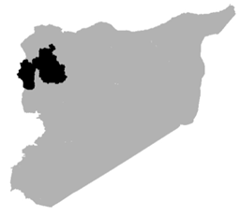
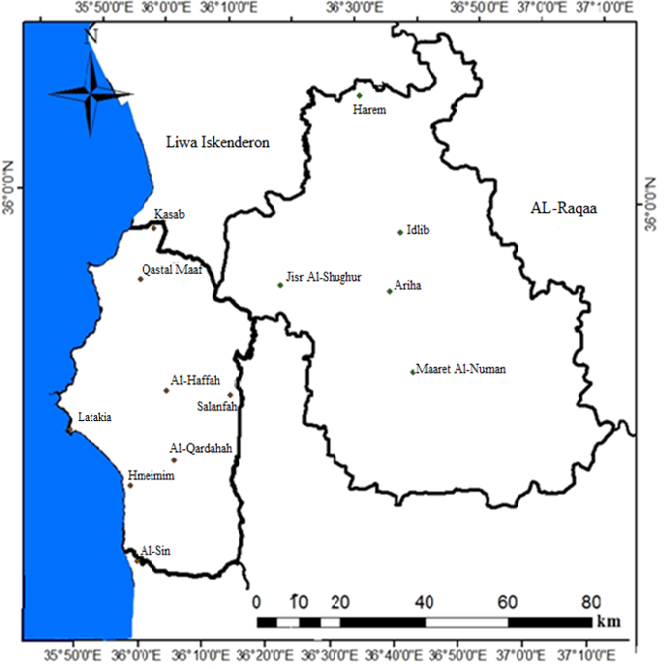
Figure 1: Map of the geographical distribution of stations used in the research
Table (1) shows all the data related to these stations, including coordinates, altitude above sea level, and station type:
Table 1: the observation network used in the research, its astronomical location, and the type of station for the period 1980-2012
No. | Station Name | Latitude (°) | Longitude (°) | Elevation (m) | Station Type
1 | Al-Qardaha | 36.05 | 35.45 | 300 | Synoptic
2 | Latakia | 35.78 | 35.52 | 7 | Synoptic
3 | Basel Airport | 35.94 | 35.41 | 48 | Synoptic
4 | Al-Haffa | 36.05 | 35.61 | 335 | Climatic
5 | Salanfa (Slinfah) | 36.19 | 35.57 | 1173 | Climatic
6 | Qastal Maaf | 35.94 | 35.83 | 675 | Climatic
7 | Kassab | 35.98 | 35.91 | 730 | Climatic
8 | Al-Sin | 35.15 | 35.58 | 8 | Climatic
9 | Wadi Qandil | 35.88 | 35.71 | 150 | Rainfall
10 | Bdama | 35.48 | 36.13 | 490 | Rainfall
11 | Idlib | 35.56 | 36.36 | 451 | Synoptic
12 | Harem | 36.12 | 36.30 | 125 | Climatic
13 | Jisr Al-Shughur | 35.48 | 36.19 | 195 | Climatic
14 | Ma'arrat Al-Nu'man | 35.64 | 36.67 | 182 | Climatic
15 | Ariha | 35.49 | 36.36 | 350 | Climatic

The simple linear regression equation was used to determine the general trend of change in precipitation amount over the given time series, and to determine how far the annual rainfall deviates or approaches the straight trend line (Kaewmesr & Varnakovida, 2018). The equation is of the form:
Where:
Y: Estimated value of precipitation amount
a: Indicates the extent to which the phenomenon under study changes over time.
b: Value of y at X time.
The statistical processing of the data was carried out using Excel 2010, as well as drawing curves and graphs, while the spatial data was processed by ArcMap 10.2.2, through which the required cartographic outputs were obtained.
Results and discussion
Based on the definition of relative humidity, which clarifies the close relationship between temperature and the percentage of water vapor in the air, it was concluded that the relationship between them differs from one area to another in the study area. The relationship is inverse in areas far from marine influences, and direct in coastal areas. In order to clarify this, the monthly average of relative humidity in the study stations was studied, which is shown in Table 2:
Table 2: Monthly average relative humidity (in %) at the study stations for the period (1980-2012):
Station | Jan | Feb | Mar | Apr | May | Jun | Jul | Aug | Sep | Oct | Nov | Dec
Latakia | 63.7 | 62.9 | 64.8 | 67.0 | 70.3 | 72.2 | 74.6 | 72.6 | 67.2 | 62.4 | 59.4 | 62.7
Al-Haffa | 62.2 | 61.5 | 63.4 | 65.5 | 68.7 | 70.6 | 72.9 | 71.0 | 65.7 | 61.0 | 58.1 | 61.2
Hmeimim | 63.7 | 62.9 | 64.8 | 67.0 | 70.3 | 72.2 | 74.6 | 72.6 | 67.2 | 62.4 | 59.4 | 62.7
Slinfah | 63.3 | 62.5 | 64.4 | 66.6 | 69.9 | 71.8 | 74.1 | 72.2 | 66.8 | 62.0 | 59.1 | 62.3
Al-Sin | 64.1 | 63.4 | 65.3 | 67.5 | 70.9 | 72.7 | 75.2 | 73.2 | 67.7 | 62.9 | 59.9 | 63.1
Kassab | 65.0 | 64.2 | 66.2 | 68.4 | 71.8 | 73.7 | 76.2 | 74.2 | 68.6 | 63.7 | 60.7 | 64.0
Qastal Maaf | 63.5 | 62.7 | 64.6 | 66.8 | 70.1 | 72.0 | 74.4 | 72.4 | 67.0 | 62.2 | 59.3 | 62.5
Al-Qardaha | 59.9 | 59.2 | 61.0 | 63.1 | 66.2 | 68.0 | 70.2 | 68.4 | 63.3 | 58.7 | 56.0 | 59.0
Idlib | 78.8 | 73.3 | 66.5 | 60.7 | 54.2 | 50.7 | 53.4 | 55.3 | 53.5 | 57.0 | 68.3 | 78.9
Ma’arrat al-Nu’man | 78.2 | 72.7 | 65.9 | 60.2 | 53.7 | 50.2 | 53.0 | 54.9 | 53.1 | 56.6 | 67.7 | 78.3
Ariha | 75.1 | 69.9 | 63.4 | 57.9 | 51.7 | 48.3 | 50.9 | 52.7 | 51.0 | 54.4 | 65.1 | 75.2
Harem | 83.8 | 78.0 | 70.7 | 64.6 | 57.6 | 53.9 | 56.8 | 58.8 | 56.9 | 60.7 | 72.7 | 83.9
Jisr al-Shughur | 77.4 | 72.0 | 65.3 | 59.6 | 53.2 | 49.8 | 52.5 | 54.3 | 52.6 | 56.0 | 67.1 | 77.5

Analysis of results
Annual relative humidity data were analyzed to determine the nature of the general trend in annual relative humidity averages at the study stations for the period (1980-2012). To obtain accurate results, a linear trend was used and measured. Any genuine general trend in relative humidity must appear at more than one meteorological station; otherwise, it would be due to chance or specific local conditions. Therefore, the appearance of the general trend at the study stations is evidence of the validity of that trend (WMO., 2011).
General Linear Trend of Precipitation Amounts at Study Stations:
Relative humidity data from meteorological stations for the period 1980-2012 were analyzed. The general trend line shows an upward trend at all stations, ranging from 0.1% at Hmeimim station to 1.11% at Maaret al-Numan station, and a decreasing trend at Al-Azhari, Qastal Maaf, and Al-Haffah stations, as shown in Table (3):
Table 3: the change in the general trend values ​​of relative humidity at the study stations for the period (1980 - 2012):
Station | Trend Value (%) | Station | Trend Value (%)
Al-Azhari | -0.22 | Qastal Maaf | -0.027
Al-Qardaha | 0.24 | Idlib | 1.05
Al-Haffa | -0.14 | Harem | 0.93
Slinfah (Salanfa) | 0.49 | Jisr al-Shughur | 0.86
Hmeimim | 0.10 | Ma’arrat al-Nu’man | 1.11
Al-Sin | 0.19 | Ariha | 0.80
Kassab | 0.21 | — | —
This change in the overall trend line is shown in Figures (2, 3, 4, 5, 6, 7, 8):
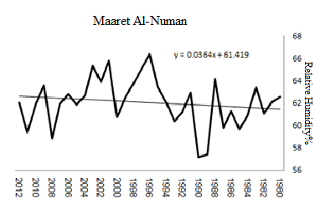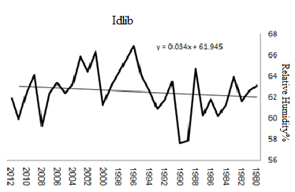
Figure 2: The general trend of annual relative humidity and its deviation from its general average at the stations of (Idlib, Maaret al-Numan)
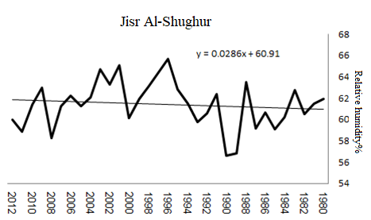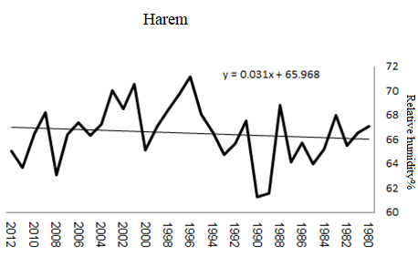
Figure 3: The general trend of annual relative humidity and its deviation from its general average at the stations of (Jisr al-Shughur, Harem)
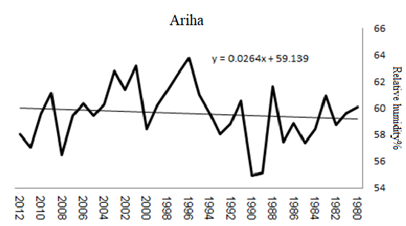
Figure 4: The general trend of annual relative humidity and its deviation from its general average at the Ariha station
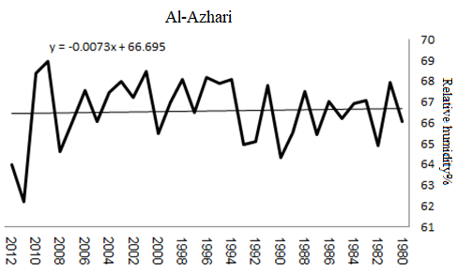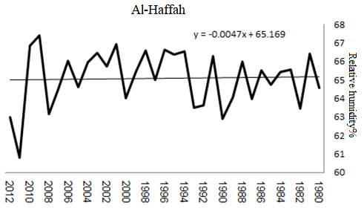
Figure 5: The general trend of annual relative humidity and its deviation from its general average at the stations (Al-Haffa, Al-Azhari)
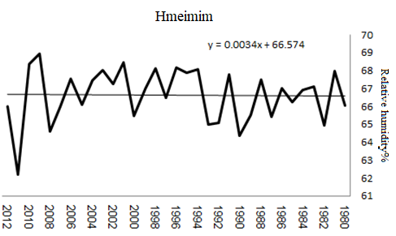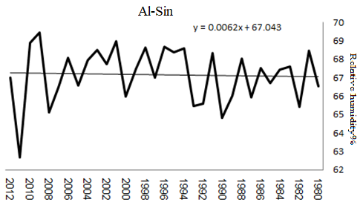
Figure 6: General trend of annual relative humidity and its deviation from the general average at (Al-Sin, Hmeimim) stations
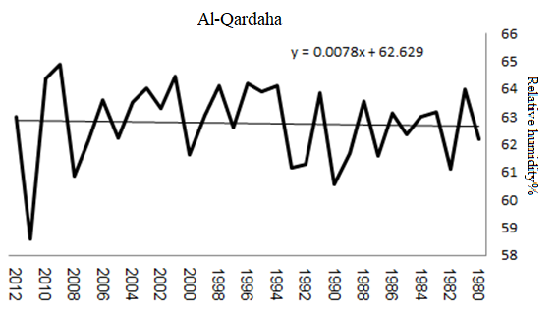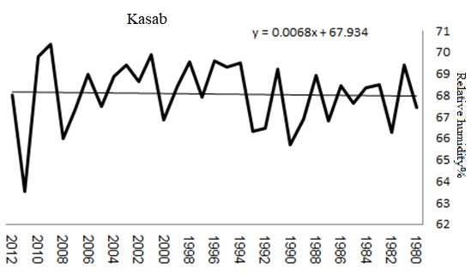
Figure 7: General trend of annual relative humidity and its deviation from the general average at (Kasab, Al-Qardaha) stations
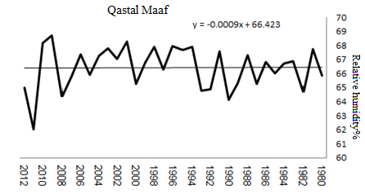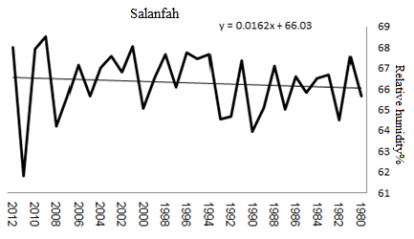
Figure 8: General trend of annual relative humidity and its deviation from the general average at the (Qastal Maaf and Salanfah) stations.

Spatial Analysis of Relative Humidity Variations and Peacock Eye Disease Intensity at the Study Stations:

The Inverse Distance Weight (IDW) method is a mathematical algorithm used to predict the values of new cells when creating continuous surfaces for the geographical distribution of different topics or geographical features (Burrough et al., 2015).This algorithm is based on predicting the value of the cell using the 12 nearest points of known value (represented by the values of the stations in Latakia), was used to generate a distribution map and perform spatial analysis of the average annual relative humidity and peacock eye disease intensity using ArcGIS 10.2.2 (Abdulrahman & Radman, 2020). The intensity of peacock eye disease in the study area was calculated by assessing disease severity on leaves monthly using a five-point scale (Kechamadze, 1972). which is:
- No visible spots on the leaves.
- One spot on the leaf.
- Three to five diseased spots on the leaf.
- Six to ten diseased spots on the leaf.
- More than eleven spots on the leaf surface.
The severity of the disease was calculated using the equation (van Jaarsveld & Knox-Davies, 1974):
∑ds% = abx100/nk
Where:
ds%: disease severity
a: degree of infection according to the standardisation scale
b: number of leaves infected at this degree per tree
n: number of leaves examined, which is 100 leaves
k: maximum value of the standardisation scale, which is 5.

Studying the effect of the region's climatic factors (temperature - humidity) on olive tree disease. on the infection of olive trees with the disease, by calculating the average disease severity in the spring during the month’s most favourable for the spread of the disease and its relationship to the average temperatures and humidity (López Doncel et al., 2000) in each study region, and the results were as shown in Table 4:

Table 4: The severity of peacock eye disease in the study areas
Location (Station) | 2009 | 2010 | 2011 | 2012
Latakia | 26.8 | 40.8 | 38.6 | 42.0
Mashqita | 40.4 | 40.4 | 42.8 | 43.6
Al-Rowaymieh | 33.0 | 37.4 | 34.4 | 34.0
Idlib | 24.6 | 29.2 | 30.3 | 28.6
Darkoush | 30.6 | 30.4 | 30.8 | 31.2
Al-Janoudiyah | 28.2 | 29.4 | 29.8 | 30.6
Source: Researcher's work based on data from the Olive Research Centre in Idlib

Through the analysis and processing of relative humidity data in the ArcGIS program, it was found that there is a clear correlation between relative humidity and the severity of disease spread, as a direct correlation was found between the high percentage of relative humidity and the severity of the disease.
It was found that the relative humidity in the study areas reaches its highest limits in the Latakia Governorate, and that the severity of infection also reaches its highest values ​​in the Latakia Governorate, as shown in Figure 8:
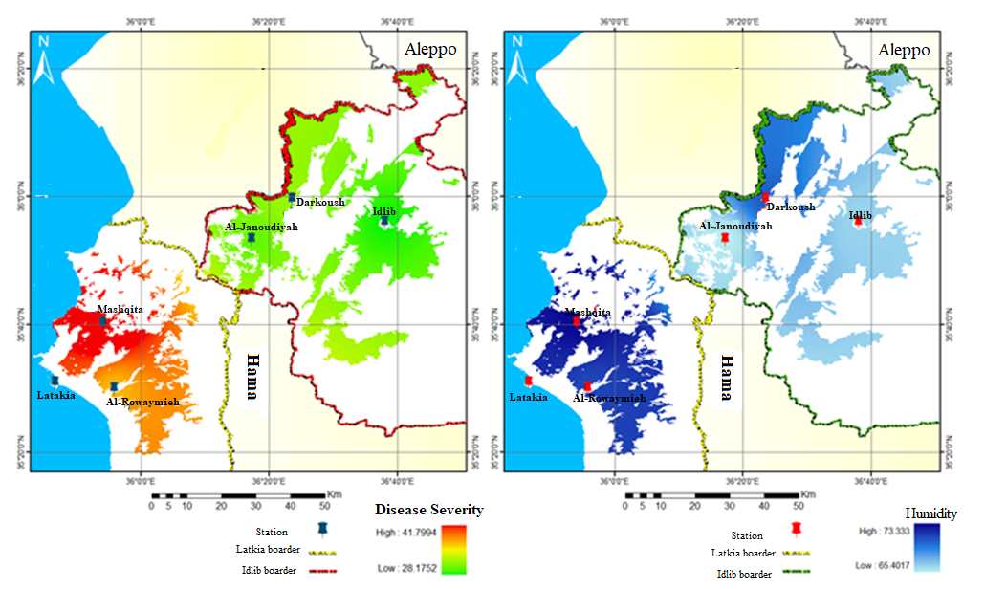
Figure 8: The distribution of humidity and disease severity in the governorates of Idlib and Latakia.

The most humid areas in Latakia Governorate were in the Mashqita region, despite its distance from the sea. This is due to the presence of the Blouran Dam in the area, which directly affected its elevation and thus contributed significantly to the spread of the disease, as shown in Figure 9,
There is a correlation in the results, as the most humid areas are associated with greater disease severity.
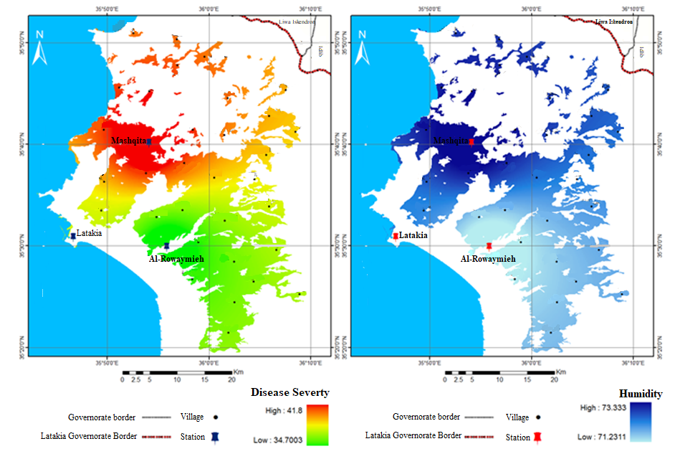
Figure 9: The distribution of humidity and disease severity in Latakia Governorate

The relative humidity in Idlib Governorate reached its highest limits in the northwestern regions of the governorate, specifically in the Darkoush area. This is due to the passage of the Orontes River through it and its effect on spreading humidity, as shown in Figure 10:
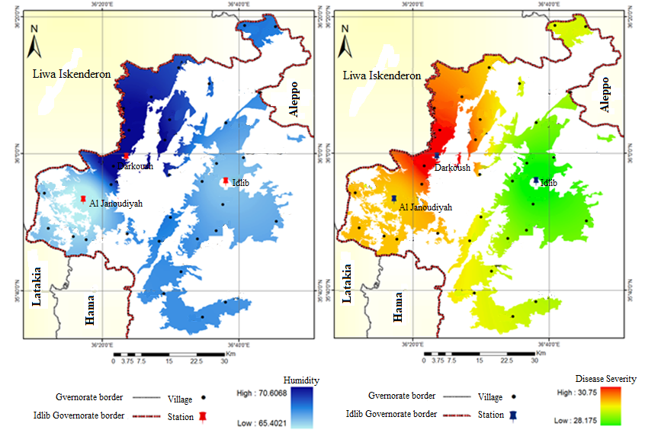
Figure 10: The distribution of humidity and disease severity in Idlib Governorate.

Conclusions and Recommendations:

Conclusions:
The most important conclusions reached by the research are summarised below:
- The general trend in humidity showed an increase at all studied stations except for Al-Azhari, Qastal Maaf, and Al-Haffa.
- The disease and its damage to olive trees are increasing year after year in both coastal and inland areas, as studies have shown.
- The severity of the disease increases proportionally with increasing humidity, particularly on the slopes of humid valleys in the studied areas.

Recommendations:
- Pay attention to the impact of relative humidity variations and attempt to predict their future trends.
- Establish additional meteorological monitoring stations in the study areas, ensure accuracy when recording data, and facilitate access to meteorological data from relevant institutions, given its relevance to the development, spread, and damage of the disease.

- Establish research centres to identify and study diseases affecting olive trees in all olive-growing governorates, and digitally archive disease data for easy retrieval and future analysis.
- Give high priority to combating peacock eye spot disease, given the significant importance of olives to farmers' livelihoods and the national economy, as olives are a strategic crop.
- Study the status of olive trees in areas where the disease has become widespread to prioritise disease control or focus on alternative crops.

References

- Abdulrahman, I., & Radman, G. (2020). Power system spatial analysis and visualization using geographic information system (GIS). Spatial Information Research, 28(1), 101-112. https://doi.org/10.1007/s41324-019-00276-y
- Anwar, M. R., Liu, D. L., Macadam, I., & Kelly, G. (2013). Adapting agriculture to climate change: a review. Theoretical and applied climatology, 113(1), 225-245. https://doi.org/10.1007/s00704-012-0780-1
- Ben-Ari, G., Biton, I., Many, Y., Namdar, D., & Samach, A. (2021). Elevated temperatures negatively affect olive productive cycle and oil quality. Agronomy, 11(8), 1492. https://doi.org/10.3390/agronomy11081492
- Buonaurio, R., Almadi, L., Famiani, F., Moretti, C., Agosteo, G. E., & Schena, L. (2023). Olive leaf spot caused by Venturia oleaginea: An updated review. Frontiers in Plant Science, 13, 1061136. https://doi.org/10.3389/fpls.2022.1061136
- Burrough, P. A., McDonnell, R. A., & Lloyd, C. D. (2015). Principles of geographical information systems. Oxford university press.
- Dyer, I. (2012). Measurement of humidity. Anaesthesia & Intensive Care Medicine, 13(3), 121-123. https://doi.org/10.1016/j.mpaic.2011.12.011
- Graniti, A. (1993). Olive scab: A review 1. Eppo Bulletin, 23(3), 377-384. https://doi.org/10.1111/j.1365-2338.1993.tb01339.x
- Hamzaoui, H., Maafa, I., Choukri, H., Bakkali, A. E., Houssaini, S. E. I. E., Razouk, R., ... & Habbadi, K. (2025). Assessment of Peacock Spot Disease (Fusicladium oleagineum) in Olive Orchards Through Agronomic Approaches and UAV-Based Multispectral Imaging. Horticulturae, 11(1), 46. https://doi.org/10.3390/horticulturae11010046
- Iqbal, B. A., & Ghauri, F. N. (2011). Climate change: the biggest challenge in 21st century. Mediterranean Journal of Social Sciences, 2(6), 41-41.
- Issa, T., Almadi, L., Jarrar, S., Tucci, M., Buonaurio, R., & Famiani, F. (2019). Factors affecting Venturia oleaginea infections on olive and effects of the disease on floral biology. Phytopathologia Mediterranea, 58(2), 221-230. https://doi.org/10.14601/phytopathol_mediter-10610
- Kaewmesr, P., & Varnakovida, P. (2018). Rainfall trend by linear regression analysis over Indochina Peninsula during 1981-2017 (37 Years). GEOMATE Journal, 15(52), 206-213. https://doi.org/10.21660/2018.52.66452
- Kareem, M. R. (2024). Image analysis and detection of olive leaf diseases using recurrent neural networks. Al-Mustansiriyah Journal of Science, 35(1), 60-65. https://doi.org/10.23851/mjs.v35i1.1416
- Karl, T. R., & Trenberth, K. E. (2003). Modern global climate change. science, 302(5651), 1719-1723. https://doi.org/10.1126/science.1090228
- Kechamadze, L. A. (1972). Nekotorie bolezni masleni I borba c nimi. Cubtropicheskie kulturi, 2, 119-123.
- Khafteh, A. (2014). Prevalence of olive peacock's eye spot (Spilocaea oleagina) and evaluation of its damages in different climatological regions of Syria.
- KHEDDAM-BENADJAL, N., BENZAHRA, A., KHEDDAM, M., & BOUZNAD, Z. (2022). Evaluation of the incidence and severity of peacock eye caused by Fusicladium oleagineum in different olive cultivars in Algeria. https://doi.org/10.21203/rs.3.rs-1715783/v1
- Kousari, M. R., Ekhtesasi, M. R., Tazeh, M., Saremi Naeini, M. A., & Asadi Zarch, M. A. (2011). An investigation of the Iranian climatic changes by considering the precipitation, temperature, and relative humidity parameters. Theoretical and Applied Climatology, 103(3), 321-335. https://doi.org/10.1007/s00704-010-0304-9
- López Doncel, L. M., Trapero Casas, A., & Viruega Puente, J. R. (2000). Respuesta del olivo a la inoculación con" Spilocaea oleagina", agente del repilo.
- Markakis, E. A., Roditakis, E. N., Kalantzakis, G. S., Chatzaki, A., Soultatos, S. K., Stavrakaki, M., ... & Goumas, D. E. (2021). Characterization of fungi associated with olive fruit rot and olive oil degradation in Crete, southern Greece. Plant disease, 105(11), 3623-3635. https://doi.org/10.1094/PDIS-10-20-2227-RE
- Misra, A. K., Yadav, S. B., Mishra, S. K., & Tripathi, M. K. (2020). Impact of meteorological variables and climate change on plant diseases. In Plant Pathogens (pp. 313-327). Apple Academic Press. https://doi.org/10.1201/9780429057212-18
- Naaouf, N. (2023). Potential for large-scale solar energy investment in Syria in relation to land use and climate change. https://doi.org/10.15476/elte.2023.053
- Ozturk, M., Altay, V., Gönenç, T. M., Unal, B. T., Efe, R., Akçiçek, E., & Bukhari, A. (2021). An overview of olive cultivation in Turkey: Botanical features, eco-physiology and phytochemical aspects. Agronomy, 11(2), 295. https://doi.org/10.3390/agronomy11020295
- Pan, Z., Meng, Q., Li, Q., Xie, J., & Liu, J. (2019). Evaporative cooling of porous tiles with seawater in a tropical climate with salty humid air. Construction and Building Materials, 204, 727-739. https://doi.org/10.1016/j.conbuildmat.2019.01.031
- Pierrehumbert, R. T., Brogniez, H., & Roca, R. (2007). On the relative humidity of the atmosphere. The global circulation of the atmosphere, 143, 185.
- Prakash, A., Rao, J., Mukherjee, A. K., Berliner, J., Pokhare, S. S., Adak, T., ... & Shashank, P. R. (2014). Climate change: impact on crop pests (pp. 2-19). Odisha: Applied Zoologists Research Association (AZRA), Central Rice Research Institute.
- Romero, F., Cazzato, S., Walder, F., Vogelgsang, S., Bender, S. F., & van der Heijden, M. G. (2022). Humidity and high temperature are important for predicting fungal disease outbreaks worldwide. New Phytologist, 234(5), 1553-1556.
- Trenberth, K. E. (2018). Climate change caused by human activities is happening and it already has major consequences. Journal of energy & natural resources law, 36(4), 463-481. https://doi.org/10.1080/02646811.2018.1450895
- van Jaarsveld, AB and Knox-Davies, P. S. (1974). Resistance of lupins to Phomopsis leptostromiformis. Phytophylactica, 6(1), 55-60. https://hdl.handle.net/10520/AJA03701263_363
- WMO. (2011). Guide to climatological practices (No. 100). World Meteorological Organization.
- Ygzao, D., Shtienberg, D., & Ezra, D. (2025). Optimizing Fungicide Application Timing to Control Olive Peacock Eye Disease: Impact on Current and Succeeding Growing Seasons. Plant Disease, (ja). https://doi.org/10.1094/PDIS-12-24-2654-RE

