Original Research Article
Application Natural Preservative Use Propolis: Effect on Reduction Sugar, Antioxidant and Physical of Milk Jelly Candy

.
ABSTRACT

Aims: To determine the effect of adding propolis as a natural preservative on reduction sugar, antioxidant, water activity, texture and color (L a* b*) of milk jelly candy.
Study design: This study used a Completely Randomized Design (CRD) with 5 treatments and 5 replications.
Place and Duration of Study: The research was conducted in the livestock technology laboratory of the Faculty of Animal Science, Brawijaya University, from August to October 2025.
Methodology: This research used the ANOVA test and DMRT follow-up test for analysis. The treatments in this study were the levels of propolis addition P0 (0%), P1 (0.3%), P2 (0.5%), P3 (1%), and P4 (1.5%). The parameters included reduction sugar, antioxidant activity, water activity, texture, and color (L* a* b*).
Results: The use of propolis on cow’s milk jelly candy has a very significant effect (P<0.01) in reduction sugar, antioxidant activity, water activity, texture, and color (L* a* b*). Increasing the concentration of propolis addition can increase sugar reduction (19.48-20.50%), antioxidant activity (66.72 - 95.67mg/ml), texture (23 - 34 N), color parameters a* ((-1.24) – (-0.65)) and color parameters b* (11.47 - 12.57); while water activity (0.82 - 0.91%), color parameters L* (55.34 - 59.08) decreased in cow’s milk jelly candy.
Conclusion: Treatment P4 is the best treatment, namely having the highest antioxidants 66.72 mg.ml the lowest water activity 0.82 with a higer texture value 34 N. The color of the P4 jelly candy is the lowest Lightness L 55.34 in reddish a* -0.65 and yellowish b* 12.57 higher. Comparable to high reduction sugar 24.50% related to the maillard reaction which can affect the browning of the color.

Keyword : bee; product; quality; processing.

1. INTRODUCTION

Consumer awareness of the importance of safe and nutritious food intake, as well as the quality and safety of processed products, is currently increasing. The use of synthetic ingredients is currently being reduced, especially the use of synthetic preservatives. Synthetic preservatives are generally used to inhibit microbial growth (Zewdie, 2017; Pongsetkul and Benjakul, 2021). However, traces of chemical residues remaining in food and the potential for long-term side effects such as disruption of the gut microbiota balance, allergic reactions, and the formation of carcinogenic compounds have raised consumer concerns (Teshome et al. 2022). On the one hand, the clean label trend and increasingly stringent consumer demands for composition transparency and the use of natural additives. Based on this, the search for safe and effective alternative natural preservatives is needed. One natural ingredient that functions as a preservative is propolis.

Propolis is a bee product collected from buds, shoots, pollen, and leaves, and secreted by bee saliva (Simone-Finstrom et al., 2017). Propolis has antioxidant, antitumor, anticancer, antifungal, antiprotozoal, and antibacterial activities (Sforcin 2016). Propolis has the potential to be used as a preservative due to its antifungal and antimicrobial properties. Propolis' use as a natural preservative in food products works by inhibiting microbial growth during storage. Propolis has potential as a preservative when used in food products that are susceptible to microbial contamination and therefore have a short shelf life. One such product is milk jelly candy.

Milk jelly candy is a soft candy made from fresh cow's milk, gelatin as a gelling agent, and honey as a natural sweetener, cooked for 10 minutes (Husna and Amertaningtyas, 2025). Milk jelly candy is considered a product susceptible to microbial contamination due to its relatively short cooking time and the absence of preservatives. Propolis has the potential to be used as a natural preservative in the production of milk jelly candy. The use of propolis in milk jelly candy has previously been demonstrated. Kaewpetch et al. (2024) created HGJ (Honey Gummy Jelly). Adding propolis at concentrations of 1% and 2% increased the candy's antioxidant activity by 648.47-705.31 µgTE/g.

Propolis has potential as a natural preservative. Previous research has not found the use of propolis as a natural preservative in milk jelly candy, as propolis is widely used in fruit-based jelly candies. Therefore, the use of propolis in milk jelly candy is necessary to determine its effects on reduction sugars, antioxidant activity, water activity, texture, and color (L a* b*).

2. methodology

2.1 Materials

The material used in this study was milk jelly candy with added propolis. The ingredients used were fresh cow's milk from a smallholder dairy farm, gelatin using Beef Gelatin, kapok honey, and propolis from PT Kembang Joyo Sriwijaya. The milk jelly candy formulation was 65% fresh cow's milk, 25% kapok honey, 10% gelatin, and propolis (0.5%, 0.7%, 1%, and 1.5%).

2.2 Sample Preparation

First, fresh cow's milk was cooked for 2 minutes until it reached 70°C. Then, gelatin was added at 70°C and stirred until the gelatin clumped. Stirring was continued at 60-70°C until the 7th minute. Next, kapok honey was added and continued stirring until the 11th minute. At the 11th minute, propolis was added according to treatments P1 (0.3%), P2 (0.5%), P3 (1%), and P4 (1.5%). The total cooking time was 13 minutes. Finally, the jelly candies were poured into molds and chilled in the refrigerator for 12 hours. The five treatments used were:
P0: 0% propolis added/no propolis added
P1: 0.3% propolis added
P2: 0.5% propolis added
P3: 1% propolis added
P4: 1.5% propolis added

2.3 Research Method

The study used a laboratory experimental method and a Completely Randomized Design (CRD) with 5 treatments and 5 replications. Data were analyzed using ANOVA. If a significant effect was found, a DMRT test was conducted.

2.4 Parameters

2.4.1 Reduction Sugar

The procedure for testing reduction sugars using the Nelson-Somogy method uses the method of Silaen and Ginting (2021). First, the solutions used for testing are prepared, such as a standard glucose solution which will later be used to prepare the standard series, an arsenomolybdate solution, and a Nelson solution (Nelson A, Nelson B, and a mixture of Nelson A and Nelson B). Next, the standard series is prepared by pipetting a certain volume of the standard glucose solution and adding distilled water to a total volume of 1 mL according to the following Table 1.

Table 1.Standart glucose
Glucose Solution (mL) | Aquadest (mL) | Total Volume (mL)
0 | 1 | 1
0,2 | 0,8 | 1
0,4 | 0,6 | 1
0,6 | 0,4 | 1
0,8 | 0,2 | 1
1,0 | 0 | 1

Next, a sample of 0.5-1.0 g was prepared and dissolved to a volume of 100 mL. The sample was then centrifuged to obtain a clear filtrate. 1 mL of the sample filtrate and each standard solution was pipetted into a test tube. 1 mL of Nelson's solution was then added to each tube. The tubes were heated in a boiling water bath for 20 minutes. After heating, the tubes were cooled to 25°C. 1 mL of arsenomolybdate solution was then added to the tubes and homogenized. 7 mL of distilled water was then added and homogenized. Finally, absorbance measurements were carried out at a wavelength of 540 nm using a spectrophotometer.

Calculation:
Create a standard curve by plotting absorbance against standard glucose concentration.
Determine the reduction sugar concentration in the sample by interpolating from the standard curve.
Calculate the reduction sugar content in the sample using the formula:
$$Kadar Gula Pereduksi \left(\%\right)= \frac{(mg/ml kurva x fp)}{berat sampel \left(gr\right)x 1000} x 100\%$$

Description
mg/ml curve : sample concentration obtained from the curve of the relationship between
the concentration of the standard series and its reading after the blank.
FP : dilution factor.
100 : normality of sodium thiosulfate.

2.4.2 Antioxidant

The procedure for measuring antioxidant activity based on Andriani et al., (2022), first 1 mL of sample was added to 10 mL of methanol calculated as 100,000 ppm obtained from 1 g/10 ml = 1000 mg/0.01 L). Then it was vortexed and placed on an ultrasonic batch for 15 minutes. Then diluted until clear. Next, 2 mL was taken then added 1 mL of DPPH solution then left in a dark room for 15-20 minutes. Then the absorbance was measured at a wavelength of 517 nm. The antioxidant activity of the sample was determined from the amount of resistance to DPPH radical absorption by calculating the percentage of DPPH absorption INHIBITION using the following formula:

$$\%Inhibition= \frac{blank absorbance-sample absorbance}{blank absorbance} x 100\%$$

2.4.3 Water Activity

The Water Activity (Aw) test procedure uses the AOAC (2005) method. First, prepare a sample and weigh 5 grams. The tool for measuring water activity (Aw), namely the Aw meter, is prepared and opened. Next, the sample is cut into small pieces and placed into a plastic container. Then, the Aw meter is inserted into the sample container. The enter button is pressed until the Aw value of the sample is identified. The Aw value reading is waited for at the second beep.

2.4.4 Texture

Texture Test Procedure (N) based on AOAC (2005) method. Jelly candy is prepared with a size of approximately 1x1 cm. The jelly candy sample is placed on the texture measuring tool, specifically on the triangular part of the knife which has a 60° angle. Next, the task is pulled until the sample is cut and will display a texture number (N) on the top of the tool. The texture number (N) will only appear when the sample is cut/broken, so you must focus to see the number that appears on the tool.

2.4.5 Color (L*a*b*)

The color procedure uses AOAC 2005. First, turn on the on button on the color reader. The instrument is calibrated by measuring the color of black and white porcelain. The color reader is placed perpendicularly and then the target button is pressed. The sample to be tested is then read in the same manner, resulting.
Note:
L* (Lightness) = Range 0 to 100 indicates black to white.
a* (Redness) = Range 0 to 100 is red, and values 0 to -100 are green.
b* (Yellowness) = Range 0 to 100 is yellow, and 0 to -100 is blue.

3. results and discussion

3.1 Reduction Sugar
Table 2 shows that the use of propolis in milk jelly candies has a very significant effect (P<0.01). The average reduction sugar content of propolis-added milk jelly candies is 19.48-24.50%. This reduction sugar content in jelly candies still complies with SNI 3547.2-2008, which is no more than 25%. Husna and Amertaningtyas' (2025) milk jelly candies using kapok honey had a reduction sugar content of 16.71%, higher than the 19.48% of the P0 milk jelly candies using kapok honey with the same ingredients and concentration. This could be because in Husna and Amertaningtyas' (2025) study, the cooking time was 10 minutes, whereas in this study each treatment was cooked for 13 minutes. The reduction sugar content in propolis-added milk jelly candies increased with increasing propolis concentration (19.48-24.50%). Reduction sugars increase with increasing propolis concentration. Propolis contains organic acids and phenolics (Wo´zniak et al., 2023). Increasing propolis concentration can increase the acidic conditions in milk jelly candies. Cooking under these acidic conditions can accelerate the hydrolysis of sucrose into glucose and fructose. Both types of monosaccharides are reduction sugars. Reduction sugars are associated with the Maillard reaction, which can produce a brownish color in the product. The increase in reduction sugars is proportional to the results of the L color test in table 2, indicating a decrease, meaning that as the propolis concentration increases, the color becomes darker (59.58-55.34).

Table 2. Result milk jelly candy with the addition propolis

Treatments | Reduction Sugar (%) ± SD | Antioxidant (mg/ml) ± SD | Water Activity ± SD | Texture (N) ± SD
P0 | 19.48 ± 0.07ª | 95.67 ± 0.87e | 0.91 ± 0.01^{c} | 23 ± 0.71ª
P1 | 19.50 ± 0.04ª | 82.98 ± 0.78^{d} | 0.90 ± 0.01^{c} | 28 ± 0.71^{b}
P2 | 21.50 ± 0.04ª | 71.07 ± 0.69^{c} | 0.85 ± 0.01^{b} | 30 ± 0.71^{c}
P3 | 21.50 ± 0.04ª | 68.07 ± 0.37^{b} | 0.84 ± 0.01^{b} | 31 ± 0.71^{d}
P4 | 24.50 ± 0.04ª | 66.72 ± 0.48ª | 0.82 ± 0.01ª | 34 ± 0.71e
P0 = 0% propolis added/ no propolis added; P1 = 0.3% propolis added; P2 = 0.5% propolis added; P3 = 1% propolis added; P4 = 1.5% propolis added. ^{a,b,c,d,e} Different superscripts in the same row indicate a highly significant effect (P<0.01)

3.2 Antioxidant

In cow's milk jelly candies, the addition of propolis has a very significant effect (P<0.01) (seen in Table 2). The average water content of the jelly candies is 0.84-0.91%. Increasing propolis addition (0%, 0.5%, 0.7%, 1%, and 1.5%) can increase antioxidants in milk jelly candies by 66.72 - 95.67 (mg/ml). The antioxidant method used is IC50 where the lower the resulting value, the stronger the antioxidant in warding off free radicals, so it can be said to have higher or stronger antioxidant activity (Maryam, 2015). This can be because propolis contains phenolic compounds, especially flavonoids, which have antioxidant activity. The increase in antioxidants is comparable to Cedeño-Pinos et al. (2021) showed that the addition of propolis extract (0.01% and 0.02% w/w) increased the antioxidant capacity of jelly candies using sugar (S-candies) by 7.05-11.32 mg TE/100g and jelly candies using fructan (F-candies) by 11.02-14.42 mg TE/100g. Kaewpetch et al. (2024) added, HGJ (Honey Gummy Jelly) with honey formulation (32%), xylitol (14%), gelatin (7%) and added 1% and 2% propolis in the jelly candy formulation can increase 648.47 µgTE/g (without propolis), 704.20 - 705.31 µgTE/g (with the addition of propolis). Antioxidants in a product can increase oxidative stability and can slow down quality decline during storage (Petcu et al., 2023). The higher the antioxidant activity in a product, the longer the product is able to maintain quality during storage.

3.3 Water Activity

The water activity of a product is related to its resistance to microbial contamination, namely the value of free water that can be used by microbes to grow. In cow's milk jelly candy, it shows from Table 2 that the addition of propolis has a very significant effect (P <0.01). The average water content of the jelly candy is 0.82-0.91%. The water activity with the addition of propolis at a concentration of 1.5% has a lower activity when compared to milk jelly candy. Husna and Amertaningtyas (2025) in milk jelly candy using kapok honey has a water activity of 0.85. The increasing use of propolis (0%; 0.3%; 0.5%; 1% and 1.5%) can reduce the water activity of milk jelly candy. This decrease can be due to the hydrophobic nature of propolis from resin and wax. This hydrophobic nature can reduce water permeability and create hydrophobic domains that break the continuity of the water phase. This limits the ability of water molecules to move freely within a product system. The limited free water movement can cause a decrease in water activity. In a study by Filgueiras et al. (2024), it was explained that the combination of gelatin and hydrophobic propolis in the production of films/gels as coatings resulted in increased barrier properties against water. Comparable to the explanation of the hydrophobic nature of propolis, it can form hydrophobic domains that inhibit the movement of free water.

3.4 Texture

In cow's milk jelly candy, the addition of propolis showed a very significant effect (P<0.01). Increasing propolis concentration (0%, 0.5%, 0.7%, 1%, and 1.5%) can increase the texture value of 23-34 N. This increase in texture value is related to a decrease in water activity due to the hydrophobic nature of propolis which can reduce water permeability. Decreased water activity causes the amount of free water to decrease, this free water is related to a soft texture, so that if free water is reduced, the gel network becomes denser and stronger. This is comparable to Delgado and Bañón (2015) who carried out drying with different times on gummy (12, 16, 20, 24 hours) resulting in a slight decrease in Aw 0.72-0.71 and resulting in an increase in hardness of 0.79-0.88 N. The hardness texture of the dried gummy increased with increasing solids content, the total solids were correlated with water activity. The decrease in water activity made the gel network denser. Said et al. (2023) added that decreasing water activity can accelerate the gel formation process and increase the resulting gel strength. When water activity decreases, gelation can occur more quickly due to less water. This forces the molecules closer together, resulting in a denser and more compact gel network.

3.5 Color L*a*b*

Color is Lightness (L*) has a value range of 0 – 100, where the value towards 100 indicates a white or bright color. The value of L* > 50 means the sample is brighter / lighter in color, and vice versa (Zulaikha and Fitria, 2020). The degree of redness (a*) is in the range of -100 to +100, a positive value (+) the color tends to be reddish and a negative value (-) the color tends to be greenish. Then, the degree of yellowness (b*) shows a value range from -100 to +100, where a positive value (+) means the color tends to be yellowish while a negative value (-) the color tends to be bluish.
Table 3. Result milk jelly candy with the addition propolis

Treatments | Color ± SD
Treatments | L* | a* | b*
P0 | 59.08 ± 0.37e | -1.24 ± 0.03^{d} | 11.47 ± 0.04ª
P1 | 58.40 ± 0.31^{d} | -0.96 ± 0.04^{c} | 11.77 ± 0.06^{b}
P2 | 57.41 ± 0.31^{c} | -0.85 ± 0.07^{b} | 11.80 ± 0.05^{bc}
P3 | 55.85 ± 0.27^{b} | -0.80 ± 0.01^{b} | 11.84^{c} 0.02^{c}
P4 | 55.34 ± 0.27ª | -0.65 ± 0.04ª | 12.57^{d} 0.06^{d}
L* = lightness; a* = redness; b* = yellowness; P0 = 0% propolis added/ no propolis added; P1 = 0.3% propolis added; P2 = 0.5% propolis added; P3 = 1% propolis added; P4 = 1.5% propolis added. ^{a,b,c,d,e} Different superscripts in the same row indicate a highly significant effect (P<0.01)

The color test results showed that the addition of propolis had a very significant effect (P<0.01). The Table 3 showed that lightness (L*) value was >50 in all treatments, indicating that the milk jelly candy tended to be bright or light in color with the brightest color in the control (0% propolis). Along with the addition of propolis (0.3%; 0.5%; 1%; 1.5%), the brightness level decreased, in accordance with Figure 1 which shows that the P0 milk jelly candy had a lighter color. This decrease was related to the increase in reduction sugars in the milk jelly candy (19.48-24.50%) which may have caused a Maillard/browning reaction so that it could reduce the brightness of the milk jelly candy. Next, the value of the degree of redness (a*) showed a negative value in all treatments, indicating that the milk jelly candy with the addition of propolis tended to be in the greenish color spectrum. Then, the results of the color analysis on the degree of yellowness (b*) showed a positive value, meaning that all samples of milk jelly candy tended to be yellowish. Along with the addition of propolis levels (0.3%; 0.5%; 1%; 1.5%), the yellowness (b*) value increases, so it can be interpreted that the more propolis added, the more yellow the sample becomes. In the study of Cedeño-Pino et al. (2021) showed that the more propolis added (0.01% and 0.02%) resulted in an increase in brightness L* (24.12-25.03), redness a* (29.06-34.88) and yellowness b* (4.37-5.96) in jelly candies that use sugar ingredients. The yellowness b* parameter is comparable to milk jelly candies, indicating that the more propolis added, the yellow color produced increases. This could be because propolis has a more clear, thick yellow-brown color, so that the more propolis added, the brightness decreases and the yellow color of the jelly candies increases.

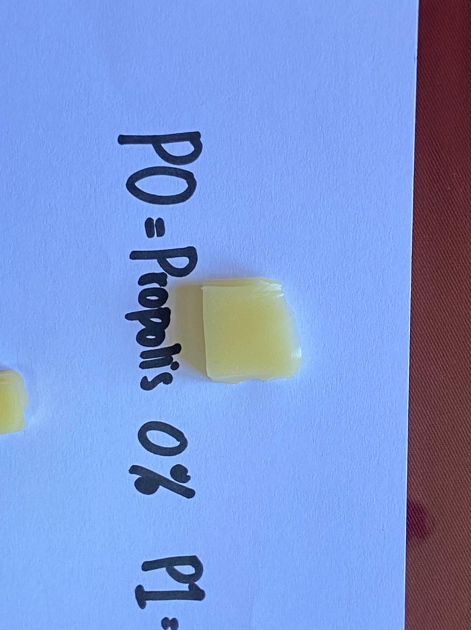  P0 (0% propolis added/no propolis added) | 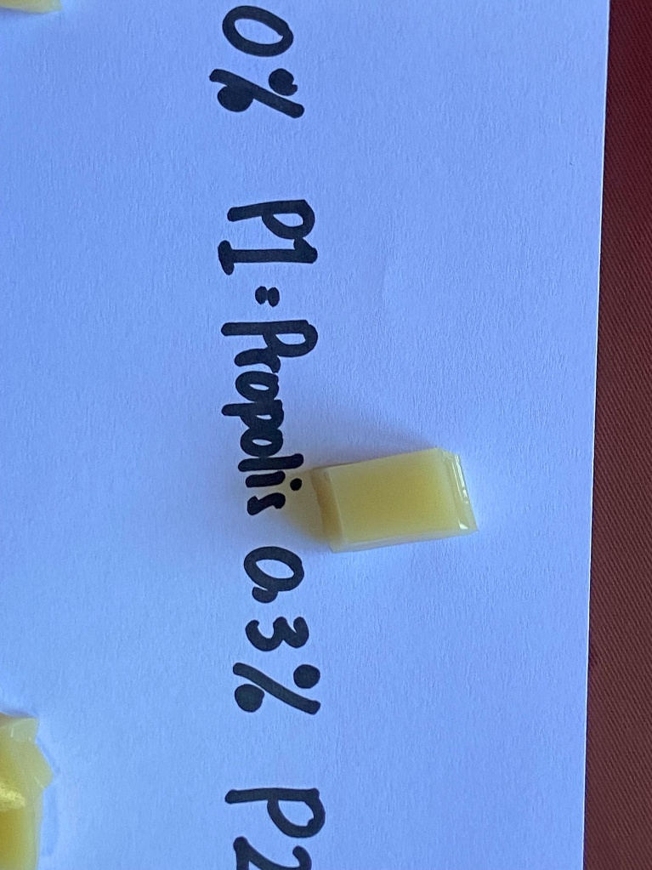  P1 (0,3% propolis added) | 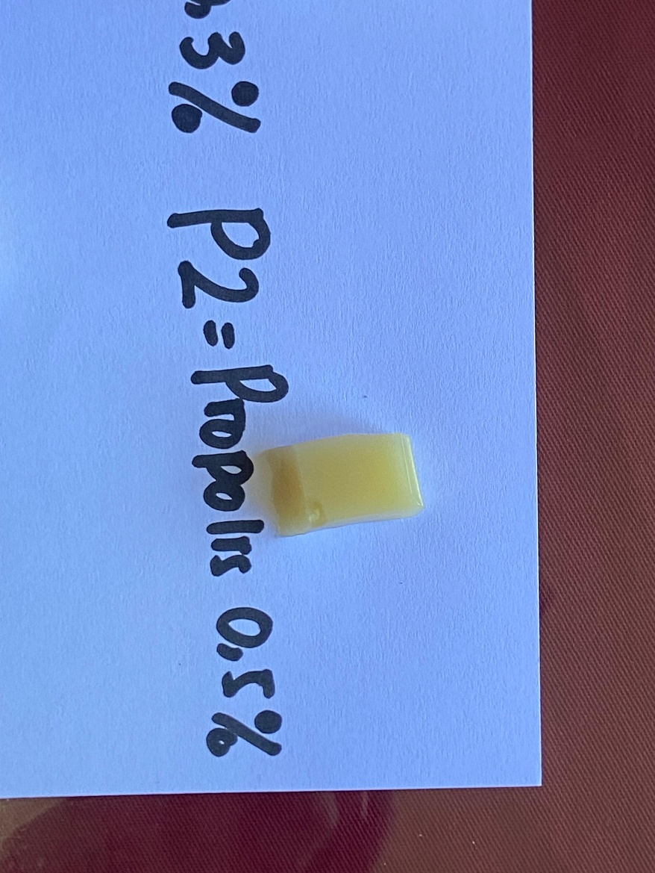  P2 (0,5% propolis added) | 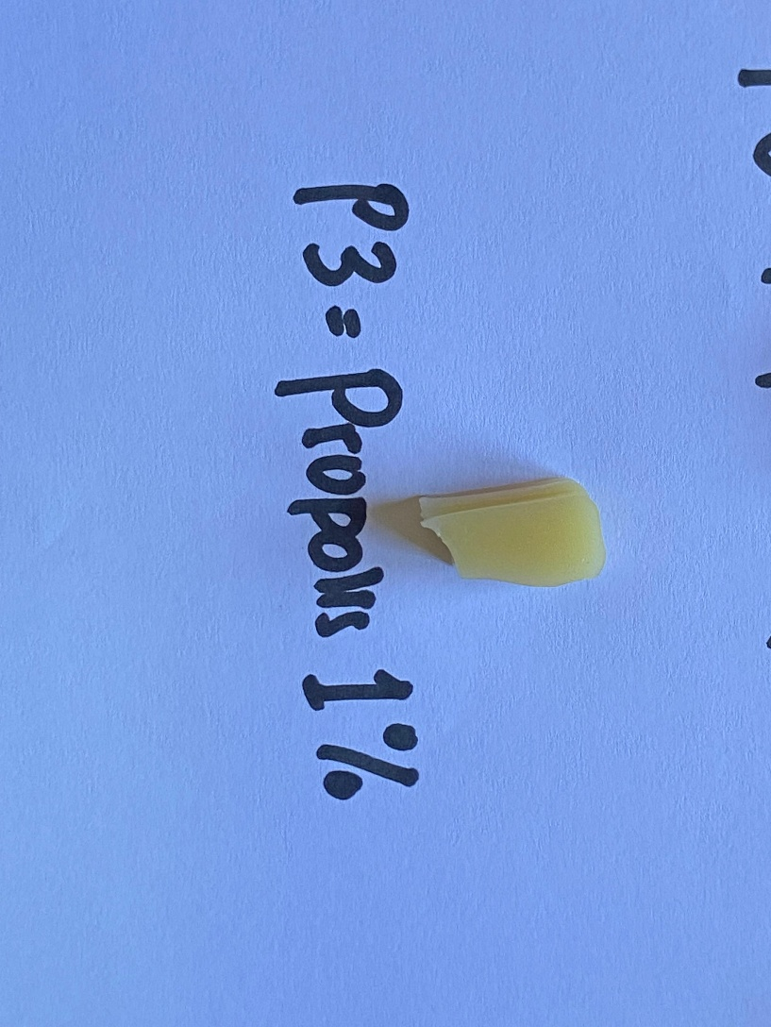  P3 (1% propolis added) | 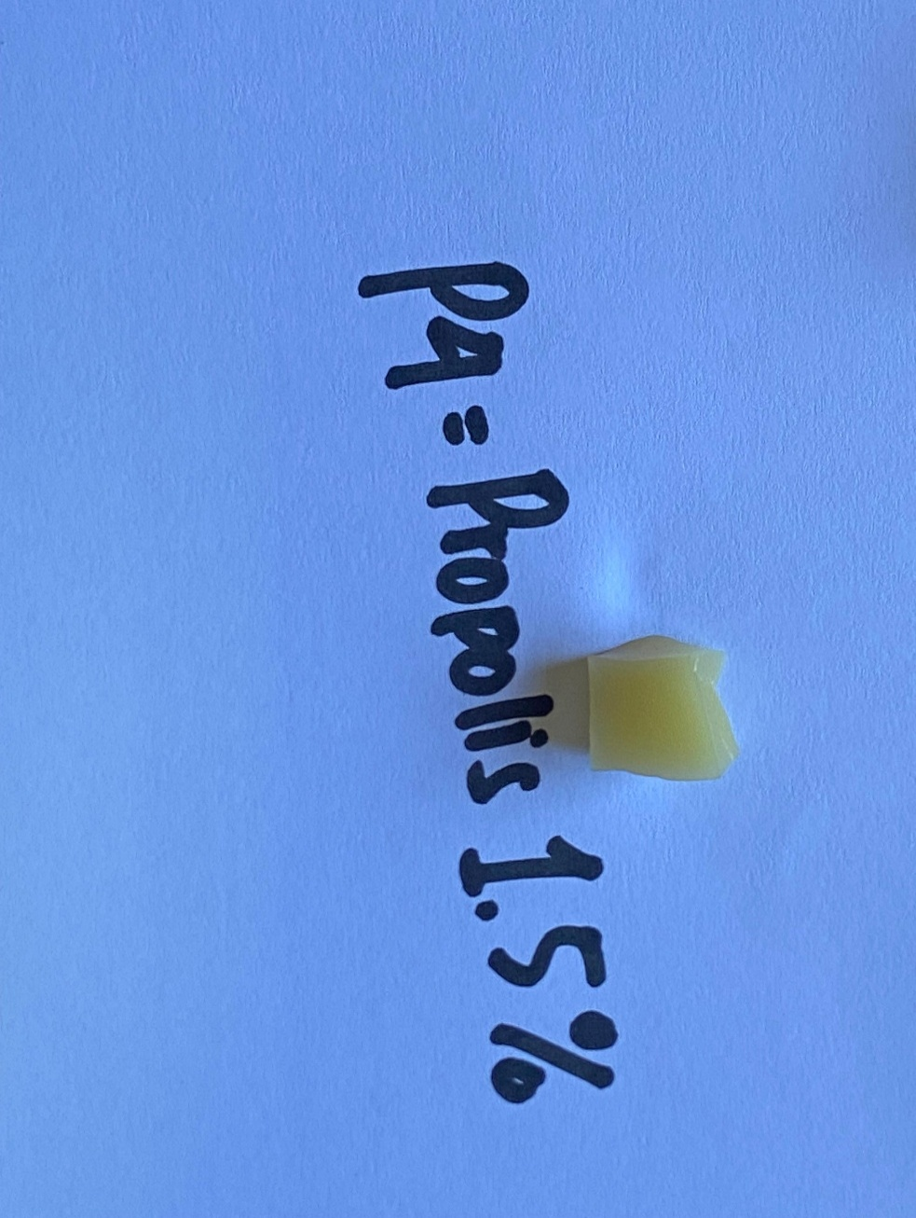  P4 (1,5% propolis added)

Fig 1. Color milk jelly candy addition propolis

4. Conclusion

The addition of 1.5% propolis (P4) has a good effect such as having the highest antioxidant activity 66.72 mg/ml (based on IC50), having the lowest water activity 0.82 and higer texture 34 N All three are important parameters for shelf life product. The color of P4 milk jelly candy in lightness (L*) 55.34 slightly less bright than other treatments, reddish (a*) -0.65 and yellowish (b*) 12.57 more yellow than other treatments and is comparable to the higher reduction sugar content 24.50% related to the maillard browning reaction.

References

Andriani, Y., Syukri, D. & Rini. (2022). Characteristics Of Milk Caramel Candy With The Addition Of Stevia (Stevia Rebaudiana Bertoni) Extract Leaf Powder. And. Int. J. Agric. Nat. Sci, 3(2), 67-86. https://doi.org/10.25077/aijans.v3.i02.67-86.2022
AOAC (Association of Official Analytical Chemist). The A of Official Analytical of Chemist, Inc. Arlington. (2005)
Badan Standarisasi Nasional. 2008. Syarat Mutu Permen Lunak Tertuang Dalam SNI 3547.2-2008. Jakarta
Cedeño-Pinos, C., Marcucci, M. C. & Bañón, S. (2021). Contribution of Green Propolis to the Antioxidant, Physical, and Sensory Properties of Fruity Jelly Candies Made with Sugars or Fructans. Foods, 10(11), 1 – 16. DOI : https://doi.org/10.3390/foods10112586
Delgado, P. & Bañón, S. (2015). Determining the minimum drying time of gummy confections based on their mechanical properties. Journal of Food, 13(3), 329-335. DOI : http://dx.doi.org/10.1080/19476337.2014.974676
Filgueiras, C.T., Fakhouri, F.M., Garcia, V.A.S., Velasco, J.I., Nogueira, G.F., Silva, L.R., et al. (2024). Effect of Adding Red Propolis to Edible Biodegradable Protein Films for Coating Grapes: Shelf Life and Sensory Analysis. Foods, 16, 1-18. DOI : https://doi.org/10.3390/polym16070888
Husna, F.Z.A. And Amertaningtyas, D. (2025). The Effect of Using Different Types of Honey As Sugar Substitute on the Quality of Milk Jelly Candy. JAPSI (Journal of Agriprecision and Social Impact), 2(2), 1-17. DOI : https://doi.org/10.62793/japsi.v2i2.55
Kaewpetch, K., Yolsuriyan, S., Disayathanoowat, T., Phokasem , P., Jannu, T., Renaldi, G. & Samakradhanrongthai, R.S. (2024). Influence of Gelatin and Propolis Extract on Honey Gummy Jelly Properties: Optimization Using D-Optimal Mixture Design, Gels. 10(4), 1-18. https://doi.org/10.3390/gels10040282
Maryam, S. 2015. Kadar Antioksidan Danic50tempe Kacang Merah (Phaseulus Vulgaris L) Yang Difermentasi Dengan Lama Fermentasi Berbeda. Proceedings Seminar Nasional FMIPA UNDIKSHA V. 347 – 352. https://ejournal.undiksha.ac.id/index.php/semnasfmipa/article/view/6690/4660
Petcu, C.D., Tăpăloagă, D., Mihai, O.D., Gheorghe-Irimia, R., Negoit, C., Georgescu, I.M., et al. (2023). Harnessing Natural Antioxidants for Enhancing Food Shelf Life: Exploring Sources and Applications in the Food Industry. Foods, 12, 1-19. DOI : https://doi.org/10.3390/foods12173176
Pongsetkul, J. & Benjakul, S. (2021). The Useof Sodium Benzoate on Shelf-Life and Quality Attributes of Dried Chili Fish Paste Stored in Different Packaging Containers. Foods, 10(1), 1-16. DOI : https://doi.org/10.3390/foods10081802
Said, N.S., Olawuyi, I.F. & Lee, W.Y. (2023). Pectin Hydrogels: Gel-Forming Behaviors, Mechanisms, and Food Applications. Foods, 9, 1-28. DOI : https://doi.org/10.3390/gels9090732
Sforcin, J.M., (2016). Biological Properties and Therapeutic Applications of Propolis. Phytother. Res., 30 (6), 894–905. https://doi.org/10.1002/ptr.5605
Silaen, N.R. dan Ginting, S. (2020). Pengaruh Penambahan Madu Pada Pembuatan Permen Jelly Kolangkaling (Arenga pinnata). Jurnal Teknologi Pangan dan Hasil Pertanian, 3 (2), 64-72. https://doi.org/10.30596/agrintech.v2i2.3661
Simone-Finstrom, M., Borba, R.S., Wilson, M. & Spivak, M. (2017). Propolis Counteracts Some Threats to Honey Bee Health. Insects, 8 (2), 1 – 20. https://doi.org/10.3390/insects8020046
Teshome, E., Forsido, S.F., Rupasinghe, H.P.V. & Keyata, E.O. (2022). Potentials of Natural Preservatives to Enhance Food Safety and Shelf Life: A Review. The Scientific World Journal, 1(1), 1-11. DOI : https://doi.org/10.1155/2022/9901018
Wo´zniak, M., Sip, A., Mrówczy´nska, L., Broniarczyk, J., Wa´skiewicz, A. & Ratajczak, I. (2023). Biological Activity and Chemical Composition of Propolis from Various Regions of Polan. Molecules, 28, 2-19. DOI : https://doi.org/10.3390/molecules28010141
Zewdie, T. M. (2017). Tomato quality is influenced by different packaging materials and practices. Journal of Scientific Agriculture, 1, 91. https://doi.org/10.25081/jsa 2017.v1i0.33
Zulaikhah, S. R. & Fitria, R. (2020). Pengaruh Penambahan Sari Buah Pisang Ambon (Musa paradisiaca) sebagai Perisa Alami terhadap Warna, Total Padatan Terlarut dan Sifat Organoleptik Yogurt. Jurnal Sain Peternakan Indonesia, 15(4), 434–440. https://doi.org/10.31186/jspi.id.15.4.434-440

