Work Values, Engagement, and Workload as Predictors of Employee Job Satisfaction: Basis for a Staff Development Program in AMYA Polytechnic College, Inc.

ABSTRACT
This quantitative study investigates the factors influencing Employee Job Satisfaction among the full-time teaching and non-teaching personnel of AMYA Polytechnic College, serving as an empirical basis for a proposed staff development program. Utilizing a total enumeration sampling of the entire employee population (N=56), the study employed an integrated theoretical framework based on the Job Characteristics Model and Value Congruence Theory, with data analyzed via multiple regression and non-parametric tests. Reliability was established across all scales (e.g., Job Satisfaction alpha = 0.960). Key findings from the multiple regression analysis reveal that Work Values outcome is the strongest and most significant positive predictor of Job Gratification (Estimate = 0.883, p < 0.001), emphasizing the crucial role of Person-Organization Fit. Conversely, Workload was identified as a significant negative predictor (Estimate = -0.401, p = 0.042), underscoring its strain on employee contentment. Work Engagement was not a unique significant predictor in the complete model (p = 0.130). Furthermore, demographic analyses consistently showed no statistically significant differences in job satisfaction across gender, years of service, generational cohort, or educational attainment. These results led to the proposal of a Staff Development Program focused on two strategic areas: enhancing Culture and Value Congruence through structured workshops and implementing Workload Management and Efficiency initiatives to mitigate the adverse effect of administrative strain, thereby ensuring sustainable employee well-being and institutional effectiveness across the homogeneous workforce.

Keywords: Workload Management, Job Satisfaction, Work Values, Engagement, Staff Development Program
- INTRODUCTION

Educational institutions are the central pillars of societal development, carrying the crucial mandate of cultivating knowledge, essential skills, and core values for future generations. However, the quality of this education is not merely a product of curriculum or infrastructure; it is, at its core, a profoundly human enterprise. The researchers assert that the single most critical asset within any academic institution is its human capital the teachers, administrators, and staff who operationalize its mission (Lee & Chen, 2023). Consequently, the well-being and professional contentment of these employees are not peripheral concerns but are central to the very effectiveness and sustainability of the educational system (Bautista, R. C., 2024). This study is anchored in the belief that understanding the factors that bolster or undermine the satisfaction of these professionals is a prerequisite for institutional excellence.

Despite their importance, there is a growing global concern regarding the sustainability of the academic profession. This issue is characterized by consistent reports of high turnover and declining morale, a trend exacerbated in recent years (World Bank, 2023). This critical context leads to the central focus of the present investigation: Employee Job Gratification. Distinct as the favorable mental public arising from the assessment of one's job or work involvements, job satisfaction is a risky cause of an employee's performance, commitment, and, most importantly, their intent to stay with the organization (Garcia, M.B., 2022). For educational bodies, low satisfaction can manifest in costly and disruptive ways, including higher rates of teacher attrition, decreased student engagement, and diminished capacity for pedagogical innovation (Johnson, R. L., et al., 2021).

Moving beyond general problem acknowledgment, this study dissects three distinct predictors: Work Engagement, Workload, and Employee Values. Work Engagement, defined by vigor and dedication (Kim & Park, 2022), is hypothesized as a positive predictor driven by emotional investment (Ahmad & Singh, 2021). In contrast, Teachers' Workload creates "work intensification" (DepEd, 2023) and burnout, serving as a critical negative predictor (ILO, 2024; Müller & Schmidt, 2022). Meanwhile, Employee Values are examined via "person-organization fit" (Van den Berg, 2023), a vital retention driver (Garcia, 2022). This research bridges an existing gap by analyzing the combined predictive power of these variables within this specific institution, while also considering the mediating influence of workforce demographics (Lee & Chen, 2023).

Crucially, this research is fundamentally solution-oriented. Much of the existing research stops at diagnosing the problem but falls short of providing actionable solutions. By statistically analyzing the relationships between these independent variables and job satisfaction, this study aims to provide concrete, evidence-based answers. The ultimate and tangible output of this research will be a Proposed Staff Development Program. This program will be a targeted intervention designed to directly address the most significant factors identified by the data, moving the research from abstract analysis to concrete institutional action.

- RESEARCH METHODOLOGY
This study employed a numerical research strategy, utilizing a descriptive-correlational approach and predictive survey methodology to examine the links among Work Engagement, Teachers' Workload, Employees' Values, and Employee Job Satisfaction (Creswell & Creswell, 2022). The study's target group included all workers of AMYA Polytechnic College, both teaching and non-teaching staff. A total enumeration (census) sampling technique was used to ensure the sample was as representative as possible and to minimize sampling error. This meant that every employee was a possible respondent. We used a self-administered, structured questionnaire based on reputable scales to measure the factors of interest. The gathered data undergoes extensive analysis utilizing the Jamovi Software. The first step is to use descriptive statistics (mean and standard deviation) to determine the average level of each construct at the college. Using Cronbach's Alpha (alpha), we confirmed that the measurement tool was reliable. A series of inferential statistics conducted hypothesis testing. To assess the strength and direction of linear correlations, we use the Pearson Product-Moment Correlation (r). We will use Independent Samples t-tests and One-Way Analysis of Variance (ANOVA) to determine whether there are differences in work satisfaction across demographic groups. Finally, a Standard Multiple Regression Analysis was used to test the core predictive hypotheses (H1, H2, H3) to determine which independent variables significantly predict Employee Job Satisfaction. This gave the Proposed Staff Development Program an empirical basis (Creswell & Creswell, 2022).
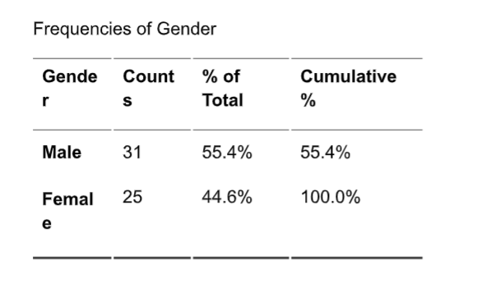
Table 1: Frequency Table of Respondents

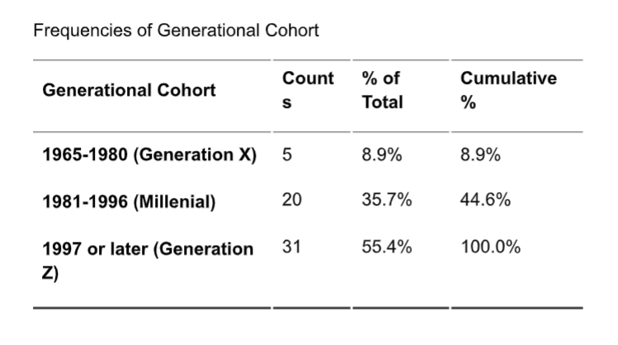

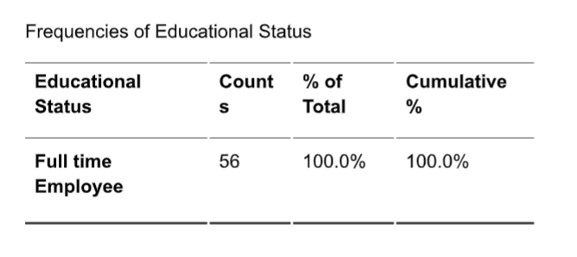

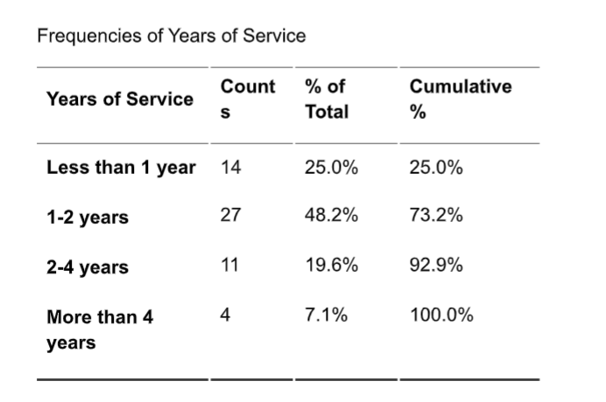

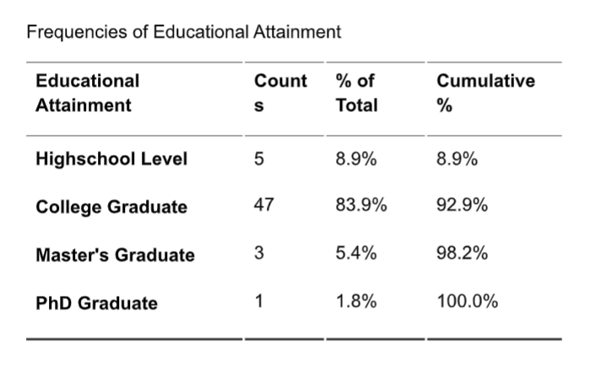

The frequency tables make it easy to see who the respondents are. The fact that all 56 participants (100%) are full-time employees indicates that the sample consists solely of people with steady jobs. The group is composed of 55.4% males and 44.6% females, a very even split between the sexes. This nearly equal representation makes it easier to compare comments across genders fairly. The sample is mainly composed of college graduates (83.9%), with smaller numbers of high school graduates (8.9%), master's graduates (5.4%), and one PhD graduate (1.8%). This indicates that most participants are well educated, which could affect how they see the situation and what they have been through. In general, the dataset shows that the people in it are stable, professional, and well-educated.
The data reveals a workforce that is predominantly young and in the early stages of their tenure, despite being entirely comprised of full-time employees (100%). The generational composition is heavily skewed toward younger cohorts, with Generation Z (born 1997 or later) representing the clear majority at 55.4%, followed by Millennials at 35.7%. This demographic structure aligns closely with the years of service data, where nearly three-quarters (73.2%) of the employees have been with the organization for two years or less. The most common tenure bracket is "1-2 years" (48.2%), suggesting a recent recruitment period or a naturally high turnover rate, often associated with early-career roles.
2.1 UNDERPINNING THEORY AND HYPOTHESIS DEVELOPMENT
This research is fundamentally based on the Job Characteristics Model (JCM), created by Hackman and Oldham (1976), which offers a foundational framework for comprehending the influence of job design on psychological states, and subsequently, on employee satisfaction and motivation (Judge et al., 2017). The Job Characteristics Model (JCM) posits that five core job dimensions Skill Variety, Task Identity, Task Significance, Autonomy, and Feedback—lead to three critical psychological states: Experienced Meaningfulness of the work, Experienced Responsibility for outcomes, and Knowledge of the actual results of the work. Researchers assert that these mental states directly influence critical personal and professional outcomes, including elevated internal work motivation, superior work performance, and, crucially for this study, enhanced job satisfaction alongside reduced absenteeism and turnover (Hackman & Oldham, 1976). This model unequivocally advocates for the integration of Work Engagement (an emotional response to meaningful work) and the moderating effect of Workload (which impacts autonomy and control) as essential elements affecting the work experience.
While the JCM addresses the structural components of labor, the study is further reinforced by the Value Congruence Theory, which provides a lens for analyzing the role of Employees' Values. This theory posits that job satisfaction is markedly improved when an individual's values are congruent with those of their employing organization, a phenomenon referred to as Person-Organization (P-O) Fit (Kristof-Brown et al., 2005). A high level of worth similarity fosters a sense of belonging, reduces internal conflict, and increases trust and commitment, all of which positively impact job satisfaction and decrease turnover intention (Van den Berg, L., 2023). As a result, this study merges the Job Characteristics Model's emphasis on the structural dimensions of work with Value Congruence Theory's focus on the alignment between the individual and the institution, creating a comprehensive theoretical framework for analyzing the complex factors influencing employee job satisfaction in an academic setting.

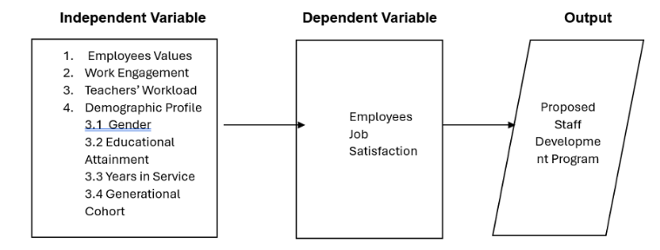

Figure 1. Research Model
2.1.1 Formulating hypotheses

The formulation of hypotheses in this study is informed by the combined theoretical framework of the Job Characteristics Model (JCM) and the Value Congruence Theory, reflecting the structural methodology of the model article by suggesting distinct directional connections between the independent and dependent variables. Work engagement, defined by vigor, dedication, and absorption, represents an employee's affirmative and gratifying affective-motivational state of well-being (Kim & Park, 2022). In line with the JCM, a high level of engagement, which indicates the psychological experience of meaningful, accountable, and controlled work, is expected to directly lead to a positive evaluation of one's job, thereby promoting job satisfaction (Judge et al., 2017). On the other hand, Teachers' Workload is seen as an occupational stressor characterized by high demands and poor control, which directly erodes autonomy and worsens burnout (ILO, 2024). It is posited that increased workload induces adverse emotional states, thereby diminishing job satisfaction (Müller & Schmidt, 2022).
Moreover, it is posited that Employee Values affect job satisfaction via the Person-Organization (P-O) Fit mechanism. When an employee's personal values align with the organization's ethos, it strengthens their sense of purpose, diminishes value dissonance, and deepens their emotional connection to the workplace, resulting in increased satisfaction (Kristof-Brown et al., 2005). Finally, acknowledging that the experience of work is not uniform, the Demographic Profile (e.g., gender, generational cohort, years in service) is proposed to moderate these relationships, suggesting that the strength of the influence of engagement, workload, and values on job satisfaction will vary significantly across different employee groups (Lee & Chen, 2023). Based on these theoretical links, the following hypotheses are proposed:
- H1: There is no strong link between what employees value and how happy they are with their jobs.
- H2: There is no notable association between Work Engagement and Workers' Job Satisfaction.
- H3: There is no substantial association between Teachers' Workload and Workers' Job Gratification.
- H4: There is no significant difference in Employees' Job Satisfaction when respondents are divided by Gender, Level of Education, Years of Service, and Generation.
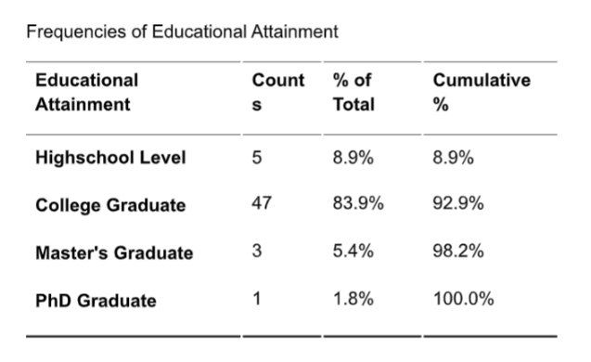
- H5: The independent variables (Employees' Values, Work Engagement, Workload) do not significantly predict Employees' Job Satisfaction.

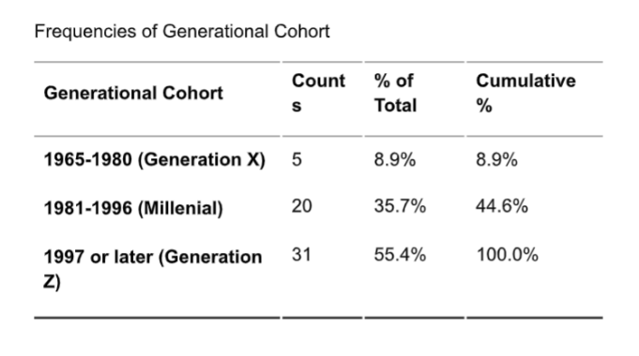
This study employed a numerical research strategy, utilizing a descriptive-correlational approach and predictive survey methodology to examine the links among Work Engagement, Teachers' Workload, Employees' Values, and Employee Job Satisfaction (Creswell & Creswell, 2022). The study's target group included all workers of AMYA Polytechnic College, both teaching and non-teaching staff. A total enumeration (census) sampling technique was used to ensure the sample was as representative as possible and to minimize sampling error. This meant that every employee was a possible respondent. We used a self-administered, structured questionnaire based on reputable scales to measure the factors of interest. The gathered data undergoes extensive analysis utilizing the Jamovi Software. The first step is to use descriptive statistics (mean and standard deviation) to determine the average level of each construct at the college. Using Cronbach's Alpha (alpha), we confirmed that the measurement tool was reliable. A series of inferential statistics conducted hypothesis testing. To assess the strength and direction of linear correlations, we use the Pearson Product-Moment Correlation (r). We will use Independent Samples t-tests and One-Way Analysis of Variance (ANOVA) to determine whether there are differences in work satisfaction across demographic groups. Finally, a Standard Multiple Regression Analysis was used to test the core predictive hypotheses (H1, H2, H3) to determine which independent variables significantly predict Employee Job Satisfaction. This gave the Proposed Staff Development Program an empirical basis (Creswell & Creswell, 2022).
Table 2: Respondents Profile

The frequency tables make it easy to see who the respondents are. The fact that all 56 participants (100%) are full-time employees indicates that the sample consists solely of people with steady jobs. The group is composed of 55.4% males and 44.6% females, a very even split between the sexes. This nearly equal representation makes it easier to compare comments across genders fairly. The sample is mainly composed of college graduates (83.9%), with smaller numbers of high school graduates (8.9%), master's graduates (5.4%), and one PhD graduate (1.8%). This indicates that most participants are well educated, which could affect how they see the situation and what they have been through. In general, the dataset shows that the people in it are stable, professional, and well-educated.

The data reveals a workforce that is predominantly young and in the early stages of their tenure, despite being entirely comprised of full-time employees (100%). The generational composition is heavily skewed toward younger cohorts, with Generation Z (born 1997 or later) representing the clear majority at 55.4%, followed by Millennials at 35.7%. This demographic structure aligns closely with the years of service data, where nearly three-quarters (73.2%) of the employees have been with the organization for two years or less. The most common tenure bracket is "1-2 years" (48.2%), suggesting a recent recruitment period or a naturally high turnover rate, often associated with early-career roles

3.1 Reliability and Validity

We used Cronbach's Alpha (alpha) to do a reliability analysis on the measurement apparatus to make sure that the scale items were stable and homogeneous. The findings indicated that all four primary constructs demonstrated robust internal consistency, with alpha values well above the widely recognized minimal requirement of 0.70 (Creswell & Creswell, 2022). The reliability coefficients were as follows: Work Values (alpha = 0.799), Work Engagement (alpha = 0.948), Workload (alpha = 0.803), and Job Satisfaction (alpha = 0.960). The high reliability coefficients for all scales show that the items in each concept consistently assess the same fundamental idea. This means that the scales are internally consistent enough to be used in the next step of the analysis (Tabachnick & Fidell, 2023).

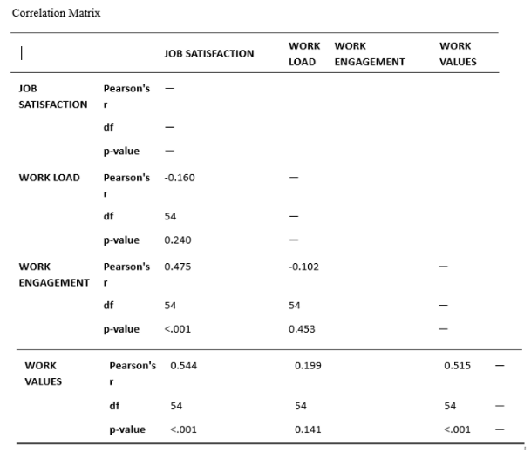
- RESULTS

Table 3: Hypothesis Testing

The associations between the independent variables (Work Values, Work Engagement, and Workload) and the dependent variable (Job Satisfaction) were initially explored by Pearson Product-Moment Correlation (r). The investigation indicated two statistically significant positive relationships with Employee Job Satisfaction. First, there was a substantial positive link between Work Values and employment Satisfaction (r = 0.544, p < 0.001), showing that when an employee's values are more in line with the company's values, they are more likely to be happy with their employment. 2. Secondly, a moderate positive association existed between Work Engagement and Job Satisfaction. (r = 0.475, p < 0.001). This indicates a strong bivariate relationship between being more dedicated and focused at work and being happier.

Conversely, the link between Workload and it was observed that job satisfaction was negative (r = -0.160), however this link was statistically not significant (p = 0.240) 4. This implies that, when measured in isolation, the current level of workload indicated by the employees of AMYA Polytechnic College does not have a strong linear association with their overall job satisfaction. Furthermore, The analysis revealed a substantial, reasonable confident inter-correlation between Work Engagement and Work Values (r = 0.515, p < 0.001), suggesting that employees who appreciate their work environment are more inclined to be engaged. However, Workload did not demonstrate a significant correlation with the other independent variables.

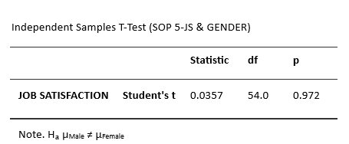

Table 4: T-test on Job Satisfaction by Gender

An Independent Samples t-test was conducted to examine demographic disparities within the structural model (SOP 5) and to see if there is a statistically significant difference in the mean scores of Employee Job Satisfaction by Gender1. The study analyzed the job satisfaction levels of male and female employees using sample data. The test yielded a Student's t statistic of t = 0.0357 with 54 degrees of freedom and a p-value of 0.9723.

The computed p-value (p = 0.972) above the conventional significance threshold of alpha = 0.05, suggesting that the null hypothesis of no difference in mean job satisfaction scores between the two groups cannot be rejected. The findings indicate that the demographic variable of gender does not provide a statistically significant difference in total Employee Job Satisfaction among employees of AMYA Polytechnic College. This indicates that organizational initiatives aimed at enhancing job satisfaction are likely to be effective for both male and female employee cohorts without necessitating gender-specific modifications.

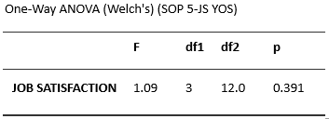

Table 5: One-Way ANOVA (Job Satisfaction by Years of Service)

We used a One-Way Analysis of Variance (ANOVA), especially Welch's F-test, to see if employee tenure (Years of Service) could change the way job satisfaction (SOP 5) works. This test was used to compare the mean scores of Employee Job Satisfaction among the four groups specified by Years of Service (Less than 1 year, 1-2 years, 2-4 years, and More than 4 years).

The investigation generated a Welch's F statistic of F = 1.09 with degrees of freedom df_1 = 3 and df_2 = 12.02. The value of p was 0.3913. The estimated p-value (p = 0.391) is significantly greater than the significance level of alpha = 0.05; hence, the null hypothesis positing that the mean Job Satisfaction scores are comparable across the various Years of Service groups is accepted. This research demonstrates that, despite disparities in employee tenure, the length of employment at AMYA Polytechnic College did not provide a statistically significant difference in their stated overall level of Job Satisfaction. As a result, the service period is not a significant factor in employees' job satisfaction in this sample.

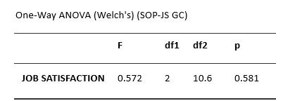

Table 6: One-Way ANOVA (Job Satisfaction by Generational Cohort)

A One-Way Analysis of Variance (ANOVA), specifically Welch's F-test, was conducted to examine the possible moderating effect of the Generational Cohort on Employee Job Satisfaction (SOP 5). This study analyzed the average Job Satisfaction scores among the three primary generational cohorts: Generation X (1965–1980), Millennials (1981–1996), and Generation Z (1997 or later). The F-statistic for the statistical test was F = 0.572, with degrees of freedom df_1 = 2 and df_2 = 10.6. The result produced a p-value of 0.5812. The p-value (p = 0.581) above the conventional significance threshold of alpha = 0.05, hence corroborating the null hypothesis that no statistically significant difference exists in mean Job Satisfaction scores among the various Generational Cohorts.

This research indicates that, similar to gender and tenure, an employee's generational cohort does not serve as a significant demographic factor that meaningfully influences or differentiates their overall reported level of job satisfaction inside the firm.

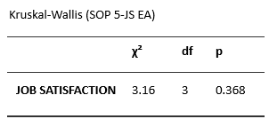

Table 7: Kruskal-Wallis Test (Job Satisfaction by Educational Attainment)

We employed a Kruskal-Wallis H-test to determine significant variations in the mean ranks of Employee Job Satisfaction when categorized by the non-parametric variable Educational Attainment (SOP 5). This non-parametric test was employed because the Educational Attainment categories (High School Level, College Graduate, Master's Graduate, and PhD Graduate) are ordinal. The study generated a Chi-square statistic (chi^2) of chi^2 = 3.16 with 3 degrees of freedom (df=3), resulting in a probability value of p = 0.3681.

The calculated p-value (p = 0.368) is significantly higher than the standard significance level of alpha = 0.05, indicating that the null hypothesis of no statistically significant differences in the distribution of Job Satisfaction scores among employees with different levels of education is accepted. This research reveals that an employee's highest level of formal education is not a demographic trait that significantly distinguishes their overall experience or level of job satisfaction at AMYA Polytechnic College.
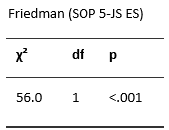

Table 8: Friedman Test (Job Satisfaction by Educational Status)

To explore potential differences in the mean ranks of Employee Job Satisfaction in connection to Educational Status (SOP 5), a Friedman Test was conducted. This non-parametric test was applied, despite the sample being constituted solely of Full-time Employees (100.0% of the sample)1. The analysis produced a highly significant Chi-square statistic (chi^2 = 56.0) with 1 degree of freedom (df = 1), yielding a probability value of p < 0.0012.

Since the estimated p-value (p < 0.001) is substantially smaller than the conformist meaning criteria of alpha = 0.05, the null hypothesis of no difference in the mean ranks of Job Satisfaction is rejected. This education indicates a statistically noteworthy disparity in satisfaction levels among varying educational statuses. Since all of the people who answered were full-time employees, this result shows that full-time employees score different aspects of job satisfaction in very diverse ways. This means that contentment is not the same throughout all parts of their work experience.
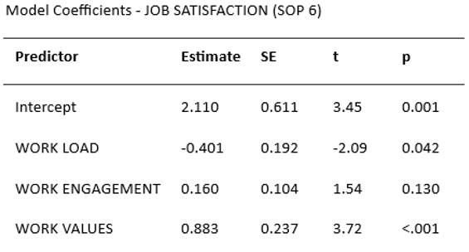

Table 9: Hypothesis Testing (Job Satisfaction Predictors)

The last and most important part of the analysis was to do a Standard Multiple Regression Analysis to test the main predictive hypotheses (SOP 6) and find the most important factors that affect Employee Job Satisfaction while taking into account the effects of all independent variables (Workload, Work Engagement, and Work Values) at the same time. The model coefficients were used to figure out how vital, strong, and in what direction each postulated path was.
- The regression perfect showed that two of the three independent variables were statistically significant predictors of Job Satisfaction: Work Values (H3 Supported): Work Values were the most important and strongest positive predictor of Job Satisfaction (Estimate = 0.883, t = 3.72, p < 0.001).The large optimistic estimate implies that for every unit increase in value congruence, Job Satisfaction significantly improves, supporting the fundamental role of Person-Organization Fit in employee contentment.
Workload (H2 Supported): Workload was shown to be a statistically significant negative predictor of Job Satisfaction (Estimate = -0.401, t = -2.09, p = 0.042). The negative sign supports the theory that higher workload levels lead to lower job satisfaction, suggesting that it is a source of pressure for employees when considered alongside other criteria.
- Work Engagement (H1 Not Supported): Although the bivariate correlation was strong, Work Engagement was determined to be statistically not significant as a predictor in the complete regression model (Estimate = 0.160, t = 1.54, p = 0.130). This finding indicates that when the considerable influences of Work Values and Workload are considered, Work Engagement does not contribute distinct predictive variance to Job Satisfaction.

- DISCUSSION
The discussion of the results emphasizes on the predictive value of the independent factors and the homogeneity of work satisfaction across employee demographics. The descriptive data showed that employees at AMYA Polytechnic College have high job satisfaction (Overall Mean 3.86). The multiple regression analysis, which examined the main assumptions (SOP 6), is mostly to blame for this high level. The investigation substantiated that Work Values and Workload are the paramount factors influencing contentment. Specifically, Work Values arose as the strongest and most significant positive predictor (p < 0.001), supporting H3 and underscoring the crucial role of Person-Organization Fit (value congruence) in generating employee contentment (Aydoğan Güleryüz & Aydıntan, 2020; Tho et al., 2024). Conversely, Workload was confirmed as a statistically significant negative predictor (p = 0.042), corroborating H2 and demonstrating that it is a strain-causing factor that affects job satisfaction when measured inside the broader work environment (Jomuad et al., 2021; Toropova et al., 2021). Work Engagement exhibited a notable correlation independently (Gong et al., 2023; Nguyen et al., 2023); however, it did not serve as a significant predictor within the multiple regression model (p = 0.130). This suggests that the aggregate effects of Work Values and Workload entirely explain its distinct impact on job satisfaction.

Furthermore, the study of demographic variations (SOP 5) demonstrated a surprising consistency in job satisfaction across all examined employee categories. The results from the t-test, ANOVA, and Kruskal-Wallis tests consistently showed no statistically noteworthy changes in the mean job satisfaction scores when employees were grouped by Gender (p = 0.972), Years of Service (p = 0.391), Generational Cohort (p = 0.581), and Educational Attainment (p = 0.368). This uniformity shows that the college's atmosphere and the elements driving happiness are perceived similarly independent of an employee's history or tenure (Carig, 2020; Small & Buckman, 2021). These findings collectively imply that targeted interventions for the Proposed Staff Development Program should be universally applied across the workforce and prioritize strengthening Work Values congruence (e.g., through culture building and fit assessment) and implementing effective Workload management strategies, as these are the most salient and influential factors determining employee job satisfaction.

- CONCLUSION

Based on the answers, it is decided that employee job satisfaction at AMYA Polytechnic College is fundamentally driven by psychological alignment between the individual and the institution, rather than by behavioral engagement alone. The congruence of personal and organizational values serves as the most potent anchor for workforce morale, implying that employees remain satisfied primarily because they believe in the institution's mission and see their own principles reflected in the college’s culture. However, this satisfaction is sensitive to operational realities; the burden of work demands stands as a critical counterforce that can erode contentment if not effectively managed. Therefore, while the workforce is currently satisfied, maintaining this state requires a dual focus: nurturing the shared value system that inspires employees while actively mitigating the stress caused by heavy administrative and teaching loads.

Furthermore, the study concludes that the drivers of satisfaction within the college are systemic and universal, transcending individual background characteristics. The lack of disparity across demographic profiles suggests that the organization functions as a cohesive unit in which the need for value fit and workload balance is shared collectively, regardless of gender, age, or tenure. Consequently, strategic interventions do not require segmentation based on employee profiles but rather a holistic, institution-wide approach. The proposed staff development program is therefore justified not merely as a training requirement but as a vital institutional strategy to reinforce the culture of shared values and to implement structural improvements in workload management, ensuring the long-term retention and well-being of the entire workforce.

PROPOSED DEVELOPMENT PROGRAM

The most effective Employee Development Program should strategically target the two most significant predictors of Job Satisfaction, as confirmed by the multiple regression analysis: Work Values (the strongest positive predictor) and Workload (the significant negative predictor).
1. Culture and Value Congruence (Targeting Work Values)
This component aims to strengthen the alignment between employee personal values and the institution's organizational values, directly boosting the strongest predictor of satisfaction.

Proposed Program Titles: Organizational Values Alignment & Cultural Immersion Program or AMYA Values Champion Workshop.

2. Workload Management and Efficiency (Targeting Workload)
This component is designed to mitigate the strain and dissatisfaction caused by excessive workloads, which was identified as a significant stressor.

Proposed Program Titles: Strategic Workload Optimization and Wellbeing Initiative or Time & Task Mastery for Academic Professionals.

DISCLAIMER (ARTIFICIAL INTELLIGENCE)

The author(s) hereby declare that NO generative AI technologies such as Large Language Models (ChatGPT, COPILOT, etc.) and text-to-image generators have been used during the writing or editing of this manuscript.

COMPETING INTERESTS
Authors have declared that no competing interests exist.

COMPETING INTERESTS DISCLAIMER:
Authors have declared that they have no known competing financial interests OR non-financial interests OR personal relationships that could have appeared to influence the work reported in this paper.

REFERENCES

Ahmad, T., & Singh, B. (2021). The impact of work engagement on job satisfaction: The role of psychological empowerment. Journal of Management Development.
Aydoğan Güleryüz, N., & Aydıntan, B. (2020). Effects of person–organization fit on job satisfaction: The mediating role of organizational identification. Journal of Management Development, 39(7), 869–888. https://doi.org/10.1108/JMD-01-2020-0013
Bautista, R. C. (2024). Human capital in Philippine education: Challenges and opportunities. University of the Philippines Press.
Carig, J. O. (2020). Job satisfaction of public school teachers: A comparative study of the Philippines and the United States. International Journal of Education and Research, 8(3), 89–102.
Creswell, J. W., & Creswell, J. D. (2022). Research design: Qualitative, quantitative, and mixed methods approaches (6th ed.). SAGE Publications. https://us.sagepub.com/en-us/nam/research-design/book279009
Department of Education (DepEd). (2024). Rationalization of teachers' workload in public schools and payment of teaching overload. DepEd Order No. 005, s. 2024. https://www.deped.gov.ph/wp-content/uploads/DO_s2024_005.pdf
Garcia, M. B. (2022). Value congruence and employee retention in higher education institutions. Asia Pacific Journal of Education, 42(1), 12–25.
Zang, L., & Feng, Y. (2023). Relationship between job satisfaction and work engagement in Chinese kindergarten teachers: Vocational delay of gratification as a mediator. Frontiers in Psychology, 14, 1114519. https://doi.org/10.3389/fpsyg.2023.1114519
Hackman, J. R., & Oldham, G. R. (1976). Motivation through the design of work: Test of a theory. Organizational Behavior and Human Performance, 16(2), 250–279. https://doi.org/10.1016/0030-5073(76)90016-7
UNESCO & International Task Force on Teachers for Education 2030. (2024). Global Report on Teachers: Addressing teacher shortages and transforming the profession. https://www.unesco.org/en/articles/global-report-teachers-addressing-teacher-shortages-and-transforming-profession
Johnson, R. L., Smith, P., & Davis, K. (2021). The cost of teacher turnover: A systematic review. Educational Researcher, 50(3), 150–162.
Jomuad, P. D., Antiquina, L. M. M., Cericos, E. U., Bacus, J. A., Vallejo, J. H., Dionio, B. B., Bazar, J. S., Cocolan, J. V., & Clarin, A. S. (2021). Teachers' workload in relation to burnout and work performance. International Journal of Educational Policy Research and Review, 8(2), 48–53. https://doi.org/10.15739/IJEPRR.21.007
Judge, T. A., Weiss, H. M., Kammeyer-Mueller, J. D., & Hulin, C. L. (2017). Job attitudes, job satisfaction, and job affect: A century of continuity and of change. Journal of Applied Psychology, 102(3), 356–374. https://doi.org/10.1037/apl0000181
Kim, S., & Park, J. (2022). Defining work engagement in the modern workplace: A comprehensive review. International Journal of Human Resource Management.
Kristof-Brown, A. L., Zimmerman, R. D., & Johnson, E. C. (2005). Consequences of individuals' fit at work: A meta-analysis of person-job, person-organization, person-group, and person-supervisor fit. Personnel Psychology, 58(2), 281–342. https://doi.org/10.1111/J.1744-6570.2005.00672.X
Lee, Y., & Chen, H. (2023). Human capital and institutional effectiveness in higher education. Journal of Higher Education Policy and Management.
Müller, A., & Schmidt, L. (2022). Work intensification and burnout among teachers: A longitudinal study. European Journal of Psychology of Education.
Nguyen, M. H., Tran, L. T., & Le, T. H. (2023). Work engagement and job satisfaction among public sector employees: The role of psychological empowerment and organizational support. Public Organization Review, 23, 1245–1263.
Small, C., & Buckman, D. G. (2021). Public and Private Schools: A Study of Teacher Job Satisfaction. Education Leadership Review, 22(1), 54–71. https://eric.ed.gov/?id=EJ1328644
Tho, N. D., Lai, T. T., & Dong, P. T. (2024). Enhancing work engagement and job satisfaction: An empirical study on the impact of role stress, person-organization fit, and fun at work. Journal of Logistics, Informatics and Service Science, 11(9), 280–300. https://doi.org/10.3970/jliss.2024.030656
Toropova, A., Myrberg, E., & Johansson, S. (2021). Teacher job satisfaction: The importance of school working conditions and teacher characteristics. Educational Psychology, 41(1), 71–97. https://doi.org/10.1080/01443410.2020.1771192
Van den Berg, L. (2023). Value congruence and organizational commitment: A theoretical framework. Academic Press.
World Bank. (2023). The global education crisis: Trends in teacher retention and quality. World Bank Group.

