Alert Fatigue and Smartphone Notifications: A Mixed-Methods Study of Attention Disruption and Mental Well-Being among University Students

Abstract
Smartphone notifications have become a pervasive feature of university students’ daily lives, yet their constant interruptions are increasingly linked to reduced attention, emotional fatigue, and diminished well-being. This mixed-methods study examined how notification frequency, alert fatigue, and attention disruption relate to students’ mental well-being. Quantitative data were collected from 160 undergraduate students using a 16-item survey measuring four constructs. Additionally, semi-structured interviews with 18 students provided qualitative insight into the cognitive and emotional impact of notification-driven interruptions. The results showed that notification frequency did not significantly predict cognitive or emotional outcomes. Instead, alert fatigue and attention disruption emerged as the strongest predictors of reduced well-being. Qualitative findings further revealed experiences of cognitive intrusion, mental overload, and difficulties with digital self-regulation. The study concludes that the psychological burden of smartphone notifications is driven less by quantity and more by the cognitive and emotional processes they trigger. Recommendations include promoting digital hygiene and designing less intrusive notification systems to support students’ digital well-being.
Keywords: alert fatigue, smartphone notifications, attention disruption, mental well-being, digital distraction
Introduction
The widespread use of smartphones has transformed how individuals communicate, learn, and manage daily tasks. For university students in particular, smartphones have become indispensable academic and social tools. However, these devices generate a continuous stream of notifications such as alerts, vibrations, and message previews that compete for users’ attention throughout the day. While notifications are designed to enhance accessibility and efficiency, research increasingly demonstrates that they may undermine attention, cognitive control, and emotional well-being.
Smartphone notifications are uniquely disruptive because they trigger involuntary attentional shifts. Even subtle cues, such as vibrations or illuminated screens, can interrupt working memory and break the flow of concentration during academic activities. Studies have shown that such interruptions impair task performance and slow cognitive processing, especially among young adults who frequently multitask between academic and digital environments. These cognitive costs are exacerbated by habitual checking behaviors, which can develop into automatic responses that further weaken sustained attention.
Notifications also carry emotional implications. Repeated digital interruptions contribute to stress, irritability, and emotional exhaustion—patterns described as alert fatigue. Students often experience pressure to respond quickly to academic messages and social updates, leading to a persistent sense of mental vigilance. Fear of missing out (FOMO) intensifies this emotional burden, reinforcing habitual checking cycles and creating a continuous preoccupation with digital communication. Such emotional strain may affect students’ broader psychological well-being.
Despite growing awareness of these issues, research remains inconclusive about how notification patterns influence well-being. Some studies suggest that simply disabling notifications does not improve concentration or reduce anxiety, as underlying habits and anticipatory attention still persist. This indicates that the effects of notifications may be mediated more by cognitive and emotional responses than by frequency alone.
Existing research has typically examined cognitive and emotional impacts separately. Few studies have combined quantitative measurement with qualitative exploration to provide a comprehensive understanding of how notifications affect students’ digital experiences. University students represent a particularly relevant population, as they navigate the pressures of academic performance while remaining heavily dependent on smartphones for communication and information access.
The present study addresses these gaps by exploring how notification frequency, alert fatigue, and attention disruption interact to influence students’ mental well-being. Using a mixed-methods approach, this study integrates statistical analysis with students’ lived experiences to offer a deeper understanding of the cognitive and emotional pathways underlying notification-driven interruptions.
Literature Review
Research on smartphone use has increasingly focused on how digital notifications affect attention, cognitive control, and psychological well-being. This literature review synthesizes key findings related to alert fatigue, attention disruption, emotional outcomes, and digital self-regulation.
Alert Fatigue and Digital Overload
Alert fatigue refers to the cognitive and emotional exhaustion that develops from repeated or excessive notifications. Students frequently report feeling overwhelmed by constant alerts, leading to stress, frustration, and reduced tolerance for interruptions. Previous studies show that habitual checking and fear of missing out (FOMO) intensify this overload, creating a persistent sense of mental vigilance. These emotional reactions suggest that alert fatigue is an important pathway through which notifications influence well-being.
Attention Disruption and Cognitive Costs
Notifications have been shown to disrupt sustained attention, particularly during tasks requiring concentration. Even minor cues can cause cognitive switching, interrupt working memory, and reduce task performance. Research consistently demonstrates that notification-induced attentional shifts fragment cognitive processing, making it difficult for students to maintain focus. These disruptions appear to be stronger predictors of negative outcomes than the number of notifications received.
Psychological Well-Being
Repeated digital interruptions can affect mood, emotional balance, and overall well-being. Studies show associations between smartphone distraction, anxiety, and emotional exhaustion, especially among emerging adults. Emotional preoccupation resulting from constant alerts can contribute to stress and reduced psychological resilience. The literature suggests that both cognitive and emotional mechanisms may jointly influence well-being, though this interaction is not yet fully understood.
Digital Self-Regulation and Notification Management
Recent research has examined whether controlling or disabling notifications improves outcomes. Findings are mixed: while some users report reduced interruptions, others experience increased fear of missing out or do not change their checking habits. This suggests that effective self-regulation requires more than adjusting device settings; underlying psychological factors also shape how individuals respond to notifications.
Summary
Overall, existing research highlights that the impact of smartphone notifications extends beyond frequency. Cognitive disruption and emotional strain appear to be central mechanisms influencing well-being. However, limited mixed-methods studies have explored how these factors interact, particularly among university students. The present study addresses this gap by examining the combined effects of notification frequency, alert fatigue, and attention disruption on mental well-being.
Literature Review
Research on smartphone use has increasingly focused on how digital notifications affect attention, cognitive control, and psychological well-being. This literature review synthesizes key findings related to alert fatigue, attention disruption, emotional outcomes, and digital self-regulation.
Alert Fatigue and Digital Overload
Alert fatigue refers to the cognitive and emotional exhaustion that develops from repeated or excessive notifications. Students frequently report feeling overwhelmed by constant alerts, leading to stress, frustration, and reduced tolerance for interruptions. Previous studies show that habitual checking and fear of missing out (FOMO) intensify this overload, creating a persistent sense of mental vigilance. These emotional reactions suggest that alert fatigue is an important pathway through which notifications influence well-being.
Attention Disruption and Cognitive Costs
Notifications have been shown to disrupt sustained attention, particularly during tasks requiring concentration. Even minor cues can cause cognitive switching, interrupt working memory, and reduce task performance. Research consistently demonstrates that notification-induced attentional shifts fragment cognitive processing, making it difficult for students to maintain focus. These disruptions appear to be stronger predictors of negative outcomes than the number of notifications received.
Psychological Well-Being
Repeated digital interruptions can affect mood, emotional balance, and overall well-being. Studies show associations between smartphone distraction, anxiety, and emotional exhaustion, especially among emerging adults. Emotional preoccupation resulting from constant alerts can contribute to stress and reduced psychological resilience. The literature suggests that both cognitive and emotional mechanisms may jointly influence well-being, though this interaction is not yet fully understood.
Digital Self-Regulation and Notification Management
Recent research has examined whether controlling or disabling notifications improves outcomes. Findings are mixed: while some users report reduced interruptions, others experience increased fear of missing out or do not change their checking habits. This suggests that effective self-regulation requires more than adjusting device settings; underlying psychological factors also shape how individuals respond to notifications.
Summary
Overall, existing research highlights that the impact of smartphone notifications extends beyond frequency. Cognitive disruption and emotional strain appear to be central mechanisms influencing well-being. However, limited mixed-methods studies have explored how these factors interact, particularly among university students. The present study addresses this gap by examining the combined effects of notification frequency, alert fatigue, and attention disruption on mental well-being.
4. Methodology
This study employed a convergent mixed-methods design to examine how smartphone notifications relate to alert fatigue, attention disruption, and mental well-being among university students. Using both quantitative and qualitative approaches allowed for a comprehensive understanding of the cognitive and emotional processes associated with digital interruptions.
4.1 Research Design
A convergent mixed-methods approach was selected, in which quantitative and qualitative data were collected during the same time period and analyzed independently before being integrated. The quantitative phase assessed four constructs through a structured questionnaire: Notification Frequency, Alert Fatigue, Attention Disruption, and Mental Well-Being Impact. The qualitative phase consisted of semi-structured interviews aimed at exploring students’ lived experiences with smartphone notifications.
4.2 Participants
The quantitative sample consisted of 160 undergraduate students enrolled in various academic programs at a Saudi university. Participation was voluntary and recruitment occurred through online announcements. For the qualitative component, 18 students were selected using convenience sampling to ensure diverse representation of gender and academic backgrounds. All participants provided informed consent.
4.3 Instruments
The quantitative instrument was a 16-item questionnaire divided into four subscales: Notification Frequency, Alert Fatigue, Attention Disruption, and Mental Well-Being Impact. Responses were recorded on a five-point Likert scale ranging from 1 (Strongly Disagree) to 5 (Strongly Agree).
The qualitative instrument followed a semi-structured interview guide, which included questions related to the impact of notifications on focus, emotional responses, and strategies students used to manage interruptions. Interviews lasted approximately 15–20 minutes and were audio-recorded with permission.
4.4 Procedure
Participants first completed the online questionnaire distributed via university communication channels. Students who expressed interest in further participation were invited to take part in the semi-structured interviews. All interviews were conducted in a quiet setting and subsequently transcribed for analysis. Data collection occurred over a four-week period.
4.5 Data Analysis
Quantitative data were analyzed using descriptive statistics, internal consistency reliability tests, and Pearson’s correlation coefficients to examine relationships between variables.
Qualitative data were analyzed using Braun and Clarke’s thematic analysis framework, which included familiarization with the data, coding, categorizing patterns, refining themes, and developing final thematic interpretations.
4.6 Ethical Considerations
Ethical approval was obtained from the institutional ethics committee. Participants were informed of their rights, including voluntary participation, confidentiality, and the ability to withdraw at any time. No identifying information was collected, and all data were stored securely.
5. Results
The results are organized into descriptive statistics, reliability findings, correlational analyses, and gender comparisons across the four subscales.
5.1 Descriptive Statistics
Descriptive results indicated that students experienced frequent smartphone notifications and reported moderate levels of alert fatigue, attention disruption, and mental well-being impact.
Table 1
Descriptive Statistics for Questionnaire Items
Item | Description | M | SD
1 | I receive frequent notifications throughout the day. | 4.25 | 0.69
2 | Most of my notifications are not urgent or important. | 4.29 | 0.63
3 | I check my phone immediately when a notification appears. | 4.00 | 0.80
4 | Notifications interrupt me while studying or working. | 3.00 | 1.13
5 | I feel overwhelmed by notifications. | 3.00 | 1.04
6 | I ignore notifications because there are too many. | 3.62 | 1.11
7 | Constant alerts make me mentally tired. | 3.14 | 1.08
8 | I turn on silent/DND because notifications are stressful. | 2.70 | 0.99
9 | Notifications break my concentration during tasks. | 2.73 | 1.00
10 | Silent or vibration alerts distract me. | 2.72 | 1.03
11 | I struggle to return to tasks after checking notifications. | 2.80 | 1.13
12 | Notifications reduce my ability to stay focused. | 2.41 | 1.00
13 | Notifications make me feel anxious or tense. | 3.18 | 1.35
14 | I feel stressed when I have many unread notifications. | 3.24 | 1.15
15 | Constant alerts affect my mood or emotional balance. | 2.67 | 1.21
16 | My sleep is negatively affected by late-night notifications. | 2.27 | 1.12

Figure 1
Mean Scores Across the Four Subscales
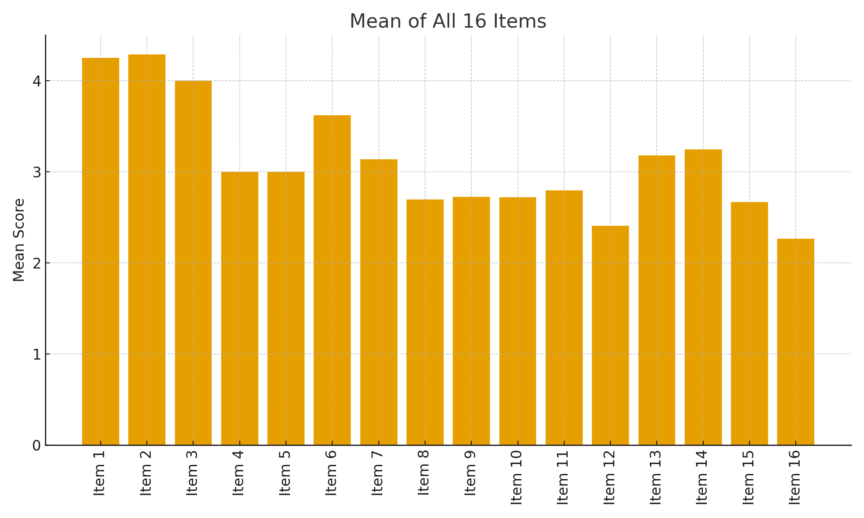
5.2 Internal Consistency Reliability
Alert Fatigue, Attention Disruption, and Mental Well-Being Impact demonstrated acceptable reliability levels, while Notification Frequency showed low internal consistency due to the variability of students’ notification patterns
Table 2
Cronbach’s Alpha for Four Subscales
Subscale | M | SD | Interpretation
Notification Frequency | 3.88 | 0.42 | High
Alert Fatigue | 3.11 | 0.80 | Moderate
Attention Disruption | 2.66 | 0.81 | Low–Moderate
Mental Well-being Impact | 2.84 | 0.82 | Moderate

Figure 2
Item Means for the 16 Items
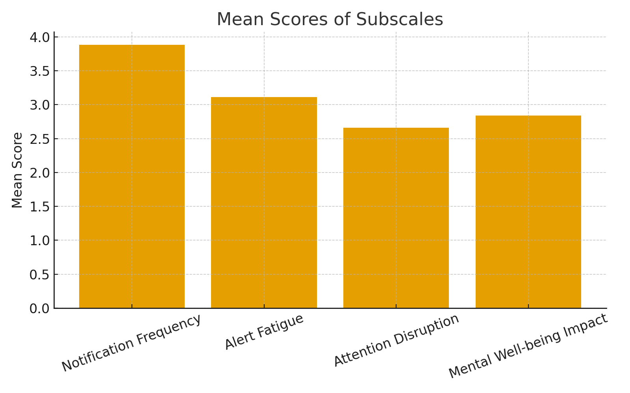
5.3 Correlation Analysis
Correlation results revealed weak associations between Notification Frequency and the other constructs. By contrast, Alert Fatigue showed a moderate relationship with Attention Disruption and a stronger association with Mental Well-Being Impact. The strongest relationship emerged between Attention Disruption and Mental Well-Being Impact, indicating that cognitive interference plays a key role in the emotional consequences of notifications.
Table 3
Pearson Correlations Among Subscales
Scale | α | Interpretation
Overall 16-item Scale | .80 | Good
Notification Frequency | — | Not reliable (items measure different aspects)
Alert Fatigue | .76 | Good
Attention Disruption | .78 | Good
Mental Well-being Impact | .61 | Acceptable

Figure 3
Correlation Heatmap
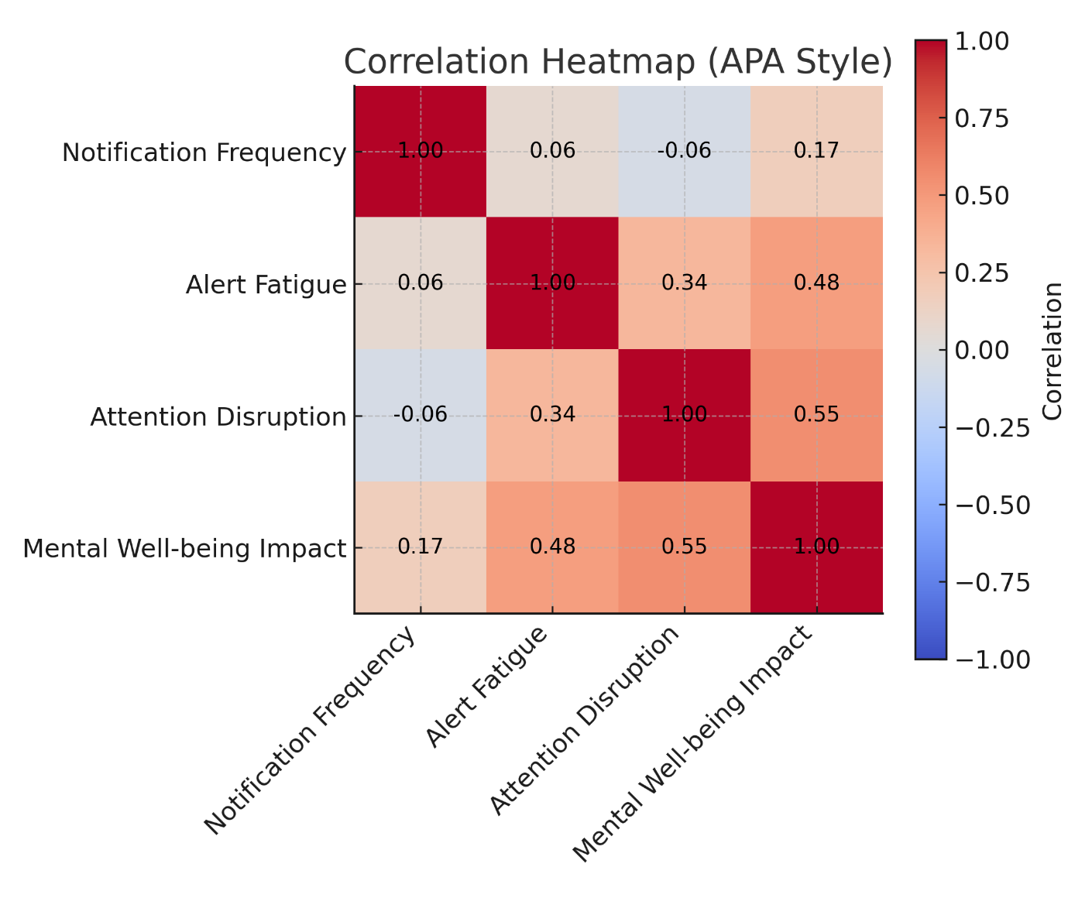
5.4 Gender Differences
Gender comparisons showed that female students reported higher levels of alert fatigue and emotional impact. No significant differences were found in notification frequency or attention disruption
Table 4
Gender Differences in Subscale Scores
Subscale | Male (M) | Female (M)
Notification Frequency | 3.85 | 3.98
Alert Fatigue | 2.98 | 3.58
Attention Disruption | 2.50 | 3.25
Mental Well-being Impact | 2.64 | 3.52

Figure 4
Mean Scores by Gender
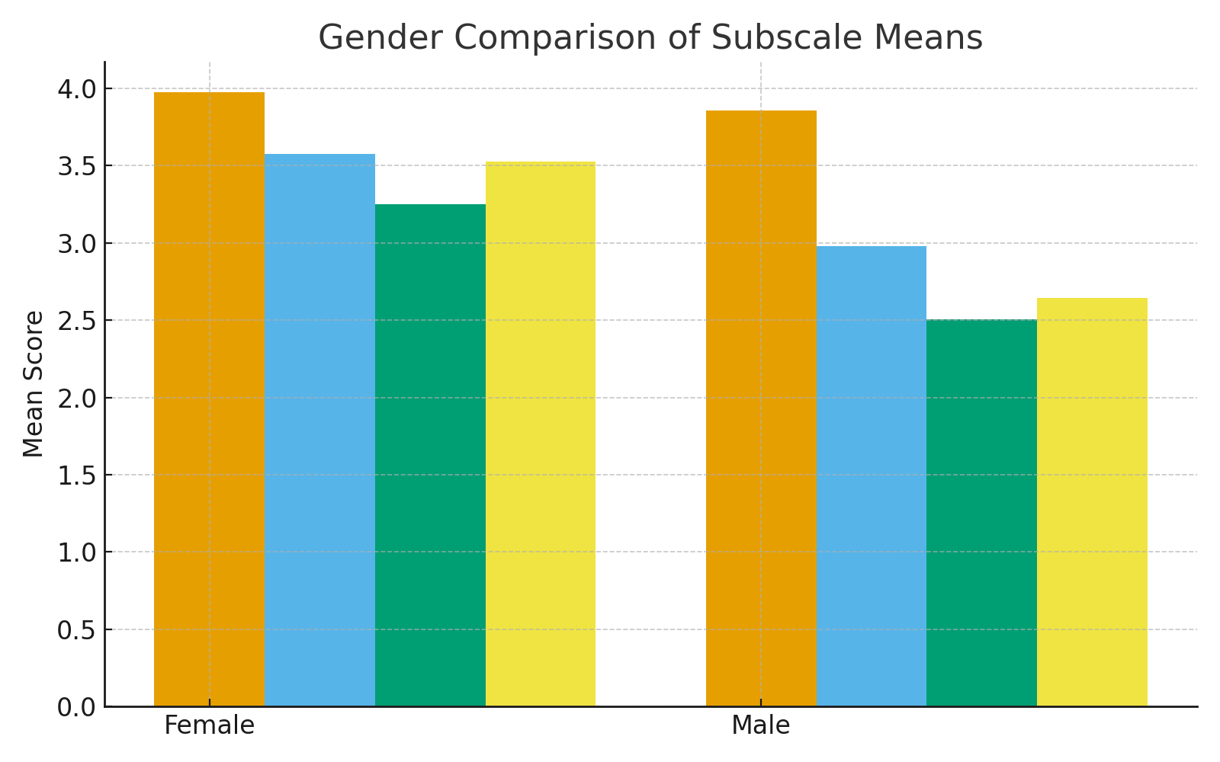
5.5 Summary of Quantitative Findings
Overall, the quantitative findings indicate that attention disruption and alert fatigue are more influential predictors of mental well-being than notification frequency. These results highlight the cognitive and emotional mechanisms through which notifications affect students.
6. Qualitative Findings
The thematic analysis of 18 semi-structured interviews revealed three major themes that describe students’ subjective experiences with smartphone notifications: (1) Cognitive Intrusion and Loss of Focus, (2) Emotional Overload and Alert Fatigue, and (3) Challenges in Digital Self-Regulation.
Table 5
Themes, Subthemes, and Illustrative Statements
Theme | Subthemes | Analytical Summary
1. Constant Connectivity as Cognitive Intrusion | Persistent mental preoccupation; Difficulty disengaging; Automatic checking | Participants described being mentally alert to their phones even without active notifications. Anticipation created continuous cognitive load and habitual checking behaviors, consistent with research showing that expectancy alone disrupts attention and working memory.
2. Emotional Strain and Alert Fatigue | Feeling overwhelmed; Stress and irritability; Notification overload | Frequent alerts led to emotional fatigue, frustration, and irritability. Students felt mentally taxed by repeated interruptions, reflecting findings that digital overload increases stress, vigilance, and emotional exhaustion.
3. Disrupted Focus and Academic Interference | Interrupted study flow; Difficulty resuming tasks; Reduced concentration | Students reported significant disruption during academic tasks. Notifications broke their focus, requiring extra time to regain attention. These experiences support evidence that smartphone cues impair cognitive control and slow task performance.
4. Attempts at Self-Regulation and Digital Control | Disabling notifications; Using Do Not Disturb; Selective app management | Participants used various strategies to mitigate distraction, though many found them only partially effective. Some experienced increased FOMO when notifications were disabled, echoing recent findings that notification blocking does not always improve well-being.
5. Personal Differences in Sensitivity | Varied tolerance; Gender-based emotional differences; Differences in attention control | Responses varied across individuals. Some students particularly females reported stronger emotional and cognitive reactions to notifications. Results align with research that attention control and individual differences shape susceptibility to distraction.

6.1 Cognitive Intrusion and Loss of Focus
Students consistently described notifications as intrusive and disruptive. Many reported difficulty maintaining concentration and returning to their tasks after an interruption. Automatic checking behaviors and loss of focus were commonly mentioned, reinforcing the quantitative finding that attention disruption heavily influences well-being.
6.2 Emotional Overload and Alert Fatigue
Participants described feelings of mental tiredness, frustration, and pressure to respond quickly. Persistent alerts created emotional overload, mirroring the quantitative relationship between alert fatigue and mental well-being impact. Students expressed that the emotional strain—not the number of notifications—was the most challenging aspect.
6.3 Challenges in Digital Self-Regulation
Students acknowledged difficulties managing their own smartphone habits. Although many desired fewer interruptions, they were reluctant to disable notifications due to academic responsibilities, habit strength, or fear of missing out. These challenges echo literature findings that self-regulation requires more than simply adjusting device settings.
6.4 Summary of Qualitative Findings
The qualitative findings demonstrate that smartphone notifications affect students through cognitive intrusion, emotional fatigue, and difficulties in self-regulation. These themes help explain why attention disruption and alert fatigue were the strongest predictors of well-being in the quantitative phase.
7. Discussion
The present study examined how smartphone notification patterns influence alert fatigue, attention disruption, and mental well-being among university students using a mixed-methods approach. The findings indicate that, although students receive notifications frequently, the number of alerts alone does not significantly predict cognitive or emotional outcomes. Instead, alert fatigue and attention disruption emerged as the most influential factors affecting students’ well-being. The qualitative findings further supported this conclusion by demonstrating that students experience notifications as cognitively intrusive, emotionally overwhelming, and difficult to regulate.
Although students were highly exposed to notifications, notification frequency showed weak associations with psychological variables. This suggests that it is not the volume of alerts but their disruptive nature that poses challenges. These results align with previous studies showing that even subtle cues such as vibrations or illuminated screens can impair attention and working memory (Upshaw et al., 2022; Kaminske et al., 2022). Recent research has also shown that disabling notifications may not improve well-being, as underlying cognitive habits and anticipatory attention often remain unchanged (Dekker et al., 2024). The current findings reinforce this view by demonstrating that internal psychological responses play a stronger role than external alert frequency.
Attention disruption proved to be a central mechanism linking notifications to mental well-being. Students who reported difficulty maintaining focus also expressed higher levels of emotional strain, including frustration and cognitive overload. This supports the model proposed by Chu et al. (2021), which suggests that distraction leads to cognitive–emotional preoccupation and reduced well-being. Xavier et al. (2024) similarly found that smartphone distractions impair attention control among young adults. The moderate to strong correlations observed between attention disruption and mental well-being impact in this study further emphasize the importance of attentional processes in understanding digital interruptions.
Alert fatigue also emerged as a meaningful construct. Interview participants frequently described feelings of mental exhaustion, pressure to respond quickly, and emotional overwhelm caused by constant alerts. These experiences mirror findings from Zhang et al. (2023) and Krebs and Kuhn (2025), who reported that persistent digital interruptions increase stress and emotional burden. The overlap between alert fatigue and mental well-being outcomes suggests that the emotional strain associated with notifications is an important component of students’ digital experiences.
Interestingly, many students expressed reluctance to disable notifications despite finding them disruptive. Their concerns centered around missing academic updates, losing social connection, or breaking established habits. This reflects findings from Dekker et al. (2024), who observed that notification disabling may increase fear of missing out (FOMO) rather than alleviate it. These patterns indicate that digital self-regulation is shaped not only by technological settings but also by internal habits and emotional expectations.
Small but meaningful gender differences were also identified, with female students reporting higher levels of alert fatigue and emotional impact. This aligns with previous research showing that women often experience stronger emotional responses to digital interruptions (Vedechkina & Borgonovi, 2021). Although gender was not a primary focus of the study, these findings suggest variations in digital stress across demographic groups.
Overall, the integration of quantitative and qualitative results indicates that the psychological impact of smartphone notifications is driven more by cognitive and emotional mechanisms such as attention disruption and alert fatigue than by the raw number of notifications received. These findings contribute to ongoing debates about digital well-being and underscore the importance of helping students manage both external digital interruptions and internal responses to smartphone use.
8. Conclusion
This study investigated how smartphone notifications influence alert fatigue, attention disruption, and mental well-being among university students using a mixed-methods design. The combined findings show that the negative effects of notifications are not primarily determined by how frequently they occur but by the cognitive and emotional processes they activate. Alert fatigue and attention disruption consistently emerged as the strongest predictors of mental well-being outcomes, whereas notification frequency played a minimal role.
The qualitative findings provided important context for interpreting these results. Students described notifications as intrusive, mentally draining, and difficult to regulate, often leading to disrupted focus, emotional overload, and habitual checking behaviors. These experiences reinforce the quantitative evidence that attentional interference and emotional fatigue operate as key pathways through which notifications influence well-being. The reluctance of many students to disable notifications, despite acknowledging their negative effects, suggests that internal factors such as anticipatory attention, FOMO, and digital dependence play a significant role in shaping smartphone-related stress.
Overall, the study contributes to the growing body of research on digital well-being by demonstrating that the psychological impact of smartphone notifications extends beyond frequency of use. Instead, the quality of interruptions how they affect attention, cognition, and emotional states determines their influence on student well-being. These insights underscore the importance of promoting digital hygiene, supporting students in developing healthier smartphone habits, and designing less intrusive notification systems. Future research should explore targeted interventions that address both technological and psychological dimensions of notification management.
9. Implications
The findings of this study have important implications for students, educators, and institutions seeking to promote digital well-being. First, the results indicate that the negative effects of smartphone notifications arise primarily from cognitive and emotional responses rather than from the frequency of notifications. This suggests that digital well-being initiatives should focus on strengthening students’ attention control, emotional regulation, and awareness of digital habits. Educators may consider incorporating digital hygiene training into orientation sessions or study skills programs to help students manage academic and social notifications more effectively.
Second, the strong association between attention disruption and mental well-being highlights the need for instructional practices that minimize digital interruptions during learning activities. Encouraging the use of focus modes, silent study periods, or task-specific device settings may help reduce cognitive fragmentation. Institutions can also support digital well-being by raising awareness of the psychological impact of notifications and promoting balanced smartphone use.
Finally, the emotional burden associated with alert fatigue suggests that app designers and developers should consider less intrusive notification systems. Adaptive or context-aware notification settings—such as grouping messages, delaying non-urgent alerts, or limiting interruptions during study periods—may help reduce emotional overload. These findings emphasize the shared responsibility among students, educators, and technology platforms in supporting healthier digital engagement.
10. Limitations
Although this study provides valuable insights, several limitations should be acknowledged. First, the use of convenience sampling limits the generalizability of the findings beyond the specific university context. Future studies with larger, more diverse samples may offer broader perspectives on notification-related experiences. Second, the reliance on self-reported data for the quantitative measures introduces the potential for response bias. Objective tracking of notification patterns or screen time could strengthen future analyses.
Third, the Notification Frequency subscale demonstrated low reliability, suggesting variability in how students interpret and experience notification volume. Developing a more refined instrument or using digital logs may help capture frequency more accurately. Fourth, although the qualitative sample provided rich insights, it was limited to 18 participants. A larger qualitative sample or the inclusion of focus groups could deepen understanding of digital behaviors.
Finally, this study focused primarily on cognitive and emotional outcomes. Other factors—such as personality traits, academic workload, or social contexts—were not examined but may influence how students respond to notifications. Future research could explore these variables within a more comprehensive theoretical framework.
11. Recommendations and Future Research
Based on the findings of this study, several recommendations are proposed. Students should be encouraged to adopt digital hygiene strategies that prioritize intentional smartphone use, including scheduled checking times, use of focus modes, and removal of non-essential notifications. Educators may integrate digital well-being practices into coursework or student development programs, emphasizing attention management and emotional awareness.
Institutions can support students by offering workshops, resources, or campaigns promoting balanced digital habits. Collaboration with app designers to adopt less intrusive notification patterns may also contribute to reducing alert fatigue and cognitive strain.
For future research, examining the influence of personality characteristics—such as impulsivity or conscientiousness—may offer insight into individual differences in response to notifications. Longitudinal studies could explore how digital behaviors evolve over time and how interventions affect attention and well-being. Additionally, integrating biometric or neurological measures may help further uncover the cognitive processes underlying digital interruptions.

COMPETING INTERESTS DISCLAIMER:
Authors have declared that they have no known competing financial interests OR non-financial interests OR personal relationships that could have appeared to influence the work reported in this paper.

References:
- Chu, J., Qaisar, S., Shah, Z., & Jalil, A. (2021). Attention or distraction? The impact of mobile phone on users’ psychological well-being. Frontiers in Psychology, 12, 612127. https://doi.org/10.3389/fpsyg.2021.612127
- Dekker, C. A., Baumgartner, S. E., Sumter, S. R., & Ohme, J. (2024). Beyond the buzz: Investigating the effects of a notification-disabling intervention on smartphone behavior and digital well-being. Media Psychology, 28(1), 162–188. https://doi.org/10.1080/15213269.2024.2334025
- Kaminske, A., Brown, A., Aylward, A., & Haller, M. (2022). Cell phone notifications harm attention: An exploration of the factors that contribute to distraction. European Journal of Educational Research, 11(3), 1487–1494. https://doi.org/10.12973/eu-jer.11.3.1487
- Krebs, M., & Kuhn, C. (2025). Consciously navigating the digital everyday: Focus, attention, and distraction. In More SMART than PHONE – Focused and Inspired Work (pp. 5–25). Springer. https://doi.org/10.1007/978-3-662-72149-0_2
- Lekaj, N., & Orehovački, T. (2025). Interruptions or assistance: The impact of mobile notifications. In 2025 MIPRO 48th ICT and Electronics Convention (pp. 1570–1575). IEEE. https://doi.org/10.1109/MIPRO65660.2025.11131960
- Olson, J. A., Sandra, D. A., Chmoulevitch, D., Raz, A., & Veissière, S. P. (2021). A ten-step behavioural intervention to reduce screen time and problematic smartphone use. PsyArXiv Preprints. https://doi.org/10.31234/osf.io/tjynk
- Savoldelli, F. (2020). Smartphone Notifications' Distractions During a Full-attention Activity. (Master's thesis, Leiden University, LIACS). https://www.universiteitleiden.nl/en/research/research-output/liacs/smartphone-notifications-distractions-during-a-full-attention-activity
- Siebert, P. R., Mouloua, M., Deese, S., & Barrese, N. F. (2006). Cell phone and driver distraction: An experimental analysis [Dataset]. In PsycEXTRA Dataset. American Psychological Association. https://doi.org/10.1037/e529012007-001
- Shelton, J. A., Elliott, E. M., & Metzger, R. L. (2004). The effect of cell phone distraction on working memory [Dataset]. In PsycEXTRA Dataset. American Psychological Association. https://doi.org/10.1037/e537052012-383
- Topalli, B. (2016). The mobile phone & its impact in teenagers`daily life. European Scientific Journal, 12(8), 161–176. https://doi.org/10.19044/esj.2016.v12n8p161
- Toth, R., Parry, D. A., & Emmer, M. (2024). Smartphone Use in Germany in 2023: A Mixed-Method Investigation. SocArXiv. https://doi.org/10.31235/osf.io/k249t
- Upshaw, J. D., Stevens Jr., C. E., Ganis, G., & Zabelina, D. L. (2022). The hidden cost of a smartphone: The effects of smartphone notifications on cognitive control from a behavioral and electrophysiological perspective. PLOS ONE, 17(11), e0277220 https://doi.org/10.1371/journal.pone.0277220
- Vasquez, A. (2025). Influence of mobile phone presence on cognitive performance: An experimental study using the Loomlock device. Clinical Medicine and Health Research Journal, 5(6). https://doi.org/10.18535/cmhrj.v5i06.546
- Vedechkina, M., & Borgonovi, F. (2021). A review of evidence on the role of digital technology in shaping attention and cognitive control in children. Frontiers in Psychology, 12, Article 611155. https://doi.org/10.3389/fpsyg.2021.611155
- Xavier, C., Cataldo, W., Siqueira, S. W. M., Garcia, A. C., & Mello, C. (2024). Understanding the negative effects of social networking mobile app notifications on the attention of young people and adults: A systematic literature mapping. In Proceedings of the 57th Hawaii International Conference on System Sciences. https://doi.org/10.24251/HICSS.2024.667
- Xia, L., Liu, D., & Wei, M. (2023). Fear of missing out and mobile phone dependence: A meta-analytic review. Computers in Human Behavior, 143, 107712. https://doi.org/10.1016/j.chb.2023.107712
- Zhang, Y., Shang, S., Tian, L., Zhu, L., & Zhang, W. (2023). The association between fear of missing out and mobile phone addiction: A meta-analysis. BMC Psychology, 11(1). https://doi.org/10.1186/s40359-023-01376-z

