Original Research Article

Beyond the Blueprint: A Multiple Case Study on Bridging the Gap between the Intended and Lived Realities of Physical Education under the MATATAG Curriculum

.
ABSTRACT
Aims: To explore the experiences of Grades 1–2 teachers implementing the MATATAG Physical Education curriculum, identify the challenges encountered in classroom practice, and describe the contextual factors and strategies that shaped curriculum implementation across different school environments.

Study Design: This study utilized a qualitative multiple case study design to explore the lived experiences of elementary teachers implementing the MATATAG Physical Education curriculum in Grades 1 to 2. Five teachers, each representing a distinct school context, were examined to identify shared challenges, contextual influences, and adaptive strategies used to bridge gaps between intended and actual PE curriculum implementation.

Place and Duration of the Study: The research was conducted in five elementary schools of two private (sectarian and non-sectarian) and three public (small-, medium-, and large-sized) located in Malita, Davao Occidental, Philippines. Data collection, including interviews and classroom observations, was carried out from July 2025 to November 2025.

Methodology: This qualitative multiple case study examined five teachers implementing the MATATAG Physical Education curriculum in selected elementary schools in Malita, Davao Occidental. Data were gathered through semi-structured interviews, and classroom observations, with all interviews recorded and transcribed. Participants were purposively selected based on their involvement in teaching the curriculum. Data were analyzed using Creswell’s iterative coding and cross-case comparison procedures. Credibility and rigor were maintained through triangulation, member checking, and reflexive documentation. Ethical clearance was obtained, and all participants provided informed consent.

Conclusion: The analysis revealed common challenges across cases, including limited time, space, equipment, and training for Physical Education. Implementation quality varied depending on school support and resources, with better-resourced schools adapting more effectively. Teachers used improvised materials, ICT, and classroom-based activities to address constraints. Overall, the findings show a persistent gap between curriculum expectations and actual classroom conditions.

Keywords: Physical Education, MATATAG Curriculum, Philippine Basic Education, Curriculum Implementation, Multiple Case Study

1. INTRODUCTION

Physical Education in the early grades is vital for developing motor skills, healthy habits, and positive attitudes toward activity. Under the MATATAG Curriculum in the Philippines, PE is integrated into MAKABANSA, requiring teachers to embed physical activities within character-building, cultural, and citizenship competencies. While this reform aims to strengthen core values, it introduces pedagogical and logistical challenges, especially in early grades with varied classroom routines, developmental readiness, and limited resources.

Teachers often struggle to translate competencies into meaningful PE experiences due to limited space, inadequate facilities, diverse learner needs, and shifting priorities. These challenges vary across schools, affecting the consistent achievement of curriculum goals. Examining teachers’ lived experiences provides critical insight into what works, what is difficult, and what support is needed to bridge policy and practice.

This case-based study highlights contextual factors influencing curriculum implementation, showcases adaptive strategies, and offers evidence to guide improvements in training, resources, and school support. It underscores the need for responsive, context-sensitive approaches to strengthen Physical Education under the MATATAG reform.

2. METHODOLOGY

2.1 Research Design

This study employed a qualitative multiple case study design, which enabled an in-depth exploration of the lived experiences of elementary teachers implementing the MATATAG Physical Education curriculum. Consistent with Creswell (2013; 2018), this approach allowed the researcher to examine each case as a bounded system while making cross-case comparisons to identify convergent and divergent patterns. Data were generated through in-depth interviews, classroom observations, and document review, ensuring a holistic understanding of how the intended curriculum was adapted within real classroom environments.

2.2 Study Site

The study was conducted in Malita, Davao Occidental, a municipality characterized by diverse geographic and socio-economic conditions. The locality contains both resource-rich and resource-limited schools, making it a suitable setting for examining contextual influences on curriculum implementation. Five elementary schools; two private and three public; were purposively selected to reflect variations in size, governance, and access to instructional resources.

2.3 Case Units

Five teachers handling Grades 1–2 under the MATATAG Curriculum served as primary participants. All were non-vulnerable adults aged 24–60 with at least two years of teaching experience. Each teacher constituted one case unit. To strengthen triangulation, two supplementary informants were interviewed per case, such as co-teachers, coordinators, ICT heads, year-level leaders, or administrators. This ensured that teacher narratives were corroborated from peer, supervisory, and institutional perspectives.

2.4 Data Sources

Primary data consisted of:
      - Transcribed in-depth interviews with the five teachers and their supporting informants;
      - Classroom observations focusing on instructional delivery, learning environment, and PE integration;
      - Supplementary documents, including lesson plans and school memos relevant to curriculum enactment.

2.5 Data Collection

Before data gathering, the researcher secured approval from the Research Ethics Committee, the Graduate School Dean, and the Schools Division Superintendent, followed by formal permission from participating school principals. Each participant received an Informed Consent Form, which was explained thoroughly prior to signing. Voluntariness, confidentiality, the right to skip questions, and the right to withdraw at any time were emphasized.
Data collection involved 30–45-minute one-on-one interviews, scheduled at convenient times for participants. When clarification was needed, follow-up communication was initiated upon the participant’s consent. Classroom observations were conducted on pre-agreed schedules and documented through field notes. All procedures complied with the Data Privacy Act of 2012, including anonymization and secure data handling.

2. 6 Data Analysis

Analysis followed Creswell’s (2013) multi-level approach. First, each case underwent within-case analysis, where interview transcripts, observation notes, and documents were read repeatedly and coded inductively. Initial descriptive codes were clustered into emerging themes that represented each case’s contextual realities.
Next, a cross-case analysis was conducted to compare themes across all cases, identifying shared challenges, unique experiences, and structural or contextual influences. Constant comparison, thematic mapping, and analytic memoing supported iterative refinement of themes. Member checking, triangulation of data sources, and an audit trail were used to ensure accuracy and analytic transparency.

2.7 Trustworthiness
Rigor was established through four criteria:
    - Credibility – prolonged engagement, triangulation, and member checking ensured that interpretations accurately reflected participant realities.
    - Transferability – rich, thick descriptions of context and participant experiences allow readers to determine applicability to their settings.
    - Dependability – systematic documentation of procedures enabled replication and demonstrated methodological consistency.
    - Confirmability – reflexive journaling, an audit trail, and strict data-based interpretation minimized researcher bias.

2.8 Role of the Researcher
As the primary instrument of data collection and analysis, the researcher facilitated interviews, conducted observations, and maintained reflexive notes to monitor personal assumptions. Prior experience as a physical education teacher in Malita provided contextual familiarity, which was managed through reflexivity to avoid undue influence on interpretation.

2.9 Ethical Considerations
The study adhered to institutional and national ethical standards. Approval from the University of the Immaculate Conception Research Ethics Committee confirmed compliance with protocols for studies involving human participants. Informed consent, confidentiality, voluntary participation, secure data storage, and the right to withdraw were strictly observed. Pseudonyms were used in all reports to safeguard participant identity.
3. results and discussion

TABLE 1. Profile of the Participants

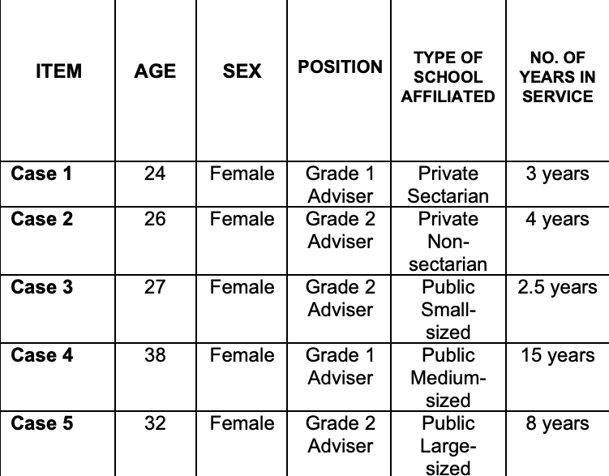

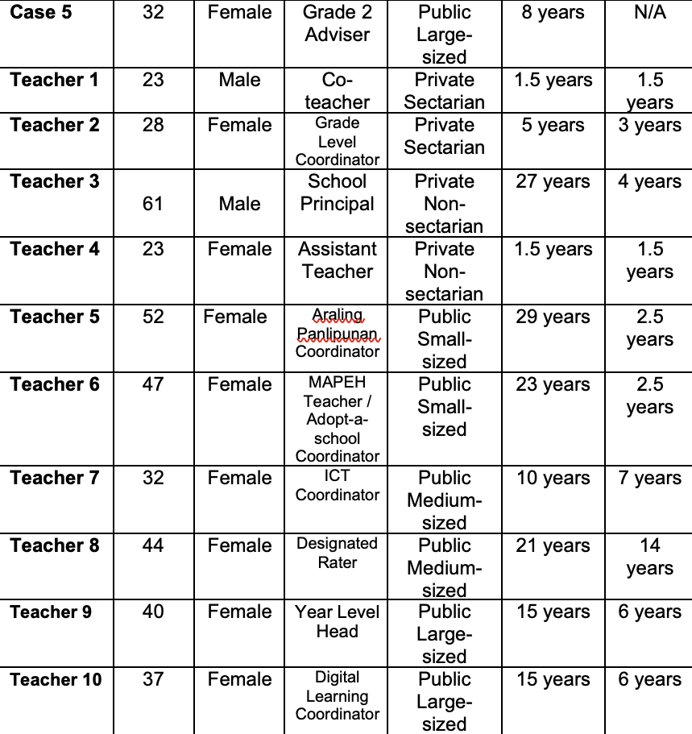

3.1 CROSS-CASE ANALYSIS

Underscored in this Table are the similarities and differences among the five cases in the context of the challenges in implementing MATATAG Physical Education in actual school setting, contextual factors contributing to the implementation of physical education curriculum, and strategies teachers employ to navigate curriculum gaps and deliver meaningful physical education instructions.

Table 2
Similarities and Differences of the Challenges, Contextual factors, and Strategies in implementing the MATATAG Physical Education curriculum in the actual school setting.
Themes on Challenges, Contextual Factors, and Teaching Strategies | Case Unit |  | Remarks
 | Similar | Different | Remarks
Challenges
Managing Classroom Behavior and Student Engagement | 3, and 4 | 1, 2, and 5 | Cases 3 and 4 faced engagement challenges due to limited space and large classes, adapting through ICT tools, music, and outdoor areas. Meanwhile, Cases 1, 2, and 5 managed behavior differently, Case 1 handled frequent distractions, Case 2 benefited from a small and flexible class setup, and Case 5 addressed restlessness with constant safety reminders.
Learner Diversity and Inclusivity | 3, and 5 | 1, 2, and 4 | Cases 3 and 5 highlighted differentiated instruction to support diverse learners. Meanwhile, Cases 1, 2, and 4 approached inclusivity differently. Case 1 navigated language barriers in teaching MAKABANSA, Case 2 supported a student with autism while ensuring fairness, and Case 4 adjusted expectations for a Muslim student with limited participation in dance activities.
Parental and Administrative Involvement | 2, 3, and 5 | 1, and 4 | Cases 2, 3, and 5 emphasized strong parental and administrative support, which fosters successful PE activities and a positive learning environment. Cases 1 and 4 also noted support but with conditions—Case 1 experienced inconsistent school backing and often turned to parents, while Case 4 received support accompanied by questions about curriculum changes, which were accepted as long as core subjects stayed prioritized.
Curriculum Shifts and Adjustments |  | 1, 2, 3, 4, and 5 | All cases experienced different challenges and approaches regarding curriculum shifts and adjustments in Physical Education.
Contextual Factors
Pedagogical Flexibility amid Physical Facility Constraints |  | 1, 2, 3, 4, and 5 | All cases faced unique challenges and developed different approaches to pedagogical flexibility amid physical facility constraints in Physical Education.
Administrative Guidance and Support | 1,2, and 3 | 4, and 5 | Cases 1, 2, and 3 emphasized that strong administrative guidance is vital for effective teaching and manageable workloads. Cases 4 and 5 also recognized the value of support but noted different experiences—Case 4 received help limited by resource constraints, while Case 5 benefited from the MOOE fund, though the school’s large population sometimes caused shortages for certain activities.
Community Recognition Influencing PE Prioritization | 4, and 5 | 1, 2, and 3 | Cases 4 and 5 emphasized strong parental support that helps prioritize PE in their schools. Cases 1, 2, and 3 also acknowledged community involvement but with varied experiences—Case 1 noted parents’ focus on academics and safety, Case 2 shared that PE activities are still developing in their new elementary department, and Case 3 observed that parents support school events to encourage physical play as children become more engaged with digital games.
Student-centered Approaches in Physical Education | 1, and 2 | 3, 4, and 5 | Cases 1 and 2 emphasized creating supportive, student-centered environments where learners participate at their own comfort level. Cases 3, 4, and 5 also used student-centered approaches—Case 3 respected religious considerations in dance activities, Case 4 adapted to varied abilities, and Case 5 prioritized student enjoyment while navigating MATATAG-related challenges.
Teaching Strategies
Creativity and Innovation in Resource-Constrained Environments | 1, and 2 | 3, 4, and 5 | All five cases demonstrated creativity and innovation despite limited resources. Cases 1 and 2 relied on hands-on adjustments to engage learners, while Cases 3, 4, and 5 used varied strategies—Case 3 filled budget gaps with personal funds, Case 4 tailored lessons to available materials, and Case 5 revised plans to match classroom realities, highlighting flexibility and resourcefulness.
Instructional Flexibility | 2, 4, and 5 | 1, and 3 | Cases 2, 4, and 5 showed instructional flexibility by adjusting lessons to student needs and available resources. Cases 1 and 3 also adapted creatively—Case 1 used ChatGPT to update outdated materials and align lessons with competencies, while Case 3 provided supplies for learners who couldn’t afford them, promoting equity and inclusion.
Interest-driven in PE Classes | 2, and 3 | 1, 4, and 5 | Cases 2 and 3 emphasized interest-driven activities to keep students engaged in PE. Cases 1, 4, and 5 also promoted engagement through different approaches—Case 1 encouraged talent-showcasing to build confidence, Case 4 used varied materials to keep lessons interactive, and Case 5 maintained high energy and a strong voice to keep young learners active.
Collaborative Practices to Bridge Gaps | 3, 4, 5 | 1, 2 | Cases 3, 4, and 5 emphasized collaboration through idea-sharing, brainstorming, and modifying activities to improve lesson delivery. Cases 1 and 2 also practiced collaboration but more minimally—Case 1 joined colleagues in organizing school events without peer-teaching, while Case 2 found peer-teaching unnecessary due to small classes and relied on assistant support instead.

This study underscores the crucial role of teacher adaptability in implementing the MATATAG Physical Education curriculum (Jones & Whipp, 2020). Effective PE instruction depends not only on curriculum design but also on teachers’ ability to modify lessons, improvise materials, and use alternative spaces in resource-constrained environments, ensuring meaningful participation and equitable access (Trabelsi et al., 2021; Petrie et al., 2024).​

Inclusive, interest-driven approaches were key to sustaining student motivation and engagement (Kumar & Naidoo, 2021). By aligning activities with learners’ cultural backgrounds, preferences, and developmental readiness, teachers supported physical competence, social-emotional growth, and a sense of belonging (Opstoel et al., 2022).​

Collaboration, administrative support, and community involvement also proved essential (Petrie et al., 2024). Shared planning and peer support enhanced instructional capacity, while leadership and parental engagement provided the structural and motivational backing for innovation (Ahmed & Konukman, 2022). These findings highlight that successful curriculum implementation relies on the interplay of teacher creativity, learner-centered strategies, and systemic support, with implications for professional development, school leadership, and policy (Kumar & Naidoo, 2021).

4. Conclusion

This study revealed that teachers implementing the MATATAG Physical Education curriculum face challenges such as limited facilities, diverse learner readiness, and time constraints due to curriculum integration. Despite these barriers, teachers demonstrated adaptability, creativity, and learner-centered strategies to sustain student engagement and achieve curriculum goals. Collaboration among teachers, support from administrators, and community involvement were identified as key factors in bridging the gap between the intended curriculum and classroom realities. These findings underscore the importance of contextualized, inclusive, and supported approaches to Physical Education in promoting holistic child development.

COMPETING INTERESTS DISCLAIMER:
Authors have declared that they have no known competing financial interests OR non-financial interests OR personal relationships that could have appeared to influence the work reported in this paper.

References

- Ahmed, M. D., & Konukman, F. (2022). Enhancing Students’ Learning of Social Inclusion in Team Activities Through Physical Education. Journal of Physical Education, Recreation & Dance. https://doi.org/10.1080/07303084.2022.2006023
- Creswell, J. W. (1997). Qualitative Inquiry and Research Design: Choosing Among the Five Traditions. Sage Publications. https://books.google.com/books/about/Qualitative_Inquiry_and_Research_Design.html?id=220_QgAACAAJ
- Creswell, J. W., & Poth, C. N. (2018). Qualitative inquiry and research design: Choosing among five approaches (4th ed.). SAGE Publications. https://edge.sagepub.com/creswellqualitativeinquiry4e
- Jones, R., & Whipp, P. (2020). Reflective teaching and curriculum adaptation in physical education: Insights from urban and rural schools in Australia and New Zealand. Sport, Education and Society, 25(7), 743-758. https://doi.org/10.1080/13573322.2019.1655497
- Kumar, S., & Naidoo, G. (2021). Professional development and reflective practice in physical education: Enhancing culturally relevant pedagogy in diverse school settings. International Journal of Sport and Exercise Psychology. https://doi.org/10.1080/1612197X.2021.1885276
- Opstoel, K., Prins, F., Jacobs, F., Haerens, L., van Tartwijk, J., & De Martelaer, K. (2022). Physical education teachers’ perceptions and operationalisations of personal and social development goals in primary education. European Physical Education Review, 28(4), 968-984. https://doi.org/10.1177/1356336X221102300
- Petrie, K., Johnson, M., & Lee, S. (2024). The role of school culture and administrative support in physical education curriculum implementation. Journal of Physical Education and Sport Pedagogy, 29(1), 45–59. https://doi.org/10.1080/17408989.2023.2187654
- Trabelsi, O., Bouchiba, M., Souissi, M. A., Gharbi, A., Mezghanni, N., Kammoun, M., Masmoudi, L., & Mrayeh, M. (2021). Technology-mediated Physical Education teaching practices in Tunisian public schools: a national teacher survey. Sport, Education and Society, 27(7), 878–892. https://doi.org/10.1080/13573322.2021.1926962

Definitions, Acronyms, Abbreviations

MATATAG Curriculum. To enhance learning and growth in public schools, the Philippine Department of Education (DepEd) introduced the MATATAG curriculum, a complete educational framework. With an emphasis on values education, fundamental skills, and reducing content overload, it promotes inclusive, culturally relevant, and holistic teaching techniques (Balansag, 2024). This study highlights the importance of looking at the real-world experiences and execution of these proposed curriculum design improvements in physical education classrooms. It also reveals potential gaps between policy and practice.

MAKABANSA subject. This term is a transdisciplinary subject introduced in the Philippine MATATAG Curriculum for Grades 1-3, integrating concepts from Araling Panlipunan (Social Studies) and MAPEH (Music, Arts, Physical Education, and Health) to foster holistic development. Unlike the former Makabayan subject, which combined multiple areas into one grade, MAKABANSA uses a unified approach to build students' self-awareness, cultural identity, physical health, creativity, and community engagement without lumping separate subjects.

