Augmented Reality-Enhanced E-module on Chemical Bonding in Salacca Fruit: Effects on High School Students' Spatial Ability

Learning chemical bonding in high school requires high spatial ability to visualize abstract concepts. This study aims to test the effectiveness and practicality of an e-module for chemical bonding practicum based on salak fruit content integrated with Augmented Reality (AR) on students' spatial abilities. Using a quasi-experimental pretest-posttest control group design. The study involved 66 tenth-grade students (experimental group n=33, control group n=33) from three high schools in Padangsidimpuan and three chemistry teachers. Data were analyzed using N-gain scores, independent sample t-tests, and descriptive percentage analysis. The results showed that the e-module was highly effective with an N-gain of 0.85 (high category) and the spatial ability score of the experimental class (80.61) was significantly higher than that of the control class (70.30) with t=3.552 (p=0.001). Teachers rated the practicality as very good: cover design and salak fruit integration (93.3%), material (91.1%), practicality (89.1%), spatial ability (88.3%), language (86.9%), and AR use (78.3%). Students gave positive responses (82.3%) on the aspects of AR (85%), language (82%), and appearance (80%). The practical e-module proved to be effective and practical in improving spatial ability by integrating AR technology and the local context of salak fruit to bridge abstract concepts into concrete ones.
.

Keywords: augmented reality; chemical bonding; e-module practicum; salak fruit; spatial ability

1. INTRODUCTION

The era of the 4.0 industrial revolution has changed the paradigm of learning from conventional models to more interactive and innovative digital learning. Chemistry learning, especially chemical bonding material, faces complex challenges due to its abstract nature and requires high three-dimensional visualization skills to understand molecular structures and interactions between atoms (Chen, 2020). Practical activities can help students understand chemical bonding material and apply it into practical knowledge after learning the theoretical concepts. However, various obstacles such as safety factors, limited learning time, and a lack of laboratory equipment have caused some teachers to choose not to conduct practical activities. This condition has resulted in a decline in students' interest in conducting experiments in laboratories and in their spatial abilities (Pohan et al., 2024), (Tarng et al., 2021).
Currently, researchers are able to conduct experiments on a large scale and macro level through innovations and advances in virtual laboratories, which also serve as a platform for community collaboration and a source for fulfilling scientific needs (Iakovides et al., 2022), (Almaatouq et al., 2021). Advances in digital technology such as Augmented Reality (AR) provide great opportunities to transform chemistry learning to be more concrete and easier to understand. This technology provides the opportunity to visualize abstract concepts more interactively.
In chemical bonding learning, Augmented Reality facilitates students to observe and interact with three-dimensional molecular models, understand molecular geometry, and witness the process of bond formation in a more understandable way. These virtual objects then appear lifelike and real, as if they were in the same (3D) space (Turan & Karabey, 2023) as shown in Figure 1 below:

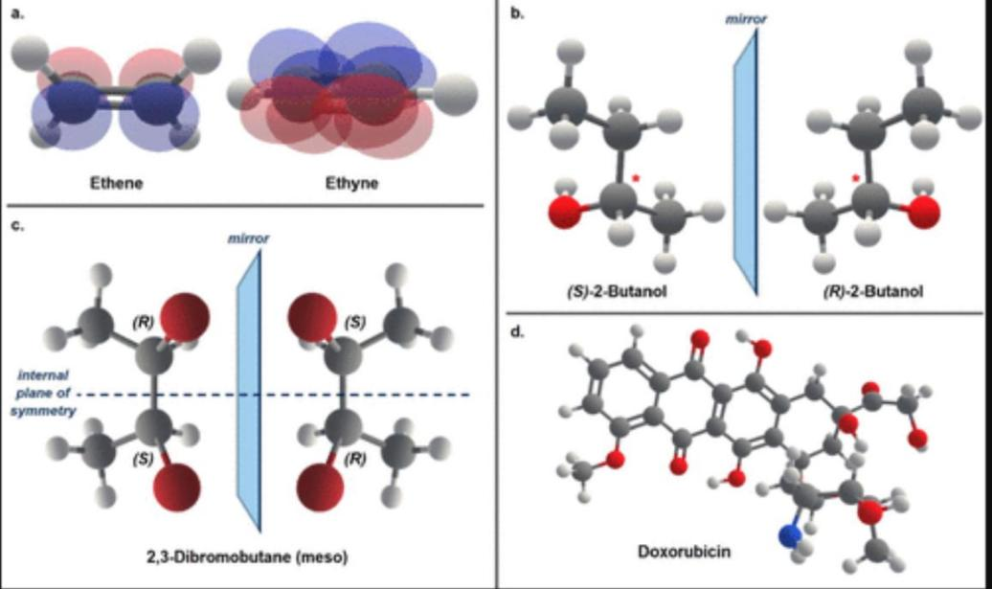
Figure 1. 3D Molecular Model

This study is considered important for several fundamental reasons in the context of modern chemistry education because spatial ability is a strong predictor of student success in understanding abstract chemistry concepts, especially molecular structure and chemical bonding (Harle & Towns, 2011), (Yip et al., 2019). Students with low spatial abilities tend to have difficulty visualizing molecular rotation, orbital orientation, and molecular geometry, which are crucial aspects in understanding chemical bonds (Lohman, 1979). The integration of local fruits in chemistry learning, such as salak fruit, which contains various complex organic compounds (carbohydrates, ascorbic acid, alanine, NaCl, and water), is expected to increase the relevance, motivation, and spatial abilities of students (Pohan et al., 2024).
The urgency of this research can be seen from several interrelated perspectives, namely from a pedagogical perspective. The results of the 2018 Programme for International Student Assessment (PISA) survey show that Indonesian students' science skills are still ranked 70th out of 78 countries, with a score of 396, which is still far below the OECD average (489) (Fuadi et al., 2020). Particularly in the field of chemistry, Indonesian students experience significant difficulties in understanding abstract concepts such as chemical bonds and molecular structures, which require good spatial abilities. Referring to the summary of the research results, students encountered difficulties in mastering the material on chemical bonds due to their dependence on learning media, where symmetry elements are often not presented in three dimensions in teaching materials, and their lack of understanding of chemical structure concepts is thought to stem from students' limited spatial capacity to convert molecular visualizations from 2D to 3D dimensions (Isaloka & Dwiningsih, 2020), (Battista et al., 1982), (Serrano-Ausejo & Mårell-Olsson, 2024).
A summary of the literature analysis shows that there is a significant research gap in several aspects, namely that although research on the use of AR in chemistry learning has developed rapidly, most of it focuses on the visualization of simple molecular structures and has not integrated local contexts that are relevant to the lives of students (Akçayır & Akçayır, 2017). Research on chemistry practicum e-modules generally still uses conventional approaches.

Methods

This study used a quasi-experimental design with a pretest-posttest control group design, using a comparison class consisting of a control class and a treatment class to test the effectiveness of the augmented reality-based e-module for salak fruit chemical bonding practical work in improving students' spatial abilities (Carbonell Carrera & Bermejo Asensio, 2017). Using a mixed method approach with without utilizing immersive technologies such as AR to enhance the learning experience of students.
The novelty of this research lies in several innovative aspects that have not been explored before, namely the integration of salak fruit content as a context for learning chemical bonds, which is a new approach that combines local fruit with modern technology. This research will identify various chemical compounds in salak fruit (ascorbic acid, alanine, carbohydrates, sodium chloride, and water) as authentic and relevant objects of chemical bonding study, which will be visualized in 3D objects.
This research is expected to make a significant contribution at several levels, namely at the theoretical level, enriching the body of knowledge about technology-based chemistry learning by integrating ethnochemistry perspectives and spatial abilities. Students showed enthusiasm in learning when teachers introduced the Augmented Reality platform as a new medium, and their spatial understanding could be developed through the use of Augmented Reality that had been designed in solving problems (Ozcakir, 2021). The research findings will provide new insights into how AR technology can effectively develop students' spatial abilities in the context of learning chemical bonds .
A sequential explanatory design, this approach was chosen because it can provide a more comprehensive understanding of the effectiveness of augmented reality-based practical e-modules on students' spatial abilities. The research population consists of all 10th grade MIA students at Padangsidimpuan State High School in the 2024/2025 academic year. The sample was selected using purposive random sampling from three schools, namely Padangsidimpuan State High Schools 1, 4, and 6. From each school, two intact groups were selected, namely class X MIA-1 as the experimental class and class X MIA-2 as the control class. This study collected two types of data, namely: 1) Quantitative data to measure the pretest and posttest scores of students' spatial abilities and the percentage scores of the practicality of the e-module from teachers and students. 2) Qualitative data to analyze the description of teachers' and students' perceptions of the practicality of the e-module.
The main research instruments were 1) a spatial ability test consisting of 10 multiple-choice questions to measure students' abilities in: (1) rotating molecular structures in three dimensions; (2) determining bond orientation in space; and (3) visualizing molecular shapes from two-dimensional to three-dimensional representations. The e-module had already been developed and validated in a previous study (Pohan et al., 2024), while this study only assessed the effectiveness and practicality of the e-module. 2) A practicality questionnaire and 3) A student response questionnaire. For the spatial ability pretest and posttest, the questions used must first be tested for feasibility through validity testing, reliability testing, difficulty level testing, and discrimination power testing using the SPSS25 program. Before the effectiveness test, prerequisite tests were conducted, including normality tests (Shapiro-Wilk test) and homogeneity tests (Levene's test), followed by an independent sample t-test to test the difference in spatial ability improvement between the experimental and control groups with a significance criterion of p<0.05. The effectiveness of the AR-based salak fruit chemical bonding practical e-module can be calculated using the N-Gain calculation with the formula:

N-Gain = $\frac{posttest-pretest score}{maximal score-pretest score}$

After obtaining the value using the above formula, it is then categorized using the N-Gain criteria as shown in Table 1 below:

Table 1. N-Gain Category
N-Gain | Category
>0,7 | High
0,3> N-Gain >0,7 | Medium
>0,3 | Low
Source : (Ramdhani et al., 2020)

The supporting instrument is a practical questionnaire sheet to describe teachers' and students' perceptions of the practicality of e-modules. To analyze the data from the practicality questionnaire, students' scores can be calculated and interpreted using the following formula:
P% = $\frac{∑f}{N x I x R}$
Description :
P% = percentage result
∑f = total score
N = highest score
I = number of indicators/aspects/statements
R = the number of respondents

Table 2. Interpretation of Practicality
Percentage | Category
0 – 20 % | Very poor
21 – 40 % | Not good
41 – 60 % | Pretty good
61 – 80 % | Good
81 – 100 % | Very good
Source : (Riduwan, 2016)

Results and Discussion

The research results are presented systematically in two main sections: quantitative findings and qualitative findings. Using an easily accessible chemistry practicum e-module, by clicking on the markers provided, students can see the compound content of salak fruit directly in 3D, as shown in the image below:

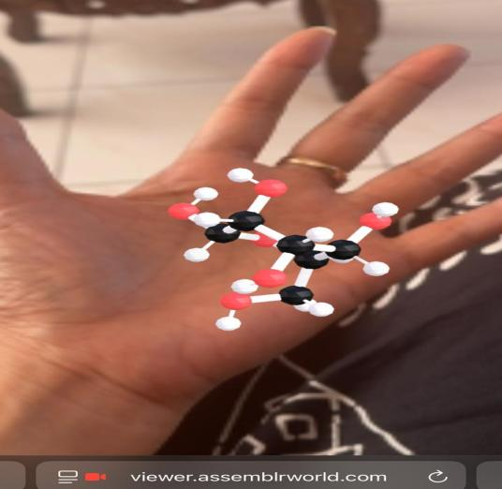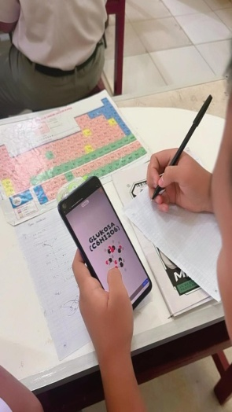
Image 2. 3D Augmented Reality View of Chemical Compounds in Salak Fruit

In line with the author's previous research (Pohan et al., 2024), when objects are displayed in three-dimensional format, the Assemblr application projects visualizations that provide users with an authentic visual stimulation experience through the representation of atomic arrangements in molecular geometric structures. The 3D representation of objects facilitates the illustration process, which was initially difficult to understand (Mansor et al., 2020). Research (Raja & Nagasubramani, 2018) reveals that learning technologies such as 3D visualization are effective tools for teachers in explaining concepts to students.
The augmented reality module is easy to use because it provides clear guidance and allows objects to be observed from various angles. (Fadhila et al., 2023) found that students' interest in learning increased with the use of AR technology, especially with the colorful design of the module. The application of AR in practical learning prioritizes visualization and user interaction with virtual objects in the real world, thereby helping students understand the abstract concept of molecular structure and develop their spatial abilities (Amirbekova et al., 2024).
Before presenting the data analysis of the learning outcomes of the experimental and control classes, the following are the test validation calculation results:

Table 3. Results of Spatial Ability Test Question Validation Calculations
No | R_{calculation} | R_{table} | Criteria | Classification
1 | 0.506 | 0.3440 | Valid | Medium
2 | 0.422 | 0.3440 | Valid | Medium
3 | 0.449 | 0.3440 | Valid | Medium
4 | 0.449 | 0.3440 | Valid | Medium
5 | 0.456 | 0.3440 | Valid | Medium
6 | 0.426 | 0.3440 | Valid | Medium
7 | 0.601 | 0.3440 | Valid | High
8 | 0.530 | 0.3440 | Valid | Medium
9 | 0.521 | 0.3440 | Valid | Medium
10 | 0.481 | 0.3440 | Valid | Medium

From the above analysis, it can be concluded that the spatial ability questions used consisted of 10 valid questions, meaning that these questions were used for the sample class test.

- Data on Spatial Ability Results of the Experimental Class Using the AR-Based Chemical Bonding Practicum E-module
Based on the research results, the researchers obtained pretest and posttest data for the experimental class before and after using the e-module for practical chemistry experiments on salak fruit content with the help of SPSS 25, as shown in Table 4 below:

Table 4. Pre-test and Post-test Spatial Ability Test Results

Experimental Class
 |  | Pretest Eksperiment | Posttest Eksperiment
N | Valid | 33 | 33
 | Missing | 0 | 0
Mean |  | 51,82 | 80,61
Median |  | 50,00 | 80,00
Std. Deviation |  | 12,363 | 9,981
Range |  | 50 | 40
Minimum |  | 30 | 60
Maximum |  | 80 | 100
Sum |  | 1710 | 2660

Based on data obtained from the research results, the pretest score for the experimental class was 1710 with an average of 51.82, while the posttest score for the experimental class, or after being given treatment with the AR-based chemical bonding practical e-module, was 2660 with an average of 80.61. It can be concluded that the spatial ability test results improved significantly after the implementation of the AR-based chemical bonding practical e-module, with a difference in score of 950. It can be concluded that the average spatial ability score of students using the AR-based salak fruit chemical bonding practical e-module in the experimental class increased by 28.8.
- Spatial Ability Test Results Control Class Using Conventional Learning
Researchers obtained data from the control class by conducting a post-test treatment using a conventional learning model on chemical bonding material can shown in Table 5

Table 5. Spatial Ability Test Data in Control Classes Using SPSS 25
Statistics
 |  | Pretest control | Posttest control
N | Valid | 33 | 33
N | Missing | 0 | 0
Mean |  | 46,67 | 70,30
Median |  | 40,00 | 70,00
Std. Deviation |  | 13,617 | 13,343
Variance |  | 185,417 | 178,030
Range |  | 50 | 50
Minimum |  | 20 | 40
Maximum |  | 70 | 90
Sum |  | 1.540 | 2.320

Based on data obtained from the research results, in the pretest, the control class had a score of 1,540 with an average of 46.67, while in the posttest, the control class with the conventional learning model had a score of 2,320 with an average of 70.30. This data from the control class also can be concluded that the spatial ability test results improved by a score difference of 780. The next data test conducted was the N-Gain Score test to examine the effectiveness of the AR-based salak fruit chemical bond practicum e-module in improving students' spatial abilities, as shown in the following table:

Table 6. N-Gain Pretest Posttest
Schools | Average of N-Gain | Interpretation
SMA 1 | 0,8 | High
SMA 4 | 0,9 | High
SMA 6 | 0,85 | High
Averages of all schools | 0,85 | High

From the data tabulation in the table above, the average spatial ability scores of the students were 0.8, 0.9, and 0.85, which were categorized as high, while the practicality scores obtained from the questionnaire distributed to three chemistry teachers in three high schools were calculated as percentages for seven aspects shown in Table 7, namely: cover design 93.3%, material 91.1%, practicality 89.1, language 86.9%, AR usage 78.3, salak fruit integration 93.3%, and spatial ability 88.3%. This is in line with the findings (Krüger et al., 2019) which state that AR has a distinctive fefeature in the form of the ability to visualize three-dimensional virtual objects in the real world environment and allows users to interact interactively with these virtual objects.

Table 7. Practicality Test Results by Chemistry Teachers (percent)
Aspect | Chemistry teachers |  |  | Average | Category
Aspect | 1 | 2 | 3
Cover Design | 95 | 90 | 95 | 93,3 | Practical
Material Aspects | 93,3 | 93,3 | 86,6 | 91,1 | Practical
Practical Aspects | 90 | 87,5 | 90 | 89,1 | Practical
language suitability | 80 | 87,5 | 93,3 | 86,9 | Practical
AR Use | 55 | 90 | 90 | 78,3 | Practical
integration of salak fruit | 90 | 90 | 100 | 93,3 | Practical
spatial intelligence | 90 | 90 | 85 | 88,3 | Practical

Data Analysis
Data analysis was conducted to determine the spatial abilities of students by calculating the average score, with the application of an AR-based chemical bonding practical e-module. After obtaining data from each group, hypothesis testing can be continued using the t-test. However, before conducting the t-test, it is necessary to perform a prerequisite analysis of the research data, namely a normality test and a homogeneity test to determine the hypothesis test.
Data on student responses to the practicality of the e-module can be seen in the Figure 2 below, namely 80% for the appearance aspect, 85% for the AR usage aspect, and 82% for the language aspect, resulting in an average percentage of 82.3% for all aspects, which is categorized as a good response.

Figure 2. Diagram of Student Assesment Result on E-module

- Normality Test
A normality test was conducted on the experimental class and control class to determine whether the two sample groups were normally distributed or not. The decision criterion was that if the significance value obtained was > 0.05, the data was normally distributed, and if the significance value was < 0.05, the data was not normally distributed.

From the table above, it can be seen that the significant value for the learning outcomes of students (post-test scores) in the experimental class is 0.193, which has a sig.α value > = 0.05. Therefore, it can be concluded that the population of student learning outcomes is normally distributed and is therefore accepted.
b. Homogeneity Test
The homogeneity test aims to determine whether the data obtained is homogeneous or not. The SPSS program analysis has a significance level of α = 0.05, which means that if the homogeneity test data analysis value is ˃ α, the data can be said to be homogeneous, whereas if the homogeneity test data analysis value is ˂ α, the data is said to be non-homogeneous.

Tabel 9. Hasil Uji Homogenitas
Test of Homogeneity of Variances
 |  | Levene Statistic | df1 | df2 | Sig.
HASIL | Based on Mean | 1,870 | 1 | 64 | ,176
HASIL | Based on Median | 2,038 | 1 | 64 | ,158
HASIL | Based on Median and with adjusted df | 2,038 | 1 | 60,368 | ,159
HASIL | Based on trimmed mean | 2,088 | 1 | 64 | ,153

Based on the results of the data analysis above, it can be seen that the value of the Levene test for students' spatial abilities is 2.088 with a sig α value of 0.176. This shows that the sig.α value is greater than 0.05, so it can be concluded that the data is homogeneous.
c. Hypothesis Testing
The hypothesis tests used by the researcher were the independent sample t- test and the N-Gain Score (%) test. The results of the prerequisite tests that have been carried out show that the data obtained meet the normality and homogeneity tests, so the analysis was carried out using an independent sample t-test with the assumption of equal variances. The testing criteria are that if the sig.α value is greater than 0.05, it is accepted, and conversely, if sig.α is less than 0.05, it is rejected.

Tabel 8. Hasil Uji Independent Samples t Test
Independent Samples Test
 |  | Levene's Test for Equality of Variances |  | t-test for Equality of Means
 |  | F | Sig. | t | Df | Sig. (2-tailed) | Mean Difference | Std. Error Difference | 95% Confidence Interval of the Difference
 |  |  |  |  |  |  |  |  | Lower | Upper
Hasil belajar kimia | Equal variances assumed | 1,870 | .176 | 3,552 | 64 | .001 | 10,30303 | 2,90063 | 4,50835 | 16,09771
Hasil belajar kimia | Equal variances not assumed |  |  | 3,552 | 59,273 | .001 | 10,30303 | 2,90063 | 4,49943 | 16,1066

From the above calculations, the calculated t-value is 3.552 and the table t-value is 2.000 at a significance level of α = 0.05. Because t-count > t-table and sig. (2-tailed) = 0.001 < 0.05, the decision taken is to reject Ha and accept that there is a significant difference between the spatial abilities of students in the control class and the experimental class. This means that the use of AR-based chemical bonding practical e-modules is effective in improving students' spatial abilities.
Discussion
The results of the study indicate that the e-module for chemical bonding practicals based on salak fruit content integrated with Augmented Reality (AR) is highly effective in improving the spatial abilities of high school students. The N-gain value of 0.85 (high category) and the significant difference between the experimental group score (80.61) and the control group score (70.30), confirmed by the t-test (t=3.552, p=0.001<0.05), prove the statistical effectiveness of the e-module. This success can be explained through three main mechanisms. First, AR technology facilitates interactive visualization of three-dimensional molecular structures that can be rotated, enlarged, and explored from various angles, thereby developing students' mental rotation and spatial visualization abilities (Reipschlager et al., 2020). Second, contextualizing learning through the chemical compound content in salak fruit creates personal relevance that increases motivation and cognitive engagement. These findings are consistent with research (Fidan & Tuncel, 2019), (Abdinejad et al., 2021) stating that AR-based e-modules can help students visualize the abstract concept of chemical bonds.
From a practical standpoint, teacher assessments showed excellent results across all aspects, with the cover design and salak fruit integration receiving the highest score (93.3%), indicating strong visual appeal and relevant contextualization. The AR usage aspect received the lowest score (78.3%), which may be due to teachers' limited familiarity with AR technology and concerns regarding infrastructure accessibility. The positive response of students (82.3%) to the AR aspect received the highest appreciation (85%), indicating that the digital native generation has a strong preference for technology-based interactive learning (Kesim & Ozarslan, 2012), (Yılmaz & Göktaş, 2018), (Iatsyshyn et al., 2020). The integration of the local context of salak fruit not only increases the relevance of learning but also strengthens students' cultural identity while developing their science literacy, in line with the principles of culturally responsive learning.
Conclusion
This study proves that the e-module on chemical bonding practicums based on snake fruit content integrated with Augmented Reality (AR) is effective and practical in improving high school students' spatial abilities. Effectiveness is demonstrated by an N-gain value of 0.85 (high category), with the experimental class' spatial ability score (80.61) significantly higher than the control group's (70.30). The independent sample t-test results showed t=3.552 with p=0.001 (p<0.05), confirming a significant difference between the two groups. The practicality of the e-module was rated very good by teachers in the aspects of cover design and snake fruit integration (93.3%), material (91.1%), practicality (89.1%), spatial ability (88.3%), language (86.9%), and AR use (78.3%). Students responded positively (82.3%) to AR use (85%), language (82%), and display (80%). This e-module successfully integrates modern technology with local wisdom to create interactive and contextually relevant learning. The integration of AR with the context of snake fruit effectively bridges the abstract concept of chemical bonds into a concrete and easily understood concept. The e-module is worthy of implementation as an innovative learning medium and is expected to inspire the development of technology-based science learning within diverse Indonesian local contexts to strengthen students' scientific literacy and cultural identity.

References

Abdinejad, M., Talaie, B., Qorbani, H. S., & Dalili, S. (2021). Student perceptions using augmented reality and 3d visualization technologies in chemistry education. Journal of Science Education and Technology, 30(1), 87–96. https://doi.org/10.1007/s10956-020-09880-2
Akçayır, M., & Akçayır, G. (2017). Advantages and challenges associated with augmented reality for education: A systematic review of the literature. Educational Research Review, 20, 1–11. https://doi.org/10.1016/j.edurev.2016.11.002
Almaatouq, A., Becker, J., Houghton, J. P., Paton, N., Watts, D. J., & Whiting, M. E. (2021). Empirica: a virtual lab for high-throughput macro-level experiments. Behavior Research Methods, 53(5), 2158–2171. https://doi.org/10.3758/s13428-020-01535-9
Amirbekova, E., Shertayeva, N., & Mironova, E. (2024). Teaching chemistry in the metaverse: the effectiveness of using virtual and augmented reality for visualization. Frontiers in Education, 8, 1184768. https://doi.org/10.3389/feduc.2023.1184768
Battista, M. T., Wheatley, G. H., & Talsma, G. (1982). The importance of spatial visualization and cognitive development for geometry learning in preservice elementary teachers. Journal for Research in Mathematics Education, 13(5), 332–340. https://doi.org/10.5951/jresematheduc.13.5.0332
Carbonell Carrera, C., & Bermejo Asensio, L. A. (2017). Landscape interpretation with augmented reality and maps to improve spatial orientation skill. Journal of Geography in Higher Education, 41(1), 119–133. https://doi.org/10.1080/03098265.2016.1260530
Chen, L. (2020). Optimization of virtual and real registration technology based on augmented reality in a surgical navigation system. BioMedical Engineering Online, 19(1). https://doi.org/10.1186/s12938-019-0745-zhttps://doi.org/10.1186/s12938-019-0745-z
Fadhila, N. S., Winarni, S., Kumalasari, A., Marlina, M., & Rohati, R. (2023). Desain Modul Berbasis Augmented Reality dalam Meningkatkan Kemampuan Spasial Siswa SMP. Jurnal Cendekia: Jurnal Pendidikan Matematika, 7(3), 3321–3337. https://doi.org/10.31004/cendekia.v7i3.2654
Fidan, M., & Tuncel, M. (2019). Integrating augmented reality into problem based learning: The effects on learning achievement and attitude in physics education. Computers & Education, 142, 103635. https://doi.org/10.1016/j.compedu.2019.103635
Fuadi, H., Robbia, A. Z., Jamaluddin, J., & Jufri, A. W. (2020). Analisis faktor penyebab rendahnya kemampuan literasi sains peserta didik. Jurnal Ilmiah Profesi Pendidikan, 5(2), 108–116. https://doi.org/10.29303/jipp.v5i2.122
Harle, M., & Towns, M. (2011). A review of spatial ability literature, its connection to chemistry, and implications for instruction. Journal of Chemical Education, 88(3), 351–360. https://doi.org/10.1021/ed900003n
Iakovides, N., Lazarou, A., Kyriakou, P., & Aristidou, A. (2022). Virtual library in the concept of digital twin. 2022 International Conference on Interactive Media, Smart Systems and Emerging Technologies (IMET), 1–8. https://doi.org/10.1109/IMET54801.2022.9929598
Iatsyshyn, A. V, Kovach, V. O., Lyubchak, V. O., Zuban, Y. O., & ... (2020). Application of augmented reality technologies for education projects preparation. elibrary.kdpu.edu.ua. https://elibrary.kdpu.edu.ua/handle/123456789/3856
Isaloka, I., & Dwiningsih, K. (2020). The development of 3D interactive multimedia oriented spatial visually on polar and nonpolar covalent bonding materials. JTK (Jurnal Tadris Kimiya), 5(2), 153–165. https://doi.org/10.15575/jtk.v5i2.8688
Kesim, M., & Ozarslan, Y. (2012). Augmented reality in education: current technologies and the potential for education. Procedia-Social and Behavioral Sciences. https://www.sciencedirect.com/science/article/pii/S1877042812023907
Krüger, J. M., Buchholz, A., & Bodemer, D. (2019). Augmented reality in education: three unique characteristics from a user’s perspective. In … 27th Int. Conf. on Comput. in …. researchgate.net. https://www.researchgate.net/profile/Jule-Krueger/publication/337900854_Augmented_Reality_in_Education_Three_Unique_Characteristics_from_a_User’s_Perspective/links/5df1277c92851c836475dcbf/Augmented-Reality-in-Education-Three-Unique-Characteristics-from-a
Lohman, D. F. (1979). Spatial ability: A review and re-analysis of the correlational literature. Aptitudes Research Project.
Mansor, N. R., Zakaria, R., Rashid, R. A., Arifin, R. M., Abd Rahim, B. H., Zakaria, R., & Razak, M. T. A. (2020). A review survey on the use computer animation in education. IOP Conference Series: Materials Science and Engineering, 917(1), 12021. https://doi.org/10.1088/1757-899X/917/1/012021
Ozcakir, B. (2021). An augmented reality learning toolkit for fostering spatial ability in mathematics lesson: Design and development. European Journal of Science and Mathematics Education, 9(4), 145–167. https://doi.org/10.30935/SCIMATH/11204
Pohan, H. M., Syaputra, A., Harahap, F. S., Yunita, D., Siregar, R. A., & Mabrouk, A. Ben. (2024). Development of an Augmented Reality-Based Practicum E-Module Integrated with Local Wisdom of Salak Fruit. JTK (Jurnal Tadris Kimiya), https://doi.org/10.15575/jtk.v9i2.39486 9(2), 124–135.
Raja, R., & Nagasubramani, P. C. (2018). Impact of modern technology in education. Journal of Applied and Advanced Research, 3(1), 33–35. https://doi.org/10.21839/jaar.2018.v3iS1.165
Ramdhani, E. P., Khoirunnisa, F., & Siregar, N. A. N. (2020). Efektifitas modul elektronik terintegrasi multiple representation pada materi ikatan kimia. Journal of Research and Technology, 6(1), 162–167. https://doi.org/10.55732/jrt.v6i1.152
Riduwan. (2016). Dasar-dasar statistik.
Serrano-Ausejo, E., & Mårell-Olsson, E. (2024). Opportunities and challenges of using immersive technologies to support students’ spatial ability and 21st-century skills in K-12 education. Education and Information Technologies, 29(5), 5571–5597. https://doi.org/10.1007/s10639-023-11981-5
Tarng, W., Lin, Y.-J., & Ou, K.-L. (2021). A virtual experiment for learning the principle of Daniell cell based on augmented reality. Applied Sciences, 11(2), 762. https://doi.org/10.3390/app11020762
Turan, Z., & Karabey, S. C. (2023). The use of immersive technologies in distance education: A systematic review. Education and Information Technologies, 28(12), 16041–16064. https://doi.org/10.1007/s10639-023-11849-8
Yip, J., Wong, S.-H., Yick, K.-L., Chan, K., & Wong, K.-H. (2019). Improving quality of teaching and learning in classes by using augmented reality video. Computers & Education, 128, 88–101. https://doi.org/10.1016/j.compedu.2018.09.014
Yılmaz, R. M., & Göktaş, Y. (2018). Using augmented reality technology in education. Cukurova University Faculty of Education Journal, 47(2), 510–537. https://doi.org/10.14812/cuefd.376066

